FILED BY MANPOWER INC.

PURSUANT TO RULE 425 UNDER THE SECURITIES ACT OF 1933, AS AMENDED

SUBJECT COMPANY: COMSYS IT PARTNERS, INC.

COMMISSION FILE NO. 000-27792


Manpower Inc. (NYSE: MAN) | February | 2
 | 2010


Forward-Looking Statement

This presentation includes forward-looking statements which are subject to risks and uncertainties. Actual results might differ materially from those projected in the forward-looking statements. Additional information concerning factors that could cause actual results to materially differ from those in the forward-looking statements is contained in the Company’s Annual Report on Form 10-K dated December 31, 2009, which information is incorporated herein by reference, and such other factors as may be described from time to time in the Company’s SEC filings.

This presentation does not constitute an offer of any securities for sale. The exchange offer related to the acquisition of COMSYS IT Partners, Inc. has not commenced. Manpower intends to commence an exchange offer and file a Schedule TO and a registration statement on Form S-4, and COMSYS intends to file a Solicitation/Recommendation Statement on Schedule 14D-9 with the Securities and Exchange Commission in connection with the transaction. Manpower and COMSYS expect to mail a Preliminary Prospectus, the Schedule 14D-9 and related exchange offer materials to stockholders of COMSYS. These documents, however, are not currently available. INVESTORS AND SECURITY HOLDERS ARE URGED TO READ THESE DOCUMENTS CAREFULLY WHEN THEY ARE AVAILABLE BECAUSE THEY CONTAIN IMPORTANT INFORMATION ABOUT MANPOWER, COMSYS AND THE TRANSACTION. Documents filed with the SEC by Manpower and COMSYS may be obtained without charge at the SEC's website at www.sec.gov, and at Manpower's website at www.manpower.com or COMSYS' website at www.comsys.com.

Manpower Inc. (NYSE: MAN) | February | 3
 | 2010
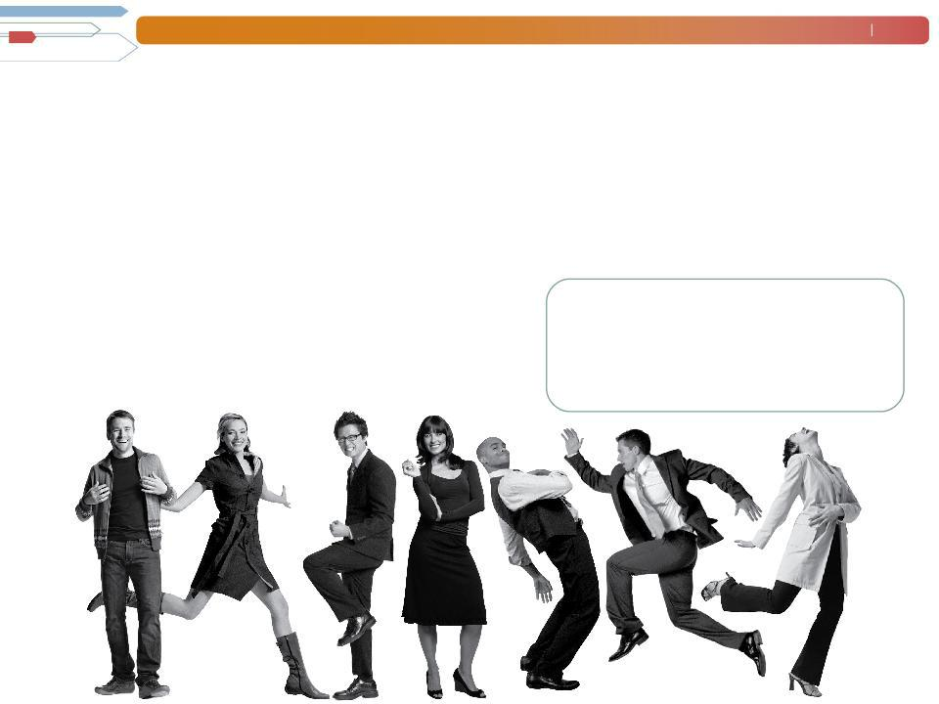

At Manpower, our job is helping the world work, and today it’s more important than ever before.

Despite the challenging business environment, we remain true to our long-term strategy. This is no easy task: It requires careful planning, expertise and agility. With confidence and focus Manpower will emerge stronger and smarter than ever.

OUR VISION is to lead in the creation and delivery of services that enable our clients to win in the changing world of work.

Manpower Inc. (NYSE: MAN) |  |  | February | 4
 |  |  | 2010
Manpower Facts
400,000 clients | 28,000 employees |  | 82 countries/territories
$16 billion in revenues in 2009 |  |  | 82 countries/territories
3 million placements |  | _{4,000 offices} 9 million trained
2009 Segment Revenues in millions ($) |  |  | 2009 Segment Operating Unit Profit* in millions ($)
 | Americas 2,561.0 (16%) |  | Americas (4.0)
 | France 4,675.5 (29%) |  | France 26.4
 | EMEA 6,322.5 (39%) |  | EMEA 73.0
 | Asia Pacific 1,728.0 (11%) |  | Asia Pacific 29.1
 | Right Management 559.4 (4%) |  | Right Management 113.4
 | Jefferson Wells 192.3 (1%) |  | Jefferson Wells (15.4)
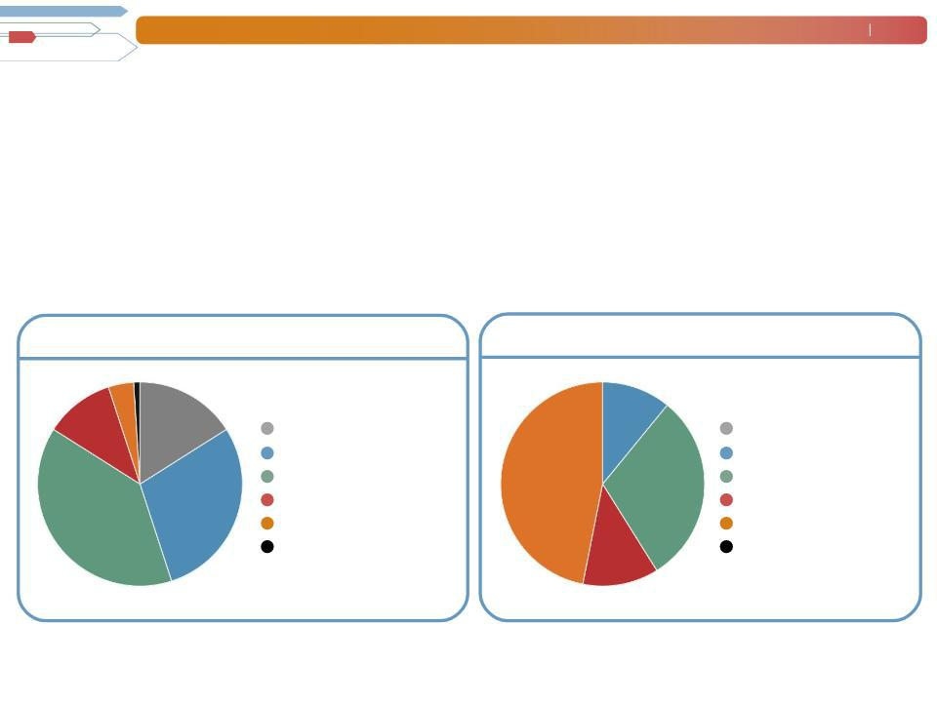

*Excludes non-recurring items as detailed in our earnings release and further explained on our website.

Manpower Inc. (NYSE: MAN) | February | 5
 | 2010
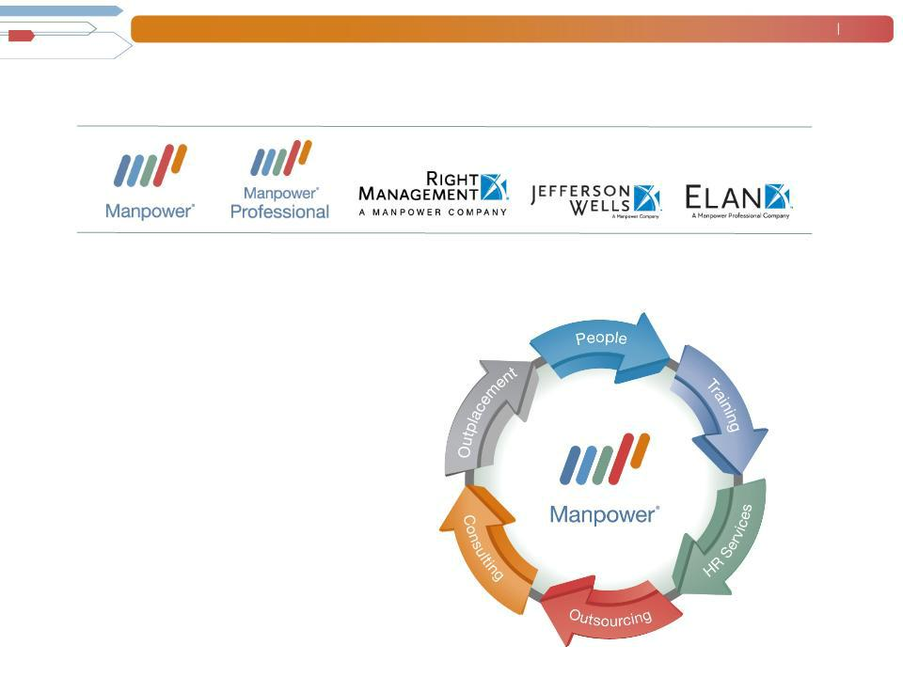
The Manpower Group of Companies:

We Offer Solutions for Employers of all Sizes

End-to-End Services for the
Employment Lifecycle

Our comprehensive range of services

allows us to help employers raise their

productivity through improved quality,

efficiency and cost-reduction strategies

at every stage of their business evolution.

And because we focus on their talent

needs, they can concentrate on their

core business activities.

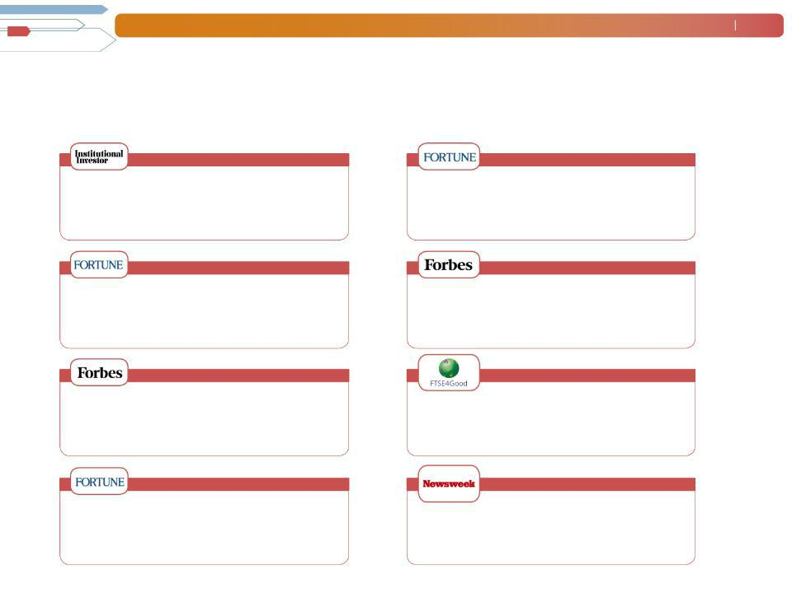
Manpower Inc. (NYSE: MAN)

A Recognized Leader

Recent accolades

America’s Most Shareholder-Friendly

In 2009, Institutional Investor magazine named Manpower the Most Shareholder-Friendly Company in the Business
- Professional Services category for the fourth year in a row, based on interviews with directors of research, chief investment officers, portfolio managers and analysts.

February 6
2010

Fortune Global 500

Manpower ranked 432nd on the 2009 Fortune Global 500 list of the largest companies in the world.

America’s Most Admired Companies

In 2009, Manpower was named as one of Fortune’s most admired companies in the staffing industry for the seventh year in a row by a group of 10,000 executives, directors and security analysts.

Forbes Global
2000

Named a Global High Performer in 2007, Manpower ranked 1,306th on the 2009 Forbes Global 2000 ranking of the largest public companies in the world.

America’s Best Managed Companies

Forbes magazine named Manpower to its 2008 list of the best-managed companies for the sixth time, citing Manpower’s integrity in the areas of accounting and governance, financial condition and earnings quality.

Fortune America 500

Manpower ranked 119th on the 2009 Fortune 500 list of the largest companies in America.

FTSE4Good
Index

Since 2008, Manpower has been listed on the FTSE4Good Index Series, which measures the performance of companies that meet globally recognized corporate responsibility standards, and facilitates investment in those companies.

Greenest Big Companies in America

In 2009, Manpower was named one of America’s greenest “big” companies by Newsweek Magazine. The U.S. Green Building Council awarded Manpower Gold Status under LEED certification system for its “green” headquarters.

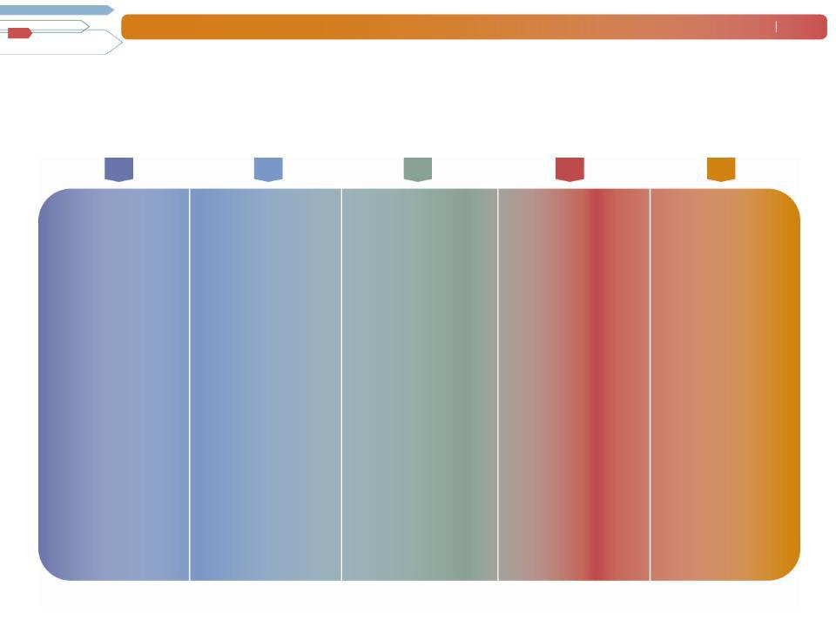
Manpower Inc. (NYSE: MAN)

Key Strategies

Thought

Revenue Efficiency Innovation Leadership

Generating more | Improving our | Demonstrating our | Maintaining our
revenue | efficiency | commitment to | thought
requires us to | means achieving | innovation | leadership
develop strategic | speed, quality and | requires us to | means
insights about | effective use of | continuously | continuously
our clients’ | resources | capture creativity in | anticipating future
needs and | throughout all our | local markets, and | dynamics of the
goals, elevating | operations. | replicate this | market and
and broadening |  | around the world. | contributing to the
our mutually- |  | Our role is to | design of social
beneficial |  | develop and | and employment
relationships and |  | expand our | systems on a
measuring our |  | capabilities, while | global basis.
contribution to |  | creating services
our clients’ |  | targeted to what’s
businesses. |  | new and what’s
 |  | next in the world of
 |  | work.

February 7 2010

Organization and Culture

Evolving our
organization and culture

requires attracting and

retaining high quality people for the long term.

It also requires creating an environment that promotes entrepreneurship, rewards high performance, and motivates us to reach our full potential.

Manpower Inc. (NYSE: MAN) | February | 8
 | 2010
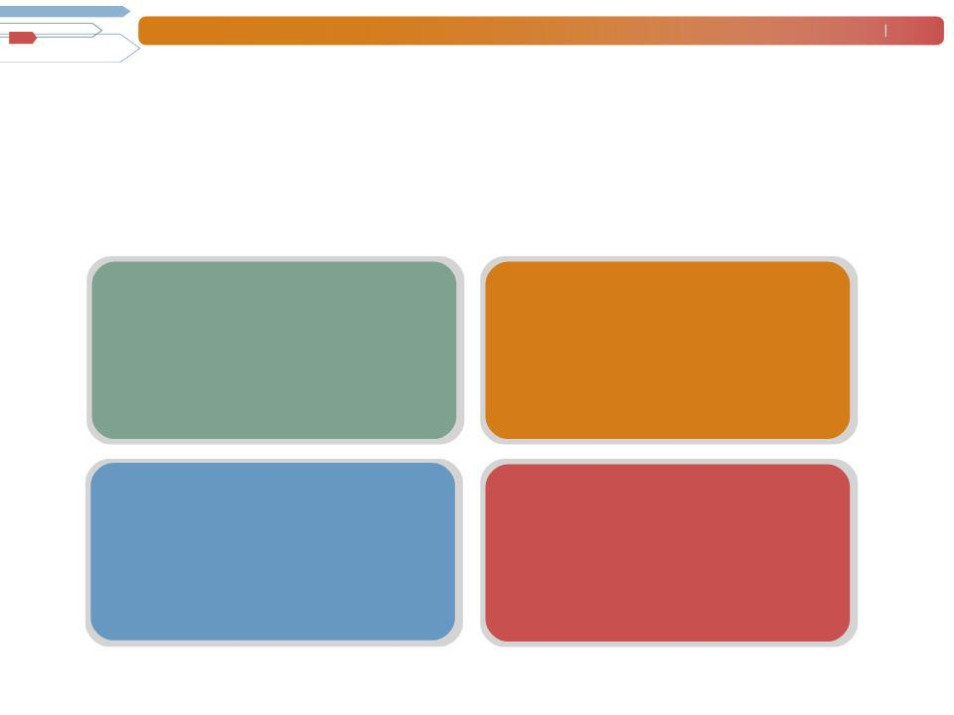
2010 Global Strategic Priorities

To achieve our vision, better service our clients and candidates, and differentiate ourselves from our competition, the Manpower group of companies will focus on:

Manpower Experience |  | Manpower Professional
• Candidate Experience | • | ICT, Engineering, Finance and
• Client Experience |  | Accounting
• Client Experience | • | Go-to-Market Strategy
 | • Enhanced Business Model

 | Digital Strategy |  | New Services & Sectors
• MyPath |  | • Manpower Business Solutions
 |  |  | -RPO (Recruitment Process Outsourcing)
• | Direct Talent |  | -MSP (Managed Service Programs)
• | Direct Office / Direct Time |  | -TBO (Task Based Outsourcing)
• | Direct Office / Direct Time | • | Workforce Strategy

• Government Sector

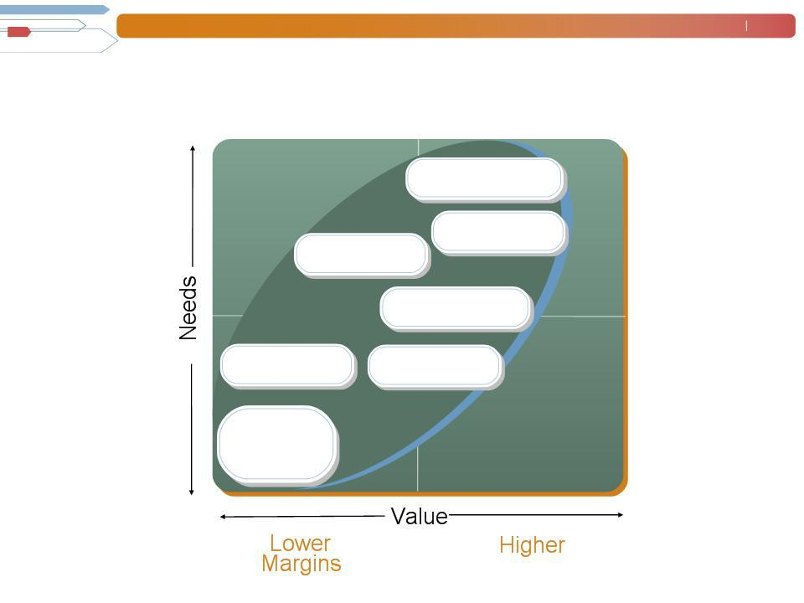
Manpower Inc. (NYSE: MAN)

Where We’re Going

_{Specialty} HR Consulting

MBS
F&A

Outplacement

Permanent Professional

Core

Staffing

Margins

February 9 2010

Manpower Inc. (NYSE: MAN) | February | 10
 | 2010
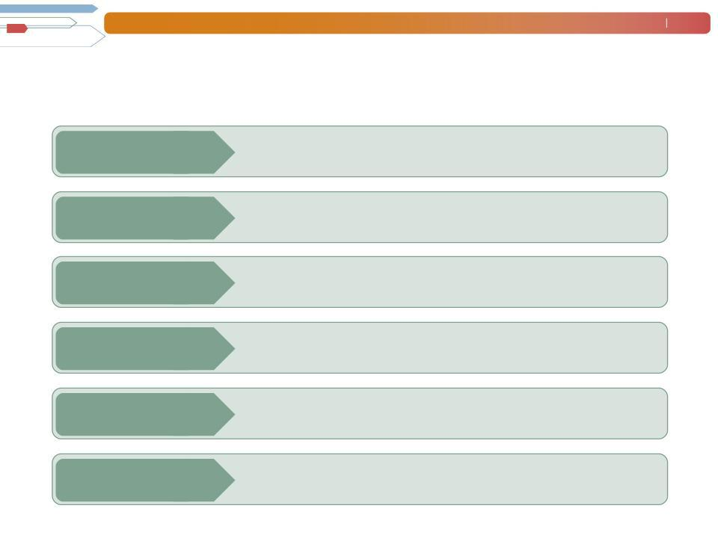
COMSYS Acquisition Summary

Announced | February 2010
Purchase Price | $17.65 per share; $431 million enterprise value
Consideration | 50% stock / 50% cash, with option to pay all cash
Expected Closing | April 2010
Synergies | $20 million by 2011 (3% of revenue)
EPS Accretive | Accretive in 2010, excluding intangible amortization costs

Manpower Inc. (NYSE: MAN) | February | 11
 | 2010

COMSYS Business Overview

- Third largest IT staffing and managed solutions company in the U.S. with $650 million in revenue.

  - Project Management

  - Business Analysis

  - Network Infrastructure

  - Business Intelligence

  - Applications Programming and

Development
- Quality Assurance and Testing

- Workforce Solutions (RPO and

MSP)

- National footprint with 52 branches

- Diversified client base across several high-growth industry sectors

Manpower Inc. (NYSE: MAN) | February | 12
 | 2010
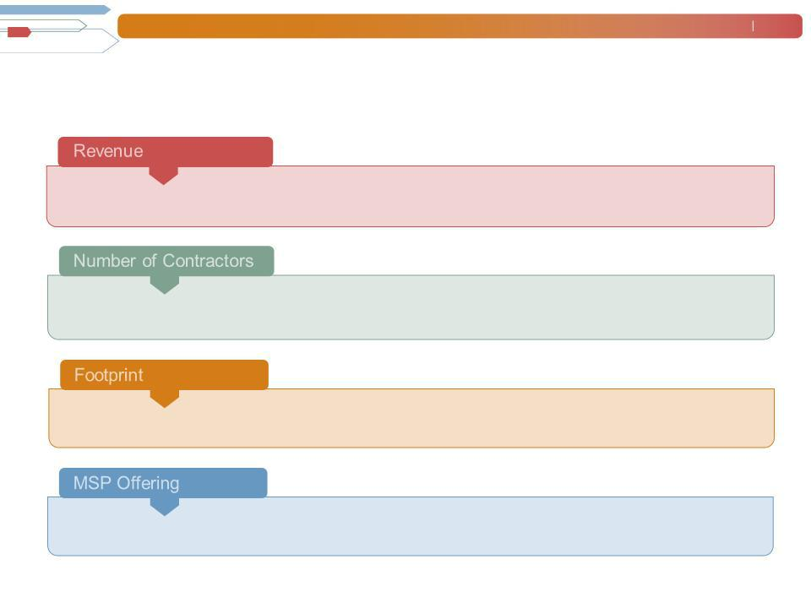
Combined Professional Staffing Business

Combined revenue of Manpower Professional and COMSYS will be over $2.5 billion

Combined number of contractors on assignment daily will be over 25,000

Combined footprint will be 400 offices

Combined MSP offering will be total flow through dollars of $3.5 billion

- Includes Manpower Professional, Elan and Comsys

Manpower Inc. (NYSE: MAN) | February | 13
 | 2010
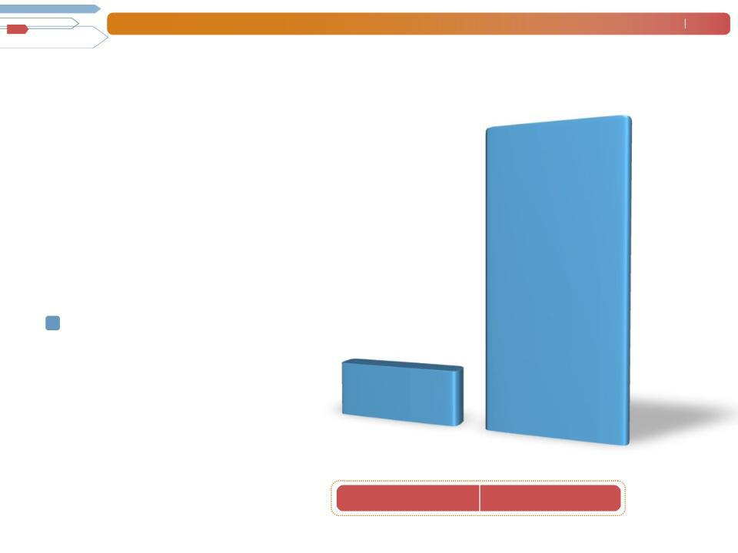
Diversifying Via Specialty Services

Evolution of Specialty Gross Margin

Gross margin from specialty services now exceeds one-third of our total gross margin.

Manpower Professional
Elan
COMSYS | $185M
Jefferson Wells | $185M
Right Management | 1999
% of Total GP | 11%

$975M

2009 Pro forma*

33%

* 2009 Pro forma includes the results of COMSYS IT Partners

Manpower Inc. (NYSE: MAN) | February | 14
 | 2010
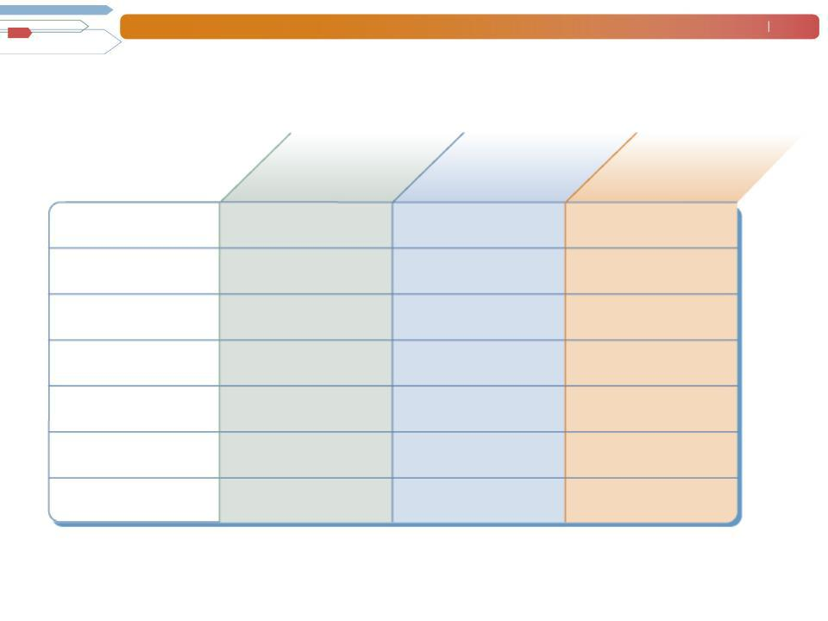
Exciting Growth Opportunities

 | Staffing Market | Growth | Manpower
 | Penetration | Opportunity | Market Share
Italy | 0.9% | +++ | 16%
Nordics | 1.0% | +++ | 30%
Germany | 1.4% | +++ | 5%
Japan | 1.8% | ++ | 3%
US | 1.5% | + | 3%
France | 2.1% | + | 21%
UK | 3.5% | + | 4%

SOURCE: Manpower estimates

Manpower Inc. (NYSE: MAN) | February | 15
 | 2010
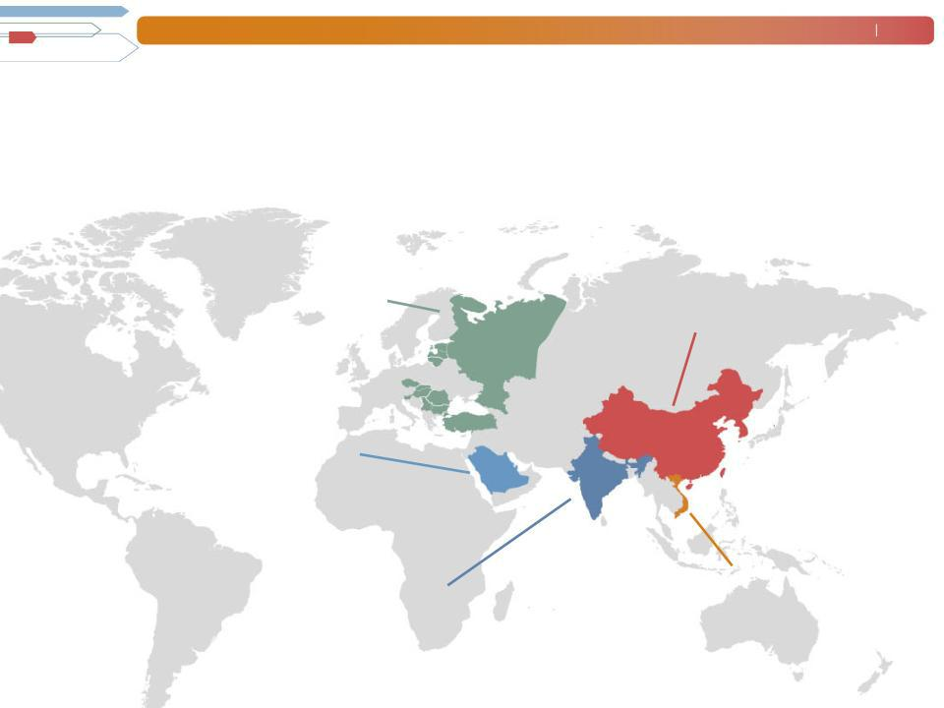
Capitalizing on Emerging Markets

Manpower continues to shape labor policy in emerging economies, resulting in new sources of revenue.

- Extensive network in Eastern Europe with 136 offices in 12 countries

  - Established operations in the Middle East with the

2007 acquisition of one of the leading professional staffing and recruitment companies in the region

    - India’s largest ITeS staffing firm with 22 offices in 13 cities

- First foreign company to receive a license to provide temporary staffing services in China; largest network with 19 offices in 19 cities

- First to provide employment services in Vietnam

Manpower Inc. (NYSE: MAN) | February | 16
 | 2010


Financial Highlights

- Quarter Financial Summary

- Full Year Cash Flow Summary

- Balance Sheet

- Trend Analysis: Revenue and Operating Profit

- Operating Cash Flows

- Return on Invested Capital

- Financial Targets

- Record of Long-Term Growth

Manpower Inc. (NYSE: MAN) | February | 17
 | 2010
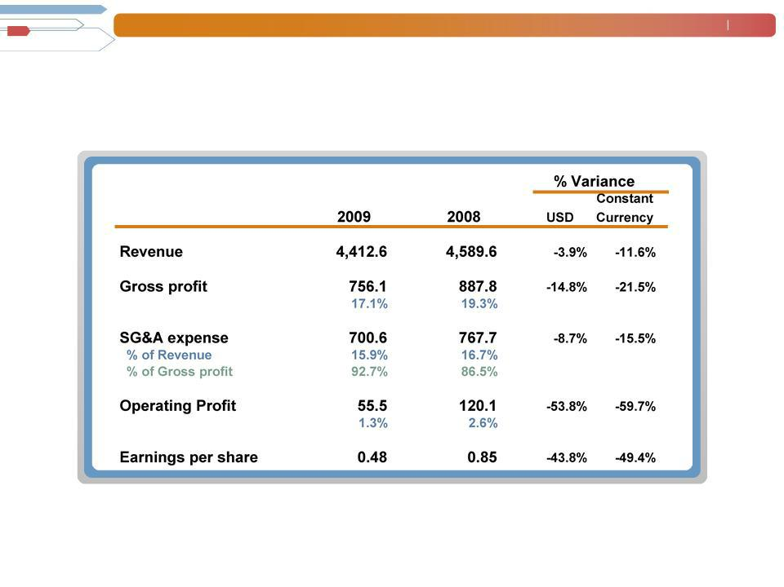

Financial Summary - Fourth Quarter
($ in millions, except EPS)

⁽²⁾ (3) (1)

  - Constant currency is further explained in our quarterly filings with the SEC.
- 2009 excludes reorganization charges of $12.7M.

- 2008 excludes the impact of the French business tax refund, French payroll tax change, and $37.2M of reorganization charges.

Manpower Inc. (NYSE: MAN) | February | 18
 | 2010
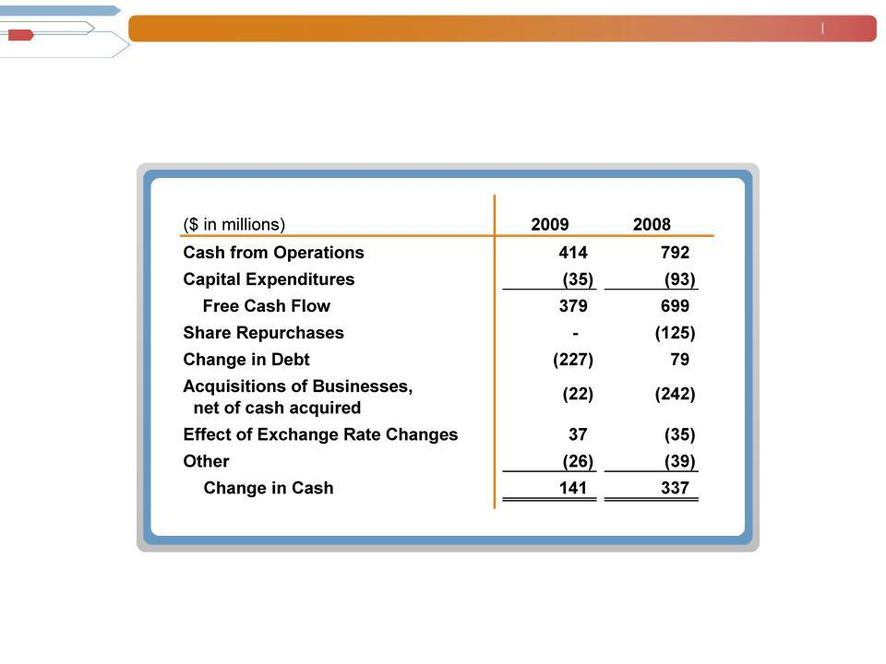

Cash Flow Summary - Full Year

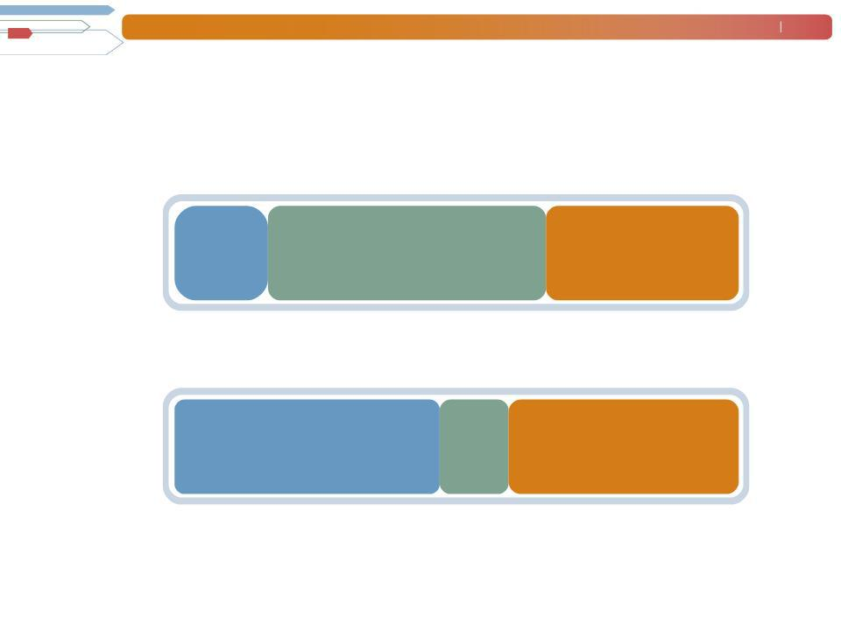
Manpower Inc. (NYSE: MAN)

Balance Sheet

December 31, 2009 ($ in millions)

 | Cash | Accounts Receivable
Assets | 1,015 | 3,071
$6,214 | 1,015 | 3,071

Other Liabilities Total Debt

Liabilities

& Equity 2,920 757
$6,214

February 19
2010

Other Assets

2,128

Equity

2,537

Manpower Inc. (NYSE: MAN) | February | 20
 | 2010
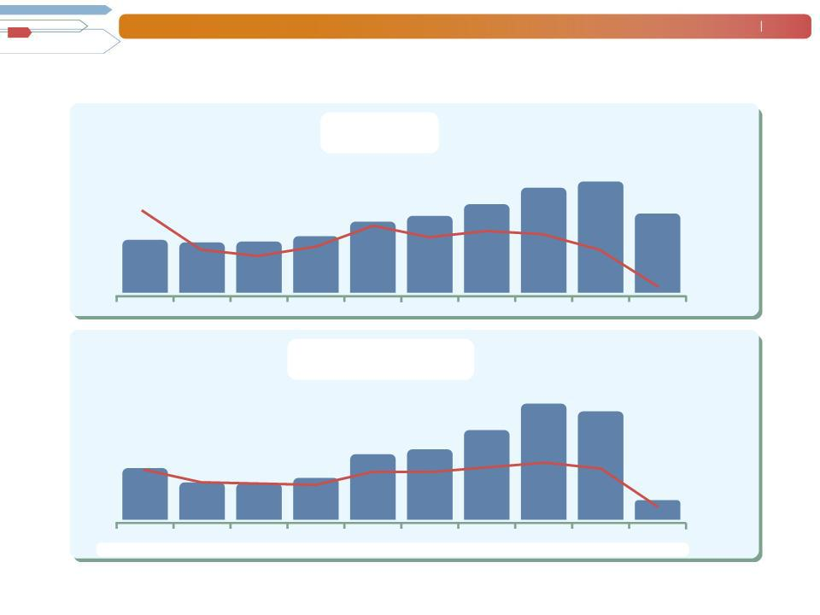
Trend Analysis

Dollars in Billions | Revenue
25 |  |  |  | +0.5%
% = Variance in constant currency |  |  | +9.0% | +0.5%
20 | +7.9% | +10.0% | 20.5 | 21.5

Y-O-Y Growth

in CC%

50.0%

35.0%

-20.9%

15 |  |  |  |  | +13.1% |  | 17.6
15 |  |  |  | +2.1% | 14.7 | 15.8 | 17.6
 | +20.8% | +0.4% | -2.6% | +2.1% | 14.7 | 15.8
10 | +20.8% | +0.4% | -2.6% | 12.1 | 14.7
10 | 10.8 | 10.5 | 10.5 | 12.1

16.0

20.0%

5.0%

5
0
2000 | 2001 | 2002 | 2003 | 2004 | 2005 | 2006 | 2007 | 2008

Dollars in |  |  |  | Operating Profit
Millions
750 |  |  |  |  |  |  |  | +17.6%
 | % = Variance in constant currency |  |  |  |  |  |  | +17.6% | -12.9%
600 |  |  |  |  |  |  |  | 680.6 | -12.9%
600 |  |  |  |  |  |  | +21.9% | 680.6 | 631.4
450 |  |  |  |  | +43.1% | +8.4% | 532.1
 |  |  |  |  | +43.1% | 428.8
300 | +47.5% | -21.6% | -7.9% | +1.5% | 397.8 | 428.8
300 | 311.0 | -21.6% | -7.9% | +1.5%
150 | 311.0 | 237.6 | 233.1 | 259.1
0 | 2000 | 2001 | 2002 | 2003 | 2004 | 2005 | 2006 | 2007 (1) | 2008 (1)
OP% | 2.9% | 2.3% | 2.2% | 2.1% | 2.7% | 2.7% | 3.0% | 3.3% | 2.9%

-10.0%

-25.0%

2009

OP Margin

7.5%

7.0%

4.5%

3.0%

-78.1% _{1.5%}

136.3
0.0%

2009(1)

0.8%

- Excludes non-recurring items as detailed in our earnings release and further explained on our website. As reported, operating profit was $41.7M in 2009, $493.5M in 2008 and $811.2M in 2007 and OP% was 0.3%, 2.3% and 4.0%, respectively.

Manpower Inc. (NYSE: MAN) | February
 | 2010
 | 792.0
Operating Cash Flows | 93.1
($ in millions)
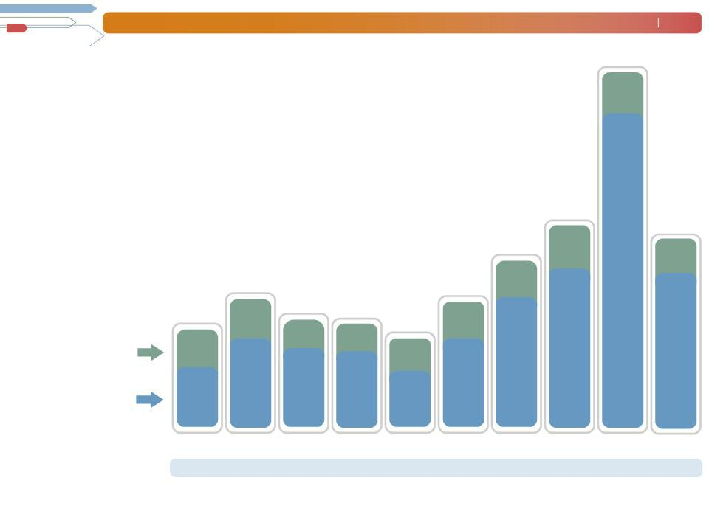

432.2

21

414.3

 | 281.0 |  |  | 268.8
212.9 |  | 227.9 | 223.4
212.9 | 87.3 |  | 223.4 | 77.6
 | 87.3 |  | 187.4 | 77.6

359.1 91.6

80.0

698.9

35.1

379.2

Capital Expenditures

Free Cash Flow *

Share Repurchases

82.6 |  | 58.5 | 55.5
82.6 |  |  |  | 67.9
 | 193.7 | 169.4 | 167.9 |  | 191.2
130.3 |  | 169.4 | 167.9 | 119.5
2000 | 2001 | 2002 | 2003 | 2004 | 2005
$20.0 | $3.3 | $30.7 | - | - | $217.6

- Free Cash Flow is equal to cash provided by operating activities less capital expenditures, and is further explained on our website.

340.6

279.1

2006 2007 2008

$235.9 $419.2 $125.4

2009

-

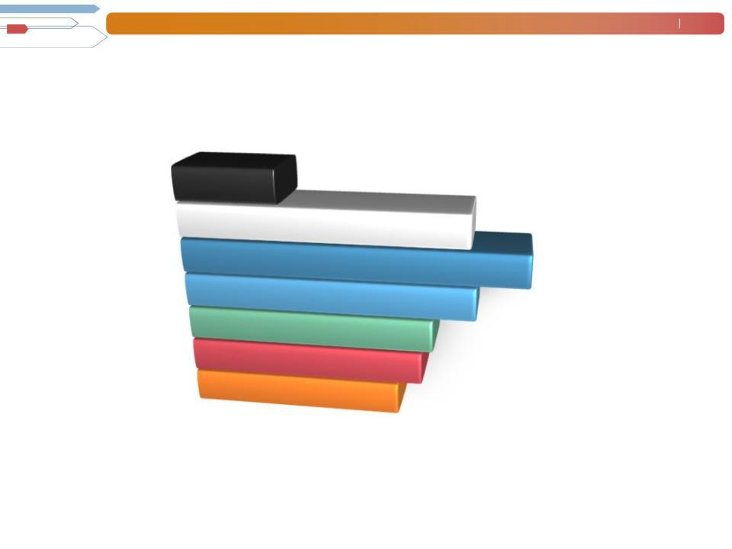
Manpower Inc. (NYSE: MAN)

Return on Invested Capital* (ROIC)

2009 5.7%

2008 | 13.0%
2007 | 15.6%
2006 | 15.6%
2006 | 13.3%
2005 | 13.3%
2005 | 11.4%
2004 | 11.4%
2004 | 10.9%
2003 | 10.9%
2003 | 9.8%

February 22 2010

- Return on Invested Capital is defined as operating profit after tax divided by the average monthly total of net debt (total debt less cash and cash equivalents) and equity for the year, and is further explained on our website. 2009, 2008 and 2007 exclude non-recurring items as detailed in our earnings releases.

Manpower Inc. (NYSE: MAN) | February | 23
 | 2010
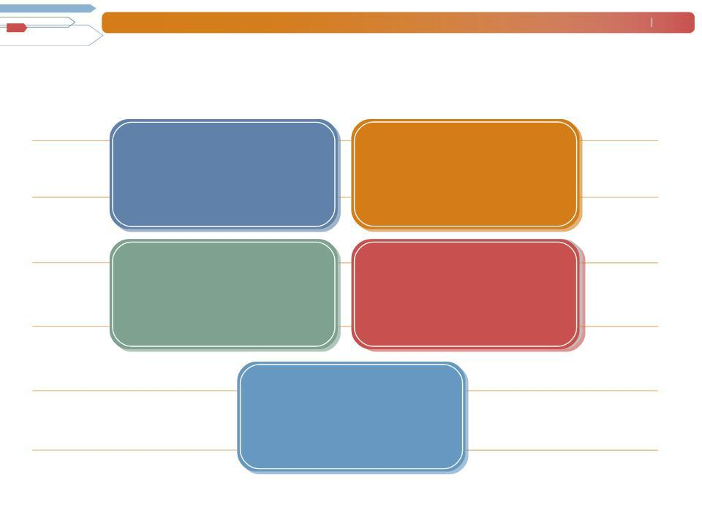
Financial Targets

Revenue | > | Market | SG&A
Growth |  | Market | Expense

Operating | > |  | EPS
Profit | > | 4% | EPS
Profit | > | 4% | Growth
Margin | > |  | Growth

<

>

80%

Grossof

Profit

15%

Constant

Currency

ROIC > 15%

Manpower Inc. (NYSE: MAN) | February | 24
 | 2010
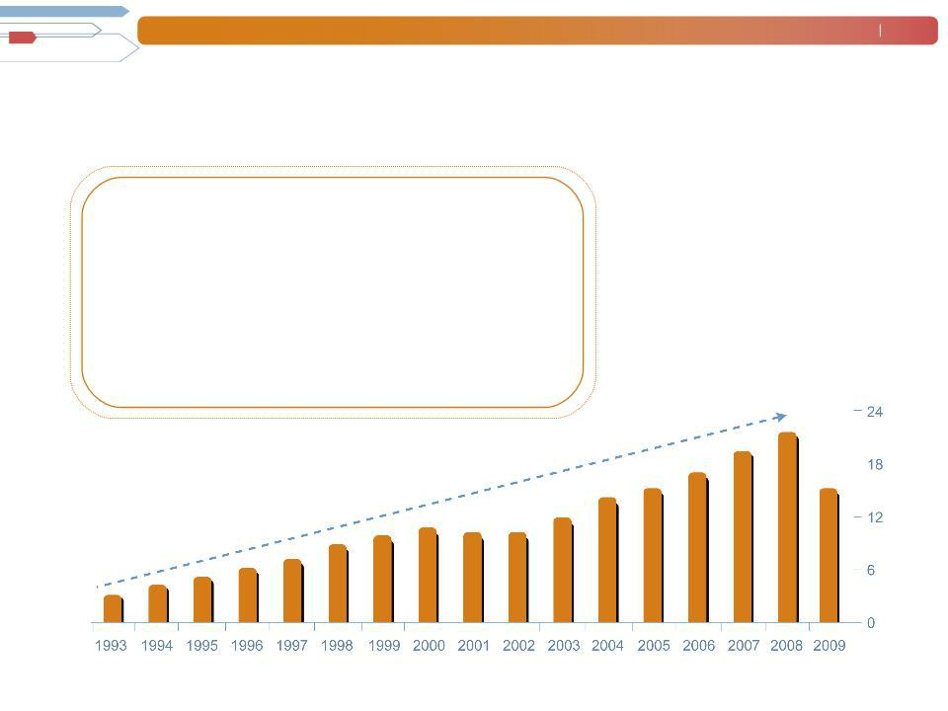
Strong Record of Long-Term Growth

- Balanced service portfolio

- Geographic diversification

- Well positioned for emerging market growth

- Clear, effective strategy

- Seasoned management team

- Industry leader with superior brand recognition

Additional Information

This presentation is being filed by Manpower Inc. pursuant to Rule 425 under the Securities Act of 1933. This presentation does not constitute an offer of any securities for sale. The exchange offer described above has not commenced. Manpower intends to commence an exchange offer and file a Schedule TO and a registration statement on Form S-4, and COMSYS intends to file a Solicitation/Recommendation Statement on Schedule 14D-9, with the Securities and Exchange Commission in connection with the transaction. Manpower and COMSYS expect to mail a Preliminary Prospectus, the Schedule 14D-9 and related exchange offer materials to stockholders of COMSYS. These documents, however, are not currently available. INVESTORS AND SECURITY HOLDERS ARE URGED TO READ THESE DOCUMENTS CAREFULLY WHEN THEY ARE AVAILABLE BECAUSE THEY CONTAIN IMPORTANT INFORMATION ABOUT MANPOWER, COMSYS AND THE TRANSACTION. Documents filed by Manpower with the SEC may be obtained without charge at the SEC’s website at www.sec.gov and at Manpower’s website at www.manpower.com. Documents filed by COMSYS with the SEC may be obtained without charge at the SEC's website and at COMSYS’ website at www.comsys.com.

Forward-Looking Statements

This presentation contains statements, including statements regarding timing, completion and results of the proposed transaction, that are forward-looking in nature and, accordingly, are subject to risks and uncertainties. Actual results may differ materially from those described or contemplated in the forward-looking statements. Factors that may cause actual results to differ materially from those contained in the forward-looking statements include, among others, the risk that the exchange offer and the merger will not close; the risk that Manpower’s business and/or COMSYS’ business will be adversely impacted during the pendency of the exchange offer and the merger; the risk that the operations of the two companies will not be integrated successfully; the risk that Manpower’s expected cost savings and other synergies from the transaction may not be fully realized, realized at all or take longer to realize than anticipated; the risk that demand for and acceptance of Manpower’s or COMSYS’ products or services may be reduced; the impact of economic conditions; the impact of competition and pricing; and other factors found in the Manpower’s and COMSYS’ reports filed with the SEC, including the information under the heading ‘Risk Factors’ in Manpower’s Annual Report on Form 10-K for the year ended December 31, 2009 and COMSYS’ Annual Report on Form 10-K for the fiscal year ended December 28, 2008, which information is incorporated herein by reference.

