UNITED STATES

SECURITIES AND EXCHANGE COMMISSION
Washington, D.C. 20549 Exhibit 99.2

FORM 8-K

CURRENT REPORT

Pursuant to Section 13 or 15(d) of the Securities Exchange Act of 1934

Date of Report (Date of earliest event reported): April 21, 2010

MANPOWER INC.

(Exact name of registrant as specified in its charter)

Wisconsin

(State or other jurisdiction of incorporation)

1-10686

(Commission File Number)

39-1672779

(IRS Employer Identification No.)

100 Manpower Place

Milwaukee, Wisconsin

(Address of principal executive offices)

53212

(Zip Code)

Registrant's telephone number, including area code: (414) 961-1000

Check the appropriate box below if the Form 8-K filing is intended to simultaneously satisfy the filing obligation of the registrant under any of the following provisions:

Written communications pursuant to Rule 425 under the Securities Act (17 CFR 230.425)

Soliciting material pursuant to Rule 14a-12 under the Securities Act (17 CFR 240.14a-12)

Pre-commencement communications pursuant to Rule 14d-2(b) under the Exchange Act (17 CFR 240.14d-2(b))

Pre-commencement communications pursuant to Rule 13e-4(c) under the Exchange Act (17 CFR 240.13e-4(c))

Item 2.02 Results of Operations and Financial Condition

On April 21, 2010, we issued a press release announcing our results of operations for the three months ended March 31, 2010. A copy of the press release is attached hereto as Exhibit 99.1 and is incorporated herein by reference.

Item 9.01. |  | Exhibits.
 | Exhibit No. |  |  | Description
 | 99.1 |  |  | Press Release dated April 21, 2010
99.2 |  |  |  | Presentation materials for April 21, 2010 conference call

SIGNATURES

Pursuant to the requirements of the Securities Exchange Act of 1934, the Registrant has duly caused this Report to be signed on its behalf by the undersigned hereunto duly authorized.

MANPOWER INC.

Dated: April 21, 2010 By: /s/ Michael J. Van Handel

Michael J. Van Handel

Executive Vice President and

Chief Financial Officer

 |  | EXHIBIT INDEX
Exhibit No. |  | Description
99.1 |  | Press Release dated April 21, 2010
99.2 |  | Presentation materials for April 21, 2010 conference call

Exhibit 99.1


FOR IMMEDIATE RELEASE

Contact:

Mike Van Handel
Manpower Inc.
+1.414.906.6305
michael.vanhandel@manpower.com

Manpower Reports 1st Quarter 2010 Results

MILWAUKEE, WI, USA, April 21, 2010 – Manpower Inc. (NYSE: MAN) today reported that net earnings for the three months ended March 31, 2010 were $2.8 million, or 4 cents per diluted share, compared to a loss of $1.8 million, or 2 cents per diluted share, a year earlier. Revenues for the first quarter were $4.1 billion, an increase of 13% from the year earlier period, or 5% in constant currency.

Net earnings in the first quarter were favorably impacted by 3 cents per diluted share, as foreign currencies were relatively stronger compared to the prior year period..

In December 2009 the French government published changes to its business tax law effective in 2010. Under the new law, a component of the business tax calculation is based upon added value (revenue less expenses as defined in the legislation). Under U.S. Generally Accepted Accounting Principles (GAAP), a tax of this nature is classified as a component of the income tax provision. Accordingly, the charge of $13.7 million related to this business tax was included in our provision for income taxes in the quarter. Previously this amount would have been classified as a component of Cost of Services. The amount of the business tax did not change materially as a result of the new calculation and, therefore, net earnings were not impacted.

Jeffrey A. Joerres, Manpower Inc. Chairman and Chief Executive Officer, said, “The Manpower team throughout the world performed extremely well. We were able to exceed our anticipated revenue plans while we effectively managed our expenses. In all major geographies we are experiencing strong cyclical trends and even stronger secular trends as companies need to respond to the increased demand but want to remain agile.

“Our major geographies, the U.S., France, Germany, U.K. and others, all have stronger revenue trajectories exiting the first quarter.

“In early April we completed the acquisition of COMSYS IT Partners, Inc. This acquisition is an important component of our strategy, when coupled with our organic growth, as we aggressively expand our presence in the specialty staffing area.

"We anticipate that favorable economic trends will continue into the second quarter, resulting in earnings per share of 14 cents to 22 cents. This includes a negative impact of 10 cents per share related to the COMSYS acquisition. We anticipate the impact of currency changes on the quarter will be negligible.”

In conjunction with its first quarter earnings release, Manpower will broadcast its conference call live over the Internet on April 21, 2010 at 7:30 a.m. CDT (8:30 a.m. EDT). Interested parties are invited to listen to the webcast and view the presentation by logging on to http://investor.manpower.com.

Supplemental financial information referenced in the conference call can be found at http://investor.manpower.com.

About Manpower Inc.

Manpower Inc. (NYSE: MAN) is a world leader in workforce solutions; creating and delivering services that enable its clients to win in the changing world of work. With more than 60 years of experience, Manpower offers employers a range of solutions and services for the entire employment and business cycle including permanent, temporary and contract recruitment; employee assessment and selection; training; outplacement; outsourcing and consulting. Manpower's worldwide network of nearly 4000 offices in 82 countries and territories enables the company to meet the needs of its 400,000 clients per year, including small and medium size enterprises in all industry sectors, as well as the world's largest multinational corporations. The focus of Manpower's work is on raising productivity through improved quality, efficiency and cost-reduction across their total workforce, enabling clients to concentrate on their core business activities. Manpower Inc. operates under five brands: Manpower, Manpower Professional, Elan, Jefferson Wells and Right Management. More information on Manpower Inc. is available at www.manpower.com.

Forward-Looking Statements

This news release contains statements, including statements regarding economic trends and future profitability, that are forward-looking in nature and, accordingly, are subject to risks and uncertainties regarding the Company’s expected future results. The Company’s actual results may differ materially from those described or contemplated in the forward-looking statements. Factors that may cause the Company’s actual results to differ materially from those contained in the forward-looking statements can be found in the Company’s reports filed with the SEC, including the information under the heading ‘Risk Factors’ in its Annual Report on Form 10-K for the year ended December 31, 2009, which information is incorporated herein by reference.

- ### -

Manpower Inc.

Results of Operations

(In millions, except per share data)

 |  |  |  |  |  |  | Three Months Ended March 31
 |  |  |  |  |  |  |  |  |  |  | % Variance
 |  |  |  |  |  |  |  |  |  | Amount |  |  |  | Constant
 |  |  | 2010 |  |  |  | 2009 |  |  | Reported |  |  |  | Currency
 |  |  |  |  |  |  |  | (Unaudited)
 | Revenues from services (a) (b) | $ |  | 4,099.3 |  | $ |  | 3,643.0 |  |  | 12.5% |  |  | 5.1%
 | Cost of services |  |  | 3,397.8 |  |  |  | 2,977.3 |  |  | 14.1% |  |  | 6.6%
 | Gross profit |  |  | 701.5 |  |  |  | 665.7 |  |  | 5.4% |  |  | -1.4%
 | Selling and administrative expenses |  |  | 668.9 |  |  |  | 664.3 |  |  | 0.7% |  |  | -5.5%
 | Operating profit |  |  | 32.6 |  |  |  | 1.4 |  |  | N/A |  |  | N/A
 | Interest and other expenses |  |  | 12.9 |  |  |  | 11.9 |  |  | 8.7%
 | Earnings (loss) before income taxes |  |  | 19.7 |  |  |  | (10.5) |  |  | N/A |  |  | N/A
 | Provision for income taxes |  |  | 16.9 |  |  |  | (8.7) |  |  | N/A
 | Net earnings (loss) |  | $ | 2.8 |  |  | $ | (1.8) |  |  | N/A |  |  | N/A
 | Net earnings (loss) per share - basic |  | $ | 0.04 |  | $ |  | (0.02) |  |  | N/A
 | Net earnings (loss) per share - diluted |  | $ | 0.04 |  | $ |  | (0.02) |  |  | N/A |  |  | N/A
 | Weighted average shares - basic |  |  | 78.6 |  |  |  | 78.1 |  |  | 0.6%
 | Weighted average shares - diluted |  |  | 79.9 |  |  |  | 78.1 |  |  | 2.2%

- Revenues from services include fees received from our franchise offices of $4.6 million and $5.1 million for the three months ended March 31, 2010 and 2009, respectively. These fees are primarily based on revenues generated by the franchise offices, which were $193.9 million and $158.9 million for the three months ended March 31, 2010 and 2009, respectively.

- Our 2009 results have been restated as disclosed in Note 16 to the Consolidated Financial Statements included in our 2009 Annual Report to Shareholders.

Manpower Inc.

Operating Unit Results

(In millions)

 |  |  |  |  |  |  |  | Three Months Ended March 31
 |  |  |  |  |  |  |  |  |  |  |  | % Variance
 |  |  |  |  |  |  |  |  |  |  | Amount |  |  |  | Constant
 |  |  |  | 2010 |  |  |  | 2009 |  |  | Reported |  |  |  | Currency
 |  |  |  |  |  |  |  |  | (Unaudited)
 | Revenues from Services:
 | Americas:
 | United States (a) | $ |  | 442.1 |  | $ |  |  | 373.8 |  |  | 18.3% |  |  | 18.3%
 | Other Americas |  |  | 294.5 |  |  |  |  | 219.2 |  |  | 34.4% |  |  | 22.8%
 |  |  |  | 736.6 |  |  |  |  | 593.0 |  |  | 24.2% |  |  | 19.9%
 | France |  |  | 1,107.5 |  |  |  |  | 956.9 |  |  | 15.7% |  |  | 9.3%
 | EMEA:
 | Italy |  |  | 234.2 |  |  |  |  | 220.4 |  |  | 6.3% |  |  | 0.4%
 | Other EMEA (b) |  |  | 1,379.6 |  |  |  |  | 1,258.8 |  |  | 9.6% |  |  | 0.4%
 |  |  |  | 1,613.8 |  |  |  |  | 1,479.2 |  |  | 9.1% |  |  | 0.4%
 | Asia Pacific |  |  | 497.5 |  |  |  |  | 425.2 |  |  | 17.0% |  |  | 5.3%
 | Right Management |  |  | 103.3 |  |  |  |  | 136.0 |  |  | -24.0% |  |  | -27.9%
 | Jefferson Wells |  |  | 40.6 |  |  |  |  | 52.7 |  |  | -22.9% |  |  | -22.9%
 |  |  | $ | 4,099.3 |  |  | $ |  | 3,643.0 |  |  | 12.5% |  |  | 5.1%
 | Operating Unit (Loss) Profit:
 | Americas:
 | United States (a) | $ |  | (8.4) |  | $ |  |  | (14.5) |  |  | N/A |  |  | N/A
 | Other Americas |  |  | 9.6 |  |  |  |  | 4.8 |  |  | 101.0% |  |  | 87.1%
 |  |  |  | 1.2 |  |  |  |  | (9.7) |  |  | N/A |  |  | N/A
 | France |  |  | 0.2 |  |  |  |  | 1.0 |  |  | -83.9% |  |  | -69.7%
 | EMEA:
 | Italy |  |  | 6.8 |  |  |  |  | 1.4 |  |  | 386.1% |  |  | 362.9%
 | Other EMEA (b) |  |  | 16.8 |  |  |  |  | (3.4) |  |  | N/A |  |  | N/A
 |  |  |  | 23.6 |  |  |  |  | (2.0) |  |  | N/A |  |  | N/A
 | Asia Pacific |  |  | 12.5 |  |  |  |  | 12.1 |  |  | 3.6% |  |  | -9.3%
 | Right Management |  |  | 12.5 |  |  |  |  | 29.1 |  |  | -56.9% |  |  | -58.1%
 | Jefferson Wells |  |  | (4.7) |  |  |  |  | (7.5) |  |  | N/A |  |  | N/A
 |  |  |  | 45.3 |  |  |  |  | 23.0
 | Corporate expenses |  |  | (26.4) |  |  |  |  | (21.6)
 | Reclassification of French business tax |  |  | 13.7 |  |  |  |  | -
 | Operating profit |  |  | 32.6 |  |  |  |  | 1.4 |  |  | N/A |  |  | N/A
 | Interest and other expenses (c) |  |  | (12.9) |  |  |  |  | (11.9)
 | Earnings (loss) before income taxes |  | $ | 19.7 |  | $ |  |  | (10.5)

- In the United States, revenues from services include fees received from our franchise offices of $2.5 million and $2.0 million for the three months ended March 31, 2010 and 2009, respectively. These fees are primarily based on revenues generated by the franchise offices, which were $132.2 million and $94.9 million for the three months ended March 31, 2010 and 2009, respectively.

- Our 2009 results have been restated as disclosed in Note 16 to the Consolidated Financial Statements included in our 2009 Annual Report to Shareholders.

- The components of interest and other expenses were:

 |  | 2010 |  |  |  |  | 2009
Interest expense | $ |  | 11.1 |  | $ |  | 13.1
Interest income |  |  | (1.6) |  |  |  | (4.4)
Foreign exchange losses |  |  | 1.9 |  |  |  | 0.5
Miscellaneous expenses, net |  |  | 1.5 |  |  |  | 2.7
 |  | $ | 12.9 |  | $ |  | 11.9

Manpower Inc.

Consolidated Balance Sheets

(In millions)

 |  | Mar. 31 |  |  |  | Dec. 31
 |  | 2010 |  |  |  | 2009
 |  | (Unaudited)
ASSETS
Current assets:
Cash and cash equivalents | $ | 943.8 |  | $ |  | 1,014.6
Accounts receivable, net |  | 3,075.7 |  |  |  | 3,070.8
Prepaid expenses and other assets |  | 202.4 |  |  |  | 179.6
Future income tax benefits |  | 55.7 |  |  |  | 67.4
Total current assets |  | 4,277.6 |  |  |  | 4,332.4
Other assets:
Goodwill and other intangible assets, net |  | 1,334.9 |  |  |  | 1,357.5
Other assets |  | 339.9 |  |  |  | 347.5
Total other assets |  | 1,674.8 |  |  |  | 1,705.0
Property and equipment:
Land, buildings, leasehold improvements and equipment |  | 666.2 |  |  |  | 703.6
Less: accumulated depreciation and amortization |  | 503.6 |  |  |  | 527.2
Net property and equipment |  | 162.6 |  |  |  | 176.4
Total assets | $ | 6,115.0 |  | $ |  | 6,213.8
LIABILITIES AND SHAREHOLDERS' EQUITY
Current liabilities:
Accounts payable | $ | 1,008.7 |  | $ |  | 944.4
Employee compensation payable |  | 159.4 |  |  |  | 187.8
Accrued liabilities |  | 465.8 |  |  |  | 465.9
Accrued payroll taxes and insurance |  | 515.4 |  |  |  | 572.0
Value added taxes payable |  | 401.2 |  |  |  | 391.2
Short-term borrowings and current maturities of long-term debt |  | 42.2 |  |  |  | 41.7
Total current liabilities |  | 2,592.7 |  |  |  | 2,603.0
Other liabilities:
Long-term debt |  | 675.5 |  |  |  | 715.6
Other long-term liabilities |  | 360.2 |  |  |  | 358.7
Total other liabilities |  | 1,035.7 |  |  |  | 1,074.3
Shareholders' equity:
Common stock |  | 1.0 |  |  |  | 1.0
Capital in excess of par value |  | 2,555.5 |  |  |  | 2,544.2
Retained earnings |  | 1,112.4 |  |  |  | 1,109.6
Accumulated other comprehensive income |  | 43.9 |  |  |  | 106.9
Treasury stock, at cost |  | (1,226.2) |  |  |  | (1,225.2)
Total shareholders' equity |  | 2,486.6 |  |  |  | 2,536.5
Total liabilities and shareholders' equity | $ | 6,115.0 |  | $ |  | 6,213.8

Manpower Inc.

Consolidated Statements of Cash Flows

(In millions)

 |  | Three Months Ended
 |  |  | Mar. 31
 |  | 2010 |  |  |  | 2009
 |  |  | (Unaudited)
 | Cash Flows from Operating Activities:
 | Net earnings (loss) | $ | 2.8 |  | $ |  | (1.8)
 | Adjustments to reconcile net earnings (loss) to net cash provided by operating activities:
 | Depreciation and amortization |  | 21.4 |  |  |  | 23.2
 | Deferred income taxes |  | (9.5) |  |  |  | 2.0
 | Provision for doubtful accounts |  | 4.1 |  |  |  | 6.6
 | Share-based compensation |  | 5.5 |  |  |  | 4.1
 | Excess tax benefit on exercise of stock options |  | (0.1) |  |  |  | (0.1)
 | Changes in operating assets and liabilities, excluding the impact of acquisitions:
 | Accounts receivable |  | (127.1) |  |  |  | 572.3
 | Other assets |  | (35.6) |  |  |  | (41.5)
 | Other liabilities |  | 95.5 |  |  |  | (315.0)
 | Cash (used in) provided by operating activities |  | (43.0) |  |  |  | 249.8
 | Cash Flows from Investing Activities:
 | Capital expenditures |  | (7.8) |  |  |  | (8.9)
 | Acquisitions of businesses, net of cash acquired |  | (0.1) |  |  |  | (10.6)
 | Proceeds from the sale of property and equipment |  | 0.3 |  |  |  | 1.0
 | Cash used in investing activities |  | (7.6) |  |  |  | (18.5)
 | Cash Flows from Financing Activities:
 | Net change in short-term borrowings |  | 0.2 |  |  |  | (17.0)
 | Proceeds from long-term debt |  | 1.5 |  |  |  | 77.6
 | Repayments of long-term debt |  | (0.7) |  |  |  | (116.1)
 | Proceeds from share-based awards |  | 4.9 |  |  |  | 4.7
 | Excess tax benefit on exercise of stock options |  | 0.1 |  |  |  | 0.1
 | Cash provided by (used in) financing activities |  | 6.0 |  |  |  | (50.7)
 | Effect of exchange rate changes on cash |  | (26.2) |  |  |  | (53.6)
 | Change in cash and cash equivalents |  | (70.8) |  |  |  | 127.0
 | Cash and cash equivalents, beginning of period |  | 1,014.6 |  |  |  | 874.0
 | Cash and cash equivalents, end of period | $ | 943.8 |  |  | $ | 1,001.0



MANPOWER INC.

2010 1st Quarter Results

Helping Clients and Candidates

Win for Over Six Decades

2010 April 21


2

Forward-Looking Statement

This presentation includes forward-looking

statements, including earnings projections

which are subject to risks and uncertainties.

Actual results might differ materially from

those projected in the forward-looking

statements. Additional information concerning

factors that could cause actual results to

materially differ from those in the forward-

looking statements is contained in the

Company’s Annual Report on Form 10-K

dated December 31, 2009, which information

is incorporated herein by reference, and such

other factors as may be described from time

to time in the Company’s SEC filings.

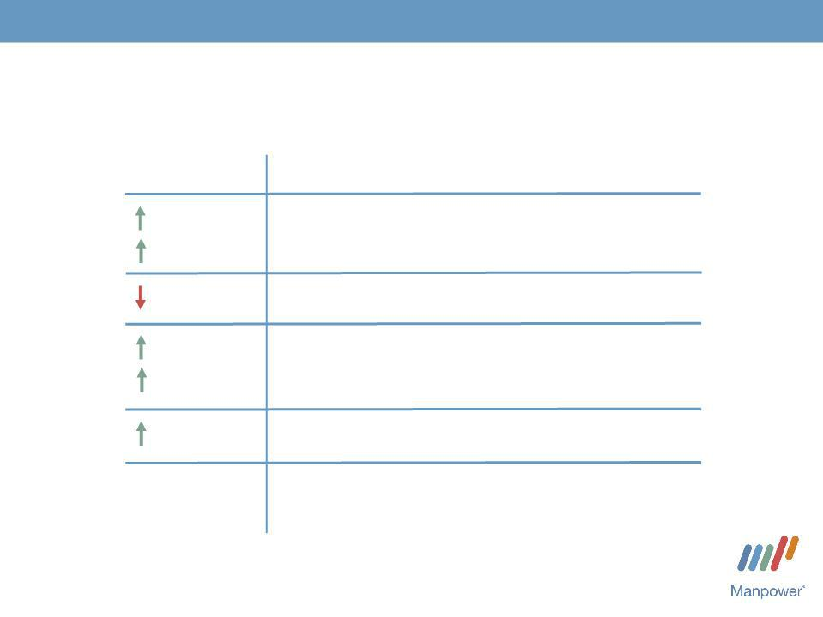
3

Consolidated Financial Highlights

 | Q1 Highlights ⁽¹⁾
13% | Revenue $4.1B
5% CC
120 bps | Gross Margin 17.1%
N/A | Operating Profit $33M
N/A | Operating Profit $33M
80 bps | OP Margin 0.8%
N/A | EPS $.04
N/A
- 2009 results include non-recurring items, including reorganization charges, totaling a net benefit of $6M

before income taxes.
Throughout this presentation, the difference between reported variances and Constant Currency (CC) variances represents the impact of currency on our financial results. Constant Currency is further explained on our Web site.

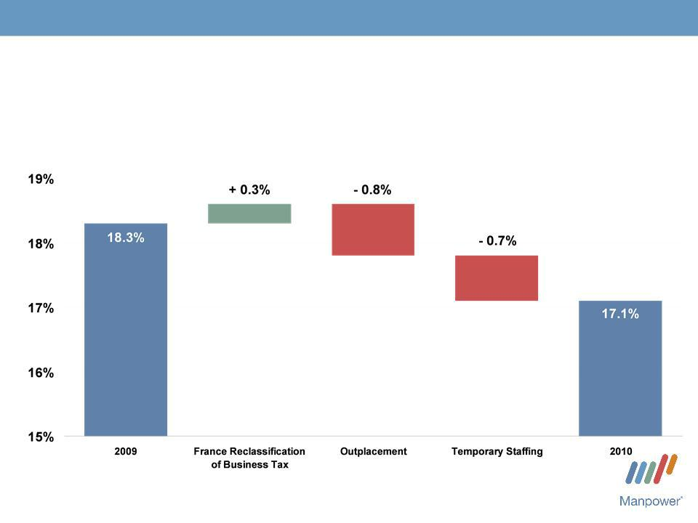
4

Consolidated Gross Margin Change

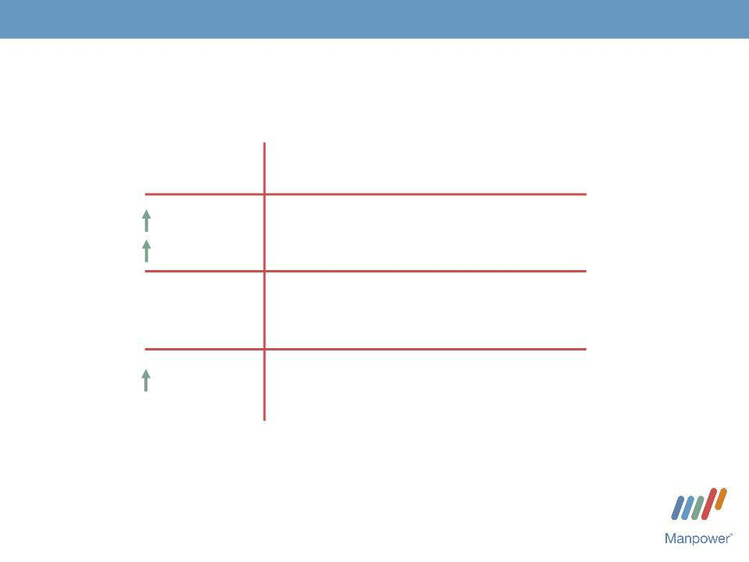
5

Americas Segment

(18% of Revenue)

Q1 Financial Highlights ⁽¹⁾

24% | Revenue $737M
20% CC | Revenue $737M
N/A | OUP $1M
N/A | OUP $1M
(2) | OUP Margin 0.2%
180 bps | OUP Margin 0.2%

- Included in these amounts is the US, which had revenue of $442M (+18%) and OUP loss of $8M.

- 2009 includes reorganization charges totaling $0.9M.

Operating Unit Profit (OUP) is the measure that we use to evaluate segment performance. OUP is equal to segment revenues less direct costs and branch and national headquarters operating costs.

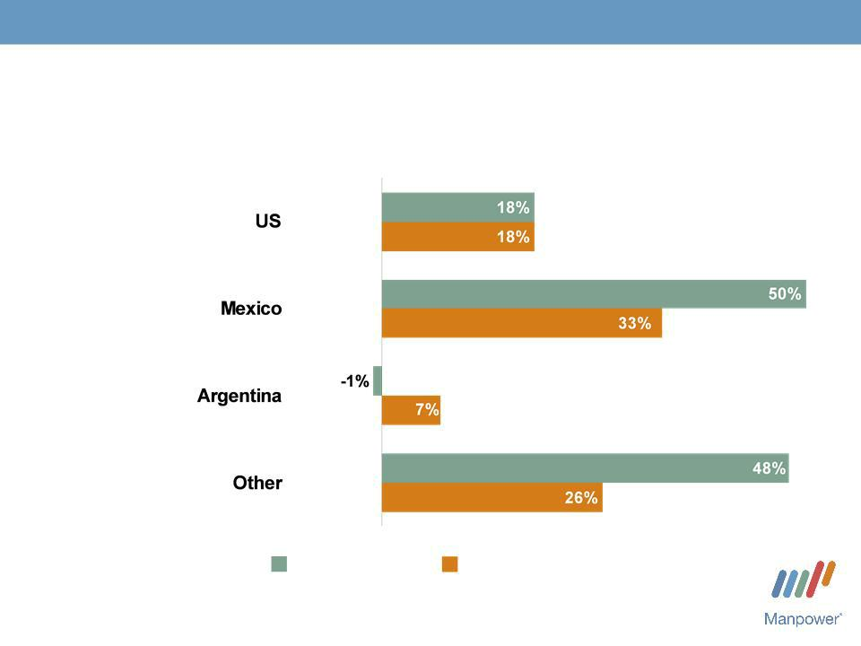
6

Americas - Q1 Revenue Growth YoY

- of Segment Revenue

60%

14%

9%

17%

Revenue | Revenue Growth - CC
Growth

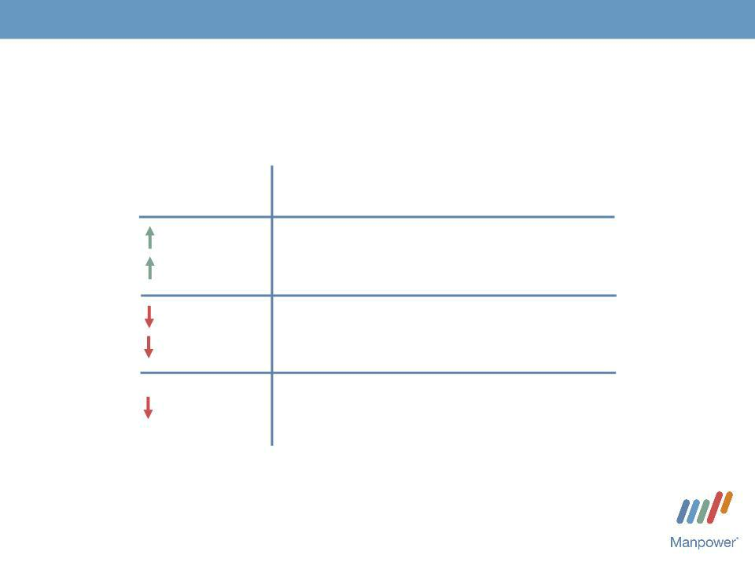
7

France Segment

(27% of Revenue)

Q1 Financial Highlights

16% |  | Revenue $1.1B
9% |  | Revenue $1.1B
CC | (1)
84% | (1) | OUP $0M
70% | (1) | OUP $0M
CC | (1) | OUP Margin 0.0%
10 | (1) | OUP Margin 0.0%
bps

- 2009 includes non-recurring items, including reorganization charges, totaling a net benefit of $3.2M.

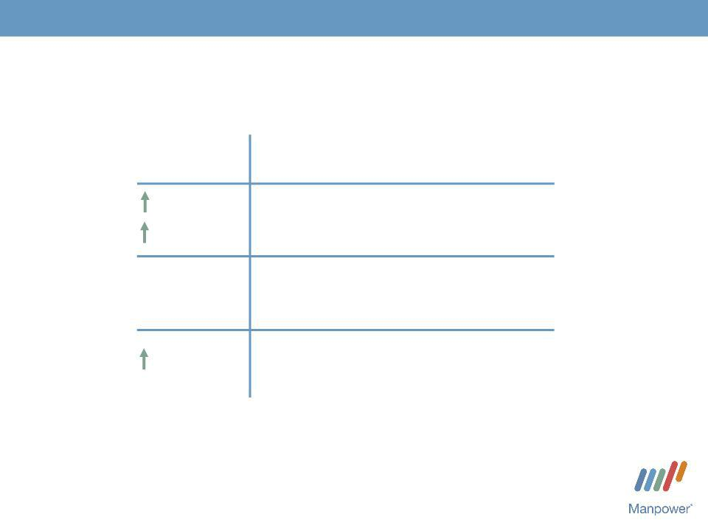
8

EMEA Segment

(39% of Revenue)

Q1 Financial Highlights ⁽¹⁾ ⁽²⁾

9% | Revenue | $1.6B
0% CC | Revenue | $1.6B
N/A | OUP $24M
N/A

160 bps OUP Margin 1.5%

- Included in these amounts is Italy, which had revenue of $234M (+6% in USD, 0% in CC) and OUP of $7M (+386% in USD, +363% in CC).

- 2009 includes non-recurring items, including reorganization charges, totaling a net benefit of $1.7M.

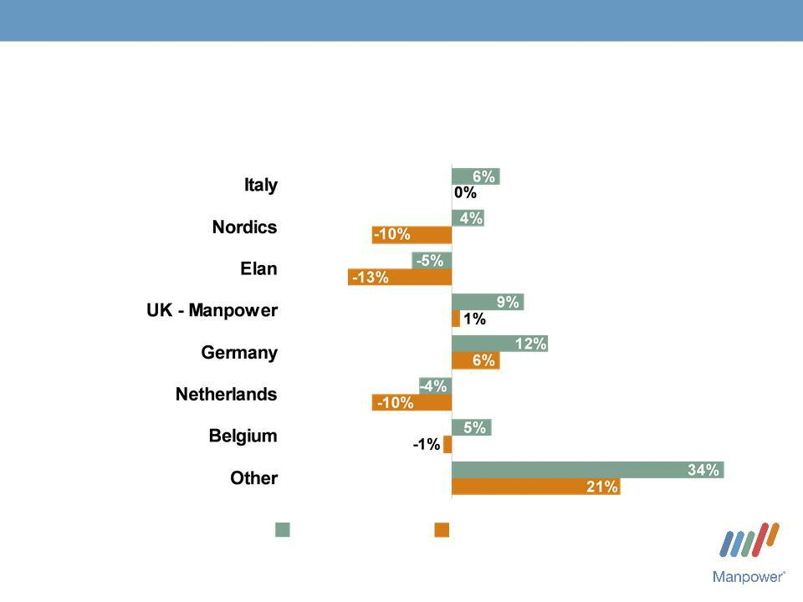
9

EMEA - Q1 Revenue Growth YoY

- of Segment Revenue

15%

14%

13%

11%

10%

9%

5%

23%

Revenue | Revenue Growth - CC
Growth

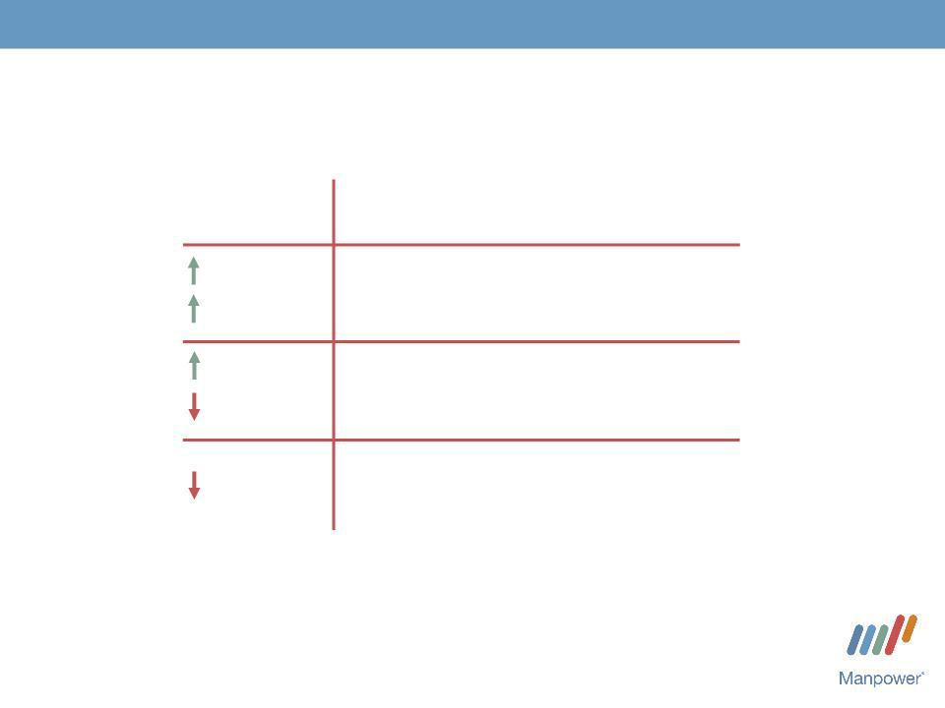
10

Asia Pacific Segment

(12% of Revenue)

 |  | Q1 Financial Highlights
17% |  | Revenue $497M
5% |  | Revenue $497M
CC | (1) | OUP $13M
4% | (1) | OUP $13M
9%
CC | (1) | OUP Margin 2.5%
30 | (1) | OUP Margin 2.5%
bps

- 2009 includes non-recurring items, including reorganization charges, totaling a net benefit of $3.9M.

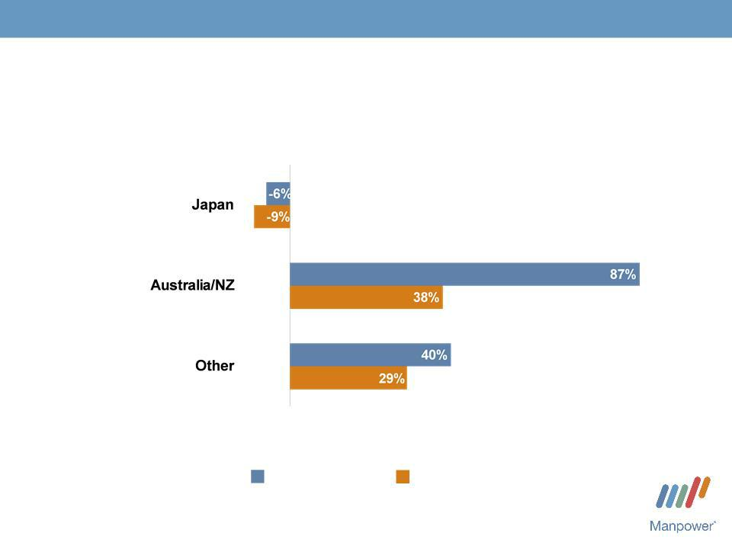
11

Asia Pacific - Q1 Revenue Growth YoY

- of Segment Revenue

52%

25%

23%

Revenue | Revenue Growth - CC
Growth

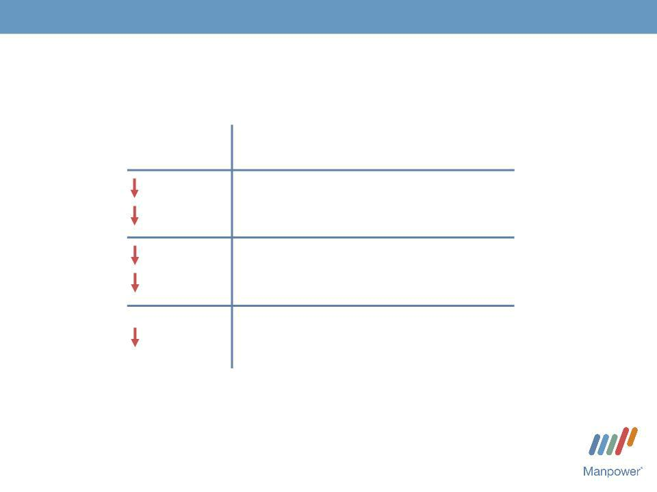
12

Right Management Segment

(3% of Revenue)

Q1 Financial Highlights

24% | Revenue $103M
28% | Revenue $103M
CC
57% | OUP $13M
58% | OUP $13M
CC
930 bps OUP Margin 12.1%

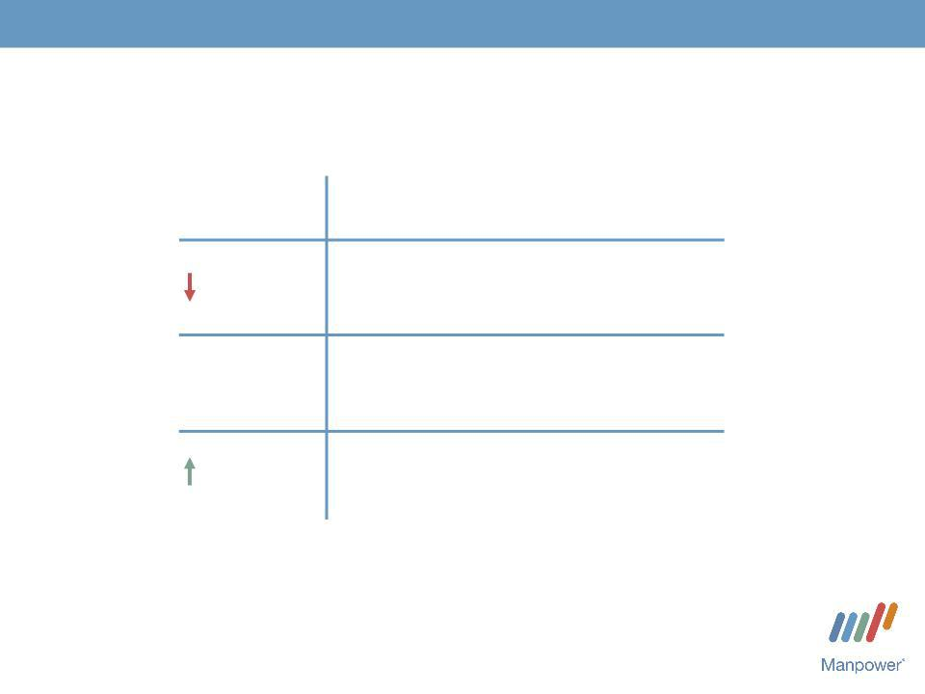
13

Jefferson Wells Segment

(1% of Revenue)

Q1 Financial Highlights

23% Revenue $41M

N/A OUP $(5M)

(1)
250 bps OUP Margin -

11.7%

- 2009 includes reorganization charges totaling $0.9M.


14

Financial Highlights

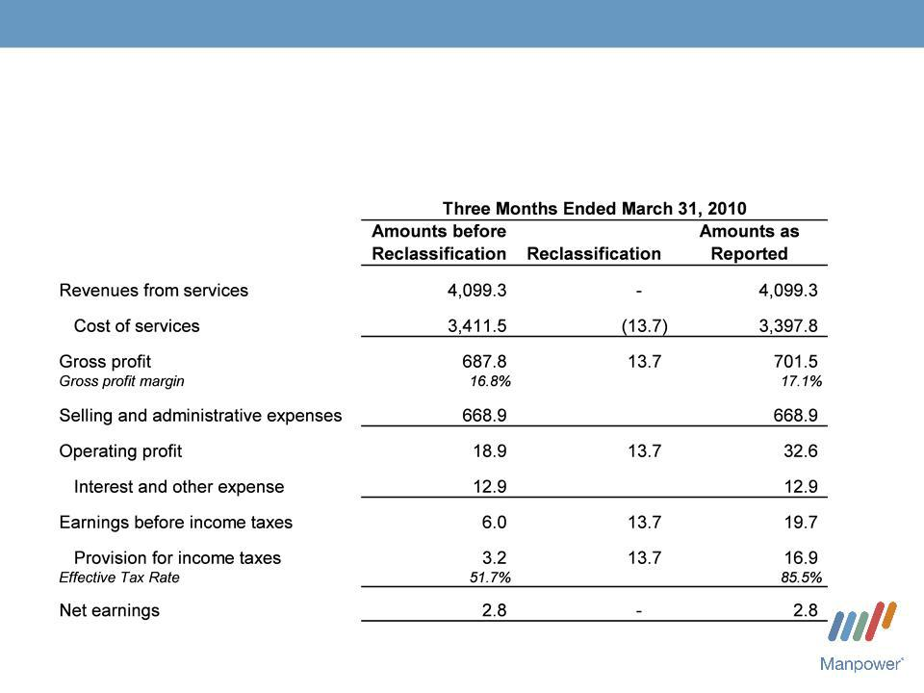
15

Results of Operations - Business Tax Reclassification

(in millions of USD)

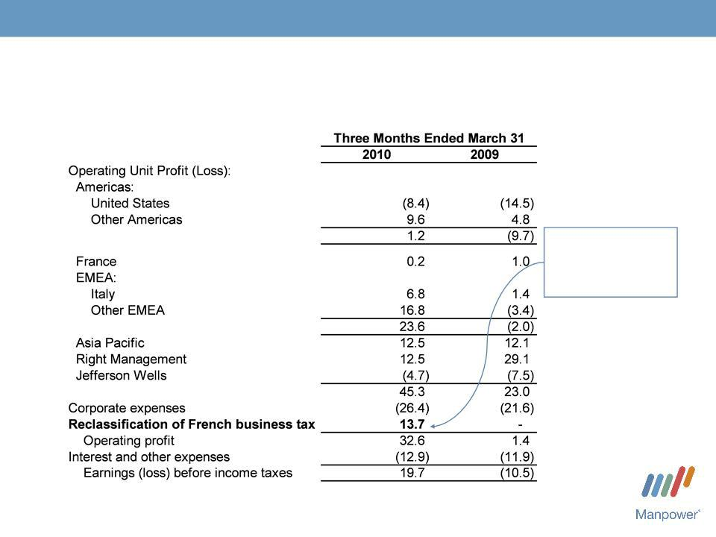
16

Segment Operating Unit Results

(in millions of USD)

Reclass of French

Business Tax to

Provision for

Income Taxes

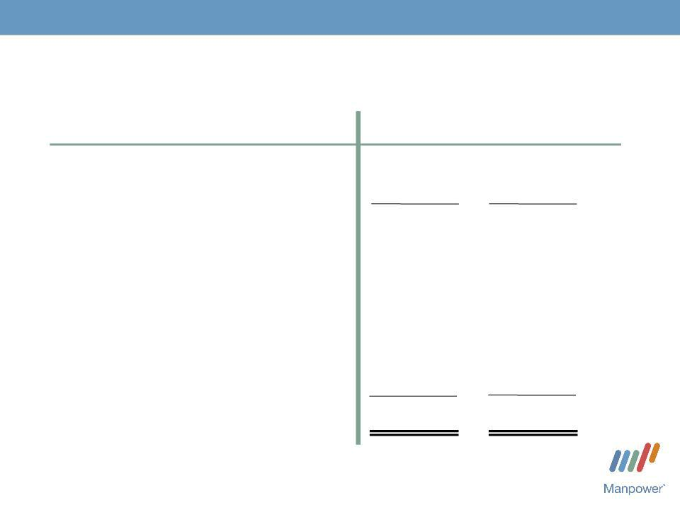

Cash Flow Summary - Q1

($ in millions)

Cash from Operations

Capital
Free^{Expenditures}CashFlow

Share Repurchases

Change in
Debt

Acquisitions of

Businesses,netofcash acquired

Effect of Exchange Rate Changes Other

Change in Cash

17

2010 2009

- 250

- (9)

- 241

- -

- (56)

  - (11)

- (54)

57

- 127

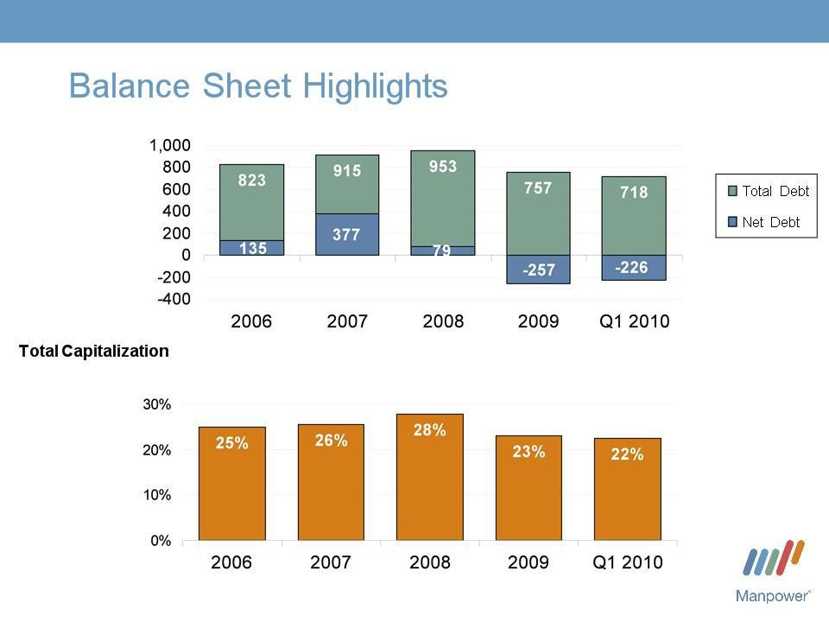
18

Total Debt

($ in millions)

Total Debt to


19

Credit Facilities as of March 31, 2010

($ in millions) |  | Interest | Maturity | Total | Remaining
 |  | Rate | Date | Outstanding | Available
Euro
Notes: |  | 4.86% | June | 269 | -
- Euro
200M |  | 4.58% | 2013 | 405 | -
- Euro |  | 4.58% | June | 405 | -
300M | (a) | 2.80% | 2012 | - | 394^{(b)}
Revolving Credit Agreement |  | 2.80% | Nov 2012 | - | 394^{(b)}
Uncommitted lines and |  | Various | Various | 44 | 351
Other |  |  |  | 718 | 745
Total Debt |  |  |  | 718 | 745

- This $400M agreement requires, as of March 31, that we comply with a Debt-to-EBITDA ratio of less than 5.75 to 1 and a fixed charge coverage ratio of greater than 1.25 to 1. As defined in the agreement, we had a Debt-to-EBITDA ratio of 3.00 and a fixed charge coverage ratio of 1.63 as of March 31, 2010.

- As of March 31, there were $6.0M of standby letters of credit issued under the agreement.


20

Comsys Acquisition Summary

Closing date: | April 5,
 | 2010
Consideration: | Cash | $192M
 | Stock | 188M | (3.2M shares @ $58.94⁽¹⁾per
 | Debt | _{47M} share)
 | Retired | $427M

- Represents the closing stock price on April 5, which is higher than the average stock price of $57.98 used to determine the conversion ratio for the tender offer.

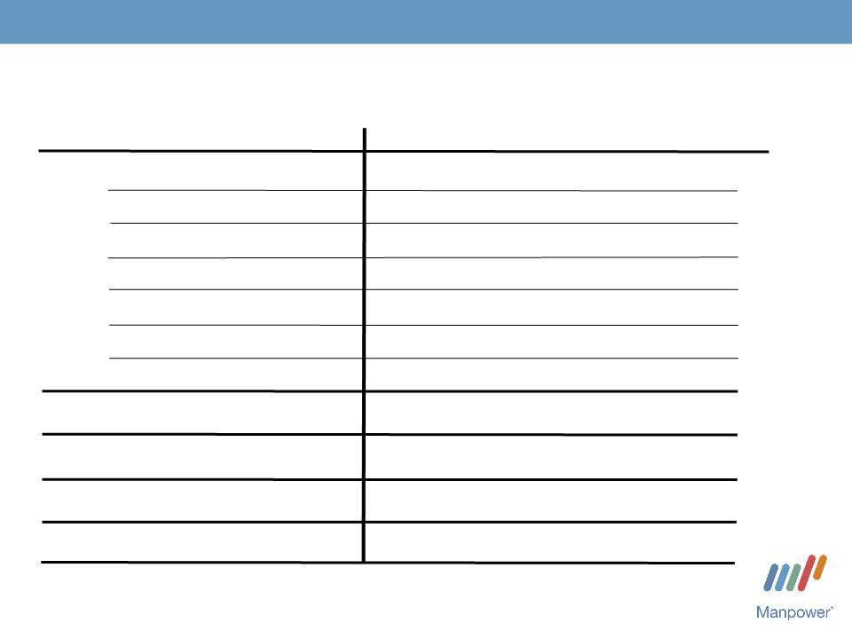
21

Second Quarter Outlook

Revenue ^{Total}
Americas

France

EMEA

Asia

RightPacific
Management
Jefferson Wells

Gross Profit
Margin
Operating Profit
Tax Rate^{Margin}
EPS

Up 17- | (Up 16-18%
19% | CC)
Up 54-56% (Up 52-54% CC)
Up 13-15% (Up 14-16% CC)
Up 11-13% | (Up 10-12%
Up 16-18% | CC)
Up 16-18% | (Up 9-11%
Down 27- | CC)
Down 27- | (Down 29-31%
29% | CC)
Down 11-
13%
17.5-17.7%

1.1-
1.3%
63%

$0.14-$0.22 ($0.24-$0.32 before Comsys)


Manpower Inc.
2010 1st Quarter Results

April 21, 2010

Questions?
Answers

