UNITED STATES

SECURITIES AND EXCHANGE COMMISSION
Washington, D.C. 20549

FORM 8-K

CURRENT REPORT

Pursuant to Section 13 or 15(d) of the Securities Exchange Act of 1934

Date of Report (Date of earliest event reported): February 1, 2012

MANPOWER INC.

(d/b/a ManpowerGroup)
(Exact name of registrant as specified in its charter)

Wisconsin | 1-10686 | 39-1672779
(State or other jurisdiction of | (Commission File Number) | (IRS Employer Identification No.)
incorporation)
100 Manpower Place
Milwaukee, Wisconsin |  | 53212
(Address of principal executive offices) |  | (Zip Code)

Registrant's telephone number, including area code: (414) 961-1000

Check the appropriate box below if the Form 8-K filing is intended to simultaneously satisfy the filing obligation of the registrant under any of the following provisions:

Written communications pursuant to Rule 425 under the Securities Act (17 CFR 230.425)

Soliciting material pursuant to Rule 14a-12 under the Securities Act (17 CFR 240.14a-12)

Pre-commencement communications pursuant to Rule 14d-2(b) under the Exchange Act (17 CFR 240.14d-2(b))

Pre-commencement communications pursuant to Rule 13e-4(c) under the Exchange Act (17 CFR 240.13e-4(c))

Item 2.02. Results of Operations and Financial Condition

On February 1, 2012, we issued a press release announcing our results of operations for the three months and year ended December 31, 2011. A copy of the press release is attached hereto as Exhibit 99.1 and is incorporated herein by reference.

Item 9.01. Exhibits.

Exhibit No. |  | Description
99.1 |  | Press Release dated February 1, 2012
99.2 |  | Presentation materials for February 1, 2012 conference call

SIGNATURES

Pursuant to the requirements of the Securities Exchange Act of 1934, the Registrant has duly caused this Report to be signed on its behalf by the undersigned hereunto duly authorized.

MANPOWER INC.

(d/b/a ManpowerGroup)

Dated: February 1, 2012 By: /s/ Michael J. Van Handel

Michael J. Van Handel

Executive Vice President and

Chief Financial Officer

 |  | EXHIBIT INDEX
Exhibit No. |  | Description
99.1 |  | Press Release dated February 1, 2012
99.2 |  | Presentation materials for February 1, 2012 conference call

Exhibit 99.1

FOR IMMEDIATE RELEASE Contact:

Mike Van Handel

+1.414.906.6305

michael.vanhandel@manpowergroup.com

ManpowerGroup Reports 4th Quarter and Full Year 2011 Results

MILWAUKEE, February 1, 2012 -- ManpowerGroup (NYSE: MAN) today reported net earnings of 78 cents per diluted share for the three months ended December 31, 2011 compared to a net loss of $4.29 per share in the prior period. The net earnings in the quarter were $63.6 million compared to a net loss of $350.4 million a year earlier. Revenues for the fourth quarter totaled $5.5 billion, an increase of 5 percent from the year earlier period, or an increase of 6 percent in constant currency.

Included in the current year fourth quarter results is a reorganization charge, primarily related to office consolidations and severance costs, of $20.5 million ($16.3 million after tax or 20 cents per diluted share). Net earnings in the quarter were not significantly impacted by changes in foreign currencies.

Prior year fourth quarter results included a goodwill and intangible asset impairment charge of $4.70 per diluted share and a reorganization charge of 25 cents per diluted share.

“We had a strong fourth quarter performance,” Jeffrey A. Joerres, ManpowerGroup Chairman and CEO, said. “The team executed well both operationally and strategically – we were able to achieve a 29% increase in underlying operating profit for the fourth quarter and 61% for the year, while substantially moving forward our strategic drivers.

“Our Solutions business continued to gain momentum as our clients are valuing our portfolio of offerings. Asia continued to lead the pack in revenue and profitability growth.

“We are cautiously optimistic about the first quarter, given the economic back drop, but any sizable disruption in Europe would affect our performance,” added Joerres. “We are anticipating the first quarter of 2012 diluted earnings per share to be in the range of 30 cents to 38 cents with an unfavorable currency impact of 2 cents per share.”

Net earnings per diluted share for the year ended December 31, 2011 was $3.04 compared to a loss of $3.26 per diluted share in 2010. Net earnings were $251.6 million compared to a loss of $263.6 million in the prior year. Revenues for the year were $22.0 billion, an increase of 17 percent from the prior year, or 12 percent in constant currency.

Earnings per diluted share for the full year 2011 include the fourth quarter reorganization costs discussed above of 20 cents per diluted share. Additionally, 2011 results were favorably impacted by 22 cents per diluted share due to changes in foreign currencies compared to the prior year. The full year 2010 results include the goodwill and intangible asset impairment charge and reorganization costs discussed above of $4.98 per diluted share for the year.

In conjunction with its fourth quarter and full year earnings release, ManpowerGroup will broadcast its conference call live over the Internet on February 1, 2012 at 7:30 a.m.

CT (8:30 a.m. ET). Interested parties are invited to listen to the webcast and view the presentation by logging on to http://www.manpowergroup.com/investors.

Supplemental financial information referenced in the conference call can be found at http://www.manpowergroup.com/investors.

About ManpowerGroup™

ManpowerGroup™ (NYSE: MAN), the world leader in innovative workforce solutions, creates and delivers high-impact solutions that enable our clients to achieve their business goals and enhance their competitiveness. With over 60 years of experience, our $22 billion company creates unique time to value through a comprehensive suite of innovative solutions that help clients win in the Human Age. These solutions cover an entire range of talent-driven needs from recruitment and assessment, training and development, and career management, to outsourcing and workforce consulting. ManpowerGroup maintains the world's largest and industry-leading network of nearly 3,800 offices in 80 countries and territories, generating a dynamic mix of an unmatched global footprint with valuable insight and local expertise to meet the needs of its 400,000 clients per year, across all industry sectors, small and medium-sized enterprises, local, multinational and global companies. By connecting our deep understanding of human potential to the ambitions of clients, ManpowerGroup helps the organizations and individuals we serve achieve more than they imagined — because their success leads to our success. And by creating these powerful connections, we create power that drives organizations forward, accelerates personal success and builds more sustainable communities. We help power the world of work. The ManpowerGroup suite of solutions is offered through ManpowerGroup™ Solutions, Manpower®, Experis™ and Right Management®. Learn more about how the ManpowerGroup can help you win in the Human Age at www.manpowergroup.com.

ManpowerGroup is the most trusted brand in the industry, being the only company in our industry to be named to the Ethisphere Institute's 2011 World's Most Ethical Companies list for our proven commitment to ethical business practices, including an outstanding commitment to ethical leadership, compliance practices and corporate social responsibility. In addition, ManpowerGroup has also been recognized as the industry leader by Fortune magazine, who named the company in first place on its 2011 list of the Most Admired Companies in the temporary help sector.

In January 2011, at the World Economic Forum Annual Meeting in Davos, Switzerland, ManpowerGroup announced the world has entered the Human Age, where talent has replaced capital as the key competitive differentiator. This concept continues to resonate and was echoed as a core theme of the 2012 Annual Meeting of the World Economic Forum in Davos. Learn more about this new age at www.manpowergroup.com/humanage

Follow ManpowerGroup Chairman and CEO Jeff Joerres on Twitter: twitter.com/manpowergroupjj. Joerres is one of only six Fortune 500 CEOs who leverages a Twitter account to get his message out.

Forward-Looking Statements

This news release contains statements, including earnings projections, that are forward-looking in nature and, accordingly, are subject to risks and uncertainties regarding the Company’s expected future results. The Company’s actual results may differ materially from those described or contemplated in the forward-looking statements. Factors that may cause the Company’s actual results to differ materially from those contained in the forward-looking statements can be found in the Company’s reports filed with the SEC, including the information under the heading ‘Risk Factors’ in its Annual Report on Form 10-K for the year ended December 31, 2010, which information is incorporated herein by reference.

###

ManpowerGroup

Results of Operations

(In millions, except per share data)

 |  |  |  |  | Three Months Ended December 31
 |  |  |  |  |  |  |  | % Variance
 |  |  |  |  |  |  |  | Amount |  | Constant
 |  |  | 2011 |  |  | 2010 |  | Reported |  | Currency
 |  |  |  |  |  | (Unaudited)
Revenues from services (a) | $ |  | 5,484.0 |  | $ | 5,209.6 |  | 5.3% |  | 5.8%
Cost of services |  |  | 4,548.8 |  |  | 4,303.9 |  | 5.7% |  | 6.3%
Gross profit |  |  | 935.2 |  |  | 905.7 |  | 3.3% |  | 3.6%
Selling and administrative expenses, excluding impairment charges |  |  | 805.4 |  |  | 819.5 |  | -1.7% |  | -1.4%
Goodwill and intangible asset impairment charges |  |  | - |  |  | 428.8 |  | N/A |  | N/A
Selling and administrative expenses |  |  | 805.4 |  |  | 1,248.3 |  | -35.5% |  | -35.3%
Operating profit (loss) |  |  | 129.8 |  |  | (342.6) |  | N/A |  | N/A
Interest and other expenses |  |  | 10.4 |  |  | 10.0 |  | 4.0%
Earnings (loss) before income taxes |  |  | 119.4 |  |  | (352.6) |  | N/A |  | N/A
Provision for income taxes |  |  | 55.8 |  |  | (2.2) |  | N/A
Net earnings (loss) | $ |  | 63.6 |  | $ | (350.4) |  | N/A |  | N/A
Net earnings (loss) per share - basic | $ |  | 0.79 |  | $ | (4.29) |  | N/A
Net earnings (loss) per share - diluted | $ |  | 0.78 |  | $ | (4.29) |  | N/A |  | N/A
Weighted average shares - basic |  |  | 80.8 |  |  | 81.6 |  | -1.0%
Weighted average shares - diluted |  |  | 81.4 |  |  | 81.6 |  | -0.3%

- Revenues from services include fees received from our franchise offices of $6.4 million for the three months ended December 31, 2011 and 2010. These fees are primarily based on revenues generated by the franchise offices, which were $257.2 million and $263.5 million for the three months ended December 31, 2011 and 2010, respectively.

ManpowerGroup

Operating Unit Results

(In millions)

 |  |  |  |  | Three Months Ended December 31
 |  |  |  |  |  |  |  | % Variance
 |  |  |  |  |  |  |  | Amount |  | Constant
 |  |  | 2011 |  |  | 2010 |  | Reported |  | Currency
 |  |  |  |  |  | (Unaudited)
Revenues from Services: (a)
Americas:
United States (b) | $ |  | 765.9 |  | $ | 777.1 |  | -1.4% |  | -1.4%
Other Americas |  |  | 389.8 |  |  | 347.8 |  | 12.1% |  | 18.3%
 |  |  | 1,155.7 |  |  | 1,124.9 |  | 2.7% |  | 4.7%
Southern Europe:
France |  |  | 1,511.0 |  |  | 1,433.6 |  | 5.4% |  | 6.3%
Italy |  |  | 305.3 |  |  | 294.1 |  | 3.8% |  | 4.6%
Other Southern Europe |  |  | 196.3 |  |  | 189.0 |  | 3.9% |  | 6.5%
 |  |  | 2,012.6 |  |  | 1,916.7 |  | 5.0% |  | 6.1%
Northern Europe |  |  | 1,540.9 |  |  | 1,492.7 |  | 3.2% |  | 3.8%
APME |  |  | 695.0 |  |  | 588.3 |  | 18.2% |  | 14.5%
Right Management |  |  | 79.8 |  |  | 87.0 |  | -8.2% |  | -8.6%
 | $ |  | 5,484.0 |  | $ | 5,209.6 |  | 5.3% |  | 5.8%
Operating Unit Profit (Loss): (a)
Americas:
United States | $ |  | 26.1 |  | $ | 14.1 |  | 83.8% |  | 83.8%
Other Americas |  |  | 12.1 |  |  | 10.0 |  | 22.6% |  | 30.9%
 |  |  | 38.2 |  |  | 24.1 |  | 58.5% |  | 61.9%
Southern Europe:
France |  |  | 20.5 |  |  | 12.0 |  | 71.0% |  | 72.4%
Italy |  |  | 19.7 |  |  | 15.8 |  | 24.3% |  | 25.4%
Other Southern Europe |  |  | 2.9 |  |  | 2.8 |  | 3.6% |  | 8.8%
 |  |  | 43.1 |  |  | 30.6 |  | 40.7% |  | 42.3%
Northern Europe |  |  | 51.8 |  |  | 63.0 |  | -17.7% |  | -17.8%
APME |  |  | 21.7 |  |  | 9.6 |  | 121.3% |  | 115.2%
Right Management |  |  | (5.6) |  |  | (16.8) |  | N/A |  | N/A
 |  |  | 149.2 |  |  | 110.5
Corporate expenses |  |  | (30.7) |  |  | (30.8)
Goodwill and intangible asset impairment charges |  |  | - |  |  | (428.8)
Intangible asset amortization expense |  |  | (10.0) |  |  | (11.2)
Reclassification of French business tax |  |  | 21.3 |  |  | 17.7
Operating profit (loss) |  |  | 129.8 |  |  | (342.6) |  | N/A |  | N/A
Interest and other expenses (c) |  |  | (10.4) |  |  | (10.0)
Earnings (loss) before income taxes | $ |  | 119.4 |  | $ | (352.6)

- Effective January 1, 2011, we created a new organizational structure in Europe in order to elevate our service quality throughout Europe, Middle East and Africa. Other Southern Europe and Northern Europe, previously reported in Other EMEA, are now separate reportable segments. France, Italy, and Other Southern Europe are aggregated into our Southern Europe reportable segment. All previously reported results have been restated to conform to the current year presentation. Additionally, we changed the name of our Asia Pacific reportable segment to APME; the results of this reportable segment have not been restated as only the name has changed.

- In the United States, revenues from services include fees received from our franchise offices of $3.8 million for the three months ended December 31, 2011 and 2010. These fees are primarily based on revenues generated by the franchise offices, which were $167.5 million and $165.0 million for the three months ended December 31, 2011 and 2010, respectively.

- The components of interest and other expenses were:

 |  | 2011 |  |  |  | 2010
Interest expense | $ |  | 10.3 |  | $ | 10.1
Interest income |  |  | (2.3) |  |  | (2.0)
Foreign exchange losses |  |  | 0.8 |  |  | 0.8
Miscellaneous expenses, net |  |  | 1.6 |  |  | 1.1
 | $ |  | 10.4 |  | $ | 10.0

ManpowerGroup

Results of Operations

(In millions, except per share data)

 |  |  |  |  |  | Year Ended December 31
 |  |  |  |  |  |  |  | % Variance
 |  |  |  |  |  |  |  | Amount |  | Constant
 |  |  | 2011 |  |  | 2010 |  | Reported |  | Currency
 |  |  |  |  |  | (Unaudited)
Revenues from services (a) | $ |  | 22,006.0 |  | $ | 18,866.5 |  | 16.6% |  | 11.6%
Cost of services |  |  | 18,299.7 |  |  | 15,621.1 |  | 17.1% |  | 12.0%
Gross profit |  |  | 3,706.3 |  |  | 3,245.4 |  | 14.2% |  | 9.4%
Selling and administrative expenses, excluding impairment charges |  |  | 3,182.1 |  |  | 2,938.6 |  | 8.3% |  | 4.1%
Goodwill and intangible asset impairment charges |  |  | - |  |  | 428.8 |  | N/A |  | N/A
Selling and administrative expenses |  |  | 3,182.1 |  |  | 3,367.4 |  | -5.5% |  | -9.2%
Operating profit (loss) |  |  | 524.2 |  |  | (122.0) |  | N/A |  | N/A
Interest and other expenses |  |  | 44.3 |  |  | 43.2 |  | 2.6%
Earnings (loss) before income taxes |  |  | 479.9 |  |  | (165.2) |  | N/A |  | N/A
Provision for income taxes |  |  | 228.3 |  |  | 98.4 |  | 132.1%
Net earnings (loss) | $ |  | 251.6 |  | $ | (263.6) |  | N/A |  | N/A
Net earnings (loss) per share - basic | $ |  | 3.08 |  | $ | (3.26) |  | N/A
Net earnings (loss) per share - diluted | $ |  | 3.04 |  | $ | (3.26) |  | N/A |  | N/A
Weighted average shares - basic |  |  | 81.6 |  |  | 81.0 |  | 0.8%
Weighted average shares - diluted |  |  | 82.8 |  |  | 81.0 |  | 2.3%

- Revenues from services include fees received from our franchise offices of $25.2 million and $23.6 million for the years ended December 31, 2011 and 2010, respectively. These fees are primarily based on revenues by the franchise offices, which were $1,075.2 million and $968.0 million for the years ended December 31, 2011 and 2010, respectively.

ManpowerGroup

Operating Unit Results

(In millions)

 |  |  |  |  |  | Year Ended December 31
 |  |  |  |  |  |  |  | % Variance
 |  |  |  |  |  |  |  | Amount |  | Constant
 |  |  | 2011 |  |  | 2010 |  | Reported |  | Currency
 |  |  |  |  |  | (Unaudited)
Revenues from Services: (a)
Americas:
United States (b) | $ |  | 3,137.3 |  | $ | 2,783.4 |  | 12.7% |  | 12.7%
Other Americas |  |  | 1,512.1 |  |  | 1,265.5 |  | 19.5% |  | 18.4%
 |  |  | 4,649.4 |  |  | 4,048.9 |  | 14.8% |  | 14.5%
Southern Europe:
France |  |  | 6,179.1 |  |  | 5,208.6 |  | 18.6% |  | 12.6%
Italy |  |  | 1,255.8 |  |  | 1,044.2 |  | 20.3% |  | 14.2%
Other Southern Europe |  |  | 776.9 |  |  | 698.9 |  | 11.2% |  | 6.8%
 |  |  | 8,211.8 |  |  | 6,951.7 |  | 18.1% |  | 12.3%
Northern Europe |  |  | 6,159.4 |  |  | 5,344.1 |  | 15.3% |  | 9.3%
APME |  |  | 2,661.7 |  |  | 2,147.2 |  | 24.0% |  | 14.2%
Right Management |  |  | 323.7 |  |  | 374.6 |  | -13.6% |  | -16.6%
 | $ |  | 22,006.0 |  | $ | 18,866.5 |  | 16.6% |  | 11.6%
Operating Unit Profit (Loss): (a)
Americas:
United States | $ |  | 94.1 |  | $ | 42.8 |  | 119.8% |  | 119.8%
Other Americas |  |  | 47.8 |  |  | 36.5 |  | 31.2% |  | 30.7%
 |  |  | 141.9 |  |  | 79.3 |  | 79.0% |  | 78.8%
Southern Europe:
France |  |  | 85.2 |  |  | 47.1 |  | 80.7% |  | 69.4%
Italy |  |  | 74.1 |  |  | 47.5 |  | 55.9% |  | 47.2%
Other Southern Europe |  |  | 10.8 |  |  | 7.2 |  | 51.5% |  | 47.5%
 |  |  | 170.1 |  |  | 101.8 |  | 67.1% |  | 57.5%
Northern Europe |  |  | 212.6 |  |  | 150.2 |  | 41.5% |  | 32.8%
APME |  |  | 78.8 |  |  | 47.2 |  | 66.7% |  | 54.8%
Right Management |  |  | (1.4) |  |  | 3.5 |  | N/A |  | N/A
 |  |  | 602.0 |  |  | 382.0
Corporate expenses |  |  | (123.1) |  |  | (101.2)
Goodwill and intangible asset impairment charges |  |  | - |  |  | (428.8)
Intangible asset amortization expense |  |  | (38.9) |  |  | (39.3)
Reclassification of French business tax |  |  | 84.2 |  |  | 65.3
Operating profit (loss) |  |  | 524.2 |  |  | (122.0) |  | N/A |  | N/A
Interest and other expenses (c) |  |  | (44.3) |  |  | (43.2)
Earnings (loss) before income taxes | $ |  | 479.9 |  | $ | (165.2)

- Effective January 1, 2011, we created a new organizational structure in Europe in order to elevate our service quality throughout Europe, Middle East and Africa. Other Southern Europe and Northern Europe, previously reported in Other EMEA, are now separate reportable segments. France, Italy, and Other Southern Europe are aggregated into our Southern Europe reportable segment. All previously reported results have been restated to conform to the current year presentation. Additionally, we changed the name of our Asia Pacific reportable segment to APME; the results of this reportable segment have not been restated as only the name has changed.

- In the United States, revenues from services include fees received from our franchise offices of $13.6 million and $13.7 million for the years ended December 31, 2011 and 2010. These fees are primarily based on revenues generated by the franchise offices, which were $646.1 million and $622.0 million for the years ended December 31, 2011 and 2010, respectively.

- The components of interest and other expenses were:

 |  | 2011 |  |  |  | 2010
Interest expense | $ |  | 42.8 |  | $ | 43.7
Interest income |  |  | (7.3) |  |  | (6.2)
Foreign exchange losses |  |  | 2.8 |  |  | 3.3
Miscellaneous expenses, net |  |  | 6.0 |  |  | 2.4
 | $ |  | 44.3 |  | $ | 43.2

ManpowerGroup

Consolidated Balance Sheets

(In millions)

 |  | Dec. 31 |  |  | Dec. 31
 |  | 2011 |  |  | 2010
 |  | (Unaudited)
ASSETS
Current assets:
Cash and cash equivalents | $ | 580.5 |  | $ | 772.6
Accounts receivable, net |  | 4,181.3 |  |  | 3,844.1
Prepaid expenses and other assets |  | 176.3 |  |  | 197.6
Future income tax benefits |  | 52.4 |  |  | 59.7
Total current assets |  | 4,990.5 |  |  | 4,874.0
Other assets:
Goodwill and other intangible assets, net |  | 1,339.6 |  |  | 1,330.3
Other assets |  | 395.1 |  |  | 355.1
Total other assets |  | 1,734.7 |  |  | 1,685.4
Property and equipment:
Land, buildings, leasehold improvements and equipment |  | 685.6 |  |  | 688.8
Less: accumulated depreciation and amortization |  | 511.1 |  |  | 518.5
Net property and equipment |  | 174.5 |  |  | 170.3
Total assets | $ | 6,899.7 |  | $ | 6,729.7
LIABILITIES AND SHAREHOLDERS' EQUITY
Current liabilities:
Accounts payable | $ | 1,370.6 |  | $ | 1,313.9
Employee compensation payable |  | 221.9 |  |  | 240.2
Accrued liabilities |  | 520.8 |  |  | 547.4
Accrued payroll taxes and insurance |  | 712.4 |  |  | 677.7
Value added taxes payable |  | 502.3 |  |  | 482.2
Short-term borrowings and current maturities of long-term debt |  | 434.2 |  |  | 28.7
Total current liabilities |  | 3,762.2 |  |  | 3,290.1
Other liabilities:
Long-term debt |  | 266.0 |  |  | 669.3
Other long-term liabilities |  | 388.1 |  |  | 373.1
Total other liabilities |  | 654.1 |  |  | 1,042.4
Shareholders' equity:
Common stock |  | 1.1 |  |  | 1.1
Capital in excess of par value |  | 2,839.9 |  |  | 2,781.7
Retained earnings |  | 971.7 |  |  | 785.2
Accumulated other comprehensive income |  | 35.3 |  |  | 87.0
Treasury stock, at cost |  | (1,364.6) |  |  | (1,257.8)
Total shareholders' equity |  | 2,483.4 |  |  | 2,397.2
Total liabilities and shareholders' equity | $ | 6,899.7 |  | $ | 6,729.7

ManpowerGroup

Consolidated Statements of Cash Flows

(In millions)

 | Year Ended December 31
 | 2011 |  |  |  | 2010
 |  | (Unaudited)
Cash Flows from Operating Activities:
Net earnings (loss) | $ | 251.6 |  | $ | (263.6)
Adjustments to reconcile net earnings (loss) to net cash used in operating activities:
Depreciation and amortization |  | 104.4 |  |  | 110.1
Non-cash goodwill and intangible asset impairment charges |  | - |  |  | 428.8
Deferred income taxes |  | 24.8 |  |  | (68.5)
Provision for doubtful accounts |  | 25.9 |  |  | 28.9
Share-based compensation |  | 31.4 |  |  | 24.1
Excess tax benefit on exercise of share-based awards |  | (1.3) |  |  | (1.3)
Changes in operating assets and liabilities, excluding the impact of acquisitions:
Accounts receivable |  | (417.1) |  |  | (708.1)
Other assets |  | (48.2) |  |  | 9.9
Other liabilities |  | 97.7 |  |  | 621.8
Cash provided by operating activities |  | 69.2 |  |  | 182.1
Cash Flows from Investing Activities:
Capital expenditures |  | (64.9) |  |  | (58.5)
Acquisitions of businesses, net of cash acquired |  | (49.0) |  |  | (270.0)
Proceeds from sales of property and equipment |  | 4.4 |  |  | 4.9
Cash used in investing activities |  | (109.5) |  |  | (323.6)
Cash Flows from Financing Activities:
Net change in short-term borrowings |  | 15.6 |  |  | (15.6)
Proceeds from long-term debt |  | 0.8 |  |  | 1.8
Repayments of long-term debt |  | (1.1) |  |  | (1.1)
Proceeds from share-based awards |  | 29.5 |  |  | 27.1
Excess tax benefit on exercise of share-based awards |  | 1.3 |  |  | 1.3
Repurchases of common stock |  | (104.5) |  |  | (34.8)
Dividends paid |  | (65.1) |  |  | (60.8)
Cash used in financing activities |  | (123.5) |  |  | (82.1)
Effect of exchange rate changes on cash |  | (28.3) |  |  | (18.4)
Change in cash and cash equivalents |  | (192.1) |  |  | (242.0)
Cash and cash equivalents, beginning of period |  | 772.6 |  |  | 1,014.6
Cash and cash equivalents, end of period | $ | 580.5 |  | $ | 772.6

Exhibit 99.2


ManpowerGroup

4th Quarter
February 1, 2012


ManpowerGroup 2011 4th Quarter Results 2012

February

Forward-Looking Statement

This presentation includes forward-looking statements, including earnings projections which are subject to risks and uncertainties. Actual results might differ materially from those projected in the forward-looking statements. Additional information concerning factors that could cause actual results to materially differ from those in the forward-looking statements is contained in the Manpower Inc. Annual Report on Form 10-K dated December 31, 2010, which information is incorporated herein by reference, and such other factors as may be described from time to time in the Company’s SEC filings.

ManpowerGroup 2011 4th Quarter Results |  |  |  |  |  | February
2012
Consolidated Financial Highlights
 | As |  | Excluding Non |  | Q4 Financial Highlights
 | Reported |  | -recurring
 |  |  | Items (1)
5% |  |  | 5% |  | Revenue $5.5B
 | 6% CC |  | 6% CC |  | Revenue $5.5B
 | 30 bps |  | 30 bps |  | Gross Margin 17.1%
 | N/A |  | 29% |  | Operating Profit | $130M
 | N/A |  | 29% CC |  | Operating Profit | $130M
 | 900 bps |  | 50 bps |  | OP Margin 2.4%
 | N/A |  | 48% |  | EPS $.78
 | N/A |  | 48% CC |  | EPS $.78
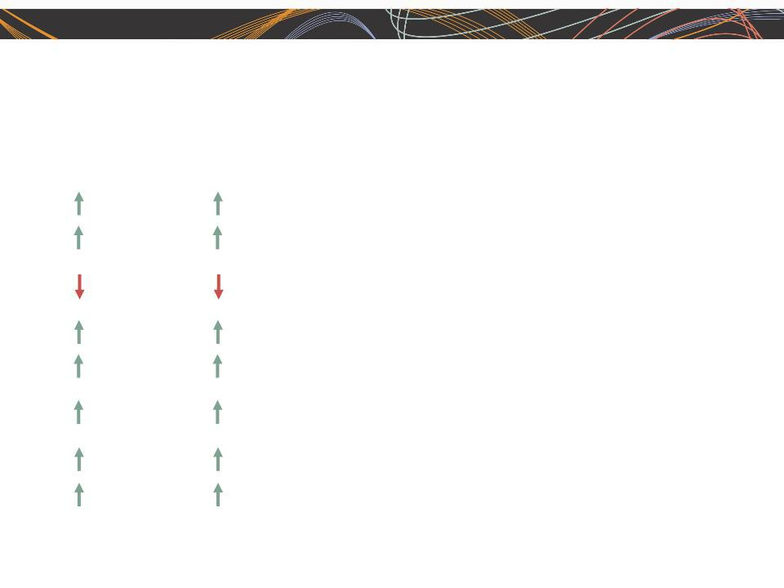
- Excludes reorganization charges for 2011 and 2010, and goodwill and intangible asset impairment in 2010.

Throughout this presentation, the difference between reported variances and Constant Currency (CC) variances | 3
represents the impact of currency on our financial results. Constant Currency is further explained on our Web site.

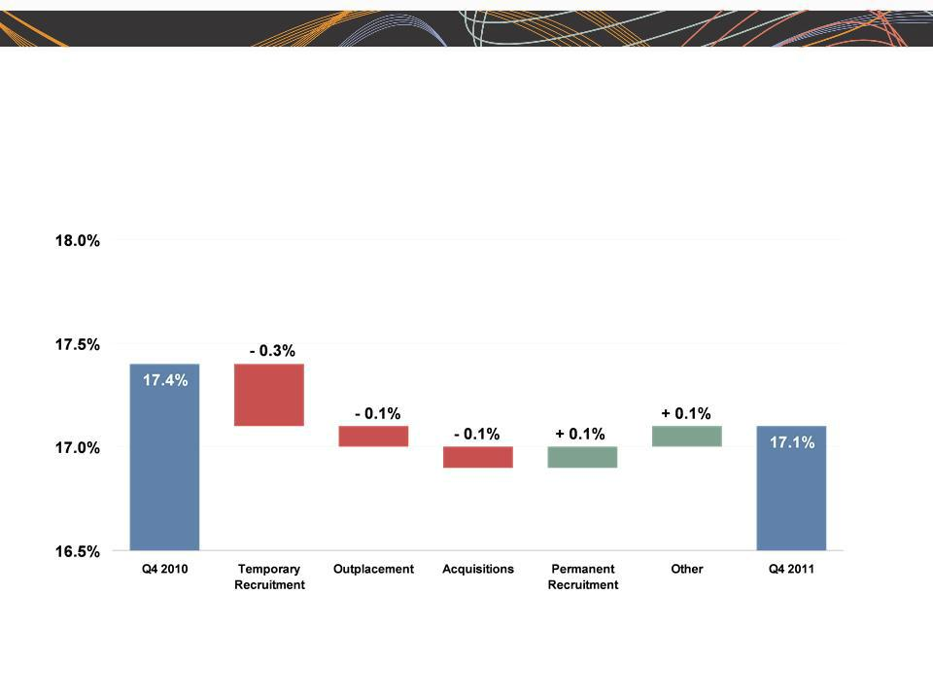
ManpowerGroup 2011 4th Quarter Results 2012

February

Consolidated Gross Margin Change

4

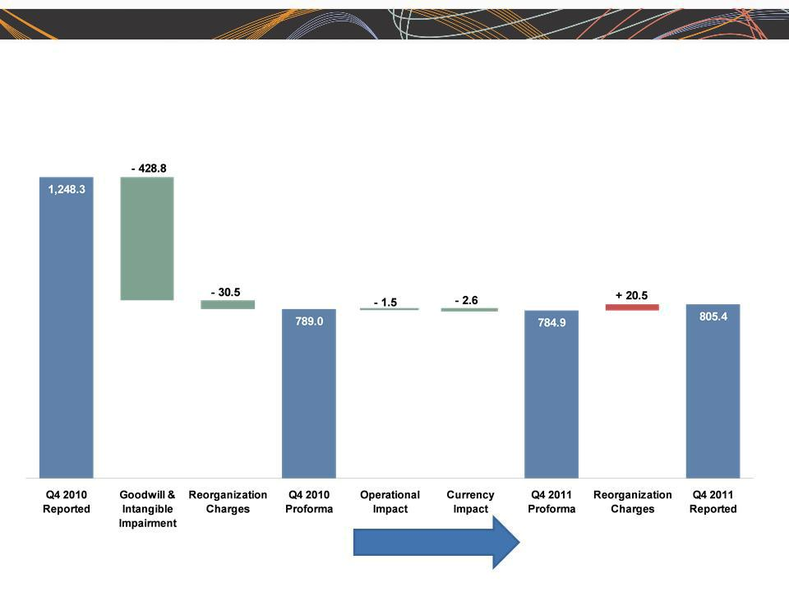
ManpowerGroup 2011 4th Quarter Results 2012

February

SG&A Expense Bridge - Q4 YOY
(in millions of USD)

87.1% | Productivity Gain | 83.9%
% of GP | Productivity Gain | % of GP

5


ManpowerGroup 2011 4th Quarter Results 2012

February

Q4 Non-Recurring Items

($ in millions, except per share amounts)

 |  |  | 2011 |  |  |  |  |  | 2010
 | Pre-tax |  |  | Net | EPS - |  |  | Pre-tax |  | Net | EPS -
 | Earnings |  | Earnings |  | Diluted |  | Earnings |  | Earnings |  | Diluted
Earnings, As Reported | $ | 119.4 | $ | 63.6 | $ | 0.78 | $ | (352.6) | $ | (350.4) | $ | (4.29)
Reorganization Charge(1)(2) |  | 20.5 |  | 16.3 |  | 0.20 |  | 30.5 |  | 20.6 |  | 0.25
Goodwill and Intangible |  | N/A |  | N/A |  | N/A |  | 428.8 |  | 384.3 |  | 4.70
Asset impairment(3)
Earnings, Excluding non- | $ | 139.9 | $ | 79.9 | $ | 0.98 | $ | 106.7 | $ | 54.5 | $ | 0.66
recurring items

- 2011 includes reorganization charges for the Americas ($2.4M), Northern Europe ($12.0M) and Right Management ($6.1M).

- 2010 includes reorganization charges for the Americas ($6.1M), Southern Europe ($7.6M) and Right Management ($16.8M).

- 2010 includes goodwill and intangible asset impairment charges for the Americas ($32.9M) and Right Management ($395.9M).

6

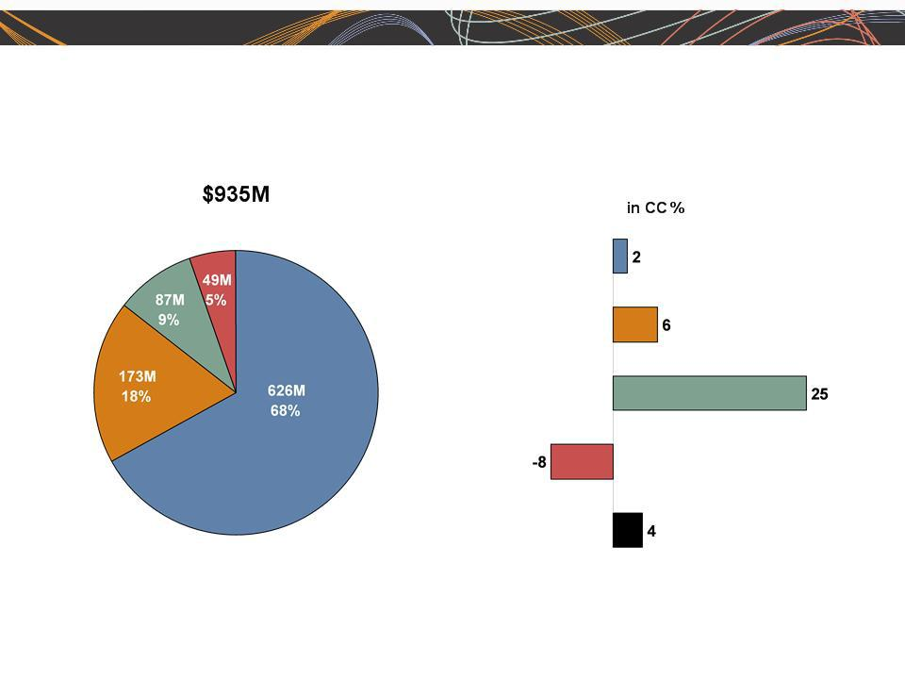
ManpowerGroup 2011 4th Quarter Results 2012

February

Business Line Gross Profit - Q4 2011

Growth

█ Manpower | █ Experis | █ ManpowerGroup - Total
█ ManpowerGroup Solutions | █ Right Management | 7

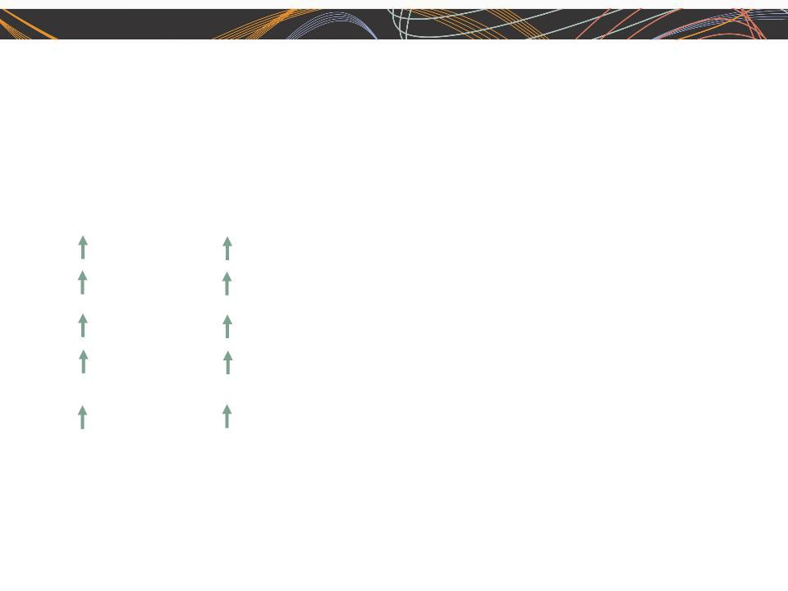
ManpowerGroup 2011 4th Quarter Results 2012

February

Americas Segment

(21% of Revenue)

As |  | Excluding Non |  | Q4 Financial Highlights⁽¹⁾
Reported |  | -recurring |  | Q4 Financial Highlights⁽¹⁾
 |  | Items (2)
3% |  | 3% |  | Revenue $1.2B
5% CC |  | 5% CC |  | Revenue $1.2B
59% |  | 35% |  | OUP $38M
62% CC |  | 37% CC |  | OUP $38M
120 bps |  | 80 bps |  | OUP Margin 3.3%

- Included in these amounts is the US, which had revenue of $766M (-1%) and OUP of $26M (+84%), including $1.7M of reorganization charges.

- Excludes the impact of reorganization charges of $2.4M in 2011 and $6.1M in 2010.

Operating Unit Profit (OUP) is the measure that we use to evaluate segment performance. OUP is

equal to segment revenues less direct costs and branch and national headquarters operating 8 costs.

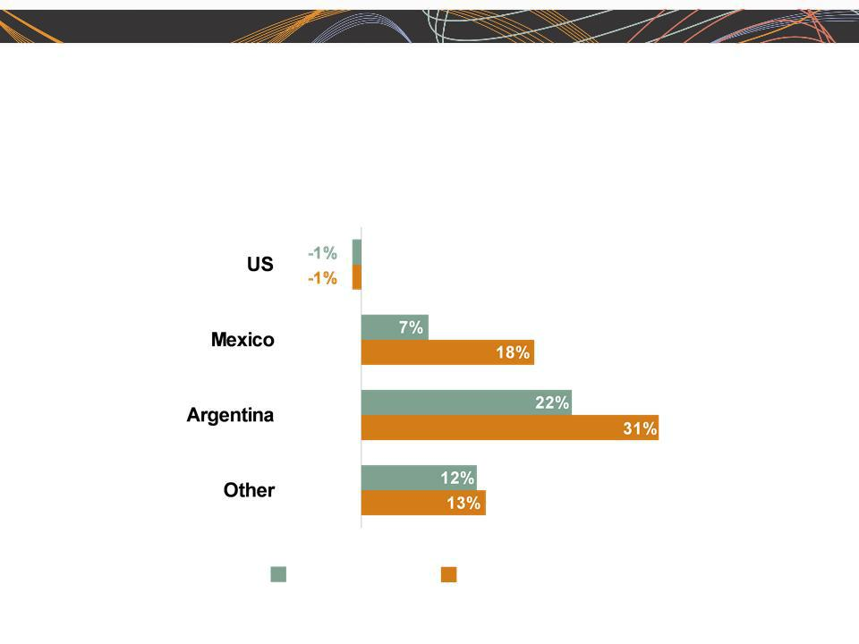
ManpowerGroup 2011 4th Quarter Results 2012

February

Americas - Q4 Revenue Growth YoY

- of Segment Revenue

66%

12%

7%

15%

Revenue

Growth

Revenue Growth - CC

9

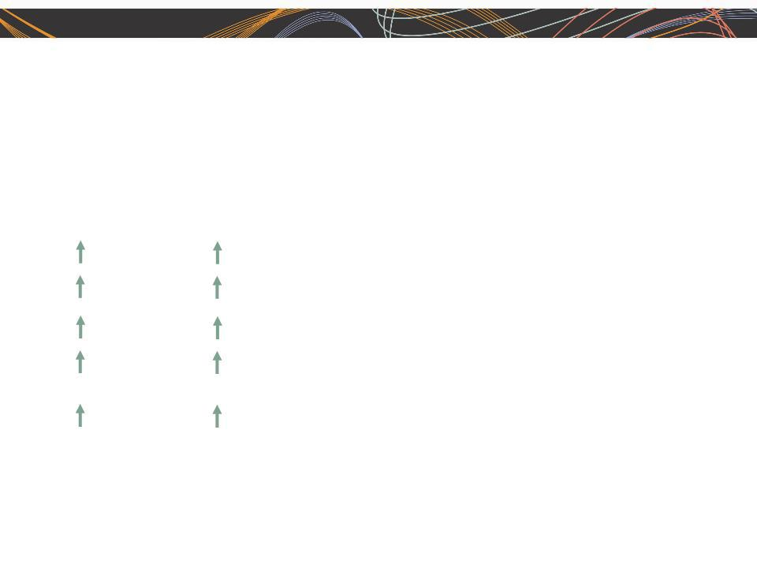
ManpowerGroup 2011 4th Quarter Results 2012

February

Southern Europe Segment

(37% of Revenue)

As |  | Excluding Non |  | Q4 Financial Highlights⁽¹⁾
Reported (2) |  | -recurring |  | Q4 Financial Highlights⁽¹⁾
 |  | Items(3)
5% |  | 5% |  | Revenue $2.0B
6% CC |  | 6% CC |  | Revenue $2.0B
41% |  | 13% |  | OUP $43M
42% CC |  | 14% CC |  | OUP $43M
50 bps |  | 10 bps |  | OUP Margin 2.1%

- Included in these amounts is France, which had revenue of $1.5B (+6% CC) and OUP of $21M (+72% CC).

- On an organic basis, revenue increased 4% (5% in CC).

- Excludes the impact of reorganization charges of $7.6M in 2010.

10

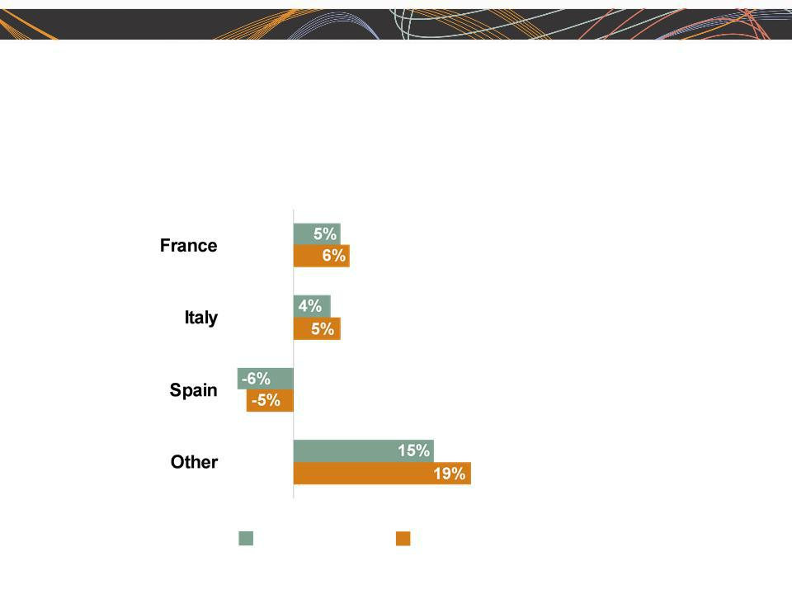
ManpowerGroup 2011 4th Quarter Results 2012

February

Southern Europe - Q4 Revenue Growth YoY

- of Segment Revenue

75%

15%

5%

5%

Revenue

Growth

Revenue Growth - CC

11

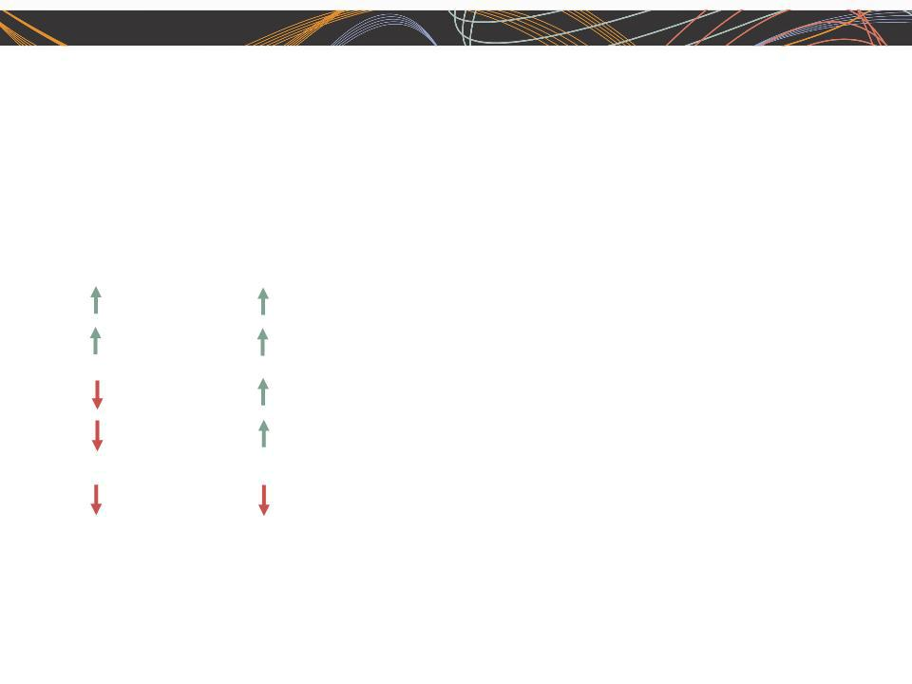
ManpowerGroup 2011 4th Quarter Results 2012

February

Northern Europe Segment

(28% of Revenue)

As |  | Excluding Non |  | Q4 Financial Highlights
Reported |  | -recurring |  | Q4 Financial Highlights
 |  | Items (1)
3% |  | 3% |  | Revenue $1.5B
4% CC |  | 4% CC |  | Revenue $1.5B
18% |  | 1% |  | OUP $52M
18% CC |  | 1% CC |  | OUP $52M
80 bps |  | 10 bps |  | OUP Margin 3.4%

- Excludes the impact of reorganization charges of $12.0M in 2011.

12

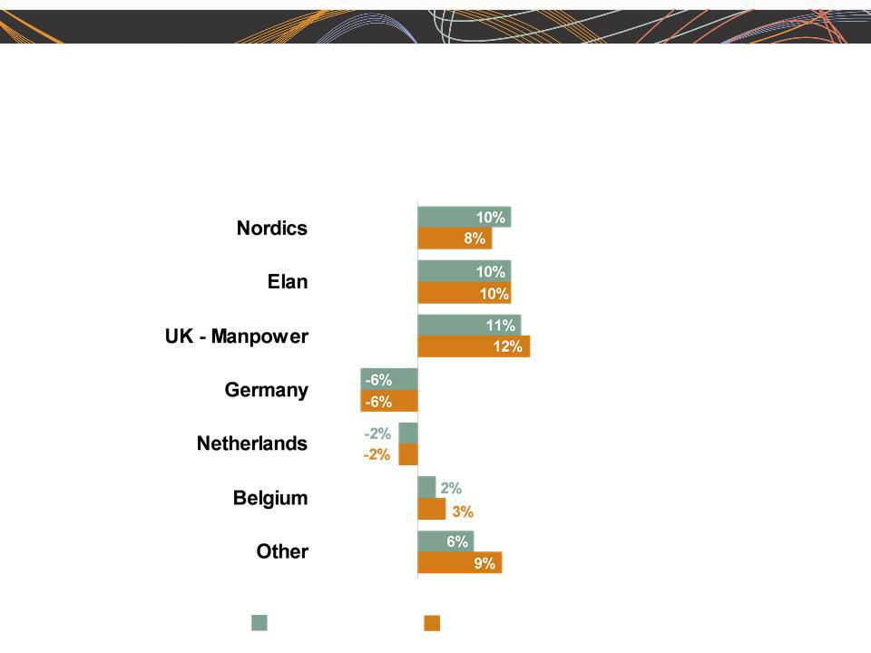
ManpowerGroup 2011 4th Quarter Results 2012

February

Northern Europe - Q4 Revenue Growth YoY

- of Segment Revenue

21%

17%

15%

12%

10%

7%

18%

Revenue | Revenue Growth - CC | 13
Growth

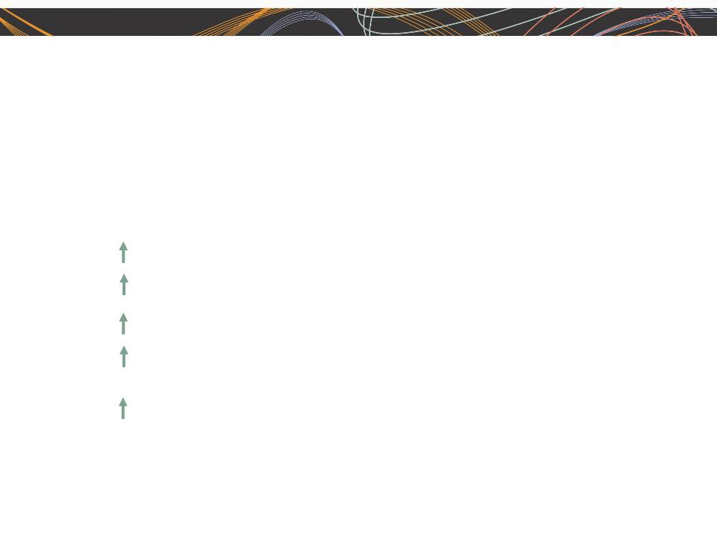
ManpowerGroup 2011 4th Quarter Results 2012

February

APME Segment

(13% of Revenue)

As | Q4 Financial Highlights
Reported⁽¹⁾ | Q4 Financial Highlights
18% | Revenue $695M
14% CC | Revenue $695M
121% | OUP $22M
115% CC | OUP $22M
140 bps | OUP Margin 3.1%

- On an organic basis, revenue increased 9% (5% in CC).

14

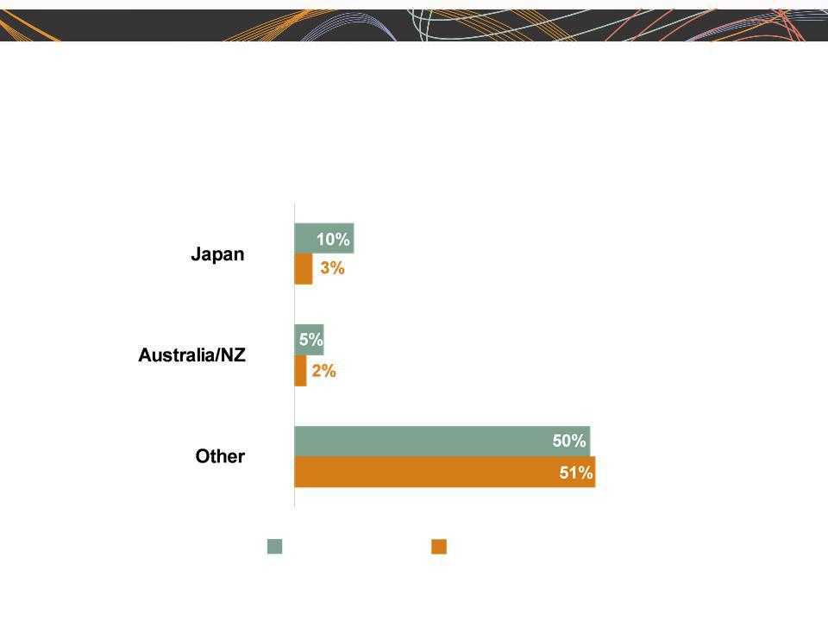
ManpowerGroup 2011 4th Quarter Results 2012

APME - Q4 Revenue Growth YoY

- of Segment Revenue

44%

26%

_{30%} (1)

Revenue Revenue Growth - CC

Growth
- On an organic basis, Other revenue growth was 11% (+13% CC).

February

15

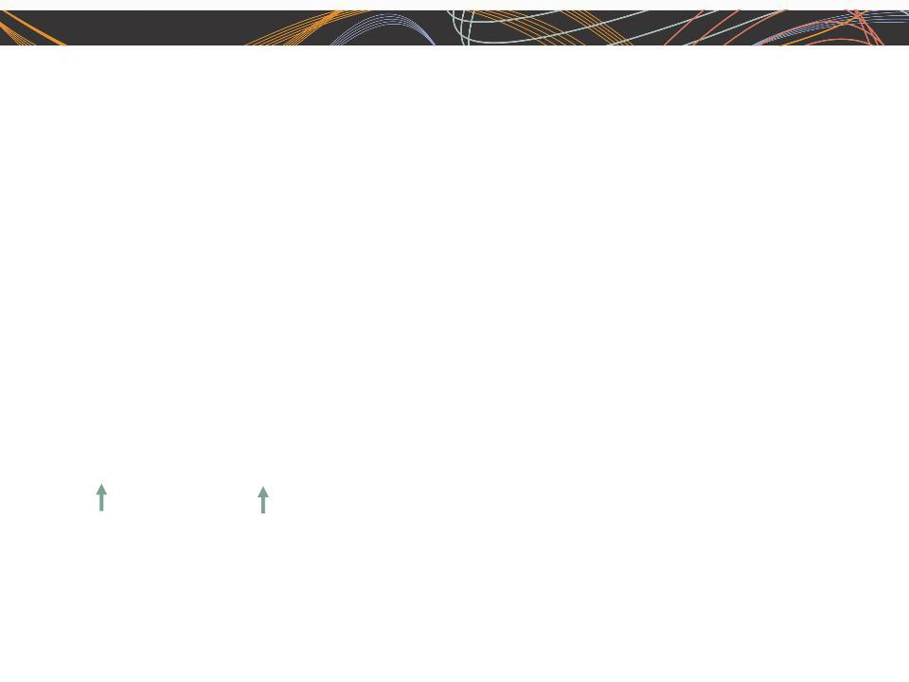
ManpowerGroup 2011 4th Quarter Results 2012

February

Right Management Segment

(1% of Revenue)

As |  | Excluding |  | Q4 Financial Highlights
Reported |  | Non-recurring |  | Q4 Financial Highlights
 |  | Items(1)
8% |  | 8% |  | Revenue $80M
9% CC |  | 9% CC |  | Revenue $80M
N/A |  | N/A |  | OUP ($6M)
N/A |  | N/A |  | OUP ($6M)
1240 bps |  | 70 bps |  | OUP Margin (7.0%)

- Excludes the impact of reorganization charges of $6.1M in 2011 and $16.8M in 2010.

16


ManpowerGroup 2011 4th Quarter Results 2012

February

Cash Flow Summary - Full Year

($ in millions) | 2011 | 2010
Cash from Operations | 69 | 182
Capital Expenditures | (65) | (58)
Free Cash Flow
Free Cash Flow | 4 |  | 124
Change in Debt | 15 | (15)
Share Repurchases | (105) | (35)
Acquisitions of Businesses | (49) | (270)
net of cash acquired | (49)
Effect of Exchange Rate Changes | (28) | (18)
Other | (29) | (28)
Change in Cash
Change in Cash | (192) |  | (242)

17

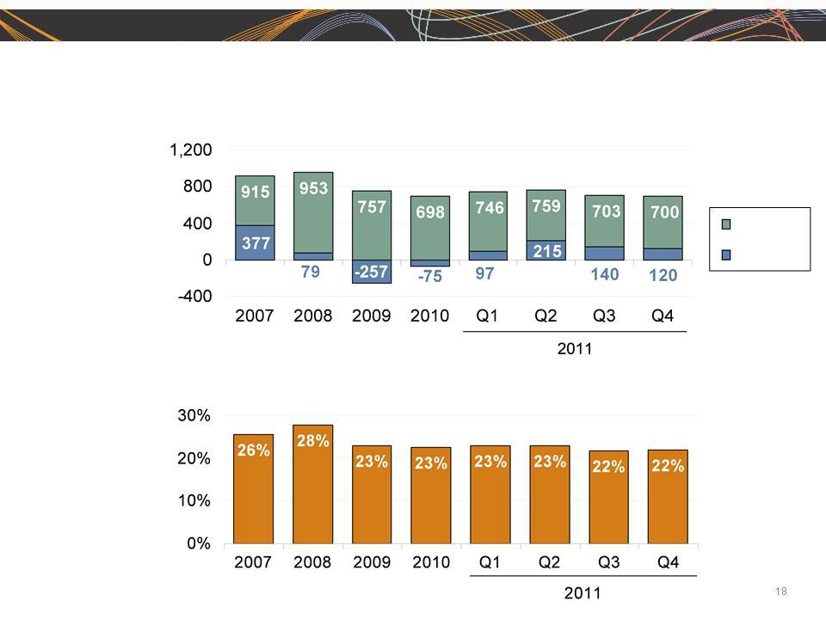
ManpowerGroup 2011 4th Quarter Results 2012

February

Balance Sheet Highlights

Total Debt

($ in millions)

Total Debt

Net
Debt

Total Debt to

Total Capitalization


ManpowerGroup 2011 4th Quarter Results 2012

February

Credit Facilities

($ in millions) |  |  | Total |  | Remaining
 | Interest | Maturity | Outstanding |  | Available
 | Rate | Date | at 12/31/11 |  | at 12/31/11
Euro Notes:
- Euro 200M | 4.86% | Jun 2013 | 259 | -
- Euro 300M | 4.58% | Jun 2012 | 389 | -
Revolving Credit Agreement ⁽¹⁾ | 1.57% | Oct 2016 | - | 798
Uncommitted lines and Other ⁽²⁾ | Various | Various | 52 | 347
Total Debt
Total Debt |  |  | 700 |  | 1,145

  - We completed a new $800M five year revolving credit agreement on October 5, 2011 with a syndicate of commercial banks .This new agreement replaces the previous $400M agreement. This agreement, which expires in October 2016, allows for borrowings in various currencies and up to $150M may be used for the issuance of stand-by letters of credit. Under this agreement, a debt ratings-based pricing grid determines the credit spread that we add to the applicable interbank borrowing rate on all borrowings as well as the facility and issuance fees. At our current credit ratings, our facility fee is 0.225% and our credit spread for borrowings is 1.275%. This agreement requires that we comply with a Leverage Ratio (Debt-to-EBITDA) of not greater than 3.5 to 1 and a Fixed Charge Coverage Ratio of not less than 1.5 to 1, in addition to other customary restrictive covenants. As defined in the agreement, we had a Debt-to-EBITDA ratio of 0.80 and a fixed charge coverage ratio of 3.13 as of December 31, 2011. As of December 31, there were $1.6M of standby letters of credit issued under the agreement.

- Represents subsidiary uncommitted lines of credit & overdraft facilities, which total $399.2M. Total subsidiary borrowing are limited to $300M due to restrictions in our Revolving Credit Facility, with the exception of Q3 when subsidiary borrowings are limited to $600M.

19

ManpowerGroup 2011 4th Quarter Results 2012

February

First Quarter Outlook

Revenue | Total | Down 1-3% (Up 0-2% CC)
 | Americas | Down 1-3% (Up 0-2% CC)
 | Southern Europe | Down 5-7% (Down 0-2% CC)
 | Northern Europe | Down 2-4% (Up 0-2% CC)
 | APME | Up 11-13% (Up 7-9% CC)
 | Right Management | Down 9-11% (Down 7-9% CC)
Gross Profit Margin |  | 16.6 - 16.8%
Operating Profit Margin |  | 1.4 - 1.6%
Tax Rate |  | 56%
EPS |  | $0.30 - $0.38 (Neg. $.02 Currency)

20

ManpowerGroup 2011 4th Quarter Results 2012

February

Last year at this time, we didn’t have…

- Introduction of Human Age

- Launch of our new parent brand - ManpowerGroup

- Launch of our new professional resourcing brand - Experis

- Launch of our solutions offering - ManpowerGroup Solutions

- Reposition of our Right Management brand to be aligned with our new branding

- Introduction of new organizational structure - Southern and Northern Europe

- Registered more than 9 million resumes on Direct Talent, our internet recruitment tool, and implemented in 31 countries

- The largest global RPO business in the industry

- The largest Vender Neutral MSP business in the industry

21

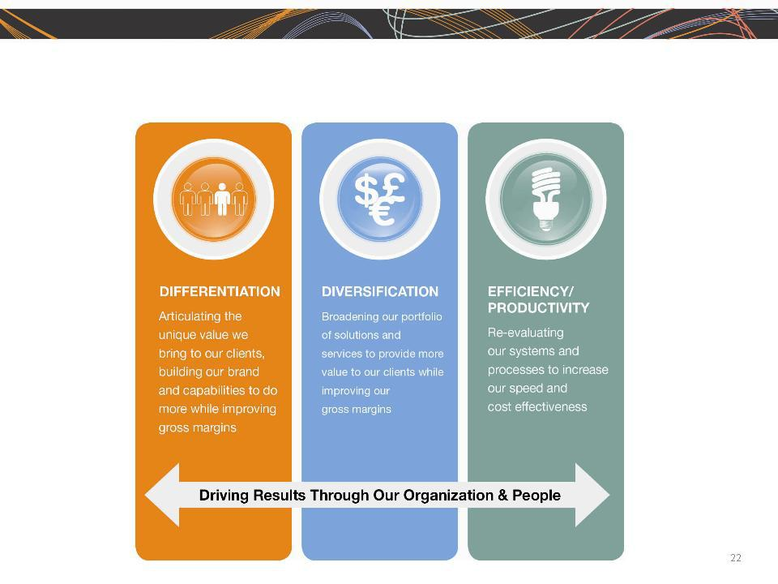
ManpowerGroup 2011 4th Quarter Results 2012

February

Strategic Drivers



Questions

