UNITED STATES
SECURITIES AND EXCHANGE COMMISSION
Washington, D.C. 20549

FORM 8-K

CURRENT REPORT

Pursuant to Section 13 or 15(d) of the Securities Exchange Act of 1934

Date of Report (Date of earliest event reported): October 15, 2026

MANPOWERGROUP INC.
(Exact name of registrant as specified in its charter)

Wisconsin |  | 1-10686 |  | 39-1672779
(State or other jurisdiction of incorporation) |  | (Commission File Number) |  | (IRS Employer Identification No.)

100 Manpower Place
Milwaukee, Wisconsin |  | 53212
(Address of principal executive offices) |  | (Zip Code)

Registrant's telephone number, including area code: (414) 961-1000

(Former name or former address, if changed since last report.)

Check the appropriate box below if the Form 8-K filing is intended to simultaneously satisfy the filing obligation of the registrant under any of the following provisions:

☐ |  | Written communications pursuant to Rule 425 under the Securities Act (17 CFR 230.425)
☐ |  | Soliciting material pursuant to Rule 14a-12 under the Exchange Act (17 CFR 240.14a-12)
☐ |  | Pre-commencement communications pursuant to Rule 14d-2(b) under the Exchange Act (17 CFR 240.14d-2(b))
☐ |  | Pre-commencement communications pursuant to Rule 13e-4(c) under the Exchange Act (17 CFR 240.13e-4(c))

Securities registered pursuant to Section 12(b) of the Act:

Title of each class | Trading Symbol(s) | Name of each exchange on which registered
Common Stock, $.01 par value | MAN | New York Stock Exchange

Indicate by check mark whether the registrant is an emerging growth company as defined in Rule 405 of the Securities Act of 1933 (§230.405 of this chapter) or Rule 12b-2 of the Securities Exchange Act of 1934 (§240.12b-2 of this chapter).

Emerging growth company ☐

If an emerging growth company, indicate by check mark if the registrant has elected not to use the extended transition period for complying with any new or revised financial accounting standards provided pursuant to Section 13(a) of the Exchange Act. ☐

Item 2.02 Results of Operations and Financial Condition

The information in this Item 2.02, including exhibit 99.1 attached hereto, is furnished solely pursuant to Item 2.02 of Form 8-K. Consequently, such information is not deemed "filed" for the purposes of Section 18 of the Securities Exchange Act of 1934, or otherwise subject to the liabilities of that section. Further, the information in this Item 2.02, including exhibit 99.1, shall not be deemed to be incorporated by reference into the filings of the registrant under the Securities Act of 1933.
On October 15, 2026, we issued a press release announcing our results of operations for the three and nine months ended September 30, 2026 and 2025. A copy of the press release is attached hereto as Exhibit 99.1 and is incorporated herein by reference.

Item 9.01. Exhibits

Exhibit No. |  | Description
99.1 |  | Press Release dated October 15, 2026
99.2 |  | Presentation materials for October 15, 2026 Conference Call
104 |  | Cover Page Interactive Data File (embedded within the Inline XBRL document)

SIGNATURE

Pursuant to the requirements of the Securities Exchange Act of 1934, the registrant has duly caused this report to be signed on its behalf by the undersigned hereunto duly authorized.

 |  |  |  |  | MANPOWERGROUP INC.
Dated: |  | October 15, 2026 |  |  | By: |  | /s/ John T. McGinnis
 |  |  |  |  | Name: |  | John T. McGinnis
 |  |  |  |  | Title: |  | Executive Vice President and  Chief Financial Officer

Exhibit 99.1



FOR IMMEDIATE RELEASE |  | Contact:
 |  | Matt Rubatt
 |  | +1.414.906.7804
 |  | matthew.rubatt@manpowergroup.com

ManpowerGroup Reports 3rd Quarter 2026 Results
•
Revenues of $4.8 billion (+4% as reported, +5% constant currency, +6% organic constant currency)
•
Continued top-line growth driven by strength in Manpower, particularly in the United States
•
Improving global Experis trends with U.S. Experis crossing over to growth during the quarter
•
Strong year-over-year revenue growth and Operating Unit Profit improvement in Northern Europe
•
SG&A improved trend reflects continued cost actions
•
Becky Frankiewicz will become CEO January 1, 2027, with Jonas Prising transitioning to Executive Chair. More details in a separate press release issued this morning

MILWAUKEE, October 15, 2026 – ManpowerGroup (NYSE: MAN) today reported net earnings of $0.71 per diluted share for the three months ended September 30, 2026 compared to net earnings of $0.38 per diluted share in the prior year period. Net earnings in the quarter were $34.1 million compared to net earnings of $18.0 million a year earlier. Revenues for the third quarter were $4.8 billion, a 4% increase from the prior year period.
The current year quarter included restructuring costs, strategic transformation program costs, a business sale adjustment, and Argentina hyperinflationary related non-cash currency translation losses, which negatively impacted earnings per share by $0.30 in the third quarter. Excluding these items, earnings per share was $1.01 per diluted share in the quarter representing an increase of 24% in constant currency in the third quarter of 2026.1
Financial results in the quarter were also impacted by the U.S. dollar relative to foreign currencies compared to the prior year period. On a constant currency basis, revenues increased 5% compared to the prior year period.
Jonas Prising, ManpowerGroup Chair & CEO, said, "We delivered another quarter of consistent performance and strong execution as momentum continues across the organization. Our Manpower brand continues to lead the way, with notable share gains in the U.S. Our Experis and Talent Solutions brands

1 The prior year period included various adjustments which reduced earnings per share by $0.45 in the third quarter, which are also excluded when determining the year over year adjusted trend.

experienced sequential revenue trend improvement which is encouraging. Our performance to date reinforces our confidence that 2026 is an inflection point for the business. At the same time, we continue to advance our transformation, expanding implementation beyond the U.S. and driving growth across our brands and regions while remaining on track to deliver on our cost savings target. Looking ahead, the combination of improving demand, strong execution, and continued progress on our transformation positions ManpowerGroup to drive sustainable, profitable growth."
We anticipate diluted earnings per share in the fourth quarter will be between $1.03 and $1.13 and a 44% effective tax rate."
Net earnings for the nine months ended September 30, 2026 were $90.1 million, or net earnings of $1.89 per diluted share compared to net losses of $43.5 million, or net losses of $0.93 per diluted share in the prior year, respectively. The current year-to-date period included restructuring costs, strategic transformation program costs, the sale of our Jefferson Wells U.S. business, a discontinued business liquidation charge, and Argentina hyperinflationary related non-cash currency translation losses which, in aggregate, reduced earnings per share by $0.62. Excluding the net impact of these charges, earnings per share for the nine-month period was $2.51 per diluted share representing an increase of 21% in constant currency.2 Revenues for the nine-month period were $14.2 billion, representing an increase of 7% compared to the prior year or 5% in constant currency.
In conjunction with its third quarter earnings release, ManpowerGroup will broadcast its conference call live over the internet on October 15, 2026 at 7:30 a.m. Central time (8:30 a.m. Eastern time). Prepared remarks for the conference call, webcast details, presentation and recordings are included within the Investor Relations section of manpowergroup.com.
Supplemental financial information referenced in the conference call can be found at http://investor.manpowergroup.com/.

2 The prior year period included restructuring costs, net losses from the sale of businesses, a non-cash goodwill and intangible asset impairment charge, and Argentina hyperinflationary related non-cash currency translation losses which reduced earnings per share by $2.98 which are also excluded when determining the year over year trend.

About ManpowerGroup
ManpowerGroup® (NYSE: MAN), the leading global workforce solutions company, helps organizations transform in a fast-changing world of work by sourcing, assessing, developing, and managing the talent that enables them to win. We develop innovative solutions for hundreds of thousands of organizations every year, providing them with skilled talent while finding meaningful, sustainable employment for millions of people across a wide range of industries and skills. Our expert family of brands – Manpower, Experis, and Talent Solutions – creates substantially more value for candidates and clients across more than 70 countries and territories and has done so for more than 75 years. We are recognized consistently for our diversity – as a best place to work for Women, Inclusion, Equality, and Disability, and in 2026 ManpowerGroup was named one of the World's Most Ethical Companies for the 17th time – all confirming our position as the brand of choice for in-demand talent. For more information, visit www.manpowergroup.com.
Forward-Looking Statements
This press release contains forward-looking statements within the meaning of Section 27A of the Securities Act of 1933, as amended, and Section 21E of the Exchange Act of 1934, as amended, including statements regarding trends in labor demand and the future strengthening of such demand, the Company’s financial outlook, and the Company’s strategic initiatives and technology investments, including our ability to increase market share and the acceleration of transformation initiatives to remove structural costs from the organization to drive efficiencies, which are subject to risks and uncertainties. The Company’s actual results may differ materially from those described or contemplated in the forward-looking statements due to numerous factors. These factors include those found in the Company’s reports filed with the SEC, including the information under the heading “Risk Factors” in its Annual Report on Form 10-K for the year ended December 31, 2025, which information is incorporated herein by reference.
We caution that any forward-looking statement reflects only our belief at the time the statement is made. The Company assumes no obligation to update or revise any forward-looking statements. We reference certain non-GAAP financial measures, which we believe provide useful information for investors. We include a reconciliation of these measures, where appropriate, to GAAP on the Investor Relations section of our website at manpowergroup.com.

ManpowerGroup
Results of Operations
(In millions, except per share data)

 |  | Three Months Ended September 30
 |  |  |  |  |  |  |  |  |  | % Variance
 |  |  |  |  |  |  |  |  |  | Amount |  |  |  | Constant
 |  | 2026 |  |  |  | 2025 |  |  |  | Reported |  |  |  | Currency
 |  | (Unaudited)
Revenues from services (a) |  | $ | 4,840.0 |  |  | $ | 4,634.4 |  |  |  | 4.4 | % |  |  | 5.2 | %
Cost of services |  |  | 4,072.7 |  |  |  | 3,865.5 |  |  |  | 5.4 | % |  |  | 6.1 | %
Gross profit |  |  | 767.3 |  |  |  | 768.9 |  |  |  | -0.2 | % |  |  | 0.4 | %
Selling and administrative expenses |  |  | 685.0 |  |  |  | 702.3 |  |  |  | -2.5 | % |  |  | -2.0 | %
Operating profit |  |  | 82.3 |  |  |  | 66.6 |  |  |  | 23.7 | % |  |  | 26.2 | %
Interest and other expenses, net |  |  | 14.3 |  |  |  | 13.7 |  |  |  | 4.8 | %
Earnings before income taxes |  |  | 68.0 |  |  |  | 52.9 |  |  |  | 28.5 | % |  |  | 31.0 | %
Provision for income taxes |  |  | 33.9 |  |  |  | 34.9 |  |  |  | -2.8 | %
Net earnings |  | $ | 34.1 |  |  | $ | 18.0 |  |  |  | 89.3 | % |  |  | 92.9 | %
Net earnings per share - basic |  | $ | 0.73 |  |  | $ | 0.39 |  |  |  | 87.7 | %
Net earnings per share - diluted |  | $ | 0.71 |  |  | $ | 0.38 |  |  |  | 84.4 | % |  |  | 87.9 | %
Weighted average shares - basic |  |  | 46.9 |  |  |  | 46.5 |  |  |  | 0.8 | %
Weighted average shares - diluted |  |  | 48.1 |  |  |  | 46.9 |  |  |  | 2.7 | %

(a)
Revenues from services include fees received from our franchise offices of $4.2 million and $4.3 million for the three months ended September 30, 2026 and 2025, respectively. These fees are primarily based on revenues generated by the franchise offices, which were $481.1 million and $300.3 million for the three months ended September 30, 2026 and 2025, respectively.

ManpowerGroup
Operating Unit Results
(In millions)

 |  | Three Months Ended September 30
 |  |  |  |  |  |  |  |  |  | % Variance
 |  |  |  |  |  |  |  |  |  | Amount |  |  |  | Constant
 |  | 2026 |  |  |  | 2025 |  |  |  | Reported |  |  |  | Currency
 |  | (Unaudited)
Revenues from Services:
Americas:
United States (a) |  | $ | 728.8 |  |  | $ | 690.8 |  |  |  | 5.5 | % |  |  | 5.5 | %
Other Americas |  |  | 517.9 |  |  |  | 407.9 |  |  |  | 27.0 | % |  |  | 21.7 | %
 |  |  | 1,246.7 |  |  |  | 1,098.7 |  |  |  | 13.5 | % |  |  | 11.5 | %
Southern Europe:
France |  |  | 1,132.9 |  |  |  | 1,173.5 |  |  |  | -3.5 | % |  |  | -1.9 | %
Italy |  |  | 483.1 |  |  |  | 462.5 |  |  |  | 4.5 | % |  |  | 6.2 | %
Other Southern Europe |  |  | 611.9 |  |  |  | 569.5 |  |  |  | 7.5 | % |  |  | 7.0 | %
 |  |  | 2,227.9 |  |  |  | 2,205.5 |  |  |  | 1.0 | % |  |  | 2.1 | %
Northern Europe |  |  | 860.6 |  |  |  | 816.8 |  |  |  | 5.4 | % |  |  | 5.9 | %
APME |  |  | 514.9 |  |  |  | 520.5 |  |  |  | -1.1 | % |  |  | 4.3 | %
 |  |  | 4,850.1 |  |  |  | 4,641.5
Intercompany Eliminations |  |  | (10.1 | ) |  |  | (7.1 | )
 |  | $ | 4,840.0 |  |  | $ | 4,634.4 |  |  |  | 4.4 | % |  |  | 5.2 | %
Operating Unit Profit (Loss):
Americas:
United States |  | $ | 24.3 |  |  | $ | 20.6 |  |  |  | 18.2 | % |  |  | 18.2 | %
Other Americas |  |  | 23.1 |  |  |  | 17.3 |  |  |  | 33.1 | % |  |  | 27.9 | %
 |  |  | 47.4 |  |  |  | 37.9 |  |  |  | 25.0 | % |  |  | 22.6 | %
Southern Europe:
France |  |  | 22.4 |  |  |  | 30.6 |  |  |  | -26.9 | % |  |  | -25.3 | %
Italy |  |  | 27.4 |  |  |  | 26.6 |  |  |  | 3.2 | % |  |  | 5.1 | %
Other Southern Europe |  |  | 14.8 |  |  |  | 8.4 |  |  |  | 74.1 | % |  |  | 68.2 | %
 |  |  | 64.6 |  |  |  | 65.6 |  |  |  | -1.7 | % |  |  | -1.0 | %
Northern Europe |  |  | 7.5 |  |  |  | (14.9 | ) |  | N/A |  |  |  | N/A
APME |  |  | 23.9 |  |  |  | 26.8 |  |  |  | -10.2 | % |  |  | -3.7 | %
 |  |  | 143.4 |  |  |  | 115.4
Corporate expenses |  |  | (54.1 | ) |  |  | (40.9 | )
Intangible asset amortization expense |  |  | (7.0 | ) |  |  | (7.9 | )
Operating profit |  |  | 82.3 |  |  |  | 66.6 |  |  |  | 23.7 | % |  |  | 26.2 | %
Interest and other expenses, net (b) |  |  | (14.3 | ) |  |  | (13.7 | )
Earnings before income taxes |  | $ | 68.0 |  |  | $ | 52.9

(a)
In the United States, revenues from services include fees received from our franchise offices of $2.4 million and $2.7 million for the three months ended September 30, 2026 and 2025, respectively. These fees are primarily based on revenues generated by the franchise offices, which were $94.5 million and $83.5 million for the three months ended September 30, 2026 and 2025, respectively.
(b)
The components of interest and other expenses, net were:
 |  | 2026 |  |  |  | 2025
Interest expense |  | $ | 28.0 |  |  | $ | 24.0
Interest income |  |  | (7.8 | ) |  |  | (6.9 | )
Foreign exchange loss |  |  | 1.3 |  |  |  | 2.4
Miscellaneous income, net |  |  | (7.2 | ) |  |  | (5.8 | )
 |  | $ | 14.3 |  |  | $ | 13.7

ManpowerGroup
Results of Operations
(In millions, except per share data)

 |  | Nine Months Ended September 30
 |  |  |  |  |  |  |  |  |  | % Variance
 |  |  |  |  |  |  |  |  |  | Amount |  |  |  | Constant
 |  | 2026 |  |  |  | 2025 |  |  |  | Reported |  |  |  | Currency
 |  | (Unaudited)
Revenues from services (a) |  | $ | 14,210.6 |  |  | $ | 13,244.0 |  |  |  | 7.3 | % |  |  | 4.7 | %
Cost of services |  |  | 11,940.0 |  |  |  | 11,013.1 |  |  |  | 8.4 | % |  |  | 5.7 | %
Gross profit |  |  | 2,270.6 |  |  |  | 2,230.9 |  |  |  | 1.8 | % |  |  | -0.5 | %
Selling and administrative expenses,  excluding impairment charges |  |  | 2,048.0 |  |  |  | 2,072.7 |  |  |  | -1.2 | % |  |  | -3.4 | %
Impairment charges (b) |  |  | — |  |  |  | 88.7 |  |  | N/A |  |  |  | N/A
Selling and administrative expenses |  |  | 2,048.0 |  |  |  | 2,161.4 |  |  |  | -5.3 | % |  |  | -7.4 | %
Operating profit |  |  | 222.6 |  |  |  | 69.5 |  |  |  | 220.4 | % |  |  | 213.8 | %
Interest and other expenses, net |  |  | 46.8 |  |  |  | 41.7 |  |  |  | 12.4 | %
Earnings before income taxes |  |  | 175.8 |  |  |  | 27.8 |  |  |  | 531.5 | % |  |  | 525.5 | %
Provision for income taxes |  |  | 85.7 |  |  |  | 71.3 |  |  |  | 20.2 | %
Net earnings (loss) |  | $ | 90.1 |  |  | $ | (43.5 | ) |  | N/A |  |  |  | N/A
Net earnings (loss) per share - basic |  | $ | 1.93 |  |  | $ | (0.93 | ) |  | N/A
Net earnings (loss) per share - diluted |  | $ | 1.89 |  |  | $ | (0.93 | ) |  | N/A |  |  |  | N/A
Weighted average shares - basic |  |  | 46.8 |  |  |  | 46.6 |  |  |  | 0.4 | %
Weighted average shares - diluted |  |  | 47.6 |  |  |  | 46.6 |  |  |  | 2.2 | %
(a)
Revenues from services include fees received from our franchise offices of $12.5 million for both the nine months ended September 30, 2026 and 2025. These fees are primarily based on revenues generated by the franchise offices, which were $1,406.8 million and $1,147.4 million for the nine months ended September 30, 2026 and 2025, respectively.
(b)
Impairment charges for the nine months ended September 30, 2025 consist of a goodwill impairment related to our investments in Switzerland and the United Kingdom and an impairment of an indefinite lived intangible asset in our Switzerland business.

ManpowerGroup
Operating Unit Results
(In millions)

 |  | Nine Months Ended September 30
 |  |  |  |  |  |  |  |  |  | % Variance
 |  |  |  |  |  |  |  |  |  | Amount |  |  |  | Constant
 |  | 2026 |  |  |  | 2025 |  |  |  | Reported |  |  |  | Currency
 |  | (Unaudited)
Revenues from Services:
Americas:
United States (a) |  | $ | 2,098.0 |  |  | $ | 2,053.7 |  |  |  | 2.2 | % |  |  | 2.2 | %
Other Americas |  |  | 1,476.6 |  |  |  | 1,161.7 |  |  |  | 27.1 | % |  |  | 21.7 | %
 |  |  | 3,574.6 |  |  |  | 3,215.4 |  |  |  | 11.2 | % |  |  | 9.2 | %
Southern Europe:
France |  |  | 3,379.1 |  |  |  | 3,288.5 |  |  |  | 2.8 | % |  |  | -0.8 | %
Italy |  |  | 1,479.7 |  |  |  | 1,336.2 |  |  |  | 10.7 | % |  |  | 6.9 | %
Other Southern Europe |  |  | 1,779.1 |  |  |  | 1,564.1 |  |  |  | 13.8 | % |  |  | 7.7 | %
 |  |  | 6,637.9 |  |  |  | 6,188.8 |  |  |  | 7.3 | % |  |  | 3.0 | %
Northern Europe |  |  | 2,476.2 |  |  |  | 2,342.0 |  |  |  | 5.7 | % |  |  | 2.0 | %
APME |  |  | 1,544.1 |  |  |  | 1,522.2 |  |  |  | 1.4 | % |  |  | 5.7 | %
 |  |  | 14,232.8 |  |  |  | 13,268.4
Intercompany Eliminations |  |  | (22.2 | ) |  |  | (24.4 | )
 |  |  | 14,210.6 |  |  |  | 13,244.0 |  |  |  | 7.3 | % |  |  | 4.7 | %
Operating Unit Profit (Loss):
Americas:
United States |  | $ | 79.2 |  |  | $ | 51.6 |  |  |  | 53.6 | % |  |  | 53.6 | %
Other Americas |  |  | 59.2 |  |  |  | 47.9 |  |  |  | 23.4 | % |  |  | 18.4 | %
 |  |  | 138.4 |  |  |  | 99.5 |  |  |  | 39.1 | % |  |  | 36.6 | %
Southern Europe:
France |  |  | 67.9 |  |  |  | 83.9 |  |  |  | -19.1 | % |  |  | -20.9 | %
Italy |  |  | 90.2 |  |  |  | 83.0 |  |  |  | 8.6 | % |  |  | 5.0 | %
Other Southern Europe |  |  | 35.8 |  |  |  | 22.2 |  |  |  | 61.1 | % |  |  | 49.5 | %
 |  |  | 193.9 |  |  |  | 189.1 |  |  |  | 2.5 | % |  |  | -1.3 | %
Northern Europe |  |  | 1.3 |  |  |  | (42.2 | ) |  | N/A |  |  |  | N/A
APME |  |  | 69.5 |  |  |  | 73.2 |  |  |  | -4.8 | % |  |  | 1.9 | %
 |  |  | 403.1 |  |  |  | 319.6
Corporate expenses |  |  | (159.5 | ) |  |  | (137.1 | )
Impairment charges (b) |  |  | — |  |  |  | (88.7 | )
Intangible asset amortization expense |  |  | (21.0 | ) |  |  | (24.3 | )
Operating profit |  |  | 222.6 |  |  |  | 69.5 |  |  |  | 220.4 | % |  |  | 213.8 | %
Interest and other expenses, net (c) |  |  | (46.8 | ) |  |  | (41.7 | )
Earnings before income taxes |  | $ | 175.8 |  |  | $ | 27.8
(a)
In the United States, revenues from services include fees received from our franchise offices of $7.5 million for both the nine months ended September 30, 2026 and 2025. These fees are primarily based on revenues generated by the franchise offices, which were $266.4 million and $247.5 million for the nine months ended September 30, 2026 and 2025, respectively.
(b)
Impairment charges for the nine months ended September 30, 2025 consist of a goodwill impairment related to our investments in Switzerland and the United Kingdom and an impairment of an indefinite lived intangible asset in our Switzerland business.
(c)
The components of interest and other expenses, net were:
 |  | 2026 |  |  |  | 2025
Interest expense |  | $ | 77.5 |  |  | $ | 72.5
Interest income |  |  | (18.7 | ) |  |  | (22.0 | )
Foreign exchange loss |  |  | 3.6 |  |  |  | 4.6
Miscellaneous income, net |  |  | (15.6 | ) |  |  | (13.4 | )
 |  | $ | 46.8 |  |  | $ | 41.7

ManpowerGroup
Consolidated Balance Sheets
(In millions)

 |  | September 30, |  |  |  | December 31,
 |  | 2026 |  |  |  | 2025
 |  | (Unaudited)
ASSETS
Current assets:
Cash and cash equivalents |  | $ | 233.1 |  |  | $ | 871.0
Accounts receivable, net |  |  | 4,619.4 |  |  |  | 4,770.3
Prepaid expenses and other assets |  |  | 204.3 |  |  |  | 149.1
Total current assets |  |  | 5,056.8 |  |  |  | 5,790.4
Other assets:
Goodwill |  |  | 1,481.7 |  |  |  | 1,544.6
Intangible assets, net |  |  | 408.3 |  |  |  | 430.1
Operating lease right-of-use assets |  |  | 345.5 |  |  |  | 392.7
Other assets |  |  | 856.5 |  |  |  | 879.1
Total other assets |  |  | 3,092.0 |  |  |  | 3,246.5
Property and equipment:
Land, buildings, leasehold improvements and equipment |  |  | 522.8 |  |  |  | 526.9
Less: accumulated depreciation and amortization |  |  | 411.7 |  |  |  | 403.7
Net property and equipment |  |  | 111.1 |  |  |  | 123.2
Total assets |  | $ | 8,259.9 |  |  | $ | 9,160.1
LIABILITIES AND SHAREHOLDERS' EQUITY
Current liabilities:
Accounts payable |  | $ | 2,432.6 |  |  | $ | 2,721.1
Employee compensation payable |  |  | 232.7 |  |  |  | 232.3
Accrued payroll taxes and insurance |  |  | 633.0 |  |  |  | 672.1
Accrued liabilities |  |  | 461.0 |  |  |  | 457.6
Value added taxes payable |  |  | 406.5 |  |  |  | 418.1
Short-term operating lease liability |  |  | 99.2 |  |  |  | 107.4
Short-term borrowings and current maturities of long-term debt |  |  | 540.6 |  |  |  | 625.0
Total current liabilities |  |  | 4,805.6 |  |  |  | 5,233.6
Other liabilities:
Long-term debt |  |  | 562.8 |  |  |  | 1,052.1
Long-term operating lease liability |  |  | 259.8 |  |  |  | 304.3
Other long-term liabilities |  |  | 491.1 |  |  |  | 509.8
Total other liabilities |  |  | 1,313.7 |  |  |  | 1,866.2
Shareholders' equity:
ManpowerGroup shareholders' equity
Common stock |  |  | 1.2 |  |  |  | 1.2
Capital in excess of par value |  |  | 3,592.8 |  |  |  | 3,572.5
Retained earnings |  |  | 3,788.9 |  |  |  | 3,732.3
Accumulated other comprehensive loss |  |  | (406.1 | ) |  |  | (412.1 | )
Treasury stock, at cost |  |  | (4,836.4 | ) |  |  | (4,834.3 | )
Total ManpowerGroup shareholders' equity |  |  | 2,140.4 |  |  |  | 2,059.6
Noncontrolling interests |  |  | 0.2 |  |  |  | 0.7
Total shareholders' equity |  |  | 2,140.6 |  |  |  | 2,060.3
Total liabilities and shareholders' equity |  | $ | 8,259.9 |  |  | $ | 9,160.1

ManpowerGroup
Consolidated Statements of Cash Flows
(In millions)

 |  | Nine Months Ended
 |  | September 30,
 |  | 2026 |  |  |  | 2025
 |  | (Unaudited)
Cash Flows from Operating Activities:
Net earnings (Loss) |  | $ | 90.1 |  |  | $ | (43.5 | )
Adjustments to reconcile net earnings to net cash used in operating activities:
Depreciation and amortization |  |  | 62.1 |  |  |  | 65.5
(Gain) Loss on sales of subsidiaries, net |  |  | (22.8 | ) |  |  | 6.2
Non-cash impairment of goodwill and other intangible assets |  |  | — |  |  |  | 88.7
Deferred income taxes |  |  | 7.1 |  |  |  | (16.1 | )
Provision for credit losses |  |  | 9.1 |  |  |  | 4.3
Share-based compensation |  |  | 20.9 |  |  |  | 20.2
Changes in operating assets and liabilities:
Accounts receivable |  |  | 36.4 |  |  |  | (8.8 | )
Other assets |  |  | (74.7 | ) |  |  | (95.4 | )
Accounts payable |  |  | (255.8 | ) |  |  | (182.9 | )
Other liabilities |  |  | (9.4 | ) |  |  | (121.2 | )
Cash used in operating activities |  |  | (137.0 | ) |  |  | (283.0 | )
Cash Flows from Investing Activities:
Capital expenditures |  |  | (23.6 | ) |  |  | (46.4 | )
Acquisition of businesses, net of cash acquired |  |  | — |  |  |  | (1.0 | )
Impact to cash resulting from sales of subsidiaries |  |  | 87.5 |  |  |  | (2.1 | )
Proceeds from the sale of property and equipment |  |  | 1.4 |  |  |  | 0.8
Cash provided by (used in) investing activities |  |  | 65.3 |  |  |  | (48.7 | )
Cash Flows from Financing Activities:
Net change in short-term borrowings |  |  | 1.5 |  |  |  | 65.7
Net proceeds from revolving debt facility |  |  | 50.0 |  |  |  | 73.0
Proceeds from long-term debt |  |  | 3.2 |  |  |  | 0.2
Repayments of long-term debt |  |  | (585.9 | ) |  |  | (0.6 | )
Payments of contingent consideration for acquisition |  |  | (0.8 | ) |  |  | (1.3 | )
Taxes paid related to net share settlement |  |  | (2.8 | ) |  |  | (6.0 | )
Repurchases of common stock and excise tax |  |  | (0.3 | ) |  |  | (38.2 | )
Dividends paid |  |  | (33.5 | ) |  |  | (33.3 | )
Cash (used in) provided by financing activities |  |  | (568.6 | ) |  |  | 59.5
Effect of exchange rate changes on cash |  |  | 2.4 |  |  |  | 37.4
Change in cash and cash equivalents |  |  | (637.9 | ) |  |  | (234.8 | )
Cash and cash equivalents, beginning of period |  |  | 871.0 |  |  |  | 509.4
Cash and cash equivalents, end of period |  | $ | 233.1 |  |  | $ | 274.6


Third Quarter Results October 15, 2026 Exhibit 99.2

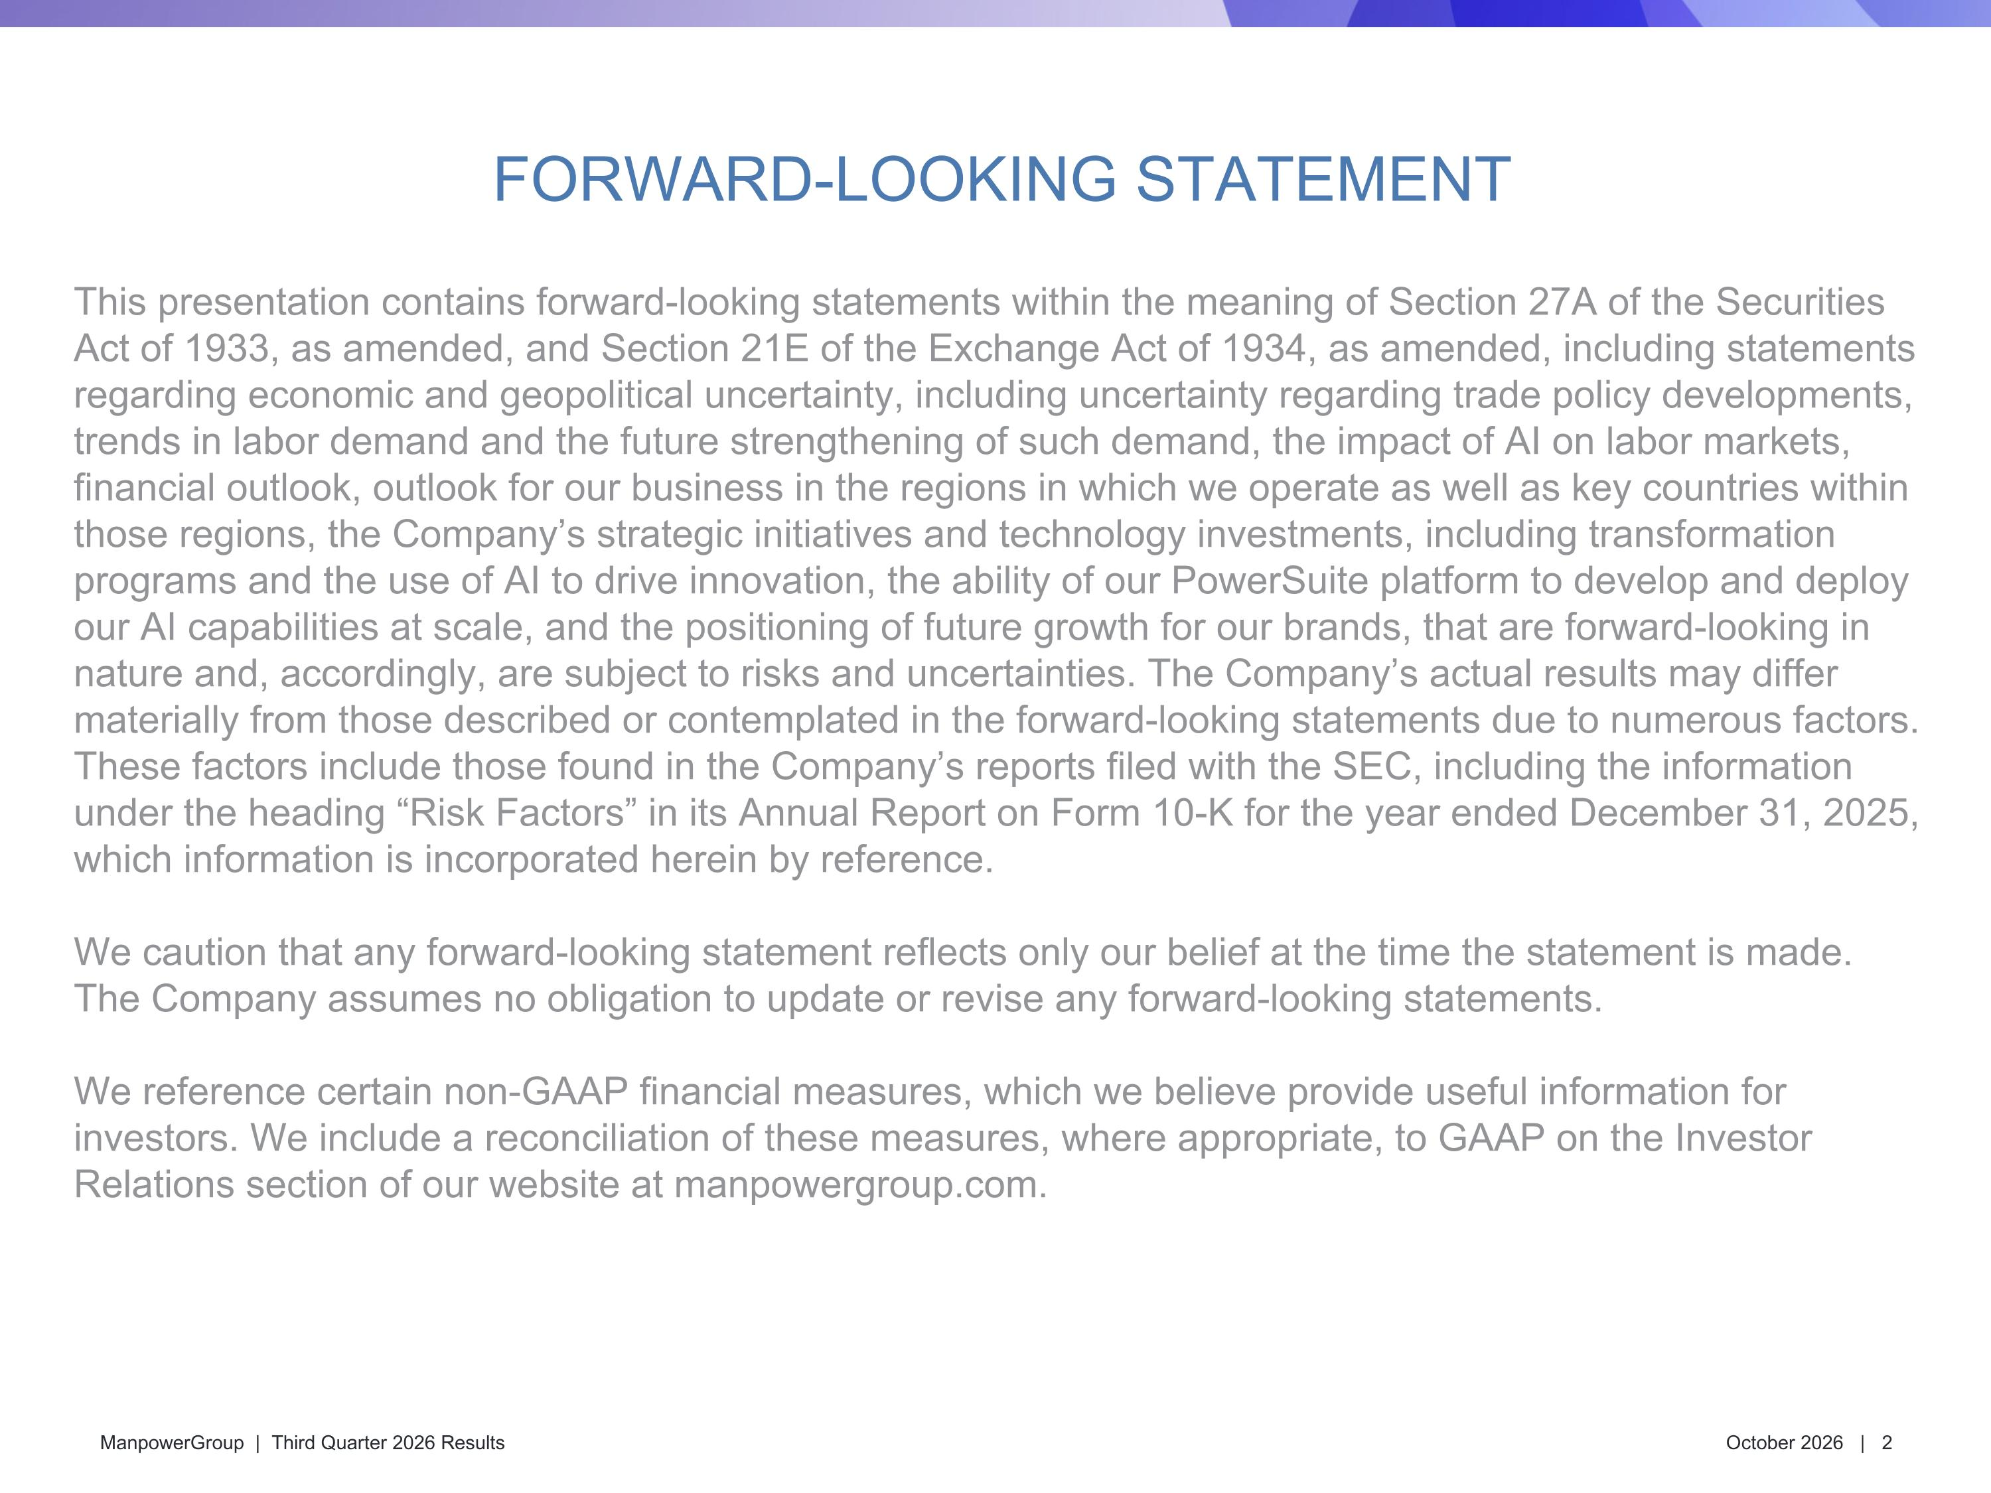
FORWARD-LOOKING STATEMENT This presentation contains forward-looking statements within the meaning of Section 27A of the Securities Act of 1933, as amended, and Section 21E of the Exchange Act of 1934, as amended, including statements regarding economic and geopolitical uncertainty, including uncertainty regarding trade policy developments, trends in labor demand and the future strengthening of such demand, the impact of AI on labor markets, financial outlook, outlook for our business in the regions in which we operate as well as key countries within those regions, the Company’s strategic initiatives and technology investments, including transformation programs and the use of AI to drive innovation, the ability of our PowerSuite platform to develop and deploy our AI capabilities at scale, and the positioning of future growth for our brands, that are forward-looking in nature and, accordingly, are subject to risks and uncertainties. The Company’s actual results may differ materially from those described or contemplated in the forward-looking statements due to numerous factors. These factors include those found in the Company’s reports filed with the SEC, including the information under the heading “Risk Factors” in its Annual Report on Form 10-K for the year ended December 31, 2025, which information is incorporated herein by reference.​ We caution that any forward-looking statement reflects only our belief at the time the statement is made. The Company assumes no obligation to update or revise any forward-looking statements. We reference certain non-GAAP financial measures, which we believe provide useful information for investors. We include a reconciliation of these measures, where appropriate, to GAAP on the Investor Relations section of our website at manpowergroup.com.

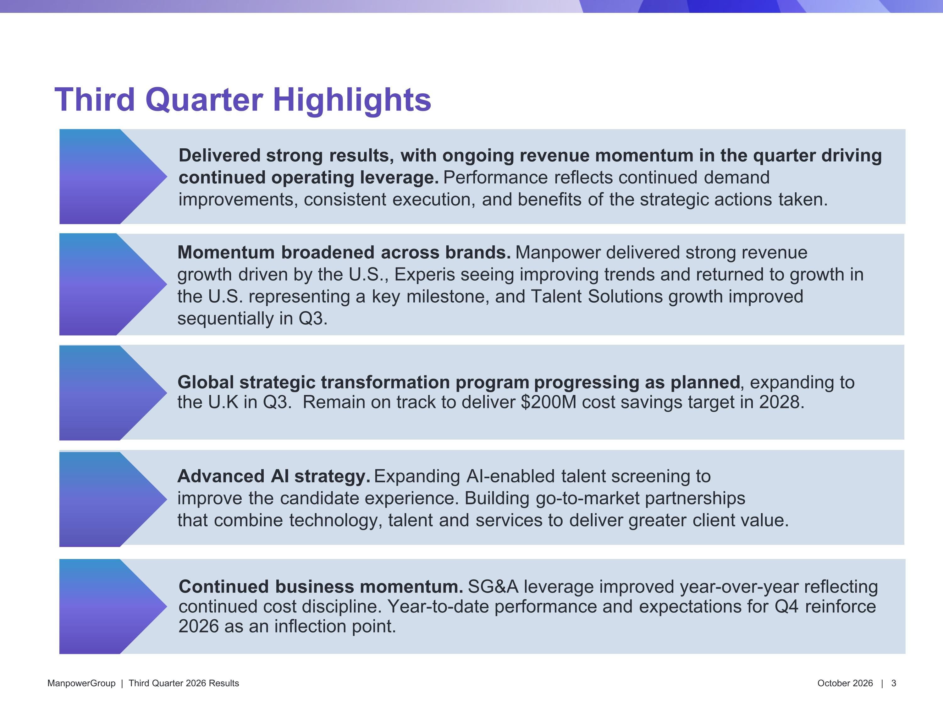
Third Quarter Highlights Momentum ​broadened ​across brands. Manpower delivered strong revenue growth ​driven by the ​U.S., Experis seeing improving trends and returned to growth in the U.S. representing a ​key ​milestone, and Talent ​Solutions growth improved sequentially in Q3. Continued ​business momentum. SG&A leverage improved year-over-year reflecting continued cost discipline. Year-to-date performance and ​expectations for ​Q4 ​reinforce 2026 as an inflection point. Delivered strong ​results, ​with ongoing revenue momentum in the quarter driving continued operating leverage. Performance ​reflects continued ​demand improvements, consistent ​execution, ​and benefits ​of ​the strategic actions ​taken. ​ Global strategic transformation program progressing as planned, expanding to the U.K in Q3. Remain on track to deliver $200M cost savings target in 2028. Advanced ​AI strategy. Expanding ​AI-enabled ​talent screening to improve ​the ​candidate experience. Building ​go-to-market partnerships that ​combine ​technology, talent ​and ​services to ​deliver greater ​client value.

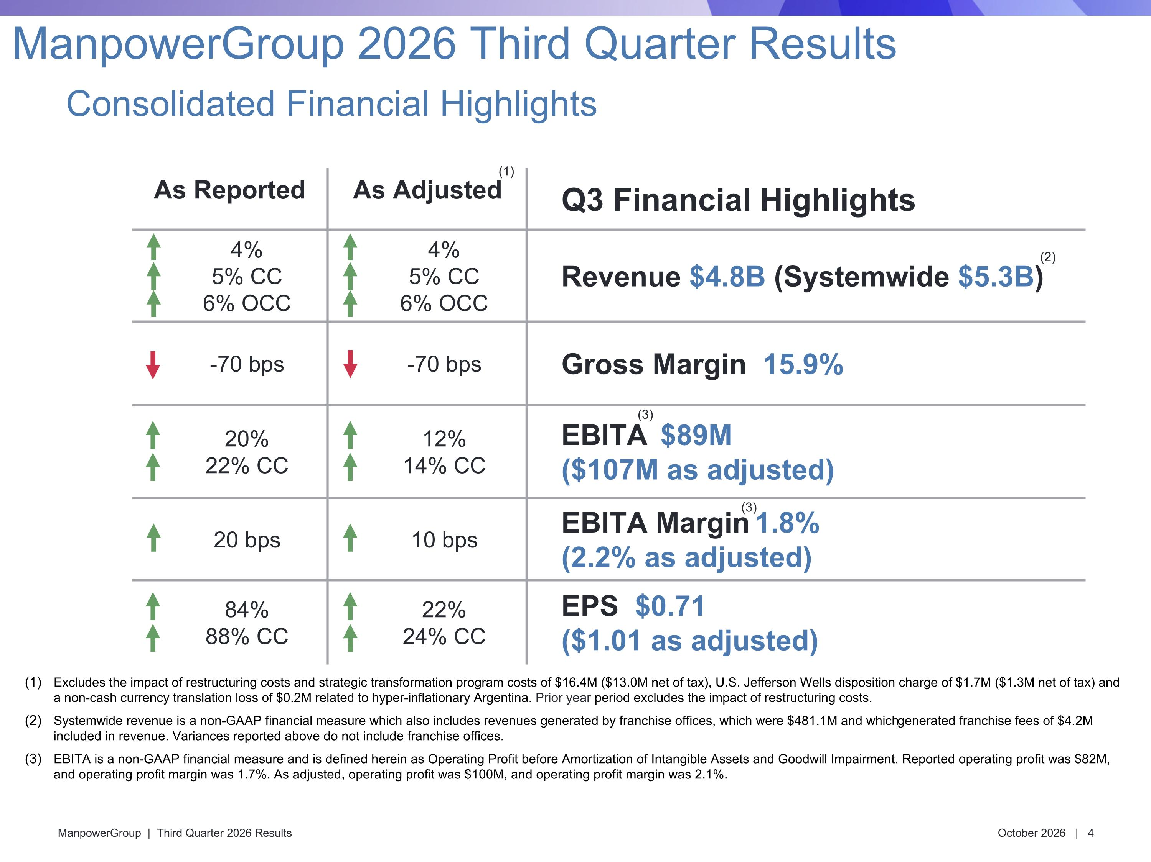
As Reported As Adjusted Q3 Financial Highlights 4% 5% CC 6% OCC 4% 5% CC 6% OCC Revenue $4.8B (Systemwide $5.3B) -70 bps -70 bps Gross Margin 15.9% 20% 22% CC 12% 14% CC EBITA $89M ($107M as adjusted) 20 bps 10 bps EBITA Margin 1.8% (2.2% as adjusted) 84% 88% CC 22% 24% CC EPS $0.71 ($1.01 as adjusted) Excludes the impact of restructuring costs and strategic transformation program costs of $16.4M ($13.0M net of tax), U.S. Jefferson Wells disposition charge of $1.7M ($1.3M net of tax) and a non-cash currency translation loss of $0.2M related to hyper-inflationary Argentina. Prior year period excludes the impact of restructuring costs. Systemwide revenue is a non-GAAP financial measure which also includes revenues generated by franchise offices, which were $481.1M and which generated franchise fees of $4.2M included in revenue. Variances reported above do not include franchise offices. EBITA is a non-GAAP financial measure and is defined herein as Operating Profit before Amortization of Intangible Assets and Goodwill Impairment. Reported operating profit was $82M, and operating profit margin was 1.7%. As adjusted, operating profit was $100M, and operating profit margin was 2.1%. (3) (3) Consolidated Financial Highlights ManpowerGroup 2026 Third Quarter Results (1) (2)

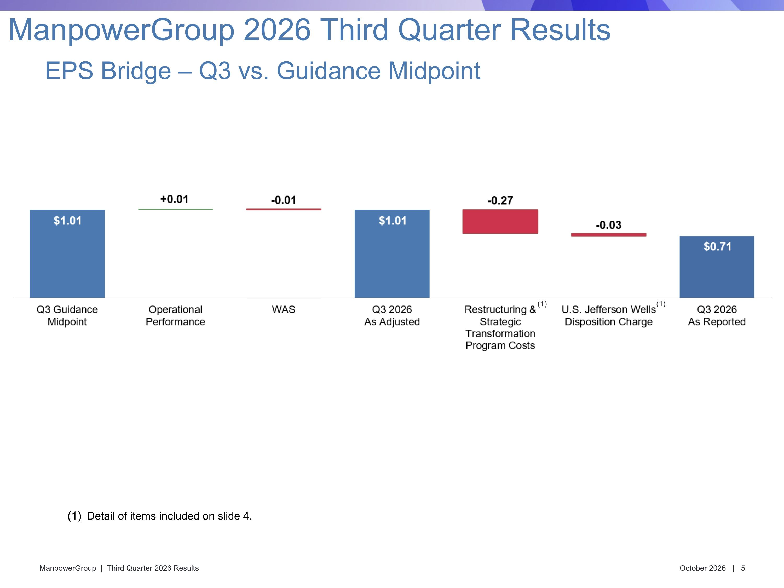
EPS Bridge – Q3 vs. Guidance Midpoint ManpowerGroup 2026 Third Quarter Results (1) Detail of items included on slide 4. (1)

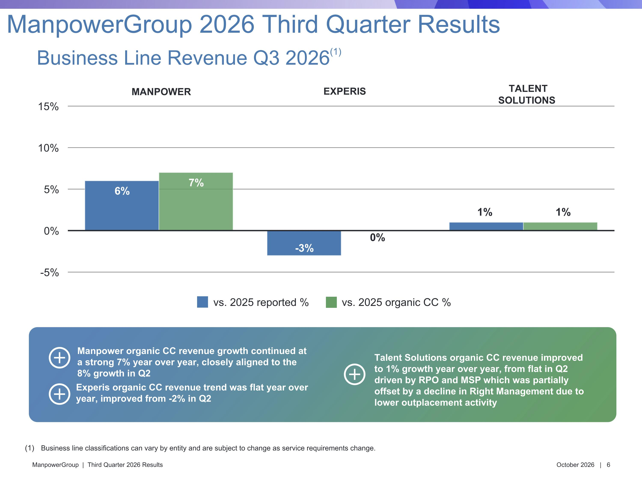
Manpower organic CC revenue growth continued at a strong 7% year over year, closely aligned to the 8% growth in Q2 Talent Solutions organic CC revenue improved to 1% growth year over year, from flat in Q2 driven by RPO and MSP which was partially offset by a decline in Right Management due to lower outplacement activity Experis organic CC revenue trend was flat year over year, improved from -2% in Q2 Business line classifications can vary by entity and are subject to change as service requirements change. Business Line Revenue Q3 2026(1) ManpowerGroup 2026 Third Quarter Results vs. 2025 reported % vs. 2025 organic CC % MANPOWER EXPERIS TALENT ?SOLUTIONS

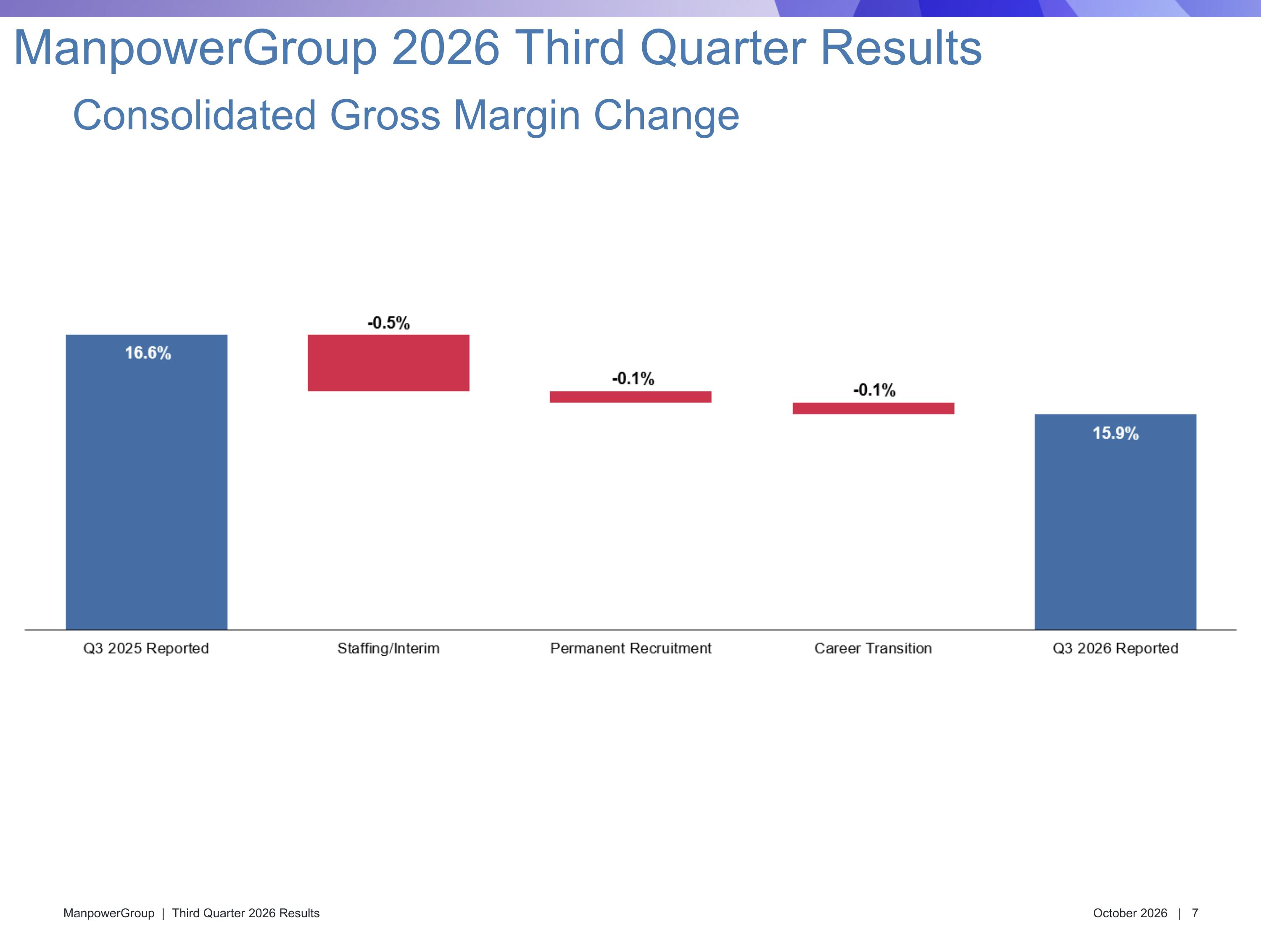
Consolidated Gross Margin Change ManpowerGroup 2026 Third Quarter Results

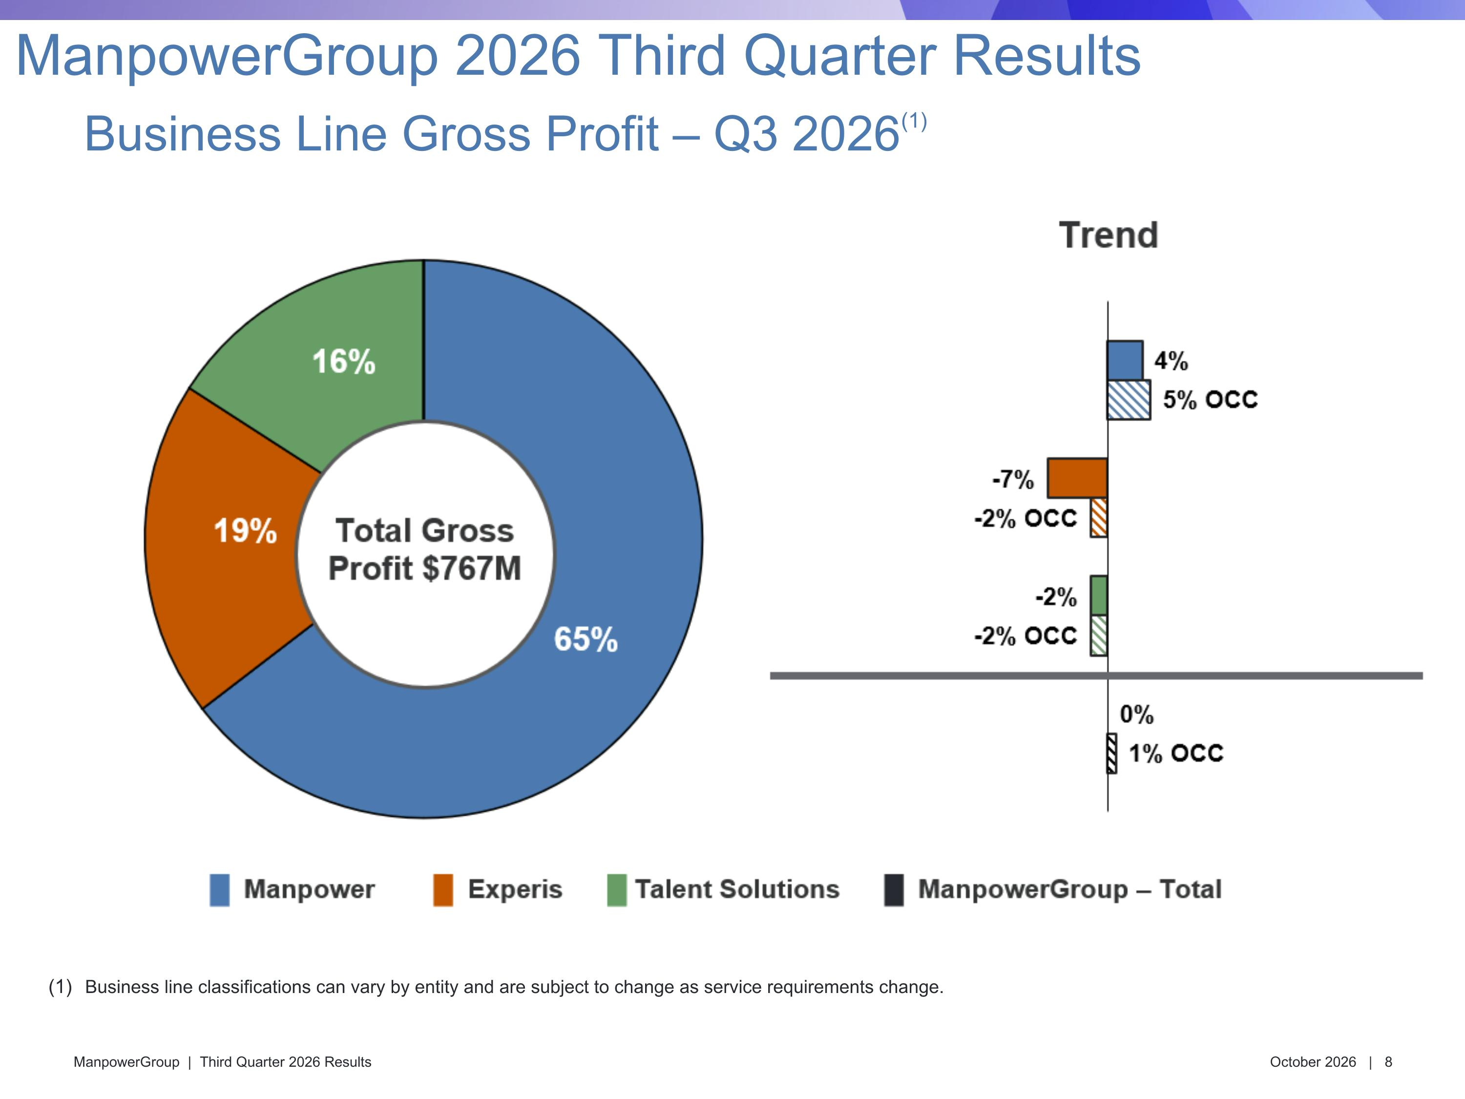
Business line classifications can vary by entity and are subject to change as service requirements change. Business Line Gross Profit – Q3 2026(1) ManpowerGroup 2026 Third Quarter Results

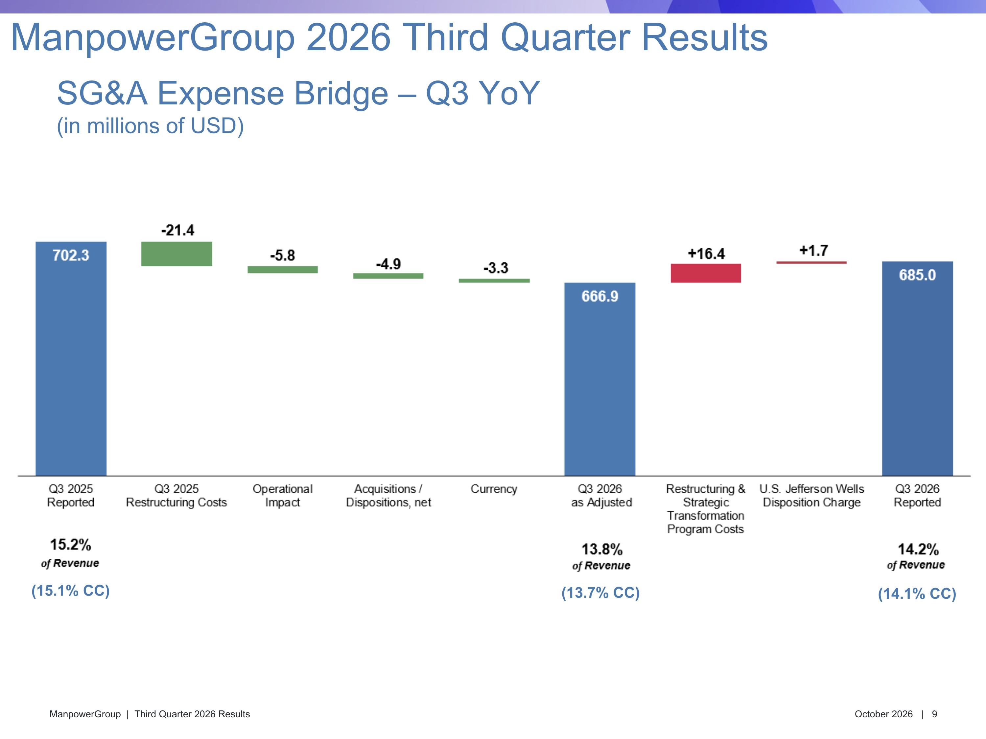
(14.1% CC) (15.1% CC) SG&A Expense Bridge – Q3 YoY?(in millions of USD) ManpowerGroup 2026 Third Quarter Results (13.7% CC)

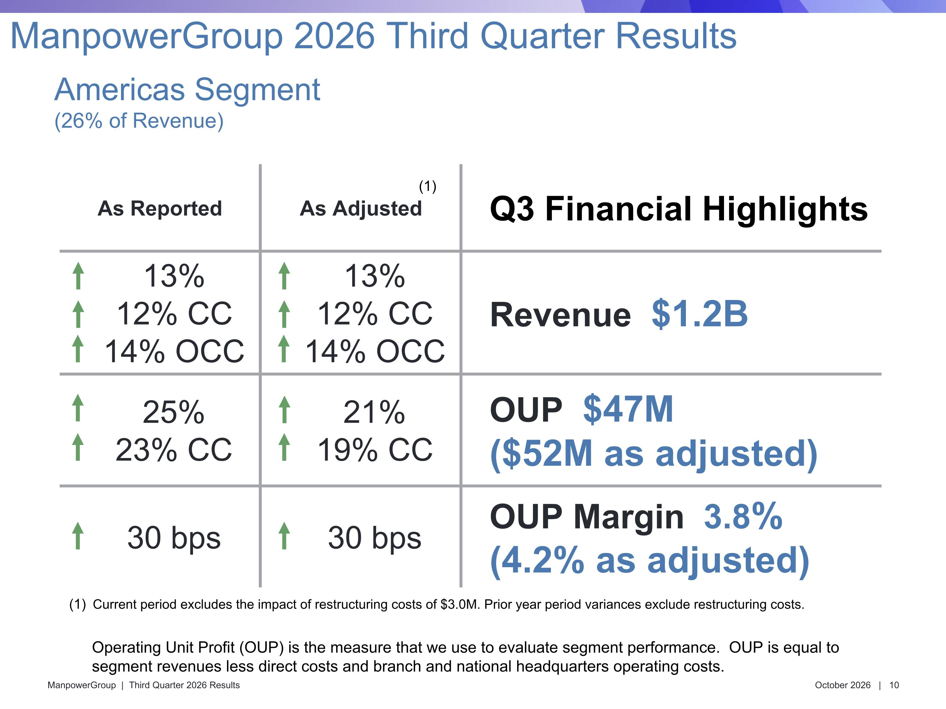
As Reported As Adjusted Q3 Financial Highlights 13% 12% CC 14% OCC 13% 12% CC 14% OCC Revenue $1.2B 25% 23% CC 21% 19% CC OUP $47M ($52M as adjusted) 30 bps 30 bps OUP Margin 3.8% (4.2% as adjusted) Americas Segment?(26% of Revenue) ManpowerGroup 2026 Third Quarter Results Operating Unit Profit (OUP) is the measure that we use to evaluate segment performance. OUP is equal to segment revenues less direct costs and branch and national headquarters operating costs. Current period excludes the impact of restructuring costs of $3.0M. Prior year period variances exclude restructuring costs. (1)

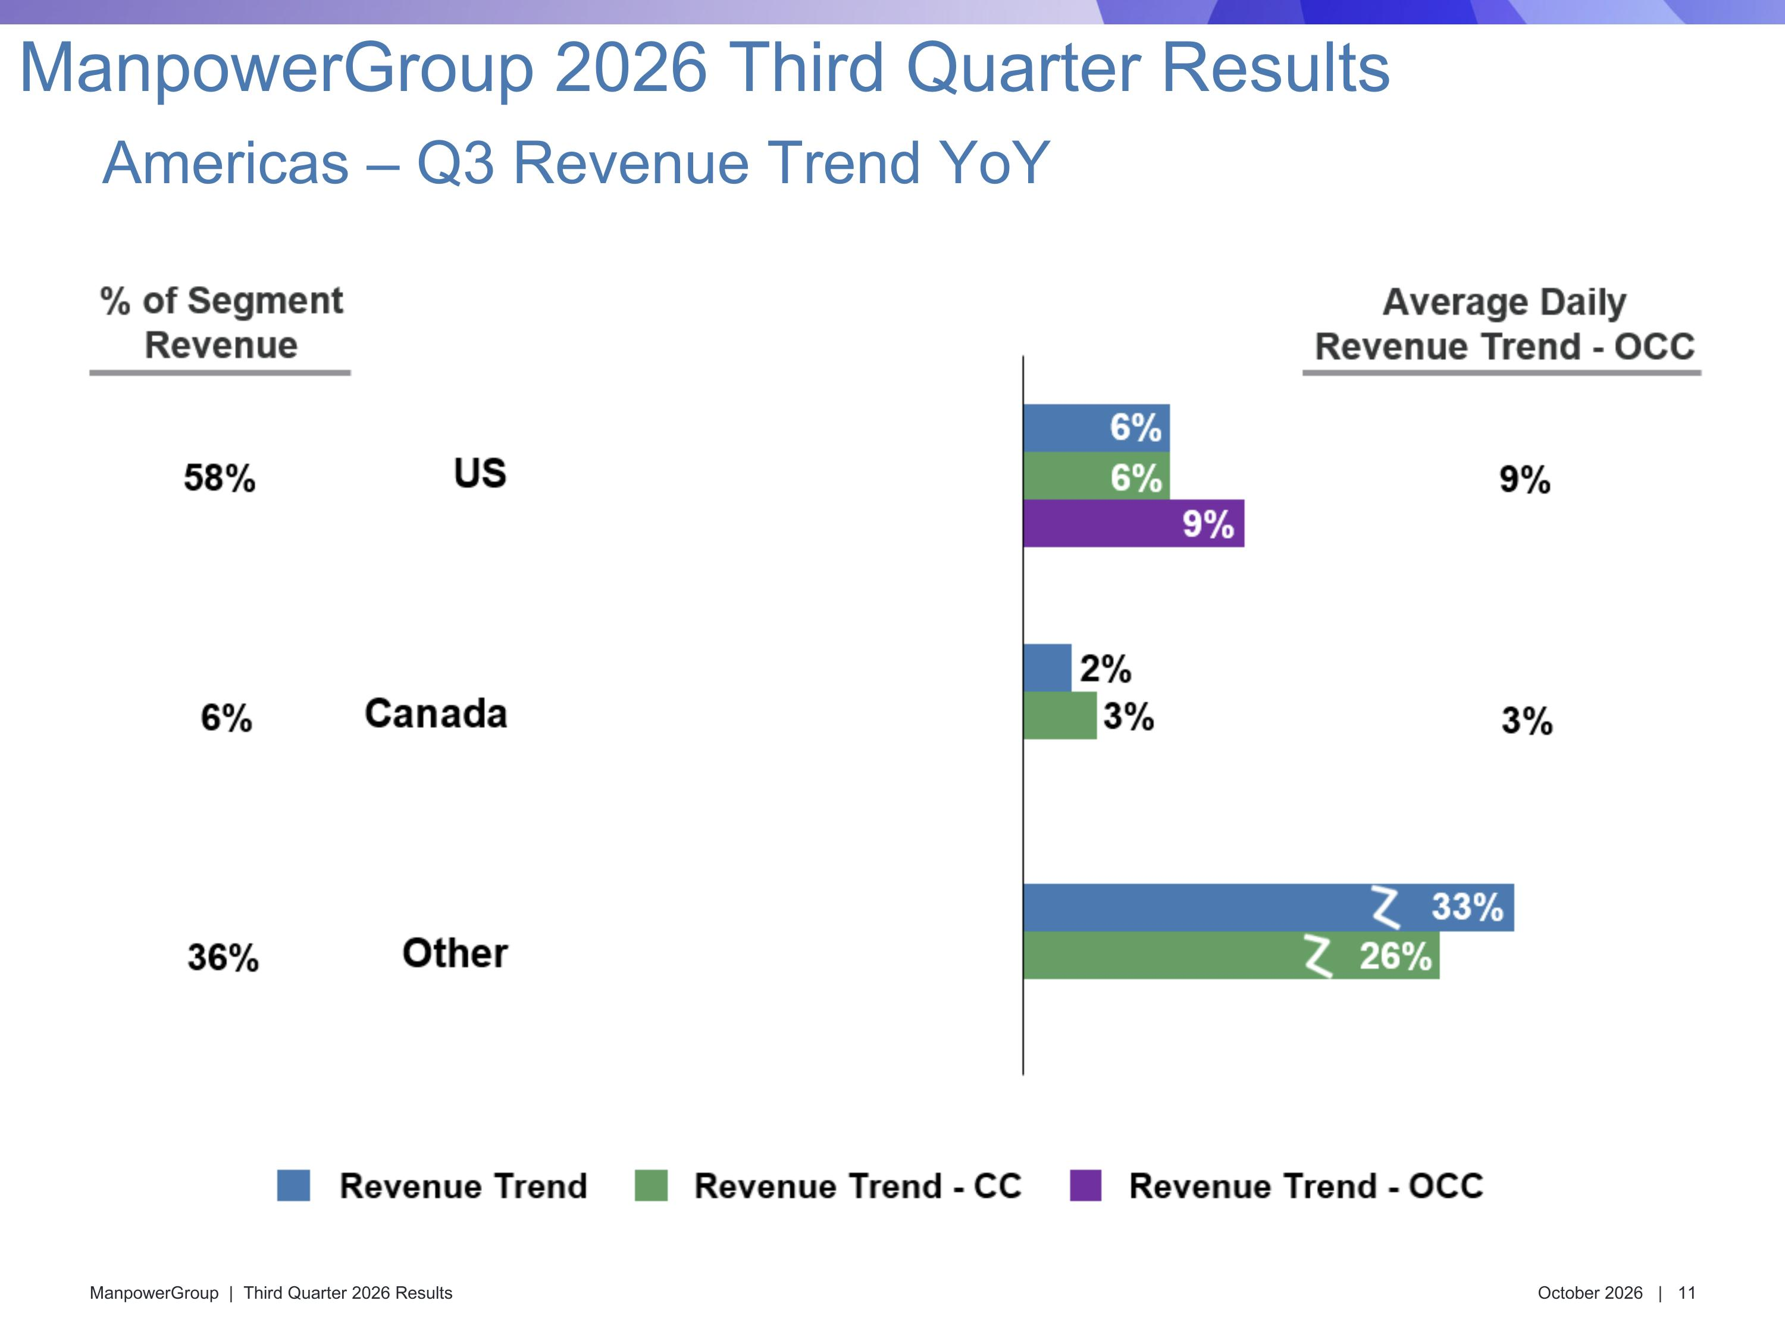
Americas – Q3 Revenue Trend YoY ManpowerGroup 2026 Third Quarter Results

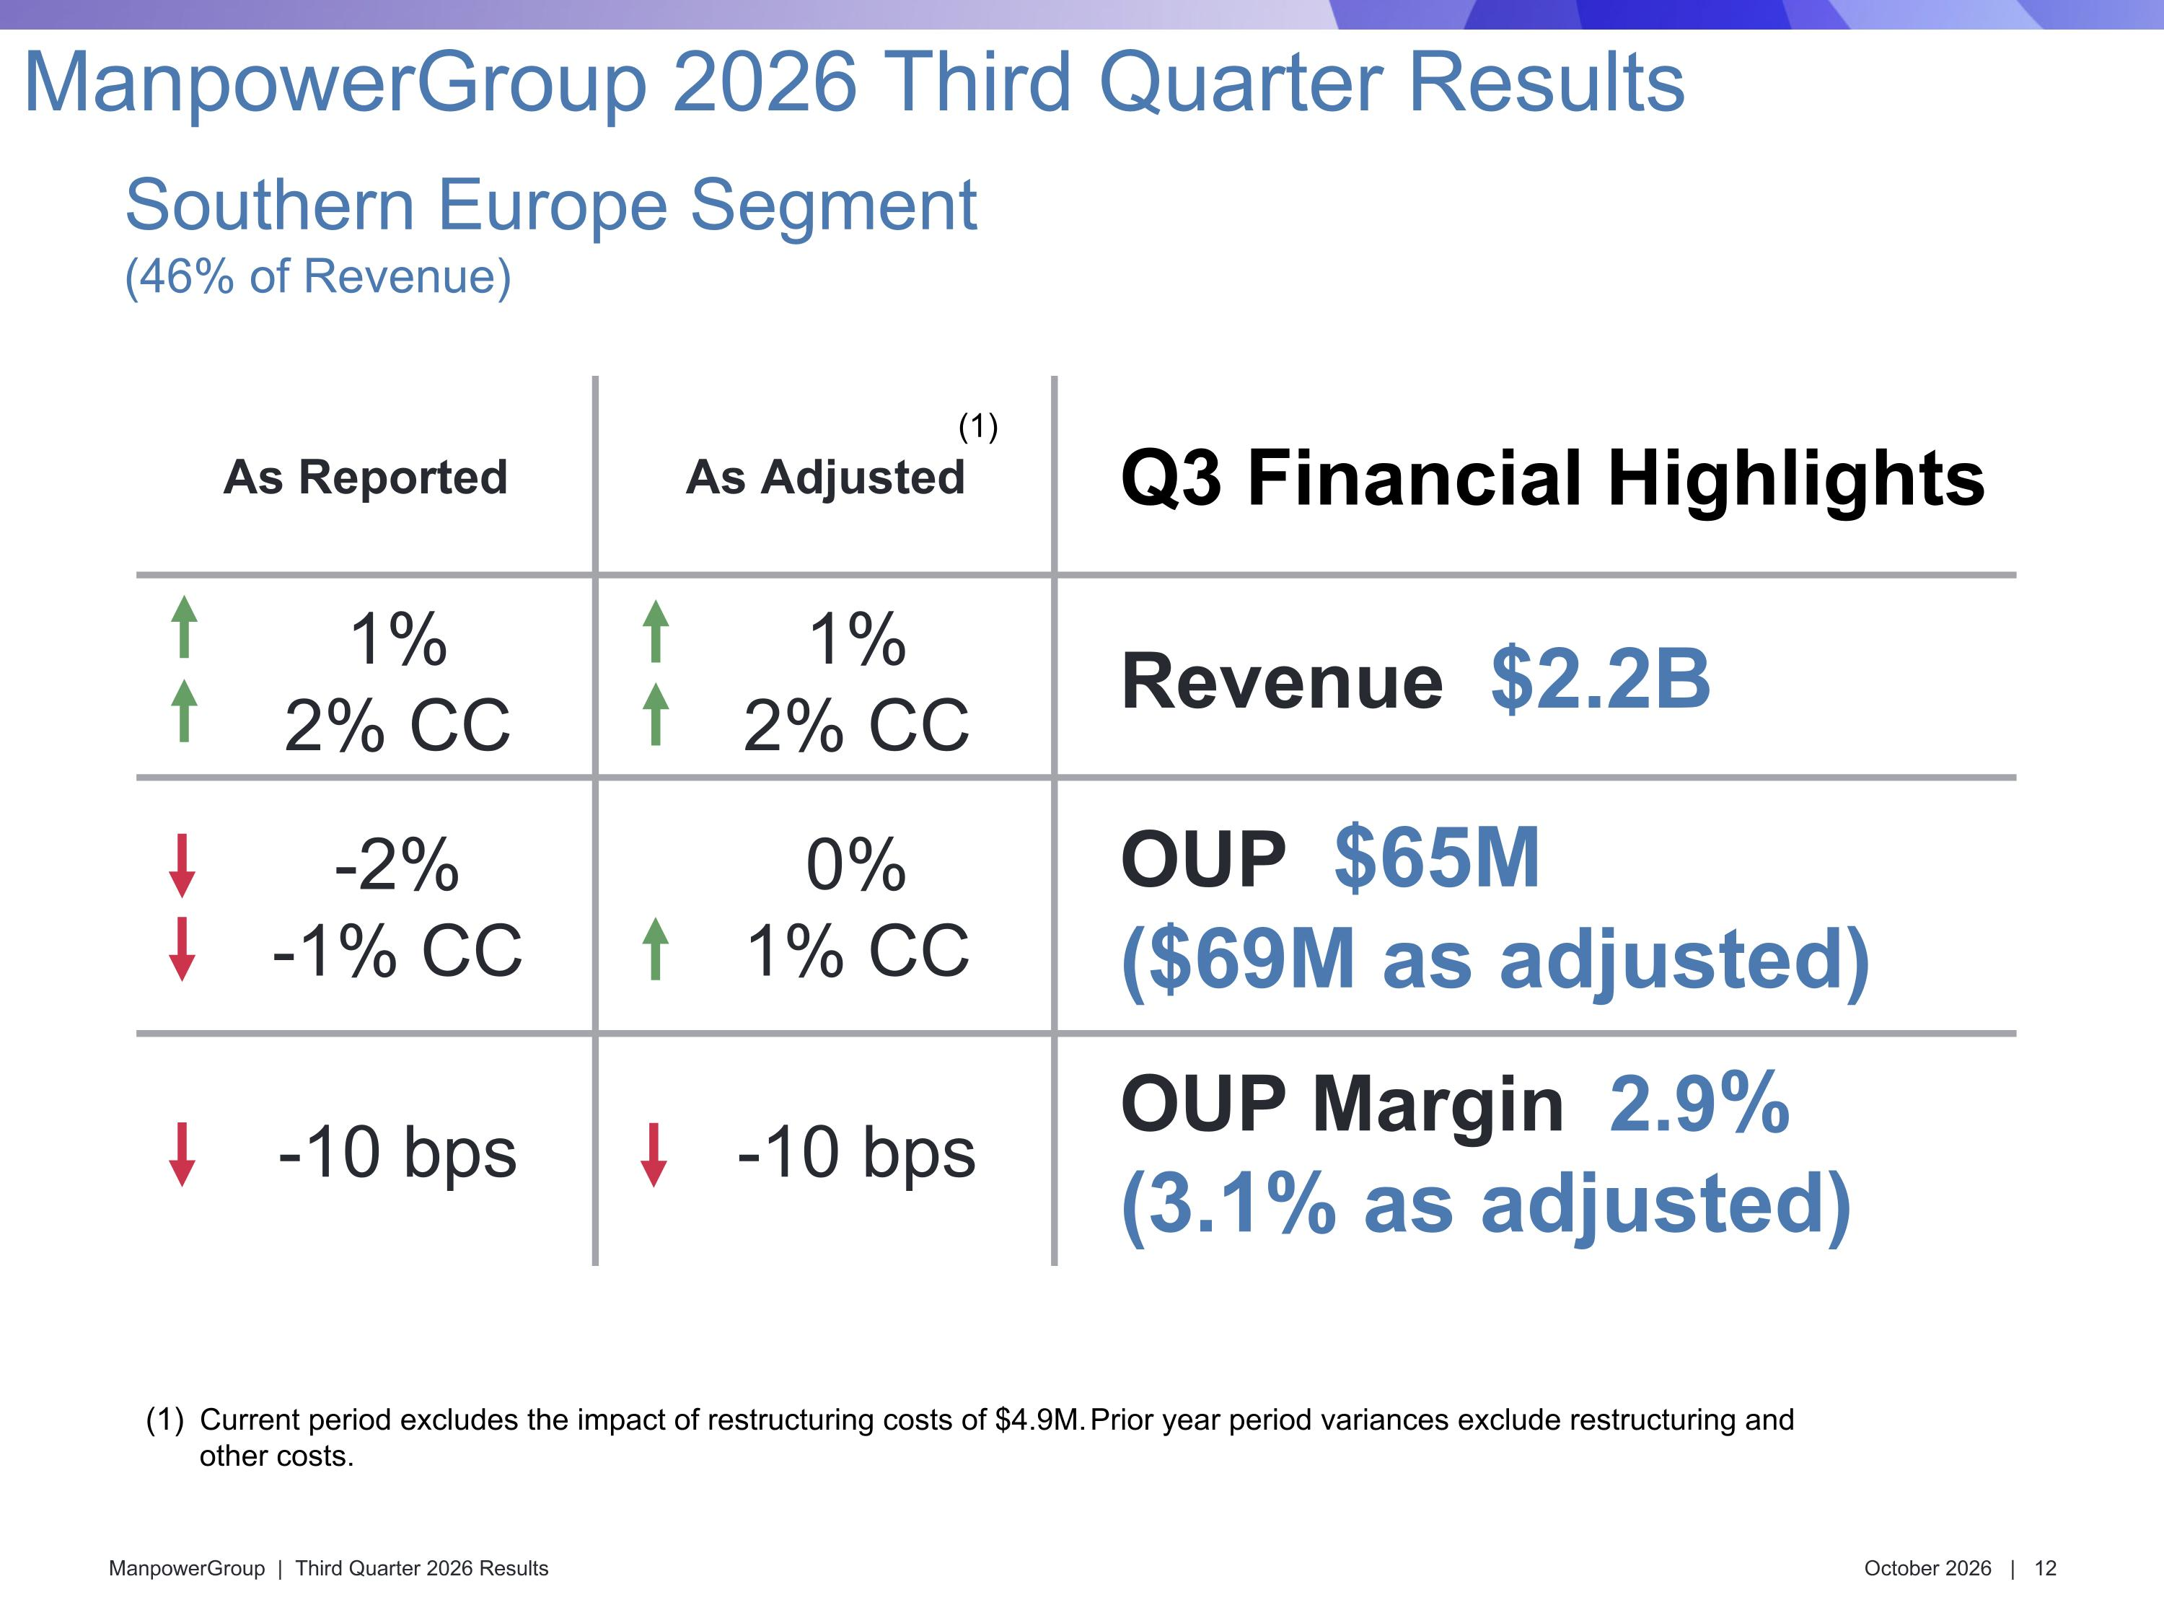
As Reported As Adjusted Q3 Financial Highlights 1% 2% CC 1% 2% CC Revenue $2.2B -2% -1% CC 0% 1% CC OUP $65M ($69M as adjusted) -10 bps -10 bps OUP Margin 2.9% (3.1% as adjusted) Southern Europe Segment?(46% of Revenue) ManpowerGroup 2026 Third Quarter Results (1) Current period excludes the impact of restructuring costs of $4.9M. Prior year period variances exclude restructuring and other costs.

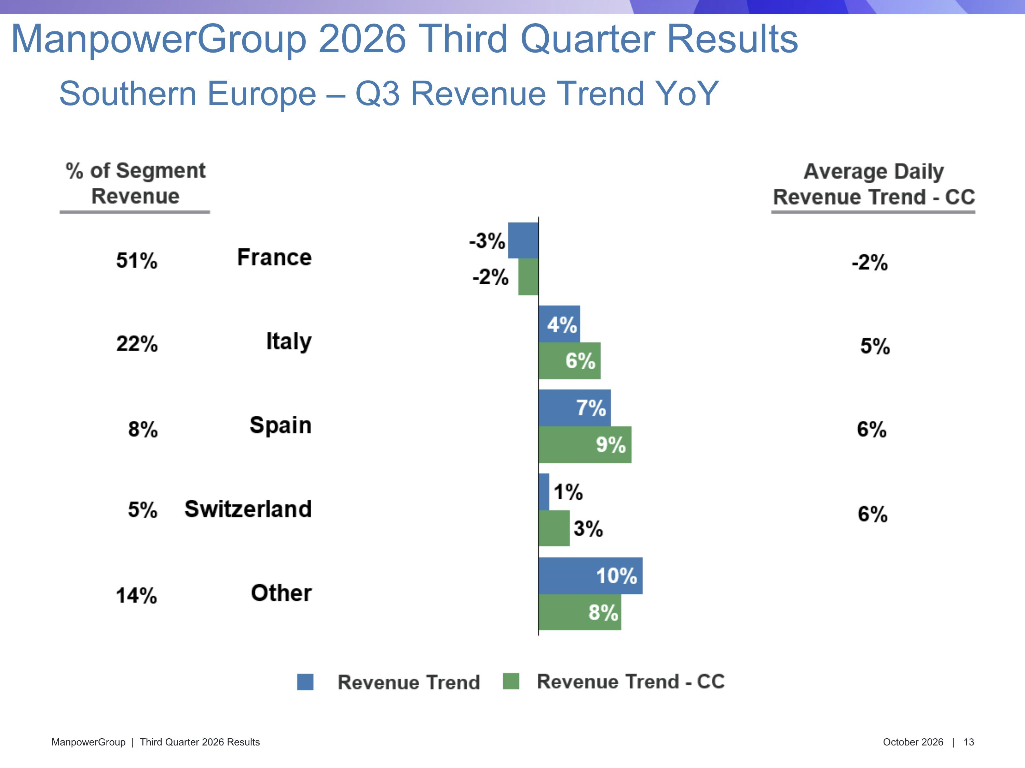
Southern Europe – Q3 Revenue Trend YoY ManpowerGroup 2026 Third Quarter Results

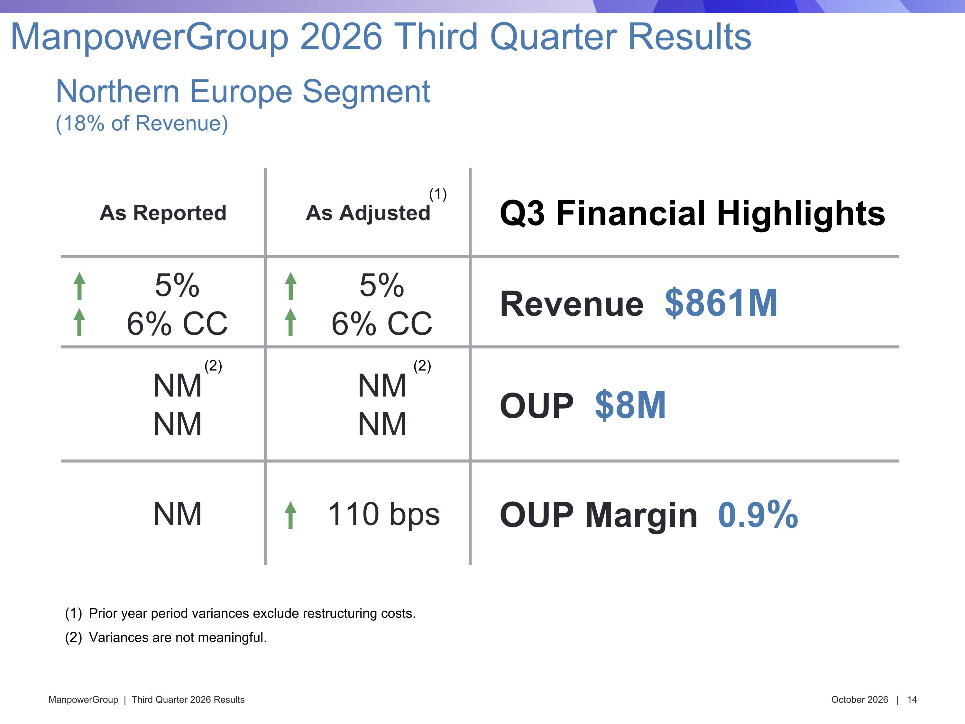
As Reported As Adjusted Q3 Financial Highlights 5% 6% CC 5% 6% CC Revenue $861M NM NM NM NM OUP $8M NM 110 bps OUP Margin 0.9% Northern Europe Segment?(18% of Revenue) ManpowerGroup 2026 Third Quarter Results (1) Prior year period variances exclude restructuring costs. Variances are not meaningful. (2) (2)

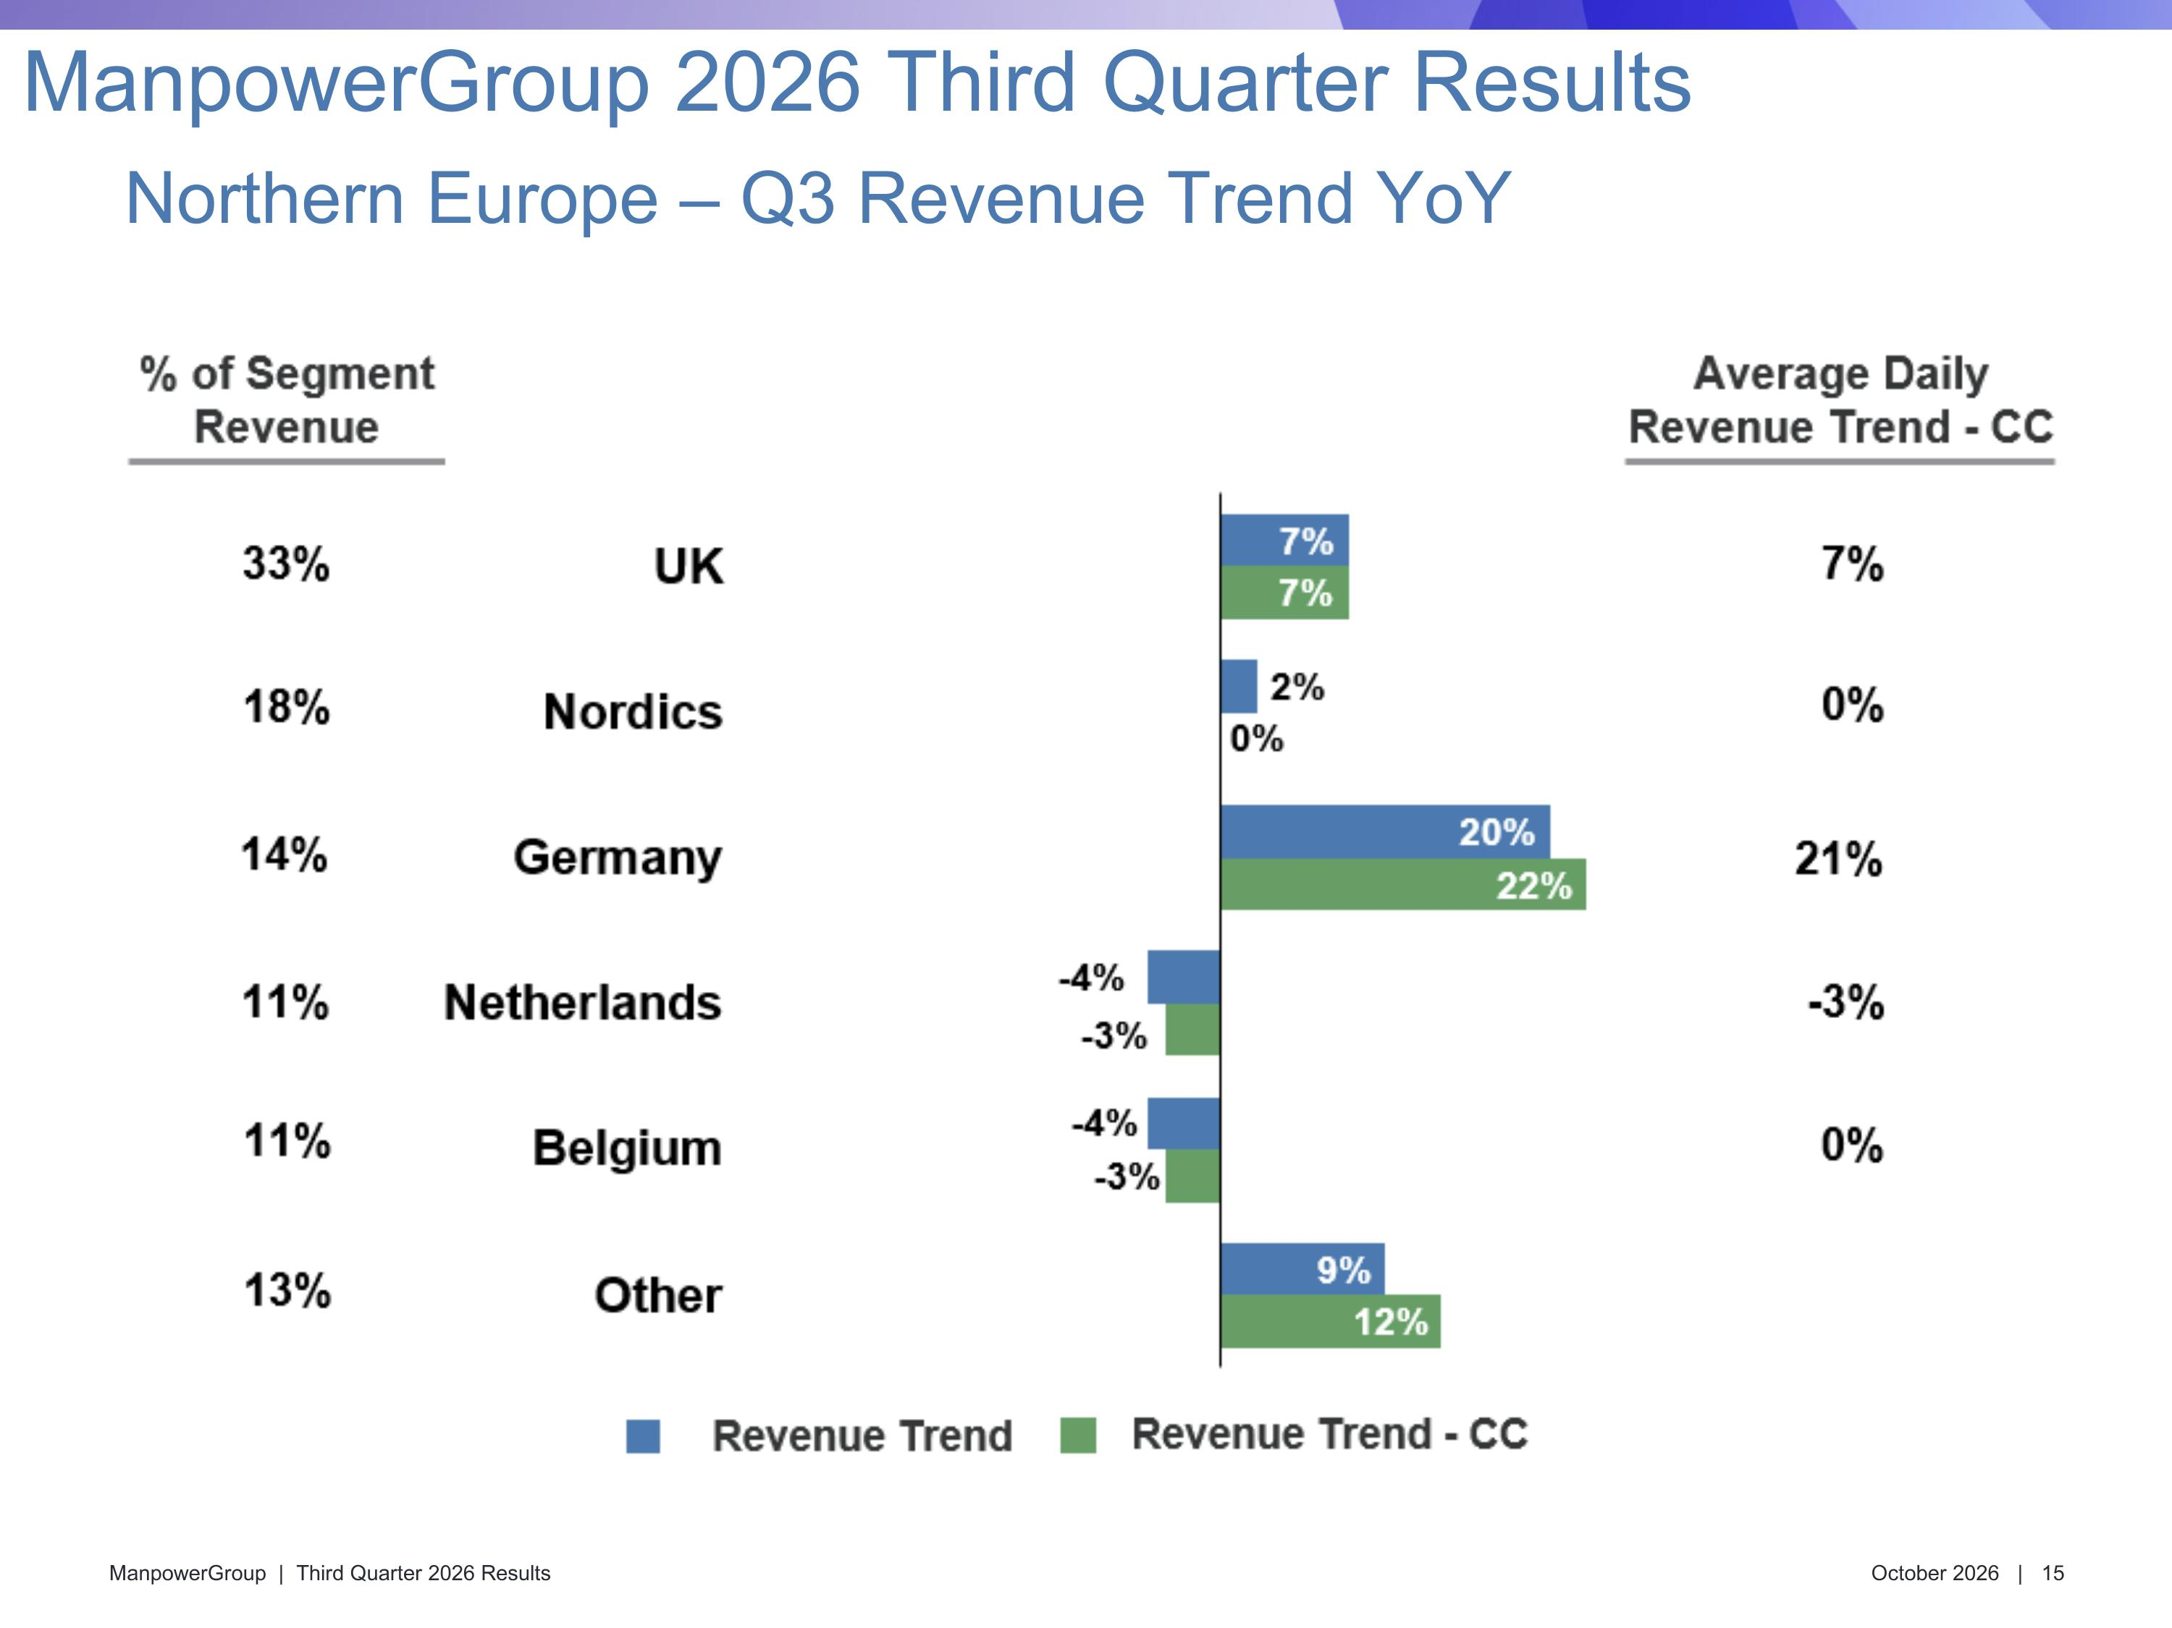
-28% Northern Europe – Q3 Revenue Trend YoY ManpowerGroup 2026 Third Quarter Results

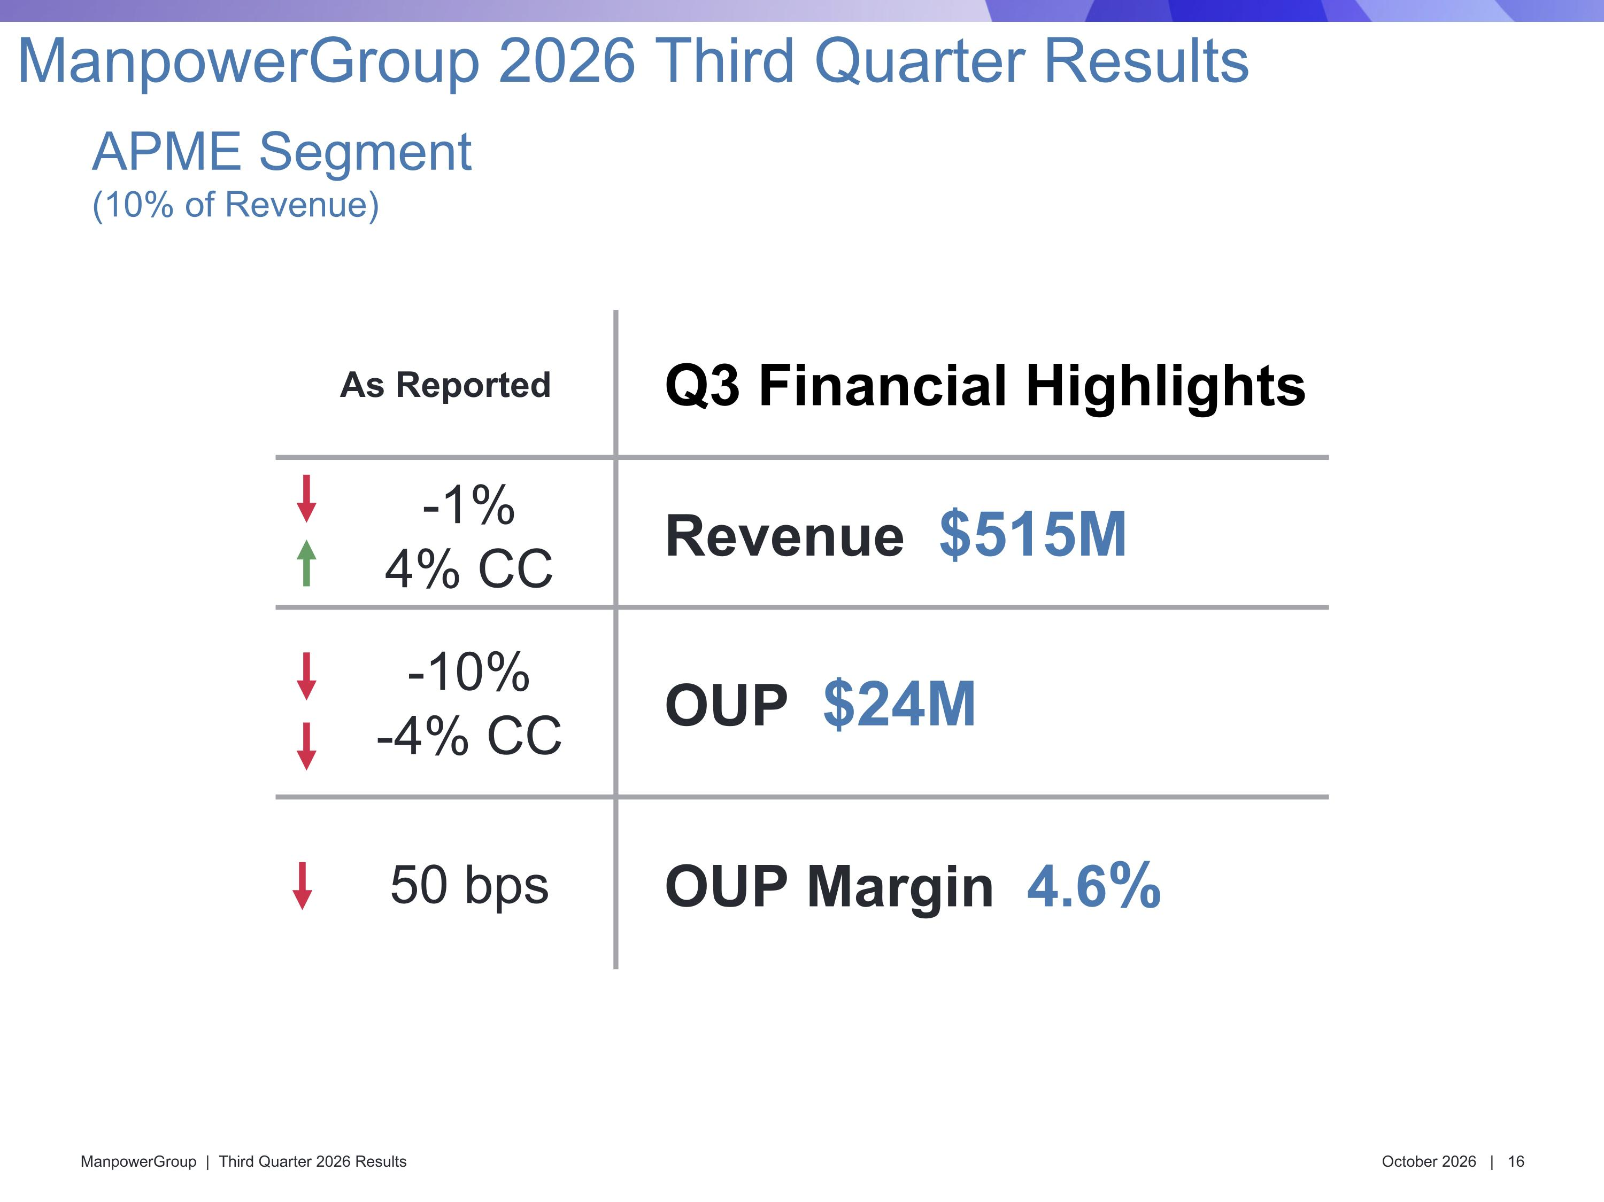
As Reported Q3 Financial Highlights -1% 4% CC Revenue $515M -10% -4% CC OUP $24M 50 bps OUP Margin 4.6% APME Segment?(10% of Revenue) ManpowerGroup 2026 Third Quarter Results

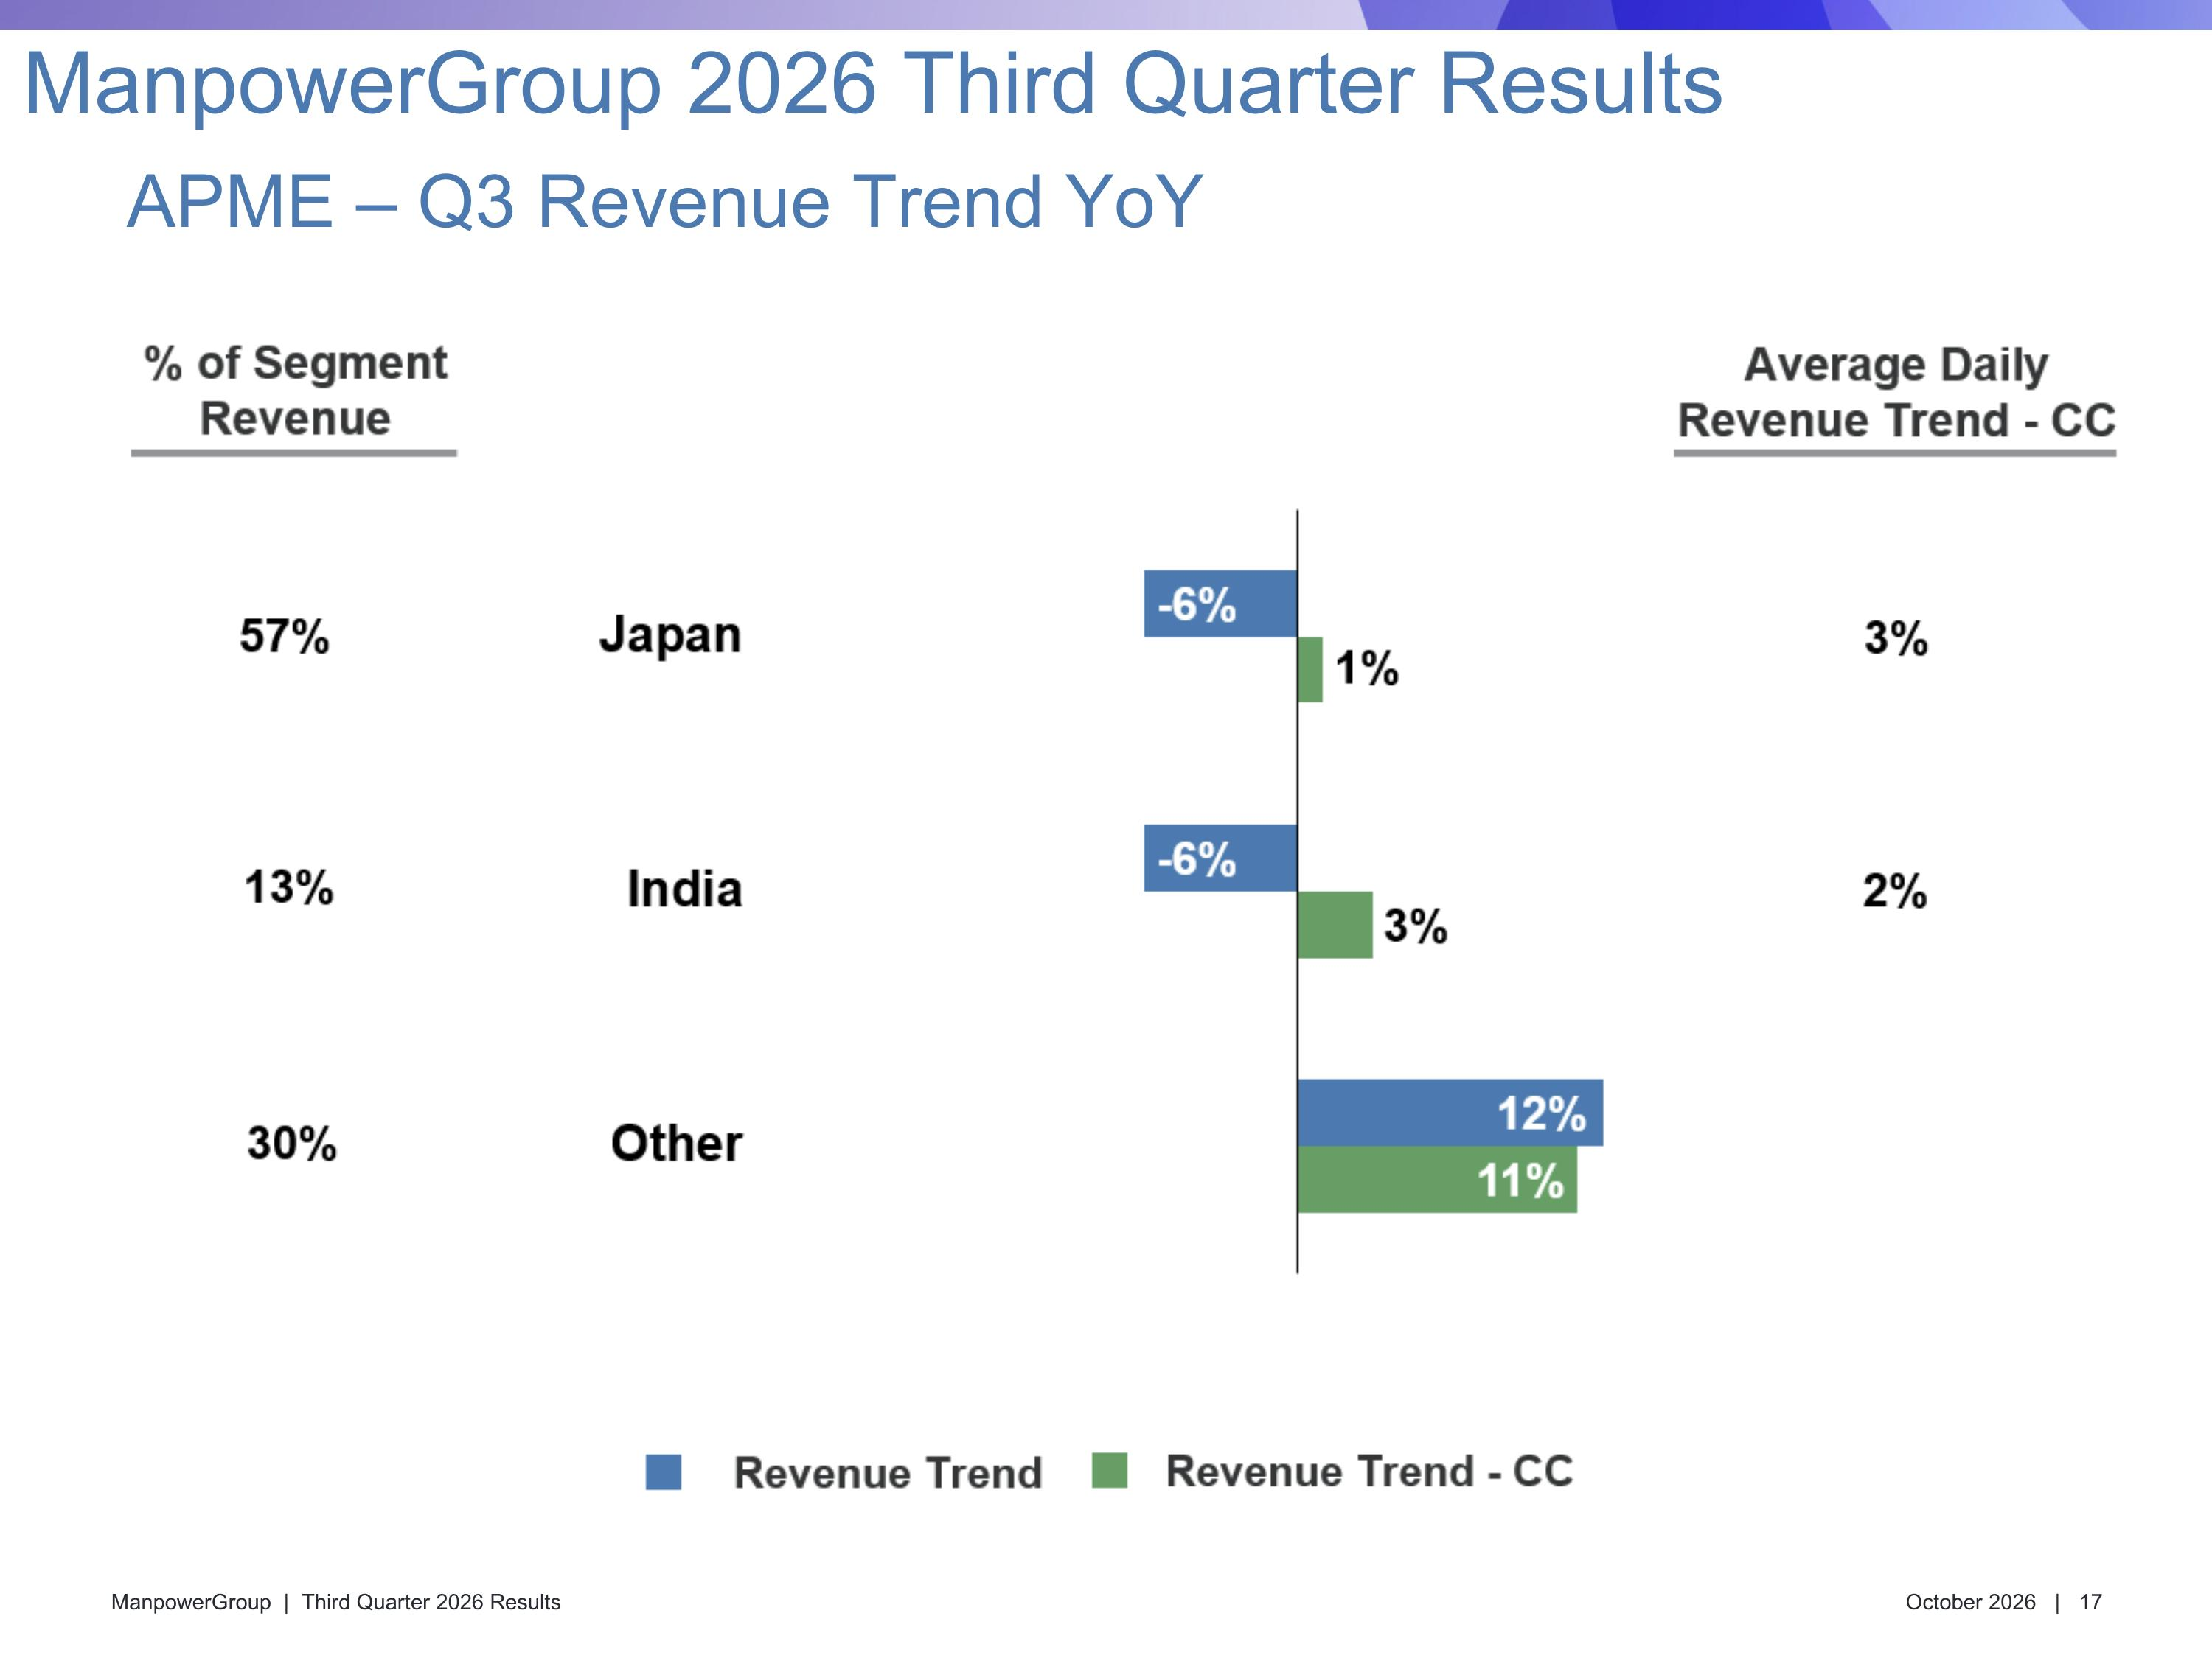
APME – Q3 Revenue Trend YoY ManpowerGroup 2026 Third Quarter Results

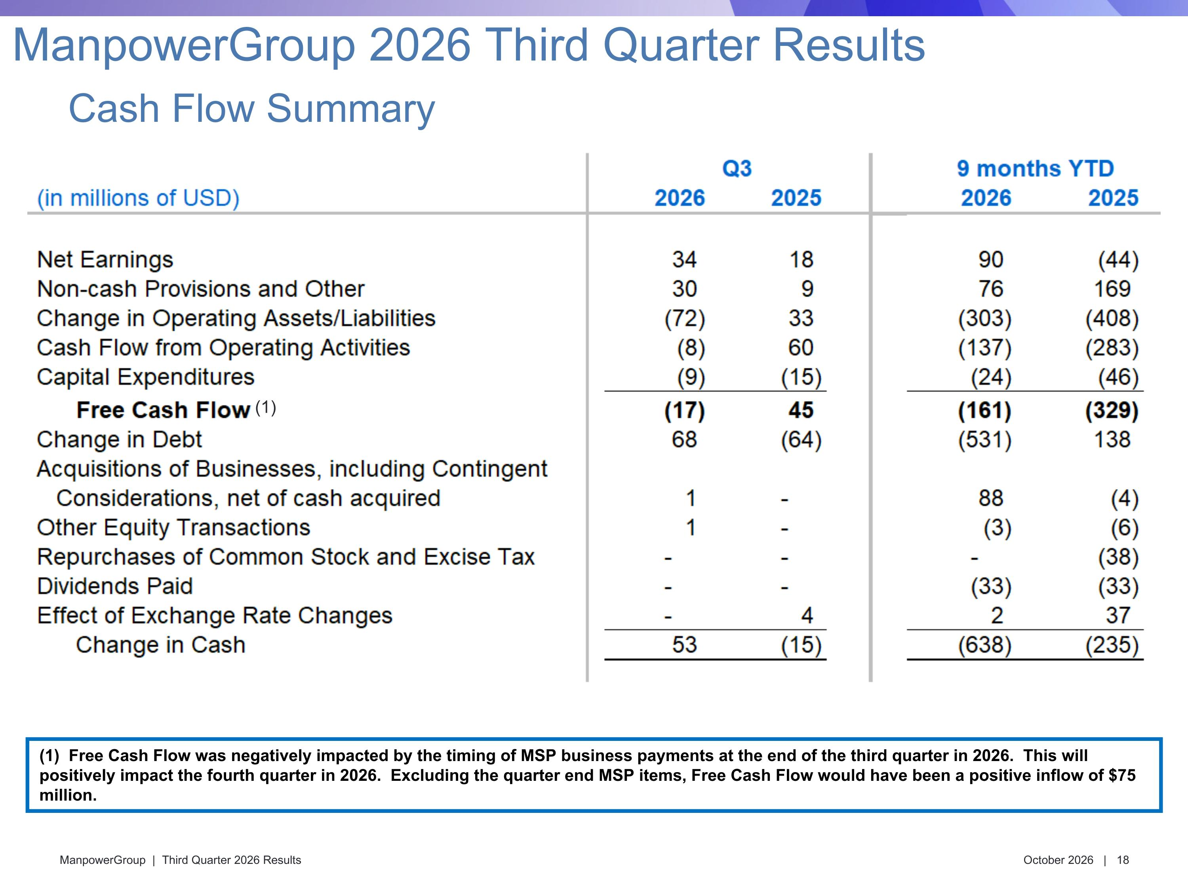
Cash Flow Summary ManpowerGroup 2026 Third Quarter Results (1) Free Cash Flow was negatively impacted by the timing of MSP business payments at the end of the third quarter in 2026. This will positively impact the fourth quarter in 2026. Excluding the quarter end MSP items, Free Cash Flow would have been a positive inflow of $75 million. (1)

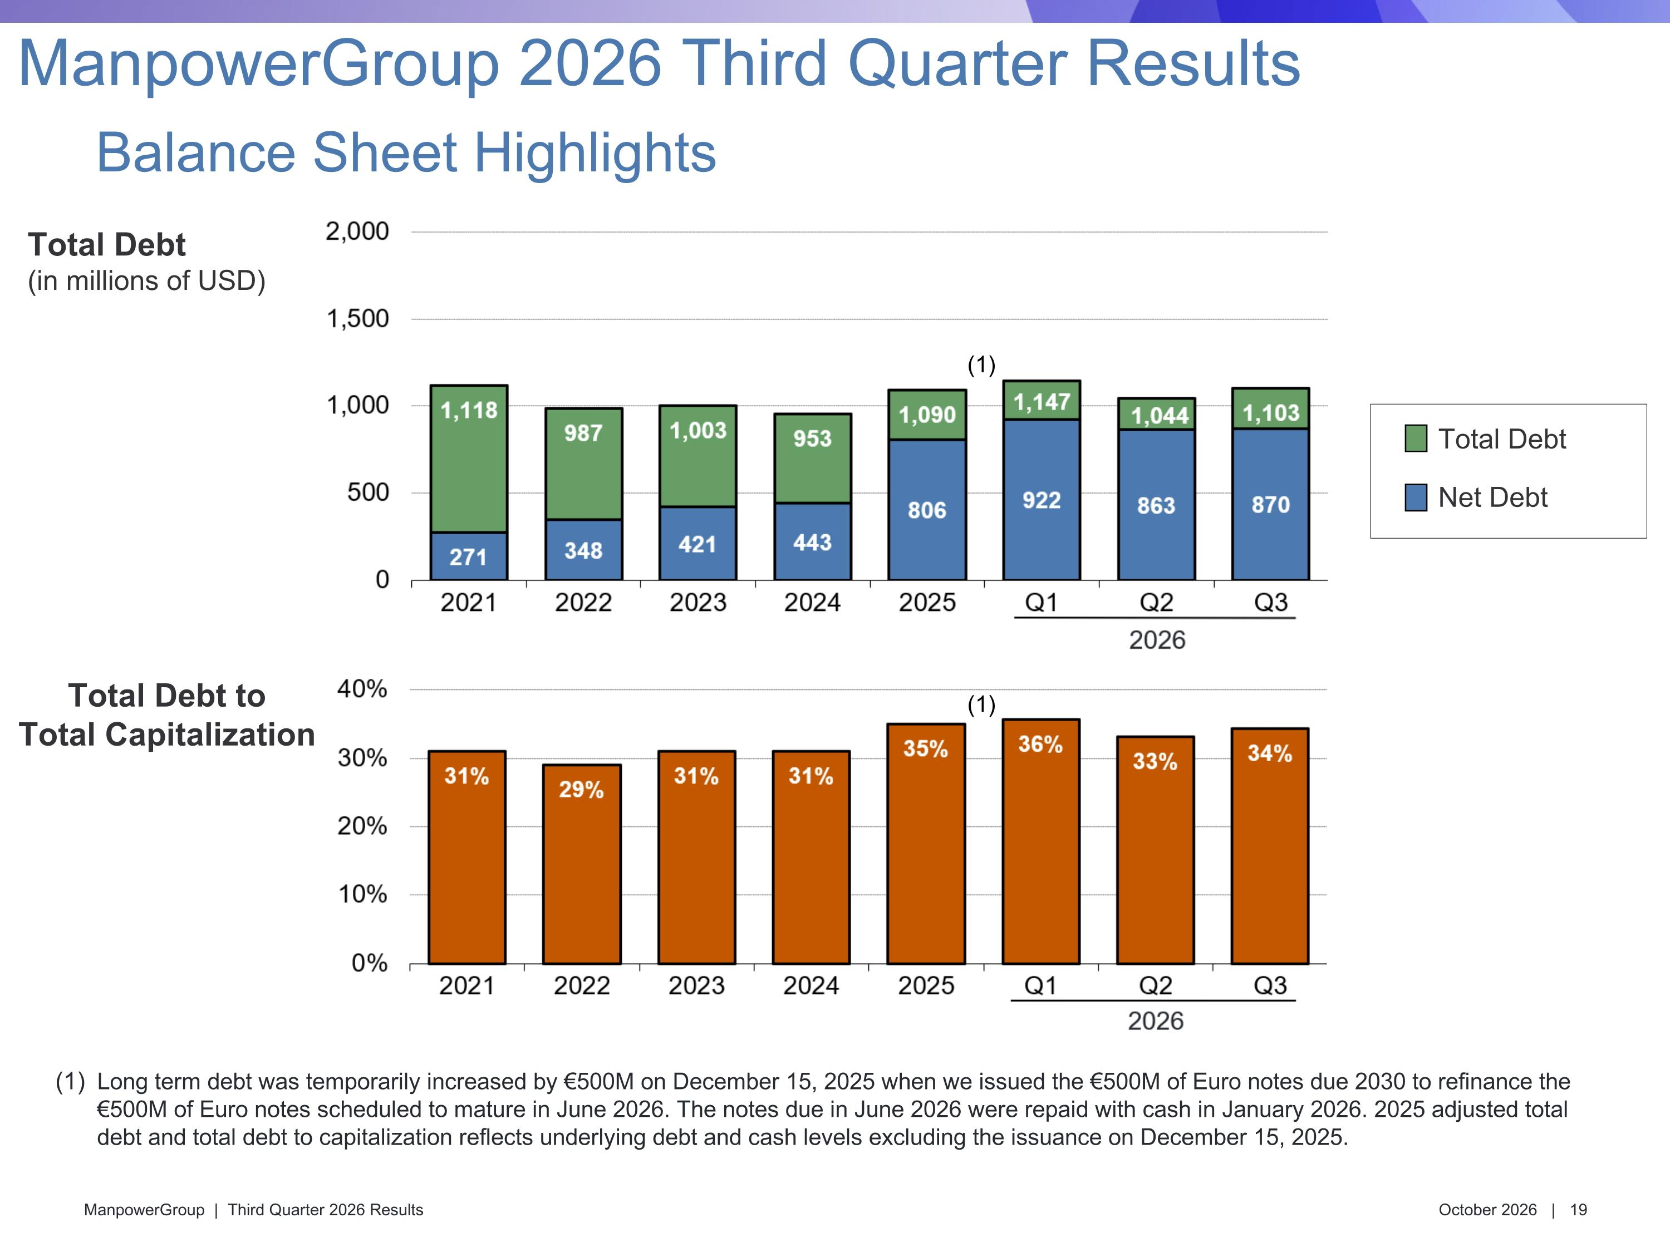
Total Debt (in millions of USD) Total Debt to Total Capitalization Total Debt Net Debt Balance Sheet Highlights ManpowerGroup 2026 Third Quarter Results Long term debt was temporarily increased by €500M on December 15, 2025 when we issued the €500M of Euro notes due 2030 to refinance the €500M of Euro notes scheduled to mature in June 2026. The notes due in June 2026 were repaid with cash in January 2026. 2025 adjusted total debt and total debt to capitalization reflects underlying debt and cash levels excluding the issuance on December 15, 2025. (1) (1)

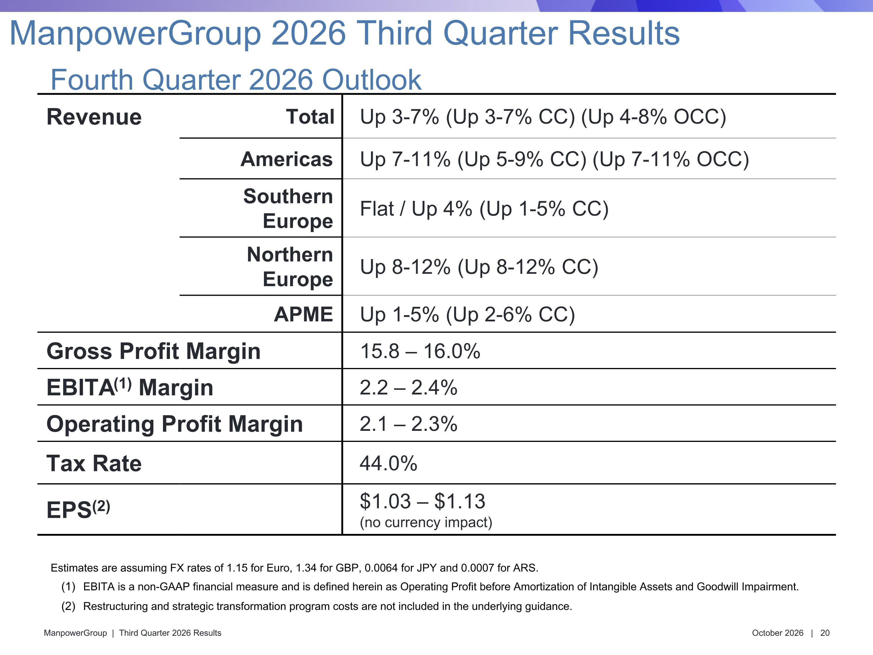
ManpowerGroup 2026 Third Quarter Results Fourth Quarter 2026 Outlook Revenue Total Up 3-7% (Up 3-7% CC) (Up 4-8% OCC) Americas Up 7-11% (Up 5-9% CC) (Up 7-11% OCC) Southern Europe Flat / Up 4% (Up 1-5% CC) Northern Europe Up 8-12% (Up 8-12% CC) APME Up 1-5% (Up 2-6% CC) Gross Profit Margin 15.8 – 16.0% EBITA(1) Margin 2.2 – 2.4% Operating Profit Margin 2.1 – 2.3% Tax Rate 44.0% EPS(2) $1.03 – $1.13 (no currency impact) Estimates are assuming FX rates of 1.15 for Euro, 1.34 for GBP, 0.0064 for JPY and 0.0007 for ARS. EBITA is a non-GAAP financial measure and is defined herein as Operating Profit before Amortization of Intangible Assets and Goodwill Impairment. Restructuring and strategic transformation program costs are not included in the underlying guidance.


Appendix

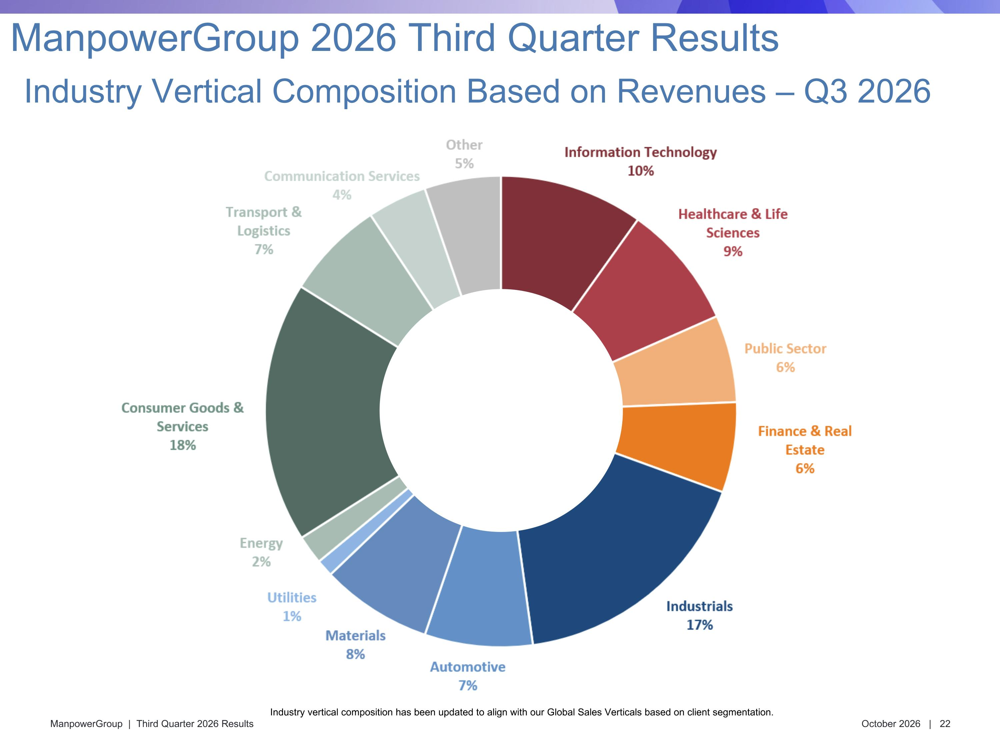
Industry Vertical Composition Based on Revenues – Q3 2026 ManpowerGroup 2026 Third Quarter Results Industry vertical composition has been updated to align with our Global Sales Verticals based on client segmentation.

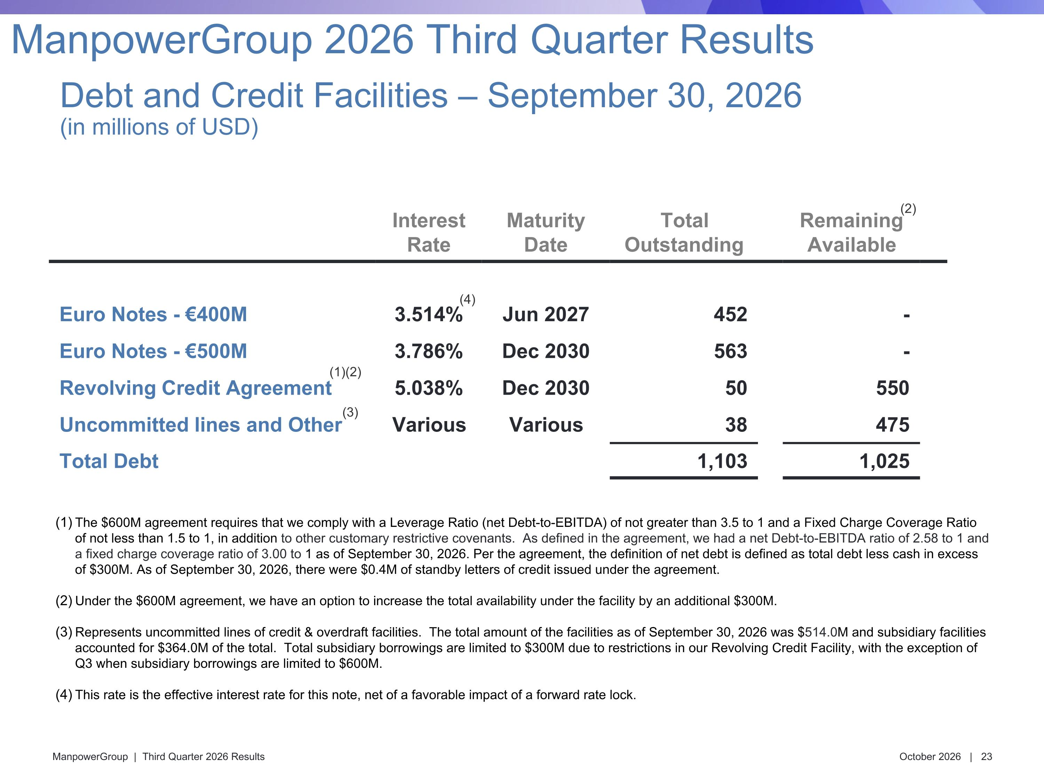
Interest Rate Maturity Date Total Outstanding Remaining Available Euro Notes - €400M 3.514% Jun 2027 452 - Euro Notes - €500M 3.786% Dec 2030 563 - Revolving Credit Agreement 5.038% Dec 2030 50 550 Uncommitted lines and Other Various Various 38 475 Total Debt 1,103 1,025 (3) (1)(2) (4) (2) Debt and Credit Facilities – September 30, 2026?(in millions of USD) ManpowerGroup 2026 Third Quarter Results The $600M agreement requires that we comply with a Leverage Ratio (net Debt-to-EBITDA) of not greater than 3.5 to 1 and a Fixed Charge Coverage Ratio of not less than 1.5 to 1, in addition to other customary restrictive covenants. As defined in the agreement, we had a net Debt-to-EBITDA ratio of 2.58 to 1 and a fixed charge coverage ratio of 3.00 to 1 as of September 30, 2026. Per the agreement, the definition of net debt is defined as total debt less cash in excess of $300M. As of September 30, 2026, there were $0.4M of standby letters of credit issued under the agreement. Under the $600M agreement, we have an option to increase the total availability under the facility by an additional $300M. Represents uncommitted lines of credit & overdraft facilities. The total amount of the facilities as of September 30, 2026 was $514.0M and subsidiary facilities accounted for $364.0M of the total. Total subsidiary borrowings are limited to $300M due to restrictions in our Revolving Credit Facility, with the exception of Q3 when subsidiary borrowings are limited to $600M. This rate is the effective interest rate for this note, net of a favorable impact of a forward rate lock.

