
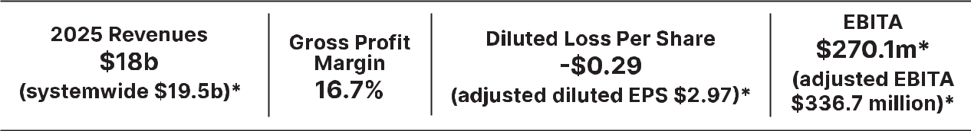

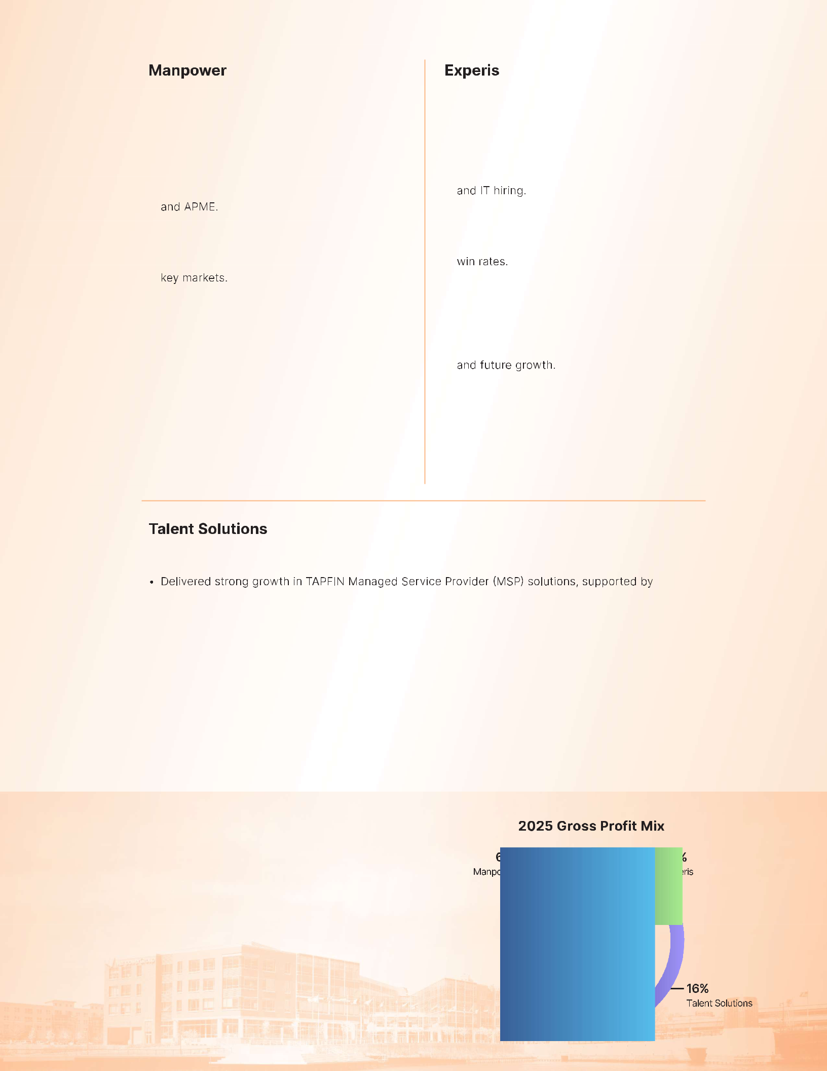









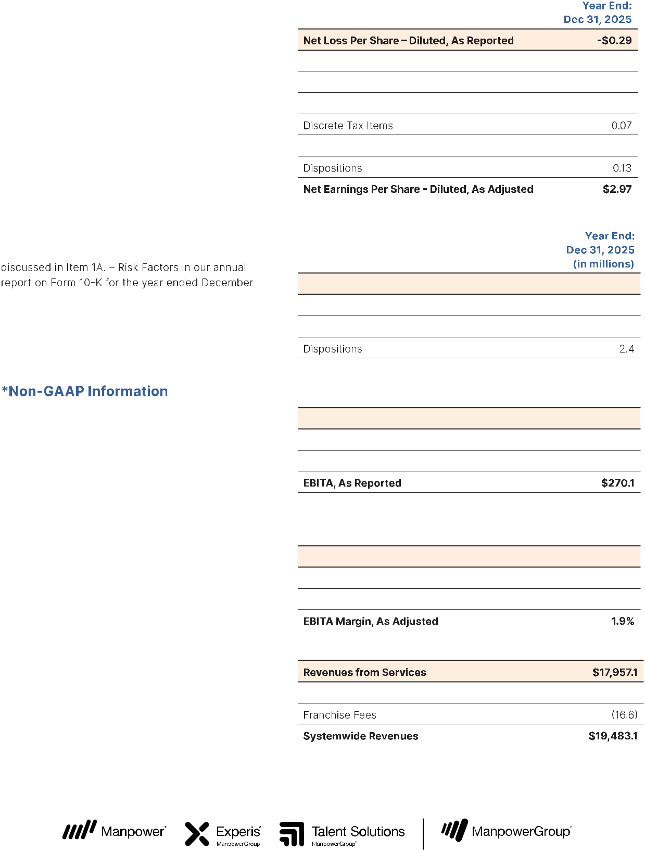

UNITED STATES
SECURITIES AND EXCHANGE COMMISSION
Washington, D.C. 20549
FORM 10-K

ANNUAL REPORT PURSUANT TO SECTION 13 OR 15(d) OF THE SECURITIES EXCHANGE ACT OF 1934:

For the fiscal year ended December 31, 2025

OR

TRANSITION REPORT PURSUANT TO SECTION 13 OR 15(d) OF THE SECURITIES EXCHANGE ACT OF 1934 Commission File No. 1-10686

MANPOWERGROUP INC.

(Exact name of registrant as specified in its charter)

WISCONSIN | 39-1672779
(State or other jurisdiction of | (I.R.S. Employer
incorporation or organization) | Identification No.)
100 MANPOWER PLACE, MILWAUKEE, WISCONSIN | 53212
(Address of principal executive offices) | (Zip Code)

Registrant’s telephone number, including area code: (414) 961-1000
Securities registered pursuant to Section 12(b) of the Act:

Title of each class

Common Stock, $.01 par value

Trading Symbol(s)

MAN

Name of Exchange on which registered New York Stock Exchange

Securities registered pursuant to Section 12(g) of the Act: None

Indicate by check mark if the registrant is a well-known seasoned issuer, as defined in Rule 405 of the Securities Act. Yes No

Indicate by check mark if the registrant is not required to file reports pursuant to Section 13 or Section 15(d) of the Act. Yes No

Indicate by check mark whether the registrant (1) has filed all reports required to be filed by Section 13 or 15(d) of the Securities Exchange Act of 1934 during the preceding 12 months (or for such shorter period that the registrant was required to file such
reports), and (2) has been subject to such filing requirements for the past 90 days. Yes No

Indicate by check mark whether the registrant has submitted electronically every Interactive Data File required to be submitted pursuant to Rule 405 of Regulation S-T (Section 232.405 of this chapter) during the preceding 12 months (or for such shorter
period that the registrant was required to submit such files). Yes No

Indicate by check mark whether the registrant is a large accelerated filer, an accelerated filer, a non-accelerated filer, a smaller reporting company, or an emerging growth company. See the definitions of “large accelerated filer,” “accelerated filer,” “smaller reporting company,” and “emerging growth company” in Rule 12b-2 of the Exchange Act.

Large accelerated filer

Accelerated filer

Non-accelerated filer

Smaller reporting company

Emerging growth company

If an emerging growth company, indicate by check mark if the registrant has elected not to use the extended transition period for complying with any new or revised financial accounting standards provided pursuant to Section 13(a) of the Exchange Act.

Indicate by check mark whether the registrant has filed a report on and attestation to its management’s assessment of the effectiveness of its internal control over financial reporting under Section 404(b) of the Sarbanes-Oxley Act (15 U.S.C. 7262(b))

by the registered public accounting firm that prepared or issued its audit report.

If securities are registered pursuant to Section 12(b) of the Act, indicate by check mark whether the financial statements of the registrant included in the filing reflect the correction of an error to previously issued financial statements

Indicate by check mark whether any of those error corrections are restatements that required a recovery analysis of incentive-based compensation received by any of the registrant's executive officers during the relevant recovery period pursuant to

§240.10D-1(b).

Indicate by check mark whether the registrant is a shell company (as defined in Rule 12b-2 of the Exchange Act). Yes No

The aggregate market value of the voting stock held by nonaffiliates of the registrant was $1,870,022,393 as of June 30, 2025.

As of February 19, 2026, there were 46,419,646 of the registrant’s shares of common stock outstanding.

DOCUMENTS INCORPORATED BY REFERENCE

Part III is incorporated by reference from the Proxy Statement for the Annual Meeting of Shareholders to be held on May 8, 2026.

Auditor Firm Id: 34 Auditor Name: Deloitte & Touche LLP Auditor Location: Milwaukee, WI

Table of Contents

ManpowerGroup Inc.
Form 10-K
For the Fiscal Year Ended December 31, 2025

TABLE OF CONTENTS

 |  | Page
 |  | Number
PART I
Item 1 | Business | 3
Item 1A | Risk Factors | 11
Item 1B | Unresolved Staff Comments | 26
Item 1C | Cybersecurity | 27
Item 2 | Properties | 27
Item 3 | Legal Proceedings | 27
Item 4 | Mine Safety Disclosures | 27
 | Information About Our Executive Officers | 28
 | Other Information | 29
PART II
Item 5 | Market for Registrant's Common Equity, Related Shareholder Matters and Issuer Purchases of
 | Equity Securities | 30
Item 6 | [Reserved] | 31
Item 7 | Management's Discussion and Analysis of Financial Condition and Results of Operations | 32
Item 7A | Quantitative and Qualitative Disclosures About Market Risk | 44
Item 8 | Financial Statements and Supplementary Data | 47
Item 9 | Changes in and Disagreements with Accountants on Accounting and Financial Disclosure | 93
Item 9A | Controls and Procedures | 93
Item 9B | Other Information | 94
Item 9C | Disclosures Regarding Foreign Jurisdictions that Prevent Inspections | 94
PART III
Item 10 | Directors, Executive Officers and Corporate Governance | 95
Item 11 | Executive Compensation | 95
Item 12 | Security Ownership of Certain Beneficial Owners and Management and Related Stockholder
 | Matters | 96
Item 13 | Certain Relationships and Related Transactions, and Director Independence | 96
Item 14 | Principal Accounting Fees and Services | 96
PART IV
Item 15 | Exhibits and Financial Statement Schedules | 97
Item 16 | Form 10-K Summary | 100
SIGNATURES |  | 101

Part I

PART I

The terms “we,” “our,” “us,” "ManpowerGroup," or “the Company” refer to ManpowerGroup Inc. and its consolidated subsidiaries.

Item 1. Business

Introduction and History

ManpowerGroup Inc. is a global leader in innovative workforce solutions. Through our network of approximately 2,100 offices in more than 70 countries and territories, we put millions of people to work each year with our global, multinational and local clients across all major industry segments. Our strong and distinct brands provide specialized solutions that drive organizations forward, accelerate individual success and help build more sustainable communities. We power the future of work.

By offering a comprehensive range of workforce solutions and services, we help companies improve strategy, quality, and efficiency, increase productivity and reduce costs across their workforce to achieve their business goals. ManpowerGroup’s offerings of innovative workforce solutions and services include:

Recruitment and Assessment – By leveraging our trusted brands, industry knowledge and expertise, we identify the right talent in the right place to help our clients quickly access the people and skills they need when they need them. Through our industry-leading and AI-enabled assessments, we help people and organizations understand their strengths and potential, resulting in better job matches, higher retention and a stronger workforce.

Upskilling, Reskilling, Training and Development – Our global insights around evolving employer needs and our expertise in training and development help us prepare candidates and associates to succeed in today’s competitive marketplace. We offer an extensive portfolio of training courses and leadership development solutions that help clients maximize talent and optimize performance.

Career Management – We help individuals find meaningful work and manage their career journey through outplacement services and targeted skills development. By helping individuals and organizations manage workforce transitions and career changes, we unleash human potential.

Outsourcing – We provide clients with outsourcing services related to human resources functions primarily in the areas of large-scale recruiting and workforce-intensive initiatives that are outcome-based, thereby sharing in the risk and reward with our clients.

Workforce Consulting – We help clients create and transform their workforce strategy to achieve their business strategy, increase business agility and flexibility, and accelerate individuals' and business success.

Our expert family of global brands - Manpower, Experis and Talent Solutions - provide innovative workforce solutions across the globe for hundreds of thousands of organizations every year.

Manpower is a global leader in contingent staffing and permanent recruitment, providing strategic and operational flexibility to organizations and connecting people to meaningful work while helping them develop skills to stay employable. With our data driven insight into people’s motivation, skills adjacencies, and performance potential, we provide learning programs, on the job training and market based certifications for rapid reskilling and upskilling at scale.

Experis is a global leader in information technology (IT) professional resourcing and project services specializing in Enterprise Applications, Business Transformation, Cloud and Infrastructure, Digital Workspace and Cyber Security. As digital transformation and skills shortages continue in the technology field, Experis provides talent with the combination of in-demand technical skills together with the soft skills that are critical for business success.

Talent Solutions Talent Solutions delivers integrated and data-driven workforce solutions to help clients more effectively attract, acquire, develop and retain qualified talent. Our lines of business — RPO, TAPFIN-MSP and Right Management

— are seamlessly integrated with our PowerSuite™ HR tech stack to deliver workforce solutions that span the talent lifecycle across multiple countries at scale. The rapid expansion and application of AI across our enterprise is enhancing these offerings, making them increasingly predictive, precise and efficient.

3

Part I

Our leadership position enables us to be a pathway to quality employment opportunities for people at all points in their career journey and we have connected people to meaningful work for over 75 years. Governments and policy makers in the markets where we operate look to us to provide employment advice, opportunities and training to assist the unemployed in gaining the skills they need to enter the workforce, providing a bridge to employment and helping build more sustainable communities.

We, and our predecessors, have been in business since 1948 when we were incorporated as a Wisconsin corporation, and have had our shares listed on the New York Stock Exchange since 1967.

Our website is www.manpowergroup.com. The Investor Relations section (investor.manpowergroup.com) provides our annual reports on Form 10-K, quarterly reports on Form 10-Q, current reports on Form 8-K, and amendments to those reports filed or furnished pursuant to Section 13(a) of the Securities Exchange Act of 1934 as soon as reasonably practicable after we electronically file such material with, or furnish it to, the Securities and Exchange Commission. In addition, we also make available through our website:

our amended and restated articles of incorporation and amended and restated bylaws; our ManpowerGroup code of business conduct and ethics;

our corporate governance guidelines; our insider trading policy;
our anti-corruption policy;

the charters of the Audit, People, Culture & Compensation and Governance & Sustainability Committees of the Board of Directors;

our guidelines for selecting board candidates;

our categorical standards for relationships deemed not to impair independence of non-employee directors; our independent auditors' services policy;

our executive officer stock ownership guidelines;

our outside director stock ownership guidelines; and our regular updates on sustainability.

Documents available on the website are also available in print for any shareholder who requests them. Requests may be made by writing to Corporate Secretary, ManpowerGroup, 100 Manpower Place, Milwaukee, Wisconsin 53212. We are not including the information contained on or available through our website as a part of, or incorporating such information by reference into, this Annual Report on Form 10-K.

Our Operations

Client demand for workforce solutions and services is dependent on the overall strength of the labor market and secular trends toward greater workforce flexibility within each of the segments where we operate. Improving economic growth typically results in increasing demand for labor, resulting in greater demand for our workforce solutions and staffing services while demand for our outplacement services typically declines. During periods of increasing demand, we are generally able to improve our profitability and operating leverage as our cost base can support some increase in business without a similar increase in selling and administrative expenses.

Correspondingly, during periods of weak economic growth or economic contraction, the demand for our staffing services typically declines, while demand for our outplacement services typically accelerates. When demand drops, our operating profit is typically impacted unfavorably as we experience a deleveraging of our selling and administrative expense base as expenses may not decline at the same pace as revenues. In periods of economic contraction, we may have more significant expense deleveraging, as we believe it is prudent not to reduce selling and administrative expenses to levels that could negatively impact the long-term potential of our branch network and brands.

4

Part I

The nature of our operations is such that our most significant current asset is accounts receivable, with a days sales outstanding of 55 days as of December 31, 2025. Our most significant current liabilities are payroll related costs, which are generally paid either weekly or monthly. As the demand for our services increases, we generally see an increase in our working capital needs, as we continue to pay our associates on a weekly or monthly basis while the related accounts receivable is outstanding for much longer, which may result in a decline in operating cash flows.

Conversely, as the demand for our services declines, we generally experience a decrease in our working capital needs, as the existing accounts receivable are collected and not replaced at the same level, resulting in a decline of our accounts receivable balance, with less of an effect on current liabilities due to the shorter cycle time of the payroll related items. While this may result in an increase in our operating cash flows, longer payment terms and timing of payroll, tax and supplier related payments significantly impact our cash positions and cash flows each period. Any increase in operating cash flows from an economic slowdown would not be sustained in the event that a downturn continues for an extended period.

Due to our industry’s sensitivity to economic factors, the inherent difficulty in forecasting the direction and strength of the economy and the short-term nature of staffing assignments, it is difficult to forecast future demand for our services with certainty. As a result, we monitor a number of economic indicators, as well as recent business trends, to predict future revenue trends for each of the countries and territories where we operate. Based upon these anticipated trends, we determine what level of personnel and office investments are necessary to take full advantage of growth opportunities.

During the last several years, secular trends toward greater workforce flexibility have impacted the demand for our innovative workforce solutions and services around the world. As companies attempt to increase the variability of their cost base, the workforce solutions we provide help them to effectively address the fluctuating demand for their products or services. As the global economy continues to grow and adapt with new technology, we are helping clients manage their workforce transformation and ensure they have the right skills now and in the future. Whether it is through workforce assessments, targeted training or by creating longer-term development paths, we help organizations and candidates adapt their skills to changing workforce needs.

Our portfolio of recruitment services includes permanent, temporary and contract recruitment of professionals, as well as administrative, industrial and IT professional positions. These services are provided under our Manpower and Experis brands. We have provided services under our core Manpower brand for over 75 years with a primary focus on the areas of office and industrial services and solutions. Our Talent Based Outsourcing offering within our Manpower brand includes outcome-based solutions such as management of financial and administrative processes, including call center and customer service activities.

We provide IT resourcing and services under our Experis brand. Our experience and expertise allow us to accurately assess candidates’ workplace potential and technical skills to match them to the needs of our clients. We plan to continue to build our Experis brand and attract the talent our clients need as skills shortages arise or continue.

Our Talent Solutions brand specializes in the delivery of customized workforce strategies and new solutions and creating added value that addresses our clients’ complex global workforce needs. Through our RPO offering, we manage customized, large-scale recruiting and workforce productivity initiatives for clients through exclusive outsourcing contracts. We can manage a single element or all of a client's permanent recruiting and hiring processes, from job profiling to on-boarding, globally or in a single location. MSP services include overall program management, reporting and tracking, supplier selection and management and order distribution. The MSP and RPO offerings both provide specialty expertise in contingent workforce management and broader administrative functions. Our Right Management offering includes our career management services that have historically been counter-cyclical to our staffing services, which helps to offset the impact of an economic downturn on our overall financial results.

Americas

We provide services as Manpower, Experis and Talent Solutions through both branch and franchise offices. The Americas segment had 415 branch and 138 franchise offices as of December 31, 2025. In the United States, where we realized 63% of the Americas’ revenue, we had 286 branch and 127 franchise offices as of December 31, 2025, as well as on-site locations at clients with significant permanent, temporary and contract recruitment requirements. In Other Americas, the largest operations of which include Canada, Mexico and Colombia, we had 129 branch and 11 franchise offices as of December 31, 2025. We provide a number of central support services to our branches and franchises, which enable us to maintain consistent service quality throughout the region regardless of whether an office is a branch or franchise.

5

Part I

Our franchise agreements provide the franchisee with the right to use the Manpower® service mark in a specifically defined exclusive territory. In the United States, franchise fees generally range from 2% to 3% of franchisee sales. Our franchise agreements provide that in the event of a proposed sale of a franchise to a third party, we have the right to acquire the franchise at the same price and on the same terms as proposed by the third party. We have exercised this right in the past and may do so in the future if opportunities arise.

Our Manpower and Experis operations provide a variety of workforce solutions and services, including permanent, temporary and contract recruitment, assessment and selection, and training. Our Talent Solutions operations provide a variety of workforce solutions offerings including RPO, MSP and Right Management. During 2025 in this segment, 91% of revenues were derived from our staffing/interim services, 3% from permanent recruitment services, 2% from outcome-based solutions and consulting and 4% from other services.

Southern Europe

We are a leading provider of permanent, temporary and contract recruitment, assessment and selection, training and outsourcing services throughout Europe. The Southern Europe segment had 1,174 branch and 5 franchise offices as of December 31, 2025. Our largest operations in this segment are in France (53% of the segment revenue) and Italy (22% of the segment revenue).

We conduct our operations in France as a leading workforce solutions and service provider through 634 branch offices as Manpower, Experis and Talent Solutions, and 169 branch offices under the name Supplay as of December 31, 2025. The employment services market in France calls for a wide range of our services including permanent, temporary and contract recruitment, assessment and selection, and training. The temporary recruitment market is predominantly focused on recruitment for industrial positions. During 2025 in France, 91% of revenues were derived from our staffing/interim services, 1% from permanent recruitment services, 6% from outcome-based solutions and consulting and 2% from other services.

In Italy, we are a leading workforce solutions and services provider. As of December 31, 2025, ManpowerGroup Italy conducted operations through a network of 212 branch offices. It provides a comprehensive suite of workforce solutions and services offered through Manpower, Experis or Talent Solutions, including permanent, temporary and contract recruitment, assessment and selection, training and outsourcing. During 2025 in Italy, 92% of revenues were derived from our staffing/interim services, 3% from permanent recruitment services, 3% from outcome-based solutions and consulting and 2% from other services.

Northern Europe

Our largest operations in Northern Europe are in the United Kingdom, the Nordics, Germany, the Netherlands and Belgium providing a comprehensive suite of workforce solutions and services through Manpower, Experis, and Talent Solutions. Collectively, we operate through 237 branch and 2 franchise offices in this region.

In the United Kingdom, where we have the largest operation in this segment, we are a leading provider of workforce solutions and services. As of December 31, 2025, we conducted operations in the United Kingdom as Manpower, Experis and Talent Solutions through a network of 35 branch offices and also provided on-site services to clients who have significant permanent, temporary and contract recruitment requirements. In the United Kingdom, we also conduct operations as Brook Street Bureau PLC, or Brook Street. Its core business is secretarial, office and light industrial recruitment. Brook Street operates as a local network of branches and competes primarily with local or regional independents. Brook Street’s revenues are comprised of temporary and contract placements as well as permanent recruitment.

During 2025 in Northern Europe, 87% of revenues were derived from our staffing/interim services, 3% from permanent recruitment services, 7% from outcome-based solutions and consulting and 3% from other services.

APME

We operate through 111 branch and 7 franchise offices in the Asia Pacific Middle East (APME) region. The largest of these operations are located in Japan and India, which operate through branch offices. Our APME operations provide a variety of workforce solutions and services offered through Manpower, Experis and Talent Solutions, including permanent, temporary and contract recruitment, assessment and selection, training and outsourcing. During 2025 in this segment, 84% of revenues were derived from our staffing/interim services, 2% from permanent recruitment services, 12% from outcome-based solutions and consulting and 2% from other services.

6

Part I

Competition


We compete in the employment services industry by offering a broad range of services, including permanent, temporary and contract recruitment, project-based workforce solutions, assessment and selection, training, career and talent management, managed service solutions, outsourcing, consulting and professional services.

Our industry is large and fragmented, comprised of thousands of firms employing millions of people and generating billions of United States dollars in annual revenues. In most areas, no single company has a dominant share of the employment services market. In addition to us, the largest publicly owned companies specializing in recruitment services are The Adecco Group and Randstad. We also compete against a variety of regional or specialized companies such as Recruit Holdings, Allegis Group, Kelly Services, Robert Half, Kforce, PageGroup, Korn/Ferry International and Alexander Mann. It is a highly competitive industry, reflecting several trends in the global marketplace such as the increasing demand for skilled people, employers’ desire for more flexible working models and consolidation among clients and in the employment services industry itself, as well as low entry costs for small firms wishing to compete in the industry, especially at the local level. We manage these trends by leveraging established strengths, including several of the employment services industry’s most recognized and respected brands; geographic diversification; size and service scope; an innovative product mix; recruiting and assessment expertise; and a strong client base. While staffing is an important aspect of our business, our strategy is focused on providing both the skilled employees our clients need and higher-value workforce management, outsourcing and consulting solutions.

Our client mix consists of both small- and medium-size businesses, and large national and multinational clients. Client relationships with small- and medium-size businesses are based on a local or regional relationship, and tend to rely less on longer-term contracts, and the competitors for this business are primarily locally-owned businesses. On the other hand, the large national and multinational clients, which comprised approximately 60% of our revenues in 2025, will frequently enter into non-exclusive arrangements with several firms, with the ultimate choice among them being left to local managers. As a result, employment services firms with a large network of offices compete most effectively for this business which generally has agreed-upon pricing or mark-up on services performed.

Legal Regulations

The employment services industry is closely regulated in most of the major markets in which we operate. Employment services firms are generally subject to one or more of the following types of government regulation:

regulation of the employer/employee relationship between the firm and its temporary and contract employees; registration, licensing, record keeping and reporting requirements;

substantive limitations on the operations or the use of temporary and contract employees by clients; and regulation that requires new or additional benefits and pay parity for our associates.

In many markets, the existence or absence of collective bargaining agreements with labor organizations has a significant impact on our operations and the ability of clients to use our services. In some markets, labor agreements are structured on an industry-wide, rather than company-by-company, basis. Changes in these collective bargaining agreements have occurred in the past and are expected to occur in the future and may have a material impact on the operations of employment services firms, including us.

In most countries, workforce solutions and services firms are considered the legal employers of temporary and contract workers. Therefore, laws regulating the employer/employee relationship, such as tax withholding or reporting, social security or retirement, health and other benefits, anti-discrimination and workers’ compensation, govern the firm.

In many countries, particularly in continental Europe and Asia, entry into the employment services market is restricted by the requirement to register with, or obtain licenses from, a government agency. In addition, a wide variety of ministerial requirements may be imposed, such as record keeping, written contracts and reporting. The United States, United Kingdom and Canada do not presently have any form of national registration or licensing requirement.

In addition to licensing or registration requirements, many countries impose substantive restrictions on the use of temporary and contract workers. Such restrictions include regulations affecting the types of work permitted, the maximum length of assignment, wage levels or reasons for which temporary and contract workers may be employed. In some countries, special taxes, fees or costs are imposed in connection with the use of temporary and contract workers. For example, temporary and contract workers in France are entitled to a 10% allowance for the uncertain duration of employment, which is eliminated if a full-time position is offered to them after assignment termination.

7

Part I

Our outplacement and consulting services generally are not subject to governmental regulation in the markets in which we operate.

In the United States, we are subject to various federal and state laws relating to franchising, principally the Federal Trade Commission’s Franchise Rules and analogous state laws which impact our agreements with our franchised operations. These laws and related rules and regulations impose specific disclosure requirements. Virtually all states also regulate the termination of franchises.

Changes in applicable laws or regulations have occurred in the past and are expected in the future to affect the extent to which workforce solutions and services firms may operate. These changes could impose additional costs, taxes, record keeping or reporting requirements; restrict the tasks to which contingent workers may be assigned; limit the duration of or otherwise impose restrictions on the nature of the relationship (with us or the client); or otherwise adversely affect the industry.

Trademarks


We maintain a number of registered trademarks, trade names and service marks in the United States and various other countries and territories. We believe that many of these marks and trade names, including ManpowerGroup®, Manpower®, Experis®, Right Management®, Brook Street®, Jefferson Wells®, Supplay®, PowerSuite® and MyPath® have significant value and are materially important to our business. In addition, we maintain other intangible property rights. The trademarks have been assigned an indefinite-life based on our expectation of renewing the trademarks, as required, without material modifications and at a minimal cost, and our expectation of positive cash flows beyond the foreseeable future.

Employees

We had approximately 25,400 full-time equivalent employees as of December 31, 2025. In addition, we recruit millions of permanent, temporary and contract workers on a worldwide basis each year on behalf of our clients.

As described above, in most jurisdictions, we, as the employer of our temporary and contract workers or as otherwise required by applicable law, are responsible for employment administration. This administration includes collection of withholding taxes, employer contributions for social security or its equivalent outside the United States, unemployment tax, workers’ compensation and fidelity and liability insurance, and other governmental requirements imposed on employers. In most jurisdictions where such benefits are not legally required, including the United States, we provide health and life insurance, paid holidays and paid vacations to qualifying temporary and contract employees.

Human Capital

We Are a Workforce Solutions and Human Capital Company.

Human capital management is at the core of our business. Our purpose is to provide meaningful and sustainable employment and is rooted in our values: People, Knowledge and Innovation. Our 25,400 employees, spanning more than 70 countries, help improve the lives of approximately 485,000 workers daily by providing guidance, advice, assessments, coaching, upskilling, reskilling and pathways to long-term sustainable employment. These efforts support local economies by increasing employability and opportunity for the millions of lives that we reach each year.

Through our sustainability report Working to Change the World, we report progress on our People & Prosperity pillar, where we are focused on being Creators of Talent at Scale, championing diversity, and improving employability and prosperity. For over 75 years, we have developed global insights on the issues and trends impacting organizations and individuals in today’s fast changing world of work. Our own research and solutions, coupled with partnerships with clients and Non-Governmental Organizations (e.g. World Economic Forum, World Employment Confederation and Junior Achievement, among others), enable us to advance the global discussion around the future of work and future for workers. These include the impact of digitization and generative AI, the green transition and shift in in-demand skills, exacerbating talent shortages, and the increased need for reskilling and upskilling. Our most recent annual Talent Shortage Survey reported that 74% of companies cannot find the skilled workers they need.

8

Part I

We Seek to Create Talent at Scale.

Our Manpower MyPath program is designed to deliver targeted upskilling at speed and scale to our Manpower associates in order to accelerate their employability at higher wage levels, while also growing the pool of in-demand talent for our clients. Through this program, Manpower recruiters provide personalized and data-driven guidance, development, training, and access to jobs especially in growth sectors including advanced manufacturing, information technology, supply chain and customer service. MyPath has impacted over 310,000 lives through 2025, and MyPath associates now represent 35% of our associate talent pool in MyPath certified countries, across over 15,000 clients and 12 markets.

We are also targeting the creation of IT talent through our Experis Academy. This accelerated development program features custom-designed curricula to upskill people into specialized roles that can meet the demand for cloud, infrastructure, business transformation and digital workforce skills. Paired with coaching and soft skills training, upon completion most Academy graduates receive a permanent job offer from our clients. Through the end of 2025, we have trained more than 4,500 developers while also bridging the skills gaps for more than 170 tech companies across approximately 20 countries.

We Are Focused on Strengthening Our Culture and Developing Our People.

Our Global Footprint

We have a global footprint, though our teams are managed locally: 33% of our people are in the Americas, 33% in Southern Europe, 16% in Northern Europe and 17% in Asia Pacific/Middle East.

Developing our People

We believe our success in creating value for individuals and organizations around the world will depend on our ability to leverage the potential of our own people. We are investing in our people to support both our strategic ambitions and their personal goals.

In 2025, we continued to broaden and deepen our investment through our Leadership Development Programs, incorporating the 3 E’s of our development philosophy: Education, Exposure and Experience.

For our Future Leaders Program (FLP) that targets individual contributors wanting to take on their first managerial role, 121 employees are enrolled in this program in 2025 and a total of 1,166 employees have completed the program since its inception in 2019.

For our Accelerated Leadership Program (XLP) that targets current managers ready to move into bigger or more complex roles, 25 employees will begin this program in 2026 - and a total of 101 employees have completed the program since it began in 2022. The program runs every even year; the last cohort took place in 2024 with 20 participants.

For our Strategic Leadership Program (SLP) that focuses on senior leaders to prepare them to move into the Global Leadership team, 9 employees completed the program in 2025 out of 12 initially selected, bringing the

total to 49 participants since its start in 2022. The program runs every odd year, and the next cohort will begin in 2027.

Upon completion of these programs, the majority of our participants have made positive leadership career moves.

Strengthening our Culture

We believe that all people deserve to feel safe, respected and able to thrive in the workplace. Our focus encompasses four areas of focus: (1) globally, support gender diversity at leadership levels; (2) locally, address a second dimension of diversity based on gaps or opportunities within a country; (3) culturally, foster an inclusive environment that supports our diverse workforce; and (4) societally, advance employment security for workers while promoting upskilling, well-being, flexibility and income opportunity.

9

Part I

Our Board of Directors has exceeded 30% gender diversity for more than 10 years. As of December 31, 2025, 18% are racially diverse and 36% are non-US born. Our Executive Leadership Team, which reports directly to the CEO, is 30% women, 30% racially diverse and 70% non-US born. Our Global Leadership Team, the top 93 leaders in the company, is 40% women. Gender diversity across all our markets globally aligns to our values. We will continue to develop our talent across all markets and at all levels, including working to ensure that the gender diversity of our leadership is aligned to the representation of the organization. Diversity in our workplaces also means that we prioritize people’s health and wellbeing and have committed to flexible work models across the globe to attract, engage and retain our people. In several markets, we have launched initiatives and trained our managers to promote greater awareness of mental wellbeing. We see diversity as a strategic enabler of our business and therefore we are focused on actions to support our diverse organization, our culture and the impact we have on the communities we serve across the globe.

Additionally, encouraging active engagement among our workforce is important for nurturing a strong and inclusive culture. We believe regular pulse surveys offer valuable insights into employee sentiments, spanning various areas such as the effectiveness of our People & Culture strategy, leadership assessments, ethics, values, and developmental opportunities. Our Culture Matters initiative has been refined, and we incorporated these behaviors into Our Standards. Our business strategy guides our actions for achieving our goals, and the behaviors in Our Standards—Clarity, Care, and Grow— illustrate how we execute these strategies. We believe our global leaders should provide clarity to our people and our clients, care about themselves and others through our people practices, and make decisions that grow our business and ourselves. Our core belief is that for ManpowerGroup to be successful, each of us needs to be accountable to delivering on these at all levels of our organization.

In 2025, we conducted a global employee survey with over 19,000 staff participating, achieving a 73% response rate. Over 8,600 employees left nearly 13,000 comments to help leaders improve the employee experience at ManpowerGroup.

10

Part I

Item 1A. Risk Factors

FORWARD-LOOKING STATEMENTS

This Annual Report on Form 10-K contains forward-looking statements within the meaning of Section 27A of the Securities Act of 1933, as amended, and Section 21E of the Exchange Act of 1934, as amended, (each a "forward-looking statement"). Statements made in this report that are not statements of historical fact are forward-looking statements. In addition, from time to time, we and our representatives may make statements that are forward-looking. Forward-looking statements are based on management’s current assumptions and expectations and are subject to risks and uncertainties that are beyond our control. This section provides you with cautionary statements identifying, for purposes of the safe harbor provisions of the Private Securities Litigation Reform Act of 1995, important factors that could materially adversely affect our business, operational and financial results and cash flows. In addition, these factors could cause our actual results to differ materially from those contained in forward-looking statements made in this report or otherwise made by us or on our behalf. You can identify these forward-looking statements by forward-looking words such as “expect”, “anticipate”, “intend”, “plan”, “may”, “will”, “believe”, “seek”, “estimate”, and similar expressions. You are cautioned not to place undue reliance on these forward-looking statements. We caution that any forward-looking statement reflects only our belief at the time the statement is made. We undertake no obligation to update any forward-looking statements to reflect subsequent events or circumstances.

The following are some of the factors that could materially adversely affect our business, operational and financial results and cash flows or cause actual results to differ materially from estimates contained in our forward-looking statements. Risks in this section are grouped in the following categories: (1) Company and Operational Risks; (2) Strategic Risks; (3) Financial and Market Risks; and (4) Regulatory and Legal Risks. Many risks affect more than one category, and the risks are not in order of significance or probability of occurrence because they have been grouped by categories.

Company and Operational Risks


Volatile, negative or uncertain economic conditions;

Inability to timely operate our business or respond to the needs of our clients;

Competition in the worldwide employment services industry limiting our ability to maintain or increase market share or profitability;

Cyberattack or improper disclosure or loss of sensitive or confidential company, employee, associate or client data, including personal data;

Disruption, increased costs and reputational risk from outsourcing various aspects of our business; Risks related to the emergence of AI;

A loss or reduction in revenues from one or more large clients; Loss of key personnel;

Competition in labor markets limiting our ability to attract, train and retain the personnel necessary to meet our clients’ staffing needs;

Political unrest, natural disasters, health crises, infrastructure disruptions and other risks beyond our control; Our ability to preserve our reputation in the marketplace;

Changes in client attitudes toward the use of our services or our industry; and Limited ability to protect our thought leadership and other intellectual property.

Strategic Risks

Inability to effectively implement our business strategy or achieve our objectives;

Failure to keep pace with technological change and marketplace demand in the development and implementation of our services and solutions;

Our sustainability strategy exposes us to business risks;

Costs or disruptions resulting from acquisitions we complete; and

Risks related to dispositions we may undertake via sales, franchises, joint ventures or other exit activities.

11

Part I

Financial and Market Risks


Foreign currency fluctuations;

Inability to meet our liquidity or working capital needs; Inability to maintain effective internal controls;
Material adverse effects on our operating flexibility resulting from our debt levels;

Failure to comply with restrictive covenants under our revolving credit facilities and other debt instruments; Inability to obtain credit on terms acceptable to us or at all;

The performance of our subsidiaries and their ability to distribute cash to our parent company, ManpowerGroup, may vary;

Inability to secure guarantees or letters of credit on acceptable terms; Changes in tax legislation; and

Fluctuation of our stock price.

Regulatory and Legal Risks

Challenges meeting contractual obligations if we or third parties fail to deliver on performance commitments;

Legal regulations in places we do business or the regulatory prohibition or restriction of employment services or the imposition of additional licensing or tax requirements;

Failure to comply with anti-corruption and bribery laws;

Legal claims, including employment-related claims, from clients or third parties; Liability resulting from competition law;

Provisions under Wisconsin law and our articles of incorporation and bylaws could make the takeover of our Company more difficult; and

Other factors that may be disclosed below or from time to time in our SEC filings or otherwise.

Some or all of these factors may be beyond our control. We caution you that any forward-looking statement reflects only our belief at the time the statement is made. We undertake no obligation to update any forward-looking statement to reflect events or circumstances after the date on which the statement is made.

RISK FACTORS

In addition to the other information set forth in this report, you should carefully consider the following factors which could materially adversely affect our business, financial condition, results of operations (including revenues and profitability) or stock price. Our business is also subject to general risks and uncertainties that may broadly affect companies. Additional risks and uncertainties not currently known to us or that we currently deem to be immaterial also could materially adversely affect our business, financial condition, results of operations or stock price.

Company and Operational Risks

Our results of operations have been and may in the future be materially adversely affected by volatile, negative, or uncertain economic conditions, including the risk of recession.

Our business is sensitive to changes in global macroeconomic conditions. We have at times experienced uncertainty and volatility in global economic conditions, including in rates of growth or decline in the markets we serve. Our operating countries and regions, which are increasingly interdependent, have experienced periods of volatile growth patterns or declines, and we expect that global conditions will continue to be characterized by instability and unpredictability. Such conditions have and may continue to cause our clients to reduce or defer their spending on new projects that require our solutions which could decrease demand for our various staffing services. If our business growth is slow, or if it contracts for an extended period of time, this could have a material adverse effect on our business and results of operations.

12

Part I

Our profitability is sensitive to decreases in demand. Based on current macroeconomic conditions, there is a significant risk that some of our most important markets will experience, or continue to experience, recessionary pressure, which would likely be accompanied by a decline in demand for our services. When demand drops or remains low, our operating profit is impacted unfavorably as we experience a deleveraging of our selling and administrative expense base as expenses do not decline as quickly as revenues. For example, our ability to achieve cost containment through reductions in our headcount may be impeded or slowed by applicable legal requirements to consult with employee representative bodies such as works councils. In periods of decline, we may not be able to reduce selling and administrative expenses without negatively impacting the long-term potential of our branch network and brands. Additionally, some clients may slow the rate at which they pay us, or become unable to pay their obligations and our cash flow and profitability may suffer.

Economic conditions in the countries and territories where we do business may be affected by recent or emerging events, such as the rise of populism, political volatility, civil violence and unrest, election results or other changes in ruling parties or governmental leadership, trade disputes, protectionism or changes in global trade policies, capital flows, the global refugee crisis, social justice movements, energy shortages or instability in the global energy market, global health crises, changes in immigration policy, the impact of supply chain challenges on our clients, changes in employment policy, changes in interest rates, inflation, the impact of terrorist activity, or by other political or economic developments. In addition, there is a risk the current inflationary environment and efforts to combat inflation could have an impact on the countries and territories where we do business. We are particularly susceptible to changes in demand patterns and economic conditions in Europe, which represents two of our operating segments and 65% of our revenue.

There is a risk that economic conditions in European markets or elsewhere may continue to be negatively impacted by geopolitical events. In recent years these have included labor unrest, civil protest, heightened trade tensions, refugee crises, and military conflicts. We cannot predict the potential consequences arising from these conflicts and the further escalation of geopolitical tensions globally, including whether they could have an effect on the global economy and on our business and results of operations. Geopolitical events could give rise to the imposition of further sanctions, regional or international expansion of current conflicts, instability in energy supplies, potential retaliatory action by governments, heightened cybersecurity threats, disruptions in the global supply chain, volatility in foreign exchange rates, and inflationary pressures. Any of these events or trends could have a material adverse effect on our business and operating results, particularly our European operations.

There is a risk that even when overall global economic conditions are positive, we could experience declines in all, or in portions, of our business. During past periods of recovery, we have experienced inconsistent results, with some geographical regions, or countries within a region, suffering declines or weakness in economic activity while others improve. Differing economic conditions and patterns of economic growth or contraction may affect demand for our solutions and services, and there is a risk that, even during times of strengthening global economic conditions, we may not experience uniform, or any, increases in demand for our solutions and services within the markets where our business is concentrated.

Even without uncertainty and volatility, it is difficult for us to forecast future demand for our services due to the inherent difficulty in forecasting the direction and strength of economic cycles, and the short-term nature of many of our staffing assignments. When it is difficult for us to accurately forecast future demand, we may not be able to determine the optimal level of personnel and office investments necessary to profitably operate our business or take advantage of growth opportunities.

We may lack the speed, agility, and resiliency to effectively operate our business and respond to the needs of our clients.

There is a risk we may not be able to respond with sufficient speed and agility to the needs of our diverse clients, which span all industries and whose needs may change rapidly as their businesses and industries evolve. The size and breadth of our organization, comprising approximately 25,400 employees based out of approximately 2,100 offices in more than 70 countries and territories, may make it difficult for us to effectively manage our resources, to maintain our corporate culture throughout the organization, to drive service improvements and to provide coordinated solutions to our clients who require our services in multiple locations. For example, client demands for uniform service across borders may be difficult to satisfy because of variation in local laws and customs. We see a trend in more multi-country and enterprise-level relationships, and we may have difficulty in profitably managing and delivering projects involving multiple countries. Also, our size and organizational structure may make it difficult to develop and implement new processes and tools across the enterprise in a consistent manner. If we are not effective at anticipating or meeting the widely ranging needs of our current and prospective clients, or our competitors are more agile or effective at doing so, our business and financial results could be materially adversely affected.

13

Part I

Our ability to perform at speed, and to meet client expectations, may also be adversely affected by limitations in our own information systems and those of our third-party vendors. We are increasingly dependent on these systems, which are subject to damage or interruption from multiple causes, including power outages, facility damage, computer and telecommunications failures, vandalism, malware, hacking and other malicious acts, catastrophic events and human error. If our information systems are damaged, fail to work properly, or otherwise become unavailable, we may incur substantial costs to repair or replace them, and may experience reputational damage, loss of critical information, customer disruption, and interruptions or delays in our ability to perform essential functions and implement new and innovative services.

The worldwide employment services industry is highly competitive with limited barriers to entry in many markets, which could limit our ability to maintain or increase our market share or profitability.

The worldwide employment services industry is highly competitive with limited barriers to entry in many markets, and in recent years has undergone significant consolidation. We compete in markets throughout the world with full-service and specialized employment services agencies. Several of our global competitors have very substantial marketing and financial resources and may be better positioned in certain markets. Portions of our industry may become increasingly commoditized, with the result that competition in key areas could become more focused on pricing. We expect that we will continue to experience pressure on price from competitors and clients. There is a risk that we will not compete effectively, including on price, which could limit our ability to maintain or increase our market share and could materially adversely affect our financial results. This may worsen as clients increasingly take advantage of low-cost alternatives including using their own in-house resources rather than engaging a third party. The increased availability and maturation of artificial intelligence (AI) tools may enable clients to use advanced automation capabilities in lieu of services provided by our employees, contractors and associates.

We could incur liabilities or suffer reputational damage from a cyberattack or improper disclosure or loss of personal or confidential data, and our use of data is subject to complex and ever-changing privacy and cybersecurity legal requirements that could negatively impact our business or subject us to claims and/or fines for non-compliance.

In connection with the operation of our business, we store, process and transmit a large amount of data, including personnel and payment data, about our employees, clients, associates and candidates, a portion of which is personal data and/or confidential data. We expect our use of data to increase, including through the use of analytics, AI and machine learning (ML). In engaging in these data-related activities, we rely on our own technology systems and software, and those of third-party vendors we use for a variety of processes, including, but not limited to cloud-based technology and systems, mobile technologies and social media. Unauthorized access to, disclosure, modification, use or loss of personal or confidential data may occur through various methods. These include, but are not limited to, ransomware, systems failure, employee negligence or malfeasance, fraud or misappropriation, or unauthorized access to or through our information systems, whether by our employees, vendors or third parties, including a cyberattack by hackers, members of organized crime and/or state-sponsored organizations, who may develop and deploy supply chain interruptions, social engineering attacks, viruses, worms or other malicious software programs, or obtain credentials to our systems through other unrelated cyber attacks.

An incident involving disclosure, system failure, data modification, loss or security breach could harm our reputation and subject us to significant monetary damages or losses, litigation, negative publicity, regulatory enforcement actions, fines, criminal prosecution, as well as liability under our contracts and laws that protect personal and/or confidential data, resulting in increased costs or loss of revenues. Cybersecurity threats continue to increase in frequency and sophistication, thereby increasing the difficulty of detecting and defending against them. In the past, we have experienced data security breaches resulting from unauthorized access to our systems and other fraudulent activities, such as social engineering, which to date have not had a material impact on our operations or financial results. We regularly engage an independent external security firm to assess our defenses to a potential cyberattack, and these assessments may uncover new or additional vulnerabilities and weaknesses that could lead to a compromise of our systems and/or a loss of personal data. As a result of previous assessments, vulnerabilities were identified that could facilitate or contribute to a security incident involving personal data. The assessment firm was able to penetrate defensive protections adopted by us, as well as protections that we obtain from third party providers. We are prioritizing the resolution of security gaps that could lead to a loss of personal data or to other damage. Despite our efforts to identify and address vulnerabilities in our systems, vulnerabilities in software products used by us are disclosed by our software providers on a daily basis, and attackers grow continuously more sophisticated in their attack methods, which may additionally make use of AI technology such as AI-generated 'deep-fake' impersonation or social engineering, making it impossible to give assurance that our cybersecurity efforts will be successful.

14

Part I

There is a risk that our and our third-party vendors’ preventative security controls and practices will be inadequate to prevent unauthorized access to, disclosure of, or loss of personal and/or confidential data, or fraudulent activity, especially given that third party attacks have become more common. In the past, our data has been exposed due to data security breaches at our third party vendors, but to date none of these incidents have had a material impact on our operations or financial results. Any such future events, such as unauthorized access or fraudulent activity with our third party vendors could have a material adverse effect on our business and financial results.

More of our employees are working from their homes or other remote locations than before, which makes it more difficult for us to monitor their activities, the security of their work locations, insider threats, and data exfiltration. This has increased the risk of security incidents, which could include unauthorized access to, disclosure of, or loss of personal and/or confidential data, as well as other types of fraudulent activity. Any such unauthorized access or fraudulent activity could have a material adverse effect on our business and financial results.

The potential risk of security breaches, fraud and cyberattacks may increase as we continue to introduce services and offerings, whether mobile, cloud, or otherwise. Any additional services and offerings inevitably increase the potential for a cyberattack against us. Further, data privacy and cybersecurity are subject to frequently changing laws and regulations, including the European Union’s General Data Protection Regulation (the “GDPR”), the California Privacy Rights Act (the “CPRA”), and additional legislation in place, or expected to become effective, in various U.S. states and other countries. These laws and regulations are increasing in number, complexity, burden and potential financial penalties, and are often inconsistent among the various jurisdictions and countries in which we provide services. For example, the GDPR and the CPRA impose significant compliance obligations that add costs and operational burdens to our business with respect to our collection, use, storage and retention of personal data. Compliance with these obligations could reduce operational efficiency and increase our regulatory compliance costs, and failure to satisfy these requirements may lead to significant regulatory enforcement actions and/or large private litigation in the event of a security breach or other violation. Under the GDPR, the maximum fine can be up to 4% of a company’s global revenue, and there is no maximum penalty under the CPRA. In addition, our liability insurance might not be sufficient in scope or amount to cover us against claims and losses related to violations of data privacy and cybersecurity laws or security breaches, social engineering, cyberattacks and other related data disclosure, loss or breach.

We have outsourced aspects of our business, which could result in disruption, increased costs, and reputational risk.

We have increasingly outsourced, and may further outsource, important processes of our business to third party vendors, which exposes us to other risks, including increased costs, supply chain interruptions, potential disruptions to our business operations, and reputational risk. For example, we rely on third parties to host, manage and secure certain aspects of our data center information and technology infrastructure, to develop and maintain new technology for attracting, onboarding, managing, and analyzing our workforce, and to provide important back-office support. We have increasingly centralized our vendor profile so that we are reliant on a small number of vendors for highly critical corporate and technology functions. While we believe these third-party vendors provide greater efficiency and expertise, our dependence on a small number of vendors increases the risk that our business will be adversely affected if our vendors are unable to provide these services consistent with our needs. Similarly, our business continuity and our margins could be adversely affected if we needed to replace one of our critical vendors for performance or economic reasons.

Our operations also depend significantly upon these vendors’ and our ability to protect our data and to ensure the availability of our servers, software applications and websites. Despite our and our third-party vendors’ implementation of security measures, our systems remain susceptible to system failures, computer viruses, natural disasters, unauthorized access, cyberattacks and other similar incidents, any of which could result in disruptions to our operations. Our vendors have experienced data losses in the past, and we can expect such data incidents will occur in the future. A successful breach of the security of our technology systems, or those of our vendors, could result in the theft of confidential, personally identifiable, or other sensitive data, including data about our employees and/or associates, or our human resources operations, any of which could damage our reputation in the market. If we are not able to realize the savings associated with outsourcing services or if there is a disruption or security breach of our outsourced services that results in a loss or damage to our data, or in an inappropriate disclosure of confidential, personally identifiable, or sensitive data, our business and financial results could be materially adversely affected.

Risks and uncertainties related to the development and use of AI could harm our business operations, reduce demand for our services, and raise legal or regulatory challenges .

Leveraging AI-based technology for our internal operations and service offerings presents risks, costs, and challenges as we continue to implement AI capabilities, including generative AI, to improve our operating efficiency and develop client offerings. If we fail to continue to develop and implement AI-based services and solutions or if those technologies fail to perform as predicted, we may not be able to recover our investment in these technologies and we may fail to realize the potential growth benefits of AI.

15

Part I

The rapidly increasing deployment of AI technology by our customers may lead to reduced demand for our services and solutions. As these technologies evolve, some services and tasks currently performed by our associates may be replaced by AI automation, which could lead to reduced demand for our services if we cannot replace such demand with new services.

The development, adoption, and use of AI technologies is still in early stages and could involve significant legal, reputational and financial harm. AI algorithms and training methodologies may be flawed and datasets may be over-broad, insufficient, or contain biased information. Moreover, the use of AI may give rise to risks related to harmful content, accuracy, bias, intellectual property infringement or misappropriation, defamation, data privacy, cybersecurity and health and safety, among others. These risks also bring the possibility of new or enhanced governmental or regulatory scrutiny, litigation or other legal liability, or ethical concerns that could adversely affect our business, reputation, or financial results.

Evolving rules, regulations, and industry standards governing AI may require us to incur significant costs to modify, maintain, or align our business practices, services and solutions to comply with US and non-US rules and regulations, the nature of which cannot be determined at this time and may be inconsistent across jurisdictions. Several jurisdictions where we operate are considering or have enacted legislation, guidance and policies regulating AI, such as the European Union’s AI Act. These regulations may impose significant requirements on how we design, build and deploy AI and use AI to make employment decisions on behalf of ourselves or our clients.

A loss or reduction in revenues from large client accounts could have a material adverse effect on our business.

Our client mix consists of both small- and medium-size businesses, which are based upon a local or regional relationship with our presence in each market, and large national and multinational clients. These large national and multinational clients will frequently enter into non-exclusive arrangements with several firms, and the client is generally able to terminate their contract with us on short notice without penalty. The deterioration of the financial condition or business prospects of one or more large national and/or multinational clients, or a change in their strategy around the use of our services, could reduce their need for our services and result in a significant decrease in the revenues and earnings we derive from them. A loss or reduction in revenues from our large national and multinational clients could have a material adverse effect on our business.

If we lose our key personnel, then our business may suffer.

Our operations are dependent on the continued efforts of our officers and executive management and the performance and productivity of headquarters management and staff, our local managers and field personnel. Our ability to attract and retain business is significantly affected by local relationships and the quality of service rendered. If we were to lose key personnel who have acquired significant experience in managing our business or managing companies on a global basis or in key markets, it could have a significant impact on our operations.

Intense competition may limit our ability to attract, train and retain the qualified personnel necessary for us to meet our clients’ staffing needs.

Our business depends on our ability to attract and retain qualified associates who meet the requirements of our clients and possess skill sets and experience that match client needs. In many markets, we have recently experienced an unusually tight labor market, with historically low levels of unemployment, and there is a risk that we may be unable to meet our clients’ requirements in identifying an adequate number of associates. These labor shortages have been exacerbated by employees and potential employees leaving the labor market due to burn-out, resignation, early retirement, immigration challenges (such as changes in visa cost and availability), workplace safety concerns, and childcare responsibilities. Workers have also impacted the labor market through increasing demands for change in employment conditions, such as demands for higher wages, remote work, and additional flexibility in work schedule. We must continually evaluate and upgrade our base of available qualified personnel through recruiting and training programs to keep pace with changing client needs and emerging technologies. This is especially acute for individuals with critical IT capabilities and other technology skills that are in high demand by many companies, as competition for such individuals with proven professional skills is intense, and we expect demand for such individuals to remain strong for the foreseeable future. Qualified personnel with relevant skills may not be available to us in sufficient numbers and on terms of employment acceptable to us. Additionally, our clients may look to us for assistance in identifying and integrating into their organizations workers from diverse backgrounds, and who may represent different generations, geographical regions, and skill sets. These needs may change due to business requirements, or in response to geopolitical and societal trends. There is a risk that we may not be able to identify workers with skills that match client demand, or that our training programs may not succeed in developing effective or adequate skills. If we fail to recruit, train and retain qualified associates who meet the needs of our clients, our reputation, business and financial results could be materially adversely affected.

16

Part I

Our global operations subject us to certain risks beyond our control.

With operations in more than 70 countries and territories around the world, we are subject to numerous risks outside of our control, including risks arising from political unrest and other political events, regional and international hostilities and international responses to these hostilities, strikes and other worker unrest, natural disasters, the impact of global climate change, acts of war, terrorism, international conflict, severe weather conditions, pandemics, and other global health emergencies, disruptions of infrastructure and utilities including energy, cyberattacks, and other events beyond our control.

Although it is not possible to predict such events or their consequences, these events could materially adversely affect our reputation, business and financial results.

Our ability to attract and retain business and employees may depend on our reputation in the marketplace.

We believe our reputation, along with our brand equity in the ManpowerGroup name and our various other brands, are important corporate resources that help distinguish our services from those of competitors and also contribute to our efforts to recruit and retain talented employees. However, our corporate reputation is potentially susceptible to material damage by events such as disputes with clients, information technology security breaches, internal control deficiencies, delivery failures or compliance violations. Similarly, our reputation could be damaged by actions or statements of current or former clients, employees, competitors, vendors, franchisees and other third-party brand licensees, adversaries in legal proceedings, government regulators, as well as members of the investment community or the media. There is a risk that negative information about ManpowerGroup, even if based on rumor or misunderstanding, could materially adversely affect our business. Damage to our reputation could be difficult, expensive and time-consuming to repair, could make potential or existing clients reluctant to select us for new engagements, resulting in a loss of business, and could materially adversely affect our recruitment and retention efforts. Damage to our reputation could also reduce the value and effectiveness of the ManpowerGroup name and our other brand names, and could reduce investor confidence in us, materially adversely affecting our share price.

Changes in sentiment toward the staffing industry could affect the marketplace for our services.

From time to time, the staffing industry has come under criticism from unions, works councils, regulatory agencies and other constituents that maintain that labor and employment protections, such as wage and benefits regulations, are subverted when clients use contingent staffing services. Our business is dependent on the continued acceptance of contingent staffing arrangements as a source of flexible labor for our clients. If attitudes or business practices in some locations change due to pressure from organized labor, political groups or regulatory agencies, it could have a material adverse effect on our business, results of operations and financial condition.

We have only a limited ability to protect our thought leadership and other intellectual property, which is important to our success.

Our success depends, in part, upon our ability to protect our proprietary methodologies and other intellectual property including the value of our brands. Existing laws of the various countries in which we provide services or solutions may offer only limited protection. We rely upon a combination of trade secrets, confidentiality, license and other contractual agreements, and copyright and trademark laws to protect our intellectual property rights. We cannot be certain that the legal steps we are taking around the world are sufficient to protect our intellectual property rights and may not be adequate to prevent or deter infringement or other misappropriation of our intellectual property by competitors, former employees or other third parties. In addition, our intellectual property rights may not prevent competitors from independently developing products, services and solutions similar to ours. Failure to adequately protect our intellectual property rights, or changes in law that diminish or remove our current legal protections could have a material adverse impact on our business and financial results.

In addition, we cannot be sure that our services and solutions do not infringe on the intellectual property rights of third parties, and these third parties could claim that we or our clients are infringing upon their intellectual property rights. These claims could harm our reputation, cause us to incur substantial costs or prevent us from offering some services or solutions in the future.

17

Part I

Strategic Risks

We may be unable to effectively implement our business strategy, and there can be no assurance that we will achieve our objectives.

Our business strategy focuses on growing revenues while improving our operating profits. An important element of our strategy is our effort to diversify our revenues beyond our core staffing and employment services. This includes expanding our sales in higher margin professional resourcing, such as our Experis brand in IT recruitment. There is a risk that our growth strategy in Experis may be impeded due to the scarcity of talent in the IT field, which is particularly in demand, and which may restrict our ability to fulfill customer requirements. Similarly, another aspect of our strategy to expand beyond our core staffing and employment services is through the sale of innovative workforce solutions designed to achieve higher operating margins. Our higher-margin Right Management career management services have historically performed well in periods of downturn, and it is part of our business strategy that this counter-cyclical effect would help cushion our results in the event of a period of decline. However, in the event of a downturn, there can be no assurances that the margin contribution from Right Management would increase, or that it would significantly offset other declines we might experience in the business. Additionally, our workforce solutions are often unique, non-repeatable and tailored to a client’s needs, and present costs, risks and complexity that may be difficult to calculate. These solutions may be unprofitable if we are not able to accurately anticipate these costs and risks in our pricing for these solutions. For example, we may fail to structure and price our solutions in a manner that properly compensates us to create an adequate delivery model, to adequately manage new solutions, or to obtain adequate insurance coverage in amount or scope to cover potential risks arising from such solutions.

Our business strategy also includes continuing efforts to transform how we use personnel and technology to manage our financial administration and to enhance our efficiency and delivery of services. For example, we continue to implement global cloud-based platforms in an effort to improve our front and back office.

These projects are complex and may consume considerable financial and personnel resources. The goal of these transformation initiatives is to become a more agile and effective competitor, to reduce the cost of operating our business and to increase our operating profit and operating profit margin. However, as these efforts may consume considerable resources, they may put pressure on our operating results or ability to address other priorities. They may not be successful, may not be achieved within our timing and cost estimates, and may not ultimately reduce our operating costs or prevent the return of any costs that are eliminated. Additionally, reductions in personnel and other changes emerging from these projects could materially adversely affect our ability to effectively operate our business. If, for these or other reasons, we are not successful in implementing our business strategy or achieving the anticipated results of our transformation initiatives, our business, financial condition, results of operations, and internal control over financial reporting could be materially adversely affected.

Our results of operations and ability to grow could be materially negatively affected if we cannot successfully keep pace with technological changes in the development and implementation of our services and solutions.

Our success depends on our ability to keep pace with rapid technological changes in the development and implementation of our services and solutions. For example, rapid changes in the functionality and potential uses of AI, machine learning and robotics are having a significant impact on some of the industries we serve. This technological disruption could also have significant and unforeseen consequences for the workforce services industry and for our business in particular, such as a reduced demand for our services or challenges to effective implementation of this technology. There is a risk that these, or other developments, could result in significant rapid disruption to our business model, and that we will be unprepared to compete effectively. This challenge is further complicated by rapidly evolving regulatory restrictions governing the permitted uses of artificial intelligence.

Additionally, our business is reliant on a variety of technologies, including those which support applicant on-boarding and tracking systems, order management, billing, payroll, and client data analytics. There is a risk we will not sufficiently invest in technology or industry developments, or evolve our business with the right strategic investments, or at sufficient speed and scale, to adapt to changes in our marketplace. Similarly, from time to time we make strategic commitments to particular technologies to recruit, manage or analyze our workforce or support our business, and there is a risk they will be unsuccessful. Additionally, there are risks and uncertainties associated with our use of, and client demand for, AI technologies which could expose us to regulatory, legal, reputational or financial harm. These and similar risks could have a negative effect on our services and solutions, our results of operations, and our ability to develop and maintain a competitive advantage in the marketplace.

18

Part I

Our sustainability commitments and disclosures may expose us to risks, legal liability, and increased costs.

Our business could be impacted in several ways by our corporate sustainability initiatives.

Our positions and disclosures on these matters, or failure to achieve our commitments, could harm our reputation or brand image. For example, we have made various commitments regarding the future reduction of our greenhouse gas emissions, and there is a risk we will be unsuccessful in making progress toward our goals or ultimately meeting them, which could have adverse reputational impacts. Reputational concerns could also cause us to examine our relationships with certain clients and vendors, and choose not to conduct business with certain partners, which could negatively affect our performance or operational efficiency.

Positions we take, or do not take, on politically sensitive social issues or other sustainability matters may be unpopular with certain existing or potential clients and employees, which may impact our ability to attract and retain those clients and employees.

We may experience increased compliance burdens and costs in order to make disclosures or implement our initiatives, including those costs associated with any new legal or regulatory requirements (such as the EU Corporate Sustainability Reporting Directive (CSRD)), or voluntary standards and commitments, designed to mitigate climate change or address human capital management concerns. If we are not able to implement processes and controls to accumulate data to support the disclosures in a timely manner, we may not be able to meet the regulatory requirements and reporting timelines or fail to meet the limited assurance requirements.

Our ability to achieve our sustainability commitments may be subject to numerous external factors outside of our control, including: (1) the availability and cost of low-carbon energy sources; (2) evolving regulatory requirements affecting sustainability standards or disclosures; (3) the availability of vendors and other business partners that can meet our sustainability, diversity, and other standards; and (4) our ability to recruit, develop, and retain diverse talent.

Standard methodologies and frameworks, as well as our processes and controls, for measuring and reporting sustainability matters across our operations are continuously evolving, including sustainability-related disclosures that may be required by the SEC, European and other regulators; and such changing standards could result in significant revisions to our current goals, reported progress in achieving such goals, or our ability to achieve such goals in the future. Methodologies for reporting sustainability data may be updated and previously reported sustainability data may be adjusted to reflect improvement in availability and quality of third-party data, changing assumptions, changes in the nature and scope of our operations and other changes in circumstances.

Our positions and disclosures on these matters may be challenged by the US Federal government or state governments. For example, on January 21, 2025, President Trump issued an Executive Order directing the Attorney General to make recommendations for enforcing Federal civil rights laws and taking other appropriate measures to encourage the private sector to end illegal discrimination and preferences, including a proposed strategic enforcement plan. Despite our efforts to ensure that our positions on these matters are compliant with all applicable laws, any challenges may be costly and time-consuming to resolve, and may not be resolved in our favor, which may have a material adverse effect on our business, including our ability to attract and retain employees, our reputation and our results of operations.

Our acquisition strategy may be unsuccessful and may introduce unexpected costs.

From time to time, we make acquisitions of other companies or operating assets. These activities involve significant strategic and operational risks, including:

in some instances, we have failed to, and may in the future fail to achieve our strategic objectives or fail to meet our performance expectations, including as a result of challenges integrating the acquired company and assimilating their corporate culture;

over-valuation by us of any companies or assets that we acquire;

we may have difficulties integrating the operations, leadership, personnel, financial reporting, services or other functions of acquired companies;

we have experienced, and may in the future experience disputes that arise with the sellers;

we may fail to effectively monitor compliance with corporate policies as well as regulatory requirements; we may face unanticipated risks and liabilities in connection with the acquired company's operations;

19

Part I

we may obtain insufficient indemnification from the selling parties for liabilities incurred by the acquired companies prior to the acquisitions; and

acquisition transactions, and the integration of acquired entities, may result in a diversion of our management’s attention from other business concerns.

These risks could have a material adverse effect on our business because they may result in substantial costs to us and disrupt our business. The integration of prior acquisitions, as well as entry into future acquisition transactions, could materially adversely affect our business, financial condition, results of operations and liquidity. Additionally, we have incurred, and may in the future incur impairment losses on goodwill and other intangible assets with an indefinite-life or restructuring charges as a result of acquisitions we make.

From time to time, we undertake dispositions via sales, franchises, joint ventures or other exit activities, and we may face risks related to such transactions.

Occasionally, we dispose of parts of our operations based on risk considerations and to optimize our global strategic and geographic footprint and overall efficiency. We have engaged in such dispositions in the past, including the dispositions of our businesses in South Africa and New Caledonia in 2025, South Korea and Austria in 2024, and the Philippines in 2023. We expect that we will continue to dispose of portions of our business that are not meeting our performance or strategic objectives. Among other alternatives, this could take the form of a closure of a business, the contribution of the business to a joint venture, or an exit by means of a sale to, or a franchise arrangement with, a third party. There are risks and costs associated with any exit activities, which could include difficulties in the separation of operations, services or personnel, the diversion of management attention, and the disruption of our business. Any such transactions may require regulatory or governmental approvals, which could impede the transaction. Divestitures may also involve continued financial involvement in, or liability with respect to, the divested businesses. As a result of divestiture transactions, we could incur severance charges for personnel and payments for lease and other commitments, charges from the impairment or write-off of assets, and other financial loss due to the transaction. Furthermore, there is the risk that we might lose customers, in particular multinational clients with operations in the exited countries or operations. Additionally, if we choose to enter into a franchise arrangement for a third party to operate our business in the exited region using our trademarks and other licensed assets, we face potential counterparty and reputational risks arising from the franchisee’s operation of the business. The reputational risks include the risk that marketplace participants, including clients, candidates and the media, may believe that we continue to control the operations of a divested or franchised business that operates utilizing our name or other trademarks.

Financial and Market Risks

Foreign currency fluctuations may have a material adverse effect on our operating results.

Although we report our results of operations in United States dollars, the majority of our revenues and expenses are denominated in currencies other than the United States dollar, and unfavorable fluctuations in foreign currency exchange rates could have a material adverse effect on our reported financial results. Highly inflationary economies of foreign countries can result in foreign currency devaluation, which may also negatively impact our reported financial results. This occurred in Argentina and is likely to continue while the country attempts to stabilize its currency exchange rate going forward.

During 2025, approximately 85% of our revenues were generated outside of the United States, the majority of which were generated in Europe. Furthermore, $1,677.1 million of our outstanding indebtedness as of December 31, 2025 was denominated in foreign currencies, including $1,639.0 million related to our Euro-denominated notes (€1,400.0 million). Increases or decreases in the value of the United States dollar against other major currencies, or the imposition of limitations on conversion of foreign currencies into United States dollars, could affect our revenues, operating profit and the value of balance sheet items denominated in foreign currencies. Our exposure to foreign currencies, in particular the Euro, could have a material adverse effect on our reported results and shareholders’ equity, however, such fluctuations generally do not affect our cash flow or result in actual economic gains or losses unless we repatriate funds. Furthermore, the volatility of currencies may make year-over-year comparability of our financial results difficult.

20

Part I

We seek to mitigate our exposure to foreign currency fluctuations by utilizing net investment hedges and, from time to time, foreign currency forward exchange contracts and cross-currency swaps. Our Euro-denominated notes are designated as a hedge of our net investment in subsidiaries with a Euro-functional currency as of December 31, 2025, to mitigate our Euro currency translation exposure. The effectiveness of this hedge in part depends on our ability to accurately forecast future cash flows, which is particularly difficult during periods of uncertain or uneven demand for our services and highly volatile exchange rates. Further, hedging activities may only offset a portion, or none at all, of the material adverse financial effects of unfavorable fluctuations in foreign exchange rates over the time the hedge is in place or effective.

Our liquidity could be adversely impacted by economic conditions affecting our clients.

Our working capital is primarily in the form of trade receivables which generally increase as sales increase. One of the ways in which we measure our working capital is in terms of working capital as a percentage of revenue with a focus on Days Sales Outstanding (“DSO”). During periods of decline or uncertainty, our clients may slow the rate at which they pay their vendors, or they may become unable to pay their obligations. In addition, some clients have begun to impose more challenging billing terms, which increases the length of time before we receive payment for services. If our clients become unable to pay amounts owed to us, or pay us more slowly, then our DSO will increase, and our cash flow, liquidity, and profitability may suffer.

Our results of operations and share price could be materially adversely affected if we are unable to maintain effective internal controls.

The accuracy of our financial reporting is dependent on the effectiveness of our internal controls. We are required to provide a report from management to our shareholders on our internal control over financial reporting that includes an assessment of the effectiveness of these controls. Internal control over financial reporting has inherent limitations, including human error, the possibility that controls could be circumvented or become inadequate because of changed conditions, and fraud. Because of these inherent limitations, internal control over financial reporting might not prevent or detect all misstatements or fraud. If we cannot maintain and execute adequate internal control over financial reporting or implement required new or improved controls that provide reasonable assurance of the reliability of the financial reporting and preparation of our financial statements for external use, we could suffer harm to our reputation, fail to meet our public reporting requirements timely, be unable to properly report on our business and our results of operations, or be required to restate our financial statements. If any of these were to occur, the market price of our securities and our ability to obtain new business could be materially adversely affected.

Our debt levels could materially adversely affect our operating flexibility and put us at a competitive disadvantage.

As of December 31, 2025, we had $1,677.1 million of total debt. On December 15, 2025, we offered and sold €500.0 aggregate principal amount of the Company’s 3.750% notes due December 2030. The net proceeds from the 2025 €500.0 notes of €497.4 were used in January 2026 to redeem our 2018 €500.0 notes due June 22, 2026. Our level of debt and the limitations imposed on us by our credit agreements could have important consequences for investors, including the following:

we may not be able to obtain additional debt financing for future working capital, capital expenditures, significant acquisition opportunities, or other corporate purposes or may have to pay more for such financing;

borrowings under our revolving credit facilities are at a variable interest rate, making us more vulnerable to increases in interest rates; and

we could be less able to take advantage of significant business opportunities and to react to changes in market or industry conditions.

Our failure to comply with restrictive covenants under our revolving credit facilities and other debt instruments could trigger prepayment obligations.

Our failure to comply with the restrictive covenants under our revolving credit facilities and other debt instruments could result in an event of default, which, if not cured or waived, could result in us being required to repay these borrowings before their due date. If we are forced to refinance these borrowings on less favorable terms, our results of operations and financial condition could be materially adversely affected by increased costs and rates.

21

Part I

The lenders under our and our subsidiaries’ credit facilities may be unwilling or unable to extend credit to us on acceptable terms or at all.

If our liquidity needs increase, we would expect to use our revolving credit facility, which is provided by a syndicate of banks. Each bank in the syndicate is responsible on a several, but not joint, basis for providing a portion of the loans under the facility. If any of the participants in the syndicate fails to satisfy its obligations to extend credit under the facility, the other participants refuse or are unable to assume its obligations and we are unable to find an alternative source of funding at comparable rates, our liquidity may be materially adversely affected, or our interest expense may increase substantially.

Furthermore, a number of our subsidiaries maintain uncommitted lines of credit with various banks. Under the terms of these lines of credit, the bank is not obligated to make loans to the subsidiary or to make loans to the subsidiary at a particular interest rate. If any of these banks cancel these lines of credit or otherwise refuse to extend credit on acceptable terms, we may need to extend credit to those subsidiaries, or the liquidity of our subsidiaries may be materially adversely affected.

The performance of our subsidiaries and their ability to distribute cash to our parent company may vary, negatively affecting our ability to service our debt at the parent company level or in other subsidiaries.

Since we conduct a significant portion of our operations through our subsidiaries, our cash flow and our consequent ability to service our debt depends in part upon the earnings of our subsidiaries and the distribution of those earnings to our parent company, or upon loans or other payments of funds by those subsidiaries to our parent company or to other subsidiaries. The payment of such dividends and the making of such loans and advances by our subsidiaries may be subject to legal or contractual restrictions, depend upon the earnings of those subsidiaries and working capital requirements, and be subject to various business considerations, including the ability of such subsidiaries to pay such dividends or make such loans and advances.

Our inability to secure guarantees or letters of credit on acceptable terms may substantially increase our cost of doing business in various countries.

In a number of countries and territories in which we conduct business, we are obligated to provide guarantees or letters of credit to secure licenses, lease space or for insurance coverage. We typically receive these guarantees and letters of credit from a number of financial institutions around the world. In the event that we are unable to secure these arrangements from a bank, lender or other third party on acceptable terms, our liquidity may be materially adversely affected, there could be a disruption to our business or there could be a substantial increase in cost for our business.

We could be subject to changes in tax rates, adoption of new United States or international tax legislation or tax audits that could result in additional income tax liabilities.

We are subject to income and other taxes in the United States and international jurisdictions where we have operations. The tax bases and rates of these respective tax jurisdictions change from time to time due to economic and political conditions. Our effective income tax rate is affected by changes in earnings in countries with differing tax rates, changes in valuation of deferred tax assets and liabilities or changes in the respective tax laws. Our other taxes are impacted by changes in local tax laws or changes in our business.

In addition, tax accounting involves complex matters and requires our judgment to determine our worldwide provision for income and other taxes and tax assets and liabilities. These complex matters include transfer pricing and reporting related to intercompany transactions. We are routinely subject to tax examinations by the United States Internal Revenue Service and other tax authorities. Tax authorities have disagreed, and may disagree in the future, with our judgments. Many taxing authorities are taking increasingly aggressive positions opposing the judgments we make, including with respect to our intercompany transactions. We regularly assess the likely outcomes of our audits and tax proceedings to determine the appropriateness of our tax liabilities. However, our judgments might not be sustained as a result of these audits and tax proceedings, and the amounts ultimately paid could be materially different from the amounts previously recorded.

22

Part I

In addition, changes in tax laws, treaties or regulations, or their interpretation or enforcement, have become more unpredictable and may become more stringent, which could materially adversely affect our tax position. A number of countries where we do business, including the United States and many countries in the European Union, have implemented, and are considering implementing, changes in relevant tax, accounting and other laws, regulations and interpretations. The overall tax environment has made it increasingly challenging for multinational corporations to operate with certainty about taxation in many jurisdictions. For example, a number of members of the Organization for Economic Co-operation and Development (OECD) have agreed to enact the Pillar Two international tax reform, which introduces a global minimum effective tax rate whereby certain multinational groups are subject to a 15% minimum tax on income derived in low-tax jurisdictions. These rules became effective in some countries in 2024 with multiple countries and the OECD continuing to issue relevant legislation and guidance. As another example, in February 2026 the French government passed the Finance Bill for 2026 which includes a one-year extension of the corporate income tax surcharge that was originally enacted for tax year 2025 and increased the corporate income tax rate for our French business from 25.825% to 36.125%. In addition, the United States Work Opportunity Tax Credit (WOTC) has not been renewed for 2026 at this time. If WOTC is enacted in the United States and retroactively applied to the beginning of 2026, we estimate it would reduce our full year estimated tax rate in the range of 1.0 to 1.5% based on current projections. These proposed and enacted changes in tax laws, treaties or regulations, or their interpretation or enforcement, could have a material impact on our current or future tax positions.

The price of our common stock may fluctuate significantly, which may result in losses for investors.

The market price for our common stock may be subject to significant volatility. For example, during 2025, the price of our common stock as reported on the New York Stock Exchange ranged from a high of $62.66 to a low of $26.63. Our stock price can fluctuate as a result of a variety of factors, including factors listed in these “Risk Factors” and others, many of which are beyond our control. These factors include:

changes in general economic conditions;

actual or anticipated variations in our quarterly operating results; announcement of new services by us or our competitors;
announcements relating to strategic relationships or acquisitions;

changes in financial estimates or other statements by securities analysts; and

changes in investor sentiment regarding the company arising from these or other events, or the economy in general.

Regulatory and Legal Risks

Our performance on contracts may be materially adversely affected if we or third parties fail to deliver on commitments.

Our contracts are increasingly complex and, in most instances, require that we partner with other parties or subcontractors to provide the workforce solutions required by our clients. Our clients have become more sophisticated in their contractual negotiation process and more detailed in defining their operational requirements, including requirements to use the client's form of agreement. Our ability to deliver these solutions and provide the services required by our clients is dependent on our and our partners’ ability to meet our clients’ delivery requirements and schedules. If we or our partners fail to deliver services on time and in accordance with contractual performance obligations, then our ability to successfully complete our contracts may be affected, which may have a material and adverse impact on our client relations, revenues and profitability. Additionally, we may incur liability for the actions or omissions of our partners, subcontractors or vendors and we may face challenges or be unable to enforce these obligations against those partners.

23

Part I

Government regulations may result in prohibition or restriction of certain types of employment services or the imposition of additional licensing or tax requirements that may reduce our future earnings.

In many jurisdictions in which we operate, such as France, Italy, Germany, Japan and Mexico, the employment services industry is heavily regulated and scrutinized. For example, in 2021, legislation was adopted in Mexico that affects many types of temporary placements under the country’s labor laws. The law broadly prohibits the provision of our traditional temporary staffing services, only allowing outsourced worker assignments for special, deliverables-based projects outside of the client’s core business activity. This has had a material adverse impact on our business in Mexico. In Europe, governmental regulations in Germany restrict the length of contracts and the industries in which our associates may be used. In some countries, special taxes, fees or costs are imposed in connection with the use of our associates. Additionally, in some countries, trade unions have used the political process to target our industry in an effort to increase the regulatory burden and expense associated with offering or utilizing contingent workforce solutions. Moreover, many countries, including the Netherlands and Japan, have established regulations that require equal-pay for equal-work for temporary workers and fixed term employees. Furthermore, some countries are adopting more restrictive immigration regulations, which may lead to greater expense or inability to fulfill client demand, particularly in our cross-border Talent Solutions business. All of these continuously-evolving regulations could have a significant impact on our revenues, costs, and operating margins.

The countries and territories in which we operate may, among other things:

create additional regulations that prohibit or restrict the types of employment services or categories of job roles that we may provide;

expand governmental or regulatory scrutiny of the use of AI within the employment context or recruitment process; require new or additional benefits be paid to our associates;

require pay parity for our associates or impose mandatory thresholds for employee diversity;

regulate the period of time for which we may or may not employ our workers, including maximum term limits or minimum time requirements for associates on assignment at our clients;

require us to obtain additional licensing to provide employment services; or increase taxes, such as sales or value-added taxes.

Other types of future regulation may have a material adverse effect on our business and financial results by making it more difficult or expensive for us to continue to cost-effectively provide employment services, particularly if we cannot pass along increases in costs to our clients.

Failure to comply with antibribery and corruption laws could materially adversely affect our business.

We are additionally subject to numerous legal and regulatory requirements that prohibit bribery and corrupt acts. These include the Foreign Corrupt Practices Act and the UK Bribery Act 2010, as well as similar legislation in many of the countries and territories in which we operate. Our employees (but not our temporary associates) are required to participate in a global anticorruption compliance training program designed to ensure compliance with these laws and regulations. However, there are no assurances this program will be effective. In many countries where we operate, practices in the local business community may not conform to international business standards and could violate anticorruption law or regulations. Furthermore, we remain subject to the risk that one of our employees (or one of our associates on a temporary or contract-based assignment) could engage in business practices that are prohibited by our policies and these laws and regulations. Any such violations could materially adversely affect our business.

We may be exposed to legal claims, including employment-related claims that could materially adversely affect our business, financial condition and results of operations.

We are subject to a wide variety of potential litigation and other legal claims that arise in the ordinary course of our business. The results of litigation and other legal proceedings are inherently uncertain, and adverse judgments or settlements in some, or all of these legal disputes may result in materially adverse monetary damages, fines, penalties or injunctive relief against us.

24

Part I

For example, through our direct interaction with our clients’ businesses and facilities, including functions and systems that are sensitive or critical to their core businesses, we may be exposed to operational, regulatory, reputational and other risks specific to their business, including data security risks. These risks may be reduced through contractual provisions that limit damages or mitigate our responsibility for losses caused by our assigned workers; but these types of contractual protections are not always possible because we may perceive an important economic opportunity, because of the contracting practices of our industry competitors or because our personnel did not adequately follow our contracting guidelines. In addition, as we expand our services and solutions into new areas, we may be exposed to additional and evolving risks specific to these new areas.

We are in the business of employing people and placing them in the workplaces of other businesses. Risks relating to these activities include claims of or relating to:

discrimination or harassment;

employee pay, including wage and hour requirements; wrongful termination or retaliation;

actions or inactions of our workers, including matters for which we may have to indemnify a client; laws governing employment screening and privacy;

classification of workers as employees or independent contractors;

employee unionization and collective bargaining activity, which we have recently experienced with certain small employee groups;

employment of undocumented or illegal workers;

issues relating to health and safety, including workers’ compensation; employee benefits, including leave and healthcare coverage;
errors and omissions relating to the performance of professional roles such as IT professionals, accountants, engineers and the like; and

our workers’ misuse of proprietary information, misappropriation of funds, other criminal activity or torts or other similar claims.

We have and may continue to incur fines and other losses or negative publicity with respect to the above risks. In addition, some or all of these claims may give rise to litigation, which could be time-consuming to our management team and costly and could have a negative impact on our business regardless of the merits of the claim. For example, in the past, we have devoted considerable time and expense to resolve several California-based “wage and hour” claims that asserted deficiencies in our payroll practices, and we are often sued by plaintiffs in various other employment-related matters, including those seeking class action status in the US. It is likely we will continue to experience similar claims in the future, which may increase in number as a result of remote working assignments as well as increasing employment regulation at the state and local level.

We cannot be certain our insurance will be sufficient in amount or scope to cover all claims that may be asserted against us. Should the ultimate judgments or settlements exceed our insurance coverage, they could have a material effect on our results of operations, financial position and cash flows. We cannot be certain we will be able to obtain appropriate types or levels of insurance in the future, that adequate replacement policies will be available on acceptable terms, if at all, or that the companies from which we have obtained insurance will be able to pay claims we make under such policies.

Our business exposes us to competition law risk.

We are subject to antitrust and competition law in the United States, the European Union, and many other regions in which we operate. Some of our business models may carry a heightened risk of regulatory inquiry under relevant competition laws. Although we have put in place safeguards designed to maintain compliance with applicable competition laws, there can be no assurance these protections will be adequate. Competition law authorities have investigated our business practices in the past in France and in other countries, and there continues to be a risk of such inquiries in the future. There is no assurance we would successfully defend against any such regulatory inquiries, and they could consume substantial amounts of our financial and managerial resources, remain outstanding for a significant duration, and result in adverse publicity, even if successfully resolved. An unfavorable outcome could result in liabilities that have a material adverse effect upon our business, financial condition or results of operations.

25

Part I

Wisconsin law and our articles of incorporation and bylaws contain provisions that could make the takeover of our company more difficult.

Certain provisions of Wisconsin law and our articles of incorporation and bylaws could have the effect of delaying or preventing a third party from acquiring us, even if a change in control would be beneficial to our shareholders. These provisions of our articles of incorporation and bylaws currently include:

permitting removal of directors only for cause;

providing that vacancies on the board of directors will be filled by the remaining directors then in office; and requiring advance notice for shareholder proposals and director nominees.

In addition, the Wisconsin control share acquisition statute and Wisconsin’s “fair price” and “business combination” provisions, in addition to other provisions of Wisconsin law, limit the ability of an acquiring person to engage in certain transactions or to exercise the full voting power of acquired shares under certain circumstances. As a result, offers to acquire us, which may represent a premium over the available market price of our common stock, may be withdrawn or otherwise fail to be realized. The provisions described above could cause our stock price to decline.

Item 1B. Unresolved Staff Comments

Not applicable.

26

Part I

Item 1C. Cybersecurity

We have an enterprise-wide information security program designed to identify, protect, detect, and respond to and manage reasonably foreseeable cybersecurity risks and threats. To protect our information systems from cybersecurity threats, we use various security tools that help prevent, detect, escalate, investigate, and remediate identified risks and security incidents in a timely manner. We also maintain a third-party security program to identify, prioritize, assess, mitigate, and remediate third-party risks; however, we often rely on the third parties we use to implement security programs commensurate with their risk, and we cannot ensure in all circumstances that their efforts will be successful.

We regularly assess risks from cybersecurity and technology threats and monitor our information systems for potential vulnerabilities. We use a widely adopted risk quantification model to identify, measure and prioritize cybersecurity and technology risks and develop related security controls and safeguards. We conduct regular reviews and tests of our information security controls and leverage audits by our internal audit team, tabletop exercises, penetration and vulnerability testing, red team exercises, and other exercises to evaluate the effectiveness of our information security program and improve our security measures and planning. We also engage an independent industry recognized security service provider to conduct an annual red team assessment of our security controls, as well as third-party penetration testing of our information systems. The results of these assessments are reported to senior management and the Audit Committee of the Board of Directors.

Our systems periodically experience directed attacks intended to lead to interruptions and delays in our operations and the services we provide to clients as well as loss, misuse or theft of personal information (candidates, associates, vendors, clients and employees) and other data, confidential information or intellectual property, and we have experienced data exposures in the past. However, to date these incidents have not materially affected nor are these specific prior incidents reasonably likely to materially affect the company, including its business strategy, results of operations, or financial condition. Any significant disruption to our services or access to our systems could result in a loss of clients and adversely affect our business and results of operations. Further, a penetration of our information systems or a third-party’s information systems or other misappropriation or misuse of personal information could subject us to business, regulatory, litigation and reputation risk, which could have a negative effect on our business, financial condition, and results of operations. See Item 1A of Part I, “Risk Factors,” under the heading “We could incur liabilities or suffer reputational damage from a cyberattack or improper disclosure or loss of personal or confidential data, and our use of data is subject to complex and ever-changing privacy and cybersecurity legal requirements that could negatively impact our business or subject us to claims and/or fines for non-compliance,” which should be read in conjunction with the information above.

The Chief Information Security Officer (CISO) leads our global information security organization responsible for overseeing the Company’s information security program. Our CISO has over 30 years of industry experience, including serving in similar roles leading and overseeing cybersecurity programs at other public companies. Team members who support our information security program have relevant educational and industry experience, including holding similar positions at various technology companies. The global information security organization provides regular reports to senior management on various cybersecurity threats, assessments and findings.

The Audit Committee of the Board of Directors oversees our annual enterprise risk assessment, where we assess key risks within the company, including security and technology risks and cybersecurity threats. The Audit Committee of the Board of Directors oversees our cybersecurity risk and regularly receives reports from our CISO on various cybersecurity matters, including risk assessments, mitigation strategies, areas of emerging risks, incidents and industry trends, and other areas of importance.

Item 2. Properties

We own properties at various locations worldwide, none of which are material. Most of our operations are conducted from leased premises and we do not anticipate any difficulty in renewing these leases or in finding alternative sites in the ordinary course of business.

Item 3. Legal Proceedings

We are involved in litigation of a routine nature and various legal matters, which are being defended and handled in the ordinary course of business.

Item 4. Mine Safety Disclosures

Not applicable.

27

Part I

INFORMATION ABOUT OUR EXECUTIVE OFFICERS (as of February 23, 2026)

Name of Officer | Office
Jonas Prising | Chairman of ManpowerGroup since December 2015. Chief Executive Officer of ManpowerGroup
Age 61 | since May 2014. ManpowerGroup President from November 2012 to May 2014. Executive Vice
 | President, President of ManpowerGroup – the Americas from January 2009 to October 2012.
 | Executive Vice President, President – United States and Canadian Operations from January 2006 to
 | December 2008. A director of ManpowerGroup since May 2014. An employee of ManpowerGroup
 | since May 1999. A director of Kohl's Corporation since August 2015. Elected to serve on the board
 | of directors of the Federal Reserve Bank of Chicago in January 2026.
Becky Frankiewicz | President and Chief Strategy Officer since June 2025. Regional President, North America and Chief
Age 54 | Commercial Officer from June 2022 to June 2025. Regional President, North America from July
 | 2017 to June 2022. General Manager Quaker Foods North America at PepsiCo from October 2014
 | to July 2017. An employee of ManpowerGroup since July 2017. A director of Energizer Holdings,
 | Inc. since January 2020.
John T. McGinnis | Executive Vice President, Chief Financial Officer of ManpowerGroup since February 2016. Global
Age 59 | Controller of Morgan Stanley from January 2014 to February 2016. Chief Financial Officer, HSBC
 | North America from July 2012 to January 2014. Chief Financial Officer, HSBC Bank USA from July
 | 2010 to January 2014. An employee of ManpowerGroup since February 2016.
Michelle S. Nettles | Executive Vice President, Chief People and Legal Officer since January 2025 and Corporate
Age 54 | Secretary since October 2025. Executive Vice President, Chief People and Culture Officer from May
 | 2022 to December 2024. Senior Vice President, Chief People and Culture Officer from July 2019 to
 | May 2022. Chief People and Diversity Officer of Molson Coors Brewing Company from October
 | 2016 to July 2019. Chief Human Resources Officer of MillerCoors from October 2014 to October
 | 2016. Prior thereto, held other positions at MillerCoors since 2009. An employee of ManpowerGroup
 | since July 2019. A director of RXO, Inc. since November 2022.


28

Part I

OTHER INFORMATION

Audit Committee Approval of Audit-Related and Non-Audit Services

The Audit Committee of our Board of Directors has approved the following audit-related and non-audit services performed or to be performed for us by our independent registered public accounting firm, Deloitte & Touche LLP and Affiliates, in 2025:

- tax compliance services with respect to tax compliance review for international returns, preparation and/or review of tax returns, including sales and use tax, excise tax, income tax, local tax, property tax, and value added tax and consultation regarding appropriate handling of items on the United States and international tax returns, assistance with U.S. and non-U.S. tax audits and examinations and advise and assist with respect to transfer pricing matters;

- tax consulting services with respect to U.S. federal, state, local and international tax research and consultation related to US tax reform and regulatory changes, U.S. foreign tax credit research and consultation and advice and assistance with respect to transfer pricing matters; and

- audit-related services with respect to certifications and attestation reports related to certain financial and non-financial information for specific client requirements and government subsidies for certain of our foreign subsidiaries, sustainability advisory services related to advice and recommendations regarding management’s sustainability program, the issuance of comfort letters in connection with debt offerings, and other permissible audit related services.

29

Part II

PART II

Item 5. Market for Registrant’s Common Equity, Related Shareholder Matters and Issuer Purchases of Equity Securities

Common Stock Listing and Trading


The Company's common stock is listed for trading on the New York Stock Exchange under the symbol MAN.

Shareholders of Record

As of February 19, 2026, the Company's common stock was held by approximately 2,400 record holders.

Dividend Policy

While we currently expect that future semi-annual dividends will continue to be paid, our dividend policy is subject to review and change at the discretion of our Board of Directors and may depend upon, among other factors, earnings, financial condition, and other requirements.

Issuer Purchases of Equity Securities

In August 2023, the Board of Directors authorized the repurchase of 5.0 million shares of our common stock. We conduct share repurchases from time to time through a variety of methods, including open market purchases, block transactions, privately negotiated transactions or similar facilities. The following table shows the total number of shares repurchased during the fourth quarter of 2025. As of December 31, 2025, there were 1.9 million shares remaining authorized for repurchase under the 2023 authorization.
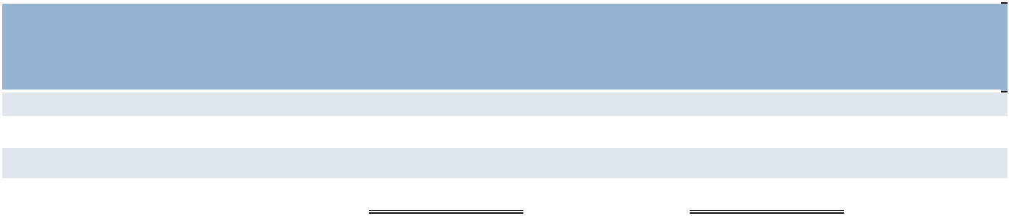

 |  |  |  | Total number of | Maximum number
 |  |  |  | shares purchased | of shares that may
 |  |  | Average | as part of publicly | yet be purchased
 | Total number of |  | price paid | announced plan or | under the plan or
 | shares purchased |  | per share | programs | programs
October 1 - 31, 2025 | — | $ | — | — | 1,931,551
November 1 - 30, 2025 | — |  | — | — | 1,931,551
December 1 - 31, 2025 | 38 | (a) | — | — | 1,931,551
Total | 38 | $ | — | — | 1,931,551

- Represents shares of common stock withheld by ManpowerGroup to satisfy tax withholding obligations on shares acquired by a board member in settlement of deferred stock.

30

Part II

Performance Graph

Set forth below is a graph for the periods ending December 31, 2020-2025 comparing the cumulative total shareholder return on our common stock with the cumulative total return of companies in the Standard & Poor’s 400 Midcap Stock Index and the Standard & Poor’s 1500 Human Resources and Employment Services Sub-Industry Index. We are included in the Standard & Poor’s 1500 Human Resources and Employment Services Sub-Industry Index and we estimate that we constituted less than 1% of the total market capitalization of the companies included in the index. The graph assumes a $100 investment on December 31, 2020 in our common stock, the Standard & Poor’s 400 Midcap Stock Index and the Standard & Poor’s 1500 Human Resources and Employment Services Sub-Industry Index and assumes the reinvestment of all dividends.
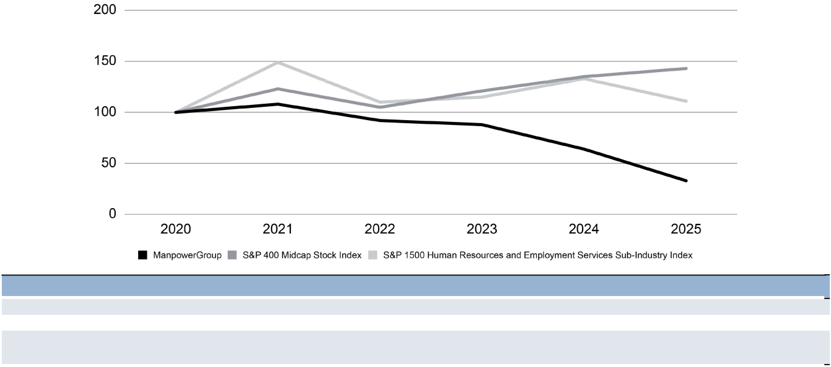

December 31 | 2020 | 2021 | 2022 |  | 2023 |  | 2024 |  | 2025
ManpowerGroup | $ 100 | $ 108 | $ 92 | $ | 88 | $ | 64 | $ | 33
S&P 400 Midcap Stock Index | 100 | 123 | 105 |  | 121 |  | 135 |  | 143
S&P 1500 Human Resources and Employment Services Sub-Industry
Index | 100 | 149 | 110 |  | 115 |  | 133 |  | 111

Item 6. [Reserved]

31

Part II

- Management’s Discussion and Analysis of Financial Condition and Results of Operations

in millions, except share and per share data

Financial Measures — Constant Currency And Organic Constant Currency


Changes in our financial results include the impact of changes in foreign currency exchange rates, acquisitions and dispositions. We provide “constant currency” and “organic constant currency” calculations in this report to remove the impact of these items. We express year-over-year variances that are calculated in constant currency and organic constant currency as a percentage.

When we use the term “constant currency,” it means that we have translated financial data for a period into United States dollars using the same foreign currency exchange rates that we used to translate financial data for the previous period. We believe that this calculation is a useful measure, indicating the actual growth of our operations. We use constant currency results in our analysis of subsidiary or segment performance, including Argentina which operates in a hyperinflationary economy. We also use constant currency when analyzing our performance against that of our competitors. Substantially all of our subsidiaries derive revenues and incur expenses within a single country and, consequently, do not generally incur currency risks in connection with the conduct of their normal business operations. Changes in foreign currency exchange rates primarily impact reported earnings and not our actual cash flow unless earnings are repatriated.

When we use the term “organic constant currency,” it means that we have further removed the impact of acquisitions in the current period and dispositions from the prior period from our constant currency calculation. We believe that this calculation is useful because it allows us to show the actual growth of our ongoing business.

The constant currency and organic constant currency financial measures are used to supplement those measures that are in accordance with United States Generally Accepted Accounting Principles (“GAAP”). These Non-GAAP financial measures may not provide information that is directly comparable to that provided by other companies in our industry, as other companies may calculate such financial results differently. These Non-GAAP financial measures are not measurements of financial performance under GAAP, and should not be considered as alternatives to measures presented in accordance with GAAP.

Constant currency and organic constant currency percent variances, along with a reconciliation of these amounts to certain of our reported results, are included in the Financial Measures section found in Item 7. "Management's Discussion and Analysis of Financial Condition and Results of Operations."

Results of Operations - For Years of Operation Ending December 31, 2025 and 2024

The financial discussion that follows focuses on 2025 results compared to 2024. For a discussion of 2024 results compared to 2023, see the company’s Annual Report on Form 10-K for the year ended December 31, 2024.

During 2025, reported revenues increased 0.6% compared to 2024. After a volatile start to 2025, reflecting macroeconomic and geopolitical uncertainties, including the impact of policy shifts and global trade dynamics, we have seen improved trends in the second half of 2025. We observed the continuation of largely stable activity levels across North America and Europe overall, with improving trends in France, despite ongoing political and budget uncertainty. Latin America and Asia Pacific continued to experience good demand. Employers remain deliberate in their workforce hiring strategies, yet engagement levels are steady and activity levels are becoming more consistent. We are seeing clear sequential improvement in key demand indicators, including Manpower associates on assignment in key markets including the United States and France. Although we are encouraged by signs of stabilization and signs of inflection in certain markets such as Italy and Spain, these trends reinforce our view that the shape of the recovery can be different by market with some inflecting earlier and others requiring longer periods of stabilization before inflecting.

Throughout 2025, the United States dollar weakened, on average, relative to the currencies in most of our markets, and overall had a favorable impact on our reported results. The changes in the foreign currency exchange rates had a 2.7% favorable impact on revenues from services. Substantially all of our subsidiaries derive revenues from services and incur expenses within the same local currency and generally do not have cross-currency transactions, and therefore, changes in foreign currency exchange rates primarily impact reported earnings and not our actual cash flow unless earnings are repatriated. To understand the performance of our underlying business, we utilize constant currency or organic constant currency variances for our consolidated and segment results.

32

Part II

During 2025, we experienced the following quarterly changes to our consolidated revenues compared to 2024: a -7.1% decrease (-4.6% in constant currency and -2.4% in organic constant currency) in revenue in the first quarter due to decreased demand in our Manpower staffing business and softening demand in our Experis interim business; revenue stayed flat (-3.5% in constant currency and -1.4% in organic constant currency) in the second quarter due to an increase in demand for our Manpower staffing business offset by decreased demand in our Experis interim business; a revenue increase of 2.3% (a decrease of -1.5% in constant currency and an increase of 0.7% in organic constant currency) in the third quarter due to an increase in demand for our Manpower staffing business and decreased demand in our Experis interim business; and ending the year with a 7.1% (1.3% in constant currency and 2.2% in organic constant currency) revenue increase in the fourth quarter of 2025 due to the increase in demand for our Manpower staffing services.

During 2025 compared to 2024, most of our markets experienced increased revenues due to currency exchange rates partially offset by softening demand for our staffing, interim and permanent recruitment services. We experienced a 2.9% revenue increase in the Americas primarily driven by an increase in demand for our Manpower staffing services, an increase in demand for our Talent Based Outsourcing (TBO) business and an increase in demand for our Right Management outplacement services, partially offset by a decrease in demand for our Experis interim services and the unfavorable impact of currency exchange rates. We experienced a 2.7% revenue increase in Southern Europe, primarily driven by the favorable impact of currency exchange rates, partially offset by a decrease in demand for our Manpower staffing and Experis interim services and a decrease in demand for our permanent recruitment services. We experienced a revenue decrease of -4.3% in Northern Europe, primarily due to decreased demand in our Manpower staffing and Experis interim services and decreased demand in our permanent recruitment business, partially offset by the favorable impact of currency exchange rates. We experienced a -5.5% revenue decrease in APME driven by the disposition of our South Korea business, partially offset by an increase in demand for our Manpower staffing services, the favorable impact of currency exchange rates, and an increase in demand for our Experis interim services.

From a brand perspective, we experienced a revenue increase in Manpower, partially offset by revenue decreases in our Experis and Talent Solutions brands during 2025 compared to 2024. The revenue increase in our Manpower brand was due to the favorable impact of currency exchange rates, partially offset by decreased demand for our outcome based services and permanent placement business. In our Experis brand, the revenue decrease was primarily due to decreased demand for our interim services, decreased demand for our Experis consulting business, and decreased demand for our Experis permanent placement services. The revenue decrease in our Talent Solutions brand, which includes Recruitment Process Outsourcing (RPO), TAPFIN - MSP, and our Right Management offerings, was driven primarily by decreased activity in our RPO permanent recruitment business, and decreased demand for our Right Management outplacement services.

In 2025 our gross profit margin decreased 60 basis points compared to 2024 primarily due to decreases in our permanent recruitment business, including Talent Solutions RPO, as permanent hiring demand continued to soften and experienced reduced levels from the prior year period. Also, we experienced a decrease in staffing and interim margins due to mix shifts towards enterprise accounts.

In 2025 our operating profit decreased -50.9% while our operating profit margin decreased 90 basis points compared to 2024. The operating profit margin decreased primarily due to the overall decrease in our gross profit margin as well as an increase in selling and administrative expenses due to increased goodwill and intangible asset impairments, corporate expense, and restructuring.

During the year, we initiated significant restructuring actions on businesses heavily impacted by the continuing economic uncertainty. With these actions, we expect our overall cost structure to decline. We expect to continue to monitor expenses closely to maintain the benefit of our efforts to optimize our organizational cost structures. At the same time, we plan to invest appropriately to enable the business to grow in the future and enhance our productivity, technology and digital capabilities. We are focused on managing costs as efficiently as possible in the short term while continuing to progress transformational actions aligned with our strategic priorities.

33

Part II

Consolidated Results - 2025 compared to 2024

The following table presents selected consolidated financial data for 2025 as compared to 2024.
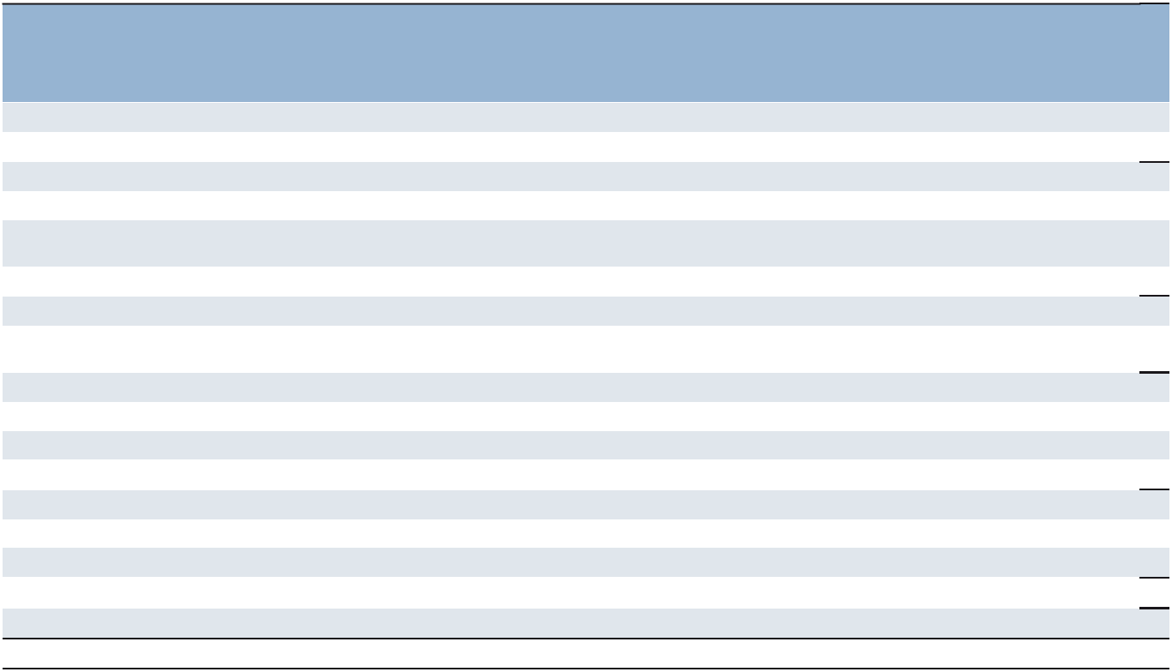

 |  |  |  |  |  |  | Variance in
 |  |  |  |  |  | Variance in | Organic
 |  |  |  |  | Reported | Constant | Constant
(in millions, except per share data) |  | 2025 |  | 2024 | Variance | Currency | Currency
Revenues from services | $ | 17,957.1 | $ | 17,853.9 | 0.6% | (2.1)% | (0.2)%
Cost of services |  | 14,959.5 |  | 14,767.1 | 1.3 | (1.4)
Gross profit |  | 2,997.6 |  | 3,086.8 | (2.9) | (5.1) | (4.1)
Gross profit margin |  | 16.7% |  | 17.3%
Selling and administrative expenses, excluding |  | 2,758.8 |  | 2,780.8 | (0.8) | (2.8)
goodwill impairment charges |  | 2,758.8 |  | 2,780.8 | (0.8) | (2.8)
Goodwill impairment charges |  | 88.7 |  | —
Selling and administrative expenses |  | 2,847.5 |  | 2,780.8 | 2.4 | 0.1 | 1.1
Selling and administrative expenses as a % of |  | 15.9% |  | 15.6%
revenues |  | 15.9% |  | 15.6%
Operating profit |  | 150.1 |  | 306.0 | (50.9) | (52.7) | (51.8)
Operating profit margin |  | 0.8% |  | 1.7%
Net interest expense |  | 67.6 |  | 56.7
Other expenses (income), net |  | (10.9) |  | (7.5)
Earnings before income taxes |  | 93.4 |  | 256.8 | (63.6) | (64.8)
Provision for income taxes |  | 106.7 |  | 111.7 | (4.6)
Effective income tax rate |  | 114.2% |  | 43.5%
Net (loss) earnings | $ | (13.3) | $ | 145.1 | (109.2) | (108.9)
Net (loss) earnings per share - diluted | $ | (0.29) | $ | 3.01 | (109.5) | (109.2)
Weighted average shares - diluted |  | 46.6 |  | 48.3 | (3.5)%

The year-over-year increase in revenues from services of 0.6% (-2.1% in constant currency and -0.2% in organic constant currency) was attributed to:

a revenue increase in the Americas of 2.9% (increase of 4.4% in constant currency) primarily driven by a $292.1 increase in demand for our Manpower staffing services, a $14.6 increase in demand for TBO, partially offset by a $133.5 decrease in demand for our Experis interim services and the $60.9 unfavorable impact of currency exchange rates. The United States, our largest market in the Americas, experienced a revenue decrease of -1.1% primarily driven by a $117.4 decrease in demand for our Experis interim services and a $16.1 decrease in demand for our permanent recruitment services, partially offset by a $75.0 increase in our Manpower staffing services;

a revenue increase in Southern Europe of 2.7% (-2.0% in constant currency and -1.5% in organic constant currency) primarily driven by a $386.0 favorable impact due to currency exchange rates and a $17.4 increase in demand for our consulting services, partially offset by a $142.9 decrease in demand for our Manpower staffing services, a $27.5 decrease in demand for our outcome based solutions and an $8.6 decrease in demand for our permanent recruitment services. France, the largest market in Southern Europe, experienced a revenue decrease of -1.6% (-5.9% in constant currency) primarily driven by a $250.1 decrease in demand for our Manpower staffing services, partially offset by a $197.4 favorable impact from currency exchange rates. Italy, our second-largest market in Southern Europe, experienced a revenue increase of 8.6% (3.8% in constant currency) primarily driven by an $80.5 favorable impact in currency exchange rates, a $61.0 increase in demand for our Manpower staffing services and an $11.4 increase in demand for our consulting business;

a revenue decrease in Northern Europe of -4.3% (-8.3% in constant currency and -8.1% in organic constant currency), primarily due to decreased demand of $112.0 for our Experis interim services, an $85.5 decrease in demand for our Manpower staffing services, a $25.2 decrease in demand in our permanent recruitment business, and a $19.2 decrease in demand in our consulting business, partially offset by the $132.4 favorable impact of currency exchange rates. Within our Northern Europe segment, we experienced revenue decreases in the United Kingdom of $101.5, Germany of $97.2, the Nordics of $12.8, Netherlands of $2.3 and an increase in Belgium of $27.0, which represented revenue decreases of -8.9%, -20.4%, -2.0%, and -0.6% and an increase of 8.7%, respectively (-11.7%, - 23.7%, -7.0%, and -4.9% and an increase of 3.7%, respectively, in constant currency); and

34

Part II

a revenue decrease in APME of -5.5% (-6.3% in constant currency and an increase of 7.4% in organic constant currency) primarily driven by the disposition and franchising of our South Korea business in 2024. Offsetting the disposition was an increase in demand of $122.9 in our Manpower staffing business, a $17.3 favorable impact of currency exchange rates, and an increase in demand of $8.3 in our Experis interim service.

The year-over-year 60 basis point decrease in gross profit margin was primarily attributed to:

a 25 basis point unfavorable impact due to decreases in permanent recruitment, including Talent Solutions RPO, as permanent hiring demand continued to soften and experienced reduced levels from the prior year period;

a 25 basis point unfavorable impact from the decrease in staffing and interim margins due to mix shifts towards enterprise clients; and

a 10 basis point unfavorable impact from decreased career transition activity in Right Management as outplacement activity increased.

The 2.4% increase in selling and administrative expenses in the year ended December 31, 2025 (0.1% in constant currency and 1.1% in organic constant currency) was primarily attributed to:

an $88.7 increase in goodwill and other impairment charges as no impairment was recorded in 2024; a $63.5 increase due to the impact of changes in currency exchange rates;

a $38.6 increase in corporate expense due to incremental investments in our transformation initiatives, one-time benefits in 2024 related to the disposition and franchising of our South Korea business and the release of a healthcare reserve; and

restructuring costs of $64.2 in 2025 compared to $53.6 incurred in 2024; partially offset by

a $69.9 decrease, (-1.8% reported, -3.9% in constant currency, and -2.9% in organic constant currency) in personnel costs primarily due to a $41.2 decrease in salary costs and a $23.8 decrease in bonuses & sales commissions; and

a $45.0 decrease, (-3.9% reported, -4.4% in constant currency, and -4.5% in organic constant currency) in non-personnel costs, primarily due to a $20.8 decrease in office lease and other office costs, an $8.8 decrease in consulting and outside services costs, and a $4.7 decrease in travel and entertainment cost.

Selling and administrative expenses as a percentage of revenues increased 30 basis points in the year ended December 31, 2025 compared to the year ended December 31, 2024 due primarily to:

a 50 basis point unfavorable impact due to goodwill and other impairment charges; a 30 basis point unfavorable impact due to increase corporate expense;
a 20 basis point favorable impact due to lower personnel costs;

a 20 basis point favorable impact as a result of lower lease and office related costs; and a 10 basis point favorable impact due to currency exchange rates.

Interest and other expenses, net is comprised of interest, foreign exchange gains and losses and other miscellaneous non-operating income and expenses, including those associated with noncontrolling interests. Interest expense, net was $67.6 in 2025 compared to $56.7 in 2024 resulting from increased short term borrowings in 2025 compared to 2024. Foreign exchange loss, net was $6.5 in 2025 compared to $6.2 in 2024. Miscellaneous income, net was $17.4 in 2025 compared to $13.7 in 2024.

We recorded income tax expense at an effective rate of 114.2% for 2025, as compared to an effective rate of 43.5% for 2024. The 2025 rate was unfavorably impacted by the goodwill and indefinite-lived intangible asset impairment charges recorded in Switzerland and the United Kingdom. The 2025 rate was also unfavorably impacted by the lower level and overall mix of earnings due in part to restructuring costs recorded and the 2025 enacted French exceptional corporate income tax surcharge. The 114.2% effective tax rate for 2025 was higher than the United States Federal statutory rate of 21% primarily due to the factors noted above as well as tax losses in certain countries for which we did not recognize a corresponding tax benefit due to valuation allowances and the French business tax.

35

Part II

Net loss per share - diluted was $0.29 in 2025 compared to net earnings per share - diluted of $3.01 in 2024. Goodwill and other impairment charges recorded in 2025 negatively impacted net earnings per share - diluted by approximately $1.78 per share, net of tax. Restructuring costs recorded in 2025 and 2024 negatively impacted net earnings per share - diluted by approximately $1.16 and $1.10 per share, net of tax, in 2025 and 2024, respectively. The loss from the disposition of subsidiaries recorded in the of 2025 and other items unfavorably impacted net earnings per share - diluted by approximately $0.26, net of tax. The pension settlement expense recorded in 2025 and 2024 negatively impacted net earnings per share - diluted by approximately $0.04 and $0.08, net of tax, in 2025 and 2024, respectively.

Weighted average shares - diluted decreased to 46.6 million in 2025 from 47.7 million in 2024. This decrease was due to the impact of share repurchases completed in 2025, partially offset by grants of share-based awards.

Segment Results

We evaluate performance based on operating unit profit (“OUP”), which is equal to segment revenues less direct costs and branch and national headquarters operating costs. This profit measure does not include goodwill and intangible asset impairment charges or amortization of intangible assets related to acquisitions, corporate expenses, interest and other income and expense amounts or income taxes.

Americas

In the Americas, revenues from services increased 2.9% (4.4% in constant currency) in 2025 compared to 2024. In the United States, revenues from services decreased -1.1% in 2025 compared to 2024, primarily driven by a $117.4 decrease in demand for our Experis interim services and a $16.1 decrease in demand for our permanent recruitment services, partially offset by a $75.0 increase in demand for our Manpower staffing services. In Other Americas, revenues from services increased 10.6% (14.8% in constant currency) in 2025 compared to 2024 primarily driven by a $217.1 increase in demand for our Manpower staffing service and a $14.6 increase in demand for our TBO business, partially offset by the $60.9 unfavorable impact of foreign currency exchange rates and a $16.1 decrease in demand for our Experis interim service. The constant currency increase in Other Americas was primarily driven by the inflation in Argentina. Within our Other Americas segment, we experienced increases in Chile, Colombia, Peru, and Argentina of $49.9, $39.9, $30.9, and $11.8, or 37.2%, 25.4%, 24.8%, and 9.4%, respectively (37.9%, 23.9%, 18.3%, and 47.5%, respectively, in constant currency), partially offset by a revenue decrease in Canada of $15.9, or -5.1% (-3.3% in constant currency).

Gross profit margin decreased 140 basis points in 2025 compared to 2024. This decrease was primarily due to decreased demand in our Experis interim services, which contributed 110 basis points to the decrease and decreased demand in our Talent Solutions business, which contributed 40 basis points to the decrease. These decreases were partially offset by increased margins in our training business, which had a 10 basis point impact.

Selling and administrative expenses decreased -3.2% (-2.1% in constant currency) in 2025 compared to 2024, primarily driven by the $11.9 decrease in non-personnel costs and the $8.5 favorable impact of currency exchange rates.

OUP decreased -3.3% (-2.6% in constant currency) in 2025, which represents a 3.1% OUP margin, a decrease from 3.4% in 2024. This decrease was primarily due to decreased profitability in our United States business of $11.7, which experienced decreased activity in our Experis interim business and decreased activity in our higher-margin permanent recruitment business, partially offset by a decrease in our selling and administrative expenses as a percentage of revenue. In the United States, OUP margin decreased to 2.4% in 2025 from 2.8% in 2024 primarily due to decreased activity in our Experis interim business and decreased activity in our higher-margin permanent recruitment business, partially offset by a decrease in our selling and administrative expenses as a percentage of revenue. Other Americas OUP margin remained flat at 4.4% in 2025 compared to 2024.

Southern Europe

In Southern Europe, revenues from services increased 2.7% (- 2.0% in constant currency and -1.5% in organic constant currency) in 2025 compared to 2024. In France, revenues from services decreased -1.6% (-5.9% in constant currency) in 2025 compared to 2024, primarily driven by a $250.1 decrease in demand for our Manpower staffing services, partially offset by a $197.4 increase due to the favorable impact of currency exchange rates. In Italy, revenues from services increased 8.6% (3.8% in constant currency) in 2025 compared to 2024, primarily driven by an $80.5 impact due to the favorable impact of currency exchange rates, a $61.0 increase in demand for our Manpower staffing services and an $11.4 increase in demand for our consulting business. In Other Southern Europe, revenues from services increased 7.2% (1.8% in constant currency and 4.3% in organic constant currency) in 2025 compared to 2024, primarily driven by the $108.1 favorable impact of currency exchange rates and a $46.2 increase in demand for our Manpower staffing services, partially offset by a $ 17.0 decrease in demand in our TBO business. Within our Other Southern Europe segment, we experienced revenue increases in Spain and Israel of $95.3 and $64.6, or 18.5% and 18.0%, respectively (13.0% and 9. 7%, respectively, in constant currency), partially offset by a revenue decrease in Switzerland of $28.0, or -6.5% (-12.1% in constant currency).

Gross profit margin decreased 40 basis points in 2025 compared to 2024. This decrease was primarily due to increased activity in our lower margin Manpower staffing services, which contributed 30 basis points to the decrease and a decrease across our permanent placement business, which contributed 10 basis points to the decrease.

36

Part II

Selling and administrative expenses, excluding impairment charges, increased 4.8% (0.1% in constant currency and 0.8% in organic constant currency) during 2025 compared to 2024 primarily due to the unfavorable impact of currency exchange rates of $41.7, $8.2 increase in restructuring costs, and $5.2 increase in consulting and outside services, partially offset by a $15.7 decrease in salary-related costs as a result of restructuring actions taken in prior years.

OUP decreased -14.3% (-18.4% in constant currency and -18.8% in organic constant currency) in 2025, which represents a 3.1% OUP margin, a decrease from 3.7% in 2024. This OUP decrease was primarily due to decreased profitability in the France reporting unit of $39.7. In France, the OUP margin decreased to 2.5% in 2025 compared to 3.3% in 2024 primarily driven by an increase in lower margin staffing demand and a decrease in our higher- margin permanent recruitment business. In Italy, the OUP margin decreased to 6.4% in 2025 from 6.7% in 2024 primarily driven by increased demand in our lower margin staffing business. In Other Southern Europe, the OUP margin decreased to 1.6% in 2025 from 2.1% in 2024 primarily due to a decrease in gross profit margin driven by softer permanent recruitment demand.

Northern Europe

In Northern Europe, the largest country operations include the United Kingdom, the Nordics, Germany, the Netherlands and Belgium (comprising 33%, 19%, 12%, 12% and 11%, respectively). In the Northern Europe region, revenues from services decreased -4.3% (-8.3% in constant currency and -8.1% in organic constant currency) in 2025 compared to 2024, primarily due to a decrease in demand of $112.0 for our Experis interim service, an $85.5 decrease in demand for our Manpower staffing service, a decrease in demand of $25.2 in our permanent recruitment business and a decrease in demand of $19.2 in our consulting business, partially offset by the $132.4 favorable impact of currency exchange rates. Within our Northern Europe segment, we experienced revenue decreases in the United Kingdom of $101.5, Germany of $97.2, the Nordics of $12.8, and Netherlands of $ $2.3, and an increase in Belgium of $27.0, which represented revenue decreases of -8.9%, -20.4%, -2.0%, and -0.6% and an increase of 8.7%, respectively (decreases of -11.7%, -23.7%, - 7.0%, and -4.9% and an increase of 3.7%, respectively, in constant currency).

Gross profit margin decreased by 90 basis points in 2025 compared to 2024 primarily due to decreased activity in our Talent Solutions brand, which contributed 50 basis points to the decrease and decreased activity in our Experis brand, which contributed 40 basis points to the decrease.

Selling and administrative expenses, excluding impairment charges, decreased -9.0% (-12.8% in constant currency and - 12.7% in organic constant currency) in 2025 compared to 2024. The decrease is primarily driven by a $59.0 decrease in personnel costs as we experience the impacts of significant restructuring actions taken in 2025 and 2024 and a $15.1 decrease in office and lease related costs incurred in 2025 compared to 2024, partially offset by an increase of $23.8 due to currency exchange rates.

Operating unit loss in Northern Europe improved 2.9% (7.5% in constant currency and 8.4% in organic constant currency) in 2025, which represents a -1.4% OUP margin, a decrease from -1.3% in 2024. The lower operating unit loss was primarily driven by an increase in profitability in Germany and the Nordics, which experienced profitability increases of $7.7 and $6.0, respectively, partially offset by an OUP decrease in the United Kingdom of $22.3.

APME

Revenues from services decreased -5.5% (-6.3% in constant currency and an increase of 7.4% in organic constant currency) in 2025 compared to 2024. In Japan, revenues from services increased 7.3% (5.9% in constant currency) primarily driven by a $50.1 increase in demand for our Manpower staffing services, a $15.7 favorable impact of currency exchange rates, and an $8.3 increase in demand for our Experis interim services.

Gross profit margin increased 90 basis points in 2025 compared to 2024 primarily due to the South Korea disposition in 2024.

Selling and administrative expenses decreased -6.8% (-7.5% in constant currency and increased 0.4% in organic constant currency) in 2025 compared to 2024. The decrease is primarily driven by the $19.8 decrease in non-personnel costs due to the South Korea Disposition.

OUP in APME increased 20.4% (19.1% in constant currency and 28.7% in organic constant currency), in 2025, which represents a 4.9% OUP margin, an increase from 3.9% in 2024. This OUP increase was primarily driven by increased margins in our Manpower staffing and Experis interim services and a decrease in selling and administrative expenses.

37

Part II

Financial Measures
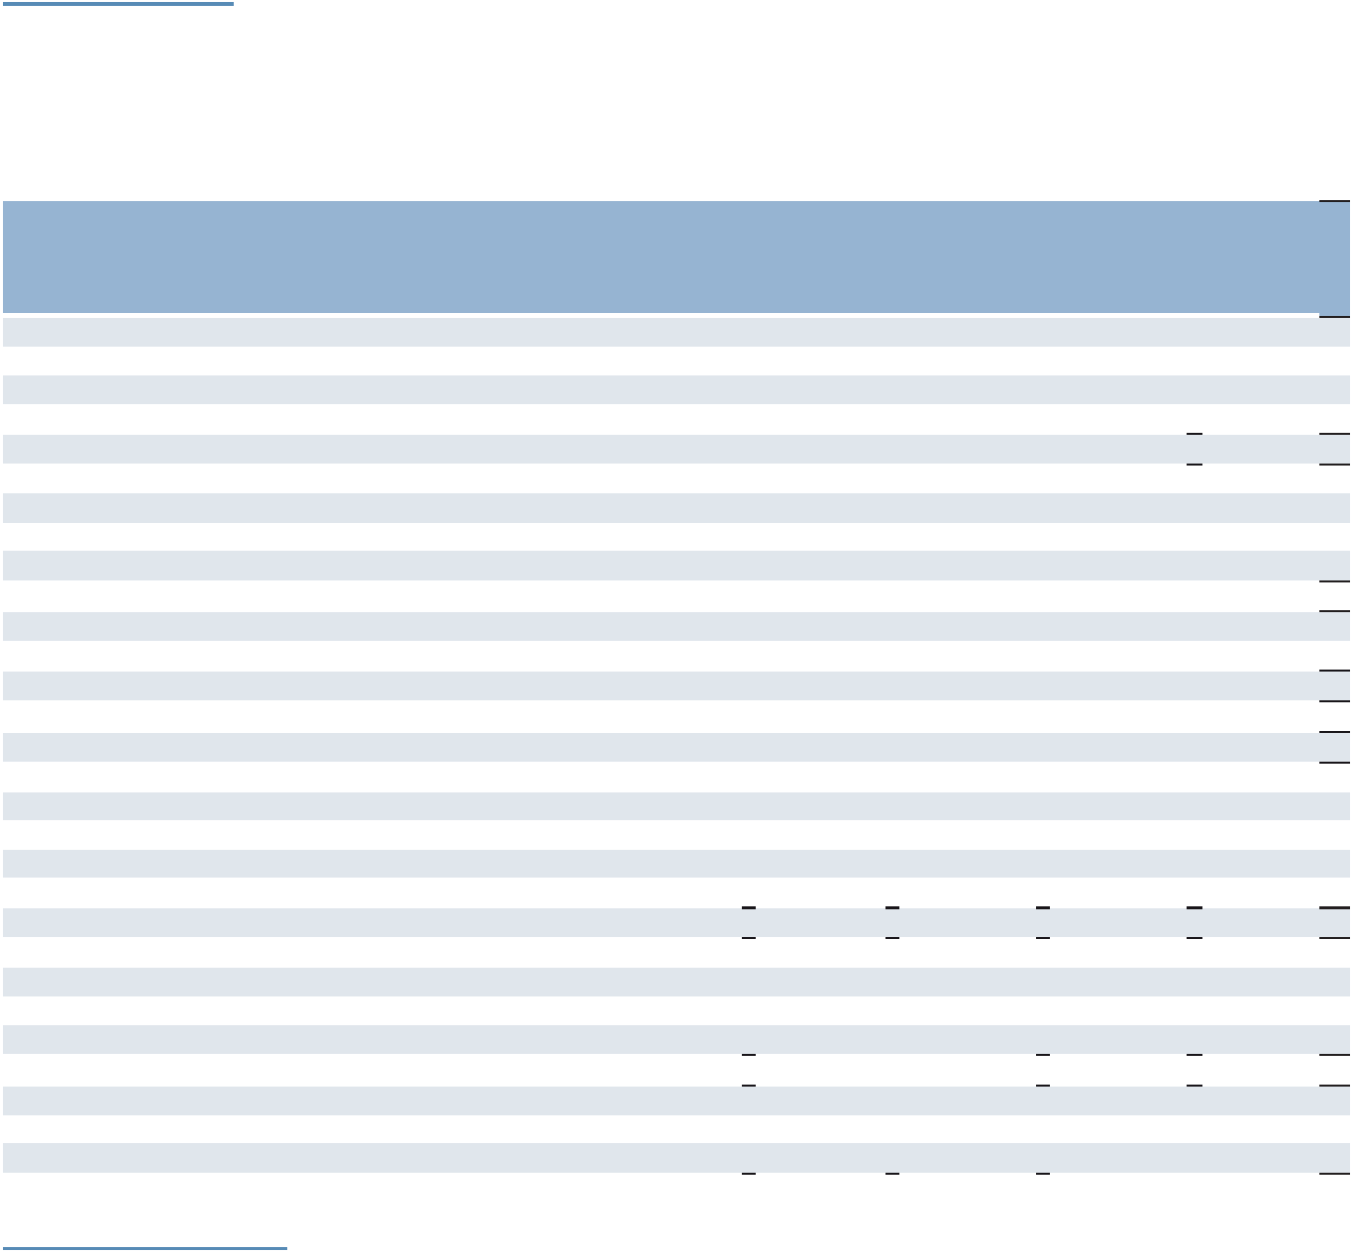

Constant Currency And Organic Constant Currency Reconciliation

Certain constant currency and organic constant currency percent variances are discussed throughout this report. A reconciliation of these Non-GAAP percent variances to the percent variances calculated based on our annual GAAP financial results is provided below. (See Financial Measures - Constant Currency and Organic Constant Currency on page 32 for information.)

 |  |  |  |  |  |  |  |  | Impact of
 |  |  |  |  |  |  |  |  | Acquisitions
 |  |  |  |  |  |  |  |  | and |  | Organic
Amounts represent 2025 |  | Reported |  |  |  |  | Variance in |  | Dispositions |  | Constant
Percentages represent 2025 compared |  | Amount | Reported |  | Impact of |  | Constant |  | (in Constant |  | Currency
to 2024 |  | (in millions) | Variance |  | Currency |  | Currency |  | Currency) |  | Variance
Revenues from Services
Americas:
United States | $ | 2,735.4 | (1.1)% |  | — | (1.1)% |  |  | — | (1.1)%
Other Americas |  | 1,613.4 | 10.6% |  | (4.2)% | 14.8% |  |  | — |  | 14.8%
 |  | 4,348.8 | 2.9% |  | (1.5)% | 4.4% |  |  | — |  | 4.4%
Southern Europe:
France |  | 4,459.4 | (1.6)% |  | 4.3% | (5.9)% |  |  | — | (5.9)%
Italy |  | 1,822.1 | 8.6% |  | 4.8% | 3.8% |  |  | — | 3.8%
Other Southern Europe |  | 2,154.8 | 7.2% |  | 5.4% | 1.8% |  |  | (2.5)% | 4.3%
 |  | 8,436.3 | 2.7% |  | 4.7% | (2.0)% |  |  | (0.5)% | (1.5)%
Northern Europe |  | 3,161.1 | (4.3)% |  | 4.0% | (8.3)% |  |  | (0.2)% | (8.1)%
APME |  | 2,041.9 | (5.5)% |  | 0.8% | (6.3)% |  |  | (13.7)% | 7.4%
 |  | 17,988.1
Intercompany Eliminations |  | (31.0)
ManpowerGroup | $ | 17,957.1 | 0.6% |  | 2.7% | (2.1)% |  |  | (1.9)% | (0.2)%
Gross Profit - ManpowerGroup | $ | 2,997.6 | (2.9)% |  | 2.2% | (5.1)% |  |  | (1.0)% | (4.1)%
Operating Unit Profit (Loss)
Americas:
United States | $ | 66.0 | (15.1)% |  | — | (15.1)% |  |  | — | (15.1)%
Other Americas |  | 70.9 | 11.0% |  | (1.7)% | 12.7% |  |  | — | 12.7%
 |  | 136.9 | (3.3)% |  | (0.7)% | (2.6)% |  |  | — | (2.6)%
Southern Europe:
France |  | 109.9 | (26.5)% |  | 3.5% | (30.0)% |  |  | — | (30.0)%
Italy |  | 115.8 | 2.3% |  | 4.6% | (2.3)% |  |  | — | (2.3)%
Other Southern Europe |  | 34.9 | (15.7)% |  | 4.7% | (20.4)% |  |  | 2.6% | (23.0)%
 |  | 260.6 | (14.3)% |  | 4.1% | (18.4)% |  |  | 0.4% | (18.8)%
Northern Europe |  | (43.3) | 2.9% |  | (4.6)% | 7.5% |  |  | (0.9)% | 8.4%
APME |  | 100.6 | 20.4% |  | 1.3% | 19.1% |  |  | (9.6)% | 28.7%
Operating Profit - ManpowerGroup | $ | 150.1 | (50.9)% |  | 1.8% | (52.7)% |  |  | (0.9)% | (51.8)%

Cash Sources and Uses

Cash used to fund our operations is primarily generated through operating activities and provided by our existing credit facilities. We believe our available cash and existing credit facilities are sufficient to cover our cash needs for the foreseeable future. We assess and monitor our liquidity and capital resources globally. We use a global cash pooling arrangement, intercompany lending, and some local credit lines to meet funding needs and allocate our capital resources among our various entities. As of December 31, 2025, we had $236.1 of cash held by foreign subsidiaries. We have historically made and anticipate future cash repatriations to the United States from certain foreign subsidiaries to fund corporate activities. As of December 31, 2025, deferred taxes related to non-United States withholding and other taxes were provided on $1,662.1 of accumulated unremitted earnings of non-United States subsidiaries that may be remitted to the United States. As of December 31, 2025 and 2024, we have recorded a deferred tax liability of $28.2 and $25.9, respectively, related to these non-United States earnings that may be remitted. As of December 31, 2025, we had an additional $372.0 of accumulated unremitted earnings of non-United States subsidiaries for which we have not provided deferred taxes as amounts are deemed indefinitely reinvested. We have not estimated the deferred tax liability on these earnings as such estimation is not practicable to determine or immaterial to the financial statements.

38

Part II

Our principal ongoing cash needs are to finance working capital, capital expenditures, debt payments, interest expense, dividends, share repurchases and acquisitions. Working capital is primarily in the form of trade receivables, which generally increase as revenues increase. The amount of financing necessary to support revenue growth depends on receivables turnover, which differs in each market where we operate.

Cash used in operating activities was $104.1 in 2025, as compared to $309.2 generated in 2024. Changes in operating assets and liabilities utilized $269.3 of cash in 2025, compared to $65.4 generated in 2024. These changes were primarily attributable to the timing of collections and payments, as well as an increase in capitalized implementation costs related to our cloud computing arrangements.

Accounts receivable increased to $4,770.3 as of December 31, 2025 from $4,297.2 as of December 31, 2024. The increase was partly attributable to the impact of changes in currency exchange rates. DSO increased by approximately three days from December 31, 2024 to 55 days as of December 31, 2025 due to unfavorable mix changes, with higher growth in countries with a higher average DSO.

Cash used in investing activities were $59.2 and $68.2 for 2025 and 2024, respectively. Capital expenditures were $57.3 and $51.1 during 2025 and 2024, respectively. These expenditures were comprised of purchases of computer equipment, office furniture and other costs related to office openings and refurbishments, as well as capitalized software costs of $17.9 and $10.1 in 2025 and 2024, respectively.

Cash provided by financing activities was $485.5 in 2025 compared to $282.4 used in 2024. Net debt borrowings were $586.1 in 2025 as compared to net debt borrowings of $16.1 in 2024. The larger borrowings in 2025 were due to the issuance of €500.0 notes in December 2025 which were used to redeem our 2018 notes in January 2026.

The Board of Directors authorized the repurchase of 5.0 million and 4.0 million shares of our common stock in August 2023 and August 2021, respectively. Share repurchases may be made from time to time through a variety of methods, including open market purchases, block transactions, privately negotiated transactions or similar facilities. In 2025, we repurchased a total of 0.7 million shares under the 2023 authorization, at a total cost of $37.5 including excise tax on share repurchases of $0.5. In 2024, we repurchased a total of 2.0 million shares under the 2023 authorization, at a total cost of $140.9 including excise tax on share repurchases of $0.9. As of December 31, 2025, there were 1.9 million shares remaining authorized for repurchase under the 2023 authorization.

During 2025 and 2024, the Board of Directors declared total cash dividends of $1.44 and $3.08 per share, respectively, resulting in total dividend payments of $66.7 and $145.8, respectively.

As of December 31, 2025, we had aggregate commitments of $3.130.9 related to debt, operating leases, purchase obligations for global technology and financial shared services, and restructuring costs, as follows:
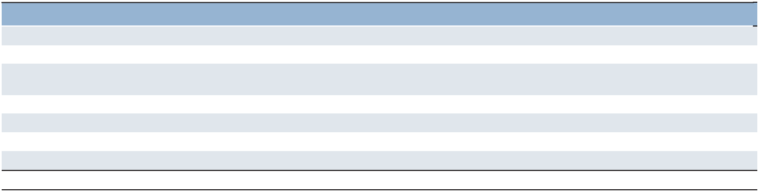

(in millions) |  | Total |  | 2026 |  |  | 2027-2028 |  | 2029-2030 |  | Thereafter
Long-term debt including interest | $ | 1,795.8 | $ | 639.2 | (a) | $ | 528.8 | $ | 627.8 | $ | —
Short-term borrowings |  | 34.6 |  | 34.6 |  |  | — |  | — |  | —
Purchase obligations for global technology and |  | 538.6 |  | 125.6 |  |  | 216.8 |  | 144.1 |  | 52.1
financial shared services |  | 538.6 |  | 125.6 |  |  | 216.8 |  | 144.1 |  | 52.1
Operating leases |  | 458.6 |  | 122.0 |  |  | 171.2 |  | 95.8 |  | 69.6
Pension funding commitments |  | 95.9 |  | 8.4 |  |  | 13.4 |  | 19.5 |  | 54.6
Restructuring costs |  | 35.1 |  | 34.7 |  |  | 0.4 |  |  |  | —
Other^{(b)} |  | 172.3 |  | 98.2 |  |  | 67.6 |  | 4.9 |  | 1.6
 | $ | 3,130.9 | $ | 1,062.7 |  | $ | 998.2 | $ | 892.1 | $ | 177.9

- Includes €500.0 notes redeemed in January 2026.

- Includes local information technology contracts and other vendor commitments.

Our liability for unrecognized tax benefits, including related interest and penalties, of $15.6 is excluded from the commitments above as we cannot determine the years in which these positions might ultimately be settled.

We recorded net restructuring costs of $64.2 and $53.6 in 2025 and 2024, respectively, in selling and administrative expenses, primarily related to severance, office closures and consolidations, and professional and other fees related to restructuring in multiple countries and territories. The costs paid out of our restructuring reserve were $72.9 in 2025.

39

Part II

We have entered into guarantee contracts and stand-by letters of credit that total $626.1 as of December 31, 2025 ($582.3 for guarantees and $43.8 for stand-by letters of credit). The guarantees primarily relate to staffing license requirements, operating leases and indebtedness. The stand-by letters of credit mainly relate to workers’ compensation in the United States. If certain conditions were met under these arrangements, we would be required to satisfy our obligation in cash. Due to the nature of these arrangements and our historical experience, we do not expect to make any significant payments under these arrangements. Therefore, they have been excluded from our aggregate commitments identified above. The cost of these guarantees and letters of credit was $1.7 for 2025.

Total capitalization as of December 31, 2025 was $3,737.4, comprised of $1,677.1 in debt and $2,060.3 in equity. Debt as a percentage of total capitalization was 45% and 31% as of December 31, 2025 and 2024, respectively. The higher debt percentage in 2025 was due to the issuance of €500.0 notes in December 2025, which were used to redeem our 2018 notes in January 2026.

Acquisitions

From time to time, we acquire and invest in companies throughout the world, including franchises. The total cash consideration paid for acquisitions, net of cash acquired, for the years ended December 31, 2025 and 2024 was $2.3 and $7.7, respectively. The 2025 payments mainly represent a contingent consideration payment related to a previous acquisition. The 2024 payments represent a consideration payment for a franchise in the United States and contingent consideration payments related to a previous acquisition.

As of December 31, 2025, goodwill and other intangible assets resulting from the 2025 acquisitions were $0.9 and $0.0, respectively. As of December 31, 2024, goodwill and other intangible assets resulting from the 2024 acquisitions were $1.4 and $3.1, respectively.

Dispositions

Occasionally, we dispose of parts of our operations based on risk considerations and to optimize our global strategic and geographic footprint as well as improve our overall efficiency. On May 31, 2025, we disposed of our New Caledonia business in our APME segment and simultaneously entered into a franchise agreement. In connection with this transaction, we recognized a one-time net loss on disposition of $1.4, of which $0.2 was included in selling and administrative expenses and $1.2 was included in interest and other expenses in the Consolidated Statements of Operations in the year ended December 31, 2025.

On May 30, 2025, we disposed of our South Africa business in our Northern Europe segment in exchange for a non-interest-bearing loan receivable of $1.4 and simultaneously entered into a franchising agreement. We recognized a one-time net loss on disposition of $4.8, of which $2.2 was included in selling and administrative expenses and $2.6 was included in interest and other expenses in the Consolidated Statements of Operations in the year ended December 31, 2025.

On November 1, 2024, we disposed of our South Korea business in our APME segment for cash proceeds of $20.6 and simultaneously entered into a franchising agreement under which the new ownership will operate Manpower Korea under the Manpower brand. In connection with the disposition, we recognized a one-time net loss on disposition of $0.4, consisting of a $3.3 gain in selling and administrative expenses and a $3.7 loss in interest and other expenses in the Consolidated Statements of Operations in the year ended December 31, 2024. The franchise arrangement represents a significant component of the transaction. Our South Korea business contributed $349.9 of revenues for the year ended December 31, 2023.

On October 15, 2024, we disposed of our Austria business in our Southern Europe segment for cash proceeds of $0.1 and simultaneously entered into a franchising agreement. In connection with the disposition, we recognized a one-time net loss on disposition of $7.7, of which $4.9 was included in selling and administrative expenses and $2.8 was included in interest and other expenses in the Consolidated Statements of Operations in the year ended December 31, 2024.

Euro Notes

On December 15, 2025, we offered and sold €500.0 aggregate principal amount of the Company’s 3.750% notes due December 2030 (the “2025 €500.0 notes”). The net proceeds from the 2025 €500.0 notes of €497.4 were used in January 2026 to redeem our 2018 €500.0 notes due June 22, 2026. The 2025 €500.0 notes were issued at a price of 99.839% to yield an effective interest rate of 3.786%. Interest on the 2025 €500.0 notes is payable in arrears on December 13 of each year. The 2025 €500.0 notes are unsecured senior obligations and rank equally with all of the Company’s existing and future senior unsecured debt and other liabilities.

40

Part II

On June 30, 2022, we offered and sold €400.0 aggregate principal amount of the Company’s 3.50% notes due June 30, 2027 (the “2022 €400.0 notes”). The proceeds from the 2022 €400.0 notes were used in July 2022 to redeem our €400.0 1.875% notes due September 11, 2022. The 2022 €400.0 notes were issued at a price of 99.465% to yield an effective interest rate of 3.514%, net of a favorable impact of a forward starting interest rate swap. Interest on the 2022 €400.0 notes is payable in arrears on June 30 of each year. The Notes are unsecured senior obligations and rank equally with all of the Company’s existing and future senior unsecured debt and other liabilities.

On June 22, 2018, we offered and sold €500.0 aggregate principal amount of the Company’s 1.750% notes due June 2026 (the “2018 €500.0 notes”). The net proceeds from the 2018 €500.0 notes of €495.7 were used to redeem our €350.0 notes due June 22, 2018, with the remaining balance used for general corporate purposes, which included share repurchases. The 2018 € 500.0 notes were issued at a price of 99.564% to yield an effective interest rate of 1.809%. We redeemed those notes in January 2026 using the proceeds from the 2025 €500.0 notes.

Both the 2018 €500.0 notes and 2022 €400.0 notes contain certain customary non-financial restrictive covenants and events of default and are unsecured senior obligations and rank equally with all of our existing and future senior unsecured debt and other liabilities. These notes have been designated as a hedge of our net investment in subsidiaries with a Euro-functional currency as of December 31, 2025. Since our net investment in these subsidiaries exceeds the respective amount of the designated borrowings, the related translation gains or losses are included as a component of accumulated other comprehensive loss ("AOCL"). (See the Significant Matters Affecting Results of Operations section and Notes 8 and 12 to the Consolidated Financial Statements found in Item 8. "Financial Statements and Supplementary Data" for further information.)

Revolving Credit Agreement

On December 15, 2025, we entered into a new $600.0 five-year Credit Agreement (the “Credit Agreement”) with a syndicate of commercial banks to replace our previous $600.0 revolving credit facility. The Credit Agreement includes increased allowances for restructuring and related charges added back to earnings for covenant calculations and other terms, generally consistent with our previous revolving credit facility. The Credit Agreement allows for borrowing of $600.0 in various currencies, and up to $150.0 may be used for the issuance of stand-by letters of credit. We may request an increase in revolving credit commitments under the facility of up to $300.0 in certain circumstances.

We had no borrowings under our $600.0 credit facility as of December 31, 2025 and 2024. Outstanding letters of credit issued totaled $0.4, hence additional borrowings of $599.6 were available to us under the facility as of both December 31, 2025 and 2024.

Under the Credit Agreement, a credit ratings-based pricing grid determines the facility fee and the credit spread that we add to the applicable interbank borrowing rate on all borrowings. At our current credit rating, the annual facility fee is 12.5 basis points paid on the entire facility and the credit spread is 112.5 basis points on any borrowings.

The Credit Agreement contains customary restrictive covenants pertaining to our management and operations, including limitations on the amount of subsidiary debt that we may incur, limitation on dividends and share repurchases if our leverage ratio (Net Debt-to-EBITDA) exceeds 3.0 to 1. EBITDA is defined as net earnings before interest and other expenses, provision for income taxes, intangible asset amortization expense and depreciation and amortization expense. The agreement also includes limitations on our ability to pledge assets, as well as financial covenants requiring that we comply with a maximum leverage ratio of 3.5 to 1 and a minimum fixed charge coverage ratio of 1.5 to 1.

For covenant purposes, net debt is defined as total debt less cash in excess of $200.0 through December 31, 2025 and less cash in excess of $300.0 thereafter. The agreement allows certain restructuring expenses to be excluded from EBITDA, up to fixed annual amounts for 2025, 2026 and 2027, and up to 15% of EBITDA beginning in 2028.

The Credit Agreement contains customary events of default, including, among others, payment defaults, material inaccuracy of representations and warranties, covenant defaults, bankruptcy or involuntary proceedings, certain monetary and non-monetary judgments, change of control and customary ERISA defaults.

As defined in the Credit Agreement, we had a net Debt-to-EBITDA ratio of 2.78 to 1 (compared to the maximum allowable ratio of 3.5 to 1) and a Fixed Charge Coverage ratio of 2.72 to 1 (compared to the minimum required ratio of 1.5 to 1) as of December 31, 2025.

Other

In addition to the previously mentioned facilities, we maintain separate bank credit lines with financial institutions to meet working capital needs of our subsidiary operations. As of December 31, 2025, such uncommitted credit lines totaled $363.1, of which $325.0 was unused. Under the Credit Agreement, total subsidiary borrowings cannot exceed $300.0 in the first, second and fourth quarters, and $600.0 in the third quarter of each year. Additional borrowings of $261.9 could have been made under these lines as of December 31, 2025.

41

Part II

Our long-term debt has a rating of Baa1 with stable outlook from Moody's Investor Services and BBB- from Standard and Poor's with negative outlook. Both of the credit ratings are investment grade. Rating agencies use proprietary methodology in determining their ratings and outlook which includes, among other things, financial ratios based upon debt levels and earnings performance.

Assessment of the Liquidity Position

We have assessed our liquidity position as of December 31, 2025 and for the near future. As of December 31, 2025, our cash and cash equivalents balance was $871.0. We also have access to the previously mentioned revolving credit facility that could have immediately provided us with up to $600.0 of additional cash, less any outstanding borrowings and letters of credit, and we have an option to request an increase to the total availability under the revolving credit facility by an additional $300.0 and each lender may participate in the requested increase at their discretion. Furthermore, we have access to the previously mentioned credit lines of up to $300.0 ($600.0 in the third quarter) to meet the working capital needs of our subsidiaries, of which $261.9 was available to use, in addition to $150.0 of uncommitted credit facilities at our parent company, as of December 31, 2025. Our 2018 €500.0 ($586.9) notes were redeemed in January 2026, our 2025 €500.0 ($583.8) notes mature in December 2030, and our 2022 €400.0 ($468.3) notes mature in June 2027. Based on the above, we believe we have sufficient liquidity and capital resources to satisfy future requirements and meet our obligations currently and in the near future.

The following table provides an informational summary of our liquidity and capital structure as of:
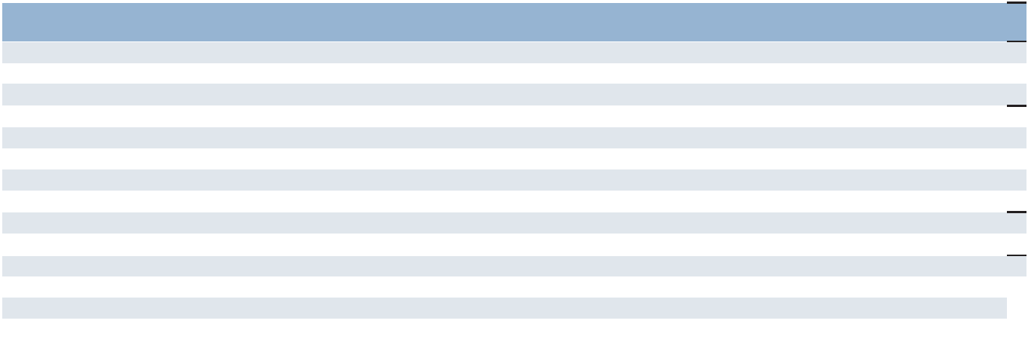

 |  | December 31, |  | December 31,
 |  | 2025 |  | 2024
Cash and cash equivalents | $ | 871.0 | $ | 509.4
Available capacity under the revolving credit facility^{(a)} |  | 599.6 |  | 599.6
Available capacity under the working capital facility^{(b)} |  | 150.0 |  | 150.0
Available liquidity | $ | 1,620.6 | $ | 1,259.0
Short-term borrowings | $ | 34.6 | $ | 23.4
Current maturities of long-term debt |  | 590.4 |  | —
Long-term debt |  | 1,052.1 |  | 929.4
Total debt | $ | 1,677.1 | $ | 952.8
Total shareholders' equity (excludes non-controlling interests) |  | 2,059.6 |  | 2,125.2
Total capitalization | $ | 3,736.7 | $ | 3,078.0
Debt to capitalization |  | 44.9% |  | 31.0%
Long-term debt to total debt |  | 62.7% |  | 97.5%

- Available capacity under the revolving credit facility represents $600.0 of total borrowing capacity less outstanding borrowings and letters of credit.

- Available capacity under the working capital facility represents $150.0 of total borrowing capacity less outstanding borrowings and letters of credit.

Application of Critical Accounting Policies

The preparation of our financial statements in conformity with accounting principles generally accepted in the United States requires us to make estimates and assumptions that affect the reported amounts. A discussion of the more significant estimates follows. Management has discussed the development, selection and disclosure of these estimates and assumptions with the Audit Committee of our Board of Directors.

Defined Benefit Pension Plans

We sponsor several qualified and nonqualified pension plans covering permanent employees. The most significant plans are located in Switzerland, the United Kingdom, the Netherlands, Germany and France. Annual expense relating to these plans was $18.2, $18.0 and $21.7 in 2025, 2024 and 2023, respectively. Pension expense is estimated to be approximately $16.0 in 2026.

42

Part II

The calculations of annual pension expense and the pension liability required at year-end include various actuarial assumptions such as discount rates, expected rate of return on plan assets, compensation increases and employee turnover rates. We review the actuarial assumptions on an annual basis and make modifications to the assumptions as necessary. We review market data and historical rates, on a country-by-country basis, to check for reasonableness in setting both the discount rate and the expected return on plan assets. We determine the discount rate based on an index of high-quality corporate bond yields and matched-funding yield curve analysis as of the end of each fiscal year. The expected return on plan assets is determined based on the expected returns of the various investment asset classes held in the plans. We estimate compensation increases and employee turnover rates for each plan based on the historical rates and the expected future rates for each respective country. Changes to any of these assumptions will impact annual expense recorded related to the plans.

In determining the estimated 2026 pension expense for non-United States plans, we used a weighted-average discount rate of 3.1% and weighted-average expected return on plan assets of 3.3%. Absent any other changes, a 25 basis point increase or decrease in the weighted-average discount rate would increase or decrease our 2026 consolidated pension expense by $0.1. Absent any other changes, a 25 basis point increase or decrease in the weighted-average expected return on plan assets would decrease or increase our 2025 consolidated pension expense by $1.6. (See Note 9 to the Consolidated Financial Statements found in Item 8. "Financial Statements and Supplementary Data" for further information.)

Income Taxes

The accounting guidance related to uncertain tax positions requires an evaluation process for all tax positions taken that involves a review of probability for sustaining a tax position. If the probability for sustaining a tax position is more likely than not, which is a 50% threshold, then the tax position is warranted and the largest amount, based on cumulative probability, that is greater than 50% likely of being realized upon settlement is recognized. An uncertain tax position, one which does not exceed the 50% threshold, will not be recognized in the financial statements.

We provide for income taxes on a quarterly basis based on an estimated annual tax rate. In determining this rate, we make estimates about taxable income for each of our largest locations worldwide, as well as the tax rate that will be in effect for each location. To the extent these estimates change during the year, or actual results differ from these estimates, our estimated annual tax rate may change between quarterly periods and may differ from the actual effective tax rate for the year.

Goodwill Impairment

In accordance with the accounting guidance on goodwill, we perform an annual impairment test of goodwill at our reporting unit level during the third quarter, or more frequently if events or circumstances change that would more likely than not reduce the fair value of our reporting units below their carrying value. In the event the fair value of a reporting unit is less than the carrying value including goodwill, we record an impairment charge equal to the excess of the carrying amount over the fair value.

We evaluate the recoverability of goodwill utilizing an income approach that estimates the fair value of the future discounted cash flows to which the goodwill relates. This approach reflects management’s internal outlook of the reporting units, which is believed to be the best determination of value due to management’s insight and experience with the reporting units. We evaluate the following assumptions which are used in our goodwill impairment tests: expected future revenue growth rates, OUP margins, working capital levels, discount rates, and terminal value revenue growth rate. We consider expected future revenue growth rates, OUP margins and discount rates to be the more significant assumptions. The expected future revenue growth rates and OUP margins are determined after taking into consideration historical performance, our assessment of future market potential, and expected future business performance conditions. We believe that the discounted cash flow model provides the most reasonable and meaningful estimate of fair value, consistent with how market participants would value our reporting units in an orderly transaction.

43

Part II

Management closely monitors the financial and operating results relative to the assumptions used in our fair value estimates, as well as macroeconomic conditions and strategic initiatives that may impact the reporting units. During the second quarter of 2025, in connection with the preparation of our financial statements, we assessed the changes in circumstances that occurred during the quarter to determine if it was more likely than not that the fair value of any reporting unit was below its carrying amount. We identified several factors affecting our United Kingdom and Switzerland reporting units that led us to conclude an interim goodwill impairment assessment was necessary. These factors included deterioration of the macroeconomic and local market conditions, financial performance below management’s planned revenue and OUP expectations for the first half of 2025, and downward revisions to full-year 2025 revenue and OUP projections. As a result, we recognized a partial non-cash goodwill impairment loss of $33.4 for our United Kingdom reporting unit in our Northern Europe segment and $24.7 for our Switzerland reporting unit in our Southern Europe segment, reducing their carrying values to estimated fair value. Key assumptions in the United Kingdom discounted cash flow valuation included a discount rate of 11.4%, revenue growth for the next 10 years ranging from -8.4% to 10.0% and average OUP margin approximating 2.5%. Key assumptions in the Switzerland discounted cash flow valuation included a discount rate of 11.2%, revenue growth for the next 10 years ranging from -12.4% to 12.0% and average OUP margin approximating 3.0%.

During the third quarter of 2025, we completed the annual impairment test of our goodwill and indefinite-lived intangible assets. The fair value exceeded the carrying amount by more than 10% for all reporting units except the United Kingdom and Switzerland, whose carrying values had already been adjusted to fair value in the second quarter. As of December 31, 2025, the goodwill balances related to our United Kingdom and Switzerland reporting units were $78.0 and $35.5, respectively.

Key assumptions for our United States reporting unit in our Americas segment, which represents the reporting unit with the most significant goodwill balance, included a discount rate of 9.4%, revenue growth rates for the next 10 years ranging from -1.7% to 8.0%, and average OUP margins approximating 5.0%. Management closely monitors the performance and assumptions used in our fair value estimates, along with macroeconomic and operational developments that may impact future impairment assessments.

During the fourth quarter of 2025, in connection with the preparation of our annual financial statements, we assessed the changes in circumstances that occurred during the quarter to determine if it was more likely than not that the fair value of any reporting units were below its carrying amount. The actual results of revenues and OUP margins for our key reporting units were consistent with the forecasted assumptions for the near-term revenue growth and OUP margins utilized in the discounted cash flow models as of our valuation date. Additionally, we performed an updated analysis of our market cap reconciliation to the values derived from our discounted cash flow models during our annual impairment testing in light of the lower stock price as of December 31, 2025. In evaluating triggering events and assessing the reasonableness of our market cap reconciliation as of December 31, 2025, we considered external data points from analysts, market peers, our past history and experience, 2025 actual results and our near term and long-term forecasts. Further, we considered the results of the fourth quarter whereby we saw largely stable activity levels across North America and Europe overall, with improving trends in certain of our reporting units and we expect these trends to continue into 2026. We concluded, based on our analysis performed, that the fair value of the reporting units continued to equal or exceed the carrying value and did not identify a triggering event.

There could be significant further decreases in the operating results of our reporting units for a sustained period, which may result in a recognition of goodwill impairment that could be material to the Consolidated Financial Statements.

Item 7A. Quantitative and Qualitative Disclosures about Market Risk

Significant Matters Affecting Results of Operations

Market Risks

We are exposed to the impact of foreign currency exchange rate fluctuations and interest rate changes.

Exchange Rates

Our exposure to foreign currency exchange rates relates primarily to our foreign subsidiaries and our Euro-denominated borrowings. For our foreign subsidiaries, exchange rates impact the United States dollar value of our reported earnings, our investments in the subsidiaries and the intercompany transactions with the subsidiaries.

44

Part II

Approximately 85% of our revenues are generated outside of the United States, with 48% generated from our European operations with a Euro-functional currency. As a result, fluctuations in the value of foreign currencies against the United States dollar, particularly the Euro, may have a significant impact on our reported results. Revenues and expenses denominated in foreign currencies are translated into United States dollars at the average exchange rates each month. Consequently, as the value of the United States dollar changes relative to the currencies of our major markets, our reported results vary.

The United States dollar generally weakened in 2025, where as it strengthened on average relative to the currencies of our major markets during 2024. Revenues from services in constant currency were 2.7% lower than reported revenues in 2025. In 2024, revenues from services in constant currency were 2.2% higher than reported revenues. A change in the strength of the United States dollar by an additional 10% would have impacted our revenues from services by approximately 8.5% from the amounts reported in both 2025 and 2024.

Fluctuations in currency exchange rates also impact the United States dollar amount of our shareholders’ equity. The assets and liabilities of our non-United States subsidiaries are translated into United States dollars at the exchange rates in effect at year-end. The resulting translation adjustments are recorded in shareholders’ equity as a component of AOCL. As a result of the United States dollar weakening against many foreign currencies as of December 31, 2025 compared to December 31, 2024, shareholders’ equity increased by $81.4 due to foreign currency translation. If the United States dollar had weakened an additional 10% as of December 31, 2025, resulting translation adjustments recorded in shareholders’ equity would have increased by approximately $70.0 from the amounts reported.

Although currency fluctuations impact our reported results and shareholders’ equity, such fluctuations generally do not affect our cash flow or result in actual economic gains or losses. Substantially all of our subsidiaries derive revenues and incur expenses within a single country and, consequently, do not generally incur currency risks in connection with the conduct of their normal business operations. We generally have few cross-border transfers of funds, except for transfers to the United States for payment of intercompany franchise fees and interest expense on intercompany loans, working capital loans made between the United States and our foreign subsidiaries, dividends from our foreign subsidiaries, and payments between certain countries and territories for services provided. To reduce the currency risk related to these transactions, we may borrow funds in the relevant foreign currency under our revolving credit agreement or we may enter into a forward contract to hedge the transfer.

As of December 31, 2025, we had outstanding $1,639.0 (€1,400.0) in principal amount of Euro-denominated notes. Of these notes, $1,055.2 (€900.0) have been designated as a hedge of our net investment in subsidiaries with a Euro-functional currency as of December 31, 2025. Since our net investment in these subsidiaries exceeds the respective amount of the designated borrowings, both net of tax, the related translation gains or losses are included as a component of AOCL. Shareholders’ equity decreased by $125.3, net of tax, due to changes in AOCL during 2025, due to the currency impact on these designated borrowings.

The hypothetical impact of the stated change in rates on 2025 total other comprehensive income/loss for the Euro Notes and forward contracts is as follows:

2025 (in millions) | 10% Depreciation |  |  | 10% Appreciation
Market Sensitive Instrument | in Exchange Rates |  |  | in Exchange Rates
Euro Notes:
€500.0, 1.81% Notes due June 2026 | $ | 58.7 | $ | (58.7)
€400.0, 3.50% Notes due June 2027 |  | 47.0 |  | (47.0)
Forward contracts:
€(195.2) to $(230.0) |  | 22.9 |  | (22.9)
¥368.1 to $2.4 |  | 0.2 |  | (0.2)
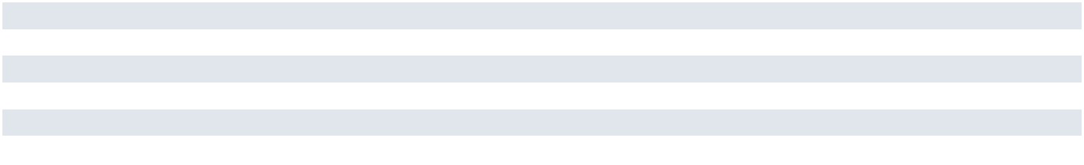

45

Part II

Interest Rates

Our exposure to market risk for changes in interest rates relates primarily to our variable rate debt obligations. We have historically managed interest rates through the use of a combination of fixed- and variable-rate borrowings. As of December 31, 2025, we had the following fixed- and variable-rate borrowings:
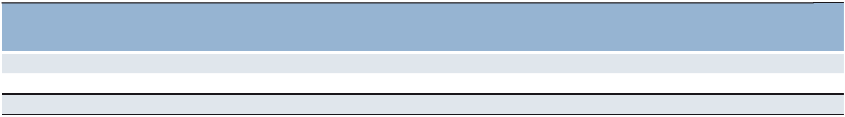

 |  |  | Weighted-
 |  |  | Average
(in millions) |  | Amount | Interest Rate^{(a)}
Variable-rate borrowings | $ | 34.6 | 13.3%
Fixed-rate borrowings |  | 1,642.5 | 3.0%
Total debt | $ | 1,677.1

- The rates are impacted by currency exchange rate movements.

Impact of Economic Conditions

One of the principal attractions of using workforce solutions and service providers is to maintain a flexible supply of labor to meet changing economic conditions. Therefore, the industry has been and remains sensitive to economic cycles. To help minimize the effects of these economic cycles, we offer clients a continuum of services to meet their needs throughout the business cycle. We believe that the breadth of our operations and the diversity of our service mix cushion us against the impact of an adverse economic cycle in any single country or industry. However, adverse economic conditions in any of our largest markets, or in several markets simultaneously, would have a material impact on our consolidated financial results.

Recently Issued Accounting Standards

See Note 1 to the Consolidated Financial Statements found in Item 8. "Financial Statements and Supplementary Data."

46

 | Part II
Item 8. Financial Statements and Supplementary Data
 | Page
 | Number
Index to Consolidated Financial Statements:
Report of Independent Registered Public Accounting Firm | 48
Consolidated Statements of Operations for the years ended December 31, 2025, 2024 and 2023 | 51
Consolidated Statements of Comprehensive Income for the years ended December 31, 2025, 2024 and
2023 | 52
Consolidated Balance Sheets as of December 31, 2025 and 2024 | 53
Consolidated Statements of Cash Flows for the years ended December 31, 2025, 2024 and 2023 | 54
Consolidated Statements of Shareholders’ Equity for the years ended December 31, 2025, 2024 and
2023 | 55
Notes to Consolidated Financial Statements | 56

47

Part II

REPORT OF INDEPENDENT REGISTERED PUBLIC ACCOUNTING FIRM

To the shareholders and the Board of Directors of ManpowerGroup Inc.

Opinion on Internal Control over Financial Reporting

We have audited the internal control over financial reporting of ManpowerGroup Inc. and subsidiaries (the "Company") as of December 31, 2025, based on criteria established in Internal Control — Integrated Framework (2013) issued by the Committee of Sponsoring Organizations of the Treadway Commission (COSO). In our opinion, the Company maintained, in all material respects, effective internal control over financial reporting as of December 31, 2025, based on criteria established in Internal Control — Integrated Framework (2013) issued by COSO.

We have also audited, in accordance with the standards of the Public Company Accounting Oversight Board (United States) (PCAOB), the consolidated financial statements as of and for the year ended December 31, 2025 of the Company and our report dated February 23, 2026, expressed an unqualified opinion on those financial statements.

Basis for Opinion

The Company's management is responsible for maintaining effective internal control over financial reporting and for its assessment of the effectiveness of internal control over financial reporting, included in the accompanying Management report on Internal Control over Financial Reporting. Our responsibility is to express an opinion on the Company's internal control over financial reporting based on our audit. We are a public accounting firm registered with the PCAOB and are required to be independent with respect to the Company in accordance with the U.S. federal securities laws and the applicable rules and regulations of the Securities and Exchange Commission and the PCAOB.

We conducted our audit in accordance with the standards of the PCAOB. Those standards require that we plan and perform the audit to obtain reasonable assurance about whether effective internal control over financial reporting was maintained in all material respects. Our audit included obtaining an understanding of internal control over financial reporting, assessing the risk that a material weakness exists, testing and evaluating the design and operating effectiveness of internal control based on the assessed risk, and performing such other procedures as we considered necessary in the circumstances. We believe that our audit provides a reasonable basis for our opinion.

Definition and Limitations of Internal Control over Financial Reporting

A company's internal control over financial reporting is a process designed to provide reasonable assurance regarding the reliability of financial reporting and the preparation of financial statements for external purposes in accordance with generally accepted accounting principles. A company's internal control over financial reporting includes those policies and procedures that (1) pertain to the maintenance of records that, in reasonable detail, accurately and fairly reflect the transactions and dispositions of the assets of the company; (2) provide reasonable assurance that transactions are recorded as necessary to permit preparation of financial statements in accordance with generally accepted accounting principles, and that receipts and expenditures of the company are being made only in accordance with authorizations of management and directors of the company; and (3) provide reasonable assurance regarding prevention or timely detection of unauthorized acquisition, use, or disposition of the company's assets that could have a material effect on the financial statements.

Because of its inherent limitations, internal control over financial reporting may not prevent or detect misstatements. Also, projections of any evaluation of effectiveness to future periods are subject to the risk that controls may become inadequate because of changes in conditions, or that the degree of compliance with the policies or procedures may deteriorate.

/s/ Deloitte & Touche LLP

Milwaukee, Wisconsin
February 23, 2026

48

Part II

REPORT OF INDEPENDENT REGISTERED PUBLIC ACCOUNTING FIRM

To the shareholders and the Board of Directors of ManpowerGroup Inc.

Opinion on the Financial Statements

We have audited the accompanying consolidated balance sheets of ManpowerGroup Inc. and subsidiaries (the "Company") as of December 31, 2025 and 2024, the related consolidated statements of operations, comprehensive income, shareholders' equity, and cash flows, for each of the three years in the period ended December 31, 2025, and the related notes and the schedule listed in the Index at Item 15(a)(2) (collectively referred to as the "financial statements"). In our opinion, the financial statements present fairly, in all material respects, the financial position of the Company as of December 31, 2025 and 2024, and the results of its operations and its cash flows for each of the three years in the period ended December 31, 2025, in conformity with accounting principles generally accepted in the United States of America.

We have also audited, in accordance with the standards of the Public Company Accounting Oversight Board (United States) (PCAOB), the Company's internal control over financial reporting as of December 31, 2025, based on criteria established in Internal Control — Integrated Framework (2013) issued by the Committee of Sponsoring Organizations of the Treadway Commission and our report dated February 23, 2026, expressed an unqualified opinion on the Company's internal control over financial reporting.

Basis for Opinion

These financial statements are the responsibility of the Company's management. Our responsibility is to express an opinion on the Company's financial statements based on our audits. We are a public accounting firm registered with the PCAOB and are required to be independent with respect to the Company in accordance with the U.S. federal securities laws and the applicable rules and regulations of the Securities and Exchange Commission and the PCAOB.

We conducted our audits in accordance with the standards of the PCAOB. Those standards require that we plan and perform the audit to obtain reasonable assurance about whether the financial statements are free of material misstatement, whether due to error or fraud. Our audits included performing procedures to assess the risks of material misstatement of the financial statements, whether due to error or fraud, and performing procedures that respond to those risks. Such procedures included examining, on a test basis, evidence regarding the amounts and disclosures in the financial statements. Our audits also included evaluating the accounting principles used and significant estimates made by management, as well as evaluating the overall presentation of the financial statements. We believe that our audits provide a reasonable basis for our opinion.

Critical Audit Matter

The critical audit matter communicated below is a matter arising from the current-period audit of the financial statements that was communicated or required to be communicated to the audit committee and that (1) relates to accounts or disclosures that are material to the financial statements and (2) involved our especially challenging, subjective, or complex judgments. The communication of critical audit matters does not alter in any way our opinion on the financial statements, taken as a whole, and we are not, by communicating the critical audit matter below, providing a separate opinion on the critical audit matter or on the accounts or disclosures to which it relates.

Goodwill – United States, United Kingdom, and Switzerland Reporting Units – Refer to Notes 1 and 7 to the financial statements

Critical Audit Matter Description

The Company’s evaluation of goodwill for impairment involves the comparison of the estimated fair value of each reporting unit to its carrying value. The annual impairment test of goodwill at a reporting unit level is performed annually on July 1st, or more frequently if events or circumstances indicate the fair value of a reporting unit may be below its respective carrying value. The Company deploys the income approach to estimate the fair value of future discounted cash flows, which requires management to make significant estimates and assumptions related to discount rates and forecasts of future revenues and operating unit profit margins. Changes in these assumptions could have a significant impact on either the fair value, the amount of any goodwill impairment charge, or both.

49

Part II

During the second quarter of 2025, the Company identified circumstances that caused it to evaluate the goodwill associated with the United Kingdom and Switzerland reporting units for potential impairment. The Company updated their cash flow estimates to reflect current market conditions and as a result of the test, recorded a goodwill impairment in the amount of $33.4 million and $24.7 million related to the amounts by which the United Kingdom and Switzerland reporting unit’s carrying amount exceed its estimated fair value, respectively.

Subsequent to the impairment charge recorded during the second quarter of 2025, the Company performed its annual impairment test of goodwill as of July 1st. Because the estimated fair value of these reporting units was not below the associated carrying value no additional impairments were recorded.

The forecasted revenues, operating unit profit margins and the discount rate for the United States, United Kingdom, and Switzerland reporting units are highly sensitive to changes in demand and the macroeconomic environment. Additionally the excess fair value of the United States reporting unit is above 10%, while the fair value of the United Kingdom and Switzerland reporting units approximate the carrying values. Therefore, minor changes to the significant estimates and assumptions could result in an impairment.

Considering these factors, we identified goodwill associated with the United States, United Kingdom and Switzerland reporting units as a critical audit matter. Auditing these estimates required a high degree of auditor judgment and an increased extent of effort, including the need to involve professionals in our firm having expertise in valuation, when performing audit procedures to evaluate the reasonableness of management’s estimates and assumptions related to revenue growth rates, operating unit margins, and selection of the discount rates.

How the Critical Audit Matter Was Addressed in the Audit

Our audit procedures related to the revenue growth rates, operating unit profit margins, and the selection of discount rates for the three reporting units included the following, among others:

We tested the design and operating effectiveness of controls over goodwill, including controls over the review of forecasts related to revenue and operating unit profit margins and selection of discount rates.

We evaluated management’s ability to accurately forecast revenue and operating unit profit margins by performing a retrospective comparison of prior forecasts to actual results.

We reviewed the reconciliation of the fair value of the reporting units to the market capitalization of the Company and assessed the resulting control premium.

We evaluated the reasonableness of management’s revenue and operating unit profit margin forecasts by comparing the forecasts to (1) historical results (2) internal communications to management and the Board of Directors, and (3) forecasted information included in Company press releases, analyst and industry reports of the Company and companies in its peer group, (4) actual financial results subsequent to the July 1st annual assessment date.

With the assistance of our fair value specialists, we evaluated the reasonableness of management’s fair value estimate by:

Testing the source information underlying the determination of the discount rate and the mathematical accuracy of the calculation.

Developing a range of independent estimates of discount rates and comparing those to the discount rates selected by management.

/s/ Deloitte & Touche LLP

Milwaukee, Wisconsin
February 23, 2026

We have served as the Company's auditor since 2005.

50

 |  |  |  |  |  | Part II
CONSOLIDATED STATEMENTS OF OPERATIONS
in millions, except per share data
Year Ended December 31 |  | 2025 |  | 2024 |  | 2023
Revenues from services | $ | 17,957.1 | $ | 17,853.9 | $ | 18,914.5
Cost of services |  | 14,959.5 |  | 14,767.1 |  | 15,556.5
Gross profit |  | 2,997.6 |  | 3,086.8 |  | 3,358.0
Selling and administrative expenses, excluding impairment charges |  | 2,758.8 |  | 2,780.8 |  | 3,047.1
Impairment charges |  | 88.7 |  | — |  | 55.1
Selling and administrative expenses |  | 2,847.5 |  | 2,780.8 |  | 3,102.2
Operating profit |  | 150.1 |  | 306.0 |  | 255.8
Interest and other expenses, net |  | 56.7 |  | 49.2 |  | 49.9
Earnings before income taxes |  | 93.4 |  | 256.8 |  | 205.9
Provision for income taxes |  | 106.7 |  | 111.7 |  | 117.1
Net (loss) earnings | $ | (13.3) | $ | 145.1 | $ | 88.8
Net (loss) earnings per share – basic | $ | (0.29) | $ | 3.04 | $ | 1.78
Net (loss) earnings per share – diluted | $ | (0.29) | $ | 3.01 | $ | 1.76
Weighted average shares – basic |  | 46.6 |  | 47.8 |  | 49.8
Weighted average shares – diluted |  | 46.6 |  | 48.3 |  | 50.4
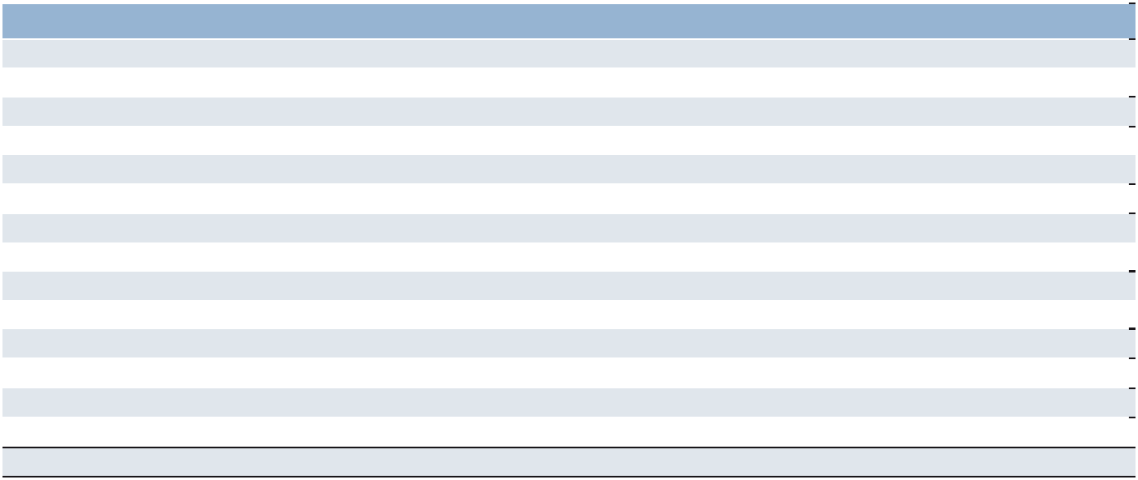

The accompanying Notes to Consolidated Financial Statements are an integral part of these statements.

51

Part II

CONSOLIDATED STATEMENTS OF COMPREHENSIVE INCOME
in millions
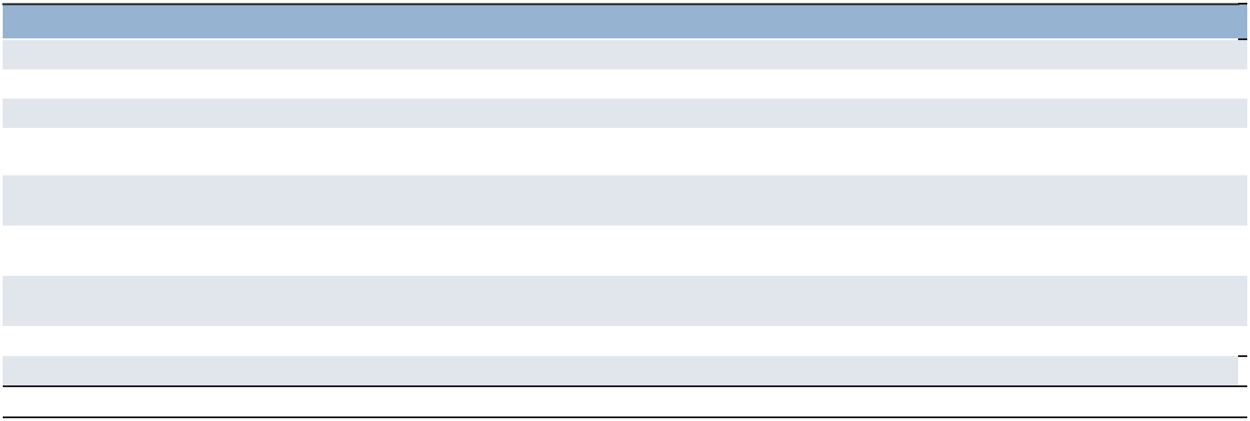

Year Ended December 31 |  | 2025 |  | 2024 |  | 2023
Net (loss) earnings | $ | (13.3) | $ | 145.1 | $ | 88.8
Other comprehensive income (loss):
Foreign currency translation |  | 92.5 |  | (81.0) |  | 108.5
Translation adjustments on long-term intercompany loans, net of income
taxes of $0.1, $0.0 and $0.0, respectively |  | (0.4) |  | 0.4 |  | (0.8)
Adjustments on derivative instruments, net of income taxes of $(20.7),
$22.0 and $(17.4), respectively |  | (92.9) |  | 76.6 |  | (91.0)
Unrealized adjustments on interest rate swap, net of income taxes of
$(0.1) for all years |  | (0.3) |  | (0.3) |  | (0.3)
Defined benefit pension plans and retiree health care plan, net of income
taxes of $3.5, $1.7 and $(3.7), respectively |  | 30.0 |  | 23.5 |  | (29.5)
Pension settlements, net of income taxes of $0.4, $0.8 and $1.2, respectively |  | 2.0 |  | 3.8 |  | 5.8
Total other comprehensive income (loss) | $ | 30.9 | $ | 23.0 | $ | (7.3)
Comprehensive income | $ | 17.6 | $ | 168.1 | $ | 81.5

The accompanying Notes to Consolidated Financial Statements are an integral part of these statements.

52

Part II

CONSOLIDATED BALANCE SHEETS
in millions, except share and per share data


December 31 |  | 2025 |  | 2024
ASSETS
Current Assets
Cash and cash equivalents | $ | 871.0 | $ | 509.4
Accounts receivable, less allowance for expected credit losses of $74.1 and
$67.6, respectively |  | 4,770.3 |  | 4,297.2
Prepaid expenses and other assets |  | 149.1 |  | 163.7
Total current assets |  | 5,790.4 |  | 4,970.3
Other Assets
Goodwill |  | 1,544.6 |  | 1,563.4
Intangible assets, less accumulated amortization of $579.1 and $530.4,
respectively |  | 430.1 |  | 486.1
Operating lease right-of-use assets |  | 392.7 |  | 361.3
Other assets |  | 879.1 |  | 701.5
Total other assets |  | 3,246.5 |  | 3,112.3
Property and Equipment
Land, buildings, leasehold improvements and equipment |  | 526.9 |  | 488.2
Less: accumulated depreciation and amortization |  | 403.7 |  | 369.8
Net property and equipment |  | 123.2 |  | 118.4
Total assets | $ | 9,160.1 | $ | 8,201.0
LIABILITIES AND SHAREHOLDERS' EQUITY
Current Liabilities
Accounts payable | $ | 2,721.1 | $ | 2,612.9
Employee compensation payable |  | 232.3 |  | 241.1
Accrued payroll taxes and insurance |  | 672.1 |  | 615.2
Accrued liabilities |  | 457.6 |  | 475.1
Value added taxes payable |  | 418.1 |  | 370.8
Short-term operating lease liability |  | 107.4 |  | 98.6
Short-term borrowings and current maturities of long-term debt |  | 625.0 |  | 23.4
Total current liabilities |  | 5,233.6 |  | 4,437.1
Other liabilities
Long-term debt |  | 1,052.1 |  | 929.4
Long-term operating lease liability |  | 304.3 |  | 279.0
Other long-term liabilities |  | 509.8 |  | 428.6
Total other liabilities |  | 1,866.2 |  | 1,637.0
Commitments and contingencies (Note 15)
Shareholders’ Equity
Preferred stock, $.01 par value, authorized 25,000,000 shares, none issued |  | — |  | —
Common stock, $.01 par value, authorized 125,000,000 shares, issued
119,161,780 and 118,853,620 shares, respectively |  | 1.2 |  | 1.2
Capital in excess of par value |  | 3,572.5 |  | 3,546.1
Retained earnings |  | 3,732.3 |  | 3,812.3
Accumulated other comprehensive loss |  | (412.1) |  | (443.0)
Treasury stock at cost, 72,864,513 and 72,105,407 shares, respectively |  | (4,834.3) |  | (4,791.4)
Total ManpowerGroup shareholders' equity |  | 2,059.6 |  | 2,125.2
Noncontrolling interests |  | 0.7 |  | 1.7
Total shareholders’ equity |  | 2,060.3 |  | 2,126.9
Total liabilities and shareholders’ equity | $ | 9,160.1 | $ | 8,201.0

The accompanying Notes to Consolidated Financial Statements are an integral part of these statements.

53

Part II

CONSOLIDATED STATEMENTS OF CASH FLOWS
in millions


Year Ended December 31 |  | 2025 |  | 2024 |  | 2023
Cash Flows from Operating Activities
Net (loss) earnings | $ | (13.3) | $ | 145.1 | $ | 88.8
Adjustments to reconcile net earnings to net cash provided by operating activities:
Depreciation and amortization |  | 86.0 |  | 86.6 |  | 88.6
Loss on sales of subsidiaries, net |  | 6.2 |  | 8.2 |  | 1.3
Non-cash goodwill and other impairment charges |  | 88.7 |  | — |  | 57.3
Deferred income taxes |  | (35.8) |  | (32.4) |  | (20.6)
Allowance for expected credit losses |  | 7.1 |  | 9.0 |  | 5.4
Share-based compensation |  | 26.3 |  | 27.3 |  | 28.7
Change in operating assets and liabilities:
Accounts receivable |  | (142.3) |  | 261.1 |  | 391.8
Other assets |  | (74.5) |  | (131.8) |  | (45.2)
Accounts payable |  | (42.5) |  | 15.7 |  | (144.7)
Other liabilities |  | (10.0) |  | (79.6) |  | (103.2)
Cash (used in) provided by operating activities |  | (104.1) |  | 309.2 |  | 348.2
Cash Flows from Investing Activities
Capital expenditures |  | (57.3) |  | (51.1) |  | (78.2)
Acquisitions of businesses, net of cash acquired |  | (1.0) |  | (4.9) |  | —
Impact to cash resulting from sales of subsidiaries |  | (2.1) |  | (14.6) |  | —
Proceeds from the sale of subsidiaries and property and equipment |  | 1.2 |  | 2.4 |  | 4.1
Cash used in investing activities |  | (59.2) |  | (68.2) |  | (74.1)
Cash Flows from Financing Activities
Net change in short-term borrowings |  | 14.4 |  | 14.0 |  | (12.8)
Proceeds from long-term debt |  | 586.8 |  | 3.7 |  | 1.0
Repayments of long-term debt |  | (0.7) |  | (1.6) |  | (4.4)
Payments for debt issuance costs |  | (2.6) |  | — |  | —
Payments of contingent consideration for acquisitions |  | (1.3) |  | (2.8) |  | —
Proceeds from share-based awards |  | — |  | 0.8 |  | 1.8
Payments to noncontrolling interests |  | — |  | (0.2) |  | (0.6)
Other share-based award transactions |  | (6.2) |  | (10.5) |  | (10.4)
Repurchases of common stock and excise tax |  | (38.2) |  | (140.0) |  | (179.8)
Dividends paid |  | (66.7) |  | (145.8) |  | (144.3)
Cash provided (used in) by financing activities |  | 485.5 |  | (282.4) |  | (349.5)
Effect of exchange rate changes on cash |  | 39.4 |  | (30.5) |  | 17.7
Change in cash and cash equivalents |  | 361.6 |  | (71.9) |  | (57.7)
Cash and cash equivalents, beginning of year |  | 509.4 |  | 581.3 |  | 639.0
Cash and cash equivalents, end of year | $ | 871.0 | $ | 509.4 | $ | 581.3
Supplemental Cash Flow Information
Cash paid during the period for:
Interest | $ | 97.5 | $ | 84.9 | $ | 75.9
Income taxes, net | $ | 147.7 | $ | 187.6 | $ | 182.2
Operating lease liabilities | $ | 130.9 | $ | 119.7 | $ | 132.0
Non-cash operating activity:
Right-of-use assets obtained in exchange for new operating lease liabilities | $ | 100.5 | $ | 82.2 | $ | 135.6

The accompanying Notes to Consolidated Financial Statements are an integral part of these statements.

54

Part II

CONSOLIDATED STATEMENTS OF SHAREHOLDERS’ EQUITY
in millions, except share and per share data
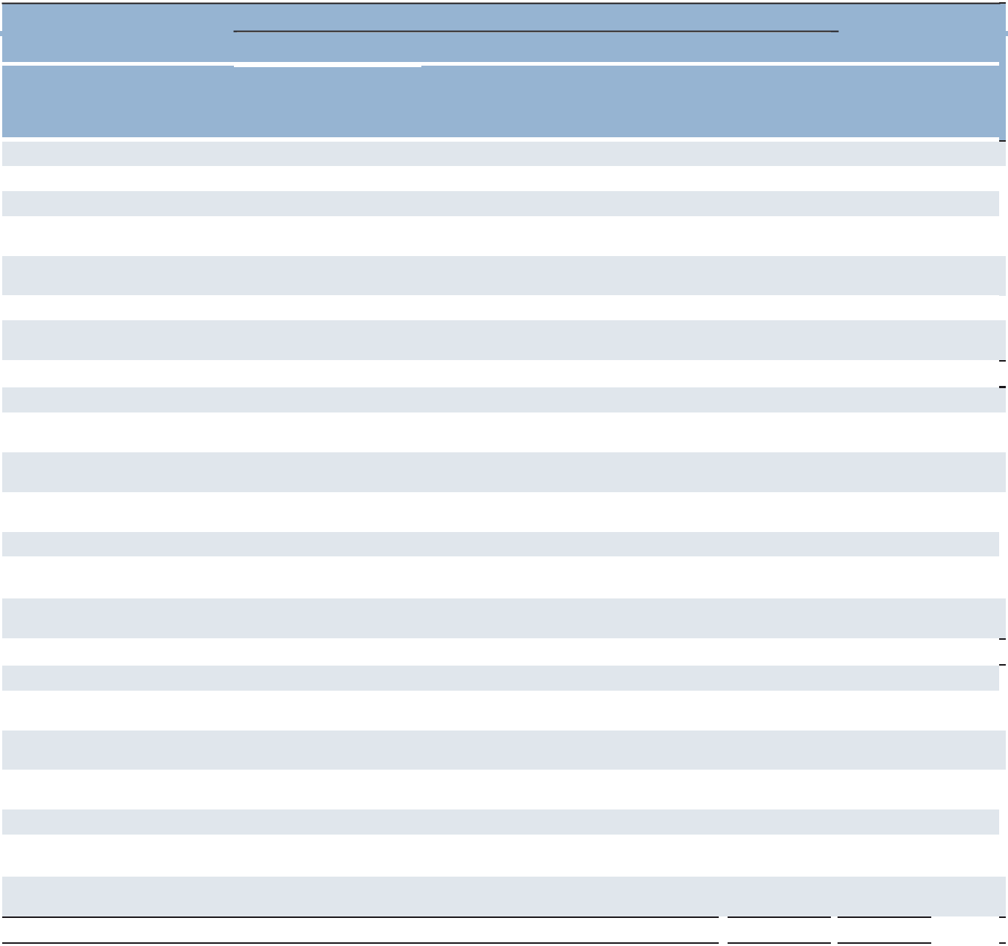

ManpowerGroup Shareholders

Common Stock
 |  |  |  |  |  |  |  |  | Accumulated
 |  |  |  | Capital in |  |  |  |  | Other |  |  |  | Non-
 | Shares |  | Par | Excess of |  | Retained |  | Comprehensive |  |  | Treasury | controlling
 | Issued | Value |  | Par Value |  | Earnings |  |  | Loss |  | Stock |  | Interests | Total
Balance, December 31, 2022 | 118,028,009 | $ | 1.2 | $ | 3,484.2 | $ | 3,868.5 | $ | (458.7) | $ | (4,447.9) | $ | 10.8 | $2,458.1
Net earnings |  |  |  |  |  |  | 88.8 |  |  |  |  |  |  | 88.8
Other comprehensive loss |  |  |  |  |  |  |  |  | (7.3) |  |  |  |  | (7.3)
Issuances under equity
plans | 359,632 |  |  |  | 2.0 |  |  |  |  |  | (10.4) |  |  | (8.4)
Share-based compensation
expense |  |  |  |  | 28.7 |  |  |  |  |  |  |  |  | 28.7
Dividends ($2.94 per share) |  |  |  |  |  |  | (144.3) |  |  |  |  |  |  | (144.3)
Repurchases of common
stock, including excise tax |  |  |  |  |  |  |  |  |  |  | (181.5) |  |  | (181.5)
Balance, December 31, 2023 | 118,387,641 | $ | 1.2 | $ | 3,514.9 | $ | 3,813.0 | $ | (466.0) | $ | (4,639.8) | $ | 10.8 | $2,234.1
Net earnings |  |  |  |  |  |  | 145.1 |  |  |  |  |  |  | 145.1
Other comprehensive
income |  |  |  |  |  |  |  |  | 23.0 |  |  |  |  | 23.0
Issuances under equity
plans | 465,979 |  |  |  | 1.0 |  |  |  |  |  | (10.7) |  |  | (9.7)
Share-based compensation
expense |  |  |  |  | 27.3 |  |  |  |  |  |  |  |  | 27.3
Dividends ($3.08 per share) |  |  |  |  |  |  | (145.8) |  |  |  |  |  |  | (145.8)
Repurchases of common
stock, including excise tax |  |  |  |  |  |  |  |  |  |  | (140.9) |  |  | (140.9)
Noncontrolling interest
transactions |  |  |  |  | 2.9 |  |  |  |  |  |  |  | (9.1) | (6.2)
Balance, December 31, 2024 | 118,853,620 | $ | 1.2 | $ | 3,546.1 | $ | 3,812.3 | $ | (443.0) | $ | (4,791.4) | $ | 1.7 | $2,126.9
Net loss |  |  |  |  |  |  | (13.3) |  |  |  |  |  |  | (13.3)
Other comprehensive
income |  |  |  |  |  |  |  |  | 30.9 |  |  |  |  | 30.9
Issuances under equity
plans | 308,160 |  |  |  | (0.7) |  |  |  |  |  | (5.4) |  |  | (6.1)
Share-based compensation
expense |  |  |  |  | 26.3 |  |  |  |  |  |  |  |  | 26.3
Dividends ($1.44 per share) |  |  |  |  |  |  | (66.7) |  |  |  |  |  |  | (66.7)
Repurchases of common
stock, including excise tax |  |  |  |  |  |  |  |  |  |  | (37.5) |  |  | (37.5)
Noncontrolling interest
transactions |  |  |  |  | 0.8 |  |  |  |  |  |  |  | (1.0) | (0.2)
Balance, December 31, 2025 | 119,161,780 | $ | 1.2 | $ | 3,572.5 | $ | 3,732.3 | $ | (412.1) $ |  | (4,834.3) | $ | 0.7 | $2,060.3

The accompanying Notes to Consolidated Financial Statements are an integral part of these statements.

55

Part II

NOTES TO CONSOLIDATED FINANCIAL STATEMENTS

in millions, except share and per share data

- Summary of Significant Accounting Policies

Nature of Operations

ManpowerGroup Inc. is a world leader in the innovative workforce solutions and services industry. Our global network of approximately 2,100 offices in more than 70 countries and territories allows us to meet the needs of our global, multinational and local clients across all major industry segments. Our largest operations, based on revenues, are located in France, the United States, Italy, and the United Kingdom. We specialize in permanent, temporary and contract recruitment and assessment; training and development; outsourcing; career management and workforce consulting services. We provide services to a wide variety of clients, none of which individually comprise a significant portion of revenues for us as a whole.

Use of Estimates

The preparation of financial statements in conformity with accounting principles generally accepted in the United States requires us to make estimates and assumptions that affect the reported amounts of assets and liabilities and disclosure of contingent assets and liabilities at the date of the financial statements and the reported amounts of revenues and expenses for the reporting period. Estimates are used for, but not limited to, the accounting for the allowance for doubtful accounts and credit losses, defined benefit plans, workers’ compensation, share-based compensation, annual performance-related incentives, leases, goodwill and long-lived asset impairment, valuation of acquired intangibles and income taxes. Actual results could differ from these estimates.

Basis of Consolidation

The Consolidated Financial Statements include our operating results and the operating results of all of our majority-owned subsidiaries and entities in which we have a controlling financial interest. We have a controlling financial interest if we own a majority of the outstanding voting common stock and the noncontrolling shareholders do not have substantive participating rights, or we have significant control over an entity through contractual or economic interests in which we are the primary beneficiary. We account for equity investments in companies over which we have the ability to exercise significant influence, but not control, using the equity method of accounting. We recognize our ownership share of earnings of these equity method investments, amortization of basis differences, and related gains or losses in the Consolidated Financial Statements. These investments, as well as certain other relationships, are also evaluated for consolidation under the accounting guidance on consolidation of variable interest entities. These investments were $100.2 and $103.9 as of December 31, 2025 and 2024, respectively, and are included in other assets in the Consolidated Balance Sheets. Included in shareholders’ equity as of December 31, 2025 and 2024 are $6.5 and $16.9, respectively, of accumulated unremitted earnings from investments accounted for using the equity method. The amounts relate to accounting for our remaining interest in ManpowerGroup Greater China under the equity method subsequent to deconsolidation in 2019.

Revenues

We recognize revenues when or as control of the promised services is transferred to our clients, in an amount that reflects the consideration we expect to be entitled to receive in exchange for those services. Our revenues are recorded net of any sales, value added or other taxes collected from our clients.

56

Part II

A performance obligation is a promise in a contract to transfer a distinct service to the client, and it is the unit of account in the accounting guidance for revenue recognition. The majority of our contracts have a single performance obligation as the promise to transfer the individual services is not separately identifiable from other promises in our contracts and, therefore, is not distinct. However, we have multiple performance obligations within our Recruitment Process Outsourcing (RPO) contracts as discussed below. For performance obligations that we satisfy over time, revenues are recognized by consistently applying a method of measuring progress toward satisfaction of that performance obligation. We generally utilize an input measure of time (e.g., hours, weeks, months) of service provided, which most accurately depicts the progress toward completion of each performance obligation.

We generally determine standalone selling prices based on the prices included in the client contracts, using expected costs plus margin or other observable prices. The price as specified in our client contracts is generally considered the standalone selling price as it is an observable input that depicts the price as if separately sold to a similar client in similar circumstances. Certain client contracts have variable consideration, including credits, sales allowances, rebates or other similar items that generally reduce the transaction price. We estimate variable consideration using whichever method, either the expected value method or most likely amount method, better predicts the amount of consideration to which we will become entitled based on the terms of the client contract and historical evidence. These amounts may be constrained and are only included in revenues to the extent we do not expect a significant reversal when the uncertainty associated with the variable consideration is resolved. Our variable consideration amounts are not material, and we do not believe that there will be significant changes to our estimates.

Our client contracts generally include standard payment terms acceptable in each of the countries and territories in which we operate. The payment terms vary by the type and location of our clients and services offered. Client payments are typically due approximately 60 days after invoicing but may be a shorter or longer term depending on the contract. Our client contracts are generally short-term in nature with a term of one year or less. The timing between satisfaction of the performance obligation, invoicing and payment is not significant. For certain services and client types, we may require payment prior to delivery of services to the client, for which deferred revenue is recorded.

In certain scenarios where a third-party vendor is involved in our revenue transactions with our clients, we evaluate whether we are the principal or the agent in the transaction. In situations where we act as principal in the transaction, we control the performance obligation prior to transfer to the client, and we report the related amounts as gross revenues and cost of services. When we act as agent in the transaction, we do not control the performance obligation prior to transfer to the client, and we report the related amounts as revenues on a net basis.

A majority of these agent transactions occur within our TAPFIN - Managed Service Provider (MSP) programs where our performance obligation is to manage our client’s contingent workforce, and we earn a commission based on the amount of staffing services that are managed through the program. We are the agent in these transactions as we do not control the third-party providers' staffing services provided to the client through our MSP program prior to those services being transferred to the client.

For certain client contracts where we recognize revenues over time, we recognize the amount that we have the right to invoice, which corresponds directly to the value provided to the client of our performance to date.

As allowed under the guidance, we do not disclose the amount of unsatisfied performance obligations for client contracts with an original expected length of one year or less and those client contracts for which we recognize revenues at the amount to which we have the right to invoice for services performed. We have other contracts with revenues expected to be recognized subsequent to December 31, 2025 related to remaining performance obligations, which are not material.

Accounts Receivable, Contract Assets and Contract Liabilities

We record accounts receivable when our right to consideration becomes unconditional. Contract assets primarily relate to our rights to consideration for services provided that they are conditional on satisfaction of future performance obligations. We record contract liabilities (deferred revenue) when payments are made or due prior to the related performance obligations being satisfied. The current portion of our contract liabilities is included in accrued liabilities in our Consolidated Balance Sheets. We do not have any material contract assets or long-term contract liabilities.

Our deferred revenue was $45.6 and $30.3 as of December 31, 2025 and 2024, respectively. We recognized the entire amount of the deferred revenue balance as of December 31, 2024 as revenue during the year ended December 31, 2025. We expect to recognize the entire amount of deferred revenue balance as of December 31, 2025 as revenue in 2026.

57

Part II

Allowance for Expected Credit Losses

We have an allowance for expected credit losses recorded as an estimate of the accounts receivable balance that may not be collected. This allowance is calculated on an entity-by-entity basis with consideration for historical write-off experience, age of receivables, market conditions, and a specific review for expected credit losses. Items that affect this balance mainly include provision for credit losses and the write-off of accounts receivable balances.

Changes in allowance for expected credit losses are as follows:
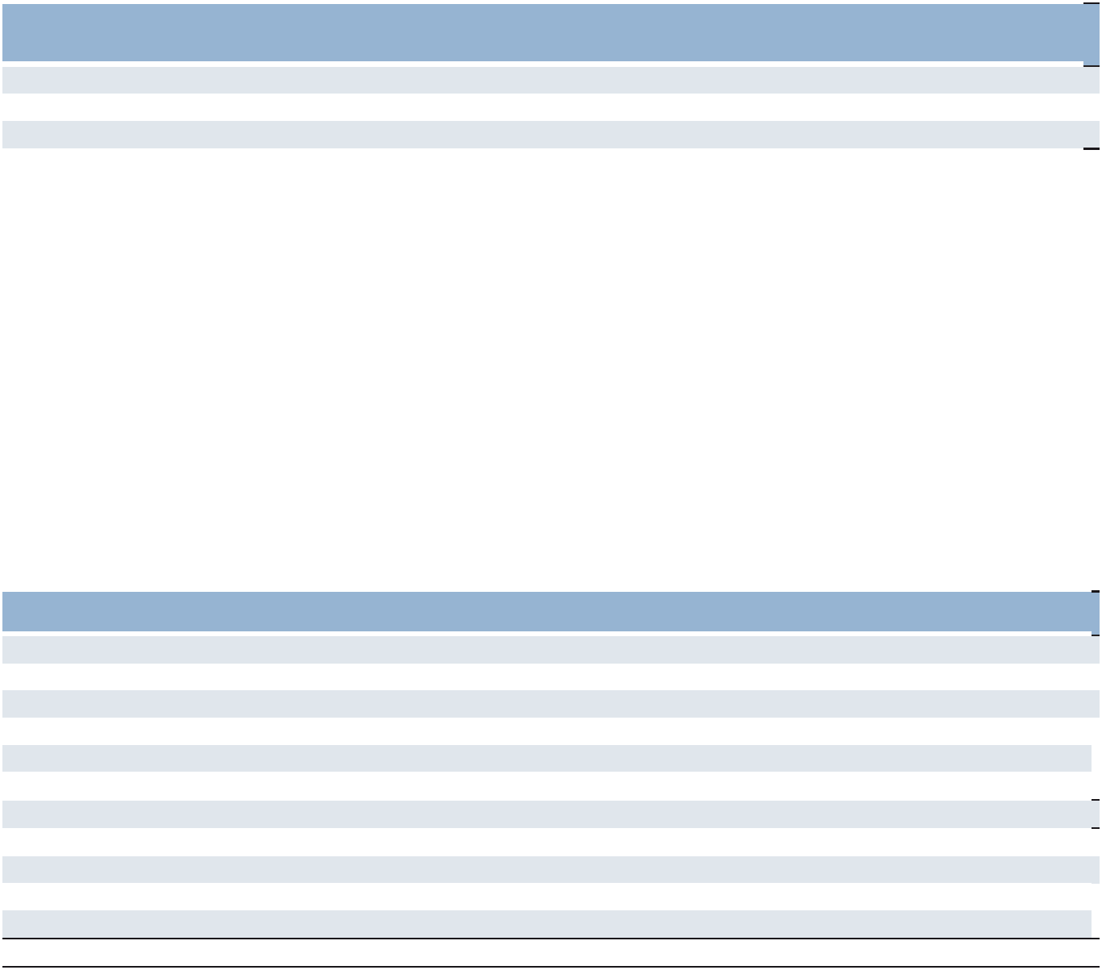

 |  | Balance at |  |  |  |  | Currency
 |  | Beginning of |  | Provision for |  |  | Impact and | Balance at End of
 |  | Year |  | Credit Losses | Write-Offs |  | Other |  | Year
2025 | $ | 67.6 | $ | 7.1 | $ (11.2) |  | $ 10.6 | $ | 74.1
2024 |  | 99.2 |  | 9.0 | (35.6) | (a) | (5.0) |  | 67.6
2023 |  | 109.3 |  | 5.4 | (18.2) |  | 2.7 |  | 99.2
- Includes a $24.7 bad debt write-off in Italy to secure tax benefits.

Provision for credit losses is recorded as selling and administrative expenses in our Consolidated Statements of Operations. Factors that would cause this provision to increase primarily relate to increased bankruptcies by our clients and other difficulties collecting amounts billed. On the other hand, an improved write-off experience and aging of receivables would result in a decrease to the provision.

Advertising Costs

We expense production costs of advertising as they are incurred. Advertising expenses were $28.1, $28.3 and $28.9 in 2025, 2024 and 2023, respectively.

Restructuring Costs

We recorded net restructuring costs of $64.2, $53.6, and $149.2 in 2025, 2024 and 2023, respectively, in selling and administrative expenses. Payments made from the restructuring reserve were $72.9 and $93.7 during 2025 and 2024, respectively. We use our restructuring reserve for severance, office closures, office consolidations, and professional and other fees related to restructuring in multiple countries and territories. We expect a majority of the remaining $35.1 reserve will be paid by the end of 2026.

Changes in the restructuring reserve by reportable segment and Corporate are shown below:

 |  |  | Southern |  | Northern
 | Americas^{(a)} |  | Europe^{(b)} |  |  | Europe |  | APME | Corporate |  |  | Total
Balance, December 31, 2023 | $ | 4.8 | $ | 5.9 | $ | 78.9 | $ | 0.4 | $ | — | $ | 90.0
Severance costs |  | 8.6 |  | 5.4 |  | 28.8 |  | 2.8 |  | 1.9 |  | 47.5
Lease costs^{(c)} |  | 0.5 |  | 0.1 |  | 2.8 |  | — |  | — |  | 3.4
Other costs |  | 0.1 |  | 0.8 |  | 1.8 |  | — |  | — |  | 2.7
Non-cash charges |  | (0.5) |  | (0.1) |  | (2.8) |  | — |  | — |  | (3.4)
Costs paid |  | (7.8) |  | (7.7) |  | (77.4) |  | (0.8) |  | — |  | (93.7)
Balance, December 31, 2024 | $ | 5.7 | $ | 4.4 | $ | 32.1 | $ | 2.4 | $ | 1.9 | $ | 46.5
Severance costs |  | 5.1 |  | 15.4 |  | 42.1 |  | 0.1 |  | (1.2) |  | 61.5
Lease costs^{(c)} |  | 1.1 |  | — |  | 1.6 |  | — |  | — |  | 2.7
Non-cash charges |  | (1.1) |  | — |  | (1.6) |  | — |  | — |  | (2.7)
Costs paid |  | (8.1) |  | (11.8) |  | (50.0) |  | (2.3) |  | (0.7) |  | (72.9)
Balance, December 31, 2025 | $ | 2.7 | $ | 8.0 | $ | 24.2 | $ | 0.2 | $ | — | $ | 35.1

- Balance related to United States was $3.7 as of December 31, 2023. In 2024, United States incurred $6.0 for severance costs, $0.1 for other costs and paid $5.8, leaving a $4.0 liability as of December 31, 2024. In 2025, United States incurred $2.6 for severance costs and paid $6.0, leaving a $0.6 liability as of December 31, 2025.

- France had a $2.5 liability as of December 31, 2023. In 2024, France incurred $1.3 for severance costs, $0.5 for other costs and paid $3.1, leaving a $1.2 liability as of December 31, 2024. In 2025, France incurred $5.0 for severance costs and paid $3.1, leaving a $3.1 liability as of December 31, 2025. As of December 31, 2023, Italy had a $1.0 liability. In 2024, Italy incurred $1.9 for severance costs, $0.1 for other costs and paid $1.0, leaving a $2.0 liability as of December 31, 2024. In 2025, Italy incurred $0.4 for severance costs and paid $1.8, leaving a $0.6 liability as of December 31, 2025.

- Liabilities related to exited leased facilities are recorded within our short-term and long-term operating lease liabilities within our Consolidated Balance Sheets.

58

Part II

Income Taxes

Deferred tax assets and liabilities are recognized for the future tax consequences attributable to differences between financial statement carrying amounts of existing assets and liabilities and their respective tax basis, and net operating loss and tax credit carryforwards. Deferred tax assets and liabilities are measured using enacted tax rates expected to apply to taxable income in the years in which those temporary differences are expected to be recovered or settled. We record a valuation allowance against deferred tax assets to reduce the assets to the amounts more likely than not to be realized.

Fair Value Measurements

The assets and liabilities measured and recorded at fair value on a recurring basis were as follows:
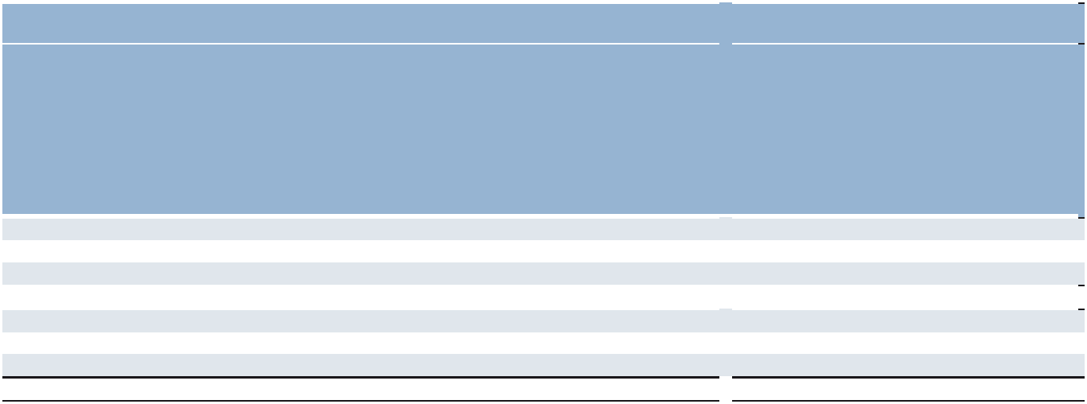

 |  | Fair Value Measurements Using |  |  |  |  |  |  |  |  | Fair Value Measurements Using
 |  |  |  |  |  |  |  |  |  |  |  | Quoted
 |  |  |  | Quoted | Significa |  |  |  |  |  |  | Prices |  | Significa
 |  |  |  | Prices |  | nt | Significa |  |  |  |  | in Active |  |  | nt | Significa
 |  |  |  | in Active |  | Other |  | nt |  |  |  | Markets |  |  | Other |  | nt
 |  |  | Markets for |  | Observab |  | Unobser |  |  |  |  |  | for | Observa |  | Unobser
 |  |  |  | Identical |  | le |  | vable |  | Decemb |  | Identical |  |  | ble |  | vable
 | December |  |  | Assets |  | Inputs |  | Inputs |  |  | er 31, | Assets |  |  | Inputs |  | Inputs
 |  | 31, 2025 |  | (Level 1) | (Level 2) |  | (Level 3) |  |  |  | 2024 | (Level 1) |  | (Level 2) |  | (Level 3)
Assets
Deferred compensation plan assets | $ | 188.6 | $ | 188.6 | $ | — | $ | — | $ |  | 165.4 | $ | 165.4 | $ | — | $ | —
Cross-currency swaps |  | 14.6 |  | — |  | 14.6 |  | — |  |  | 10.3 |  | — |  | 10.3 |  | —
 | $ | 203.2 | $ | 188.6 | $ | 14.6 | $ | — | $ |  | 175.7 | $ | 165.4 | $ | 10.3 | $ | —
Liabilities
Cross-currency swaps | $ | 102.9 | $ | — | $ | 102.9 | $ | — | $ |  | 37.0 | $ | — | $ | 37.0 | $ | —
Foreign currency forward contracts |  | 0.8 |  | — |  | 0.8 |  | — |  |  | 0.7 |  | — |  | 0.7 |  | —
 | $ | 103.7 | $ | — | $ | 103.7 | $ | — | $ |  | 37.7 | $ | — | $ | 37.7 | $ | —

Our deferred compensation plan assets are comprised of publicly traded securities, of which fair value is determined using market quotes as of the last day of the period. We record them in other assets in the Consolidated Balance Sheets. The fair value of the cross-currency swaps and foreign currency forward contracts are measured at the value based on a third party valuation model that performs a discounted cash flow analysis based on the terms of the contracts and market observable inputs such as current and forward interest rates and current and forward foreign exchange rates.

The carrying values of cash and cash equivalents, accounts receivable, accounts payable and other current assets and liabilities approximate their fair values because of the short-term nature of these instruments. The carrying value of our variable-rate long-term debt and revolving debt facility approximates fair value. The fair value of the Euro-denominated notes, as observable at commonly quoted intervals (Level 2 inputs), was $1,645.3 and $928.5 as of December 31, 2025 and 2024, respectively, compared to a carrying value of $1,639.0 and $928.4, respectively.

59

Part II

Goodwill and Other Intangible Assets

We had goodwill, finite-lived intangible assets and indefinite-lived intangible assets as follows:
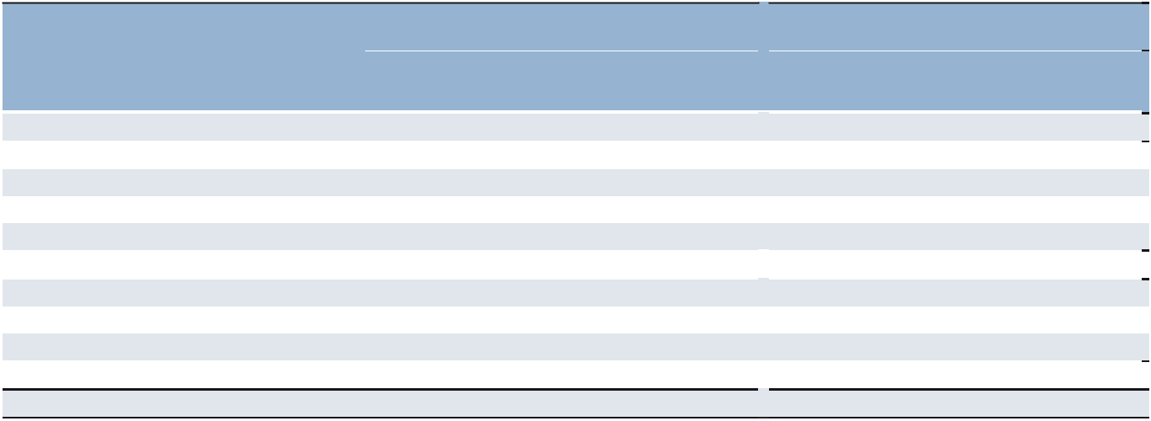

 |  |  |  | December 31, 2025 |  |  |  |  |  |  | December 31, 2024
 |  |  |  | Accumulated |  |  |  |  |  |  |  | Accumulated
 |  |  | Gross |  | Amortization |  | Net |  |  | Gross |  | Amortization |  | Net
Goodwill^{(a)} | $ |  | 1,544.6 | $ | — | $ | 1,544.6 |  | $ | 1,563.4 | $ | — | $ | 1,563.4
Intangible assets:
Finite-lived:
Customer relationships | $ |  | 833.2 | $ | 556.1 | $ | 277.1 | $ |  | 814.2 | $ | 509.1 | $ | 305.1
Other |  |  | 25.3 |  | 23.0 |  | 2.3 |  |  | 24.4 |  | 21.3 |  | 3.1
 |  |  | 858.5 |  | 579.1 |  | 279.4 |  |  | 838.6 |  | 530.4 |  | 308.2
Indefinite-lived:
Tradenames^{(b)} |  |  | 52.0 |  | — |  | 52.0 |  |  | 52.0 |  | — |  | 52.0
Reacquired franchise rights^{(c)} |  |  | 98.7 |  | — |  | 98.7 |  |  | 125.9 |  | — |  | 125.9
 |  |  | 150.7 |  | — |  | 150.7 |  |  | 177.9 |  | — |  | 177.9
Total intangible assets | $ |  | 1,009.2 | $ | 579.1 | $ | 430.1 | $ |  | 1,016.5 | $ | 530.4 | $ | 486.1

- Balances were net of accumulated impairment loss of $807.4 and $749.3 as of December 31, 2025 and 2024, respectively.

- Balances were net of accumulated impairment loss of $139.5 as of both December 31, 2025 and 2024.

- Balances were net of accumulated impairment loss of $30.6 and none as of December 31, 2025 and 2024, respectively.

The consolidated amortization expense related to intangibles was $31.3, $32.7 and $34.6 in 2025, 2024 and 2023, respectively. Amortization expense expected in each of the next five years related to acquisitions completed as of December 31, 2025 is as follows: 2026 - $27.9, 2027 - $27.1, 2028 - $27.1, 2029 - $26.8 and 2030 - $26.3. The weighted-average useful lives of the customer relationships and other are approximately 15 and 5 years, respectively. The tradenames have been assigned an indefinite-life based on our expectation of renewing the tradenames, as required, without material modifications and at a minimal cost, and our expectation of positive cash flows beyond the foreseeable future. Indefinite-lived reacquired franchise rights resulted from our franchise acquisitions in the United States, Switzerland and Canada. These rights entitled the franchisees with unilateral control to operate perpetually in particular territories and have therefore been assigned an indefinite-life.

In accordance with the accounting guidance on goodwill and other intangible assets, we perform an annual impairment test of goodwill at our reporting unit level and indefinite-lived intangible assets at our unit of account level during the third quarter, or more frequently if events or circumstances change that would more likely than not reduce the fair value of our reporting units below their carrying value. In the event the fair value of a reporting unit is less than the carrying value including goodwill, we record an impairment charge equal to the excess of the carrying amount over the fair value. Similarly, if the fair value of an indefinite-lived intangible asset is less than its carrying value, we record an impairment charge for the difference.

We evaluate the recoverability of goodwill utilizing an income approach that estimates the fair value of the future discounted cash flows to which the goodwill relates. This approach reflects management’s internal outlook of the reporting units, which is believed to be the best determination of value due to management’s insight and experience with the reporting units. We evaluate the following assumptions which are used in our goodwill impairment tests: expected future revenue growth rates, operating unit profit (OUP) margins, working capital levels, discount rates, and terminal value revenue growth rate. We consider expected future revenue growth rates, OUP margins and discount rates to be the more significant assumptions. The expected future revenue growth rates and OUP margins are determined after taking into consideration historical performance, our assessment of future market potential, and expected future business performance conditions. We believe that the discounted cash flow model provides the most reasonable and meaningful estimate of fair value, consistent with how market participants would value our reporting units in an orderly transaction.

For indefinite-lived intangible assets, we use either an income approach or a relief-from-royalty method, depending on the nature of the asset. Significant assumptions include expected future revenue growth rates, profit margins, discount rates, and market participant assumptions.

60

Part II

Management closely monitors the financial and operating results relative to the assumptions used in our fair value estimates, as well as macroeconomic conditions and strategic initiatives that may impact the reporting units and indefinite-lived intangible assets. During the second quarter of 2025, in connection with the preparation of our financial statements, we assessed the changes in circumstances that occurred during the quarter to determine if it was more likely than not that the fair value of any reporting unit or indefinite-lived intangible asset was below its carrying amount. We identified several factors affecting our United Kingdom and Switzerland reporting units that led us to conclude an interim goodwill impairment assessment was necessary. These factors included deterioration of the macroeconomic and local market conditions, financial performance below management’s planned revenue and OUP expectations for the first half of 2025, and downward revisions to full-year 2025 revenue and OUP projections. As a result, we recognized a partial non-cash goodwill impairment loss of $33.4 for our United Kingdom reporting unit in our Northern Europe segment and $24.7 for our Switzerland reporting unit in our Southern Europe segment, reducing their carrying values to estimated fair value. Key assumptions in the United Kingdom discounted cash flow valuation included a discount rate of 11.4%, revenue growth for the next 10 years ranging from -8.4% to 10.0%, and average OUP margin approximating 2.5%. Key assumptions in the Switzerland discounted cash flow valuation included a discount rate of 11.2%, revenue growth for the next 10 years ranging from -12.4% to 12.0% and average OUP margin approximating 3.0%.

In addition, we recognized a full impairment of $30.6 related to the reacquired franchise right associated with our Switzerland business, which is an indefinite-lived intangible asset. Key assumptions included in the indefinite-lived intangible asset impairment test included a discount rate of 13.7% and OUP margins ranging from 1.0% to 4.0%.

During the third quarter of 2025, we completed the annual impairment test of our goodwill and indefinite-lived intangible assets. The fair value exceeded the carrying amount by more than 10% for all reporting units except the United Kingdom and Switzerland, whose carrying values had already been adjusted to fair value in the second quarter. As of December 31, 2025, the goodwill balances related to our United Kingdom and Switzerland reporting units were $78.0 and $35.5, respectively.

Key assumptions for our United States reporting unit in our Americas segment, which represents the reporting unit with the most significant goodwill balance, included a discount rate of 9.4%, revenue growth rates for the next 10 years ranging from -1.7% to 8.0% and average OUP margins approximating 5.0%. Management closely monitors the performance and assumptions used in our fair value estimates, along with macroeconomic and operational developments that may impact future impairment assessments.

During the fourth quarter of 2025, in connection with the preparation of our annual financial statements, we assessed the changes in circumstances that occurred during the quarter to determine if it was more likely than not that the fair value of any reporting unit were below its carrying amount. The actual results of revenues and OUP margins for our key reporting units were consistent with the forecasted assumptions for the near-term revenue growth and OUP margins utilized in the discounted cash flow models as of our valuation date. Additionally, we performed an updated analysis of our market capitalization reconciliation to the values derived from our discounted cash flow models during our annual impairment testing in light of the lower stock price as of December 31, 2025. In evaluating triggering events and assessing the reasonableness of our market cap reconciliation as of December 31, 2025, we considered external data points from analysts, market peers, our past history and experience, 2025 actual results and our near term and long-term forecasts. Further, we considered the results of the fourth quarter whereby we saw largely stable activity levels across North America and Europe overall, with improving trends in certain of our reporting units and we expect these trends to continue into 2026. We concluded, based on our analysis performed, that the fair value of the reporting units continued to equal or exceed the carrying value and did not identify a triggering event.

There could be significant further decreases in the operating results of our reporting units for a sustained period, which may result in a recognition of goodwill impairment that could be material to the Consolidated Financial Statements.

Capitalized Software for Internal Use

We capitalize purchased software as well as internally developed software. Internal software development costs are capitalized from the time when the internal-use software is considered probable of completion until the software is ready for use. Business analysis, system evaluation, selection and software maintenance costs are expensed as incurred. Capitalized software costs are amortized using the straight-line method over the estimated useful life of the software which ranges from 3 to 10 years. The net capitalized software balance of $39.3 and $36.5 as of December 31, 2025 and 2024, respectively, is included in other assets in the Consolidated Balance Sheets. Amortization expense related to the capitalized software costs, which is included in selling and administrative expenses, was $17.2, $15.8 and $13.8 for 2025, 2024 and 2023, respectively. In 2023, we also recorded software impairment charges of $2.2.

61

Part II

Cloud Computing Arrangements

We utilize cloud computing arrangements such as hosting arrangements that are service contracts, whereby we gain remote access to use software hosted by the vendor or another third party on an as-needed basis for a period of time in exchange for a subscription fee. Subscription fees are usually prepaid and recorded in selling and administrative expenses over the related subscription period. Certain implementation costs for cloud computing arrangements are capitalized in prepaid expenses or other noncurrent assets if they consist of internal and external costs directly attributable to developing and configuring cloud computing software for its intended use. Amortization of capitalized implementation costs is recorded in selling and administrative expenses on a straight-line basis over the term of the cloud computing arrangement, which is the non-cancellable period of agreement, together with periods covered by renewal options that we are reasonably certain to exercise. The unamortized implementation costs related to our cloud computing arrangements were $166.5, $110.8 and $54.6 as of December 31, 2025, 2024 and 2023, respectively.

Property and Equipment

A summary of property and equipment as of December 31 is as follows:
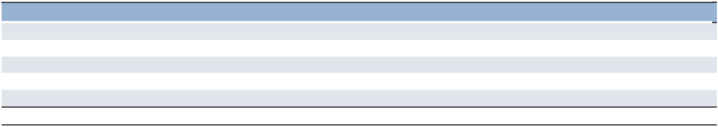

 | 2025 |  |  | 2024
Land | $ | 0.5 | $ | 0.4
Buildings |  | 6.3 |  | 6.0
Furniture, fixtures, and autos |  | 153.5 |  | 145.6
Computer equipment |  | 107.9 |  | 106.1
Leasehold improvements |  | 258.7 |  | 230.1
Property and equipment | $ | 526.9 | $ | 488.2

Property and equipment are stated at cost and are depreciated using primarily the straight-line method over the following estimated useful lives: buildings - up to 40 years; furniture, fixtures, autos and computer equipment - 3 to 16 years; leasehold improvements - lesser of life of asset or expected lease term. Expenditures for renewals and betterments are capitalized whereas expenditures for repairs and maintenance are charged to income as incurred. Upon sale or disposition of property and equipment, the difference between the unamortized cost and the proceeds is recorded as either a gain or a loss and is included in our Consolidated Statements of Operations. Long-lived assets are evaluated for impairment in accordance with the provisions of the accounting guidance on the impairment or disposal of long-lived assets.

Leases

We recognize right-of-use assets (“ROU”) and lease liabilities on the balance sheet for leases with lease terms longer than 12 months and we classify the lease as a finance or operating lease which affects the recognition, measurement, and presentation of lease expenses and cash flows. Our Consolidated Balance Sheets now present ROU assets, short-term lease liability and long-term lease liability as separate line items.

We have operating leases for real estate, vehicles, and equipment. Our leases have remaining lease terms of 1 month to 14 years. Our lease agreements may include renewal or termination options for varying periods that are generally at our discretion. In our lease term, we only include those periods related to renewal options we are reasonably certain to exercise. However, we generally do not include these renewal options as we are not reasonably certain to renew at the lease commencement date. This determination is based on our consideration of certain economic, strategic and other factors that we evaluate at lease commencement date and reevaluate throughout the lease term. Some leases also include options to terminate the contracts, and we only include those periods beyond the termination date if we are reasonably certain not to exercise the termination option.

Some leasing arrangements require variable payments that are dependent on usage or may vary for other reasons, such as payments for insurance and tax payments. The variable portion of lease payments is not included in our ROU assets or lease liabilities. Rather, variable payments, other than those dependent upon an index or rate, are expensed when the obligation for those payments is incurred and are included in lease expenses recorded in selling and administrative expenses on the Consolidated Statements of Operations.

We have lease agreements with both lease and non-lease components that are treated as a single lease component for all underlying asset classes. Accordingly, all expenses associated with a lease contract are accounted for as lease expenses.

62

Part II

Leases with a term of 12 months or less are not recognized on the balance sheet, but rather expensed on a straight-line basis over the lease term. We do not include significant restrictions or covenants in our lease agreements, and residual value guarantees are generally not included within our operating leases. As of December 31, 2025, we did not have any material additional operating leases that have not yet commenced.

Derivative Financial Instruments

Derivative instruments are recorded on the balance sheet as either an asset or liability measured at their fair value. If the derivative is designated as a fair value hedge, the changes in the fair value of the derivative and of the hedged item attributable to the hedged risk are recognized in earnings. If the derivative is designated as a cash flow hedge, the effective portions of the changes in the fair value of the derivative are recorded as a component of AOCL and recognized in the Consolidated Statements of Operations when the hedged item affects earnings. The ineffective portions of the changes in the fair value of cash flow hedges are recognized in earnings. If the derivative is designated as a net investment hedge in a foreign operation, the changes in the fair value of the derivative are recognized in cumulative translation adjustment ("CTA") within other comprehensive income and held there until the hedged net investment is sold or liquidated. At that point, the amount recognized in CTA is reclassified to earnings and reported in the same line item as the gain or loss on the liquidation of the net investment.

Foreign Currency Translation

Asset and liability accounts are translated at the current exchange rates and income statement items are translated at the average exchange rates each month. The resulting translation adjustments are recorded as a component of AOCL, which is included in shareholders’ equity.

As of July 1, 2018, the Argentina economy was designated as highly-inflationary and was treated as such for accounting purposes for all periods presented.

A portion of our Euro-denominated notes is accounted for as a hedge of our net investment in our subsidiaries with a Euro-functional currency. For this portion of the Euro-denominated notes, since our net investment in these subsidiaries exceeds the amount of the related borrowings, net of tax, the related translation gains or losses are included as a component of AOCL.

Shareholders’ Equity

The Board of Directors authorized the repurchase of 5.0 million and 4.0 million shares of our common stock in August 2023 and August 2021, respectively. Share repurchases may be made from time to time through a variety of methods, including open market purchases, block transactions, privately negotiated transactions or similar facilities. In 2025, we repurchased a total of 0.7 million shares under the 2023 authorization, at a total cost of $37.5 including excise tax on share repurchases of $0.5. In 2024, we repurchased a total of 2.0 million shares under the 2023 authorization, at a total cost of $140.9 including excise tax on share repurchases of $0.9. In 2023, we repurchased a total of 2.4 million shares comprised of 2.0 million shares under the 2021 authorization and 0.4 million shares under the 2023 authorization, at a total cost of $181.5 including excise tax on share repurchases of $1.7. As of December 31, 2025, there were 1.9 million shares remaining authorized for repurchase under the 2023 authorization and no shares remaining authorized for repurchase under the 2021 authorization.

During 2025, 2024 and 2023, the Board of Directors declared total cash dividends of $1.44, $3.08 and $2.94 per share, respectively, resulting in total dividend payments of $66.7, $145.8 and $144.3, respectively.

Noncontrolling interests, included in total shareholders' equity in our Consolidated Balance Sheets, represent amounts related to majority-owned subsidiaries in which we have a controlling financial interest. Net earnings attributable to these noncontrolling interests are recorded in interest and other expenses in our Consolidated Statements of Operations. We recorded income of $0.2 for 2025 and expenses of $0.3 and $0.4 for 2024 and 2023, respectively.

Cash and Cash Equivalents

Cash and cash equivalents comprise cash on hand, term deposits with banks and short-term highly-liquid financial investments that are readily convertible to known amounts of cash which are subject to insignificant risk of changes in value; and have a maturity of three months or less from the date of acquisition.

63

Part II

Accounting Standards Effective in 2025

In December 2023, the FASB issued a final standard on improvements to income tax disclosures. The guidance requires that public entities on an annual basis disclose disaggregated information about the rate reconciliation as well as income taxes paid. We adopted the new guidance for our 2025 annual disclosures on a prospective basis. See Note 5 to the Consolidated Financial Statements for more information.

Recently Issued Accounting Standards

In November 2024, the FASB issued new guidance on disaggregation of income statement expenses. The guidance requires disclosures about specific types of expenses included in the expense captions presented on the face of the income statement, as well as disclosures about selling expenses. The guidance is effective for our 2027 annual financial statements and can be adopted prospectively or retrospectively. Adoption of this guidance will not have a material impact on our Consolidated Financial Statements.

In September 2025, the FASB issued new guidance on internal-use software. The guidance removes the requirement to evaluate costs by development stage and allows capitalization to begin once management commits funding and completion is probable. The new standard is effective as of January 1, 2028, with early adoption permitted. It may be adopted prospectively or retrospectively. We are currently assessing the impact of this guidance on our Consolidated Financial Statements.

In November 2025, the FASB issued new guidance on hedge accounting. The guidance provides additional requirements in five areas: similar risk assessment, treatment of Choose-Your-Rate debt, nonfinancial forecasted transactions, net written options, and dual-hedging foreign-currency-denominated debt. The guidance is effective for us as of January 1, 2027. Adoption of this guidance will not have a material impact on our Consolidated Financial Statements.

In December 2025, the FASB issued new guidance on government grants. The guidance requires entities to recognize government grants when they meet the conditions for receipt and to present them either as a reduction of related expenses or as other income, based on the nature of the grant. It also requires specific disclosures about the nature, terms, and amounts of government grants received. The guidance is effective for us as of January 1, 2029. Adoption of this guidance will not have a material impact on our Consolidated Financial Statements.

In December 2025, the FASB issued new guidance on interim reporting. The guidance clarifies which annual disclosures must be repeated in interim periods, aligns interim reporting guidance with other recent standards, and simplifies certain interim presentation requirements. The guidance is effective for us as of January 1, 2028. Adoption of this guidance will not have a material impact on our Consolidated Financial Statements.

- Revenue Recognition

Revenue Service Types

The following is a description of our revenue service types, including Staffing and Interim, Outcome-Based Solutions and Consulting, Permanent Recruitment and Other services.

Staffing and Interim

Staffing and Interim services include the augmentation of clients’ workforce with our contingent employees performing services under the client’s supervision, which provides our clients with a source of flexible labor. Staffing and Interim client contracts are generally short-term in nature, and we generally enter into contracts that include only a single performance obligation. We recognize revenues over time based on a fixed amount for each hour of Staffing and Interim service provided as our clients benefit from our services as we provide them.

64

Part II

Outcome-Based Solutions and Consulting

Our Outcome-Based Solutions and Consulting services include utilizing consultants and contingent employees who are generally experts in a specific field advising the client to help find strategic solutions to specific matters or achieve a particular outcome. Our services may also include managing certain processes and functions within the client’s organization. We recognize revenues over time based on (i) our clients benefiting from our services as we are providing them, (ii) our clients controlling an asset as it is created or enhanced, or (iii) our performance not creating an asset with an alternative use and having an enforceable right to payment for the services we have provided to date. We generally utilize an input measure of time for the service provided, which most accurately depicts the progress toward completion of these performance obligations. The price as specified in our client contracts is generally considered the standalone selling price as it is an observable input that depicts the price as if sold to a similar client in similar circumstances.

Permanent Recruitment

Permanent Recruitment services include providing qualified candidates to our clients to hire on a permanent basis. We recognize revenues for our Permanent Recruitment services at a point in time when we place the qualified candidate, because we have determined that control of the performance obligation has transferred to the client (i.e., service performed) as we have the right to payment for our service and the client has accepted our service of providing a qualified candidate to fill a permanent position. Revenues recognized from our Permanent Recruitment services are based upon either a fixed fee per placement or as a percentage of the candidate’s salary.

Our RPO services, which include RPO management services and placement services, are also included in our Permanent Recruitment revenues. RPO management services include the various activities of managing a client's permanent workforce, which can include candidate assessments, screening, conducting candidate interviews, providing sourcing technology, and providing our marketing and recruiting expertise. We perform these activities to fulfill the overall obligation to provide permanent workforce management services, so they are not individually distinct, and therefore, we account for them as a single performance obligation. We generally utilize an input measure of time in months, but we do have a few contracts for which we use labor hours of management services provided as this more accurately depicts the progress toward completion of the performance obligation. We recognize revenues over time for each month of management services provided, as each month of management services is distinct, and the client benefits from each month of management services as we provide them. For those contracts for which we use labor hours as the input measure, we recognize revenues over time based on a fixed amount for each labor hour of management services provided as our clients benefit from our services as we provide them.

We consider the RPO management services and placement services to be distinct, and therefore separate performance obligations within our RPO contracts as (i) our clients can benefit from each service on its own, and (ii) each service is separately identifiable within the client contract. The prices as specified in our contracts will generally be broken out between management fees and placement fees, which we consider the standalone selling price of each service as they are the observable inputs which depict the prices as if they were sold to a similar client in similar circumstances. The consideration from our client contracts is allocated to each performance obligation based on the relative standalone selling price.

Other Services

Other services include revenues from outplacement services, MSP services, training services and franchise fees.

Outplacement services include assisting our clients in managing their workforce transitions and their employees in managing career changes by developing additional skills and finding new employment. We recognize revenues over time as we provide the service (i.e., transfer control of the performance obligation) using the input measure of hours of service to measure progress toward completion of the performance obligation.

MSP services include overall program management of our clients’ contingent workforce and generally include various activities such as reporting and tracking, supplier selection and management and order distribution, depending on each client contract. We provide these services to fulfill the overall obligation of contingent workforce management services so the individual activities are not distinct and therefore we account for them as a single performance obligation. We recognize revenues over time for each month of MSP services provided as each month of MSP services is distinct, and the client benefits from each month of MSP services as we provide them.

Training services include teaching skills that relate to specific competencies in order for our client’s workforce to acquire knowledge and develop skills proficiencies. We recognize revenues over time for each hour of training service provided as our clients benefit from our services as we provide them.

65

Part II

Our franchise fees include the performance obligation of providing the right to use our intellectual property in a specifically defined exclusive territory as defined in a franchise agreement. Our franchise agreements generally state that franchise fees are calculated based on a percentage of revenues earned by the franchise operations and are payable on a monthly basis. As such, we record franchise fee revenues monthly over time calculated based on the specific fee percentage and the monthly revenues of the franchise operations. Franchise fees were $16.6, $14.4 and $14.8 for the years ended December 31, 2025, 2024 and 2023, respectively.

Disaggregation of Revenues

In the following table, revenue is disaggregated by service types and timing of revenue recognition and then reconciled by reportable segment.
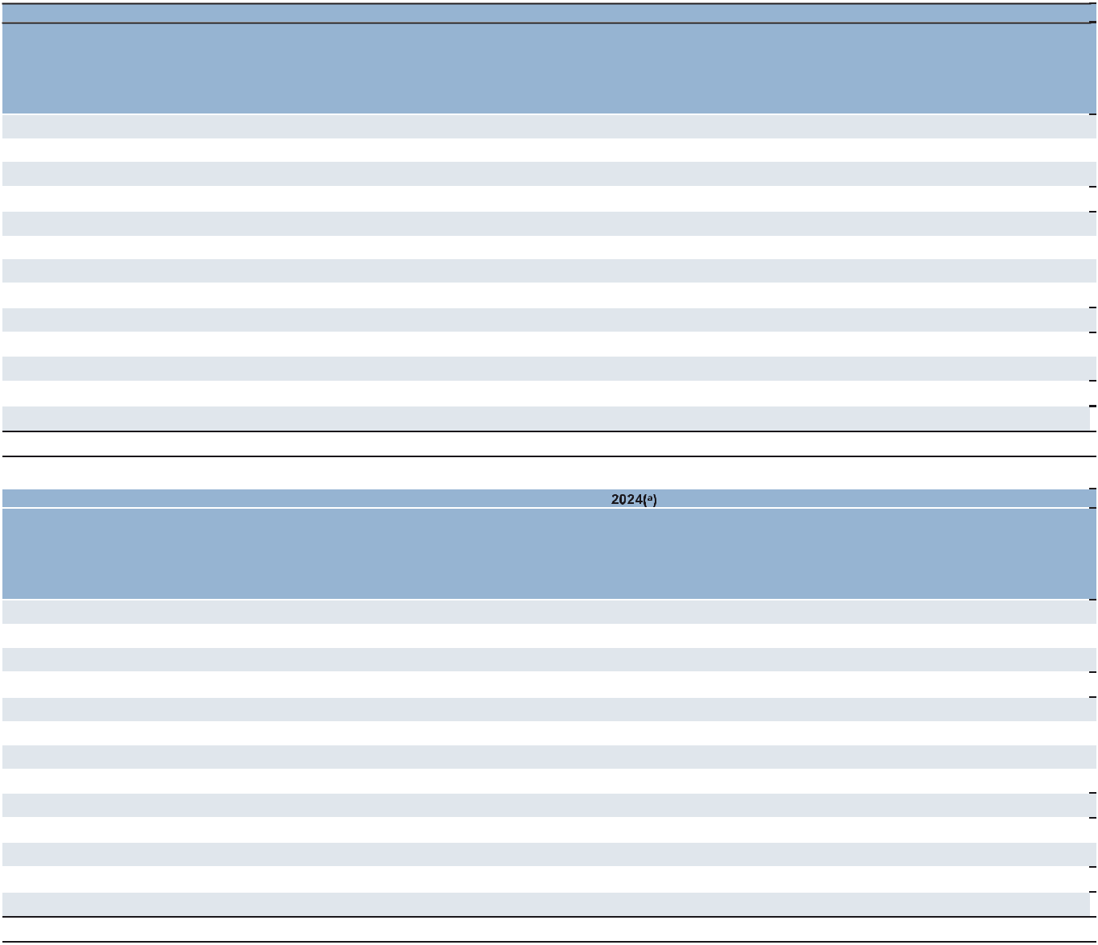

Year Ended December 31, 2025

 |  |  |  | Outcome-
 |  |  |  | Based
 |  | Staffing |  | Solutions
 |  | and |  | and |  | Permanent
 |  | Interim |  | Consulting |  | Recruitment |  | Other |  | Total
Americas:
United States | $ | 2,438.2 | $ | 10.6 | $ | 110.0 | $ | 176.6 | $ | 2,735.4
Other Americas |  | 1,497.0 |  | 66.3 |  | 37.6 |  | 12.5 |  | 1,613.4
 |  | 3,935.2 |  | 76.9 |  | 147.6 |  | 189.1 |  | 4,348.8
Southern Europe:
France |  | 4,072.4 |  | 263.4 |  | 41.3 |  | 82.3 |  | 4,459.4
Italy |  | 1,694.9 |  | 50.0 |  | 48.2 |  | 29.0 |  | 1,822.1
Other Southern Europe |  | 1,740.5 |  | 320.7 |  | 56.3 |  | 37.3 |  | 2,154.8
 |  | 7,507.8 |  | 634.1 |  | 145.8 |  | 148.6 |  | 8,436.3
Northern Europe |  | 2,731.0 |  | 231.0 |  | 100.4 |  | 98.7 |  | 3,161.1
APME |  | 1,704.2 |  | 249.0 |  | 48.5 |  | 40.2 |  | 2,041.9
 |  | 15,878.2 |  | 1,191.0 |  | 442.3 |  | 476.6 |  | 17,988.1
Intercompany Eliminations |  |  |  |  |  |  |  |  |  | (31.0)
Total |  |  |  |  |  |  |  |  | $ | 17,957.1
 |  | Year Ended December 31,
 |  |  |  | Outcome-
 |  |  |  | Based
 |  | Staffing |  | Solutions
 |  | and |  | and |  | Permanent
 |  | Interim |  | Consulting |  | Recruitment |  | Other |  | Total
Americas:
United States | $ | 2,454.5 | $ | 11.3 | $ | 126.1 | $ | 174.7 | $ | 2,766.6
Other Americas |  | 1,350.6 |  | 54.2 |  | 43.0 |  | 10.5 |  | 1,458.3
 |  | 3,805.1 |  | 65.5 |  | 169.1 |  | 185.2 |  | 4,224.9
Southern Europe:
France |  | 4,136.6 |  | 264.1 |  | 49.4 |  | 81.4 |  | 4,531.5
Italy |  | 1,561.5 |  | 36.0 |  | 48.0 |  | 31.5 |  | 1,677.0
Other Southern Europe |  | 1,613.3 |  | 314.1 |  | 50.8 |  | 31.6 |  | 2,009.8
 |  | 7,311.4 |  | 614.2 |  | 148.2 |  | 144.5 |  | 8,218.3
Northern Europe |  | 2,814.0 |  | 257.2 |  | 121.5 |  | 111.6 |  | 3,304.3
APME |  | 1,746.1 |  | 321.9 |  | 52.8 |  | 40.5 |  | 2,161.3
 |  | 15,676.6 |  | 1,258.8 |  | 491.6 |  | 481.8 |  | 17,908.8
Intercompany Eliminations |  |  |  |  |  |  |  |  |  | (54.9)
Total |  |  |  |  |  |  |  |  | $ | 17,853.9

- Effective January 1, 2025, our segment reporting was realigned to include our Morocco business within Other Southern Europe. Accordingly, France is now adjusted to exclude Morocco. All previously reported results have been recast to conform to the current year presentation.

66

Part II
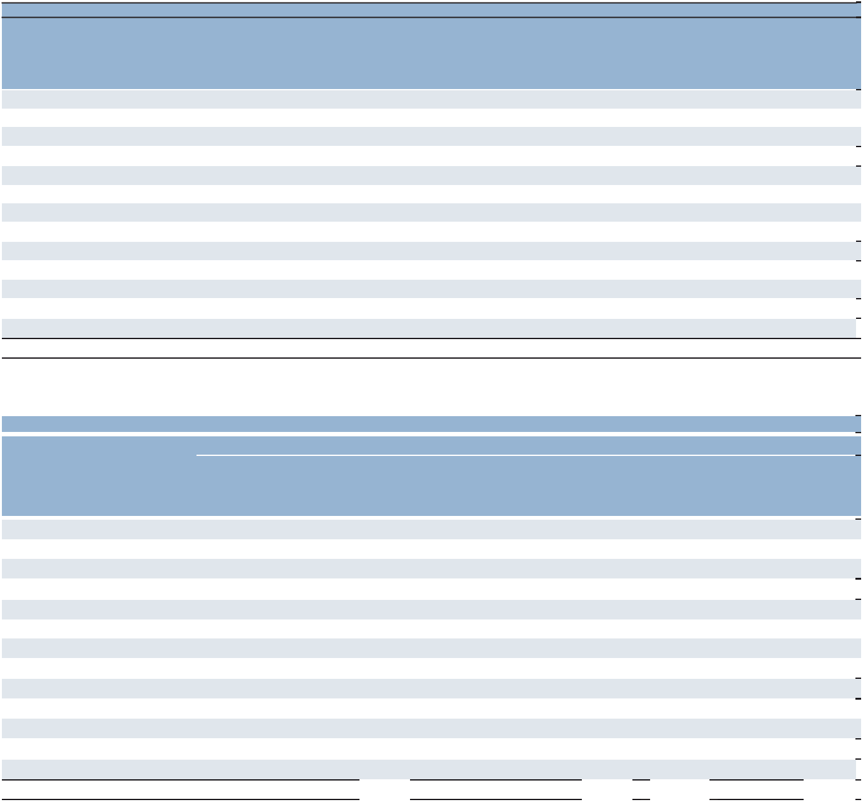

Year Ended December 31,

 |  |  |  | Outcome-
 |  |  |  | Based
 |  | Staffing |  | Solutions
 |  | and |  | and |  | Permanent
 |  | Interim |  | Consulting |  | Recruitment |  | Other |  | Total
Americas:
United States | $ | 2,552.5 | $ | 18.3 | $ | 132.7 | $ | 162.7 | $ | 2,866.2
Other Americas |  | 1,442.6 |  | 49.4 |  | 47.2 |  | 9.4 |  | 1,548.6
 |  | 3,995.1 |  | 67.7 |  | 179.9 |  | 172.1 |  | 4,414.8
Southern Europe:
France |  | 4,393.5 |  | 267.7 |  | 58.9 |  | 70.0 |  | 4,790.1
Italy |  | 1,590.1 |  | 36.9 |  | 55.0 |  | 26.8 |  | 1,708.8
Other Southern Europe |  | 1,608.4 |  | 320.9 |  | 58.9 |  | 28.2 |  | 2,016.4
 |  | 7,592.0 |  | 625.5 |  | 172.8 |  | 125.0 |  | 8,515.3
Northern Europe |  | 3,160.2 |  | 332.5 |  | 153.2 |  | 102.1 |  | 3,748.0
APME |  | 1,781.8 |  | 386.3 |  | 109.4 |  | 44.8 |  | 2,322.3
 |  | 16,529.1 |  | 1,412.0 |  | 615.3 |  | 444.0 |  | 19,000.4
Intercompany Eliminations |  |  |  |  |  |  |  |  |  | (85.9)
Total |  |  |  |  |  |  |  |  | $ | 18,914.5

- Effective January 1, 2025, our segment reporting was realigned to include our Morocco business within Other Southern Europe. Accordingly, France is now adjusted to exclude Morocco. All previously reported results have been recast to conform to the current year presentation.

 |  |  |  |  |  |  |  | Year Ended December 31,
 |  |  |  | 2025 |  |  |  |  |  | 2024^{(a)} |  |  |  |  |  | 2023^{(a)}
 |  |  |  | Services |  |  |  |  |  | Services |  |  |  |  |  | Services
 |  | Services | transferred |  |  |  |  | Services | transferred |  |  |  |  | Services | transferred
 | transferred |  | at a point |  |  |  | transferred |  | at a point |  |  |  | transferred |  | at a point
 | over time |  |  | in time |  | Total | over time |  |  | in time |  | Total | over time |  |  | in time |  | Total
Americas:
United States | $ | 2,678.0 | $ | 57.4 | $ | 2,735.4 | $ | 2,695.4 | $ | 71.2 | $ | 2,766.6 | $ | 2,789.8 | $ | 76.4 | $ | 2,866.2
Other Americas |  | 1,592.5 |  | 20.9 |  | 1,613.4 |  | 1,432.0 |  | 26.3 |  | 1,458.3 |  | 1,518.8 |  | 29.8 |  | 1,548.6
 |  | 4,270.5 |  | 78.3 |  | 4,348.8 |  | 4,127.4 |  | 97.5 |  | 4,224.9 |  | 4,308.6 |  | 106.2 |  | 4,414.8
Southern Europe:
France |  | 4,421.6 |  | 37.8 |  | 4,459.4 |  | 4,486.7 |  | 44.8 |  | 4,531.5 |  | 4,753.3 |  | 36.8 |  | 4,790.1
Italy |  | 1,777.2 |  | 44.9 |  | 1,822.1 |  | 1,632.6 |  | 44.4 |  | 1,677.0 |  | 1,657.8 |  | 51.0 |  | 1,708.8
Other Southern Europe |  | 2,111.0 |  | 43.8 |  | 2,154.8 |  | 1,967.2 |  | 42.6 |  | 2,009.8 |  | 1,952.3 |  | 64.1 |  | 2,016.4
 |  | 8,309.8 |  | 126.5 |  | 8,436.3 |  | 8,086.5 |  | 131.8 |  | 8,218.3 |  | 8,363.4 |  | 151.9 |  | 8,515.3
Northern Europe |  | 3,084.6 |  | 76.5 |  | 3,161.1 |  | 3,208.9 |  | 95.4 |  | 3,304.3 |  | 3,627.5 |  | 120.5 |  | 3,748.0
APME |  | 2,000.0 |  | 41.9 |  | 2,041.9 |  | 2,116.2 |  | 45.1 |  | 2,161.3 |  | 2,255.2 |  | 67.1 |  | 2,322.3
 |  | 17,664.9 |  | 323.2 |  | 17,988.1 |  | 17,539.0 |  | 369.8 |  | 17,908.8 |  | 18,554.7 |  | 445.7 |  | 19,000.4
Intercompany Eliminations |  |  |  |  |  | (31.0) |  |  |  |  |  | (54.9) |  |  |  |  |  | (85.9)
Total |  |  |  |  | $ | 17,957.1 |  |  |  |  | $ | 17,853.9 |  |  |  |  | $ | 18,914.5

- Effective January 1, 2025, our segment reporting was realigned to include our Morocco business within Other Southern Europe. Accordingly, France is now adjusted to exclude Morocco. All previously reported results have been recast to conform to the current year presentation.

67

Part II

- Share-Based Compensation Plans

During 2025, 2024 and 2023, we recognized $26.3, $27.3 and $28.7, respectively, in share-based compensation expense related to stock options, deferred stock, restricted stock, performance share units and savings-related share option scheme, all of which is recorded in selling and administrative expenses. Consideration received from share-based awards for 2025, 2024 and 2023 was $0.0, $0.8 and $1.8, respectively. We recognized income tax expense of $0.3 in 2025, and income tax benefits of $1.3 and $1.0 in 2024 and 2023, respectively, for the United States share-based compensation. For non-United States share-based compensation, we recognized income tax benefits of $1.0, $1.2 and $1.6 for 2025, 2024 and 2023, respectively. We recognize compensation expense on grants of share-based compensation awards on a straight-line basis over the vesting period of each award.

Stock Options and Stock Appreciation Rights

All share-based compensation is granted under the 2011 Equity Incentive Plan of ManpowerGroup Inc. (“2011 Plan”). Under the 2011 Plan, stock options and stock appreciation rights are required to be granted at a price not less than 100% of the fair market value of the common stock at the date of grant. Generally, options are granted with a ratable vesting period of up to four years and expire 10 years from date of grant. No options were granted subsequent to 2021, and we have not granted stock appreciation rights under the 2011 Plan. A summary of stock option activity is as follows:
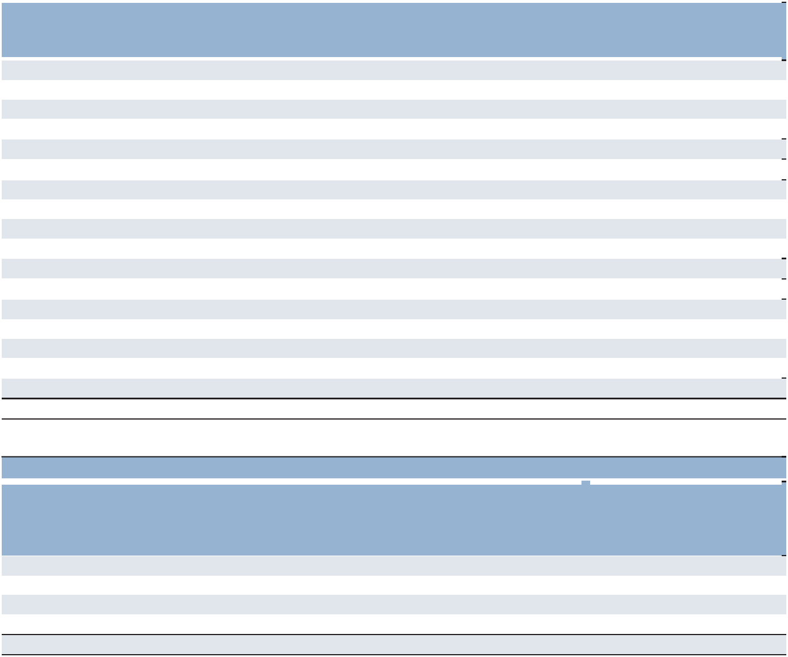

 |  |  |  | Wtd. Avg.
 |  | Wtd. Avg. |  | Remaining |  | Aggregate
 |  | Exercise Price |  | Contractual |  | Intrinsic Value
 | Shares (000) | Per Share |  | Term (years) |  | (in millions)
Outstanding, January 1, 2023 | 852 | $ | 90
Granted | — |  | N/A
Exercised | (23) |  | 76
Expired or cancelled | (19) |  | 109
Outstanding, December 31, 2023 | 810 | $ | 90 | 4.4 | $ | 1
Exercisable, December 31, 2023 | 706 | $ | 90 | 4.1 | $ | 1
Outstanding, January 1, 2024 | 810 | $ | 90
Granted | — |  | N/A
Exercised | — |  | N/A
Expired or cancelled | (48) |  | 80
Outstanding, December 31, 2024 | 762 | $ | 91 | 3.7 | $ | —
Exercisable, December 31, 2024 | 730 | $ | 91 | 3.5 | $ | —
Outstanding, January 1, 2025 | 762 | $ | 91
Granted | — |  | N/A
Exercised | — |  | N/A
Expired or cancelled | (52) |  | 77
Outstanding, December 31, 2025 | 710 | $ | 92 | 2.9 | $ | —
Exercisable, December 31, 2025 | 710 | $ | 92 | 2.9 | $ | —

Options outstanding and exercisable as of December 31, 2025 were as follows:

 |  | Options Outstanding |  |  |  |  | Options Exercisable
 |  | Weighted-
 |  | Average |  | Weighted- |  |  |  |  | Weighted-
 |  | Remaining |  | Average |  |  |  |  | Average
 |  | Contractual |  | Exercise |  |  |  |  | Exercise
Exercise Price | Shares (000) | Life (years) |  | Price |  |  | Shares (000) |  | Price
$75-$80 | 103 | 0.1 | $ | 75 | 103 |  |  | $ | 75
$81-$89 | 153 | 3.2 |  | 84 | 153 |  |  |  | 84
$90-$95 | 286 | 4.6 |  | 93 | 286 |  |  |  | 93
$96-$123 | 168 | 1.6 |  | 109 | 168 |  |  |  | 109
 | 710 | 2.9 | $ | 92 | 710 |  |  | $ | 92

68

Part II

We recognized expense of $0.0, $0.2 and $0.5 related to stock options for the years ended December 31, 2025, 2024 and 2023, respectively. The total fair value of options vested during the same periods was $0.7, $1.5 and $2.2, respectively. As of December 31, 2025, there was no unrecognized compensation cost.

Deferred Stock

Our non -employee directors may elect to receive deferred stock in lieu of part or all of their annual cash retainer otherwise payable to them. The number of shares of deferred stock is determined pursuant to a formula set forth in the terms and conditions adopted under the 2011 Plan; the deferred stock is settled in shares of common stock according to these terms and conditions. During December 31, 2025, 2024 and 2023, there were 7,232, 4,716 and 4,463, respectively, shares of deferred stock awarded under this arrangement, all of which are vested.

Non-employee directors also receive an annual grant of deferred stock (or restricted stock, if they so elect) as additional compensation for board service. The award vests in equal quarterly installments over one year and the vested portion of the deferred stock is settled in shares of common stock either three years after the date of grant (which may in most cases be extended at the directors’ election) or upon a director’s termination of service in accordance with the terms and conditions under the 2011 Plan. During 2025, 2024 and 2023, there were 18,714, 14,362 and 14,721, respectively, shares of deferred stock awarded under this arrangement, all of which are vested. We recognized expense of $1.5, $1.7 and $1.9 related to deferred stock in 2025, 2024 and 2023, respectively.

Restricted Stock and Restricted Stock Units

We grant restricted stock and restricted stock unit awards to certain employees and to non-employee directors who may elect to receive restricted stock rather than deferred stock as described above. Restrictions lapse over periods ranging up to five years, and in some cases upon retirement. We value restricted stock awards at the closing market value of our common stock on the date of grant.

A summary of restricted stock and restricted stock unit activity is as follows:
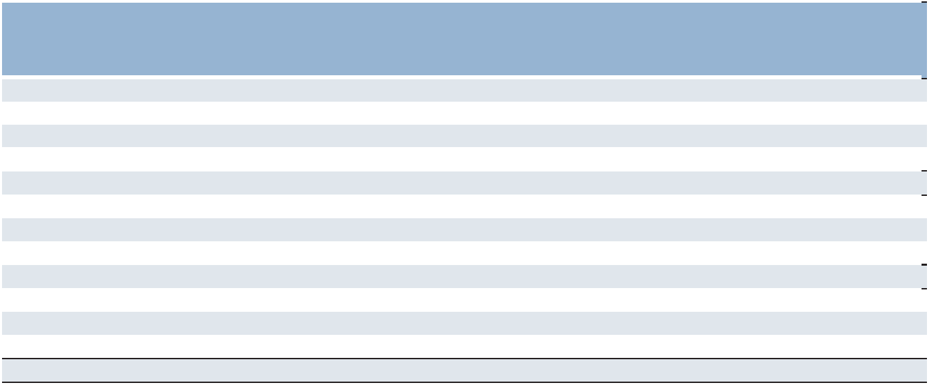

 |  |  |  | Wtd. Avg. |  | Aggregate
 |  | Wtd. Avg. |  | Remaining |  | Intrinsic
 |  | Price Per |  | Contractual |  | Value
 | Shares (000) | Share |  | Term (years) |  | (in millions)
Unvested, January 1, 2023 | 588 | $ | 94 | 1.4
Granted | 261 |  | 82
Vested | (177) |  | 87
Forfeited | (44) |  | 90
Unvested, December 31, 2023 | 628 | $ | 91 | 1.4
Granted | 343 |  | 64
Vested | (180) |  | 86
Forfeited | (38) |  | 83
Unvested, December 31, 2024 | 753 | $ | 80 | 1.4
Granted | 442 |  | 48
Vested | (240) |  | 94
Forfeited | (40) |  | 66
Unvested, December 31, 2025 | 915 | $ | 63 | 1.4 | $ | 27

During 2025, 2024 and 2023, there were 12,476, 9,060 and 8,412, respectively, shares of restricted stock granted to our non-employee directors, all of which are vested. During 2025, 2024 and 2023, we recognized expense of $19.4, $18.9 and $18.9, respectively, related to restricted stock awards. As of December 31, 2025, there was $13.9 of total unrecognized compensation cost related to unvested restricted stock, which we expect to recognize over a weighted-average period of approximately 2.0 years.

69

Part II

Performance Share Units

Our 2011 Plan allows us to grant performance share units. We grant performance share units with a performance period ranging from one to three years. Vesting of units occurs at the end of the performance period or after a subsequent holding period, except in the case of termination of employment where the units are forfeited immediately. Upon retirement, a prorated number of units vest depending on the period worked from the grant date to retirement date or in certain cases all of the units vest. In the case of death or disability, the units immediately vest at the Target Award level if the death or disability date is during the performance period, or at the level determined by the performance criteria met during the performance period if the death or disability occurs during the subsequent holding period. The units are settled in shares of our common stock. A payout multiple may be applied to the units awarded based on the performance criteria determined by the People, Culture and Compensation Committee of the Board of Directors ("the Committee") at the time of grant. Final determination of the payout is at the discretion of the Committee.

In the event the performance criteria exceed the Target Award level, an additional number of shares, up to the Outstanding Award level, may be granted. In the event the performance criteria fall below the Target Award level, a reduced number of shares, as low as the Threshold Award level, may be granted. If the performance criteria fall below the Threshold Award level, no shares will be granted.

A summary of the performance share units detail by grant year is as follows:
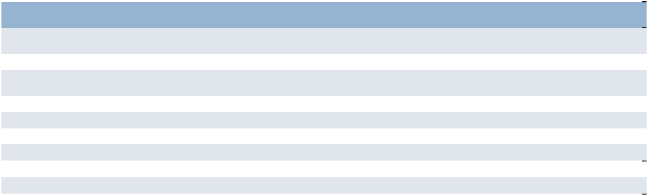

 | 2022 | 2022
 | (Regular) | (Experis) | 2023 | 2024 | 2025
 | February 11, | February 11, | February 17, | February 16, | February 14,
Grant Date(s) | 2022 | 2022 | 2023 | 2024 | 2025
Performance Period (years) | 2022-2024 | 2022-2024 | 2023-2025 | 2024-2026 | 2025-2027
Vesting Date^{(a)} |  |  |  | February | February
Vesting Date^{(a)} | February 2025 | February 2025 | February 2026 | 2027 | 2028
Payout Levels (in units):
Threshold Award | — | — | — | — | —
Target Award | 106,116 | 28,275 | 132,537 | 179,099 | 215,054
Outstanding Award | 212,232 | 84,826 | 265,074 | 358,198 | 430,108
Shares Issued in 2025 | 67,422 | — | N/A | N/A | N/A
Payout Achieved Over Performance Period | 67,422 | — | 56,835 | N/A | N/A
- Awards are scheduled to vest after the Committee determines the achievement of the performance criteria.

We recognize and adjust compensation expense based on the likelihood of the performance criteria specified in the award being achieved. The compensation expense is recognized over the performance and holding periods and is recorded in selling and administrative expenses. We recognized total compensation expense of $5.3, $6.1 and $7.2 in 2025, 2024 and 2023, respectively, related to the performance share units. The lower expense in 2025 and 2024 compared to 2023 resulted from lower estimated payout levels for all the grants.

Savings-Related Share Option Scheme

We also maintain the Savings Related Share Option Scheme for United Kingdom employees with at least two years of service. The employees are offered the opportunity to obtain an option for a specified number of shares of common stock at 85% of its market value on the day prior to the offer to participate in the plan. Options vest after three years, but may lapse earlier. Funds used to purchase the shares are accumulated through specified payroll deductions over a 36-month period. We recognized expense of $0.1, $0.4 and $0.2 in 2025, 2024 and 2023, respectively, for shares purchased under the plan.

- Acquisitions and Dispositions

Acquisitions

From time to time, we acquire and invest in companies throughout the world, including franchises. The total cash consideration paid for acquisitions, net of cash acquired, for the years ended December 31, 2025, 2024, and 2023 was $2.3, $7.7 and $0.0, respectively. The 2025 payments mainly represent a contingent consideration payment related to a previous acquisition. The 2024 payments represent a consideration payment for a franchise in the United States and contingent consideration payments related to a previous acquisition.

70

Part II

As of December 31, 2025, goodwill and other intangible assets resulting from the 2025 acquisitions were $0.9 and $0.0, respectively. As of December 31, 2024, goodwill and other intangible assets resulting from the 2024 acquisitions were $1.4 and $3.1, respectively.

Dispositions

Occasionally, we dispose of parts of our operations based on risk considerations and to optimize our global strategic and geographic footprint as well as improve our overall efficiency. On May 31, 2025, we disposed of our New Caledonia business in our APME segment and simultaneously entered into a franchise agreement. In connection with this transaction, we recognized a one-time net loss on disposition of $1.4, of which $0.2 was included in selling and administrative expenses and $1.2 was included in interest and other expenses in the Consolidated Statements of Operations in the year ended December 31, 2025.

On May 30, 2025, we disposed of our South Africa business in our Northern Europe segment in exchange for a non-interest-bearing loan receivable of $1.4 and simultaneously entered into a franchising agreement. We recognized a one-time net loss on disposition of $4.8, of which $2.2 was included in selling and administrative expenses and $2.6 was included in interest and other expenses in the Consolidated Statements of Operations in the year ended December 31, 2025.

On November 1, 2024, we disposed of our South Korea business in our APME segment for cash proceeds of $20.6 and simultaneously entered into a franchising agreement under which the new ownership will operate Manpower Korea under the Manpower brand. In connection with the disposition, we recognized a one-time net loss on disposition of $0.4, consisting of a $3.3 gain in selling and administrative expenses and a $3.7 loss in interest and other expenses in the Consolidated Statements of Operations in the year ended December 31, 2024. The franchise arrangement represents a significant component of the transaction. Our South Korea business contributed $349.9 of revenues for the year ended December 31, 2023.

On October 15, 2024, we disposed of our Austria business in our Southern Europe segment for cash proceeds of $0.1 and simultaneously entered into a franchising agreement. In connection with the disposition, we recognized a one-time net loss on disposition of $7.7, of which $4.9 was included in selling and administrative expenses and $2.8 was included in interest and other expenses in the Consolidated Statements of Operations in the year ended December 31, 2024.

On September 29, 2023, we disposed of our Philippines business in our APME segment for total consideration of $6.5. In connection with the disposition, we recognized a one-time net loss on disposition of $1.3, which was included in interest and other expenses in the Consolidated Statements of Operations in the year ended December 31, 2023.

71

Part II

- Income Taxes

The earnings (loss) before income taxes was as follows:
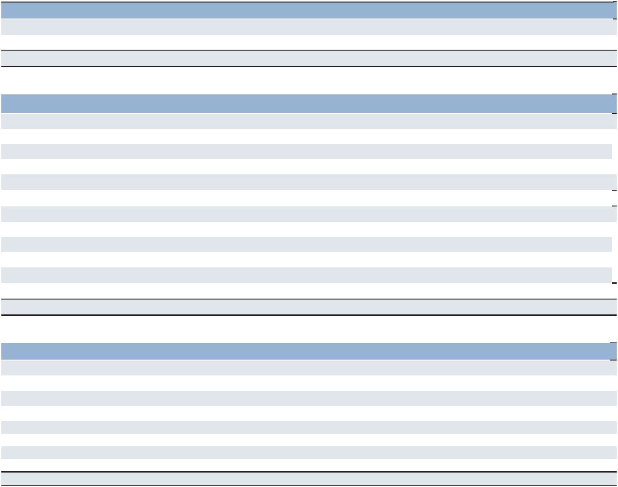

Year Ended December 31 | 2025 | 2024 | 2023

United States | $ | (4.3) | $ | 10.8 | $ | 40.7
Non-United States |  | 97.7 |  | 246.0 |  | 165.2
Total earnings before income taxes | $ | 93.4 | $ | 256.8 | $ | 205.9
The provision for income taxes was as follows:
Year Ended December 31 |  | 2025 |  | 2024 |  | 2023
Current
United States
Federal | $ | 31.6 | $ | 2.4 | $ | (2.9)
State |  | 3.9 |  | 0.8 |  | 7.3
Non-United States |  | 107.0 |  | 140.9 |  | 133.3
Total current |  | 142.5 |  | 144.1 |  | 137.7
Deferred
United States
Federal |  | (34.2) |  | (22.6) |  | (8.6)
State |  | (2.0) |  | 2.9 |  | (4.0)
Non-United States |  | 0.4 |  | (12.7) |  | (8.0)
Total deferred |  | (35.8) |  | (32.4) |  | (20.6)
Total provision | $ | 106.7 | $ | 111.7 | $ | 117.1
The cash paid, net of refunds, for income taxes was as follows:
Year Ended December 31 |  |  |  |  |  | 2025
United States
Federal |  |  |  |  | $ | 32.2
States |  |  |  |  |  | 1.1
Non-United States
France |  |  |  |  |  | 50.4
Italy |  |  |  |  |  | 9.6
Japan |  |  |  |  |  | 14.7
Other, net |  |  |  |  |  | 39.7
Total income taxes paid, net |  |  |  |  |  | 147.7

72

Part II

A tax reconciliation, between taxes computed at the United States federal statutory rate of 21% and the consolidated effective tax rate for 2025 is as follows:


Year Ended December 31 |  | 2025
 |  | Amount | Percent
Tax provision at the U.S. federal statutory rate | $ | 19.6 | 21.0%
Foreign tax effects
France
Statutory income tax rate differential |  | 4.6 | 4.9%
Effects of changes in tax legislation^{(a)} |  | 10.8 | 11.6%
French business tax^{(b)} |  | 9.3 | 10.0%
Other, net |  | 0.9 | 1.0%
Germany
Statutory income tax rate differential |  | 2.9 | 3.1%
Change in valuation allowance |  | 7.4 | 7.9%
Other, net |  | 1.1 | 1.2%
Italy
Statutory income tax rate differential |  | 2.1 | 2.2%
Withholding Taxes |  | 3.6 | 3.9%
Italy Regional Production Tax |  | 3.2 | 3.4%
Other, net |  | 0.8 | 0.9%
United Kingdom
Goodwill Impairment^{(c)} |  | 6.4 | 6.9%
Other, net |  | 0.8 | 0.9%
Switzerland
Goodwill Impairment^{(c)} |  | 5.2 | 5.6%
Other, net |  | (1.5) | (1.6)%
Denmark
Nondeductible interest |  | 3.6 | 3.9%
Other, net |  | 1.1 | 1.2%
Netherlands
Change in valuation allowance |  | 5.2 | 5.6%
Other, net |  | (1.1) | (1.2)%
Japan
Statutory income tax rate differential |  | 4.5 | 4.8%
Other, net |  | (0.5) | (0.5)%
Other foreign jurisdictions, net |  | 23.0 | 24.6%
Effect of cross-border tax laws |  | 4.4 | 4.7%
State and local income taxes, net of federal benefit^{(d)} |  | 1.4 | 1.5%
Tax Credits
Foreign Tax Credits |  | (8.5) | (9.1)%
General business tax credits^{(e)} |  | (5.9) | (6.3)%
Change in valuation allowance |  | (0.7) | (0.7)%
Nontaxable or nondeductible items |  | 5.6 | 6.0%
Change in unrecognized tax benefits |  | 2.6 | 2.8%
Other, net |  | (5.2) | (6.0)%
Tax provision | $ | 106.7 | 114.2%

73

Part II

- In February 2025, the French Parliament approved the Finance Bill for 2025 which enacted an exceptional corporate income tax surcharge. In February 2026, the French government passed the Finance Bill for 2026 which includes a one-year extension of the exceptional corporate income tax surcharge.

- The French business tax is allowed as a deduction for French income tax purposes. The gross amount of the French business tax was $11.8 for 2025. The $9.3 for 2025 represents the French business tax expense net of the French tax benefit using the United States federal rate of 21%. In addition to the previously mentioned exceptional surcharge, the Finance bill for 2025 included a three-year delay to the scheduled phase-out of the French business tax.
- Non-deductible portion of the goodwill impairment charges recorded in Switzerland and the United Kingdom in 2025.

- New York and Texas account for the majority of the state and local income tax expense.

- The Work Opportunity Tax Credit expired on December 31, 2025.

A tax reconciliation between taxes computed at the United States federal statutory rate of 21% and the consolidated effective tax rate for 2024 and 2023 is as follows:
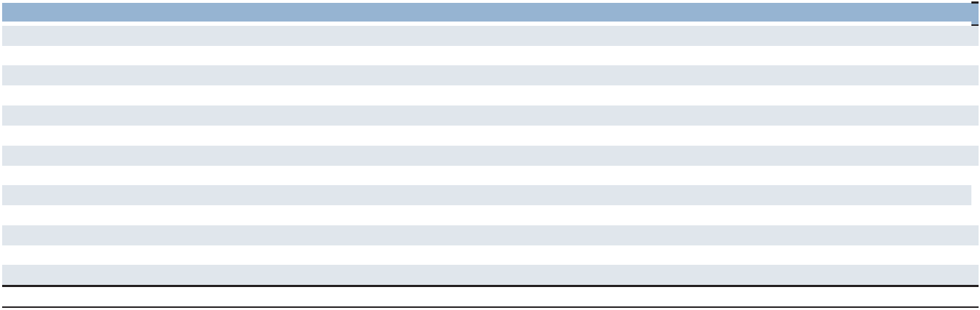

Year Ended December 31 |  | 2024 |  | 2023
Income tax based on statutory rate | $ | 53.9 | $ | 43.2
Increase (decrease) resulting from:
Non-United States tax rate difference:
French business tax^{(a)} |  | 9.2 |  | 13.0
Other^{(b)} |  | 18.0 |  | 10.4
Repatriation of non-United States earnings |  | (5.8) |  | 4.6
State income taxes, net of federal benefit |  | 3.6 |  | 2.0
Change in valuation allowance^{(c)} |  | 34.1 |  | 53.5
Work Opportunity Tax Credit |  | (4.6) |  | (5.6)
Foreign-Derived Intangible Income deduction |  | (3.6) |  | (7.2)
Goodwill impairment^{(d)} |  | — |  | 10.9
Change in unrecognized tax benefits^{(e)} |  | (0.3) |  | (14.4)
Other, net |  | 7.2 |  | 6.7
Tax provision | $ | 111.7 | $ | 117.1

- The French business tax is allowed as a deduction for French income tax purposes. The gross amount of the French business tax was $11.7, and $16.4 for 2024 and 2023 respectively. The $9.2 and $13.0 for 2024 and 2023, respectively, represent the French business tax expense net of the French tax benefit using the United States federal rate of 21%.

- Included in Other Non-United States tax rate differences is the impact of all Non-United States pre-tax earnings and permanent tax differences at the local statutory tax rate versus the United States federal rate of 21%.

- Losses incurred in 2024 and 2023 in Germany resulted in an increase in valuation allowance of $16.1 and $46.3, respectively.

- Non-deductible portion of the goodwill impairment charges recorded in the Netherlands in 2023.

- The 2023 amount includes a tax benefit of $10.8 resulting from an effective settlement of an audit.

74

Part II

Deferred income taxes are recorded based on temporary differences at the tax rate expected to be in effect when the temporary differences reverse. Temporary differences, which give rise to the deferred taxes, are as follows:


December 31 |  | 2025 |  | 2024
Future Income Tax Benefits (Expense)
Accrued payroll taxes and insurance | $ | 11.8 | $ | 11.5
Employee compensation payable |  | 41.2 |  | 40.9
Pension and postretirement benefits |  | 71.4 |  | 66.9
Intangible assets |  | (132.6) |  | (130.9)
Repatriation of non-United States earnings |  | (31.3) |  | (24.2)
Loans denominated in foreign currencies |  | 15.8 |  | (4.8)
Operating lease ROU assets |  | (99.6) |  | (95.1)
Operating lease liabilities |  | 104.6 |  | 90.8
Tax credit and other carryforwards |  | 87.1 |  | 59.2
Tax loss carryforwards |  | 264.5 |  | 212.1
Other |  | 108.3 |  | 115.9
Valuation allowance |  | (262.5) |  | (222.9)
Total future tax benefits | $ | 178.7 | $ | 119.4
Deferred tax asset | $ | 185.0 | $ | 135.0
Deferred tax liability |  | (6.3) |  | (15.6)
Total future tax benefits | $ | 178.7 | $ | 119.4

The tax loss carryforward category includes capital loss carryforwards of $25.6 and $27.4 for 2025 and 2024, respectively, which are fully offset by valuation allowance due to the expiration of carryforwards and uncertain source of future capital gains. The tax credit and other carryforwards consist primarily of U.S. foreign and general business tax credits. A related valuation allowance of $13.4 was recorded as of December 31, 2025, as management believes that realization of certain tax credit carryforwards is unlikely.

We have not provided deferred taxes on $372.0 of accumulated unremitted earnings of non-United States subsidiaries that are considered indefinitely reinvested. We have not estimated the deferred tax liability on these earnings as such estimation is not practicable to determine or immaterial to the financial statements. As of December 31, 2025, deferred taxes for non-United States withholding and other taxes were provided on $1,662.1 of accumulated unremitted earnings of non-United States subsidiaries that may be remitted to the United States. As of December 31, 2025 and 2024, we have recorded a deferred tax liability of $28.2 and $25.9, respectively, related to these non-United States earnings that may be remitted.

We had United States federal and non-United States net operating loss carryforwards and United States state net operating loss carryforwards totaling $1,303.1 and $178.4, respectively, as of December 31, 2025. The net operating loss carryforwards expire as follows:

 |  | United States
 |  | Federal and
 |  | Non-United |  | United States
 |  | States |  | State
2026 |  | — |  | 6.6
2027 |  | 0.2 |  | 5.6
2028 |  | 3.8 |  | 0.1
2029 |  | 7.1 |  | 3.1
2030 |  | 6.2 |  | 4.1
Thereafter |  | 27.3 |  | 129.4
No expirations |  | 1,258.5 |  | 29.5
Total net operating loss carryforwards | $ | 1,303.1 | $ | 178.4

We have recorded a deferred tax asset of $238.9 as of December 31, 2025 for the benefit of these net operating losses. Realization of this asset is dependent on generating sufficient taxable income prior to the expiration of the loss

75

Part II

carryforwards. A related valuation allowance of $206.8 was recorded as of December 31, 2025, due to the expiration of net operating loss carryforwards and uncertain source of future taxable income.

We had gross unrecognized tax benefits related to various tax jurisdictions, including interest and penalties, of $41.4, $36.1 and $32.8 in 2025, 2024 and 2023, respectively. If recognized, the entire amount would favorably affect the effective tax rate except for $10.0. Our unrecognized tax benefits decreased by $48.8 during 2023 primarily due to the effective settlement of an audit during the third quarter, which resulted in the recognition of a tax benefit of $10.8.

We recognize accrued interest and penalties related to unrecognized tax benefits in income tax expense. We accrued net interest and penalties of $0.4, $0.5 and $0.6 in 2025, 2024 and 2023, respectively. We reduced our accrued interest and penalties related to unrecognized tax benefits by $4.2 primarily due to the effectively settled income tax audit in the third quarter of 2023.

The following table summarizes the activity related to our unrecognized tax benefits during 2025, 2024, and 2023:
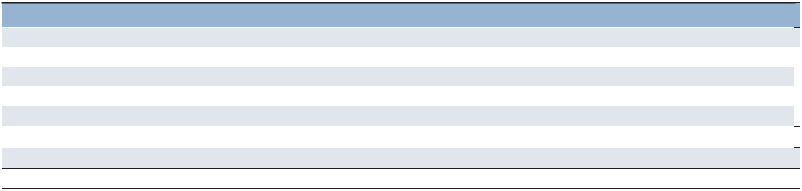

 |  | 2025 |  | 2024 |  | 2023
Gross unrecognized tax benefits, beginning of year | $ | 34.7 | $ | 31.1 | $ | 76.3
Increases in prior year tax positions |  | 5.6 |  | 6.5 |  | 4.6
Decreases in prior year tax positions |  | (0.4) |  | (0.6) |  | (1.2)
Increases for current year tax positions |  | 2.4 |  | 2.2 |  | 2.6
Expiration of statute of limitations and audit settlements |  | (2.5) |  | (4.5) |  | (51.2)
Gross unrecognized tax benefits, end of year | $ | 39.8 | $ | 34.7 | $ | 31.1
Potential interest and penalties |  | 1.6 |  | 1.4 |  | 1.7
Balance, end of year | $ | 41.4 | $ | 36.1 | $ | 32.8

We conduct business globally in various countries and territories. We are routinely audited by the tax authorities of the various tax jurisdictions in which we operate. Generally, the tax years that could be subject to examination are 2018 through 2025 for our major operations in France, Italy, the United Kingdom and the United States. As of December 31, 2025, we were subject to tax audits in Germany, India, Israel, Spain and the United States.

- Net (Loss) Earnings Per Share

The calculation of net (loss) earnings per share - basic and net (loss) earnings per share - diluted were as follows:
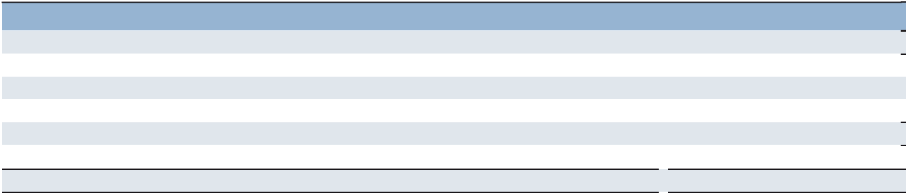

Year Ended December 31 |  | 2025 |  | 2024 |  | 2023
Net (loss) earnings available to common shareholders: | $ | (13.3) | $ | 145.1 | $ | 88.8
Weighted-average common shares outstanding (in millions):
Weighted-average common shares outstanding – basic |  | 46.6 |  | 47.8 |  | 49.8
Effect of share-based awards |  | — |  | 0.5 |  | 0.6
Weighted-average common shares outstanding – diluted |  | 46.6 |  | 48.3 |  | 50.4
Net (loss) earnings per share – basic | $ | (0.29) | $ | 3.04 | $ | 1.78
Net (loss) earnings per share – diluted | $ | (0.29) | $ | 3.01 | $ | 1.76

There were 1.1 million, 0.8 million and 0.6 million share-based awards excluded from the calculation of net (loss) earnings per share - diluted for the years ended December 31, 2025, 2024 and 2023, respectively, because their impact was anti-dilutive.

76

Part II

(7) Goodwill


Changes in the carrying value of goodwill by reportable segment and Corporate were as follows:

 |  |  | Southern |  | Northern
 |  | Americas^{(a)} | Europe^{(b)} |  |  | Europe |  | APME |  | Corporate^{(c)} |  | Total
Balance, January 1, 2024^{(d)} | $ | 1,050.4 | $ | 154.7 | $ | 188.0 | $ | 67.7 | $ | 126.0 | $ | 1,586.8
Acquisitions |  | 1.4 |  | — |  | — |  | — |  | — |  | 1.4
Currency impact |  | (3.6) |  | (9.4) |  | (6.6) |  | (4.7) |  | (0.5) |  | (24.8)
Balance, December 31, 2024^{(d)} |  | 1,048.2 |  | 145.3 |  | 181.4 |  | 63.0 |  | 125.5 |  | 1,563.4
Acquisitions |  | — |  | — |  | — |  | 0.9 |  | — |  | 0.9
Dispositions |  | — |  | — |  | (0.7) |  | — |  | — |  | (0.7)
Impairment Charges^{(e)} |  | — |  | (24.7) |  | (33.4) |  | — |  | — |  | (58.1)
Currency impact |  | 2.2 |  | 19.3 |  | 17.4 |  | 0.2 |  | — |  | 39.1
Balance, December 31, 2025^{(d)} | $ | 1,050.4 | $ | 139.9 | $ | 164.7 | $ | 64.1 | $ | 125.5 | $ | 1,544.6

- Balances related to United States were $1,005.8, $1,007.2 and $1,007.2 as of January 1, 2024, December 31, 2024 and December 31, 2025, respectively.

- Balances related to France were $75.6, $70.9 and $80.5 as of January 1, 2024, December 31, 2024 and December 31, 2025, respectively. Balances related to Italy were $3.8, $3.5 and $4.0 as of January 1, 2024, December 31, 2024 and December 31, 2025, respectively.

- The majority of the Corporate balance as of January 1, 2024, December 31, 2024 and 2025 relates to goodwill attributable to our acquisitions of Right Management ($62.1) and Jefferson Wells ($55.5). Jefferson Wells is part of the United States reporting unit. Right Management is allocated to the reporting units of the countries in which Right Management operates. For purposes of monitoring our total assets by segment, we do not allocate the Corporate balance to the respective reportable segments as this is commensurate with how we operate our business. We do, however, include these balances within the appropriate reporting units for our goodwill impairment testing.

- Balances were net of accumulated impairment loss of $749.3 ($232.1 related to Northern Europe, $3.8 related to APME, $235.2 related to Right Management and $278.2 related to Corporate) as of both January 1, 2024 and December 31, 2024; and $807.4 ($24.7 related to Southern Europe, $265.5 related to Northern Europe, $3.8 related to APME, $235.2 related to Right Management and $278.2 related to Corporate) as of December 31, 2025.

- The impairment charges relate to our Switzerland and United Kingdom reporting units, which were recorded during the second quarter of 2025. See Note 1 to the Consolidated Financial Statements for further information.

(8) Debt

Information concerning short-term borrowings is as follows:

December 31 |  | 2025 |  | 2024
Short-term borrowings | $ | 34.6 | $ | 21.0
Weighted-average interest rates |  | 13.3% |  | 33.3%

We maintain separate bank credit lines with financial institutions to meet working capital needs of our subsidiary operations. As of December 31, 2025, such uncommitted credit lines totaled $363.1, of which $325.0 was unused. Under our revolving credit agreement, total subsidiary borrowings cannot exceed $300.0 in the first, second and fourth quarters, and $600.0 in the third quarter of each year. Due to these limitations, additional borrowings of $261.9 could have been made under these lines as of December 31, 2025.

A summary of long-term debt is as follows:

December 31 |  | 2025 |  | 2024
Euro-denominated notes:
€500.0 due June 2026 | $ | 586.9 | $ | 516.6
€400.0 due June 2027 |  | 468.3 |  | 411.8
€500.0 due December 2030 |  | 583.8 |  | —
Other |  | 3.5 |  | 3.4
 |  | 1,642.5 |  | 931.8
Less current maturities |  | 590.4 |  | 2.4
Long-term debt | $ | 1,052.1 | $ | 929.4

77

Part II

Euro Notes

On December 15, 2025, we offered and sold €500.0 aggregate principal amount of the Company’s 3.750% notes due December 2030 (the “2025 €500.0 notes”). The net proceeds from the 2025 €500.0 notes of €497.4 were used in January 2026 to redeem our 2018 €500.0 notes due June 22, 2026. The 2025 €500.0 notes were issued at a price of 99.839% to yield an effective interest rate of 3.786%. Interest on the 2025 €500.0 notes is payable in arrears on December 13 of each year. The 2025 €500.0 notes are unsecured senior obligations and rank equally with all of the Company’s existing and future senior unsecured debt and other liabilities.

On June 30, 2022, we offered and sold €400.0 aggregate principal amount of the Company’s 3.50% notes due June 30, 2027 (the “2022 €400.0 notes”). The proceeds from the 2022 €400.0 notes were used in July 2022 to redeem our €400.0 1.875% notes due September 11, 2022. The 2022 €400.0 notes were issued at a price of 99.465% to yield an effective interest rate of 3.514%, net of a favorable impact of a forward starting interest rate swap. Interest on the Notes is payable in arrears on June 30 of each year. The Notes are unsecured senior obligations and rank equally with all of the Company’s existing and future senior unsecured debt and other liabilities.

On June 22, 2018, we offered and sold €500.0 aggregate principal amount of the Company’s 1.750% notes due June 2026 (the “2018 €500.0 notes”). The net proceeds from the 2018 €500.0 notes of €495.7 were used to repay our €350.0 notes due June 22, 2018, with the remaining balance used for general corporate purposes, which included share repurchases. The 2018 € 500.0 notes were issued at a price of 99.564% to yield an effective interest rate of 1.809%. We redeemed those notes in January 2026 using the proceeds from the 2025 €500.0 notes.

Both the 2018 €500.0 notes and 2022 €400.0 notes contain certain customary non-financial restrictive covenants and events of default and are unsecured senior obligations and rank equally with all of our existing and future senior unsecured debt and other liabilities. These notes have been designated as a hedge of our net investment in subsidiaries with a Euro-functional currency as of December 31, 2025. Since our net investment in these subsidiaries exceeds the respective amount of the designated borrowings, the related translation gains or losses are included as a component of accumulated other comprehensive loss. (See Note 12 to the Consolidated Financial Statements for further information.)

Revolving Credit Agreement

On December 15, 2025, we entered into a new $600.0 five-year Credit Agreement (the “Credit Agreement”) with a syndicate of commercial banks to replace our previous $600.0 revolving credit facility. The Credit Agreement includes increased allowances for restructuring and related charges added back to earnings for covenant calculations and other terms, generally consistent with our previous revolving credit facility. The Credit Agreement allows for borrowing of $600.0 in various currencies, and up to $150.0 may be used for the issuance of stand-by letters of credit. We may request an increase in revolving credit commitments under the facility of up to $300.0 in certain circumstances.

We had no borrowings under our $600.0 credit facility as of December 31, 2025 and 2024. Outstanding letters of credit issued totaled $0.4, hence additional borrowings of $599.6 were available to us under the facility as of both December 31, 2025 and 2024.

Under the Credit Agreement, a credit ratings-based pricing grid determines the facility fee and the credit spread that we add to the applicable interbank borrowing rate on all borrowings. At our current credit rating, the annual facility fee is 12.5 basis points paid on the entire facility and the credit spread is 112.5 basis points on any borrowings.

The Credit Agreement contains customary restrictive covenants pertaining to our management and operations, including limitations on the amount of subsidiary debt that we may incur, limitation on dividends and share repurchases if our leverage ratio (Net Debt-to-EBITDA) exceeds 3.0 to 1. EBITDA is defined as net earnings before interest and other expenses, provision for income taxes, intangible asset amortization expense and depreciation and amortization expense. The agreement also includes limitations on our ability to pledge assets, as well as financial covenants requiring that we comply with a maximum leverage ratio of 3.5 to 1 and a minimum fixed charge coverage ratio of 1.5 to 1.

For covenant purposes, net debt is defined as total debt less cash in excess of $200.0 through December 31, 2025 and less cash in excess of $300.0 thereafter. The agreement allows certain restructuring expenses to be excluded from EBITDA, up to fixed annual amounts for 2025, 2026 and 2027, and up to 15% of EBITDA beginning in 2028.

The Credit Agreement contains customary events of default, including, among others, payment defaults, material inaccuracy of representations and warranties, covenant defaults, bankruptcy or involuntary proceedings, certain monetary and non-monetary judgments, change of control and customary ERISA defaults.

The maturities of long-term debt payable within each of the four years subsequent to December 31, 2026 are as follows:

2027- $468.3, 2028 - $0.0, 2029 - $0.0, 2030 - $583.8.

78

Part II

- Retirement and Deferred Compensation Plans

For all of our United States defined benefit and retiree health care plans, we adopted the Society of Actuaries’ Pri-2012 Mortality Table with MP-2021 Mortality Improvement Scale in determining the plans’ benefit obligations as of December 31, 2025.

Defined Benefit Pension Plans

We sponsor qualified and nonqualified pension plans covering permanent employees in several countries. In our Switzerland pension plan, we recognized a partial settlement as a result of local regulations and turnover common to our industry and reclassified pension losses of $2.0, $3.8 and $5.8 in 2025, 2024 and 2023, respectively, net of tax, recorded in other comprehensive loss in the Consolidated Statements of Comprehensive Income. The reconciliation of the changes in the plans’ benefit obligations, the fair value of plan assets and the funded status of the plans are as follows:
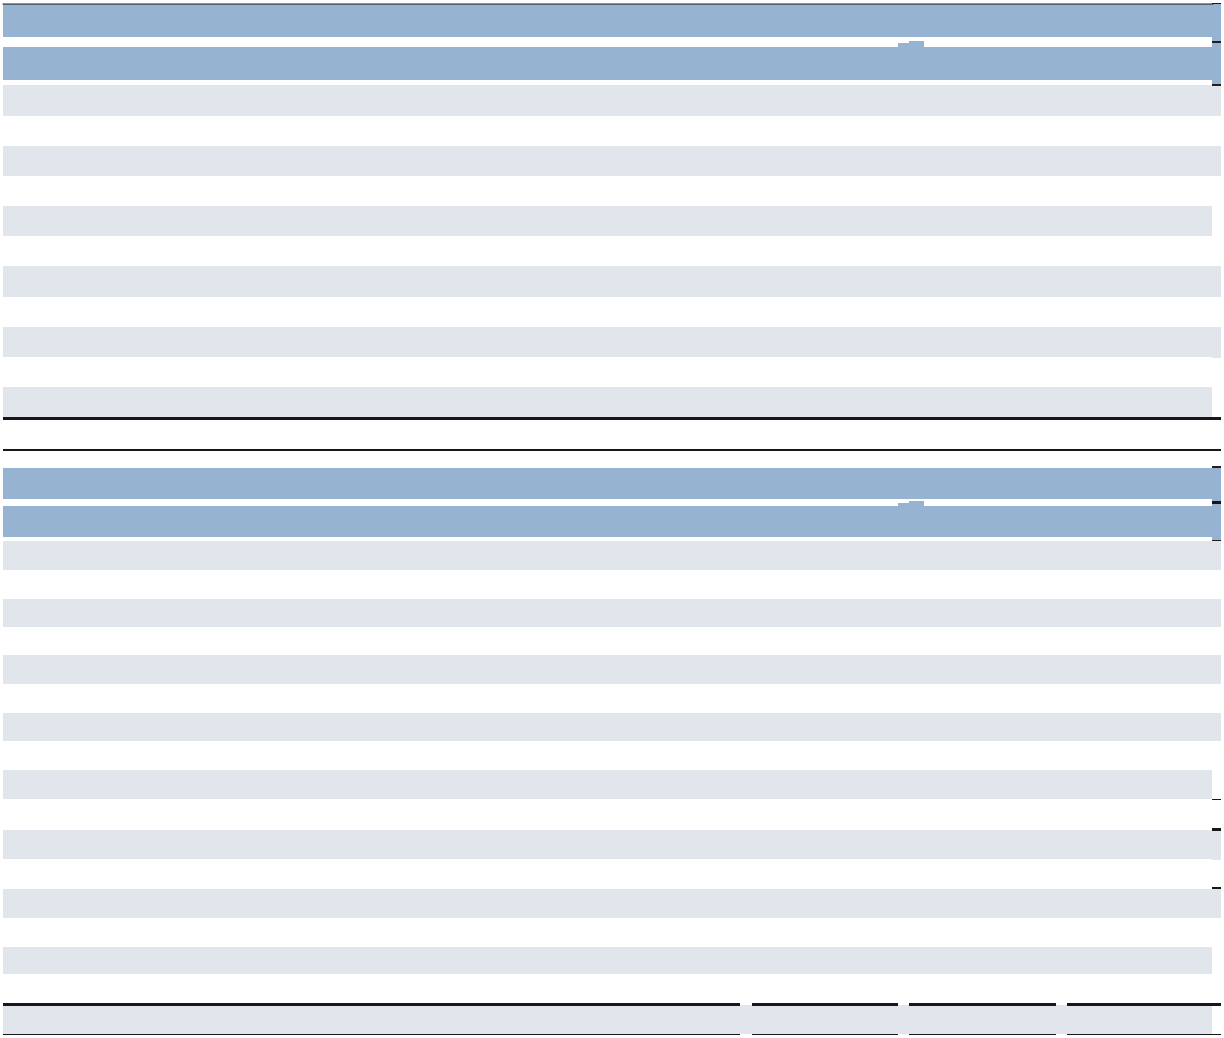

 |  | United States Plans |  |  |  |  | Non-United States Plans
Year Ended December 31 |  | 2025 |  | 2024 |  |  | 2025 |  | 2024
Change in Benefit Obligation
Benefit obligation, beginning of year | $ | 18.0 | $ | 19.2 | $ |  | 669.8 | $ | 713.2
Service cost |  | — |  | — |  |  | 15.4 |  | 16.5
Interest cost |  | 0.9 |  | 0.9 |  |  | 19.0 |  | 18.5
Curtailments |  | — |  | — |  |  | — |  | (2.7)
Settlements |  | — |  | — |  |  | (49.5) |  | (50.9)
Transfers |  | — |  | — |  |  | 31.3 |  | 26.5
Actuarial loss (gain) |  | 1.0 |  | — |  |  | (42.9) |  | (3.9)
Plan participant contributions |  | — |  | — |  |  | 11.6 |  | 11.4
Benefits paid |  | (2.1) |  | (2.1) |  |  | (18.1) |  | (16.0)
Currency exchange rate changes |  | — |  | — |  |  | 87.7 |  | (42.8)
Benefit obligation, end of year | $ | 17.8 | $ | 18.0 | $ |  | 724.3 | $ | 669.8
 |  | United States Plans |  |  |  |  | Non-United States Plans
Year Ended December 31 |  | 2025 |  | 2024 |  |  | 2025 |  | 2024
Change in Plan Assets
Fair value of plan assets, beginning of year | $ | — | $ | — | $ |  | 586.1 | $ | 596.3
Actual return on plan assets |  | — |  | — |  |  | 12.6 |  | 40.7
Settlements |  | — |  | — |  |  | (49.5) |  | (50.9)
Transfers |  | — |  | — |  |  | 31.6 |  | 23.7
Plan participant contributions |  | — |  | — |  |  | 11.6 |  | 11.4
Company contributions |  | 2.1 |  | 2.1 |  |  | 18.5 |  | 17.4
Benefits paid |  | (2.1) |  | (2.1) |  |  | (18.1) |  | (16.0)
Currency exchange rate changes |  | — |  | — |  |  | 78.0 |  | (36.5)
Fair value of plan assets, end of year | $ | — | $ | — | $ |  | 670.8 | $ | 586.1
Funded Status at End of Year
Funded status, end of year | $ | (17.8) | $ | (18.0) | $ |  | (53.5) | $ | (83.7)
Amounts Recognized
Noncurrent assets | $ | — | $ | — | $ |  | 42.2 | $ | 22.7
Current liabilities |  | (2.1) |  | (2.2) |  |  | (0.8) |  | (1.2)
Noncurrent liabilities |  | (15.7) |  | (15.8) |  |  | (94.9) |  | (105.2)
Net amount recognized | $ | (17.8) | $ | (18.0) | $ |  | (53.5) | $ | (83.7)

79

Part II

The curtailments in 2024 primarily resulted from the wind down of Proservia Germany. For both 2025 and 2024, the settlements and transfers mostly represent transfers in and out of temporary associates within our Switzerland plan. The actuarial gain and loss are mainly related to changes in discount rates.

One of our plans is located in the United Kingdom. In July 2024, the United Kingdom Court of Appeal upheld a ruling in the Virgin Media vs. NTL Pension Trustee case, a decision in which we were not a party, that certain historical amendments for contracted-out defined benefit schemes were invalid if they were not accompanied by the correct actuarial confirmation. In June 2025, the Department for Work and Pensions confirmed that the government will introduce legislation allowing affected pension schemes to retrospectively obtain written actuarial confirmation that historic benefit changes met the necessary standards. We have agreed with our plan trustees that, if needed, we intend to utilize this legislation when introduced. Since there remain significant areas of uncertainty, we are unable to determine the impact of the ruling, if any, on our pension plan obligations as of December 31, 2025.

Amounts recognized in AOCL, net of tax, consisted of:
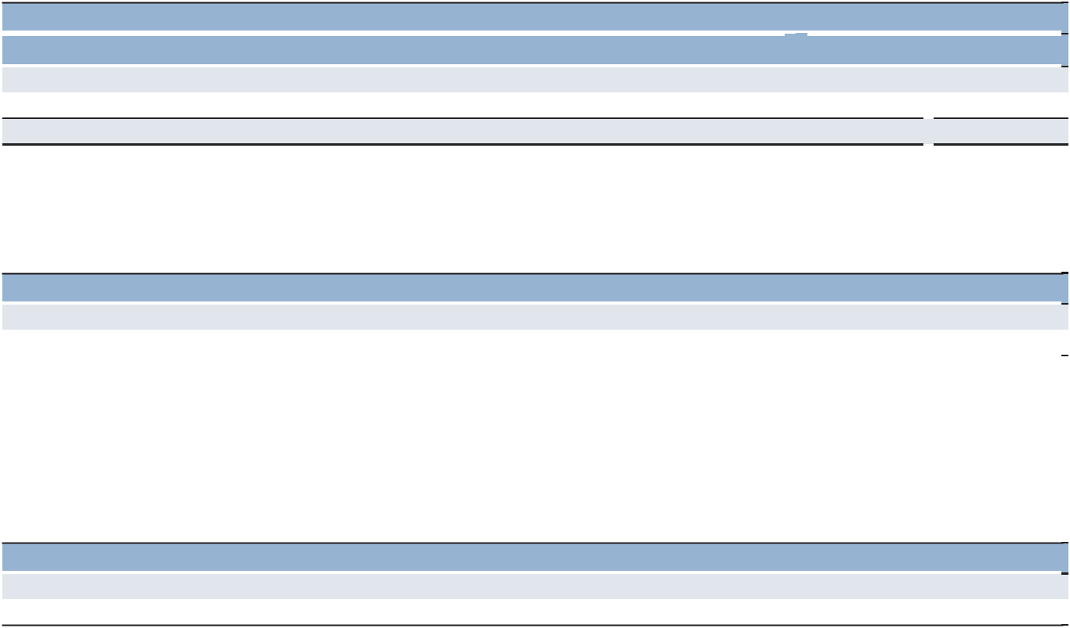

 | United States Plans |  |  |  |  |  | Non-United States Plans
Year Ended December 31 | 2025 |  | 2024 |  |  |  | 2025 |  | 2024
Net loss (gain) | $ | 4.2 | $ | 3.6 |  | $ | (31.4) | $ | 1.2
Prior service cost |  | — |  | — |  |  | 3.2 |  | 4.1
Total | $ | 4.2 | $ | 3.6 |  | $ | (28.2) | $ | 5.3

The accumulated benefit obligation (ABO) for all qualified defined benefit pension plans was $717.9 and $663.7 as of December 31, 2025 and 2024, respectively. The ABO for plans that have plan assets was $634.3 and $584.4 as of December 31, 2025 and 2024, respectively. The accumulated benefit obligation for some of our plans exceeded the fair value of plan assets as follows:

December 31 |  | 2025 |  | 2024
Accumulated benefit obligation | $ | 28.9 | $ | 117.2
Plan assets |  | 20.5 |  | 93.4

In 2025, one of our larger plans merged with a smaller funded plan. As a result of the transfer of assets and obligations from the merged plan, the surviving plan's assets exceeded its accumulated benefit obligation as of December 31, 2025. As a result, this plan was included in the amounts disclosed above for 2024 but not for 2025.

The projected benefit obligation (PBO) for all qualified defined benefit pension plans was $742.1 and $687.8 as of December 31, 2025 and 2024, respectively. The PBO for some of our plans exceeded the fair value of plan assets as follows:

December 31 |  | 2025 |  | 2024
Projected benefit obligation | $ | 31.9 | $ | 123.8
Plan assets |  | 20.5 |  | 96.9

By their nature, some of our plans do not have plan assets. The accumulated benefit obligation for these plans was $83.6 and $79.3 as of December 31, 2025 and 2024, respectively.

80

Part II

The components of the net periodic benefit cost and other amounts recognized in other comprehensive income/loss for all plans were as follows:
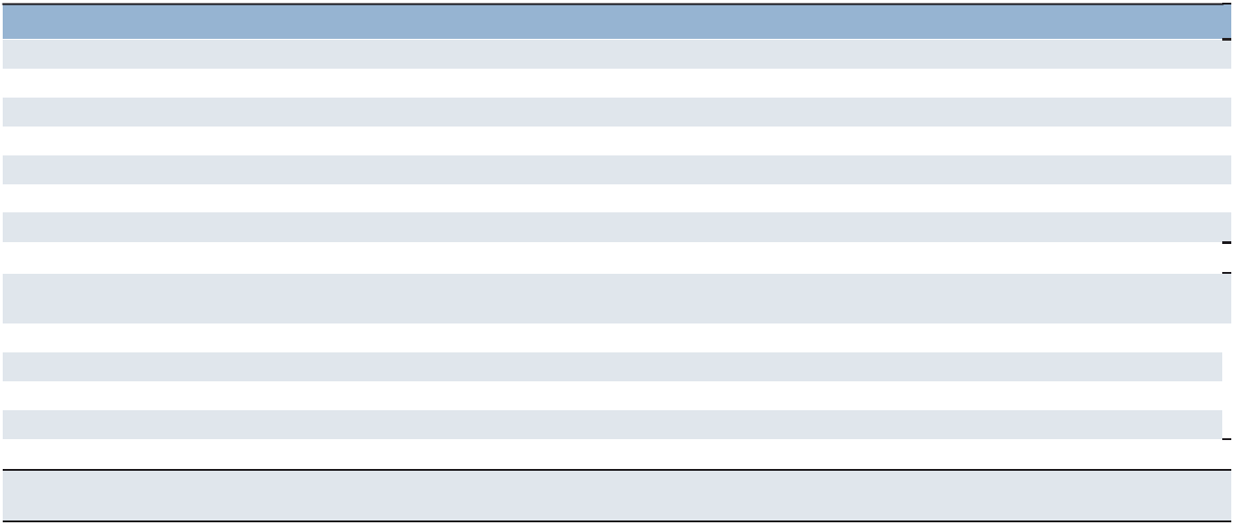

Year Ended December 31 |  | 2025 |  | 2024 |  | 2023
Net Periodic Benefit Cost
Service cost | $ | 15.4 | $ | 16.5 | $ | 15.5
Interest cost |  | 19.9 |  | 19.4 |  | 21.1
Expected return on assets |  | (20.7) |  | (18.9) |  | (19.0)
Settlements |  | 2.6 |  | 1.8 |  | 6.7
Net loss (gain) |  | 0.3 |  | (1.5) |  | (3.3)
Prior service cost |  | 0.7 |  | 0.7 |  | 0.7
Net periodic benefit cost |  | 18.2 |  | 18.0 |  | 21.7
Other Changes in Plan Assets and Benefit Obligation Recognized
in Other Comprehensive Income/Loss
Net (gain) loss |  | (33.7) |  | (25.7) |  | 31.9
Prior service credit |  | — |  | — |  | (1.2)
Amortization of net loss |  | (2.9) |  | (3.0) |  | (3.7)
Amortization of prior service cost |  | (0.7) |  | (0.7) |  | (0.7)
Total recognized in other comprehensive income/loss |  | (37.3) |  | (29.4) |  | 26.3
Total recognized in net periodic benefit cost and other comprehensive
income/loss | $ | (19.1) | $ | (11.4) | $ | 48.0

The estimated net gain and prior service cost for the defined benefit pension plans that will be amortized from AOCL into net periodic benefit cost during 2026 are $0.6 and $0.7, respectively.

The weighted-average assumptions used in the measurement of the benefit obligation were as follows:
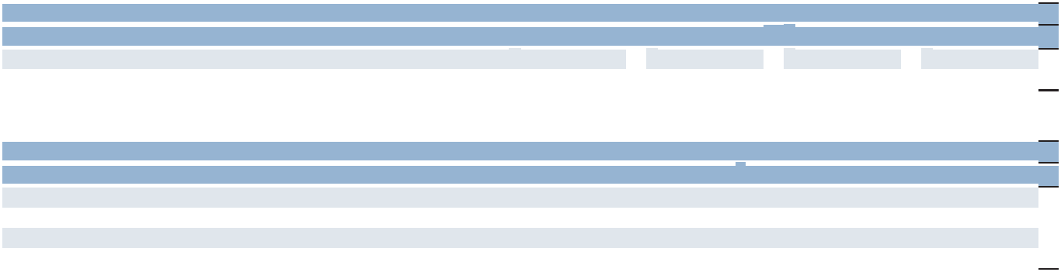

 | United States Plans |  |  |  | Non-United States Plans
Year Ended December 31 | 2025 | 2024 |  |  | 2025 | 2024
Discount rate |  | 5.0% | 5.5% |  | 3.1% | 2.7%
Rate of compensation increase |  | 1.4% | 1.4% |  | 1.4% | 1.5%

The weighted-average assumptions used in the measurement of the net periodic benefit cost were as follows:

 | United States Plans |  |  |  | Non-United States Plans
Year Ended December 31 | 2025 | 2024 | 2023 |  | 2025 | 2024 | 2023
Discount rate | 5.5% | 5.2% | 5.4% | 2.7% |  | 2.7% | 3.2%
Expected long-term return on plan assets | N/A | N/A | N/A | 3.4% |  | 3.4% | 3.5%
Rate of compensation increase | 1.4% | 1.4% | 1.3% | 1.5% |  | 1.9% | 1.9%
Interest crediting rates for cash balance plans | N/A | N/A | N/A | 1.8% |  | 2.6% | 2.6%

We determine our assumption for the discount rate based on an index of high-quality corporate bond yields and matched-funding yield curve analysis as of the end of each fiscal year.

Our overall expected long-term rate of return used in the measurement of the 2025 net periodic benefit cost on non-United States plans varied by country and ranged from 2.5% to 5.9%. For a majority of our plans, a building block approach has been employed to establish this return. Historical markets are studied and long-term historical relationships between equity securities and fixed income instruments are preserved, consistent with the widely accepted capital market principle that assets with higher volatility generate a greater return over time. Current market factors such as inflation and interest rates are evaluated before long-term capital market assumptions are determined. The long-term portfolio return is established with proper consideration of diversification and rebalancing. We also use guaranteed insurance contracts for five of our foreign plans. Peer data and historical returns are reviewed to check for reasonableness and appropriateness of our expected rate of return. None of our United States plans has plan assets.

Projected salary levels utilized in the determination of the projected benefit obligation for the pension plans are based upon historical experience and the future expectations for each respective country.

81

Part II

Our plans’ investment policies are to optimize the long-term return on plan assets at an acceptable level of risk and to maintain careful control of the risk level within each asset class. Our long-term objective is to minimize plan expenses and contributions by outperforming plan liabilities. We have historically used a balanced portfolio strategy based primarily on a target allocation of equity securities and fixed-income instruments, which vary by location. These target allocations, which are similar to the 2025 allocations, are determined based on the favorable risk tolerance characteristics of the plan and, at times, may be adjusted within a specified range to advance our overall objective.

The fair values of our Level 1 and Level 2 pension plan assets are primarily determined by using market quotes and other relevant information that is generated by market transactions involving identical or comparable assets. Insurance contracts and annuity contracts are measured at the present value of expected future benefit payments primarily using associated interest curves. Hedge funds consist of a number of diversified funds including those investing in international securities, equity and private partnership interests valued using market available data and various models and assumptions.

The fair value of our pension plan assets by asset category was as follows:
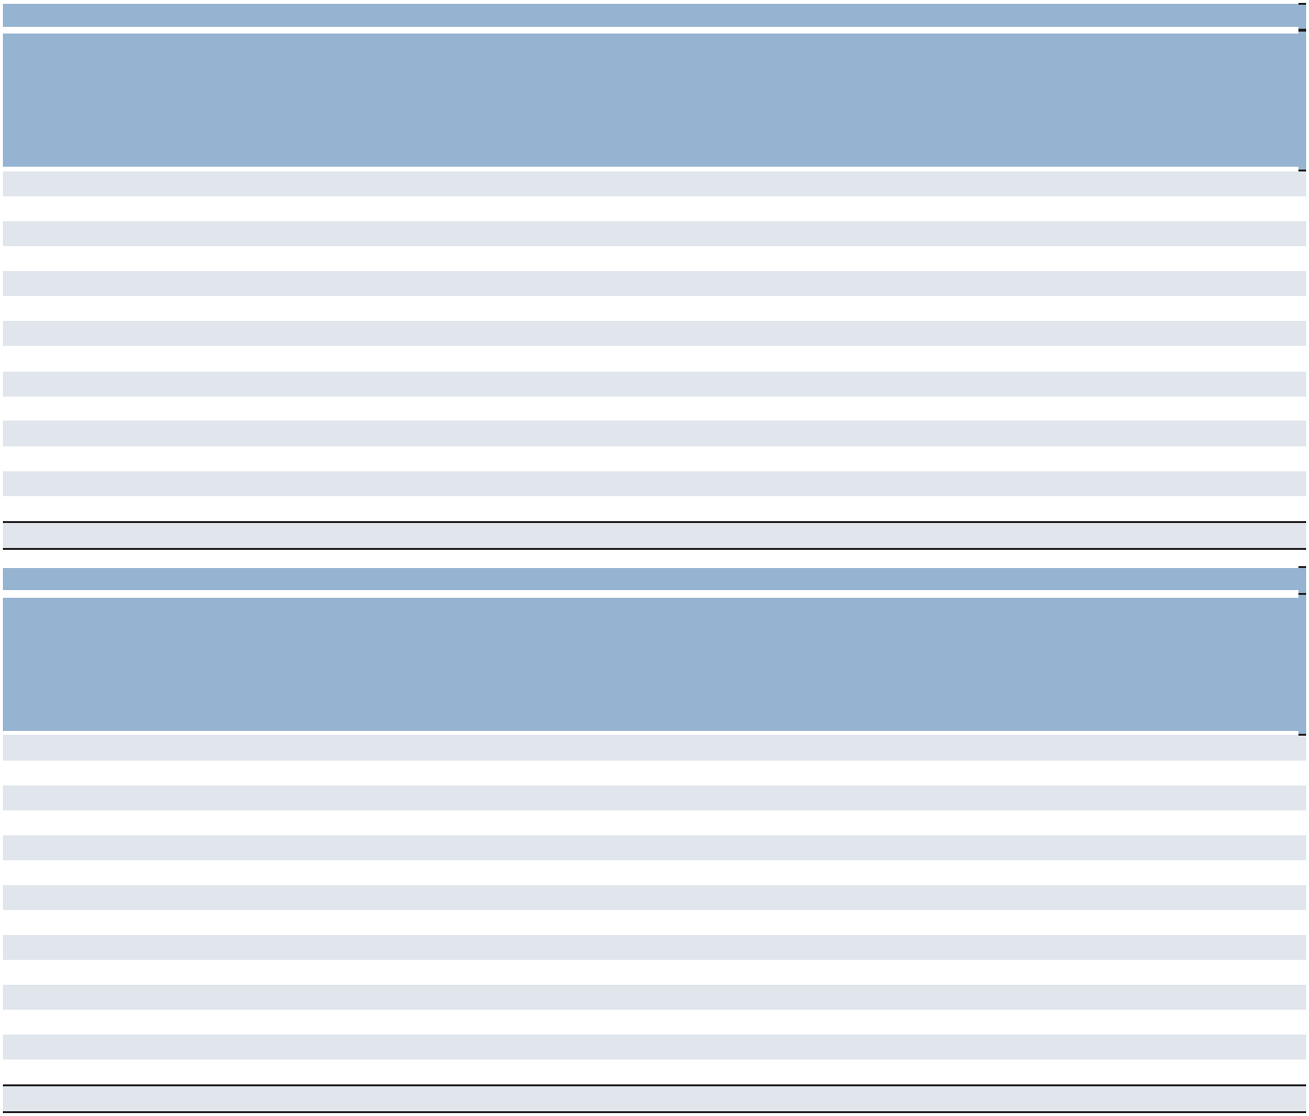

 |  |  | Fair Value Measurements Using
 |  |  | Quoted Prices
 |  |  |  | in Active |  | Significant
 |  |  |  | Markets for |  | Other |  | Significant
 |  |  |  | Identical |  | Observable | Unobservable
 | December 31, |  |  | Assets |  | Inputs |  | Inputs
 |  | 2025 |  | (Level 1) |  | (Level 2) |  | (Level 3)
Asset Category
Cash and cash equivalents | $ | 12.5 | $ | 12.5 | $ | — | $ | —
Equity securities:
Mutual funds |  | 178.0 |  | 178.0 |  | — |  | —
Common stock |  | 35.9 |  | 35.9 |  | — |  | —
Fixed income instruments:
Fixed income funds |  | 151.7 |  | — |  | 151.7 |  | —
Annuity contract |  | 32.4 |  | — |  | — |  | 32.4
Guaranteed insurance contracts |  | 30.2 |  | — |  | 30.2 |  | —
Other types of investments:
Real estate funds |  | 102.7 |  | — |  | 101.3 |  | 1.4
Insurance contracts |  | 76.0 |  | — |  | — |  | 76.0
Hedge funds |  | 27.3 |  | — |  | 21.7 |  | 5.6
Other |  | 24.1 |  | — |  | 4.4 |  | 19.7
 | $ | 670.8 | $ | 226.4 | $ | 309.3 | $ | 135.1
 |  |  | Fair Value Measurements Using
 |  |  | Quoted Prices
 |  |  |  | in Active |  | Significant
 |  |  |  | Markets for |  | Other |  | Significant
 |  |  |  | Identical |  | Observable | Unobservable
 | December 31, |  |  | Assets |  | Inputs |  | Inputs
 |  | 2024 |  | (Level 1) |  | (Level 2) |  | (Level 3)
Asset Category
Cash and cash equivalents | $ | 3.0 | $ | 3.0 | $ | — | $ | —
Equity securities:
Mutual funds |  | 142.7 |  | 142.7 |  | — |  | —
Common stock |  | 30.1 |  | 30.1 |  | — |  | —
Fixed income instruments:
Fixed income funds |  | 123.8 |  | — |  | 123.8 |  | —
Annuity contract |  | 31.4 |  | — |  | — |  | 31.4
Guaranteed insurance contracts |  | 25.6 |  | — |  | 25.6 |  | —
Other types of investments:
Real estate funds |  | 96.4 |  | — |  | 95.1 |  | 1.3
Insurance contracts |  | 80.9 |  | — |  | — |  | 80.9
Hedge funds |  | 29.0 |  | — |  | 11.5 |  | 17.5
Other |  | 23.2 |  | — |  | 3.6 |  | 19.6
 | $ | 586.1 | $ | 175.8 | $ | 259.6 | $ | 150.7

82

Part II

The following table summarizes the changes in fair value of the pension assets that are measured using Level 3 inputs. We determined that transfers between fair-value-measurement levels occurred on the date of the event that caused the transfer.
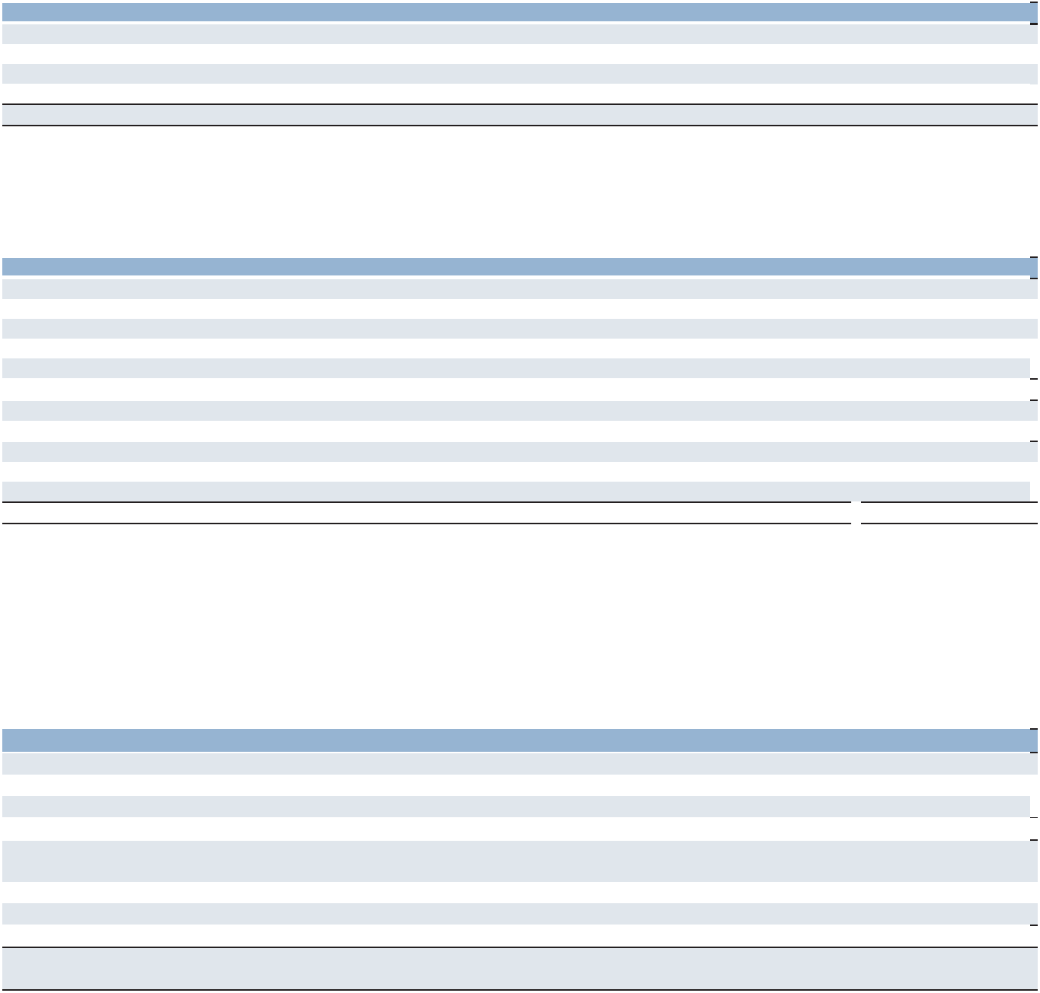

Year Ended December 31 |  | 2025 |  | 2024
Balance, beginning of year | $ | 150.7 | $ | 154.3
Actual return on plan assets |  | (15.9) |  | 4.4
Purchases, sales and settlements, net |  | (17.6) |  | —
Currency exchange rate changes |  | 17.9 |  | (8.0)
Balance, end of year | $ | 135.1 | $ | 150.7

Retiree Health Care Plan

We provide medical and dental benefits to certain eligible retired employees in the United States. Due to the nature of the plan, there are no plan assets. The reconciliation of the changes in the plan’s benefit obligation and the statement of the funded status of the plan were as follows:

Year Ended December 31 |  | 2025 |  | 2024
Change in Benefit Obligation
Benefit obligation, beginning of year | $ | 8.8 | $ | 10.2
Interest cost |  | 0.4 |  | 0.5
Actuarial loss (gain) |  | 0.4 |  | (1.1)
Benefits paid |  | (0.7) |  | (0.8)
Benefit obligation, end of year | $ | 8.9 | $ | 8.8
Funded Status at End of Year
Funded status, end of year | $ | (8.9) | $ | (8.8)
Amounts Recognized
Current liabilities | $ | (1.0) | $ | (1.0)
Noncurrent liabilities |  | (7.9) |  | (7.8)
Net amount recognized | $ | (8.9) | $ | (8.8)

The amount recognized in AOCL, net of tax, consists of a net gain of $0.8 and $1.1 as of December 31, 2025 and 2024, respectively, and a prior service cost of $0.2 and a credit of $0.4 as of December 31, 2025 and 2024, respectively.

The discount rate used in the measurement of the benefit obligation was 5.1% and 5.5% in 2025 and 2024, respectively. The discount rate used in the measurement of net periodic benefit cost was 5.5%, 4.9% and 5.1% in 2025, 2024 and 2023, respectively.

The components of net periodic benefit credit and other amounts recognized in other comprehensive income/loss for this plan were as follows:

Year Ended December 31 |  | 2025 |  | 2024 |  | 2023
Net Periodic Benefit Credit
Interest cost | $ | 0.4 | $ | 0.5 | $ | 0.5
Prior service credit |  | (0.8) |  | (0.8) |  | (0.8)
Net periodic benefit credit | $ | (0.4) | $ | (0.3) | $ | (0.3)
Other Changes in Plan Assets and Benefit Obligations Recognized
in Other Comprehensive Income/Loss
Net loss (gain) | $ | 0.4 | $ | (1.1) | $ | (1.0)
Amortization of prior service credit |  | 0.8 |  | 0.8 |  | 0.8
Total recognized in other comprehensive income/loss |  | 1.2 |  | (0.3) |  | (0.2)
Total recognized in net periodic benefit cost and other comprehensive
income/loss | $ | 0.8 | $ | (0.6) | $ | (0.5)

The estimated prior service credit for the retiree health care plan that will be amortized from AOCL into net periodic benefit cost during 2026 is $0.8.

The health care cost trend rate is assumed to be 7.8% in 2026, decreasing gradually to an ultimate rate of 4.5% in 2036.

Assumed health care cost trend rates are not expected to have a material effect on the amounts reported.

83

Part II

Future Contributions and Payments

During 2026, we plan to contribute approximately $17.0 to our pension plans and to fund our retiree health care payments as incurred. Projected benefit payments from the plans as of December 31, 2025 were estimated as follows:


 |  |  |  | Retiree Health
Year |  | Pension Plans |  | Care Plan
2026 | $ | 72.7 | $ | 1.0
2027 |  | 47.1 |  | 1.0
2028 |  | 38.0 |  | 0.9
2029 |  | 35.2 |  | 0.9
2030 |  | 36.3 |  | 0.9
2031–2035 |  | 201.7 |  | 3.6
Total projected benefit payments | $ | 431.0 | $ | 8.3

Defined Contribution Plans and Deferred Compensation Plans

We have defined contribution plans covering substantially all permanent United States employees and various other employees throughout the world. With our company-sponsored plans, employees may elect to contribute a portion of their salary to the plans and we match a portion of their contributions up to a maximum percentage of the employee’s salary. In addition, profit sharing contributions are made if a targeted earnings level is reached at management’s discretion. The total expense for our match and any profit sharing contributions was $16.1, $17.8 and $19.2 for the years ended December 31, 2025, 2024 and 2023, respectively. In certain countries with statutory defined contribution plans, we pay a percentage of the employees' salary in pension premiums. The total expense for the statutory defined contribution plans was $21.2, $24.4 and $29.5 for the years ended December 31, 2025, 2024 and 2023, respectively.

We also have deferred compensation plans in the United States. These plans had an asset and liability of $188.6 and $165.4 as of December 31, 2025 and 2024, respectively. We recognized investment gains of $23.3, $21.7 and $21.9 in 2025, 2024 and 2023, respectively. These fair value adjustments are fully offset by corresponding impact to compensation expense within selling and administrative expenses.

(10) Accumulated Other Comprehensive Loss

The components of AOCL, net of tax, were as follows:

December 31 | 2025 | 2024

Foreign currency translation

Translation loss on long-term intercompany loans, net of income taxes of $19.2 and $19.1, respectively

(Loss) gain on derivative instruments, net of income tax benefit of $(21.4) and $(0.7), respectively

Gain on interest rate swap, net of income taxes of $0.1 and $0.2, respectively

Defined benefit pension plans, net of income tax benefit of $(16.4) and $(20.6), respectively

Retiree health care plan, net of income taxes of $1.8 and $2.1, respectively

Accumulated other comprehensive loss

$ | (249.7) | $ | (342.2)
 | (133.6) |  | (133.2)
 | (53.9) |  | 39.0
 | 0.5 |  | 0.8
 | 24.0 |  | (8.9)
 | 0.6 |  | 1.5
$ | (412.1) | $ | (443.0)

(11) Interest and Other Expenses, Net

Interest and other expenses, net consisted of the following:

Year Ended December 31 |  | 2025 |  | 2024 |  | 2023
Interest expense | $ | 95.4 | $ | 90.0 | $ | 79.7
Interest income |  | (27.8) |  | (33.3) |  | (34.2)
Foreign exchange loss |  | 6.5 |  | 6.2 |  | 21.8
Miscellaneous income, net |  | (17.4) |  | (13.7) |  | (17.4)
Interest and other expenses, net | $ | 56.7 | $ | 49.2 | $ | 49.9

84

Part II

- Derivative Financial Instruments

We are exposed to various market risks relating to our ongoing business operations. The primary market risks, which are managed using derivative instruments, are foreign currency exchange rate risk and interest rate risk. In certain circumstances, we enter into cross-currency swaps and foreign currency forward exchange contracts (“forward contracts”) to reduce the effects of fluctuating foreign currency exchange rates on our cash flows denominated in foreign currencies. Our exposure to market risk for changes in interest rates relates primarily to our long-term debt obligations. We have historically managed interest rate risk through the use of a combination of fixed and variable rate borrowings.

Net Investment Hedges

We use cross-currency swaps, forward contracts and a portion of our foreign currency denominated debt, a non-derivative financial instrument, to protect the value of our net investments in certain of our foreign subsidiaries. For derivative instruments that are designated and qualify as hedges of our net investments in foreign operations, the changes in fair values of the derivative instruments are recognized in foreign currency translation adjustments, a component of AOCL, to offset the changes in the values of the net investments being hedged. For non-derivative financial instruments that are designated and qualify as hedges of net investments in foreign operations, the change in the carrying value of the designated portion of the non-derivative financial instrument due to changes in foreign currency exchange rates is recorded in foreign currency translation adjustments.

The 2022 €400.0 ($468.3) notes due June 2027 and the 2018 €500.0 ($586.9) notes due June 2026 were designated as a hedge of our net investment in our foreign subsidiaries with a Euro-functional currency as of December 31, 2025. The 2025 €500.0 notes were designated as a hedge of our net investment in subsidiaries with a Euro-functional currency upon the redemption of the 2018 €500.0 notes due June 2026.

On September 10, 2025, we de-designated our previous cross-currency swap and entered into a new agreement under which we pay fixed-rate Swiss franc (“CHF”) and receive fixed-rate United States dollar (“USD”) payments. The new swap, designated as a net investment hedge of our foreign subsidiary with a CHF functional currency, includes modified terms such as a reset of the USD fixed rate and an extension of maturity. The notional amount of the swap is $413.8 and consists of three tranches, each representing one-third of the total notional amount, with staggered maturities on September 10, 2026, September 10, 2027 and September 11, 2028. The swap contains a significant financing component. Accordingly, future cash settlements related to the swap will be classified within financing activities in the Consolidated Statements of Cash Flows.

The new swap was designated as a net investment hedge under the spot method. At the time of de-designation, the total mark-to-market loss on the original swap was $99.6, of which $82.2 was related to currency effects and was recorded in foreign currency translation within AOCL. The remaining $17.4 represents the excluded component, which is being amortized into interest expense over the life of the new swap.

The effect of our net investment hedges on AOCL for the year ended December 31, 2025, and 2024 was as follows:


 |  | Gain (Loss) Recognized in Other
 |  | Comprehensive Income
 |  | Year Ended December 31,
Instrument |  | 2025 |  | 2024
Euro Notes | $ | (125.3) | $ | 61.5
Cross-currency swaps |  | 12.0 |  | 36.2

Cash Flow Hedges

We use forward currency exchange contracts to hedge the changes in cash flows of certain operational expenses denominated in foreign currency due to changes in foreign currency exchange rates. The changes in fair value of the forward currency exchange contracts derivatives are recorded in AOCL and reclassified into earnings when the underlying operating expense is recognized in earnings.

In 2022, we entered into a forward starting interest rate swap agreement with a notional amount of €300.0 and a fixed rate of 1.936%, which was accounted for as a cash flow hedge to manage interest rate exposure related to our anticipated issuance of 2022 €400.0 notes. Upon the issuance of the notes, the swap was settled, resulting in a gain of $2.0, which was recorded in AOCL and is amortized over the term of the notes as an offset to interest expense.

85

Part II

The following table presents the impact that changes in the fair values of derivatives designated as cash flow hedges had on OCI, AOCL and earnings for the year ended December 31, 2025, and 2024:


 |  |  |  | Gain (Loss) Reclassified
 | Gain (Loss) Recognized in OCI |  |  | from AOCL into Income
 | Year Ended December 31, |  | Location of Gain Reclassified | Year Ended December 31,
Instrument | 2025 | 2024 | from AOCL into Income | 2025 | 2024
Forward starting interest
swap | — | — | Interest and other expenses, net | 0.3 | 0.3

We expect the net amount of pre-tax derivative gains and losses included in AOCL on December 31, 2025 to be reclassified into earnings over the next 12 months will not be significant. The actual amount that will be reclassified to earnings will vary due to future currency exchange rates.

Fair Value Hedges

We account for derivatives as fair value hedges when the hedged item is a recognized asset, liability, or firm commitment. We use cross currency swaps to hedge the changes in cash flows of certain of our foreign currency denominated intercompany notes due to changes in foreign currency exchange rates. We record the change in carrying value of the foreign currency denominated notes due to changes in exchange rates into earnings each period. The changes in fair value of the cross-currency swap derivatives are recorded in other comprehensive income/loss with an immediate reclassification into earnings for the change in fair value attributable to fluctuations in foreign currency exchange rates.

In April 2024, we settled our previous cross-currency swaps at maturity for a net cash inflow of $14.9 and entered into a new cross-currency swap with a maturity date of April 2027. The swaps hedge an intercompany fixed-rate CHF denominated note, including annual interest payments and the payment of remaining principal at maturity, by converting it to a fixed-rate Euro denominated note. The economic effect of the swaps is to eliminate the uncertainty of cash flows in CHF associated with the note by fixing the principal at €236.9 with a fixed annual interest rate of 3.45%.

In September 2024, we settled our previous cross-currency swaps at maturity for a net cash inflow of $1.6 and entered into a new cross currency swap with a maturity date of September 2027. The swaps hedge an intercompany fixed-rate CHF denominated note, including the annual interest payments and the payment of remaining principal at maturity, by converting it to a fixed-rate Euro denominated note. The economic effect of the swaps is to eliminate the uncertainty of cash flows in CHF associated with the note by fixing the principal at €63.6 with a fixed annual interest rate of 3.27%.

The following tables present the impact that the fair value hedges had on our Consolidated Statements of Operations for the year ended December 31, 2025 and 2024:

 |  |  |  |  |  | Gain (Loss) Recognized in
 |  | Gain (Loss) Recognized in OCI |  |  |  | Income
 |  | Year Ended December 31, |  | Location of Gain (Loss) |  | Year Ended December 31,
Instrument |  | 2025 | 2024 | Recognized in Income |  | 2025 |  | 2024
Intercompany CHF notes | $ | — $ | — | Interest and other expenses, net $ |  | (3.5) | $ | 3.8
Cross-currency swaps |  | (0.3) | 0.9 | Interest and other expenses, net |  | 3.5 |  | (3.8)

Non-Designated Instruments

We also use certain derivatives, which are not designated as hedging instruments, as economic hedges of foreign currency and interest rate exposure. For our forward contracts that are not designated as hedges, any gain or loss resulting from the change in fair value is recognized in current period earnings. These gains or losses are offset by the exposure related to receivables and payables with our foreign subsidiaries and to interest due on our Euro-denominated notes, which is paid annually in June. The effect of our forward contracts that are not designated as hedging instruments on the consolidated statements of operations for the year ended December 31, 2025 was as follows:

 | Location of Gain |  | Gain (Loss) Recognized in Income
Instrument | Recognized in Income |  | Year Ended December 31,
 |  | 2025 |  |  | 2024
Foreign currency forward contracts | Interest and other expenses, net | $ |  | 1.5 | $ | (1.7)

86

Part II

Derivative and Non-Derivative Assets and Liabilities

The following tables present the fair value of derivative and non-derivative assets and liabilities on the Consolidated Balance Sheets as of December 31, 2025, and 2024:
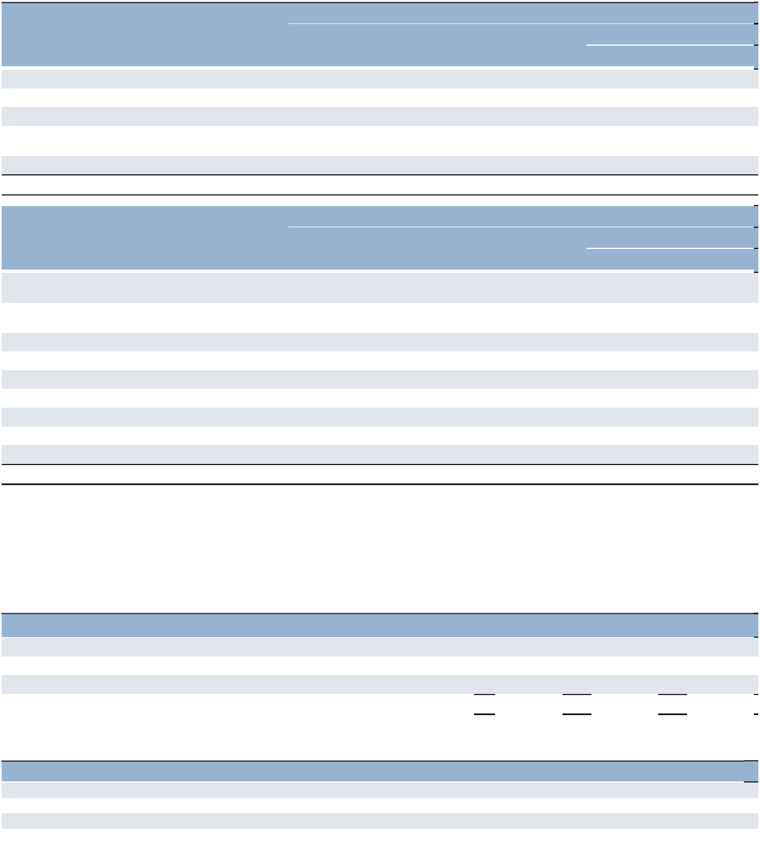

 | Assets
 |  | December 31, |  | December 31,
 | Balance Sheet Location |  | 2025 |  | 2024
Instruments designated as fair value hedges:
Cross-currency swaps | Accounts receivable, net | $ | — | $ | 10.3
Cross-currency swaps | Other assets |  | 14.6 |  | —
Instruments designated as net investment
hedges:
Cross-currency swaps | Accounts receivable, net |  | — |  | 7.8
Total instruments |  | $ | 14.6 | $ | 18.1
 | Liabilities
 |  | December 31, |  | December 31,
 | Balance Sheet Location |  | 2025 |  | 2024

Instruments designated as net investment hedges:

Euro Notes due in 2026

Euro Notes due in 2026

Euro Notes due in 2027

Cross-currency swaps

Cross-currency swaps

Instruments not designated as hedges:

Foreign currency forward contracts

Euro Notes due in 2030

Total instruments

Short-term borrowings and current maturities of long-term debt

Long-term debt

Long-term debt

Accrued liabilities

Other long-term liabilities

Accrued liabilities

Long-term debt

$ | 586.9 | $ | —
 | — |  | 516.6
 | 468.3 |  | 411.8
 | 33.1 |  | 44.8
 | 69.8 |  | —
 | 0.8 |  | 0.7
 | 583.8 |  | —
$ | 1,742.7 | $ | 973.9

The fair value measurements of these items recorded in our Consolidated Balance Sheets for the years ended December 31, 2025 and 2024 are disclosed in Note 1 to the Consolidated Financial Statements.

- Leases

The components of lease expense were as follows:

Year Ended December 31 |  | 2025 |  | 2024 |  | 2023
Operating lease expense | $ | 135.2 | $ | 129.7 | $ | 137.4
Short-term lease expense |  | 18.5 |  | 15.3 |  | 4.9
Variable lease expense |  | 7.1 |  | 6.8 |  | 13.1
Total lease expense | $ | 160.8 | $ | 151.8 | $ | 155.4

Other information related to leases was as follows:

Year Ended December 31 |  | 2025 |  | 2024 |  | 2023
Cash paid for amounts included in the measurement of liabilities | $ | 130.9 | $ | 119.7 | $ | 132.0
Right-of-use assets obtained in exchange for new liabilities |  | 100.5 |  | 82.2 |  | 135.6
Weighted-average remaining lease term – operating leases |  | 5.2 years |  | 5.2 years |  | 5.6 years
Weighted-average discount rate – operating leases |  | 4.0% |  | 4.0% |  | 3.8%

87

Part II

Maturities of operating lease liabilities as of December 31, 2025 were as follows:
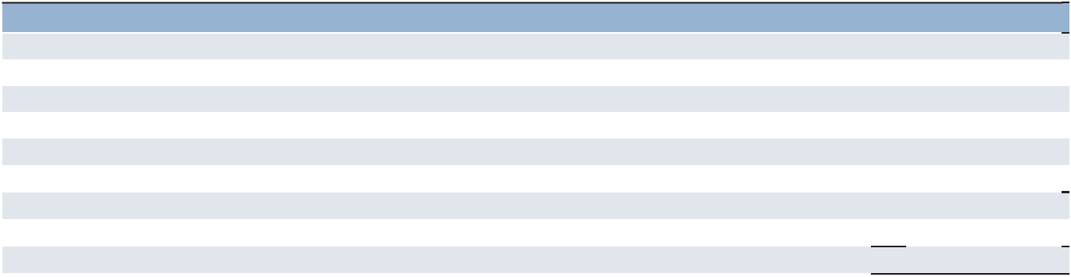

 |  | Operating Leases
2026 | $ | 122.0
2027 |  | 96.7
2028 |  | 74.5
2029 |  | 53.9
2030 |  | 41.9
Thereafter |  | 69.6
Total future undiscounted lease payments |  | 458.6
Less imputed interest |  | (46.9)
Total operating lease liabilities | $ | 411.7

- Segment Data

Effective January 1, 2025, our segment reporting was realigned to break out our Morocco business from France. Accordingly, France is now adjusted to exclude Morocco. All previously reported results have been recast to conform to the current year presentation.

Our chief operating decision maker ("CODM") is our Chief Executive Officer, who evaluates the performance of our operating segments using operating unit profit ("OUP"). OUP serves as the measure of profitability for monitoring actual results against budgeted expectations as well as investment and resource allocation among our segments. In addition, the CODM utilizes OUP in conducting competitive analysis, benchmarking our performance against that of our competitors and determining compensation.

We are organized and managed primarily on a geographic basis. Each country and business unit generally has its own distinct management team, providing services under our global brands and maintains its own financial reports. Each operation reports directly or indirectly through a regional manager to a member of executive management. Given this reporting structure, we operate using the following reporting segments: Americas, which includes United States and Other Americas; Southern Europe, which includes France, Italy and Other Southern Europe; Northern Europe; and APME.

The segments derive a majority of their revenues from our staffing and interim services. The remaining revenues within these segments are derived from our outcome-based solutions and consulting services, permanent recruitment services, outplacement services, talent management services and other services. Segment revenues represent sales to external clients. We provide services to a wide variety of clients, none of which individually comprise a significant portion of revenues for us as a whole. Due to the nature of our business, we generally do not have export sales.

88

Part II

Total assets for the segments are reported after the elimination of investments in subsidiaries and intercompany accounts.
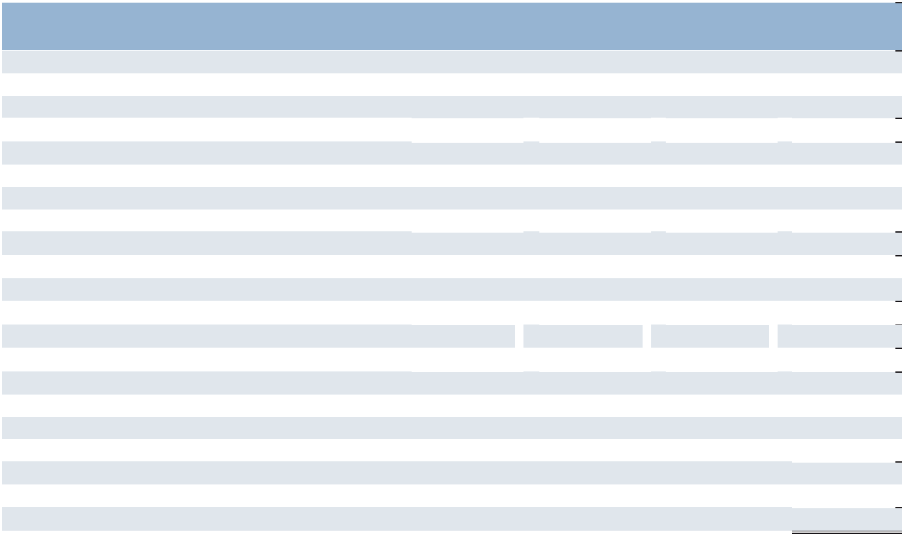
 |  |  |  |  |  |  |  | Selling and
 |  |  |  |  | Cost of |  | Administrative
Year Ended December 31, 2025 |  | Revenue |  |  | Services |  |  | Expenses |  |  | OUP
Americas:
United States^{(a)} | $ | 2,735.4 | $ |  | 2,039.5 | $ |  | 629.9 | $ |  | 66.0
Other Americas |  | 1,613.4 |  |  | 1,368.0 |  |  | 174.5 |  |  | 70.9
 |  | 4,348.8 |  |  | 3,407.5 |  |  | 804.4 |  |  | 136.9
Southern Europe:
France |  | 4,459.4 |  |  | 3,831.8 |  |  | 517.7 |  |  | 109.9
Italy |  | 1,822.1 |  |  | 1,533.3 |  |  | 173.0 |  |  | 115.8
Other Southern Europe |  | 2,154.8 |  |  | 1,871.2 |  |  | 248.7 |  |  | 34.9
 |  | 8,436.3 |  |  | 7,236.3 |  |  | 939.4 |  |  | 260.6
Northern Europe |  | 3,161.1 |  |  | 2,639.2 |  |  | 565.2 |  |  | (43.3)
APME |  | 2,041.9 |  |  | 1,701.4 |  |  | 239.9 |  |  | 100.6
Total Segments |  | 17,988.1 |  |  | 14,984.4 |  |  | 2,548.9 |  |  | 454.8
Intercompany Eliminations |  | (31.0) |  |  | (24.9) |  |  | (6.1) |  |  | —
 | $ | 17,957.1 | $ |  | 14,959.5 | $ |  | 2,542.8 | $ |  | 454.8
Reconciliation of operating unit profit (segment OUP)
Corporate expenses |  |  |  |  |  |  |  |  | $ |  | (184.7)
Impairment charges^{(b)} |  |  |  |  |  |  |  |  |  |  | (88.7)
Intangible asset amortization expense^{(c)} |  |  |  |  |  |  |  |  |  |  | (31.3)
Operating profit |  |  |  |  |  |  |  |  |  |  | 150.1
Interest and other expenses, net |  |  |  |  |  |  |  |  | $ |  | (56.7)
Earnings before income taxes |  |  |  |  |  |  |  |  | $ |  | 93.4

- The United States revenues above represent revenues from our company-owned branches and franchise fees received from our franchise operations, which were $10.1 for 2025.

- Impairment charges for the year ended December 31, 2025 consist of a goodwill impairment related to our investments in Switzerland and the United Kingdom and an impairment of an indefinite-lived intangible asset in our Switzerland business.

- Intangible asset amortization related to acquisitions is excluded from operating costs within the reportable segments and corporate expenses, and shown separately.
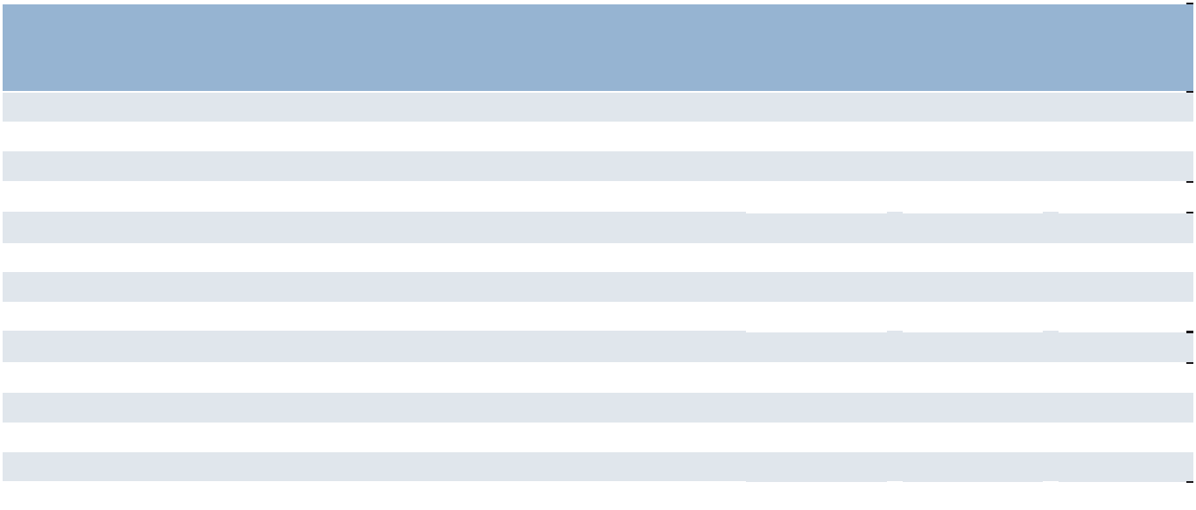
 |  |  |  |  |  |  | Depreciation
 |  |  |  |  |  |  |  | and
 |  |  |  |  | Long-lived |  | Amortization
Year Ended December 31, 2025 |  | Total Assets |  |  | Assets^{(a)} |  |  | Expense
Americas:
United States | $ | 2,973.4 | $ |  | 76.4 | $ |  | 9.2
Other Americas |  | 547.6 |  |  | 15.0 |  |  | 2.4
 |  | 3,521.0 |  |  | 91.4 |  |  | 11.6
Southern Europe:
France |  | 2,236.5 |  |  | 180.5 |  |  | 15.5
Italy |  | 555.2 |  |  | 50.1 |  |  | 2.1
Other Southern Europe |  | 893.3 |  |  | 50.2 |  |  | 4.4
 |  | 3,685.0 |  |  | 280.8 |  |  | 22.0
Northern Europe |  | 443.9 |  |  | 117.2 |  |  | 11.8
APME |  | 668.2 |  |  | 55.4 |  |  | 5.8
Corporate^{(b)} |  | 842.0 |  |  | 10.4 |  |  | 3.5
Intangible asset amortization expense^{(c)} |  | — |  |  | — |  |  | 31.3
 | $ | 9,160.1 | $ |  | 555.2 | $ |  | 86.0
- Long-lived assets consist of net property and equipment, net capitalized software and right-of-use assets.

- Corporate assets include assets that were not used in the operations of any segment. The most significant assets were purchased intangibles and cash, including the proceeds from the €500.0 Euro notes issued in December 2025.

- Intangible asset amortization related to acquisitions is excluded from operating costs within the reportable segments and corporate expenses, and shown separately.

89

Part II
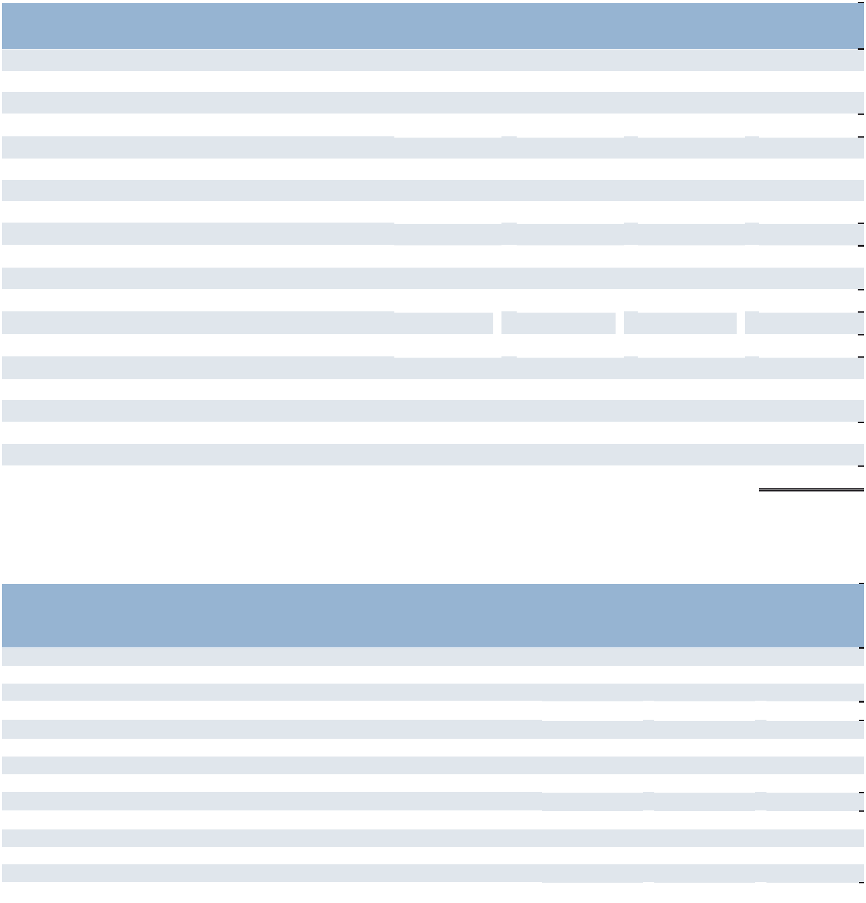

 |  |  |  |  |  |  |  | Selling and
 |  |  |  |  | Cost of |  | Administrative
Year Ended December 31, 2024 |  | Revenue |  |  | Services |  |  | Expenses |  |  | OUP
Americas:
United States^{(a)} | $ | 2,766.6 | $ |  | 2,032.3 | $ |  | 656.6 | $ |  | 77.7
Other Americas |  | 1,458.3 |  |  | 1,220.4 |  |  | 174.0 |  |  | 63.9
 |  | 4,224.9 |  |  | 3,252.7 |  |  | 830.6 |  |  | 141.6
Southern Europe:^{(b)}
France |  | 4,531.5 |  |  | 3,873.8 |  |  | 508.2 |  |  | 149.5
Italy |  | 1,677.0 |  |  | 1,398.1 |  |  | 165.8 |  |  | 113.1
Other Southern Europe |  | 2,009.8 |  |  | 1,745.7 |  |  | 222.6 |  |  | 41.5
 |  | 8,218.3 |  |  | 7,017.6 |  |  | 896.6 |  |  | 304.1
Northern Europe |  | 3,304.3 |  |  | 2,728.0 |  |  | 620.9 |  |  | (44.6)
APME |  | 2,161.3 |  |  | 1,820.1 |  |  | 257.5 |  |  | 83.7
Total Segments |  | 17,908.8 |  |  | 14,818.4 |  |  | 2,605.6 |  |  | 484.8
Intercompany Eliminations |  | (54.9) |  |  | (51.3) |  |  | (3.6) |  |  | —
 | $ | 17,853.9 | $ |  | 14,767.1 | $ |  | 2,602.0 | $ |  | 484.8
Reconciliation of operating unit profit (segment OUP)
Corporate expenses |  |  |  |  |  |  |  |  | $ |  | (146.1)
Intangible asset amortization expense^{(c)} |  |  |  |  |  |  |  |  |  |  | (32.7)
Operating profit |  |  |  |  |  |  |  |  |  |  | 306.0
Interest and other expenses, net |  |  |  |  |  |  |  |  |  |  | (49.2)
Earnings before income taxes |  |  |  |  |  |  |  |  | $ |  | 256.8

- The United States revenues above represent revenues from our company-owned branches and franchise fees received from our franchise operations, which were $10.7 for 2024.

- Effective January 1, 2025, our segment reporting was realigned to include our Morocco business within Other Southern Europe. Accordingly, France is now adjusted to exclude Morocco. All previously reported results have been recast to conform to the current year presentation.

- Intangible asset amortization related to acquisitions is excluded from operating costs within the reportable segments and corporate expenses, and shown separately.

 |  |  |  |  |  |  |  | Depreciation
 |  |  |  |  |  |  |  |  | and
 |  |  |  |  |  | Long-lived |  | Amortization
Year Ended December 31, 2024 |  | Total Assets |  |  |  | Assets^{(a)} |  |  | Expense
Americas:
United States | $ |  | 2,902.4 | $ |  | 77.7 | $ |  | 9.7
Other Americas |  |  | 465.3 |  |  | 13.3 |  |  | 2.6
 |  |  | 3,367.7 |  |  | 91.0 |  |  | 12.3
Southern Europe:^{(b)}
France |  |  | 2,021.2 |  |  | 171.8 |  |  | 15.2
Italy |  |  | 479.3 |  |  | 45.6 |  |  | 2.0
Other Southern Europe |  |  | 790.9 |  |  | 45.5 |  |  | 3.9
 |  |  | 3,291.4 |  |  | 262.9 |  |  | 21.1
Northern Europe |  |  | 597.7 |  |  | 115.1 |  |  | 10.9
APME |  |  | 615.0 |  |  | 39.7 |  |  | 5.5
Corporate^{(c)} |  |  | 329.2 |  |  | 7.5 |  |  | 4.1
Intangible asset amortization expense^{(d)} |  |  | — |  |  | — |  |  | 32.7
 | $ |  | 8,201.0 | $ |  | 516.2 | $ |  | 86.6
- Long-lived assets consist of net property and equipment, net capitalized software and right-of-use assets.

- Effective January 1, 2025, our segment reporting was realigned to include our Morocco business within Other Southern Europe. Accordingly, France is now adjusted to exclude Morocco's total assets.

- Corporate assets include assets that were not used in the operations of any segment, the most significant of which were purchased intangibles and cash.

- Intangible asset amortization related to acquisitions is excluded from operating costs within the reportable segments and corporate expenses, and shown separately.

90

 |  |  |  |  |  |  |  |  |  |  | Part II
 |  |  |  |  |  |  |  | Selling and
 |  |  |  |  | Cost of |  | Administrative
Year Ended December 31, 2023 |  | Revenue |  |  | Services |  |  | Expenses |  |  | OUP
Americas:^{(a)}
United States | $ | 2,866.2 | $ |  | 2,081.6 | $ |  | 690.2 | $ |  | 94.4
Other Americas |  | 1,548.6 |  |  | 1,294.5 |  |  | 182.9 |  |  | 71.2
 |  | 4,414.8 |  |  | 3,376.1 |  |  | 873.1 |  |  | 165.6
Southern Europe:^{(b)}
France |  | 4,790.1 |  |  | 4,076.7 |  |  | 526.6 |  |  | 186.8
Italy |  | 1,708.8 |  |  | 1,418.4 |  |  | 165.7 |  |  | 124.7
Other Southern Europe |  | 2,016.4 |  |  | 1,731.8 |  |  | 238.4 |  |  | 46.2
 |  | 8,515.3 |  |  | 7,226.9 |  |  | 930.7 |  |  | 357.7
Northern Europe |  | 3,748.0 |  |  | 3,099.0 |  |  | 765.7 |  |  | (116.7)
APME |  | 2,322.3 |  |  | 1,940.2 |  |  | 289.5 |  |  | 92.6
Total Segments |  | 19,000.4 |  |  | 15,642.2 |  |  | 2,859.0 |  |  | 499.2
Intercompany Eliminations |  | (85.9) |  |  | (85.9) |  |  | — |  |  | —
 | $ | 18,914.5 | $ |  | 15,556.3 | $ |  | 2,859.0 | $ |  | 499.2
Reconciliation of operating unit profit (segment OUP)
Corporate expenses |  |  |  |  |  |  |  |  | $ |  | (153.7)
Goodwill impairment charges |  |  |  |  |  |  |  |  |  |  | (55.1)
Intangible asset amortization expense^{(c)} |  |  |  |  |  |  |  |  |  |  | (34.6)
Operating profit |  |  |  |  |  |  |  |  |  |  | 255.8
Interest and other expenses, net |  |  |  |  |  |  |  |  |  |  | (49.9)
Earnings before income taxes |  |  |  |  |  |  |  |  | $ |  | 205.9
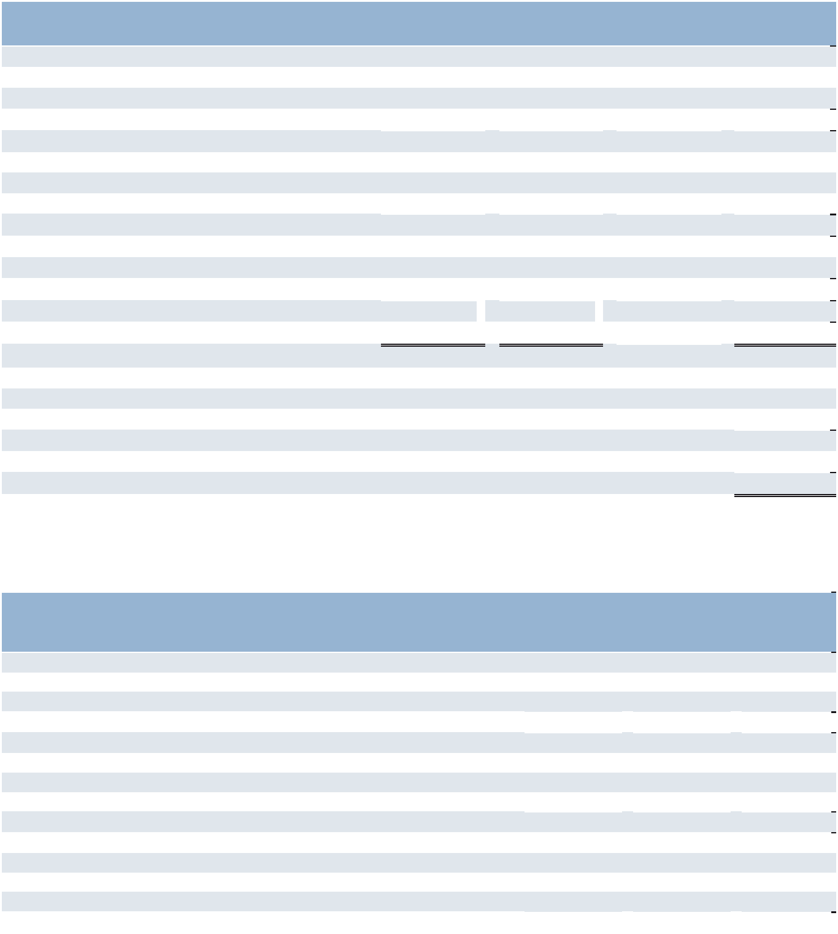

- The United States revenues above represent revenues from our company-owned branches and franchise fees received from our franchise operations, which were $11.9 for 2023.

- Effective January 1, 2025, our segment reporting was realigned to include our Morocco business within Other Southern Europe. Accordingly, France is now adjusted to exclude Morocco. All previously reported results have been recast to conform to the current year presentation.

- Intangible asset amortization related to acquisitions is excluded from operating costs within the reportable segments and corporate expenses, and shown separately.

 |  |  |  |  |  |  |  | Depreciation
 |  |  |  |  |  |  |  |  | and
 |  |  | Total |  |  | Long-lived |  | Amortization
Year Ended December 31, 2023 |  |  | Assets |  |  | Assets^{(a)} |  |  | Expense
Americas:
United States | $ |  | 3,050.4 | $ |  | 87.9 | $ |  | 9.5
Other Americas |  |  | 437.8 |  |  | 16.5 |  |  | 2.2
 |  |  | 3,488.2 |  |  | 104.4 |  |  | 11.7
Southern Europe:^{(b)}
France |  |  | 2,222.4 |  |  | 182.9 |  |  | 12.7
Italy |  |  | 487.0 |  |  | 50.6 |  |  | 2.2
Other Southern Europe |  |  | 831.6 |  |  | 55.9 |  |  | 4.4
 |  |  | 3,541.0 |  |  | 289.4 |  |  | 19.3
Northern Europe |  |  | 586.3 |  |  | 138.0 |  |  | 13.9
APME |  |  | 719.1 |  |  | 46.1 |  |  | 6.3
Corporate^{(c)} |  |  | 495.6 |  |  | 10.7 |  |  | 2.8
Intangible asset amortization expense^{(d)} |  |  | — |  |  | — |  |  | 34.6
 | $ |  | 8,830.2 | $ |  | 588.6 | $ |  | 88.6
- Long-lived assets consist of net property and equipment, net capitalized software and right-of-use assets.

- Effective January 1, 2025, our segment reporting was realigned to include our Morocco business within Other Southern Europe. Accordingly, France is now adjusted to exclude Morocco's total assets.

- Corporate assets include assets that were not used in the operations of any segment, the most significant of which were purchased intangibles and cash.

- Intangible asset amortization related to acquisitions is excluded from operating costs within the reportable segments and corporate expenses, and shown separately.

91

Part II

- Commitments and Contingencies

Guarantees

We have entered into certain guarantee contracts and stand-by letters of credit that total $626.1 as of December 31, 2025 ($582.3 for guarantees and $43.8 for stand-by letters of credit). The guarantees primarily relate to staffing license requirements, operating leases and indebtedness. The stand-by letters of credit mainly relate to workers’ compensation in the United States. If certain conditions were met under these arrangements, we would be required to satisfy our obligation in cash. Due to the nature of these arrangements and our historical experience, we do not expect to make any significant payments under these arrangements.

Litigation

In the normal course of business, the Company is named as a defendant in various legal proceedings in which claims are asserted against the Company. We record accruals for loss contingencies based on the circumstances of each claim, when it is probable that a loss has been incurred as of the balance sheet date and can be reasonably estimated. Although the outcome of litigation cannot be predicted with certainty, we believe the ultimate resolution of these legal proceedings will not have a material effect on our business or financial condition.

92

Part II

Item 9. Changes in and Disagreements with Accountants on Accounting and Financial Disclosure

Not applicable.

Item 9A. Controls and Procedures

Disclosure Controls and Procedures

We maintain a set of disclosure controls and procedures that are designed to ensure that information required to be disclosed by us in the reports that we file or submit under the Securities Exchange Act of 1934, as amended (the "Exchange Act") is recorded, processed, summarized and reported, within the time periods specified in the SEC’s rules and forms. Disclosure controls and procedures include, without limitation, controls and procedures designed to ensure that information required to be disclosed by us in the reports we file under the Exchange Act is accumulated and communicated to our management, including our principal executive and principal financial officers, or persons performing similar functions, as appropriate to allow timely decisions regarding required disclosure. We carried out an evaluation, under the supervision and with the participation of our management, including our Chief Executive Officer and our Executive Vice President and Chief Financial Officer, of the effectiveness of the design and operation of our disclosure controls and procedures at a reasonable assurance level pursuant to Rule 13a-15 of the Exchange Act. Based on that evaluation, our Chief Executive Officer and our Executive Vice President and Chief Financial Officer concluded that, as of the end of the period covered by this report, our disclosure controls and procedures were effective at the reasonable assurance level.

Management Report on Internal Control over Financial Reporting

We are responsible for establishing and maintaining effective internal control over financial reporting as defined in Rule 13a-15(f) under the Exchange Act. Our internal control over financial reporting is a process designed to provide reasonable assurance to management and the Board of Directors regarding the reliability of financial reporting and the preparation of financial statements for external purposes in accordance with generally accepted accounting principles.

Because of its inherent limitations, internal control over financial reporting may not prevent or detect misstatements. Also, projections of any evaluation of effectiveness to future periods are subject to the risk that controls may become inadequate because of changes in conditions, or that the degree of compliance with the policies or procedures may deteriorate.

Under the supervision and with the participation of management, including our Chief Executive Officer and our Executive Vice President and Chief Financial Officer, we conducted an evaluation of the effectiveness of our internal control over financial reporting based on the framework in Internal Control — Integrated Framework (2013) issued by the Committee of Sponsoring Organizations of the Treadway Commission. This evaluation included review of the documentation of controls, evaluation of the design effectiveness of controls, testing of the operating effectiveness of controls and a conclusion on this evaluation. Based on our evaluation we have concluded that our internal control over financial reporting was effective as of December 31, 2025.

The effectiveness of our internal control over financial reporting as of December 31, 2025 has been audited by Deloitte & Touche LLP, an independent registered public accounting firm, as stated in their report which appears herein.

Internal Control over Financial Reporting

We completed the implementation of a new enterprise resource planning (ERP) system Oracle Cloud ERP related to our North America segment and Corporate, which replaced several legacy systems used for procurement, invoice to cash processes and general ledger functions. As a result, we have made changes to our internal control over financial reporting to reflect the changes in the system environment and related processes.

There were no other changes in our internal control over financial reporting identified in connection with the evaluation discussed above that occurred during our last fiscal quarter that have materially affected, or are reasonably likely to materially affect, our internal control over financial reporting.

93

Part II

Item 9B. Other Information

Trading Plans

During the quarter ended December 31, 2025, no director or Section 16 officer adopted or terminated any "Rule 10b5-1 trading arrangements" or "non-Rule 10b5-1 trading arrangements" as each term is defined in Item 408(a) of Regulation S-K.

Item 9C. Disclosure Regarding Foreign Jurisdictions that Prevent Inspections

Not applicable.

94

Part III

PART III
Item 10. Directors, Executive Officers and Corporate Governance

- Executive Officers. Reference is made to “Information about out Executive Officers” in Part I after Item 4.

- Directors. The information required by this Item is set forth in our Proxy Statement for the Annual Meeting of Shareholders to be held on May 8, 2026 under the captions “Election of Directors” and "Director Nominee Biographies," which information is hereby incorporated herein by reference.

- The board of directors has determined that John F. Ferraro, chair of the audit committee and Paul Read, are “audit committee financial experts.” Mr. Ferraro and Mr. Read are both “independent” as that term is used in the applicable New York Stock Exchange listing standard.

- Audit Committee. The information required by this Item is set forth in our Proxy Statement for the Annual Meeting of Shareholders to be held on May 8, 2026 under the caption “Meetings and Committees of the Board,” which information is hereby incorporated herein by reference.

- We have adopted a Code of Business Conduct and Ethics that applies to our directors, officers and employees, including our principal executive officer, principal financial officer, principal accounting officer and controller. We have posted the Code on our Internet website at www.manpowergroup.com. We intend to satisfy our disclosure requirements under Item 5.05 of Form 8-K, regarding any amendments to, or waiver of, a provision of our Code of Business Conduct and Ethics that applies to our principal executive officer, principal financial officer, principal accounting officer and controller or our directors by posting such information at this location on our website.

- Insider Trading Policy. The information required by this Item is set forth in our Proxy Statement for the Annual Meeting of Shareholders to be held on May 8, 2026 under the caption “Our Insider Trading Policy Prohibits Hedging, Pledging and Short-Sale Transactions.”

Item 11. Executive Compensation

The information required by this Item is set forth in our Proxy Statement for the Annual Meeting of Shareholders to be held on May 8, 2026, under the captions "Compensation Discussion and Analysis," "Compensation Tables," "Compensation Policies and Practices as they Relate to Risk Management," "CEO Pay Ratio," “People, Culture and Compensation Committee Interlocks and Insider Participation;” and “Report of the People, Culture and Compensation Committee of the Board of Directors,” and "Equity Grant and Approval Timing Practices", which information is hereby incorporated herein by reference.

95

Part III

Item 12. Security Ownership of Certain Beneficial Owners and Management and Related Shareholder Matters

The information required by this Item is set forth in our Proxy Statement for the Annual Meeting of Shareholders to be held on May 8, 2026, under the captions “Security Ownership of Certain Beneficial Owners,” “Beneficial Ownership of Directors and Executive Officers” and “Equity Compensation Plan Information,” which information is hereby incorporated herein by reference.

Item 13. Certain Relationships and Related Transactions, and Director Independence

The information required by this Item is set forth in our Proxy Statement for the Annual Meeting of Shareholders to be held on May 8, 2026, under the caption “Board Independence and Related Party Transactions” and “Meetings and Committees of the Board,” which information is hereby incorporated herein by reference.

Item 14. Principal Accounting Fees and Services

The information required by this Item is set forth in our Proxy Statement for the Annual Meeting of Shareholders to be held on May 8, 2026, under the captions “Fees Billed by Deloitte” and “Independent Auditor Services Policy” in the Audit Committee Report, which information is hereby incorporated herein by reference.

96

Part IV

PART IV

Item 15. Exhibits and Financial Statement Schedules.

(a)(1) Financial Statements.

 |  |  |  |  |  |  |  | Page
 |  |  |  |  |  |  |  | Number
Consolidated Financial Statements:
Report of Independent Registered Public Accounting Firm |  |  |  |  |  |  |  | 48
Consolidated Statements of Operations for the years ended December 31, 2025, 2024 and 2023 |  |  |  |  |  |  |  | 51
Consolidated Statements of Comprehensive Income for the years ended December 31, 2025, 2024 |  |  |  |  |  |  |  | 52
and 2023 |  |  |  |  |  |  |  | 52
Consolidated Balance Sheets as of December 31, 2025 and 2024 |  |  |  |  |  |  |  | 53
Consolidated Statements of Cash Flows for the years ended December 31, 2025, 2024 and 2023 |  |  |  |  |  |  |  | 54
Consolidated Statements of Shareholders’ Equity for the years ended December 31, 2025, 2024 and
2023 |  |  |  |  |  |  |  | 55
Notes to Consolidated Financial Statements |  |  |  |  |  |  |  | 56
(a)(2) Financial Statement Schedule.
SCHEDULE II—Valuation and Qualifying Accounts
For the years ended December 31, 2025, 2024 and 2023, in millions:
Allowance for Expected Credit Losses:
 |  | Balance at |  |  |  | Currency
 |  | Beginning of |  | Provision for |  | Impact and |  | Balance at
 |  | Year |  | Credit Losses | Write-Offs | Other | End of Year
2025 | $ | 67.6 | $ | 7.1 | $ (11.2) | $ 10.6 | $ | 74.1
2024 |  | 99.2 |  | 9.0 | (35.6) | (5.0) |  | 67.6
2023 |  | 109.3 |  | 5.4 | (18.2) | 2.7 |  | 99.2
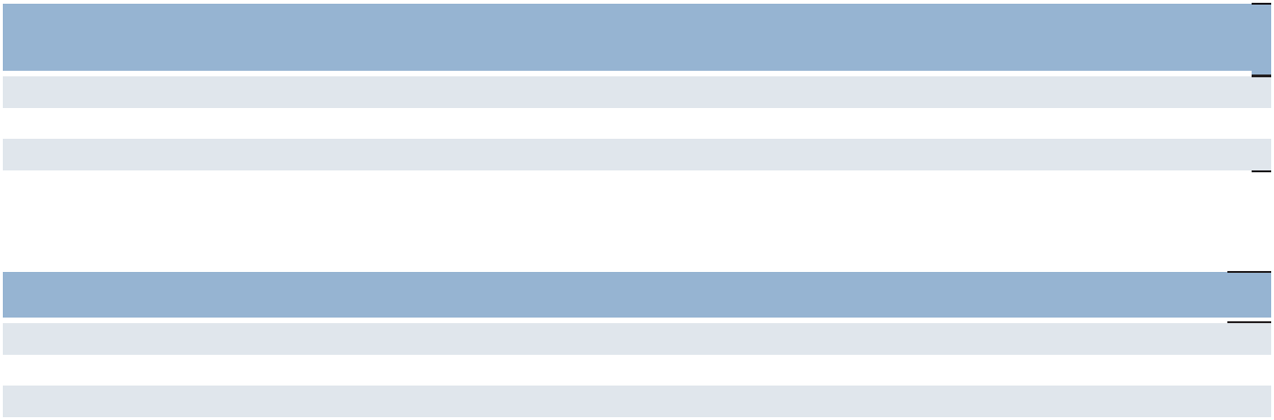

Valuation Allowance for Deferred Tax Assets

 |  | Balance at |  | Charged to Income | Charged to Other |  | Balance at End of
 | Beginning of Year |  |  | Tax Expense |  | Accounts^{(a)} |  | Year
2025 | $ | 222.9 | $ | 22.8 | $ | 16.8 | $ | 262.5
2024 |  | 219.8 |  | 34.1 |  | (31.0) |  | 222.9
2023 |  | 161.1 |  | 53.5 |  | 5.2 |  | 219.8

- Reflects other increases (decreases) to our valuation allowance that did not impact total tax expense, including the effects of currency and other comprehensive income/loss.

(a)(3) Exhibits.

See (c) below.

Pursuant to Regulation S-K, Item 601(b)(4)(iii), ManpowerGroup Inc. hereby agrees to furnish to the Commission, upon request, a copy of each instrument and agreement with respect to long-term debt of ManpowerGroup Inc. and its consolidated subsidiaries which does not exceed 10 percent of the total assets of ManpowerGroup Inc. and its subsidiaries on a consolidated basis.

97

Part IV

(c) Exhibits.

3.1 Amended and Restated Articles of Incorporation of ManpowerGroup Inc., incorporated by reference to the Quarterly Report on Form 10-Q for the quarter ended June 30, 2013.

3.2 | Amended and Restated By-laws of ManpowerGroup Inc., incorporated by reference to the Company's Current
 | Report on Form 8-K dated August 5, 2022.
4.1 | Fiscal and Paying Agency Agreement between the Company and Citibank, N.A., London Branch as Fiscal
 | Agent, Principal Paying Agent and Registrar and Transfer Agent, dated as of June 22, 2018 (including the form
 | of Note attached thereto as Schedule I), incorporated by reference to the Company’s Current Report on Form 8-
 | K dated June 22, 2018.
4.2 | Fiscal and Paying Agency Agreement between the Company and Citibank, N.A., as Fiscal Agent, Principal
 | Paying Agent and Registrar and Transfer Agent, dated as of June 30, 2022 (including the form of Note attached
 | thereto as Schedule I), incorporated by reference to the Company’s Current Report on Form 8-K dated June 30,
 | 2022.
 | Fiscal and Paying Agency Agreement between the Company and Citibank, N.A., London Branch, as Fiscal
4.3 | Agent, Principal Paying Agent and Registrar and Transfer Agent, dated as of December 15, 2025 (including the
4.3 | form of Note attached thereto as Schedule I), incorporated by reference to the Company’s Current Report on
 | Form 8-K dated December 15, 2025.
4.4 | Description of Securities Registered Pursuant to Section 12 of the Securities Exchange Act of 1934 incorporated
4.4 | by reference to the Company’s Annual Report on Form 10-K for the year ended December 31, 2020.
10.1 | Credit Agreement dated as of May 27, 2022 among the Company, a syndicate of lenders and JPMorgan Chase
 | Bank, N.A., as Administrative Agent, incorporated by reference to the Company’s Current Report on Form 8-K
 | dated May 27, 2022.
 | Amendment No. 2 dated as of June 26, 2025 to the Credit Agreement dated as of May 27, 2022 among the
10.2 | Company, a syndicate of lenders and JPMorgan Chase Bank, N.A., as Administrative Agent, incorporated by
 | reference to the Company’s Quarterly Report on Form 10-Q for the quarter ended June 30, 2025.
 | Credit Agreement dated as of December 15, 2025 among the Company, a syndicate of lenders and JPMorgan
10.3 | Chase Bank, N.A., as Administrative Agent, incorporated by reference to the Company’s Current Report on
 | Form 8-K dated December 15, 2025.
10.4 | Manpower Savings Related Share Option Scheme incorporated by reference to the Company’s Annual Report
 | on Form 10-K for the year ended December 31, 2010. **
10.5(a) | Terms and Conditions Regarding the Grant of Awards to Non-Employee Directors Under the 2011 Equity
 | Incentive Plan (Amended and Restated January 1, 2024), incorporated by reference to Exhibit 10.6(a) of the
 | Company's Annual Report on Form 10-K for the year ended December 31, 2023. **
 | ManpowerGroup Inc. Compensation for Non-Employee Directors (Amended and Restated Effective January 1,
10.5(b) | 2024). incorporate by reference to Exhibit 10.6(b) of the Company's Annual Report on Form 10-K for the year
 | ended December 31, 2023.**
10.5(c) | Letter Agreement between Jonas Prising and the Company dated as of February 13, 2026, incorporated by
 | reference to the Company's Current Report on Form 8-K dated February 19, 2026.**
10.5(d) | 2011 Equity Incentive Plan of Manpower Inc. (Amended and Restated Effective May 8, 2020), incorporated by
 | reference to the Company’s Registration Statement on Form S-8 dated May 29, 2020. **
10.5(e) | Form of Indemnification Agreement, incorporated by reference to the Company’s Current Report on Form 8-K
 | dated October 31, 2006.
10.6(a) | Form of Stock Option Agreement under 2011 Equity Incentive Plan, incorporated by reference to the Company’s
 | Quarterly Report on Form 10-Q for the quarter ended March 31, 2019. **

98

Part IV

10.6(b) Form of Restricted Stock Unit Agreement under 2011 Equity Incentive Plan, incorporated by reference to the Company’s Quarterly Report on Form 10-Q for the quarter ended March 31, 2012. **

10.6(c) Form of 2014 Career Share Agreement under the 2011 Equity Incentive Plan, incorporated by reference to the Company’s Quarterly Report on Form 10-Q for the quarter ended March 31, 2014. **

10.6(d) Form of 2021 Performance Share Unit Agreement Under the 2011 Equity Incentive Plan of ManpowerGroup Inc., incorporated by reference to the Company’s Quarterly Report on Form 10-Q for the Quarter ended March 31, 2021.

10.6(e) Form of 2022 Performance Share Unit Agreement Under the 2011 Equity Inventive Plan of ManpowerGroup Inc., incorporated by reference to the Company's Quarterly Report on Form 10-Q for the Quarter ended March 31, 2022.

10.6(f) Form of 2024 Performance Share Unit Agreement Under the 2011 Equity Inventive Plan of ManpowerGroup Inc., incorporated by reference to the Company's Quarterly Report on Form 10-Q for the Quarter ended March 31, 2024.

10.7(a) Letter Agreement between Michelle S. Nettles and the Company dated as of February 13, 2026, incorporated by reference to the Company's Current Report on Form 8-K dated February 19, 2026.**

10.7(b) Letter Agreement between John T. McGinnis and the Company dated as of February 13, 2026, incorporated by reference to the Company's Current Report on Form 8-K dated February 19, 2026.**

10.7(c) Letter Agreement between Becky Frankiewicz and the Company dated as of February 13, 2026, incorporated by reference to the Company's Current Report on Form 8-K dated February 19, 2026.**

10.8 ManpowerGroup Inc. Annual Incentive Plan, incorporated by reference to the Company's Current Report on Form 8-K dated February 15, 2018. **

19.1 Insider Trading policy, incorporated by reference to Exhibit 19.1 of the Company's Annual Report on Form 10-K for the year ended December 31, 2024.

21 Subsidiaries of the Company.

23.1 Consent of Deloitte & Touche LLP.

24 Power of Attorney.

31.1 Certification of Jonas Prising, Chief Executive Officer, pursuant to Section 13a-14(a) of the Securities Exchange Act of 1934.

31.2 Certification of John T. McGinnis, Executive Vice President and Chief Financial Officer, pursuant to Section 13a-14(a) of the Securities Exchange Act of 1934.

32.1 Statement of Jonas Prising, Chief Executive Officer, pursuant to 18 U.S.C. ss. 1350.

32.2 Statement of John T. McGinnis, Executive Vice President and Chief Financial Officer, pursuant to 18 U.S.C. ss.
1350.

- Senior Executive Compensation Recovery Policy, incorporated by reference to Exhibit 97 of the Company's Annual Report on Form 10-K for the year ended December 31, 2024. **

101.INS Inline XBRL Instance Document - the instance document does not appear in the Interactive Data File because its XBRL tags are embedded within the Inline XBRL document.

101.SCH Inline XBRL Taxonomy Extension Schema With Embedded Linkbase Documents

99

Part IV

- The cover page from the Company’s Annual Report on Form 10-K for the fiscal year ended December 31, 2025 has been formatted in Inline XBRL (Inline Extensible Business Reporting Language).

- Management contract or compensatory plan or arrangement.

Item 16. Form 10-K summary

Not applicable.

100

Part IV

SIGNATURES

Pursuant to the requirements of Section 13 or 15(d) of the Securities Exchange Act of 1934, the Registrant has duly caused this report to be signed on its behalf by the undersigned, thereunto duly authorized.

MANPOWERGROUP INC.

By: /s/ Jonas Prising
Jonas Prising

Chairman and Chief Executive Officer

Date: February 23, 2026

Pursuant to the requirements of the Securities Exchange Act of 1934, this report has been signed below by the following persons on behalf of the registrant and in the capacities and on the dates indicated.

Name | Title | Date
/s/ Jonas Prising | Chairman, Chief Executive Officer and a Director | February 23, 2026
Jonas Prising | (Principal Executive Officer)
/s/ John T. McGinnis | Executive Vice President and Chief Financial Officer | February 23, 2026
John T. McGinnis | (Principal Financial Officer)
/s/ Eric Rozek | Vice President and Global Controller | February 23, 2026
Eric Rozek | (Principal Accounting Officer)

Directors: Jean-Philippe Courtois, John F. Ferraro, William P. Gipson, Julie M. Howard, Muriel Pénicaud, Ulice Payne, Jr., Paul Read, Elizabeth P. Sartain, and Michael J. Van Handel

By: | /s/ John T. McGinnis
 | John T. McGinnis
 | Attorney-In-Fact*

Date: February 23, 2026

* Pursuant to authority granted by powers of attorney, copies of which are filed herewith.

101

