UNITED STATES

SECURITIES AND EXCHANGE COMMISSION
Washington, D.C. 20549

FORM 8-K

CURRENT REPORT

Pursuant to Section 13 or 15(d) of the Securities Exchange Act of 1934

Date of Report (Date of earliest event reported): April 18, 2024

MANPOWERGROUP INC.

(Exact name of registrant as specified in its charter)

Wisconsin |  |  | 1-10686 |  |  | 39-1672779
(State or other jurisdiction of incorporation) |  |  | (Commission File Number) |  |  |  | (IRS Employer Identification No.)
100 Manpower Place
Milwaukee, Wisconsin |  |  |  |  |  | 53212
(Address of principal executive offices) |  |  |  |  |  |  | (Zip Code)

Registrant's telephone number, including area code: (414) 961-1000

(Former name or former address, if changed since last report.)

Check the appropriate box below if the Form 8-K filing is intended to simultaneously satisfy the filing obligation of the registrant under any of the following provisions:

- Written communications pursuant to Rule 425 under the Securities Act (17 CFR 230.425)

- Soliciting material pursuant to Rule 14a-12 under the Exchange Act (17 CFR 240.14a-12)

- Pre-commencement communications pursuant to Rule 14d-2(b) under the Exchange Act (17 CFR 240.14d-2(b))

- Pre-commencement communications pursuant to Rule 13e-4(c) under the Exchange Act (17 CFR 240.13e-4(c))

Securities registered pursuant to Section 12(b) of the Act:
Title of each class | Trading Symbol(s) | Name of each exchange on which registered
Common Stock, $.01 par value | MAN | New York Stock Exchange

Indicate by check mark whether the registrant is an emerging growth company as defined in Rule 405 of the Securities Act of 1933 (§230.405 of this chapter) or Rule 12b-2 of the Securities Exchange Act of 1934 (§240.12b-2 of this chapter).

Emerging growth company ☐

If an emerging growth company, indicate by check mark if the registrant has elected not to use the extended transition period for complying with any new or revised financial accounting standards provided pursuant to Section 13(a) of the Exchange Act. ☐

Item 2.02 Results of Operations and Financial Condition

The information in this Item 2.02, including exhibit 99.1 attached hereto, is furnished solely pursuant to Item 2.02 of Form 8-K. Consequently, such information is not deemed "filed" for the purposes of Section 18 of the Securities Exchange Act of 1934, or otherwise subject to the liabilities of that section. Further, the information in this Item 2.02, including exhibit 99.1, shall not be deemed to be incorporated by reference into the filings of the registrant under the Securities Act of 1933.

On April 18, 2024, we issued a press release announcing our results of operations for the three months ended March 31, 2024 and 2023. A copy of the press release is attached hereto as Exhibit 99.1 and is incorporated herein by reference.

Effective January 1, 2024, our segment reporting was realigned to include our Puerto Rico business within Other Americas. Accordingly, our reportable segment, United States, is now adjusted to exclude Puerto Rico. All previously reported results have been restated to conform to the current year presentation. Attached hereto as Exhibit 99.3 is our Operating Unit Results since January 1, 2022.

Item 9.01. |  | Exhibits
 | Exhibit No. |  |  | Description
 | 99.1 |  |  | Press Release dated April 18, 2024
99.2 |  |  |  | Presentation materials for April 18, 2024 Conference Call
99.3 |  |  |  | Operating Unit Results reflecting the restatement of segment results
104 |  |  |  | Cover Page Interactive Data File (embedded within the Inline XBRL document)

SIGNATURE

Pursuant to the requirements of the Securities Exchange Act of 1934, the registrant has duly caused this report to be signed on its behalf by the undersigned hereunto duly authorized.

 |  | MANPOWERGROUP INC.
Dated:April 18, 2024 |  | By: |  | /s/ John T. McGinnis
 |  | Name: |  | John T. McGinnis
 |  | Title: |  | Executive Vice President and
 |  |  |  | Chief Financial Officer

Exhibit 99.1


FOR IMMEDIATE RELEASE Contact:

Nick Hengst

+1.414.906.7356

nicholas.hengst@manpowergroup.com

ManpowerGroup Reports 1st Quarter 2024 Results

- Revenues of $4.4 billion (-7% as reported, -5% constant currency)

- Continuation of challenging environment in North America and Europe during the quarter, solid demand in Latin America and Asia-Pacific region

- Gross profit margin of 17.3% as reported, 17.5% as adjusted. Staffing margins remained strong; permanent recruitment trends were stable at lower levels

- Good management of SG&A (-6% as reported, -5% constant currency year-over-year)

- $50 million of common stock repurchased during the quarter

- Strong cash flow during the quarter

MILWAUKEE, April 18, 2024 -- ManpowerGroup (NYSE: MAN) today reported net earnings of $0.81 per diluted share for the three months ended March 31, 2024 compared to net earnings of $ 1.51 per diluted share in the prior year period. Net earnings in the quarter were $39.7 million compared to net earnings of $77.8 million a year earlier. Revenues for the first quarter were $4.4 billion, a 7% decrease from the prior year period.

The quarter included run-off losses related to the run-off Proservia Germany business and a minor loss for Argentina related currency translation losses^{[1]}. These losses reduced earnings per share by $0.13 in the first quarter and reduced our gross profit margin by 20 basis points. Excluding these losses, earnings per share was $0.94 per diluted share in the quarter representing a decrease of 39% in constant currency.^{[2]}

- Argentina is required to be treated as a hyperinflationary economy and the currency translation losses reflect the devaluation of the Argentine peso during the quarter.

- The prior year period included restructuring costs which reduced earnings per share by $0.10 which are also excluded when determining the year over year trend.

Financial results in the quarterwere also impacted by the U.S. dollar relativeto foreign currencies comparedto the prior year period. The first quarter earnings per share guidance estimated a negative 2 cents foreign currency impact and the actual impact was worse at a negative 4 cents. On a constant currency basis, revenues decreased 5% compared to the prior year period, or decreased 6% as adjusted.

Jonas Prising, ManpowerGroup Chairman & CEO, said, “Employers in North America and Europe remain cautious as they wait for signs that the economic environment is on a sustainable path of improvement. In some of those markets demand for staffing and permanent recruitment stabilized at lower levels, while demand across Latin America and Asia Pacific Middle East remained solid. We continue to prioritize the execution of our strategic initiatives and are accelerating sales activities to drive profitable growth when demand trends strengthen.

We anticipate diluted earnings per share in the second quarter will be between $1.24 and $1.34, which includes an estimated unfavorable currency impact of 7 cents and excludes unfavorable operating losses for the run-off Proservia Germany business estimated at 8 cents. Our guidance excludes any restructuring costs and any Argentina related impact of non-cash currency translation losses.”

In conjunction with its first quarter earnings release, ManpowerGroup will broadcast its conference call live over the Internet on April 18, 2024 at 7:30 a.m. central time (8:30 a.m. eastern time). Prepared remarks for the conference call, webcast details, presentation and recordings are included within the Investor Relations section of manpowergroup.com.

Supplemental financial information referenced in the conference call can be found at http://investor.manpowergroup.com/.

About ManpowerGroup

ManpowerGroup® (NYSE: MAN), the leading global workforce solutions company, helps organizations transform in a fast-changing world of work by sourcing, assessing, developing, and managing the talent that enables them to win. We develop innovative solutions for hundreds of thousands of organizations every year, providing them with skilled talent while finding meaningful, sustainable employment for millions of people across a wide range of industries and skills. Our expert family of brands – Manpower, Experis, and Talent Solutions – creates substantially more value for candidates and clients across more than 70 countries and territories and has done so for 75 years. We are recognized consistently for our diversity – as a best place to work for Women, Inclusion, Equality, and Disability, and in 2024 ManpowerGroup was named one of the World's Most Ethical Companies for the 15th time – all confirming our position as the brand of choice for in-demand talent. For more information, visit www.manpowergroup.com.

Forward-Looking Statements

This press release contains statements, including statements regarding economic and geopolitical uncertainty, trends in labor demand and the future strengthening of such demand, financial outlook, including any residual costs resulting from the wind-down of the Proservia business in Germany and the Company’s strategic initiatives and technology investments that are forward-looking in nature and, accordingly, are subject to risks and uncertainties regarding the Company’s expected future results. The Company’s actual results may differ materially from those described or contemplated in the forward-looking statements due to numerous factors. These factors include those found in the Company’s reports filed with the SEC, including the information under the heading “Risk Factors” in its Annual Report on Form 10-K for the year ended December 31, 2023, which information is incorporated herein by reference.

The Company assumes no obligation to update or revise any forward-looking statements. We reference certain non-GAAP financial measures, which we believe provide useful information for investors. We include a reconciliation of these measures, where appropriate, to GAAP on the Investor Relations section of our website at manpowergroup.com.

###

ManpowerGroup

Results of Operations

(In millions, except per share data)

 |  |  |  |  |  | Three Months Ended March 31
 |  |  |  |  |  |  |  |  |  | % Variance
 |  |  |  |  |  |  |  |  |  | Amount |  |  | Constant
 |  | 2024 |  |  |  | 2023 |  |  |  | Reported |  |  | Currency
 |  |  |  |  |  | (Unaudited)
Revenues from services (a) | $ | 4,403.3 | $ |  |  | 4,752.3 |  |  |  | -7.3 % |  |  | -5.5 %
Cost of services |  | 3,639.6 |  |  |  | 3,889.2 |  |  |  | -6.4 % |  |  | -4.4 %
Gross profit |  | 763.7 |  |  |  | 863.1 |  |  |  | -11.5 % |  |  | -10.1 %
Selling and administrative expenses |  | 697.8 |  |  |  | 745.2 |  |  |  | -6.4 % |  |  | -5.1 %
Operating profit |  | 65.9 |  |  |  | 117.9 |  |  |  | -44.1 % |  |  | -41.7 %
Interest and other expenses, net |  | 8.4 |  |  |  | 7.5 |  |  |  | 12.2 %
Earnings before income taxes |  | 57.5 |  |  |  | 110.4 |  |  |  | -47.9 % |  |  | -45.3 %
Provision for income taxes |  | 17.8 |  |  |  | 32.6 |  |  |  | -45.4 %
Net earnings | $ | 39.7 | $ |  |  | 77.8 |  |  |  | -49.0 % |  |  | -46.4 %
Net earnings per share - basic | $ | 0.82 | $ |  |  | 1.53 |  |  |  | -46.2 %
Net earnings per share - diluted | $ | 0.81 | $ |  |  | 1.51 |  |  |  | -46.2 % |  |  | -43.5 %
Weighted average shares - basic |  | 48.3 |  |  |  | 50.9 |  |  |  | -5.1 %
Weighted average shares - diluted |  | 48.9 |  |  |  | 51.6 |  |  |  | -5.1 %
- Revenues from services include fees received from our franchise offices of $3.3 million and $3.9 million for the three months ended March 31, 2024 and 2023, respectively. These fees are primarily based on revenues generated by the franchise offices, which were $277.2 million and $250.2 million for the three months ended March 31, 2024 and 2023, respectively.

ManpowerGroup

Operating Unit Results

(In millions)

 |  |  |  |  |  | Three Months Ended March 31
 |  |  |  |  |  |  |  |  |  | % Variance
 |  |  |  |  |  | 2023 ^{(a)} |  |  |  | Amount |  |  | Constant
 |  | 2024 |  |  |  | 2023 ^{(a)} |  |  |  | Reported |  |  | Currency
 |  |  |  |  |  | (Unaudited)
Revenues from Services:
Americas:
United States ^{(b)} | $ | 680.4 |  | $ |  | 741.6 |  |  |  | -8.3 % |  |  | -8.3 %
Other Americas |  | 356.0 |  |  |  | 388.6 |  |  |  | -8.4 % |  |  | 12.5 %
 |  | 1,036.4 |  |  |  | 1,130.2 |  |  |  | -8.3 % |  |  | -1.1 %
Southern Europe:
France |  | 1,119.3 |  |  |  | 1,169.3 |  |  |  | -4.3 % |  |  | -5.4 %
Italy |  | 404.3 |  |  |  | 422.2 |  |  |  | -4.2 % |  |  | -5.4 %
Other Southern Europe |  | 457.7 |  |  |  | 476.4 |  |  |  | -3.9 % |  |  | -3.3 %
 |  | 1,981.3 |  |  |  | 2,067.9 |  |  |  | -4.2 % |  |  | -4.9 %
Northern Europe |  | 870.3 |  |  |  | 967.6 |  |  |  | -10.1 % |  |  | -12.1 %
APME |  | 535.1 |  |  |  | 605.9 |  |  |  | -11.7 % |  |  | -4.8 %
 |  | 4,423.1 |  |  |  | 4,771.6
Intercompany Eliminations |  | (19.8 ) |  |  |  | (19.3 )
 | $ | 4,403.3 |  |  | $ | 4,752.3 |  |  |  | -7.3 % |  |  | -5.5 %
Operating Unit Profit:
Americas:
United States | $ | 12.0 |  | $ |  | 30.0 |  |  |  | -60.2 % |  |  | -60.2 %
Other Americas |  | 14.1 |  |  |  | 18.6 |  |  |  | -24.1 % |  |  | -15.2 %
 |  | 26.1 |  |  |  | 48.6 |  |  |  | -46.4 % |  |  | -43.0 %
Southern Europe:
France |  | 33.1 |  |  |  | 44.9 |  |  |  | -26.3 % |  |  | -27.2 %
Italy |  | 27.4 |  |  |  | 30.7 |  |  |  | -10.7 % |  |  | -11.8 %
Other Southern Europe |  | 9.4 |  |  |  | 14.3 |  |  |  | -34.0 % |  |  | -31.9 %
 |  | 69.9 |  |  |  | 89.9 |  |  |  | -22.2 % |  |  | -22.7 %
Northern Europe |  | 0.0 |  |  |  | 5.0 |  |  |  | -99.9 % |  |  | -108.6 %
APME |  | 19.9 |  |  |  | 21.1 |  |  |  | -6.1 % |  |  | 3.3 %
 |  | 115.9 |  |  |  | 164.6
Corporate expenses |  | (41.7 ) |  |  |  | (37.9 )
Intangible asset amortization expense |  | (8.3 ) |  |  |  | (8.8 )
Operating profit |  | 65.9 |  |  |  | 117.9 |  |  |  | -44.1 % |  |  | -41.7 %
Interest and other expenses, net ^{(c)} |  | (8.4 ) |  |  |  | (7.5 )
Earnings before income taxes | $ | 57.5 |  |  | $ | 110.4
- Effective January 1, 2024, our segment reporting was realigned to include our Puerto Rico business within Other Americas. Accordingly, our reportable segment, United States, is now adjusted to exclude Puerto Rico. All previously reported results have been restated to the current year presentation.
- In the United States, revenues from services include fees received from our franchise offices of $2.4 million and $3.2 million for the three months ended March 31, 2024 and 2023, respectively. These fees are primarily based on revenues generated by the franchise offices, which were $87.4 million and $99.3 million for the three months
ended March 31, 2024 and 2023, respectively.

- The components of interest and other expenses, net were:

 | 2024 |  |  |  |  | 2023
Interest expense | $ | 20.4 |  | $ |  | 18.7
Interest income |  | (8.1 ) |  |  |  | (8.1 )
Foreign exchange loss |  | 2.4 |  |  |  | 3.1
Miscellaneous income |  | (6.3 ) |  |  |  | (6.2 )
 | $ | 8.4 |  |  | $ | 7.5

ManpowerGroup

Consolidated Balance Sheets

(In millions)

 |  | March 31, |  |  |  | December 31,
 |  | 2024 |  |  |  | 2023
 |  | (Unaudited)
ASSETS
Current assets:
Cash and cash equivalents | $ | 604.8 |  | $ |  | 581.3
Accounts receivable, net |  | 4,458.5 |  |  |  | 4,830.0
Prepaid expenses and other assets |  | 186.5 |  |  |  | 160.8
Total current assets |  | 5,249.8 |  |  |  | 5,572.1
Other assets:
Goodwill |  | 1,574.5 |  |  |  | 1,586.8
Intangible assets, net |  | 507.8 |  |  |  | 519.6
Operating lease right-of-use assets |  | 403.9 |  |  |  | 414.0
Other assets |  | 628.4 |  |  |  | 607.8
Total other assets |  | 3,114.6 |  |  |  | 3,128.2
Property and equipment:
Land, buildings, leasehold improvements and equipment |  | 518.3 |  |  |  | 526.5
Less: accumulated depreciation and amortization |  | 394.1 |  |  |  | 396.6
Net property and equipment |  | 124.2 |  |  |  | 129.9
Total assets | $ | 8,488.6 |  | $ |  | 8,830.2
LIABILITIES AND SHAREHOLDERS' EQUITY
Current liabilities:
Accounts payable | $ | 2,614.7 |  | $ |  | 2,723.0
Employee compensation payable |  | 215.4 |  |  |  | 243.1
Accrued liabilities |  | 604.3 |  |  |  | 693.0
Accrued payroll taxes and insurance |  | 668.4 |  |  |  | 695.8
Value added taxes payable |  | 385.7 |  |  |  | 432.7
Short-term borrowings and current maturities of long-term debt |  | 15.6 |  |  |  | 12.1
Total current liabilities |  | 4,504.1 |  |  |  | 4,799.7
Other liabilities:
Long-term debt |  | 968.9 |  |  |  | 990.5
Long-term operating lease liability |  | 315.5 |  |  |  | 323.2
Other long-term liabilities |  | 512.4 |  |  |  | 482.7
Total other liabilities |  | 1,796.8 |  |  |  | 1,796.4
Shareholders' equity:
ManpowerGroup shareholders' equity
Common stock |  | 1.2 |  |  |  | 1.2
Capital in excess of par value |  | 3,518.7 |  |  |  | 3,514.9
Retained earnings |  | 3,852.7 |  |  |  | 3,813.0
Accumulated other comprehensive loss |  | (495.5 ) |  |  |  | (466.0 )
Treasury stock, at cost |  | (4,700.4 ) |  |  |  | (4,639.8 )
Total ManpowerGroup shareholders' equity |  | 2,176.7 |  |  |  | 2,223.3
Noncontrolling interests |  | 11.0 |  |  |  | 10.8
Total shareholders' equity |  | 2,187.7 |  |  |  | 2,234.1
Total liabilities and shareholders' equity | $ | 8,488.6 |  | $ |  | 8,830.2

ManpowerGroup

Consolidated Statements of Cash Flows

(In millions)

 |  | Three Months Ended
 |  | March 31,
 | 2024 |  |  |  |  | 2023
 |  | (Unaudited)
Cash Flows from Operating Activities:
Net earnings | $ | 39.7 |  | $ |  | 77.8
Adjustments to reconcile net earnings to net cash provided by operating activities:
Depreciation and amortization |  | 21.6 |  |  |  | 21.0
Deferred income taxes |  | 7.5 |  |  |  | 18.2
Provision for doubtful accounts |  | 2.6 |  |  |  | 0.1
Share-based compensation |  | 7.5 |  |  |  | 5.1
Changes in operating assets and liabilities:
Accounts receivable |  | 283.9 |  |  |  | 398.0
Other assets |  | (62.5 ) |  |  |  | (37.3 )
Other liabilities |  | (184.3 ) |  |  |  | (358.3 )
Cash provided by operating activities |  | 116.0 |  |  |  | 124.6
Cash Flows from Investing Activities:
Capital expenditures |  | (11.8 ) |  |  |  | (13.2 )
Proceeds from the sale of property and equipment |  | 2.1 |  |  |  | —
Cash used in investing activities |  | (9.7 ) |  |  |  | (13.2 )
Cash Flows from Financing Activities:
Net change in short-term borrowings |  | 3.7 |  |  |  | (10.7 )
Proceeds from long-term debt |  | — |  |  |  | 0.2
Repayments of long-term debt |  | (0.2 ) |  |  |  | (0.2 )
Payments of contingent consideration for acquisitions |  | (1.1 ) |  |  |  | —
Proceeds from share-based awards |  | 0.4 |  |  |  | 1.7
Other share-based award transactions |  | (10.3 ) |  |  |  | (9.8 )
Repurchases of common stock |  | (50.0 ) |  |  |  | (30.0 )
Cash used in financing activities |  | (57.5 ) |  |  |  | (48.8 )
Effect of exchange rate changes on cash |  | (25.3 ) |  |  |  | 5.1
Change in cash and cash equivalents |  | 23.5 |  |  |  | 67.7
Cash and cash equivalents, beginning of period |  | 581.3 |  |  |  | 639.0
Cash and cash equivalents, end of period | $ | 604.8 |  | $ |  | 706.7



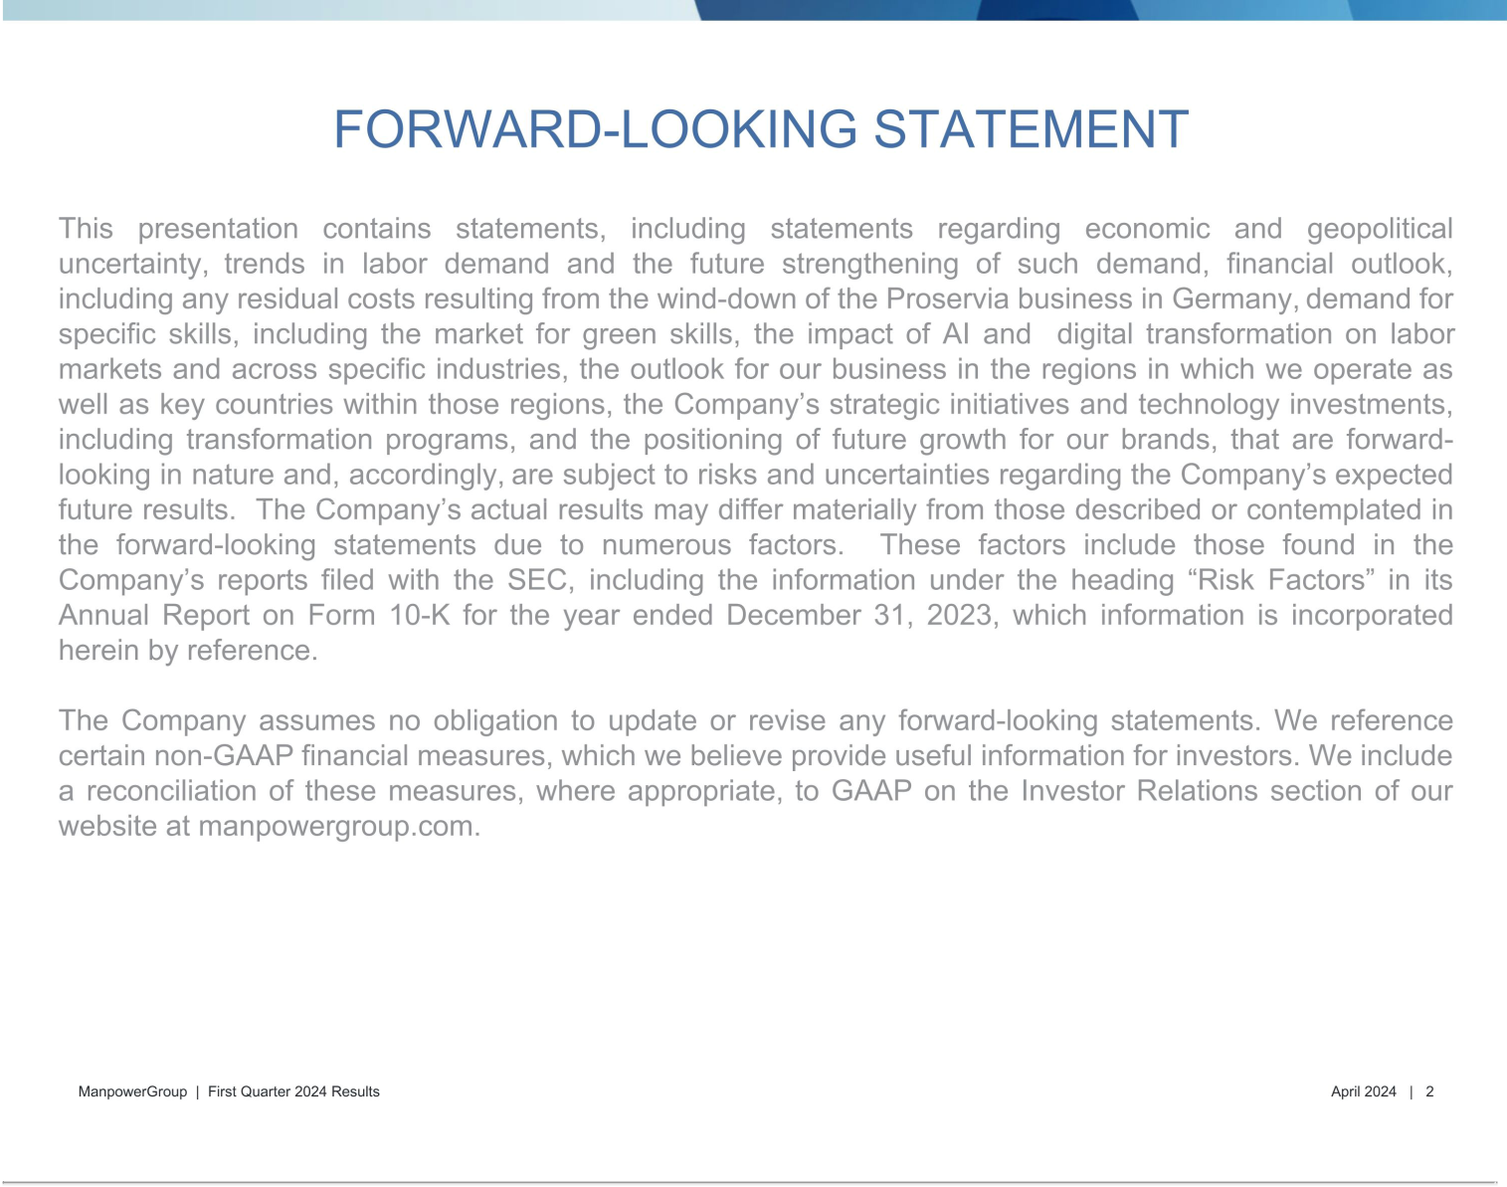

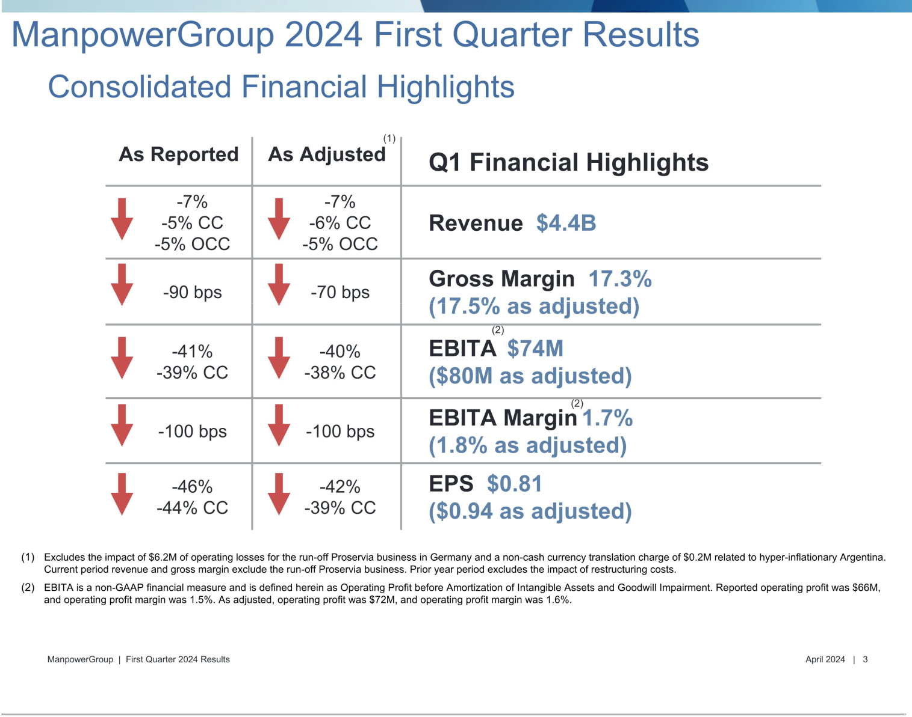

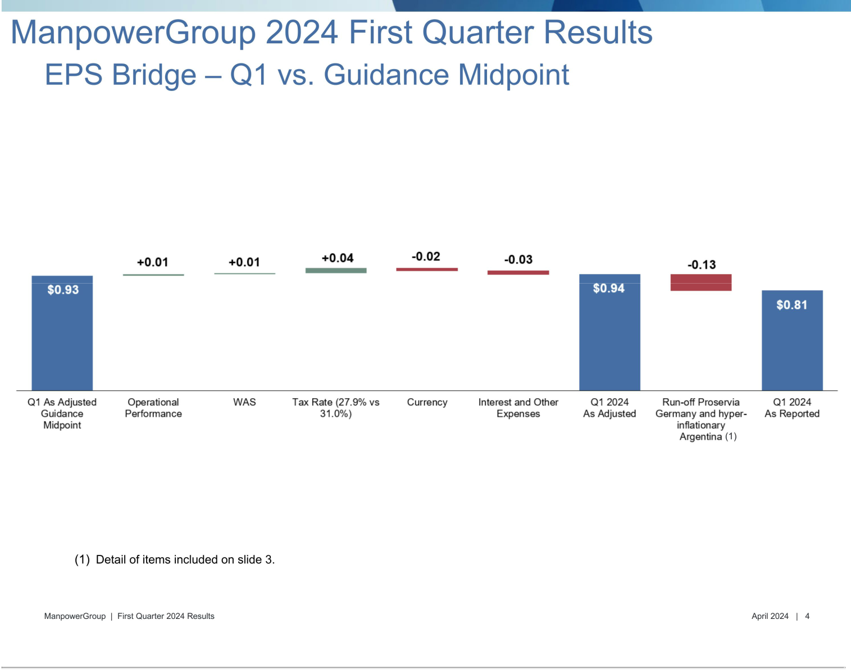

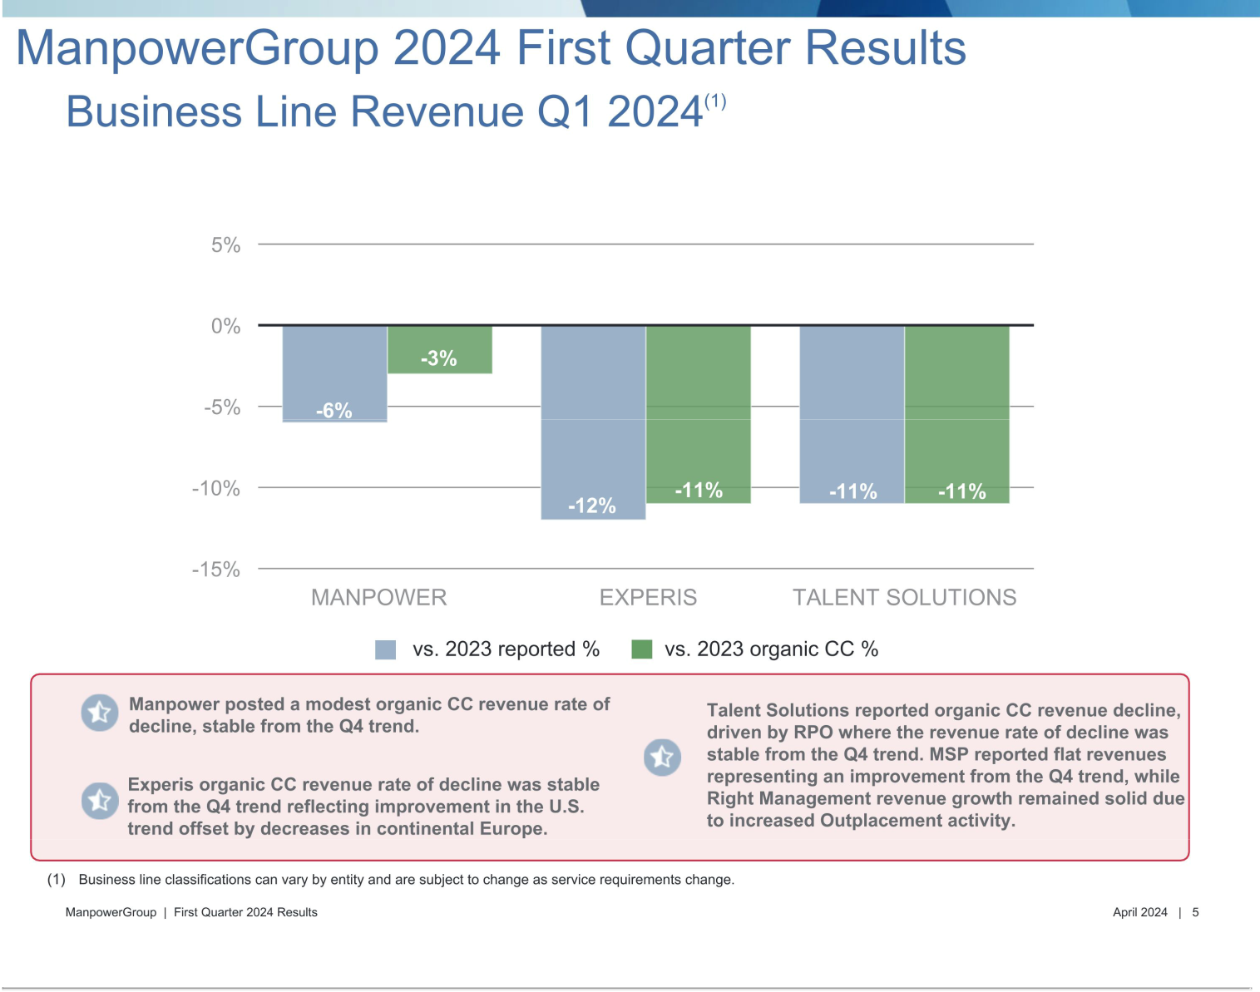

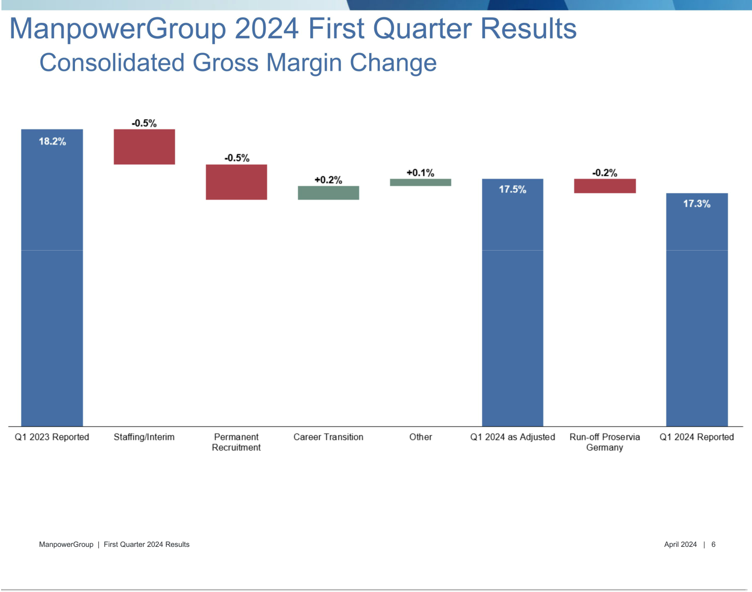

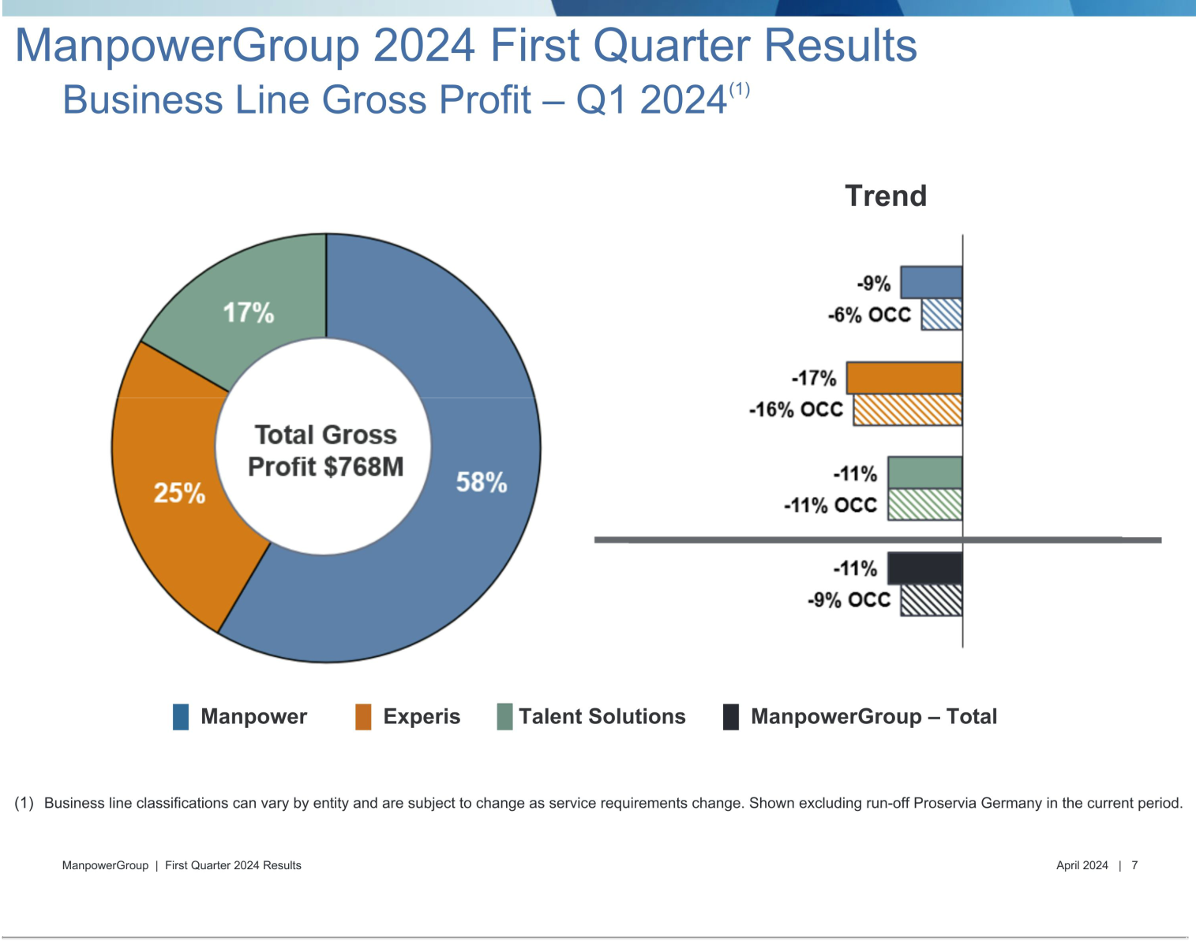

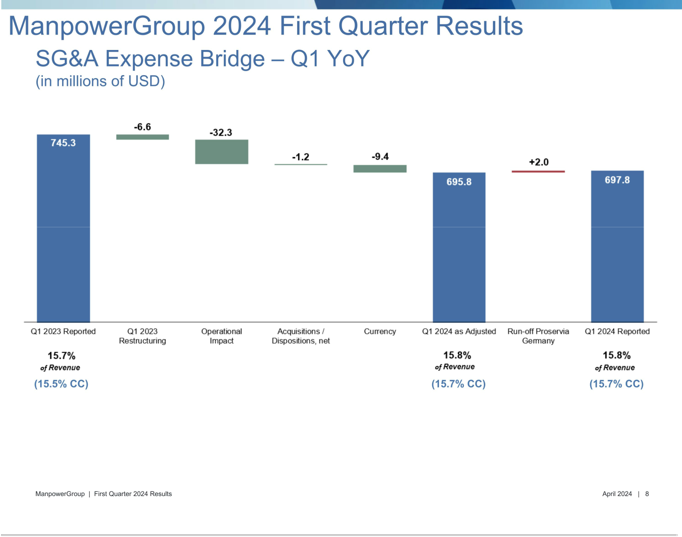

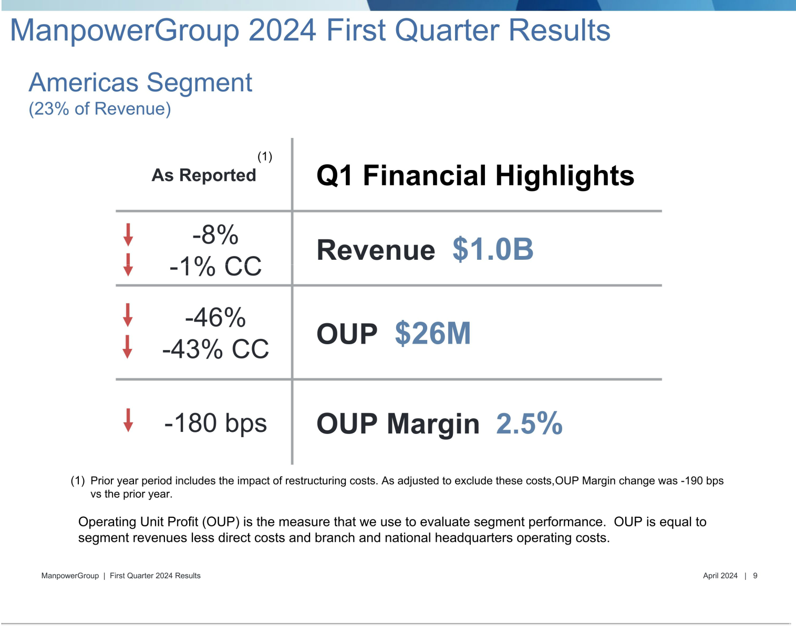

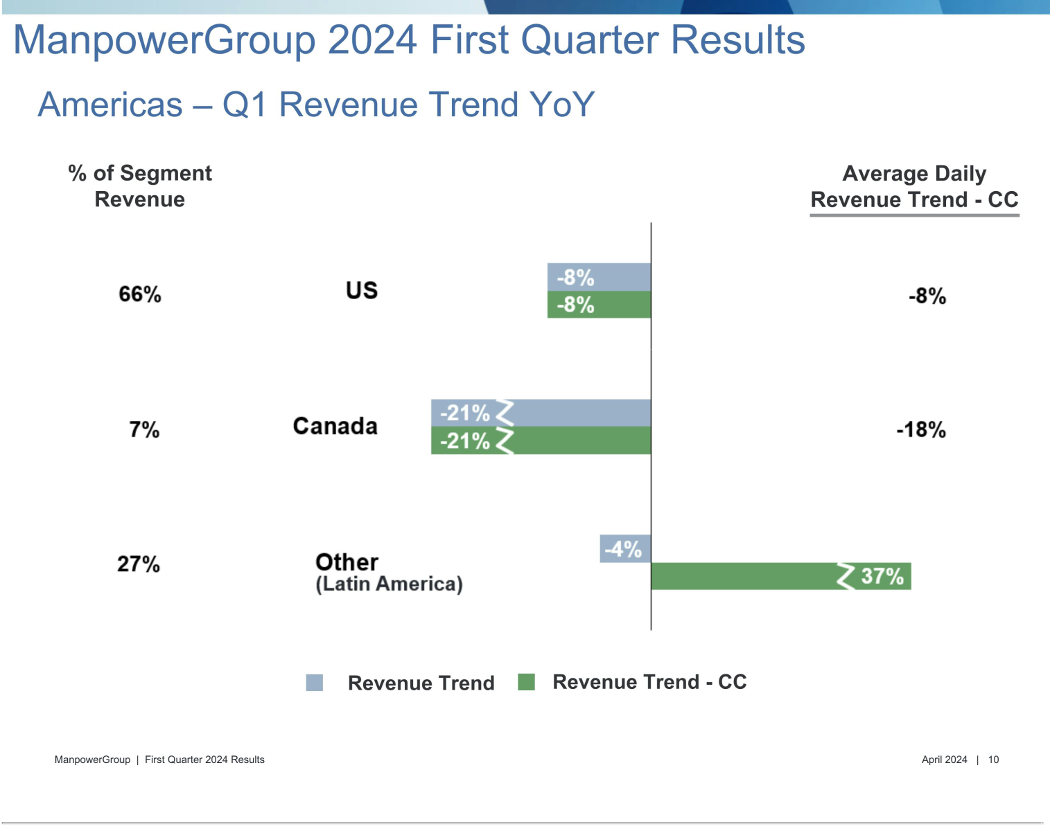

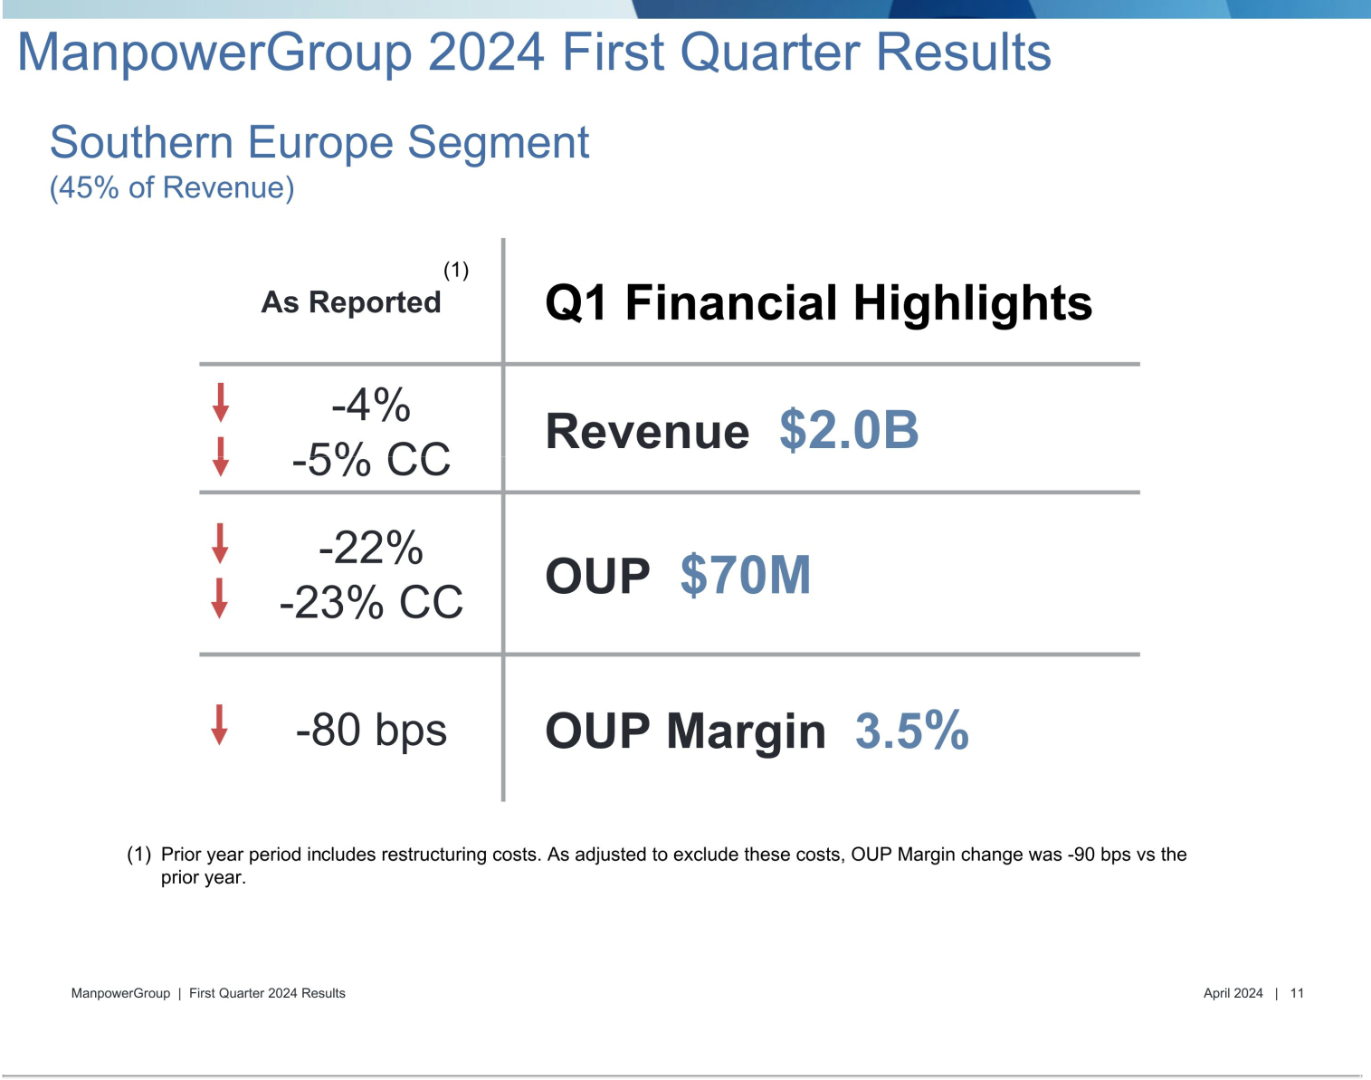

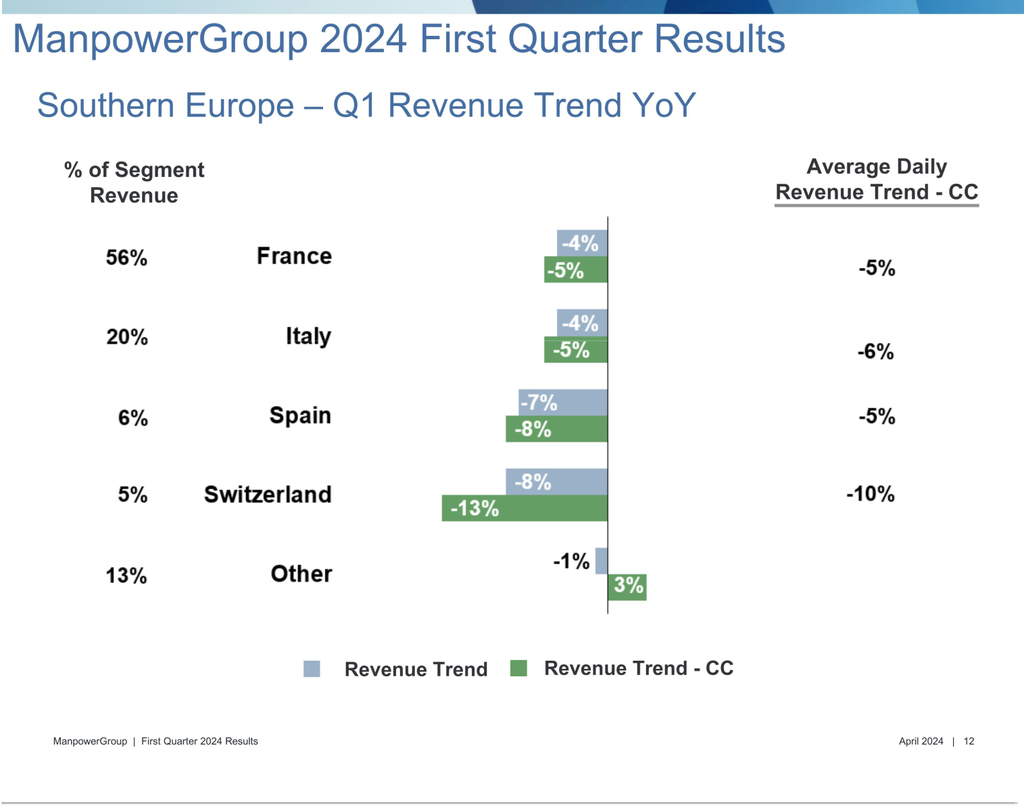

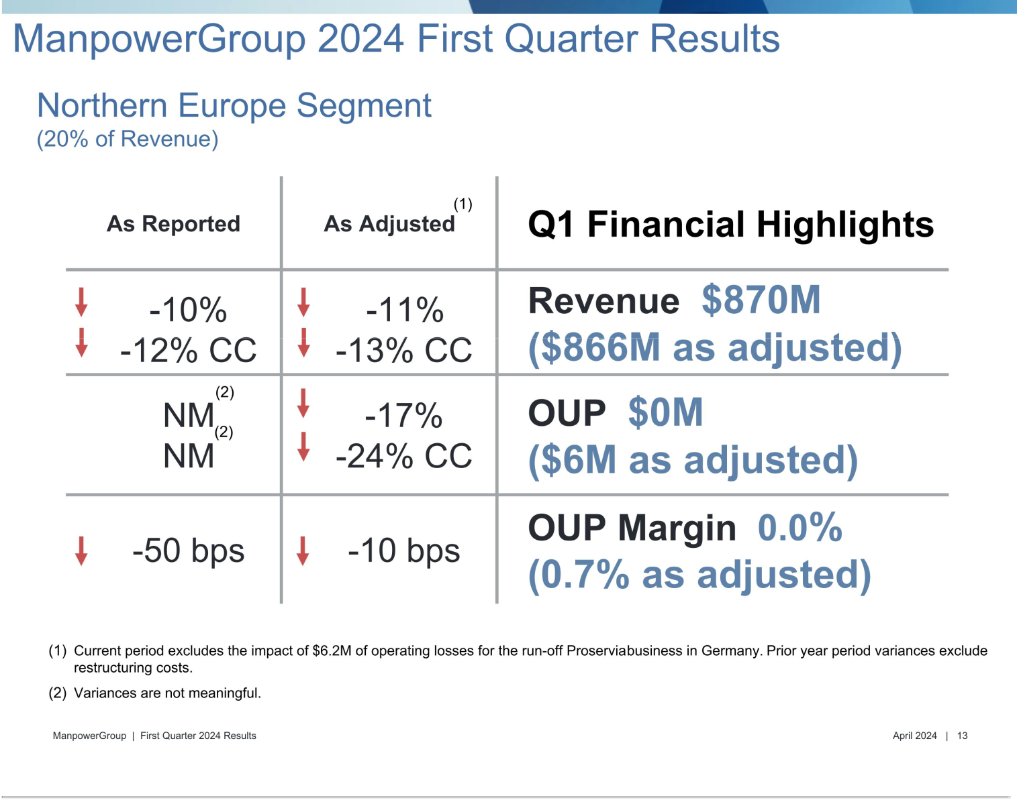

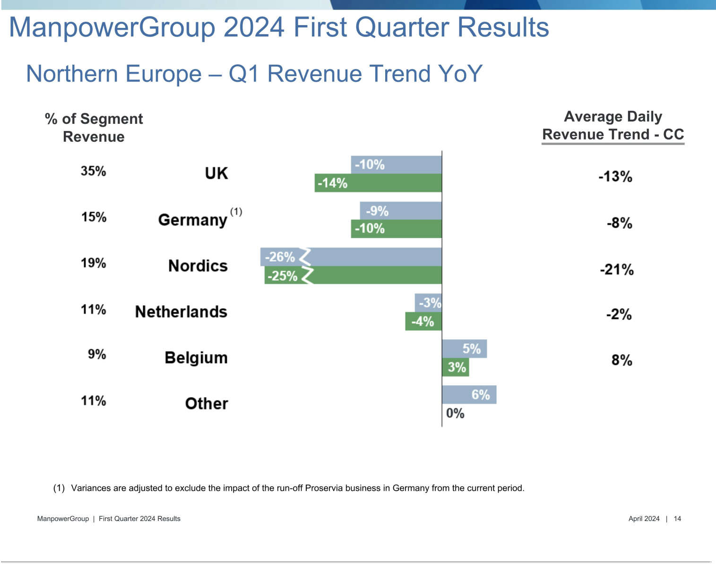

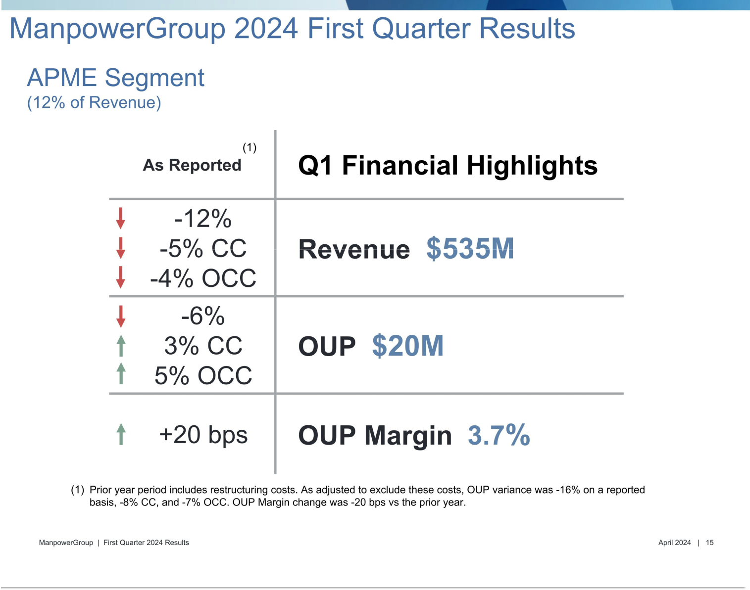

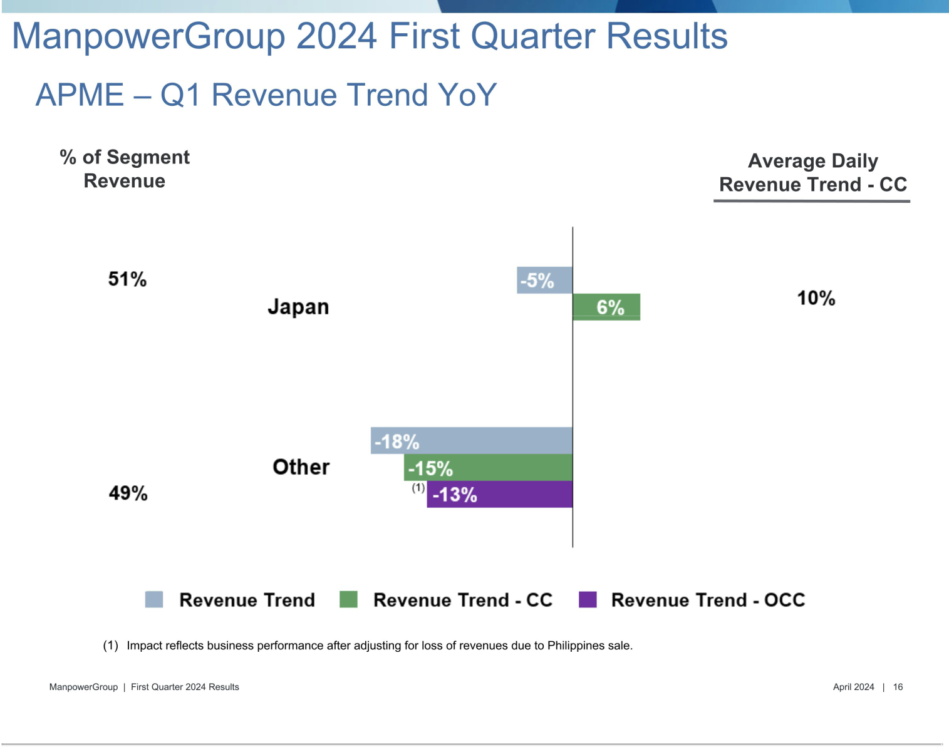

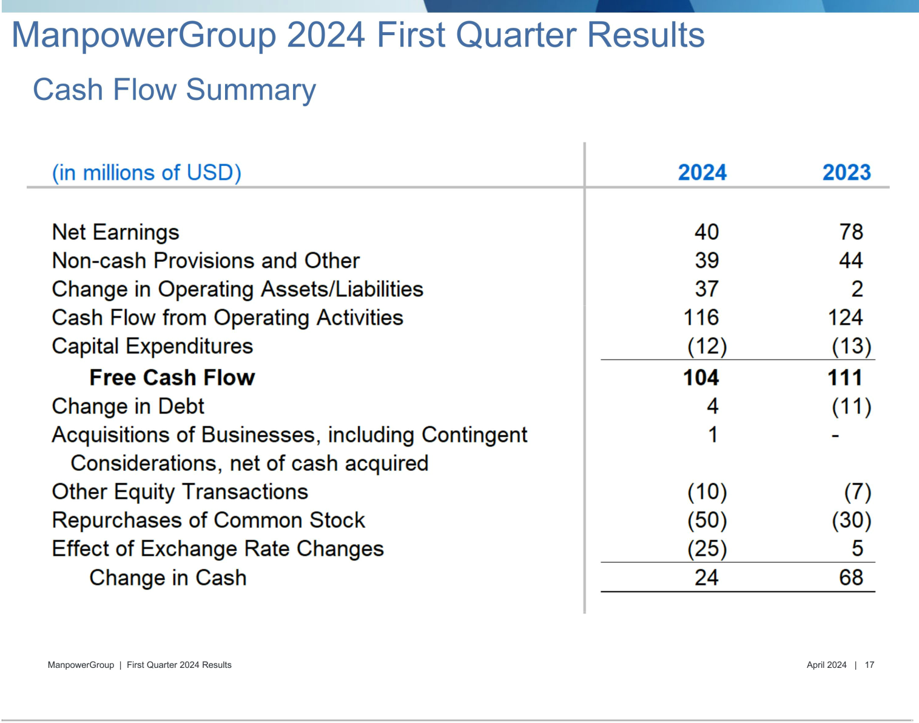

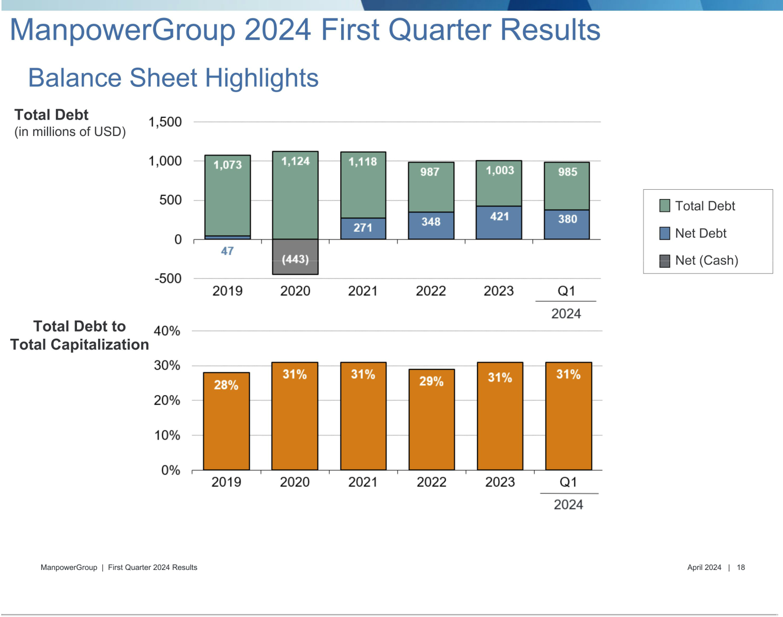

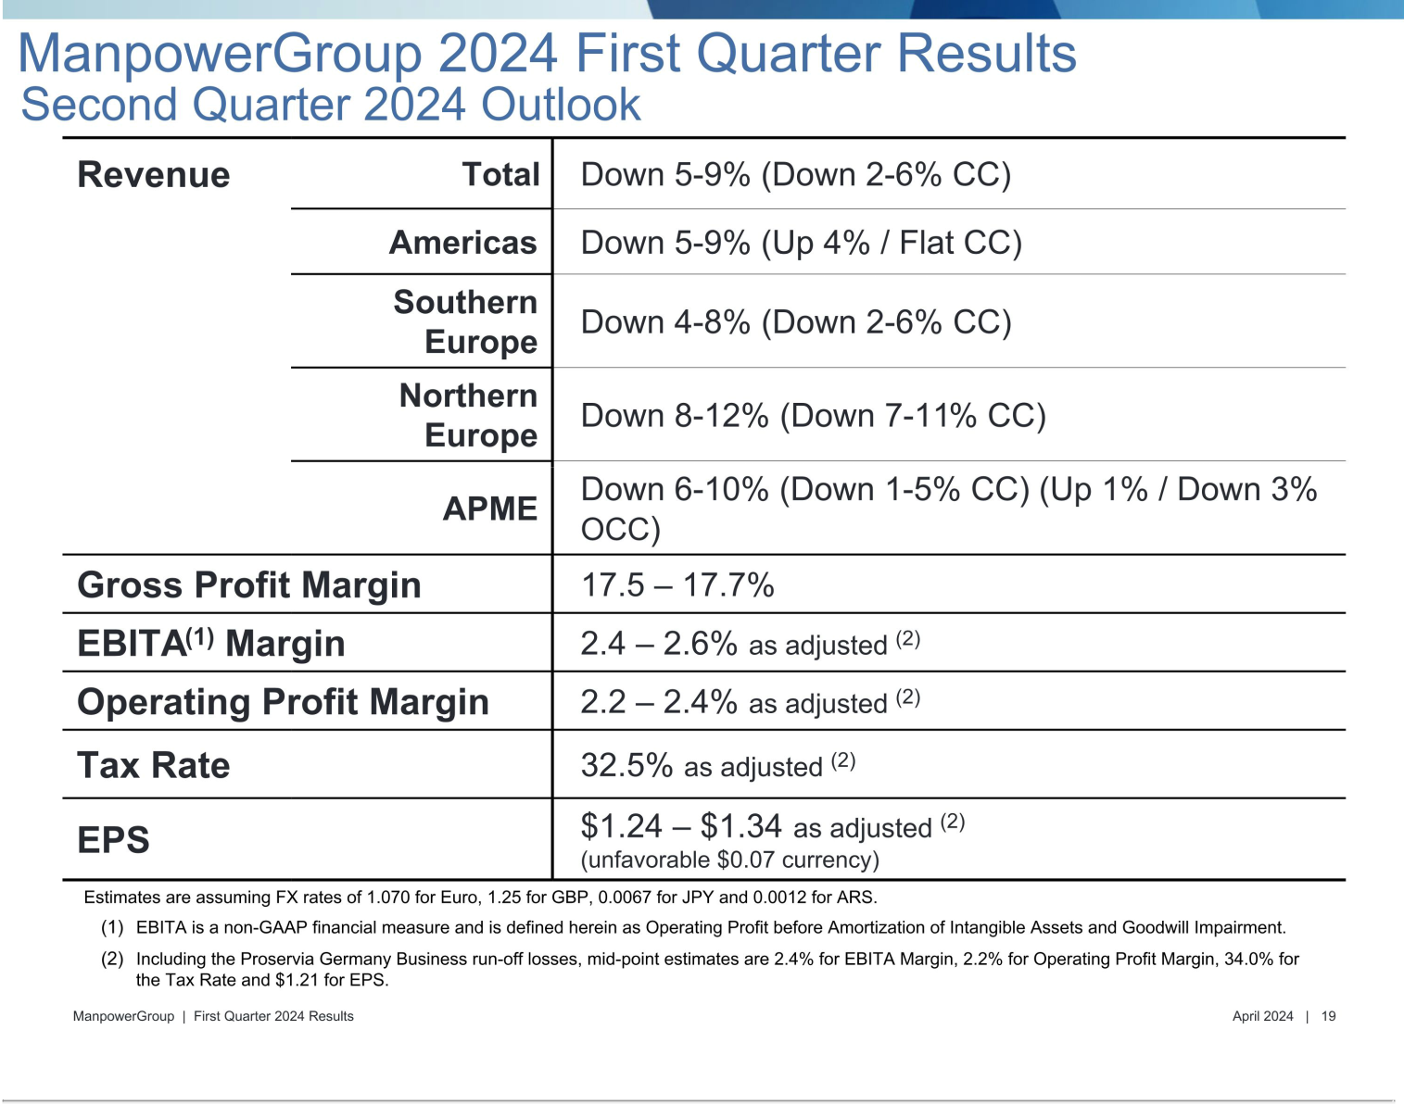

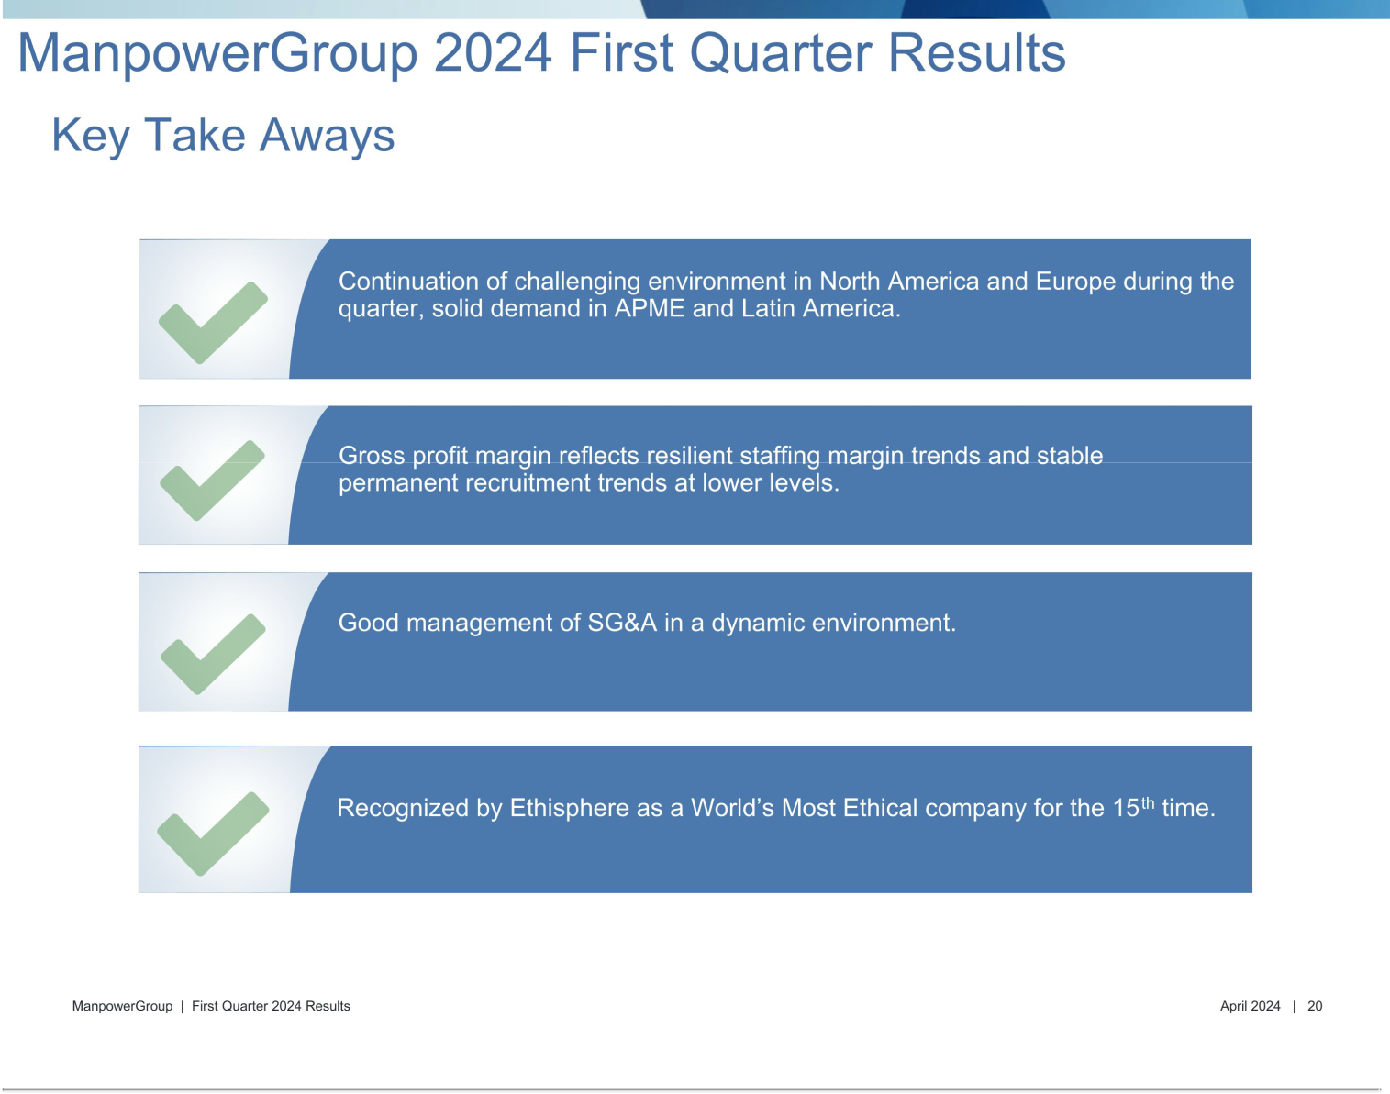



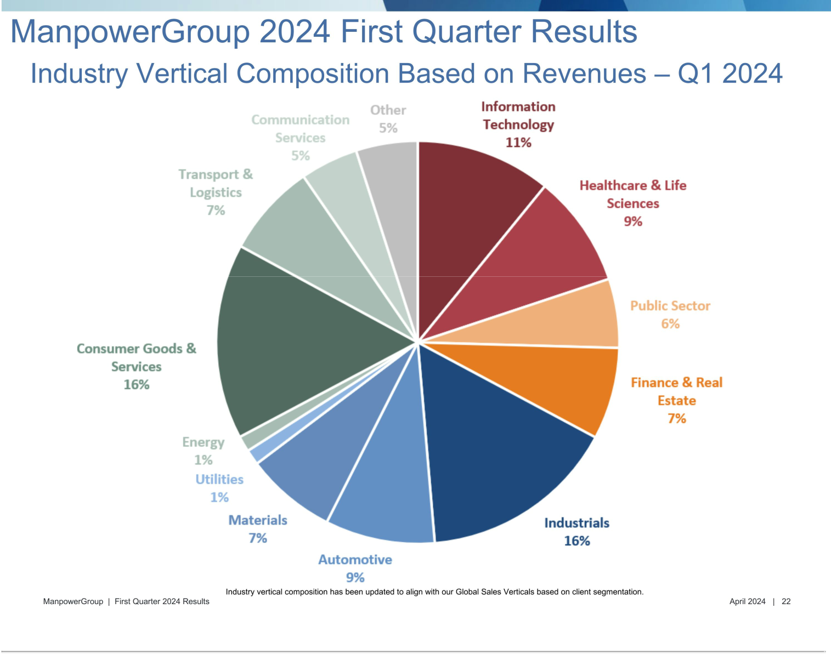

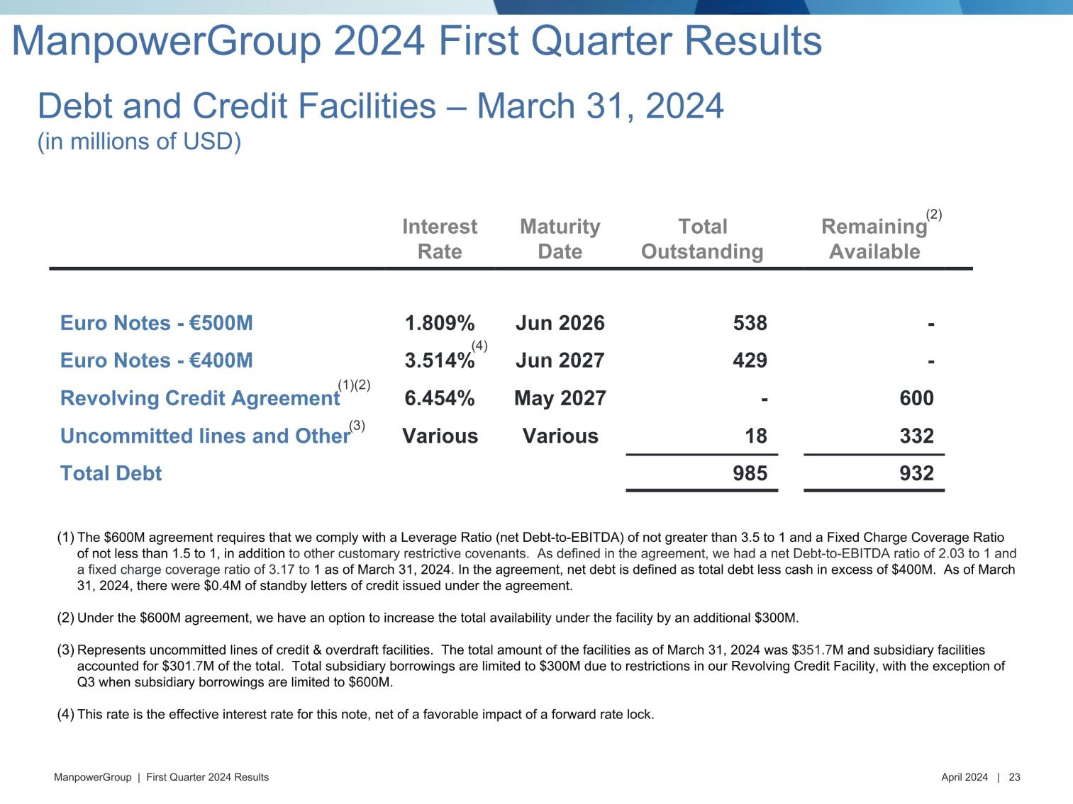

Exhibit 99.3

ManpowerGroup

Restated Operating Unit Results
(In millions)

Effective January 1, 2024, our segment reporting was realigned to include our Puerto Rico business within Other Americas. Accordingly, our reportable segment, United States, is now adjusted to exclude Puerto Rico. All previously reported results have been restated to conform to the current year presentation.

 |  |  |  |  |  | Three Months Ended March 31
 |  |  |  |  |  |  |  |  |  |  | % Variance
 |  |  |  |  |  |  |  |  |  | Amount |  |  |  | Constant
 |  | 2023 |  |  |  | 2022 |  |  |  | Reported |  |  |  | Currency
 |  |  |  |  |  |  | (Unaudited)
Revenues from Services:
Americas:
United States | $ | 741.6 |  | $ |  |  | 854.2 |  |  |  | -13.2 % |  |  | -13.2 %
Other Americas |  | 388.6 |  |  |  |  | 397.0 |  |  |  | -2.1 % |  |  | 9.0 %
 |  | 1,130.2 |  |  |  |  | 1,251.2 |  |  |  | -9.7 % |  |  | -6.1 %
Southern Europe:
France |  | 1,169.3 |  |  |  |  | 1,192.4 |  |  |  | -1.9 % |  |  | 2.5 %
Italy |  | 422.2 |  |  |  |  | 445.0 |  |  |  | -5.1 % |  |  | -0.8 %
Other Southern Europe |  | 476.4 |  |  |  |  | 556.5 |  |  |  | -14.4 % |  |  | -10.3 %
 |  | 2,067.9 |  |  |  |  | 2,193.9 |  |  |  | -5.7 % |  |  | -1.4 %
Northern Europe |  | 967.6 |  |  |  |  | 1,094.5 |  |  |  | -11.6 % |  |  | -3.9 %
APME |  | 605.9 |  |  |  |  | 618.2 |  |  |  | -2.0 % |  |  | 7.3 %
 |  | 4,771.6 |  |  |  |  | 5,157.8
Intercompany Eliminations |  | (19.3 ) |  |  |  |  | (14.5 )
 | $ | 4,752.3 |  |  | $ |  | 5,143.3 |  |  |  | -7.6 % |  |  | -2.2 %
Operating Unit Profit:
Americas:
United States | $ | 30.0 |  | $ |  |  | 53.6 |  |  |  | -44.0 % |  |  | -44.0 %
Other Americas |  | 18.6 |  |  |  |  | 19.2 |  |  |  | -3.2 % |  |  | 9.1 %
 |  | 48.6 |  |  |  |  | 72.8 |  |  |  | -33.2 % |  |  | -30.0 %
Southern Europe:
France |  | 44.9 |  |  |  |  | 49.6 |  |  |  | -9.4 % |  |  | -5.7 %
Italy |  | 30.7 |  |  |  |  | 29.0 |  |  |  | 5.9 % |  |  | 10.6 %
Other Southern Europe |  | 14.3 |  |  |  |  | 16.6 |  |  |  | -14.3 % |  |  | -9.1 %
 |  | 89.9 |  |  |  |  | 95.2 |  |  |  | -5.6 % |  |  | -1.3 %
Northern Europe |  | 5.0 |  |  |  |  | 3.3 |  |  |  | 53.6 % |  |  | 107.7 %
APME |  | 21.1 |  |  |  |  | 19.0 |  |  |  | 11.5 % |  |  | 23.9 %
 |  | 164.6 |  |  |  |  | 190.3
Corporate expenses |  | (37.9 ) |  |  |  |  | (42.0 )
Intangible asset amortization expense |  | (8.8 ) |  |  |  |  | (9.6 )
Operating profit |  | 117.9 |  |  |  |  | 138.7 |  |  |  | -15.0 % |  |  | -7.4 %
Interest and other expenses, net |  | (7.5 ) |  |  |  |  | (2.7 )
Earnings before income taxes | $ | 110.4 |  |  | $ |  | 136.0

 |  |  |  | Three Months Ended June 30 |  |  |  |  |  |  |  |  |  |  |  |  |  |  | Six Months Ended June 30
 |  |  |  |  |  |  |  |  | % Variance |  |  |  |  |  |  |  |  |  |  |  |  |  | % Variance
 |  |  |  |  |  |  |  |  | Amount |  |  | Constant |  |  |  |  |  |  |  |  |  |  | Amount |  |  | Constant
 |  | 2023 |  |  |  | 2022 |  |  | Reported |  |  | Currency |  |  |  | 2023 |  |  |  | 2022 |  |  | Reported |  |  | Currency
 |  |  |  |  |  |  |  |  |  |  |  | (Unaudited)
Revenues from Services:
Americas:
United States | $ | 709.1 |  | $ |  | 870.2 |  |  | -18.5 % |  |  | -18.5 % |  |  | $ | 1,450.7 |  | $ |  | 1,724.4 |  |  | -15.9 % |  |  | -15.9 %
Other Americas |  | 389.6 |  |  |  | 392.5 |  |  | -0.7 % |  |  | 11.3 % |  |  |  | 778.2 |  |  |  | 789.5 |  |  | -1.4 % |  |  | 10.1 %
 |  | 1,098.7 |  |  |  | 1,262.7 |  |  | -13.0 % |  |  | -9.3 % |  |  |  | 2,228.9 |  |  |  | 2,513.9 |  |  | -11.3 % |  |  | -7.7 %
Southern Europe:
France |  | 1,278.2 |  |  |  | 1,238.2 |  |  | 3.2 % |  |  | 0.9 % |  |  |  | 2,447.5 |  |  |  | 2,430.6 |  |  | 0.7 % |  |  | 1.7 %
Italy |  | 457.8 |  |  |  | 454.3 |  |  | 0.8 % |  |  | -1.5 % |  |  |  | 880.0 |  |  |  | 899.3 |  |  | -2.1 % |  |  | -1.2 %
Other Southern Europe |  | 490.9 |  |  |  | 508.9 |  |  | -3.5 % |  |  | -4.7 % |  |  |  | 967.3 |  |  |  | 1,065.4 |  |  | -9.2 % |  |  | -7.6 %
 |  | 2,226.9 |  |  |  | 2,201.4 |  |  | 1.2 % |  |  | -0.9 % |  |  |  | 4,294.8 |  |  |  | 4,395.3 |  |  | -2.3 % |  |  | -1.2 %
Northern Europe |  | 952.5 |  |  |  | 1,027.1 |  |  | -7.3 % |  |  | -6.3 % |  |  |  | 1,920.1 |  |  |  | 2,121.6 |  |  | -9.5 % |  |  | -5.1 %
APME |  | 599.4 |  |  |  | 603.7 |  |  | -0.7 % |  |  | 4.2 % |  |  |  | 1,205.3 |  |  |  | 1,221.9 |  |  | -1.4 % |  |  | 5.8 %
 |  | 4,877.5 |  |  |  | 5,094.9 |  |  |  |  |  |  |  |  |  | 9,649.1 |  |  |  | 10,252.7
Intercompany Eliminations |  | (21.4 ) |  |  |  | (20.8 ) |  |  |  |  |  |  |  |  |  | (40.7 ) |  |  |  | (35.3 )
 | $ | 4,856.1 |  |  | $ | 5,074.1 |  |  | -4.3 % |  |  | -3.5 % |  |  | $ | 9,608.4 |  |  | $ | 10,217.4 |  |  | -6.0 % |  |  | -2.8 %
Operating Unit Profit (Loss):
Americas:
United States | $ | 23.1 |  | $ |  | 60.6 |  |  | -61.9 % |  |  | -61.9 % |  |  | $ | 53.1 |  | $ |  | 114.2 |  |  | -53.5 % |  |  | -53.5 %
Other Americas |  | 20.1 |  |  |  | 20.3 |  |  | -0.9 % |  |  | 13.2 % |  |  |  | 38.7 |  |  |  | 39.5 |  |  | -2.0 % |  |  | 11.2 %
 |  | 43.2 |  |  |  | 80.9 |  |  | -46.6 % |  |  | -43.1 % |  |  |  | 91.8 |  |  |  | 153.7 |  |  | -40.3 % |  |  | -36.9 %
Southern Europe:
France |  | 49.5 |  |  |  | 62.3 |  |  | -20.5 % |  |  | -22.4 % |  |  |  | 94.4 |  |  |  | 111.9 |  |  | -15.6 % |  |  | -15.0 %
Italy |  | 36.3 |  |  |  | 35.5 |  |  | 2.1 % |  |  | -0.3 % |  |  |  | 67.0 |  |  |  | 64.5 |  |  | 3.8 % |  |  | 4.6 %
Other Southern Europe |  | 6.8 |  |  |  | 13.9 |  |  | -50.4 % |  |  | -48.7 % |  |  |  | 21.1 |  |  |  | 30.5 |  |  | -30.7 % |  |  | -27.1 %
 |  | 92.6 |  |  |  | 111.7 |  |  | -17.0 % |  |  | -18.6 % |  |  |  | 182.5 |  |  |  | 206.9 |  |  | -11.8 % |  |  | -10.6 %
Northern Europe |  | (9.7 ) |  |  |  | 10.8 |  |  | -188.9 % |  |  | -190.4 % |  |  |  | (4.7 ) |  |  |  | 14.1 |  |  | -133.0 % |  |  | -121.7 %
APME |  | 25.7 |  |  |  | 22.5 |  |  | 13.9 % |  |  | 20.0 % |  |  |  | 46.8 |  |  |  | 41.5 |  |  | 12.8 % |  |  | 21.8 %
 |  | 151.8 |  |  |  | 225.9 |  |  |  |  |  |  |  |  |  | 316.4 |  |  |  | 416.2
Corporate expenses |  | (35.5 ) |  |  |  | (35.8 ) |  |  |  |  |  |  |  |  |  | (73.4 ) |  |  |  | (77.8 )
Intangible asset amortization expense |  | (8.7 ) |  |  |  | (9.4 ) |  |  |  |  |  |  |  |  |  | (17.5 ) |  |  |  | (19.0 )
Operating (loss) profit |  | 107.6 |  |  |  | 180.7 |  |  | -40.4 % |  |  | -39.1 % |  |  |  | 225.5 |  |  |  | 319.4 |  |  | -29.4 % |  |  | -25.4 %
Interest and other expenses, net |  | (11.8 ) |  |  |  | (6.7 ) |  |  |  |  |  |  |  |  |  | (19.3 ) |  |  |  | (9.4 )
Earnings before income taxes | $ | 95.8 |  |  | $ | 174.0 |  |  |  |  |  |  |  |  | $ | 206.2 |  |  | $ | 310.0

 |  | Three Months Ended September 30 |  |  |  |  |  |  |  |  |  |  |  |  |  | Nine Months Ended September 30
 |  |  |  |  |  |  |  |  | % Variance |  |  |  |  |  |  |  |  |  |  |  |  |  | % Variance
 |  |  |  |  |  |  |  |  | Amount |  |  | Constant |  |  |  |  |  |  |  |  |  |  | Amount |  |  | Constant
 |  | 2023 |  |  |  | 2022 |  |  | Reported |  |  | Currency |  |  |  | 2023 |  |  |  | 2022 |  |  | Reported |  |  | Currency
 |  |  |  |  |  |  |  |  |  |  |  | (Unaudited)
Revenues from Services:
Americas:
United States | $ | 730.2 |  | $ |  | 854.3 |  |  | -14.5 % |  |  | -14.5 % |  |  | $ | 2,180.9 |  | $ |  | 2,578.8 |  |  | -15.4 % |  |  | -15.4 %
Other Americas |  | 381.1 |  |  |  | 385.5 |  |  | -1.1 % |  |  | 9.6 % |  |  |  | 1,159.3 |  |  |  | 1,174.9 |  |  | -1.3 % |  |  | 10.0 %
 |  | 1,111.3 |  |  |  | 1,239.8 |  |  | -10.4 % |  |  | -7.0 % |  |  |  | 3,340.2 |  |  |  | 3,753.7 |  |  | -11.0 % |  |  | -7.5 %
Southern Europe:
France |  | 1,209.9 |  |  |  | 1,159.5 |  |  | 4.4 % |  |  | -3.4 % |  |  |  | 3,657.4 |  |  |  | 3,590.1 |  |  | 1.9 % |  |  | 0.0 %
Italy |  | 413.7 |  |  |  | 395.1 |  |  | 4.7 % |  |  | -3.1 % |  |  |  | 1,293.7 |  |  |  | 1,294.4 |  |  | -0.1 % |  |  | -1.8 %
Other Southern Europe |  | 485.1 |  |  |  | 485.2 |  |  | 0.0 % |  |  | -3.7 % |  |  |  | 1,452.4 |  |  |  | 1,550.6 |  |  | -6.3 % |  |  | -6.4 %
 |  | 2,108.7 |  |  |  | 2,039.8 |  |  | 3.4 % |  |  | -3.4 % |  |  |  | 6,403.5 |  |  |  | 6,435.1 |  |  | -0.5 % |  |  | -1.9 %
Northern Europe |  | 914.2 |  |  |  | 954.1 |  |  | -4.2 % |  |  | -9.5 % |  |  |  | 2,834.3 |  |  |  | 3,075.7 |  |  | -7.8 % |  |  | -6.5 %
APME |  | 564.8 |  |  |  | 586.9 |  |  | -3.8 % |  |  | -1.6 % |  |  |  | 1,770.1 |  |  |  | 1,808.8 |  |  | -2.1 % |  |  | 3.4 %
 |  | 4,699.0 |  |  |  | 4,820.6 |  |  |  |  |  |  |  |  |  | 14,348.1 |  |  |  | 15,073.3
Intercompany Eliminations |  | (23.4 ) |  |  |  | (19.7 ) |  |  |  |  |  |  |  |  |  | (64.1 ) |  |  |  | (55.0 )
 | $ | 4,675.6 |  |  | $ | 4,800.9 |  |  | -2.6 % |  |  | -5.4 % |  |  | $ | 14,284.0 |  |  | $ | 15,018.3 |  |  | -4.9 % |  |  | -3.6 %
Operating Unit Profit (Loss):
Americas:
United States | $ | 24.5 |  | $ |  | 52.0 |  |  | -52.9 % |  |  | -52.9 % |  |  | $ | 77.6 |  | $ |  | 166.3 |  |  | -53.3 % |  |  | -53.3 %
Other Americas |  | 13.4 |  |  |  | 19.1 |  |  | -29.9 % |  |  | -21.1 % |  |  |  | 52.1 |  |  |  | 58.5 |  |  | -11.1 % |  |  | 0.7 %
 |  | 37.9 |  |  |  | 71.1 |  |  | -46.7 % |  |  | -44.4 % |  |  |  | 129.7 |  |  |  | 224.8 |  |  | -42.3 % |  |  | -39.3 %
Southern Europe:
France |  | 47.9 |  |  |  | 56.6 |  |  | -15.5 % |  |  | -21.8 % |  |  |  | 142.3 |  |  |  | 168.5 |  |  | -15.6 % |  |  | -17.3 %
Italy |  | 27.0 |  |  |  | 29.0 |  |  | -6.5 % |  |  | -13.5 % |  |  |  | 94.0 |  |  |  | 93.5 |  |  | 0.6 % |  |  | -1.0 %
Other Southern Europe |  | 9.5 |  |  |  | 14.7 |  |  | -36.1 % |  |  | -35.8 % |  |  |  | 30.6 |  |  |  | 45.2 |  |  | -32.5 % |  |  | -29.9 %
 |  | 84.4 |  |  |  | 100.3 |  |  | -15.9 % |  |  | -21.5 % |  |  |  | 266.9 |  |  |  | 307.2 |  |  | -13.1 % |  |  | -14.2 %
Northern Europe |  | (30.6 ) |  |  |  | 12.8 |  |  | -341.0 % |  |  | -332.1 % |  |  |  | (35.3 ) |  |  |  | 26.9 |  |  | -231.5 % |  |  | -221.3 %
APME |  | 24.2 |  |  |  | 23.4 |  |  | 3.4 % |  |  | 7.3 % |  |  |  | 71.0 |  |  |  | 64.9 |  |  | 9.4 % |  |  | 16.5 %
 |  | 115.9 |  |  |  | 207.6 |  |  |  |  |  |  |  |  |  | 432.3 |  |  |  | 623.8
Corporate expenses |  | (37.4 ) |  |  |  | (37.0 ) |  |  |  |  |  |  |  |  |  | (110.8 ) |  |  |  | (114.8 )
Intangible asset amortization expense |  | (8.7 ) |  |  |  | (9.1 ) |  |  |  |  |  |  |  |  |  | (26.2 ) |  |  |  | (28.1 )
Operating (loss) profit |  | 69.8 |  |  |  | 161.5 |  |  | -56.8 % |  |  | -57.9 % |  |  |  | 295.3 |  |  |  | 480.9 |  |  | -38.6 % |  |  | -36.3 %
Interest and other expenses, net |  | (15.1 ) |  |  |  | (4.7 ) |  |  |  |  |  |  |  |  |  | (34.4 ) |  |  |  | (14.1 )
Earnings before income taxes | $ | 54.7 |  |  | $ | 156.8 |  |  |  |  |  |  |  |  | $ | 260.9 |  |  | $ | 466.8

 |  | Three Months Ended December 31 |  |  |  |  |  |  |  |  |  |  |  |  |  |  |  |  | Year Ended December 31
 |  |  |  |  |  |  |  |  | % Variance |  |  |  |  |  |  |  |  |  |  |  |  |  | % Variance
 |  |  |  |  |  |  |  |  | Amount |  |  | Constant |  |  |  |  |  |  |  |  |  |  | Amount |  |  | Constant
 |  | 2023 |  |  |  | 2022 |  |  | Reported |  |  | Currency |  |  |  | 2023 |  |  |  | 2022 |  |  | Reported |  |  | Currency
 |  |  |  |  |  |  |  |  |  |  |  | (Unaudited)
Revenues from Services:
Americas:
United States | $ | 685.2 |  | $ |  | 789.3 |  |  | -13.2 % |  |  | -13.2 % |  |  | $ | 2,866.2 |  | $ |  | 3,368.1 |  |  | -14.9 % |  |  | -14.9 %
Other Americas |  | 389.4 |  |  |  | 392.7 |  |  | -0.8 % |  |  | 13.1 % |  |  |  | 1,548.6 |  |  |  | 1,567.6 |  |  | -1.2 % |  |  | 10.7 %
 |  | 1,074.6 |  |  |  | 1,182.0 |  |  | -9.1 % |  |  | -4.5 % |  |  |  | 4,414.8 |  |  |  | 4,935.7 |  |  | -10.6 % |  |  | -6.8 %
Southern Europe:
France |  | 1,209.7 |  |  |  | 1,194.9 |  |  | 1.2 % |  |  | -4.1 % |  |  |  | 4,867.1 |  |  |  | 4,785.0 |  |  | 1.7 % |  |  | -1.0 %
Italy |  | 415.1 |  |  |  | 412.5 |  |  | 0.6 % |  |  | -4.6 % |  |  |  | 1,708.8 |  |  |  | 1,706.9 |  |  | 0.1 % |  |  | -2.5 %
Other Southern Europe |  | 487.0 |  |  |  | 493.8 |  |  | -1.4 % |  |  | -3.7 % |  |  |  | 1,939.4 |  |  |  | 2,044.4 |  |  | -5.1 % |  |  | -5.7 %
 |  | 2,111.8 |  |  |  | 2,101.2 |  |  | 0.5 % |  |  | -4.1 % |  |  |  | 8,515.3 |  |  |  | 8,536.3 |  |  | -0.2 % |  |  | -2.4 %
Northern Europe |  | 913.7 |  |  |  | 972.6 |  |  | -6.1 % |  |  | -10.1 % |  |  |  | 3,748.0 |  |  |  | 4,048.3 |  |  | -7.4 % |  |  | -7.3 %
APME |  | 552.2 |  |  |  | 578.5 |  |  | -4.5 % |  |  | -2.7 % |  |  |  | 2,322.3 |  |  |  | 2,387.3 |  |  | -2.7 % |  |  | 1.9 %
 |  | 4,652.3 |  |  |  | 4,834.3 |  |  |  |  |  |  |  |  |  | 19,000.4 |  |  |  | 19,907.6
Intercompany Eliminations |  | (21.8 ) |  |  |  | (25.1 ) |  |  |  |  |  |  |  |  |  | (85.9 ) |  |  |  | (80.1 )
 | $ | 4,630.5 |  |  | $ | 4,809.2 |  |  | -3.7 % |  |  | -5.2 % |  |  | $ | 18,914.5 |  |  | $ | 19,827.5 |  |  | -4.6 % |  |  | -4.0 %
Operating Unit Profit (Loss):
Americas:
United States | $ | 16.8 |  | $ |  | 38.1 |  |  | -56.1 % |  |  | -56.1 % |  |  | $ | 94.4 |  | $ |  | 204.4 |  |  | -53.8 % |  |  | -53.8 %
Other Americas |  | 19.1 |  |  |  | 19.7 |  |  | -2.5 % |  |  | 18.9 % |  |  |  | 71.2 |  |  |  | 78.2 |  |  | -8.9 % |  |  | 5.2 %
 |  | 35.9 |  |  |  | 57.8 |  |  | -37.9 % |  |  | -30.6 % |  |  |  | 165.6 |  |  |  | 282.6 |  |  | -41.4 % |  |  | -37.5 %
Southern Europe:
France |  | 46.0 |  |  |  | 58.2 |  |  | -21.0 % |  |  | -25.4 % |  |  |  | 188.3 |  |  |  | 226.7 |  |  | -17.0 % |  |  | -19.3 %
Italy |  | 30.7 |  |  |  | 29.4 |  |  | 4.1 % |  |  | -1.5 % |  |  |  | 124.7 |  |  |  | 122.9 |  |  | 1.5 % |  |  | -1.1 %
Other Southern Europe |  | 14.1 |  |  |  | 18.2 |  |  | -21.8 % |  |  | -22.1 % |  |  |  | 44.7 |  |  |  | 63.4 |  |  | -29.4 % |  |  | -27.7 %
 |  | 90.8 |  |  |  | 105.8 |  |  | -14.1 % |  |  | -18.2 % |  |  |  | 357.7 |  |  |  | 413.0 |  |  | -13.4 % |  |  | -15.2 %
Northern Europe |  | (81.4 ) |  |  |  | 15.5 |  |  | -622.3 % |  |  | -609.2 % |  |  |  | (116.7 ) |  |  |  | 42.4 |  |  | -375.0 % |  |  | -363.8 %
APME |  | 21.6 |  |  |  | 22.9 |  |  | -5.4 % |  |  | -2.3 % |  |  |  | 92.6 |  |  |  | 87.8 |  |  | 5.6 % |  |  | 11.6 %
 |  | 66.9 |  |  |  | 202.0 |  |  |  |  |  |  |  |  |  | 499.2 |  |  |  | 825.8
Corporate expenses |  | (42.9 ) |  |  |  | (42.2 ) |  |  |  |  |  |  |  |  |  | (153.7 ) |  |  |  | (157.0 )
Goodwill impairment charges |  | (55.1 ) |  |  |  | (50.0 ) |  |  |  |  |  |  |  |  |  | (55.1 ) |  |  |  | (50.0 )
Intangible asset amortization expense |  | (8.4 ) |  |  |  | (9.0 ) |  |  |  |  |  |  |  |  |  | (34.6 ) |  |  |  | (37.1 )
Operating (loss) profit |  | (39.5 ) |  |  |  | 100.8 |  |  | -139.2 % |  |  | -134.8 % |  |  |  | 255.8 |  |  |  | 581.7 |  |  | -56.0 % |  |  | -53.3 %
Interest and other expenses, net |  | (15.5 ) |  |  |  | (10.5 ) |  |  |  |  |  |  |  |  |  | (49.9 ) |  |  |  | (24.6 )
(Loss) earnings before income taxes | $ | (55.0 ) |  | $ |  | 90.3 |  |  |  |  |  |  |  |  | $ | 205.9 |  | $ |  | 557.1

