UNITED STATES

SECURITIES AND EXCHANGE COMMISSION
Washington, D.C. 20549

FORM 8-K

CURRENT REPORT

Pursuant to Section 13 or 15(d) of the Securities Exchange Act of 1934

Date of Report (Date of earliest event reported): January 31, 2020

MANPOWERGROUP INC.

(Exact name of registrant as specified in its charter)

Wisconsin |  |  | 1-10686 |  |  |  | 39-1672779
(State or other jurisdiction of incorporation) |  |  | (Commission File Number) |  |  |  | (IRS Employer Identification No.)
100 Manpower Place
Milwaukee, Wisconsin |  |  |  |  |  |  | 53212
(Address of principal executive offices) |  |  |  |  |  |  | (Zip Code)

Registrant's telephone number, including area code: (414) 961-1000

(Former name or former address, if changed since last report.)

Check the appropriate box below if the Form 8-K filing is intended to simultaneously satisfy the filing obligation of the registrant under any of the following provisions:

- Written communications pursuant to Rule 425 under the Securities Act (17 CFR 230.425)

- Soliciting material pursuant to Rule 14a-12 under the Exchange Act (17 CFR 240.14a-12)

- Pre-commencement communications pursuant to Rule 14d-2(b) under the Exchange Act (17 CFR 240.14d-2(b))

- Pre-commencement communications pursuant to Rule 13e-4(c) under the Exchange Act (17 CFR 240.13e-4(c))

Securities registered pursuant to Section 12(b) of the Act:

Title of each class | Trading Symbol(s) | Name of each exchange on which registered
Common Stock, $.01 par value | MAN | New York Stock Exchange

Indicate by check mark whether the registrant is an emerging growth company as defined in Rule 405 of the Securities Act of 1933 (§230.405 of this chapter) or Rule 12b-2 of the Securities Exchange Act of 1934 (§240.12b-2 of this chapter).

Emerging growth company ☐

If an emerging growth company, indicate by check mark if the registrant has elected not to use the extended transition period for complying with any new or revised financial accounting standards provided pursuant to Section 13(a) of the Exchange Act. ☐

Item 2.02Results of Operations and Financial Condition

The information in this Item 2.02, including exhibit 99.1 attached herto, is furnished solely pursuant to Item 2.02 of Form 8-K. Consequently, such information is not deemed "filed" for the purposes of Section 18 of the Securities Exchange Act of 1934, or otherwise subject to the liabilities of that section. Further, the information in this Item 2.02, including exhibit 99.1, shall not be deemed to be incorporated by reference into the filings of the registrant under the Securities Act of 1933.

On January 31, 2020, we issued a press release announcing our results of operations for the three months and year ended December 31, 2019. A copy of the press release is attached hereto as Exhibit 99.1 and is incorporated herein by reference.

Effective January 1, 2020, our segment reporting was realigned due to our Right Management business being combined with each of our respective country business units. Accordingly, our former reportable segment, Right Management, is now reported within each of our respective reportable segments. All previously reported results have been restated to conform to the current year presentation. Attached hereto as Exhibit 99.3 is our Operating Unit Results since January 1, 2018, revised to conform to the current year presentation.

Item 9.01.Exhibits

Exhibit No. |  |  | Description
 | 99.1 |  | Press Release dated January 31, 2020
99.2 |  |  | Presentation materials for January 31, 2020 Conference Call
99.3 |  |  | Operating Unit Results reflecting the restatement of segment results
104 |  |  | Cover Page Interactive Data File (embedded within the Inline XBRL document)

SIGNATURE

Pursuant to the requirements of the Securities Exchange Act of 1934, the registrant has duly caused this report to be signed on its behalf by the undersigned hereunto duly authorized.

 |  | MANPOWERGROUP INC.
Dated:January 31, 2020 |  | By: | /s/ John T. McGinnis
 |  | Name: | John T. McGinnis
 |  | Title: | Executive Vice President and
 |  |  | Chief Financial Officer

Exhibit 99.1


FOR IMMEDIATE RELEASE Contact:

Jack McGinnis

+1.414.906.7977

jack.mcginnis@manpowergroup.com

ManpowerGroup Reports 4th Quarter and Full Year 2019 Results

- Fourth quarter results reflect a continuation of the challenging revenue trends in Europe, partially offset by growth in Americas and Right Management

- Key markets UK, Japan, Spain, Norway and Canada drove revenue growth during fourth quarter
- Strong Free Cash Flow and improved Days Sales Outstanding during fourth quarter
- $51 million of common stock repurchased during fourth quarter
- New global brand Talent Solutions launched today
- Anticipate slightly lower revenue trend into the first quarter of 2020

MILWAUKEE, January 31, 2020 -- ManpowerGroup (NYSE: MAN) today reported net earnings of $2.33 per diluted share for the three months ended December 31, 2019 compared to $2.54 per diluted share in the prior year period. Net earnings in the quarter were $138.8 million compared to $158.3 million a year earlier. Revenues for the fourth quarter were $5.2 billion, a 4% decline from the prior year period.

Financial results in the quarter were impacted by the stronger U.S. dollar relative to foreign currencies compared to the prior year period. On a constant currency basis, revenues were down 2%. On a constant currency basis, net earnings per diluted share decreased 6%. Earnings per share in the quarter were negatively impacted 5 cents by changes in foreign currencies compared to the prior year. Discrete net tax benefits positively impacted earnings per share by 23 cents in the fourth quarter of 2019.

“We executed well in a slow growth global economy,” said Jonas Prising, ManpowerGroup Chairman & CEO. “Our fourth quarter performance reflects a challenging revenue environment in Europe, partially offset by growth in the Americas, Right Management and most markets within APME. While the global economy continues to face a high level of complex trade and geopolitical related risks, there are growth opportunities in this environment for our market leading services and workforce solutions offerings.”

“With that, we are excited to announce today’s launch of our new brand Talent Solutions, combining three of our current global offerings to leverage our deep expertise in RPO, Tapfin MSP and Right Management. This is how we will continue to deliver new solutions and create added value that addresses our clients’ complex global workforce needs.”

“We anticipate diluted earnings per share in the first quarter will be between $1.33 and $1.41, which includes an estimated unfavorable currency impact of 3 cents.”

Free Cash Flow in the fourth quarter of $303 million represented a significant increase from $156 million in the prior year period. At December 31, 2019, Days Sales Outstanding decreased by one day from the prior year. ManpowerGroup repurchased 579 thousand shares of common stock for $51 million during the quarter.

Net earnings for the year ended December 31, 2019 were $465.7 million, or $7.72 per diluted share compared to net earnings of $556.7 million, or $8.56 per diluted share in the prior year. The year to date period included special items and restructuring costs which increased earnings per share by 4 cents and discrete income tax benefits that increased earnings per share by 23 cents. The prior year to date period included restructuring costs which reduced earnings per share by 46 cents. Revenues for the year were $20.9 billion, a decrease of 5% from the prior year or a decrease of 1% in constant currency. Earnings per share for the year were negatively impacted 28 cents by changes in foreign currencies compared to the prior year, or 36 cents excluding the special items and restructuring costs. ManpowerGroup repurchased 2.4 million shares of common stock for $203 million during the year ended December 31, 2019.

In conjunction with its fourth quarter and full year earnings release, ManpowerGroup will broadcast its conference call live over the Internet on January 31, 2020 at 7:30 a.m. CST (8:30 a.m. EST). Interested parties are invited to listen to the webcast and view the presentation by logging on to http://investor.manpowergroup.com/ in the section titled “Investor Relations.”

Supplemental financial information referenced in the conference call can be found at http://investor.manpowergroup.com/ .

About ManpowerGroup

ManpowerGroup® (NYSE: MAN), the leading global workforce solutions company, helps organizations transform in a fast-changing world of work by sourcing, assessing, developing and managing the talent that enables them to win. We develop innovative solutions for hundreds of thousands of organizations every year, providing them with skilled talent while finding meaningful, sustainable employment for millions of people across a wide range of industries and skills. Our expert family of brands – Manpower, Experis and Talent Solutions – creates substantially more value for candidates and clients across 80 countries and territories and has done so for over 70 years. In 2019, ManpowerGroup was named one of Fortune's Most Admired Companies for the seventeenth year and one of the World's Most Ethical Companies for the tenth year, confirming our position as the most trusted brand in the industry. See how ManpowerGroup is powering the future of work: www.manpowergroup.com

Forward-Looking Statements

This news release contains statements, including earnings projections, predictions about revenue trends and the effect of currency fluctuations, that are forward-looking in nature and, accordingly, are subject to risks and uncertainties regarding the Company’s expected future results. The Company’s actual results may differ materially from those described or contemplated in the forward-looking statements. Factors that may cause the Company’s actual results to differ materially from those contained in the forward-looking statements can be found in the Company’s reports filed with the SEC, including the information under the heading ‘Risk Factors’ in its Annual Report on Form 10-K for the year ended December 31, 2018, which information is incorporated herein by reference.

###

ManpowerGroup

Results of Operations

(In millions, except per share data)

 |  |  |  |  | Three Months Ended December 31
 |  |  |  |  |  |  |  | % Variance
 |  |  |  |  |  |  |  | Amount | Constant
 |  | 2019 |  |  | 2018 |  |  | Reported | Currency
 |  |  |  |  | (Unaudited)
Revenues from services (a) | $ | 5,196.6 |  | $ | 5,393.2 |  |  | -3.6% | -1.8%
Cost of services |  | 4,337.0 |  |  | 4,512.9 |  |  | -3.9% | -2.1%
Gross profit |  | 859.6 |  |  | 880.3 |  |  | -2.4% | -0.5%
Selling and administrative expenses |  | 668.0 |  |  | 662.4 |  |  | 0.8% | 2.6%
Operating profit |  | 191.6 |  |  | 217.9 |  |  | -12.1% | -10.0%
Interest and other expenses |  | 5.5 |  |  | 3.6 |  |  | 47.7%
Earnings before income taxes |  | 186.1 |  |  | 214.3 |  |  | -13.1% | -11.1%
Provision for income taxes |  | 47.3 |  |  | 56.0 |  |  | -15.3%
Net earnings | $ | 138.8 |  | $ | 158.3 |  |  | -12.4% | -10.4%
Net earnings per share - basic |  |  |  |  |  |  |  | -8.2%
Net earnings per share - basic | $ | 2.35 |  | $ | 2.56 |  |  | -8.2%
Net earnings per share - diluted | $ | 2.33 |  | $ | 2.54 |  |  | -8.3% | -6.3%
Weighted average shares - basic |  |  |  |  |  |  |  | -4.7%
Weighted average shares - basic |  | 59.0 |  |  | 61.9 |  |  | -4.7%
Weighted average shares - diluted |  | 59.5 |  |  | 62.3 |  |  | -4.4%

- Revenues from services include fees received from our franchise offices of $4.4 million and $6.5 million for the three months ended December 31, 2019 and 2018, respectively. These fees are primarily based on revenues generated by the franchise offices, which were $141.9 million and $267.2 million for the three months ended December 31, 2019 and 2018, respectively.

ManpowerGroup

Operating Unit Results

(In millions)

 |  |  |  |  | Three Months Ended December 31
 |  |  |  |  |  |  |  | % Variance
 |  |  |  |  |  |  |  | Amount | Constant
 |  | 2019 |  |  | 2018 |  |  | Reported | Currency
 |  |  |  |  | (Unaudited)
Revenues from Services:
Americas:
United States (a) | $ | 626.8 |  | $ | 632.3 |  |  | -0.9% | -0.9%
Other Americas |  | 434.1 |  |  | 411.9 |  |  | 5.4% | 9.5%
 |  | 1,060.9 |  |  | 1,044.2 |  |  | 1.6% | 3.2%
Southern Europe:
France |  | 1,356.0 |  |  | 1,430.6 |  |  | -5.2% | -2.3%
Italy |  | 380.0 |  |  | 403.8 |  |  | -5.9% | -3.0%
Other Southern Europe |  | 589.4 |  |  | 459.6 |  |  | 28.2% | 29.3%
 |  | 2,325.4 |  |  | 2,294.0 |  |  | 1.4% | 3.9%
Northern Europe |  | 1,161.8 |  |  | 1,272.6 |  |  | -8.7% | -6.4%
APME |  | 596.5 |  |  | 732.3 |  |  | -18.5% | -19.4%
Right Management |  | 52.0 |  |  | 50.1 |  |  | 3.8% | 4.6%
 | $ | 5,196.6 |  | $ | 5,393.2 |  |  | -3.6% | -1.8%
Operating Unit Profit:
Americas:
United States | $ | 28.8 |  | $ | 32.7 |  |  | -12.1% | -12.1%
Other Americas |  | 22.1 |  |  | 20.3 |  |  | 8.9% | 13.9%
 |  | 50.9 |  |  | 53.0 |  |  | -4.0% | -2.1%
Southern Europe:
France |  | 82.7 |  |  | 80.9 |  |  | 2.2% | 5.4%
Italy |  | 29.1 |  |  | 28.3 |  |  | 2.5% | 5.6%
Other Southern Europe |  | 15.9 |  |  | 17.4 |  |  | -7.9% | -8.1%
 |  | 127.7 |  |  | 126.6 |  |  | 0.9% | 3.6%
Northern Europe |  | 20.8 |  |  | 40.9 |  |  | -49.1% | -47.5%
APME |  | 21.1 |  |  | 27.3 |  |  | -23.1% | -25.4%
Right Management |  | 11.4 |  |  | 9.4 |  |  | 22.1% | 23.1%
 |  | 231.9 |  |  | 257.2
Corporate expenses |  | (32.9) |  |  | (31.0)
Intangible asset amortization expense |  | (7.4) |  |  | (8.3)
Operating profit |  | 191.6 |  |  | 217.9 |  |  | -12.1% | -10.0%
Interest and other expenses (b) |  | (5.5) |  |  | (3.6)
Earnings before income taxes | $ | 186.1 |  | $ | 214.3

- In the United States, revenues from services include fees received from our franchise offices of $3.3 million and $4.2 million for the three months ended December 31, 2019 and 2018, respectively. These fees are primarily based on revenues generated by the franchise offices, which were $131.5 million and $165.6 million for the three months ended December 31, 2019 and 2018, respectively.

- The components of interest and other expenses were:

 | 2019 |  |  |  |  | 2018
Interest expense |  | $ | 11.1 |  | $ | 9.9
Interest income |  |  | (2.8) |  |  | (1.9)
Foreign exchange loss (gain) |  |  | 0.2 |  |  | (1.4)
Miscellaneous income |  |  | (3.0) |  |  | (3.0)
 |  | $ | 5.5 |  | $ | 3.6

 |  |  |  |  | Year Ended December 31
 |  |  |  |  |  |  |  | % Variance
 |  |  |  |  |  |  |  | Amount | Constant
 |  | 2019 |  |  | 2018 |  |  | Reported | Currency
 |  |  |  |  | (Unaudited)
Revenues from services (a) | $ | 20,863.5 |  | $ | 21,991.2 |  |  | -5.1% | -0.9%
Cost of services |  | 17,488.4 |  |  | 18,412.2 |  |  | -5.0% | -0.8%
Gross profit |  | 3,375.1 |  |  | 3,579.0 |  |  | -5.7% | -1.8%
Selling and administrative expenses, excluding
impairment charge |  | 2,666.2 |  |  | 2,782.3 |  |  | -4.2% | -0.2%
Goodwill impairment charge (b) |  | 64.0 |  |  | — |  |  | — | —
Selling and administrative expenses |  | 2,730.2 |  |  | 2,782.3 |  |  | -1.9% | 2.2%
Operating profit |  | 644.9 |  |  | 796.7 |  |  | -19.1% | -15.6%
Interest and other (income) expenses, net |  | (40.6) |  |  | 42.0 |  |  | —
Earnings before income taxes |  | 685.5 |  |  | 754.7 |  |  | -9.2% | -5.7%
Provision for income taxes |  | 219.8 |  |  | 198.0 |  |  | 11.1%
Net earnings | $ | 465.7 |  | $ | 556.7 |  |  | -16.4% | -13.3%
Net earnings per share - basic |  |  |  |  |  |  |  | -9.7%
Net earnings per share - basic | $ | 7.78 |  | $ | 8.62 |  |  | -9.7%
Net earnings per share - diluted | $ | 7.72 |  | $ | 8.56 |  |  | -9.8% | -6.5%
Weighted average shares - basic |  |  |  |  |  |  |  | -7.3%
Weighted average shares - basic |  | 59.9 |  |  | 64.6 |  |  | -7.3%
Weighted average shares - diluted |  | 60.3 |  |  | 65.1 |  |  | -7.3%

- Revenues from services include fees received from our franchise offices of $18.4 million and $24.1 million for the years ended December 31, 2019 and 2018, respectively. These fees are primarily based on revenues generated by the franchise offices, which were $822.1 million and $1,056.6 million for the years ended December 31, 2019 and 2018, respectively.

- The goodwill impairment charge for the year ended December 31, 2019 relates to our investments in Germany and New Zealand.

 |  |  |  |  | Year Ended December 31
 |  |  |  |  |  |  |  |  | % Variance
 |  |  |  |  |  |  |  | Amount |  | Constant
 |  | 2019 |  |  | 2018 |  |  | Reported |  | Currency
 |  |  |  |  | (Unaudited)
Revenues from Services:
Americas:
United States (a) | $ | 2,507.0 |  | $ | 2,522.3 |  |  |  | -0.6% | -0.6%
Other Americas |  | 1,675.3 |  |  | 1,637.0 |  |  |  | 2.3% | 10.0%
 |  | 4,182.3 |  |  | 4,159.3 |  |  |  | 0.6% | 3.6%
Southern Europe:
France |  | 5,459.7 |  |  | 5,827.7 |  |  |  | -6.3% | -1.2%
Italy |  | 1,506.5 |  |  | 1,670.6 |  |  |  | -9.8% | -4.9%
Other Southern Europe |  | 2,200.2 |  |  | 1,873.3 |  |  |  | 17.5% | 21.9%
 |  | 9,166.4 |  |  | 9,371.6 |  |  |  | -2.2% | 2.8%
Northern Europe |  | 4,691.3 |  |  | 5,370.5 |  |  |  | -12.6% | -7.6%
APME |  | 2,627.2 |  |  | 2,890.3 |  |  |  | -9.1% | -7.2%
Right Management |  | 196.3 |  |  | 199.5 |  |  |  | -1.6% | 0.9%
 | $ | 20,863.5 |  | $ | 21,991.2 |  |  |  | -5.1% | -0.9%
Operating Unit Profit:
Americas:
United States | $ | 113.2 |  | $ | 130.8 |  |  |  | -13.4% | -13.4%
Other Americas |  | 73.1 |  |  | 73.1 |  |  |  | -0.1% | 4.9%
 |  | 186.3 |  |  | 203.9 |  |  |  | -8.6% | -6.8%
Southern Europe:
France |  | 284.3 |  |  | 290.4 |  |  |  | -2.1% | 3.0%
Italy |  | 102.6 |  |  | 111.1 |  |  |  | -7.7% | -2.7%
Other Southern Europe |  | 67.7 |  |  | 66.1 |  |  |  | 2.4% | 5.3%
 |  | 454.6 |  |  | 467.6 |  |  |  | -2.8% | 2.0%
Northern Europe |  | 67.1 |  |  | 122.7 |  |  |  | -45.3% | -42.4%
APME |  | 122.6 |  |  | 114.8 |  |  |  | 6.8% | 7.4%
Right Management |  | 30.0 |  |  | 32.8 |  |  |  | -8.6% | -6.9%
 |  | 860.6 |  |  | 941.8
Corporate expenses |  | (121.9) |  |  | (110.0)
Goodwill impairment charge |  | (64.0) |  |  | —
Intangible asset amortization expense |  | (29.8) |  |  | (35.1)
Operating profit |  | 644.9 |  |  | 796.7 |  |  |  | -19.1% | -15.6%
Interest and other (income) expenses, net (b) |  | 40.6 |  |  | (42.0)
Earnings before income taxes | $ | 685.5 |  | $ | 754.7

- In the United States, revenues from services include fees received from our franchise offices of $14.1 million and 15.0 million for the years ended December 31, 2019 and 2018, respectively. These fees are primarily based on revenues generated by the franchise offices, which were $594.3 million and $651.2 million for the years ended December 31, 2019 and 2018, respectively.

- The components of interest and other expenses were:

 | 2019 |  |  |  |  | 2018
Interest expense |  | $ | 44.4 |  | $ | 47.0
Interest income |  |  | (6.0) |  |  | (6.0)
Foreign exchange loss |  |  | 6.7 |  |  | 1.4
Miscellaneous income (c) |  |  | (85.7) |  |  | (0.4)
 |  | $ | (40.6) |  | $ | 42.0

- Includes an $80.0 million gain related to our acquisition of the remaining controlling interest in our Swiss franchise.

ManpowerGroup

Consolidated Balance Sheets

(In millions)

 |  | Dec.31 |  |  |  | Dec.31
 | 2019 |  |  |  |  | 2018
 |  |  | (Unaudited)
ASSETS
Current assets:
Cash and cash equivalents | $ |  | 1,025.8 |  | $ | 591.9
Accounts receivable, net |  |  | 5,273.1 |  |  | 5,276.1
Prepaid expenses and other assets |  |  | 185.6 |  |  | 129.1
Total current assets |  |  | 6,484.5 |  |  | 5,997.1
Other assets:
Goodwill |  |  | 1,260.1 |  |  | 1,297.1
Intangible assets, net |  |  | 268.6 |  |  | 246.3
Operating lease right-of-use asset |  |  | 448.5 |  |  | —
Other assets |  |  | 618.8 |  |  | 826.7
Total other assets |  |  | 2,596.0 |  |  | 2,370.1
Property and equipment:
Land, buildings, leasehold improvements and equipment |  |  | 605.5 |  |  | 613.6
Less: accumulated depreciation and amortization |  |  | 462.2 |  |  | 461.0
Net property and equipment |  |  | 143.3 |  |  | 152.6
Total assets |  | $ | 9,223.8 |  | $ | 8,519.8
LIABILITIES AND SHAREHOLDERS' EQUITY
Current liabilities:
Accounts payable | $ |  | 2,474.9 |  | $ | 2,266.7
Employee compensation payable |  |  | 206.4 |  |  | 209.7
Accrued liabilities |  |  | 545.4 |  |  | 411.0
Accrued payroll taxes and insurance |  |  | 649.7 |  |  | 729.8
Value added taxes payable |  |  | 504.0 |  |  | 508.6
Short-term borrowings and current maturities of long-term debt |  |  | 61.0 |  |  | 50.1
Total current liabilities |  |  | 4,441.4 |  |  | 4,175.9
Other liabilities:
Long-term debt |  |  | 1,012.4 |  |  | 1,025.3
Long-term operating lease liability |  |  | 336.7 |  |  | —
Other long-term liabilities |  |  | 671.8 |  |  | 620.1
Total other liabilities |  |  | 2,020.9 |  |  | 1,645.4
Shareholders' equity:
ManpowerGroup shareholders' equity
Common stock |  |  | 1.2 |  |  | 1.2
Capital in excess of par value |  |  | 3,370.6 |  |  | 3,337.5
Retained earnings |  |  | 3,494.1 |  |  | 3,157.7
Accumulated other comprehensive loss |  |  | (441.0) |  |  | (399.8)
Treasury stock, at cost |  |  | (3,681.9) |  |  | (3,471.7)
Total ManpowerGroup shareholders' equity |  |  | 2,743.0 |  |  | 2,624.9
Noncontrolling interests |  |  | 18.5 |  |  | 73.6
Total shareholders' equity |  |  | 2,761.5 |  |  | 2,698.5
Total liabilities and shareholders' equity |  | $ | 9,223.8 |  | $ | 8,519.8

ManpowerGroup

Consolidated Statements of Cash Flows

(In millions)

 |  |  | Year Ended
 |  |  | December 31
 |  | 2019 |  |  |  | 2018
 |  |  | (Unaudited)
Cash Flows from Operating Activities:
Net earnings | $ |  | 465.7 |  | $ | 556.7
Adjustments to reconcile net earnings to net cash provided by operating activities:
Depreciation and amortization |  |  | 77.2 |  |  | 85.8
Non-cash gain on disposition of previously held equity interest |  |  | (80.4) |  |  | —
Non-cash gain on disposition of previously held controlling interest |  |  | (30.4) |  |  | —
Non-cash lease expense |  |  | 136.4 |  |  | —
Non-cash goodwill impairment charge |  |  | 64.0 |  |  | —
Deferred income taxes |  |  | (43.0) |  |  | (11.9)
Provision for doubtful accounts |  |  | 21.8 |  |  | 23.0
Share-based compensation |  |  | 26.3 |  |  | 27.8
Changes in operating assets and liabilities, excluding the impact of acquisitions:
Accounts receivable |  |  | (80.2) |  |  | (146.4)
Other assets |  |  | 122.3 |  |  | 58.7
Other liabilities |  |  | 134.7 |  |  | (110.6)
Cash provided by operating activities |  |  | 814.4 |  |  | 483.1
Cash Flows from Investing Activities:
Capital expenditures |  |  | (52.9) |  |  | (64.7)
Acquisitions of businesses, net of cash acquired |  |  | 77.8 |  |  | (9.1)
Impact to cash resulting from deconsolidation of subsidiaries |  |  | (57.9) |  |  | —
Proceeds from the sale of subsidiaries, investments, property and equipment |  |  | 16.8 |  |  | 18.9
Cash used in investing activities |  |  | (16.2) |  |  | (54.9)
Cash Flows from Financing Activities:
Net change in short-term borrowings |  |  | 11.2 |  |  | 3.5
Proceeds from long-term debt |  |  | 9.6 |  |  | 583.3
Repayments of long-term debt |  |  | (1.3) |  |  | (408.6)
Payments for debt issuance costs |  |  | — |  |  | (2.5)
Payments of contingent consideration for acquisitions |  |  | (22.8) |  |  | (18.6)
Proceeds from share-based awards |  |  | 7.0 |  |  | 5.2
Payments to noncontrolling interests |  |  | (2.1) |  |  | (1.9)
Other share-based award transactions |  |  | (7.2) |  |  | (17.3)
Repurchases of common stock |  |  | (203.0) |  |  | (500.7)
Dividends paid |  |  | (129.3) |  |  | (127.3)
Miscellaneous, net |  |  | 0.5 |  |  | —
Cash used in financing activities |  |  | (337.4) |  |  | (484.9)
Effect of exchange rate changes on cash |  |  | (26.9) |  |  | (40.4)
Change in cash and cash equivalents |  |  | 433.9 |  |  | (97.1)
Cash and cash equivalents, beginning of period |  |  | 591.9 |  |  | 689.0
Cash and cash equivalents, end of period |  | $ | 1,025.8 |  | $ | 591.9



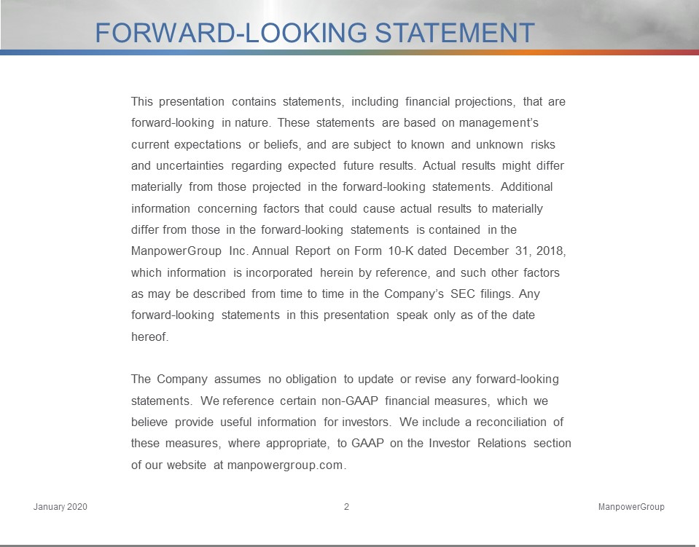

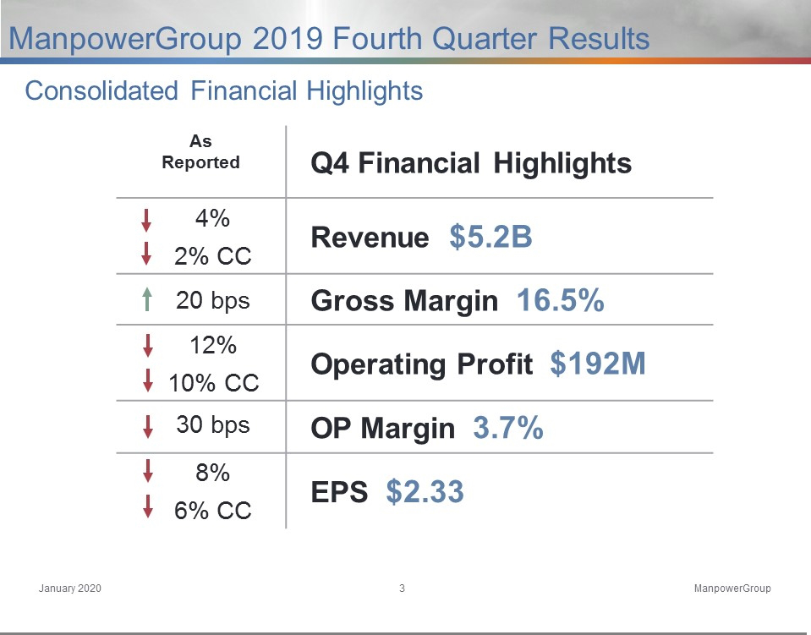

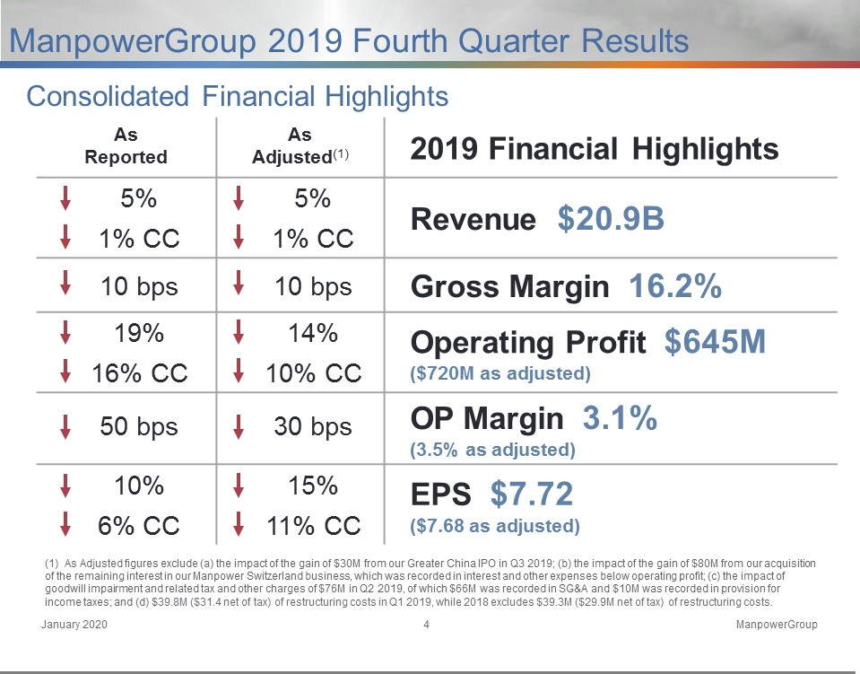

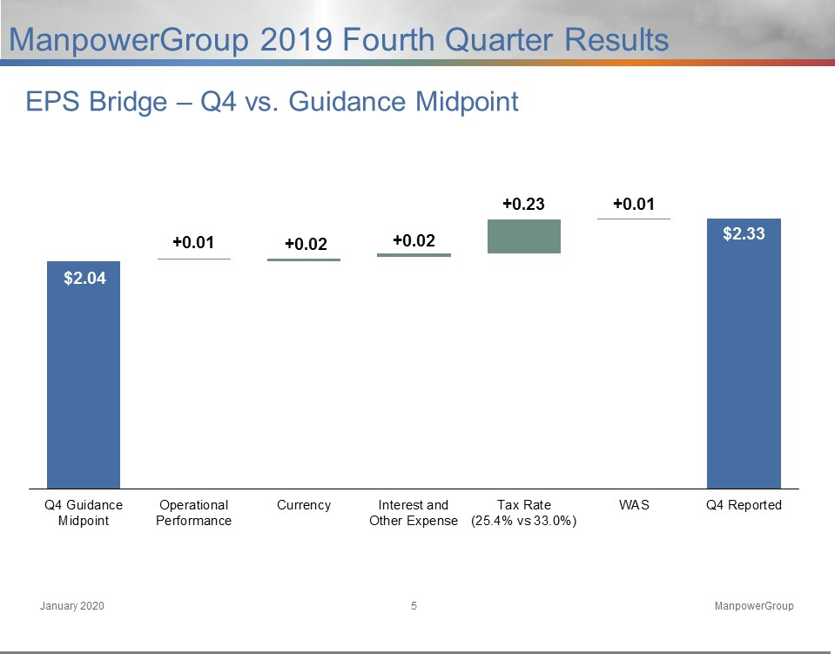

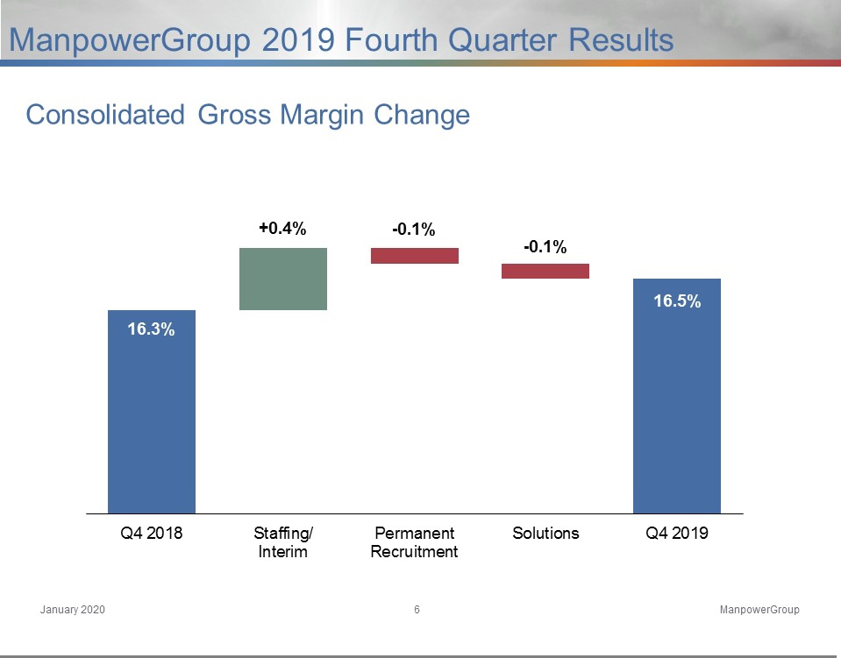

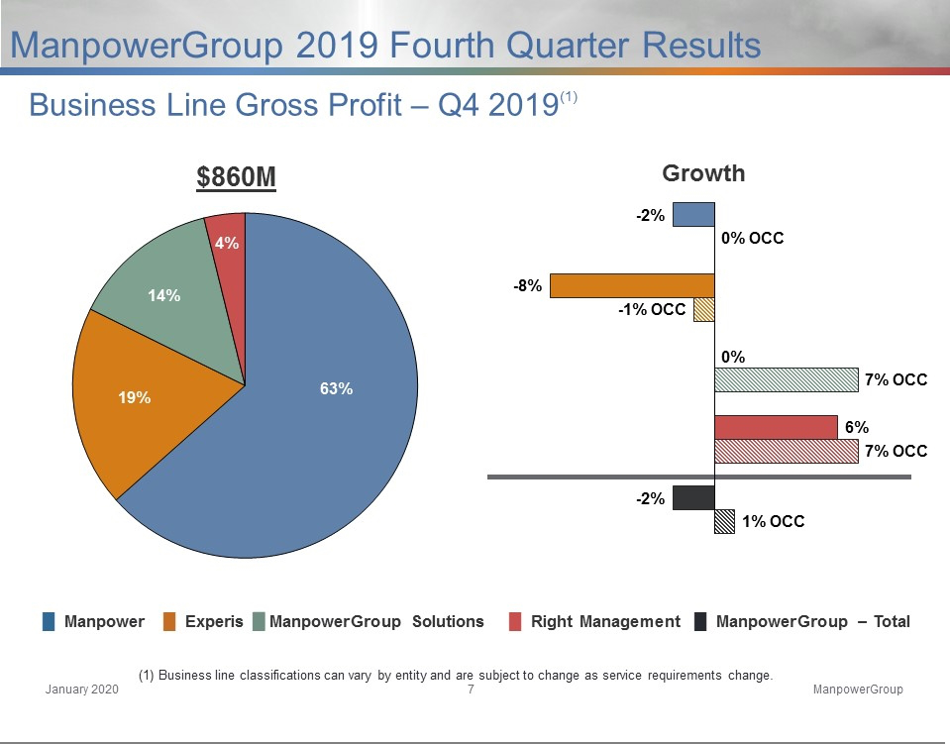

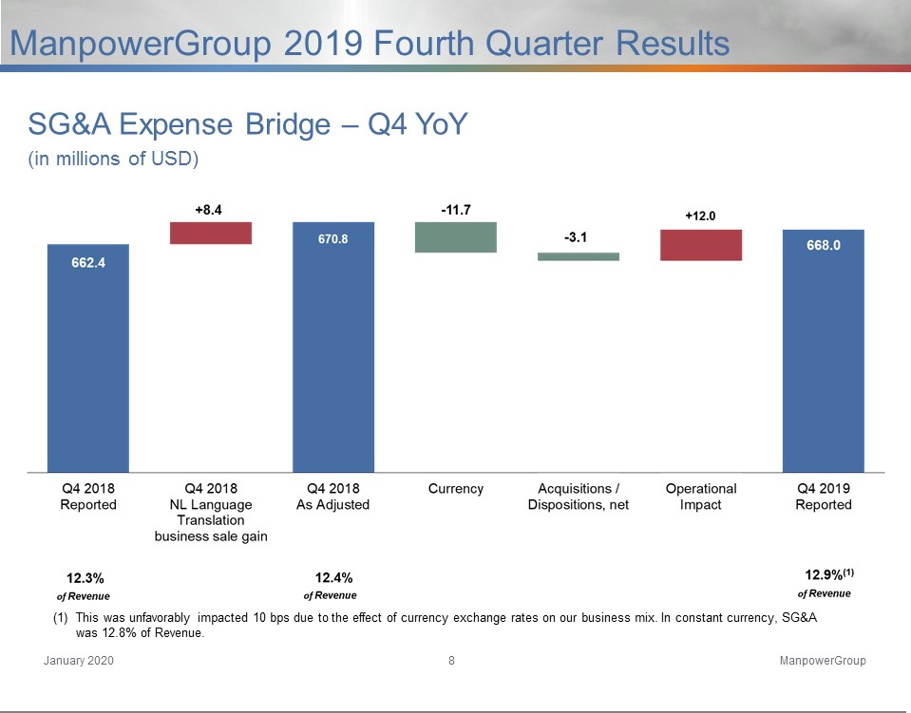

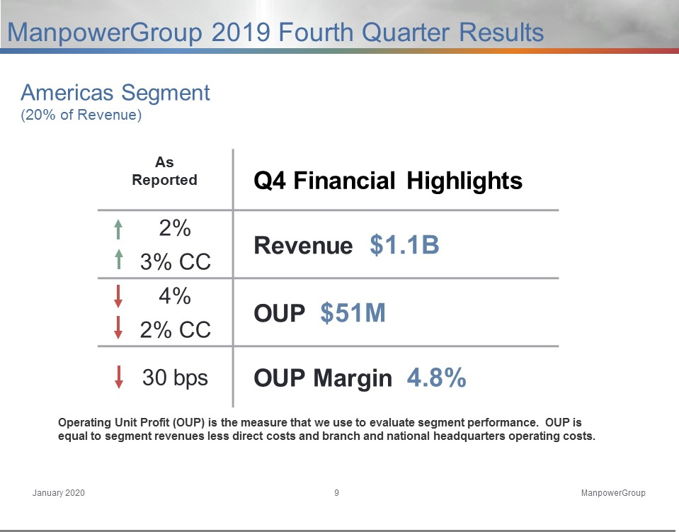

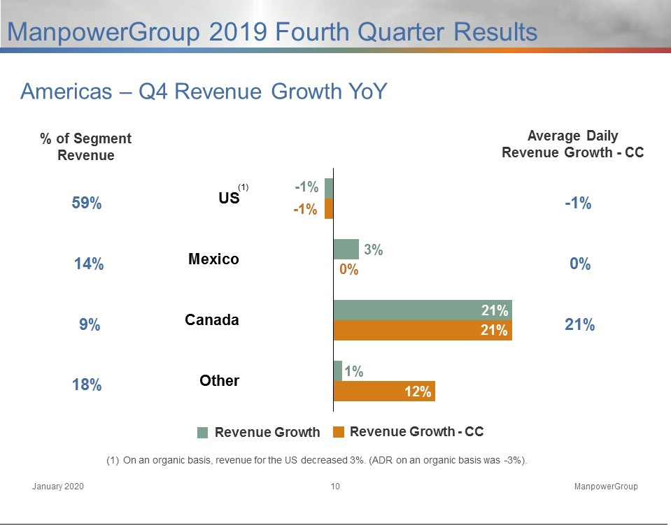

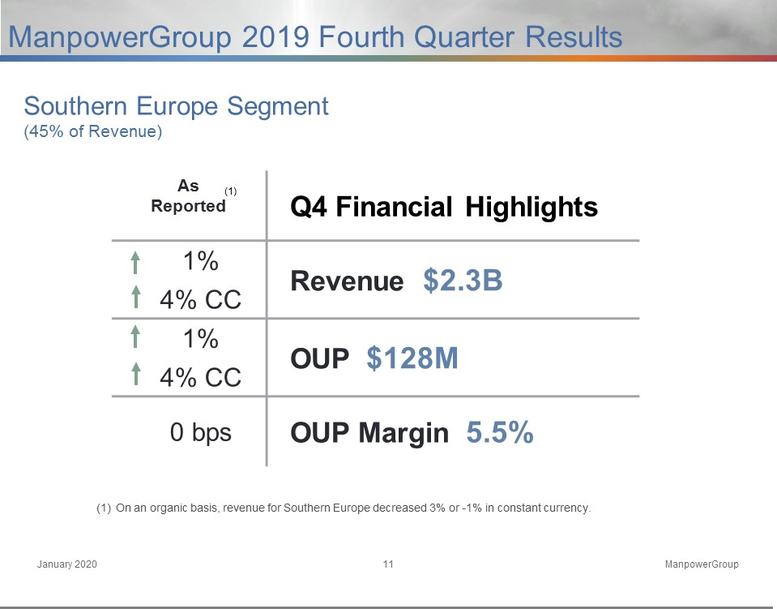

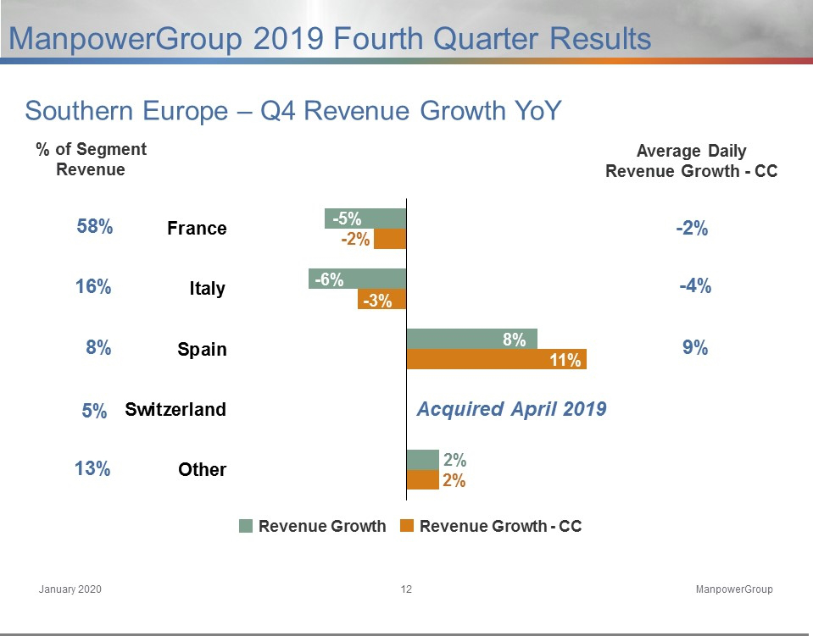

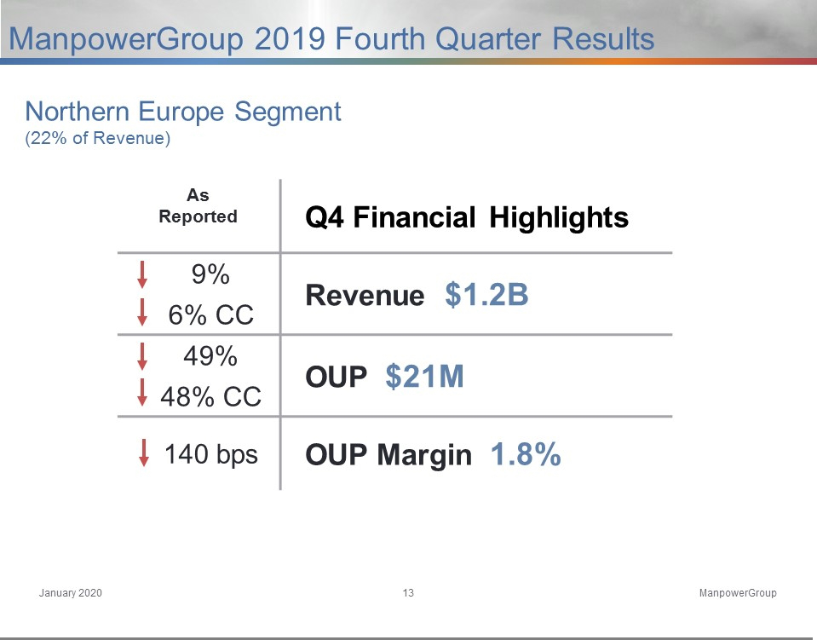

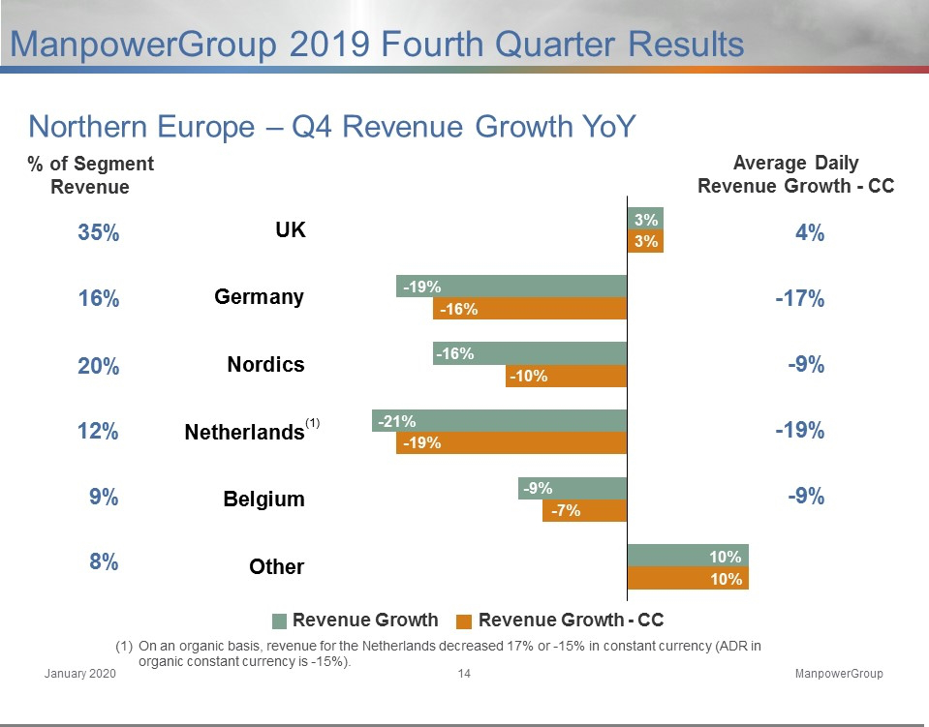

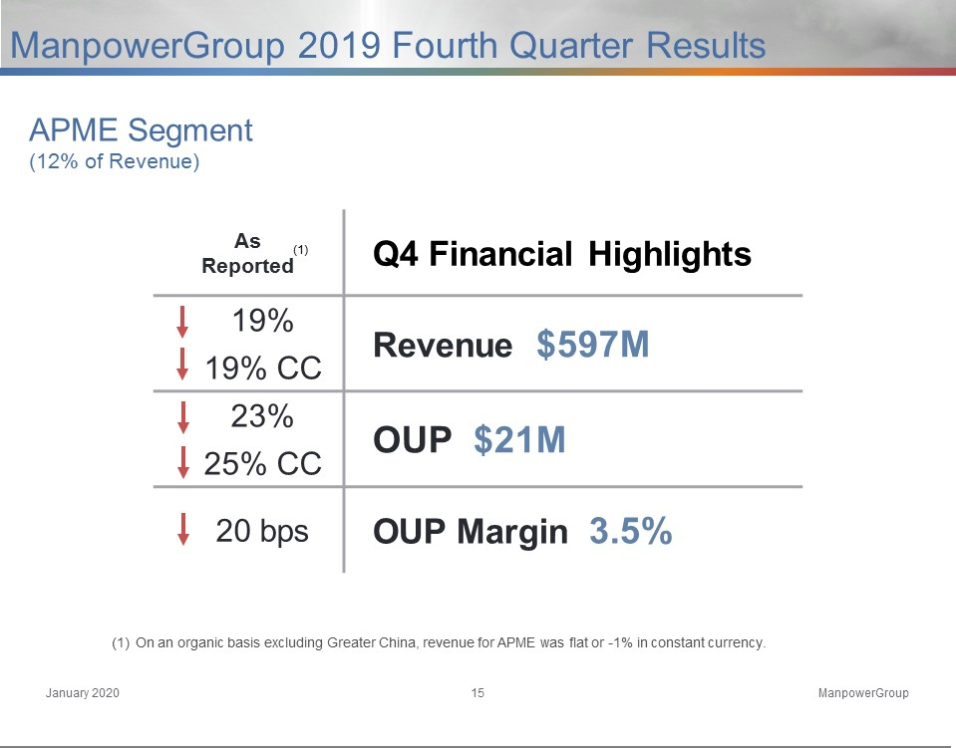

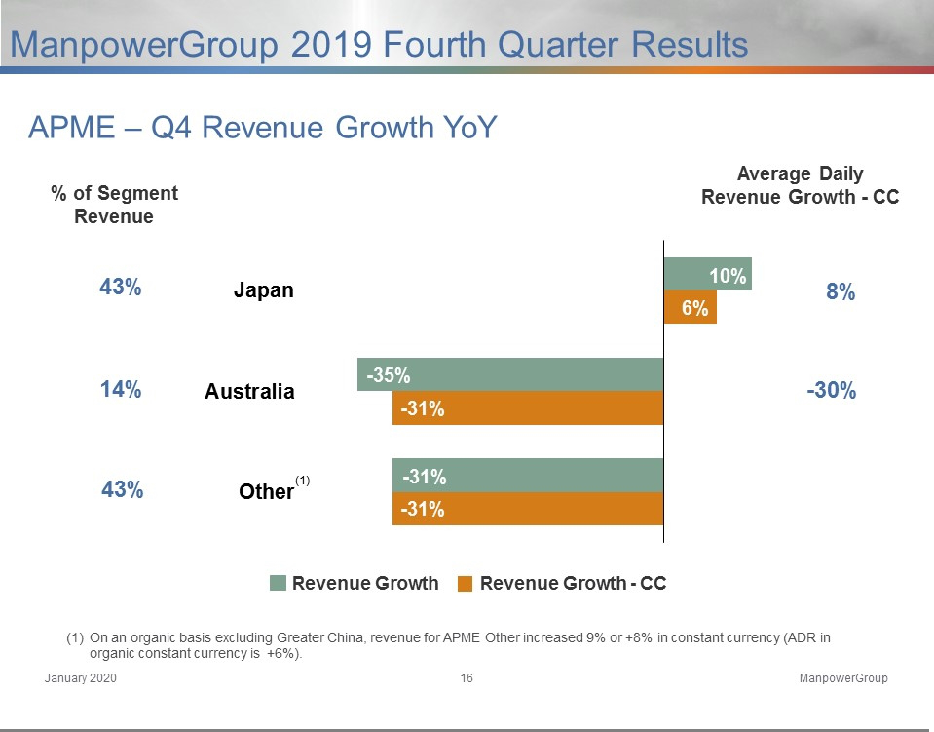

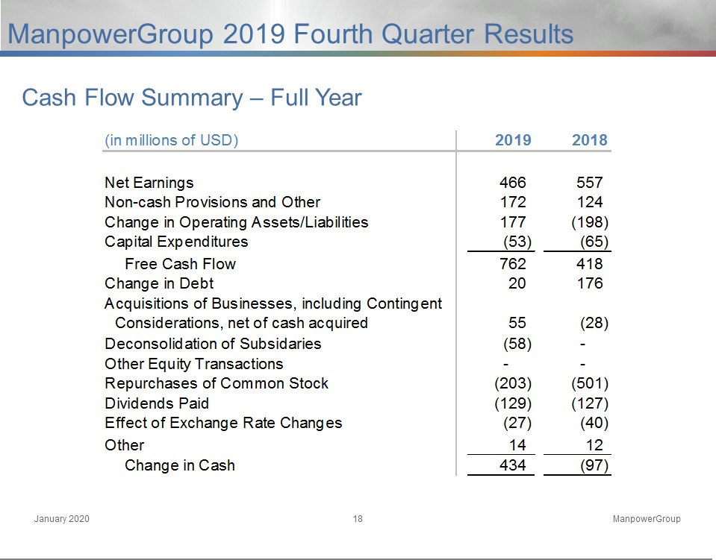

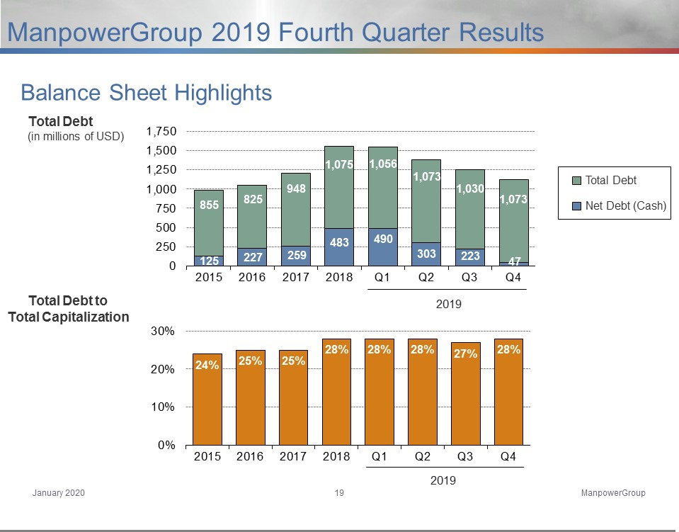

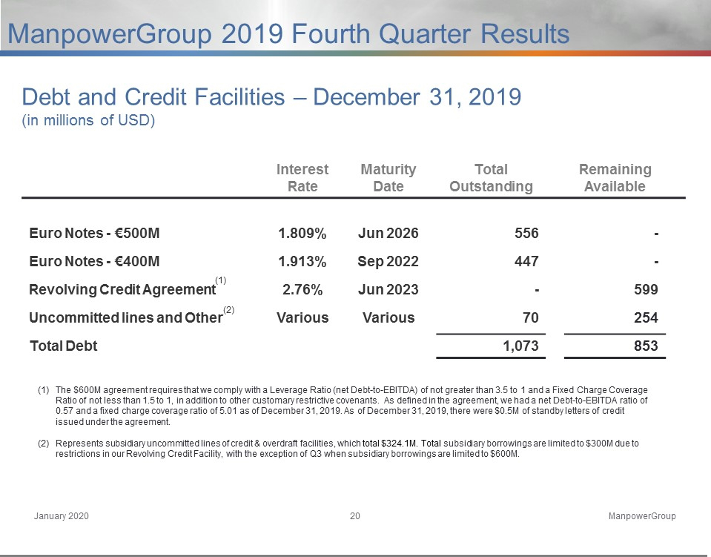







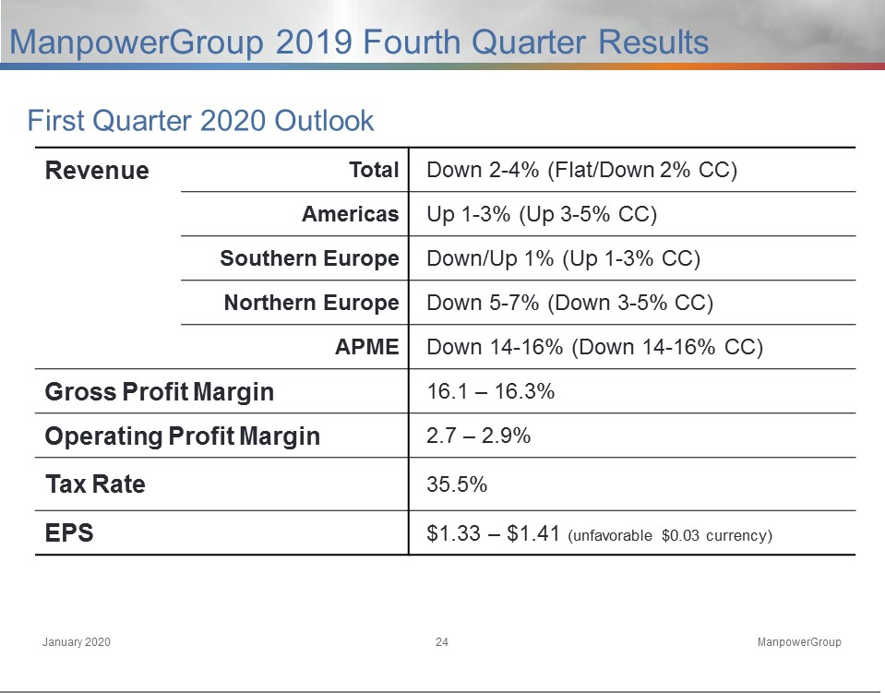

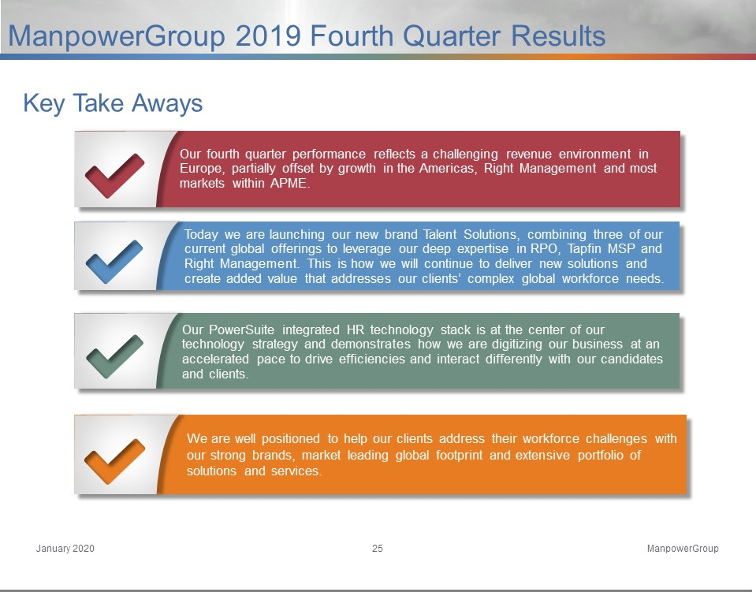



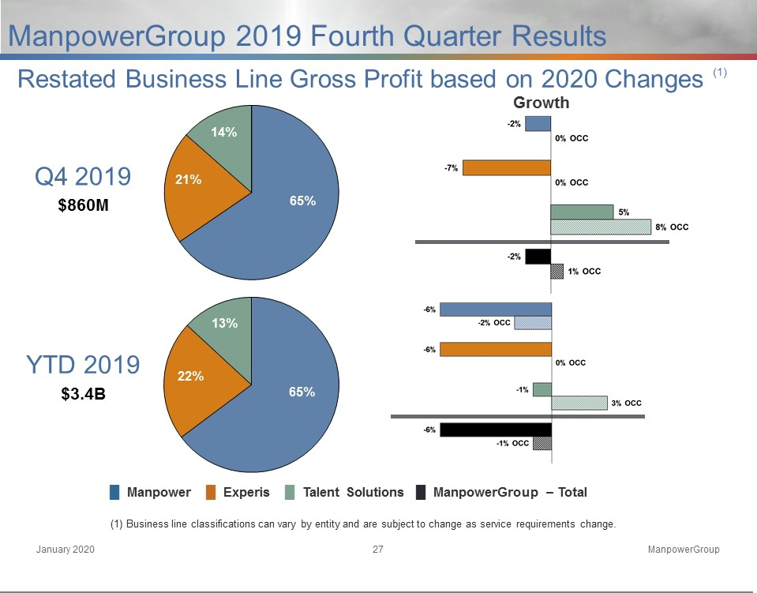

Exhibit 99.3

ManpowerGroup
Restated Operating Unit Results

(In millions)

Effective January 1, 2020, our segment reporting was realigned due to our Right Management business being combined with each of our respective country business units. Accordingly, our former reportable segment, Right Management, is now reported within each of our respective reportable segments. All previously reported results have been restated to conform to the current year presentation.

 |  |  | Three Months Ended March 31
 |  |  |  |  |  |  | % Variance
 |  |  |  |  |  |  | Amount |  |  | Constant
 |  | 2019 |  | 2018 |  |  | Reported |  |  | Currency
Revenues from Services: |  |  |  | (Unaudited)
Americas:
United States | $ | 623.2 | $ | 637.8 |  |  | -2.3% |  |  | -2.3%
Other Americas |  | 407.0 |  | 409.8 |  |  | -0.7% |  |  | 10.6%
 |  | 1,030.2 |  | 1,047.6 |  |  | -1.7% |  |  | 2.8%
Southern Europe:
France |  | 1,306.1 |  | 1,428.6 |  |  | -8.6% |  |  | -1.0%
Italy |  | 356.4 |  | 414.5 |  |  | -14.0% |  |  | -6.9%
Other Southern Europe |  | 446.3 |  | 476.1 |  |  | -6.3% |  |  | 1.5%
 |  | 2,108.8 |  | 2,319.2 |  |  | -9.1% |  |  | -1.6%
Northern Europe |  | 1,200.5 |  | 1,429.5 |  |  | -16.0% |  |  | -8.8%
APME |  | 705.4 |  | 726.1 |  |  | -2.8% |  |  | 1.9%
 | $ | 5,044.9 | $ | 5,522.4 |  |  | -8.6% |  |  | -2.2%
Operating Unit Profit:
Americas:
United States | $ | 16.6 | $ | 31.1 |  |  | -46.6% |  |  | -46.6%
Other Americas |  | 15.2 |  | 16.8 |  |  | -10.0% |  |  | -7.1%
 |  | 31.8 |  | 47.9 |  |  | -33.7% |  |  | -32.7%
Southern Europe:
France |  | 55.3 |  | 57.7 |  |  | -4.2% |  |  | 3.7%
Italy |  | 20.3 |  | 25.2 |  |  | -19.3% |  |  | -12.7%
Other Southern Europe |  | 11.0 |  | 15.1 |  |  | -27.1% |  |  | -21.9%
 |  | 86.6 |  | 98.0 |  |  | -11.6% |  |  | -4.4%
Northern Europe |  | 1.9 |  | 17.5 |  |  | -89.3% |  |  | -88.0%
APME |  | 20.6 |  | 26.1 |  |  | -20.9% |  |  | -17.6%
 |  | 140.9 |  | 189.5
Corporate expenses |  | (27.9) |  | (26.8)
Intangible asset amortization expense |  | (7.5) |  | (8.9)
Operating profit |  | 105.5 |  | 153.8 |  |  | -31.4% |  |  | -26.0%
Interest and other (expenses) income, net |  | (11.9) |  | (16.1)
Earnings before income taxes | $ | 93.6 | $ | 137.7
 |  |  | Three Months Ended June 30 |  |  |  |  |  |  |  |  |  |  |  | Six Months Ended June 30
 |  |  |  |  |  |  | % Variance |  |  |  |  |  |  |  |  |  |  | % Variance
 |  |  |  |  |  |  | Amount |  |  | Constant |  |  |  |  |  |  |  | Amount | Constant
 |  | 2019 |  | 2018 |  |  | Reported |  |  | Currency |  |  | 2019 |  | 2018 |  |  | Reported | Currency
Revenues from Services: |  |  |  | (Unaudited) |  |  |  |  |  |  |  |  |  |  | (Unaudited)
Americas:
United States | $ | 652.7 | $ | 663.4 |  |  | -1.6% |  |  | -1.6% |  | $ | 1,275.9 | $ | 1,301.2 |  |  | -1.9% | -1.9%
Other Americas |  | 415.5 |  | 415.2 |  |  | 0.1% |  |  | 8.7% |  |  | 822.5 |  | 825.0 |  |  | -0.3% | 9.7%
 |  | 1,068.2 |  | 1,078.6 |  |  | -1.0% |  |  | 2.4% |  |  | 2,098.4 |  | 2,126.2 |  |  | -1.3% | 2.6%
Southern Europe:
France |  | 1,425.3 |  | 1,517.2 |  |  | -6.1% |  |  | -0.3% |  |  | 2,731.4 |  | 2,945.8 |  |  | -7.3% | -0.7%
Italy |  | 394.4 |  | 444.1 |  |  | -11.2% |  |  | -5.8% |  |  | 750.8 |  | 858.6 |  |  | -12.6% | -6.4%
Other Southern Europe |  | 574.6 |  | 480.1 |  |  | 19.7% |  |  | 25.2% |  |  | 1,020.9 |  | 956.2 |  |  | 6.8% | 13.4%
 |  | 2,394.3 |  | 2,441.4 |  |  | -1.9% |  |  | 3.7% |  |  | 4,503.1 |  | 4,760.6 |  |  | -5.4% | 1.1%
Northern Europe |  | 1,194.1 |  | 1,405.6 |  |  | -15.0% |  |  | -9.6% |  |  | 2,394.6 |  | 2,835.1 |  |  | -15.5% | -9.2%
APME |  | 716.5 |  | 731.3 |  |  | -2.0% |  |  | 1.5% |  |  | 1,421.9 |  | 1,457.4 |  |  | -2.4% | 1.7%
 | $ | 5,373.1 | $ | 5,656.9 |  |  | -5.0% |  |  | -0.1% |  | $ | 10,418.0 | $ | 11,179.3 |  |  | -6.8% | -1.1%
Operating Unit Profit:
Americas:
United States | $ | 37.7 | $ | 44.0 |  |  | -14.2% |  |  | -14.2% |  | $ | 54.3 | $ | 75.1 |  |  | -27.6% | -27.6%
Other Americas |  | 17.8 |  | 19.1 |  |  | -6.4% |  |  | 0.4% |  |  | 33.0 |  | 35.9 |  |  | -8.1% | -3.1%
 |  | 55.5 |  | 63.1 |  |  | -11.9% |  |  | -9.8% |  |  | 87.3 |  | 111.0 |  |  | -21.3% | -19.7%
Southern Europe:
France |  | 75.7 |  | 73.5 |  |  | 3.0% |  |  | 9.0% |  |  | 131.0 |  | 131.2 |  |  | -0.2% | 6.7%
Italy |  | 29.8 |  | 32.1 |  |  | -7.1% |  |  | -1.6% |  |  | 50.1 |  | 57.3 |  |  | -12.5% | -6.5%
Other Southern Europe |  | 18.1 |  | 16.9 |  |  | 6.9% |  |  | 11.1% |  |  | 29.1 |  | 32.0 |  |  | -9.1% | -4.4%
 |  | 123.6 |  | 122.5 |  |  | 0.9% |  |  | 6.5% |  |  | 210.2 |  | 220.5 |  |  | -4.7% | 1.6%
Northern Europe |  | 25.6 |  | 26.7 |  |  | -3.8% |  |  | 2.3% |  |  | 27.5 |  | 44.2 |  |  | -37.7% | -33.4%
APME |  | 29.7 |  | 30.5 |  |  | -3.3% |  |  | -0.2% |  |  | 50.3 |  | 56.6 |  |  | -11.4% | -8.2%
 |  | 234.4 |  | 242.8 |  |  |  |  |  |  |  |  | 375.3 |  | 432.3
Corporate expenses |  | (31.9) |  | (25.9) |  |  |  |  |  |  |  |  | (59.8) |  | (52.7)
Goodwill impairment charge |  | (64.0) |  | - |  |  |  |  |  |  |  |  | (64.0) |  | -
Intangible asset amortization expense |  | (7.7) |  | (8.6) |  |  |  |  |  |  |  |  | (15.2) |  | (17.5)
Operating profit |  | 130.8 |  | 208.3 |  |  | -37.2% |  |  | -33.2% |  |  | 236.3 |  | 362.1 |  |  | -34.8% | -30.2%
Interest and other income (expenses), net |  | 70.2 |  | (10.5) |  |  |  |  |  |  |  |  | 58.3 |  | (26.6)
Earnings before income taxes | $ | 201.0 | $ | 197.8 |  |  |  |  |  |  |  | $ | 294.6 | $ | 335.5

ManpowerGroup

Restated Operating Unit Results
(In millions)

 |  | Three Months Ended September 30 |  |  |  |  |  |  |  |  | Nine Months Ended September 30
 |  |  |  |  |  |  | % Variance |  |  |  |  |  |  |  |  | % Variance
 |  |  |  |  |  |  | Amount | Constant |  |  |  |  |  |  |  | Amount | Constant
 |  | 2019 |  | 2018 |  |  | Reported | Currency |  |  | 2019 |  | 2018 |  |  | Reported | Currency
Revenues from Services: |  |  |  | (Unaudited) |  |  |  |  |  |  |  |  | (Unaudited)
Americas:
United States | $ | 666.4 | $ | 654.5 |  |  | 1.8% | 1.8% |  | $ | 1,942.3 | $ | 1,955.7 |  |  | -0.7% | -0.7%
Other Americas |  | 428.1 |  | 409.6 |  |  | 4.5% | 11.1% |  |  | 1,250.6 |  | 1,234.6 |  |  | 1.3% | 10.1%
Southern Europe: |  | 1,094.5 |  | 1,064.1 |  |  | 2.9% | 5.4% |  |  | 3,192.9 |  | 3,190.3 |  |  | 0.1% | 3.5%
France |  | 1,386.4 |  | 1,464.5 |  |  | -5.3% | -0.9% |  |  | 4,117.8 |  | 4,410.3 |  |  | -6.6% | -0.8%
Italy |  | 376.9 |  | 411.1 |  |  | -8.3% | -4.0% |  |  | 1,127.7 |  | 1,269.7 |  |  | -11.2% | -5.6%
Other Southern Europe |  | 594.5 |  | 462.1 |  |  | 28.7% | 31.8% |  |  | 1,615.4 |  | 1,418.3 |  |  | 13.9% | 19.4%
 |  | 2,357.8 |  | 2,337.7 |  |  | 0.9% | 5.0% |  |  | 6,860.9 |  | 7,098.3 |  |  | -3.3% | 2.4%
Northern Europe |  | 1,166.8 |  | 1,297.6 |  |  | -10.1% | -5.2% |  |  | 3,561.4 |  | 4,132.7 |  |  | -13.8% | -7.9%
APME |  | 629.8 |  | 719.3 |  |  | -12.5% | -12.3% |  |  | 2,051.7 |  | 2,176.7 |  |  | -5.7% | -2.9%
 | $ | 5,248.9 | $ | 5,418.7 |  |  | -3.1% | 0.3% |  | $ | 15,666.9 | $ | 16,598.0 |  |  | -5.6% | -0.7%
Operating Unit Profit:
Americas:
United States | $ | 39.8 | $ | 37.7 |  |  | 5.4% | 5.4% |  | $ | 94.1 | $ | 112.8 |  |  | -16.6% | -16.6%
Other Americas |  | 19.5 |  | 18.4 |  |  | 6.1% | 11.2% |  |  | 52.5 |  | 54.3 |  |  | -3.3% | 1.7%
Southern Europe: |  | 59.3 |  | 56.1 |  |  | 5.6% | 7.3% |  |  | 146.6 |  | 167.1 |  |  | -12.3% | -10.6%
France |  | 70.3 |  | 78.3 |  |  | -10.2% | -5.9% |  |  | 201.3 |  | 209.5 |  |  | -3.9% | 2.0%
Italy |  | 23.3 |  | 25.7 |  |  | -9.6% | -5.2% |  |  | 73.4 |  | 83.0 |  |  | -11.6% | -6.1%
Other Southern Europe |  | 22.8 |  | 17.2 |  |  | 33.1% | 35.8% |  |  | 51.9 |  | 49.2 |  |  | 5.7% | 9.7%
 |  | 116.4 |  | 121.2 |  |  | -3.9% | 0.2% |  |  | 326.6 |  | 341.7 |  |  | -4.4% | 1.1%
Northern Europe |  | 22.8 |  | 41.6 |  |  | -45.2% | -42.1% |  |  | 50.3 |  | 85.8 |  |  | -41.3% | -37.7%
APME |  | 54.9 |  | 33.4 |  |  | 64.9% | 63.9% |  |  | 105.2 |  | 90.0 |  |  | 16.8% | 18.5%
 |  | 253.4 |  | 252.3 |  |  |  |  |  |  | 628.7 |  | 684.6
Corporate expenses |  | (29.2) |  | (26.3) |  |  |  |  |  |  | (89.0) |  | (79.0)
Goodwill impairment charge |  | - |  | - |  |  |  |  |  |  | (64.0) |  | -
Intangible asset amortization expense |  | (7.2) |  | (9.3) |  |  |  |  |  |  | (22.4) |  | (26.8)
Operating profit |  | 217.0 |  | 216.7 |  |  | 0.2% | 3.3% |  |  | 453.3 |  | 578.8 |  |  | -21.7% | -17.7%
Interest and other (expenses) income, net |  | (12.2) |  | (11.8) |  |  |  |  |  |  | 46.1 |  | (38.4)
Earnings before income taxes | $ | 204.8 | $ | 204.9 |  |  |  |  |  | $ | 499.4 | $ | 540.4
 |  | Three Months Ended December 31 |  |  |  |  |  |  |  |  |  | Year Ended December 31
 |  |  |  |  |  |  | % Variance |  |  |  |  |  |  |  |  | % Variance
 |  |  |  |  |  |  | Amount | Constant |  |  |  |  |  |  |  | Amount | Constant
 |  | 2019 |  | 2018 |  |  | Reported | Currency |  |  | 2019 |  | 2018 |  |  | Reported | Currency
Revenues from Services: |  |  |  | (Unaudited) |  |  |  |  |  |  |  |  | (Unaudited)
Americas:
United States | $ | 648.3 | $ | 653.2 |  |  | -0.7% | -0.7% |  | $ | 2,590.6 | $ | 2,608.9 |  |  | -0.7% | -0.7%
Other Americas |  | 437.4 |  | 415.4 |  |  | 5.3% | 9.4% |  |  | 1,688.0 |  | 1,650.0 |  |  | 2.3% | 9.9%
Southern Europe: |  | 1,085.7 |  | 1,068.6 |  |  | 1.6% | 3.2% |  |  | 4,278.6 |  | 4,258.9 |  |  | 0.5% | 3.4%
France |  | 1,361.8 |  | 1,436.1 |  |  | -5.2% | -2.3% |  |  | 5,479.6 |  | 5,846.4 |  |  | -6.3% | -1.1%
Italy |  | 380.6 |  | 404.2 |  |  | -5.9% | -3.0% |  |  | 1,508.3 |  | 1,673.9 |  |  | -9.9% | -5.0%
Other Southern Europe |  | 591.1 |  | 461.3 |  |  | 28.1% | 29.2% |  |  | 2,206.5 |  | 1,879.6 |  |  | 17.4% | 21.8%
 |  | 2,333.5 |  | 2,301.6 |  |  | 1.4% | 3.9% |  |  | 9,194.4 |  | 9,399.9 |  |  | -2.2% | 2.8%
Northern Europe |  | 1,174.1 |  | 1,284.8 |  |  | -8.6% | -6.3% |  |  | 4,735.5 |  | 5,417.5 |  |  | -12.6% | -7.6%
APME |  | 603.3 |  | 738.2 |  |  | -18.3% | -19.1% |  |  | 2,655.0 |  | 2,914.9 |  |  | -8.9% | -7.0%
 | $ | 5,196.6 | $ | 5,393.2 |  |  | -3.6% | -1.8% |  | $ | 20,863.5 | $ | 21,991.2 |  |  | -5.1% | -0.9%
Operating Unit Profit:
Americas:
United States | $ | 33.9 | $ | 37.1 |  |  | -8.5% | -8.5% |  | $ | 128.0 | $ | 149.9 |  |  | -14.6% | -14.6%
Other Americas |  | 22.9 |  | 20.7 |  |  | 10.5% | 15.5% |  |  | 75.4 |  | 75.0 |  |  | 0.5% | 5.5%
Southern Europe: |  | 56.8 |  | 57.8 |  |  | -1.7% | 0.1% |  |  | 203.4 |  | 224.9 |  |  | -9.5% | -7.9%
France |  | 83.6 |  | 81.4 |  |  | 2.7% | 5.9% |  |  | 284.9 |  | 290.9 |  |  | -2.1% | 3.1%
Italy |  | 29.1 |  | 28.3 |  |  | 2.8% | 5.9% |  |  | 102.5 |  | 111.3 |  |  | -7.9% | -3.0%
Other Southern Europe |  | 16.0 |  | 17.3 |  |  | -7.8% | -7.9% |  |  | 67.9 |  | 66.5 |  |  | 2.1% | 5.1%
 |  | 128.7 |  | 127.0 |  |  | 1.3% | 4.0% |  |  | 455.3 |  | 468.7 |  |  | -2.9% | 1.9%
Northern Europe |  | 24.1 |  | 44.1 |  |  | -45.3% | -43.8% |  |  | 74.4 |  | 129.9 |  |  | -42.7% | -39.7%
APME |  | 22.3 |  | 28.3 |  |  | -21.5% | -23.7% |  |  | 127.5 |  | 118.3 |  |  | 7.6% | 8.4%
 |  | 231.9 |  | 257.2 |  |  |  |  |  |  | 860.6 |  | 941.8
Corporate expenses |  | (32.9) |  | (31.0) |  |  |  |  |  |  | (121.9) |  | (110.0)
Goodwill impairment charge |  | - |  | - |  |  |  |  |  |  | (64.0) |  | -
Intangible asset amortization expense |  | (7.4) |  | (8.3) |  |  |  |  |  |  | (29.8) |  | (35.1)
Operating profit |  | 191.6 |  | 217.9 |  |  | -12.1% | -10.0% |  |  | 644.9 |  | 796.7 |  |  | -19.1% | -15.6%
Interest and other income (expenses), net |  | (5.5) |  | (3.6) |  |  |  |  |  |  | 40.6 |  | (42.0)
Earnings before income taxes | $ | 186.1 | $ | 214.3 |  |  |  |  |  | $ | 685.5 | $ | 754.7

