UNITED STATES

SECURITIES AND EXCHANGE COMMISSION

Washington, D.C. 20549

FORM 8-K

CURRENT REPORT

Pursuant to Section 13 or 15(d) of the Securities Exchange Act of 1934

Date of Report (Date of earliest event reported): July 18, 2008

MANPOWER INC.

(Exact name of registrant as specified in its charter)

Wisconsin

1-10686

39-1672779

(State or other jurisdiction

of incorporation)

(Commission

File Number)

(IRS Employer
Identification No.)

100 Manpower Place

Milwaukee, Wisconsin

53212

(Address of principal executive offices)

(Zip Code)

Registrant’s telephone number, including area code: (414) 961-1000

Check the appropriate box below if the Form 8-K filing is intended to simultaneously satisfy the filing obligation of the registrant under any of the following provisions:

- Written communications pursuant to Rule 425 under the Securities Act (17 CFR 230.425)

- Soliciting material pursuant to Rule 14a-12 under the Securities Act (17 CFR 240.14a-12)

- Pre-commencement communications pursuant to Rule 14d-2(b) under the Exchange Act (17 CFR 240.14d-2(b))

- Pre-commencement communications pursuant to Rule 13e-4(c) under the Exchange Act (17 CFR 240.13e-4(c))

Item 2.02 Results of Operations and Financial Condition

On July 18, 2008, we issued a press release announcing our results of operations for the three- and six- month periods ended June 30, 2008. A copy of the press release is attached hereto as Exhibit 99.1 and is incorporated herein by reference.

Item 9.01. |  | Exhibits.
 | Exhibit No. |  |  |  | Description
99.1 |  |  |  | Press Release dated July 18, 2008
99.2 |  |  |  | Presentation materials for July 18, 2008 conference call

SIGNATURES

Pursuant to the requirements of the Securities Exchange Act of 1934, the Registrant has duly caused this Report to be signed on its behalf by the undersigned hereunto duly authorized.

 | MANPOWER INC.
Dated: July 18, 2008 | By: /s/ Michael J. Van Handel
 |  | Michael J. Van Handel
 |  | Executive Vice President and
 |  | Chief Financial Officer

EXHIBIT INDEX

Exhibit No. |  | Description
99.1 | Press Release dated July 18, 2008
99.2 | Presentation materials for July 18, 2008 conference call

Exhibit 99.1


FOR IMMEDIATE RELEASE

Contact:

Mike Van Handel

Manpower Inc.

+1.414.906.6305

michael.vanhandel@manpower.com

Manpower Reports 2ND Quarter and First Half 2008 Results

MILWAUKEE, WI, USA, July 18, 2008 – Manpower Inc. (NYSE: MAN) today reported that earnings per diluted share for the three months ended June 30, 2008 were $1.34 compared to $1.86 in the prior year period. Net earnings in the quarter were $107.4 million compared to $160.4 million a year earlier. Revenues for the second quarter were $5.9 billion, an increase of 17 percent from the year earlier period.

Second quarter 2008 results include a net charge of $14.8 million after tax, or 18 cents per diluted share. This net charge is comprised of income of $35.2 million after tax, or 44 cents per diluted share, related to recoverable 2005 payroll taxes in France, offset by a charge of $50.0 million after tax, or 62 cents per diluted share, related to an increase in our legal reserve pertaining to allegations by the French Competition Council. Second quarter results were also favorably impacted by 21 cents per diluted share as foreign currencies were relatively stronger compared to the second quarter of 2007. On a constant currency basis, revenues increased 5% over the prior year period.

Second quarter 2007 results were favorably impacted $57.2 million after tax, or 66 cents per diluted share, as a result of a change in the calculation of French payroll taxes for 2006 and the first half of 2007.

Jeffrey A. Joerres, Manpower Inc. Chairman and Chief Executive Officer, said, “Despite a more difficult economic environment, the Manpower team performed well in the second quarter, supported by our geographically balanced portfolio of services. We were able to increase our revenues to record levels, contributed primarily by many of our major European countries. At the same time, we have experienced some stabilization in the U.S. operations. Right Management, our career transition and organizational consulting business, is doing well and continues to add strategic value to our clients. Although the economic environment has softened, we are confident that we are well-positioned and well-equipped to maximize the opportunities that typically come with economic downturns.

“We are anticipating the third quarter of 2008 diluted earnings per share to be in the range of $1.45 to $1.49, which includes an estimated favorable currency impact of 17 cents,” Joerres stated.

Earnings per diluted share for the six months ended June 30, 2008 were $2.27 compared to $2.54 per diluted share in 2007. Net earnings were $182.9 million compared to $219.9 million in the prior year. Revenues for the six-month period were $11.3 billion, an increase of 18 percent from the prior year or 6 percent in constant currency. Foreign currency exchange rates had a favorable impact of 36 cents for the six-month period.

In conjunction with its second quarter earnings release, Manpower will broadcast its conference call live over the Internet on July 18, 2008 at 7:30 a.m. CDT (8:30 a.m. EDT).

Interested parties are invited to listen to the webcast and view the presentation by logging on to http://investor.manpower.com.

Supplemental financial information referenced in the conference call can be found at http://investor.manpower.com.

About Manpower Inc.

Manpower Inc. (NYSE: MAN) is a world leader in the employment services industry; creating and delivering services that enable its clients to win in the changing world of work. Celebrating its 60th anniversary in 2008, the $21 billion company offers employers a range of services for the entire employment and business cycle including permanent, temporary and contract recruitment; employee assessment and selection; training; outplacement; outsourcing and consulting. Manpower’s worldwide network of 4,500 offices in 80 countries and territories enables the company to meet the needs of its 400,000 clients per year, including small and medium size enterprises in all industry sectors, as well as the world’s largest multinational corporations. The focus of Manpower’s work is on raising productivity through improved quality, efficiency and cost-reduction across their total workforce, enabling clients to concentrate on their core business activities. Manpower Inc. operates under five brands: Manpower, Manpower Professional, Elan, Jefferson Wells and Right Management. More information on Manpower Inc. is available at www.manpower.com.

Forward-Looking Statements

This news release contains statements, including earnings projections, that are forward-looking in nature and, accordingly, are subject to risks and uncertainties regarding the Company’s expected future results. The Company’s actual results may differ materially from those described or contemplated in the forward-looking statements. Factors that may cause the Company’s actual results to differ materially from those contained in the forward-looking statements can be found in the Company’s reports filed with the SEC, including the information under the heading ‘Risk Factors’ in its Annual Report on Form 10-K for the year ended December 31, 2007, which information is incorporated herein by reference.

- ### -

Manpower Inc.

Results of Operations

(In millions, except per share data)

 |  |  |  | Three Months Ended June 30
 |  |  |  |  |  |  |  | % Variance
 |  |  |  |  |  |  |  | Amount |  | Constant
 |  |  | 2008 |  |  | 2007 | Reported |  |  | Currency
 |  |  |  |  |  |  | (Unaudited)
Revenues from services (a) | $ |  | 5,904.9 | $ |  | 5,034.4 | 17.3% |  |  | 5.4%
Cost of services |  |  | 4,751.3 |  |  | 4,010.3 | 18.5%
Gross profit |  |  | 1,153.6 |  |  | 1,024.1 | 12.6% |  |  | 1.3%
Selling and administrative expenses |  |  | 946.3 |  |  | 747.1 | 26.7% |  |  | 14.7%
Operating profit |  |  | 207.3 |  |  | 277.0 | -25.2% |  |  | -34.9%
Interest and other expenses |  |  | 13.9 |  |  | 7.7 | 77.4%
Earnings before income taxes |  |  | 193.4 |  |  | 269.3 | -28.2% |  |  | -38.3%
Provision for income taxes |  |  | 86.0 |  |  | 108.9 | -21.0%
Net earnings |  | $ | 107.4 | $ |  | 160.4 | -33.0% |  |  | -42.5%
Net earnings per share - basic |  |  |  |  |  |  | -28.4%
Net earnings per share - basic | $ |  | 1.36 | $ |  | 1.90
Net earnings per share - diluted | $ |  | 1.34 | $ |  | 1.86 | -28.0% |  |  | -38.2%
Weighted average shares - basic |  |  |  |  |  |  | -6.2%
Weighted average shares - basic |  |  | 79.2 |  |  | 84.4
Weighted average shares - diluted |  |  | 80.3 |  |  | 86.2 | -6.8%

- Revenues from services include fees received from our franchise offices of $8.3 million and $9.0 million for the three months ended June 30, 2008 and 2007, respectively. These fees are primarily based on revenues generated by the franchise offices which were $325.4 million and $361.8 million for the three months ended ended June 30, 2008 and 2007, respectively.

Manpower Inc.

Operating Unit Results

(In millions)

 |  |  |  | Three Months Ended June 30
 |  |  |  |  |  |  |  | % Variance
 |  |  |  |  |  |  |  | Amount |  | Constant
 |  | 2008 |  |  |  | 2007 |  | Reported |  | Currency
 |  |  |  |  |  | (Unaudited)
Revenues from Services:
United States (a) | $ | 491.6 |  | $ |  | 488.6 | 0.6% |  |  | 0.6%
France |  | 1,958.1 |  |  |  | 1,784.9 | 9.7% |  |  | -5.4%
Other EMEA |  | 2,050.7 |  |  |  | 1,582.0 | 29.6% |  |  | 17.6%
Italy |  | 441.4 |  |  |  | 353.8 | 24.8% |  |  | 7.6%
Jefferson Wells |  | 75.8 |  |  |  | 83.8 | -9.6% |  |  | -9.6%
Right Management |  | 115.7 |  |  |  | 105.8 | 9.4% |  |  | 4.1%
Other Operations |  | 771.6 |  |  |  | 635.5 | 21.5% |  |  | 9.9%
 | $ | 5,904.9 |  | $ |  | 5,034.4 | 17.3% |  |  | 5.4%
Operating Unit Profit:
United States | $ | 14.8 |  | $ |  | 26.1 | -43.3% |  |  | -43.3%
France |  | 69.8 |  |  |  | 163.7 | -57.3% |  |  | -63.2%
Other EMEA |  | 85.1 |  |  |  | 55.7 | 53.0% |  |  | 36.0%
Italy |  | 37.6 |  |  |  | 29.1 | 29.3% |  |  | 11.6%
Jefferson Wells |  | (1.6) |  |  |  | 1.1 |  | N/A |  | N/A
Right Management |  | 13.3 |  |  |  | 11.0 | 21.3% |  |  | 15.5%
Other Operations |  | 16.6 |  |  |  | 15.0 | 9.4% |  |  | -4.5%
 |  | 235.6 |  |  |  | 301.7
Corporate expenses |  | 25.0 |  |  |  | 21.4
Amortization of intangible assets |  | 3.3 |  |  |  | 3.3
Operating profit |  | 207.3 |  |  |  | 277.0 | -25.2% |  |  | -34.9%
Interest and other expenses (b) |  | 13.9 |  |  |  | 7.7
Earnings before income taxes | $ | 193.4 |  | $ |  | 269.3

- In the United States, revenues from services include fees received from our franchise offices of $4.7 million and $6.5 million for the three months ended June 30, 2008 and 2007, respectively. These fees are primarily based on revenues generated by the franchise offices, which were $214.6 million and $278.5 million for the three months ended June 30, 2008 and 2007, respectively.

- The components of interest and other expenses were:

 | 2008 |  |  | 2007
Interest expense | $17.1 |  | $ |  | 13.1
Interest income | (6.0) |  |  |  | (6.2)
Foreign exchange losses | 0.4 |  |  |  | 0.1
Miscellaneous expenses, net | 2.4 |  |  |  | 0.7
 | $13.9 |  | $ |  | 7.7

Manpower Inc.

Results of Operations

(In millions, except per share data)

 |  |  | Six Months Ended June 30
 |  |  |  |  |  |  | % Variance
 |  |  |  |  |  |  | Amount |  | Constant
 |  | 2008 |  |  | 2007 |  | Reported |  | Currency
 |  |  |  |  | (Unaudited)
Revenues from services (a) | $ | 11,291.5 | $ |  | 9,570.0 | 18.0% |  |  | 6.4%
Cost of services |  | 9,170.2 |  |  | 7,745.9 | 18.4%
Gross profit |  | 2,121.3 |  |  | 1,824.1 | 16.3% |  |  | 5.0%
Selling and administrative expenses |  | 1,782.0 |  |  | 1,443.8 | 23.4% |  |  | 12.3%
Operating profit |  | 339.3 |  |  | 380.3 | -10.8% |  |  | -22.5%
Interest and other expenses |  | 25.2 |  |  | 17.3 | 44.8%
Earnings before income taxes |  | 314.1 |  |  | 363.0 | -13.5% |  |  | -25.9%
Provision for income taxes |  | 131.2 |  |  | 143.1 | -8.3%
Net earnings | $ | 182.9 | $ |  | 219.9 | -16.8% |  |  | -28.8%
Net earnings per share - basic |  |  |  |  |  | -11.2%
Net earnings per share - basic | $ | 2.31 | $ |  | 2.60
Net earnings per share - diluted | $ | 2.27 | $ |  | 2.54 | -10.6% |  |  | -23.2%
Weighted average shares - basic |  |  |  |  |  | -6.3%
Weighted average shares - basic |  | 79.3 |  |  | 84.6
Weighted average shares - diluted |  | 80.4 |  |  | 86.5 | -7.0%

- Revenues from services include fees received from our franchise offices of $15.6 million and $17.4 million for the six months ended June 30, 2008 and 2007. These fees are primarily based on revenues generated by the franchise offices, which were $629.4 million and $724.2 million for the six months ended June 30, 2008 and 2007, respectively.

Manpower Inc.

Operating Unit Results

(In millions)

 |  |  |  |  | Six Months Ended June 30
 |  |  |  |  |  |  |  |  | % Variance
 |  |  |  |  |  |  |  |  | Amount |  | Constant
 |  |  | 2008 |  |  |  | 2007 |  | Reported |  | Currency
 |  |  |  |  |  |  | (Unaudited)
Revenues from Services:
United States (a) | $ |  | 963.1 |  | $ |  | 972.2 | -0.9% |  |  | -0.9%
France |  |  | 3,692.1 |  |  |  | 3,277.9 | 12.6% |  |  | -2.2%
Other EMEA |  |  | 3,904.4 |  |  |  | 3,058.4 | 27.7% |  |  | 16.1%
Italy |  |  | 842.6 |  |  |  | 658.6 | 27.9% |  |  | 11.0%
Jefferson Wells |  |  | 153.2 |  |  |  | 165.1 | -7.2% |  |  | -7.2%
Right Management |  |  | 219.0 |  |  |  | 199.7 | 9.7% |  |  | 4.3%
Other Operations |  |  | 1,517.1 |  |  |  | 1,238.1 | 22.5% |  |  | 10.8%
 | $ |  | 11,291.5 |  | $ |  | 9,570.0 | 18.0% |  |  | 6.4%
Operating Unit Profit:
United States | $ |  | 22.0 |  | $ |  | 37.6 | -41.6% |  |  | -41.6%
France |  |  | 123.8 |  |  |  | 207.6 | -40.3% |  |  | -48.3%
Other EMEA |  |  | 132.8 |  |  |  | 92.4 | 43.8% |  |  | 28.5%
Italy |  |  | 66.7 |  |  |  | 45.5 | 46.5% |  |  | 27.1%
Jefferson Wells |  |  | (4.2) |  |  |  | 2.1 |  | N/A |  | N/A
Right Management |  |  | 20.0 |  |  |  | 17.1 | 16.8% |  |  | 13.3%
Other Operations |  |  | 37.9 |  |  |  | 27.8 | 36.1% |  |  | 20.1%
 |  |  | 399.0 |  |  |  | 430.1
Corporate expenses |  |  | 53.2 |  |  |  | 43.3
Amortization of intangible assets |  |  | 6.5 |  |  |  | 6.5
Operating profit |  |  | 339.3 |  |  |  | 380.3 | -10.8% |  |  | -22.5%
Interest and other expenses (b) |  |  | 25.2 |  |  |  | 17.3
Earnings before income taxes | $ |  | 314.1 |  | $ |  | 363.0

- In the United States, revenues from services include fees received from our franchise offices of $9.3 million and $11.8 million for the six months ended June 30, 2008 and 2007, respectively. These fees are primarily based on revenues generated by the franchise offices, which were $427.3 million and $547.6 million for the six months ended June 30, 2008 and 2007, respectively.

- The components of interest and other expenses were:

 |  | 2008 |  |  | 2007
Interest expense | $ 32.7 |  |  | $ 25.1
Interest income | (11.1) |  |  | (11.2)
Foreign exchange (gain) loss | (1.5) |  |  | 0.2
Miscellaneous expenses, net |  | 5.1 |  | 3.2
 |  | $ 25.2 |  | $ 17.3

Manpower Inc.

Consolidated Balance Sheets

(In millions)

 |  | Jun. 30 |  |  |  | Dec. 31
 |  | 2008 |  |  |  | 2007
 |  |  | (Unaudited)
ASSETS
Current assets:
Cash and cash equivalents | $ | 561.3 |  | $ |  | 537.5
Accounts receivable, net |  | 4,857.6 |  |  |  | 4,478.8
Prepaid expenses and other assets |  | 150.4 |  |  |  | 122.2
Future income tax benefits |  | 76.7 |  |  |  | 76.3
Total current assets |  | 5,646.0 |  |  |  | 5,214.8
Other assets:
Goodwill and other intangible assets, net |  | 1,602.3 |  |  |  | 1,410.7
Other assets |  | 398.2 |  |  |  | 377.7
Total other assets |  | 2,000.5 |  |  |  | 1,788.4
Property and equipment:
Land, buildings, leasehold improvements and equipment |  | 842.7 |  |  |  | 760.8
Less: accumulated depreciation and amortization |  | 601.7 |  |  |  | 539.6
Net property and equipment |  | 241.0 |  |  |  | 221.2
Total assets
Total assets | $ | 7,887.5 |  | $ |  | 7,224.4
LIABILITIES AND SHAREHOLDERS’ EQUITY
Current liabilities:
Accounts payable | $ | 1,208.3 |  | $ |  | 1,014.4
Employee compensation payable |  | 217.7 |  |  |  | 213.6
Accrued liabilities |  | 726.1 |  |  |  | 679.4
Accrued payroll taxes and insurance |  | 739.1 |  |  |  | 724.7
Value added taxes payable |  | 630.1 |  |  |  | 583.7
Short-term borrowings and current maturities of long-term debt |  | 69.3 |  |  |  | 39.7
Total current liabilities |  | 3,590.6 |  |  |  | 3,255.5
Other liabilities:
Long-term debt |  | 944.5 |  |  |  | 874.8
Other long-term liabilities |  | 448.3 |  |  |  | 424.8
Total other liabilities |  | 1,392.8 |  |  |  | 1,299.6
Shareholders’ equity:
Common stock |  | 1.0 |  |  |  | 1.0
Capital in excess of par value |  | 2,505.7 |  |  |  | 2,481.8
Retained earnings |  | 1,194.0 |  |  |  | 1,040.3
Accumulated other comprehensive income |  | 356.8 |  |  |  | 257.6
Treasury stock, at cost |  | (1,153.4) |  |  |  | (1,111.4)
Total shareholders’ equity
Total shareholders’ equity |  | 2,904.1 |  |  |  | 2,669.3
Total liabilities and shareholders’ equity | $ | 7,887.5 |  | $ |  | 7,224.4

Manpower Inc.

Consolidated Statements of Cash Flows

(In millions)

 |  | Six Months Ended
 |  |  | Jun. 30
 |  | 2008 |  | 2007
 |  |  | (Unaudited)
 | Cash Flows from Operating Activities:
 | Net earnings | $ 182.9 |  | $ 219.9
 | Adjustments to reconcile net earnings to net cash provided by operating activities:
 | Depreciation and amortization | 53.4 |  | 44.1
 | Deferred income taxes | 8.7 |  | 41.8
 | Provision for doubtful accounts | 8.4 |  | 8.8
 | Share-based compensation | 14.3 |  | 11.8
 | Excess tax benefit on exercise of stock options | (0.1) |  | (5.4)
 | Changes in operating assets and liabilities, excluding the impact of acquisitions:
 | Accounts receivable | (75.8) |  | (296.2)
 | Other assets | (6.1) |  | (42.9)
 | Other liabilities | 78.3 |  | 159.4
 | Cash provided by operating activities | 264.0 |  | 141.3
Cash Flows from Investing Activities:
 | Capital expenditures | (51.4) |  | (41.8)
 | Acquisitions of businesses, net of cash acquired | (193.7) |  | (18.1)
 | Proceeds from the sale of property and equipment | 4.4 |  | 5.0
 | Cash used by investing activities | (240.7) |  | (54.9)
 | Cash Flows from Financing Activities:
 | Net borrowings of short-term facilities and long-term debt | 26.0 |  | 3.0
 | Proceeds from stock option and purchase plans | 11.1 |  | 31.7
 | Excess tax benefit on exercise of stock options | 0.1 |  | 5.4
 | Repurchases of common stock | (52.7) |  | (89.0)
 | Dividends paid | (29.2) |  | (27.1)
 | Cash used by financing activities | (44.7) |  | (76.0)
Effect of exchange rate changes on cash |  | 45.2 |  | 12.5
 | Change in cash and cash equivalents | 23.8 |  | 22.9
 | Cash and cash equivalents, beginning of period | 537.5 |  | 687.9
 | Cash and cash equivalents, end of period | $ 561.3 |  | $ 710.8


Exhibit 99.2

MANPOWER INC.
2008 2nd QUARTER RESULTS
JULY 18, 2008

Manpower Inc. 2008 2nd Quarter Results | 2
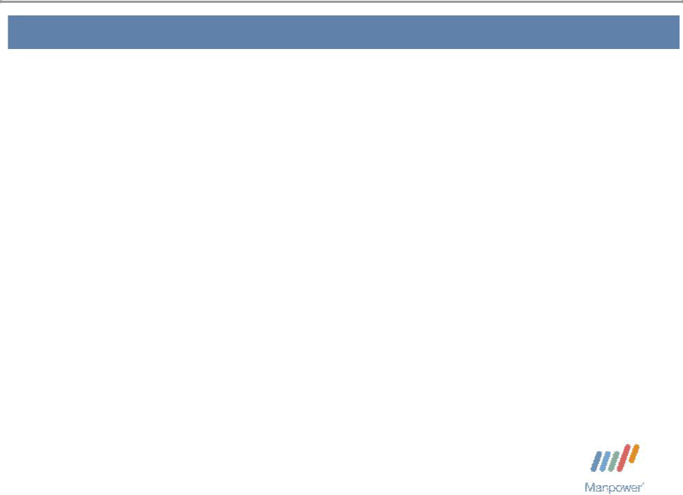

Forward Looking Statement

This presentation includes forward-looking statements which are subject to risks and uncertainties. Actual results might differ materially from those projected in the forward-looking statements. Forward-looking statements can be identified by words such as “expect,” “plan,” “may,” “will,” and similar expressions. Additional information concerning factors that could cause actual results to materially differ from those in the forward-looking statements is contained in the Company’s Annual Report on Form 10-K dated December 31, 2007, which information is incorporated herein by reference, and such other factors as may be described from time to time in the Company’s SEC filings.

Manpower Inc. 2008 2nd Quarter Results | 3
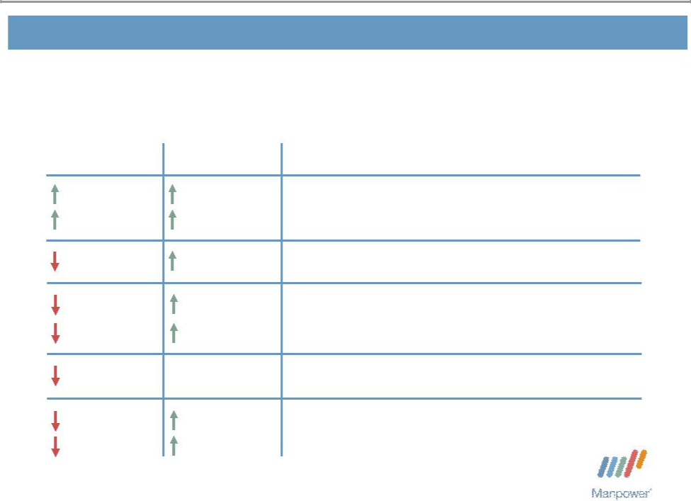

Consolidated Financial Highlights

 | Excluding
As | Non-recurring
Reported | Items⁽¹⁾
17% | 17%
5% CC | 5% CC
80 bps | 55 bps
25% | 17%
35% CC | 2% CC
200 bps | 0 bps
28% | 27%
38% CC | 9% CC

Q2 Highlights Revenue $5.9B

Gross Margin 19.5% Operating Profit $207M OP Margin 3.5%

EPS $1.34

- Excludes the impact of the French payroll tax change from both years, and the French legal

reserve in 2008.

Throughout this presentation, the difference between reported variances and Constant Currency (CC) variances represents the impact of currency on our financial results. Constant Currency is further explained on our Web site.

Manpower Inc. 2008 2nd Quarter Results | 4

Consolidated Gross Profit Margin Change

21% | - 1.35%
20.34% | + 0.47% | + 0.28% | - 0.20%
19% |  |  | 19.54%

17%

15%

Q2 2007 | Decrease in | Temporary | Permanent | Mix - | Q2 2008
 | Impact of | Recruitment | Recruitment | Specialty
 | Payroll Tax
 | Changes

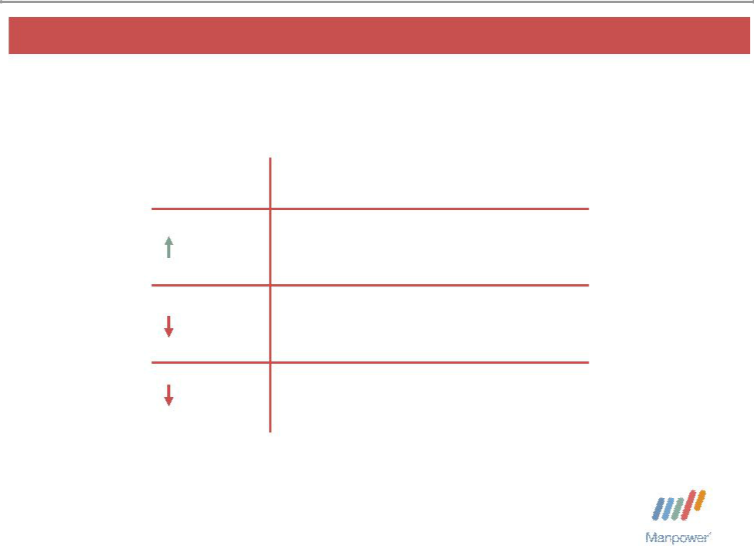
Manpower Inc. 2008 2nd Quarter Results | 5

United States Segment
(8% of Revenue)

Q2 Financial Highlights

1%⁽¹⁾ Revenue $492M

43% OUP $15M

230 bps OUP Margin 3.0%

- The results above include the impact of acquisitions. On an organic basis, revenue decreased 9%.

Operating Unit Profit (OUP) is the measure that we use to evaluate segment performance. OUP is equal to segment revenues less direct costs and branch and national headquarters operating costs.

Manpower Inc. 2008 2nd Quarter Results | 6
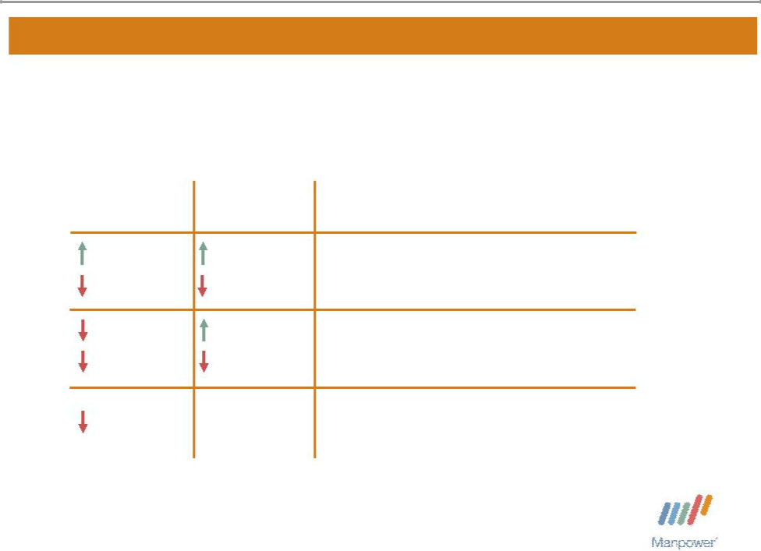

France Segment
(33% of Revenue)

As | Excluding
As | Non-recurring
Reported | Items⁽¹⁾
10% | 10%
5% CC | 5% CC
57% | 9%
63% CC | 6% CC
560 bps | 0 bps

Q2 Financial Highlights Revenue $2.0B

OUP $70M

OUP Margin 3.6%

- Excludes the impact of the French payroll tax change from both years, and the French legal reserve in 2008.

Manpower Inc. 2008 2nd Quarter Results | 7
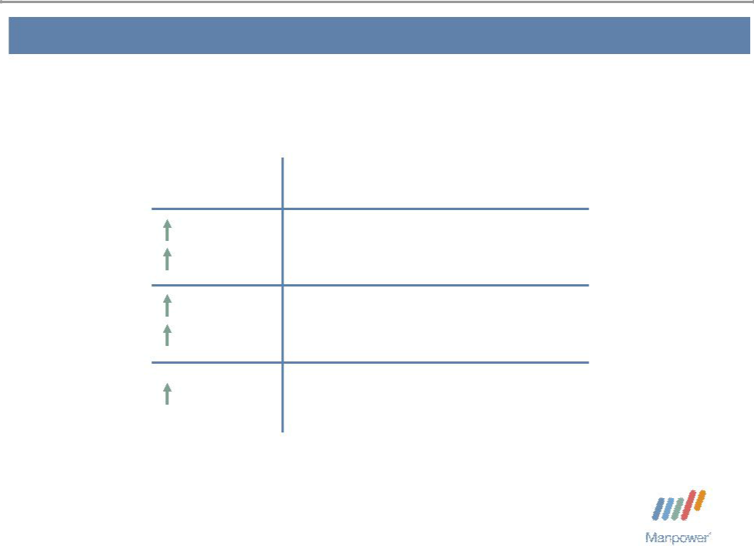

Other EMEA Segment
(35% of Revenue)

Q2 Financial Highlights

⁽¹⁾

18% CC
^{53%} OUP $85M

36% CC

70 bps OUP Margin 4.2%

- The results above include the results of Vitae, which was acquired in April 2008. On an organic basis, revenue increased 27% in USD (15% in CC).

Manpower Inc. 2008 2nd Quarter Results | 8
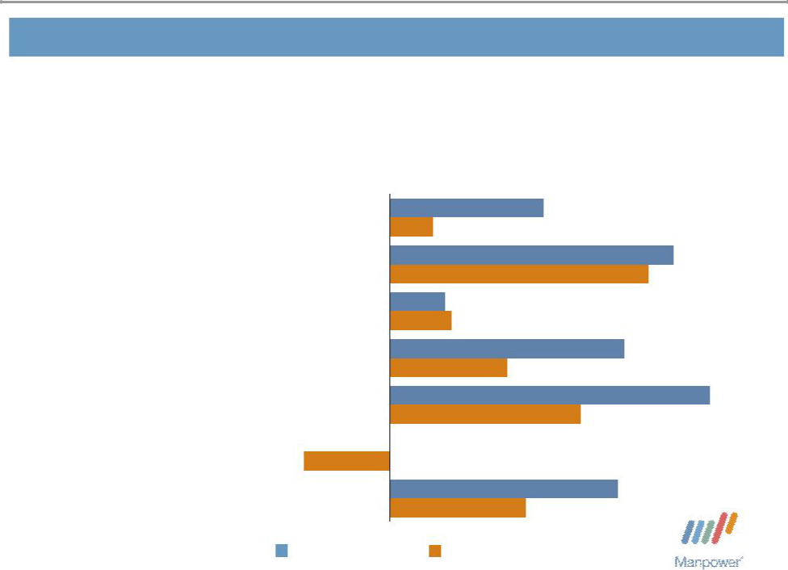

Other EMEA – Q2 Revenue Growth YoY

- of Segment Revenue

20% Nordics

17% Elan

13% UK - Manpower

11% Germany

10% | Netherlands⁽¹⁾
6% | Spain | -14%
23% | Other

25%

7%

46%

42%

9%

10%

38%

19%

52%

31%

0%

37%

22%

Revenue Growth Revenue Growth - CC

- The Netherlands results include the results of Vitae, which was acquired in April 2008. On an organic basis, revenue increased 22% in USD (5% in CC).

Manpower Inc. 2008 2nd Quarter Results | 9
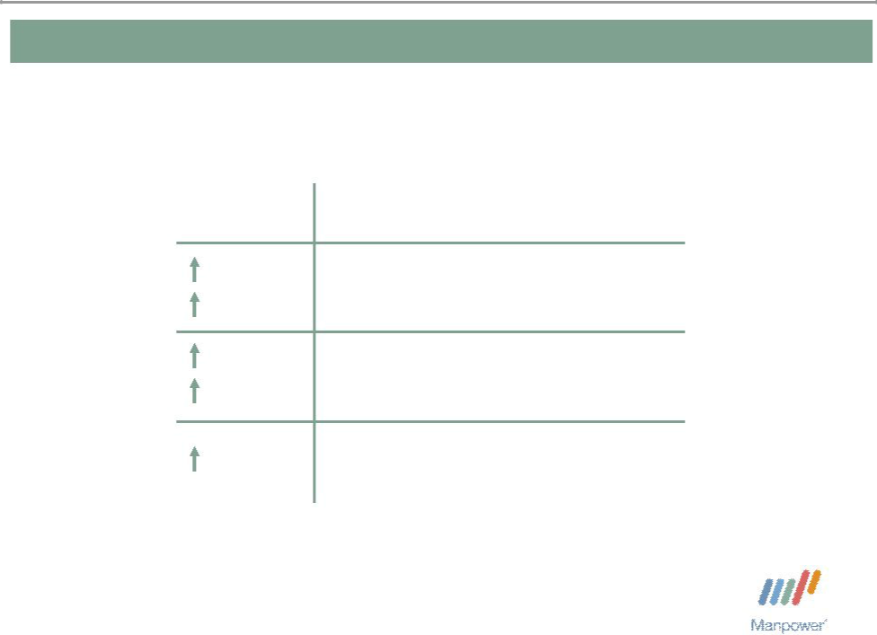

Italy Segment
(8% of Revenue)

Q2 Financial Highlights
^{25%} Revenue $441M
8% CC
^{29%} OUP $38M

12% CC

30 bps OUP Margin 8.5%

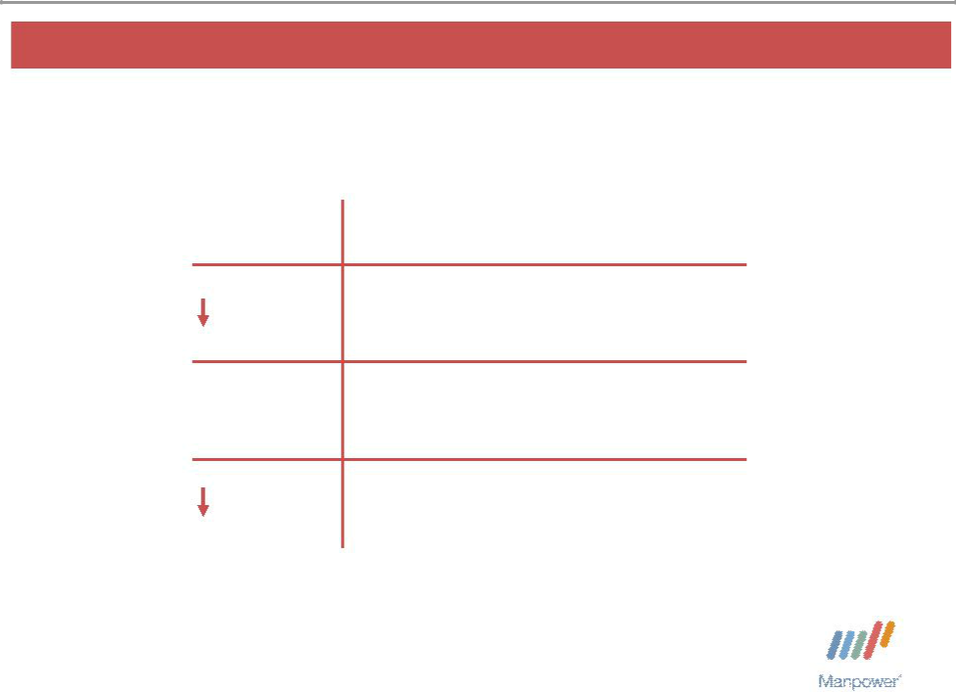
Manpower Inc. 2008 2nd Quarter Results 10

Jefferson Wells Segment
(1% of Revenue)

Q2 Financial Highlights

10% Revenue $76M

N/A OUP $(2M)

350 bps OUP Margin - 2.2%

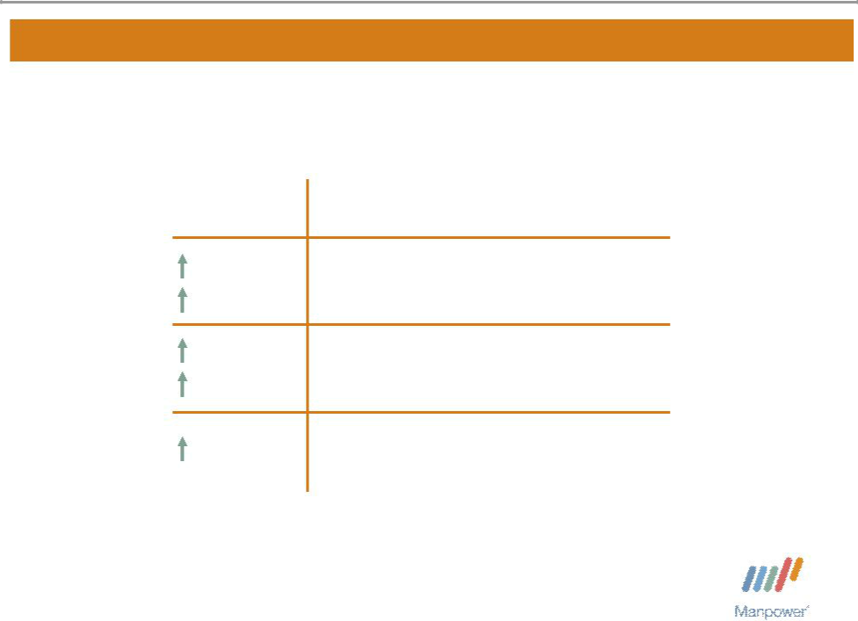
Manpower Inc. 2008 2nd Quarter Results 11

Right Management Segment
(2% of Revenue)

 | Q2 Financial Highlights
9% | Revenue $116M
4% CC | Revenue $116M
21% | OUP $13M
16% CC | OUP $13M
110 bps | OUP Margin 11.5%

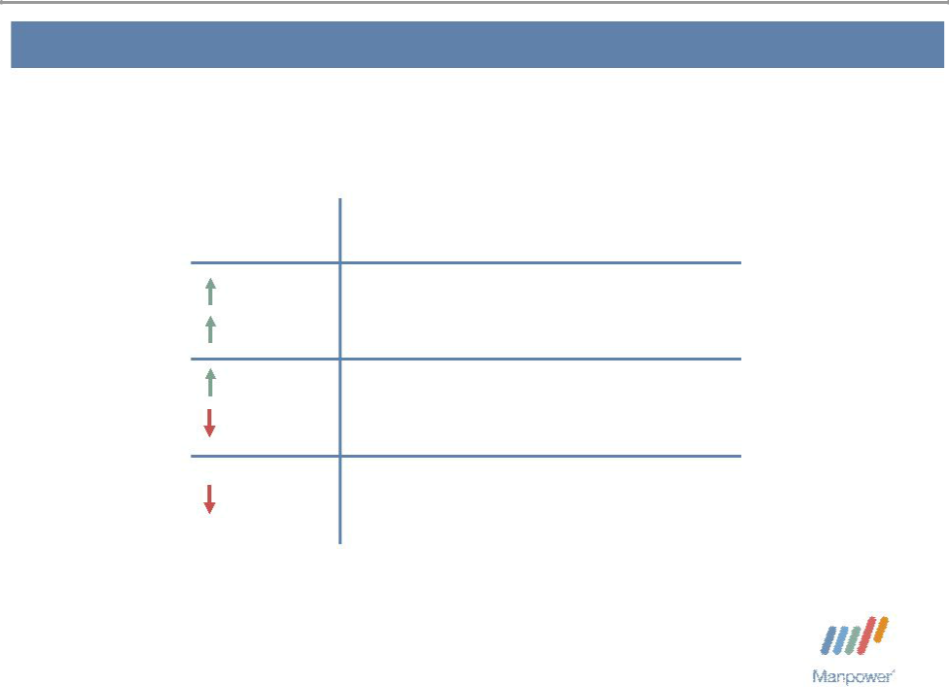
Manpower Inc. 2008 2nd Quarter Results | 12

Other Operations Segment
(13% of Revenue)

Q2 Financial Highlights
^{21%} Revenue $772M
10% CC
^{9%} OUP $17M

5% CC

30 bps OUP Margin 2.1%

Manpower Inc. 2008 2nd Quarter Results | 13
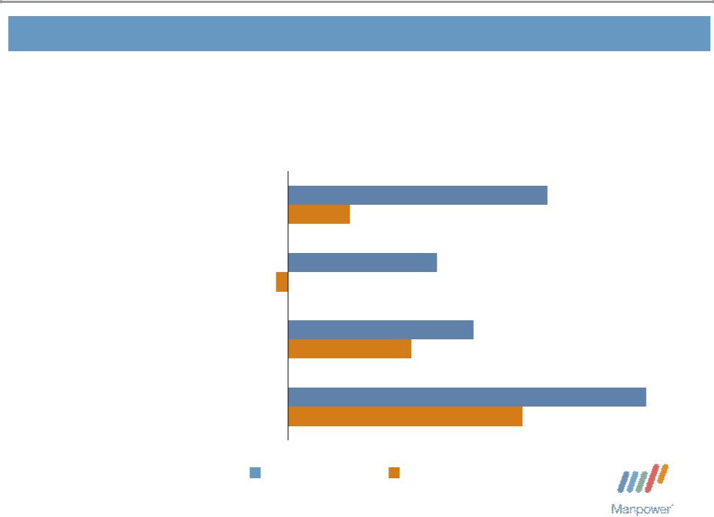

Other Operations – Q2 Revenue Growth YoY

- of Segment Revenue
34% | Japan | 21%
34% | Japan | 5%
15% | Australia/NZ | 12%
15% | Australia/NZ | -1%
14% | Mexico | 15%
14% | Mexico | 10%
37% | Other | 29%
37% | Other | 19%

Revenue Growth Revenue Growth - CC

Manpower Inc. 2008 2nd Quarter Results | 14


Financial Highlights

Manpower Inc. 2008 2nd Quarter Results | 15
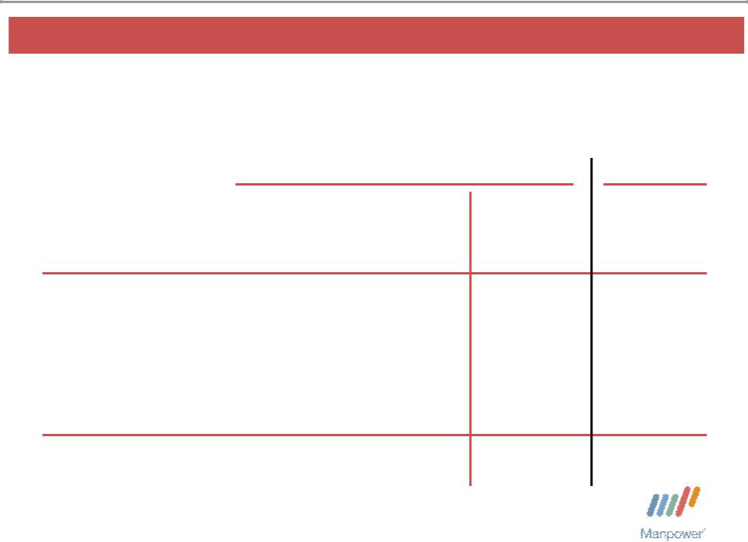

Q2 Non-recurring Items
($ in millions, except per share amounts)

 |  |  |  | 2008 |  |  |  | 2007
 |  | French |  |  |  |  |  | French
 | Payroll Tax |  |  | French |  |  | Payroll Tax
 | Change - |  |  | Legal |  |  | Change -
 |  | 2005 | Reserve |  |  | Total | 2006-2007
Gross profit | $ | 53.7 |  |  | $ | 53.7 | $ | 114.0
S&A expenses |  |  |  | (54.1) |  | (54.1) |  | 14.7
Operating profit |  | 53.7 |  | (54.1) |  | (0.4) |  | 99.3
Net earnings |  | 35.2 |  | (50.0) |  | (14.8) |  | 57.2
Net earnings
per share - diluted | $ | 0.44 | $ | (0.62) | $ | (0.18) | $ | 0.66

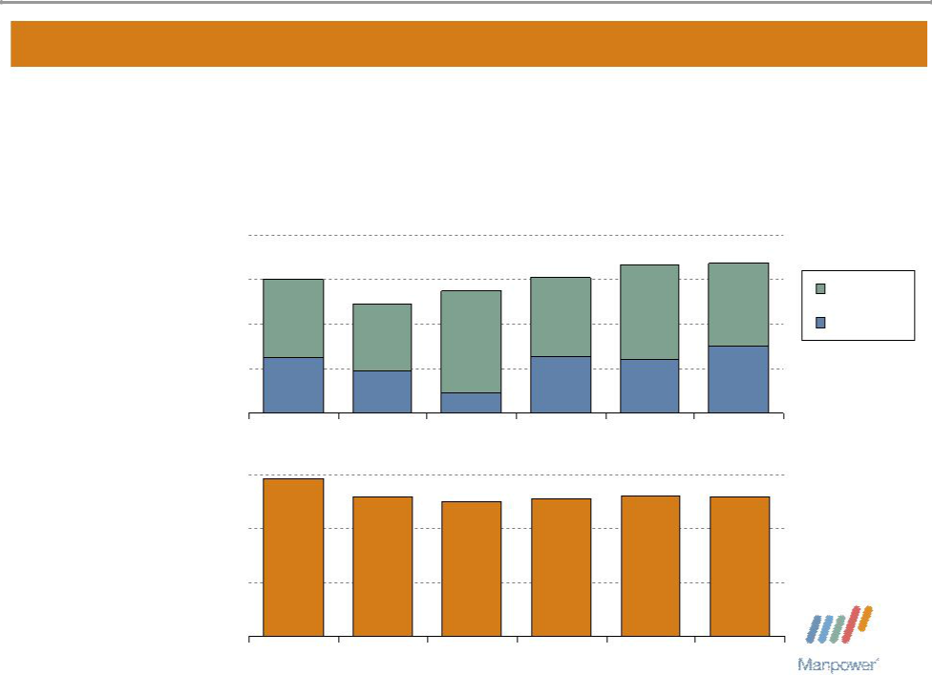
Manpower Inc. 2008 2nd Quarter Results | 16

Balance Sheet Highlights

Total Debt
($ in millions) | 1,200

900

600

300

0

Total Debt to

Total Capitalization
30%

20%

10%

0%

902
823

735

370
280

135

2004 2005 2006

29%
^{26%} 25%

2004 2005 2006

915 | 999 | 1,014 | Total Debt
 |  |  | Net Debt
377 | 358 | 453
2007 | Q1 2008 | Q2 2008
26% | 26% | 26%

2007 Q1 2008 Q2 2008

Manpower Inc. 2008 2nd Quarter Results | 17
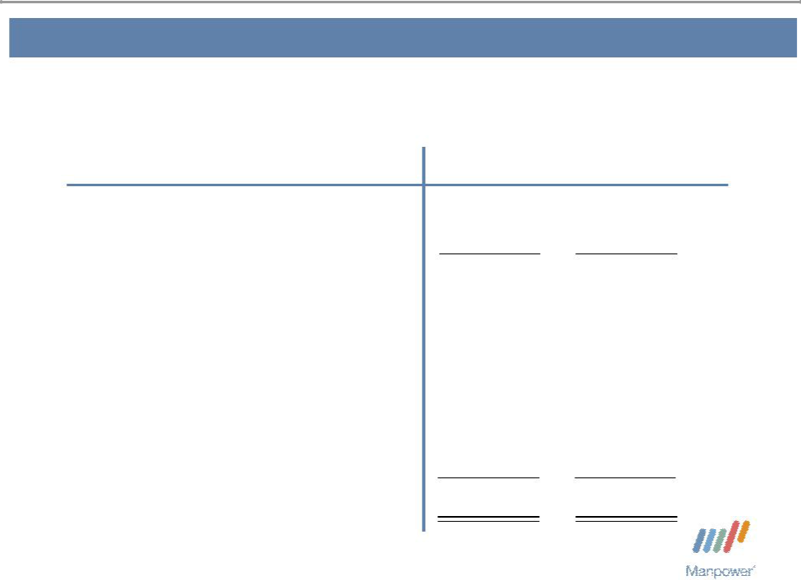

Cash Flow Summary – First Half

($ in millions) | 2008 | 2007
Cash from Operations | 264 | 141
Capital Expenditures | (51) | (41)
Free Cash Flow | 213 | 100
Share Repurchases * | (53) | (89)
Proceeds from Equity Plans | 11 | 37
Change in Debt | 26 | 3
Acquisitions of Businesses, | (194) | (18)
net of cash acquired | (194) | (18)
Other | 21 | (10)
Change in Cash | 24 | 23

- 752,300 shares in 2008 and 1,214,800 shares in 2007. $11.5M of cash paid in 2008 was for shares repurchased in 2007.

Manpower Inc. 2008 2nd Quarter Results | 18
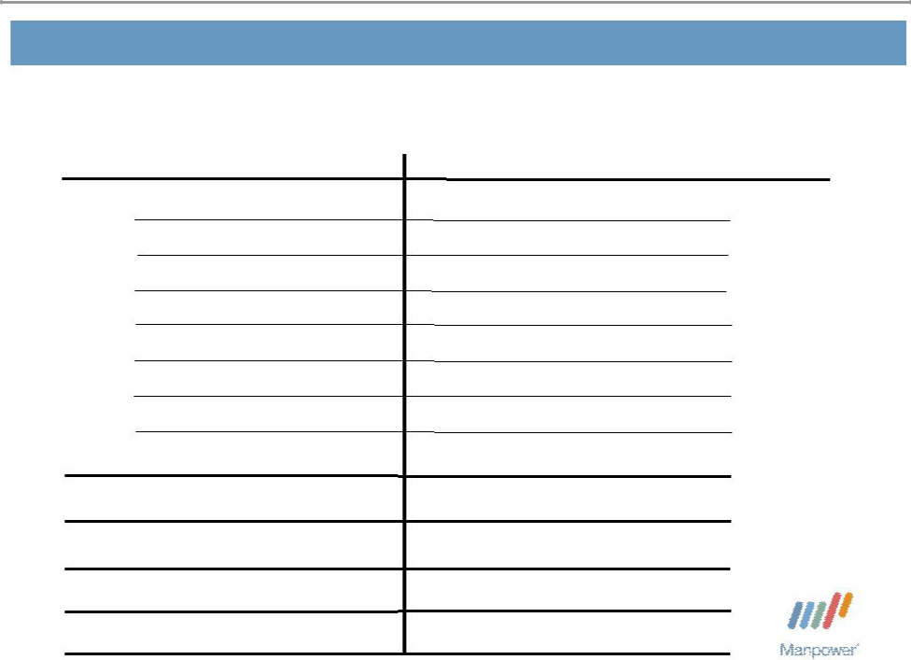

Third Quarter Outlook

Revenue U.S.

France

Other EMEA

Italy

Jefferson Wells

Right Management

Other

Total

Gross Profit Margin Operating Profit Margin

Tax Rate

EPS

Up 7-9%

Up 4-6% (Down 7-9% CC)

Up 22-24% (Up 11-13% CC)

Up 21-23% (Up 6-8% CC)

Down 9-11%

Up 8-10%(Up 3-5% CC)

Up 17-19%(Up 5-7% CC)

Up 13-15%(Up 2-4% CC)

18.3-18.5%

3.2-3.4%

36.0%

$1.45-$1.49 (Pos. $.17 Currency)

Manpower Inc.
2008 2nd Quarter Results


July 18, 2008

Questions?
Answers

