UNITED STATES

SECURITIES AND EXCHANGE COMMISSION
Washington, D.C. 20549

SCHEDULE 14A INFORMATION

Proxy Statement Pursuant to Section 14(a) of the

Securities Exchange Act of 1934
(Amendment No. )

Filed by the Registrant ☒ Filed by a Party other than the Registrant ☐

Check the appropriate box:

- Preliminary Proxy Statement

- Confidential, for Use of the Commission Only (as permitted by Rule 14a-6(e)(2))

- Definitive Proxy Statement

- Definitive Additional Materials

- Soliciting Material under § 240.14a-12

MANPOWERGROUP INC.

(Name of registrant as specified in its charter)

(Name of person(s) filing proxy statement, if other than the registrant)

Payment of Filing Fee (Check the appropriate box):

- No fee required.

- Fee computed on table below per Exchange Act Rules 14a-6(i)(1) and 0-11.

  - Title of each class of securities to which the transaction applies:

  - Aggregate number of securities to which the transaction applies:

  - Per unit price or other underlying value of the transaction computed pursuant to Exchange Act Rule 0-11 (set forth the amount on which the filing fee is calculated and state how it was determined):

  - Proposed maximum aggregate value of the transaction:

  - Total fee paid:

- Fee paid previously with preliminary materials.

- Check box if any part of the fee is offset as provided by Exchange Act Rule 240.0-11(a)(2) and identify the filing for which the offsetting fee was paid previously. Identify the previous filing by registration statement number, or the Form or Schedule and the date of its filing.

  - Amount Previously Paid:

  - Form, Schedule or Registration Statement No.:

- Filing Party:

- Date Filed:

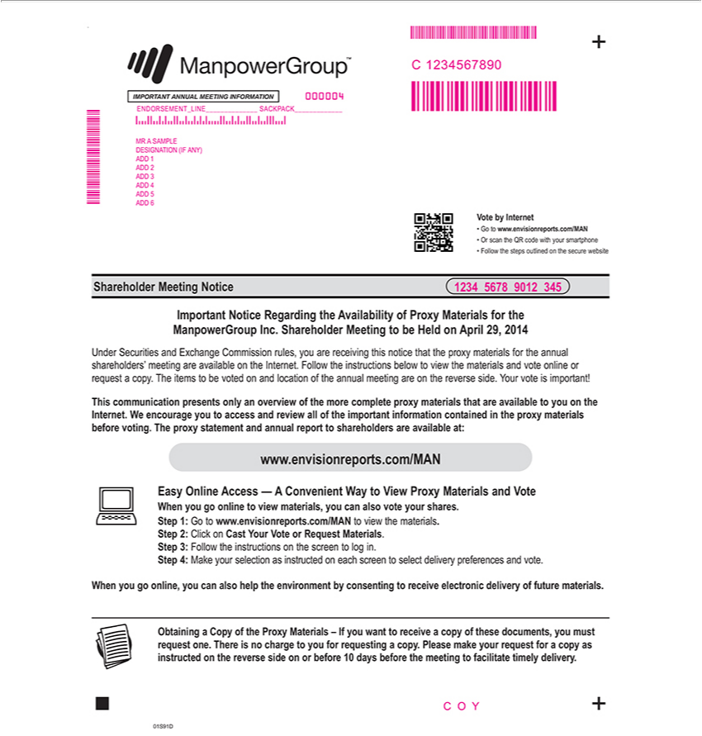

www.envisionreports.com/MAN Step 1: Go to www.envisionreports.com/MAN to view the materials. Step 2: Click on Cast Your Vote or Request Materials. Step 3: Follow the instructions on the screen to log
. Vote by Internet Go to www.envisionreports.com/MAN Or scan the QR code with your smartphone Follow the steps outlined on the secure website Shareholder Meeting Notice 01S91D + + Important Notice
Regarding the Availability of Proxy Materials for the ManpowerGroup Inc. Shareholder Meeting to be Held on April 29, 2014 Under Securities and Exchange Commission rules, you are receiving this notice that
the proxy materials for the annual shareholders’ meeting are available on the Internet. Follow the instructions below to view the materials and vote online or request copy. The items to be voted on and location
of the annual meeting are on the reverse side. Your vote is important! This communication presents only an overview of the more complete proxy materials that are available to you on the Internet. We encourage
you to access and review all of the important information contained the proxy | before voting. The proxy statement and annual report to shareholders are available at: _ Easy Online Access — A
Convenient^{When}ay to View Proxy Materials and Vote When you go online to view materials, you can also vote your shares. Step 4: Make your selection as instructed on each screen to select delivery preferences
and vote. you go online, you can also help the environment by consenting to receive electronic delivery of future materials. Obtaining a Copy of the Proxy Materials – If you want to receive a copy of _{timely}hesedocuments, you must request one. There is no charge to you for requesting a copy. Please make your request for a copy as instructed on the reverse side on or before 10 days before the meeting to facilitate
delivery. .

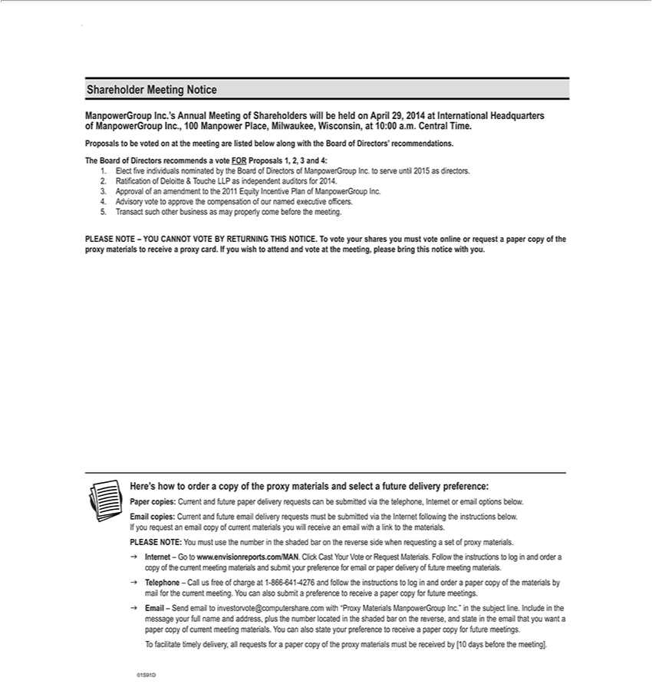

IMPORTANT ANNUAL MEETING INFORMATION 1234 5678 9012 345 NNNNNNNNNNNN NNNNNNNNN NNNNNN C 1234567890 C O Y 000004 MR A SAMPLE DESIGNATION (IF ANY) ADD 1
ADD 2 ADD 3 ADD 4 ADD 5 ADD 6 ENDORSEMENT LINE SACKPACK Here’s how to order a copy of the proxy materials and select a future delivery preference: Paper copies: Current and future paper
delivery requests can be submitted via the telephone, Internet or email options below. Email copies: Current and future email delivery requests must be submitted via the Internet following the instructions below.
If you request an email copy of current materials you will receive an email with a link to the materials. PLEASE NOTE: You must use the number in the |  |  |  |  | bar on the reverse side when requesting a set of
proxy materials. g Internet – Go to www.envisionreports.com/MAN. Click Cast Your Vote or Request |  |  | . Follow the instructions to log in and ordershadedcopy of the current meeting materials and submit
your preference for email or paper delivery of future meeting materials. g Telephone – Call us free of chargeMaterials1-866-641-4276 and follow the instructions |  |  |  |  | log in and order a paper copy of the materials by
mail for the current meeting. You can also submit a preference to receive paper copy for future |  |  | . g Email – Send email to |  | .com with “Proxy Materials ManpowerGroup
Inc.” the subject line. Include in the message your full name and address, plus the number locatedmeetingsthe shaded bar on the reverse,investorvote@computershareandstatetheemailthatyou want a paper copy of current meeting
aterials. You can also state your preference to receive paper copy for future meetings. T |  | facilitate timely delivery, all requests for |  | paper copy of the proxy materials must be received by [10 days before the
meeting]. . Shareholder Meeting Notice ManpowerGroup Inc.’s Annual Meeting of |  | will | held April 29, 2014 at International Headquarters of ManpowerGroup Inc., 100 Manpower
Milwaukee, Wisconsin, at | a.m. Central Time. Proposals to be voted on at the meetingShareholderslisted below along with the Board of Directors’ recommendations. The Board of Directors recommends Place,vote
FOR Proposals 1, 2, 3 and 10:004:.Elect five individuals nominated by the Board of Directors of ManpowerGroup Inc. to serve until 2015 as directors. 2. Ratification of Deloitte & Touche LLP as independent
auditors for 2014. 3. Approval of an amendment to the 2011 Equity Incentive Plan of ManpowerGroup Inc. 4. Advisory vote to |  |  |  | the compensation of our named executive officers. 5. Transact such other
business as may properly come before the meeting. PLEASE NOTE – YOU CANNOT VOTE BY RETURNING THIS NOTICE.approveTvote your shares you must vote online or request a paper copy of the proxy materials to receive a proxy card. If you wish to attend and vote at the meeting, please bring this notice with you. 01S91D

