UNITED STATES

SECURITIES AND EXCHANGE COMMISSION
Washington, D.C. 20549

FORM 8-K

CURRENT REPORT

Pursuant to Section 13 or 15(d) of the Securities Exchange Act of 1934

Date of Report (Date of earliest event reported): July 23, 2009

MANPOWER INC.

(Exact name of registrant as specified in its charter)

Wisconsin

(State or other jurisdiction of

1-10686

(Commission File Number)

39-1672779

(IRS Employer Identification No.)

incorporation)

100 Manpower Place

Milwaukee, Wisconsin

(Address of principal executive offices)

53212

(Zip Code)

Registrant's telephone number, including area code: (414) 961-1000

Check the appropriate box below if the Form 8-K filing is intended to simultaneously satisfy the filing obligation of the registrant under any of the following provisions:

Written communications pursuant to Rule 425 under the Securities Act (17 CFR 230.425)

Soliciting material pursuant to Rule 14a-12 under the Securities Act (17 CFR 240.14a-12)

Pre-commencement communications pursuant to Rule 14d-2(b) under the Exchange Act (17 CFR 240.14d-2(b))

Pre-commencement communications pursuant to Rule 13e-4(c) under the Exchange Act (17 CFR 240.13e-4(c))

Item 2.02 Results of Operations and Financial Condition

On July 23, 2009, we issued a press release announcing our results of operations for the three- and six- month periods ended June 30, 2009. A copy of the press release is attached hereto as Exhibit 99.1 and is incorporated herein by reference.

Item 9.01. Exhibits.
 | Exhibit No. |  | Description
 | 99.1 |  |  | Press Release dated July 23, 2009
99.2 |  |  | Presentation materials for July 23, 2009 conference call

SIGNATURES

Pursuant to the requirements of the Securities Exchange Act of 1934, the Registrant has duly caused this Report to be signed on its behalf by the undersigned hereunto duly authorized.

MANPOWER INC.

Dated: July 23, 2009 By: /s/ Michael J. Van Handel

Michael J. Van Handel

Executive Vice President and

Chief Financial Officer

 |  | EXHIBIT INDEX
Exhibit No. | Description
99.1 |  | Press Release dated July 23, 2009
99.2 | Presentation materials for July 23, 2009 conference call

Exhibit 99.1


FOR IMMEDIATE RELEASE Contact:

Mike Van Handel

Manpower Inc.

+1.414.906.6305

michael.vanhandel@manpower.com

Manpower Reports 2ND Quarter and First Half 2009 Results

MILWAUKEE, WI, USA, July 23, 2009 – Manpower Inc. (NYSE: MAN) today reported that earnings per diluted share for the three months ended June 30, 2009 were 25 cents compared to $1.34 in the prior year period. Net earnings in the quarter were $19.3 million compared to $107.4 million a year earlier. Revenues for the second quarter were $3.8 billion, a decrease of 36 percent from the year earlier period, or a decrease of 27 percent in constant currency.

Second quarter 2009 results include a reorganization charge of $13.1 million, $9.0 million after tax, or 11 cents per diluted share primarily related to severances and office consolidations. Second quarter results also include an unfavorable impact from currency of 1 cent per diluted share and a favorable impact from a lower effective income tax rate.

Manpower Inc. Chairman and Chief Executive Officer Jeffrey A. Joerres said, “While we have continued to see stabilization, and in our major geographies slight improvement, we have yet to experience real recovery. The months of September and October, which are traditionally strong seasonal months, will be an important period of time to give us an indication of whether or not 2009 will show signs of recovery.

"We continue to benefit greatly from our outplacement business, as Right Management had a record setting profit for the second quarter. Right Management's profitability, coupled with good expense management, is allowing us to have a longitudinal view of the company and remain poised for growth at the time of recovery, whenever that may be.

“We are anticipating the third quarter of 2009 diluted earnings per share to be in the range of 7 cents to 21 cents, which includes an estimated unfavorable currency impact of 1 cent,” Joerres stated.

Earnings per diluted share for the six months ended June 30, 2009 were 27 cents compared to $2.27 per diluted share in 2008. Net earnings were $21.6 million compared to $182.9 million in the prior year. Revenues for the six-month period were $7.4 billion, a decrease of 34 percent from the prior year or 24 percent in constant currency. Foreign currency exchange rates had an unfavorable impact of 2 cents for the six-month period.

In conjunction with its second quarter earnings release, Manpower will broadcast its conference call live over the Internet on July 23, 2009 at 7:30 a.m. CDT (8:30 a.m. EDT). Interested parties are invited to listen to the webcast and view the presentation by logging on to http://investor.manpower.com.

Supplemental financial information referenced in the conference call can be found at http://investor.manpower.com.

About Manpower Inc.

Manpower Inc. (NYSE: MAN) is a world leader in the employment services industry; creating and delivering services that enable clients to win in the changing world of work. 61 years old in 2009, the company offers a range of services for the entire employment and business cycle including permanent, temporary and contract recruitment; employee assessment and selection; training; outplacement; outsourcing and consulting. Manpower's network of 4,100 offices in 82 countries and territories enables the company to meet the needs of 400,000 clients per year, including small and medium size enterprises in all industry sectors, as well as the world's largest multinational corporations. Manpower focuses on raising productivity through improved quality, efficiency and cost-reduction across the total workforce, enabling clients to concentrate on their core business activities. Manpower Inc. operates under five brands: Manpower, Manpower Professional, Elan, Jefferson Wells and Right Management. Web site is www.manpower.com.

Forward-Looking Statements

This news release contains statements, including earnings projections, that are forward-looking in nature and, accordingly, are subject to risks and uncertainties regarding the Company’s expected future results. The Company’s actual results may differ materially from those described or contemplated in the forward-looking statements. Factors that may cause the Company’s actual results to differ materially from those contained in the forward-looking statements can be found in the Company’s reports filed with the SEC, including the information under the heading ‘Risk Factors’ in its Annual Report on Form 10-K for the year ended December 31, 2008, which information is incorporated herein by reference.

- ### -

Manpower Inc.

Results of Operations

(In millions, except per share data)

 |  |  |  |  |  | Three Months Ended June 30
 |  |  |  |  |  |  |  | % Variance
 |  |  |  |  |  |  |  | Amount |  | Constant
 |  |  | 2009 |  |  | 2008 |  | Reported |  | Currency
 |  |  |  |  |  | (Unaudited)
 | Revenues from services (a) | $ | 3,796.6 |  | $ | 5,904.9 |  | -35.7% |  | -26.6%
 | Cost of services |  | 3,101.2 |  |  | 4,751.3 |  | -34.7% |  | -25.3%
 | Gross profit |  | 695.4 |  |  | 1,153.6 |  | -39.7% |  | -31.9%
 | Selling and administrative expenses |  | 673.3 |  |  | 946.3 |  | -28.8% |  | -19.7%
 | Operating profit |  | 22.1 |  |  | 207.3 |  | -89.3% |  | -87.5%
 | Interest and other expenses |  | 10.8 |  |  | 13.9 |  | -21.7%
 | Earnings before income taxes |  | 11.3 |  |  | 193.4 |  | -94.1% |  | -93.5%
 | Provision for income taxes |  | (8.0) |  |  | 86.0 |  | N/A
 | Net earnings | $ | 19.3 |  | $ | 107.4 |  | -82.0% |  | -80.0%
 | Net earnings per share - basic | $ | 0.25 |  | $ | 1.36 |  | -81.6%
 | Net earnings per share - diluted | $ | 0.25 |  | $ | 1.34 |  | -81.3% |  | -81.0%
 | Weighted average shares - basic |  | 78.3 |  |  | 79.2 |  | -1.1%
 | Weighted average shares - diluted |  | 78.8 |  |  | 80.3 |  | -1.9%

- Revenues from services include fees received from our franchise offices of $5.8 million and $8.3 million for the three months ended June 30, 2009 and 2008, respectively. These fees are primarily based on revenues generated by the franchise offices, which were $174.1 million and $325.4 million for the three months ended June 30, 2009 and 2008, respectively.

Manpower Inc.

Operating Unit Results

(In millions)

 |  |  |  |  |  | Three Months Ended June 30
 |  |  |  |  |  |  |  | % Variance
 |  |  |  |  |  |  |  | Amount |  | Constant
 |  |  | 2009 |  |  | 2008 |  | Reported |  | Currency
 |  |  |  |  |  | (Unaudited)
 | Revenues from Services: (a)
 | Americas:
 | United States (b) | $ | 374.3 |  | $ | 491.6 |  | -23.9% |  | -23.9%
 | Other Americas |  | 220.7 |  |  | 296.2 |  | -25.5% |  | -9.9%
 |  |  | 595.0 |  |  | 787.8 |  | -24.5% |  | -18.6%
 | France |  | 1,100.1 |  |  | 1,958.1 |  | -43.8% |  | -35.6%
 | EMEA:
 | Italy |  | 230.1 |  |  | 441.4 |  | -47.9% |  | -40.3%
 | Other EMEA |  | 1,259.0 |  |  | 2,050.7 |  | -38.6% |  | -25.0%
 |  |  | 1,489.1 |  |  | 2,492.1 |  | -40.2% |  | -27.7%
 | Asia Pacific |  | 406.2 |  |  | 474.8 |  | -14.5% |  | -12.7%
 | Right Management |  | 158.1 |  |  | 116.3 |  | 35.9% |  | 46.5%
 | Jefferson Wells |  | 48.1 |  |  | 75.8 |  | -36.5% |  | -36.5%
 |  | $ | 3,796.6 |  | $ | 5,904.9 |  | -35.7% |  | -26.6%
 | Operating Unit Profit:
 | Americas:
 | United States (b) | $ | (5.8) |  | $ | 14.8 |  | N/A |  | N/A
 | Other Americas |  | 3.9 |  |  | 7.4 |  | -46.9% |  | -34.7%
 |  |  | (1.9) |  |  | 22.2 |  | N/A |  | N/A
 | France |  | 4.2 |  |  | 69.8 |  | -94.0% |  | -93.1%
 | EMEA:
 | Italy |  | 6.8 |  |  | 37.6 |  | -82.0% |  | -79.4%
 | Other EMEA |  | (3.8) |  |  | 85.1 |  | N/A |  | N/A
 |  |  | 3.0 |  |  | 122.7 |  | -97.5% |  | -96.7%
 | Asia Pacific |  | 3.5 |  |  | 9.3 |  | -62.2% |  | -71.4%
 | Right Management |  | 42.3 |  |  | 13.4 |  | 216.9% |  | 232.4%
 | Jefferson Wells |  | (10.2) |  |  | (1.6) |  | N/A |  | N/A
 |  |  | 40.9 |  |  | 235.8
 | Corporate expenses |  | 18.8 |  |  | 28.5
 | Operating profit |  | 22.1 |  |  | 207.3 |  | -89.3% |  | -87.5%
 | Interest and other expenses (c) |  | 10.8 |  |  | 13.9
 | Earnings before income taxes | $ | 11.3 |  | $ | 193.4

- Our segment reporting was realigned during the first quarter of 2009 due to a change in management structure. Other Americas and Asia Pacific, previously reported in Other Operations, are now separate reportable segments. The United States and Other Americas reportable segments are reported as Americas. The Italy and Other EMEA reportable segments are reported as EMEA. Historical amounts have been restated to conform to the current year presentation.

- In the United States, revenues from services include fees received from our franchise offices of $2.4 million and $4.7 million for the three months ended June 30, 2009 and 2008, respectively. These fees are primarily based on revenues generated by the franchise offices, which were $107.2 million and $214.6 million for the three months ended June 30, 2009 and 2008, respectively.

- The components of interest and other expenses were:

 | 2009 |  |  |  | 2008
Interest expense | $ | 13.9 |  | $ | 17.1
Interest income |  | (3.2) |  |  | (6.0)
Foreign exchange losses |  | 1.0 |  |  | 0.4
Miscellaneous (income) expense, net |  | (0.9) |  |  | 2.4
 | $ | 10.8 |  | $ | 13.9

Manpower Inc.

Results of Operations

(In millions, except per share data)

 |  |  |  |  |  | Six Months Ended June 30
 |  |  |  |  |  |  |  | % Variance
 |  |  |  |  |  |  |  | Amount |  | Constant
 |  |  | 2009 |  |  | 2008 |  | Reported |  | Currency
 |  |  |  |  |  | (Unaudited)
 | Revenues from services (a) | $ | 7,443.7 |  | $ | 11,291.5 |  | -34.1% |  | -24.3%
 | Cost of services |  | 6,078.5 |  |  | 9,170.2 |  | -33.7% |  | -23.7%
 | Gross profit |  | 1,365.2 |  |  | 2,121.3 |  | -35.6% |  | -26.8%
 | Selling and administrative expenses |  | 1,337.6 |  |  | 1,782.0 |  | -24.9% |  | -14.8%
 | Operating profit |  | 27.6 |  |  | 339.3 |  | -91.9% |  | -89.5%
 | Interest and other expenses |  | 22.7 |  |  | 25.2 |  | -9.8%
 | Earnings before income taxes |  | 4.9 |  |  | 314.1 |  | -98.4% |  | -97.9%
 | Provision for income taxes |  | (16.7) |  |  | 131.2 |  | N/A
 | Net earnings | $ | 21.6 |  | $ | 182.9 |  | -88.2% |  | -84.2%
 | Net earnings per share - basic | $ | 0.28 |  | $ | 2.31 |  | -87.9%
 | Net earnings per share - diluted | $ | 0.27 |  | $ | 2.27 |  | -88.1% |  | -86.9%
 | Weighted average shares - basic |  | 78.2 |  |  | 79.3 |  | -1.4%
 | Weighted average shares - diluted |  | 78.6 |  |  | 80.4 |  | -2.3%

- Revenues from services include fees received from our franchise offices of $10.9 million and $15.6 million for the six months ended June 30, 2009 and 2008, respectively. These fees are primarily based on revenues generated by the franchise offices, which were $333.0 million and $629.4 million for the six months ended June 30, 2009 and 2008, respectively.

Manpower Inc.

Operating Unit Results

(In millions)

 |  |  |  |  |  | Six Months Ended June 30
 |  |  |  |  |  |  |  | % Variance
 |  |  |  |  |  |  |  | Amount |  | Constant
 |  |  | 2009 |  |  | 2008 |  | Reported |  | Currency
 |  |  |  |  |  | (Unaudited)
 | Revenues from Services: (a)
 | Americas:
 | United States (b) | $ | 748.1 |  | $ | 963.1 |  | -22.3% |  | -22.3%
 | Other Americas |  | 439.9 |  |  | 576.9 |  | -23.7% |  | -7.6%
 |  |  | 1,188.0 |  |  | 1,540.0 |  | -22.9% |  | -16.8%
 | France |  | 2,057.0 |  |  | 3,692.1 |  | -44.3% |  | -36.1%
 | EMEA:
 | Italy |  | 450.5 |  |  | 842.6 |  | -46.5% |  | -38.7%
 | Other EMEA |  | 2,521.9 |  |  | 3,904.4 |  | -35.4% |  | -19.9%
 |  |  | 2,972.4 |  |  | 4,747.0 |  | -37.4% |  | -23.3%
 | Asia Pacific |  | 831.4 |  |  | 938.9 |  | -11.4% |  | -9.9%
 | Right Management |  | 294.1 |  |  | 220.3 |  | 33.4% |  | 45.0%
 | Jefferson Wells |  | 100.8 |  |  | 153.2 |  | -34.2% |  | -34.2%
 |  | $ | 7,443.7 |  | $ | 11,291.5 |  | -34.1% |  | -24.3%
 | Operating Unit Profit:
 | Americas:
 | United States (b) | $ | (20.3) |  | $ | 22.0 |  | N/A |  | N/A
 | Other Americas |  | 8.7 |  |  | 15.4 |  | -43.5% |  | -32.3%
 |  |  | (11.6) |  |  | 37.4 |  | N/A |  | N/A
 | France |  | 5.2 |  |  | 123.8 |  | -95.8% |  | -95.0%
 | EMEA:
 | Italy |  | 8.2 |  |  | 66.7 |  | -87.7% |  | -86.2%
 | Other EMEA |  | (3.1) |  |  | 132.8 |  | N/A |  | N/A
 |  |  | 5.1 |  |  | 199.5 |  | -97.4% |  | -95.8%
 | Asia Pacific |  | 15.6 |  |  | 22.6 |  | -30.9% |  | -38.5%
 | Right Management |  | 71.4 |  |  | 20.2 |  | 254.1% |  | 272.7%
 | Jefferson Wells |  | (17.7) |  |  | (4.2) |  | N/A |  | N/A
 |  |  | 68.0 |  |  | 399.3
 | Corporate expenses |  | 40.4 |  |  | 60.0
 | Operating profit |  | 27.6 |  |  | 339.3 |  | -91.9% |  | -89.5%
 | Interest and other expenses (c) |  | 22.7 |  |  | 25.2
 | Earnings before income taxes | $ | 4.9 |  | $ | 314.1

- Our segment reporting was realigned during the first quarter of 2009 due to a change in management structure. Other Americas and Asia Pacific, previously reported in Other Operations, are now separate reportable segments. The United States and Other Americas reportable segments are reported as Americas. The Italy and Other EMEA reportable segments are reported as EMEA. Historical amounts have been restated to conform to the current year presentation.

- In the United States, revenues from services include fees received from our franchise offices of $4.4 million and $9.3 million for the six months ended June 30, 2009 and 2008, respectively. These fees are primarily based on revenues generated by the franchise offices, which were $202.1 million and $427.3 million for the six months ended June 30, 2009 and 2008, respectively.

- The components of interest and other expenses were:

 | 2009 |  |  |  | 2008
Interest expense | $ | 27.0 |  | $ | 32.7
Interest income |  | (7.6) |  |  | (11.1)
Foreign exchange loss (gain) |  | 1.5 |  |  | (1.5)
Miscellaneous expenses, net |  | 1.8 |  |  | 5.1
 | $ | 22.7 |  | $ | 25.2

Manpower Inc.

Consolidated Balance Sheets

(In millions)

 |  | Jun. 30 |  |  |  | Dec. 31
 |  | 2009 |  |  |  | 2008
 |  | (Unaudited)
ASSETS
Current assets:
Cash and cash equivalents | $ | 1,107.3 |  | $ |  | 874.0
Accounts receivable, net |  | 2,944.9 |  |  |  | 3,629.7
Prepaid expenses and other assets |  | 166.4 |  |  |  | 119.9
Future income tax benefits |  | 59.2 |  |  |  | 66.5
Total current assets |  | 4,277.8 |  |  |  | 4,690.1
Other assets:
Goodwill and other intangible assets, net |  | 1,419.9 |  |  |  | 1,388.1
Other assets |  | 349.0 |  |  |  | 326.6
Total other assets |  | 1,768.9 |  |  |  | 1,714.7
Property and equipment:
Land, buildings, leasehold improvements and equipment |  | 728.4 |  |  |  | 744.0
Less: accumulated depreciation and amortization |  | 533.2 |  |  |  | 530.6
Net property and equipment |  | 195.2 |  |  |  | 213.4
Total assets | $ | 6,241.9 |  | $ |  | 6,618.2
LIABILITIES AND SHAREHOLDERS' EQUITY
Current liabilities:
Accounts payable | $ | 999.2 |  | $ |  | 903.2
Employee compensation payable |  | 175.5 |  |  |  | 213.2
Accrued liabilities |  | 451.2 |  |  |  | 577.9
Accrued payroll taxes and insurance |  | 500.2 |  |  |  | 617.5
Value added taxes payable |  | 350.1 |  |  |  | 479.2
Short-term borrowings and current maturities of long-term debt |  | 32.0 |  |  |  | 115.6
Total current liabilities |  | 2,508.2 |  |  |  | 2,906.6
Other liabilities:
Long-term debt |  | 841.8 |  |  |  | 837.3
Other long-term liabilities |  | 348.4 |  |  |  | 390.5
Total other liabilities |  | 1,190.2 |  |  |  | 1,227.8
Shareholders' equity:
Common stock |  | 1.0 |  |  |  | 1.0
Capital in excess of par value |  | 2,525.9 |  |  |  | 2,514.8
Retained earnings |  | 1,193.8 |  |  |  | 1,201.2
Accumulated other comprehensive income (loss) |  | 49.2 |  |  |  | (8.9)
Treasury stock, at cost |  | (1,226.4) |  |  |  | (1,224.3)
Total shareholders' equity |  | 2,543.5 |  |  |  | 2,483.8
Total liabilities and shareholders' equity | $ | 6,241.9 |  | $ |  | 6,618.2

Manpower Inc.

Consolidated Statements of Cash Flows

(In millions)

 |  |  | Six Months Ended
 |  |  | Jun. 30
 |  |  | 2009 |  |  |  | 2008
 |  |  | (Unaudited)
 | Cash Flows from Operating Activities:
 | Net earnings | $ | 21.6 |  | $ |  | 182.9
 | Adjustments to reconcile net earnings to net cash provided by operating activities:
 | Depreciation and amortization |  | 46.9 |  |  |  | 53.4
 | Deferred income taxes |  | (27.5) |  |  |  | 8.7
 | Provision for doubtful accounts |  | 13.7 |  |  |  | 8.4
 | Share-based compensation |  | 7.5 |  |  |  | 14.3
 | Excess tax benefit on exercise of stock options |  | (0.1) |  |  |  | (0.1)
 | Changes in operating assets and liabilities, excluding the impact of acquisitions:
 | Accounts receivable |  | 753.3 |  |  |  | (75.8)
 | Other assets |  | (40.7) |  |  |  | (4.3)
 | Other liabilities |  | (395.4) |  |  |  | 78.3
 | Cash provided by operating activities |  | 379.3 |  |  |  | 265.8
 | Cash Flows from Investing Activities:
 | Capital expenditures |  | (16.9) |  |  |  | (51.4)
 | Acquisitions of businesses, net of cash acquired |  | (21.7) |  |  |  | (195.5)
 | Proceeds from the sale of property and equipment |  | 2.1 |  |  |  | 4.4
 | Cash used by investing activities |  | (36.5) |  |  |  | (242.5)
 | Cash Flows from Financing Activities:
 | Net (repayments) borrowings of short-term facilities and long-term debt |  | (85.0) |  |  |  | 26.0
 | Proceeds from share-based awards |  | 5.5 |  |  |  | 11.1
 | Excess tax benefit on exercise of stock options |  | 0.1 |  |  |  | 0.1
 | Repurchases of common stock |  | - |  |  |  | (52.7)
 | Dividends paid |  | (29.0) |  |  |  | (29.2)
 | Cash used by financing activities |  | (108.4) |  |  |  | (44.7)
 | Effect of exchange rate changes on cash |  | (1.1) |  |  |  | 45.2
 | Change in cash and cash equivalents |  | 233.3 |  |  |  | 23.8
 | Cash and cash equivalents, beginning of period |  | 874.0 |  |  |  | 537.5
 | Cash and cash equivalents, end of period | $ | 1,107.3 |  | $ |  | 561.3


Exhibit ¹
99.2

MANPOWER INC.

2009 2nd Quarter Results

Helping Clients and Candidates Win for Over Six Decades

2009 July 23


2

Forward-Looking Statement

This presentation includes forward-looking statements which are subject to risks and uncertainties. Actual results might differ materially from those projected in the forward-looking statements. Additional information concerning factors that could cause actual results to materially differ from those in the forward-looking statements is contained in the Company’s Annual Report on Form 10-K dated December 31, 2008, which information is incorporated herein by reference, and such other factors as may be described from time to time in the Company’s SEC filings.

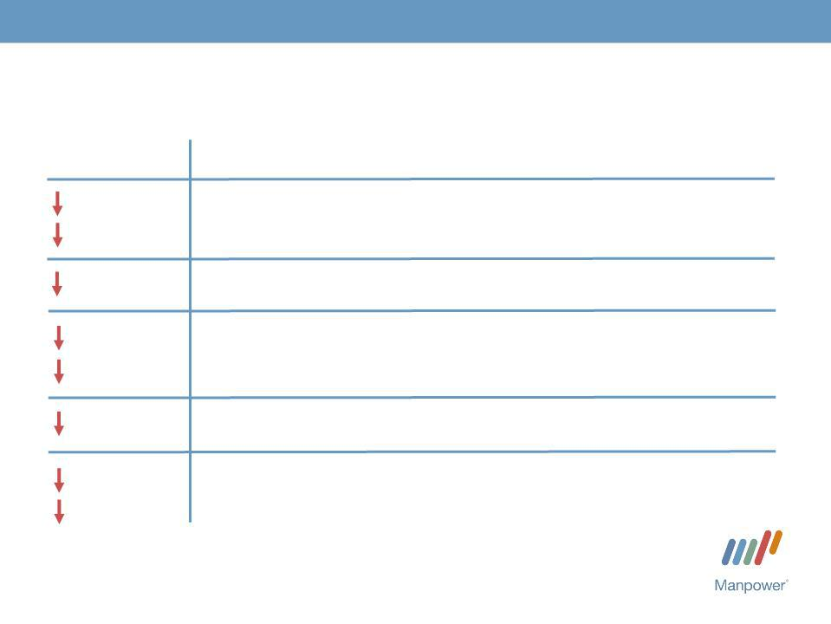
3

Consolidated Financial Highlights

36%

27% CC

(1)
122 bps

89%

88% CC

290 bps

81%

81% CC

Q2 Highlights Revenue $3.8B

Gross Margin 18.3% Operating Profit $22M⁽²⁾ OP Margin 0.6%

EPS $0.25

- Gross profit margin declined 31 bps excluding the impact of the French payroll tax change in 2008.

- Includes reorganization charges of $13.1M recorded in 2009.

Throughout this presentation, the difference between reported variances and Constant Currency (CC) variances represents the impact of currency on our financial results. Constant Currency is further explained on our Web site.

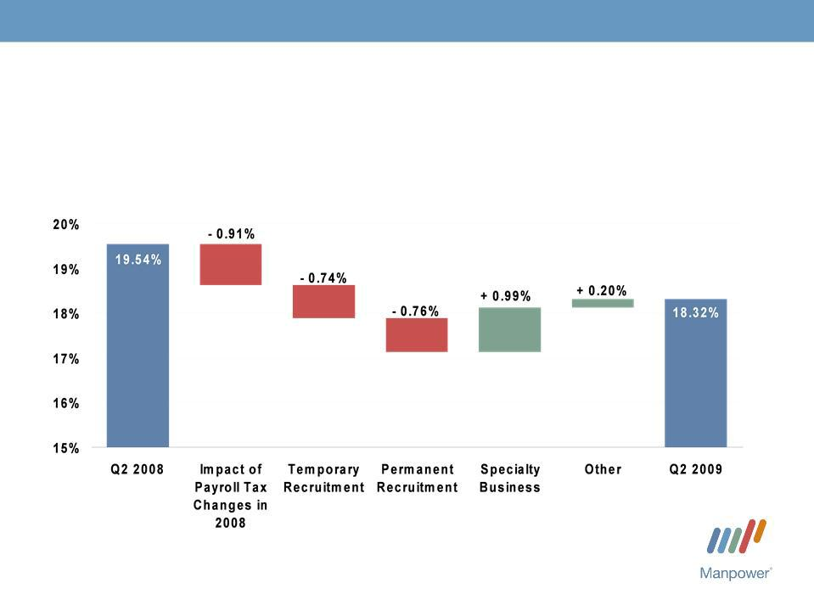
4

Consolidated Gross Margin Change

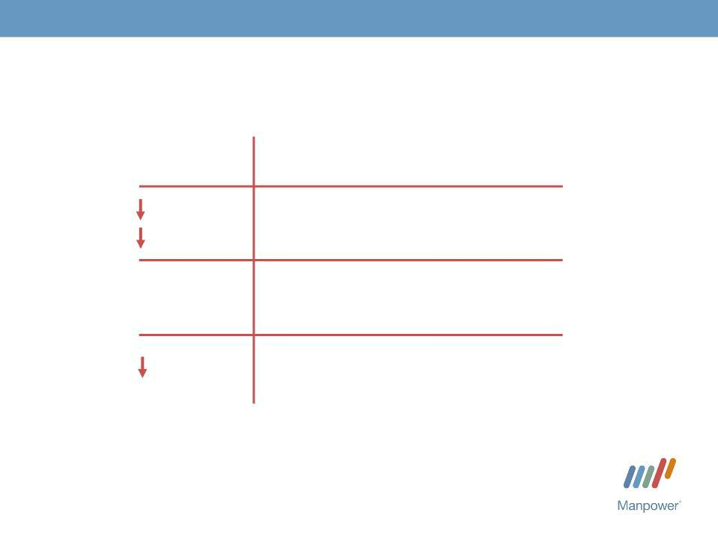
5

Americas Segment

(16% of Revenue)

 | Q2 Financial Highlights ⁽¹⁾
24%⁽²⁾ | Revenue $595M
(2) | Revenue $595M
19% CC
N/A | OUP $(2M)
310 bps | OUP Margin - 0.3%

- Included in these amounts is the US, which had revenue of $374M (-24%) and OUP of $(6M).

- The results above include the impact of acquisitions. On an organic basis, Americas revenue decreased 29% in USD (23% in CC).

Operating Unit Profit (OUP) is the measure that we use to evaluate segment performance. OUP is equal to segment revenues less direct costs and branch and national headquarters operating costs.

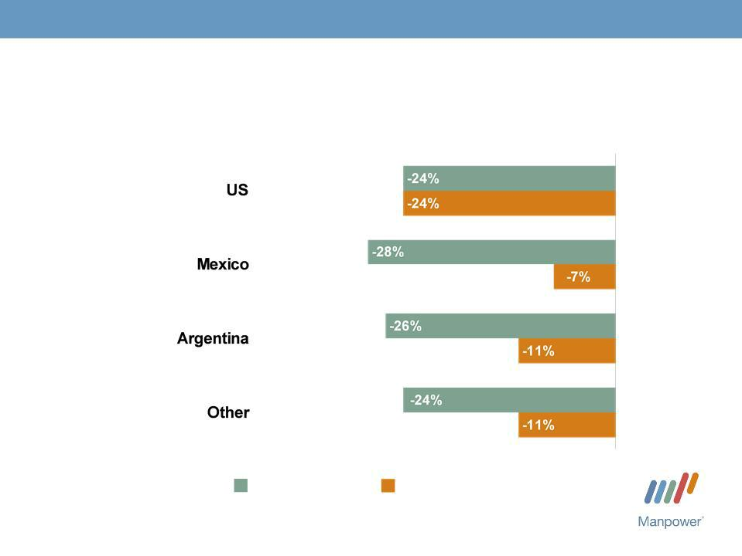
6

Americas - Q2 Revenue Growth YoY

- of Segment Revenue
(1)

63%

13%

8%

16%

Revenue

Growth

Revenue Growth - CC

- On an organic basis, US revenue decreased 31% in USD.

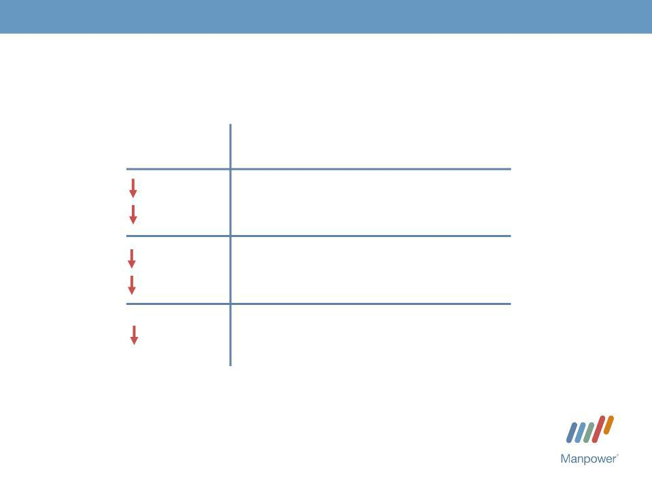
7

France Segment

(29% of Revenue)

 | Q2 Financial Highlights
44% | Revenue $1.1B
36% | Revenue $1.1B
CC
94% | OUP $4M
93%
CC | OUP Margin 0.4%
320 bps | OUP Margin 0.4%

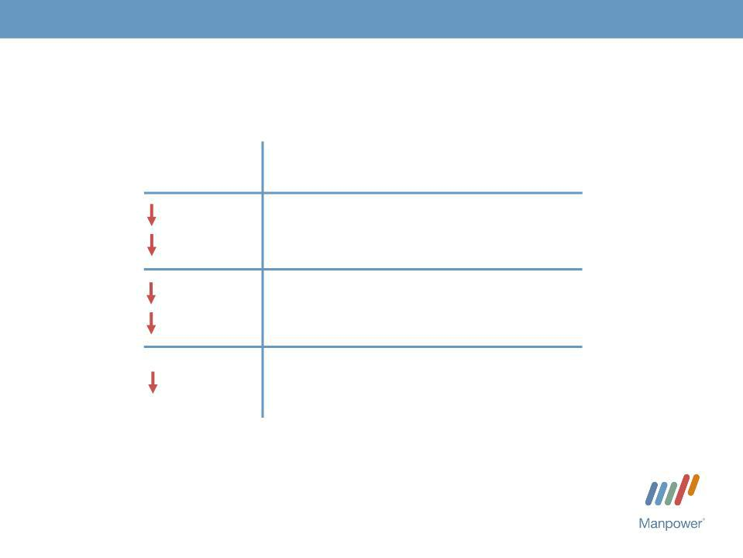
8

EMEA Segment

(39% of Revenue)

Q2 Financial Highlights ⁽¹⁾

40% | Revenue | $1.5B
28% | Revenue | $1.5B
CC
98% |  | (2)
97% | OUP $3M
CC
470 bps OUP Margin 0.2%

- Included in these amounts is Italy, which had revenue of $230M (-48% in USD, -40% in CC) and OUP of $7M (-82% in USD, -79% in CC).

- Includes reorganization charges of $5.5M recorded in 2009.

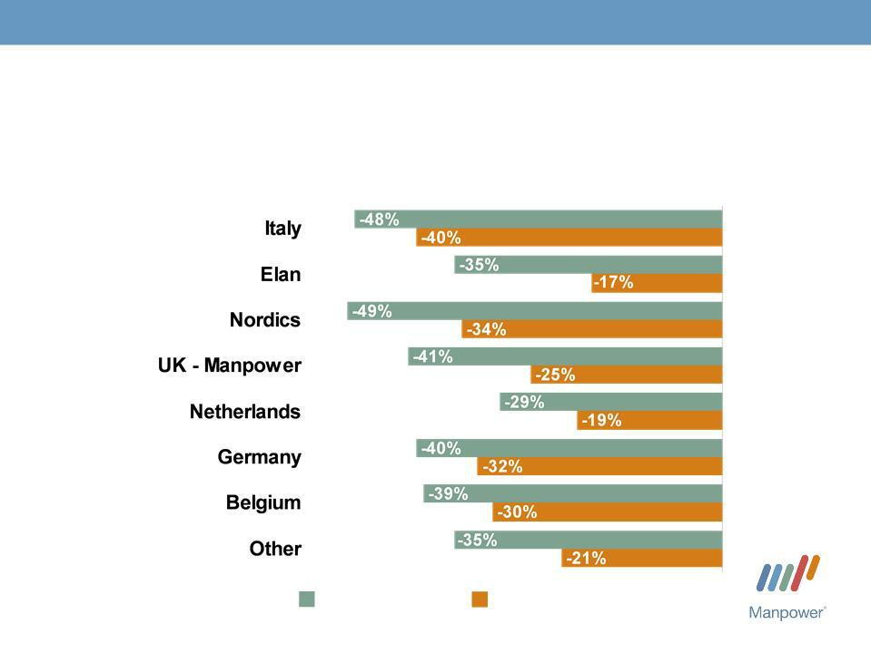
9

EMEA - Q2 Revenue Growth YoY

- of Segment Revenue

15%

15%

14%

11%

10%

9%

5%
21%

Revenue | Revenue Growth - CC
Growth

10

Asia Pacific Segment

(11% of Revenue)

Q2 Financial Highlights

14% | Revenue $406M
13%
CC
62% | OUP $4M | (1)
71% | OUP $4M
CC
110 bps OUP Margin 0.9%

- Includes reorganization charges of $1.5M recorded in 2009.

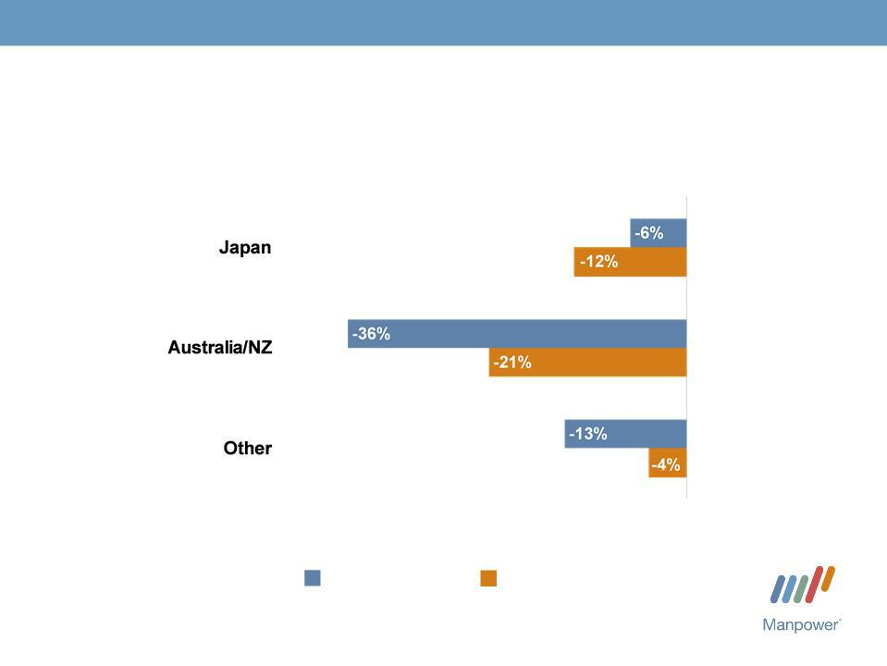
11

Asia Pacific - Q2 Revenue Growth YoY

- of Segment Revenue

61%

18%

21%

Revenue | Revenue Growth - CC
Growth

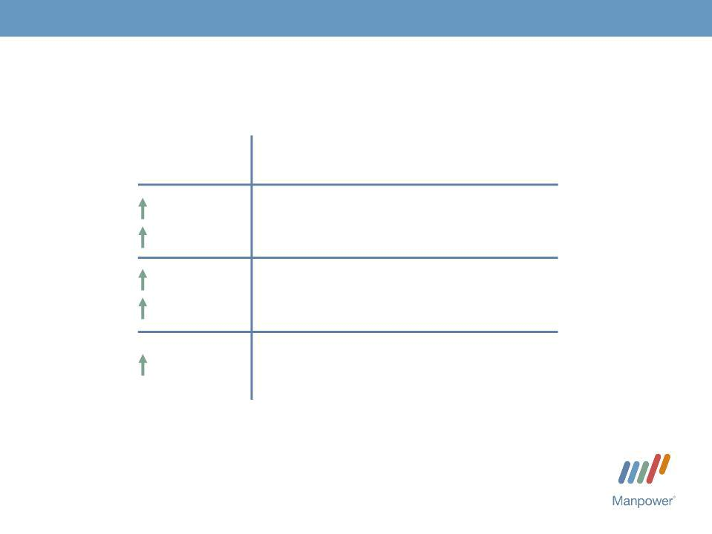
12

Right Management Segment

(4% of Revenue)

Q2 Financial Highlights

36% | Revenue $158M
46% | Revenue $158M
CC
217% | OUP $42M
232% CC | OUP $42M
1530 | OUP Margin 26.8%
bps

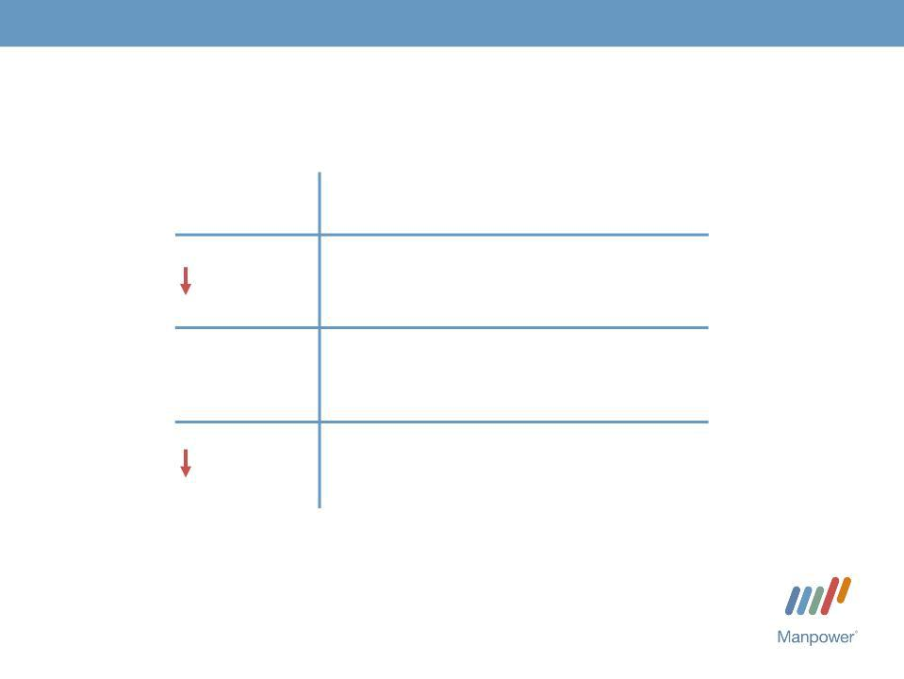
13

Jefferson Wells Segment

(1% of Revenue)

 | Q2 Financial Highlights
36% | Revenue $48M
N/A | OUP $(10M)⁽¹⁾
1900 | OUP Margin -
bps | 21.2%

- Includes reorganization charges of $5.9M recorded in 2009.


14

Financial Highlights

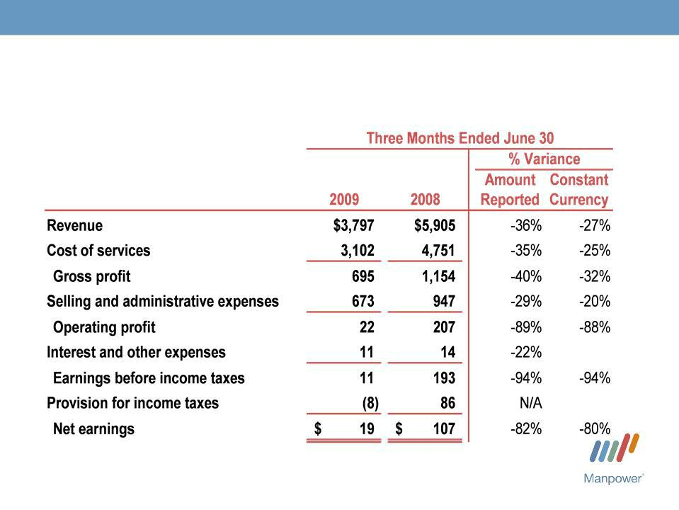
15

Results of Operations

(in millions)

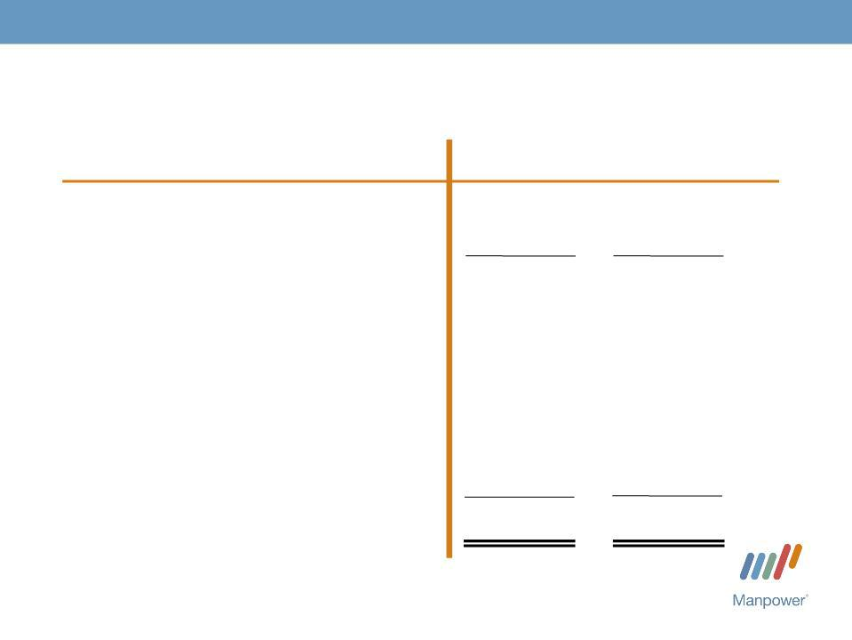
16

Cash Flow Summary - First Half

($ in millions)

Cash from Operations

Capital
Free^{Expenditures}CashFlow

Share Repurchases

Change in
Debt
Acquisitions of Businesses,netofcash acquired

Effect of Exchange Rate Changes Other

Change in Cash

2009 2008

- 266

  - (52)

362 214

- | (53)
(85) | 26

  - (196)

    - 45

- (12)

233 24

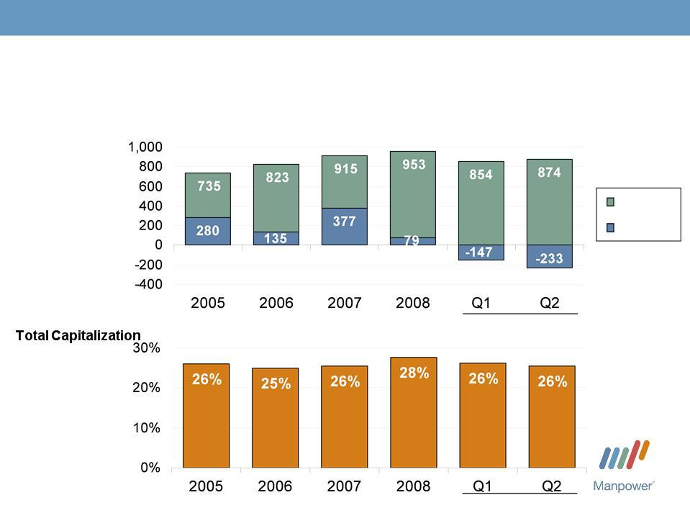
17

Balance Sheet Highlights

Total Debt

($ in millions)

Total Debt

Net
Debt

Total Debt to | 2009

2009


18

Credit Facilities as of June 30, 2009

($ in millions)

Euro
Notes:
- Euro
200M
- Euro
300M

Revolving Credit Agreement

Uncommitted lines and
Other

Total Debt

(a)

(b)

Interest | Maturity | Total | Remaining
Rate | Date | Outstanding | Available
4.86% | June | 281 | -
4.58% | 2013 | 421 | -
4.58% | June | 421 | -
6.11% | 2012 | 140 | 474
6.11% | Nov 2012 | 140 | 474
Various | Various | 32 | 368
 |  | 874 | 842

  - $625M multi-currency Revolving Credit Agreement provided by 17 banks. As of June 30, 2009, there was a €100M borrowing under the Revolving Credit Agreement at Euro LIBOR + 40 bps (our current credit spread). The Euro LIBOR portion has been swapped to a 5.71% fixed rate until July 2010, resulting in a total current borrowing cost of 6.11%. The credit agreement requires, among other things, that we comply with a Debt-to-EBITDA ratio of less than 3.25 to 1 and a fixed charge ratio of greater than 2.00 to 1. As defined in the agreement, we had a Debt-to-EBITDA ratio of 1.9 to 1 and a fixed charge ratio of 2.5 to 1 as of June 30, 2009.

- During June we terminated our $100M U.S. Accounts Receivable Securitization program which would have expired in July 2009.

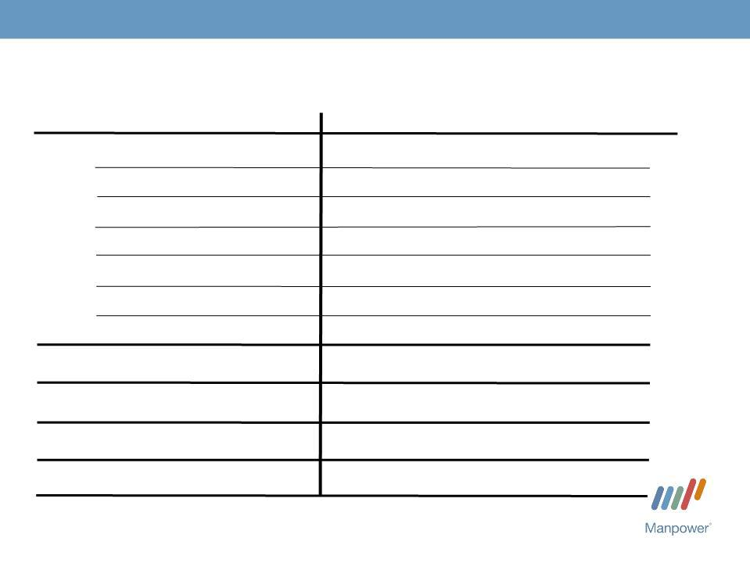
19

Third Quarter Outlook

Revenue Americas

France

EMEA

Asia

RightPacific

Management Jefferson Wells

Total

Gross Profit
Margin
Operating Profit
Tax Rate^{Margin}

EPS

_{Down 21-23%} (Down 16-18% CC)

Down 36-38% (Down 31-33% CC)

Down 32-34% | (Down 26-28%
Down 10-12% | CC)
Down 10-12% | (Down 11-13%
Up 23- | CC)
Up 23- | (Up 29-31%
25% | CC)
Down 38-
40% | (Down 24-26%
Down 29- | (Down 24-26%
31% | CC)
17.5-17.7%
0.7-
0.9%
37%
$0.07-$0.21 | (Neg. $.01
 | Currency)


Manpower Inc.
2009 2nd Quarter Results

July 23, 2009

Questions?
Answers

