UNITED STATES

SECURITIES AND EXCHANGE COMMISSION
Washington, D.C. 20549

FORM 8-K

CURRENT REPORT

Pursuant to Section 13 or 15(d) of the Securities Exchange Act of 1934

Date of Report (Date of earliest event reported): October 20, 2010

MANPOWER INC.

(Exact name of registrant as specified in its charter)

Wisconsin

(State or other jurisdiction of incorporation)

1-10686

(Commission File Number)

39-1672779

(IRS Employer Identification No.)

100 Manpower Place

Milwaukee, Wisconsin

(Address of principal executive offices)

53212

(Zip Code)

Registrant's telephone number, including area code: (414) 961-1000

Check the appropriate box below if the Form 8-K filing is intended to simultaneously satisfy the filing obligation of the registrant under any of the following provisions:

Written communications pursuant to Rule 425 under the Securities Act (17 CFR 230.425)

Soliciting material pursuant to Rule 14a-12 under the Securities Act (17 CFR 240.14a-12)

Pre-commencement communications pursuant to Rule 14d-2(b) under the Exchange Act (17 CFR 240.14d-2(b))

Pre-commencement communications pursuant to Rule 13e-4(c) under the Exchange Act (17 CFR 240.13e-4(c))

Item 2.02 Results of Operations and Financial Condition

On October 20, 2010, we issued a press release announcing our results of operations for the three- and nine- month periods ended September 30, 2010. A copy of the press release is attached hereto as Exhibit 99.1 and is incorporated herein by reference.

Item 9.01. | Exhibits.
Exhibit No. | Description
99.1 | Press Release dated October 20, 2010
99.2 | Presentation materials for October 20, 2010 conference call

SIGNATURES

Pursuant to the requirements of the Securities Exchange Act of 1934, the Registrant has duly caused this Report to be signed on its behalf by the undersigned hereunto duly authorized.

MANPOWER INC.

Dated: October 20, 2010 By: /s/ Michael J. Van Handel

Michael J. Van Handel

Executive Vice President and

Chief Financial Officer

 | EXHIBIT INDEX
Exhibit No. | Description
99.1 | Press Release dated October 20, 2010
99.2 | Presentation materials for October 20, 2010 conference call

Exhibit 99.1


FOR IMMEDIATE RELEASE Contact:

Mike Van Handel
Manpower Inc.
+1.414.906.6305
michael.vanhandel@manpower.com

Manpower Inc. Reports 3rd Quarter 2010 Results

MILWAUKEE, WI, USA, October 20, 2010 – Manpower Inc. (NYSE: MAN) today reported that earnings per diluted share for the three months ended September 30, 2010 were 62 cents compared to a loss of 67 cents in the prior year period. Revenues for the third quarter were $5.0 billion, an increase of 19 percent from the year earlier period, or an increase of 24 percent in constant currency.

Third quarter results were unfavorably impacted by 3 cents per diluted share as foreign currencies were relatively weaker compared to the third quarter of 2009.

Third quarter 2009 results include a loss on the sale of an equity investment and a goodwill impairment charge totaling $71.3 million ($66.3 million after tax) or 84 cents per diluted share. Also included in third quarter 2009 results is a $7.5 million ($4.6 million after tax) or 6 cents per diluted share charge related to the repayment of our revolver borrowings and the extinguishment of an interest rate swap agreement. Excluding these charges, third quarter 2009 net earnings would have been $18.1 million, or 23 cents per diluted share.

Jeffrey A. Joerres, Manpower Inc. Chairman and Chief Executive Officer, said, “Our team around the world did an outstanding job in the third quarter. We were able to sustain our growth from the second quarter and substantially improve our operating margin. We continue to benefit from our office network and strong portfolio of offerings.

“The U.S., Germany and the U.K. did particularly well, as did the emerging markets. The trends continue to be strong for our industry, and we continue to hear and experience encouraging signs from our clients.

“We are anticipating the fourth quarter of 2010 diluted earnings per share to be in the range of $.54 to $.62, which includes an estimated negative currency impact of 2 cents. This is before expected reorganization charges related to Right Management and Jefferson Wells of 15 to 20 cents per share,” Joerres stated.

Earnings per diluted share for the nine months ended September 30, 2010 were $1.06 compared to a loss of 49 cents per diluted share in 2009. Net earnings were $86.8 million compared to a loss of $38.3 million in the prior year. Revenues for the nine-month period were $13.7 billion, an increase of 18 percent from the prior year. Foreign currency exchange rates had an unfavorable impact of 1 cent for the nine-month period.

Earnings per diluted share for the nine month period in 2009 include the loss on the sale of the equity investment and goodwill impairment charge totaling 84 cents, the charge of 6 cents related to the repayment of our revolver borrowings and extinguishment of an interest rate swap, and the first and second quarter reorganization charges totaling 17 cents.

In conjunction with its third quarter earnings release, Manpower will broadcast its conference call live over the Internet on October 20, 2010 at 7:30 a.m. CDT (8:30 a.m. EDT). Interested parties are invited to listen to the webcast and view the presentation by logging on to http://investor.manpower.com.

Supplemental financial information referenced in the conference call can be found at http://investor.manpower.com.

About Manpower Inc.

Manpower Inc. (NYSE: MAN) is a world leader in innovative workforce solutions; creating and delivering services that enable its clients to win in the changing world of work. With over 60 years’ experience, Manpower offers employers a range of services and solutions for the entire employment and business cycle including permanent, temporary and contract recruitment; employee assessment and selection; training; outplacement; outsourcing and consulting. Manpower’s worldwide network of nearly 4,000 offices in 82 countries and territories is the world’s largest in the industry and enables the company to meet the needs of its 400,000 clients per year, including small and medium size enterprises in all industry sectors, as well as the world's largest multinational corporations. The focus of Manpower’s work is on raising productivity through improved quality, efficiency and cost-reduction across their total workforce, enabling clients to concentrate on their core business activities. Manpower Inc. operates under five brands: Manpower, Manpower Professional, Elan, Jefferson Wells and Right Management. More information about Manpower Inc. is available at www.manpower.com.

Forward-Looking Statements

This news release contains statements, including earnings projections, that are forward-looking in nature and, accordingly, are subject to risks and uncertainties regarding the Company’s expected future results. The Company’s actual results may differ materially from those described or contemplated in the forward-looking statements. Factors that may cause the Company’s actual results to differ materially from those contained in the forward-looking statements can be found in the Company’s reports filed with the SEC, including the information under the heading ‘Risk Factors’ in its Annual Report on Form 10-K for the year ended December 31, 2009, which information is incorporated herein by reference.

- ### -

Manpower Inc.

Results of Operations

(In millions, except per share data)

 |  |  |  |  |  |  | Three Months Ended September 30
 |  |  |  |  |  |  |  |  |  | % Variance
 |  |  |  |  |  |  |  |  |  | Amount |  |  | Constant
 |  |  | 2010 |  |  |  | 2009 |  |  | Reported |  |  | Currency
 |  |  |  |  |  |  | (Unaudited)
 | Revenues from services (a) (b) | $ | 4,972.0 |  | $ |  | 4,189.6 |  |  | 18.7% |  |  | 24.1%
 | Cost of services |  | 4,130.8 |  |  |  | 3,485.5 |  |  | 18.5% |  |  | 24.1%
 | Gross profit |  | 841.2 |  |  |  | 704.1 |  |  | 19.5% |  |  | 24.4%
 | Selling and administrative expenses |  | 732.3 |  |  |  | 664.6 |  |  | 10.2% |  |  | 14.4%
 | Goodwill and intangible asset impairment charges |  | - |  |  |  | 61.0 |  |  | N/A |  |  | N/A
 | Selling and administrative expenses |  | 732.3 |  |  |  | 725.6 |  |  | 0.9% |  |  | 4.8%
 | Operating profit (loss) |  | 108.9 |  |  |  | (21.5) |  |  | N/A |  |  | N/A
 | Interest and other expenses |  | 8.4 |  |  |  | 29.3 |  |  | -71.4%
 | Earnings (loss) before income taxes |  | 100.5 |  |  |  | (50.8) |  |  | N/A |  |  | N/A
 | Provision for income taxes |  | 49.2 |  |  |  | 2.0 |  |  | N/A
 | Net earnings (loss) | $ | 51.3 |  | $ |  | (52.8) |  |  | N/A |  |  | N/A
 | Net earnings (loss) per share - basic | $ | 0.63 |  | $ |  | (0.67) |  |  | N/A
 | Net earnings (loss) per share - diluted | $ | 0.62 |  | $ |  | (0.67) |  |  | N/A |  |  | N/A
 | Weighted average shares - basic |  | 81.9 |  |  |  | 78.4 |  |  | 4.5%
 | Weighted average shares - diluted |  | 82.7 |  |  |  | 78.4 |  |  | 5.5%

- Revenues from services include fees received from our franchise offices of $6.8 million and $5.7 million for the three months ended September 30, 2010 and 2009, respectively. These fees are primarily based on revenues generated by the franchise offices, which were $273.3 million and $200.3 million for the three months ended September 30, 2010 and 2009, respectively.

- Our 2009 results have been restated as disclosed in Note 16 to the Consolidated Financial Statements included in our 2009 Annual Report to Shareholders.

Manpower Inc.

Operating Unit Results

(In millions)

 |  |  |  |  |  |  | Three Months Ended September 30
 |  |  |  |  |  |  |  |  |  | % Variance
 |  |  |  |  |  |  |  |  |  | Amount |  |  | Constant
 |  |  | 2010 |  |  |  | 2009 |  |  | Reported |  |  | Currency
 |  |  |  |  |  |  | (Unaudited)
 | Revenues from Services:
 | Americas:
 | United States (a) | $ | 752.1 |  | $ |  | 409.8 |  |  | 83.5% |  |  | 83.5%
 | Other Americas |  | 317.1 |  |  |  | 243.5 |  |  | 30.3% |  |  | 25.8%
 |  |  | 1,069.2 |  |  |  | 653.3 |  |  | 63.7% |  |  | 62.0%
 | France |  | 1,411.6 |  |  |  | 1,314.1 |  |  | 7.4% |  |  | 18.8%
 | EMEA:
 | Italy |  | 257.1 |  |  |  | 231.0 |  |  | 11.3% |  |  | 23.1%
 | Other EMEA (b) |  | 1,548.0 |  |  |  | 1,379.3 |  |  | 12.2% |  |  | 19.6%
 |  |  | 1,805.1 |  |  |  | 1,610.3 |  |  | 12.1% |  |  | 20.1%
 | Asia Pacific |  | 555.7 |  |  |  | 427.9 |  |  | 29.8% |  |  | 20.5%
 | Right Management |  | 85.5 |  |  |  | 135.7 |  |  | -37.0% |  |  | -36.5%
 | Jefferson Wells |  | 44.9 |  |  |  | 48.3 |  |  | -6.9% |  |  | -6.9%
 |  | $ | 4,972.0 |  | $ |  | 4,189.6 |  |  | 18.7% |  |  | 24.1%
 | Operating Unit Profit (Loss) (c):
 | Americas:
 | United States (a) | $ | 27.4 |  | $ |  | 1.7 |  |  | N/A |  |  | N/A
 | Other Americas |  | 8.2 |  |  |  | 5.5 |  |  | 49.4% |  |  | 43.2%
 |  |  | 35.6 |  |  |  | 7.2 |  |  | 395.3% |  |  | 390.5%
 | France |  | 25.0 |  |  |  | 10.6 |  |  | 135.6% |  |  | 160.6%
 | EMEA:
 | Italy |  | 11.4 |  |  |  | 8.6 |  |  | 30.7% |  |  | 44.6%
 | Other EMEA (b) |  | 43.0 |  |  |  | 16.0 |  |  | 171.0% |  |  | 190.8%
 |  |  | 54.4 |  |  |  | 24.6 |  |  | 121.5% |  |  | 139.3%
 | Asia Pacific |  | 13.1 |  |  |  | 4.0 |  |  | 234.1% |  |  | 210.9%
 | Right Management |  | - |  |  |  | 21.2 |  |  | N/A |  |  | N/A
 | Jefferson Wells |  | (1.5) |  |  |  | (0.6) |  |  | N/A |  |  | N/A
 |  |  | 126.6 |  |  |  | 67.0
 | Corporate expenses |  | (23.6) |  |  |  | (21.1)
 | Goodwill and intangible asset impairment charge |  | - |  |  |  | (61.0)
 | Intangible asset amortization expense (c) |  | (11.6) |  |  |  | (6.4)
 | Reclassification of French business tax |  | 17.5 |  |  |  | -
 | Operating profit (loss) |  | 108.9 |  |  |  | (21.5) |  |  | N/A |  |  | N/A
 | Interest and other expenses (d) |  | (8.4) |  |  |  | (29.3)
 | Earnings (loss) before income taxes | $ | 100.5 |  | $ |  | (50.8)

- The United States results include the results of COMSYS IT Partners, Inc., which was acquired on April 5, 2010. United States revenues from services include fees received from our franchise offices of $4.0 million and $3.0 million for the three months ended September 30, 2010 and 2009, respectively. These fees are primarily based on revenues generated by the franchise offices, which were $169.0 million and $121.6 million for the three months ended September 30, 2010 and 2009, respectively.

- Our 2009 results have been restated as disclosed in Note 16 to the Consolidated Financial Statements included in our 2009 Annual Report to Shareholders.

- During the third quarter of 2010, we redefined Operating Unit Profit (Loss) to exclude intangible asset amortization. Therefore, these costs are no longer included as operating costs within the reportable segments and Corporate Expenses, and all intangible asset amortization expense is now shown separately. All previously reported results have been restated to conform to the current year presentation.

- The components of interest and other expenses were:

 |  | 2010 |  |  |  | 2009
Interest expense | $ | 10.0 |  | $ |  | 21.5
Interest income |  | (1.2) |  |  |  | (1.7)
Foreign exchange gains |  | (0.3) |  |  |  | (0.6)
Miscellaneous income, net |  | (0.1) |  |  |  | (0.2)
Loss from sale of an equity investment |  | - |  |  |  | 10.3
 | $ | 8.4 |  | $ |  | 29.3

Manpower Inc.

Results of Operations

(In millions, except per share data)

 |  |  |  |  |  |  | Nine Months Ended September 30
 |  |  |  |  |  |  |  |  |  | % Variance
 |  |  |  |  |  |  |  |  |  | Amount |  |  | Constant
 |  |  | 2010 |  |  |  | 2009 |  |  | Reported |  |  | Currency
 |  |  |  |  |  |  | (Unaudited)
 | Revenues from services (a) (b) | $ | 13,656.9 |  | $ |  | 11,626.1 |  |  | 17.5% |  |  | 18.0%
 | Cost of services |  | 11,317.2 |  |  |  | 9,564.0 |  |  | 18.3% |  |  | 19.0%
 | Gross profit |  | 2,339.7 |  |  |  | 2,062.1 |  |  | 13.5% |  |  | 13.7%
 | Selling and administrative expenses |  | 2,119.1 |  |  |  | 2,002.2 |  |  | 5.8% |  |  | 5.8%
 | Goodwill and intangible asset impairment charges |  | - |  |  |  | 61.0 |  |  | N/A |  |  | N/A
 | Selling and administrative expenses |  | 2,119.1 |  |  |  | 2,063.2 |  |  | 2.7% |  |  | 2.7%
 | Operating profit (loss) |  | 220.6 |  |  |  | (1.1) |  |  | N/A |  |  | N/A
 | Interest and other expenses |  | 33.2 |  |  |  | 52.0 |  |  | -36.2%
 | Earnings (loss) before income taxes |  | 187.4 |  |  |  | (53.1) |  |  | N/A |  |  | N/A
 | Provision for income taxes |  | 100.6 |  |  |  | (14.8) |  |  | N/A
 | Net earnings (loss) | $ | 86.8 |  | $ |  | (38.3) |  |  | N/A |  |  | N/A
 | Net earnings (loss) per share - basic | $ | 1.08 |  | $ |  | (0.49) |  |  | N/A
 | Net earnings (loss) per share - diluted | $ | 1.06 |  | $ |  | (0.49) |  |  | N/A |  |  | N/A
 | Weighted average shares - basic |  | 80.7 |  |  |  | 78.3 |  |  | 3.1%
 | Weighted average shares - diluted |  | 81.7 |  |  |  | 78.3 |  |  | 4.4%

- Revenues from services include fees received from our franchise offices of $17.2 million and $16.6 million for the nine months ended September 30, 2010 and 2009, respectively. These fees are primarily based on revenues generated by the franchise offices, which were $704.5 million and $533.3 million for the nine months ended September 30, 2010 and 2009, respectively.

- Our 2009 results have been restated as disclosed in Note 16 to the Consolidated Financial Statements included in our 2009 Annual Report to Shareholders.

Manpower Inc.

Operating Unit Results

(In millions)

 |  |  |  |  |  |  | Nine Months Ended September 30
 |  |  |  |  |  |  |  |  |  | % Variance
 |  |  |  |  |  |  |  |  |  | Amount |  |  | Constant
 |  |  | 2010 |  |  |  | 2009 |  |  | Reported |  |  | Currency
 |  |  |  |  |  |  | (Unaudited)
 | Revenues from Services:
 | Americas:
 | United States (a) | $ | 1,880.2 |  | $ |  | 1,157.9 |  |  | 62.4% |  |  | 62.4%
 | Other Americas |  | 917.7 |  |  |  | 683.4 |  |  | 34.3% |  |  | 26.5%
 |  |  | 2,797.9 |  |  |  | 1,841.3 |  |  | 52.0% |  |  | 49.1%
 | France |  | 3,775.0 |  |  |  | 3,371.1 |  |  | 12.0% |  |  | 17.4%
 | EMEA:
 | Italy |  | 750.1 |  |  |  | 681.5 |  |  | 10.1% |  |  | 14.9%
 | Other EMEA (b) |  | 4,361.3 |  |  |  | 3,894.0 |  |  | 12.0% |  |  | 12.9%
 |  |  | 5,111.4 |  |  |  | 4,575.5 |  |  | 11.7% |  |  | 13.2%
 | Asia Pacific |  | 1,558.9 |  |  |  | 1,259.3 |  |  | 23.8% |  |  | 13.7%
 | Right Management |  | 287.6 |  |  |  | 429.8 |  |  | -33.1% |  |  | -34.2%
 | Jefferson Wells |  | 126.1 |  |  |  | 149.1 |  |  | -15.4% |  |  | -15.4%
 |  | $ | 13,656.9 |  | $ |  | 11,626.1 |  |  | 17.5% |  |  | 18.0%
 | Operating Unit Profit (Loss) (c):
 | Americas:
 | United States (a) | $ | 38.0 |  | $ |  | (15.4) |  |  | N/A |  |  | N/A
 | Other Americas |  | 26.5 |  |  |  | 14.2 |  |  | 87.1% |  |  | 76.8%
 |  |  | 64.5 |  |  |  | (1.2) |  |  | N/A |  |  | N/A
 | France |  | 35.1 |  |  |  | 15.8 |  |  | 122.7% |  |  | 148.0%
 | EMEA:
 | Italy |  | 31.7 |  |  |  | 16.8 |  |  | 87.9% |  |  | 99.5%
 | Other EMEA (b) |  | 91.6 |  |  |  | 8.2 |  |  | N/A |  |  | N/A
 |  |  | 123.3 |  |  |  | 25.0 |  |  | 392.8% |  |  | 410.2%
 | Asia Pacific |  | 37.6 |  |  |  | 19.6 |  |  | 93.4% |  |  | 76.6%
 | Right Management |  | 20.3 |  |  |  | 92.6 |  |  | -78.0% |  |  | -78.9%
 | Jefferson Wells |  | (9.3) |  |  |  | (18.3) |  |  | N/A |  |  | N/A
 |  |  | 271.5 |  |  |  | 133.5
 | Corporate expenses |  | (70.4) |  |  |  | (56.6)
 | Goodwill and intangible asset impairment charge |  | - |  |  |  | (61.0)
 | Intangible asset amortization expense (c) |  | (28.1) |  |  |  | (17.0)
 | Reclassification of French business tax |  | 47.6 |  |  |  | -
 | Operating profit (loss) |  | 220.6 |  |  |  | (1.1) |  |  | N/A |  |  | N/A
 | Interest and other expenses (d) |  | (33.2) |  |  |  | (52.0)
 | Earnings (loss) before income taxes | $ | 187.4 |  | $ |  | (53.1)

- The United States results include the results of COMSYS IT Partners, Inc., which was acquired on April 5, 2010. United States, revenues from services include fees received from our franchise offices of $9.9 million and $7.4 million for the nine months ended September 30, 2010 and 2009, respectively. These fees are primarily based on revenues generated by the franchise offices, which were $457.0 million and $323.7 million for the nine months ended September 30, 2010 and 2009, respectively.

- Our 2009 results have been restated as disclosed in Note 16 to the Consolidated Financial Statements included in our 2009 Annual Report to Shareholders.

- During the third quarter of 2010, we redefined Operating Unit Profit (Loss) to exclude intangible asset amortization. Therefore, these costs are no longer included as operating costs within the reportable segments and Corporate Expenses, and all intangible asset amortization expense is now shown separately. All previously reported results have been restated to conform to the current year presentation.

- The components of interest and other expenses were:

 |  | 2010 |  |  |  | 2009
Interest expense | $ | 33.6 |  | $ |  | 48.5
Interest income |  | (4.2) |  |  |  | (9.3)
Foreign exchange losses |  | 2.5 |  |  |  | 0.9
Miscellaneous expenses, net |  | 1.3 |  |  |  | 1.6
Loss from sale of an equity investment |  | - |  |  |  | 10.3
 | $ | 33.2 |  | $ |  | 52.0

Manpower Inc.

Consolidated Balance Sheets

(In millions)

 |  | Sep. 30 |  |  |  | Dec. 31
 |  | 2010 |  |  |  | 2009
 |  | (Unaudited)
ASSETS
Current assets:
Cash and cash equivalents | $ | 598.3 |  | $ |  | 1,014.6
Accounts receivable, net |  | 3,890.9 |  |  |  | 3,070.8
Prepaid expenses and other assets |  | 146.1 |  |  |  | 179.6
Future income tax benefits |  | 73.9 |  |  |  | 67.4
Total current assets |  | 4,709.2 |  |  |  | 4,332.4
Other assets:
Goodwill and other intangible assets, net |  | 1,758.0 |  |  |  | 1,357.5
Other assets |  | 374.6 |  |  |  | 347.5
Total other assets |  | 2,132.6 |  |  |  | 1,705.0
Property and equipment:
Land, buildings, leasehold improvements and equipment |  | 711.1 |  |  |  | 703.6
Less: accumulated depreciation and amortization |  | 537.5 |  |  |  | 527.2
Net property and equipment |  | 173.6 |  |  |  | 176.4
Total assets | $ | 7,015.4 |  | $ |  | 6,213.8
LIABILITIES AND SHAREHOLDERS' EQUITY
Current liabilities:
Accounts payable | $ | 1,293.5 |  | $ |  | 944.4
Employee compensation payable |  | 221.5 |  |  |  | 187.8
Accrued liabilities |  | 516.0 |  |  |  | 465.9
Accrued payroll taxes and insurance |  | 633.6 |  |  |  | 572.0
Value added taxes payable |  | 502.5 |  |  |  | 391.2
Short-term borrowings and current maturities of long-term debt |  | 24.6 |  |  |  | 41.7
Total current liabilities |  | 3,191.7 |  |  |  | 2,603.0
Other liabilities:
Long-term debt |  | 681.8 |  |  |  | 715.6
Other long-term liabilities |  | 376.3 |  |  |  | 358.7
Total other liabilities |  | 1,058.1 |  |  |  | 1,074.3
Shareholders' equity:
Common stock |  | 1.1 |  |  |  | 1.0
Capital in excess of par value |  | 2,765.1 |  |  |  | 2,544.2
Retained earnings |  | 1,165.8 |  |  |  | 1,109.6
Accumulated other comprehensive income |  | 94.4 |  |  |  | 106.9
Treasury stock, at cost |  | (1,260.8) |  |  |  | (1,225.2)
Total shareholders' equity |  | 2,765.6 |  |  |  | 2,536.5
Total liabilities and shareholders' equity | $ | 7,015.4 |  | $ |  | 6,213.8

Manpower Inc.

Consolidated Statements of Cash Flows

(In millions)

 |  |  | Nine Months Ended
 |  |  | September 30
 |  |  | 2010 |  |  |  | 2009
 |  |  | (Unaudited)
 | Cash Flows from Operating Activities:
 | Net earnings (loss) | $ | 86.8 |  | $ |  | (38.3)
 | Adjustments to reconcile net earnings (loss) to net cash provided by operating activities:
 | Depreciation and amortization |  | 80.2 |  |  |  | 72.8
 | Non-cash goodwill and intangible asset impairment |  | - |  |  |  | 61.0
 | Deferred income taxes |  | (44.9) |  |  |  | (12.1)
 | Provision for doubtful accounts |  | 22.0 |  |  |  | 20.9
 | Loss from sale of an equity investment |  | - |  |  |  | 10.3
 | Share-based compensation |  | 17.9 |  |  |  | 12.5
 | Excess tax benefit on exercise of stock options |  | (0.8) |  |  |  | (0.1)
 | Changes in operating assets and liabilities, excluding the impact of acquisitions:
 | Accounts receivable |  | (730.2) |  |  |  | 655.2
 | Other assets |  | 17.9 |  |  |  | (69.5)
 | Other liabilities |  | 494.7 |  |  |  | (300.8)
 | Cash (used in) provided by operating activities |  | (56.4) |  |  |  | 411.9
 | Cash Flows from Investing Activities:
 | Capital expenditures |  | (41.8) |  |  |  | (27.0)
 | Acquisitions of businesses, net of cash acquired |  | (260.6) |  |  |  | (21.3)
 | Proceeds from the sale of an equity investment |  | - |  |  |  | 13.3
 | Proceeds from the sale of property and equipment |  | 3.1 |  |  |  | 3.3
 | Cash used in investing activities |  | (299.3) |  |  |  | (31.7)
 | Cash Flows from Financing Activities:
 | Net change in short-term borrowings |  | (19.5) |  |  |  | (25.1)
 | Proceeds from long-term debt |  | 1.4 |  |  |  | 146.4
 | Repayments of long-term debt |  | (1.0) |  |  |  | (210.0)
 | Proceeds from share-based awards |  | 15.0 |  |  |  | 9.7
 | Excess tax benefit on exercise of stock options |  | 0.8 |  |  |  | 0.1
 | Repurchases of common stock |  | (34.8) |  |  |  | -
 | Dividends paid |  | (30.6) |  |  |  | (29.0)
 | Cash used in financing activities |  | (68.7) |  |  |  | (107.9)
 | Effect of exchange rate changes on cash |  | 8.1 |  |  |  | 54.3
 | Change in cash and cash equivalents |  | (416.3) |  |  |  | 326.6
 | Cash and cash equivalents, beginning of period |  | 1,014.6 |  |  |  | 874.0
 | Cash and cash equivalents, end of period | $ | 598.3 |  | $ |  | 1,200.6

Exhibit 99.2


Manpower Inc.

2010 3rd Quarter

2010 October 20

Manpower Inc. 2010 3rd Quarter Results | October | 2
 | 2010

Forward-Looking Statement

This presentation includes forward-looking statements, including earnings projections which are subject to risks and uncertainties. Actual results might differ materially from those projected in the forward-looking statements. Additional information concerning factors that could cause actual results to materially differ from those in the forward-looking statements is contained in the Company’s Annual Report on Form 10-K dated December 31, 2009, which information is incorporated herein by reference, and such other factors as may be described from time to time in the Company’s SEC filings.

Manpower Inc. 2010 3rd Quarter Results | October | 3
 | 2010
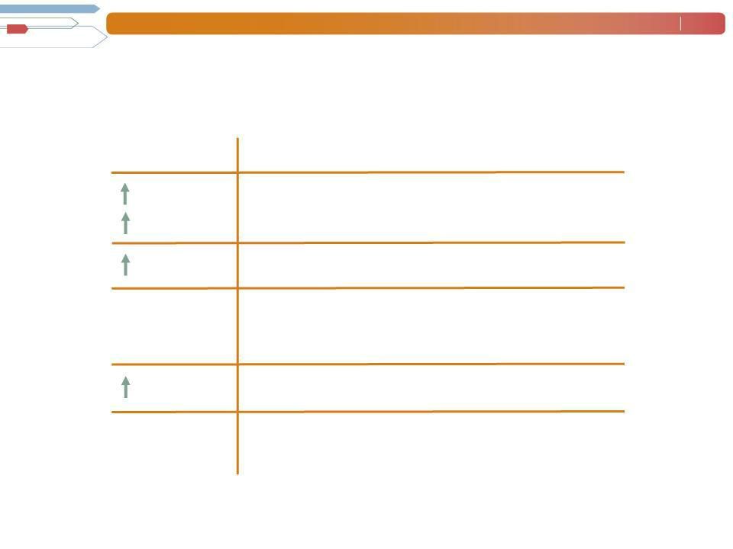
Consolidated Financial Highlights

Q3 Highlights

19%

24% CC

10 bps

N/A

N/A

270 bps

N/A

N/A

Revenue $5.0B Gross Margin 16.9% Operating Profit $109M OP Margin 2.2%

EPS $.62

Throughout this presentation, the difference between reported variances and Constant Currency (CC) variances represents the impact of currency on our financial results. Constant Currency is further explained on our Web site.

Manpower Inc. 2010 3rd Quarter Results | October | 4
 | 2010
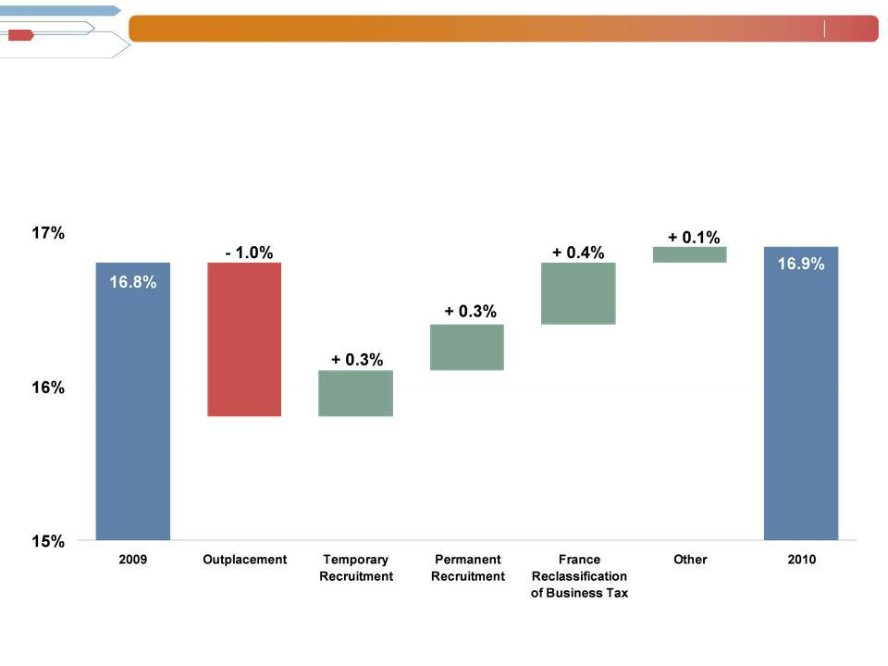

Consolidated Gross Margin Change

Manpower Inc. 2010 3rd Quarter Results | October | 5
 | 2010
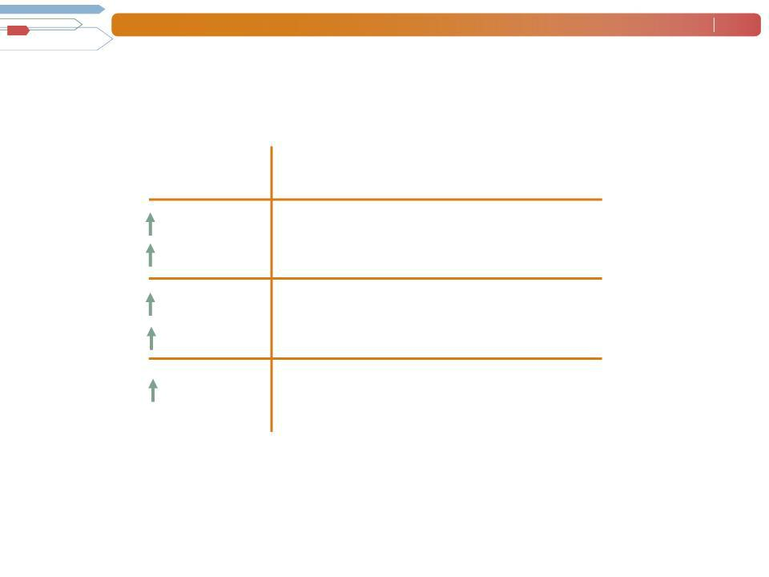

Americas Segment
(22% of Revenue)

Q3 Financial Highlights ⁽¹⁾
^{64%(2)}₍₂₎ Revenue $1.1B

62% CC
^{395%} OUP $36M

391%CC

220 bps OUP Margin 3.3%

- Included in these amounts is the US, which had revenue of $752M (+84%) and OUP of $27M. On an organic basis, US revenue was $552M (+35%) and OUP was $18M.

- On an organic basis, Americas revenue increased 33% in USD (31% in CC).

Operating Unit Profit (OUP) is the measure that we use to evaluate segment performance. OUP is equal to segment revenues less direct costs and branch and national headquarters operating costs.

Manpower Inc. 2010 3rd Quarter Results | October | 6
 | 2010
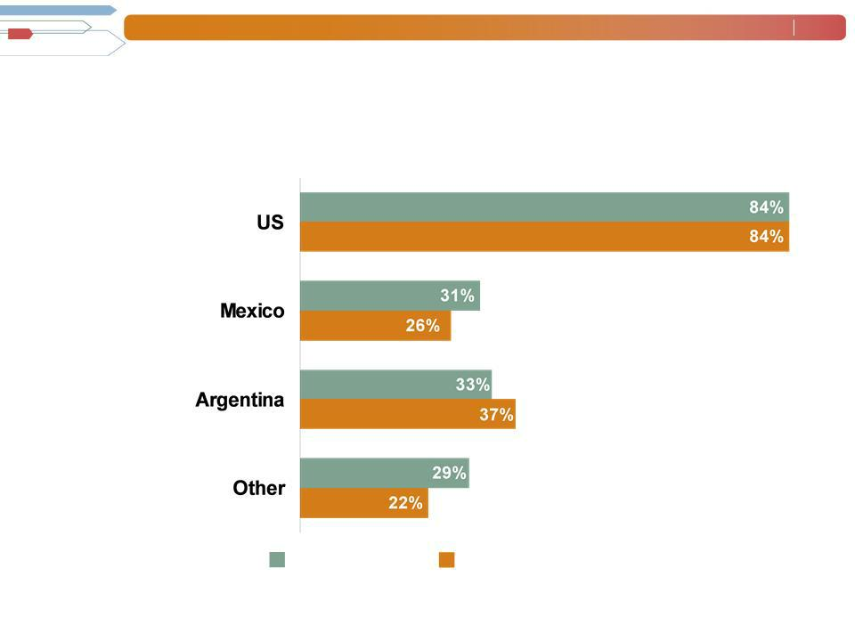

Americas - Q3 Revenue Growth YoY

% of Segment
Revenue
(1)

70%

11%

5%

14%

Revenue

Growth

Revenue Growth - CC

- On an organic basis, US revenue was $552M (+35%).

Manpower Inc. 2010 3rd Quarter Results | October | 7
 | 2010
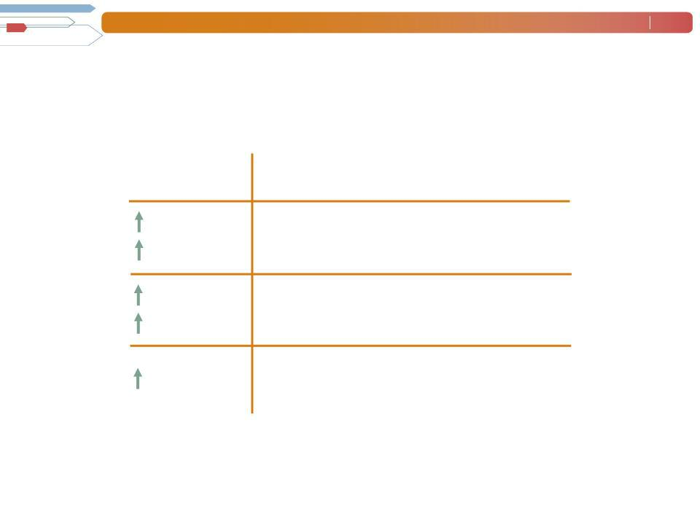

France Segment
(28% of Revenue)

Q3 Financial Highlights

7% | Revenue | $1.4B
19% | Revenue | $1.4B
CC
136% | OUP $25M
161% CC

100 bps OUP Margin 1.8%

Manpower Inc. 2010 3rd Quarter Results | October | 8
 | 2010
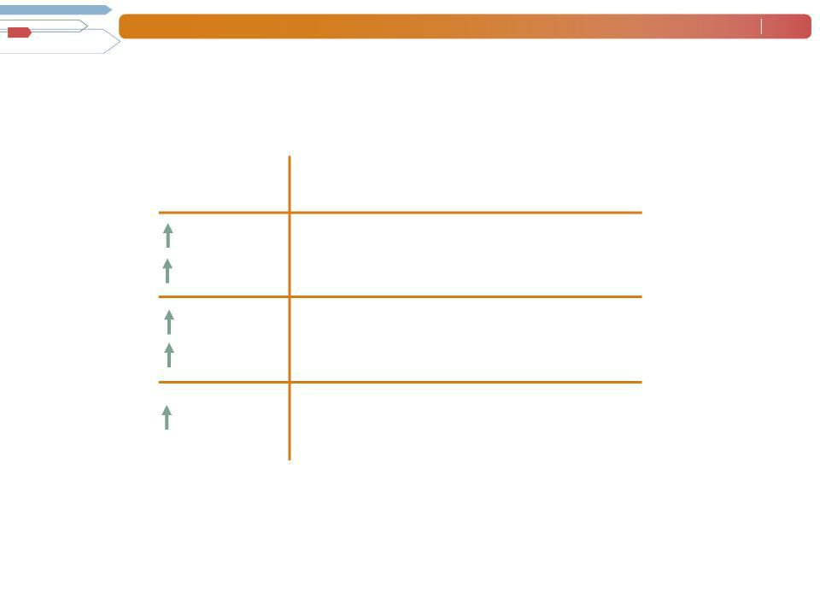

EMEA Segment
(36% of Revenue)

 | Q3 Financial Highlights
12% | Revenue $1.8B
20% CC | Revenue $1.8B
122% | OUP $54M
139% CC | OUP $54M
150 bps | OUP Margin 3.0%

Manpower Inc. 2010 3rd Quarter Results | October | 9
 | 2010
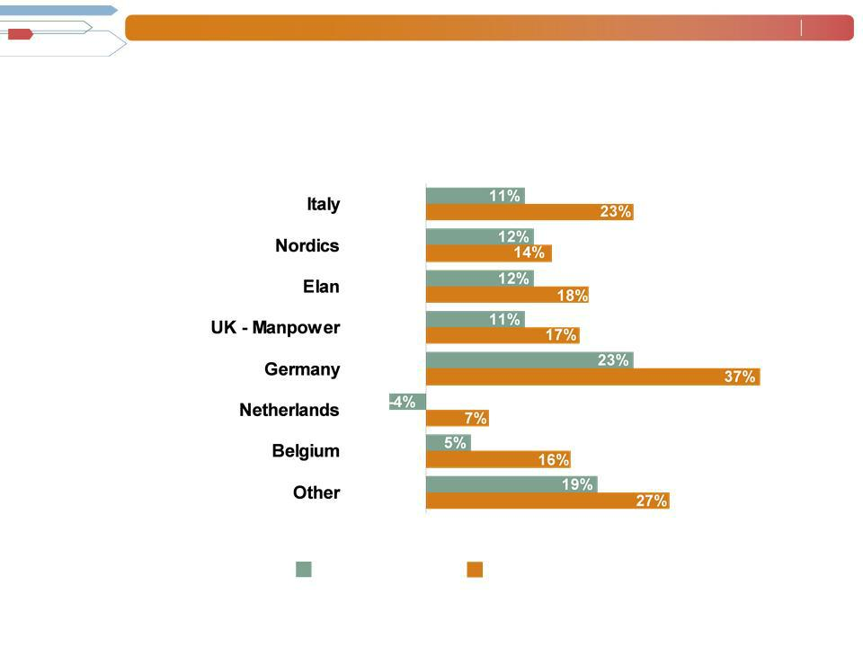
EMEA - Q3 Revenue Growth YoY

- of Segment Revenue

14%

14%

13%

11%

10%

8%

6%

24%

Revenue | Revenue Growth - CC
Growth

Manpower Inc. 2010 3rd Quarter Results | October | 10
 | 2010
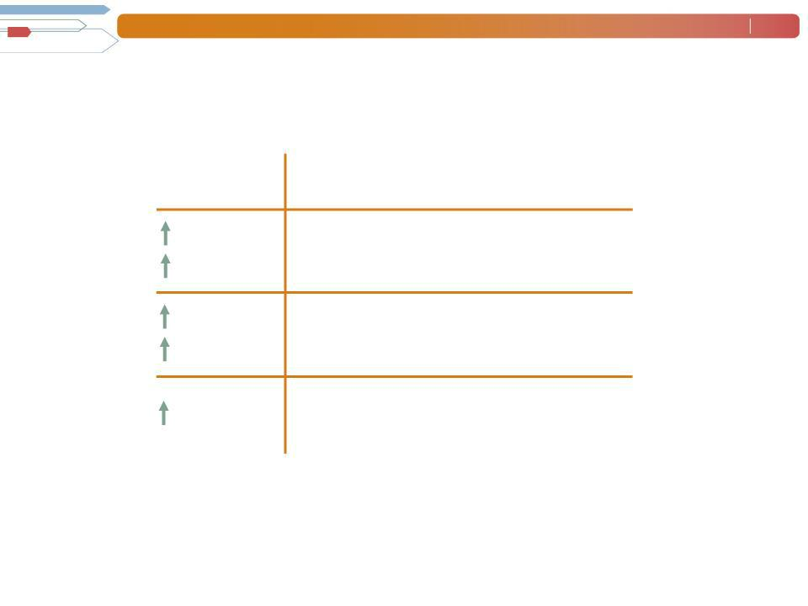

Asia Pacific Segment
(11% of Revenue)

Q3 Financial Highlights

30% | Revenue $556M
21% | Revenue $556M
CC
234% | OUP $13M
211% CC | OUP $13M
150 bps | OUP Margin 2.4%

Manpower Inc. 2010 3rd Quarter Results | October | 11
 | 2010
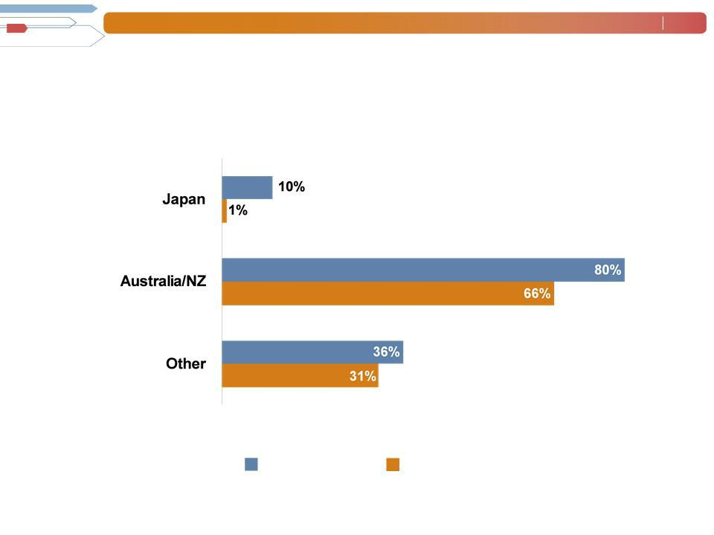

Asia Pacific - Q3 Revenue Growth YoY

- of Segment Revenue

49%

27%

24%

Revenue | Revenue Growth - CC
Growth

Manpower Inc. 2010 3rd Quarter Results | October | 12
 | 2010
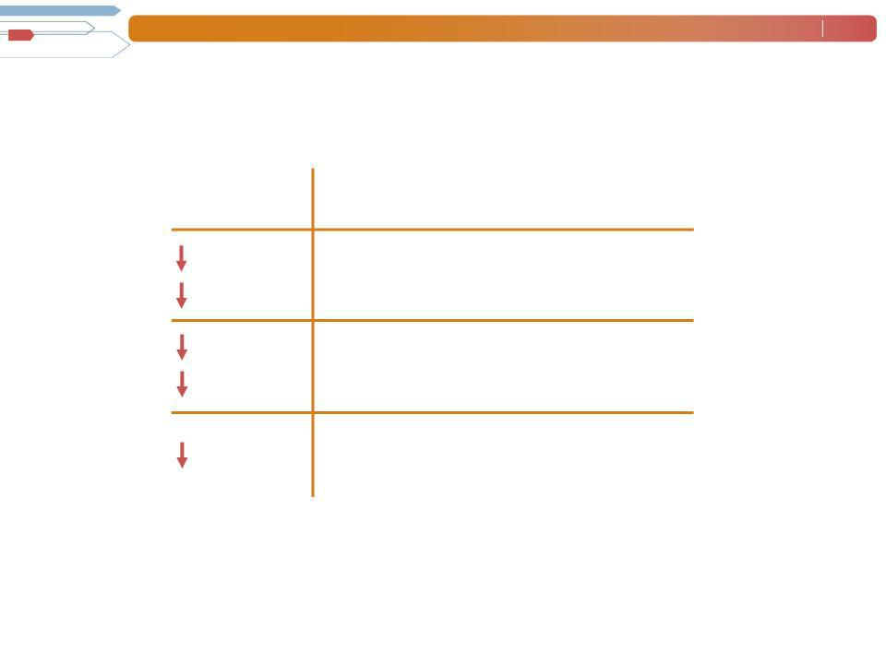

Right Management Segment
(2% of Revenue)

Q3 Financial Highlights

37% | Revenue $86M
36% | Revenue $86M
CC
100% | OUP $0M
102% CC | OUP $0M
1570 | OUP Margin 0.0%
bps

Manpower Inc. 2010 3rd Quarter Results | October | 13
 | 2010
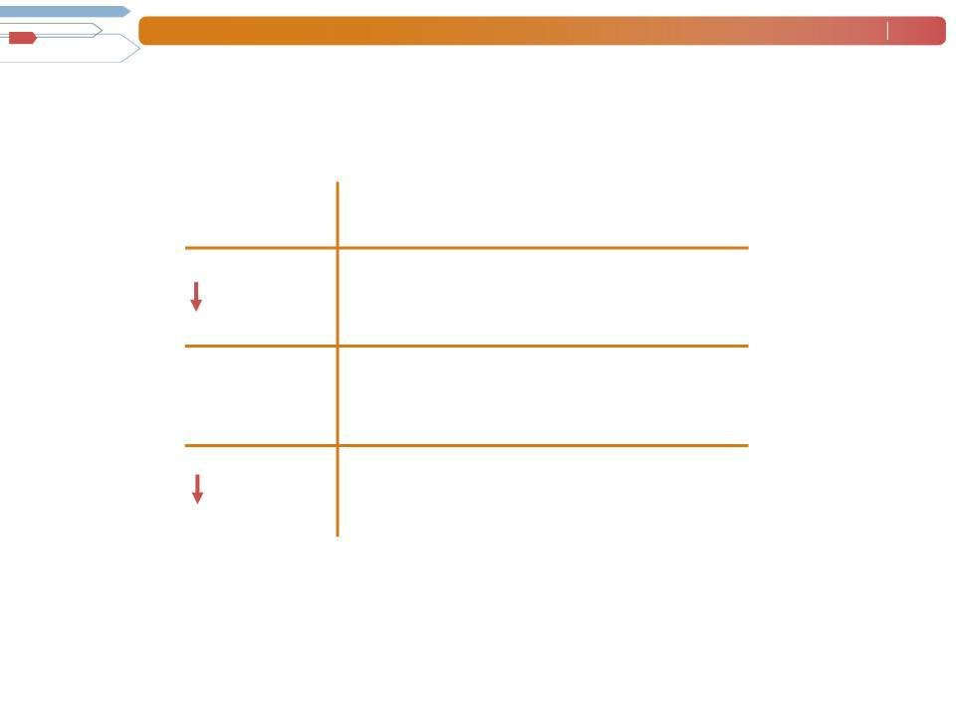

Jefferson Wells Segment
(1% of Revenue)

Q3 Financial Highlights

7% Revenue $45M

N/A OUP $(2M)

230 bps OUP Margin - 3.5%

Manpower Inc. 2010 3rd Quarter Results | October | 14
 | 2010
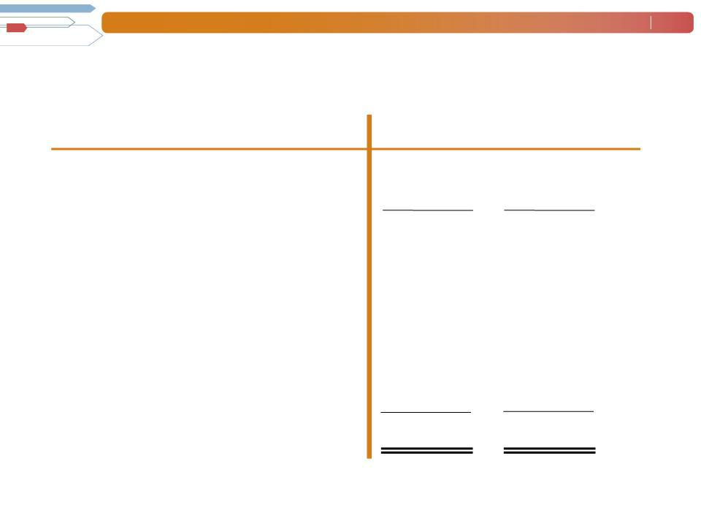

Cash Flow Summary - Nine Months

($ in millions)

Cash from Operations

Capital

Free^{Expenditures}CashFlow

Change in
Debt
Acquisitions of Businesses,netofcash acquired

Share Repurchases

Effect of Exchange Rate Changes Other

Change in Cash

2010 2009

  - 412

- (27)

  - 385

    - (89)

- (21)

(35) | -
8 | 54
  - (2)

- 327

Manpower Inc. 2010 3rd Quarter Results | October | 15
 | 2010
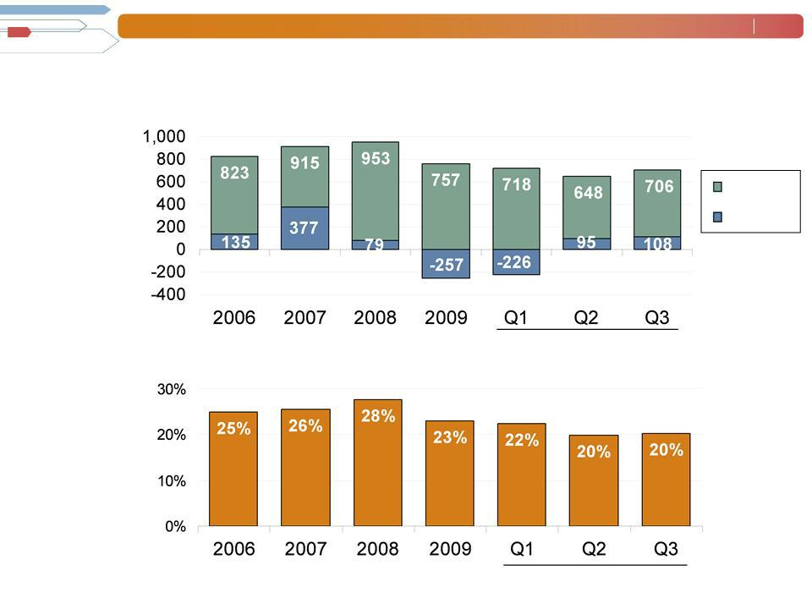
Balance Sheet Highlights

Total Debt

($ in millions)

Total Debt

Net
Debt

Total Debt to | 2010
Total Capitalization | 2010

2010

Manpower Inc. 2010 3rd Quarter Results | October | 16
 | 2010
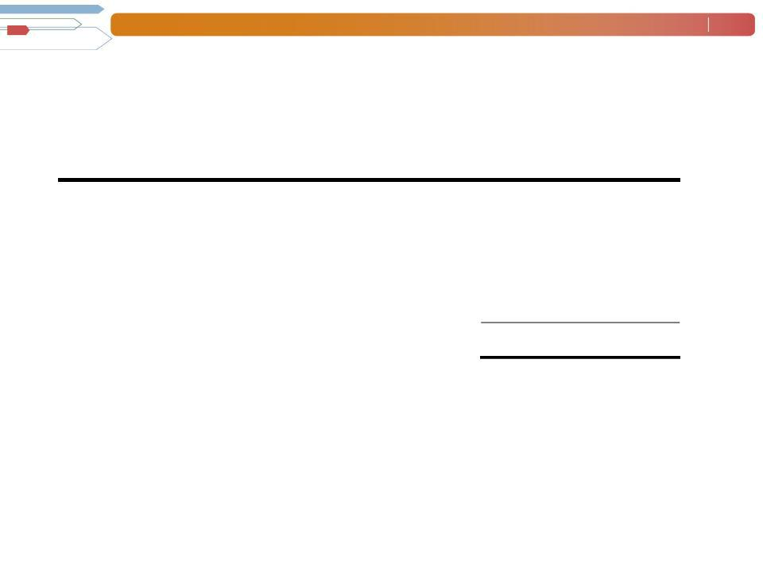

Credit Facilities as of September 30, 2010

($ in millions)

 |  | Interest | Maturity | Total | Remaining
 |  | Rate | Date | Outstanding | Available
Euro
Notes: |  | 4.86% | June | 272 | -
- Euro
200M |  | 4.58% | 2013 | 409 | -
- Euro |  | 4.58% | June | 409 | -
300M | (a) | 2.81% | 2012 | - | 396^{(b)}
Revolving Credit Agreement |  | 2.81% | Nov 2012 | - | 396^{(b)}
Uncommitted lines and |  | Various | Various | 25 | 374
Other |  |  |  | 706 | 770
Total Debt |  |  |  | 706 | 770

- This $400M agreement requires, as of September 30, that we comply with a Debt-to-EBITDA ratio of less than 5.75 to 1 and a fixed charge coverage ratio of greater than 1.25 to 1. As defined in the agreement, we had a Debt-to-EBITDA ratio of 1.85 and a fixed charge coverage ratio of 2.17 as of September 30, 2010.

  - As of September 30, there were $4.0M of standby letters of credit issued under the agreement.

Manpower Inc. 2010 3rd Quarter Results | October | 17
 | 2010
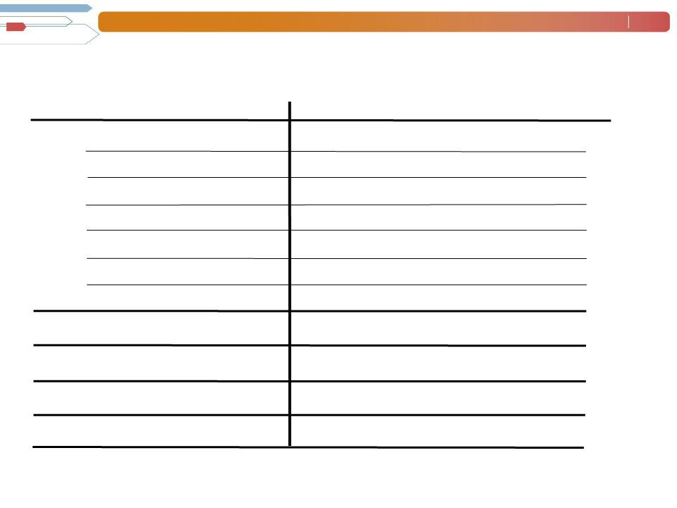

Fourth Quarter Outlook

Revenue ^{Total}
Americas

France

EMEA

Asia

RightPacific
Management
Jefferson Wells

Gross Profit
Margin
Operating Profit Margin (a)

Tax Rate

EPS ^{(a)}

Up 16- | (Up 19-21%
18% | CC)
Up 48-50% | (Up 47-49% CC)
Up 8-10% (Up 15-17% CC)
Up 12-14% | (Up 16-18%
Up 19-21% | CC)
Up 19-21% | (Up 14-16%
Down 33- | CC)
Down 33- | (Down 31-33%
35% | CC)
Up 0-
2%
17.0-17.2%

2.0-
2.2%

51%

$0.54-$0.62 (Neg. $.02 Currency)

- Excludes anticipated reorganization charges of $20M-$25M ($0.15-$0.20 per diluted share).

Manpower Inc. 2010 3rd Quarter Results | October | 18
 | 2010

Questions?
Answers

