UNITED STATES

SECURITIES AND EXCHANGE COMMISSION

Washington, D.C. 20549

FORM 8-K

CURRENT REPORT

Pursuant to Section 13 or 15(d) of the Securities Exchange Act of 1934

Date of Report (Date of earliest event reported): October 21, 2008

MANPOWER INC.

(Exact name of registrant as specified in its charter)

Wisconsin | 1-10686 | 39-1672779
(State or other jurisdiction | (Commission | (IRS Employer
of incorporation) | File Number) | Identification No.)
100 Manpower Place
Milwaukee, Wisconsin |  | 53212
(Address of principal executive offices) |  | (Zip Code)

Registrant’s telephone number, including area code: (414) 961-1000

Check the appropriate box below if the Form 8-K filing is intended to simultaneously satisfy the filing obligation of the registrant under any of the following provisions:

- Written communications pursuant to Rule 425 under the Securities Act (17 CFR 230.425)

- Soliciting material pursuant to Rule 14a-12 under the Securities Act (17 CFR 240.14a-12)

- Pre-commencement communications pursuant to Rule 14d-2(b) under the Exchange Act (17 CFR 240.14d-2(b))

- Pre-commencement communications pursuant to Rule 13e-4(c) under the Exchange Act (17 CFR 240.13e-4(c))

Item 2.02 Results of Operations and Financial Condition

On October 21, 2008, we issued a press release announcing our results of operations for the three- and nine- month periods ended September 30, 2008. A copy of the press release is attached hereto as Exhibit 99.1 and is incorporated herein by reference.

Item 9.01. |  | Exhibits.
 | Exhibit No. |  |  |  | Description
99.1 |  |  |  | Press Release dated October 21, 2008
99.2 |  |  |  | Presentation materials for October 21, 2008 conference call
99.3 |  |  |  | Earnings, As Adjusted

SIGNATURES

Pursuant to the requirements of the Securities Exchange Act of 1934, the Registrant has duly caused this Report to be signed on its behalf by the undersigned hereunto duly authorized.

 | MANPOWER INC.
Dated: October 21, 2008 | By: /s/ Michael J. Van Handel
 |  | Michael J. Van Handel
 |  | Executive Vice President and
 |  | Chief Financial Officer

EXHIBIT INDEX

Exhibit No. |  | Description
99.1 | Press Release dated October 21, 2008
99.2 | Presentation materials for October 21, 2008 conference call
99.3 | Earnings, As Adjusted

Exhibit 99.1


FOR IMMEDIATE RELEASE

Contact:

Mike Van Handel

Manpower Inc.

+1.414.906.6305

michael.vanhandel@manpower.com

Manpower Inc. Reports 3rd Quarter 2008 Results

MILWAUKEE, WI, USA, October 21, 2008 – Manpower Inc. (NYSE: MAN) today reported that earnings per diluted share for the three months ended September 30, 2008 were a loss of 55 cents compared to income of $1.57 in the prior year period. Revenues for the third quarter were $5.7 billion, an increase of 7 percent from the year earlier period.

Third quarter 2008 results include a goodwill and intangible asset impairment charge of $163.1 million ($154.6 million after tax) or $1.97 per diluted share related to our investment in Right Management. Excluding this impairment charge, third quarter net earnings per diluted share would have been $1.42, with net earnings of $111.4 million.

Third quarter results were favorably impacted by 11 cents per diluted share as foreign currencies were relatively stronger compared to the third quarter of 2007. On a constant currency basis, revenues increased 1% over the prior year period.

Third quarter 2007 results were positively impacted $27.0 million ($16.1 million after tax) or 19 cents per diluted share as a result of a non-recurring favorable change in the calculation of French payroll taxes.

Jeffrey A. Joerres, Manpower Inc. Chairman and Chief Executive Officer, said, “The slowdown that we have been experiencing in the U.S. has now moved to Europe. While we are still seeing year-over-year growth in some of our European operations, we expect the full impact of the economic slowdown has yet to be felt by the labor market. Our emerging markets continue to grow at a rapid pace.

“We will continue to benefit from a geographically balanced business, diverse portfolio of services and well-equipped Manpower team that will take advantage of the opportunities that are presented in an economic downturn.

“While the current dynamic economic environment makes forecasting demand for our services more difficult, we are presently anticipating the fourth quarter of 2008 diluted earnings per share to be in the range of $.97 to $1.01, which includes an estimated negative currency impact of 6 cents,” Joerres stated.

Earnings per diluted share for the nine months ended September 30, 2008 were $1.75 compared to $4.10 per diluted share in 2007. Net earnings were $139.7 million compared to $351.6 million in the prior year. Revenues for the nine-month period were $17.0 billion, an increase of 14 percent from the prior year or 5 percent in constant currency. Foreign currency exchange rates had a favorable impact of 45 cents for the nine-month period.

Earnings per diluted share for the nine month period in 2008 include the goodwill and intangible asset impairment charge of $1.93 (based on the weighted average shares for the nine-month period) and a net charge of 18 cents recorded in the second quarter related to an increase in our legal reserve and recoverable 2005 payroll taxes in France. Earnings per diluted share for the nine-month period in 2007 include a favorable impact of 85 cents related to the revised calculation in French payroll taxes.

In conjunction with its third quarter earnings release, Manpower will broadcast its conference call live over the Internet on October 21, 2008 at 7:30 a.m. CDT (8:30 a.m. EDT).

Interested parties are invited to listen to the webcast and view the presentation by logging on to http://investor.manpower.com.

Supplemental financial information referenced in the conference call can be found at http://investor.manpower.com.

About Manpower Inc.

Manpower Inc. (NYSE: MAN) is a world leader in the employment services industry; creating and delivering services that enable its clients to win in the changing world of work. Celebrating its 60th anniversary in 2008, the $21 billion company offers employers a range of services for the entire employment and business cycle including permanent, temporary and contract recruitment; employee assessment and selection; training; outplacement; outsourcing and consulting. Manpower’s worldwide network of 4,500 offices in 80 countries and territories enables the company to meet the needs of its 400,000 clients per year, including small and medium size enterprises in all industry sectors, as well as the world’s largest multinational corporations. The focus of Manpower’s work is on raising productivity through improved quality, efficiency and cost-reduction across their total workforce, enabling clients to concentrate on their core business activities. Manpower Inc. operates under five brands: Manpower, Manpower Professional, Elan, Jefferson Wells and Right Management. More information on Manpower Inc. is available at http://www.manpower.com/.

Forward-Looking Statements

This news release contains statements, including earnings projections, that are forward-looking in nature and, accordingly, are subject to risks and uncertainties regarding the Company’s expected future results. The Company’s actual results may differ materially from those described or contemplated in the forward-looking statements. Factors that may cause the Company’s actual results to differ materially from those contained in the forward-looking statements can be found in the Company’s reports filed with the SEC, including the information under the heading ‘Risk Factors’ in its Annual Report on Form 10-K for the year ended December 31, 2007, which information is incorporated herein by reference.

- ### -

Manpower Inc.

Results of Operations

(In millions, except per share data)

 |  |  |  |  | Three Months Ended September 30
 |  |  |  |  |  |  |  |  | % Variance
 |  |  |  |  |  |  |  |  | Amount |  | Constant
 |  |  | 2008 |  |  |  | 2007 |  | Reported |  | Currency
 |  |  |  |  |  |  | (Unaudited)
Revenues from services (a) | $ |  | 5,668.4 |  | $ |  | 5,295.4 |  | 7.0% |  | 1.0%
Cost of services |  |  | 4,640.8 |  |  |  | 4,321.0 |  | 7.4%
Gross profit |  |  | 1,027.6 |  |  |  | 974.4 |  | 5.5% |  | -0.1%
Selling and administrative expenses, excluding impairment |  |  | 843.5 |  |  |  | 752.5 |  | 12.1% |  | 6.6%
Goodwill and intangible asset impairment (b) |  |  | 163.1 |  |  |  | — |  | N/A |  | N/A
Selling and administrative expenses |  |  | 1,006.6 |  |  |  | 752.5 |  | 33.8% |  | 28.3%
Operating profit |  |  | 21.0 |  |  |  | 221.9 |  | -90.5% |  | -96.4%
Interest and other expenses |  |  | 13.4 |  |  |  | 9.1 |  | 50.1%
Earnings before income taxes |  |  | 7.6 |  |  |  | 212.8 |  | -96.5% |  | -102.9%
Provision for income taxes |  |  | 50.8 |  |  |  | 81.1 |  | -37.5%
Net (loss) earnings | $ |  | (43.2) |  | $ |  | 131.7 |  | -132.8% |  | -139.6%
Net (loss) earnings per share - basic |  |  |  |  |  |  |  |  | -134.6%
Net (loss) earnings per share - basic | $ |  | (0.55) |  | $ |  | 1.59
Net (loss) earnings per share - diluted | $ |  | (0.55) |  | $ |  | 1.57 |  | -135.0% |  | -142.0%
Weighted average shares - basic |  |  |  |  |  |  |  |  | -5.3%
Weighted average shares - basic |  |  | 78.6 |  |  |  | 82.7
Weighted average shares - diluted |  |  | 78.6 |  |  |  | 84.1 |  | -6.6%

- Revenues from services include fees received from our franchise offices of $8.0 million and $9.4 million for the three months ended September 30, 2008 and 2007, respectively. These fees are primarily based on revenues generated by the franchise offices which were $282.2 million and $387.4 million for the three months ended September 30, 2008 and 2007, respectively.

- The goodwill and intangible asset impairment relates to our investment in Right Management. The impact on net earnings is $154.6 million, or $1.97 per diluted share.

Manpower Inc.

Operating Unit Results

(In millions)

 |  |  |  | Three Months Ended September 30
 |  |  |  |  |  |  |  |  | % Variance
 |  |  |  |  |  |  |  |  | Amount |  | Constant
 |  | 2008 |  |  |  | 2007 |  | Reported |  |  | Currency
 |  |  |  |  |  |  | (Unaudited)
Revenues from Services:
United States (a) | $ | 519.8 |  | $ |  | 502.2 |  | 3.5% |  |  | 3.5%
France |  | 1,892.1 |  |  |  | 1,871.3 |  | 1.1% |  |  | -7.9%
Other EMEA |  | 1,951.7 |  |  |  | 1,740.3 |  | 12.1% |  |  | 8.0%
Italy |  | 375.7 |  |  |  | 334.5 |  | 12.3% |  |  | 2.5%
Jefferson Wells |  | 74.2 |  |  |  | 85.5 |  | -13.3% |  |  | -13.3%
Right Management |  | 107.7 |  |  |  | 98.7 |  | 9.1% |  |  | 7.9%
Other Operations |  | 747.2 |  |  |  | 662.9 |  | 12.7% |  |  | 5.9%
 | $ | 5,668.4 |  | $ |  | 5,295.4 |  | 7.0% |  |  | 1.0%
Operating Unit Profit:
United States | $ | 12.1 |  | $ |  | 24.1 |  | -49.6% |  |  | -49.6%
France |  | 66.1 |  |  |  | 100.7 |  | -34.4% |  |  | -40.0%
Other EMEA |  | 76.3 |  |  |  | 74.4 |  | 2.5% |  |  | -2.3%
Italy |  | 29.3 |  |  |  | 24.6 |  | 19.1% |  |  | 8.5%
Jefferson Wells |  | (1.6) |  |  |  | (1.7) |  |  | N/A |  | N/A
Right Management |  | 7.6 |  |  |  | 5.7 |  | 33.5% |  |  | 39.4%
Other Operations |  | 14.2 |  |  |  | 18.8 |  | -23.8% |  |  | -32.4%
 |  | 204.0 |  |  |  | 246.6
Corporate expenses |  | 16.6 |  |  |  | 21.4
Goodwill and intangible asset impairment |  | 163.1 |  |  |  | —
Amortization of intangible assets |  | 3.3 |  |  |  | 3.3
Operating profit |  | 21.0 |  |  |  | 221.9 |  | -90.5% |  |  | -96.4%
Interest and other expenses (b) |  | 13.4 |  |  |  | 9.1
Earnings before income taxes | $ | 7.6 |  | $ |  | 212.8

- In the United States, revenues from services include fees received from our franchise offices of $4.5 million and $6.5 million for the three months ended September 30, 2008 and 2007, respectively. These fees are primarily based on revenues generated by the franchise offices, which were $175.4 million and $270.7 million for the three months ended September 30, 2008 and 2007, respectively.

- The components of interest and other expenses were:

 | 2008 |  |  | 2007
Interest expense | $16.2 |  | $ |  | 14.2
Interest income | (5.4) |  |  |  | (5.9)
Foreign exchange gains | (0.6) |  |  |  | (0.1)
Miscellaneous expenses, net | 3.2 |  |  |  | 0.9
 | $13.4 |  | $ |  | 9.1

Manpower Inc.

Results of Operations

(In millions, except per share data)

 |  |  |  | Nine Months Ended September 30
 |  |  |  |  |  |  |  | % Variance
 |  |  |  |  |  |  |  | Amount |  | Constant
 |  | 2008 |  |  |  | 2007 |  | Reported |  | Currency
 |  |  |  |  |  | (Unaudited)
Revenues from services (a) | $ | 16,959.9 |  | $ |  | 14,865.4 | 14.1% |  |  | 4.5%
Cost of services |  | 13,811.0 |  |  |  | 12,066.9 | 14.5%
Gross profit |  | 3,148.9 |  |  |  | 2,798.5 | 12.5% |  |  | 3.3%
Selling and administrative expenses, excluding impairment charge |  | 2,625.5 |  |  |  | 2,196.3 | 19.5% |  |  | 10.4%
Goodwill and intangible asset impairment (b) |  | 163.1 |  |  |  | — |  | N/A |  | N/A
Selling and administrative expenses |  |  |  |  |  |  | 27.0% |  |  | 17.8%
Selling and administrative expenses |  | 2,788.6 |  |  |  | 2,196.3
Operating profit |  | 360.3 |  |  |  | 602.2 | -40.2% |  |  | -49.7%
Interest and other expenses |  | 38.6 |  |  |  | 26.4 | 46.6%
Earnings before income taxes |  | 321.7 |  |  |  | 575.8 | -44.1% |  |  | -54.3%
Provision for income taxes |  | 182.0 |  |  |  | 224.2 | -18.9%
Net earnings | $ | 139.7 |  | $ |  | 351.6 | -60.3% |  |  | -70.4%
Net earnings per share - basic |  |  |  |  |  |  | -57.8%
Net earnings per share - basic | $ | 1.77 |  | $ |  | 4.19
Net earnings per share - diluted | $ | 1.75 |  | $ |  | 4.10 | -57.3% |  |  | -68.3%
Weighted average shares - basic |  |  |  |  |  |  | -5.8%
Weighted average shares - basic |  | 79.1 |  |  |  | 84.0
Weighted average shares - diluted |  | 80.0 |  |  |  | 85.7 | -6.7%

- Revenues from services include fees received from our franchise offices of $23.6 million and $26.8 million for the nine months ended September 30, 2008 and 2007, respectively. These fees are primarily based on revenues generated by the franchise offices, which were $911.6 million and $1,111.6 million for the nine months ended September 30, 2008 and 2007,

respectively.

- The goodwill and intangible asset impairment relates to our investment in Right Management. The impact on net earnings is $154.6 million, or $1.93 per diluted share.

Manpower Inc.

Operating Unit Results

(In millions)

 |  |  |  | Nine Months Ended September 30
 |  |  |  |  |  |  |  | % Variance
 |  |  |  |  |  |  |  | Amount |  | Constant
 |  | 2008 |  |  |  | 2007 |  | Reported |  | Currency
 |  |  |  |  |  | (Unaudited)
Revenues from Services:
United States (a) | $ | 1,482.9 |  | $ |  | 1,474.4 | 0.6% |  |  | 0.6%
France |  | 5,584.2 |  |  |  | 5,149.2 | 8.4% |  |  | -4.3%
Other EMEA |  | 5,856.1 |  |  |  | 4,798.7 | 22.0% |  |  | 13.2%
Italy |  | 1,218.3 |  |  |  | 993.1 | 22.7% |  |  | 8.2%
Jefferson Wells |  | 227.4 |  |  |  | 250.6 | -9.3% |  |  | -9.3%
Right Management |  | 326.7 |  |  |  | 298.4 | 9.5% |  |  | 5.5%
Other Operations |  | 2,264.3 |  |  |  | 1,901.0 | 19.1% |  |  | 9.1%
 | $ | 16,959.9 |  | $ |  | 14,865.4 | 14.1% |  |  | 4.5%
Operating Unit Profit:
United States | $ | 34.1 |  | $ |  | 61.7 | -44.7% |  |  | -44.7%
France |  | 189.9 |  |  |  | 308.3 | -38.4% |  |  | -45.6%
Other EMEA |  | 209.1 |  |  |  | 166.8 | 25.4% |  |  | 14.8%
Italy |  | 96.0 |  |  |  | 70.1 | 36.9% |  |  | 20.6%
Jefferson Wells |  | (5.8) |  |  |  | 0.4 |  | N/A |  | N/A
Right Management |  | 27.6 |  |  |  | 22.8 | 21.0% |  |  | 19.8%
Other Operations |  | 52.1 |  |  |  | 46.6 | 12.0% |  |  | -1.1%
 |  | 603.0 |  |  |  | 676.7
Corporate expenses |  | 69.8 |  |  |  | 64.7
Goodwill and intangible asset impairment |  | 163.1 |  |  |  | —
Amortization of intangible assets |  | 9.8 |  |  |  | 9.8
Operating profit |  | 360.3 |  |  |  | 602.2 | -40.2% |  |  | -49.7%
Interest and other expenses (b) |  | 38.6 |  |  |  | 26.4
Earnings before income taxes | $ | 321.7 |  | $ |  | 575.8

- In the United States, revenues from services include fees received from our franchise offices of $13.8 million and $18.3 million for the nine months ended September 30, 2008 and 2007, respectively. These fees are primarily based on revenues generated by the franchise offices, which were $602.7 million and $818.3 million for the nine months ended September 30, 2008 and 2007, respectively.

- The components of interest and other expenses were:

 |  |  | 2008 |  |  | 2007
Interest expense | $ |  | 48.9 |  | $ | 39.3
Interest income |  |  | (16.5) |  |  | (17.1)
Foreign exchange (gain) loss |  |  | (2.1) |  |  | 0.1
Miscellaneous expenses, net |  |  | 8.3 |  |  | 4.1
 | $ |  | 38.6 |  | $ | 26.4

Manpower Inc.

Consolidated Balance Sheets

(In millions)

 |  | Sep. 30 |  |  |  | Dec. 31
 |  | 2008 |  |  |  | 2007
 |  |  | (Unaudited)
ASSETS
Current assets:
Cash and cash equivalents | $ | 632.0 |  | $ |  | 537.5
Accounts receivable, net |  | 4,290.2 |  |  |  | 4,478.8
Prepaid expenses and other assets |  | 177.9 |  |  |  | 122.2
Future income tax benefits |  | 63.3 |  |  |  | 76.3
Total current assets |  | 5,163.4 |  |  |  | 5,214.8
Other assets:
Goodwill and other intangible assets, net |  | 1,410.8 |  |  |  | 1,410.7
Other assets |  | 321.2 |  |  |  | 377.7
Total other assets |  | 1,732.0 |  |  |  | 1,788.4
Property and equipment:
Land, buildings, leasehold improvements and equipment |  | 789.6 |  |  |  | 760.8
Less: accumulated depreciation and amortization |  | 570.6 |  |  |  | 539.6
Net property and equipment |  | 219.0 |  |  |  | 221.2
Total assets
Total assets | $ | 7,114.4 |  | $ |  | 7,224.4
LIABILITIES AND SHAREHOLDERS’ EQUITY
Current liabilities:
Accounts payable | $ | 1,071.9 |  | $ |  | 1,014.4
Employee compensation payable |  | 222.0 |  |  |  | 213.6
Accrued liabilities |  | 684.4 |  |  |  | 679.4
Accrued payroll taxes and insurance |  | 641.3 |  |  |  | 724.7
Value added taxes payable |  | 586.2 |  |  |  | 583.7
Short-term borrowings and current maturities of long-term debt |  | 127.5 |  |  |  | 39.7
Total current liabilities |  | 3,333.3 |  |  |  | 3,255.5
Other liabilities:
Long-term debt |  | 844.8 |  |  |  | 874.8
Other long-term liabilities |  | 366.2 |  |  |  | 424.8
Total other liabilities |  | 1,211.0 |  |  |  | 1,299.6
Shareholders’ equity:
Common stock |  | 1.0 |  |  |  | 1.0
Capital in excess of par value |  | 2,507.0 |  |  |  | 2,481.8
Retained earnings |  | 1,150.8 |  |  |  | 1,040.3
Accumulated other comprehensive income |  | 135.6 |  |  |  | 257.6
Treasury stock, at cost |  | (1,224.3) |  |  |  | (1,111.4)
Total shareholders’ equity
Total shareholders’ equity |  | 2,570.1 |  |  |  | 2,669.3
Total liabilities and shareholders’ equity | $ | 7,114.4 |  | $ |  | 7,224.4

Manpower Inc.

Consolidated Statements of Cash Flows

(In millions)

 |  | Nine Months Ended
 |  |  |  | Sep. 30
 |  | 2008 |  |  | 2007
 |  |  | (Unaudited)
 | Cash Flows from Operating Activities:
 | Net earnings | $ 139.7 |  |  | $ 351.6
 | Adjustments to reconcile net earnings to net cash provided by operating activities:
 | Depreciation and amortization | 81.9 |  |  | 68.2
 | Non-cash goodwill and intangible asset impairment | 163.1 |  |  | —
 | Deferred income taxes | (36.8) |  |  | (13.6)
 | Provision for doubtful accounts | 14.2 |  |  | 17.3
 | Share-based compensation | 15.3 |  |  | 18.8
 | Excess tax benefit on exercise of stock options | (0.5) |  |  | (5.5)
 | Changes in operating assets and liabilities, excluding the impact of acquisitions:
 | Accounts receivable | 76.8 |  |  | (430.1)
 | Other assets | (35.5) |  |  | (25.7)
 | Other liabilities | 31.0 |  |  | 318.2
 | Cash provided by operating activities | 449.2 |  |  | 299.2
 | Cash Flows from Investing Activities:
 | Capital expenditures | (70.6) |  |  | (65.8)
 | Acquisitions of businesses, net of cash acquired | (224.4) |  |  | (100.2)
 | Proceeds from the sale of property and equipment | 4.1 |  |  | 3.7
 | Cash used by investing activities | (290.9) |  |  | (162.3)
Cash Flows from Financing Activities:
 | Net borrowings of short-term facilities and long-term debt | 87.4 |  |  | 15.7
 | Proceeds from stock option and purchase plans | 12.5 |  |  | 34.1
 | Excess tax benefit on exercise of stock options | 0.5 |  |  | 5.5
 | Repurchases of common stock | (125.3) |  |  | (359.5)
 | Dividends paid | (29.2) |  |  | (27.1)
 | Cash used by financing activities
 | Cash used by financing activities | (54.1) |  |  | (331.3)
 | Effect of exchange rate changes on cash | (9.7) |  |  | 45.3
Change in cash and cash equivalents
 |  | 94.5 |  |  | (149.1)
 | Cash and cash equivalents, beginning of period | 537.5 |  |  | 687.9
Cash and cash equivalents, end of period |  | $ 632.0 |  |  | $ 538.8


Exhibit 99.2

MANPOWER INC.
2008 3rd QUARTER RESULTS

OCTOBER 21, 2008

Manpower Inc. 2008 3rd Quarter Results | 2
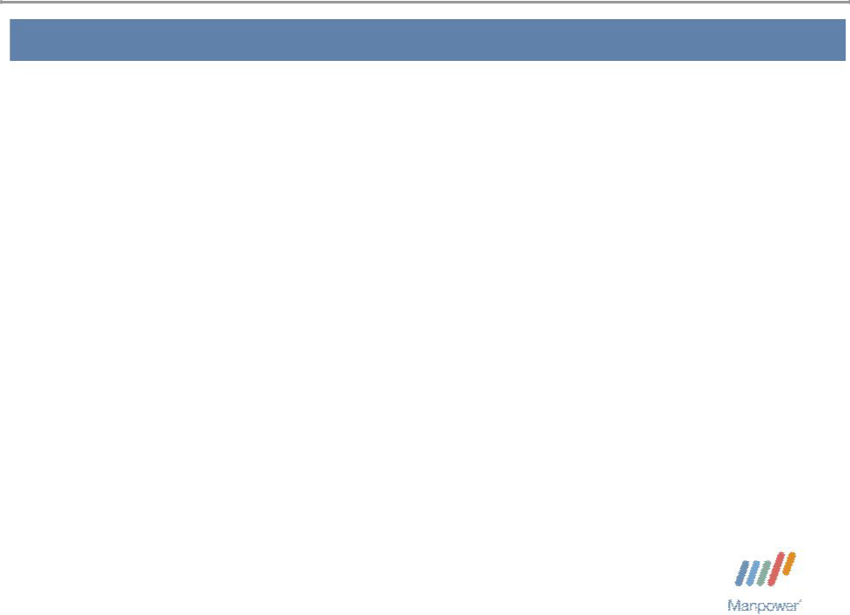

Forward Looking Statement

This presentation includes forward-looking statements which are subject to risks and uncertainties. Actual results might differ materially from those projected in the forward-looking statements. Forward-looking statements can be identified by words such as “expect,” “plan,” “may,” “will,” and similar expressions. Additional information concerning factors that could cause actual results to materially differ from those in the forward-looking statements is contained in the Company’s Annual Report on Form 10-K dated December 31, 2007, which information is incorporated herein by reference, and such other factors as may be described from time to time in the Company’s SEC filings.

Manpower Inc. 2008 3rd Quarter Results | 3

Consolidated Financial Highlights

 | Excluding
As | Non-recurring
Reported | Items⁽¹⁾
7% | 7%
1% CC | 1% CC
27 bps | 30 bps
91% | 6%
96% CC | 12% CC
380 bps | 40 bps
135% | 3%
142% CC | 5% CC

Q3 Highlights Revenue $5.7B

Gross Margin 18.1% Operating Profit $21M OP Margin 0.4%

EPS ($.55)

- Excludes the impact of the goodwill and intangible asset impairment from 2008 and the French payroll tax change from 2007.
Throughout this presentation, the difference between reported variances and Constant Currency (CC) variances represents the impact of currency on our financial results. Constant Currency is further explained on our Web site.

Manpower Inc. 2008 3rd Quarter Results | 4
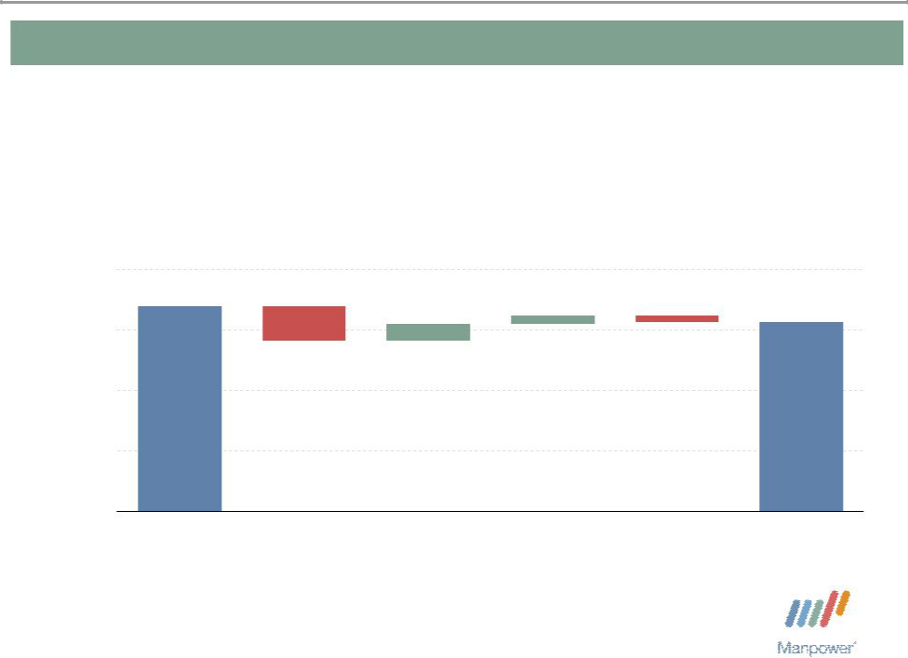

Consolidated Gross Profit Margin Change

19%
- 0.57% | + 0.28% | + 0.14% | - 0.12%

18% | 18.40%
18% | 18.13%
17%

16%

15%

Q3 2007 | Decrease in | Temporary | Permanent | Mix - | Q3 2008
 | Impact of | Recruitment | Recruitment | Specialty
 | Payroll Tax
 | Changes

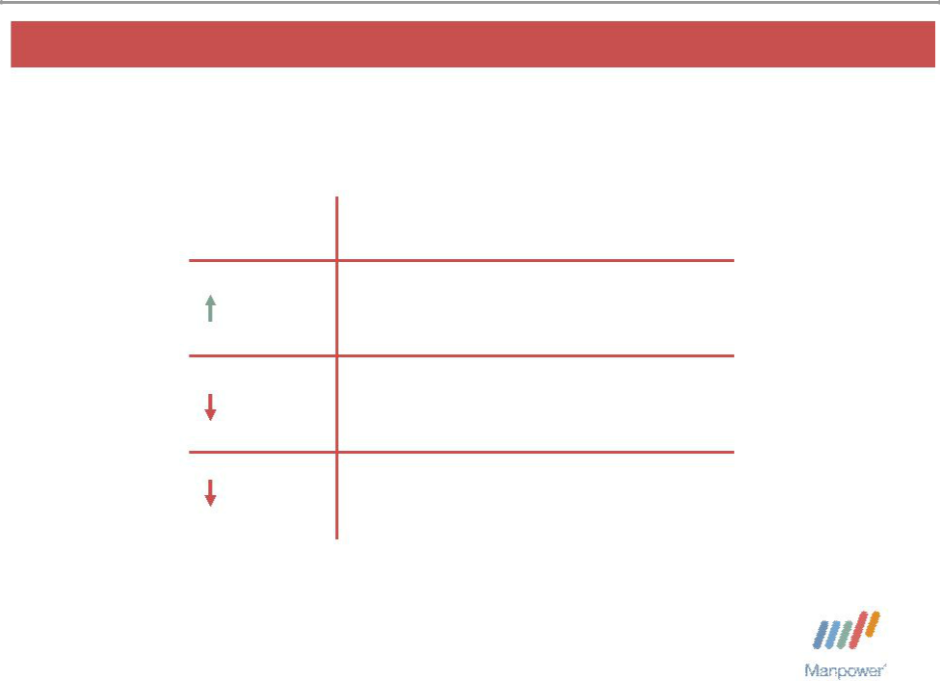
Manpower Inc. 2008 3rd Quarter Results | 5

United States Segment
(9% of Revenue)

Q3 Financial Highlights

4%⁽¹⁾ Revenue $520M

50% OUP $12M

250 bps OUP Margin 2.3%

- The results above include the impact of acquisitions. On an organic basis, revenue decreased 10%.

Operating Unit Profit (OUP) is the measure that we use to evaluate segment performance. OUP is equal to segment revenues less direct costs and branch and national headquartersoperatingcosts.

Manpower Inc. 2008 3rd Quarter Results | 6
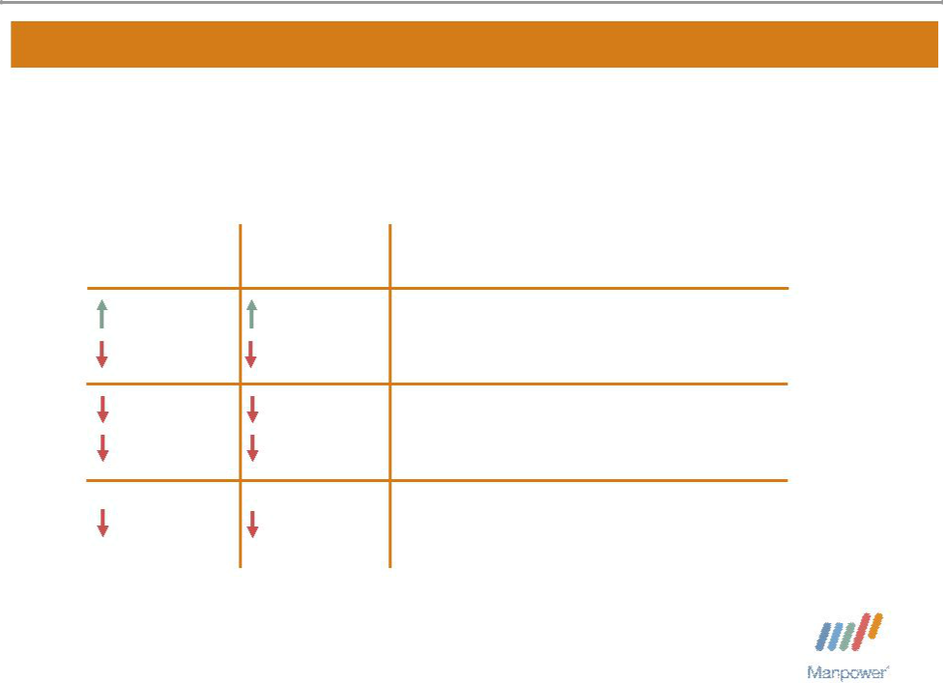

France Segment
(33% of Revenue)

As | Excluding
As | Non-recurring
Reported | Items⁽¹⁾
1% | 1%
8% CC | 8% CC
34% | 10%
40% CC | 18% CC
190 bps | 40 bps

Q3 Financial Highlights Revenue $1.9B

OUP $66M

OUP Margin 3.5%

- Excludes the impact of the French payroll tax change from 2007.

Manpower Inc. 2008 3rd Quarter Results | 7
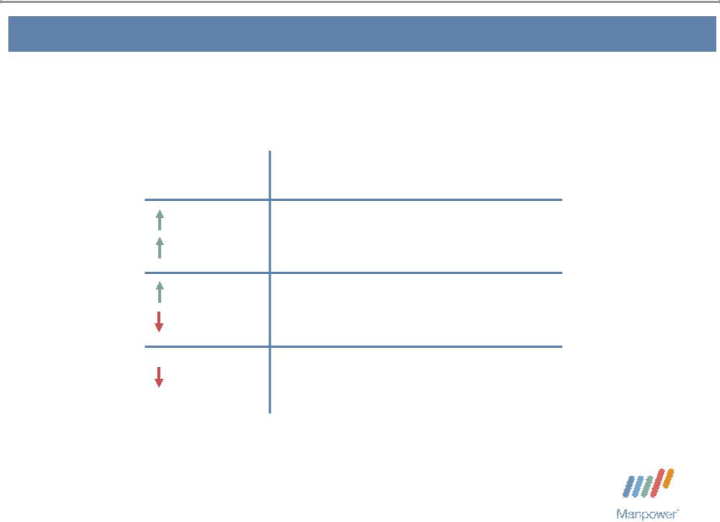

Other EMEA Segment
(35% of Revenue)

Q3 Financial Highlights

⁽¹⁾

8% CC
^{2%} OUP $76M

2% CC

40 bps OUP Margin 3.9%

- The results above include the results of Vitae, which was acquired in April 2008. On an organic basis, revenue increased 10% in USD (6% in CC).

Manpower Inc. 2008 3rd Quarter Results | 8
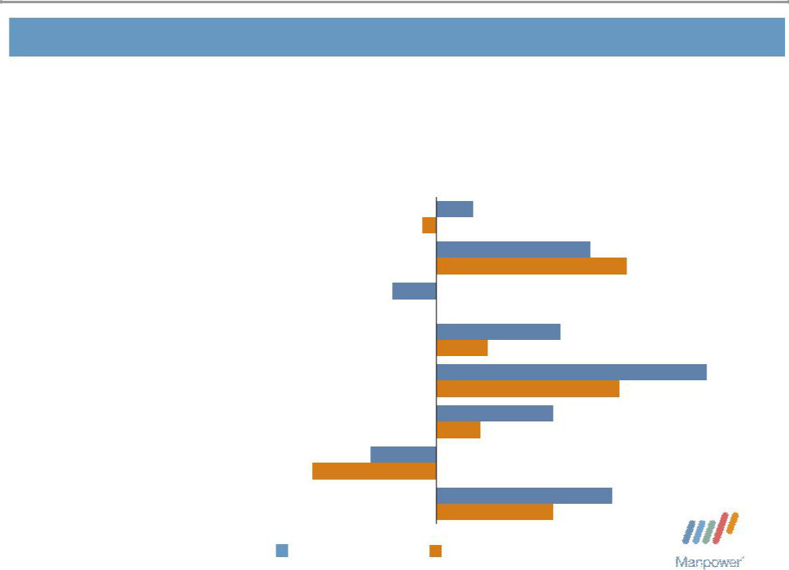

Other EMEA – Q3 Revenue Growth YoY

- of Segment Revenue

18% Nordics

17% Elan

13% UK - Manpower

12% Germany

10% Netherlands⁽¹⁾

7% | Belgium
6% | Spain | -17%

5%

-2%

21%

26%

-6%

0%

17%

7%

37%

25%

16%

6%

-9%

17% | Other | 24%
17% | Other | 16%

Revenue Growth Revenue Growth - CC

- The Netherlands results include the results of Vitae, which wasacquired in April 2008. On an organic basis, revenue increased 10% in USD (1% in CC).

Manpower Inc. 2008 3rd Quarter Results | 9
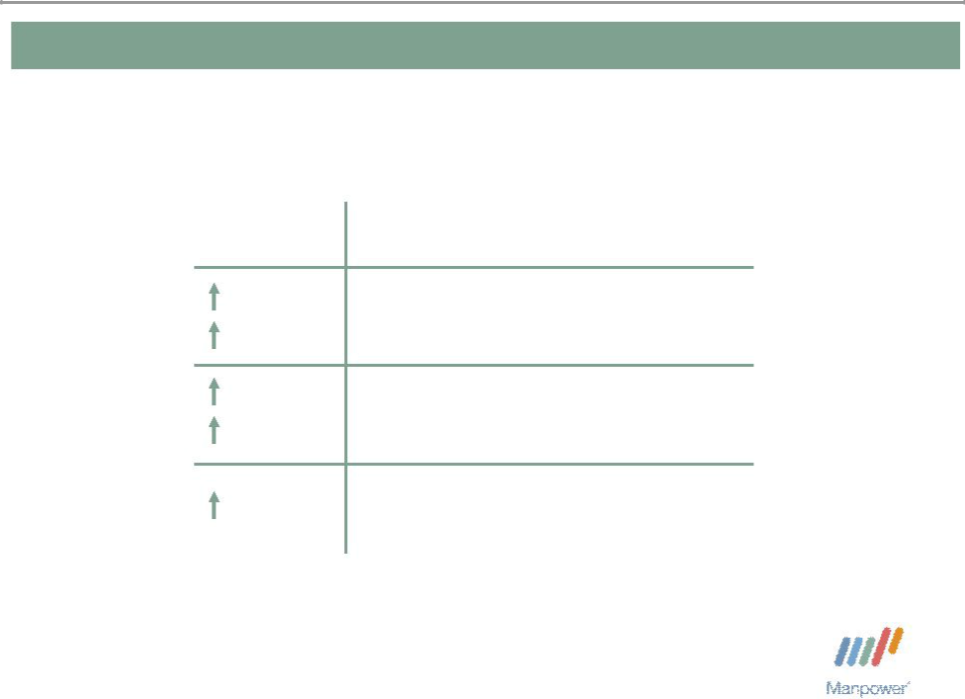

Italy Segment
(7% of Revenue)

12%

2% CC

19%

9% CC

50 bps

Q3 Financial Highlights Revenue $376M

OUP $29M

OUP Margin 7.8%

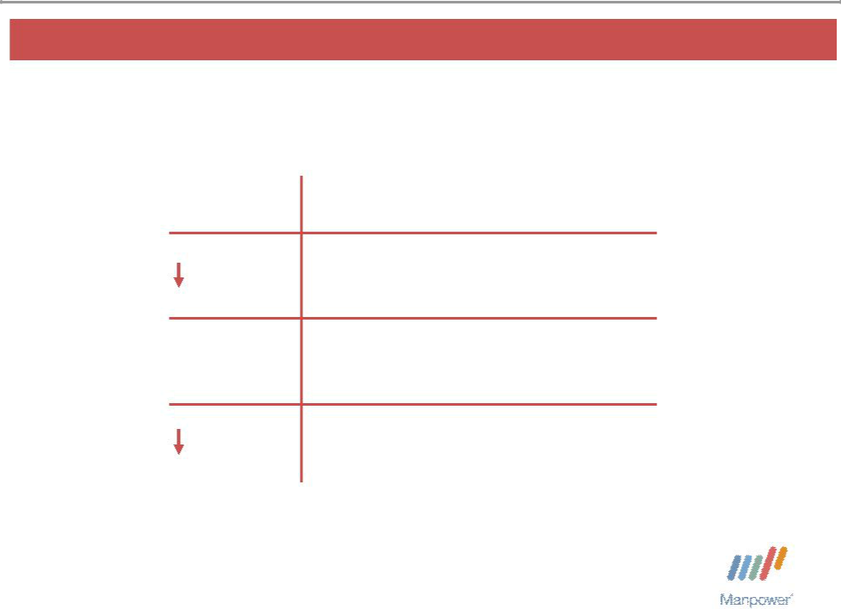
Manpower Inc. 2008 3rd Quarter Results 10

Jefferson Wells Segment
(1% of Revenue)

Q3 Financial Highlights

13% Revenue $74M

N/A OUP $(2M)

10 bps OUP Margin - 2.1%

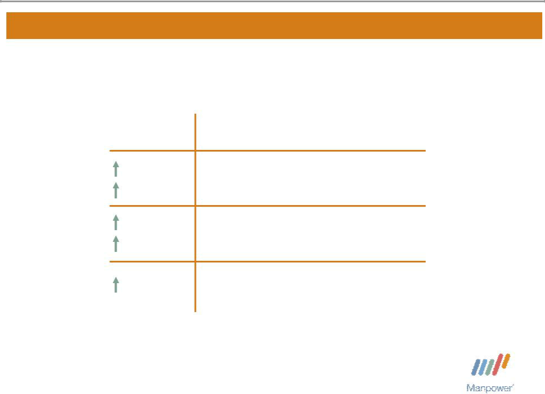
Manpower Inc. 2008 3rd Quarter Results 11

Right Management Segment
(2% of Revenue)

 | Q3 Financial Highlights
9% | Revenue $108M
8% CC | Revenue $108M
34% | OUP $8M
39% CC | OUP $8M
130 bps | OUP Margin 7.1%

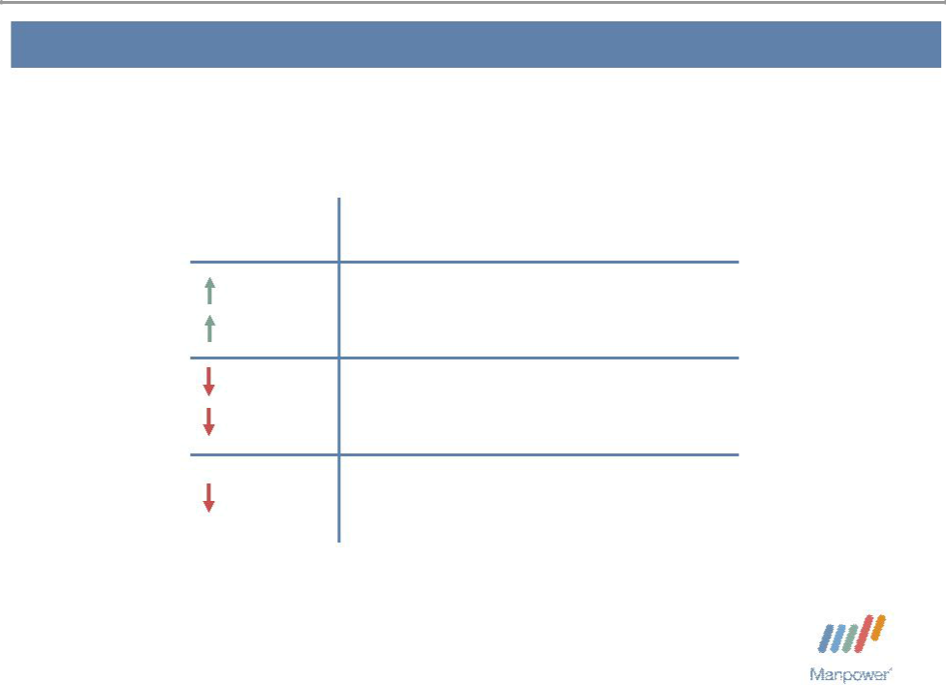
Manpower Inc. 2008 3rd Quarter Results | 12

Other Operations Segment
(13% of Revenue)

Q3 Financial Highlights
^{13%} Revenue $747M
6% CC
^{24%} OUP $14M

32% CC

90 bps OUP Margin 1.9%

Manpower Inc. 2008 3rd Quarter Results | 13
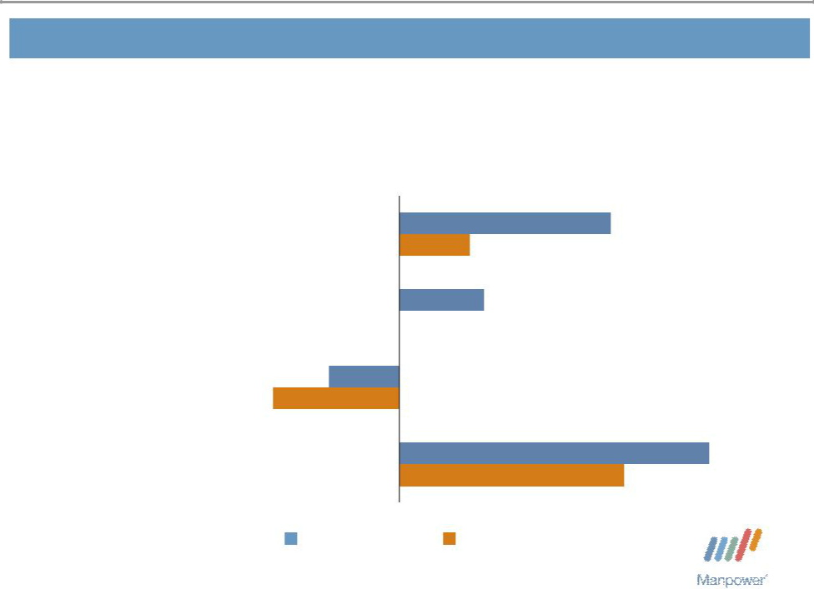

Other Operations – Q3 Revenue Growth YoY

- of Segment Revenue

34% | Japan | 15%
34% | Japan | 5%
14% | Mexico | 6%
14% | Mexico | 0%
13% | Australia/NZ | -5%
13% | Australia/NZ | -9%
39% | Other | 22%
39% | Other | 16%

Revenue Growth Revenue Growth - CC

Manpower Inc. 2008 3rd Quarter Results | 14


Financial Highlights

Manpower Inc. 2008 3rd Quarter Results | 15
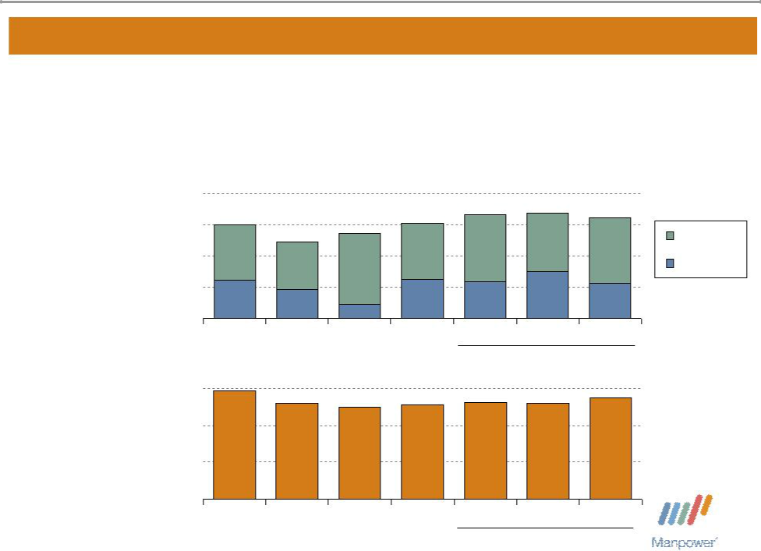

Balance Sheet Highlights

Total Debt | 1,200
($ in millions) | 1,200
 | 900
 | 600
 | 300
 | 0

Total Debt to
Total Capitalization _{30%}

20%

10%

0%

902 | 735 | 823 | 915
370 | 280 |  | 377
 | 280 | 135
2004 | 2005 | 2006 | 2007

29%
26% 25% 26%

2004 2005 2006 2007

999 | 1,014 | 972 | Total Debt
 | 453 |  | Net Debt
358 | 453 | 340
Q1 | Q2 | Q3
 | 2008
26% | 26% | 27%

Q1 Q2 Q3

2008

Manpower Inc. 2008 3rd Quarter Results | 16
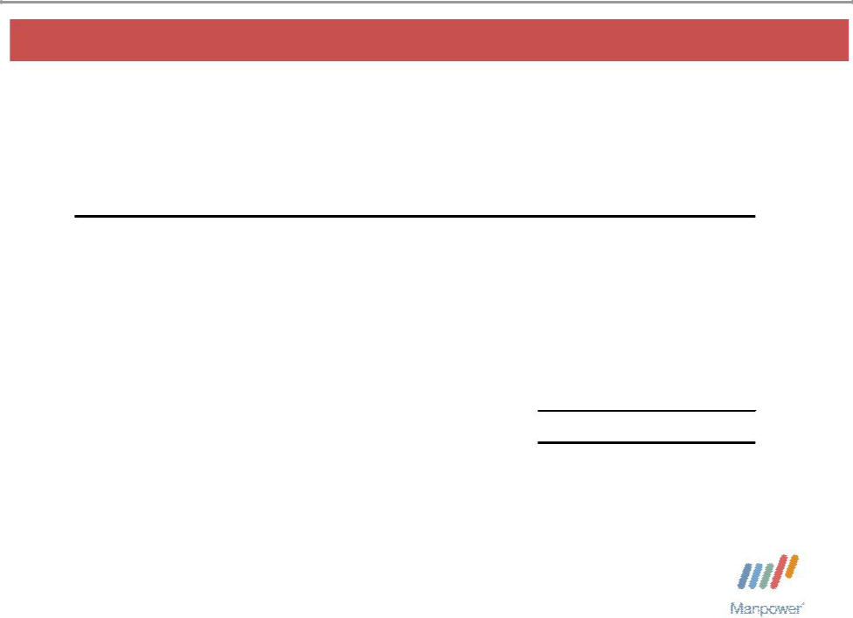

Credit Facilities as of September 30, 2008

($ in millions) | Interest | Maturity | Total | Remaining
 | Rate | Date | Outstanding | Available
Euro Notes:
- Euro 200M | 4.86% | June 2013 | 281 | -
- Euro 300M | 4.58% | June 2012 | 422 | -
Revolving Credit Agreement^{(a)} | 5.71% | Nov 2012 | 141 | 480
A/R Securitization ^{(b)} | 3.06% | July 2009 | 73 | 27
Uncommitted lines and Other ^{(c)} | Various | Various | 55 | 312
Total Debt |  |  | 972 | 819

  - $625M multi-currency Revolving Credit Agreement provided by 17 banks. No lender represents more than 10% of the total amount. As of September 30, 2008, there was a €100M borrowing under the Revolving Credit Agreement which has been swapped to a fixed rate of 5.71% until July 2010. New borrowings under the agreement would be made at the interbank rate for the relevant currency and tenor plus a credit spread based upon our public debt rating. At September 30, 2008, new 30-day USD borrowings would cost 4.32% (30-day LIBOR plus 40 bps).

- The interest rate is based on the issuance cost of commercial paper from Citigroup conduits which are rated A1+/P1 by the rating agencies. The commercial paper is sold into public, private or bank financing markets. Our cost of funds is comprised of the issuance cost for this commercial paper plus a commission and will vary based on market and interest rate conditions.

- Represents borrowings under uncommitted lines of credit & overdraft facilities, which total $365M, and other long-term debt of $2M. Total subsidiary borrowings are limited to $300M due to restrictions in our Revolving Credit Agreement, with the exception of Q3 when subsidiary borrowings are limited to $600M.

Manpower Inc. 2008 3rd Quarter Results | 17
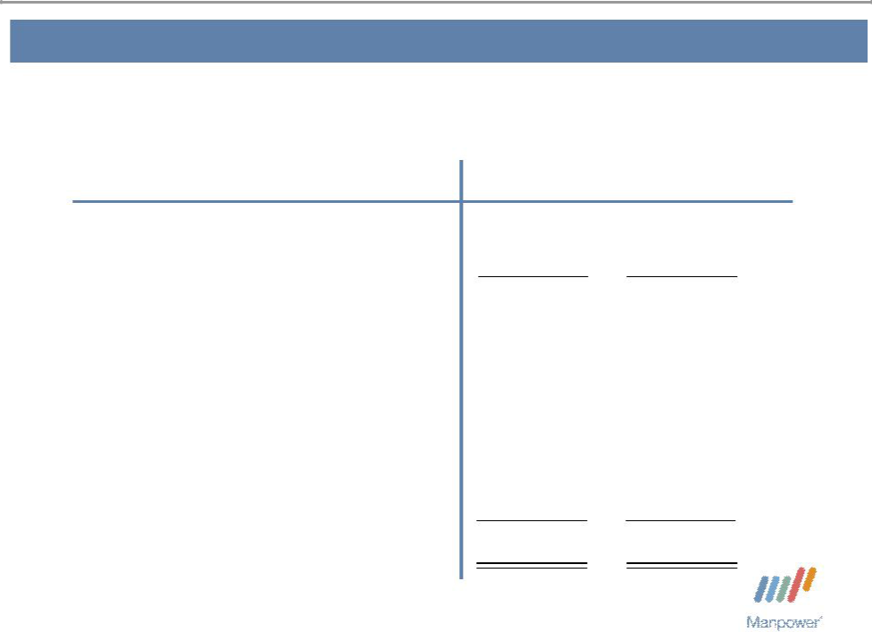

Cash Flow Summary – Nine Months

($ in millions) | 2008 | 2007
Cash from Operations | 449 | 299
Capital Expenditures | (70) | (66)
Free Cash Flow | 379 | 233
Share Repurchases * | (125) | (360)
Proceeds from Equity Plans | 13 | 40
Change in Debt | 87 | 16
Acquisitions of Businesses, | (224) | (100)
net of cash acquired | (224) | (100)
Other | (36) | 22
Change in Cash | 94 | (149)

- 2,231,610 shares in 2008 and 4,944,200 shares in 2007. $11.5M of cash paid in 2008 was for shares repurchased in 2007.

Manpower Inc. 2008 3rd Quarter Results | 18
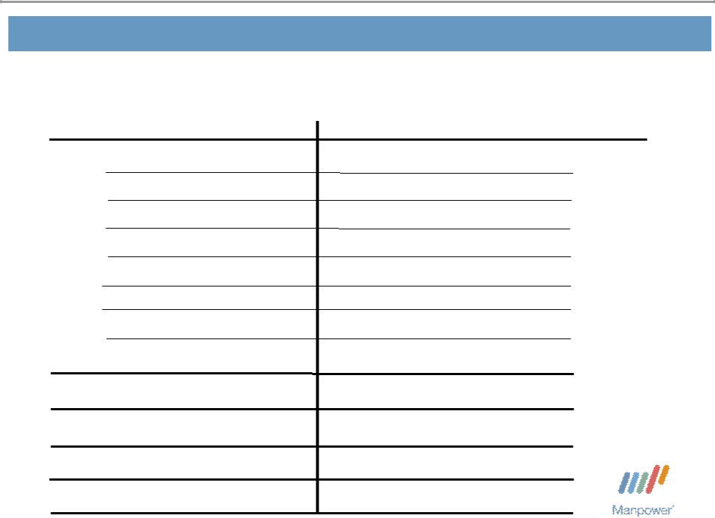

Fourth Quarter Outlook

Revenue U.S.

France

Other EMEA

Italy

Jefferson Wells

Right Management

Other

Total

Gross Profit Margin Operating Profit Margin

Tax Rate

EPS

Down 2-4%

Down 21-23%(Down 15-17% CC)

Down 6-8% (Up/Down 1% CC)

Down 11-13% (Down 4-6% CC)

Down 16-18%

Up 4-6% (Up 7-9% CC)

Up 5-7% (Up 0-2% CC)

Down 9-11% (Down 5-7% CC)

18.6-18.8%

2.6-2.8%

36.5%

$0.97-$1.01(Neg. $.06 Currency)

Manpower Inc.

2008 3 ^{rd}Quarter Results

October 21, 2008

Questions?
Answers

Earnings, As Adjusted |  |  |  |  |  |  |  |  |  |  |  |  |  |  |  |  |  | Exhibit 99.3
 |  | Three Months Ended September 30 |  |  |  |  |  |  |  |  |  | Nine Months Ended September 30
 |  | Earnings |  | Impairment |  |  |  |  | Earnings |  |  | Earnings |  |  | Impairment |  |  |  |  | Earnings
 | As Reported |  |  |  | Charge |  |  | As Adjusted |  |  | As Reported |  |  |  |  | Charge |  |  | As Adjusted
Gross profit | $ | 1,027.6 |  | $ | — |  | $ |  | 1,027.6 | $ |  | 3,148.9 |  | $ |  | — |  | $ |  | 3,148.9
Selling and administrative expenses |  | 1,006.6 |  |  | (163.1) |  |  |  | 843.5 |  |  | 2,788.6 |  |  |  | (163.1) |  |  |  | 2,625.5
Operating profit |  | 21.0 |  |  | 163.1 |  |  |  | 184.1 |  |  | 360.3 |  |  |  | 163.1 |  |  |  | 523.4
Interest and other expenses |  | 13.4 |  |  | — |  |  |  | 13.4 |  |  | 38.6 |  |  |  | — |  |  |  | 38.6
Earnings before income taxes |  | 7.6 |  |  | 163.1 |  |  |  | 170.7 |  |  | 321.7 |  |  |  | 163.1 |  |  |  | 484.8
Provision for income taxes |  | 50.8 |  |  | 8.5 |  |  |  | 59.3 |  |  | 182.0 |  |  |  | 8.5 |  |  |  | 190.5
Net (loss) earnings | $ | (43.2) |  | $ | 154.6 |  | $ |  | 111.4 | $ |  | 139.7 |  | $ |  | 154.6 |  | $ |  | 294.3
Net (loss) earnings per share - diluted
Net (loss) earnings per share - diluted | $ | (0.55) |  | $ | 1.97 |  | $ |  | 1.42 | $ |  | 1.75 |  | $ |  | 1.93 |  | $ |  | 3.68

The Earnings, As Adjusted, amounts exclude the impact of the goodwill and intangible asset impairment charge that we recorded in the third quarter of 2008 related to our investment in Right Management. We believe that these adjusted earnings amounts provide useful information to investors because they better reflect the operating performance of the company. Management also uses these adjusted results when analyzing our performance against that of our competitors, and we believe that many of our shareholders and other interested parties will exclude this charge as they analyze our operating results.

