UNITED STATES

SECURITIES AND EXCHANGE COMMISSION
Washington, D.C. 20549

FORM 8-K

CURRENT REPORT

Pursuant to Section 13 or 15(d) of the Securities Exchange Act of 1934

Date of Report (Date of earliest event reported): April 20, 2007

MANPOWER INC.

(Exact name of registrant as specified in its charter)

Wisconsin | 1-10686 | 39-1672779
(State or other jurisdiction | (Commission File Number) | (IRS Employer
of incorporation) |  | Identification No.)
5301 North Ironwood Road
Milwaukee, Wisconsin |  | 53217
(Address of principal executive offices) |  | (Zip Code)

Registrant’s telephone number, including area code: (414) 961-1000

Check the appropriate box below if the Form 8-K filing is intended to simultaneously satisfy the filing obligation of the registrant under any of the following provisions:

- Written communications pursuant to Rule 425 under the Securities Act (17 CFR 230.425)

- Soliciting material pursuant to Rule 14a-12 under the Securities Act (17 CFR 240.14a-12)

- Pre-commencement communications pursuant to Rule 14d-2(b) under the Exchange Act (17 CFR 240.14d-2(b))

- Pre-commencement communications pursuant to Rule 13e-4(c) under the Exchange Act (17 CFR 240.13e-4(c))

Item 2.02 Results of Operations and Financial Condition

On April 20, 2007, we issued a press release announcing our results of operations for the quarter ended March 31, 2007. A copy of the press release is attached hereto as Exhibit 99.1 and is incorporated herein by reference.

Reflected in our earnings for the quarter ended March 31, 2007 is one item that requires us to revise previously reported financial results. Italy and Other EMEA are now identified as separate reportable segments, which were previously combined and reported as the EMEA segment. Attached hereto as Exhibit 99.3 is our Operating Unit Results since January 1, 2005, restated to conform to the current year presentation.

Item 9.01. Exhibits.

Exhibit No. |  | Description
99.1 |  | Press Release dated April 20, 2007
99.2 |  | Presentation materials for April 20, 2007 conference call
99.3 |  | Operating Unit Results reflecting the restatement of segment results

SIGNATURES

Pursuant to the requirements of the Securities Exchange Act of 1934, the Registrant has duly caused this Report to be signed on its behalf by the undersigned hereunto duly authorized.

MANPOWER INC.

Dated: April 20, 2007 By: /s/ Michael J. Van Handel

Michael J. Van Handel

Executive Vice President,

Chief Financial Officer and Secretary

 |  | EXHIBIT INDEX
Exhibit No. |  | Description
99.1 | Press Release dated April 20, 2007
99.2 | Presentation materials for April 20, 2007 conference call
99.3 | Operating Unit Results reflecting the restatement of segment results
Exhibit 99.1

[MANPOWER logo]

FOR IMMEDIATE RELEASE Contact:

Mike Van Handel

Manpower Inc.

+1.414.906.6305

michael.vanhandel@manpower.com

Manpower Reports 1st Quarter 2007 Results

MILWAUKEE, WI, USA, April 20, 2007 – Manpower Inc. (NYSE: MAN) today reported that net earnings from continuing operations for the three months ended March 31, 2007 more than doubled to $59.5 million, or 69 cents per diluted share, compared to $29.5 million, or 33 cents per diluted share, a year earlier. Revenues for the first quarter were $4.5 billion, an increase of 17 percent from the year earlier period.

Results for the first quarter were favorably impacted by 5 cents per diluted share as foreign currencies were relatively stronger compared to the first quarter of 2006. On a constant currency basis, revenues increased 10 percent over the prior year period. Included in prior year net earnings of 59 cents per diluted share is 26 cents per diluted share of earnings related to discontinued operations. Also included in prior year net earnings is a 16 cents per diluted share charge related to reorganization costs and a global cost reduction initiative.

Jeffrey A. Joerres, Manpower Chairman and Chief Executive Officer, said, “The strength of our European geography combined with company-wide operational excellence resulted in a very strong first quarter for Manpower.

“The Manpower team is executing extremely well, our Other EMEA segment (Europe excluding France and Italy) increased profitability by 144 percent, while Manpower France, our single largest operation, increased profitability by 33 percent on a constant currency basis. The U.S. operation, expectedly, experienced softness in revenue, but realized an increase in profitability of 22 percent.

“Our ability to deliver such strong earnings, given the softness in the U.S. market, demonstrates the strength of our geographic and business mix as well as the underlying quality, talent and dedication of our people throughout the world.

“Given the current trends, we anticipate our second quarter diluted earnings per share to be in the range of $1.12 to $1.16, which includes an estimated favorable currency impact of 6 cents.”

In conjunction with its first quarter earnings release, Manpower will broadcast its conference call live over the Internet on April 20, 2007 at 7:30 a.m. CDT (8:30 a.m. EDT).

Interested parties are invited to listen to the webcast and view the presentation by logging on to http://investor.manpower.com.

Supplemental financial information referenced in the conference call can be found at http://investor.manpower.com.

About Manpower Inc.

Manpower Inc. (NYSE: MAN) is a world leader in the employment services industry; creating and delivering services that enable its clients to win in the changing world of work. The $18 billion company offers employers a range of services for the entire employment and business cycle including permanent, temporary and contract recruitment; employee assessment and selection; training; outplacement; outsourcing and consulting. Manpower's worldwide network of 4,400 offices in 73 countries and territories enables the company to meet the needs of its 400,000 clients per year, including small and medium size enterprises in all industry sectors, as well as the world's largest multinational corporations. The focus of Manpower's work is on raising productivity through improved quality, efficiency and cost-reduction across their total workforce, enabling clients to concentrate on their core business activities. Manpower Inc. operates under five brands: Manpower, Manpower Professional, Elan, Jefferson Wells and Right Management. More information on Manpower Inc. is available at www.manpower.com.

Forward-Looking Statements

This news release contains statements, including earning projections, that are forward-looking in nature and, accordingly, are subject to risks and uncertainties regarding the Company’s expected future results. The Company’s actual results may differ materially from those described or contemplated in the forward-looking statements. Factors that may cause the Company’s actual results to differ materially from those contained in the forward-looking statements can be found in the Company’s reports filed with the SEC, including the information under the heading ‘Risk Factors’ in its Annual Report on Form 10-K for the year ended December 31, 2006, which information is incorporated herein by reference.

- ### -

Manpower Inc.

Results of Operations

(In millions, except per share data)

 |  |  |  |  | Three Months Ended March 31
 |  |  |  |  |  |  |  |  | % Variance
 |  |  |  |  |  |  |  |  | Amount |  | Constant
 |  |  |  | 2007 |  |  | 2006 |  | Reported |  | Currency
 |  |  |  |  |  |  |  | (Unaudited)
Revenues from services (a) |  | $ |  | 4,535.6 | $ |  | 3,877.2 |  | 17.0% |  | 9.6%
Cost of services |  |  |  | 3,735.6 |  |  | 3,184.0 |  | 17.3%
Gross profit |  |  |  | 800.0 |  |  | 693.2 |  | 15.4% |  | 8.5%
Selling and administrative expenses |  |  |  | 696.7 |  |  | 632.9 |  | 10.1% |  | 3.9%
Operating profit |  |  |  | 103.3 |  |  | 60.3 |  | 71.2% |  | 57.1%
Interest and other expenses |  |  |  | 9.6 |  |  | 13.0 |  | -26.2%
Earnings before income taxes and discontinued operations |  |  |  | 93.7 |  |  | 47.3 |  | 97.9% |  | 84.5%
Provision for income taxes |  |  |  | 34.2 |  |  | 17.8 |  | 91.5%
Net earnings from continuing operations |  |  |  | 59.5 |  |  | 29.5 |  | 101.8% |  | 88.1%
Income from discontinued operations, net of income taxes |  |  |  | — |  |  | 23.1 |  | N/A
Net earnings |  | $ |  | 59.5 | $ |  | 52.6 |  | 13.1% |  | 5.4%
Net earnings per share - basic:
Continuing operations |  | $ |  | 0.70 | $ |  | 0.34 |  | 105.9%
Discontinued operations |  |  |  | — |  |  | 0.26 |  | N/A
Total |  | $ |  | 0.70 | $ |  | 0.60 |  | 16.7%
Net earnings per share - diluted:
Continuing operations |  | $ |  | 0.69 | $ |  | 0.33 |  | 109.1% |  | 93.9%
Discontinued operations |  |  |  | — |  |  | 0.26 |  | N/A
Total |  | $ |  | 0.69 | $ |  | 0.59 |  | 16.9% |  | 8.5%
Weighted average shares - basic |  |  |  |  |  |  |  |  | -2.9%
 |  |  |  | 84.9 |  |  | 87.4
Weighted average shares - diluted |  |  |  | 86.5 |  |  | 88.7 |  | -2.4%

- Revenues from services include fees received from our franchise offices of $8.4 million and $8.0 million for the three months ended March 31, 2007 and 2006, respectively. These fees are primarily based on revenues generated by the franchise offices, which were $362.4 million and $362.8 million for the three months ended March 31, 2007 and 2006, respectively.

Manpower Inc.

Operating Unit Results

(In millions)

 |  |  |  |  |  | Three Months Ended March 31
 |  |  |  |  |  |  |  |  |  | % Variance
 |  |  |  |  |  |  |  |  |  | Amount |  | Constant
 |  |  |  | 2007 |  |  |  | 2006 |  | Reported |  | Currency
 |  |  |  |  |  |  |  |  | (Unaudited)
Revenues from Services:
United States (a) |  | $ |  | 483.6 |  | $ |  | 510.3 |  | -5.2% |  | -5.2%
France |  |  |  | 1,493.0 |  |  |  | 1,240.5 |  | 20.4% |  | 10.4%
Other EMEA (b) |  |  |  | 1,476.4 |  |  |  | 1,149.8 |  | 28.4% |  | 17.0%
Italy (b) |  |  |  | 304.8 |  |  |  | 242.4 |  | 25.7% |  | 15.3%
Jefferson Wells |  |  |  | 81.3 |  |  |  | 95.5 |  | -14.9% |  | -14.9%
Right Management |  |  |  | 93.9 |  |  |  | 95.3 |  | -1.5% |  | -5.5%
Other Operations |  |  |  | 602.6 |  |  |  | 543.4 |  | 10.9% |  | 10.6%
 |  | $ |  | 4,535.6 |  | $ |  | 3,877.2 |  | 17.0% |  | 9.6%
Operating Unit Profit:
United States |  | $ |  | 11.5 |  | $ |  | 9.5 |  | 21.6% |  | 21.6%
France |  |  |  | 43.9 |  |  |  | 30.4 |  | 44.4% |  | 32.6%
Other EMEA (b) |  |  |  | 36.7 |  |  |  | 13.6 |  | 168.6% |  | 144.5%
Italy (b) |  |  |  | 16.4 |  |  |  | 9.4 |  | 75.2% |  | 60.4%
Jefferson Wells |  |  |  | 1.0 |  |  |  | 5.7 |  | -82.4% |  | -82.4%
Right Management |  |  |  | 6.1 |  |  |  | 4.6 |  | 31.8% |  | 28.7%
Other Operations |  |  |  | 12.8 |  |  |  | 17.6 |  | -27.7% |  | -28.1%
 |  |  |  | 128.4 |  |  |  | 90.8
Corporate expenses |  |  |  | 21.9 |  |  |  | 27.3
Amortization of intangible assets |  |  |  | 3.2 |  |  |  | 3.2
Operating profit |  |  |  | 103.3 |  |  |  | 60.3 |  | 71.2% |  | 57.1%
Interest and other expenses (c) |  |  |  | 9.6 |  |  |  | 13.0
Earnings before income taxes and discontinued operations |  | $ |  | 93.7 |  | $ |  | 47.3

- In the United States, revenues from services include fees received from the related franchise offices of $5.3 million for the three months ended March 31, 2007 and 2006. These fees are primarily based on revenues generated by the franchise offices, which were $269.1 million and $282.3 million for the three months ended March 31, 2007 and 2006, respectively.

- Italy and Other EMEA were previously combined as the EMEA segment. All previously reported results have been revised to conform to the current year presentation.

- The components of interest and other expenses were:

 | 2007 |  |  |  | 2006
Interest expense | $ | 14.2 |  | $11.6
Interest income |  | (7.2) |  | (3.3)
Foreign exchange losses |  | 0.1 |  | 0.9
Miscellaneous expenses |  | 2.5 |  |  | 3.8
 | $ | 9.6 |  | $13.0

Manpower Inc.

Consolidated Balance Sheets

(In millions)

 |  | Mar. 31 |  |  | Dec. 31
 |  | 2007 |  |  | 2006
 |  | (Unaudited)
ASSETS
Current assets:
Cash and cash equivalents | $ | 727.3 |  | $ | 687.9
Accounts receivable, net |  | 3,775.2 |  |  | 3,837.2
Prepaid expenses and other assets |  | 142.4 |  |  | 90.5
Future income tax benefits |  | 87.0 |  |  | 66.4
Total current assets |  | 4,731.9 |  |  | 4,682.0
Other assets:
Goodwill and other intangible assets, net |  | 1,305.7 |  |  | 1,293.6
Other assets |  | 320.7 |  |  | 336.4
Total other assets |  | 1,626.4 |  |  | 1,630.0
Property and equipment:
Land, buildings, leasehold improvements and equipment |  | 712.5 |  |  | 693.2
Less: accumulated depreciation and amortization |  | 511.1 |  |  | 491.1
Net property and equipment |  | 201.4 |  |  | 202.1
Total assets | $ | 6,559.7 |  | $ | 6,514.1
LIABILITIES AND SHAREHOLDERS' EQUITY
Current liabilities:
Accounts payable | $ | 939.2 |  | $ | 889.9
Employee compensation payable |  | 150.2 |  |  | 180.7
Accrued liabilities |  | 554.4 |  |  | 562.1
Accrued payroll taxes and insurance |  | 652.2 |  |  | 699.9
Value added taxes payable |  | 510.7 |  |  | 517.0
Short-term borrowings and current maturities of long-term debt |  | 36.1 |  |  | 32.0
Total current liabilities |  | 2,842.8 |  |  | 2,881.6
Other liabilities:
Long-term debt |  | 800.5 |  |  | 791.2
Other long-term liabilities |  | 416.1 |  |  | 367.1
Total other liabilities |  | 1,216.6 |  |  | 1,158.3
Shareholders’ equity:
Common stock |  | 1.0 |  |  | 1.0
Capital in excess of par value |  | 2,446.7 |  |  | 2,420.7
Retained earnings |  | 672.2 |  |  | 617.0
Accumulated other comprehensive income |  | 136.2 |  |  | 120.6
Treasury stock, at cost |  | (755.8) |  |  | (685.1)
Total shareholders’ equity |  | 2,500.3 |  |  | 2,474.2
Total liabilities and shareholders’ equity | $ | 6,559.7 |  | $ | 6,514.1

Manpower Inc.

Consolidated Statements of Cash Flows

(In millions)

Cash Flows from Operating Activities:

Net earnings

Adjustments to reconcile net earnings to net cash provided by operating activities:
Gain on sale of business

Depreciation and amortization
Deferred income taxes

Provision for doubtful accounts
Stock based compensation

Excess tax benefit on exercise of stock options
Changes in operating assets and liabilities excluding the impact of acquisitions:

Accounts receivable
Other assets

Other liabilities

Cash provided by operating activities

Cash Flows from Investing Activities:

Capital expenditures

Acquisitions of businesses, net of cash acquired
Proceeds from sale of business

Proceeds from sale of an equity interest
Proceeds from the sale of property and equipment

Cash (used) provided by investing activities

Cash Flows from Financing Activities:

Net borrowings of short-term facilities and long-term debt
Proceeds from stock option and purchase plans

Excess tax benefit on exercise of stock options
Repurchases of common stock

Cash used by financing activities

Effect of exchange rate changes on cash

Change in cash and cash equivalents

Cash and cash equivalents, beginning of period

Cash and cash equivalents, end of period

Three Months Ended

Mar. 31
2007 2006
(Unaudited)

$ 59.5 $ 52.6

—(29.3)

21.521.8

15.7 |  | (10.0)
5.1 |  | 6.1
5.7 |  | 4.6
(2.3) |  | (2.7)
88.2 |  | 76.9
(57.4) |  | (19.5)
(33.2) |  | (26.0)
102.8 |  | 74.5

(16.8) (15.2)

(5.0) (7.2)

—29.6

—8.8

1.62.2

(20.2) 18.2

3.8 3.2

20.0 26.5

2.3 2.7

(72.7) (33.0)

(46.6) (0.6)

3.4 7.5

39.4 99.6

687.9 454.9

$ 727.3 $ 554.5

Exhibit 99.2
Manpower Inc.
2007 1st Quarter Results


April 20, 2007

New Face
New Place

Manpower Inc. 2007 1st Quarter Results | 2
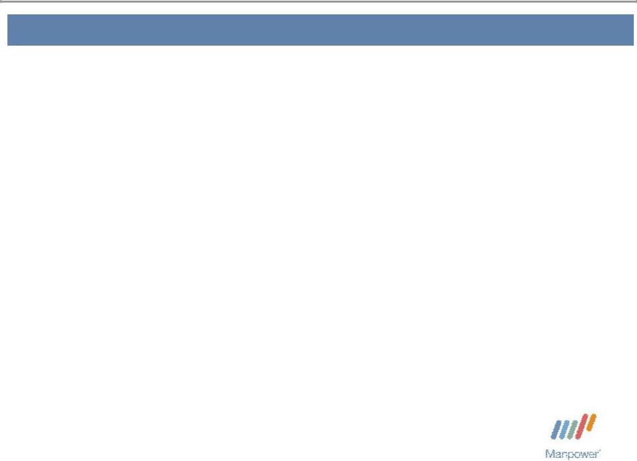

Forward Looking Statement

This presentation includes forward-looking statements which are subject to risks and uncertainties. Actual results might differ materially from those projected in the forward-looking statements. Forward-looking statements can be identified by words such as “expect,” “plan,” “may,” “will,” and similar expressions. Additional information concerning factors that could cause actual results to materially differ from those in the forward-looking statements is contained in the Company’s Annual Report on Form 10-K dated December 31, 2006, which information is incorporated herein by reference, and such other factors as may be described from time to time in the Company’s SEC filings.

Manpower Inc. 2007 1st Quarter Results | 3
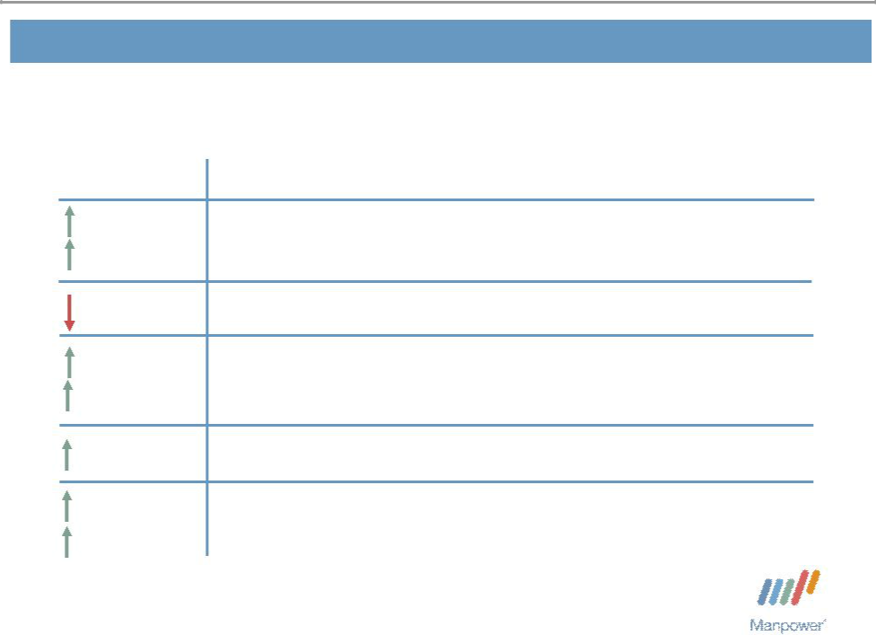

Consolidated Financial Highlights

17%

10% CC

24 bps

71%

57% CC

70 bps

109%

94% CC

Q1 Highlights Revenue $4.5B

Gross Margin 17.6%

Operating Profit $103M

OP Margin 2.3%

EPS from Continuing Operations $.69

Throughout this presentation, the difference between reported variances and Constant Currency

- variances represents the impact of currency on our financial results. Constant Currency is further explained on our Web site.

Manpower Inc. 2007 1st Quarter Results | 4
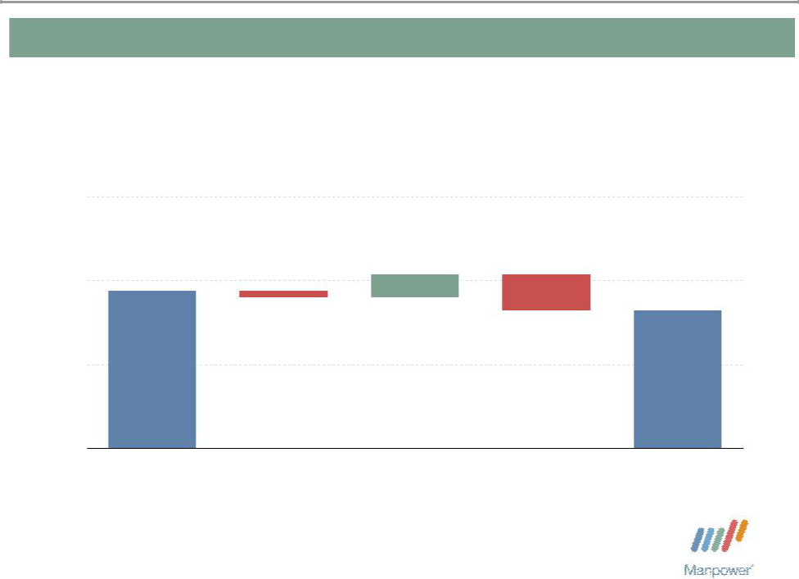

Consolidated Gross Profit Margin Change

19%

+ 0.27% - 0.43%
_{18%} - 0.08%

17.88%

17.64%

17%

16%

Q1 2006 | Temporary | Permanent | Mix - Specialty | Q1 2007
 | Recruitment | Recruitment

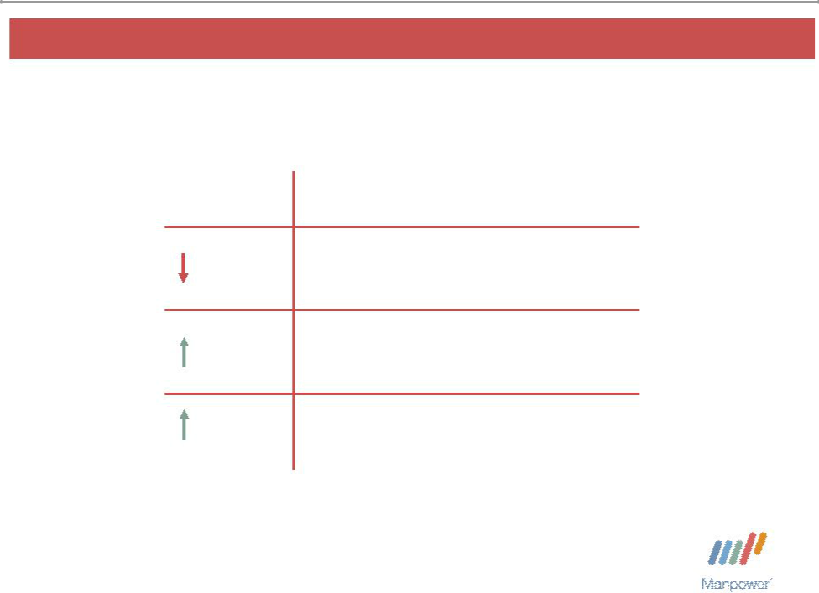
Manpower Inc. 2007 1st Quarter Results | 5

United States Segment
(11% of Revenue)

Q1 Financial Highlights

5% Revenue $484M

22% OUP $12M

50 bps OUP Margin 2.4%

Operating Unit Profit (OUP) is the measure that we use to evaluate segment performance. OUP is equal to segment revenues less direct costs and branch and national headquarters operating costs.

Manpower Inc. 2007 1st Quarter Results | 6
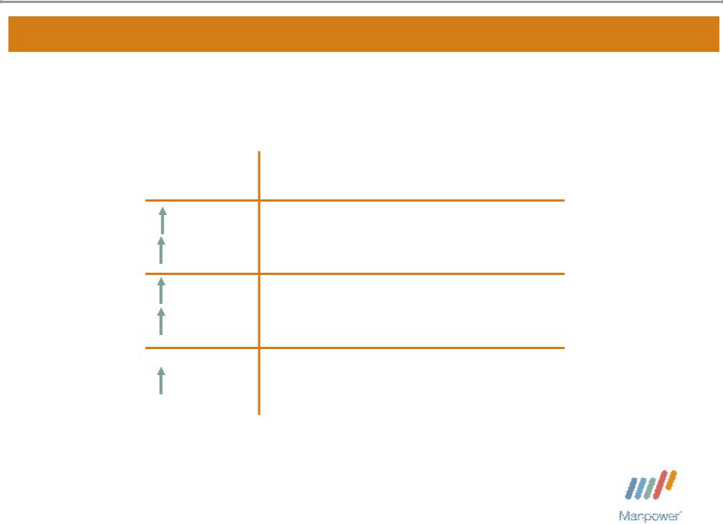

France Segment
(33% of Revenue)

Q1 Financial Highlights
^{20%} Revenue $1.5B

10% CC
^{44%} OUP $44M

33% CC

40 bps OUP Margin 2.9%

Manpower Inc. 2007 1st Quarter Results | 7
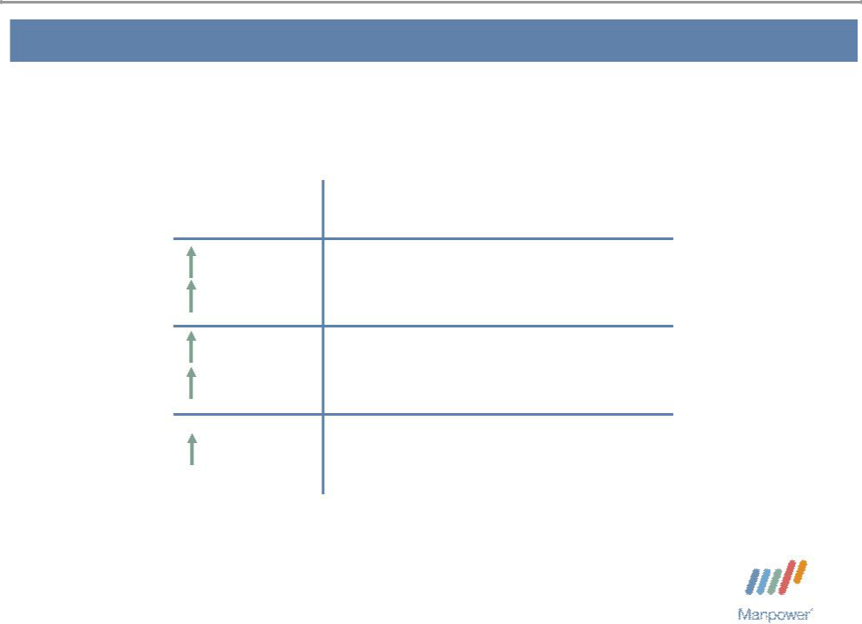

Other EMEA Segment
(33% of Revenue)

Q1 Financial Highlights
^{28%} Revenue $1.5B

17% CC
^{169%} OUP $37M

144% CC

130 bps OUP Margin 2.5%

Manpower Inc. 2007 1st Quarter Results | 8
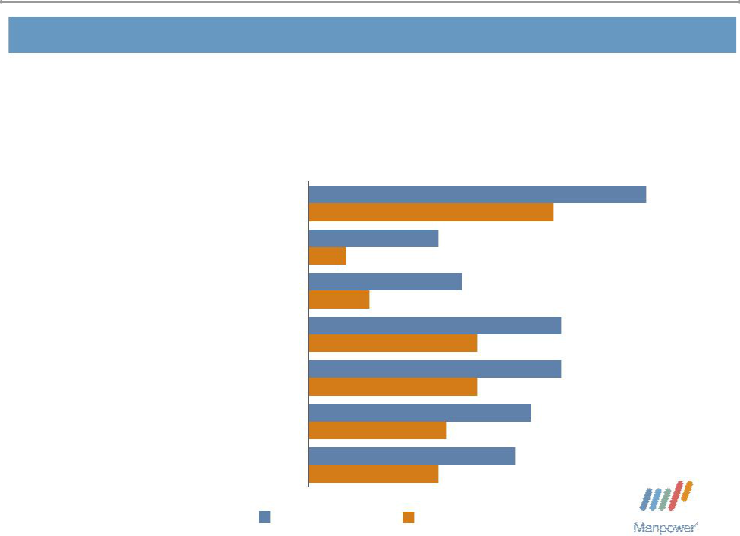

Other EMEA – Q1 Revenue Growth YoY

- of Segment Revenue

20% Nordics

18% UK - Manpower

14% Elan

10% Germany

9% Netherlands

8% Spain

21% Other

44%

32%

17%

5%

20%

8%

33%

22%

33%

22%

29%

18%

27%

17%

Revenue Growth Revenue Growth - CC

Manpower Inc. 2007 1st Quarter Results | 9
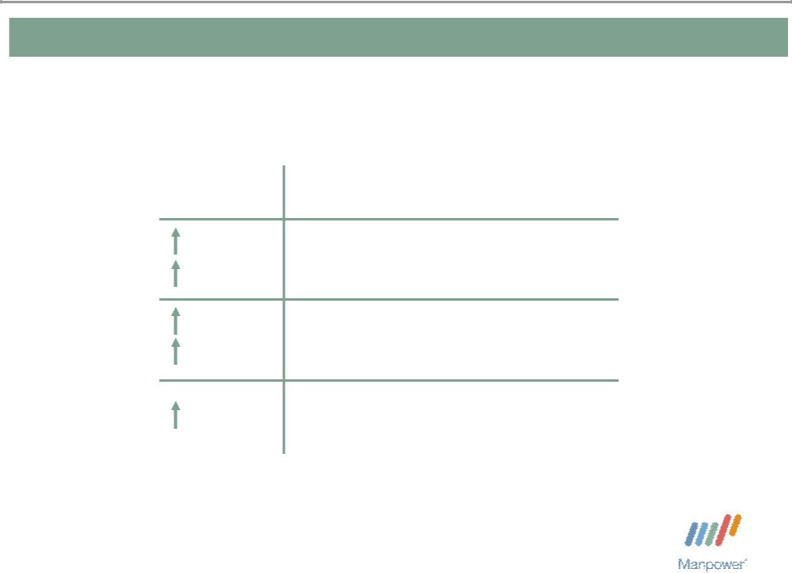

Italy Segment
(7% of Revenue)

Q1 Financial Highlights
^{26%} Revenue $305M
15% CC
^{75%} OUP $16M

60% CC

150 bps OUP Margin 5.4%

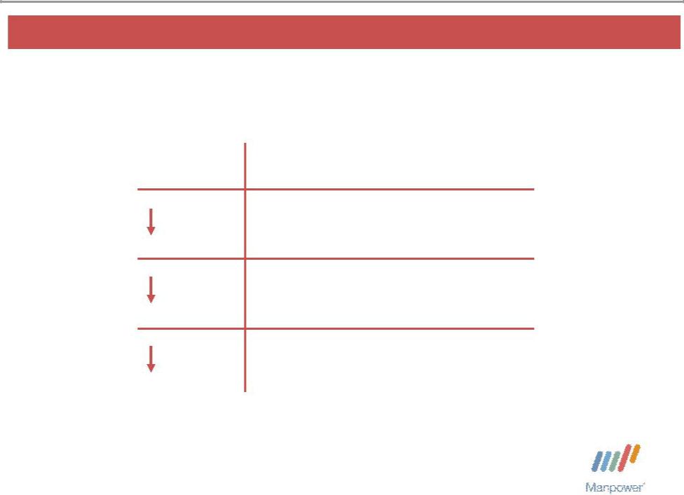
Manpower Inc. 2007 1st Quarter Results 10

Jefferson Wells Segment
(2% of Revenue)

Q1 Financial Highlights

15% Revenue $81M

82% OUP $1M

480 bps OUP Margin 1.2%

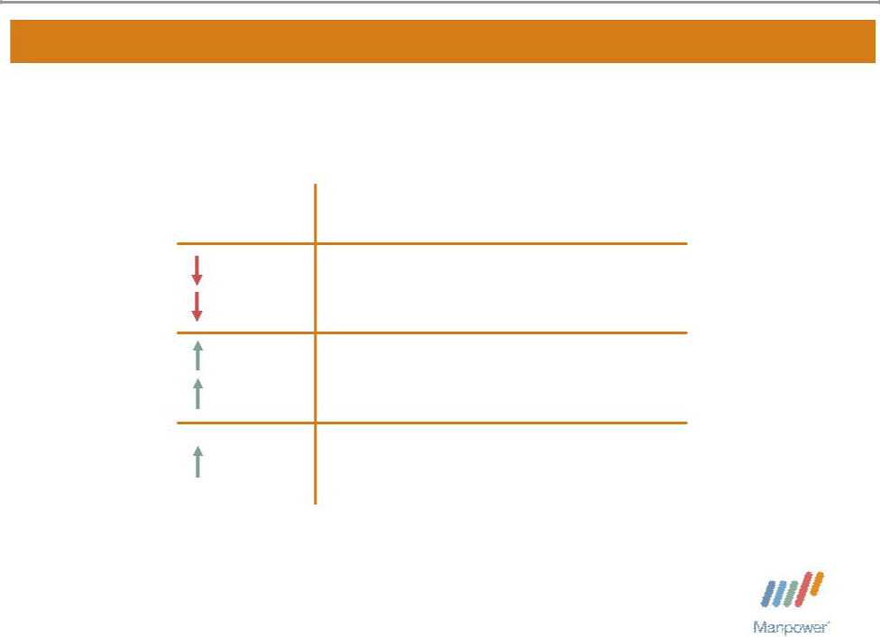
Manpower Inc. 2007 1st Quarter Results 11

Right Management Segment
(2% of Revenue)

Q1 Financial Highlights
^{1%} Revenue $94M

5% CC
^{32%} OUP $6M

29% CC

160 bps OUP Margin 6.5%

Manpower Inc. 2007 1st Quarter Results | 12
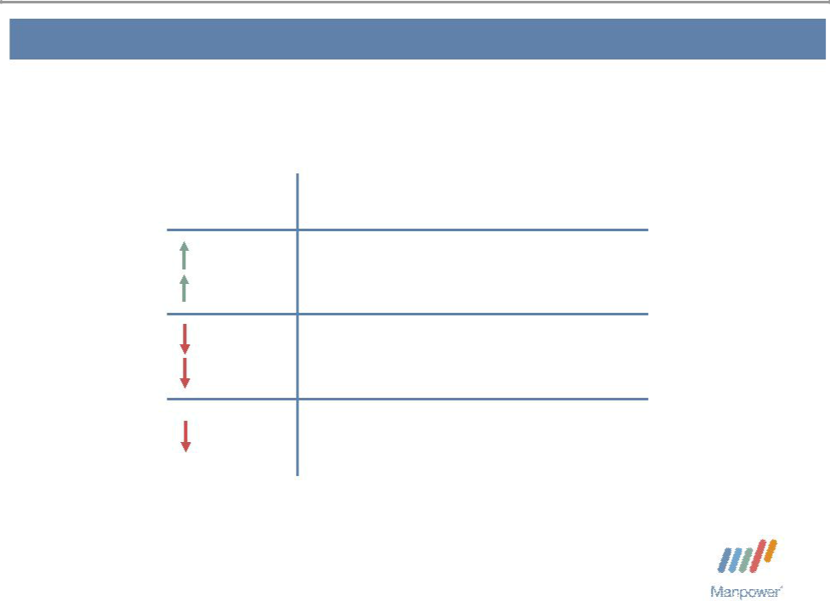

Other Operations Segment
(12% of Revenue)

Q1 Financial Highlights
^{11%} Revenue $603M
11% CC
^{28%} OUP $13M

28% CC

110 bps OUP Margin 2.1%

Manpower Inc. 2007 1st Quarter Results | 13
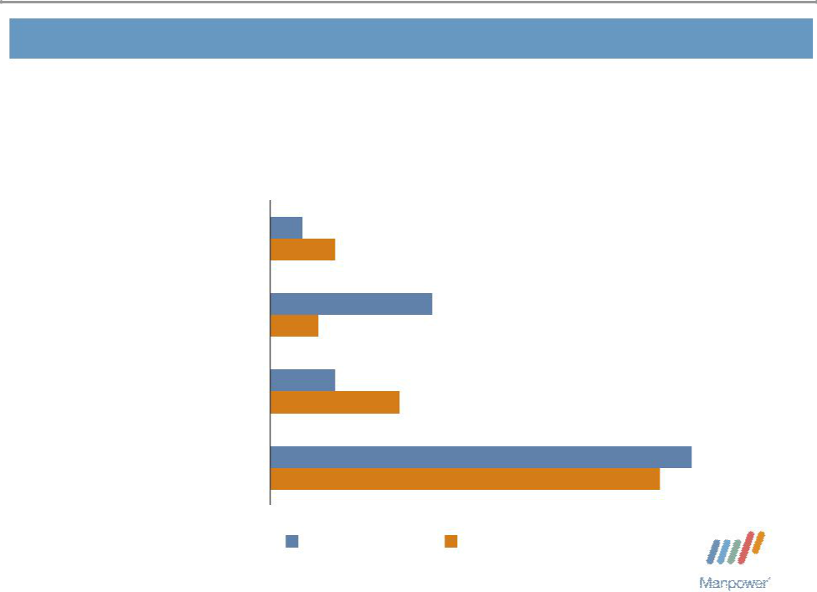

Other Operations – Q1 Revenue Growth YoY

- of Segment Revenue

35% | Japan | 2%
35% | Japan | 4%
16% | Australia/NZ | 10%
16% | Australia/NZ | 3%
15% | Mexico | 4%
15% | Mexico | 8%
34% | Other | 26%
34% | Other | 24%

Revenue Growth Revenue Growth - CC


Manpower Inc. 2007 1st Quarter Results 14

Financial Highlights

Manpower Inc. 2007 1st Quarter Results | 15
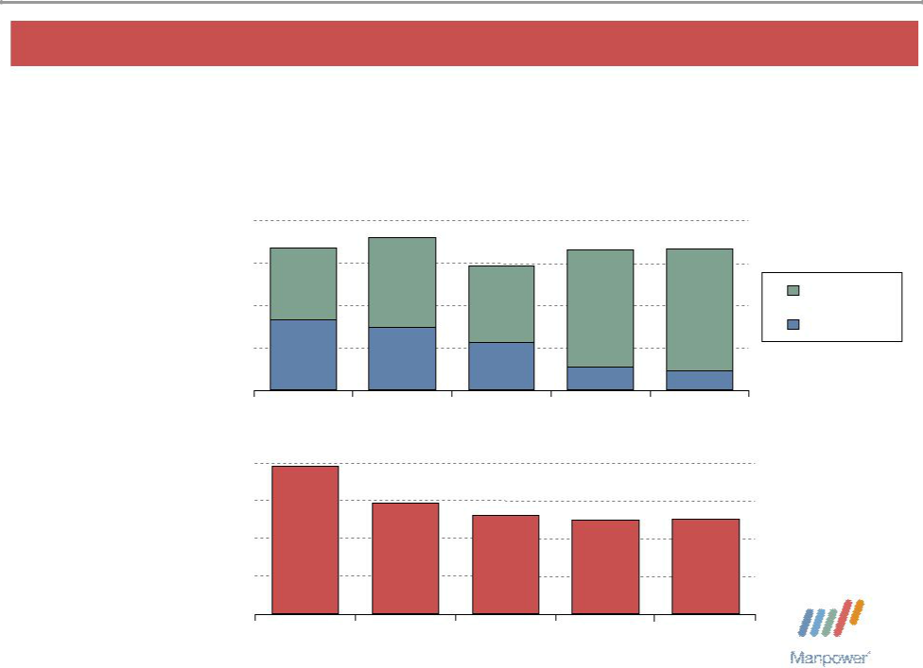

Balance Sheet Highlights

Total Debt | 1,000

($ in millions)

750

500

250

0

842 ⁹⁰²

416 ₃₇₀

735

280

823 837

Total Debt

Net Debt

135 109

Total Debt to

Total Capitalization

40%

30%

20%

10%

0%

2003 2004 2005

39%

29% _{26%}

2003 2004 2005

2006 Q1 2007

25% 25%

2006 Q1 2007

Manpower Inc. 2007 1st Quarter Results | 16

Cash Flow Summary – First Quarter

($ in millions) | 2007 | 2006
Cash from Operations | 103 | 74
Capital Expenditures | (17) | (15)
Free Cash Flow | 86 | 59
Share Repurchases * | (73) | (33)
Proceeds from Equity Plans | 20 | 27
Change in Debt | 4 | 3
Proceeds from Sale of Businesses | - | 30
Other | 2 | 14
Change in Cash | 39 | 100

* 991,900 shares in 2007 and 612,600 shares in 2006.

Manpower Inc. 2007 1st Quarter Results | 17
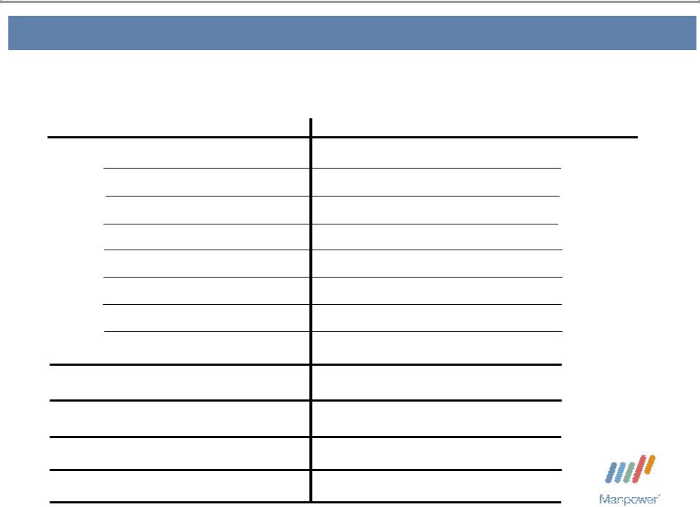

Second Quarter Outlook

Revenue U.S.

France

Other EMEA

Italy

Jefferson Wells

Right Management

Other

Total

Gross Profit Margin Operating Profit Margin

Tax Rate from Continuing Operations EPS from Continuing Operations

Down 3-5%

Up 16-18%(Up 10-12% CC)

Up 22-24% (Up 15-17% CC)

Up 20-22% (Up 14-16% CC)

Down 16-18%

Up/Down 1%(Down 2-4% CC)

Up 11-13% (Up 11-13% CC)

Up 14-16% (Up 9-11% CC)

17.6-17.8%

3.2 - 3.4%

36.5%

$1.12-$1.16 (Pos. $.06 Currency)

Manpower Inc.
2007 1st Quarter Results


April 20, 2007

Questions?
Answers

Exhibit 99.3

Manpower Inc.

Restated Operating Unit Results

(In millions)

The following identifies Italy and Other EMEA as separate reportable segments, which were previously combined and reported as the EMEA segment. Historical amounts have been restated to conform to the current year presentation.

 |  |  | Three Months Ended March 31 |  |  |  |  |  |  |  |  |  |  | Three Months Ended June 30
 |  |  |  |  |  |  | % Variance |  |  |  |  |  |  |  |  |  | % Variance
 |  |  |  |  |  |  | Amount |  | Constant |  |  |  |  |  |  |  | Amount |  | Constant
 |  | 2006 |  |  | 2005 |  | Reported |  | Currency |  |  | 2006 |  |  | 2005 |  | Reported |  | Currency
 |  |  |  |  |  | (Unaudited) |  |  |  |  |  |  |  |  |  | (Unaudited)
Revenue from Services:
United States | $ | 510.3 | $ |  | 475.9 |  | 7.2% |  | 7.2% |  | $ | 534.6 | $ |  | 506.7 | 5.5% |  |  | 5.5%
France |  | 1,240.5 |  |  | 1,238.0 |  | 0.2% |  | 9.2% |  |  | 1,535.6 |  |  | 1,397.0 | 9.9% |  |  | 9.8%
Other EMEA |  | 1,149.8 |  |  | 1,074.2 |  | 7.0% |  | 16.1% |  |  | 1,257.5 |  |  | 1,148.0 | 9.5% |  |  | 10.0%
Italy |  | 242.4 |  |  | 215.3 |  | 12.6% |  | 22.7% |  |  | 291.7 |  |  | 233.1 | 25.1% |  |  | 25.0%
Jefferson Wells |  | 95.5 |  |  | 92.7 |  | 3.0% |  | 3.0% |  |  | 98.8 |  |  | 93.5 | 5.7% |  |  | 5.7%
Right Management |  | 95.3 |  |  | 103.3 |  | -7.7% |  | -4.4% |  |  | 102.6 |  |  | 107.1 | -4.2% |  |  | -4.2%
Other Operations |  | 543.4 |  |  | 496.7 |  | 9.4% |  | 13.8% |  |  | 563.8 |  |  | 508.0 | 11.0% |  |  | 13.7%
 | $ | 3,877.2 | $ |  | 3,696.1 |  | 4.9% |  | 11.8% |  | $ | 4,384.6 | $ |  | 3,993.4 | 9.8% |  |  | 10.2%
Operating Unit Profit:
United States | $ | 9.5 | $ |  | 4.9 |  | 93.3% |  | 93.3% |  | $ | 22.5 | $ |  | 18.0 | 25.2% |  |  | 25.2%
France |  | 30.4 |  |  | 28.4 |  | 7.1% |  | 16.7% |  |  | 49.7 |  |  | 42.0 | 18.3% |  |  | 17.7%
Other EMEA |  | 13.6 |  |  | 4.7 |  | 194.6% |  | 224.9% |  |  | 29.5 |  |  | 23.3 | 26.2% |  |  | 25.3%
Italy |  | 9.4 |  |  | 7.4 |  | 26.0% |  | 37.7% |  |  | 21.2 |  |  | 12.6 | 68.1% |  |  | 67.0%
Jefferson Wells |  | 5.7 |  |  | 8.1 |  | -29.4% |  | -29.4% |  |  | 10.0 |  |  | 9.3 | 7.7% |  |  | 7.7%
Right Management |  | 4.6 |  |  | 10.3 |  | -54.8% |  | -55.5% |  |  | 11.1 |  |  | 9.5 | 15.8% |  |  | 14.3%
Other Operations |  | 17.6 |  |  | 12.1 |  | 44.7% |  | 53.8% |  |  | 14.8 |  |  | 12.8 | 16.5% |  |  | 21.2%
 | $ | 90.8 | $ |  | 75.9 |  |  |  |  |  | $ | 158.8 | $ |  | 127.5
 |  |  |  |  |  |  |  |  |  |  |  |  |  |  | Six Months Ended June 30
 |  |  |  |  |  |  |  |  |  |  |  |  |  |  |  |  | % Variance
 |  |  |  |  |  |  |  |  |  |  |  |  |  |  |  |  | Amount |  | Constant
 |  |  |  |  |  |  |  |  |  |  |  | 2006 |  |  | 2005 |  | Reported |  | Currency
 |  |  |  |  |  |  |  |  |  |  |  |  |  |  |  | (Unaudited)
Revenue from Services:
United States |  |  |  |  |  |  |  |  |  |  | $ | 1,044.9 | $ |  | 982.6 | 6.3% |  |  | 6.3%
France |  |  |  |  |  |  |  |  |  |  |  | 2,776.1 |  |  | 2,635.0 | 5.4% |  |  | 9.5%
Other EMEA |  |  |  |  |  |  |  |  |  |  |  | 2,407.3 |  |  | 2,222.2 | 8.3% |  |  | 13.0%
Italy |  |  |  |  |  |  |  |  |  |  |  | 534.1 |  |  | 448.4 | 19.1% |  |  | 23.9%
Jefferson Wells |  |  |  |  |  |  |  |  |  |  |  | 194.3 |  |  | 186.2 | 4.3% |  |  | 4.3%
Right Management |  |  |  |  |  |  |  |  |  |  |  | 197.9 |  |  | 210.4 | -6.0% |  |  | -4.3%
Other Operations |  |  |  |  |  |  |  |  |  |  |  | 1,107.2 |  |  | 1,004.7 | 10.2% |  |  | 13.8%
 |  |  |  |  |  |  |  |  |  |  | $ | 8,261.8 | $ |  | 7,689.5 | 7.4% |  |  | 11.0%
Operating Unit Profit:
United States |  |  |  |  |  |  |  |  |  |  | $ | 32.0 | $ |  | 22.9 | 39.8% |  |  | 39.8%
France |  |  |  |  |  |  |  |  |  |  |  | 80.1 |  |  | 70.4 | 13.8% |  |  | 17.3%
Other EMEA |  |  |  |  |  |  |  |  |  |  |  | 43.1 |  |  | 28.0 | 54.1% |  |  | 58.4%
Italy |  |  |  |  |  |  |  |  |  |  |  | 30.6 |  |  | 20.0 | 52.5% |  |  | 56.1%
Jefferson Wells |  |  |  |  |  |  |  |  |  |  |  | 15.7 |  |  | 17.4 | -9.6% |  |  | -9.6%
Right Management |  |  |  |  |  |  |  |  |  |  |  | 15.7 |  |  | 19.8 | -20.9% |  |  | -21.9%
Other Operations |  |  |  |  |  |  |  |  |  |  |  | 32.4 |  |  | 24.9 | 30.3% |  |  | 37.2%
 |  |  |  |  |  |  |  |  |  |  | $ | 249.6 | $ |  | 203.4

1

Manpower Inc.

Restated Operating Unit Results

(In millions)

 |  |  | Three Months Ended September 30 |  |  |  |  |  |  |  |  |  |  | Three Months Ended December 31
 |  |  |  |  |  |  | % Variance |  |  |  |  |  |  |  |  |  |  | % Variance
 |  |  |  |  |  |  | Amount |  | Constant |  |  |  |  |  |  |  |  | Amount |  | Constant
 |  | 2006 |  |  | 2005 |  | Reported |  | Currency |  |  | 2006 |  |  |  | 2005 |  | Reported |  | Currency
 |  |  |  |  |  | (Unaudited) |  |  |  |  |  |  |  |  |  | (Unaudited)
Revenue from Services:
United States | $ | 542.1 | $ |  | 531.5 |  | 2.0% |  | 2.0% |  | $ | 527.9 |  | $ |  | 534.2 |  | -1.2% |  | -1.2%
France |  | 1,654.0 |  |  | 1,479.3 |  | 11.8% |  | 7.0% |  |  | 1,589.0 |  |  |  | 1,361.5 |  | 16.7% |  | 7.7%
Other EMEA |  | 1,353.4 |  |  | 1,145.2 |  | 18.2% |  | 13.2% |  |  | 1,470.0 |  |  |  | 1,204.0 |  | 22.1% |  | 12.4%
Italy |  | 276.3 |  |  | 210.7 |  | 31.1% |  | 25.5% |  |  | 322.2 |  |  |  | 240.7 |  | 33.9% |  | 23.5%
Jefferson Wells |  | 93.9 |  |  | 103.9 |  | -9.6% |  | -9.6% |  |  | 84.8 |  |  |  | 96.1 |  | -11.9% |  | -11.9%
Right Management |  | 90.5 |  |  | 94.8 |  | -4.6% |  | -6.7% |  |  | 98.9 |  |  |  | 96.6 |  | 2.4% |  | -1.8%
Other Operations |  | 579.8 |  |  | 522.2 |  | 11.0% |  | 12.8% |  |  | 617.9 |  |  |  | 535.2 |  | 15.5% |  | 14.7%
 | $ | 4,590.0 | $ |  | 4,087.6 |  | 12.3% |  | 9.0% |  | $ | 4,710.7 |  | $ |  | 4,068.3 |  | 15.8% |  | 9.1%
Operating Unit Profit:
United States | $ | 28.6 | $ |  | 22.6 |  | 26.7% |  | 26.7% |  | $ | 26.8 |  | $ |  | 23.2 |  | 15.2% |  | 15.2%
France |  | 62.0 |  |  | 50.6 |  | 22.4% |  | 17.1% |  |  | 61.2 |  |  |  | 47.7 |  | 28.3% |  | 18.4%
Other EMEA |  | 49.2 |  |  | 34.8 |  | 41.2% |  | 35.5% |  |  | 64.4 |  |  |  | 37.7 |  | 70.8% |  | 57.9%
Italy |  | 16.7 |  |  | 9.4 |  | 79.0% |  | 70.9% |  |  | 16.2 |  |  |  | 14.2 |  | 14.4% |  | 6.2%
Jefferson Wells |  | 10.0 |  |  | 11.5 |  | -13.7% |  | -13.7% |  |  | 6.2 |  |  |  | 4.4 |  | 41.4% |  | 41.4%
Right Management |  | 2.2 |  |  | 2.3 |  | -5.2% |  | -10.3% |  |  | 0.4 |  |  |  | 3.6 |  | -87.5% |  | -74.1%
Other Operations |  | 16.4 |  |  | 16.3 |  | 1.3% |  | 3.8% |  |  | 21.1 |  |  |  | 19.2 |  | 9.9% |  | 10.3%
 | $ | 185.1 | $ |  | 147.5 |  |  |  |  |  | $ | 196.3 |  | $ |  | 150.0
 |  |  | Nine Months Ended September 30 |  |  |  |  |  |  |  |  |  |  |  |  | Year Ended December 31
 |  |  |  |  |  |  | % Variance |  |  |  |  |  |  |  |  |  |  | % Variance
 |  |  |  |  |  |  | Amount |  | Constant |  |  |  |  |  |  |  |  | Amount |  | Constant
 |  | 2006 |  |  | 2005 |  | Reported |  | Currency |  |  | 2006 |  |  |  | 2005 |  | Reported |  | Currency
 |  |  |  |  |  | (Unaudited) |  |  |  |  |  |  |  |  |  | (Unaudited)
Revenue from Services:
United States | $ | 1,587.0 | $ |  | 1,514.1 |  | 4.8% |  | 4.8% |  | $ | 2,114.9 |  | $ |  | 2,048.3 |  | 3.2% |  | 3.2%
France |  | 4,430.1 |  |  | 4,114.3 |  | 7.7% |  | 8.6% |  |  | 6,019.1 |  |  |  | 5,475.8 |  | 9.9% |  | 8.4%
Other EMEA |  | 3,760.7 |  |  | 3,367.4 |  | 11.7% |  | 13.0% |  |  | 5,230.7 |  |  |  | 4,571.4 |  | 14.4% |  | 12.9%
Italy |  | 810.4 |  |  | 659.1 |  | 23.0% |  | 24.4% |  |  | 1,132.6 |  |  |  | 899.8 |  | 25.9% |  | 24.2%
Jefferson Wells |  | 288.2 |  |  | 290.1 |  | -0.6% |  | -0.6% |  |  | 373.0 |  |  |  | 386.2 |  | -3.4% |  | -3.4%
Right Management |  | 288.4 |  |  | 305.2 |  | -5.5% |  | -5.0% |  |  | 387.3 |  |  |  | 401.8 |  | -3.6% |  | -4.2%
Other Operations |  | 1,687.0 |  |  | 1,526.9 |  | 10.5% |  | 13.4% |  |  | 2,304.9 |  |  |  | 2,062.1 |  | 11.8% |  | 13.8%
 | $ | 12,851.8 | $ 11,777.1 |  |  |  | 9.1% |  | 10.3% |  | $ | 17,562.5 |  | $ |  | 15,845.4 |  | 10.8% |  | 10.0%
Operating Unit Profit:
United States | $ | 60.6 | $ |  | 45.5 |  | 33.3% |  | 33.3% |  | $ | 87.4 |  | $ |  | 68.7 |  | 27.2% |  | 27.2%
France |  | 142.1 |  |  | 121.0 |  | 17.4% |  | 17.2% |  |  | 203.3 |  |  |  | 168.7 |  | 20.5% |  | 17.6%
Other EMEA |  | 92.3 |  |  | 62.8 |  | 47.0% |  | 45.7% |  |  | 156.7 |  |  |  | 100.5 |  | 55.9% |  | 50.3%
Italy |  | 47.3 |  |  | 29.4 |  | 60.9% |  | 60.8% |  |  | 63.5 |  |  |  | 43.6 |  | 45.8% |  | 43.1%
Jefferson Wells |  | 25.7 |  |  | 28.9 |  | -11.2% |  | -11.2% |  |  | 31.9 |  |  |  | 33.3 |  | -4.2% |  | -4.2%
Right Management |  | 17.9 |  |  | 22.1 |  | -19.2% |  | -20.7% |  |  | 18.3 |  |  |  | 25.7 |  | -28.8% |  | -28.2%
Other Operations |  | 48.8 |  |  | 41.2 |  | 18.8% |  | 23.9% |  |  | 69.9 |  |  |  | 60.4 |  | 16.0% |  | 19.6%
 | $ | 434.7 | $ |  | 350.9 |  |  |  |  |  | $ | 631.0 |  | $ |  | 500.9

2

