UNITED STATES

SECURITIES AND EXCHANGE COMMISSION
Washington, D.C. 20549

FORM 8-K

CURRENT REPORT

Pursuant to Section 13 or 15(d) of the Securities Exchange Act of 1934

Date of Report (Date of earliest event reported): July 19, 2013

MANPOWERGROUP INC.

(Exact name of registrant as specified in its charter)

Wisconsin | 1-10686 | 39-1672779
(State or other jurisdiction of incorporation) | (Commission File Number) | (IRS Employer Identification No.)
100 Manpower Place
Milwaukee, Wisconsin |  | 53212
(Address of principal executive offices) |  | (Zip Code)

Registrant's telephone number, including area code: (414) 961-1000

Check the appropriate box below if the Form 8-K filing is intended to simultaneously satisfy the filing obligation of the registrant under any of the following provisions:

Written communications pursuant to Rule 425 under the Securities Act (17 CFR 230.425)

Soliciting material pursuant to Rule 14a-12 under the Securities Act (17 CFR 240.14a-12)

Pre-commencement communications pursuant to Rule 14d-2(b) under the Exchange Act (17 CFR 240.14d-2(b))

Pre-commencement communications pursuant to Rule 13e-4(c) under the Exchange Act (17 CFR 240.13e-4(c))

Item 2.02 Results of Operations and Financial Condition

On July 19, 2013, we issued a press release announcing our results of operations for the three month and six month periods ended June 30, 2013. A copy of the press release is attached hereto as Exhibit 99.1 and is incorporated herein by reference.

On a consolidated basis, the French business tax is reported in provision for income taxes, in accordance with the current accounting guidance on income taxes. Prior to the second quarter of 2013, we internally reviewed the financial results of our French operations including the French business tax within Operating Unit Profit (“OUP”) given the operational nature of these taxes. While we continue to view this tax as operational, during the second quarter of 2013 we changed our internal reporting to exclude the French business tax from the OUP of our France reportable segment. Therefore our France reportable segment OUP now excludes the business tax and we no longer need to show the business tax amount separately to reconcile to the consolidated results. All previously reported segment results have been restated to conform to the current year presentation. This change in segment reporting has no impact on our reporting of consolidated results. Attached hereto as Exhibit 99.3 is our Operating Unit Results since January 1, 2010, revised to conform to the current year presentation.

Item 9.01. | Exhibits.
Exhibit No. | Description
99.1 | Press Release dated July 19, 2013
99.2 | Presentation materials for July 19, 2013 conference call
99.3 | Operating Unit Results reflecting the restatement of segment results

SIGNATURES

Pursuant to the requirements of the Securities Exchange Act of 1934, the Registrant has duly caused this Report to be signed on its behalf by the undersigned hereunto duly authorized.

MANPOWERGROUP INC.

Dated: July 19, 2013 By: /s/ Michael J. Van Handel

Michael J. Van Handel

Executive Vice President and

Chief Financial Officer

 | EXHIBIT INDEX
Exhibit No. | Description
99.1 | Press Release dated July 19, 2013
99.2 | Presentation materials for July 19, 2013 conference call
99.3 | Operating Unit Results reflecting the restatement of segment results

Exhibit 99.1


FOR IMMEDIATE RELEASE

Contact:

Mike Van Handel

+1.414.906.6305

michael.vanhandel@manpowergroup.com

ManpowerGroup Reports 2nd Quarter and First Half 2013 Results

MILWAUKEE, July 19, 2013 -- ManpowerGroup (NYSE: MAN) today reported that net earnings per diluted share for the three months ended June 30, 2013 were 87 cents compared to 51 cents in the prior year period. Net earnings in the second quarter were $68.2 million compared to $41.0 million a year earlier. Revenues for the second quarter were $5.0 billion, a decrease of 3 percent from the year earlier period in U.S. dollars and in constant currency.

Included in the current year second quarter results is a restructuring charge, primarily related to office consolidations and severance costs, of $20.0 million ($14.4 million after tax or 18 cents per diluted share). Excluding these charges, earnings per diluted share in the quarter were $1.05. Net earnings in the second quarter were unfavorably impacted by 1 cent per diluted share, as foreign currencies were relatively weaker compared to the prior year period.

ManpowerGroup Chairman and CEO Jeffrey A. Joerres, said, “The second quarter results are solid evidence of our team’s strong execution of our recalibration efforts and a stabilizing global economy. We continue to make progress on improving our business mix with our ManpowerGroup Solutions, led by Recruitment Process Outsourcing growing at 19%.

“We are anticipating the third quarter of 2013 diluted earnings per share to be in the range of $1.02 to $1.10, which includes an estimated unfavorable currency impact of 1 cent,” Joerres stated.

Earnings per diluted share for the six months ended June 30, 2013 were $1.17 compared to $1.01 per diluted share in 2012. Net earnings for the period were $92.1 million compared to $81.2 million in the prior year. Revenues for the six-month period were $9.8 billion, a decrease of 5 percent from the prior year or a decrease of 4 percent in constant currency. Earnings per diluted share for the current year six month period include restructuring charges of 51 cents per diluted share. Foreign currency exchange rates had an unfavorable impact of 2 cents for the six-month period.

In conjunction with its second quarter earnings release, ManpowerGroup will broadcast its conference call live over the Internet on July 19, 2013 at 7:30 a.m. CDT (8:30 a.m. EDT). Interested parties are invited to listen to the webcast and view the presentation by logging on to http://www.manpowergroup.com/investors. Supplemental financial information referenced in the conference call can be found at http://www.manpowergroup.com/investors.

About ManpowerGroup™

ManpowerGroup™ (NYSE: MAN) is the world leader in innovative workforce solutions that ensure the talent sustainability of the world's workforce for the good of companies, communities, countries, and individuals themselves. Specializing in solutions that help organizations achieve business agility and workforce flexibility, ManpowerGroup leverages its 65 years of world of work expertise to create the work models, design the people practices and access the talent sources its clients need for the future. From staffing, recruitment, workforce consulting, outsourcing and career management to assessment, training and development, ManpowerGroup delivers the talent to drive the innovation and productivity of organizations in a world where talentism is the dominant economic system. Every day, ManpowerGroup connects more than 630,000 people to work and builds their experience and employability through its relationships with 400,000 clients across 80 countries and territories. ManpowerGroup's suite of solutions is offered through ManpowerGroup™ Solutions, Manpower®, Experis™ and Right Management®. ManpowerGroup was named one of the World's Most Ethical Companies for the third consecutive year in 2013, confirming our position as the most trusted brand in the industry. See how ManpowerGroup makes powering the world of work humanly possible at www.manpowergroup.com. Follow ManpowerGroup Chairman and CEO Jeff Joerres on Twitter: Twitter.com/manpowergroupjj.

Forward-Looking Statements

This news release contains statements, including earnings projections, that are forward-looking in nature. These statements are based on management’s current expectations or beliefs, and are subject to known and unknown risks and uncertainties regarding the Company's expected future results. The Company's actual results may differ materially from those described or contemplated in the forward-looking statements. Factors that may cause the Company's actual results to differ materially from those contained in the forward-looking statements can be found in the Company's reports filed with the SEC, including the information under the heading 'Risk Factors' in its Annual Report on Form 10-K for the year ended December 31, 2012, which information is incorporated herein by reference. Any forward-looking statement in this release speaks only as of the date on which it is made. The company assumes no obligation to update or revise any forward-looking statements.

###

ManpowerGroup

Results of Operations

(In millions, except per share data)

 |  |  |  |  |  | Three Months Ended June 30
 |  |  |  |  |  |  |  | % Variance
 |  |  |  |  |  |  |  | Amount |  | Constant
 |  |  | 2013 |  |  | 2012 |  | Reported |  | Currency
 |  |  |  |  |  | (Unaudited)
 | Revenues from services (a) | $ | 5,040.7 |  | $ | 5,206.7 |  | -3.2% |  | -2.9%
 | Cost of services |  | 4,204.3 |  |  | 4,345.0 |  | -3.2% |  | -2.9%
 | Gross profit |  | 836.4 |  |  | 861.7 |  | -2.9% |  | -2.6%
 | Selling and administrative expenses |  | 708.3 |  |  | 767.3 |  | -7.7% |  | -7.5%
 | Operating profit |  | 128.1 |  |  | 94.4 |  | 35.6% |  | 37.2%
 | Interest and other expenses |  | 10.3 |  |  | 11.3 |  | -9.1%
 | Earnings before income taxes |  | 117.8 |  |  | 83.1 |  | 41.7% |  | 43.3%
 | Provision for income taxes |  | 49.6 |  |  | 42.1 |  | 17.7%
 | Net earnings | $ | 68.2 |  | $ | 41.0 |  | 66.4% |  | 69.2%
 | Net earnings per share - basic | $ | 0.88 |  | $ | 0.51 |  | 72.5%
 | Net earnings per share - diluted | $ | 0.87 |  | $ | 0.51 |  | 70.6% |  | 72.5%
 | Weighted average shares - basic |  | 77.4 |  |  | 80.1 |  | -3.3%
 | Weighted average shares - diluted |  | 78.6 |  |  | 80.4 |  | -2.3%

- Revenues from services include fees received from our franchise offices of $6.1 million for both the three months ended June 30, 2013 and 2012. These fees are primarily based on revenues generated by the franchise offices, which were $272.3 million and $270.0 million for the three months ended June 30, 2013 and 2012, respectively.

ManpowerGroup

 |  | Operating Unit Results
 |  | (In millions) |  |  |  |  | Three Months Ended June 30
 |  |  |  |  |  |  |  |  | % Variance
 |  |  |  |  |  |  |  |  | Amount |  | Constant
 |  |  |  | 2013 |  |  | 2012 |  | Reported |  | Currency
 |  |  |  |  |  |  | (Unaudited)
 | Revenues from Services:
 | Americas:
 | United States (b) | $ |  | 748.5 |  | $ | 763.2 |  | -1.9% |  | -1.9%
 | Other Americas |  |  | 387.2 |  |  | 389.2 |  | -0.5% |  | 0.4%
 |  |  |  | 1,135.7 |  |  | 1,152.4 |  | -1.4% |  | -1.1%
 | Southern Europe:
 | France |  |  | 1,320.6 |  |  | 1,427.6 |  | -7.5% |  | -9.1%
 | Italy |  |  | 278.4 |  |  | 274.0 |  | 1.6% |  | -0.2%
 | Other Southern Europe |  |  | 203.0 |  |  | 190.1 |  | 6.8% |  | 3.7%
 |  |  |  | 1,802.0 |  |  | 1,891.7 |  | -4.7% |  | -6.6%
 | Northern Europe |  |  | 1,398.8 |  |  | 1,415.8 |  | -1.2% |  | -1.6%
 | APME |  |  | 623.3 |  |  | 662.9 |  | -6.0% |  | 1.9%
 | Right Management |  |  | 80.9 |  |  | 83.9 |  | -3.5% |  | -2.0%
 |  | $ |  | 5,040.7 |  | $ | 5,206.7 |  | -3.2% |  | -2.9%
 | Operating Unit Profit (Loss): (a)
 | Americas:
 | United States | $ |  | 30.6 |  | $ | 7.7 |  | 296.3% |  | 296.3%
 | Other Americas |  |  | 11.9 |  |  | 10.5 |  | 13.1% |  | 11.7%
 |  |  |  | 42.5 |  |  | 18.2 |  | 133.3% |  | 132.5%
 | Southern Europe:
 | France |  |  | 40.9 |  |  | 34.6 |  | 17.6% |  | 16.0%
 | Italy |  |  | 14.7 |  |  | 12.6 |  | 16.2% |  | 14.0%
 | Other Southern Europe |  |  | 1.2 |  |  | 3.0 |  | -59.7% |  | -62.6%
 |  |  |  | 56.8 |  |  | 50.2 |  | 12.7% |  | 10.8%
 | Northern Europe |  |  | 33.2 |  |  | 39.2 |  | -15.4% |  | -14.9%
 | APME |  |  | 20.2 |  |  | 21.8 |  | -7.0% |  | 2.7%
 | Right Management |  |  | 7.4 |  |  | (2.9) |  | N/A |  | N/A
 |  |  |  | 160.1 |  |  | 126.5
 | Corporate expenses |  |  | (23.6) |  |  | (22.9)
 | Intangible asset amortization expense |  |  | (8.4) |  |  | (9.2)
 | Operating profit |  |  | 128.1 |  |  | 94.4 |  | 35.6% |  | 37.2%
 | Interest and other expenses (c) |  |  | (10.3) |  |  | (11.3)
 | Earnings before income taxes | $ |  | 117.8 |  | $ | 83.1

- On a consolidated basis, the French business tax is reported in provision for income taxes, in accordance with the current accounting guidance on income taxes. Prior to the second quarter of 2013, we internally reviewed the financial results of our French operations including the French business tax within OUP given the operational nature of these taxes. While we continue to view this tax as operational, during the second quarter of 2013 we changed our internal reporting to exclude the French business tax from the OUP of our France reportable segment. Therefore our France reportable segment OUP now excludes the business tax and we no longer need to show the business tax amount separately to reconcile to the consolidated results. All previously reported segment results have been restated to conform to the current year presentation. This change in segment reporting has no impact on our reporting of consolidated results.

- In the United States, revenues from services include fees received from our franchise offices of $3.8 for both the three months ended June 30, 2013 and 2012. These fees are primarily based on revenues generated by the franchise offices, which were $175.3 million and $180.6 million for the three months ended June 30, 2013 and 2012, respectively.

- The components of interest and other expenses were:

Interest expense | $ | 10.3 |  | $ | 10.2
Interest income |  | (0.9) |  |  | (1.4)
Foreign exchange loss |  | 1.4 |  |  | 0.5
Miscellaneous (income) expense, net |  | (0.5) |  |  | 2.0
 | $ | 10.3 |  | $ | 11.3

ManpowerGroup

Results of Operations

(In millions, except per share data)

 |  |  |  |  |  | Six Months Ended June 30
 |  |  |  |  |  |  |  | % Variance
 |  |  |  |  |  |  |  | Amount |  | Constant
 |  |  | 2013 |  |  | 2012 |  | Reported |  | Currency
 |  |  |  |  |  | (Unaudited)
 | Revenues from services (a) | $ | 9,809.6 |  | $ | 10,303.1 |  | -4.8% |  | -4.3%
 | Cost of services |  | 8,183.1 |  |  | 8,594.0 |  | -4.8% |  | -4.3%
 | Gross profit |  | 1,626.5 |  |  | 1,709.1 |  | -4.8% |  | -4.4%
 | Selling and administrative expenses |  | 1,444.0 |  |  | 1,520.9 |  | -5.1% |  | -4.7%
 | Operating profit |  | 182.5 |  |  | 188.2 |  | -3.1% |  | -1.5%
 | Interest and other expenses |  | 21.8 |  |  | 23.1 |  | -5.7%
 | Earnings before income taxes |  | 160.7 |  |  | 165.1 |  | -2.7% |  | -1.1%
 | Provision for income taxes |  | 68.6 |  |  | 83.9 |  | -18.3%
 | Net earnings | $ | 92.1 |  | $ | 81.2 |  | 13.4% |  | 16.0%
 | Net earnings per share - basic | $ | 1.19 |  | $ | 1.01 |  | 17.8%
 | Net earnings per share - diluted | $ | 1.17 |  | $ | 1.01 |  | 15.8% |  | 18.8%
 | Weighted average shares - basic |  | 77.3 |  |  | 80.1 |  | -3.6%
 | Weighted average shares - diluted |  | 78.6 |  |  | 80.8 |  | -2.7%

- Revenues from services include fees received from our franchise offices of $11.4 million and $11.5 million for the six months ended June 30, 2013 and 2012, respectively. These fees are primarily based on revenues generated by the franchise offices, which were $507.0 million and $523.9 million for the six months ended June 30, 2013 and 2012, respectively.

ManpowerGroup

 |  | Operating Unit Results
 |  | (In millions) |  |  |  |  | Six Months Ended June 30
 |  |  |  |  |  |  |  |  | % Variance
 |  |  |  |  |  |  |  |  | Amount |  | Constant
 |  |  |  | 2013 |  |  | 2012 |  | Reported |  | Currency
 |  |  |  |  |  |  | (Unaudited)
 | Revenues from Services:
 | Americas:
 | United States (b) | $ |  | 1,454.6 |  | $ | 1,499.0 |  | -3.0% |  | -3.0%
 | Other Americas |  |  | 774.1 |  |  | 791.7 |  | -2.2% |  | -0.5%
 |  |  |  | 2,228.7 |  |  | 2,290.7 |  | -2.7% |  | -2.1%
 | Southern Europe:
 | France |  |  | 2,465.8 |  |  | 2,719.4 |  | -9.3% |  | -10.4%
 | Italy |  |  | 536.3 |  |  | 541.5 |  | -1.0% |  | -2.1%
 | Other Southern Europe |  |  | 396.4 |  |  | 385.3 |  | 2.9% |  | 0.9%
 |  |  |  | 3,398.5 |  |  | 3,646.2 |  | -6.8% |  | -8.0%
 | Northern Europe |  |  | 2,769.1 |  |  | 2,859.8 |  | -3.2% |  | -3.7%
 | APME |  |  | 1,255.8 |  |  | 1,342.9 |  | -6.5% |  | 0.2%
 | Right Management |  |  | 157.5 |  |  | 163.5 |  | -3.7% |  | -2.3%
 |  | $ |  | 9,809.6 |  | $ | 10,303.1 |  | -4.8% |  | -4.3%
 | Operating Unit Profit (Loss): (a)
 | Americas:
 | United States | $ |  | 38.0 |  | $ | 14.6 |  | 160.6% |  | 160.6%
 | Other Americas |  |  | 20.6 |  |  | 25.8 |  | -20.3% |  | -21.2%
 |  |  |  | 58.6 |  |  | 40.4 |  | 45.0% |  | 44.4%
 | Southern Europe:
 | France |  |  | 70.6 |  |  | 57.5 |  | 22.7% |  | 21.9%
 | Italy |  |  | 26.4 |  |  | 27.1 |  | -2.9% |  | -4.1%
 | Other Southern Europe |  |  | 3.5 |  |  | 6.5 |  | -45.7% |  | -47.9%
 |  |  |  | 100.5 |  |  | 91.1 |  | 10.2% |  | 9.2%
 | Northern Europe |  |  | 43.8 |  |  | 83.1 |  | -47.3% |  | -47.0%
 | APME |  |  | 35.0 |  |  | 41.4 |  | -15.6% |  | -7.8%
 | Right Management |  |  | 9.4 |  |  | (0.4) |  | N/A |  | N/A
 |  |  |  | 247.3 |  |  | 255.6
 | Corporate expenses |  |  | (48.0) |  |  | (49.2)
 | Intangible asset amortization expense |  |  | (16.8) |  |  | (18.2)
 | Operating profit |  |  | 182.5 |  |  | 188.2 |  | -3.1% |  | -1.5%
 | Interest and other expenses (c) |  |  | (21.8) |  |  | (23.1)
 | Earnings before income taxes | $ |  | 160.7 |  | $ | 165.1

- On a consolidated basis, the French business tax is reported in provision for income taxes, in accordance with the current accounting guidance on income taxes. Prior to the second quarter of 2013, we internally reviewed the financial results of our French operations including the French business tax within OUP given the operational nature of these taxes. While we continue to view this tax as operational, during the second quarter of 2013 we changed our internal reporting to exclude the French business tax from the OUP of our France reportable segment. Therefore our France reportable segment OUP now excludes the business tax and we no longer need to show the business tax amount separately to reconcile to the consolidated results. All previously reported segment results have been restated to conform to the current year presentation. This change in segment reporting has no impact on our reporting of consolidated results.

- In the United States, revenues from services include fees received from our franchise offices of $7.0 million for both the six months ended June 30, 2013 and 2012. These fees are primarily based on revenues generated by the franchise offices, which were $330.4 million and $345.0 million for the six months ended June 30, 2013 and 2012, respectively.

- The components of interest and other expenses were:

Interest expense | $ | 21.0 |  | $ | 20.8
Interest income |  | (1.8) |  |  | (3.2)
Foreign exchange losses |  | 1.8 |  |  | 0.3
Miscellaneous expenses, net |  | 0.8 |  |  | 5.2
 | $ | 21.8 |  | $ | 23.1

ManpowerGroup

Consolidated Balance Sheets

(In millions)

 |  | Jun. 30 |  |  |  | Dec. 31
 |  | 2013 |  |  |  | 2012
 |  | (Unaudited)
ASSETS
Current assets:
Cash and cash equivalents | $ | 280.9 |  | $ |  | 648.1
Accounts receivable, net |  | 4,172.0 |  |  |  | 4,179.0
Prepaid expenses and other assets |  | 158.6 |  |  |  | 172.9
Future income tax benefits |  | 76.2 |  |  |  | 60.6
Total current assets |  | 4,687.7 |  |  |  | 5,060.6
Other assets:
Goodwill and other intangible assets, net |  | 1,360.3 |  |  |  | 1,371.9
Other assets |  | 451.0 |  |  |  | 395.3
Total other assets |  | 1,811.3 |  |  |  | 1,767.2
Property and equipment:
Land, buildings, leasehold improvements and equipment |  | 694.3 |  |  |  | 704.1
Less: accumulated depreciation and amortization |  | 520.0 |  |  |  | 519.3
Net property and equipment |  | 174.3 |  |  |  | 184.8
Total assets | $ | 6,673.3 |  | $ |  | 7,012.6
LIABILITIES AND SHAREHOLDERS' EQUITY
Current liabilities:
Accounts payable | $ | 1,505.0 |  | $ |  | 1,466.5
Employee compensation payable |  | 178.9 |  |  |  | 210.7
Accrued liabilities |  | 473.8 |  |  |  | 533.8
Accrued payroll taxes and insurance |  | 629.2 |  |  |  | 685.7
Value added taxes payable |  | 455.6 |  |  |  | 472.5
Short-term borrowings and current maturities of long-term debt |  | 78.6 |  |  |  | 308.0
Total current liabilities |  | 3,321.1 |  |  |  | 3,677.2
Other liabilities:
Long-term debt |  | 455.5 |  |  |  | 462.1
Other long-term liabilities |  | 364.2 |  |  |  | 372.5
Total other liabilities |  | 819.7 |  |  |  | 834.6
Shareholders' equity:
Common stock |  | 1.1 |  |  |  | 1.1
Capital in excess of par value |  | 2,903.1 |  |  |  | 2,873.2
Retained earnings |  | 1,158.1 |  |  |  | 1,101.5
Accumulated other comprehensive (loss) income |  | (22.9) |  |  |  | 34.4
Treasury stock, at cost |  | (1,506.9) |  |  |  | (1,509.4)
Total shareholders' equity |  | 2,532.5 |  |  |  | 2,500.8
Total liabilities and shareholders' equity | $ | 6,673.3 |  | $ |  | 7,012.6

ManpowerGroup

Consolidated Statements of Cash Flows

(In millions)

 |  | Six Months Ended
 |  |  | June 30
 |  | 2013 |  |  |  |  | 2012
 |  |  | (Unaudited)
 | Cash Flows from Operating Activities:
 | Net earnings | $ | 92.1 |  | $ |  | 81.2
 | Adjustments to reconcile net earnings to net
 | cash used in operating activities:
 | Depreciation and amortization |  | 48.0 |  |  |  | 49.2
 | Deferred income taxes |  | 3.3 |  |  |  | (3.7)
 | Provision for doubtful accounts |  | 13.5 |  |  |  | 10.0
 | Share-based compensation |  | 14.8 |  |  |  | 14.9
 | Excess tax benefit on exercise of share-based awards |  | (0.5) |  |  |  | -
 | Changes in operating assets and liabilities, excluding
 | the impact of acquisitions:
 | Accounts receivable |  | (119.0) |  |  |  | (127.7)
 | Other assets |  | (61.1) |  |  |  | (17.1)
 | Other liabilities |  | (62.7) |  |  |  | (46.4)
 | Cash used in operating activities |  | (71.6) |  |  |  | (39.6)
 | Cash Flows from Investing Activities:
 | Capital expenditures |  | (25.1) |  |  |  | (33.8)
 | Acquisitions of businesses, net of cash acquired |  | (16.9) |  |  |  | (34.0)
 | Proceeds from sales of property and equipment |  | 1.7 |  |  |  | 0.9
 | Cash used in investing activities |  | (40.3) |  |  |  | (66.9)
 | Cash Flows from Financing Activities:
 | Net change in short-term borrowings |  | 37.6 |  |  |  | 4.6
 | Proceeds from long-term debt |  | 0.1 |  |  |  | 751.6
 | Repayments of long-term debt |  | (267.5) |  |  |  | (700.6)
 | Proceeds from share-based awards |  | 15.0 |  |  |  | 3.9
 | Other share-based award transactions, net |  | 3.0 |  |  |  | (4.8)
 | Repurchases of common stock |  | - |  |  |  | (32.6)
 | Dividends paid |  | (35.5) |  |  |  | (34.3)
 | Cash used in financing activities |  | (247.3) |  |  |  | (12.2)
 | Effect of exchange rate changes on cash |  | (8.0) |  |  |  | (7.2)
 | Change in cash and cash equivalents |  | (367.2) |  |  |  | (125.9)
 | Cash and cash equivalents, beginning of period |  | 648.1 |  |  |  | 580.5
 | Cash and cash equivalents, end of period | $ | 280.9 |  | $ |  | 454.6

Exhibit 99.2




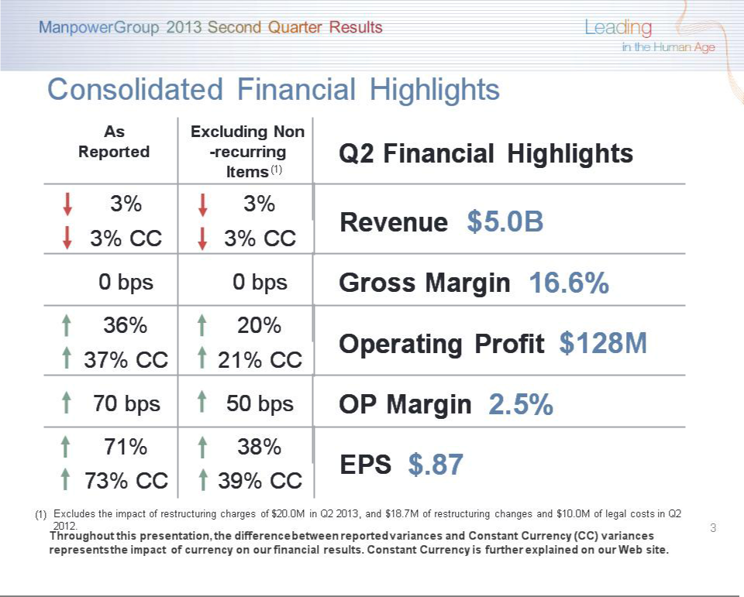

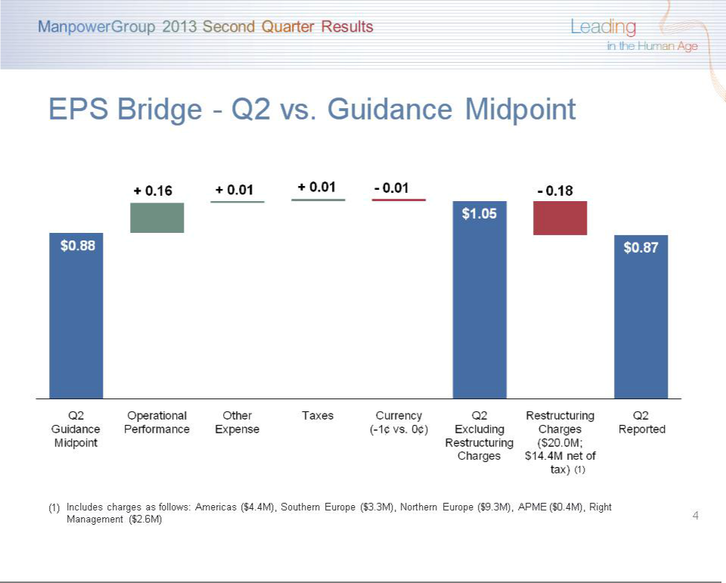

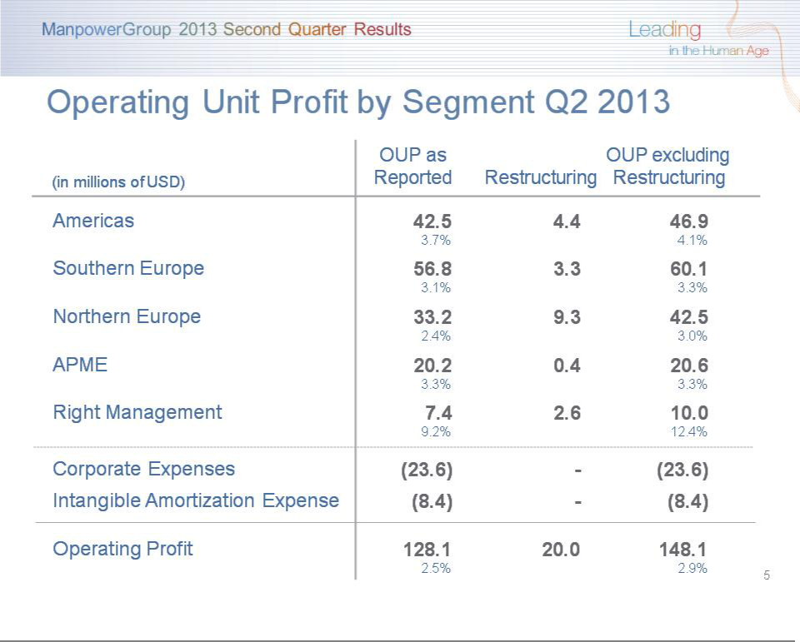

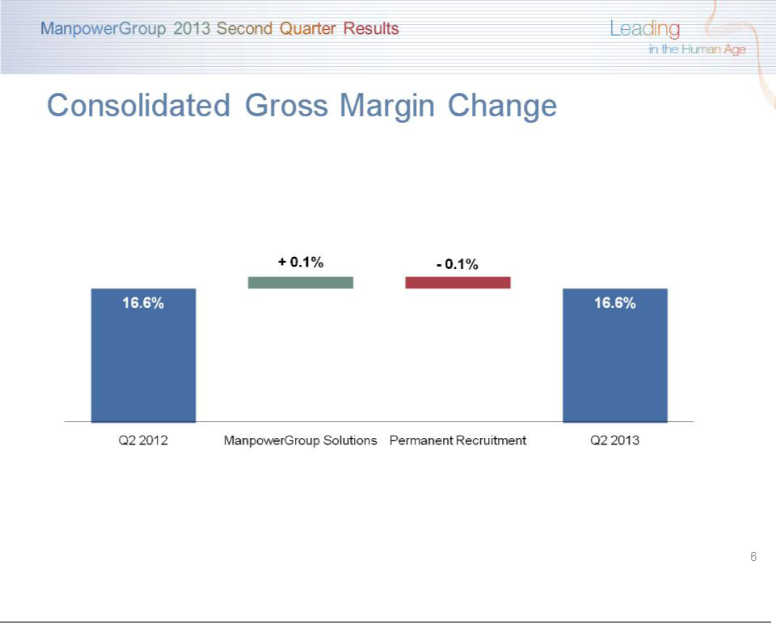

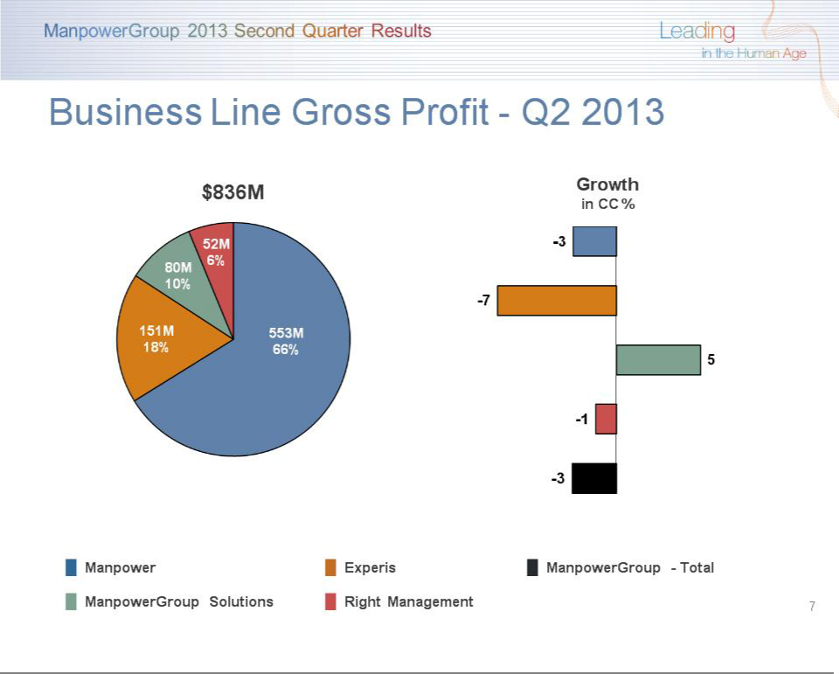

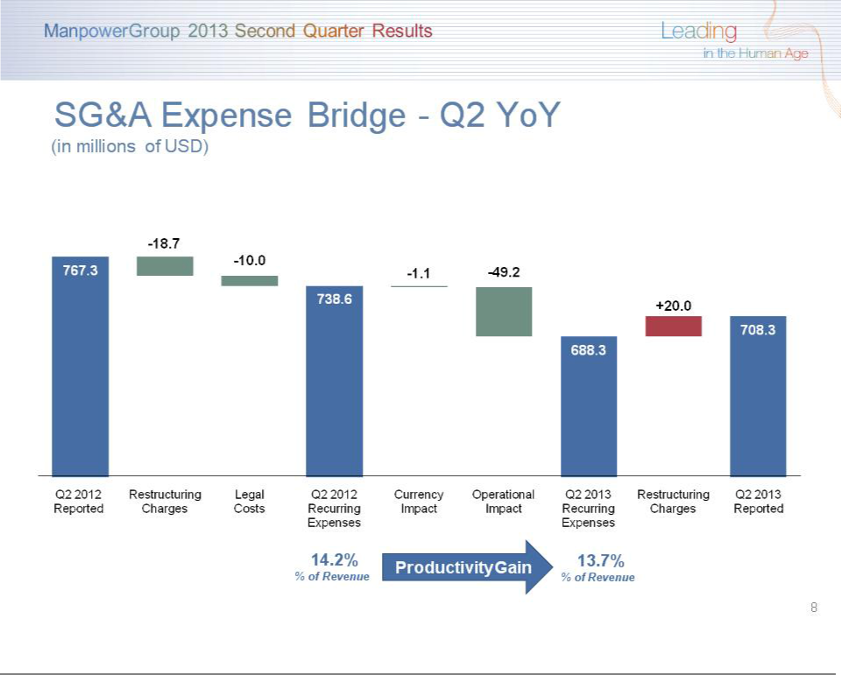

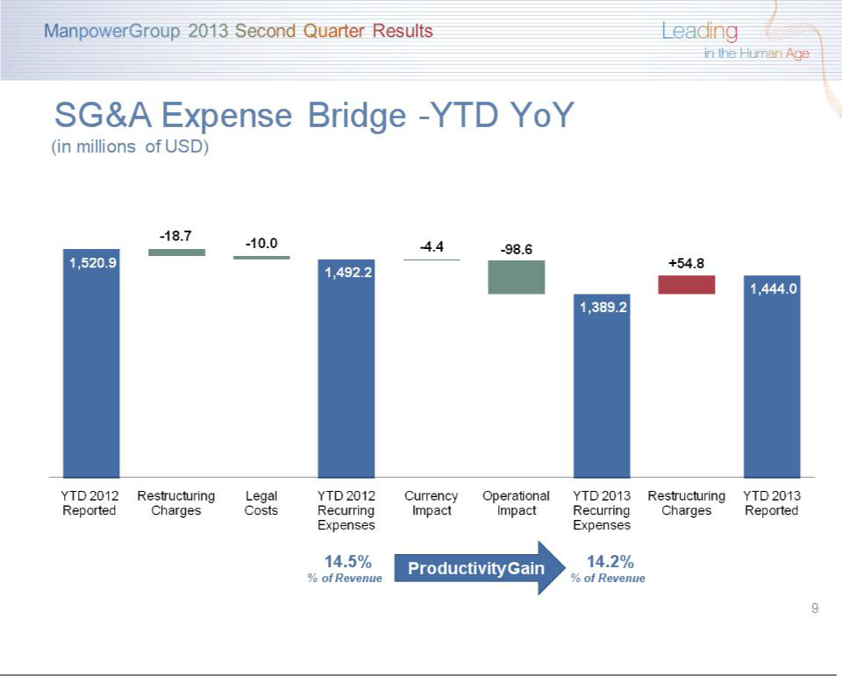

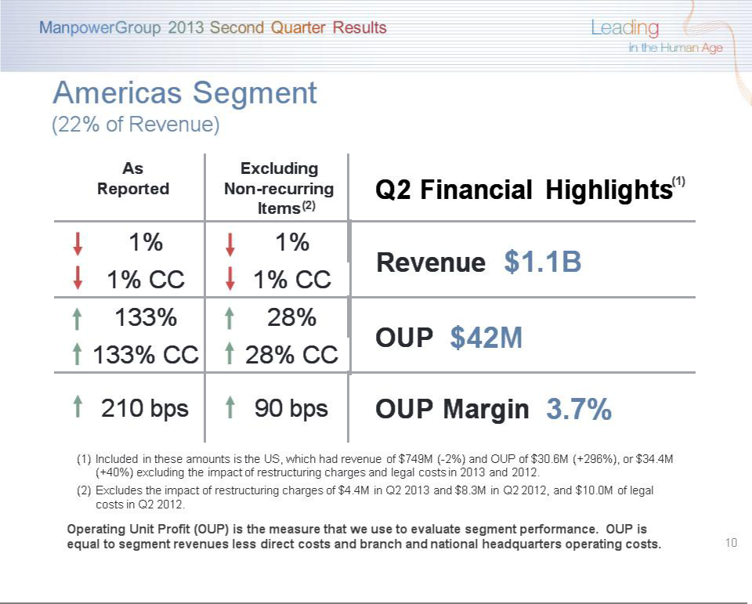

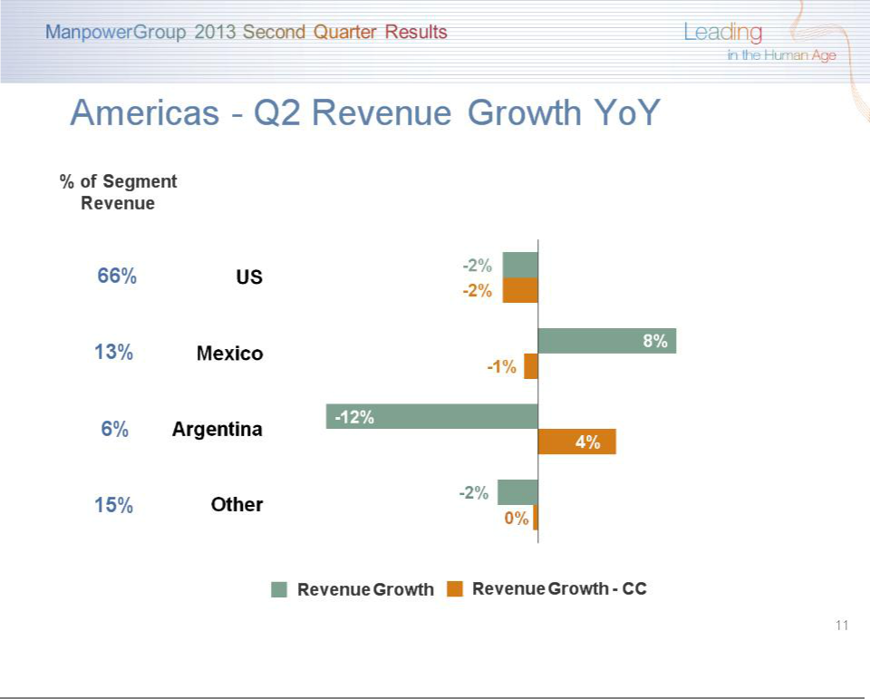

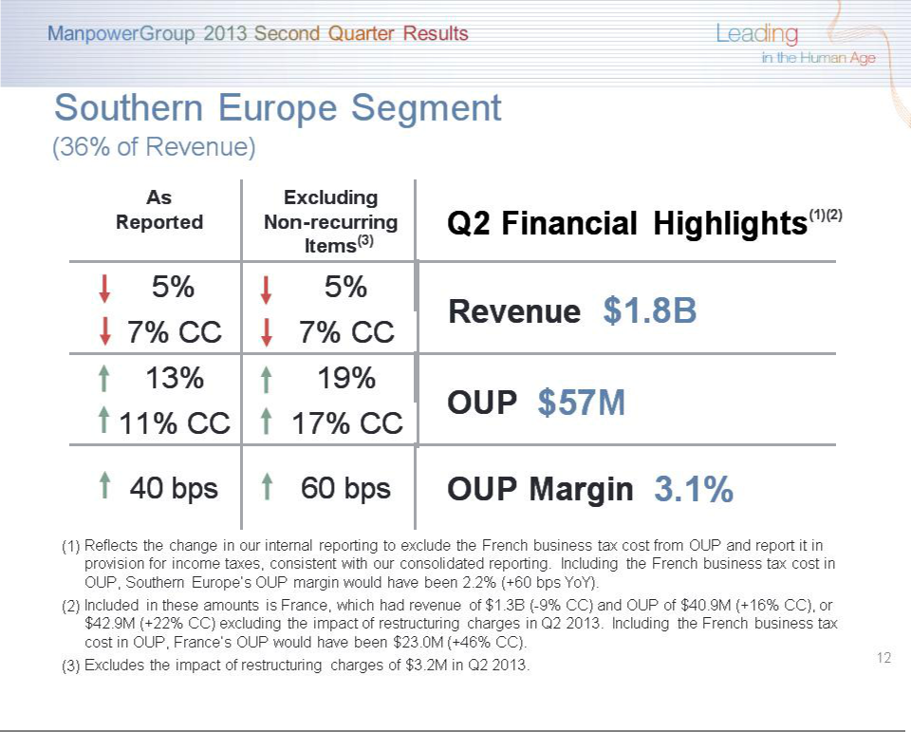

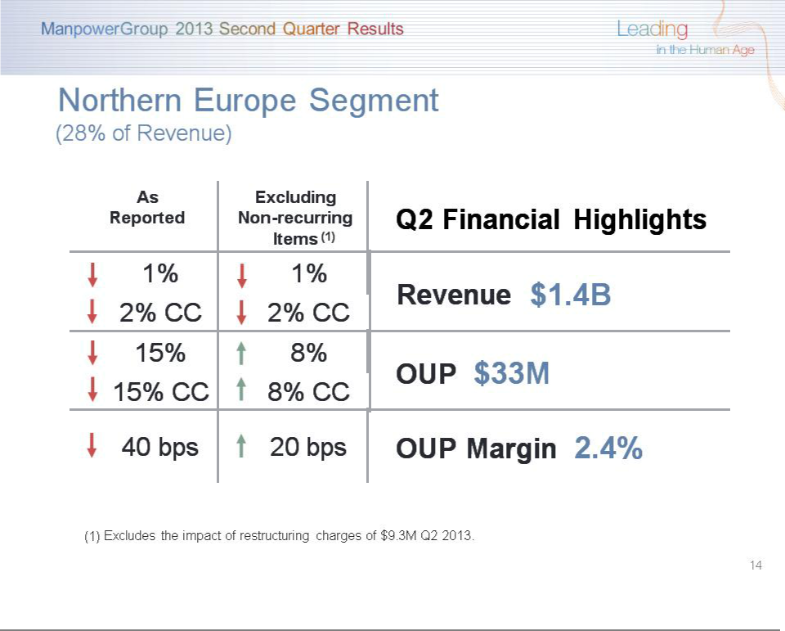

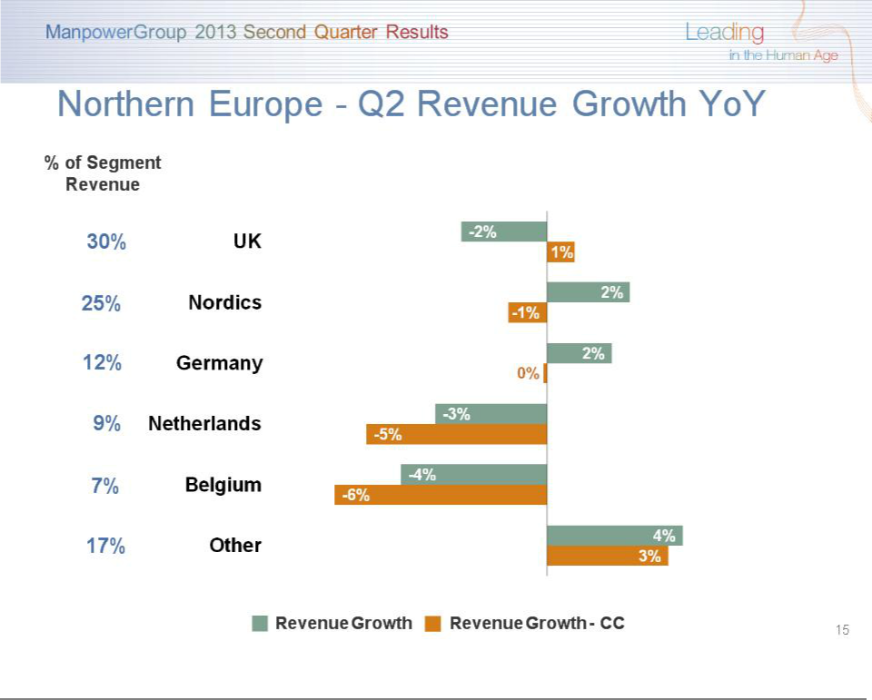

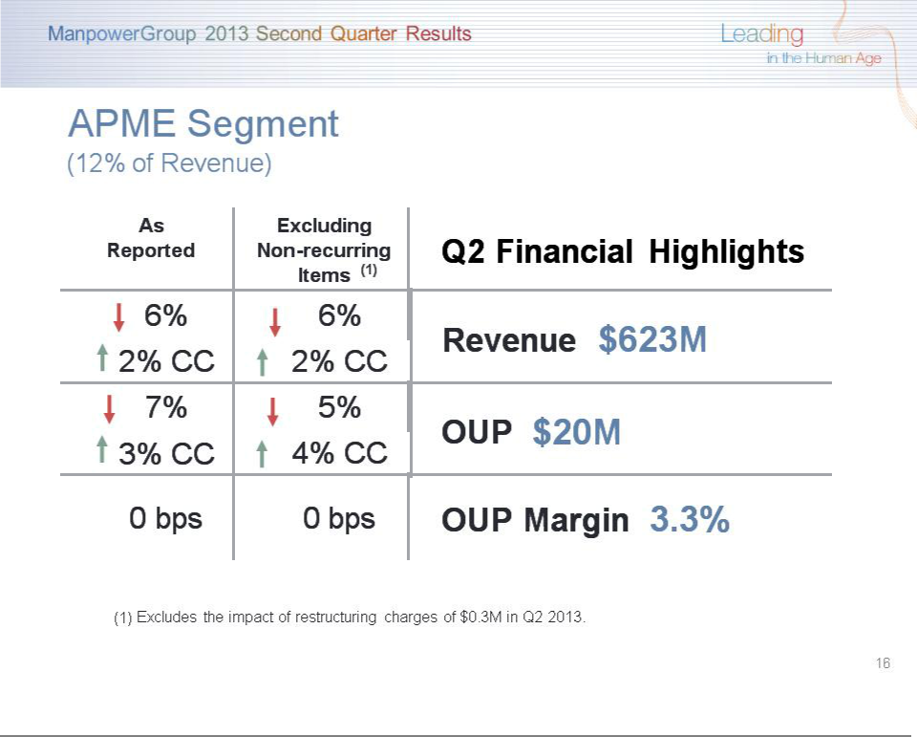

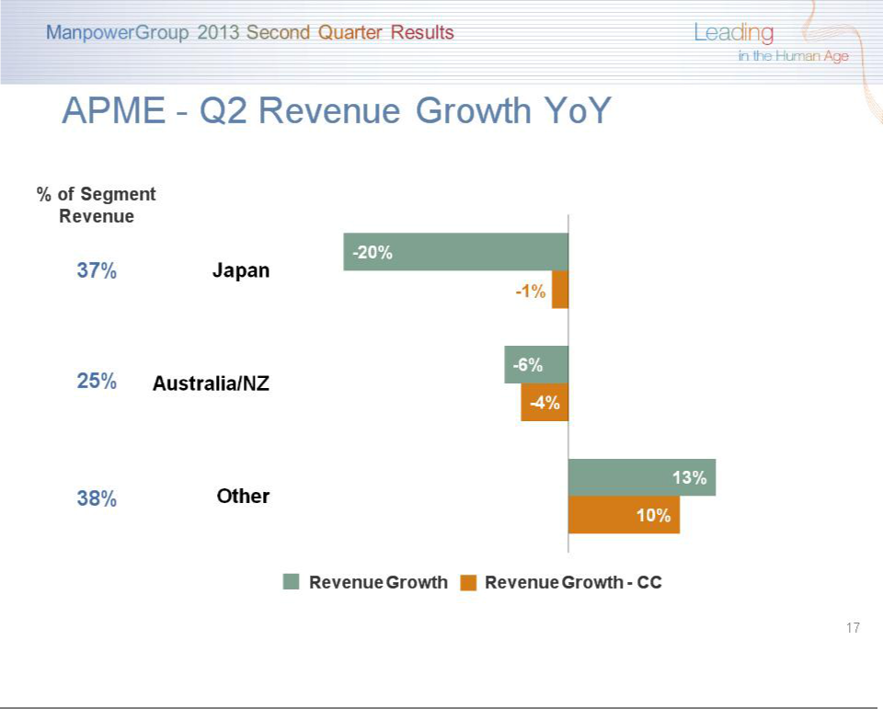

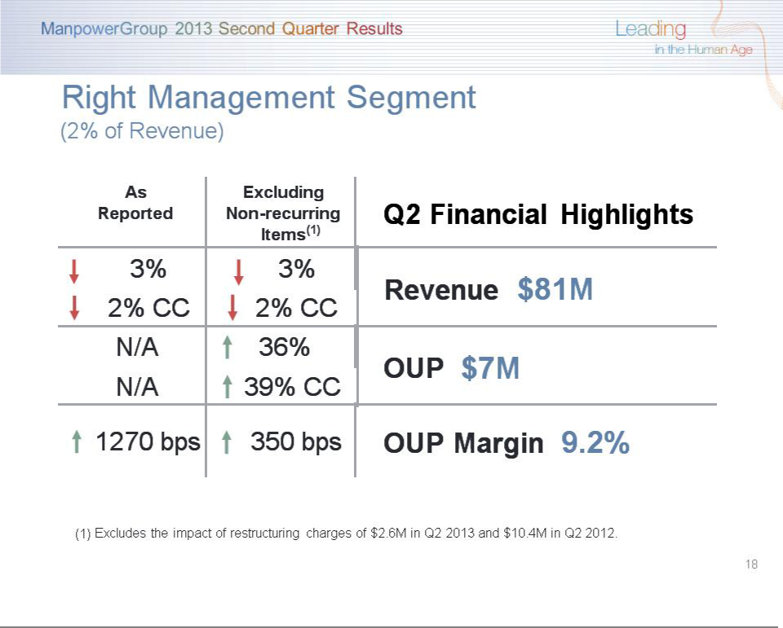

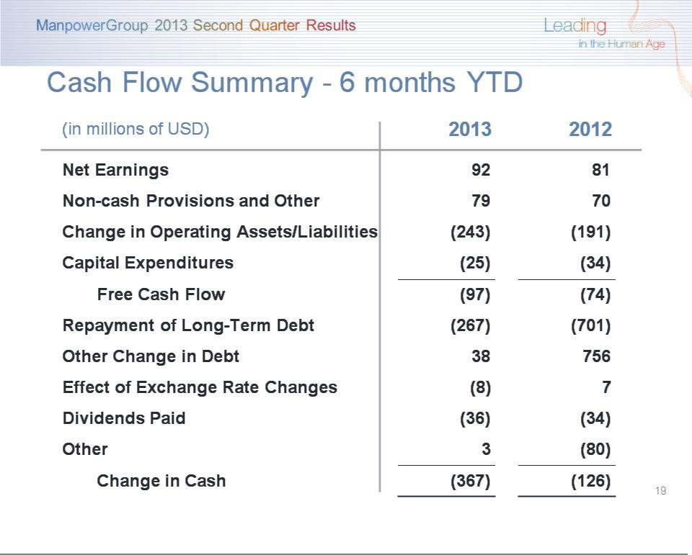

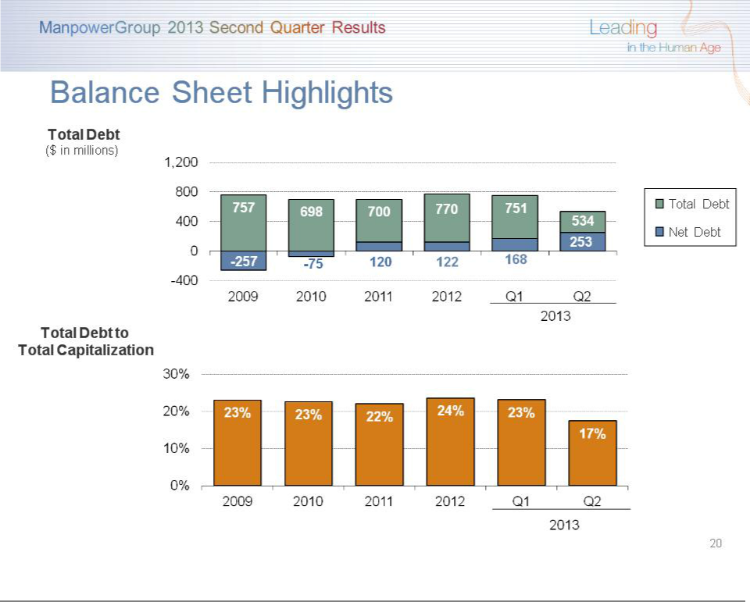

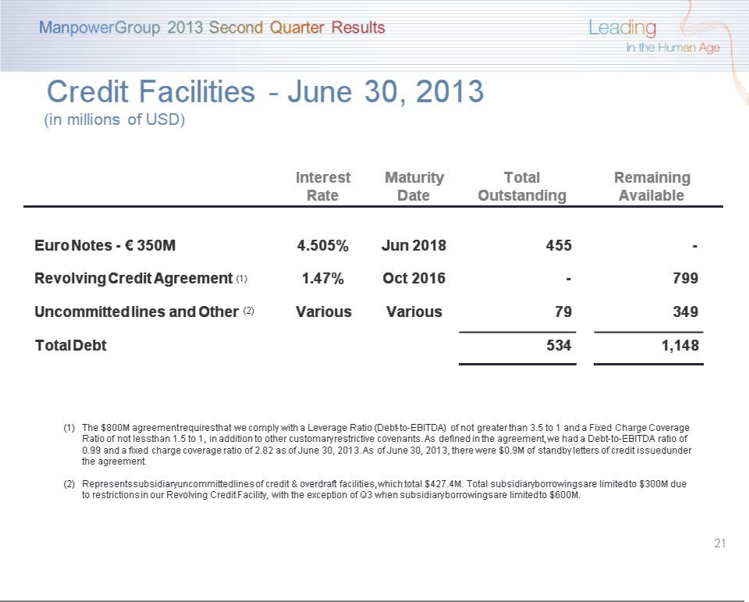

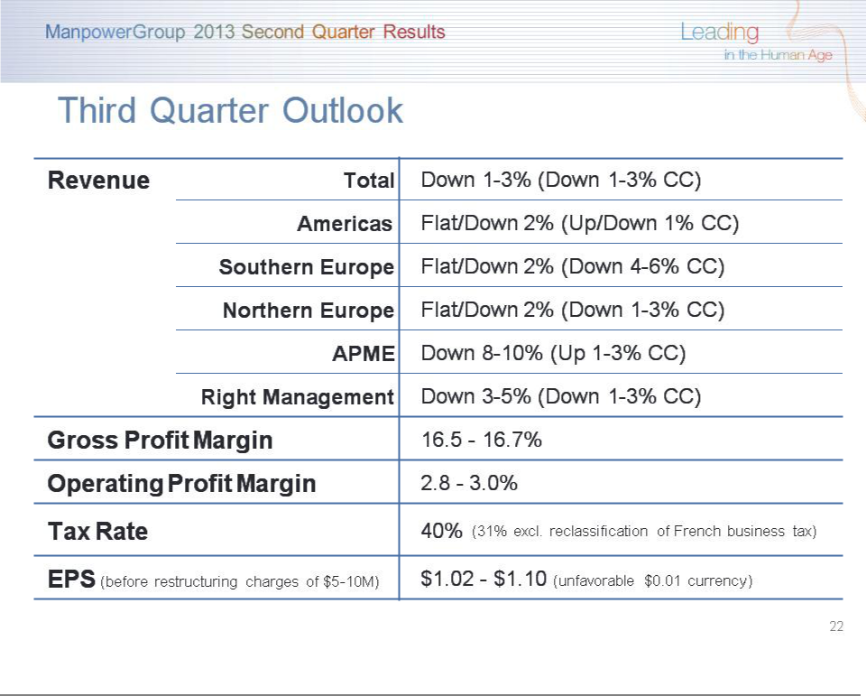

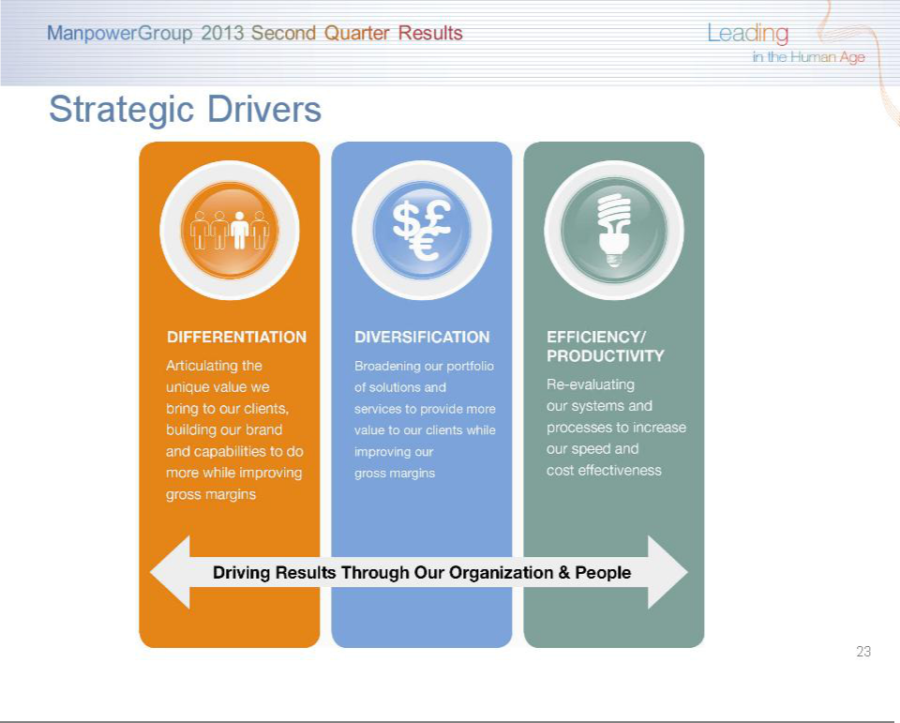



Exbhibit 99.3

ManpowerGroup
Restated Operating Unit Results

(In millions)

On a consolidated basis, the French business tax is reported in provision for income taxes, in accordance with the current accounting guidance on income taxes. Prior to the second quarter of 2013, we internally reviewed the financial results of our French operations including the French business tax within Operating Unit Profit ("OUP") given the operational nature of these taxes. While we continue to view this tax as operational, during the second quarter of 2013 we changed our internal reporting to exclude the French business tax from the OUP of our France reportable segment. Therefore our France reportable segment OUP now excludes the business tax and we no longer need to show the business tax amount separately to reconcile to the consolidated results. All previously reported segment results have been restated to conform to the current year presentation. This change in segment reporting has no impact on our reporting of consolidated results.

Three Months Ended March 31

- Variance

AmountConstant

 |  | 2013 |  |  |  | 2012 |  | Reported |  | Currency
 |  |  |  |  |  | (Unaudited)
Revenues from Services:
Americas:
United States | $ | 706.1 |  | $ |  | 735.8 |  | -4.0% |  | -4.0%
Other Americas |  | 386.9 |  |  |  | 402.5 |  | -3.9% |  | -1.4%
 |  | 1,093.0 |  |  |  | 1,138.3 |  | -4.0% |  | -3.1%
Southern Europe:
France |  | 1,145.2 |  |  |  | 1,291.8 |  | -11.3% |  | -11.8%
Italy |  | 257.9 |  |  |  | 267.5 |  | -3.6% |  | -4.1%
Other Southern Europe |  | 193.4 |  |  |  | 195.2 |  | -0.9% |  | -1.9%
 |  | 1,596.5 |  |  |  | 1,754.5 |  | -9.0% |  | -9.6%
Northern Europe |  | 1,370.3 |  |  |  | 1,444.0 |  | -5.1% |  | -5.6%
APME |  | 632.5 |  |  |  | 680.0 |  | -7.0% |  | -1.4%
Right Management |  | 76.6 |  |  |  | 79.6 |  | -3.8% |  | -2.5%
 | $ | 4,768.9 |  | $ |  | 5,096.4 |  | -6.4% |  | -5.8%
Operating Unit Profit:
Americas:
United States | $ | 7.4 |  | $ |  | 6.9 |  | 7.9% |  | 7.9%
Other Americas |  | 8.7 |  |  |  | 15.3 |  | -43.1% |  | -43.6%
 |  | 16.1 |  |  |  | 22.2 |  | -27.4% |  | -27.7%
Southern Europe:
France |  | 29.7 |  |  |  | 22.9 |  | 30.3% |  | 30.8%
Italy |  | 11.7 |  |  |  | 14.5 |  | -19.5% |  | -19.9%
Other Southern Europe |  | 2.3 |  |  |  | 3.5 |  | -33.8% |  | -35.4%
 |  | 43.7 |  |  |  | 40.9 |  | 7.1% |  | 7.2%
Northern Europe |  | 10.6 |  |  |  | 43.9 |  | -75.8% |  | -75.6%
APME |  | 14.8 |  |  |  | 19.6 |  | -25.2% |  | -19.4%
Right Management |  | 2.0 |  |  |  | 2.5 |  | -18.4% |  | -7.5%
 |  | 87.2 |  |  |  | 129.1
Corporate expenses |  | (24.4) |  |  |  | (26.3)
Intangible asset amortization
expense |  | (8.4) |  |  |  | (9.0)
Operating profit |  | 54.4 |  |  |  | 93.8 |  | -42.0% |  | -40.5%
Interest and other expenses |  | (11.5) |  |  |  | (11.8)
Earnings before income taxes | $ | 42.9 |  | $ |  | 82.0
 |  |  |  | Three Months Ended March 31 |  |  |  |  |  |  |  |  |  |  |  | Three Months Ended June 30
 |  |  |  |  |  |  |  | % Variance |  |  |  |  |  |  |  |  |  |  | % Variance
 |  |  |  |  |  |  |  | Amount |  | Constant |  |  |  |  |  |  |  |  | Amount |  | Constant
 |  | 2012 |  |  |  | 2011 |  | Reported |  | Currency |  |  | 2012 |  |  |  | 2011 |  | Reported |  | Currency
 |  |  |  |  |  | (Unaudited) |  |  |  |  |  |  |  |  |  |  | (Unaudited)
Revenues from Services:
Americas:
United States | $ | 735.8 |  | $ |  | 750.9 |  | -2.0% |  | -2.0% | $ |  | 763.2 |  | $ |  | 791.6 |  | -3.6% |  | -3.6%
Other Americas |  | 402.5 |  |  |  | 361.8 |  | 11.3% |  | 16.1% |  |  | 389.2 |  |  |  | 379.4 |  | 2.6% |  | 12.0%
 |  | 1,138.3 |  |  |  | 1,112.7 |  | 2.3% |  | 3.9% |  |  | 1,152.4 |  |  |  | 1,171.0 |  | -1.6% |  | 1.4%
Southern Europe:
France |  | 1,291.8 |  |  |  | 1,353.8 |  | -4.6% |  | -0.4% |  |  | 1,427.6 |  |  |  | 1,644.0 |  | -13.2% |  | -2.5%
Italy |  | 267.5 |  |  |  | 284.6 |  | -6.0% |  | -1.9% |  |  | 274.0 |  |  |  | 344.9 |  | -20.6% |  | -10.8%
Other Southern Europe |  | 195.2 |  |  |  | 180.0 |  | 8.5% |  | 13.7% |  |  | 190.1 |  |  |  | 193.7 |  | -1.9% |  | 9.8%
 |  | 1,754.5 |  |  |  | 1,818.4 |  | -3.5% |  | 0.7% |  |  | 1,891.7 |  |  |  | 2,182.6 |  | -13.3% |  | -2.7%
Northern Europe |  | 1,444.0 |  |  |  | 1,456.6 |  | -0.9% |  | 2.6% |  |  | 1,415.8 |  |  |  | 1,566.3 |  | -9.6% |  | -1.2%
APME |  | 680.0 |  |  |  | 602.9 |  | 12.8% |  | 9.8% |  |  | 662.9 |  |  |  | 662.8 |  | 0.0% |  | 1.8%
Right Management |  | 79.6 |  |  |  | 81.8 |  | -2.6% |  | -2.0% |  |  | 83.9 |  |  |  | 84.6 |  | -0.9% |  | 2.9%
 | $ | 5,096.4 |  | $ |  | 5,072.4 |  | 0.5% |  | 3.0% | $ |  | 5,206.7 |  | $ |  | 5,667.3 |  | -8.1% |  | -0.8%
Operating Unit Profit (Loss):
Americas:
United States | $ | 6.9 |  | $ |  | 8.7 |  | -20.8% |  | -20.8% | $ |  | 7.7 |  | $ |  | 27.2 |  | -71.6% |  | -71.6%
Other Americas |  | 15.3 |  |  |  | 12.8 |  | 19.7% |  | 26.2% |  |  | 10.5 |  |  |  | 12.3 |  | -15.0% |  | -8.3%
 |  | 22.2 |  |  |  | 21.5 |  | 3.4% |  | 7.2% |  |  | 18.2 |  |  |  | 39.5 |  | -54.0% |  | -51.9%
Southern Europe:
France |  | 22.9 |  |  |  | 28.9 |  | -21.0% |  | -17.1% |  |  | 34.6 |  |  |  | 48.3 |  | -28.1% |  | -19.1%
Italy |  | 14.5 |  |  |  | 12.9 |  | 12.7% |  | 18.0% |  |  | 12.6 |  |  |  | 22.4 |  | -43.6% |  | -36.6%
Other Southern Europe |  | 3.5 |  |  |  | 2.2 |  | 56.0% |  | 64.9% |  |  | 3.0 |  |  |  | 2.7 |  | 12.8% |  | 26.3%

 |  | 40.9 |  |  | 44.0 |  | -7.2% |  | -2.7% |  |  | 50.2 |  |  |  | 73.4 |  | -31.3% |  | -22.8%
Northern Europe |  | 43.9 |  |  | 41.9 |  | 4.8% |  | 8.3% |  |  | 39.2 |  |  |  | 56.1 |  | -30.2% |  | -23.9%
APME |  | 19.6 |  |  | 16.5 |  | 18.5% |  | 16.1% |  |  | 21.8 |  |  |  | 18.9 |  | 16.0% |  | 17.6%
Right Management |  | 2.5 |  |  | 3.3 |  | -24.6% |  | -24.5% |  |  | (2.9) |  |  |  | 2.8 |  | N/A |  | N/A
 |  | 129.1 |  |  | 127.2 |  |  |  |  |  |  | 126.5 |  |  |  | 190.7
Corporate expenses |  | (26.3) |  |  | (32.0) |  |  |  |  |  |  | (22.9) |  |  |  | (30.5)
Intangible asset amortization
expense |  | (9.0) |  |  | (9.6) |  |  |  |  |  |  | (9.2) |  |  |  | (9.4)
Operating profit |  | 93.8 |  |  | 85.6 |  | 9.5% |  | 13.9% |  |  | 94.4 |  |  |  | 150.8 |  | -37.3% |  | -30.5%
Interest and other expenses |  | (11.8) |  |  | (11.1) |  |  |  |  |  |  | (11.3) |  |  |  | (11.8)
Earnings before income taxes | $ | 82.0 |  | $ | 74.5 |  |  |  |  |  | $ | 83.1 |  | $ |  | 139.0
 |  |  |  |  |  |  |  |  |  |  |  |  |  |  |  | Six Months Ended June 30
 |  |  |  |  |  |  |  |  |  |  |  |  |  |  |  |  |  | % Variance
 |  |  |  |  |  |  |  |  |  |  |  |  |  |  |  |  |  | Amount |  | Constant
 |  |  |  |  |  |  |  |  |  |  |  | 2012 |  |  |  | 2011 |  | Reported |  | Currency
 |  |  |  |  |  |  |  |  |  |  |  |  |  |  |  | (Unaudited)
Revenues from Services:
Americas:
United States |  |  |  |  |  |  |  |  |  |  | $ | 1,499.0 |  | $ |  | 1,542.5 |  | -2.8% |  | -2.8%
Other Americas |  |  |  |  |  |  |  |  |  |  |  | 791.7 |  |  |  | 741.2 |  | 6.8% |  | 14.0%
 |  |  |  |  |  |  |  |  |  |  |  | 2,290.7 |  |  |  | 2,283.7 |  | 0.3% |  | 2.6%
Southern Europe:
France |  |  |  |  |  |  |  |  |  |  |  | 2,719.4 |  |  |  | 2,997.8 |  | -9.3% |  | -1.6%
Italy |  |  |  |  |  |  |  |  |  |  |  | 541.5 |  |  |  | 629.5 |  | -14.0% |  | -6.8%
Other Southern Europe |  |  |  |  |  |  |  |  |  |  |  | 385.3 |  |  |  | 373.7 |  | 3.1% |  | 11.7%
 |  |  |  |  |  |  |  |  |  |  |  | 3,646.2 |  |  |  | 4,001.0 |  | -8.9% |  | -1.2%
Northern Europe |  |  |  |  |  |  |  |  |  |  |  | 2,859.8 |  |  |  | 3,022.9 |  | -5.4% |  | 0.6%
APME |  |  |  |  |  |  |  |  |  |  |  | 1,342.9 |  |  |  | 1,265.7 |  | 6.1% |  | 5.6%
Right Management |  |  |  |  |  |  |  |  |  |  |  | 163.5 |  |  |  | 166.4 |  | -1.8% |  | 0.5%
 |  |  |  |  |  |  |  |  |  |  | $ | 10,303.1 |  | $ |  | 10,739.7 |  | -4.1% |  | 1.0%
Operating Unit Profit (Loss):
Americas:
United States |  |  |  |  |  |  |  |  |  |  | $ | 14.6 |  | $ |  | 35.9 |  | -59.3% |  | -59.3%
Other Americas |  |  |  |  |  |  |  |  |  |  |  | 25.8 |  |  |  | 25.1 |  | 2.7% |  | 9.3%
 |  |  |  |  |  |  |  |  |  |  |  | 40.4 |  |  |  | 61.0 |  | -33.8% |  | -31.1%
Southern Europe:
France |  |  |  |  |  |  |  |  |  |  |  | 57.5 |  |  |  | 77.2 |  | -25.4% |  | -18.3%
Italy |  |  |  |  |  |  |  |  |  |  |  | 27.1 |  |  |  | 35.3 |  | -23.1% |  | -16.7%
Other Southern Europe |  |  |  |  |  |  |  |  |  |  |  | 6.5 |  |  |  | 4.9 |  | 32.6% |  | 44.0%
 |  |  |  |  |  |  |  |  |  |  |  | 91.1 |  |  |  | 117.4 |  | -22.3% |  | -15.3%
Northern Europe |  |  |  |  |  |  |  |  |  |  |  | 83.1 |  |  |  | 98.0 |  | -15.3% |  | -10.1%
APME |  |  |  |  |  |  |  |  |  |  |  | 41.4 |  |  |  | 35.4 |  | 17.2% |  | 16.9%
Right Management |  |  |  |  |  |  |  |  |  |  |  | (0.4) |  |  |  | 6.1 |  | N/A |  | N/A
 |  |  |  |  |  |  |  |  |  |  |  | 255.6 |  |  |  | 317.9
Corporate expenses |  |  |  |  |  |  |  |  |  |  |  | (49.2) |  |  |  | (62.5)
Intangible asset amortization
expense |  |  |  |  |  |  |  |  |  |  |  | (18.2) |  |  |  | (19.0)
Operating profit |  |  |  |  |  |  |  |  |  |  |  | 188.2 |  |  |  | 236.4 |  | -20.4% |  | -14.4%
Interest and other expenses |  |  |  |  |  |  |  |  |  |  |  | (23.1) |  |  |  | (22.9)
Earnings before income taxes |  |  |  |  |  |  |  |  |  |  | $ | 165.1 |  | $ |  | 213.5
 |  |  | Three Months Ended September 30 |  |  |  |  |  |  |  |  |  | Three Months Ended December 31
 |  |  |  |  |  |  | % Variance |  |  |  |  |  |  |  |  |  |  | % Variance
 |  |  |  |  |  |  | Amount |  | Constant |  |  |  |  |  |  |  |  | Amount |  | Constant
 |  | 2012 |  |  | 2011 |  | Reported |  | Currency |  |  | 2012 |  |  |  | 2011 |  | Reported |  | Currency
 |  |  |  |  | (Unaudited) |  |  |  |  |  |  |  |  |  |  | (Unaudited)
Revenues from Services:
Americas:
United States | $ | 760.8 |  | $ | 828.9 |  | -8.2% |  | -8.2% |  | $ | 750.7 |  | $ |  | 765.9 |  | -2.0% |  | -2.0%
Other Americas |  | 388.3 |  |  | 381.1 |  | 1.9% |  | 8.1% |  |  | 405.4 |  |  |  | 389.8 |  | 4.0% |  | 4.1%
 |  | 1,149.1 |  |  | 1,210.0 |  | -5.0% |  | -3.1% |  |  | 1,156.1 |  |  |  | 1,155.7 |  | 0.0% |  | 0.1%
Southern Europe:
France |  | 1,392.0 |  |  | 1,670.3 |  | -16.7% |  | -5.7% |  |  | 1,314.2 |  |  |  | 1,511.0 |  | -13.0% |  | -9.5%
Italy |  | 246.8 |  |  | 321.0 |  | -23.1% |  | -13.3% |  |  | 268.5 |  |  |  | 305.3 |  | -12.0% |  | -8.5%
Other Southern Europe |  | 189.2 |  |  | 206.9 |  | -8.5% |  | 2.8% |  |  | 194.0 |  |  |  | 196.3 |  | -1.2% |  | 2.2%
 |  | 1,828.0 |  |  | 2,198.2 |  | -16.8% |  | -6.0% |  |  | 1,776.7 |  |  |  | 2,012.6 |  | -11.7% |  | -8.2%
Northern Europe |  | 1,426.9 |  |  | 1,595.6 |  | -10.6% |  | -3.5% |  |  | 1,487.2 |  |  |  | 1,540.9 |  | -3.5% |  | -2.8%
APME |  | 688.2 |  |  | 701.0 |  | -1.8% |  | 0.2% |  |  | 697.7 |  |  |  | 695.0 |  | 0.4% |  | 1.4%
Right Management |  | 80.1 |  |  | 77.5 |  | 3.4% |  | 6.4% |  |  | 84.9 |  |  |  | 79.8 |  | 6.3% |  | 6.5%
 | $ | 5,172.3 |  | $ | 5,782.3 |  | -10.5% |  | -3.8% |  | $ | 5,202.6 |  | $ |  | 5,484.0 |  | -5.1% |  | -3.5%
Operating Unit Profit (Loss):
Americas:
United States | $ | 24.5 |  | $ | 32.1 |  | -23.7% |  | -23.7% |  | $ | 21.7 |  | $ |  | 26.1 |  | -16.9% |  | -16.9%
Other Americas |  | 10.9 |  |  | 10.6 |  | 3.3% |  | 6.1% |  |  | 13.9 |  |  |  | 12.1 |  | 13.9% |  | 11.1%
 |  | 35.4 |  |  | 42.7 |  | -17.1% |  | -16.4% |  |  | 35.6 |  |  |  | 38.2 |  | -7.1% |  | -7.9%
Southern Europe:
France |  | 36.4 |  |  | 50.4 |  | -27.9% |  | -18.0% |  |  | 35.7 |  |  |  | 41.8 |  | -14.4% |  | -10.6%
Italy |  | 9.4 |  |  | 19.1 |  | -51.0% |  | -45.0% |  |  | 8.9 |  |  |  | 19.7 |  | -54.9% |  | -52.0%
Other Southern Europe |  | 2.2 |  |  | 3.0 |  | -28.5% |  | -20.0% |  |  | 1.4 |  |  |  | 2.9 |  | -50.1% |  | -49.1%
 |  | 48.0 |  |  | 72.5 |  | -34.0% |  | -25.2% |  |  | 46.0 |  |  |  | 64.4 |  | -28.4% |  | -25.0%

Northern Europe |  | 42.5 |  |  | 62.8 |  | -32.3% |  | -27.6% |  |  | 34.2 |  |  |  | 51.8 |  | -33.9% |  | -33.6%
APME |  | 20.8 |  |  | 21.7 |  | -4.0% |  | -1.6% |  |  | 28.5 |  |  |  | 21.7 |  | 31.2% |  | 33.0%
Right Management |  | 5.6 |  |  | (1.9) |  | N/A |  | N/A |  |  | 8.2 |  |  |  | (5.6) |  | N/A |  | N/A
 |  | 152.3 |  |  | 197.8 |  |  |  |  |  |  | 152.5 |  |  |  | 170.5
Corporate expenses |  | (24.5) |  |  | (29.9) |  |  |  |  |  |  | (38.3) |  |  |  | (30.7)
Intangible asset amortization
expense |  | (9.2) |  |  | (9.9) |  |  |  |  |  |  | (9.3) |  |  |  | (10.0)
Operating profit |  | 118.6 |  |  | 158.0 |  | -25.0% |  | -18.7% |  |  | 104.9 |  |  |  | 129.8 |  | -19.1% |  | -17.5%
Interest and other expenses |  | (10.1) |  |  | (11.0) |  |  |  |  |  |  | (10.1) |  |  |  | (10.4)
Earnings before income taxes | $ | 108.5 | $ |  | 147.0 |  |  |  |  |  | $ | 94.8 |  | $ |  | 119.4
 |  |  | Nine Months Ended September 30 |  |  |  |  |  |  |  |  |  |  |  |  | Year Ended December 31
 |  |  |  |  |  |  | % Variance |  |  |  |  |  |  |  |  |  |  | % Variance
 |  |  |  |  |  |  | Amount |  | Constant |  |  |  |  |  |  |  |  | Amount |  | Constant
 |  | 2012 |  |  | 2011 |  | Reported |  | Currency |  |  | 2012 |  |  |  | 2011 |  | Reported |  | Currency
 |  |  |  |  | (Unaudited) |  |  |  |  |  |  |  |  |  |  | (Unaudited)
Revenues from Services:
Americas:
United States | $ | 2,259.8 | $ |  | 2,371.4 |  | -4.7% |  | -4.7% |  | $ | 3,010.5 |  | $ |  | 3,137.3 |  | -4.0% |  | -4.0%
Other Americas |  | 1,180.0 |  |  | 1,122.3 |  | 5.1% |  | 12.0% |  |  | 1,585.4 |  |  |  | 1,512.1 |  | 4.8% |  | 9.9%
 |  | 3,439.8 |  |  | 3,493.7 |  | -1.5% |  | 0.7% |  |  | 4,595.9 |  |  |  | 4,649.4 |  | -1.2% |  | 0.5%
Southern Europe:
France |  | 4,111.4 |  |  | 4,668.1 |  | -11.9% |  | -3.0% |  |  | 5,425.6 |  |  |  | 6,179.1 |  | -12.2% |  | -4.6%
Italy |  | 788.3 |  |  | 950.5 |  | -17.1% |  | -9.0% |  |  | 1,056.8 |  |  |  | 1,255.8 |  | -15.8% |  | -8.9%
Other Southern Europe |  | 574.5 |  |  | 580.6 |  | -1.0% |  | 8.5% |  |  | 768.5 |  |  |  | 776.9 |  | -1.1% |  | 6.9%
 |  | 5,474.2 |  |  | 6,199.2 |  | -11.7% |  | -2.9% |  |  | 7,250.9 |  |  |  | 8,211.8 |  | -11.7% |  | -4.2%
Northern Europe |  | 4,286.7 |  |  | 4,618.5 |  | -7.2% |  | -0.8% |  |  | 5,773.9 |  |  |  | 6,159.4 |  | -6.3% |  | -1.3%
APME |  | 2,031.1 |  |  | 1,966.7 |  | 3.3% |  | 3.7% |  |  | 2,728.8 |  |  |  | 2,661.7 |  | 2.5% |  | 3.1%
Right Management |  | 243.6 |  |  | 243.9 |  | -0.1% |  | 2.4% |  |  | 328.5 |  |  |  | 323.7 |  | 1.5% |  | 3.4%
 | $ | 15,475.4 | $ |  | 16,522.0 |  | -6.3% |  | -0.7% |  | $ | 20,678.0 |  | $ |  | 22,006.0 |  | -6.0% |  | -1.4%
Operating Unit Profit (Loss):
Americas:
United States | $ | 39.1 | $ |  | 68.0 |  | -42.5% |  | -42.5% |  | $ | 60.8 |  | $ |  | 94.1 |  | -35.4% |  | -35.4%
Other Americas |  | 36.7 |  |  | 35.7 |  | 2.9% |  | 8.4% |  |  | 50.6 |  |  |  | 47.8 |  | 5.7% |  | 9.1%
 |  | 75.8 |  |  | 103.7 |  | -26.9% |  | -25.0% |  |  | 111.4 |  |  |  | 141.9 |  | -21.6% |  | -20.4%
Southern Europe:
France |  | 93.9 |  |  | 127.6 |  | -26.4% |  | -18.2% |  |  | 129.6 |  |  |  | 169.4 |  | -23.5% |  | -16.3%
Italy |  | 36.5 |  |  | 54.4 |  | -32.9% |  | -26.6% |  |  | 45.4 |  |  |  | 74.1 |  | -38.7% |  | -33.4%
Other Southern Europe |  | 8.7 |  |  | 7.9 |  | 8.7% |  | 19.0% |  |  | 10.1 |  |  |  | 10.8 |  | -6.8% |  | 1.0%
 |  | 139.1 |  |  | 189.9 |  | -26.8% |  | -19.0% |  |  | 185.1 |  |  |  | 254.3 |  | -27.2% |  | -20.6%
Northern Europe |  | 125.6 |  |  | 160.8 |  | -21.9% |  | -16.9% |  |  | 159.8 |  |  |  | 212.6 |  | -24.8% |  | -21.0%
APME |  | 62.2 |  |  | 57.1 |  | 9.1% |  | 9.9% |  |  | 90.7 |  |  |  | 78.8 |  | 15.2% |  | 16.2%
Right Management |  | 5.2 |  |  | 4.2 |  | 23.2% |  | 9.6% |  |  | 13.4 |  |  |  | (1.4) |  | N/A |  | N/A
 |  | 407.9 |  |  | 515.7 |  |  |  |  |  |  | 560.4 |  |  |  | 686.2
Corporate expenses |  | (73.7) |  |  | (92.4) |  |  |  |  |  |  | (112.0) |  |  |  | (123.1)
Intangible asset amortization
expense |  | (27.4) |  |  | (28.9) |  |  |  |  |  |  | (36.7) |  |  |  | (38.9)
Operating profit |  | 306.8 |  |  | 394.4 |  | -22.2% |  | -16.1% |  |  | 411.7 |  |  |  | 524.2 |  | -21.5% |  | -16.5%
Interest and other expenses |  | (33.2) |  |  | (33.9) |  |  |  |  |  |  | (43.3) |  |  |  | (44.3)
Earnings before income taxes | $ | 273.6 | $ |  | 360.5 |  |  |  |  |  | $ | 368.4 |  | $ |  | 479.9

Year Ended December 31

- Variance

AmountConstant

 |  | 2011 |  |  | 2010 |  | Reported |  | Currency
 |  |  |  |  | (Unaudited)
Revenues from Services:
Americas:
United States | $ | 3,137.3 |  | $ | 2,783.4 |  | 12.7% |  | 12.7%
Other Americas |  | 1,512.1 |  |  | 1,265.5 |  | 19.5% |  | 18.4%
 |  | 4,649.4 |  |  | 4,048.9 |  | 14.8% |  | 14.5%
Southern Europe:
France |  | 6,179.1 |  |  | 5,208.6 |  | 18.6% |  | 12.6%
Italy |  | 1,255.8 |  |  | 1,044.2 |  | 20.3% |  | 14.2%
Other Southern Europe |  | 776.9 |  |  | 698.9 |  | 11.2% |  | 6.8%
 |  | 8,211.8 |  |  | 6,951.7 |  | 18.1% |  | 12.3%
Northern Europe |  | 6,159.4 |  |  | 5,344.1 |  | 15.3% |  | 9.3%
APME |  | 2,661.7 |  |  | 2,147.2 |  | 24.0% |  | 14.2%
Right Management |  | 323.7 |  |  | 374.6 |  | -13.6% |  | -16.6%
 | $ | 22,006.0 |  | $ | 18,866.5 |  | 16.6% |  | 11.6%
Operating Unit Profit (Loss):
Americas:
United States | $ | 94.1 |  | $ | 42.8 |  | 119.8% |  | 119.8%
Other Americas |  | 47.8 |  |  | 36.5 |  | 31.2% |  | 30.7%
 |  | 141.9 |  |  | 79.3 |  | 79.0% |  | 78.8%
Southern Europe:
France |  | 169.4 |  |  | 112.4 |  | 50.7% |  | 42.0%
Italy |  | 74.1 |  |  | 47.5 |  | 55.9% |  | 47.2%
Other Southern Europe |  | 10.8 |  |  | 7.2 |  | 51.5% |  | 47.5%
 |  | 254.3 |  |  | 167.1 |  | 52.2% |  | 43.7%
Northern Europe |  | 212.6 |  |  | 150.2 |  | 41.5% |  | 32.8%

APME |  | 78.8 |  |  | 47.2 |  | 66.7% | 54.8%
Right Management |  | (1.4) |  |  | 3.5 |  | N/A | N/A
 |  | 686.2 |  |  | 447.3
Corporate expenses |  | (123.1) |  |  | (101.2)
Goodwill and intangible asset
impairment charges |  | - |  |  | (428.8)
Intangible asset amortization
expense |  | (38.9) |  |  | (39.3)
Operating profit (loss) |  | 524.2 |  |  | (122.0) |  | N/A | N/A
Interest and other expenses |  | (44.3) |  |  | (43.2)
Earnings (loss) before income
taxes | $ | 479.9 |  | $ | (165.2)

