UNITED STATES

SECURITIES AND EXCHANGE COMMISSION
Washington, D.C. 20549

FORM 8-K

CURRENT REPORT

Pursuant to Section 13 or 15(d) of the Securities Exchange Act of 1934

Date of Report (Date of earliest event reported): July 21, 2010

MANPOWER INC.

(Exact name of registrant as specified in its charter)

Wisconsin

(State or other jurisdiction of incorporation)

1-10686

(Commission File Number)

39-1672779

(IRS Employer Identification No.)

100 Manpower Place

Milwaukee, Wisconsin

(Address of principal executive offices)

53212

(Zip Code)

Registrant's telephone number, including area code: (414) 961-1000

Check the appropriate box below if the Form 8-K filing is intended to simultaneously satisfy the filing obligation of the registrant under any of the following provisions:

Written communications pursuant to Rule 425 under the Securities Act (17 CFR 230.425)

Soliciting material pursuant to Rule 14a-12 under the Securities Act (17 CFR 240.14a-12)

Pre-commencement communications pursuant to Rule 14d-2(b) under the Exchange Act (17 CFR 240.14d-2(b))

Pre-commencement communications pursuant to Rule 13e-4(c) under the Exchange Act (17 CFR 240.13e-4(c))

Item 2.02 Results of Operations and Financial Condition

On July 21, 2010, we issued a press release announcing our results of operations for the three- and six- month periods ended June 30, 2010. A copy of the press release is attached hereto as Exhibit 99.1 and is incorporated herein by reference.

Item 9.01. |  |  | Exhibits.
 | Exhibit No. |  | Description
 | 99.1 |  | Press Release dated July 21, 2010
99.2 |  |  | Presentation materials for July 21, 2010 conference call

SIGNATURES

Pursuant to the requirements of the Securities Exchange Act of 1934, the Registrant has duly caused this Report to be signed on its behalf by the undersigned hereunto duly authorized.

MANPOWER INC.

Dated: July 21, 2010 By: /s/ Michael J. Van Handel

Michael J. Van Handel

Executive Vice President and

Chief Financial Officer

EXHIBIT INDEX

Exhibit No. |  | Description
99.1 |  | Press Release dated July 21, 2010
99.2 |  | Presentation materials for July 21, 2010 conference call

Exhibit 99.1


FOR IMMEDIATE RELEASE

Contact:

Mike Van Handel

Manpower Inc.

+1.414.906.6305

michael.vanhandel@manpower.com

Manpower Reports 2ND Quarter and First Half 2010 Results

MILWAUKEE, WI, USA, July 21, 2010 – Manpower Inc. (NYSE: MAN) today reported that earnings per diluted share for the three months ended June 30, 2010 were 40 cents compared to 21 cents in the prior year period. Net earnings in the quarter were $32.7 million compared to $16.3 million a year earlier. Revenues for the second quarter were $4.6 billion, an increase of 21 percent from the year earlier period, or an increase of 24 percent in constant currency.

Second quarter 2010 results include the COMSYS acquisition which was completed on April 5, 2010. Revenue growth on an organic basis, excluding the impact of COMSYS was 16%, or 19% on a constant currency basis. Second quarter results also include an unfavorable impact from currency of 2 cents per diluted share.

Manpower Inc. Chairman and Chief Executive Officer Jeffrey A. Joerres said, “The improving secular trends are continuing as companies across all major geographies are adding flexible talent to their organizations.

“We are constantly monitoring the economic trends and their potential uncertainties; however, we have not felt any slowdown as we enter the third quarter. Our investments in infrastructure, key initiatives, and an outstanding team were the prime accelerants to the strong performance in the second quarter. Germany, Sweden, U.K., U.S., Canada, Mexico, France and Italy all had extremely strong revenue growth throughout the quarter.

“The integration of COMSYS into our U.S. Professional staffing business is well ahead of schedule, and revenue growth is exceeding expectations.

“We are anticipating the third quarter of 2010 diluted earnings per share to be in the range of 41 cents to 51 cents, which includes an estimated unfavorable currency impact of 4 cents,” Joerres stated.

Earnings per diluted share for the six months ended June 30, 2010 were 44 cents compared to 18 cents per diluted share in 2009. Net earnings were $35.5 million compared to $14.5 million in the prior year. Revenues for the six-month period were $8.7 billion, an increase of 17 percent from the prior year or 15 percent in constant currency. Foreign currency exchange rates had a favorable impact of 1 cent for the six-month period.

In conjunction with its second quarter earnings release, Manpower will broadcast its conference call live over the Internet on July 21, 2010 at 7:30 a.m. CDT (8:30 a.m. EDT). Interested parties are invited to listen to the webcast and view the presentation by logging on to http://investor.manpower.com.

Supplemental financial information referenced in the conference call can be found at http://investor.manpower.com.

About Manpower Inc.

Manpower Inc. (NYSE: MAN) is a world leader in innovative workforce solutions; creating and delivering services that enable its clients to win in the changing world of work. With over 60 years of experience, Manpower offers employers a range of services and solutions for the entire employment and business cycle including permanent, temporary and contract recruitment; employee assessment and selection; training; outplacement; outsourcing and consulting. Manpower's worldwide network of nearly 4,000 offices in 82 countries and territories enables the company to meet the needs of its 400,000 clients per year, including small and medium size enterprises in all industry sectors, as well as the world's largest multinational corporations. The focus of Manpower's work is on raising productivity through improved quality, efficiency and cost-reduction across their total workforce, enabling clients to concentrate on their core business activities. Manpower Inc. operates under five brands: Manpower, Manpower Professional, Elan, Jefferson Wells and Right Management. More information on Manpower Inc. is available at www.manpower.com.

Forward-Looking Statements

This news release contains statements, including statements regarding economic trends and future profitability, that are forward-looking in nature and, accordingly, are subject to risks and uncertainties regarding the Company’s expected future results. The Company’s actual results may differ materially from those described or contemplated in the forward-looking statements. Factors that may cause the Company’s actual results to differ materially from those contained in the forward-looking statements can be found in the Company’s reports filed with the SEC, including the information under the heading ‘Risk Factors’ in its Annual Report on Form 10-K for the year ended December 31, 2009, which information is incorporated herein by reference.

- ### -

Manpower Inc.

Results of Operations

(In millions, except per share data)

 |  |  |  |  |  |  | Three Months Ended June 30
 |  |  |  |  |  |  |  |  |  | % Variance
 |  |  |  |  |  |  |  |  |  | Amount |  |  | Constant
 |  |  | 2010 |  |  |  | 2009 |  |  | Reported |  |  | Currency
 |  |  |  |  |  |  | (Unaudited)
 | Revenues from services (a) (b) | $ | 4,585.6 |  | $ |  | 3,793.5 |  |  | 20.9% |  |  | 23.7%
 | Cost of services |  | 3,788.6 |  |  |  | 3,101.2 |  |  | 22.2% |  |  | 25.1%
 | Gross profit |  | 797.0 |  |  |  | 692.3 |  |  | 15.1% |  |  | 17.4%
 | Selling and administrative expenses |  | 717.9 |  |  |  | 673.3 |  |  | 6.6% |  |  | 8.6%
 | Operating profit |  | 79.1 |  |  |  | 19.0 |  |  | 314.9% |  |  | 331.0%
 | Interest and other expenses |  | 11.9 |  |  |  | 10.8 |  |  | 10.2%
 | Earnings before income taxes |  | 67.2 |  |  |  | 8.2 |  |  | 712.1% |  |  | 736.2%
 | Provision for income taxes |  | 34.5 |  |  |  | (8.1) |  |  | N/A
 | Net earnings | $ | 32.7 |  | $ |  | 16.3 |  |  | 99.7% |  |  | 105.6%
 | Net earnings per share - basic | $ | 0.40 |  | $ |  | 0.21 |  |  | 90.5%
 | Net earnings per share - diluted | $ | 0.40 |  | $ |  | 0.21 |  |  | 90.5% |  |  | 157.0%
 | Weighted average shares - basic |  | 81.5 |  |  |  | 78.3 |  |  | 4.1%
 | Weighted average shares - diluted |  | 82.5 |  |  |  | 78.8 |  |  | 4.7%

- Revenues from services include fees received from our franchise offices of $5.8 million for the three months ended June 30, 2010 and 2009. These fees are primarily based on revenues generated by the franchise offices, which were $237.3 million and $174.1 million for the three months ended June 30, 2010 and 2009, respectively.

- Our 2009 results have been restated as disclosed in Note 16 to the Consolidated Financial Statements included in our 2009 Annual Report to Shareholders.

Manpower Inc.

Operating Unit Results

(In millions)

 |  |  |  |  |  |  | Three Months Ended June 30
 |  |  |  |  |  |  |  |  |  | % Variance
 |  |  |  |  |  |  |  |  |  | Amount |  |  | Constant
 |  |  | 2010 |  |  |  | 2009 |  |  | Reported |  |  | Currency
 |  |  |  |  |  |  | (Unaudited)
 | Revenues from Services:
 | Americas:
 | United States (a) | $ | 686.0 |  | $ |  | 374.3 |  |  | 83.3% |  |  | 83.3%
 | Other Americas |  | 306.1 |  |  |  | 220.7 |  |  | 38.6% |  |  | 30.9%
 |  |  | 992.1 |  |  |  | 595.0 |  |  | 66.7% |  |  | 63.9%
 | France |  | 1,255.9 |  |  |  | 1,100.1 |  |  | 14.2% |  |  | 22.6%
 | EMEA:
 | Italy |  | 258.8 |  |  |  | 230.1 |  |  | 12.5% |  |  | 20.6%
 | Other EMEA (b) |  | 1,433.7 |  |  |  | 1,255.9 |  |  | 14.2% |  |  | 18.0%
 |  |  | 1,692.5 |  |  |  | 1,486.0 |  |  | 13.9% |  |  | 18.4%
 | Asia Pacific |  | 505.7 |  |  |  | 406.2 |  |  | 24.5% |  |  | 15.4%
 | Right Management |  | 98.8 |  |  |  | 158.1 |  |  | -37.5% |  |  | -37.8%
 | Jefferson Wells |  | 40.6 |  |  |  | 48.1 |  |  | -15.8% |  |  | -15.8%
 |  | $ | 4,585.6 |  | $ |  | 3,793.5 |  |  | 20.9% |  |  | 23.7%
 | Operating Unit (Loss) Profit:
 | Americas:
 | United States (a) | $ | 9.6 |  | $ |  | (5.8) |  |  | N/A |  |  | N/A
 | Other Americas |  | 8.6 |  |  |  | 3.9 |  |  | 121.6% |  |  | 110.0%
 |  |  | 18.2 |  |  |  | (1.9) |  |  | N/A |  |  | N/A
 | France |  | 9.9 |  |  |  | 4.2 |  |  | 139.8% |  |  | 168.6%
 | EMEA:
 | Italy |  | 13.5 |  |  |  | 6.8 |  |  | 99.5% |  |  | 115.3%
 | Other EMEA (b) |  | 29.5 |  |  |  | (6.9) |  |  | N/A |  |  | N/A
 |  |  | 43.0 |  |  |  | (0.1) |  |  | N/A |  |  | N/A
 | Asia Pacific |  | 12.0 |  |  |  | 3.5 |  |  | 237.3% |  |  | 215.1%
 | Right Management |  | 7.8 |  |  |  | 42.3 |  |  | -81.5% |  |  | -81.7%
 | Jefferson Wells |  | (3.1) |  |  |  | (10.2) |  |  | N/A |  |  | N/A
 |  |  | 87.8 |  |  |  | 37.8
 | Corporate expenses |  | (25.1) |  |  |  | (18.8)
 | Reclassification of French business tax |  | 16.4 |  |  |  | -
 | Operating profit |  | 79.1 |  |  |  | 19.0 |  |  | 314.9% |  |  | 331.0%
 | Interest and other expenses (c) |  | (11.9) |  |  |  | (10.8)
 | Earnings before income taxes | $ | 67.2 |  | $ |  | 8.2

- The United States results include the results of COMSYS IT Partners, Inc., which was acquired on April 5, 2010. United States revenues from services include fees received from our franchise offices of $3.4 million and $2.4 million for the three months ended June 30, 2010 and 2009, respectively. These fees are primarily based on revenues generated by the franchise offices, which were $155.8 million and $107.2 million for the three months ended June 30, 2010 and 2009, respectively.

- Our 2009 results have been restated as disclosed in Note 16 to the Consolidated Financial Statements included in our 2009 Annual Report to Shareholders.

- The components of interest and other expenses were:

 |  | 2010 |  |  |  | 2009
Interest expense | $ | 12.5 |  | $ |  | 13.9
Interest income |  | (1.4) |  |  |  | (3.2)
Foreign exchange losses |  | 0.9 |  |  |  | 1.0
Miscellaneous income, net |  | (0.1) |  |  |  | (0.9)
 | $ | 11.9 |  | $ |  | 10.8

Manpower Inc.

Results of Operations

(In millions, except per share data)

 |  |  |  |  |  |  | Six Months Ended June 30
 |  |  |  |  |  |  |  |  |  | % Variance
 |  |  |  |  |  |  |  |  |  | Amount |  |  | Constant
 |  |  | 2010 |  |  |  | 2009 |  |  | Reported |  |  | Currency
 |  |  |  |  |  |  | (Unaudited)
 | Revenues from services (a) (b) | $ | 8,684.9 |  | $ |  | 7,436.5 |  |  | 16.8% |  |  | 14.6%
 | Cost of services |  | 7,186.4 |  |  |  | 6,078.5 |  |  | 18.2% |  |  | 16.0%
 | Gross profit |  | 1,498.5 |  |  |  | 1,358.0 |  |  | 10.3% |  |  | 8.2%
 | Selling and administrative expenses |  | 1,386.8 |  |  |  | 1,337.6 |  |  | 3.7% |  |  | 1.6%
 | Operating profit |  | 111.7 |  |  |  | 20.4 |  |  | 447.6% |  |  | 441.4%
 | Interest and other expenses |  | 24.8 |  |  |  | 22.7 |  |  | 9.4%
 | Earnings (loss) before income taxes |  | 86.9 |  |  |  | (2.3) |  |  | N/A |  |  | N/A
 | Provision for income taxes |  | 51.4 |  |  |  | (16.8) |  |  | N/A
 | Net earnings | $ | 35.5 |  | $ |  | 14.5 |  |  | 143.9% |  |  | 140.0%
 | Net earnings per share - basic | $ | 0.44 |  | $ |  | 0.19 |  |  | 131.6%
 | Net earnings per share - diluted | $ | 0.44 |  | $ |  | 0.18 |  |  | 144.4% |  |  | 264.9%
 | Weighted average shares - basic |  | 80.1 |  |  |  | 78.2 |  |  | 2.4%
 | Weighted average shares - diluted |  | 81.2 |  |  |  | 78.6 |  |  | 3.4%

- Revenues from services include fees received from our franchise offices of $10.4 million and $10.9 million for the six months ended June 30, 2010 and 2009, respectively. These fees are primarily based on revenues generated by the franchise offices, which were $431.2 million and $333.0 million for the six months ended June 30, 2010 and 2009, respectively.

- Our 2009 results have been restated as disclosed in Note 16 to the Consolidated Financial Statements included in our 2009 Annual Report to Shareholders.

Manpower Inc.

Operating Unit Results

(In millions)

 |  |  |  |  |  |  | Six Months Ended June 30
 |  |  |  |  |  |  |  |  |  | % Variance
 |  |  |  |  |  |  |  |  |  | Amount |  |  | Constant
 |  |  | 2010 |  |  |  | 2009 |  |  | Reported |  |  | Currency
 |  |  |  |  |  |  | (Unaudited)
 | Revenues from Services:
 | Americas:
 | United States (a) | $ | 1,128.1 |  | $ |  | 748.1 |  |  | 50.8% |  |  | 50.8%
 | Other Americas |  | 600.6 |  |  |  | 439.9 |  |  | 36.5% |  |  | 26.9%
 |  |  | 1,728.7 |  |  |  | 1,188.0 |  |  | 45.5% |  |  | 41.9%
 | France |  | 2,363.4 |  |  |  | 2,057.0 |  |  | 14.9% |  |  | 16.4%
 | EMEA:
 | Italy |  | 493.0 |  |  |  | 450.5 |  |  | 9.4% |  |  | 10.7%
 | Other EMEA (b) |  | 2,813.3 |  |  |  | 2,514.7 |  |  | 11.9% |  |  | 9.2%
 |  |  | 3,306.3 |  |  |  | 2,965.2 |  |  | 11.5% |  |  | 9.4%
 | Asia Pacific |  | 1,003.2 |  |  |  | 831.4 |  |  | 20.7% |  |  | 10.2%
 | Right Management |  | 202.1 |  |  |  | 294.1 |  |  | -31.3% |  |  | -33.2%
 | Jefferson Wells |  | 81.2 |  |  |  | 100.8 |  |  | -19.5% |  |  | -19.5%
 |  | $ | 8,684.9 |  | $ |  | 7,436.5 |  |  | 16.8% |  |  | 14.6%
 | Operating Unit (Loss) Profit:
 | Americas:
 | United States (a) | $ | 1.2 |  | $ |  | (20.3) |  |  | N/A |  |  | N/A
 | Other Americas |  | 18.2 |  |  |  | 8.7 |  |  | 110.2% |  |  | 97.4%
 |  |  | 19.4 |  |  |  | (11.6) |  |  | N/A |  |  | N/A
 | France |  | 10.1 |  |  |  | 5.2 |  |  | 96.2% |  |  | 122.1%
 | EMEA:
 | Italy |  | 20.3 |  |  |  | 8.2 |  |  | 148.6% |  |  | 157.7%
 | Other EMEA (b) |  | 46.3 |  |  |  | (10.3) |  |  | N/A |  |  | N/A
 |  |  | 66.6 |  |  |  | (2.1) |  |  | N/A |  |  | N/A
 | Asia Pacific |  | 24.5 |  |  |  | 15.6 |  |  | 57.0% |  |  | 41.9%
 | Right Management |  | 20.3 |  |  |  | 71.4 |  |  | -71.5% |  |  | -72.1%
 | Jefferson Wells |  | (7.8) |  |  |  | (17.7) |  |  | N/A |  |  | N/A
 |  |  | 133.1 |  |  |  | 60.8
 | Corporate expenses |  | (51.5) |  |  |  | (40.4)
 | Reclassification of French business tax |  | 30.1 |  |  |  | -
 | Operating profit |  | 111.7 |  |  |  | 20.4 |  |  | 447.6% |  |  | 441.4%
 | Interest and other expenses (c) |  | (24.8) |  |  |  | (22.7)
 | Earnings (loss) before income taxes | $ | 86.9 |  | $ |  | (2.3)

- The United States results include the results of COMSYS IT Partners, Inc., which was acquired on April 5, 2010. United States, revenues from services include fees received from our franchise offices of $5.9 million and $4.4 million for the six months ended June 30, 2010 and 2009, respectively. These fees are primarily based on revenues generated by the franchise offices, which were $288.0 million and $202.1 million for the years ended June 30, 2010 and 2009, respectively.

- Our 2009 results have been restated as disclosed in Note 16 to the Consolidated Financial Statements included in our 2009 Annual Report to Shareholders.

- The components of interest and other expenses were:

 |  | 2010 |  |  |  | 2009
Interest expense | $ | 23.6 |  | $ |  | 27.0
Interest income |  | (3.0) |  |  |  | (7.6)
Foreign exchange losses |  | 2.8 |  |  |  | 1.5
Miscellaneous expenses, net |  | 1.4 |  |  |  | 1.8
 | $ | 24.8 |  | $ |  | 22.7

Manpower Inc.

Consolidated Balance Sheets

(In millions)

 |  | Jun. 30 |  |  |  | Dec. 31
 |  | 2010 |  |  |  | 2009
 |  | (Unaudited)
ASSETS
Current assets:
Cash and cash equivalents | $ | 552.5 |  | $ |  | 1,014.6
Accounts receivable, net |  | 3,415.7 |  |  |  | 3,070.8
Prepaid expenses and other assets |  | 172.4 |  |  |  | 179.6
Future income tax benefits |  | 65.4 |  |  |  | 67.4
Total current assets |  | 4,206.0 |  |  |  | 4,332.4
Other assets:
Goodwill and other intangible assets, net |  | 1,732.3 |  |  |  | 1,357.5
Other assets |  | 326.9 |  |  |  | 347.5
Total other assets |  | 2,059.2 |  |  |  | 1,705.0
Property and equipment:
Land, buildings, leasehold improvements and equipment |  | 655.0 |  |  |  | 703.6
Less: accumulated depreciation and amortization |  | 492.3 |  |  |  | 527.2
Net property and equipment |  | 162.7 |  |  |  | 176.4
Total assets | $ | 6,427.9 |  | $ |  | 6,213.8
LIABILITIES AND SHAREHOLDERS' EQUITY
Current liabilities:
Accounts payable | $ | 1,193.4 |  | $ |  | 944.4
Employee compensation payable |  | 184.6 |  |  |  | 187.8
Accrued liabilities |  | 426.4 |  |  |  | 465.9
Accrued payroll taxes and insurance |  | 543.9 |  |  |  | 572.0
Value added taxes payable |  | 407.2 |  |  |  | 391.2
Short-term borrowings and current maturities of long-term debt |  | 36.1 |  |  |  | 41.7
Total current liabilities |  | 2,791.6 |  |  |  | 2,603.0
Other liabilities:
Long-term debt |  | 611.9 |  |  |  | 715.6
Other long-term liabilities |  | 396.0 |  |  |  | 358.7
Total other liabilities |  | 1,007.9 |  |  |  | 1,074.3
Shareholders' equity:
Common stock |  | 1.0 |  |  |  | 1.0
Capital in excess of par value |  | 2,758.9 |  |  |  | 2,544.2
Retained earnings |  | 1,114.5 |  |  |  | 1,109.6
Accumulated other comprehensive (loss) income |  | (20.0) |  |  |  | 106.9
Treasury stock, at cost |  | (1,226.0) |  |  |  | (1,225.2)
Total shareholders' equity |  | 2,628.4 |  |  |  | 2,536.5
Total liabilities and shareholders' equity | $ | 6,427.9 |  | $ |  | 6,213.8

Manpower Inc.

Consolidated Statements of Cash Flows

(In millions)

 |  |  | Six Months Ended
 |  |  | June 30
 |  |  | 2010 |  |  |  | 2009
 |  |  | (Unaudited)
 | Cash Flows from Operating Activities:
 | Net earnings | $ | 35.5 |  | $ |  | 14.5
 | Adjustments to reconcile net earnings to net cash provided by operating activities:
 | Depreciation and amortization |  | 50.5 |  |  |  | 46.9
 | Deferred income taxes |  | (6.9) |  |  |  | (27.5)
 | Provision for doubtful accounts |  | 13.5 |  |  |  | 13.7
 | Share-based compensation |  | 11.5 |  |  |  | 7.5
 | Excess tax benefit on exercise of stock options |  | (0.8) |  |  |  | (0.1)
 | Changes in operating assets and liabilities, excluding the impact of acquisitions:
 | Accounts receivable |  | (480.1) |  |  |  | 759.5
 | Other assets |  | (26.3) |  |  |  | (40.7)
 | Other liabilities |  | 337.4 |  |  |  | (394.5)
 | Cash (used in) provided by operating activities |  | (65.7) |  |  |  | 379.3
 | Cash Flows from Investing Activities:
 | Capital expenditures |  | (27.9) |  |  |  | (16.9)
 | Acquisitions of businesses, net of cash acquired |  | (258.5) |  |  |  | (21.7)
 | Proceeds from the sale of property and equipment |  | 2.3 |  |  |  | 2.1
 | Cash used in investing activities |  | (284.1) |  |  |  | (36.5)
 | Cash Flows from Financing Activities:
 | Net change in short-term borrowings |  | (5.5) |  |  |  | (21.7)
 | Proceeds from long-term debt |  | 1.4 |  |  |  | 137.3
 | Repayments of long-term debt |  | (0.8) |  |  |  | (200.6)
 | Proceeds from share-based awards |  | 14.8 |  |  |  | 5.5
 | Excess tax benefit on exercise of stock options |  | 0.8 |  |  |  | 0.1
 | Dividends paid |  | (30.6) |  |  |  | (29.0)
 | Cash used in financing activities |  | (19.9) |  |  |  | (108.4)
 | Effect of exchange rate changes on cash |  | (92.4) |  |  |  | (1.1)
 | Change in cash and cash equivalents |  | (462.1) |  |  |  | 233.3
 | Cash and cash equivalents, beginning of period |  | 1,014.6 |  |  |  | 874.0
 | Cash and cash equivalents, end of period | $ | 552.5 |  | $ |  | 1,107.3

Exhibit 99.2


Manpower Inc.

2010 2nd Quarter

Results

2010 July 21

Manpower Inc. 2010 2nd Quarter Results | July | 2
 | 2010

Forward-Looking Statement

This presentation includes forward-looking statements, including earnings projections which are subject to risks and uncertainties. Actual results might differ materially from those projected in the forward-looking statements. Additional information concerning factors that could cause actual results to materially differ from those in the forward-looking statements is contained in the Company’s Annual Report on Form 10-K dated December 31, 2009, which information is incorporated herein by reference, and such other factors as may be described from time to time in the Company’s SEC filings.

Manpower Inc. 2010 2nd Quarter Results | July | 3
 | 2010
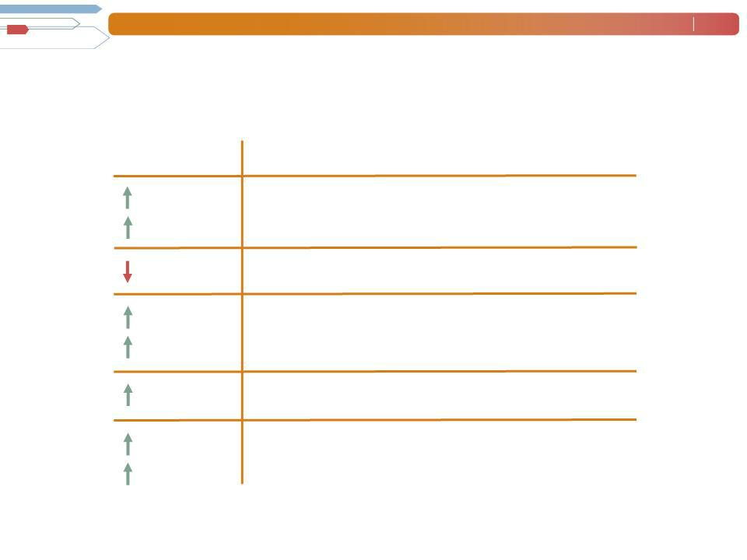
Consolidated Financial Highlights

Q1 Highlights

21%

24% CC

90 bps

315%

331% CC

120 bps

90%

157% CC

Revenue $4.6B Gross Margin 17.4% Operating Profit $79M⁽¹⁾ OP Margin 1.7%

EPS $.40

- 2009 results include reorganization charges of $13M.

Throughout this presentation, the difference between reported variances and Constant Currency (CC) variances represents the impact of currency on our financial results. Constant Currency is further explained on our Web site.

Manpower Inc. 2010 2nd Quarter Results | July | 4
 | 2010
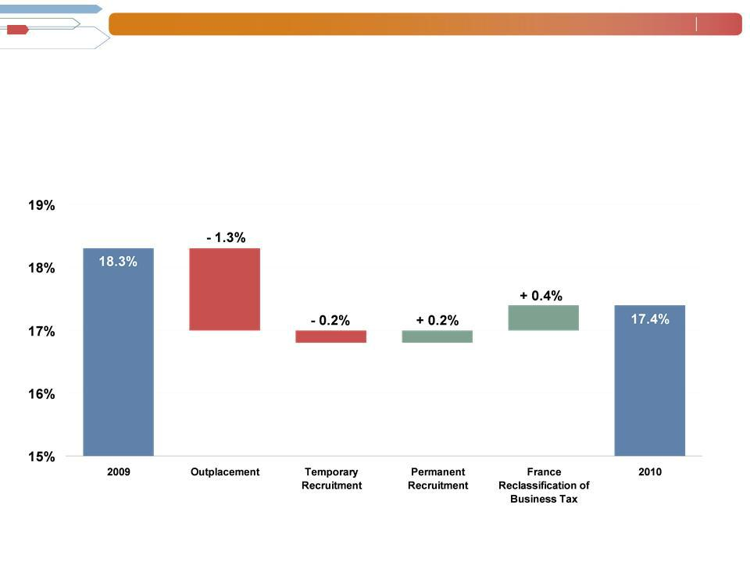

Consolidated Gross Margin Change

Manpower Inc. 2010 2nd Quarter Results | July | 5
 | 2010
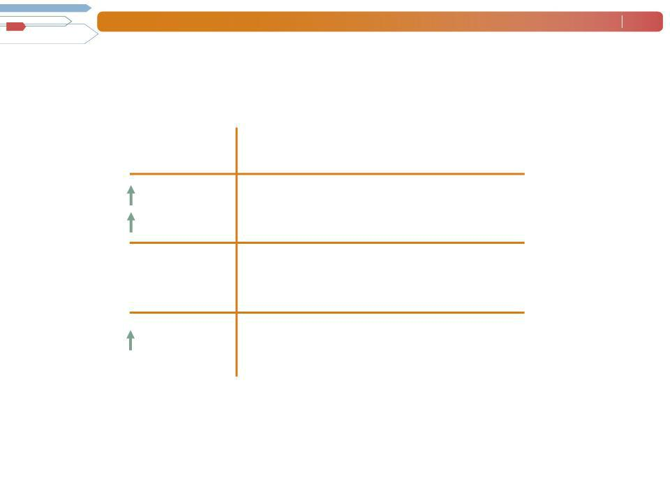

Americas Segment
(22% of Revenue)

 | Q2 Financial Highlights ⁽¹⁾
67%⁽²⁾ | Revenue $992M
(2) | Revenue $992M
64% CC
N/A | OUP $18M
N/A | OUP $18M
210 bps | OUP Margin 1.8%

- Included in these amounts is the US, which had revenue of $686M (+83%) and OUP of $10M. On an organic basis, US revenue was $504M (+35%) and OUP was $10M.

- On an organic basis, Americas revenue increased 36% in USD (33% in CC).

Operating Unit Profit (OUP) is the measure that we use to evaluate segment performance. OUP is equal to segment revenues less direct costs and branch and national headquarters operating costs.

Manpower Inc. 2010 2nd Quarter Results | July | 6
 | 2010
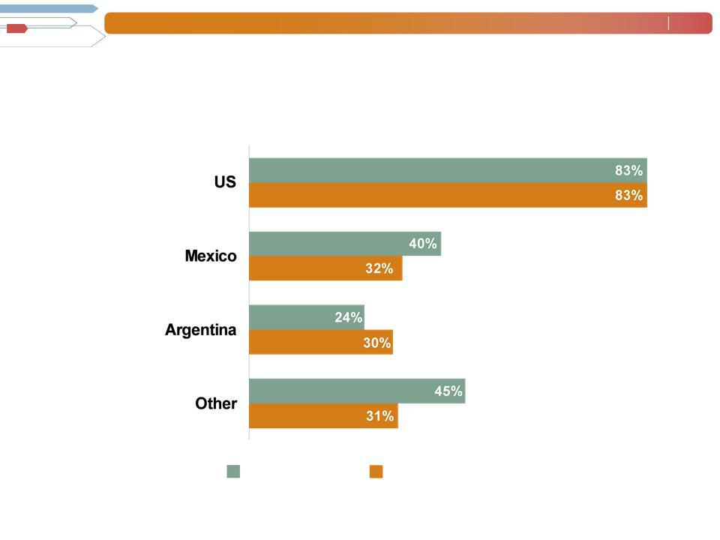

Americas - Q2 Revenue Growth YoY

- of Segment Revenue

(1)

69%

11%

6%

14%

Revenue

Growth

Revenue Growth - CC

- On an organic basis, US revenue was $504M (+35%).

Manpower Inc. 2010 2nd Quarter Results | July | 7
 | 2010
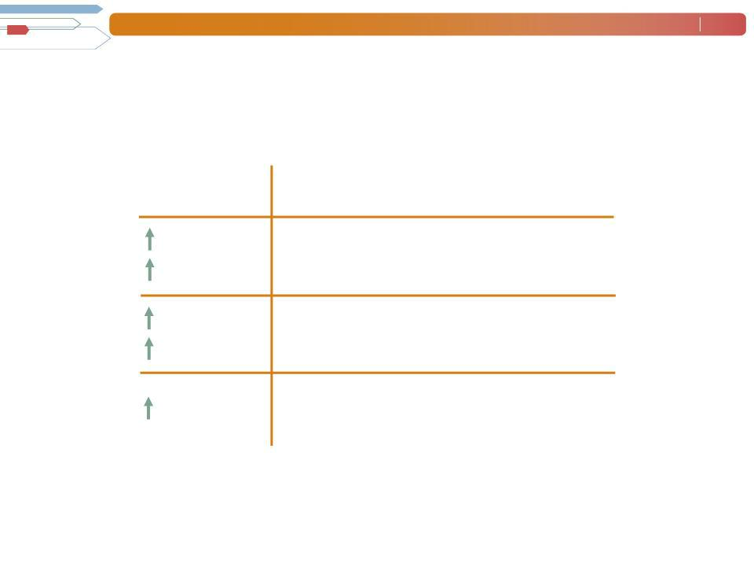

France Segment
(27% of Revenue)

Q2 Financial Highlights

14% | Revenue $1.3B
23% | Revenue $1.3B
CC
140% | OUP $10M
169% CC | OUP $10M
40 | OUP Margin 0.8%
bps

Manpower Inc. 2010 2nd Quarter Results | July | 8
 | 2010
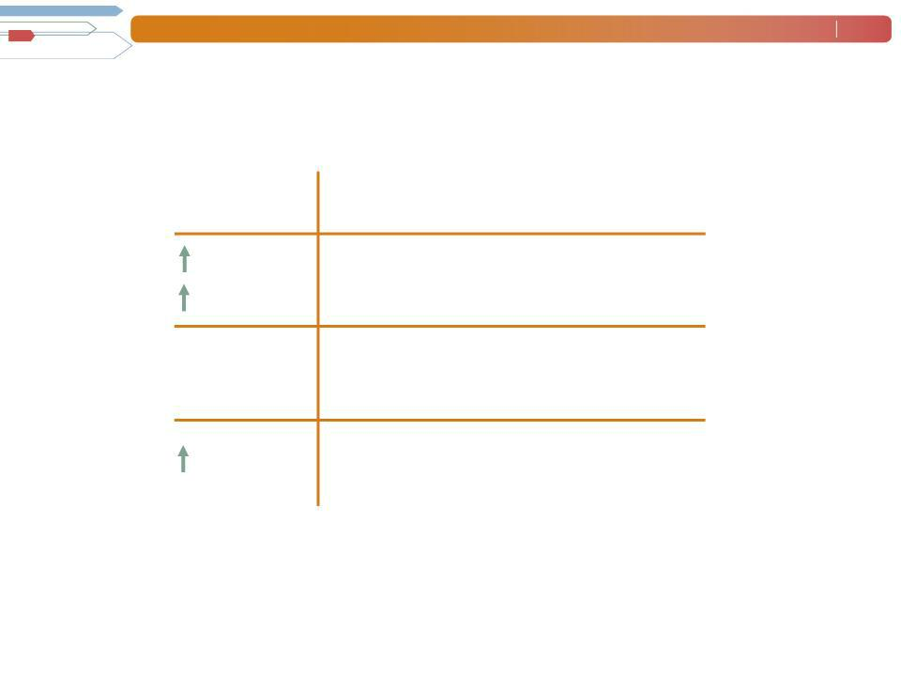

EMEA Segment
(37% of Revenue)

14%

18% CC

N/A

N/A

250 bps

Q2 Financial Highlights ⁽¹⁾

Revenue $1.7B

OUP $43M ⁽²⁾

OUP Margin 2.5%

- Included in these amounts is Italy, which had revenue of $259M (+12% in USD, 21% in CC) and OUP of $14M (+99% in USD, +115% in CC).

  - 2009 includes reorganization charges of $5.5M.

Manpower Inc. 2010 2nd Quarter Results | July | 9
 | 2010
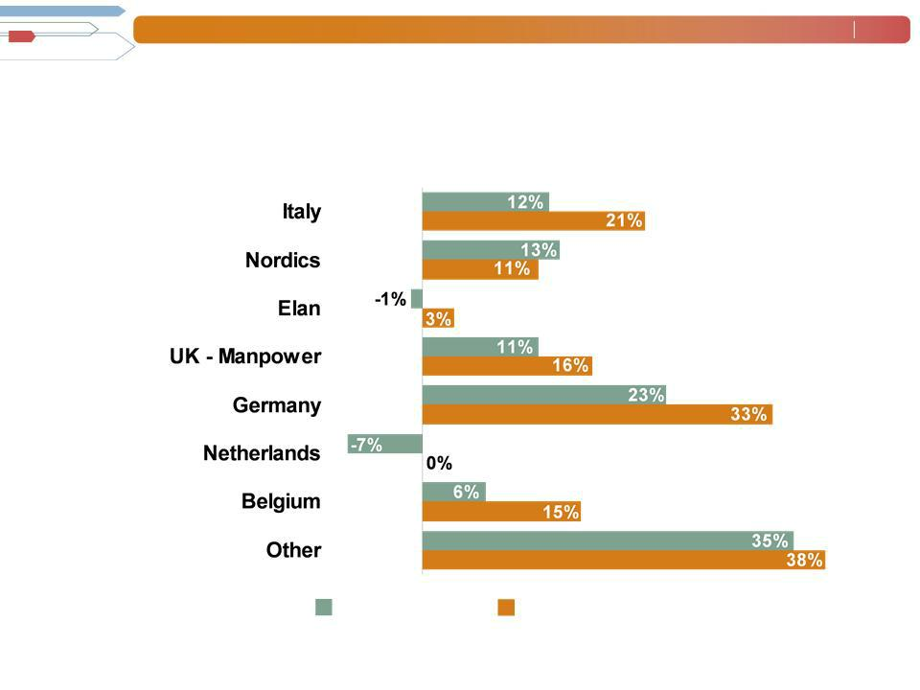
EMEA - Q2 Revenue Growth YoY

- of Segment Revenue

15%

14%

14%

11%

10%

8%

5%

23%

Revenue | Revenue Growth - CC
Growth

Manpower Inc. 2010 2nd Quarter Results | July | 10
 | 2010
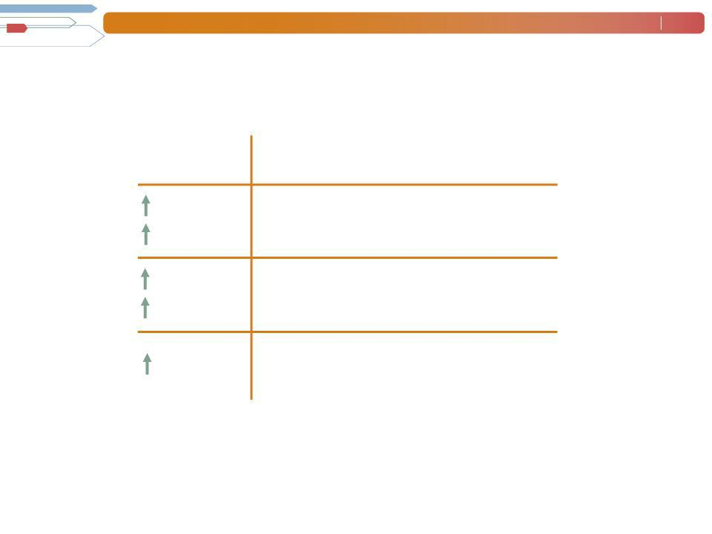

Asia Pacific Segment
(11% of Revenue)

 | Q2 Financial Highlights
25% | Revenue $506M
15% | Revenue $506M
_{237%}CC(1) | OUP $12M
215% CC⁽¹⁾ | OUP $12M
(1) | OUP Margin 2.3%
140 bps | OUP Margin 2.3%

- 2009 includes reorganization charges of $1.5M.

Manpower Inc. 2010 2nd Quarter Results | July | 11
 | 2010
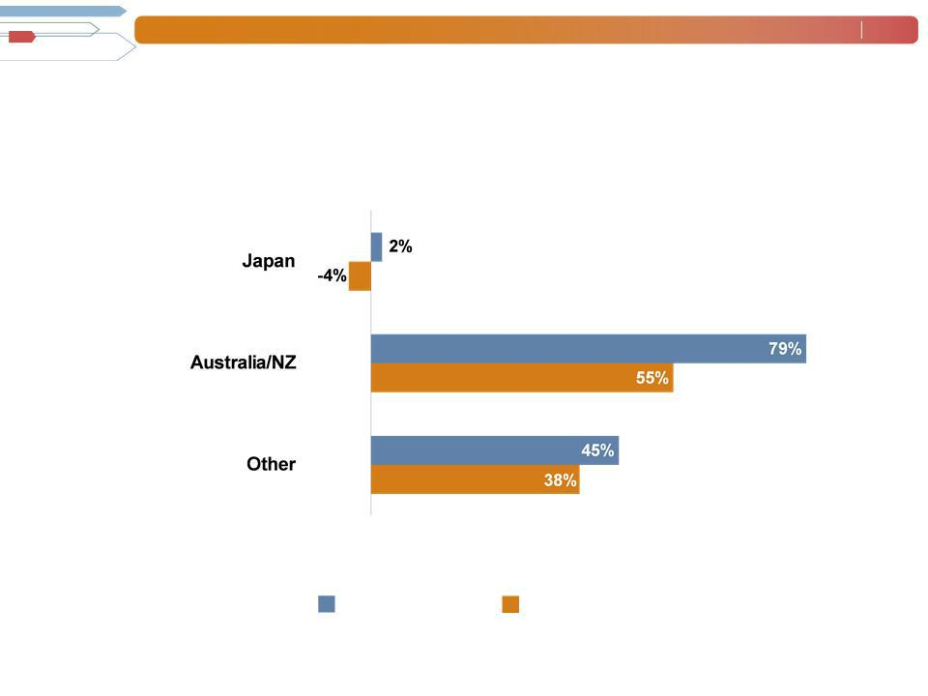

Asia Pacific - Q2 Revenue Growth YoY

- of Segment Revenue

50%

26%

24%

Revenue | Revenue Growth - CC
Growth

Manpower Inc. 2010 2nd Quarter Results | July | 12
 | 2010
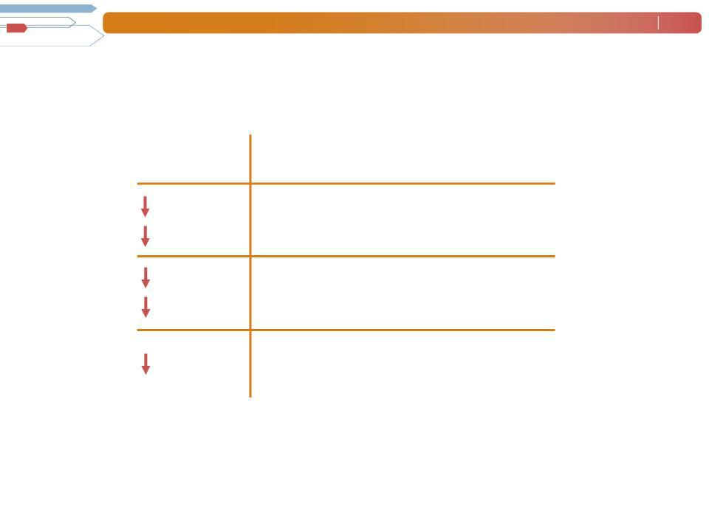

Right Management Segment
(2% of Revenue)

Q2 Financial Highlights

38% | Revenue | $99M
38% | Revenue | $99M

CC
82% | OUP $8M
82% | OUP $8M
CC
1890OUP Margin 7.9%
bps

Manpower Inc. 2010 2nd Quarter Results | July | 13
 | 2010
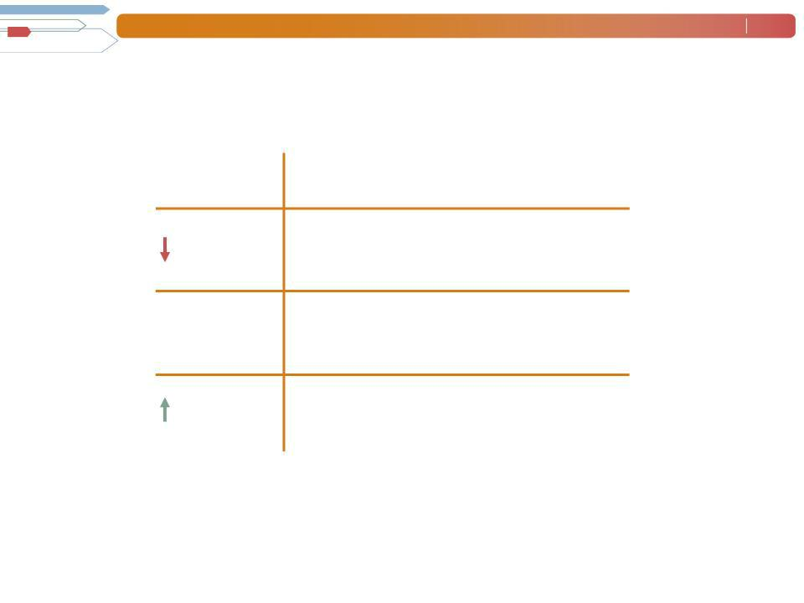

Jefferson Wells Segment
(1% of Revenue)

Q2 Financial Highlights

16% Revenue $41M

N/A OUP $(3M)

1370 ⁽¹⁾ OUP Margin - 7.5%

bps

- 2009 includes reorganization charges of $5.9M.

Manpower Inc. 2010 2nd Quarter Results | July | 14
 | 2010
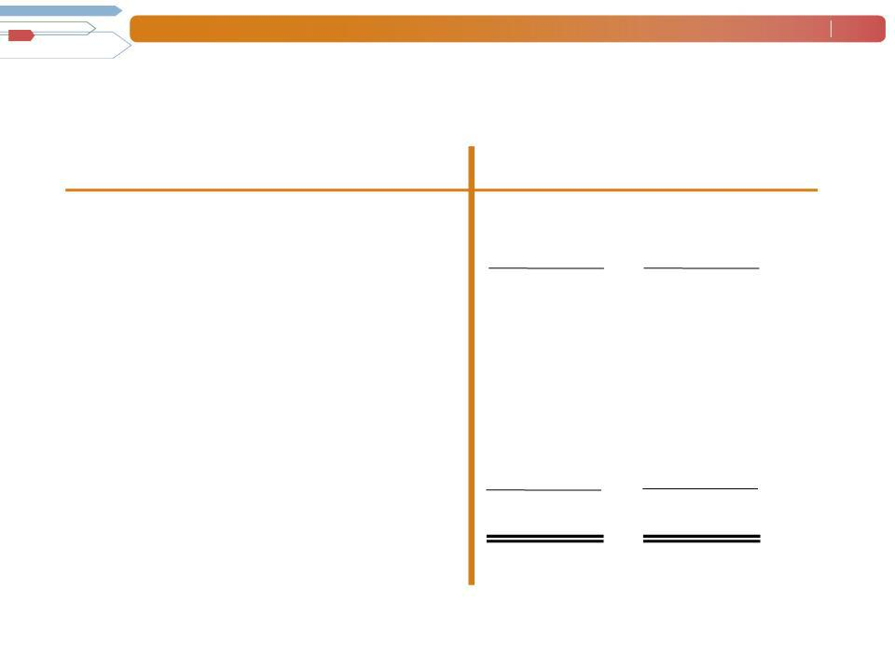

Cash Flow Summary - First Half

($ in millions)

Cash from Operations

Capital

Free^{Expenditures}CashFlow

Change in
Debt
Acquisitions of Businesses,netofcash acquired

Effect of Exchange Rate Changes Other
Change in Cash

2010 2009

  - 379

- (17)

  - 362

    - (85)

- (22)

- (1)

  - (21)

- 233

Manpower Inc. 2010 2nd Quarter Results | July | 15
 | 2010
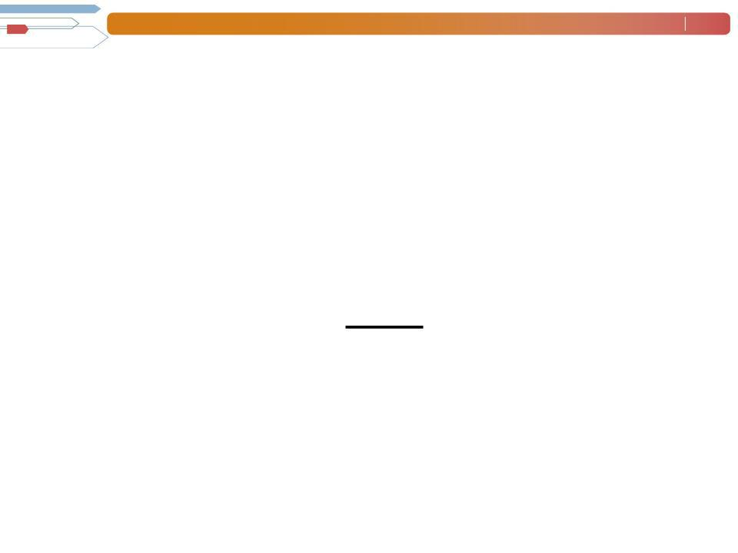
COMSYS Acquisition Summary

Closing date: | April 5,
 | 2010
Consideration: | Cash | $192M
 | Stock | 188M | (3.2M shares @ $58.94⁽¹⁾per
 | Debt | _{47M} share)
 | Retired | $427M

- Represents the closing stock price on April 5, which is higher than the average stock price of $57.98 used to determine the conversion ratio for the tender offer.

Manpower Inc. 2010 2nd Quarter Results | July | 16
 | 2010
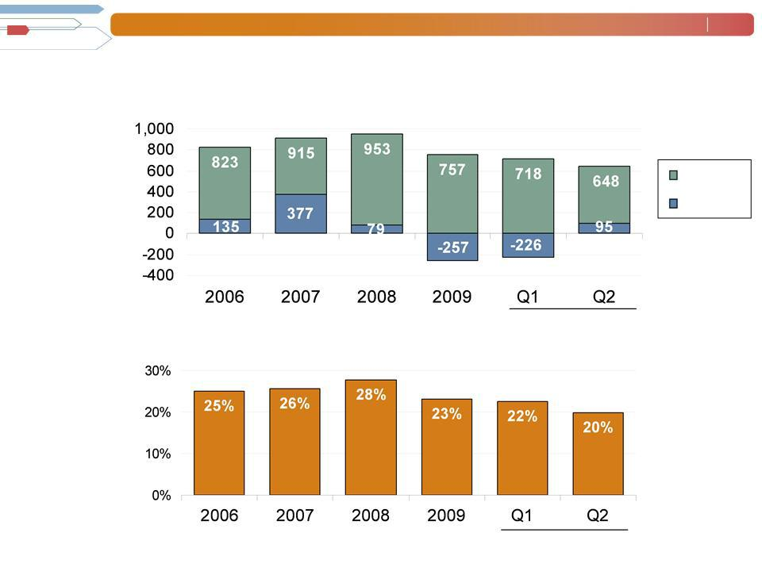
Balance Sheet Highlights

Total Debt

($ in millions)

Total Debt

Net
Debt

Total Debt to | 2010
Total Capitalization | 2010

2010

Manpower Inc. 2010 2nd Quarter Results | July | 17
 | 2010
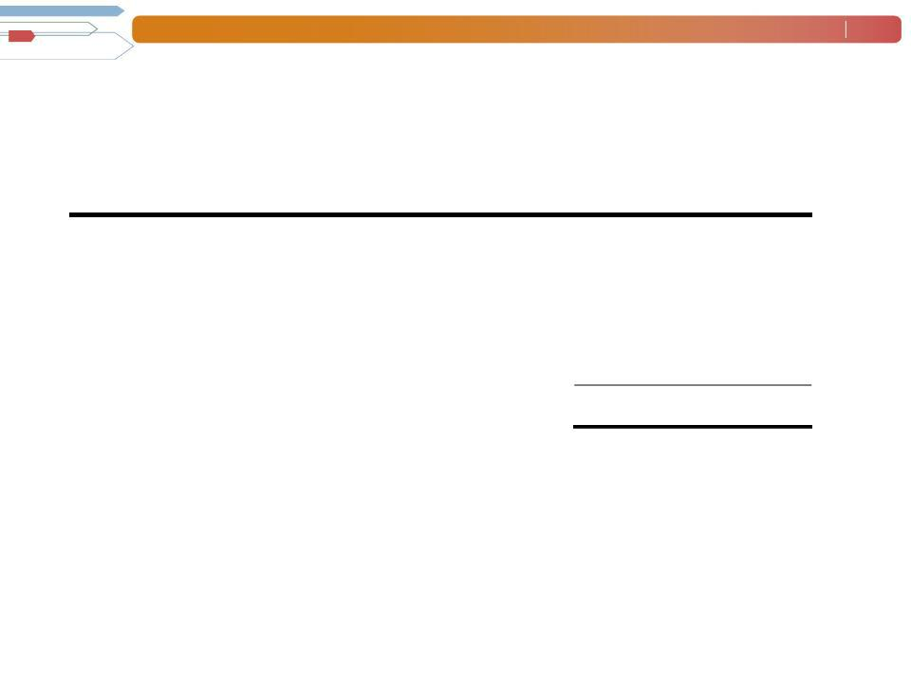

Credit Facilities as of June 30, 2010

($ in millions)

 |  | Interest | Maturity | Total | Remaining
 |  | Rate | Date | Outstanding | Available
Euro
Notes: |  | 4.86% | June | 244 | -
- Euro
200M |  | 4.58% | 2013 | 367 | -
- Euro |  | 4.58% | June | 367 | -
300M | (a) | 2.90% | 2012 | - | ₃₉₆(b)
Revolving Credit Agreement |  | 2.90% | Nov 2012 | - | ₃₉₆(b)
Uncommitted lines and |  | Various | Various | 37 | 346
Other |  |  |  | 648 | 742
Total Debt |  |  |  | 648 | 742

- This $400M agreement requires, as of June 30, that we comply with a Debt-to-EBITDA ratio of less than 6.00 to 1 and a fixed charge coverage
ratio of greater than 1.25 to 1. As defined in the agreement, we had a Debt-to-EBITDA ratio of 2.13 and a fixed charge coverage ratio of 1.84 as of June 30, 2010.

  - As of June 30, there were $4.0M of standby letters of credit issued under the agreement.

Manpower Inc. 2010 2nd Quarter Results | July | 18
 | 2010
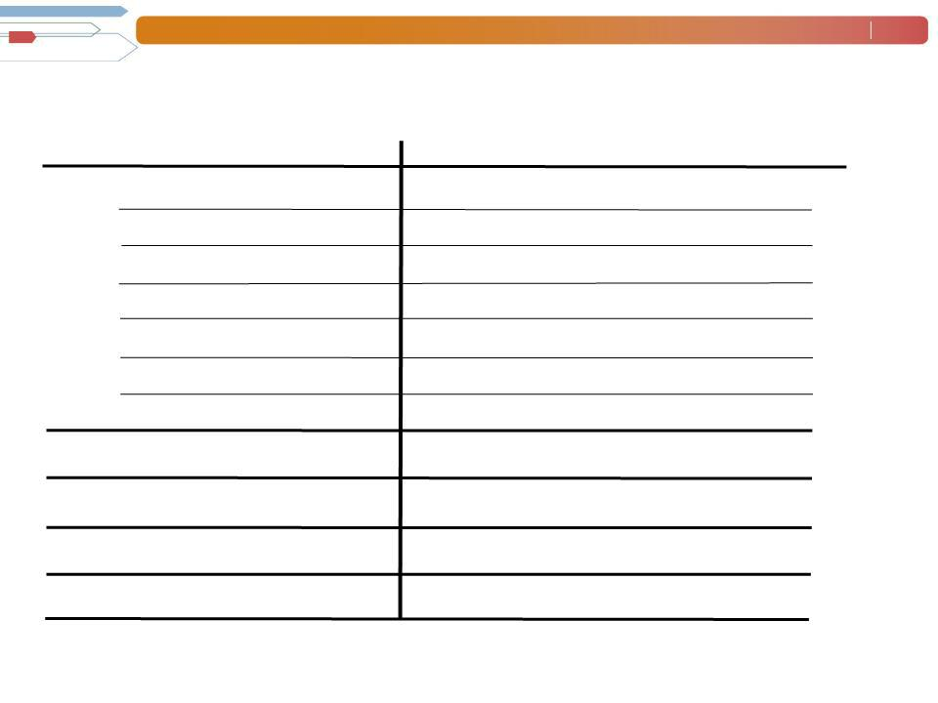

Third Quarter Outlook

Revenue ^{Total}
Americas

France

EMEA

Asia

RightPacific
Management
Jefferson Wells

Gross Profit
Margin
Operating Profit
Tax Rate^{Margin}

EPS

Up 13- | (Up 20-22%
15% | CC)
Up 60-62% (Up 56-58% CC)
Up 2-4% (Up 14-16% CC)
Up 8-10% | (Up 17-19%
Up 18-20% | CC)
Up 18-20% | (Up 14-16%
Down 34- | CC)
Down 34- | (Down 32-34%
36% | CC)
Down 10-
12%
16.8-17.0%

1.8-
2.0%

52%

$0.41-$0.51 (Neg. $.04 Currency)

Manpower Inc.

2010 2nd Quarter

Results

