UNITED STATES

SECURITIES AND EXCHANGE COMMISSION
Washington, D.C. 20549

FORM 8-K

CURRENT REPORT

Pursuant to Section 13 or 15(d) of the Securities Exchange Act of 1934

Date of Report (Date of earliest event reported): April 21, 2011

MANPOWER INC.

(d/b/a ManpowerGroup)

(Exact name of registrant as specified in its charter)

Wisconsin | 1-10686 | 39-1672779
(State or other jurisdiction of incorporation) | (Commission File Number) | (IRS Employer Identification No.)
100 Manpower Place
Milwaukee, Wisconsin |  | 53212
(Address of principal executive offices) |  | (Zip Code)

Registrant's telephone number, including area code: (414) 961-1000

Check the appropriate box below if the Form 8-K filing is intended to simultaneously satisfy the filing obligation of the registrant under any of the following provisions:

Written communications pursuant to Rule 425 under the Securities Act (17 CFR 230.425)

Soliciting material pursuant to Rule 14a-12 under the Securities Act (17 CFR 240.14a-12)

Pre-commencement communications pursuant to Rule 14d-2(b) under the Exchange Act (17 CFR 240.14d-2(b))

Pre-commencement communications pursuant to Rule 13e-4(c) under the Exchange Act (17 CFR 240.13e-4(c))

Item 2.02 Results of Operations and Financial Condition

On April 21, 2011, we issued a press release announcing our results of operations for the three months ended March 31, 2011. A copy of the press release is attached hereto as Exhibit 99.1 and is incorporated herein by reference.

Item 9.01. | Exhibits.
Exhibit No. | Description
99.1 | Press Release dated April 21, 2011
99.2 | Presentation materials for April 21, 2011 conference call

SIGNATURES

Pursuant to the requirements of the Securities Exchange Act of 1934, the Registrant has duly caused this Report to be signed on its behalf by the undersigned hereunto duly authorized.

MANPOWER INC.

(d/b/a ManpowerGroup)

Dated: April 21, 2011 By: /s/ Michael J. Van Handel

Michael J. Van Handel

Executive Vice President and

Chief Financial Officer

EXHIBIT INDEX

Exhibit No. | Description
99.1 | Press Release dated April 21, 2011
99.2 | Presentation materials for April 21, 2011 conference call

Exhibit 99.1


FOR IMMEDIATE RELEASE Contact:

Mike Van Handel

+1.414.906.6305

michael.vanhandel@manpowergroup.com

ManpowerGroup Reports 1st Quarter 2011 Results

MILWAUKEE, April 21, 2011 -- ManpowerGroup (NYSE: MAN) today reported that net earnings for the three months ended March 31, 2011 were $35.7 million, or 43 cents per diluted share, compared to net earnings of $2.8 million, or 4 cents per diluted share, a year earlier. Revenues for the first quarter were $5.1 billion, an increase of 24% from the year earlier period, or 22% in constant currency.

Net earnings in the first quarter were favorably impacted by 3 cents per diluted share, as foreign currencies were relatively stronger compared to the prior year period.

Jeffrey A. Joerres, ManpowerGroup Chairman and CEO, said, “ManpowerGroup posted a very solid first quarter, with gains in both revenue and profitability coming from almost all business lines and geographies. Several European and emerging markets showed particularly strong trends.

“During the quarter, we launched the reinvention of the brand with the evolution to ManpowerGroup. We also launched our new brand family and our new professional resourcing company, ExperisTM.

“Additionally, earlier this month we made an acquisition which is strategically significant – an IT resourcing company in India with 5 locations throughout the country. Not only does this give ManpowerGroup a strong foothold in India, but it also is a springboard for growth throughout the Asia Pacific Middle East region.

“We anticipate that favorable trends will continue into the second quarter, resulting in earnings per share of 74 cents to 82 cents. This includes a favorable impact of 8 cents per share related to currency changes in the quarter.”

In conjunction with its first quarter earnings release, ManpowerGroup will broadcast its conference call live over the Internet on April 21, 2011 at 7:30 a.m. CDT (8:30 a.m. EDT).

Interested parties are invited to listen to the webcast and view the presentation by logging on to http://www.manpowergroup.com/investors.

Supplemental financial information referenced in the conference call can be found at http://www.manpowergroup.com/investors.

About ManpowerGroup™

ManpowerGroup™ (NYSE: MAN), the world leader in innovative workforce solutions, creates and delivers high-impact solutions that enable our clients to achieve their business goals and enhance their competitiveness. With over 60 years of experience, our $19 billion company creates unique time to value through a comprehensive suite of innovative solutions that help clients win in the Human Age. These solutions cover an entire range of talent-driven needs from recruitment and assessment, training and development, and career management, to outsourcing and workforce consulting. ManpowerGroup maintains the world’s largest and industry-leading network of nearly 3,900 offices in over 80 countries and territories, generating a dynamic mix of an unmatched global footprint with valuable insight and local expertise to meet the needs of its 400,000 clients per year, across all industry sectors, small and medium-sized enterprises, local, multinational and global companies. By connecting our deep understanding of human potential to the ambitions of clients, ManpowerGroup helps the organizations and individuals we serve achieve more than they imagined – because their success leads to our success. And by creating these powerful connections, we create power that drives organizations forward, accelerates personal success and builds more sustainable communities. We help power the world of work. The ManpowerGroup suite of solutions is offered through ManpowerGroup™ Solutions, Manpower®, Experis™ and Right Management®. Learn more about how the ManpowerGroup can help you win in the Human Age at www.manpowergroup.com. Enter the Human Age at: www.manpowergroup.com/humanage.

Forward-Looking Statements

This news release contains statements, including earnings projections, that are forward-looking in nature and, accordingly, are subject to risks and uncertainties regarding the Company’s expected future results. The Company’s actual results may differ materially from those described or contemplated in the forward-looking statements. Factors that may cause the Company’s actual results to differ materially from those contained in the forward-looking statements can be found in the Company’s reports filed with the SEC, including the information under the heading ‘Risk Factors’ in its Annual Report on Form 10-K for the year ended December 31, 2010, which information is incorporated herein by reference.

###

ManpowerGroup

Results of Operations

(In millions, except per share data)

 |  |  |  |  |  |  | Three Months Ended March 31
 |  |  |  |  |  |  |  |  |  | % Variance
 |  |  |  |  |  |  |  |  |  | Amount |  |  | Constant
 |  |  | 2011 |  |  |  | 2010 |  |  | Reported |  |  | Currency
 |  |  |  |  |  |  | (Unaudited)
 | Revenues from services (a) | $ | 5,072.4 |  | $ |  | 4,099.3 |  |  | 23.7% |  |  | 21.8%
 | Cost of services |  | 4,214.8 |  |  |  | 3,397.8 |  |  | 24.0% |  |  | 22.1%
 | Gross profit |  | 857.6 |  |  |  | 701.5 |  |  | 22.2% |  |  | 20.1%
 | Selling and administrative expenses |  | 772.0 |  |  |  | 668.9 |  |  | 15.4% |  |  | 13.7%
 | Operating profit |  | 85.6 |  |  |  | 32.6 |  |  | 162.7% |  |  | 152.3%
 | Interest and other expenses |  | 11.1 |  |  |  | 12.9 |  |  | -13.7%
 | Earnings before income taxes |  | 74.5 |  |  |  | 19.7 |  |  | 278.4% |  |  | 259.7%
 | Provision for income taxes |  | 38.8 |  |  |  | 16.9 |  |  | 130.5%
 | Net earnings | $ | 35.7 |  | $ |  | 2.8 |  |  | N/A |  |  | N/A
 | Net earnings per share - basic | $ | 0.44 |  | $ |  | 0.04 |  |  | N/A
 | Net earnings per share - diluted | $ | 0.43 |  | $ |  | 0.04 |  |  | N/A |  |  | N/A
 | Weighted average shares - basic |  | 81.9 |  |  |  | 78.6 |  |  | 4.1%
 | Weighted average shares - diluted |  | 83.6 |  |  |  | 79.9 |  |  | 4.7%

- Revenues from services include fees received from our franchise offices of $5.9 million and $4.6 million for the three months ended March 31, 2011 and 2010, respectively. These fees are primarily based on revenues generated by the franchise offices, which were $274.5 million and $193.9 million for the three months ended March 31, 2011 and 2010, respectively.

ManpowerGroup

Operating Unit Results

(In millions)

 |  |  |  |  |  |  | Three Months Ended March 31
 |  |  |  |  |  |  |  |  |  | % Variance
 |  |  |  |  |  |  |  |  |  | Amount |  |  | Constant
 |  |  | 2011 |  |  |  | 2010 |  |  | Reported |  |  | Currency
 |  |  |  |  |  |  | (Unaudited)
 | Revenues from Services: (a)
 | Americas:
 | United States (b) | $ | 750.9 |  | $ |  | 482.7 |  |  | 55.6% |  |  | 55.6%
 | Other Americas |  | 361.8 |  |  |  | 294.5 |  |  | 22.8% |  |  | 19.4%
 |  |  | 1,112.7 |  |  |  | 777.2 |  |  | 43.2% |  |  | 41.9%
 | Southern Europe:
 | France |  | 1,353.8 |  |  |  | 1,107.5 |  |  | 22.2% |  |  | 23.2%
 | Italy |  | 284.6 |  |  |  | 234.2 |  |  | 21.5% |  |  | 22.4%
 | Other Southern Europe |  | 180.0 |  |  |  | 158.4 |  |  | 13.7% |  |  | 13.1%
 |  |  | 1,818.4 |  |  |  | 1,500.1 |  |  | 21.2% |  |  | 22.0%
 | Northern Europe |  | 1,456.6 |  |  |  | 1,221.2 |  |  | 19.3% |  |  | 16.7%
 | APME |  | 602.9 |  |  |  | 497.5 |  |  | 21.2% |  |  | 11.2%
 | Right Management |  | 81.8 |  |  |  | 103.3 |  |  | -20.9% |  |  | -22.7%
 |  | $ | 5,072.4 |  | $ |  | 4,099.3 |  |  | 23.7% |  |  | 21.8%
 | Operating Unit Profit (Loss): (a)
 | Americas:
 | United States | $ | 8.7 |  | $ |  | (11.9) |  |  | N/A |  |  | N/A
 | Other Americas |  | 12.8 |  |  |  | 9.6 |  |  | 32.9% |  |  | 30.6%
 |  |  | 21.5 |  |  |  | (2.3) |  |  | N/A |  |  | N/A
 | Southern Europe:
 | France |  | 12.0 |  |  |  | 0.2 |  |  | N/A |  |  | N/A
 | Italy |  | 12.9 |  |  |  | 6.8 |  |  | 88.8% |  |  | 88.4%
 | Other Southern Europe |  | 2.2 |  |  |  | (0.9) |  |  | N/A |  |  | N/A
 |  |  | 27.1 |  |  |  | 6.1 |  |  | 343.6% |  |  | 339.1%
 | Northern Europe |  | 41.9 |  |  |  | 19.0 |  |  | 121.1% |  |  | 112.5%
 | APME |  | 16.5 |  |  |  | 12.5 |  |  | 31.9% |  |  | 21.1%
 | Right Management |  | 3.3 |  |  |  | 12.5 |  |  | -73.5% |  |  | -73.8%
 |  |  | 110.3 |  |  |  | 47.8
 | Corporate expenses |  | (32.0) |  |  |  | (24.0)
 | Intangible asset amortization expense |  | (9.6) |  |  |  | (4.9)
 | Reclassification of French business tax |  | 16.9 |  |  |  | 13.7
 | Operating profit |  | 85.6 |  |  |  | 32.6 |  |  | 162.7% |  |  | 152.3%
 | Interest and other expenses (c) |  | (11.1) |  |  |  | (12.9)
 | Earnings before income taxes | $ | 74.5 |  | $ |  | 19.7

- Effective January 1, 2011, we created a new organizational structure in Europe in order to elevate our service quality throughout Europe, Middle East and Africa. Other Southern Europe and Northern Europe, previously reported in Other EMEA, are now separate reportable segments. France, Italy, and Other Southern Europe are aggregated into our Southern Europe reportable segment. All previously reported results have been restated to conform to the current year presentation. Additionally, we changed the name of our Asia Pacific reportable segment to APME; the results of this reportable segment have not been restated as only the name has changed.

- In the United States, revenues from services include fees received from our franchise offices of $2.7 million and $2.5 million for the three months ended March 31, 2011 and 2010, respectively. These fees are primarily based on revenues generated by the franchise offices, which were $148.5 million and $132.2 million for the three months ended March 31, 2011 and 2010, respectively.

- The components of interest and other expenses were:

 |  | 2011 |  |  |  | 2010
Interest expense | $ | 10.2 |  | $ |  | 11.1
Interest income |  | (1.4) |  |  |  | (1.6)
Foreign exchange losses |  | 0.5 |  |  |  | 1.9
Miscellaneous expenses, net |  | 1.8 |  |  |  | 1.5
 | $ | 11.1 |  | $ |  | 12.9

ManpowerGroup

Consolidated Balance Sheets

(In millions)

 |  | Mar. 31 |  |  |  | Dec. 31
 |  | 2011 |  |  |  | 2010
 |  | (Unaudited)
ASSETS
Current assets:
Cash and cash equivalents | $ | 649.5 |  | $ |  | 772.6
Accounts receivable, net |  | 4,201.0 |  |  |  | 3,844.1
Prepaid expenses and other assets |  | 204.9 |  |  |  | 197.6
Future income tax benefits |  | 61.1 |  |  |  | 59.7
Total current assets |  | 5,116.5 |  |  |  | 4,874.0
Other assets:
Goodwill and other intangible assets, net |  | 1,335.7 |  |  |  | 1,330.3
Other assets |  | 393.6 |  |  |  | 355.1
Total other assets |  | 1,729.3 |  |  |  | 1,685.4
Property and equipment:
Land, buildings, leasehold improvements and equipment |  | 714.4 |  |  |  | 688.8
Less: accumulated depreciation and amortization |  | 542.8 |  |  |  | 518.5
Net property and equipment |  | 171.6 |  |  |  | 170.3
Total assets | $ | 7,017.4 |  | $ |  | 6,729.7
LIABILITIES AND SHAREHOLDERS' EQUITY
Current liabilities:
Accounts payable | $ | 1,454.9 |  | $ |  | 1,313.9
Employee compensation payable |  | 195.3 |  |  |  | 240.2
Accrued liabilities |  | 555.0 |  |  |  | 547.4
Accrued payroll taxes and insurance |  | 665.4 |  |  |  | 677.7
Value added taxes payable |  | 512.3 |  |  |  | 482.2
Short-term borrowings and current maturities of long-term debt |  | 38.2 |  |  |  | 28.7
Total current liabilities |  | 3,421.1 |  |  |  | 3,290.1
Other liabilities:
Long-term debt |  | 708.1 |  |  |  | 669.3
Other long-term liabilities |  | 390.9 |  |  |  | 373.1
Total other liabilities |  | 1,099.0 |  |  |  | 1,042.4
Shareholders' equity:
Common stock |  | 1.1 |  |  |  | 1.1
Capital in excess of par value |  | 2,797.9 |  |  |  | 2,781.7
Retained earnings |  | 820.9 |  |  |  | 785.2
Accumulated other comprehensive income |  | 137.8 |  |  |  | 87.0
Treasury stock, at cost |  | (1,260.4) |  |  |  | (1,257.8)
Total shareholders' equity |  | 2,497.3 |  |  |  | 2,397.2
Total liabilities and shareholders' equity | $ | 7,017.4 |  | $ |  | 6,729.7

ManpowerGroup

Consolidated Statements of Cash Flows

(In millions)

 |  | Three Months Ended
 |  |  | March 31
 |  | 2011 |  |  |  |  | 2010
 |  |  | (Unaudited)
 | Cash Flows from Operating Activities:
 | Net earnings | $ | 35.7 |  | $ |  | 2.8
 | Adjustments to reconcile net earnings to net cash used in operating activities:
 | Depreciation and amortization |  | 25.9 |  |  |  | 21.4
 | Deferred income taxes |  | (2.9) |  |  |  | (9.5)
 | Provision for doubtful accounts |  | 5.9 |  |  |  | 4.1
 | Share-based compensation |  | 8.2 |  |  |  | 5.5
 | Excess tax benefit on exercise of stock options |  | (0.5) |  |  |  | (0.1)
 | Changes in operating assets and liabilities, excluding the impact of acquisitions:
 | Accounts receivable |  | (212.9) |  |  |  | (127.1)
 | Other assets |  | (6.3) |  |  |  | (35.6)
 | Other liabilities |  | (12.8) |  |  |  | 95.5
 | Cash used in operating activities |  | (159.7) |  |  |  | (43.0)
 | Cash Flows from Investing Activities:
 | Capital expenditures |  | (11.2) |  |  |  | (7.8)
 | Acquisitions of businesses, net of cash acquired |  | - |  |  |  | (0.1)
 | Proceeds from sales of property and equipment |  | 1.1 |  |  |  | 0.3
 | Cash used in investing activities |  | (10.1) |  |  |  | (7.6)
 | Cash Flows from Financing Activities:
 | Net change in short-term borrowings |  | 9.6 |  |  |  | 0.2
 | Proceeds from long-term debt |  | 0.1 |  |  |  | 1.5
 | Repayments of long-term debt |  | (0.1) |  |  |  | (0.7)
 | Proceeds from share-based awards |  | 5.2 |  |  |  | 4.9
 | Excess tax benefit on exercise of stock options |  | 0.5 |  |  |  | 0.1
 | Cash provided by financing activities |  | 15.3 |  |  |  | 6.0
 | Effect of exchange rate changes on cash |  | 31.4 |  |  |  | (26.2)
 | Change in cash and cash equivalents |  | (123.1) |  |  |  | (70.8)
 | Cash and cash equivalents, beginning of period |  | 772.6 |  |  |  | 1,014.6
 | Cash and cash equivalents, end of period | $ | 649.5 |  | $ |  | 943.8

Exhibit 99.2


ManpowerGroup

2011 1st Quarter
April 21, 2011


ManpowerGroup 2011 1st Quarter Results April 2011

Forward-Looking Statement

This presentation includes forward-looking statements, including earnings projections which are subject to risks and uncertainties. Actual results might differ materially from those projected in the forward-looking statements. Additional information concerning factors that could cause actual results to materially differ from those in the forward-looking statements is contained in the Manpower Inc. Annual Report on Form 10-K dated December 31, 2010, which information is incorporated herein by reference, and such other factors as may be described from time to time in the Company’s SEC filings.

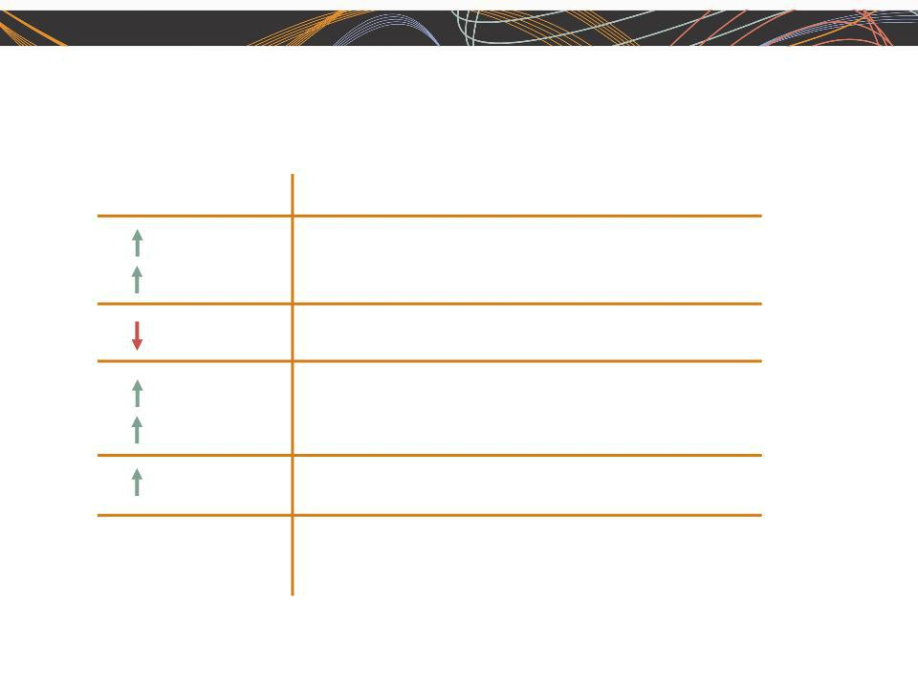
ManpowerGroup 2011 1st Quarter Results April 2011

Consolidated Financial Highlights

24%

22% CC

20 bps

163%

152% CC

90 bps

N/A

N/A

Q1 Highlights

Revenue $5.1B

Gross Margin 16.9% Operating Income $86M OP Margin 1.7%

EPS $0.43

Throughout this presentation, the difference between reported variances and Constant Currency (CC) variances | 3
represents the impact of currency on our financial results. Constant Currency is further explained on our Web site. | 3

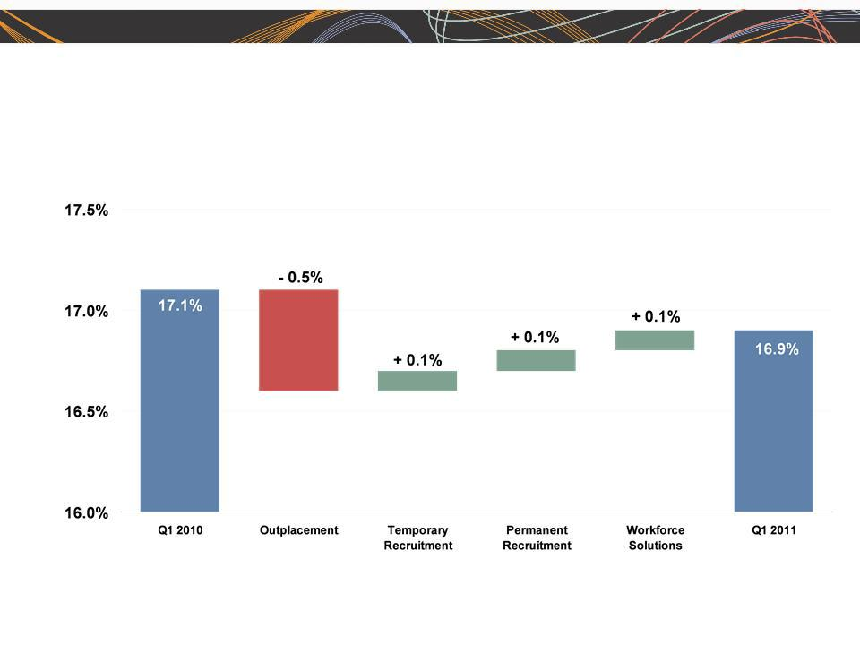
ManpowerGroup 2011 1st Quarter Results April 2011

Consolidated Gross Margin Change

4

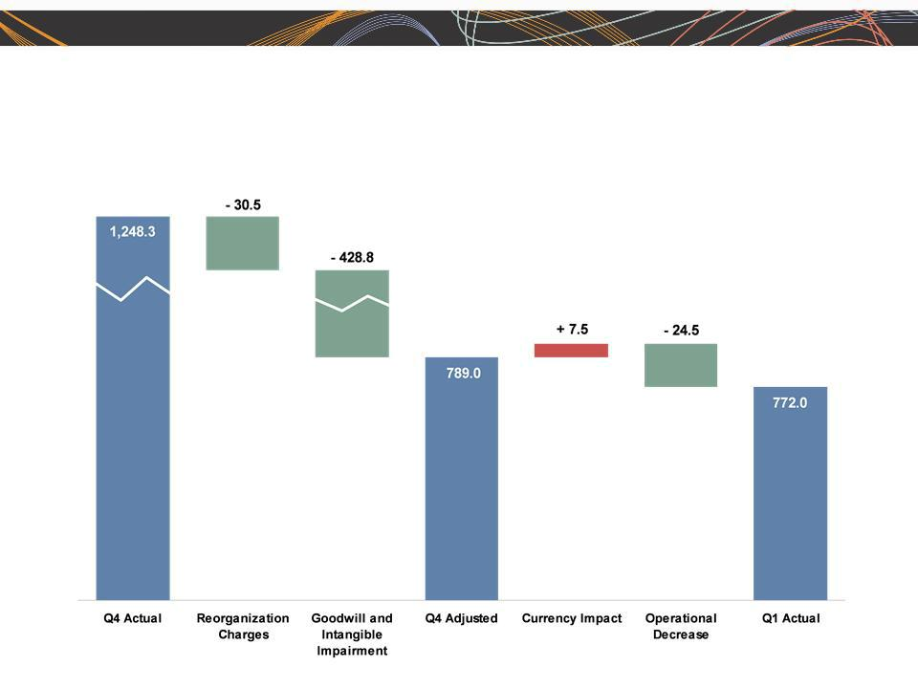
ManpowerGroup 2011 1st Quarter Results April 2011

SG&A Expense Sequential Bridge - Q1 vs. Q4

(in millions of USD)

5


ManpowerGroup 2011 1st Quarter Results April 2011

Americas Segment

(22% of Revenue)

Q1 Financial Highlights ⁽¹⁾

43% | Revenue $1.1B
42% CC | Revenue $1.1B
N/A | OUP $22M
N/A | OUP $22M

220 bps OUP Margin 1.9%

- Included in these amounts is the US, which had revenue of $751M (+56%) and OUP of $9M.

Operating Unit Profit (OUP) is the measure that we use to evaluate segment performance.

OUP is equal to segment revenues less direct costs and branch and national ₆ headquarters operating costs.

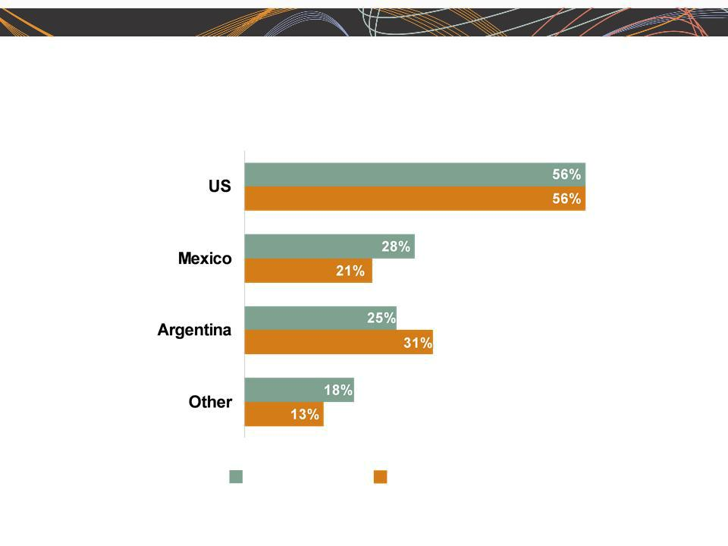
ManpowerGroup 2011 1st Quarter Results April 2011

Americas - Q1 Revenue Growth YoY

- of Segment Revenue

68%

11%

7%

14%

Revenue

Growth

Revenue Growth - CC

7


ManpowerGroup 2011 1st Quarter Results April 2011

Southern Europe Segment

(36% of Revenue)

Q1 Financial Highlights ⁽¹⁾

21% | Revenue | $1.8B
22% | Revenue | $1.8B
CC
344% | OUP $27M
339% CC

110 bps OUP Margin 1.5%

- Included in these amounts is France, which had revenue of $1.4B (+23% CC) and OUP of $12M.

8

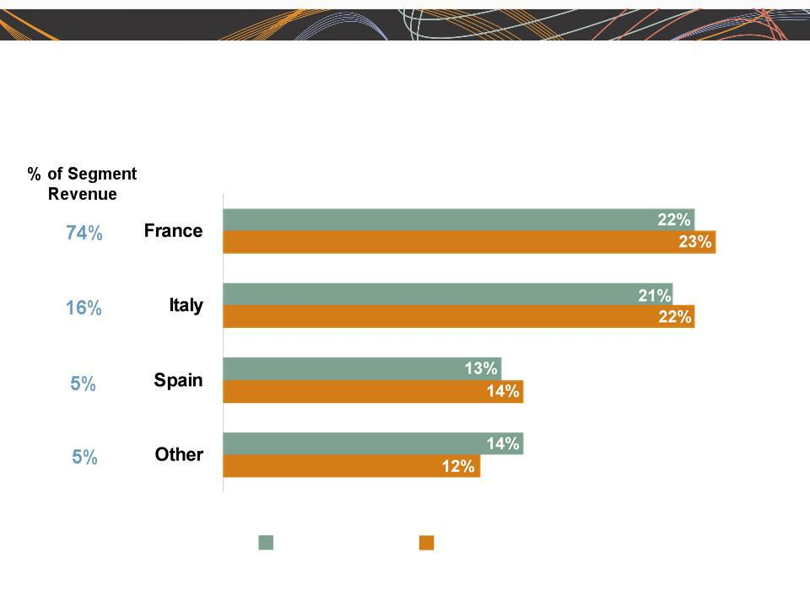
ManpowerGroup 2011 1st Quarter Results April 2011

Southern Europe - Q1 Revenue Growth YoY

Revenue

Growth

Revenue Growth - CC

9


ManpowerGroup 2011 1st Quarter Results April 2011

Northern Europe Segment

(28% of Revenue)

 | Q1 Financial Highlights
19% | Revenue $1.5B
17% CC | Revenue $1.5B
121% | OUP $42M
112% CC | OUP $42M
130 bps | OUP Margin 2.9%

10

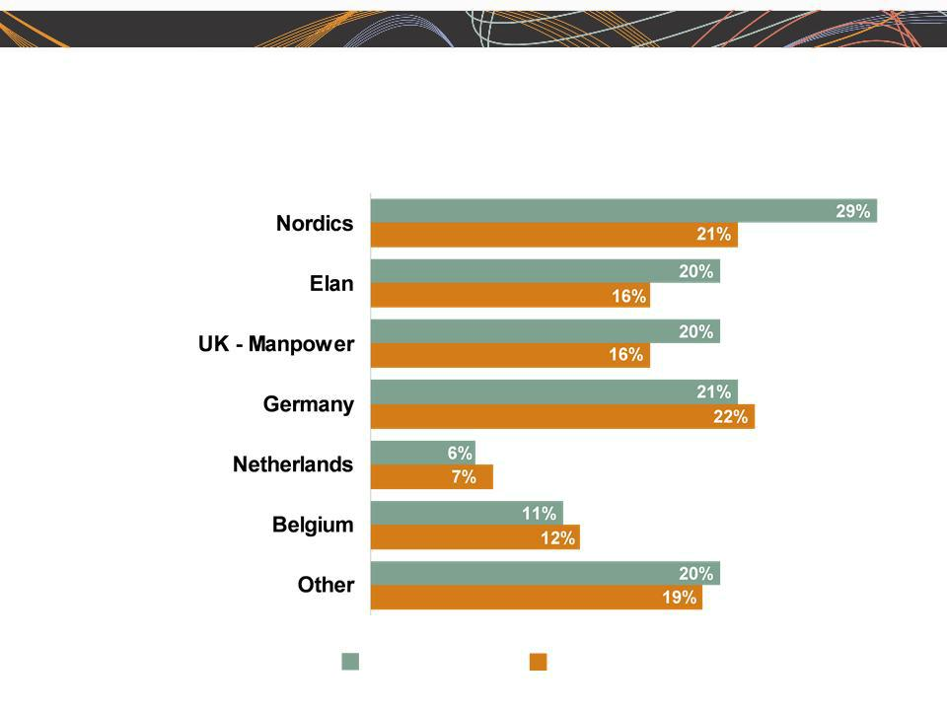
ManpowerGroup 2011 1st Quarter Results April 2011

Northern Europe - Q1 Revenue Growth YoY

- of Segment Revenue

20%

18%

14%

13%

10%

7%

18%

Revenue | Revenue Growth - CC
Growth | 11


ManpowerGroup 2011 1st Quarter Results April 2011

APME Segment

(12% of Revenue)

Q1 Financial Highlights

21% | Revenue $603M
11% | Revenue $603M
CC
32% | OUP $17M
21% | OUP $17M
CC
- OUP Margin 2.7%

bps

12

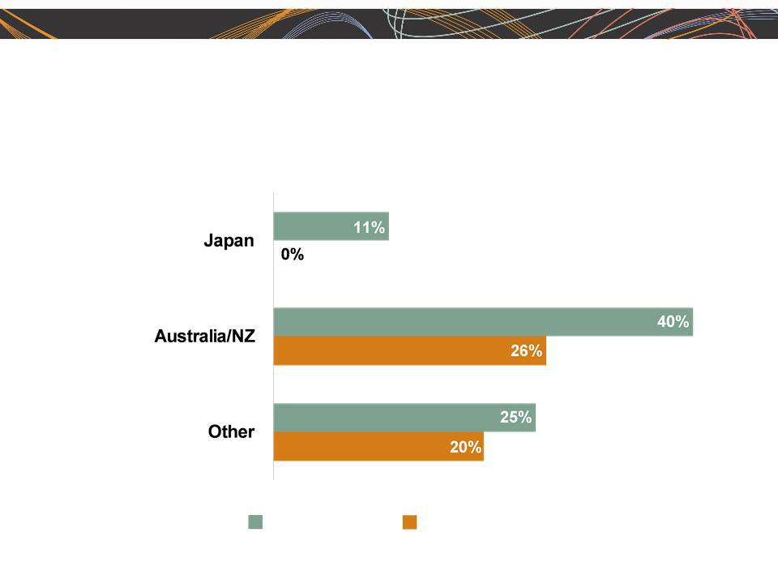
ManpowerGroup 2011 1st Quarter Results April 2011

APME - Q1 Revenue Growth YoY

- of Segment Revenue

48%

28%

24%

Revenue

Growth

Revenue Growth - CC

13


ManpowerGroup 2011 1st Quarter Results April 2011

Right Management Segment

(2% of Revenue)

Q1 Financial Highlights

21% | Revenue | $82M
23% | Revenue | $82M
CC
74% | OUP $3M
74%
CC
810 bps OUP Margin 4.0%

14


ManpowerGroup 2011 1st Quarter Results April 2011

Cash Flow Summary - Q1

($ in millions) | 2011 | 2010
Cash from Operations | (160) | (43)
Capital | (11) | (8)
Expenditures | (171) | (51)
Free Cash Flow | (171) | (51)
Change in | 10 | 1
Debt | 31 | (26)
Effect of Exchange Rate Changes | 31 | (26)
Other | 7 | 5
Change in Cash | (123) | (71)

15

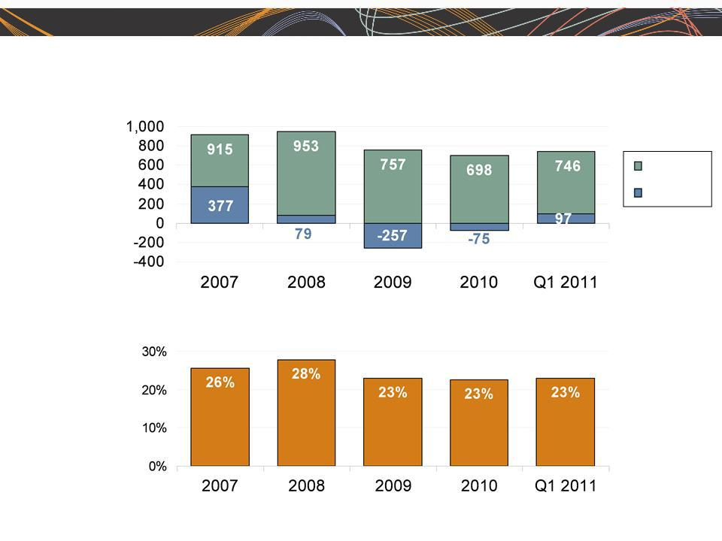
ManpowerGroup 2011 1st Quarter Results April 2011

Balance Sheet Highlights

Total Debt

($ in millions)

Total Debt

Net
Debt

Total Debt to

Total Capitalization

16


ManpowerGroup 2011 1st Quarter Results April 2011

Credit Facilities as of March 31, 2011

($ in millions) |  |  | Interest | Maturity | Total | Remaining
 |  |  | Rate | Date | Outstanding | Available
Euro
Notes: |  |  | 4.86% | Jun 2013 | 283 | -
- Euro
200M |  |  | 4.58% | Jun 2012 | 424 | -
- Euro
300M | (a) |  | 2.79% | Nov 2012 | - | 398
Revolving Credit Agreement
Uncommitted lines and |  | (b) | Various | Various | 39 | 378
Other |  |  |  |  | 746 | 776
Total Debt |  |  |  |  | 746 | 776

- This $400M agreement requires, as of March 31, 2011 that we comply with a Debt-to-EBITDA ratio of less than 4.50 to 1 and a fixed charge coverage ratio of greater than 1.25 to 1. As defined in the agreement, we had a Debt-to-EBITDA ratio of 1.52 and a fixed charge coverage ratio of 2.61 as of March 31, 2011. As of March 31, 2011 there were $2.2M of standby letters of credit issued under the agreement.

  - Represents subsidiary uncommitted lines of credit & overdraft facilities, which total $415.6M. Total subsidiary borrowings are limited to $300M due to restrictions in our Revolving Credit Facility, with the exception of Q3 when subsidiary borrowings are limited to $600M.

17


ManpowerGroup 2011 1st Quarter Results April 2011

Second Quarter Outlook

Revenue ^{Total}
Americas

Southern

Northern^{Europe}Europe APME

Right
Management

Gross Profit
Margin
Operating Profit Margin Tax Rate

EPS

Up 20- | (Up 10-12%
22% | CC)
Up 13- | (Up 12-14%
15% | CC)
15% | (Up 11-13%
Up 25- | (Up 11-13%
27% | CC)
Up 23- | (Up 10-12%
25% | CC)
25% | (Up 7-9%
Up 17- | (Up 7-9%
19% | CC)
Down 13- | (Down 10-12%
15% | CC)
17.0-17.2%

2.4-
2.6%
48% (38% excl. reclassification of
France business tax)

$0.74-$0.82 (Favorable $.08 Currency)

18


ManpowerGroup 2011 1st Quarter Results April 2011

The Human Age is Creating Complexity

• There are new demands for:

ØProductivity

ØInnovation

ØTalent

19


ManpowerGroup 2011 1st Quarter Results April 2011

The Human Age

- Our Opportunity

– ManpowerGroup is uniquely qualified to help our clients and candidates navigate this new complexity to win in the world of work with:

    - Our differentiated competitive position

    - Our trusted brand and strong values

    - Our unmatched global footprint

    - Our unparalleled thought leadership position

    - Our deep understanding of talent and business

20

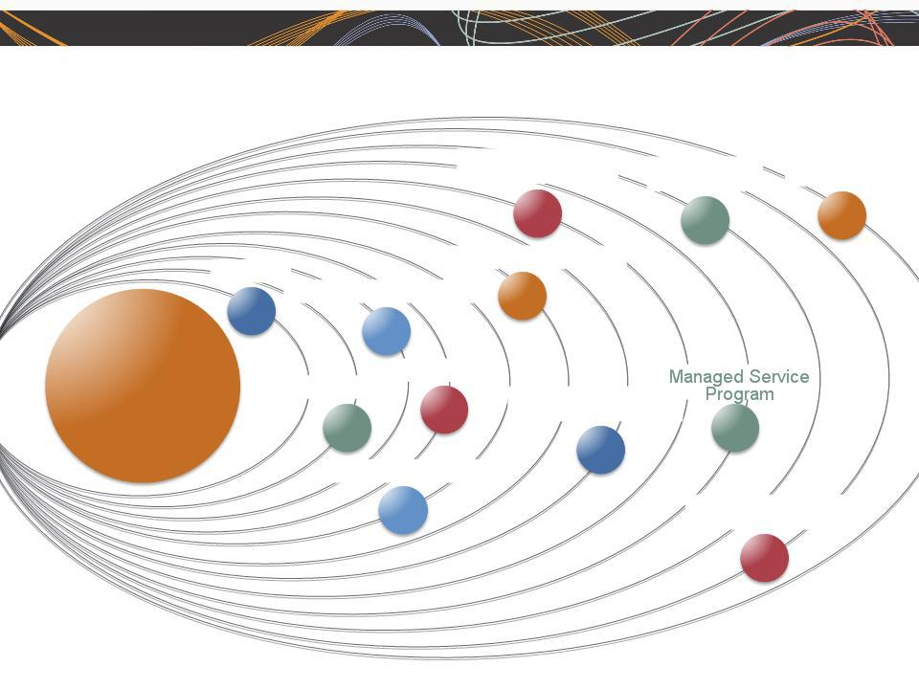
ManpowerGroup 2011 1st Quarter Results April 2011

Sophistication of Offerings Increasing Exponentially

On-Site

Human Resource | Talent Based | Talent
Services | Outsourcing | Management

Career Management

Permanent Recruitment

Core

Staffing

Assessment
Consulting | Recruitment Process
 | Outsourcing
Specialty Services

Borderless Talent
Solutions

21

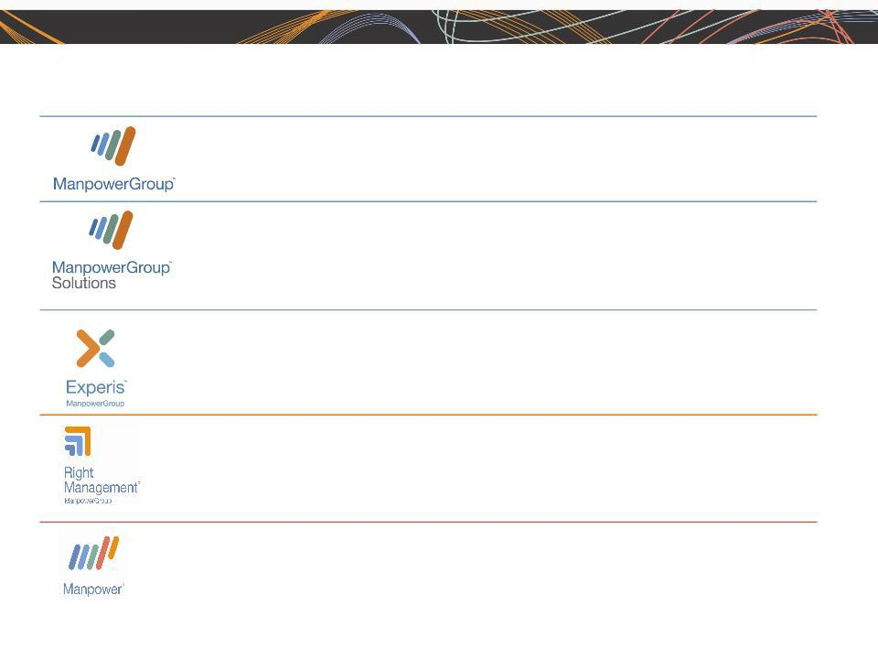
ManpowerGroup 2011 1st Quarter Results April 2011

We Are ManpowerGroup

ManpowerGroupTM is the world leader in innovative workforce solutions. We leverage our global reach and local expertise of tens of thousands of people across more than 80 countries, making it possible for businesses to access the talent they need when they need it.

ManpowerGroupTM Solutions provides clients with human resources outsourcing services primarily in the areas of large-scale recruiting and outcome-based workforce-intensive initiatives, thereby sharing in the risk and reward with our clients.

ExperisTM is the global leader in professional resourcing and project-based workforce solutions. With operations in more than 50 countries, we deliver 53 million hours of professional talent specializing in IT, Finance and Engineering to accelerate clients’ businesses each year.

Right Management® is the global leader in talent and career management workforce solutions. Through our innovative and proprietary process, we leverage our expertise to successfully increase productivity and optimize business performance..

Manpower® is the global leader in contingent and permanent recruitment workforce solutions. We provide the personal flexibility and agility businesses need with a continuum of staffing solutions.

22


ManpowerGroup 2011 1st Quarter Results April 2011

Key
Differentiators

- One Global Operating Model with Fixed & Flexible Components

- Deep Vertical Expertise at the Global & Local Levels

- Efficiencies Driven through a Research and Sourcing Center (RSC)

- Consolidation of Existing Brands and Global Best Practices

23



Questions

