UNITED STATES

SECURITIES AND EXCHANGE COMMISSION

Washington, D.C. 20549

FORM 8-K

CURRENT REPORT

Pursuant to Section 13 or 15(d) of the Securities Exchange Act of 1934

Date of Report (Date of earliest event reported): April 20, 2018

MANPOWERGROUP INC.

(Exact name of registrant as specified in its charter)

Wisconsin | 1-10686 | 39-1672779
(State or other jurisdiction of incorporation) | (Commission File Number) | (IRS Employer Identification No.)
100 Manpower Place
Milwaukee, Wisconsin |  | 53212
(Address of principal executive offices) |  | (Zip Code)

Registrant's telephone number, including area code: (414) 961-1000

Check the appropriate box below if the Form 8-K filing is intended to simultaneously satisfy the filing obligation of the registrant under any of the following provisions:

- Written communications pursuant to Rule 425 under the Securities Act (17 CFR 230.425)

- Soliciting material pursuant to Rule 14a-12 under the Securities Act (17 CFR 240.14a-12)

- Pre-commencement communications pursuant to Rule 14d-2(b) under the Exchange Act (17 CFR 240.14d-2(b))

- Pre-commencement communications pursuant to Rule 13e-4(c) under the Exchange Act (17 CFR 240.13e-4(c))

Indicate by check mark whether the registrant is an emerging growth company as defined in Rule 405 of the Securities Act of 1933 (§230.405 of this chapter) or Rule 12b-2 of the Securities Exchange Act of 1934 (§240.12b-2 of this chapter).

Emerging growth company ☐

If an emerging growth company, indicate by check mark if the registrant has elected not to use the extended transition period for complying with any new or revised financial accounting standards provided pursuant to Section 13(a) of the Exchange Act. ☐

Item 2.02 Results of Operations and Financial Condition

The information in this Item 2.02, including exhibit 99.1 attached hereto, is furnished solely pursuant to Item 2.02 of Form 8-K. Consequently, such information is not deemed “filed” for the purposes of Section 18 of the Securities Exchange Act of 1934, or otherwise subject to the liabilities of that section. Further, the information in this Item 2.02, including exhibit 99.1, shall not be deemed to be incorporated by reference into the filings of the registrant under the Securities Act of 1933.

On April 20, 2018, we issued a press release announcing our results of operations for the three months ended March 31, 2018. A copy of the press release is attached hereto as Exhibit 99.1 and is incorporated herein by reference.

Effective January 1, 2018, we adopted new accounting guidance on the presentation of net periodic pension and postretirement benefit cost (“net benefit cost”). Under the new guidance, we are required to present non-service cost components of net benefit cost in interest and other expenses, as opposed to selling and administrative expenses. All previously reported results have been restated to conform to the current year presentation. Attached hereto as Exhibit 99.3 is our Operating Profit and Interest and Other Expenses since January 1, 2016, revised to conform to the current year presentation.

Item 9.01. |  |  |  | Exhibits.
 |  | Exhibit No. |  |  | Description
99.1 |  |  |  |  | Press Release dated April 20, 2018
99.2 |  |  |  |  | Presentation materials for April 20, 2018 conference call
99.3 |  |  |  |  | Operating Profit and Interest and Other Expenses reflecting the restated presentation of net periodic pension and postretirement benefit cost

SIGNATURES

Pursuant to the requirements of the Securities Exchange Act of 1934, the Registrant has duly caused this Report to be signed on its behalf by the undersigned hereunto duly authorized.

MANPOWERGROUP INC.

Dated: April 20, 2018 By: /s/ John T. McGinnis

John T. McGinnis

Executive Vice President and

Chief Financial Officer

 |  |  |  | EXHIBIT INDEX
 | Exhibit No. |  | Description
99.1 |  |  | Press Release dated April 20, 2018
99.2 |  |  | Presentation materials for April 20, 2018 conference call
99.3 |  |  | Operating Profit and Interest and Other Expenses reflecting the restated presentation of net periodic pension and postretirement benefit cost

Exhibit 99.1


FOR IMMEDIATE RELEASE Contact:

Jack McGinnis

+1.414.906.7977

jack.mcginnis@manpowergroup.com

ManpowerGroup Reports 1st Quarter 2018 Results

MILWAUKEE, April 20, 2018 -- ManpowerGroup (NYSE: MAN) today reported that net earnings for the three months ended March 31, 2018 were $97.0 million, or $1.45 per diluted share, compared to net earnings of $74.4 million, or $1.09 cents per diluted share, a year earlier. Revenues for the first quarter were $5.5 billion, an increase of 16% from the prior year period.
The current year quarter included restructuring costs which reduced earnings per share by 27 cents.

Financial results in the quarter were also significantly impacted by stronger foreign currencies relative to the U.S. dollar compared to the prior year period. On a constant currency basis, revenues increased 5% and net earnings per diluted share increased 20%. Earnings per share in the quarter were positively impacted 14 cents by changes in foreign currencies compared to the prior year, or 17 cents excluding the restructuring costs.

Jonas Prising, ManpowerGroup Chairman & CEO, said, “We are pleased with the solid start to the year, with strong revenue growth, improved productivity and increased earnings. We are seeing good broad-based demand globally for our services and workforce solutions. We are very well placed to seize future growth opportunities thanks to our industry leading global footprint and extensive portfolio of innovative workforce solutions.

“We anticipate second quarter earnings per share will be between $2.33 and $2.41, which includes an estimated favorable currency impact of 18 cents and excludes restructuring costs.”

In conjunction with its first quarter earnings release, ManpowerGroup will broadcast its conference call live over the Internet on April 20, 2018 at 7:30 a.m. CDT (8:30 a.m. EDT). Interested parties are invited to listen to the webcast and view the presentation by logging on to http://investor.manpowergroup.com/ in the section titled “Investor Relations.”

Supplemental financial information referenced in the conference call can be found at http://investor.manpowergroup.com/ in the section titled “Investor Relations.”

About ManpowerGroup

ManpowerGroup® (NYSE: MAN), the leading global workforce solutions company, helps organizations transform in a fast-changing world of work by sourcing, assessing, developing and managing the talent that enables them to win. We develop innovative solutions for hundreds of thousands of organizations every year, providing them with skilled talent while finding meaningful, sustainable employment for millions of people across a wide range of industries and skills. Our expert family of brands - Manpower®, Experis®, Right Management® and ManpowerGroup® Solutions - creates substantially more value for candidates and clients across 80 countries and territories and has done so for 70 years. In 2018, ManpowerGroup was named one of the World's Most Ethical Companies for the ninth year and one of Fortune's Most Admired Companies for the sixteenth year, confirming our position as the most trusted and admired brand in the industry. See how ManpowerGroup is powering the future of work: www.manpowergroup.com

Forward-Looking Statements

This news release contains statements, including earnings projections, that are forward-looking in nature and, accordingly, are subject to risks and uncertainties regarding the Company’s expected future results. The Company’s actual results may differ materially from those described or contemplated in the forward-looking statements. Factors that may cause the Company’s actual results to differ materially from those contained in the forward-looking statements can be found in the Company’s reports filed with the SEC, including the information under the heading ‘Risk Factors’ in its Annual Report on Form 10-K for the year ended December 31, 2017, which information is incorporated herein by reference.

###

ManpowerGroup

Results of Operations

(In millions, except per share data)

 |  |  |  |  | Three Months Ended March 31
 |  |  |  |  |  |  | % Variance
 |  |  |  |  |  |  | Amount | Constant
 |  | 2018 |  |  | 2017 |  | Reported | Currency
 |  |  |  |  | (Unaudited)
Revenues from services (a) | $ | 5,522.4 |  | $ | 4,757.2 | 16.1 % |  | 5.4%
Cost of services |  | 4,637.0 |  |  | 3,969.4 | 16.8 % |  | 5.9%
Gross profit |  | 885.4 |  |  | 787.8 | 12.4 % |  | 2.8%
Selling and administrative expenses |  | 731.6 |  |  | 659.9 | 10.9 % |  | 1.8%
Operating profit |  | 153.8 |  |  | 127.9 | 20.2 % |  | 8.4%
Interest and other expenses |  | 16.1 |  |  | 15.8 | 1.5 %
Earnings before income taxes |  | 137.7 |  |  | 112.1 | 22.8 % |  | 10.7%
Provision for income taxes |  | 40.7 |  |  | 37.7 | 8.0 %
Net earnings | $ | 97.0 |  | $ | 74.4 | 30.4 % |  | 18.2%
Net earnings per share - basic | $ | 1.46 |  | $ | 1.10 | 32.7 %
Net earnings per share - diluted | $ | 1.45 |  | $ | 1.09 | 33.0 % |  | 20.2%
Weighted average shares - basic |  | 66.3 |  |  | 67.7 | -2.1 %
Weighted average shares - diluted |  | 66.9 |  |  | 68.4 | -2.1 %

- Revenues from services include fees received from our franchise offices of $5.2 million and $5.3 million for the three months ended March 31, 2018 and 2017, respectively. These fees are primarily based on revenues generated by the franchise offices, which were $236.8 million and $239.1 million for the three months ended March 31, 2018 and 2017, respectively.

ManpowerGroup

Operating Unit Results

(In millions)

 |  |  |  |  | Three Months Ended March 31
 |  |  |  |  |  |  | % Variance
 |  |  |  |  |  |  | Amount | Constant
 |  | 2018 |  |  | 2017 |  | Reported | Currency
 |  |  |  |  | (Unaudited)
Revenues from Services:
Americas:
United States (a) | $ | 616.3 |  | $ | 661.5 | -6.8 % |  | -6.8 %
Other Americas |  | 406.3 |  |  | 364.7 | 11.4 % |  | 10.6 %
 |  | 1,022.6 |  |  | 1,026.2 | -0.3 % |  | -0.6 %
Southern Europe:
France |  | 1,424.0 |  |  | 1,137.5 | 25.2 % |  | 8.5 %
Italy |  | 413.6 |  |  | 294.4 | 40.5 % |  | 21.8 %
Other Southern Europe |  | 474.4 |  |  | 372.0 | 27.5 % |  | 12.3 %
 |  | 2,312.0 |  |  | 1,803.9 | 28.2 % |  | 11.5 %
Northern Europe |  | 1,417.6 |  |  | 1,238.7 | 14.4 % |  | 1.2 %
APME |  | 720.2 |  |  | 632.4 | 13.9 % |  | 8.2 %
Right Management |  | 50.0 |  |  | 56.0 | -10.6 % |  | -15.1 %
 | $ | 5,522.4 |  | $ | 4,757.2 | 16.1 % |  | 5.4 %
Operating Unit Profit:
Americas:
United States | $ | 26.7 |  | $ | 26.3 | 1.4 % |  | 1.4 %
Other Americas |  | 16.2 |  |  | 12.4 | 31.3 % |  | 30.2 %
 |  | 42.9 |  |  | 38.7 | 10.9 % |  | 10.6 %
Southern Europe:
France |  | 57.7 |  |  | 50.6 | 13.9 % |  | -1.2 %
Italy |  | 25.2 |  |  | 18.2 | 38.1 % |  | 19.7 %
Other Southern Europe |  | 14.8 |  |  | 12.7 | 17.5 % |  | 6.3 %
 |  | 97.7 |  |  | 81.5 | 19.9 % |  | 4.6 %
Northern Europe |  | 16.6 |  |  | 11.8 | 40.7 % |  | 25.8 %
APME |  | 25.9 |  |  | 20.1 | 28.4 % |  | 22.1 %
Right Management |  | 6.4 |  |  | 8.8 | -27.0 % |  | -28.8 %
 |  | 189.5 |  |  | 160.9
Corporate expenses |  | (26.8) |  |  | (24.6)
Intangible asset amortization expense |  | (8.9) |  |  | (8.4)
Operating profit |  | 153.8 |  |  | 127.9 | 20.2 % |  | 8.4 %
Interest and other expenses (b) |  | (16.1) |  |  | (15.8)
Earnings before income taxes | $ | 137.7 |  | $ | 112.1

- In the United States, revenues from services include fees received from our franchise offices of $3.2 million and $3.5 million for the three months ended March 31, 2018 and 2017, respectively. These fees are primarily based on revenues generated by the franchise offices, which were $149.0 million and $167.7 million for the three months ended March 31, 2018 and 2017, respectively.

- The components of interest and other expenses were:

 | 2018 |  |  |  | 2017
Interest expense | $ | 13.6 |  | $ | 11.9
Interest income |  | (1.2) |  |  | (1.0)
Foreign exchange losses |  | (0.1) |  |  | 0.1
Miscellaneous expenses, net |  | 3.8 |  |  | 4.8
 | $ | 16.1 |  | $ | 15.8

ManpowerGroup

Consolidated Balance Sheets

(In millions)

 |  | Mar. 31 |  |  | Dec. 31
 |  | 2018 |  |  | 2017
 |  | (Unaudited)
ASSETS
Current assets:
Cash and cash equivalents | $ | 552.2 |  | $ | 689.0
Accounts receivable, net |  | 5,408.3 |  |  | 5,370.5
Prepaid expenses and other assets |  | 366.5 |  |  | 111.7
Total current assets |  | 6,327.0 |  |  | 6,171.2
Other assets:
Goodwill |  | 1,360.0 |  |  | 1,343.0
Intangible assets, net |  | 276.3 |  |  | 284.0
Other assets |  | 774.4 |  |  | 927.7
Total other assets |  | 2,410.7 |  |  | 2,554.7
Property and equipment:

Land, buildings, leasehold improvements and equipment

Less: accumulated depreciation and amortization

Net property and equipment

Total assets

 | 653.2 |  |  | 633.4
 | 494.8 |  |  | 475.7
 | 158.4 |  |  | 157.7
$ | 8,896.1 |  | $ | 8,883.6

LIABILITIES AND SHAREHOLDERS' EQUITY

Current liabilities:

Accounts payable | $ | 2,311.2 |  | $ | 2,279.4
Employee compensation payable |  | 196.3 |  |  | 230.6
Accrued liabilities |  | 504.5 |  |  | 490.9
Accrued payroll taxes and insurance |  | 722.1 |  |  | 794.7
Value added taxes payable |  | 537.0 |  |  | 545.4
Short-term borrowings and current maturities of long-term debt |  | 478.9 |  |  | 469.4
Total current liabilities |  | 4,750.0 |  |  | 4,810.4
Other liabilities:
Long-term debt |  | 491.1 |  |  | 478.1
Other long-term liabilities |  | 716.0 |  |  | 737.5
Total other liabilities |  | 1,207.1 |  |  | 1,215.6
Shareholders' equity:
ManpowerGroup shareholders' equity
Common stock |  | 1.2 |  |  | 1.2
Capital in excess of par value |  | 3,313.3 |  |  | 3,302.6
Retained earnings |  | 2,825.3 |  |  | 2,713.0
Accumulated other comprehensive loss |  | (264.1) |  |  | (288.2)
Treasury stock, at cost |  | (3,020.5) |  |  | (2,953.7)
Total ManpowerGroup shareholders' equity |  | 2,855.2 |  |  | 2,774.9
Noncontrolling interests |  | 83.8 |  |  | 82.7
Total shareholders' equity |  | 2,939.0 |  |  | 2,857.6
Total liabilities and shareholders' equity | $ | 8,896.1 |  | $ | 8,883.6

ManpowerGroup

Consolidated Statements of Cash Flows

(In millions)

 |  | Three Months Ended
 |  | March 31
 |  | 2018 |  |  | 2017
 |  | (Unaudited)
Cash Flows from Operating Activities:
Net earnings | $ | 97.0 |  | $ | 74.4
Adjustments to reconcile net earnings to net cash (used in) provided by operating activities:
Depreciation and amortization |  | 21.7 |  |  | 20.3
Deferred income taxes |  | (11.9) |  |  | 13.6
Provision for doubtful accounts |  | 5.1 |  |  | 5.9
Share-based compensation |  | 7.5 |  |  | 7.2
Changes in operating assets and liabilities, excluding the impact of acquisitions:
Accounts receivable |  | 66.7 |  |  | 50.3
Other assets |  | (72.6) |  |  | 65.1
Other liabilities |  | (171.9) |  |  | (45.8)
Cash (used in) provided by operating activities |  | (58.4) |  |  | 191.0
Cash Flows from Investing Activities:
Capital expenditures |  | (12.7) |  |  | (10.8)
Acquisitions of businesses, net of cash acquired |  | (8.2) |  |  | (11.7)
Proceeds from the sale of investments, property and equipment |  | 5.9 |  |  | 0.7
Cash used in investing activities |  | (15.0) |  |  | (21.8)
Cash Flows from Financing Activities:
Net change in short-term borrowings |  | (4.3) |  |  | (3.6)
Repayments of long-term debt |  | (0.1) |  |  | (0.1)
Payments of contingent consideration for acquisitions |  | (8.7) |  |  | (12.9)
Proceeds from share-based awards and other equity transactions |  | 3.6 |  |  | 33.8
Payments to noncontrolling interests |  | (0.7) |  |  | —
Other share-based award transactions |  | (16.8) |  |  | (15.8)
Repurchases of common stock |  | (50.1) |  |  | (57.0)
Cash used in financing activities |  | (77.1) |  |  | (55.6)
Effect of exchange rate changes on cash |  | 13.7 |  |  | 12.3
Change in cash and cash equivalents |  | (136.8) |  |  | 125.9
Cash and cash equivalents, beginning of period |  | 689.0 |  |  | 598.5
Cash and cash equivalents, end of period | $ | 552.2 |  | $ | 724.4



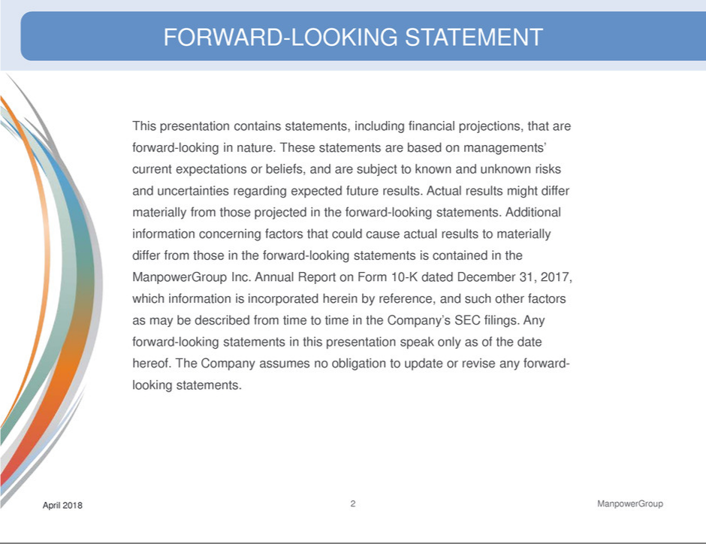

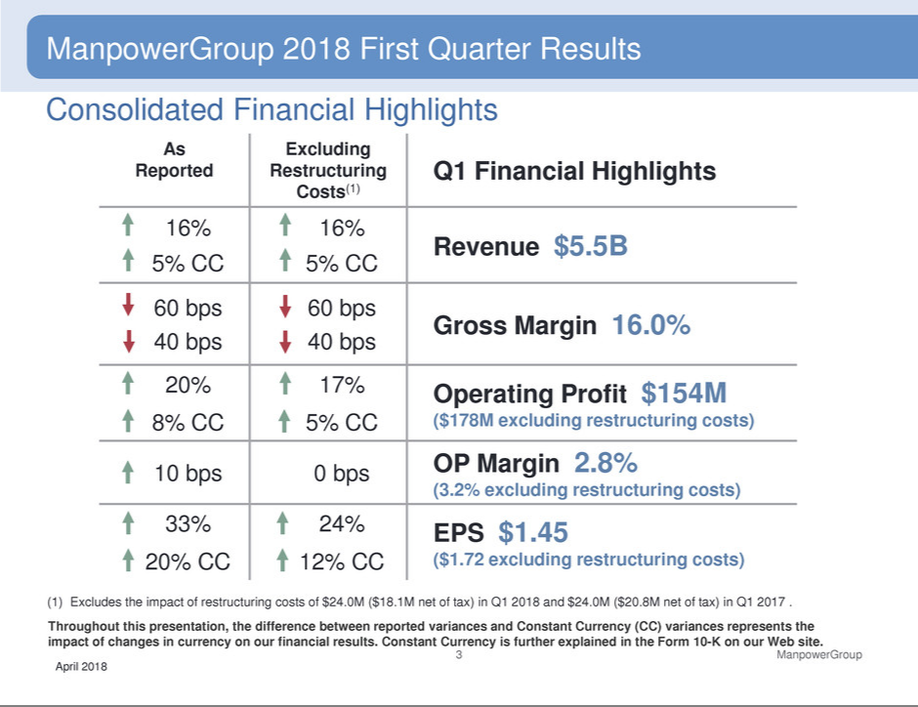

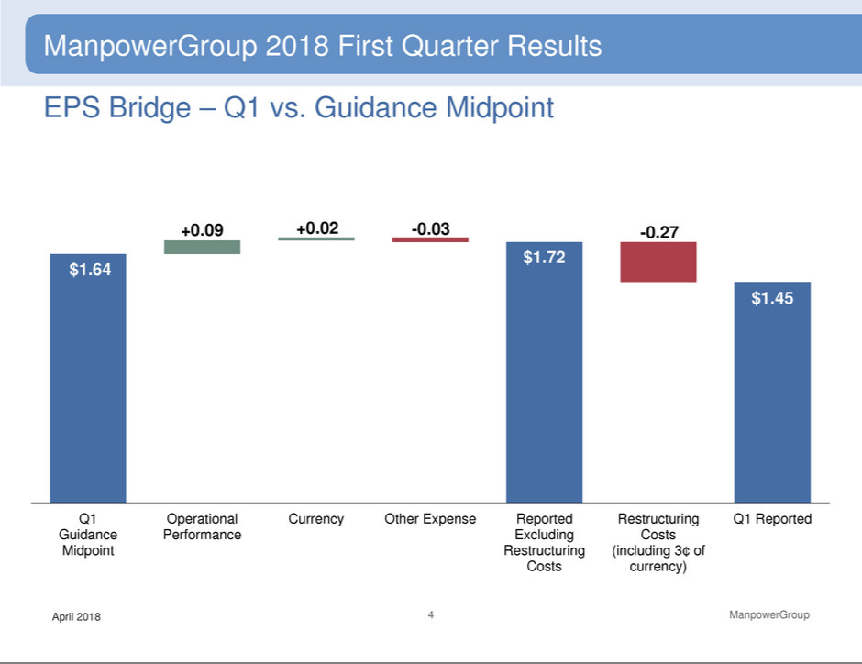

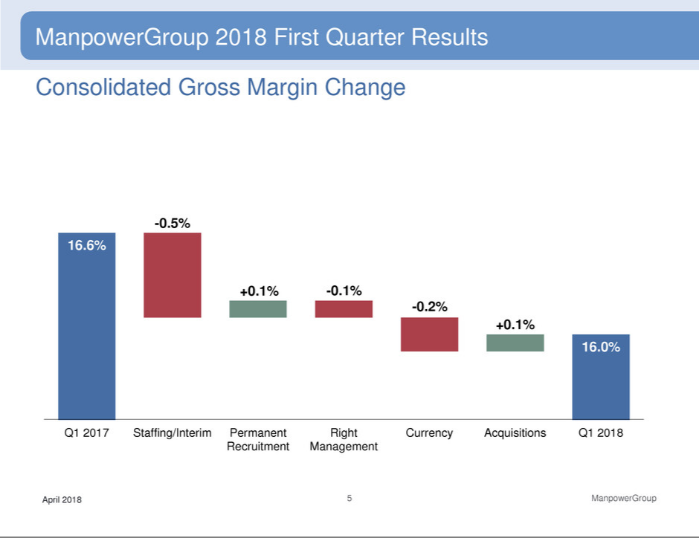

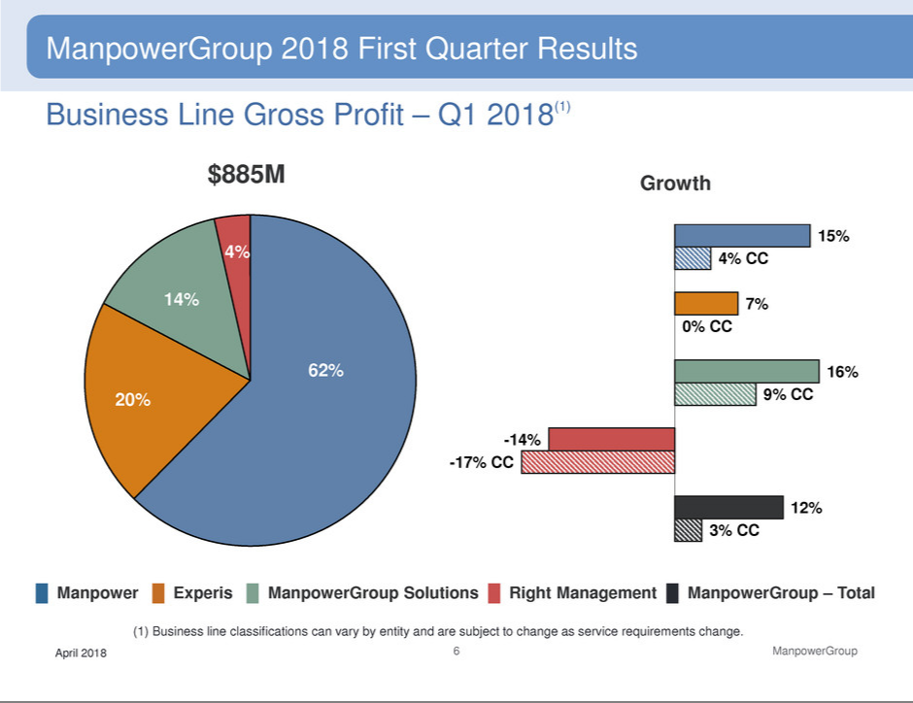

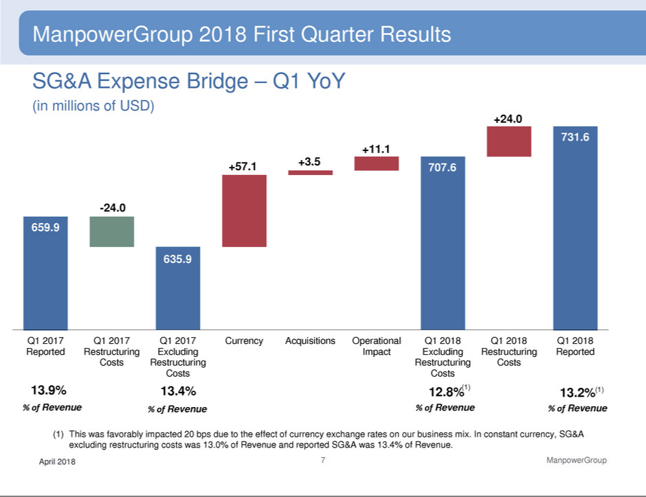

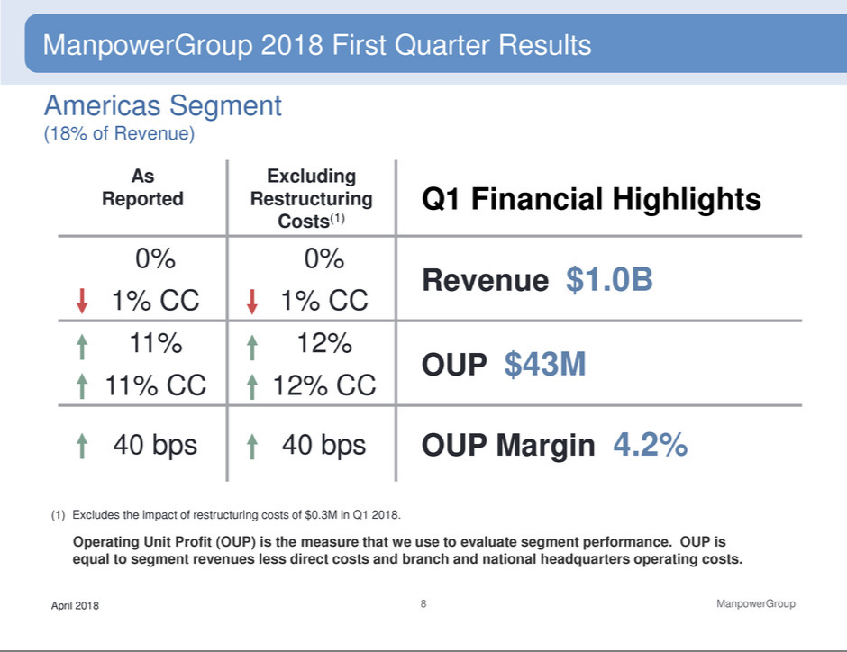

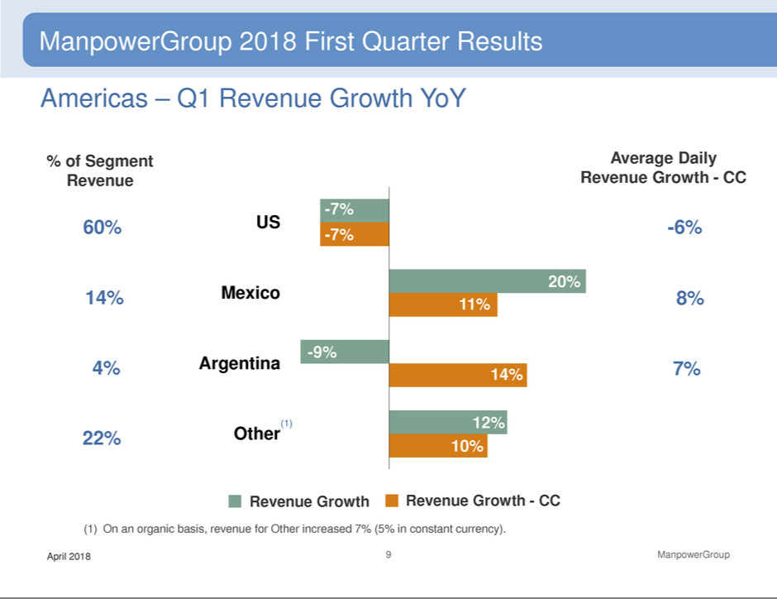

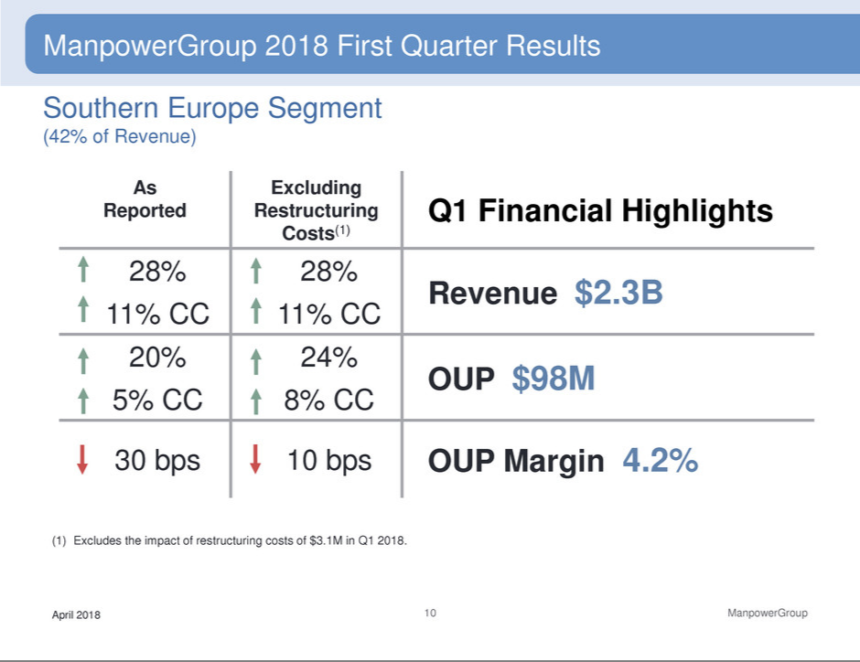

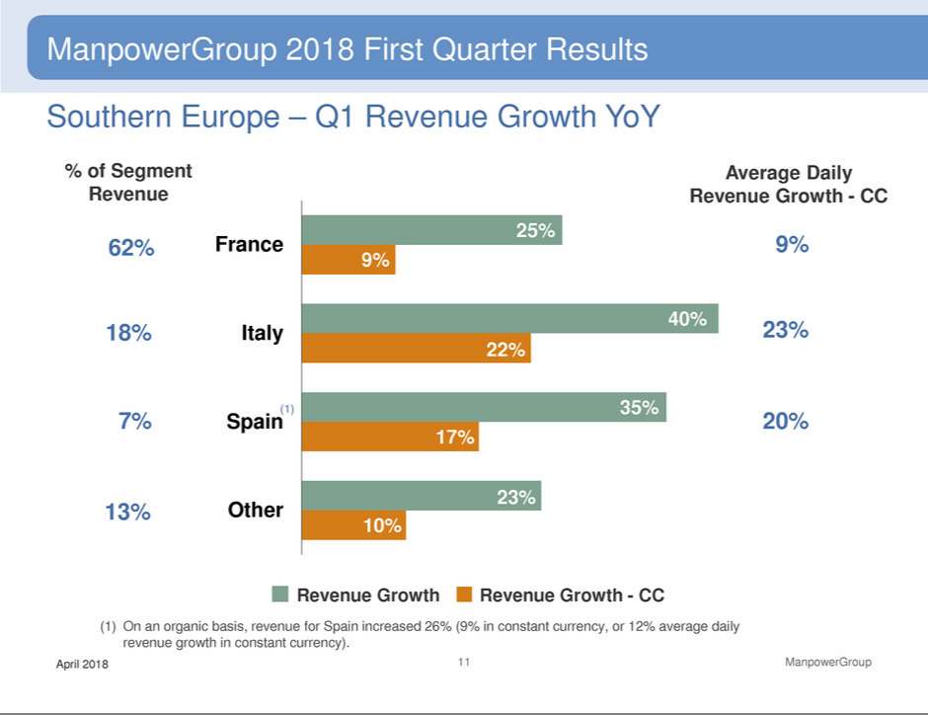

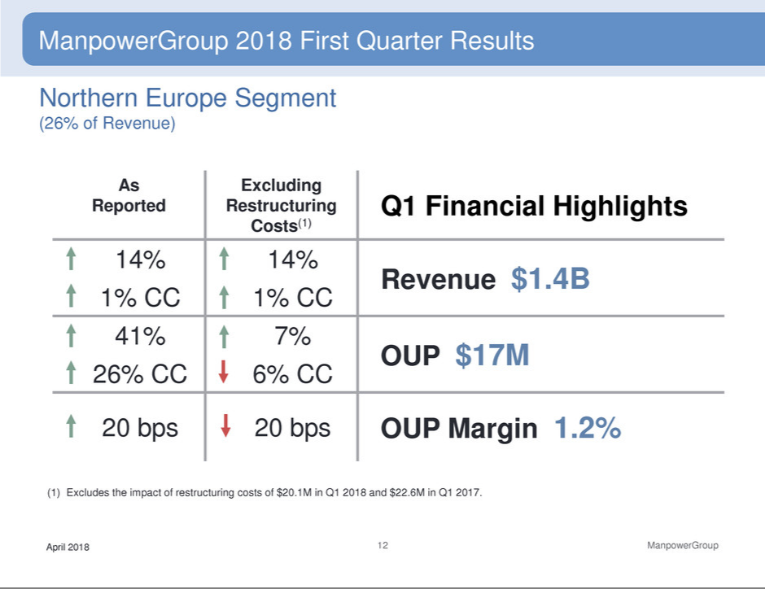

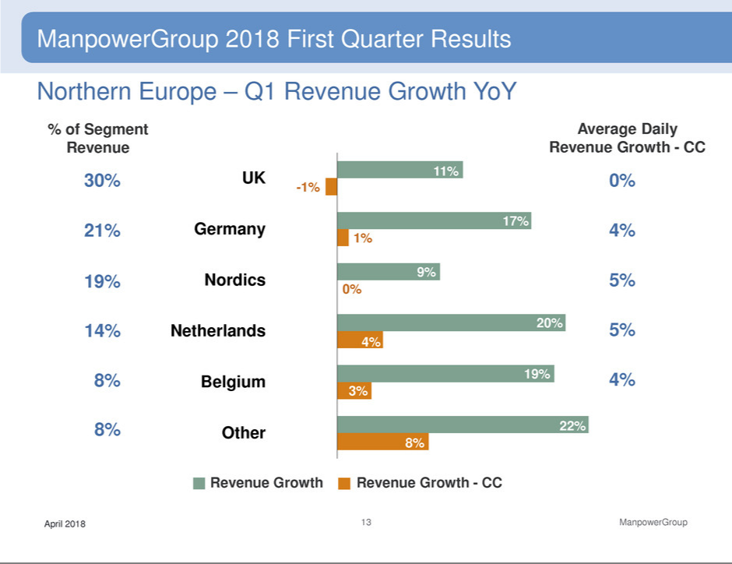

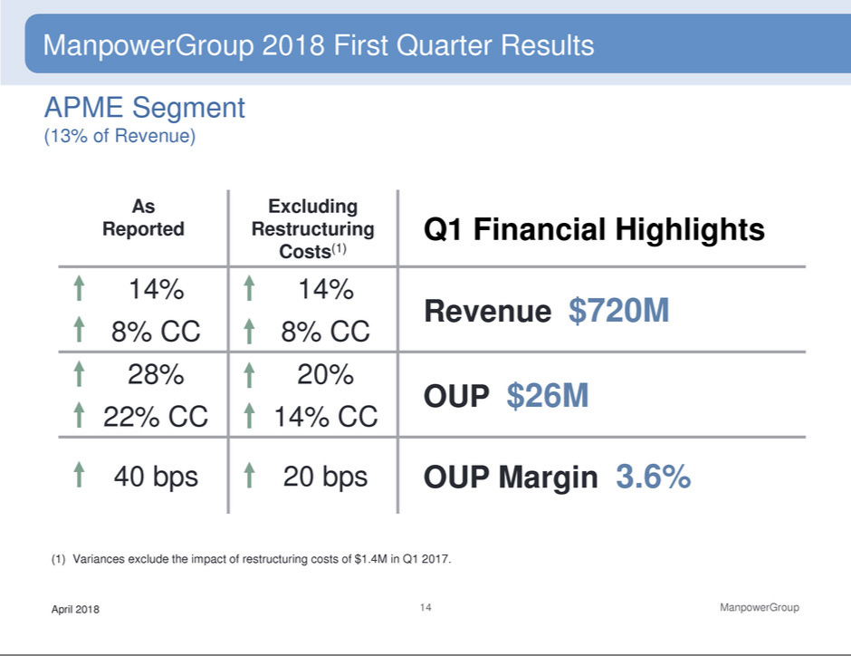

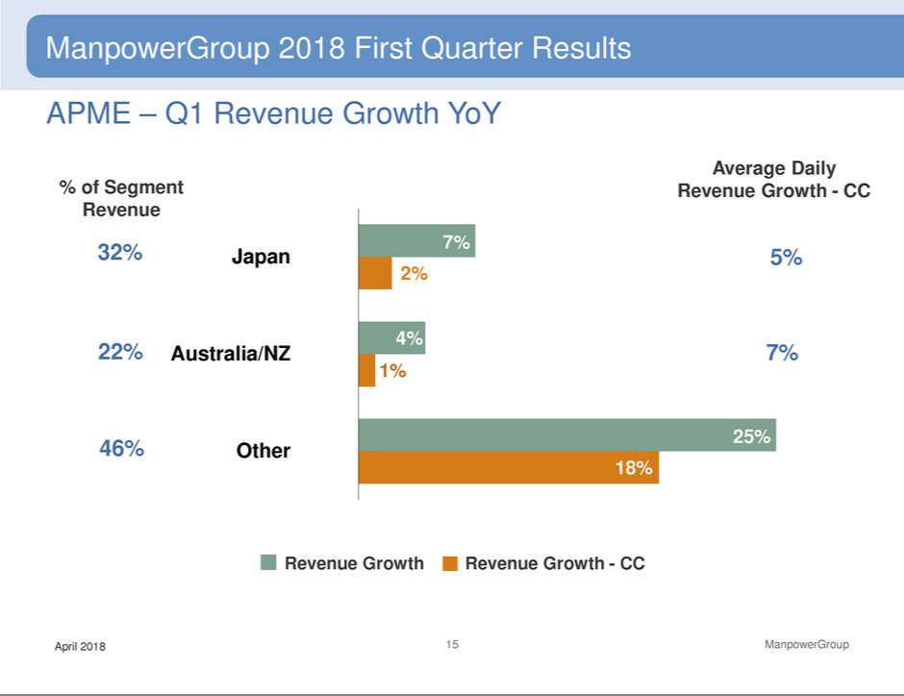

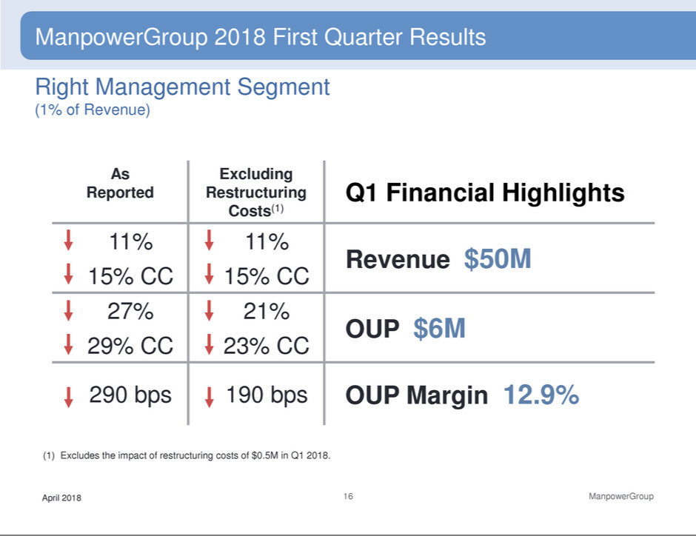

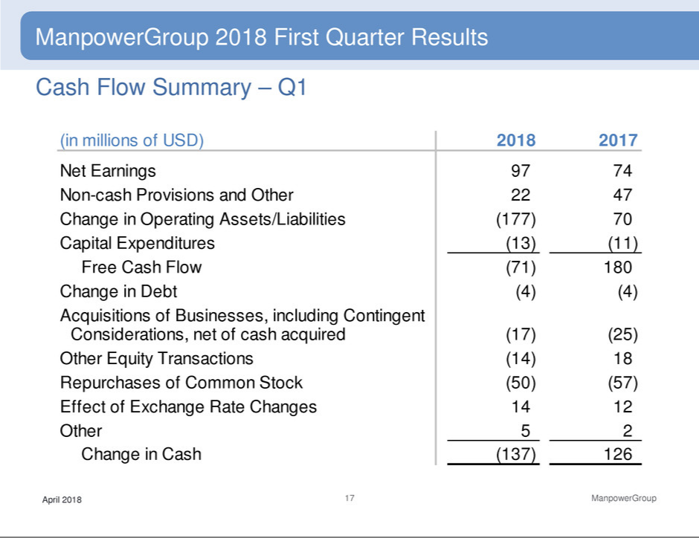

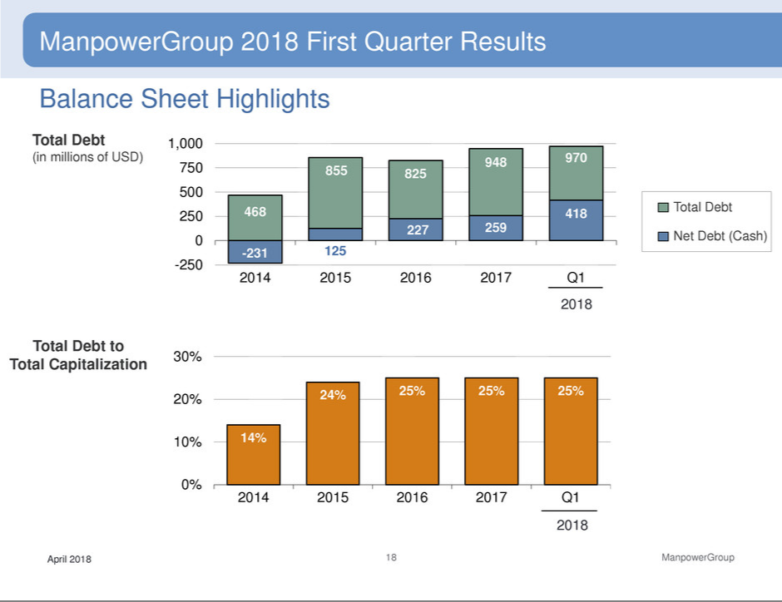

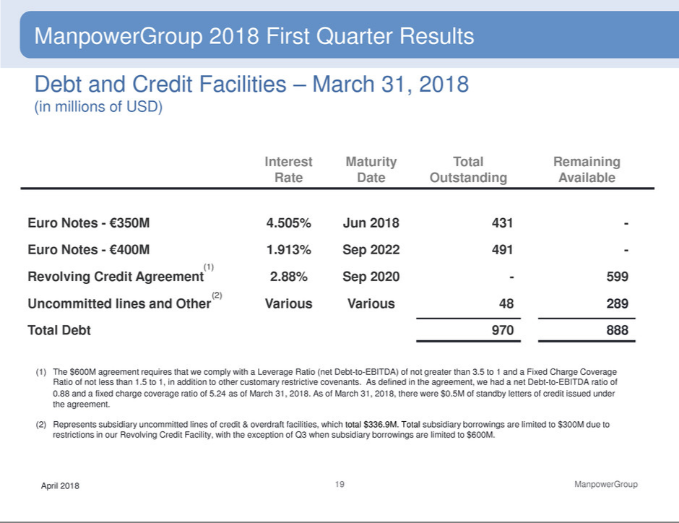

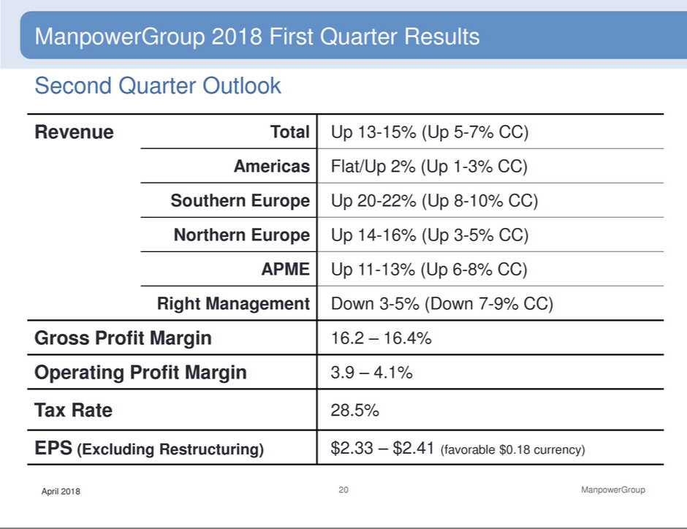

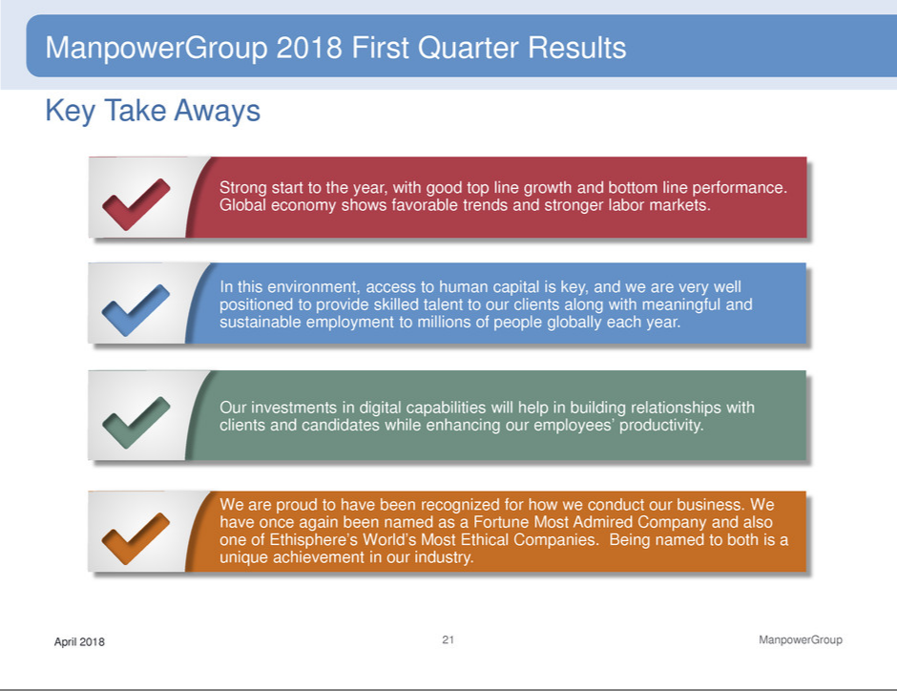

Exhibit 99.3

ManpowerGroup

Restated Operating Profit and Interest and Other Expenses

(In millions)

Effective January 1, 2018, we adopted new accounting guidance on the presentation of net periodic pension and postretirement benefit cost (“net benefit cost”). Under the new guidance, we are required to present non-service cost components of net benefit cost in interest and other expenses, as opposed to selling and administrative expenses. All previously reported results have been restated to conform to the current year presentation.

 |  |  | Three Months Ended March 31 |  |  |  |  |  |  |  | Three Months Ended June 30
 |  |  |  |  | % Variance |  |  |  |  |  |  | % Variance
 |  |  |  |  | Amount | Constant |  |  |  |  |  | Amount | Constant
 |  | 2017 |  | 2016 | Reported | Currency |  |  | 2017 |  | 2016 | Reported | Currency
 |  |  |  | (Unaudited) |  |  |  |  |  |  | (Unaudited)
Operating Unit Profit:
Americas:
United States | $ | 26.3 | $ | 22.6 | 16.3 % | 16.3 % |  | $ | 44.5 | $ | 39.9 | 11.6 % | 11.6 %
Other Americas |  | 12.4 |  | 11.6 | 6.3 % | 10.7 % |  |  | 13.0 |  | 13.8 | -6.0 % | -4.6 %
 |  | 38.7 |  | 34.2 | 12.9 % | 14.4 % |  |  | 57.5 |  | 53.7 | 7.1 % | 7.4 %
Southern Europe:
France |  | 50.6 |  | 47.7 | 6.2 % | 10.2 % |  |  | 70.7 |  | 68.0 | 3.9 % | 6.2 %
Italy |  | 18.2 |  | 16.1 | 13.0 % | 17.3 % |  |  | 27.6 |  | 22.8 | 21.0 % | 24.0 %
Other Southern Europe |  | 12.7 |  | 8.4 | 50.6 % | 53.9 % |  |  | 12.5 |  | 12.0 | 5.2 % | 5.9 %
 |  | 81.5 |  | 72.2 | 12.9 % | 16.9 % |  |  | 110.8 |  | 102.8 | 7.9 % | 10.1 %
Northern Europe |  | 11.8 |  | 32.6 | -63.7 % | -62.7 % |  |  | 33.1 |  | 37.5 | -11.8 % | -7.8 %
APME |  | 20.1 |  | 19.3 | 4.4 % | 2.9 % |  |  | 23.3 |  | 22.2 | 4.7 % | 5.5 %
Right Management |  | 8.8 |  | 9.5 | -7.4 % | -6.2 % |  |  | 8.5 |  | 14.5 | -41.4 % | -40.9 %
 |  | 160.9 |  | 167.8 |  |  |  |  | 233.2 |  | 230.7
Corporate expenses |  | (24.6) |  | (26.7) |  |  |  |  | (29.6) |  | (25.6)
Intangible asset amortization expense |  | (8.4) |  | (9.0) |  |  |  |  | (8.4) |  | (9.0)
Operating profit |  | 127.9 |  | 132.1 | -3.2 % | -0.7 % |  |  | 195.2 |  | 196.1 | -0.4 % | 1.7 %
Interest and other expenses (a) |  | (15.8) |  | (13.1) |  |  |  |  | (11.0) |  | (10.4)
Earnings before income taxes | $ | 112.1 | $ | 119.0 |  |  |  | $ | 184.2 | $ | 185.7

(a) The components of interest and other expenses were:

 |  | 2017 |  | 2016 |  |  | 2017 |  | 2016
Interest expense | $ | 11.9 | $ | 11.0 |  | $ | 11.9 | $ | 11.5
Interest income |  | (1.0) |  | (0.7) |  |  | (1.2) |  | (0.8)
Foreign exchange losses |  | 0.1 |  | 0.9 |  |  | 0.2 |  | 0.7
Miscellaneous expense (income), net |  | 4.8 |  | 1.9 |  |  | 0.1 |  | (1.0)
 | $ | 15.8 | $ | 13.1 |  | $ | 11.0 | $ | 10.4

 |  |  |  | Six Months Ended June 30
 |  |  |  |  | % Variance
 |  |  |  |  | Amount | Constant
 |  | 2017 |  | 2016 | Reported | Currency
 |  |  |  | (Unaudited)
Operating Unit Profit:
Americas:
United States | $ | 70.8 | $ | 62.5 | 13.3 % | 13.3 %
Other Americas |  | 25.4 |  | 25.4 | -0.4 % | 2.4 %
 |  | 96.2 |  | 87.9 | 9.3 % | 10.1 %
Southern Europe:
France |  | 121.3 |  | 115.7 | 4.9 % | 7.8 %
Italy |  | 45.8 |  | 38.9 | 17.7 % | 21.2 %
Other Southern Europe |  | 25.2 |  | 20.4 | 23.9 % | 25.7 %
 |  | 192.3 |  | 175.0 | 10.0 % | 12.9 %
Northern Europe |  | 44.9 |  | 70.1 | -35.9 % | -33.3 %
APME |  | 43.4 |  | 41.5 | 4.6 % | 4.3 %
Right Management |  | 17.3 |  | 24.0 | -27.9 % | -27.1 %
 |  | 394.1 |  | 398.5
Corporate expenses |  | (54.2) |  | (52.3)
Intangible asset amortization expense |  | (16.8) |  | (18.0)
Operating profit |  | 323.1 |  | 328.2 | -1.5 % | 0.7 %
Interest and other expenses (a) |  | (26.8) |  | (23.5)
Earnings before income taxes | $ | 296.3 | $ | 304.7
(a) The components of interest and other expenses were:
 |  | 2017 |  | 2016
Interest expense | $ | 23.8 | $ | 22.5
Interest income |  | (2.2) |  | (1.5)
Foreign exchange losses |  | 0.3 |  | 1.6
Miscellaneous expenses, net |  | 4.9 |  | 0.9
 | $ | 26.8 | $ | 23.5

 |  | Three Months Ended September 30 |  |  |  |  |  |  |  | Three Months Ended December 31
 |  |  |  |  | % Variance |  |  |  |  |  |  | % Variance
 |  |  |  |  | Amount | Constant |  |  |  |  |  | Amount | Constant
 |  | 2017 |  | 2016 | Reported | Currency |  |  | 2017 |  | 2016 | Reported | Currency
 |  |  |  |  | (Unaudited) |  |  |  |  |  |  | (Unaudited)
Operating Unit Profit:
Americas:
United States | $ | 43.5 | $ | 40.8 | 6.5 % | 6.5 % |  | $ | 37.8 | $ | 39.0 | -3.1 % | -3.1 %
Other Americas |  | 16.0 |  | 14.0 | 14.9 % | 13.2 % |  |  | 19.8 |  | 14.2 | 39.3 % | 38.3 %
 |  | 59.5 |  | 54.8 | 8.7 % | 8.2 % |  |  | 57.6 |  | 53.2 | 8.2 % | 8.0 %
Southern Europe:
France |  | 77.6 |  | 69.4 | 11.8 % | 6.3 % |  |  | 81.1 |  | 67.4 | 20.2 % | 10.3 %
Italy |  | 24.2 |  | 18.4 | 31.5 % | 25.0 % |  |  | 34.5 |  | 21.8 | 58.3 % | 44.8 %
Other Southern Europe |  | 16.2 |  | 13.7 | 18.0 % | 13.3 % |  |  | 18.0 |  | 13.1 | 37.5 % | 28.5 %
 |  | 118.0 |  | 101.5 | 16.2 % | 10.6 % |  |  | 133.6 |  | 102.3 | 30.5 % | 19.9 %
Northern Europe |  | 49.8 |  | 47.4 | 5.1 % | 0.8 % |  |  | 45.4 |  | 48.9 | -7.1 % | -13.2 %
APME |  | 27.4 |  | 25.3 | 7.8 % | 9.1 % |  |  | 28.1 |  | 21.7 | 30.6 % | 29.6 %
Right Management |  | 8.1 |  | 8.8 | -7.8 % | -8.3 % |  |  | 10.6 |  | 11.9 | -11.0 % | -13.3 %
 |  | 262.8 |  | 237.8 |  |  |  |  | 275.3 |  | 238.0
Corporate expenses |  | (25.3) |  | (23.9) |  |  |  |  | (28.9) |  | (16.6)
Intangible asset amortization expense |  | (8.8) |  | (9.0) |  |  |  |  | (9.0) |  | (9.0)
Operating profit |  | 228.7 |  | 204.9 | 11.5 % | 7.9 % |  |  | 237.4 |  | 212.4 | 11.8 % | 5.2 %
Interest and other expenses (a) |  | (11.7) |  | (5.2) |  |  |  |  | (13.4) |  | (15.5)
Earnings before income taxes | $ | 217.0 | $ | 199.7 |  |  |  | $ | 224.0 | $ | 196.9

(a) The components of interest and other expenses were:

 |  | 2017 |  | 2016 |  |  | 2017 |  | 2016
Interest expense | $ | 12.6 | $ | 13.3 |  | $ | 13.0 | $ | 13.7
Interest income |  | (1.2) |  | (1.0) |  |  | (1.4) |  | (1.1)
Foreign exchange losses |  | 0.1 |  | — |  |  | 0.4 |  | 1.2
Miscellaneous expense (income), net |  | 0.2 |  | (7.1) |  |  | 1.4 |  | 1.7
 | $ | 11.7 | $ | 5.2 |  | $ | 13.4 | $ | 15.5

 |  |  | Nine Months Ended September 30 |  |  |  |  |  |  |  | Year Ended December 31
 |  |  |  |  | % Variance |  |  |  |  |  |  | % Variance
 |  |  |  |  | Amount | Constant |  |  |  |  |  | Amount | Constant
 |  | 2017 |  | 2016 | Reported | Currency |  |  | 2017 |  | 2016 | Reported | Currency
 |  |  |  | (Unaudited) |  |  |  |  |  |  | (Unaudited)
Operating Unit Profit:
Americas:
United States | $ | 114.3 | $ | 103.3 | 10.6 % | 10.6 % |  | $ | 152.1 | $ | 142.3 | 6.9 % | 6.9 %
Other Americas |  | 41.4 |  | 39.4 | 5.1 % | 6.2 % |  |  | 61.2 |  | 53.6 | 14.1 % | 14.7 %
 |  | 155.7 |  | 142.7 | 9.1 % | 9.4 % |  |  | 213.3 |  | 195.9 | 8.9 % | 9.0 %
Southern Europe:
France |  | 198.9 |  | 185.1 | 7.5 % | 7.2 % |  |  | 280.0 |  | 252.5 | 10.9 % | 8.0 %
Italy |  | 70.0 |  | 57.3 | 22.1 % | 22.4 % |  |  | 104.5 |  | 79.1 | 32.1 % | 28.6 %
Other Southern Europe |  | 41.4 |  | 34.1 | 21.6 % | 20.7 % |  |  | 59.4 |  | 47.2 | 26.0 % | 22.9 %
 |  | 310.3 |  | 276.5 | 12.3 % | 12.0 % |  |  | 443.9 |  | 378.8 | 17.2 % | 14.2 %
Northern Europe |  | 94.7 |  | 117.5 | -19.4 % | -19.6 % |  |  | 140.1 |  | 166.4 | -15.8 % | -17.7 %
APME |  | 70.8 |  | 66.8 | 5.8 % | 6.1 % |  |  | 98.9 |  | 88.5 | 11.8 % | 11.9 %
Right Management |  | 25.4 |  | 32.8 | -22.5 % | -22.1 % |  |  | 36.0 |  | 44.7 | -19.4 % | -19.7 %
 |  | 656.9 |  | 636.3 |  |  |  |  | 932.2 |  | 874.3
Corporate expenses |  | (79.5) |  | (76.2) |  |  |  |  | (108.4) |  | (92.8)
Intangible asset amortization expense |  | (25.6) |  | (27.0) |  |  |  |  | (34.6) |  | (36.0)
Operating profit |  | 551.8 |  | 533.1 | 3.5 % | 3.5 % |  |  | 789.2 |  | 745.5 | 5.9 % | 4.0 %
Interest and other expenses (a) |  | (38.5) |  | (28.7) |  |  |  |  | (51.9) |  | (44.2)
Earnings before income taxes | $ | 513.3 | $ | 504.4 |  |  |  | $ | 737.3 | $ | 701.3
(a) The components of interest and other expenses were:
 |  | 2017 |  | 2016 |  |  |  |  | 2017 |  | 2016
Interest expense | $ | 36.4 | $ | 35.8 |  |  |  | $ | 49.4 | $ | 49.5
Interest income |  | (3.4) |  | (2.5) |  |  |  |  | (4.8) |  | (3.6)
Foreign exchange losses |  | 0.4 |  | 1.6 |  |  |  |  | 0.8 |  | 2.8
Miscellaneous expense (income), net |  | 5.1 |  | (6.2) |  |  |  |  | 6.5 |  | (4.5)
 | $ | 38.5 | $ | 28.7 |  |  |  | $ | 51.9 | $ | 44.2

