UNITED STATES

SECURITIES AND EXCHANGE COMMISSION
Washington, D.C. 20549

FORM 8-K

CURRENT REPORT

Pursuant to Section 13 or 15(d) of the Securities Exchange Act of 1934

Date of Report (Date of earliest event reported): January 30, 2007

MANPOWER INC.

(Exact name of registrant as specified in its charter)

Wisconsin

1-10686

39-1672779

(State or other jurisdiction

of incorporation)

(Commission File Number)

(IRS Employer
Identification No.)

5301 North Ironwood Road

Milwaukee, Wisconsin

53217

(Address of principal executive offices)

(Zip Code)

Registrant’s telephone number, including area code: (414) 961-1000

Check the appropriate box below if the Form 8-K filing is intended to simultaneously satisfy the filing obligation of the registrant under any of the following provisions:

- Written communications pursuant to Rule 425 under the Securities Act (17 CFR 230.425)

- Soliciting material pursuant to Rule 14a-12 under the Securities Act (17 CFR 240.14a-12)

- Pre-commencement communications pursuant to Rule 14d-2(b) under the Exchange Act (17 CFR 240.14d-2(b))

- Pre-commencement communications pursuant to Rule 13e-4(c) under the Exchange Act (17 CFR 240.13e-4(c))

Item 2.02 Results of Operations and Financial Condition

On January 30, 2007, we issued a press release announcing our results of operations for the three months and year ended December 31, 2006. A copy of the press release is attached hereto as Exhibit 99.1 and is incorporated herein by reference.

Reflected in our earnings for the three months and year ended December 31, 2006 are three items that require us to revise previously reported financial results. First, we have income from discontinued operations, primarily related to the sales of our Nordic payroll processing and facilities management services businesses. Second, our French business tax and profit sharing expenses, previously reported as Selling and administrative expenses, are now reported as Cost of services as we believe this presentation is more appropriate given the nature of these costs. Third, certain Eastern European subsidiaries previously reported in our France segment, and our Russian operations previously reported in our Other Operations segment, are now reported in our EMEA segment due to a change in the management structure. Attached hereto as Exhibit 99.3 are our Results of Operations and Operating Unit Results since January 1, 2004, reflecting the restatement of our financial results to exclude the earnings of the discontinued operations and reflecting the reclassification of the business tax and profit sharing expenses and the segment results.

Item 9.01. Exhibits.

Exhibit No. |  |  | Description
 | 99.1 |  | Press Release dated January 30, 2007
99.2 |  |  | Presentation materials for January 30, 2007 conference call
99.3 |  |  | Results of Operations and Operating Unit Results reflecting the restatement for discontinued operations and reclassification of certain expenses and segment results.

SIGNATURES

Pursuant to the requirements of the Securities Exchange Act of 1934, the Registrant has duly caused this Report to be signed on its behalf by the undersigned hereunto duly authorized.

MANPOWER INC.

Dated: January 30, 2007 By: /s/ Michael J. Van Handel

Michael J. Van Handel

Executive Vice President,

Chief Financial Officer and Secretary

 |  |  | EXHIBIT INDEX
Exhibit No. |  |  | Description
 | 99.1 |  | Press Release dated January 30, 2007
99.2 |  |  | Presentation materials for January 30, 2007 conference call
99.3 |  |  | Results of Operations and Operating Unit Results reflecting the restatement for discontinued operations and reclassification of certain expenses and segment results.
Exhibit 99.1

[MANPOWER logo]

FOR IMMEDIATE RELEASE Contact:

Mike Van Handel

Manpower Inc.

+1.414.906.6305

michael.vanhandel@manpower.com

Manpower Reports 4th Quarter and Full-Year 2006 Results

MILWAUKEE, WI, USA, January 30, 2007 – Manpower Inc. (NYSE: MAN) today reported that net earnings per diluted share for the three months ended December 31, 2006 increased 88 percent to $1.90 from $1.01 in the prior year period. Net earnings in the quarter increased to $164.4 million from $89.1 million a year earlier. Revenues for the fourth quarter totaled $4.7 billion, an increase of 16 percent from the year-earlier period, or an increase of 9 percent in constant currency.

Included in the fourth quarter results is net income from discontinued operations, primarily related to the sale of our Nordic facility management services, of $64.8 million or 75 cents per diluted share. Net earnings per diluted share from continuing operations in the fourth quarter were $1.15, an increase of 15 percent. Included in net earnings from continuing operations are severance costs related to Right Management of $6.9 million ($5.4 million net of income taxes or 6 cents per diluted share). Additionally, results from continuing operations in the fourth quarter were favorably impacted by 6 cents as foreign currencies were relatively stronger compared to the prior year period.

Jeffrey A. Joerres, Manpower Chairman and Chief Executive Officer, said, “Manpower performed extremely well in the fourth quarter and for the full year. 2006 was a pivotal year for us as we executed very well to affect the present, and laid the groundwork for outstanding performance in the future. Our continued growth in Europe, emerging markets and our specialty service lines will fuel solid growth into 2007.

“We are anticipating diluted net earnings per share for the first quarter of 2007 to be in the range of 57 to 61 cents. This includes an estimated favorable currency impact of 4 cents per diluted share.”

Net earnings per diluted share for the year ended December 31, 2006 were $4.54, an increase of 58 percent from $2.87 per diluted share in 2005. Net earnings were $398.0 million compared to $260.1 million in the prior year. Revenues for the year were $17.6 billion, an increase of 11 percent from the prior year, or an increase of 10 percent in constant currency.

Included in the full year 2006 results is net income from discontinued operations, primarily related to the sale of our Swedish payrolling business in the first quarter and our sale of the Nordic facility management services in the fourth quarter, of $92.3 million

or $1.06 per diluted share. Net earnings per diluted share from continuing operations for 2006 were $3.48, an increase of 23 percent. Included in net earnings from continuing operations are charges related to reorganization and a global cost reduction initiative totaling $26.8 million ($18.8 million net of income taxes or 22 cents per diluted share). Additionally, results from continuing operations were favorably impacted by 6 cents due to changes in foreign currencies compared to the prior year.

In conjunction with its fourth quarter earnings release, Manpower will broadcast its conference call live over the Internet on January 30, 2007 at 7:30 a.m. CST (8:30 a.m. EST).

Interested parties are invited to listen to the webcast by logging on to http://investor.manpower.com.

Supplemental financial information referenced in the conference call can be found at http://investor.manpower.com.

About Manpower Inc.

Manpower Inc. (NYSE: MAN) is a world leader in the employment services industry; creating and delivering services that enable its clients to win in the changing world of work. The $18 billion company offers employers a range of services for the entire employment and business cycle including permanent, temporary and contract recruitment; employee assessment and selection; training; outplacement; outsourcing and consulting. Manpower’s worldwide network of 4,400 offices in 73 countries and territories enables the company to meet the needs of its 400,000 clients per year, including small and medium size enterprises in all industry sectors, as well as the world’s largest multinational corporations. The focus of Manpower’s work is on raising productivity through improved quality, efficiency and cost-reduction across their total workforce, enabling clients to concentrate on their core business activities. Manpower Inc. operates under five brands: Manpower, Manpower Professional, Elan, Jefferson Wells and Right Management. More information on Manpower Inc. is available at www.manpower.com.

Forward-Looking Statements

This news release contains statements, including earning projections, that are forward-looking in nature and, accordingly, are subject to risks and uncertainties regarding the Company’s expected future results. The Company’s actual results may differ materially from those described or contemplated in the forward-looking statements. Factors that may cause the Company’s actual results to differ materially from those contained in the forward-looking statements can be found in the Company’s reports filed with the SEC, including the information under the heading ‘Risk Factors’ in its Annual Report on Form 10-K for the year ended December 31, 2005, which information is incorporated herein by reference.

- ### -

Manpower Inc.

Results of Operations

(In millions, except per share data)

 |  |  |  |  | Three Months Ended December 31
 |  |  |  |  |  |  |  |  | % Variance
 |  |  |  |  |  |  |  |  | Amount |  | Constant
 |  |  | 2006 |  |  |  | 2005 | Reported |  |  | Currency
 |  |  |  |  |  |  |  | (Unaudited)
Revenues from services (a) |  | $ | 4,710.7 |  | $ |  | 4,068.3 | 15.8% |  |  | 9.1%
Cost of services (b) |  |  | 3,844.9 |  |  |  | 3,321.9 | 15.7%
Gross profit |  |  | 865.8 |  |  |  | 746.4 | 16.0% |  |  | 9.6%
Selling and administrative expenses (b) |  |  | 696.0 |  |  |  | 615.6 | 13.0% |  |  | 6.9%
Operating profit |  |  | 169.8 |  |  |  | 130.8 | 29.8% |  |  | 22.0%
Interest and other expenses |  |  | 14.1 |  |  |  | 7.0 |  | N/A
Earnings before income taxes and discontinued operations |  |  | 155.7 |  |  |  | 123.8 | 25.7% |  |  | 19.3%
Provision for income taxes |  |  | 56.1 |  |  |  | 35.4 | 58.6%
Net earnings from continuing operations |  |  | 99.6 |  |  |  | 88.4 | 12.6% |  |  | 6.8%
Income from discontinued operations, net of income taxes |  |  | 64.8 |  |  |  | 0.7 |  | N/A
Net earnings |  | $ | 164.4 |  | $ |  | 89.1 | 84.6% |  |  | 69.4%
Net earnings per share - basic:
Continuing operations |  | $ | 1.17 |  | $ |  | 1.01 | 15.8%
Discontinued operations |  |  | 0.77 |  |  |  | 0.01 |  | N/A
Total |  | $ | 1.94 |  | $ |  | 1.02 | 90.2%
Net earnings per share - diluted:
Continuing operations |  | $ | 1.15 |  | $ |  | 1.00 | 15.0% |  |  | 9.0%
Discontinued operations |  |  | 0.75 |  |  |  | 0.01 |  | N/A
Total |  | $ | 1.90 |  | $ |  | 1.01 | 88.1% |  |  | 73.3%
Weighted average shares - basic |  |  |  |  |  |  |  | -2.8%
 |  |  | 84.8 |  |  |  | 87.2
Weighted average shares - diluted |  |  | 86.5 |  |  |  | 88.5 | -2.3%

- Revenues from services include fees received from our franchise offices of $9.3 million and $9.1 million for the three months ended December 31, 2006 and 2005, respectively. These fees are primarily based on revenues generated by the franchise offices, which were $353.2 million and $388.6 million for the three months ended December 31, 2006 and 2005, respectively.

- Our French business tax and profit sharing expenses, totaling $35.0 million and $19.7 million for the three months ended December 31, 2006 and 2005 respectively, previously reported as Selling and administrative expenses, are now reported in Cost of services as we believe this presentation is more appropriate given the nature of these expenses. All previously reported results have been revised to conform to the current year presentation.

Manpower Inc.

Operating Unit Results

(In millions)

 |  |  |  |  | Three Months Ended December 31
 |  |  |  |  |  |  |  |  | % Variance
 |  |  |  |  |  |  |  |  | Amount |  | Constant
 |  |  | 2006 |  |  |  | 2005 | Reported |  |  | Currency
 |  |  |  |  |  |  |  | (Unaudited)
Revenues from Services: (a)
United States (b) |  | $ | 527.9 |  | $ |  | 534.2 | -1.2% |  |  | -1.2%
France |  |  | 1,589.0 |  |  |  | 1,361.5 | 16.7% |  |  | 7.7%
EMEA |  |  | 1,792.2 |  |  |  | 1,444.7 | 24.0% |  |  | 14.2%
Jefferson Wells |  |  | 84.8 |  |  |  | 96.1 | -11.9% |  |  | -11.9%
Right Management |  |  | 98.9 |  |  |  | 96.6 | 2.4% |  |  | -1.8%
Other Operations |  |  | 617.9 |  |  |  | 535.2 | 15.5% |  |  | 14.7%
 |  | $ | 4,710.7 |  | $ |  | 4,068.3 | 15.8% |  |  | 9.1%
Operating Unit Profit: (a)
United States |  | $ | 26.8 |  | $ |  | 23.2 | 15.2% |  |  | 15.2%
France |  |  | 61.2 |  |  |  | 47.7 | 28.3% |  |  | 18.4%
EMEA |  |  | 80.6 |  |  |  | 51.9 | 55.4% |  |  | 43.8%
Jefferson Wells |  |  | 6.2 |  |  |  | 4.4 | 41.4% |  |  | 41.4%
Right Management |  |  | 0.4 |  |  |  | 3.6 | -87.5% |  |  | -74.1%
Other Operations |  |  | 21.1 |  |  |  | 19.2 | 9.9% |  |  | 10.3%
 |  |  | 196.3 |  |  |  | 150.0
Corporate expenses |  |  | 23.2 |  |  |  | 15.9
Amortization of intangible assets |  |  | 3.3 |  |  |  | 3.3
Operating profit |  |  | 169.8 |  |  |  | 130.8 | 29.8% |  |  | 22.0%
Interest and other expenses (c) |  |  | 14.1 |  |  |  | 7.0
Earnings before income taxes and discontinued operations |  | $ | 155.7 |  | $ |  | 123.8

- Certain Eastern European countries previously reported in France, and our Russian operations previously reported in Other Operations, are now reported in EMEA due to a change in management structure. All previously reported results for France, EMEA, and Other Operations have been revised to conform to the current presentation. The impact of these revisions is not significant.

- In the United States, revenues from services include fees received from the related franchise offices of $6.5 million for the three months ended December 31, 2006 and 2005. These fees are primarily based on revenues generated by the franchise offices, which were $286.0 million and $311.8 million for the three months ended December 31, 2006 and 2005, respectively.

- The components of interest and other expenses were:

 | 2006 |  |  |  | 2005
Interest expense | $ 15.0 |  | $ |  | 12.0
Interest income | (6.8) |  |  |  | (3.4)
Foreign exchange losses | 0.7 |  |  |  | —
Miscellaneous expense (income), net | 5.2 |  |  |  | (1.6)
 | $ 14.1 |  |  | $ | 7.0

Manpower Inc.

Operating Unit Results

(In millions)

 |  |  |  |  |  | Year Ended December 31
 |  |  |  |  |  |  |  |  | % Variance
 |  |  |  |  |  |  |  |  | Amount |  | Constant
 |  |  |  | 2006 |  |  | 2005 |  | Reported |  | Currency
 |  |  |  |  |  |  | (Unaudited)
Revenues from services (a) |  | $ |  | 17,562.5 |  | $ | 15,845.4 |  | 10.8% |  | 10.0%
Cost of services (b) |  |  |  | 14,416.5 |  |  | 13,013.6 |  | 10.8%
Gross profit |  |  |  | 3,146.0 |  |  | 2,831.8 |  | 11.1% |  | 10.3%
Selling and administrative expenses (b) |  |  |  | 2,613.9 |  |  | 2,403.0 |  | 8.8% |  | 8.2%
Operating profit |  |  |  | 532.1 |  |  | 428.8 |  | 24.1% |  | 21.9%
Interest and other expenses |  |  |  | 50.2 |  |  | 41.8 |  | 20.2%
Earnings before income taxes and discontinued operations |  |  |  | 481.9 |  |  | 387.0 |  | 24.5% |  | 22.1%
Provision for income taxes |  |  |  | 176.2 |  |  | 131.9 |  | 33.6%
Net earnings from continuing operations |  |  |  | 305.7 |  |  | 255.1 |  | 19.8% |  | 17.5%
Income from discontinued operations, net of income taxes |  |  |  | 92.3 |  |  | 5.0 |  | N/A
Net earnings |  |  | $ | 398.0 |  |  | 260.1 |  | 53.0% |  | 48.2%
Net earnings per share - basic:
Continuing operations |  | $ |  | 3.55 |  | $ | 2.89 |  | 22.8%
Discontinued operations |  |  |  | 1.07 |  |  | 0.06 |  | N/A
Total |  |  | $ | 4.62 |  | $ | 2.95 |  | 56.6%
Net earnings per share - diluted:
Continuing operations |  | $ |  | 3.48 |  | $ | 2.81 |  | 23.8% |  | 21.7%
Discontinued operations |  |  |  | 1.06 |  |  | 0.06 |  | N/A
Total |  |  | $ | 4.54 |  | $ | 2.87 |  | 58.2% |  | 53.0%
Weighted average shares - basic |  |  |  |  |  |  |  |  | -2.2%
 |  |  |  | 86.2 |  |  | 88.1
Weighted average shares - diluted |  |  |  | 87.7 |  |  | 91.1 |  | -3.7%

- Revenues from services include fees received from our franchise offices of $35.7 million and $35.8 million for the year ended December 31, 2006 and 2005, respectively. These fees are primarily based on revenues generated by the franchise offices, which were $1,497.0 million and $1,510.7 million for the year ended December 31, 2006 and 2005, respectively.

- Our French business tax and profit sharing expenses, totaling $117.4 million and $94.9 million for the year ended December 31, 2006 and 2005 respectively, previously reported as Selling and administrative expenses, are now reported in Cost of services, as we believe this presentation is more appropriate given the nature of these expenses. All previously reported results have been revised to conform to the current year presentation.

Manpower Inc.

Operating Unit Results

(In millions)

 |  |  |  |  |  | Year Ended December 31
 |  |  |  |  |  |  |  |  | % Variance
 |  |  |  |  |  |  |  |  | Amount |  | Constant
 |  |  |  | 2006 |  |  | 2005 |  | Reported |  | Currency
 |  |  |  |  |  |  | (Unaudited)
Revenues from Services: (a)
United States (b) |  | $ |  | 2,114.9 |  | $ | 2,048.3 |  | 3.2% |  | 3.2%
France |  |  |  | 6,019.1 |  |  | 5,475.8 |  | 9.9% |  | 8.4%
EMEA |  |  |  | 6,363.3 |  |  | 5,471.2 |  | 16.3% |  | 14.7%
Jefferson Wells |  |  |  | 373.0 |  |  | 386.2 |  | -3.4% |  | -3.4%
Right Management |  |  |  | 387.3 |  |  | 401.8 |  | -3.6% |  | -4.2%
Other Operations |  |  |  | 2,304.9 |  |  | 2,062.1 |  | 11.8% |  | 13.8%
 |  |  |  |  |  |  |  |  | 10.8% |  | 10.0%
 |  |  | $ | 17,562.5 |  | $ | 15,845.4
Operating Unit Profit: (a)
United States |  | $ |  | 87.4 |  | $ | 68.7 |  | 27.2% |  | 27.2%
France |  |  |  | 203.3 |  |  | 168.7 |  | 20.5% |  | 17.6%
EMEA |  |  |  | 220.2 |  |  | 144.1 |  | 52.9% |  | 48.1%
Jefferson Wells |  |  |  | 31.9 |  |  | 33.3 |  | -4.2% |  | -4.2%
Right Management |  |  |  | 18.3 |  |  | 25.7 |  | -28.8% |  | -28.2%
Other Operations |  |  |  | 69.9 |  |  | 60.4 |  | 16.0% |  | 19.6%
 |  |  |  | 631.0 |  |  | 500.9
Corporate expenses |  |  |  | 85.8 |  |  | 59.0
Amortization of intangible assets |  |  |  | 13.1 |  |  | 13.1
Operating profit |  |  |  | 532.1 |  |  | 428.8 |  | 24.1% |  | 21.9%
Interest and other expenses (c) |  |  |  | 50.2 |  |  | 41.8
Earnings before income taxes and discontinued operations |  | $ |  | 481.9 |  | $ | 387.0

- Certain Eastern European countries previously reported in France, and our Russian operations previously reported in Other Operations, are now reported in EMEA due to a change in management structure. All previously reported results for France, EMEA, and Other Operations have been revised to conform to the current presentation. The impact of these revisions is not significant.

- In the United States, revenues from services include fees received from the related franchise offices of $24.4 million and $24.9 million for the year ended December 31, 2006 and 2005, respectively. These fees are primarily based on revenues generated by the franchise offices, which were $1,146.1 million and $1,196.9 million for the year ended December 31, 2006 and 2005, respectively.

- The components of interest and other expenses were:

 |  |  | 2006 |  |  | 2005
Interest expense | $ |  | 54.1 |  | $ 46.7
Interest income |  |  | (18.3) |  | (9.8)
Foreign exchange losses |  |  | 3.2 |  |  | —
Miscellaneous expense, net |  |  | 11.2 |  |  | 4.9
 | $ |  | 50.2 |  | $ 41.8

Manpower Inc.

Consolidated Balance Sheets

(In millions)

 |  | Dec. 31 |  |  | Dec. 31
 |  | 2006 |  |  | 2005
 |  | (Unaudited)
ASSETS
Current assets:
Cash and cash equivalents | $ | 687.9 |  | $ | 454.9
Accounts receivable, net |  | 3,837.2 |  |  | 3,208.2
Prepaid expenses and other assets |  | 90.5 |  |  | 107.5
Future income tax benefits |  | 66.4 |  |  | 71.1
Total current assets |  | 4,682.0 |  |  | 3,841.7
Other assets:
Goodwill and other intangible assets, net |  | 1,293.6 |  |  | 1,256.5
Other assets |  | 336.4 |  |  | 273.8
Total other assets |  | 1,630.0 |  |  | 1,530.3
Property and equipment:
Land, buildings, leasehold improvements and equipment |  | 693.2 |  |  | 642.4
Less: accumulated depreciation and amortization |  | 491.1 |  |  | 446.0
Net property and equipment |  | 202.1 |  |  | 196.4
 | $ | 6,514.1 |  | $ | 5,568.4
LIABILITIES AND SHAREHOLDERS’ EQUITY
Current liabilities:
Accounts payable | $ | 889.9 |  | $ | 685.4
Employee compensation payable |  | 180.7 |  |  | 150.6
Accrued liabilities |  | 562.1 |  |  | 435.4
Accrued payroll taxes and insurance |  | 699.9 |  |  | 607.2
Value added taxes payable |  | 517.0 |  |  | 441.9
Short-term borrowings and current maturities of long-term debt |  | 32.0 |  |  | 260.0
Total current liabilities |  | 2,881.6 |  |  | 2,580.5
Other liabilities:
Long-term debt |  | 791.2 |  |  | 475.0
Other long-term liabilities |  | 367.1 |  |  | 366.3
Total other liabilities |  | 1,158.3 |  |  | 841.3
Shareholders’ equity:
Common stock |  | 1.0 |  |  | 1.0
Capital in excess of par value |  | 2,420.7 |  |  | 2,346.7
Retained earnings |  | 617.0 |  |  | 269.9
Accumulated other comprehensive income (loss) |  | 120.6 |  |  | (11.0)
Treasury stock, at cost |  | (685.1) |  |  | (460.0)
Total shareholders’ equity |  | 2,474.2 |  |  | 2,146.6
Total liabilities and shareholders’ equity | $ | 6,514.1 |  | $ | 5,568.4

Manpower Inc.

Consolidated Statements of Cash Flows

(In millions)

Year Ended

Dec. 31

 |  | 2006 |  | 2005
 |  |  | (Unaudited)
 | Cash Flows from Operating Activities:
 | Net earnings | $ 398.0 |  | $ 260.1
 | Adjustments to reconcile net earnings to net cash provided by operating activities:
 | Gain on sale of businesses | (121.8) |  | (2.6)
 | Depreciation and amortization | 88.8 |  | 92.9
 | Amortization of discount on convertible debentures | — |  | 1.9
 | Deferred income taxes | (37.3) |  | 49.1
 | Provision for doubtful accounts | 27.4 |  | 22.9
 | Stock based compensation | 22.5 |  | 1.7
 | Excess tax benefit on exercise of stock options | (8.2) |  | —
 | Changes in operating assets and liabilities excluding the impact of acquisitions:
 | Accounts receivable | (381.0) |  | (350.4)
 | Other assets | 35.1 |  | (46.1)
 | Other liabilities | 335.6 |  | 239.3
 | Cash provided by operating activities | 359.1 |  | 268.8
Cash Flows from Investing Activities:
 | Capital expenditures | (80.0) |  | (77.6)
 | Acquisitions of businesses, net of cash acquired | (13.0) |  | (12.9)
 | Proceeds from sale of businesses | 123.9 |  | —
 | Proceeds from sale of an equity interest | 8.8 |  | —
 | Proceeds from the sale of property and equipment | 5.3 |  | 4.8
 | Cash provided (used) by investing activities | 45.0 |  | (85.7)
 | Cash Flows from Financing Activities:
 | Net borrowings of short-term facilities and long-term debt | 2.1 |  | 174.8
 | Cash paid to settle convertible debentures | — |  | (206.6)
 | Proceeds from settlement of swap agreements | — |  | 50.7
 | Proceeds from stock option and purchase plans | 54.0 |  | 28.0
 | Excess tax benefit on exercise of stock options | 8.2 |  | —
 | Repurchases of common stock | (235.9) |  | (217.6)
 | Dividends paid | (50.8) |  | (41.2)
 | Cash used by financing activities | (222.4) |  | (211.9)
Effect of exchange rate changes on cash
 |  | 51.3 |  | (48.1)
 | Change in cash and cash equivalents | 233.0 |  | (76.9)
Cash and cash equivalents, beginning of period |  | 454.9 |  | 531.8
 | Cash and cash equivalents, end of period | $ 687.9 |  | $ 454.9

Manpower Inc.

2006 4th Quarter Results
January 30, 2007

Now

Exhibit 99.2


Next

Manpower Inc. 2006 4th Quarter Results | 2
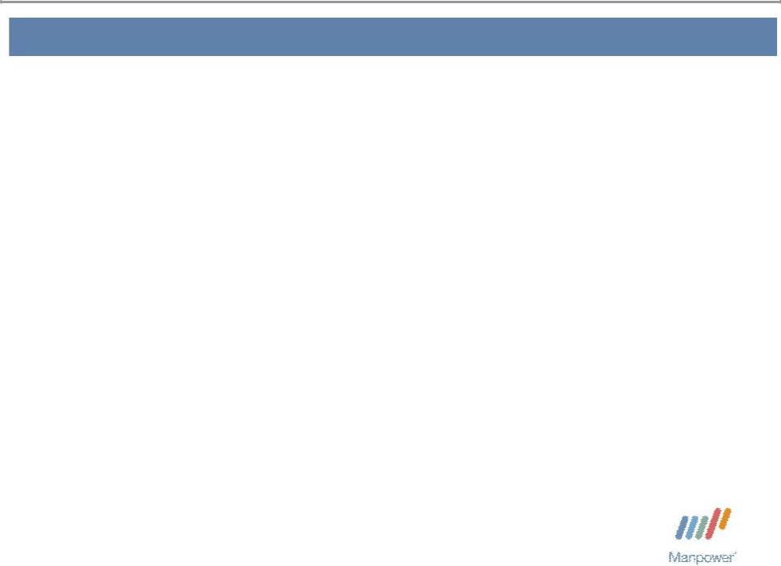

Forward Looking Statement

This presentation includes forward-looking statements which are subject to risks and uncertainties. Actual results might differ materially from those projected in the forward-looking statements. Forward-looking statements can be identified by words such as “expect,” “plan,” “may,” “will,” and similar expressions. Additional information concerning factors that could cause actual results to materially differ from those in the forward-looking statements is contained in the Company’s Annual Report on Form 10-K dated December 31, 2005, which information is incorporated herein by reference, and such other factors as may be described from time to time in the Company’s SEC filings.

Manpower Inc. 2006 4th Quarter Results | 3
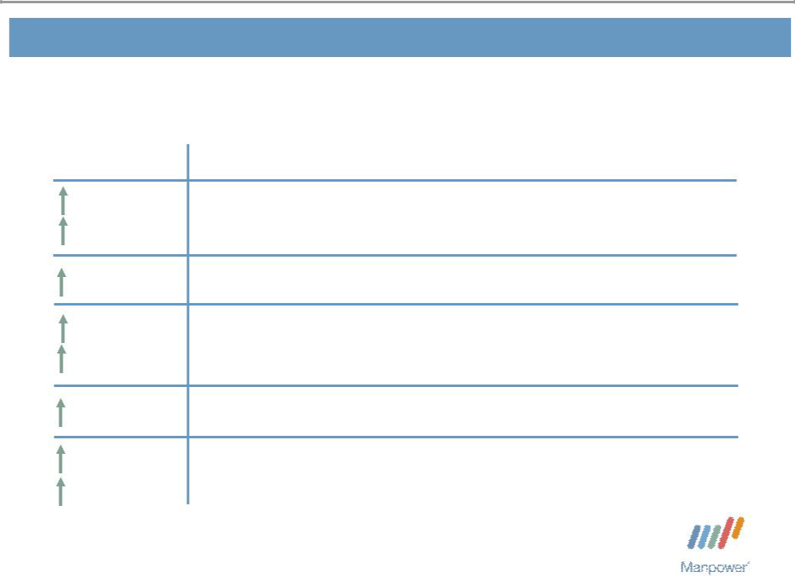

Consolidated Financial Highlights

 | Q4 Highlights
16% | Revenue $4.7B
9% CC | Revenue $4.7B
3 bps Gross Margin 18.4%
30% | Operating Profit $170M
22% CC | Operating Profit $170M
40 bps | OP Margin 3.6%
15% | EPS from Continuing Operations $1.15
9% CC

Throughout this presentation, the difference between reported variances and Constant Currency

- variances represents the impact of currency on our financial results. Constant Currency is further explained on our Web site.

Manpower Inc. 2006 4th Quarter Results | 4
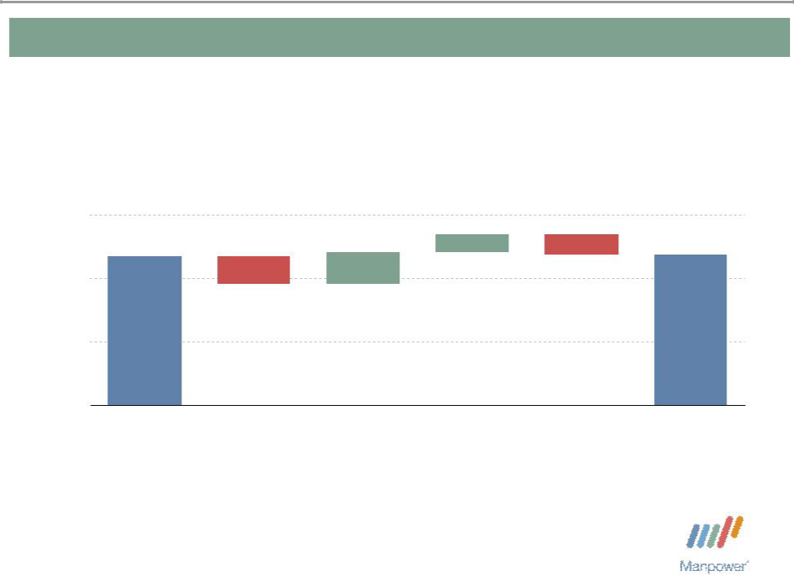

Consolidated Gross Profit Margin Change

19%
 |  |  | + 0.29% | - 0.32%
18% | 18.35% | - 0.45% | + 0.51% | 18.38%

17%

16%

Q4 2005 | 2005 France | Temporary | Permanent | Mix - Specialty | Q4 2006
 | Payroll Tax | Recruitment | Recruitment
 | Audit
 | Settlement

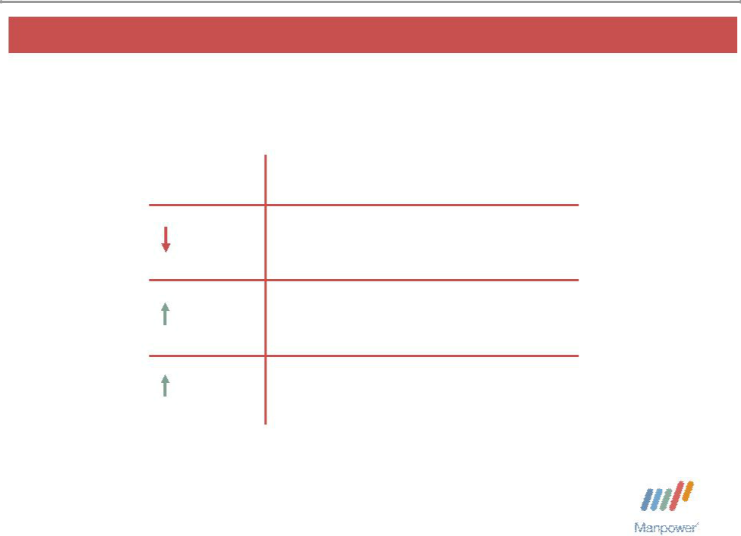
Manpower Inc. 2006 4th Quarter Results | 5

United States Segment

Q4 Financial Highlights

1% Revenue $528M

15% OUP $27M

80 bps OUP Margin 5.1%

Operating Unit Profit (OUP) is the measure that we use to evaluate segment performance. OUP is equal to segment revenues less direct costs and branch and national headquarters operating costs.

Manpower Inc. 2006 4th Quarter Results | 6
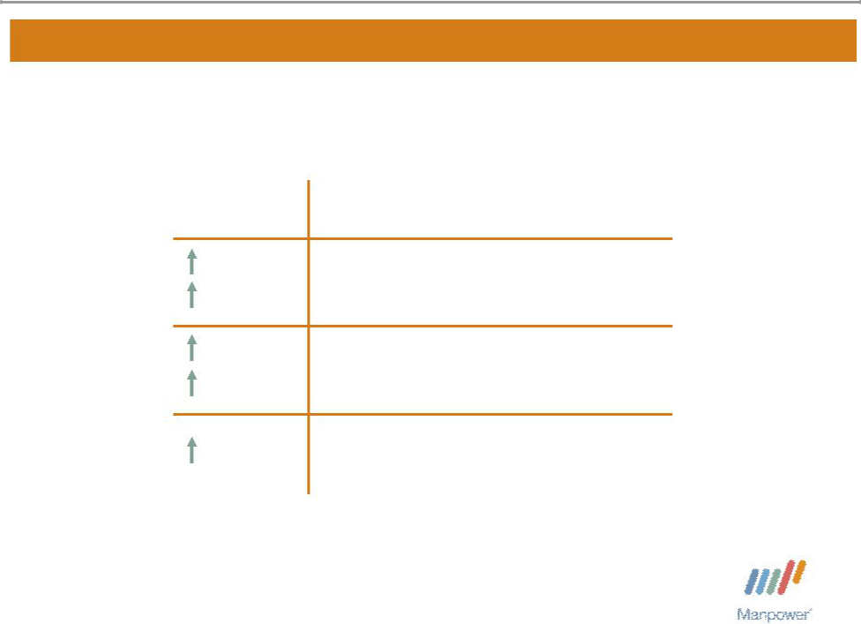

France Segment

Q4 Financial Highlights
^{17%} Revenue $1.6B

8% CC
^{28%} OUP $61M

18% CC

40 bps OUP Margin 3.9%

Manpower Inc. 2006 4th Quarter Results | 7
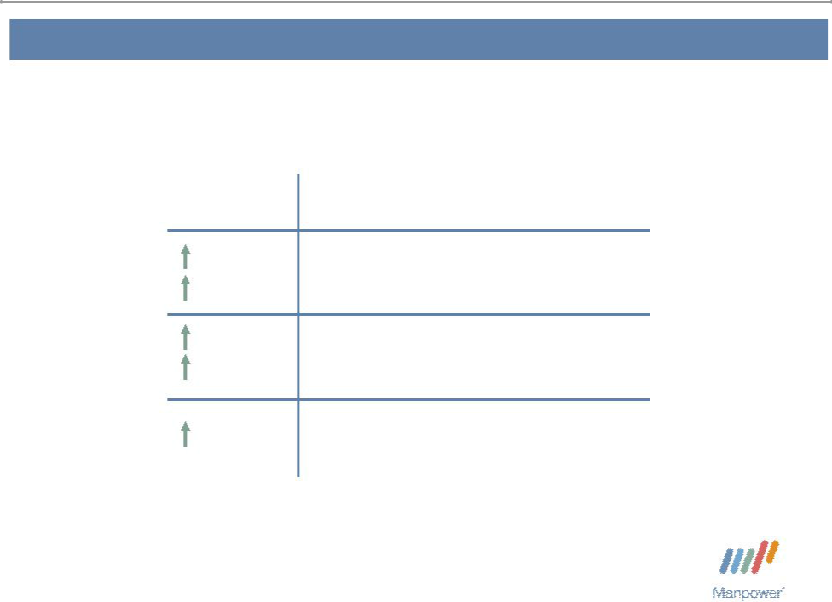

EMEA Segment

Q4 Financial Highlights
^{24%} Revenue $1.8B

14% CC
^{55%} OUP $81M

44% CC

90 bps OUP Margin 4.5%

Manpower Inc. 2006 4th Quarter Results | 8
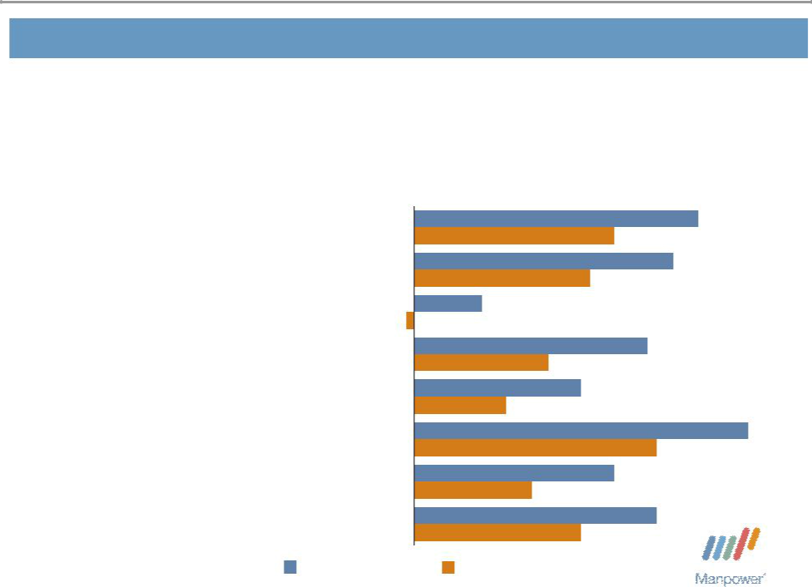

EMEA – Q4 Revenue Growth YoY

- of Segment Revenue

18% Italy
^{16%} Nordics

14% UK - Manpower

13% Elan

8% Germany

7% Netherlands

7% Spain

17% Other

 | 34%
 | 24%
 | 31%
 | 21%
-1% | 8%
 | 28%
 | 16%
 | 20%
 | 11%
 | 40%
 | 29%
 | 24%
 | 14%
 | 29%
 | 20%
Revenue Growth | Revenue Growth - CC

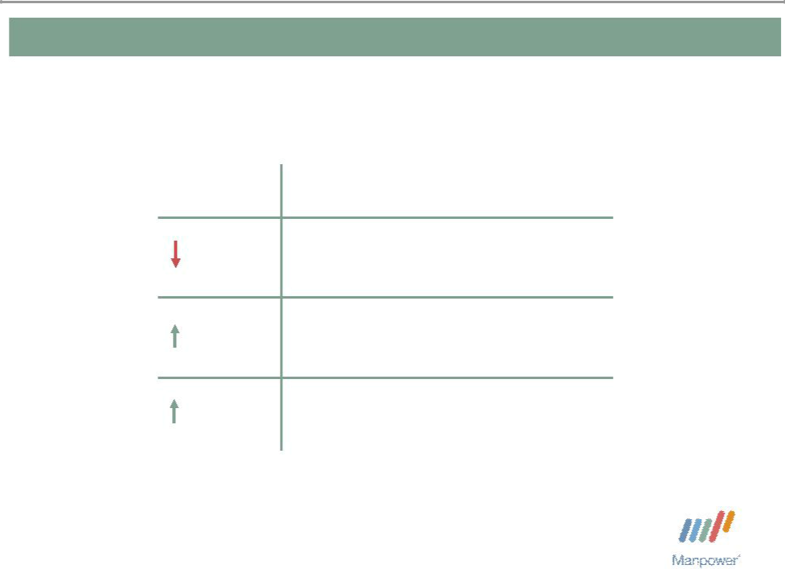
Manpower Inc. 2006 4th Quarter Results 9

Jefferson Wells Segment

Q4 Financial Highlights

12% Revenue $85M

41% OUP $6M

280 bps OUP Margin 7.4%

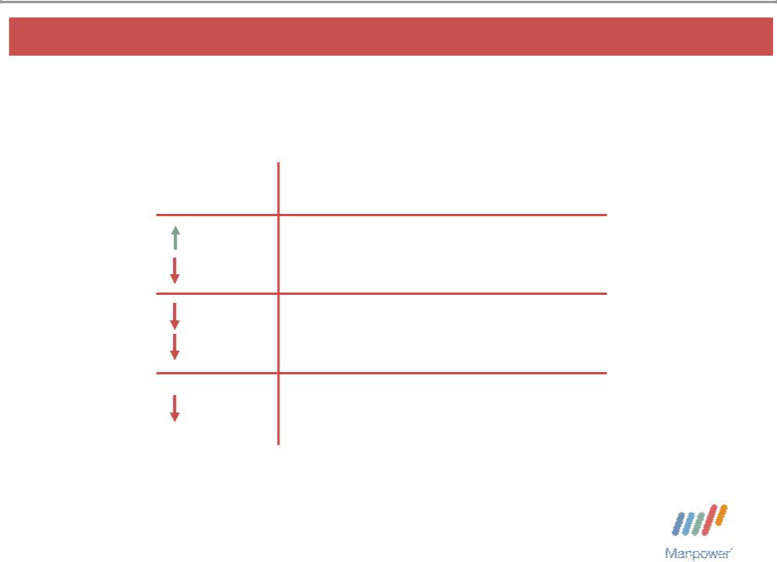
Manpower Inc. 2006 4th Quarter Results 10

Right Management Segment

Q4 Financial Highlights
^{2%} Revenue $99M

2% CC
88% OUP _{$0.4M}

74% CC

320 bps OUP Margin 0.5%

Manpower Inc. 2006 4th Quarter Results | 11
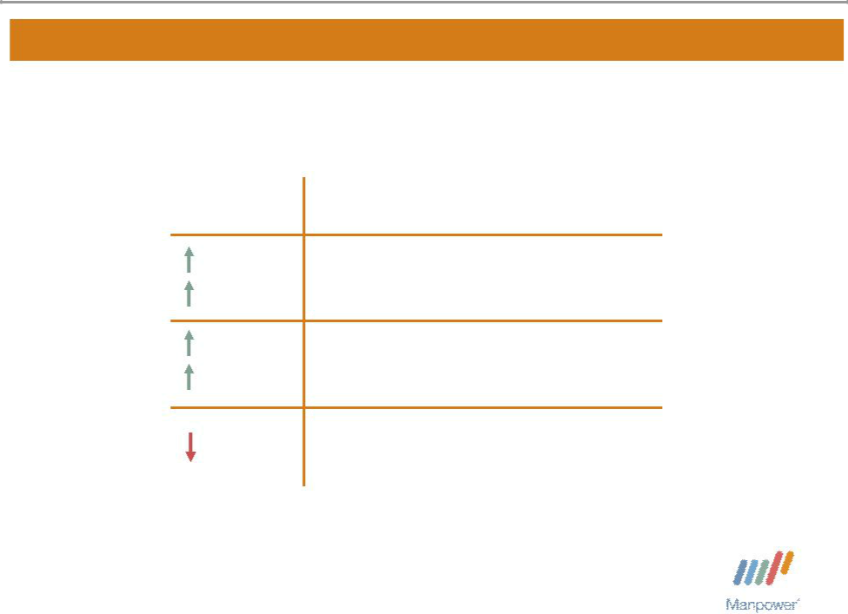

Other Operations Segment

Q4 Financial Highlights
^{15%} Revenue $618M

15% CC
^{10%} OUP $21M

10% CC

20 bps OUP Margin 3.4%

Manpower Inc. 2006 4th Quarter Results | 12
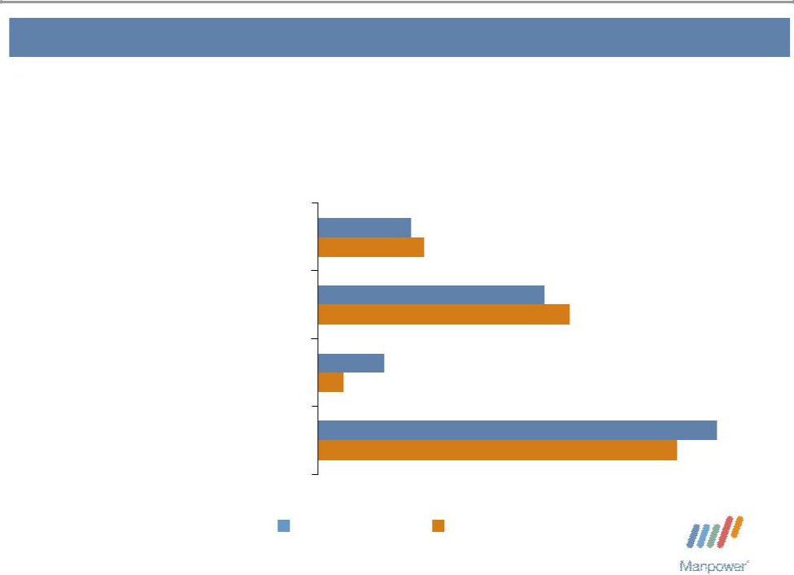

Other Operations – Q4 Revenue Growth YoY

- of Segment Revenue

35% | Japan | 7%
 | Japan | 8%
17% | Mexico | 17%
17% | Mexico | 19%
14% | Australia/NZ | 5%
14% | Australia/NZ | 2%
34% | Other | 30%
34% | Other | 27%

Revenue Growth Revenue Growth - CC

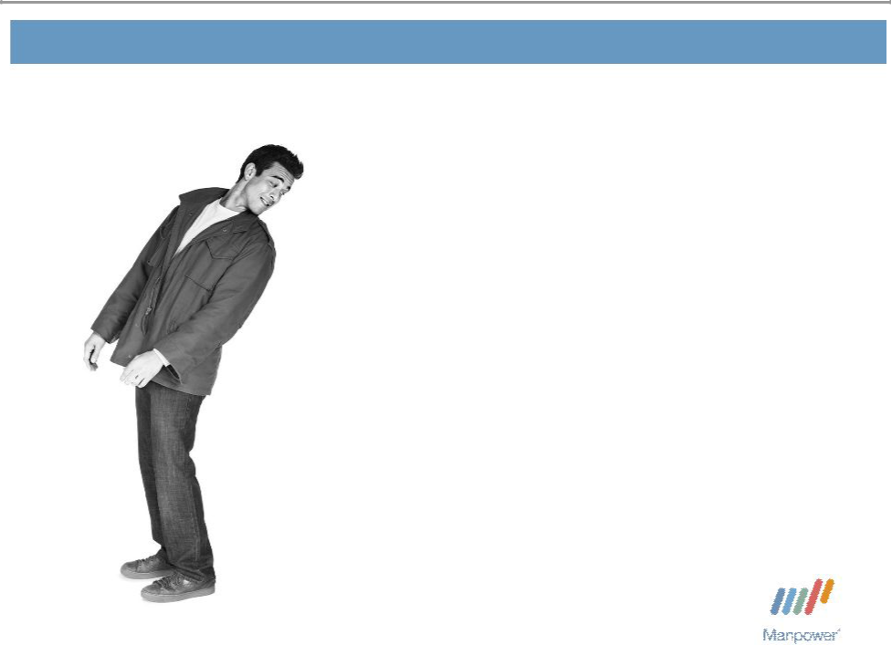
Manpower Inc. 2006 4th Quarter Results 13

Financial Highlights

Manpower Inc. 2006 4th Quarter Results | 14
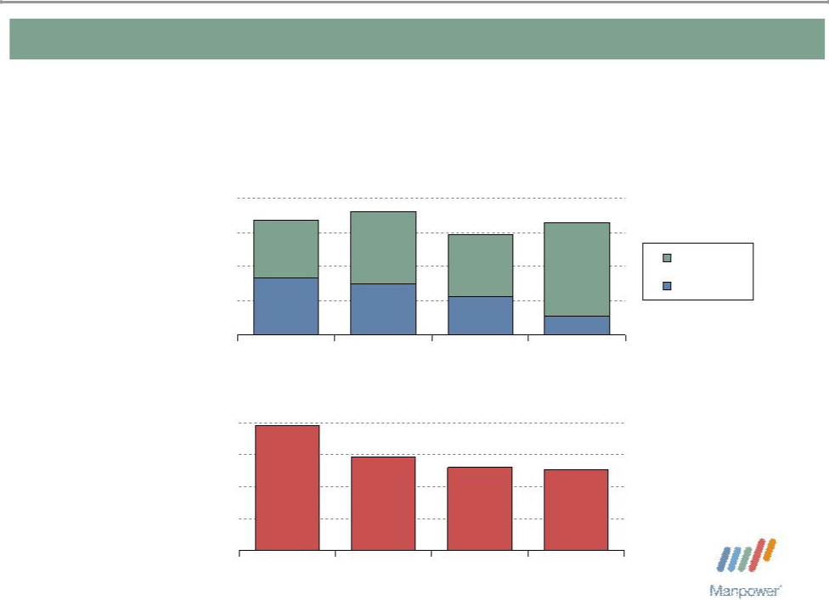

Balance Sheet Highlights

Total Debt | 1,000
($ in millions) |  | 842
 | 750 | 842
 | 500
 | 250 | 416

0
 | 2003
Total Debt to
Total Capitalization
40% | 39%
30% | 39%
20%
10%
0%
 | 2003

902 | 823
735 | 823
735 | Total Debt
 | Net Debt
370
280 ₁₃₅

2004 2005 2006

^{29%} 26% 25%

2004 2005 2006

Manpower Inc. 2006 4th Quarter Results | 15
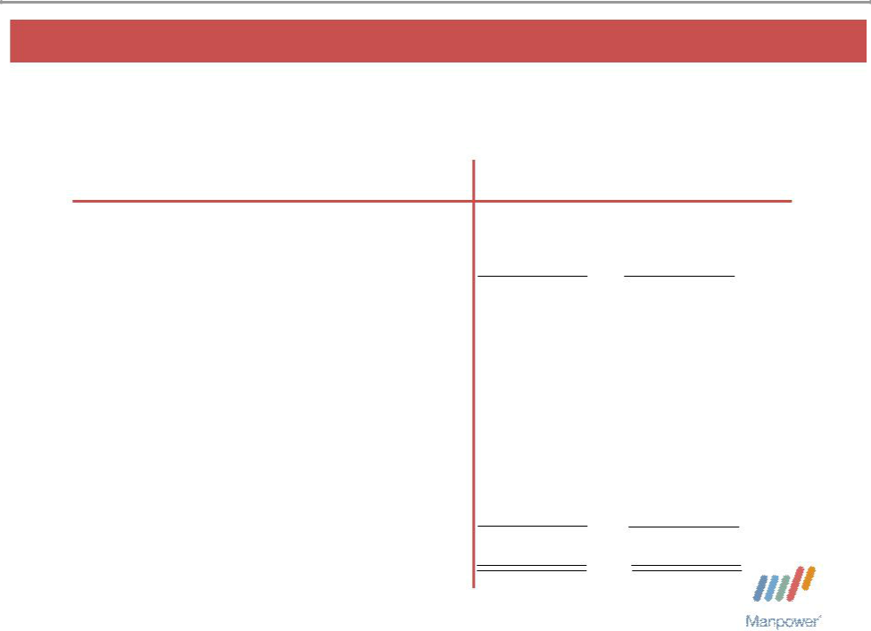

Cash Flow Summary – Full Year

($ in millions) | 2006 | 2005
Cash from Operations | 359 | 269
Capital Expenditures | (80) | (78)
Free Cash Flow | 279 | 191
Share Repurchases * | (236) | (218)
Proceeds from Equity Plans | 54 | 28
Dividends Paid | (51) | (41)
Change in Debt | 2 | 19
Proceeds from Sales of Businesses | 133 | –
Other | 52 | (56)
Change in Cash | 233 | (77)

* 3,972,600 shares in 2006 and 5,000,000 shares in 2005.

Manpower Inc. 2006 4th Quarter Results | 16
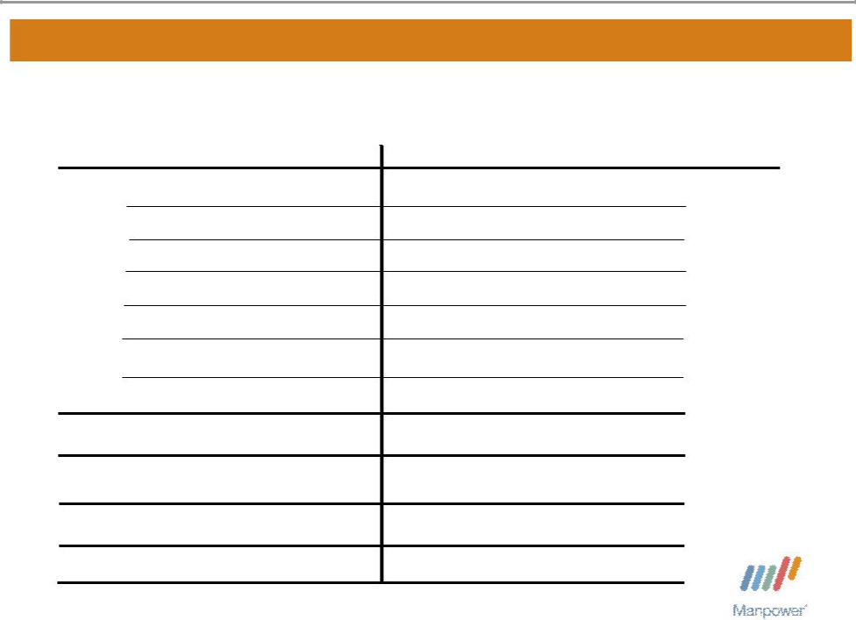

First Quarter Outlook

Revenue U.S.

France

EMEA

Jefferson Wells

Right Management

Other

Total

Gross Profit Margin Operating Profit Margin

Tax Rate from Continuing Operations EPS from Continuing Operations

Flat/Down 2%

Up 15-17% (Up 7-9% CC)

Up 20-22% (Up 13-15% CC)

Down 4-6%

Up 2-4% (Up/Down 1% CC)

Up 11-13% (Up 11-13% CC)

Up 13-15% (Up 8-10% CC)

17.8 - 18.0%

2.0 – 2.2%

36.5%

$0.57 - $0.61 (Pos. $.04 Currency)

2006 4th Quarter Results

January 30, 2007

Now
Next

2006 4th Quarter Results


January 30, 2007

Questions?
Answers

 |  |  |  |  |  |  |  |  |  |  |  |  |  |  |  |  |  |  |  |  |  | Exhibit 99.3
 |  |  |  |  |  |  |  |  |  |  |  |  |  |  |  |  |  |  |  |  |  | (Page 1 of 9)
 |  | Manpower Inc.
 |  | Results of Operations ⁽¹⁾
 |  | (In millions)
 |  |  |  |  |  | Three Months Ended March 31 |  |  |  |  |  |  |  |  |  | Three Months Ended June 30
 |  |  |  |  |  |  |  |  |  | % Variance |  |  |  |  |  |  |  |  |  | % Variance
 |  |  |  | 2006 |  |  |  | 2005 |  | Amount |  | Constant |  |  | 2006 |  |  | 2005 |  | Amount |  |  | Constant
 |  |  |  | 2006 |  |  |  | 2005 | Reported |  |  | Currency |  |  | 2006 |  |  | 2005 |  | Reported |  |  | Currency
 |  |  |  |  |  |  |  | (Unaudited) |  |  |  |  |  |  |  |  |  | (Unaudited)
Revenues from services |  | $ |  | 3,877.2 |  | $ |  | 3,696.1 | 4.9% |  |  | 11.8% |  | $ | 4,384.6 | $3,993.4 |  |  | 9.8% |  |  | 10.2%
Cost of services |  |  |  | 3,184.0 |  |  |  | 3,040.7 | 4.7% |  |  |  |  |  | 3,601.8 |  |  | 3,285.4 | 9.6%
Gross profit |  |  |  | 693.2 |  |  |  | 655.4 | 5.8% |  |  | 12.3% |  |  | 782.8 |  |  | 708.0 | 10.6% |  |  | 11.0%
Selling and administrative expenses |  |  |  | 632.9 |  |  |  | 594.8 | 6.4% |  |  | 12.6% |  |  | 644.7 |  |  | 600.5 | 7.4% |  |  | 7.9%
Operating profit |  |  |  | 60.3 |  |  |  | 60.6 | -0.4% |  |  | 9.5% |  |  | 138.1 |  |  | 107.5 | 28.4% |  |  | 28.3%
Interest and other expenses |  |  |  | 13.0 |  |  |  | 11.8 | 10.6% |  |  |  |  |  | 12.5 |  |  | 11.2 | 11.3%
Earnings before income taxes and discontinued operations |  |  |  | 47.3 |  |  |  | 48.8 | -3.1% |  |  | 5.7% |  |  | 125.6 |  |  | 96.3 | 30.4% |  |  | 29.9%
Provision for income taxes |  |  |  | 17.8 |  |  |  | 17.8 | 0.0% |  |  |  |  |  | 46.0 |  |  | 35.5 | 29.6%
Net earnings from continuing operations |  |  |  | 29.5 |  |  |  | 31.0 | -4.9% |  |  | 3.8% |  |  | 79.6 |  |  | 60.8 | 30.9% |  |  | 30.4%
Income from discontinued operations, net of income taxes |  |  |  |  |  |  |  |  |  | N/A |  |  |  |  |  |  |  |  |  | N/A
 |  |  |  | 23.1 |  |  |  | 1.2 |  |  |  |  |  |  | 0.8 |  |  | 1.7
Net earnings |  |  | $ | 52.6 |  | $ |  | 32.2 | 63.2% |  |  | 79.4% |  | $ | 80.4 | $ |  | 62.5 | 28.6% |  |  | 28.2%
Net earnings per share - basic:
Continuing operations |  | $ |  | 0.34 |  | $ |  | 0.34 | 0.0% |  |  |  |  | $ | 0.91 | $ |  | 0.69 | 31.9%
Discontinued operations |  |  |  | 0.26 |  |  |  | 0.02 |  | N/A |  |  |  |  | 0.01 |  |  | 0.02 |  | N/A
Total |  |  | $ | 0.60 |  | $ |  | 0.36 | 66.7% |  |  |  |  | $ | 0.92 | $ |  | 0.71 | 29.6%
Net earnings per share - diluted:
Continuing operations |  | $ |  | 0.33 |  | $ |  | 0.33 | 0.0% |  |  | 9.0% |  | $ | 0.90 | $ |  | 0.68 | 32.4% |  |  | 30.9%
Discontinued operations |  |  |  | 0.26 |  |  |  | 0.02 |  | N/A |  |  |  |  | 0.01 |  |  | 0.02 |  | N/A
Total |  |  | $ | 0.59 |  | $ |  | 0.35 | 68.6% |  |  | 85.7% |  | $ | 0.91 | $ |  | 0.70 | 30.0% |  |  | 28.6%
Weighted average shares - basic |  |  |  |  |  |  |  |  | -2.6% |  |  |  |  |  |  |  |  |  | -1.5%
 |  |  |  | 87.4 |  |  |  | 89.8 |  |  |  |  |  |  | 87.3 |  |  | 88.6
Weighted average shares - diluted |  |  |  | 88.7 |  |  |  | 96.9 | -8.5% |  |  |  |  |  | 88.7 |  |  | 89.5 | -0.9%
 |  |  |  |  |  |  |  |  |  |  |  |  |  |  |  | Six Months Ended June 30
 |  |  |  |  |  |  |  |  |  |  |  |  |  |  |  |  |  |  |  | % Variance
 |  |  |  |  |  |  |  |  |  |  |  |  |  |  | 2006 |  |  | 2005 |  | Amount |  |  | Constant
 |  |  |  |  |  |  |  |  |  |  |  |  |  |  | 2006 |  |  | 2005 |  | Reported |  |  | Currency
 |  |  |  |  |  |  |  |  |  |  |  |  |  |  |  |  |  | (Unaudited)
Revenues from services |  |  |  |  |  |  |  |  |  |  |  |  |  | $ | 8,261.8 | $7,689.5 |  |  | 7.4% |  |  | 11.0%
Cost of services |  |  |  |  |  |  |  |  |  |  |  |  |  |  | 6,785.8 |  |  | 6,326.1 | 7.3%
Gross profit |  |  |  |  |  |  |  |  |  |  |  |  |  |  | 1,476.0 |  |  | 1,363.4 | 8.3% |  |  | 11.6%
Selling and administrative expenses |  |  |  |  |  |  |  |  |  |  |  |  |  |  | 1,277.6 |  |  | 1,195.3 | 6.9% |  |  | 10.2%
Operating profit |  |  |  |  |  |  |  |  |  |  |  |  |  |  | 198.4 |  |  | 168.1 | 18.0% |  |  | 21.5%
Interest and other expenses |  |  |  |  |  |  |  |  |  |  |  |  |  |  | 25.5 |  |  | 23.0 | 11.0%
Earnings before income taxes and discontinued operations |  |  |  |  |  |  |  |  |  |  |  |  |  |  | 172.9 |  |  | 145.1 | 19.1% |  |  | 21.8%
Provision for income taxes |  |  |  |  |  |  |  |  |  |  |  |  |  |  | 63.8 |  |  | 53.3 | 19.7%
Net earnings from continuing operations |  |  |  |  |  |  |  |  |  |  |  |  |  |  | 109.1 |  |  | 91.8 | 18.8% |  |  | 21.4%
Income from discontinued operations, net of income taxes |  |  |  |  |  |  |  |  |  |  |  |  |  |  | 23.9 |  |  | 2.9 |  | N/A
Net earnings |  |  |  |  |  |  |  |  |  |  |  |  |  | $ | 133.0 | $ |  | 94.7 | 40.4% |  |  | 45.3%
Net earnings per share - basic:
Continuing operations |  |  |  |  |  |  |  |  |  |  |  |  |  | $ | 1.25 | $ |  | 1.03 | 21.4%
Discontinued operations |  |  |  |  |  |  |  |  |  |  |  |  |  |  | 0.27 |  |  | 0.03 |  | N/A
Total |  |  |  |  |  |  |  |  |  |  |  |  |  | $ | 1.52 | $ |  | 1.06 | 43.4%
Net earnings per share - diluted:
Continuing operations |  |  |  |  |  |  |  |  |  |  |  |  |  | $ | 1.23 | $ |  | 1.00 | 23.0% |  |  | 26.0%
Discontinued operations |  |  |  |  |  |  |  |  |  |  |  |  |  |  | 0.27 |  |  | 0.03 |  | N/A
Total |  |  |  |  |  |  |  |  |  |  |  |  |  | $ | 1.50 | $ |  | 1.03 | 45.6% |  |  | 50.5%
Weighted average shares - basic |  |  |  |  |  |  |  |  |  |  |  |  |  |  |  |  |  |  | -2.1%
 |  |  |  |  |  |  |  |  |  |  |  |  |  |  | 87.3 |  |  | 89.2
Weighted average shares - diluted |  |  |  |  |  |  |  |  |  |  |  |  |  |  | 88.8 |  |  | 93.2 | -4.8%

- Restatement for discontinued operations and reclassifications of business tax and profit sharing expenses.

(Page 2 of 9)

Manpower Inc.
Results of Operations ⁽¹⁾

(In millions)

 |  |  |  |  |  | Three Months Ended September 30
 |  |  |  |  |  |  |  |  |  | % Variance
 |  |  |  | 2006 |  |  |  | 2005 |  | Amount |  | Constant
 |  |  |  | 2006 |  |  |  | 2005 |  | Reported |  | Currency
 |  |  |  |  |  |  |  | (Unaudited)
Revenues from services |  | $ |  | 4,590.0 |  | $ |  | 4,087.6 |  | 12.3% |  | 9.0%
Cost of services |  |  |  | 3,785.8 |  |  |  | 3,365.6 |  | 12.5%
Gross profit |  |  |  | 804.2 |  |  |  | 722.0 |  | 11.4% |  | 8.4%
Selling and administrative expenses |  |  |  | 640.3 |  |  |  | 592.1 |  | 8.1% |  | 5.4%
Operating profit |  |  |  | 163.9 |  |  |  | 129.9 |  | 26.2% |  | 22.3%
Interest and other expenses |  |  |  | 10.6 |  |  |  | 11.8 |  | -10.5%
Earnings before income taxes and discontinued operations |  |  |  | 153.3 |  |  |  | 118.1 |  | 29.9% |  | 25.6%
Provision for income taxes |  |  |  | 56.3 |  |  |  | 43.2 |  | 30.3%
Net earnings from continuing operations |  |  |  | 97.0 |  |  |  | 74.9 |  | 29.6% |  | 25.3%
Income from discontinued operations, net of income taxes |  |  |  |  |  |  |  |  |  | N/A
 |  |  |  | 3.6 |  |  |  | 1.4
Net earnings |  |  | $ | 100.6 |  |  | $ | 76.3 |  | 31.8% |  | 27.3%
Net earnings per share - basic:
Continuing operations |  | $ |  | 1.14 |  | $ |  | 0.86 |  | 32.6%
Discontinued operations |  |  |  | 0.04 |  |  |  | 0.02 |  | N/A
Total |  |  | $ | 1.18 |  |  | $ | 0.88 |  | 34.1%
Net earnings per share - diluted:
Continuing operations |  | $ |  | 1.12 |  | $ |  | 0.85 |  | 31.8% |  | 27.1%
Discontinued operations |  |  |  | 0.04 |  |  |  | 0.02 |  | N/A
Total |  |  | $ | 1.16 |  |  | $ | 0.87 |  | 33.3% |  | 28.7%
Weighted average shares - basic |  |  |  |  |  |  |  |  |  | -2.0%
 |  |  |  | 85.3 |  |  |  | 87.0
Weighted average shares - diluted |  |  |  | 86.7 |  |  |  | 88.2 |  | -1.8%
 |  |  |  |  |  | Nine Months Ended September 30
 |  |  |  |  |  |  |  |  |  | % Variance
 |  |  |  | 2006 |  |  |  | 2005 |  | Amount |  | Constant
 |  |  |  | 2006 |  |  |  | 2005 |  | Reported |  | Currency
 |  |  |  |  |  |  |  | (Unaudited)
Revenues from services |  | $ |  | 12,851.8 |  | $ 11,777.1 |  |  |  | 9.1% |  | 10.3%
Cost of services |  |  |  | 10,571.6 |  |  |  | 9,691.7 |  | 9.1%
Gross profit |  |  |  | 2,280.2 |  |  |  | 2,085.4 |  | 9.3% |  | 10.5%
Selling and administrative expenses |  |  |  | 1,917.9 |  |  |  | 1,787.4 |  | 7.3% |  | 8.6%
Operating profit |  |  |  | 362.3 |  |  |  | 298.0 |  | 21.6% |  | 21.8%
Interest and other expenses |  |  |  | 36.1 |  |  |  | 34.8 |  | 3.7%
Earnings before income taxes and discontinued operations |  |  |  | 326.2 |  |  |  | 263.2 |  | 24.0% |  | 23.5%
Provision for income taxes |  |  |  | 120.1 |  |  |  | 96.5 |  | 24.4%
Net earnings from continuing operations |  |  |  | 206.1 |  |  |  | 166.7 |  | 23.7% |  | 23.2%
Income from discontinued operations, net of income taxes |  |  |  |  |  |  |  |  |  | N/A
 |  |  |  | 27.5 |  |  |  | 4.3
Net earnings |  |  | $ | 233.6 |  |  | $ | 171.0 |  | 36.6% |  | 37.2%
Net earnings per share - basic:
Continuing operations |  | $ |  | 2.38 |  | $ |  | 1.88 |  | 26.6%
Discontinued operations |  |  |  | 0.32 |  |  |  | 0.05 |  | N/A
Total |  |  | $ | 2.70 |  |  | $ | 1.93 |  | 39.9%
Net earnings per share - diluted:
Continuing operations |  | $ |  | 2.34 |  | $ |  | 1.83 |  | 27.9% |  | 27.3%
Discontinued operations |  |  |  | 0.31 |  |  |  | 0.05 |  | N/A
Total |  |  | $ | 2.65 |  |  | $ | 1.88 |  | 41.0% |  | 42.0%
Weighted average shares - basic |  |  |  |  |  |  |  |  |  | -2.2%
 |  |  |  | 86.5 |  |  |  | 88.4
Weighted average shares - diluted |  |  |  | 88.0 |  |  |  | 91.7 |  | -4.0%

- Restatement for discontinued operations and reclassifications of business tax and profit sharing expenses.

 |  |  |  |  |  |  |  |  |  |  |  |  |  |  |  |  |  |  |  |  | (Page 3 of 9)
 |  | Manpower Inc.
 |  | Results of Operations ⁽¹⁾
 |  |  |  | (In millions)
 |  |  |  |  | Three Months Ended March 31 |  |  |  |  |  |  |  |  |  | Three Months Ended June 30
 |  |  |  |  |  |  |  |  | % Variance |  |  |  |  |  |  |  |  |  | % Variance
 |  |  |  | 2005 |  |  | 2004 |  | Amount |  | Constant |  |  | 2005 |  |  | 2004 |  | Amount |  |  | Constant
 |  |  |  | 2005 |  |  | 2004 |  | Reported |  | Currency |  |  | 2005 |  |  | 2004 |  | Reported |  |  | Currency
 |  |  |  |  |  |  | (Unaudited) |  |  |  |  |  |  |  |  |  | (Unaudited)
Revenues from services |  | $ |  | 3,696.1 | $ |  | 3,270.8 |  | 13.0% |  | 9.1% |  | $ | 3,993.4 | $3,560.5 |  |  |  | 12.2% |  | 8.4%
Cost of services |  |  |  | 3,040.7 |  |  | 2,679.8 |  | 13.5% |  |  |  |  | 3,285.4 |  |  | 2,911.1 |  | 12.9%
Gross profit |  |  |  | 655.4 |  |  | 591.0 |  | 10.9% |  | 7.3% |  |  | 708.0 |  |  | 649.4 |  | 9.0% |  | 5.6%
Selling and administrative expenses |  |  |  | 594.8 |  |  | 534.0 |  | 11.4% |  | 7.9% |  |  | 600.5 |  |  | 553.8 |  | 8.4% |  | 5.1%
Operating profit |  |  |  | 60.6 |  |  | 57.0 |  | 6.4% |  | 1.9% |  |  | 107.5 |  |  | 95.6 |  | 12.4% |  | 8.6%
Interest and other expenses |  |  |  | 11.8 |  |  | (3.9) |  | N/A |  |  |  |  | 11.2 |  |  | 12.2 |  | -8.1%
Earnings before income taxes and discontinued operations |  |  |  | 48.8 |  |  | 60.9 |  | -19.9% |  | -22.9% |  |  | 96.3 |  |  | 83.4 |  | 15.5% |  | 11.9%
Provision for income taxes |  |  |  | 17.8 |  |  | 20.6 |  | -13.6% |  |  |  |  | 35.5 |  |  | 30.0 |  | 18.4%
Net earnings from continuing operations |  |  |  | 31.0 |  |  | 40.3 |  | -23.1% |  | -26.0% |  |  | 60.8 |  |  | 53.4 |  | 13.8% |  | 10.3%
Income from discontinued operations, net of income taxes |  |  |  | 1.2 |  |  | (0.7) |  | N/A |  |  |  |  | 1.7 |  |  | (0.3) |  | N/A
Net earnings |  |  | $ | 32.2 |  | $ | 39.6 |  | -18.6% |  | -21.7% |  | $ | 62.5 |  | $ | 53.1 |  | 17.7% |  | 14.2%
Net earnings per share - basic:
Continuing operations |  | $ |  | 0.34 | $ |  | 0.47 |  | -27.7% |  |  |  | $ | 0.69 | $ |  | 0.60 |  | 15.0%
Discontinued operations |  |  |  | 0.02 |  |  | (0.01) |  | N/A |  |  |  |  | 0.02 |  |  | (0.01) |  | N/A
Total |  |  | $ | 0.36 |  | $ | 0.46 |  | -21.7% |  |  |  | $ | 0.71 |  | $ | 0.59 |  | 20.3%
Net earnings per share - diluted:
Continuing operations |  | $ |  | 0.33 | $ |  | 0.44 |  | -25.0% |  | -25.6% |  | $ | 0.68 | $ |  | 0.56 |  | 21.4% |  | 17.9%
Discontinued operations |  |  |  | 0.02 |  |  | (0.01) |  | N/A |  |  |  |  | 0.02 |  |  | — |  | N/A
Total |  |  | $ | 0.35 |  | $ | 0.43 |  | -18.6% |  | -21.6% |  | $ | 0.70 |  | $ | 0.56 |  | 25.0% |  | 21.4%
Weighted average shares - basic |  |  |  |  |  |  |  |  | 4.6% |  |  |  |  |  |  |  |  |  | -1.2%
 |  |  |  | 89.8 |  |  | 85.9 |  |  |  |  |  |  | 88.6 |  |  | 89.6
Weighted average shares - diluted |  |  |  | 96.9 |  |  | 93.9 |  | 3.2% |  |  |  |  | 89.5 |  |  | 97.4 |  | -8.1%
 |  |  |  |  |  |  |  |  |  |  |  |  |  |  |  | Six Months Ended June 30
 |  |  |  |  |  |  |  |  |  |  |  |  |  |  |  |  |  |  | % Variance
 |  |  |  |  |  |  |  |  |  |  |  |  |  | 2005 |  |  | 2004 |  | Amount |  |  | Constant
 |  |  |  |  |  |  |  |  |  |  |  |  |  | 2005 |  |  | 2004 |  | Reported |  |  | Currency
 |  |  |  |  |  |  |  |  |  |  |  |  |  |  |  |  | (Unaudited)
Revenues from services |  |  |  |  |  |  |  |  |  |  |  |  | $ | 7,689.5 | $6,831.3 |  |  |  | 12.6% |  | 8.8%
Cost of services |  |  |  |  |  |  |  |  |  |  |  |  |  | 6,326.1 |  |  | 5,590.9 |  | 13.1%
Gross profit |  |  |  |  |  |  |  |  |  |  |  |  |  | 1,363.4 |  |  | 1,240.4 |  | 9.9% |  | 6.4%
Selling and administrative expenses |  |  |  |  |  |  |  |  |  |  |  |  |  | 1,195.3 |  |  | 1,087.8 |  | 9.9% |  | 6.5%
Operating profit |  |  |  |  |  |  |  |  |  |  |  |  |  | 168.1 |  |  | 152.6 |  | 10.2% |  | 6.1%
Interest and other expenses |  |  |  |  |  |  |  |  |  |  |  |  |  | 23.0 |  |  | 8.3 |  | N/A
Earnings before income taxes and discontinued operations |  |  |  |  |  |  |  |  |  |  |  |  |  | 145.1 |  |  | 144.3 |  | 0.5% |  | -2.8%
Provision for income taxes |  |  |  |  |  |  |  |  |  |  |  |  |  | 53.3 |  |  | 50.6 |  | 5.4%
Net earnings from continuing operations |  |  |  |  |  |  |  |  |  |  |  |  |  | 91.8 |  |  | 93.7 |  | -2.1% |  | -5.3%
Income from discontinued operations, net of income taxes |  |  |  |  |  |  |  |  |  |  |  |  |  | 2.9 |  |  | (1.0) |  | N/A
Net earnings |  |  |  |  |  |  |  |  |  |  |  |  | $ | 94.7 |  | $ | 92.7 |  | 2.2% |  | -1.2%
Net earnings per share - basic:
Continuing operations |  |  |  |  |  |  |  |  |  |  |  |  | $ | 1.03 | $ |  | 1.07 |  | -3.7%
Discontinued operations |  |  |  |  |  |  |  |  |  |  |  |  |  | 0.03 |  |  | (0.01) |  | N/A
Total |  |  |  |  |  |  |  |  |  |  |  |  | $ | 1.06 |  | $ | 1.06 |  | 0.0%
Net earnings per share - diluted:
Continuing operations |  |  |  |  |  |  |  |  |  |  |  |  | $ | 1.00 | $ |  | 1.00 |  | 0.0% |  | -3.0%
Discontinued operations |  |  |  |  |  |  |  |  |  |  |  |  |  | 0.03 |  |  | (0.01) |  | N/A
Total |  |  |  |  |  |  |  |  |  |  |  |  | $ | 1.03 |  | $ | 0.99 |  | 4.0% |  | 1.0%
Weighted average shares - basic |  |  |  |  |  |  |  |  |  |  |  |  |  |  |  |  |  |  | 1.7%
 |  |  |  |  |  |  |  |  |  |  |  |  |  | 89.2 |  |  | 87.7
Weighted average shares - diluted |  |  |  |  |  |  |  |  |  |  |  |  |  | 93.2 |  |  | 96.0 |  | -2.9%
- Restatement for discontinued operations and reclassifications of business tax and profit sharing expenses.

 |  |  |  |  |  |  |  |  |  |  |  |  |  |  |  |  |  |  |  |  |  | (Page 4 of 9)
 |  |  | Manpower Inc.
 |  | Results of Operations ⁽¹⁾
 |  |  | (In millions)
 |  |  | Three Months Ended September 30 |  |  |  |  |  |  |  |  |  |  |  |  | Three Months Ended December 31
 |  |  |  |  |  |  |  |  | % Variance |  |  |  |  |  |  |  |  |  |  | % Variance
 |  |  | 2005 |  |  |  | 2004 |  | Amount |  | Constant |  |  | 2005 |  |  |  | 2004 |  | Amount |  |  | Constant
 |  |  | 2005 |  |  |  | 2004 |  | Reported |  | Currency |  |  | 2005 |  |  |  | 2004 |  | Reported |  |  | Currency
 |  |  |  |  |  |  | (Unaudited) |  |  |  |  |  |  |  |  |  |  | (Unaudited)
Revenues from services |  | $ | 4,087.6 |  | $ |  | 3,838.2 |  | 6.5% |  | 6.3% |  | $ | 4,068.3 |  | $ |  | 4,005.5 |  | 1.6% |  | 8.1%
Cost of services |  |  | 3,365.6 |  |  |  | 3,144.4 |  | 7.0% |  |  |  |  | 3,321.9 |  |  |  | 3,270.4 |  | 1.6%
Gross profit |  |  | 722.0 |  |  |  | 693.8 |  | 4.1% |  | 3.8% |  |  | 746.4 |  |  |  | 735.1 |  | 1.5% |  | 7.7%
Selling and administrative expenses |  |  | 592.1 |  |  |  | 566.5 |  | 4.5% |  | 4.3% |  |  | 615.6 |  |  |  | 617.2 |  | -0.2% |  | 5.6%
Operating profit |  |  | 129.9 |  |  |  | 127.3 |  | 2.0% |  | 1.7% |  |  | 130.8 |  |  |  | 117.9 |  | 10.9% |  | 18.7%
Interest and other expenses |  |  | 11.8 |  |  |  | 9.0 |  | 30.6% |  |  |  |  | 7.0 |  |  |  | 8.9 |  | -22.5%
Earnings before income taxes and discontinued operations |  |  | 118.1 |  |  |  | 118.3 |  | -0.2% |  | -0.4% |  |  | 123.8 |  |  |  | 109.0 |  | 13.6% |  | 25.2%
Provision for income taxes |  |  | 43.2 |  |  |  | 34.5 |  | 25.3% |  |  |  |  | 35.4 |  |  |  | 39.2 |  | -9.6%
Net earnings from continuing operations |  |  | 74.9 |  |  |  | 83.8 |  | -10.6% |  | -10.9% |  |  | 88.4 |  |  |  | 69.8 |  | 26.7% |  | 39.6%
Income from discontinued operations, net of income taxes |  |  |  |  |  |  |  |  | N/A |  |  |  |  |  |  |  |  |  |  | N/A
 |  |  | 1.4 |  |  |  | (0.4) |  |  |  |  |  |  | 0.7 |  |  |  | (0.2)
Net earnings |  | $ | 76.3 |  | $ |  | 83.4 |  | -8.5% |  | -8.7% |  | $ | 89.1 |  | $ |  | 69.6 |  | 27.9% |  | 41.0%
Net earnings per share - basic:
Continuing operations |  | $ | 0.86 |  | $ |  | 0.93 |  | -7.5% |  |  |  | $ | 1.01 |  | $ |  | 0.77 |  | 31.2%
Discontinued operations |  |  | 0.02 |  |  |  | — |  | N/A |  |  |  |  | 0.01 |  |  |  | — |  | N/A
Total |  | $ | 0.88 |  | $ |  | 0.93 |  | -5.4% |  |  |  | $ | 1.02 |  | $ |  | 0.77 |  | 32.5%
Net earnings per share - diluted:
Continuing operations |  | $ | 0.85 |  | $ |  | 0.87 |  | -2.3% |  | 2.3% |  | $ | 1.00 |  | $ |  | 0.73 |  | 37.0% |  | 45.2%
Discontinued operations |  |  | 0.02 |  |  |  | — |  | N/A |  |  |  |  | 0.01 |  |  |  | — |  | N/A
Total |  | $ | 0.87 |  | $ |  | 0.87 |  | 0.0% |  | -1.1% |  | $ | 1.01 |  | $ |  | 0.73 |  | 38.4% |  | 46.6%
Weighted average shares - basic |  |  |  |  |  |  |  |  | -3.4% |  |  |  |  |  |  |  |  |  |  | -3.2%
 |  |  | 87.0 |  |  |  | 90.0 |  |  |  |  |  |  | 87.2 |  |  |  | 90.1
Weighted average shares - diluted |  |  | 88.2 |  |  |  | 97.2 |  | -9.2% |  |  |  |  | 88.5 |  |  |  | 97.5 |  | -9.2%
 |  |  |  |  | Nine Months Ended September 30 |  |  |  |  |  |  |  |  |  |  |  | Year Ended December 31
 |  |  |  |  |  |  |  |  | % Variance |  |  |  |  |  |  |  |  |  |  | % Variance
 |  |  | 2005 |  |  |  | 2004 |  | Amount |  | Constant |  |  | 2005 |  |  |  | 2004 |  | Amount |  |  | Constant
 |  |  | 2005 |  |  |  | 2004 |  | Reported |  | Currency |  |  | 2005 |  |  |  | 2004 |  | Reported |  |  | Currency
 |  |  |  |  |  |  | (Unaudited) |  |  |  |  |  |  |  |  |  |  | (Unaudited)
Revenues from services |  | $ | 11,777.1 |  | $10,669.5 |  |  |  | 10.4% |  | 7.9% |  | $ | 15,845.4 |  | $14,675.0 |  |  |  | 8.0% |  | 7.9%
Cost of services |  |  | 9,691.7 |  |  |  | 8,735.3 |  | 10.9% |  |  |  |  | 13,013.6 |  |  |  | 12,005.7 |  | 8.4%
Gross profit |  |  | 2,085.4 |  |  |  | 1,934.2 |  | 7.8% |  | 5.5% |  |  | 2,831.8 |  |  |  | 2,669.3 |  | 6.1% |  | 6.1%
Selling and administrative expenses |  |  | 1,787.4 |  |  |  | 1,654.3 |  | 8.0% |  | 5.7% |  |  | 2,403.0 |  |  |  | 2,271.5 |  | 5.8% |  | 5.7%
Operating profit |  |  | 298.0 |  |  |  | 279.9 |  | 6.5% |  | 4.1% |  |  | 428.8 |  |  |  | 397.8 |  | 7.8% |  | 8.4%
Interest and other expenses |  |  | 34.8 |  |  |  | 17.3 |  | N/A |  |  |  |  | 41.8 |  |  |  | 26.2 |  | 59.2%
Earnings before income taxes and discontinued operations |  |  | 263.2 |  |  |  | 262.6 |  | 0.2% |  | -1.7% |  |  | 387.0 |  |  |  | 371.6 |  | 4.2% |  | 6.2%
Provision for income taxes |  |  | 96.5 |  |  |  | 85.1 |  | 13.4% |  |  |  |  | 131.9 |  |  |  | 124.3 |  | 6.2%
Net earnings from continuing operations |  |  | 166.7 |  |  |  | 177.5 |  | -6.1% |  | -7.9% |  |  | 255.1 |  |  |  | 247.3 |  | 3.1% |  | 5.2%
Income from discontinued operations, net of income taxes |  |  |  |  |  |  |  |  | N/A |  |  |  |  |  |  |  |  |  |  | N/A
 |  |  | 4.3 |  |  |  | (1.4) |  |  |  |  |  |  | 5.0 |  |  |  | (1.6)
Net earnings |  | $ | 171.0 |  | $ |  | 176.1 |  | -2.9% |  | -4.7% |  | $ | 260.1 |  | $ |  | 245.7 |  | 5.9% |  | 7.9%
Net earnings per share - basic:
Continuing operations |  | $ | 1.88 |  | $ |  | 2.01 |  | -6.5% |  |  |  | $ | 2.89 |  | $ |  | 2.78 |  | 4.0%
Discontinued operations |  |  | 0.05 |  |  |  | (0.02) |  | N/A |  |  |  |  | 0.06 |  |  |  | (0.02) |  | N/A
Total |  | $ | 1.93 |  | $ |  | 1.99 |  | -3.0% |  |  |  | $ | 2.95 |  | $ |  | 2.76 |  | 6.9%
Net earnings per share - diluted:
Continuing operations |  | $ | 1.83 |  | $ |  | 1.88 |  | -2.7% |  | -4.3% |  | $ | 2.81 |  | $ |  | 2.61 |  | 7.7% |  | 8.4%
Discontinued operations |  |  | 0.05 |  |  |  | (0.02) |  | N/A |  |  |  |  | 0.06 |  |  |  | (0.02) |  | N/A
Total |  | $ | 1.88 |  | $ |  | 1.86 |  | 1.1% |  | -1.1% |  | $ | 2.87 |  | $ |  | 2.59 |  | 10.8% |  | 11.6%
Weighted average shares - basic |  |  |  |  |  |  |  |  | -0.1% |  |  |  |  |  |  |  |  |  |  | -0.9%
 |  |  | 88.4 |  |  |  | 88.5 |  |  |  |  |  |  | 88.1 |  |  |  | 88.9
Weighted average shares - diluted |  |  | 91.7 |  |  |  | 96.4 |  | -4.9% |  |  |  |  | 91.1 |  |  |  | 96.8 |  | -5.8%
- Restatement for discontinued operations and reclassifications of business tax and profit sharing expenses.

 |  |  |  |  |  |  |  |  |  |  |  |  |  |  |  |  |  |  |  |  |  | (Page 5 of 9)
 | Manpower Inc.
 | Operating unit Results ⁽¹⁾
 |  | (In millions)
 |  |  |  | Three Months Ended March 31 |  |  |  |  |  |  |  |  |  |  |  | Three Months Ended June 30
 |  |  |  |  |  |  |  | % Variance |  |  |  |  |  |  |  |  |  |  |  | % Variance
 |  |  |  |  |  |  |  | Amount |  | Constant |  |  |  |  |  |  |  |  |  | Amount |  |  | Constant
 |  |  | 2006 |  |  | 2005 | Reported |  |  | Currency |  |  |  | 2006 |  |  |  | 2005 |  | Reported |  |  | Currency
 |  |  |  |  |  | (Unaudited) |  |  |  |  |  |  |  |  |  |  |  | (Unaudited)
Revenue from Services:
United States | $ |  | 510.3 | $ |  | 475.9 | 7.2% |  |  | 7.2% |  | $ |  | 534.6 |  | $ |  | 506.7 |  | 5.5% |  | 5.5%
France |  |  | 1,240.5 |  |  | 1,238.0 | 0.2% |  |  | 9.2% |  |  |  | 1,535.6 |  |  |  | 1,397.0 |  | 9.9% |  | 9.8%
EMEA |  |  | 1,392.2 |  |  | 1,289.5 | 8.0% |  |  | 17.2% |  |  |  | 1,549.2 |  |  |  | 1,381.1 |  | 12.2% |  | 12.6%
Jefferson Wells |  |  | 95.5 |  |  | 92.7 | 3.0% |  |  | 3.0% |  |  |  | 98.8 |  |  |  | 93.5 |  | 5.7% |  | 5.7%
Right Management |  |  | 95.3 |  |  | 103.3 | -7.7% |  |  | -4.4% |  |  |  | 102.6 |  |  |  | 107.1 |  | -4.2% |  | -4.2%
Other Operations |  |  | 543.4 |  |  | 496.7 | 9.4% |  |  | 13.8% |  |  |  | 563.8 |  |  |  | 508.0 |  | 11.0% |  | 13.7%
 | $ |  | 3,877.2 | $ |  | 3,696.1 | 4.9% |  |  | 11.8% |  |  |  | 4,384.6 |  |  |  | 3,993.4 |  | 9.8% |  | 10.2%
Operating Unit Profit:
United States | $ |  | 9.5 | $ |  | 4.9 | 93.3% |  |  | 93.3% |  | $ |  | 22.5 |  | $ |  | 18.0 |  | 25.2% |  | 25.2%
France |  |  | 30.4 |  |  | 28.4 | 7.1% |  |  | 16.7% |  |  |  | 49.7 |  |  |  | 42.0 |  | 18.3% |  | 17.7%
EMEA |  |  | 23.0 |  |  | 12.1 | 90.8% |  |  | 109.6% |  |  |  | 50.7 |  |  |  | 35.9 |  | 40.9% |  | 39.9%
Jefferson Wells |  |  | 5.7 |  |  | 8.1 | -29.4% |  |  | -29.4% |  |  |  | 10.0 |  |  |  | 9.3 |  | 7.7% |  | 7.7%
Right Management |  |  | 4.6 |  |  | 10.3 | -54.8% |  |  | -55.5% |  |  |  | 11.1 |  |  |  | 9.5 |  | 15.8% |  | 14.3%
Other Operations |  |  | 17.6 |  |  | 12.1 | 44.7% |  |  | 53.8% |  |  |  | 14.8 |  |  |  | 12.8 |  | 16.5% |  | 21.2%
 |  |  | 90.8 |  |  | 75.9 |  |  |  |  |  |  |  | 158.8 |  |  |  | 127.5
Corporate Expenses |  |  | 27.3 |  |  | 12.1 |  |  |  |  |  |  |  | 17.4 |  |  |  | 16.7
Amortization of intangible assets |  |  | 3.2 |  |  | 3.2 |  |  |  |  |  |  |  | 3.3 |  |  |  | 3.3
Operating profit |  |  | 60.3 |  |  | 60.6 | -0.4% |  |  | 9.5% |  |  |  | 138.1 |  |  |  | 107.5 |  | 28.4% |  | 28.3%
Interest and other expenses |  |  | 13.0 |  |  | 11.8 |  |  |  |  |  |  |  | 12.5 |  |  |  | 11.2
Earnings before income taxes and discontinued operations |  | $ | 47.3 | $ |  | 48.8 |  |  |  |  |  | $ |  | 125.6 |  | $ |  | 96.3
 |  |  |  |  |  |  |  |  |  |  |  |  |  |  |  | Six Months Ended June 30
 |  |  |  |  |  |  |  |  |  |  |  |  |  |  |  |  |  |  |  | % Variance
 |  |  |  |  |  |  |  |  |  |  |  |  |  |  |  |  |  |  |  | Amount |  |  | Constant
 |  |  |  |  |  |  |  |  |  |  |  |  |  | 2006 |  |  |  | 2005 |  | Reported |  |  | Currency
 |  |  |  |  |  |  |  |  |  |  |  |  |  |  |  |  |  | (Unaudited)
Revenue from Services:
United States |  |  |  |  |  |  |  |  |  |  |  | $ |  | 1,044.9 |  | $ |  | 982.6 |  | 6.3% |  | 6.3%
France |  |  |  |  |  |  |  |  |  |  |  |  |  | 2,776.1 |  |  |  | 2,635.0 |  | 5.4% |  | 9.5%
EMEA |  |  |  |  |  |  |  |  |  |  |  |  |  | 2,941.4 |  |  |  | 2,670.6 |  | 10.1% |  | 14.8%
Jefferson Wells |  |  |  |  |  |  |  |  |  |  |  |  |  | 194.3 |  |  |  | 186.2 |  | 4.3% |  | 4.3%
Right Management |  |  |  |  |  |  |  |  |  |  |  |  |  | 197.9 |  |  |  | 210.4 |  | -6.0% |  | -4.3%
Other Operations |  |  |  |  |  |  |  |  |  |  |  |  |  | 1,107.2 |  |  |  | 1,004.7 |  | 10.2% |  | 13.8%
 |  |  |  |  |  |  |  |  |  |  |  | $ |  | 8,261.8 |  | $7,689.5 |  |  |  | 7.4% |  | 11.0%
Operating Unit Profit:
United States |  |  |  |  |  |  |  |  |  |  |  | $ |  | 32.0 |  | $ |  | 22.9 |  | 39.8% |  | 39.8%
France |  |  |  |  |  |  |  |  |  |  |  |  |  | 80.1 |  |  |  | 70.4 |  | 13.8% |  | 17.3%
EMEA |  |  |  |  |  |  |  |  |  |  |  |  |  | 73.7 |  |  |  | 48.0 |  | 53.4% |  | 57.4%
Jefferson Wells |  |  |  |  |  |  |  |  |  |  |  |  |  | 15.7 |  |  |  | 17.4 |  | -9.6% |  | -9.6%
Right Management |  |  |  |  |  |  |  |  |  |  |  |  |  | 15.7 |  |  |  | 19.8 |  | -20.9% |  | -21.9%
Other Operations |  |  |  |  |  |  |  |  |  |  |  |  |  | 32.4 |  |  |  | 24.9 |  | 30.3% |  | 37.2%
 |  |  |  |  |  |  |  |  |  |  |  |  |  | 249.6 |  |  |  | 203.4
Corporate Expenses |  |  |  |  |  |  |  |  |  |  |  |  |  | 44.7 |  |  |  | 28.8
Amortization of intangible assets |  |  |  |  |  |  |  |  |  |  |  |  |  | 6.5 |  |  |  | 6.5
Operating profit |  |  |  |  |  |  |  |  |  |  |  |  |  | 198.4 |  |  |  | 168.1 |  | 18.0% |  | 21.5%
Interest and other expenses |  |  |  |  |  |  |  |  |  |  |  |  |  | 25.5 |  |  |  | 23.0
Earnings before income taxes and discontinued operations |  |  |  |  |  |  |  |  |  |  |  | $ |  | 172.9 |  | $ |  | 145.1
- Restatement for discontinued operations and reclass of segment results.

(Page 6 of 9)

Manpower Inc.
Operating unit Results ⁽¹⁾

(In millions)

 |  |  |  |  |  | Three Months Ended September 30
 |  |  |  |  |  |  |  |  |  | % Variance
 |  |  |  |  |  |  |  |  |  | Amount |  | Constant
 |  |  |  | 2006 |  |  |  | 2005 |  | Reported |  | Currency
 |  |  |  |  |  |  |  | (Unaudited)
Revenue from Services:
United States |  | $ |  | 542.1 |  | $ |  | 531.5 |  | 2.0% |  | 2.0%
France |  |  |  | 1,654.0 |  |  |  | 1,479.3 |  | 11.8% |  | 7.0%
EMEA |  |  |  | 1,629.7 |  |  |  | 1,355.9 |  | 20.2% |  | 15.1%
Jefferson Wells |  |  |  | 93.9 |  |  |  | 103.9 |  | -9.6% |  | -9.6%
Right Management |  |  |  | 90.5 |  |  |  | 94.8 |  | -4.6% |  | -6.7%
Other Operations |  |  |  | 579.8 |  |  |  | 522.2 |  | 11.0% |  | 12.8%
 |  |  |  |  |  |  |  |  |  | 12.3% |  | 9.0%
 |  |  | $ | 4,590.0 |  |  | $ | 4,087.6
Operating Unit Profit:
United States |  | $ |  | 28.6 |  | $ |  | 22.6 |  | 26.7% |  | 26.7%
France |  |  |  | 62.0 |  |  |  | 50.6 |  | 22.4% |  | 17.1%
EMEA |  |  |  | 65.9 |  |  |  | 44.2 |  | 49.2% |  | 43.0%
Jefferson Wells |  |  |  | 10.0 |  |  |  | 11.5 |  | -13.7% |  | -13.7%
Right Management |  |  |  | 2.2 |  |  |  | 2.3 |  | -5.2% |  | -10.3%
Other Operations |  |  |  | 16.4 |  |  |  | 16.3 |  | 1.3% |  | 3.8%
 |  |  |  | 185.1 |  |  |  | 147.5
Corporate Expenses |  |  |  | 17.9 |  |  |  | 14.3
Amortization of intangible assets |  |  |  | 3.3 |  |  |  | 3.3
Operating profit |  |  |  | 163.9 |  |  |  | 129.9 |  | 26.2% |  | 22.3%
Interest and other expenses |  |  |  | 10.6 |  |  |  | 11.8
Earnings before income taxes and discontinued operations |  |  | $ | 153.3 |  |  | $ | 118.1
 |  |  |  |  |  | Nine Months Ended September 30
 |  |  |  |  |  |  |  |  |  | % Variance
 |  |  |  |  |  |  |  |  |  | Amount |  | Constant
 |  |  |  | 2006 |  |  |  | 2005 |  | Reported |  | Currency
 |  |  |  |  |  |  |  | (Unaudited)
Revenue from Services:
United States |  | $ |  | 1,587.0 |  | $ |  | 1,514.1 |  | 4.8% |  | 4.8%
France |  |  |  | 4,430.1 |  |  |  | 4,114.3 |  | 7.7% |  | 8.6%
EMEA |  |  |  | 4,571.1 |  |  |  | 4,026.5 |  | 13.5% |  | 14.9%
Jefferson Wells |  |  |  | 288.2 |  |  |  | 290.1 |  | -0.6% |  | -0.6%
Right Management |  |  |  | 288.4 |  |  |  | 305.2 |  | -5.5% |  | -5.0%
Other Operations |  |  |  | 1,687.0 |  |  |  | 1,526.9 |  | 10.5% |  | 13.4%
 |  |  |  |  |  |  |  |  |  | 9.1% |  | 10.3%
 |  |  | $ | 12,851.8 |  |  | $ 11,777.1
Operating Unit Profit:
United States |  | $ |  | 60.6 |  | $ |  | 45.5 |  | 33.3% |  | 33.3%
France |  |  |  | 142.1 |  |  |  | 121.0 |  | 17.4% |  | 17.2%
EMEA |  |  |  | 139.6 |  |  |  | 92.2 |  | 51.4% |  | 50.5%
Jefferson Wells |  |  |  | 25.7 |  |  |  | 28.9 |  | -11.2% |  | -11.2%
Right Management |  |  |  | 17.9 |  |  |  | 22.1 |  | -19.2% |  | -20.7%
Other Operations |  |  |  | 48.8 |  |  |  | 41.2 |  | 18.8% |  | 23.9%
 |  |  |  | 434.7 |  |  |  | 350.9
Corporate Expenses |  |  |  | 62.6 |  |  |  | 43.1
Amortization of intangible assets |  |  |  | 9.8 |  |  |  | 9.8
Operating profit |  |  |  | 362.3 |  |  |  | 298.0 |  | 21.6% |  | 21.8%
Interest and other expenses |  |  |  | 36.1 |  |  |  | 34.8
Earnings before income taxes and discontinued operations |  |  | $ | 326.2 |  |  | $ | 263.2

- Restatement for discontinued operations and reclass of segment results.

 |  |  |  |  |  |  |  |  |  |  |  |  |  |  |  |  |  |  |  |  |  | (Page 7 of 9)
 |  | Manpower Inc.
 |  | Operating unit Results ⁽¹⁾
 |  |  | (In millions)
 |  |  |  |  | Three Months Ended March 31 |  |  |  |  |  |  |  |  |  |  | Three Months Ended June 30
 |  |  |  |  |  |  |  |  |  | % Variance |  |  |  |  |  |  |  |  |  | % Variance
 |  |  |  |  |  |  |  |  |  | Amount |  | Constant |  |  |  |  |  |  |  | Amount |  |  | Constant
 |  |  |  | 2005 |  |  | 2004 |  | Reported |  |  | Currency |  |  | 2005 |  |  | 2004 |  | Reported |  |  | Currency
 |  |  |  |  |  |  | (Unaudited) |  |  |  |  |  |  |  |  |  |  | (Unaudited)
Revenue from Services:
United States |  | $ |  | 475.9 | $ |  | 474.6 |  | 0.3% |  |  | 0.3% |  | $ | 506.7 | $ |  | 517.3 |  | -2.1% |  | -2.1%
France |  |  |  | 1,238.0 |  |  | 1,131.4 |  | 9.4% |  |  | 4.3% |  |  | 1,397.0 |  |  | 1,272.7 |  | 9.8% |  | 5.3%
EMEA |  |  |  | 1,289.5 |  |  | 1,088.0 |  | 18.5% |  |  | 13.5% |  |  | 1,381.1 |  |  | 1,152.2 |  | 19.9% |  | 15.4%
Jefferson Wells |  |  |  | 92.7 |  |  | 50.5 |  | 83.7% |  |  | 83.7% |  |  | 93.5 |  |  | 76.6 |  | 22.0% |  | 22.0%
Right Management |  |  |  | 103.3 |  |  | 100.4 |  | 2.9% |  |  | 0.4% |  |  | 107.1 |  |  | 118.1 |  | -9.4% |  | -11.8%
Other Operations |  |  |  | 496.7 |  |  | 425.9 |  | 16.6% |  |  | 13.9% |  |  | 508.0 |  |  | 423.6 |  | 20.0% |  | 14.9%
 |  | $ |  | 3,696.1 | $ |  | 3,270.8 |  | 13.0% |  |  | 9.1% |  | $ | 3,993.4 | $3,560.5 |  |  |  | 12.2% |  | 8.4%
Operating Unit Profit:
United States |  | $ |  | 4.9 | $ |  | 2.8 |  | 74.6% |  |  | 74.6% |  | $ | 18.0 | $ |  | 14.1 |  | 27.3% |  | 27.3%
France |  |  |  | 28.4 |  |  | 28.8 |  | -1.5% |  |  | -6.7% |  |  | 42.0 |  |  | 39.5 |  | 6.5% |  | 2.5%
EMEA |  |  |  | 12.1 |  |  | 14.1 |  | -14.1% |  |  | -17.8% |  |  | 35.9 |  |  | 26.8 |  | 34.4% |  | 29.7%
Jefferson Wells |  |  |  | 8.1 |  |  | 2.0 |  |  | N/A |  | N/A |  |  | 9.3 |  |  | 11.1 |  | -16.0% |  | -16.0%
Right Management |  |  |  | 10.3 |  |  | 9.6 |  | 7.4% |  |  | 4.9% |  |  | 9.5 |  |  | 12.6 |  | -25.0% |  | -27.2%
Other Operations |  |  |  | 12.1 |  |  | 15.2 |  | -20.0% |  |  | -21.9% |  |  | 12.8 |  |  | 9.3 |  | 36.1% |  | 30.0%
 |  |  |  | 75.9 |  |  | 72.5 |  |  |  |  |  |  |  | 127.5 |  |  | 113.4
Corporate Expenses |  |  |  | 12.1 |  |  | 13.2 |  |  |  |  |  |  |  | 16.7 |  |  | 14.4
Amortization of intangible assets |  |  |  | 3.2 |  |  | 2.3 |  |  |  |  |  |  |  | 3.3 |  |  | 3.4
Operating profit |  |  |  | 60.6 |  |  | 57.0 |  | 6.4% |  |  | 1.9% |  |  | 107.5 |  |  | 95.6 |  | 12.4% |  | 8.6%
Interest and other expenses |  |  |  | 11.8 |  |  | (3.9) |  |  |  |  |  |  |  | 11.2 |  |  | 12.2
Earnings before income taxes and discontinued operations |  |  | $ | 48.8 |  | $ | 60.9 |  |  |  |  |  |  | $ | 96.3 | $ |  | 83.4
 |  |  |  |  |  |  |  |  |  |  |  |  |  |  |  | Six Months Ended June 30
 |  |  |  |  |  |  |  |  |  |  |  |  |  |  |  |  |  |  |  | % Variance
 |  |  |  |  |  |  |  |  |  |  |  |  |  |  |  |  |  |  |  | Amount |  |  | Constant
 |  |  |  |  |  |  |  |  |  |  |  |  |  |  | 2005 |  |  | 2004 |  | Reported |  |  | Currency
 |  |  |  |  |  |  |  |  |  |  |  |  |  |  |  |  |  | (Unaudited)
Revenue from Services:
United States |  |  |  |  |  |  |  |  |  |  |  |  |  | $ | 982.6 | $ |  | 991.9 |  | -0.9% |  | -0.9%
France |  |  |  |  |  |  |  |  |  |  |  |  |  |  | 2,635.0 |  |  | 2,404.1 |  | 9.6% |  | 4.8%
EMEA |  |  |  |  |  |  |  |  |  |  |  |  |  |  | 2,670.6 |  |  | 2,240.2 |  | 19.2% |  | 14.5%
Jefferson Wells |  |  |  |  |  |  |  |  |  |  |  |  |  |  | 186.2 |  |  | 127.1 |  | 46.5% |  | 46.5%
Right Management |  |  |  |  |  |  |  |  |  |  |  |  |  |  | 210.4 |  |  | 218.5 |  | -3.7% |  | -6.2%
Other Operations |  |  |  |  |  |  |  |  |  |  |  |  |  |  | 1,004.7 |  |  | 849.5 |  | 18.3% |  | 14.4%
 |  |  |  |  |  |  |  |  |  |  |  |  |  |  | 7,689.5 |  |  | 6,831.3 |  | 12.6% |  | 8.8%
Operating Unit Profit:
United States |  |  |  |  |  |  |  |  |  |  |  |  |  |  | 22.9 |  |  | 16.9 |  | 35.2% |  | 35.2%
France |  |  |  |  |  |  |  |  |  |  |  |  |  |  | 70.4 |  |  | 68.3 |  | 3.1% |  | -1.4%
EMEA |  |  |  |  |  |  |  |  |  |  |  |  |  |  | 48.0 |  |  | 40.9 |  | 17.7% |  | 13.3%
Jefferson Wells |  |  |  |  |  |  |  |  |  |  |  |  |  |  | 17.4 |  |  | 13.1 |  | 32.7% |  | 32.7%
Right Management |  |  |  |  |  |  |  |  |  |  |  |  |  |  | 19.8 |  |  | 22.2 |  | -11.1% |  | -13.4%
Other Operations |  |  |  |  |  |  |  |  |  |  |  |  |  |  | 24.9 |  |  | 24.5 |  | 1.4% |  | -2.1%
 |  |  |  |  |  |  |  |  |  |  |  |  |  |  | 203.4 |  |  | 185.9
Corporate Expenses |  |  |  |  |  |  |  |  |  |  |  |  |  |  | 28.8 |  |  | 27.6
Amortization of intangible assets |  |  |  |  |  |  |  |  |  |  |  |  |  |  | 6.5 |  |  | 5.7
Operating profit |  |  |  |  |  |  |  |  |  |  |  |  |  |  | 168.1 |  |  | 152.6 |  | 10.2% |  | 6.1%
Interest and other expenses |  |  |  |  |  |  |  |  |  |  |  |  |  |  | 23.0 |  |  | 8.3
Earnings before income taxes and discontinued operations |  |  |  |  |  |  |  |  |  |  |  |  |  | $ | 145.1 | $ |  | 144.3
- Restatement for discontinued operations and reclass of segment results.

 |  |  |  |  |  |  |  |  |  |  |  |  |  |  |  |  |  |  |  |  |  | (Page 8 of 9)
 |  |  |  | Manpower Inc.
 |  | Operating unit Results ⁽¹⁾
 |  |  |  | (In millions)
 |  |  |  | Three Months Ended September 30 |  |  |  |  |  |  |  |  |  |  |  | Three Months Ended December 31
 |  |  |  |  |  |  |  |  | % Variance |  |  |  |  |  |  |  |  |  |  | % Variance
 |  |  |  | 2005 |  |  | 2004 |  | Amount |  | Constant |  |  | 2005 |  |  |  | 2004 |  | Amount |  |  | Constant
 |  |  |  | 2005 |  |  | 2004 |  | Reported |  | Currency |  |  | 2005 |  |  |  | 2004 |  | Reported |  |  | Currency
 |  |  |  |  |  |  | (Unaudited) |  |  |  |  |  |  |  |  |  |  | (Unaudited)
Revenue from Services:
United States |  | $ |  | 531.5 |  | $ | 531.8 |  | — |  | — |  | $ | 534.2 |  | $ |  | 517.4 |  | 3.2% |  | 3.2%
France |  |  |  | 1,479.3 |  |  | 1,394.8 |  | 6.1% |  | 6.4% |  |  | 1,361.5 |  |  |  | 1,401.2 |  | -2.8% |  | 6.0%
EMEA |  |  |  | 1,355.9 |  |  | 1,257.3 |  | 7.8% |  | 8.4% |  |  | 1,444.7 |  |  |  | 1,385.5 |  | 4.3% |  | 12.9%
Jefferson Wells |  |  |  | 103.9 |  |  | 110.6 |  | -6.1% |  | -6.1% |  |  | 96.1 |  |  |  | 102.9 |  | -6.5% |  | -6.5%
Right Management |  |  |  | 94.8 |  |  | 100.7 |  | -5.8% |  | -6.3% |  |  | 96.6 |  |  |  | 105.4 |  | -8.3% |  | -4.7%
Other Operations |  |  |  | 522.2 |  |  | 443.0 |  | 17.9% |  | 14.0% |  |  | 535.2 |  |  |  | 493.1 |  | 8.5% |  | 11.5%
 |  |  |  |  |  |  |  |  | 6.5% |  | 6.3% |  |  |  |  |  |  |  |  | 1.6% |  | 8.1%
 |  | $ |  | 4,087.6 |  | $ | 3,838.2 |  |  |  |  |  | $ | 4,068.3 |  | $ |  | 4,005.5
Operating Unit Profit:
United States |  | $ |  | 22.6 |  | $ | 15.6 |  | 44.7% |  | 44.7% |  | $ | 23.2 |  | $ |  | 16.8 |  | 38.4% |  | 38.4%
France |  |  |  | 50.6 |  |  | 55.4 |  | -8.7% |  | -8.3% |  |  | 47.7 |  |  |  | 55.1 |  | -13.5% |  | -5.5%
EMEA |  |  |  | 44.2 |  |  | 34.4 |  | 27.7% |  | 28.2% |  |  | 51.9 |  |  |  | 41.6 |  | 24.7% |  | 36.3%
Jefferson Wells |  |  |  | 11.5 |  |  | 25.1 |  | -54.2% |  | -54.2% |  |  | 4.4 |  |  |  | 13.2 |  | -66.5% |  | -66.5%
Right Management |  |  |  | 2.3 |  |  | 3.5 |  | -32.0% |  | -35.9% |  |  | 3.6 |  |  |  | (0.3) |  | N/A |  |  | N/A
Other Operations |  |  |  | 16.3 |  |  | 10.6 |  | 55.1% |  | 49.4% |  |  | 19.2 |  |  |  | 10.2 |  | 87.0% |  | 91.2%
 |  |  |  | 147.5 |  |  | 144.6 |  |  |  |  |  |  | 150.0 |  |  |  | 136.6
Corporate Expenses |  |  |  | 14.3 |  |  | 14.0 |  |  |  |  |  |  | 15.9 |  |  |  | 15.4
Amortization of intangible assets |  |  |  | 3.3 |  |  | 3.3 |  |  |  |  |  |  | 3.3 |  |  |  | 3.3
Operating profit |  |  |  | 129.9 |  |  | 127.3 |  | 2.0% |  | 1.7% |  |  | 130.8 |  |  |  | 117.9 |  | 10.9% |  | 18.7%
Interest and other expenses |  |  |  | 11.8 |  |  | 9.0 |  |  |  |  |  |  | 7.0 |  |  |  | 8.9
Earnings before income taxes and discontinued operations |  | $ |  | 118.1 |  | $ | 118.3 |  |  |  |  |  | $ | 123.8 |  | $ |  | 109.0
 |  |  |  | Nine Months Ended September 30 |  |  |  |  |  |  |  |  |  |  |  |  | Year Ended December 31
 |  |  |  |  |  |  |  |  | % Variance |  |  |  |  |  |  |  |  |  |  | % Variance
 |  |  |  | 2005 |  |  | 2004 |  | Amount |  | Constant |  |  | 2005 |  |  |  | 2004 |  | Amount |  |  | Constant
 |  |  |  | 2005 |  |  | 2004 |  | Reported |  | Currency |  |  | 2005 |  |  |  | 2004 |  | Reported |  |  | Currency
 |  |  |  |  |  |  | (Unaudited) |  |  |  |  |  |  |  |  |  |  | (Unaudited)
Revenue from Services:
United States |  | $ |  | 1,514.1 |  | $ | 1,523.7 |  | -0.6% |  | -0.6% |  | $ | 2,048.3 |  | $ |  | 2,041.1 |  | 0.4% |  | 0.4%
France |  |  |  | 4,114.3 |  |  | 3,798.9 |  | 8.3% |  | 5.4% |  |  | 5,475.8 |  |  |  | 5,200.1 |  | 5.3% |  | 5.5%
EMEA |  |  |  | 4,026.5 |  |  | 3,497.5 |  | 15.1% |  | 12.3% |  |  | 5,471.2 |  |  |  | 4,883.0 |  | 12.0% |  | 12.5%
Jefferson Wells |  |  |  | 290.1 |  |  | 237.7 |  | 22.0% |  | 22.0% |  |  | 386.2 |  |  |  | 340.6 |  | 13.4% |  | 13.4%
Right Management |  |  |  | 305.2 |  |  | 319.2 |  | -4.4% |  | -6.3% |  |  | 401.8 |  |  |  | 424.6 |  | -5.4% |  | -5.9%
Other Operations |  |  |  | 1,526.9 |  |  | 1,292.5 |  | 18.1% |  | 14.2% |  |  | 2,062.1 |  |  |  | 1,785.6 |  | 15.5% |  | 13.5%
 |  |  |  |  |  |  |  |  | 10.4% |  | 7.9% |  |  |  |  |  |  |  |  | 8.0% |  | 7.9%
 |  |  |  | 11,777.1 |  |  | 10,669.5 |  |  |  |  |  | $ | 15,845.4 |  | $14,675.0
Operating Unit Profit:
United States |  |  |  | 45.5 |  |  | 32.5 |  | 39.8% |  | 39.8% |  | $ | 68.7 |  | $ |  | 49.3 |  | 39.3% |  | 39.3%
France |  |  |  | 121.0 |  |  | 123.7 |  | -2.1% |  | -4.5% |  |  | 168.7 |  |  |  | 178.8 |  | -5.6% |  | -4.8%
EMEA |  |  |  | 92.2 |  |  | 75.3 |  | 22.3% |  | 20.1% |  |  | 144.1 |  |  |  | 116.9 |  | 23.1% |  | 25.9%
Jefferson Wells |  |  |  | 28.9 |  |  | 38.2 |  | -24.4% |  | -24.4% |  |  | 33.3 |  |  |  | 51.4 |  | -35.2% |  | -35.2%
Right Management |  |  |  | 22.1 |  |  | 25.7 |  | -13.9% |  | -16.4% |  |  | 25.7 |  |  |  | 25.4 |  | 1.4% |  | -3.2%
Other Operations |  |  |  | 41.2 |  |  | 35.1 |  | 17.5% |  | 13.3% |  |  | 60.4 |  |  |  | 45.3 |  | 33.3% |  | 31.0%
 |  |  |  | 350.9 |  |  | 330.5 |  |  |  |  |  |  | 500.9 |  |  |  | 467.1
Corporate Expenses |  |  |  | 43.1 |  |  | 41.6 |  |  |  |  |  |  | 59.0 |  |  |  | 57.0
Amortization of intangible assets |  |  |  | 9.8 |  |  | 9.0 |  |  |  |  |  |  | 13.1 |  |  |  | 12.3
Operating profit |  |  |  | 298.0 |  |  | 279.9 |  | 6.5% |  | 4.1% |  |  | 428.8 |  |  |  | 397.8 |  | 7.8% |  | 8.4%
Interest and other expenses |  |  |  | 34.8 |  |  | 17.3 |  |  |  |  |  |  | 41.8 |  |  |  | 26.2
Earnings before income taxes and discontinued operations |  | $ |  | 263.2 |  | $ | 262.6 |  |  |  |  |  | $ | 387.0 |  | $ |  | 371.6
- Restatement for discontinued operations and reclass of segment results.

 |  |  |  |  |  |  |  |  |  |  |  |  | (Page 9 of 9)
 |  | Manpower Inc.
 |  | Results of Operations ⁽¹⁾
 |  | (Unaudited)
 |  | (In millions)
 |  |  |  | Three Months Ended March 31 |  |  |  |  |  | Three Months Ended June 30
 |  |  | Quarter to Date |  |  | Year to Date |  |  | Quarter to Date |  |  |  | Year to Date
 |  |  |  | Restated |  |  | Restated |  |  | Restated |  |  |  | Restated
 | 2004
 | Interest expense | $ |  | 11.1 |  |  |  |  | $ | 11.9 |  | $ |  | 23.0
 | Interest income |  |  | (2.4) |  |  |  |  |  | (1.6) |  |  |  | (4.0)
 | Foreign exchange loss (gain) |  |  | 0.1 |  |  |  |  |  | 0.2 |  |  |  | 0.3
 | Miscellaneous expense (income), net |  |  | (12.7) |  |  |  |  |  | 1.7 |  |  |  | 11.0
 | Interest and other expenses
 | Interest and other expenses | $ |  | (3.9) |  |  |  |  | $ | 12.2 |  | $ |  | 30.3
 | 2005
 | Interest expense | $ |  | 11.5 |  |  |  |  | $ | 10.8 |  | $ |  | 22.3
 | Interest income |  |  | (2.3) |  |  |  |  |  | (2.1) |  |  |  | (4.4)
 | Foreign exchange loss (gain) |  |  | 0.8 |  |  |  |  |  | (0.6) |  |  |  | 0.2
 | Miscellaneous expense (income), net |  |  | 1.8 |  |  |  |  |  | 3.1 |  |  |  | 4.9
 | Interest and other expenses
 | Interest and other expenses | $ |  | 11.8 |  |  |  |  | $ | 11.2 |  | $ |  | 23.0
 | 2006
 | Interest expense | $ |  | 11.6 |  |  |  |  | $ | 13.1 |  | $ |  | 24.7
 | Interest income |  |  | (3.3) |  |  |  |  |  | (3.8) |  |  |  | (7.1)
 | Foreign exchange loss (gain) |  |  | 0.9 |  |  |  |  |  | 1.3 |  |  |  | 2.2
 | Miscellaneous expense (income), net |  |  | 3.8 |  |  |  |  |  | 1.9 |  |  |  | 5.7
 | Interest and other expenses
 | Interest and other expenses | $ |  | 13.0 |  |  |  |  | $ | 12.5 |  | $ |  | 25.5
 |  |  |  | Three Months Ended September 30 |  |  |  |  |  | Three Months Ended December 31
 |  |  | Quarter to Date |  |  | Year to Date |  |  | Quarter to Date |  |  |  | Year to Date
 |  |  |  | Restated |  |  | Restated |  |  | Restated |  |  |  | Restated
 | 2004
 | Interest expense | $ |  | 10.9 |  | $ | 33.9 |  | $ | 11.4 |  | $ |  | 45.3
 | Interest income |  |  | (2.2) |  |  | (6.2) |  |  | (3.2) |  |  |  | (9.4)
 | Foreign exchange loss (gain) |  |  | (0.4) |  |  | (0.1) |  |  | (1.5) |  |  |  | (1.6)
 | Miscellaneous expense (income), net |  |  | 0.7 |  |  | (10.3) |  |  | 2.2 |  |  |  | (8.1)
 | Interest and other expenses
 | Interest and other expenses | $ |  | 9.0 |  | $ | 17.3 |  | $ | 8.9 |  | $ |  | 26.2
 | 2005
 | Interest expense | $ |  | 12.4 |  | $ | 34.7 |  | $ | 12.0 |  | $ |  | 46.7
 | Interest income |  |  | (2.0) |  |  | (6.4) |  |  | (3.4) |  |  |  | (9.8)
 | Foreign exchange loss (gain) |  |  | (0.2) |  |  | — |  |  | — |  |  |  | —
 | Miscellaneous expense (income), net |  |  | 1.6 |  |  | 6.5 |  |  | (1.6) |  |  |  | 4.9
 | Interest and other expenses
 | Interest and other expenses | $ |  | 11.8 |  | $ | 34.8 |  | $ | 7.0 |  | $ |  | 41.8
 | 2006
 | Interest expense | $ |  | 14.4 |  | $ | 39.1
 | Interest income |  |  | (4.4) |  |  | (11.5)
 | Foreign exchange loss (gain) |  |  | 0.3 |  |  | 2.5
 | Miscellaneous expense (income), net |  |  | 0.3 |  |  | 6.0
 | Interest and other expenses
 | Interest and other expenses | $ |  | 10.6 |  | $ | 36.1

- Restatement for discontinued operations.

