UNITED STATES

SECURITIES AND EXCHANGE COMMISSION
Washington, D.C. 20549

FORM 8-K

CURRENT REPORT

Pursuant to Section 13 or 15(d) of the Securities Exchange Act of 1934

Date of Report (Date of earliest event reported): October 21, 2011

MANPOWER INC.

(d/b/a ManpowerGroup)

(Exact name of registrant as specified in its charter)

Wisconsin | 1-10686 | 39-1672779
(State or other jurisdiction of | (Commission File Number) | (IRS Employer Identification No.)
incorporation)
100 Manpower Place
Milwaukee, Wisconsin |  | 53212
(Address of principal executive offices) |  | (Zip Code)

Registrant's telephone number, including area code: (414) 961-1000

Check the appropriate box below if the Form 8-K filing is intended to simultaneously satisfy the filing obligation of the registrant under any of the following provisions:

Written communications pursuant to Rule 425 under the Securities Act (17 CFR 230.425)

Soliciting material pursuant to Rule 14a-12 under the Securities Act (17 CFR 240.14a-12)

Pre-commencement communications pursuant to Rule 14d-2(b) under the Exchange Act (17 CFR 240.14d-2(b))

Pre-commencement communications pursuant to Rule 13e-4(c) under the Exchange Act (17 CFR 240.13e-4(c))

Item 2.02 Results of Operations and Financial Condition

On October 21, 2011, we issued a press release announcing our results of operations for the three- and nine- month periods ended September 30, 2011. A copy of the press release is attached hereto as Exhibit 99.1 and is incorporated herein by reference.

Item 9.01. |  | Exhibits.
 | Exhibit No. | Description
 | 99.1 |  | Press Release dated October 21, 2011
99.2 |  | Presentation materials for October 21, 2011 conference call

SIGNATURES

Pursuant to the requirements of the Securities Exchange Act of 1934, the Registrant has duly caused this Report to be signed on its behalf by the undersigned hereunto duly authorized.

MANPOWER INC.

(d/b/a ManpowerGroup)

Dated: October 21, 2011 By: /s/ Michael J. Van Handel

Michael J. Van Handel

Executive Vice President and

Chief Financial Officer

 |  | EXHIBIT INDEX
Exhibit No. | Description
99.1 |  | Press Release dated October 21, 2011
99.2 | Presentation materials for October 21, 2011 conference call

Exhibit 99.1


FOR IMMEDIATE RELEASE Contact:

Mike Van Handel

+1.414.906.6305

michael.vanhandel@manpowergroup.com

ManpowerGroup Reports 3rd Quarter 2011 Results

MILWAUKEE, October 21, 2011 -- ManpowerGroup (NYSE: MAN) today reported that earnings per diluted share for the three months ended September 30, 2011 were 97 cents compared to 62 cents in the prior year period. Net earnings in the quarter were $79.6 million compared to $51.3 million a year earlier. Revenues for the third quarter were $5.8 billion, an increase of 16 percent from the year earlier period, or an increase of 9 percent in constant currency.

Third quarter results were favorably impacted by 8 cents per diluted share, as foreign currencies were relatively stronger compared to the third quarter of 2010.

Jeffrey A. Joerres, ManpowerGroup Chairman and CEO, said, “We experienced solid growth throughout all geographies. In the third quarter, our strategic investments in differentiation, diversification and productivity contributed to our operating profit increase of 45%. Our core business, Manpower, continues to grow despite the tepid economic environment, while our professional and project-based resourcing business, Experis, and our solutions business are rapidly adding to profitability and enhancing ManpowerGroup’s positioning with our clients.

“We are anticipating the fourth quarter of 2011 diluted earnings per share to be in the range of 85 cents to 95 cents, which includes an estimated favorable currency impact of 3 cents. This is before expected reorganization charges of 15 to 20 cents per diluted share,” Joerres stated.

Earnings per diluted share for the nine months ended September 30, 2011 were $2.26 compared to $1.06 per diluted share in 2010. Net earnings were $188.0 million compared to $86.8 million in the prior year. Revenues for the nine-month period were $16.5 billion, an increase of 21 percent from the prior year, or an increase of 14 percent in constant currency. Foreign currency exchange rates had a favorable impact of 22 cents for the nine-month period.

In conjunction with its third quarter earnings release, ManpowerGroup will broadcast its conference call live over the Internet on October 21, 2011 at 7:30 a.m. CDT (8:30 a.m. EDT). Interested parties are invited to listen to the webcast and view the presentation by logging on to http://www.manpowergroup.com/investors.

Supplemental financial information referenced in the conference call can be found at http://www.manpowergroup.com/investors.

About ManpowerGroup™

ManpowerGroup™ (NYSE: MAN), the world leader in innovative workforce solutions, creates and delivers high-impact solutions that enable our clients to achieve their business goals and enhance their competitiveness. With over 60 years of experience, our $22 billion company creates unique time to value through a comprehensive suite of innovative solutions that help clients win in the Human Age. These solutions cover an entire range of talent-driven needs from recruitment and assessment, training and development, and career management, to outsourcing and workforce consulting. ManpowerGroup maintains the world’s largest and industry-leading network of nearly 3,900 offices in over 80 countries and territories, generating a dynamic mix of an unmatched global footprint with valuable insight and local expertise to meet the needs of its 400,000 clients per year, across all industry sectors, small and medium-sized enterprises, local, multinational and global companies. By connecting our deep understanding of human potential to the ambitions of clients, ManpowerGroup helps the organizations and individuals we serve achieve more than they imagined – because their success leads to our success. And by creating these powerful connections, we create power that drives organizations forward, accelerates personal success and builds more sustainable communities. We help power the world of work. The ManpowerGroup suite of solutions is offered through ManpowerGroup™ Solutions, Manpower®, Experis™ and Right Management®. Learn more about how the ManpowerGroup can help you win in the Human Age at www.manpowergroup.com.

ManpowerGroup is the most trusted brand in the industry, being the only company in our industry to be named to the Ethisphere Institute's 2011 World's Most Ethical Companies list for our proven commitment to ethical business practices, including an outstanding commitment to ethical leadership, compliance practices and corporate social responsibility. In addition, ManpowerGroup has also been recognized as the industry leader by Fortune magazine, who named the company in first place on its 2011 list of the Most Admired Companies in the temporary help sector.

In January 2011, at the World Economic Forum Annual Meeting in Davos, Switzerland, ManpowerGroup announced the world has entered the Human Age, where talent has replaced capital as the key competitive differentiator. Learn more about this new age at www.manpowergroup.com/humanage

Gain access to ManpowerGroup’s extensive thought leadership papers, annual Talent Shortage surveys and the Manpower Employment Outlook Survey, one of the most trusted indices of employment activity in the world, via the ManpowerGroup World of Work Insight iPad application. This thought leadership app explores the challenges faced by employers navigating the changing world of work and provides in-depth commentary, analysis, insight and advice on strategies for success.

Follow ManpowerGroup Chairman and CEO Jeff Joerres on Twitter: twitter.com/manpowergroupjj. Joerres is one of only six Fortune 500 CEOs who leverages a Twitter account to get his message out.

Forward-Looking Statements

This news release contains statements, including earnings projections and statements about revenue growth, that are forward-looking in nature and, accordingly, are subject to risks and uncertainties regarding the Company’s expected future results. The Company’s actual results may differ materially from those described or contemplated in the forward-looking statements. Factors that may cause the Company’s actual results to differ materially from those contained in the forward-looking statements can be found in the Company’s reports filed with the SEC, including the information under the heading ‘Risk Factors’ in its Annual Report on Form 10-K for the year ended December 31, 2010, which information is incorporated herein by reference.

###

ManpowerGroup

Results of Operations

(In millions, except per share data)

 |  |  |  |  | Three Months Ended September 30
 |  |  |  |  |  |  |  | % Variance
 |  |  |  |  |  |  |  | Amount |  | Constant
 |  |  | 2011 |  |  | 2010 |  | Reported |  | Currency
 |  |  |  |  |  | (Unaudited)
 | Revenues from services (a) | $ | 5,782.3 |  | $ | 4,972.0 |  | 16.3% |  | 8.8%
 | Cost of services |  | 4,831.0 |  |  | 4,130.8 |  | 16.9% |  | 9.3%
 | Gross profit |  | 951.3 |  |  | 841.2 |  | 13.1% |  | 6.1%
 | Selling and administrative expenses |  | 793.3 |  |  | 732.3 |  | 8.3% |  | 2.0%
 | Operating profit |  | 158.0 |  |  | 108.9 |  | 45.1% |  | 34.2%
 | Interest and other expenses |  | 11.0 |  |  | 8.4 |  | 31.3%
 | Earnings before income taxes |  | 147.0 |  |  | 100.5 |  | 46.3% |  | 34.6%
 | Provision for income taxes |  | 67.4 |  |  | 49.2 |  | 37.2%
 | Net earnings | $ | 79.6 |  | $ | 51.3 |  | 55.0% |  | 42.6%
 | Net earnings per share - basic | $ | 0.97 |  | $ | 0.63 |  | 54.0%
 | Net earnings per share - diluted | $ | 0.97 |  | $ | 0.62 |  | 56.5% |  | 43.5%
 | Weighted average shares - basic |  | 81.7 |  |  | 81.9 |  | -0.2%
 | Weighted average shares - diluted |  | 82.4 |  |  | 82.7 |  | -0.4%

- Revenues from services include fees received from our franchise offices of $7.2 million and $6.8 million for the three months ended September 30, 2011 and 2010, respectively. These fees are primarily based on revenues generated by the franchise offices, which were $293.9 million and $273.3 million for the three months ended September 30, 2011 and 2010, respectively.

ManpowerGroup

Operating Unit Results

(In millions)

 |  |  |  |  | Three Months Ended September 30
 |  |  |  |  |  |  |  | % Variance
 |  |  |  |  |  |  |  | Amount |  | Constant
 |  |  | 2011 |  |  | 2010 |  | Reported |  | Currency
 |  |  |  |  |  | (Unaudited)
 | Revenues from Services: (a)
 | Americas:
 | United States (b) | $ | 828.9 |  | $ | 797.0 |  | 4.0% |  | 4.0%
 | Other Americas |  | 381.1 |  |  | 317.1 |  | 20.2% |  | 17.5%
 |  |  | 1,210.0 |  |  | 1,114.1 |  | 8.6% |  | 7.8%
 | Southern Europe:
 | France |  | 1,670.3 |  |  | 1,411.6 |  | 18.3% |  | 8.2%
 | Italy |  | 321.0 |  |  | 257.1 |  | 24.9% |  | 14.4%
 | Other Southern Europe |  | 206.9 |  |  | 183.0 |  | 13.0% |  | 5.2%
 |  |  | 2,198.2 |  |  | 1,851.7 |  | 18.7% |  | 8.8%
 | Northern Europe |  | 1,595.6 |  |  | 1,365.0 |  | 16.9% |  | 8.5%
 | APME |  | 701.0 |  |  | 555.7 |  | 26.2% |  | 14.5%
 | Right Management |  | 77.5 |  |  | 85.5 |  | -9.5% |  | -13.6%
 |  | $ | 5,782.3 |  | $ | 4,972.0 |  | 16.3% |  | 8.8%
 | Operating Unit Profit: (a)
 | Americas:
 | United States | $ | 32.1 |  | $ | 25.9 |  | 24.5% |  | 24.5%
 | Other Americas |  | 10.6 |  |  | 8.2 |  | 28.0% |  | 24.6%
 |  |  | 42.7 |  |  | 34.1 |  | 25.3% |  | 24.5%
 | Southern Europe:
 | France |  | 27.9 |  |  | 25.0 |  | 11.5% |  | 2.4%
 | Italy |  | 19.1 |  |  | 11.4 |  | 68.6% |  | 54.6%
 | Other Southern Europe |  | 3.0 |  |  | 3.2 |  | -3.7% |  | -7.6%
 |  |  | 50.0 |  |  | 39.6 |  | 26.6% |  | 16.5%
 | Northern Europe |  | 62.8 |  |  | 39.8 |  | 57.7% |  | 47.0%
 | APME |  | 21.7 |  |  | 13.1 |  | 64.4% |  | 50.6%
 | Right Management |  | (1.9) |  |  | - |  | N/A |  | N/A
 |  |  | 175.3 |  |  | 126.6
 | Corporate expenses |  | (29.9) |  |  | (23.6)
 | Intangible asset amortization expense |  | (9.9) |  |  | (11.6)
 | Reclassification of French business tax |  | 22.5 |  |  | 17.5
 | Operating profit |  | 158.0 |  |  | 108.9 |  | 45.1% |  | 34.2%
 | Interest and other expenses (c) |  | (11.0) |  |  | (8.4)
 | Earnings before income taxes | $ | 147.0 |  | $ | 100.5

- Effective January 1, 2011, we created a new organizational structure in Europe in order to elevate our service quality throughout Europe, Middle East and Africa. Other Southern Europe and Northern Europe, previously reported in Other EMEA, are now separate reportable segments. France, Italy, and Other Southern Europe are aggregated into our Southern Europe reportable segment. All previously reported results have been restated to conform to the current year presentation. Additionally, we changed the name of our Asia Pacific reportable segment to APME; the results of this reportable segment have not been restated as only the name has changed.

- In the United States, revenues from services include fees received from our franchise offices of $3.9 million and $4.0 million for the three months ended September 30, 2011 and 2010, respectively. These fees are primarily based on revenues generated by the franchise offices, which were $166.9 million and $169.0 million for the three months ended September 30, 2011 and 2010, respectively.

- The components of interest and other expenses were:

 |  | 2011 |  |  | 2010
Interest expense | $ | 11.2 |  | $ | 10.0
Interest income |  | (2.0) |  |  | (1.2)
Foreign exchange loss (gain) |  | 1.7 |  |  | (0.3)
Miscellaneous expense (income), net |  | 0.1 |  |  | (0.1)
 | $ | 11.0 |  | $ | 8.4

ManpowerGroup

Results of Operations

(In millions, except per share data)

 |  |  |  |  | Nine Months Ended September 30
 |  |  |  |  |  |  |  | % Variance
 |  |  |  |  |  |  |  | Amount |  | Constant
 |  |  | 2011 |  |  | 2010 |  | Reported |  | Currency
 |  |  |  |  |  | (Unaudited)
 | Revenues from services (a) | $ | 16,522.0 |  | $ | 13,656.9 |  | 21.0% |  | 13.7%
 | Cost of services |  | 13,750.9 |  |  | 11,317.2 |  | 21.5% |  | 14.2%
 | Gross profit |  | 2,771.1 |  |  | 2,339.7 |  | 18.4% |  | 11.6%
 | Selling and administrative expenses |  | 2,376.7 |  |  | 2,119.1 |  | 12.2% |  | 6.2%
 | Operating profit |  | 394.4 |  |  | 220.6 |  | 78.8% |  | 63.6%
 | Interest and other expenses |  | 33.9 |  |  | 33.2 |  | 2.1%
 | Earnings before income taxes |  | 360.5 |  |  | 187.4 |  | 92.4% |  | 74.8%
 | Provision for income taxes |  | 172.5 |  |  | 100.6 |  | 71.5%
 | Net earnings | $ | 188.0 |  | $ | 86.8 |  | 116.6% |  | 96.7%
 | Net earnings per share - basic | $ | 2.30 |  | $ | 1.08 |  | 113.0%
 | Net earnings per share - diluted | $ | 2.26 |  | $ | 1.06 |  | 113.2% |  | 92.5%
 | Weighted average shares - basic |  | 81.9 |  |  | 80.7 |  | 1.5%
 | Weighted average shares - diluted |  | 83.3 |  |  | 81.7 |  | 1.9%

- Revenues from services include fees received from our franchise offices of $18.8 million and $17.2 million for the nine months ended September 30, 2011 and 2010, respectively. These fees are primarily based on revenues generated by the franchise offices, which were $818.0 million and $704.5 million for the nine months ended September 30, 2011 and 2010, respectively.

ManpowerGroup

Operating Unit Results

(In millions)

 |  |  |  |  | Nine Months Ended September 30
 |  |  |  |  |  |  |  | % Variance
 |  |  |  |  |  |  |  | Amount |  | Constant
 |  |  | 2011 |  |  | 2010 |  | Reported |  | Currency
 |  |  |  |  |  | (Unaudited)
 | Revenues from Services: (a)
 | Americas:
 | United States (b) | $ | 2,371.4 |  | $ | 2,006.3 |  | 18.2% |  | 18.2%
 | Other Americas |  | 1,122.3 |  |  | 917.7 |  | 22.3% |  | 18.4%
 |  |  | 3,493.7 |  |  | 2,924.0 |  | 19.5% |  | 18.3%
 | Southern Europe:
 | France |  | 4,668.1 |  |  | 3,775.0 |  | 23.7% |  | 15.0%
 | Italy |  | 950.5 |  |  | 750.1 |  | 26.7% |  | 18.0%
 | Other Southern Europe |  | 580.6 |  |  | 509.9 |  | 13.8% |  | 6.9%
 |  |  | 6,199.2 |  |  | 5,035.0 |  | 23.1% |  | 14.7%
 | Northern Europe |  | 4,618.5 |  |  | 3,851.4 |  | 19.9% |  | 11.4%
 | APME |  | 1,966.7 |  |  | 1,558.9 |  | 26.1% |  | 14.1%
 | Right Management |  | 243.9 |  |  | 287.6 |  | -15.2% |  | -19.0%
 |  | $ | 16,522.0 |  | $ | 13,656.9 |  | 21.0% |  | 13.7%
 | Operating Unit Profit: (a)
 | Americas:
 | United States | $ | 68.0 |  | $ | 28.7 |  | 137.6% |  | 137.6%
 | Other Americas |  | 35.7 |  |  | 26.5 |  | 34.5% |  | 30.5%
 |  |  | 103.7 |  |  | 55.2 |  | 88.0% |  | 86.1%
 | Southern Europe:
 | France |  | 64.7 |  |  | 35.1 |  | 84.1% |  | 68.4%
 | Italy |  | 54.4 |  |  | 31.7 |  | 71.7% |  | 58.1%
 | Other Southern Europe |  | 7.9 |  |  | 4.4 |  | 81.6% |  | 71.9%
 |  |  | 127.0 |  |  | 71.2 |  | 78.4% |  | 64.0%
 | Northern Europe |  | 160.8 |  |  | 87.2 |  | 84.4% |  | 69.5%
 | APME |  | 57.1 |  |  | 37.6 |  | 51.8% |  | 38.4%
 | Right Management |  | 4.2 |  |  | 20.3 |  | -79.3% |  | -78.1%
 |  |  | 452.8 |  |  | 271.5
 | Corporate expenses |  | (92.4) |  |  | (70.4)
 | Intangible asset amortization expense |  | (28.9) |  |  | (28.1)
 | Reclassification of French business tax |  | 62.9 |  |  | 47.6
 | Operating profit |  | 394.4 |  |  | 220.6 |  | 78.8% |  | 63.6%
 | Interest and other expenses (c) |  | (33.9) |  |  | (33.2)
 | Earnings before income taxes | $ | 360.5 |  | $ | 187.4

- Effective January 1, 2011, we created a new organizational structure in Europe in order to elevate our service quality throughout Europe, Middle East and Africa. Other Southern Europe and Northern Europe, previously reported in Other EMEA, are now separate reportable segments. France, Italy, and Other Southern Europe are aggregated into our Southern Europe reportable segment. All previously reported results have been restated to conform to the current year presentation. Additionally, we changed the name of our Asia Pacific reportable segment to APME; the results of this reportable segment have not been restated as only the name has changed.

- In the United States, revenues from services include fees received from our franchise offices of $9.8 million and $9.9 million for the nine months ended September 30, 2011 and 2010. These fees are primarily based on revenues generated by the franchise offices, which were $478.6 million and $457.0 million for the nine months ended September 30, 2011 and 2010, respectively.

- The components of interest and other expenses were:

 |  | 2011 |  |  | 2010
Interest expense | $ | 32.5 |  | $ | 33.6
Interest income |  | (5.0) |  |  | (4.2)
Foreign exchange losses |  | 2.0 |  |  | 2.5
Miscellaneous expenses, net |  | 4.4 |  |  | 1.3
 | $ | 33.9 |  | $ | 33.2

ManpowerGroup

Consolidated Balance Sheets

(In millions)

 |  | Sep. 30 |  |  |  | Dec. 31
 |  | 2011 |  |  |  | 2010
 |  | (Unaudited)
ASSETS
Current assets:
Cash and cash equivalents | $ | 563.5 |  | $ |  | 772.6
Accounts receivable, net |  | 4,342.0 |  |  |  | 3,844.1
Prepaid expenses and other assets |  | 166.1 |  |  |  | 197.6
Future income tax benefits |  | 58.2 |  |  |  | 59.7
Total current assets |  | 5,129.8 |  |  |  | 4,874.0
Other assets:
Goodwill and other intangible assets, net |  | 1,356.4 |  |  |  | 1,330.3
Other assets |  | 416.8 |  |  |  | 355.1
Total other assets |  | 1,773.2 |  |  |  | 1,685.4
Property and equipment:
Land, buildings, leasehold improvements and equipment |  | 703.0 |  |  |  | 688.8
Less: accumulated depreciation and amortization |  | 530.3 |  |  |  | 518.5
Net property and equipment |  | 172.7 |  |  |  | 170.3
Total assets | $ | 7,075.7 |  | $ |  | 6,729.7
LIABILITIES AND SHAREHOLDERS' EQUITY
Current liabilities:
Accounts payable | $ | 1,458.7 |  | $ |  | 1,313.9
Employee compensation payable |  | 221.8 |  |  |  | 240.2
Accrued liabilities |  | 508.5 |  |  |  | 547.4
Accrued payroll taxes and insurance |  | 719.8 |  |  |  | 677.7
Value added taxes payable |  | 538.1 |  |  |  | 482.2
Short-term borrowings and current maturities of long-term debt |  | 435.2 |  |  |  | 28.7
Total current liabilities |  | 3,882.1 |  |  |  | 3,290.1
Other liabilities:
Long-term debt |  | 268.2 |  |  |  | 669.3
Other long-term liabilities |  | 399.4 |  |  |  | 373.1
Total other liabilities |  | 667.6 |  |  |  | 1,042.4
Shareholders' equity:
Common stock |  | 1.1 |  |  |  | 1.1
Capital in excess of par value |  | 2,824.1 |  |  |  | 2,781.7
Retained earnings |  | 940.4 |  |  |  | 785.2
Accumulated other comprehensive income |  | 63.1 |  |  |  | 87.0
Treasury stock, at cost |  | (1,302.7) |  |  |  | (1,257.8)
Total shareholders' equity |  | 2,526.0 |  |  |  | 2,397.2
Total liabilities and shareholders' equity | $ | 7,075.7 |  | $ |  | 6,729.7

ManpowerGroup

Consolidated Statements of Cash Flows

(In millions)

 |  | Nine Months Ended
 |  |  | September 30
 |  | 2011 |  |  |  |  | 2010
 |  |  | (Unaudited)
 | Cash Flows from Operating Activities:
 | Net earnings | $ | 188.0 |  | $ |  | 86.8
 | Adjustments to reconcile net earnings to net cash used in operating activities:
 | Depreciation and amortization |  | 78.3 |  |  |  | 80.2
 | Deferred income taxes |  | (2.6) |  |  |  | (44.9)
 | Provision for doubtful accounts |  | 19.5 |  |  |  | 22.0
 | Share-based compensation |  | 24.7 |  |  |  | 17.9
 | Excess tax benefit on exercise of stock options |  | (1.2) |  |  |  | (0.8)
 | Changes in operating assets and liabilities, excluding the impact of acquisitions:
 | Accounts receivable |  | (521.7) |  |  |  | (730.2)
 | Other assets |  | (31.5) |  |  |  | 17.9
 | Other liabilities |  | 173.1 |  |  |  | 494.7
 | Cash used in operating activities |  | (73.4) |  |  |  | (56.4)
 | Cash Flows from Investing Activities:
 | Capital expenditures |  | (45.9) |  |  |  | (41.8)
 | Acquisitions of businesses, net of cash acquired |  | (32.1) |  |  |  | (260.6)
 | Proceeds from sales of property and equipment |  | 4.3 |  |  |  | 3.1
 | Cash used in investing activities |  | (73.7) |  |  |  | (299.3)
 | Cash Flows from Financing Activities:
 | Net change in short-term borrowings |  | 6.3 |  |  |  | (19.5)
 | Proceeds from long-term debt |  | 0.1 |  |  |  | 1.4
 | Repayments of long-term debt |  | (0.4) |  |  |  | (1.0)
 | Proceeds from share-based awards |  | 18.8 |  |  |  | 15.0
 | Excess tax benefit on exercise of stock options |  | 1.2 |  |  |  | 0.8
 | Repurchases of common stock |  | (42.7) |  |  |  | (34.8)
 | Dividends paid |  | (32.8) |  |  |  | (30.6)
 | Cash used in financing activities |  | (49.5) |  |  |  | (68.7)
 | Effect of exchange rate changes on cash |  | (12.5) |  |  |  | 8.1
 | Change in cash and cash equivalents |  | (209.1) |  |  |  | (416.3)
 | Cash and cash equivalents, beginning of period |  | 772.6 |  |  |  | 1,014.6
 | Cash and cash equivalents, end of period | $ | 563.5 |  | $ |  | 598.3

Exhibit 99.2


ManpowerGroup 2011 3rd Quarter Results October 2011

ManpowerGroup

3rd Quarter
October 21, 2011


ManpowerGroup 2011 3rd Quarter Results October 2011

Forward-Looking Statement

This presentation includes forward-looking statements, including earnings projections which are subject to risks and uncertainties. Actual results might differ materially from those projected in the forward-looking statements. Additional information concerning factors that could cause actual results to materially differ from those in the forward-looking statements is contained in the Manpower Inc. Annual Report on Form 10-K dated December 31, 2010, which information is incorporated herein by reference, and such other factors as may be described from time to time in the Company’s SEC filings.


ManpowerGroup 2011 3rd Quarter Results 2011

October

Consolidated Financial Highlights

 |  | Q3 Financial Highlights
16% |  | Revenue $5.8B
 | 9% CC
 | 40 bps | Gross Margin 16.5%
45% |  | Operating Profit $158M
 | 34% CC
 | 50 bps | OP Margin 2.7%
57% |  | EPS $.97
 | 44% CC
Throughout this presentation, the difference between reported variances and Constant Currency (CC) variances |  |  |  | 3
represents the impact of currency on our financial results. Constant Currency is further explained on our Web site. |  |  |  | 3

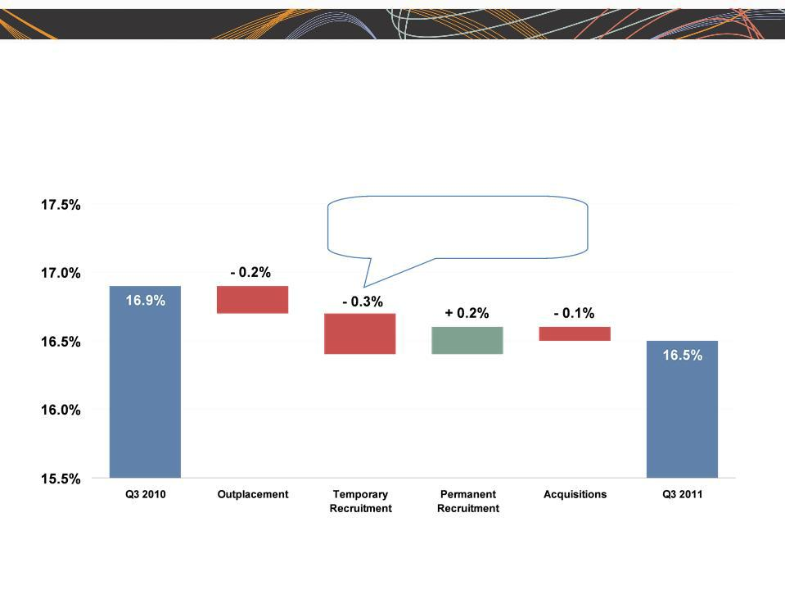
ManpowerGroup 2011 3rd Quarter Results 2011

October

Consolidated Gross Margin Change

U.S.: 2010 Hire Act credits -0.1%

France : lower payroll tax subsidies -0.1%

4

ManpowerGroup 2011 3rd Quarter Results 2011

October

Americas Segment

(21% of Revenue)


Q3 Financial Highlights⁽¹⁾

9% | Revenue $1.2B
8% CC
25% | OUP | $43M
25% CC | OUP | $43M

40 bps OUP Margin 3.5%

- Included in these amounts is the US, which had revenue of $829M (+4%) and OUP of $32M (+24%).

Operating Unit Profit (OUP) is the measure that we use to evaluate segment performance.

OUP is equal to segment revenues less direct costs and branch and national ₅ headquarters operating costs.

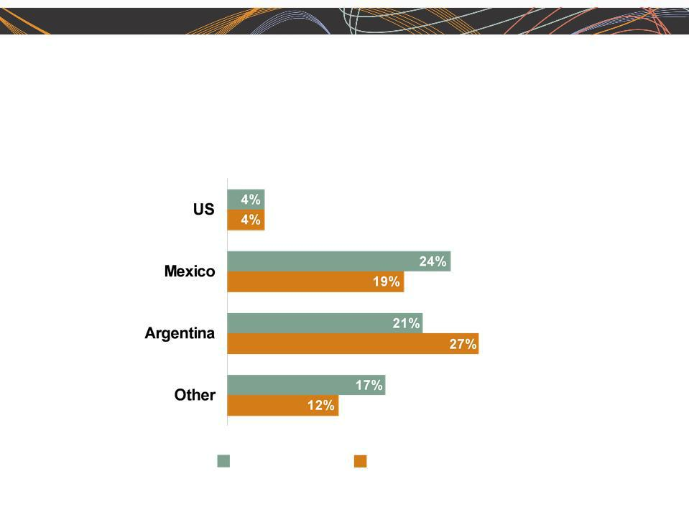
ManpowerGroup 2011 3rd Quarter Results 2011

October

Americas - Q3 Revenue Growth YoY

- of Segment Revenue

69%

12%

6%

13%

Revenue

Growth

Revenue Growth - CC

6

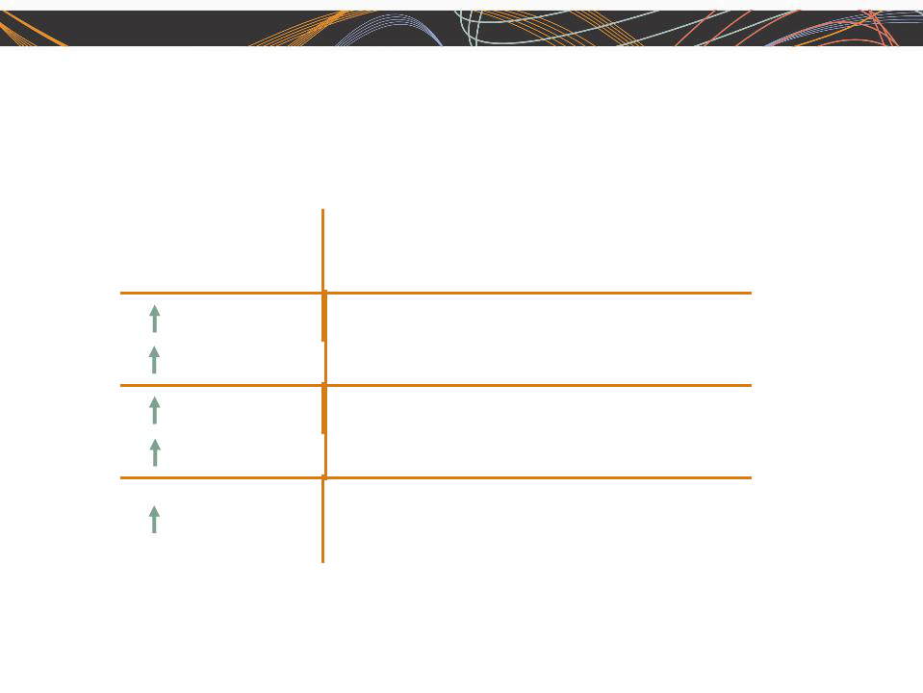
ManpowerGroup 2011 3rd Quarter Results 2011

October

Southern Europe Segment

(38% of Revenue)

Q3 Financial Highlights⁽¹⁾

19% | Revenue $2.2B
9% CC
27% | OUP | $50M
17% CC | OUP | $50M

20 bps OUP Margin 2.3%

- Included in these amounts is France, which had revenue of $1.7B (+8% CC) and OUP of $28M (+2% CC).

7

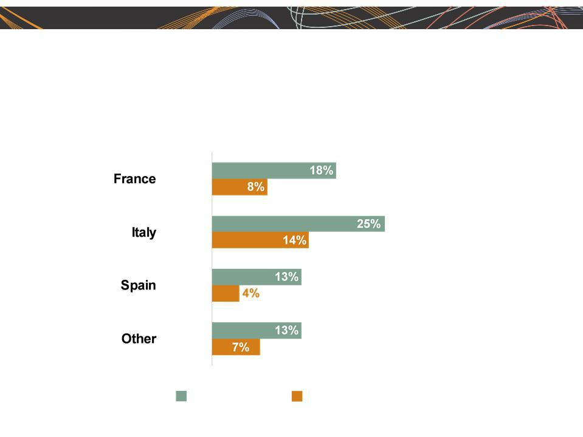
ManpowerGroup 2011 3rd Quarter Results 2011

October

Southern Europe - Q3 Revenue Growth YoY

- of Segment Revenue

76%

15%

5%

4%

Revenue

Growth

Revenue Growth - CC

8

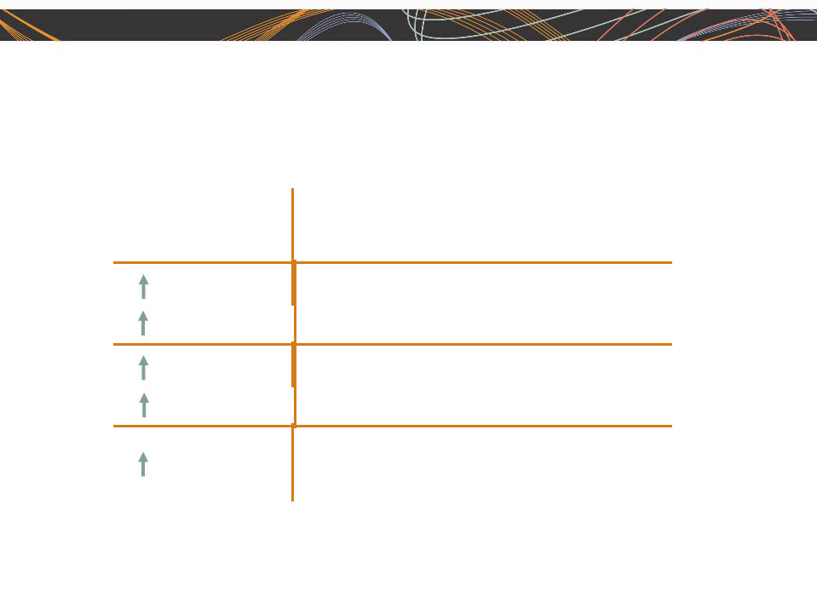
ManpowerGroup 2011 3rd Quarter Results 2011

October

Northern Europe Segment

(28% of Revenue)

Q3 Financial Highlights

17% | Revenue $1.6B
9% CC
58% | OUP | $63M
47% CC | OUP | $63M

100 bps OUP Margin 3.9%

9

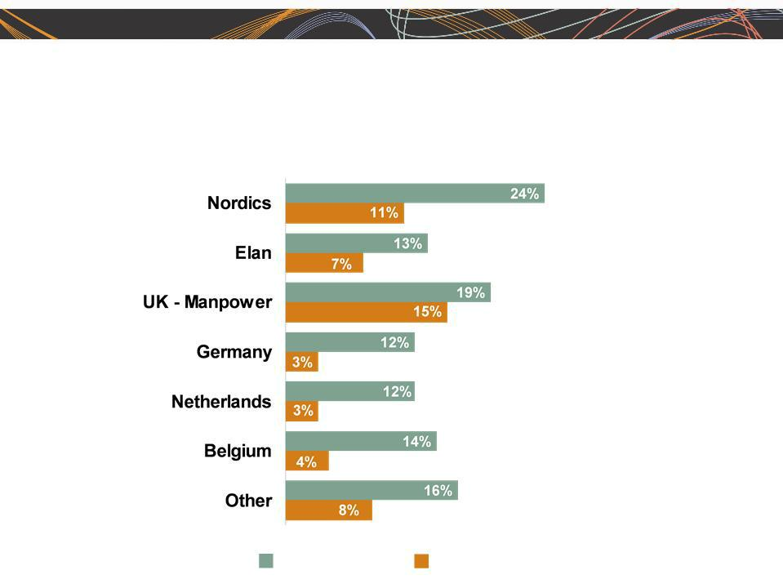
ManpowerGroup 2011 3rd Quarter Results 2011

October

Northern Europe - Q3 Revenue Growth YoY

- of Segment Revenue

19%

17%

15%

13%

10%

7%

19%

Revenue | Revenue Growth - CC | 10
Growth

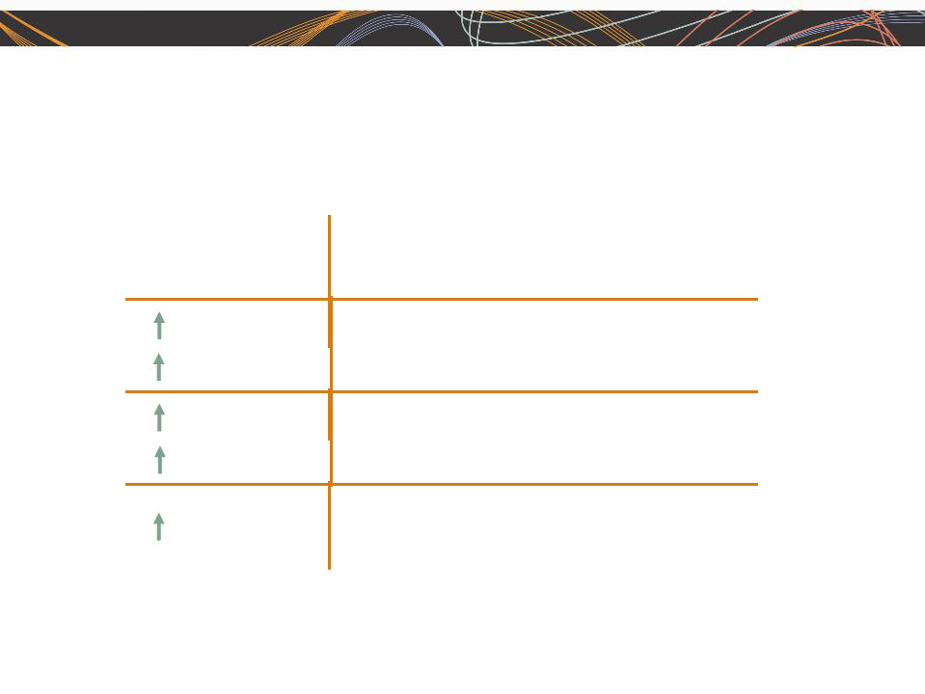
ManpowerGroup 2011 3rd Quarter Results 2011

October

APME Segment

(12% of Revenue)

Q3 Financial Highlights

26% | Revenue $701M
15% CC
64% | OUP | $22M
51% CC | OUP | $22M

70 bps OUP Margin 3.1%

11

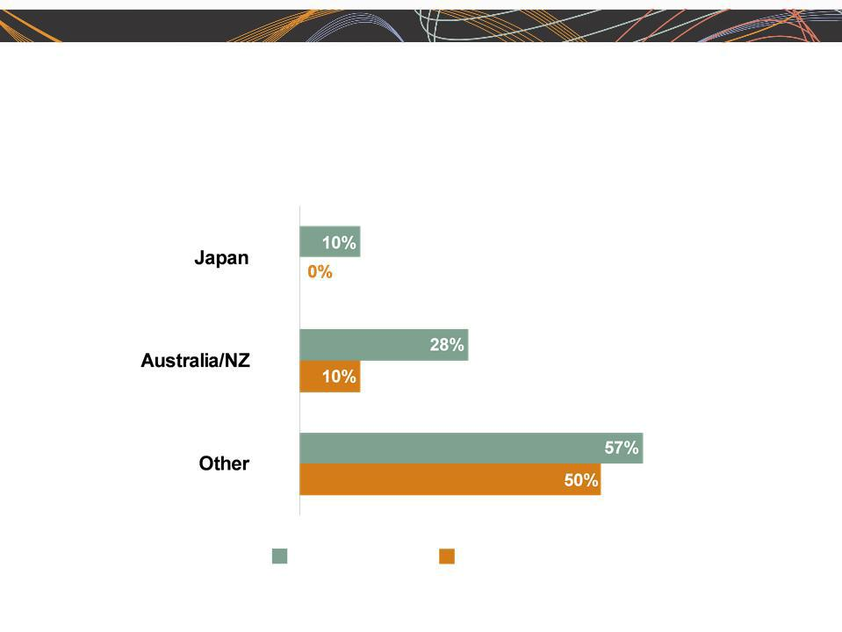
ManpowerGroup 2011 3rd Quarter Results 2011

APME - Q3 Revenue Growth YoY

- of Segment Revenue

43%

28%

29% ⁽¹⁾

Revenue Revenue Growth - CC

Growth
- On an organic basis, Other revenue growth was 19% (+13% CC).

October

12


ManpowerGroup 2011 3rd Quarter Results 2011

October

Right Management Segment

(1% of Revenue)

 | Q3 Financial Highlights
9% | Revenue | $77M
14% CC | Revenue | $77M

N/A | OUP $(2)M
240 bps | OUP Margin (2.4)%

13


ManpowerGroup 2011 3rd Quarter Results 2011

October

Cash Flow Summary - Nine Months

($ in millions) | 2011 | 2010
Cash from Operations | (73) | (56)
Capital Expenditures | (46) | (42)
Free Cash Flow
Free Cash Flow | (119) |  | (98)
Change in Debt | 6 | (19)
Share Repurchases | (43) | (35)
Acquisitions of Business | (32) | (261)
net of cash acquired | (32)
Effect of Exchange Rate Changes | (12) | 8
Other | (9) | (11)
Change in Cash
Change in Cash | (209) |  | (416)

14

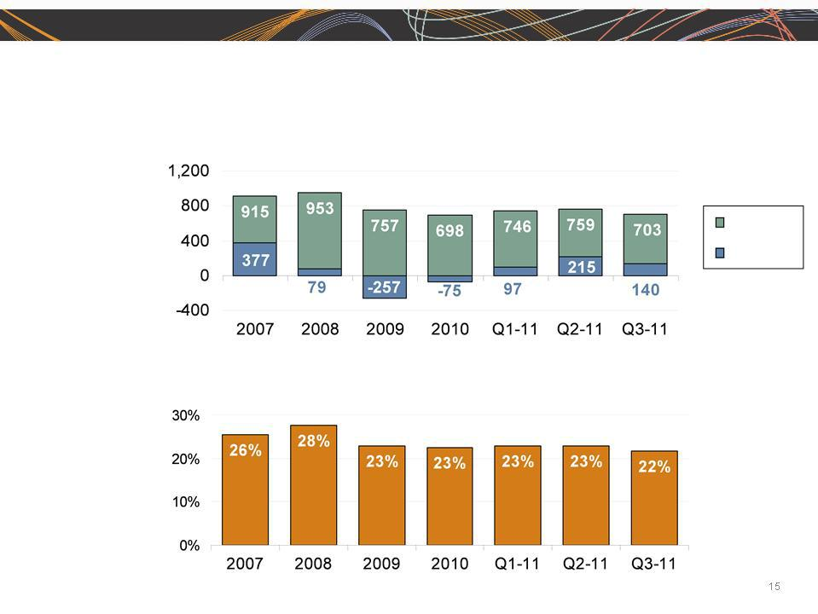
ManpowerGroup 2011 3rd Quarter Results 2011

October

Balance Sheet Highlights

Total Debt

($ in millions)

Total Debt

Net
Debt

Total Debt to

Total Capitalization

ManpowerGroup 2011 3rd Quarter Results |  |  |  |  |  | October
2011
Credit Facilities |  |  |  |  |  |  | Remaining
 |  |  |  |  |  |  | Adjusted
 |  |  |  |  |  |  | Available
($ in millions) |  |  | Total |  | Remaining |  | for New
($ in millions) | Interest | Maturity | Outstanding |  | Available |  | for New
 | Interest | Maturity | Outstanding |  | Available |  | Agreement
 | Rate | Date | at 9/30/11 |  | at 9/30/11 |  | Agreement
Euro Notes:
- Euro 200M | 4.86% | Jun 2013 | 267 | - |  | -
- Euro 300M | 4.58% | Jun 2012 | 401 | - |  | -
Revolving Credit Agreement ⁽¹⁾ | 2.79% | Nov 2012 | - | 398 |  |  | n/a
Revolving Credit Agreement - | 1.51% | Oct 2016 | n/a |  | n/a | 800
New (2)
Uncommitted lines and Other ⁽³⁾ | Various | Various | 35 | 354 |  | 354
Total Debt
Total Debt |  |  | 703 |  | 752 |  | 1,154

  - This $400M agreement required, as of September 30, that we comply with a Debt-to-EBITDA ratio of less than 3.25 to 1 and a fixed charge coverage ratio of greater than 1.50 to 1. As defined in the agreement, we had a Debt-to-EBITDA ratio of 1.17 and a fixed charge coverage ratio of 2.96 as of September 30, 2011. As of September 30, there were $2.2M of standby letters of credit issued under the agreement. This agreement was terminated on October 5, 2011 in connection with our entry into our new $800M agreement.

- We completed a new $800M five year revolving credit agreement on October 5, 2011 with a syndicate of commercial banks .This new agreement replaces the previous $400M agreement. This agreement, which expires in October 2016, allows for borrowings in various currencies and up to $150M may be used for the issuance of stand-by letters of credit. Under this agreement, a debt ratings-based pricing grid determines the credit spread that we add to the applicable interbank borrowing rate on all borrowings as well as the facility and issuance fees. At our current credit ratings, our facility fee is 0.225% and our credit spread for borrowings is 1.275%. This agreement requires that we comply with a Leverage Ratio (Debt-to-EBITDA) of not greater than 3.5 to 1 and a Fixed Charge Coverage Ratio of not less than 1.5 to 1, in addition to other customary restrictive covenants.

(3) Represents subsidiary uncommitted lines of credit & overdraft facilities, which total $386.9M. Total subsidiary borrowing are limited to $300M due to | 16
restrictions in our Revolving Credit Facility, with the exception of Q3 when subsidiary borrowings are limited to $600M. | 16

ManpowerGroup 2011 3rd Quarter Results 2011

October

Fourth Quarter Outlook

 | Revenue | Total | Up 7-9% (Up 5-7% CC)
 |  | Americas | Up 3-5% (Up 4-6% CC)
 |  | Southern Europe | Up 7-9% (Up 5-7% CC)
 |  | Northern Europe | Up 7-9% (Up 5-7% CC)
 |  | APME | Up 16-18% (Up 10-12% CC)
 |  | Right Management | Down 7-9% (Down 8-10% CC)
 | Gross Profit Margin |  | 16.9 - 17.1%
 | Operating Profit Margin^{(a)} |  | 2.5 - 2.7%
 | Tax Rate |  | 46%
 | EPS^{(a)} |  | $0.85 - $0.95 (Favorable $.03 Currency)
 | ^{(a)} Excludes anticipated reorganization charges of $16M-$22M ($0.15-$0.20 per diluted share). |  |  | 17

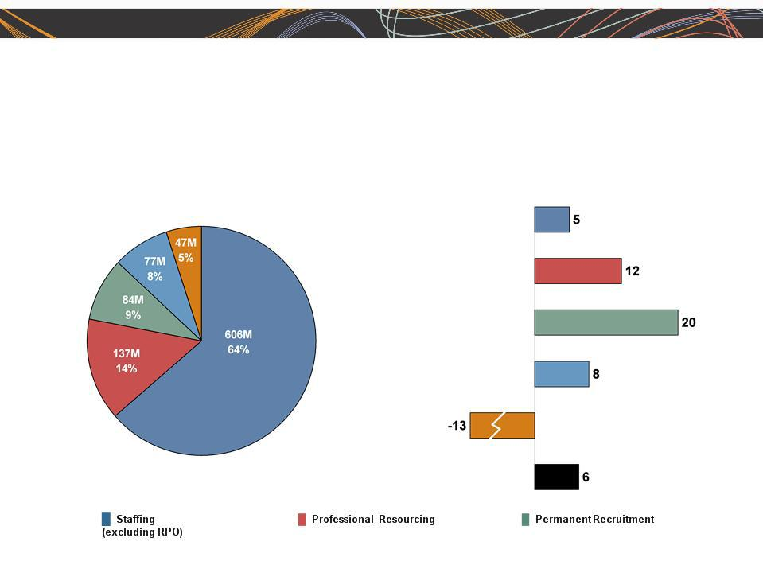
ManpowerGroup 2011 3rd Quarter Results 2011

October

Gross Profit Development - Q3 2011

Business Line Gross Profit | Gross Profit Growth
$951M | in CC %

18
█ ManpowerGroup Solutions █ Talent & Career Management █ ManpowerGroup - Total



Questions

