UNITED STATES

SECURITIES AND EXCHANGE COMMISSION

Washington, D.C. 20549

FORM 8-K

CURRENT REPORT

Pursuant to Section 13 or 15(d) of the Securities Exchange Act of 1934

Date of Report (Date of earliest event reported): July 19, 2006

MANPOWER INC.

(Exact name of registrant as specified in its charter)

Wisconsin

1-10686

39-1672779

(State or other jurisdiction

of incorporation)

(Commission

File Number)

(IRS Employer
Identification No.)

5301 North Ironwood Road

Milwaukee, Wisconsin

53217

(Address of principal executive offices)

(Zip Code)

Registrant’s telephone number, including area code: (414) 961-1000

Check the appropriate box below if the Form 8-K filing is intended to simultaneously satisfy the filing obligation of the registrant under any of the following provisions:

- Written communications pursuant to Rule 425 under the Securities Act (17 CFR 230.425)

- Soliciting material pursuant to Rule 14a-12 under the Securities Act (17 CFR 240.14a-12)

- Pre-commencement communications pursuant to Rule 14d-2(b) under the Exchange Act (17 CFR 240.14d-2(b))

- Pre-commencement communications pursuant to Rule 13e-4(c) under the Exchange Act (17 CFR 240.13e-4(c))

Item 2.02 Results of Operations and Financial Condition

On July 19, 2006, we issued a press release announcing our results of operations for the quarter and six-month period ended June 30, 2006. A copy of the press release is attached hereto as Exhibit 99.1 and is incorporated herein by reference.

Item 9.01. |  | Exhibits.
 | Exhibit No. |  |  | Description
 | 99.1 |  |  | Press Release dated July 19, 2006
99.2 |  |  |  | Presentation materials for July 19, 2006 conference call

SIGNATURES

Pursuant to the requirements of the Securities Exchange Act of 1934, the Registrant has duly caused this Report to be signed on its behalf by the undersigned hereunto duly authorized.

 | MANPOWER INC.
Dated: July 19, 2006 | By: /s/ Michael J. Van Handel
 |  | Michael J. Van Handel
 |  | Executive Vice President,
 |  | Chief Financial Officer and Secretary

 |  | EXHIBIT INDEX
Exhibit No. |  | Description
99.1 |  | Press Release dated July 19, 2006
99.2 |  | Presentation materials for July 19, 2006 conference call

Exhibit 99.1

[MANPOWER logo]

FOR IMMEDIATE RELEASE

Contact:

Mike Van Handel

Manpower Inc.

+1.414.906.6305

michael.vanhandel@manpower.com

Manpower Reports 2nd Quarter and First Half 2006 Results

MILWAUKEE, WI, USA, July 19, 2006 – Manpower Inc. (NYSE: MAN) today reported that earnings per diluted share for the three months ended June 30, 2006 increased 30 percent to 91 cents from 70 cents in the prior year period. Net income in the quarter increased to $80.4 million from $62.5 million a year earlier. Revenues for the second quarter totaled $4.4 billion, an increase of 10 percent from the year-earlier period. Results for the second quarter were not significantly impacted by changes in foreign currency exchange rates.

Jeffrey A. Joerres, Manpower Chairman and Chief Executive Officer, said, “We had very strong results across nearly all business units in the second quarter. The relentless execution of our key strategies of elevating and broadening our relationships with our clients, and improving our efficiency through speed and quality is producing superior results.

“Our performance underscores the momentum that we have established over the past eighteen months. As we move into the second half of 2006, our major geographies and business units continue to be well-positioned for a strong year.

“We are anticipating the third quarter of 2006 diluted earnings per share to be in the range of $1.00 to $1.04, which includes an estimated favorable currency impact of 2 cents,” Joerres stated.

Earnings per diluted share for the six months ended June 30, 2006 were $1.50, an increase of 46 percent from $1.03 per diluted share in 2005. Net income was $133.0 million compared to $94.7 million the prior year. Revenues for the six-month period were $8.4 billion, an increase of 7 percent from the prior year or 11 percent in constant currency. Foreign currency exchange rates had a negative impact of 5 cents for the six-month period.

Included in the 2006 six-month period was a 27 cents per diluted share gain on the sale of a payroll processing business in Sweden, and a 16 cents per diluted share charge related to reorganization and a global cost reduction initiative.

- MORE -

Manpower Inc. Reports 2nd Quarter Results/Page 2

In conjunction with its second quarter earnings release, Manpower will broadcast its conference call live over the Internet on July 19, 2006 at 7:30 a.m. CDT (8:30 a.m. EDT).

Interested parties are invited to listen to the webcast by logging on to http://investor.manpower.com.

Supplemental financial information referenced in the conference call can be found at http://investor.manpower.com.

About Manpower Inc.

Manpower Inc. (NYSE: MAN) is a world leader in the employment services industry; creating and delivering services that enable its clients to win in the changing world of work. The $16 billion company offers employers a range of services for the entire employment and business cycle including permanent, temporary and contract recruitment; employee assessment and selection; training; outplacement; outsourcing and consulting. Manpower’s worldwide network of 4,400 offices in 72 countries and territories enables the company to meet the needs of its 400,000 clients per year, including small and medium size enterprises in all industry sectors, as well as the world’s largest multinational corporations. The focus of Manpower’s work is on raising productivity through improved quality, efficiency and cost-reduction across their total workforce, enabling clients to concentrate on their core business activities. Manpower Inc. operates under five brands: Manpower, Manpower Professional, Elan, Jefferson Wells and Right Management. More information on Manpower Inc. is available at www.manpower.com.

Forward-Looking Statements

This news release contains statements, including earning projections, that are forward-looking in nature and, accordingly, are subject to risks and uncertainties regarding the Company’s expected future results. The Company’s actual results may differ materially from those described or contemplated in the forward-looking statements. Factors that may cause the Company’s actual results to differ materially from those contained in the forward-looking statements can be found in the Company’s reports filed with the SEC, including the information under the heading ‘Risk Factors’ in its Annual Report on Form 10-K for the year ended December 31, 2005, which information is incorporated herein by reference.

Manpower Inc.

Results of Operations

(In millions, except per share data)

 |  |  |  | Three Months Ended June 30
 |  |  |  |  |  |  |  |  | % Variance
 |  |  |  |  |  |  |  |  | Amount |  | Constant
 |  |  | 2006 |  |  | 2005 |  | Reported |  |  | Currency
 |  |  |  |  |  |  | (Unaudited)
Revenues from services (a) | $ |  | 4,440.0 | $ |  | 4,053.7 |  | 9.5% |  |  | 10.0%
Cost of services |  |  | 3,623.6 |  |  | 3,314.5 |  | 9.3%
Gross profit |  |  | 816.4 |  |  | 739.2 |  | 10.4% |  |  | 10.9%
Selling and administrative expenses |  |  | 677.3 |  |  | 629.5 |  | 7.6% |  |  | 8.1%
Operating profit |  |  | 139.1 |  |  | 109.7 |  | 26.9% |  |  | 26.8%
Interest and other expenses |  |  | 12.5 |  |  | 11.3 |  | 11.2%
Earnings before income taxes |  |  | 126.6 |  |  | 98.4 |  | 28.7%
Provision for income taxes |  |  | 46.2 |  |  | 35.9 |  | 28.7%
Net earnings |  | $ | 80.4 | $ |  | 62.5 |  | 28.6% |  |  | 28.2%
Net earnings per share - basic |  |  |  |  |  |  |  | 29.6%
Net earnings per share - basic | $ |  | 0.92 | $ |  | 0.71
Net earnings per share - diluted | $ |  | 0.91 | $ |  | 0.70 |  | 30.0% |  |  | 28.6%
Weighted average shares - basic |  |  |  |  |  |  |  | -1.5%
Weighted average shares - basic |  |  | 87.3 |  |  | 88.6
Weighted average shares - diluted |  |  | 88.7 |  |  | 89.5 |  | -0.9%

- Revenues from services include fees received from our franchise offices of $8.8 million for the three months ended June 30, 2006 and 2005. These fees are primarily based on revenues generated by the franchise offices, which were $388.8 million and $375.7 million for the three months ended June 30, 2006 and 2005, respectively.

Manpower Inc.

Operating Unit Results

(In millions)

 |  |  |  | Three Months Ended June 30
 |  |  |  |  |  |  |  |  | % Variance
 |  |  |  |  |  |  |  |  | Amount |  | Constant
 |  | 2006 |  |  |  | 2005 |  | Reported |  |  | Currency
 |  |  |  |  |  |  | (Unaudited)
Revenues from Services: (a)
United States (b) | $ | 534.6 |  | $ |  | 506.7 |  | 5.5% |  |  | 5.5%
France |  | 1,535.6 |  |  |  | 1,397.0 |  | 9.9% |  |  | 9.8%
EMEA |  | 1,590.1 |  |  |  | 1,430.4 |  | 11.2% |  |  | 11.6%
Jefferson Wells |  | 98.8 |  |  |  | 93.5 |  | 5.7% |  |  | 5.7%
Right Management |  | 103.9 |  |  |  | 108.5 |  | -4.2% |  |  | -4.1%
Other Operations |  | 577.0 |  |  |  | 517.6 |  | 11.4% |  |  | 14.2%
 | $ | 4,440.0 |  | $ |  | 4,053.7 |  | 9.5% |  |  | 10.0%
Operating Unit Profit: (a)
United States | $ | 22.5 |  | $ |  | 18.0 |  | 25.2% |  |  | 25.2%
France |  | 49.7 |  |  |  | 42.0 |  | 18.3% |  |  | 17.7%
EMEA |  | 51.7 |  |  |  | 37.9 |  | 36.3% |  |  | 35.4%
Jefferson Wells |  | 10.0 |  |  |  | 9.3 |  | 7.7% |  |  | 7.7%
Right Management |  | 11.1 |  |  |  | 9.3 |  | 19.0% |  |  | 17.6%
Other Operations |  | 14.8 |  |  |  | 13.2 |  | 13.0% |  |  | 17.6%
 |  | 159.8 |  |  |  | 129.7
Corporate expenses |  | 17.4 |  |  |  | 16.7
Amortization of intangible assets |  | 3.3 |  |  |  | 3.3
Operating profit |  | 139.1 |  |  |  | 109.7 |  | 26.9% |  |  | 26.8%
Interest and other expenses (c) |  | 12.5 |  |  |  | 11.3
Earnings before income taxes | $ | 126.6 |  | $ |  | 98.4

- Certain Eastern European countries previously reported in France are now reported in EMEA due to a change in management structure. All previously reported results for France and EMEA have been restated to conform to the current presentation.

- In the United States, revenues from services include fees received from the related franchise offices of $6.0 million and $6.3 million for the three months ended June 30, 2006 and 2005, respectively. These fees are primarily based on revenues generated by the franchise offices, which were $291.9 million and $296.8 million for the three months ended June 30, 2006 and 2005, respectively.

- The components of interest and other expenses were:

 | 2006 |  |  | 2005
Interest expense | $13.1 |  | $10.7
Interest income | (3.8) |  | (2.1)
Foreign exchange losses (gains) | 1.3 |  | (0.6)
Miscellaneous expenses, net | 1.9 |  |  | 3.3
 | $12.5 |  | $11.3

Manpower Inc.

Results of Operations

(In millions, except per share data)

 |  |  |  | Six Months Ended June 30
 |  |  |  |  |  |  |  | % Variance
 |  |  |  |  |  |  |  | Amount |  | Constant
 |  | 2006 |  |  |  | 2005 |  | Reported |  | Currency
 |  |  |  |  |  | (Unaudited)
Revenues from services (a) | $ | 8,369.9 |  | $ |  | 7,812.4 | 7.1% |  |  | 10.7%
Cost of services |  | 6,836.1 |  |  |  | 6,391.2 | 7.0%
Gross profit |  | 1,533.8 |  |  |  | 1,421.2 | 7.9% |  |  | 11.3%
Selling and administrative expenses |  | 1,335.0 |  |  |  | 1,249.0 | 6.9% |  |  | 10.2%
Operating profit |  | 198.8 |  |  |  | 172.2 | 15.5% |  |  | 18.9%
Interest and other (income) expenses |  | (3.8) |  |  |  | 23.0 |  | N/A
Earnings before income taxes |  | 202.6 |  |  |  | 149.2 | 35.8%
Provision for income taxes |  | 69.6 |  |  |  | 54.5 | 27.8%
Net earnings | $ | 133.0 |  |  | $ | 94.7 | 40.4% |  |  | 45.3%
Net earnings per share - basic |  |  |  |  |  |  | 43.4%
Net earnings per share - basic | $ | 1.52 |  | $ |  | 1.06
Net earnings per share - diluted | $ | 1.50 |  |  | $ | 1.03 | 45.6% |  |  | 50.5%
Weighted average shares - basic |  |  |  |  |  |  | -2.1%
Weighted average shares - basic |  | 87.3 |  |  |  | 89.2
Weighted average shares - diluted |  | 88.8 |  |  |  | 93.2 | -4.8%

- Revenues from services include fees received from our franchise offices of $16.8 million and $17.1 million for the six months ended June 30, 2006 and 2005, respectively. These fees are primarily based on revenues generated by the franchise offices, which were $751.6 million and $725.5 million for the six months ended June 30, 2006 and 2005, respectively.

Manpower Inc.

Operating Unit Results

(In millions)

 |  |  |  | Six Months Ended June 30
 |  |  |  |  |  |  |  | % Variance
 |  |  |  |  |  |  |  | Amount |  | Constant
 |  | 2006 |  |  |  | 2005 |  | Reported |  | Currency
 |  |  |  |  |  | (Unaudited)
Revenues from Services: (a)
United States (b) | $ | 1,044.9 |  | $ |  | 982.6 | 6.3% |  |  | 6.3%
France |  | 2,776.1 |  |  |  | 2,635.0 | 5.4% |  |  | 9.5%
EMEA |  | 3,023.0 |  |  |  | 2,773.0 | 9.0% |  |  | 13.7%
Jefferson Wells |  | 194.3 |  |  |  | 186.2 | 4.3% |  |  | 4.3%
Right Management |  | 199.9 |  |  |  | 212.5 | -5.9% |  |  | -4.2%
Other Operations |  | 1,131.7 |  |  |  | 1,023.1 | 10.6% |  |  | 14.1%
 | $ | 8,369.9 |  | $ |  | 7,812.4 | 7.1% |  |  | 10.7%
Operating Unit Profit: (a)
United States | $ | 32.0 |  | $ |  | 22.9 | 39.8% |  |  | 39.8%
France |  | 80.1 |  |  |  | 70.4 | 13.8% |  |  | 17.3%
EMEA |  | 74.1 |  |  |  | 52.0 | 42.3% |  |  | 45.9%
Jefferson Wells |  | 15.7 |  |  |  | 17.4 | -9.6% |  |  | -9.6%
Right Management |  | 15.4 |  |  |  | 19.1 | -19.5% |  |  | -20.7%
Other Operations |  | 32.7 |  |  |  | 25.7 | 27.7% |  |  | 34.4%
 |  | 250.0 |  |  |  | 207.5
Corporate expenses |  | 44.7 |  |  |  | 28.8
Amortization of intangible assets |  | 6.5 |  |  |  | 6.5
Operating profit |  | 198.8 |  |  |  | 172.2 | 15.5% |  |  | 18.9%
Interest and other (income) expenses (c) |  | (3.8) |  |  |  | 23.0
Earnings before income taxes | $ | 202.6 |  |  | $ | 149.2

- Certain Eastern European countries previously reported in France are now reported in EMEA due to a change in management structure. All previously reported results for France and EMEA have been restated to conform to the current presentation.

- In the United States, revenues from services include fees received from the related franchise offices of $11.3 million and $11.7 million for the six months ended June 30, 2006 and 2005, respectively. These fees are primarily based on revenues generated by the franchise offices, which were $574.2 million and $574.4 million for the six months ended June 30, 2006 and 2005, respectively.

- The components of interest and other (income) expenses were:

 |  |  | 2006 |  |  | 2005
Interest expense | $ |  | 24.7 |  | $22.3
Interest income |  |  | (7.1) |  | (4.4)
Foreign exchange losses |  |  | 2.2 |  | 0.2
Miscellaneous (income) expense, net |  |  | (23.6) |  | 4.9
 |  | $ | (3.8) |  | $23.0

Manpower Inc.

Consolidated Balance Sheets

(In millions)

 |  | Jun. 30 |  |  | Dec. 31
 |  | 2006 |  |  | 2005
 |  | (Unaudited)
ASSETS
Current assets:
Cash and cash equivalents | $ | 768.1 |  | $ | 454.9
Accounts receivable, net |  | 3,610.8 |  |  | 3,208.2
Prepaid expenses and other assets |  | 109.6 |  |  | 107.5
Future income tax benefits |  | 94.8 |  |  | 71.1
Total current assets |  | 4,583.3 |  |  | 3,841.7
Other assets:
Goodwill and other intangible assets, net |  | 1,281.1 |  |  | 1,256.5
Other assets |  | 334.2 |  |  | 273.8
Total other assets |  | 1,615.3 |  |  | 1,530.3
Property and equipment:
Land, buildings, leasehold improvements and equipment |  | 687.0 |  |  | 642.4
Less: accumulated depreciation and amortization |  | 485.4 |  |  | 446.0
Net property and equipment |  | 201.6 |  |  | 196.4
 | $ | 6,400.2 |  | $ | 5,568.4
LIABILITIES AND SHAREHOLDERS’ EQUITY
Current liabilities:
Accounts payable | $ | 898.0 |  | $ | 685.4
Employee compensation payable |  | 151.7 |  |  | 150.6
Accrued liabilities |  | 559.0 |  |  | 435.4
Accrued payroll taxes and insurance |  | 603.8 |  |  | 607.2
Value added taxes payable |  | 480.6 |  |  | 441.9
Short-term borrowings and current maturities of long-term debt |  | 281.3 |  |  | 260.0
Total current liabilities |  | 2,974.4 |  |  | 2,580.5
Other liabilities:
Long-term debt |  | 766.3 |  |  | 475.0
Other long-term liabilities |  | 390.6 |  |  | 366.3
Total other liabilities |  | 1,156.9 |  |  | 841.3
Shareholders’ equity:
Common stock |  | 1.0 |  |  | 1.0
Capital in excess of par value |  | 2,389.5 |  |  | 2,346.7
Retained earnings |  | 379.2 |  |  | 269.9
Accumulated other comprehensive income (loss) |  | 68.8 |  |  | (11.0)
Treasury stock, at cost |  | (569.6) |  |  | (460.0)
Total shareholders’ equity |  | 2,268.9 |  |  | 2,146.6
Total liabilities and shareholders’ equity | $ | 6,400.2 |  | $ | 5,568.4

Manpower Inc.

Consolidated Statements of Cash Flows

(In millions)

 |  | Six Months Ended
 |  |  | June 30
 |  | 2006 |  |  | 2005
 |  |  | (Unaudited)
 | Cash Flows from Operating Activities:
 | Net earnings | $ 133.0 |  | $ | 94.7
 | Adjustments to reconcile net earnings to net cash provided by operating activities:
 | Depreciation and amortization | 43.8 |  |  | 45.5
 | Amortization of discount on convertible debentures | — |  |  | 1.9
 | Deferred income taxes | (25.3) |  |  | (6.8)
 | Provision for doubtful accounts | 11.8 |  |  | 8.2
 | Stock based compensation | 10.2 |  |  | 0.8
 | Excess tax benefit on exercise of stock options | (1.6) |  |  | —
 | Other non-operating gains | (29.3) |  |  | —
 | Changes in operating assets and liabilities excluding the impact of acquisitions:
 | Accounts receivable | (216.4) |  |  | (140.9)
 | Other assets | 18.1 |  |  | (23.9)
 | Other liabilities | 191.3 |  |  | 119.7
 | Cash provided by operating activities | 135.6 |  |  | 99.2
Cash Flows from Investing Activities:
 | Capital expenditures | (34.8) |  |  | (36.1)
 | Acquisitions of businesses, net of cash acquired | (7.2) |  |  | (3.1)
 | Proceeds from sale of business | 29.6 |  |  | —
 | Proceeds from sale of an equity interest | 8.8 |  |  | —
 | Proceeds from the sale of property and equipment | 3.1 |  |  | 3.1
 | Cash used by investing activities | (0.5) |  |  | (36.1)
 | Cash Flows from Financing Activities:
 | Net borrowings of short-term facilities and long-term debt | 250.8 |  |  | 174.2
 | Cash paid to settle convertible debentures | — |  |  | (206.6)
 | Proceeds from settlement of swap agreements | — |  |  | 50.7
 | Proceeds from stock option and purchase plans | 40.6 |  |  | 8.4
 | Excess tax benefit on exercise of stock options | 1.6 |  |  | —
 | Repurchases of common stock | (119.1) |  |  | (203.5)
 | Dividends paid | (23.7) |  |  | (17.6)
 | Cash provided (used) by financing activities | 150.2 |  |  | (194.4)
Effect of exchange rate changes on cash
 |  | 27.9 |  |  | (37.2)
 | Change in cash and cash equivalents | 313.2 |  |  | (168.5)
 | Cash and cash equivalents, beginning of period | 454.9 |  |  | 531.8
 | Cash and cash equivalents, end of period | $ 768.1 |  | $ | 363.3

Manpower Inc.
nd

Exhibit 99.2


July 19, 2006

Now
Next

Manpower Inc. 2006 2nd Quarter Results | 2
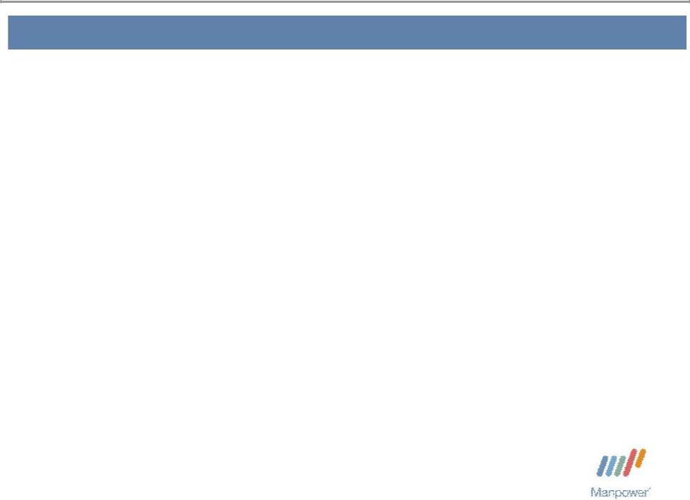

Forward Looking Statement

This presentation includes forward-looking statements which are subject to risks and uncertainties. Actual results might differ materially from those projected in the forward-looking statements. Forward-looking statements can be identified by words such as “expect,” “plan,” “may,” “will,” and similar expressions. Additional information concerning factors that could cause actual results to materially differ from those in the forward-looking statements is contained in the Company’s Annual Report on Form 10-K dated December 31, 2005, which information is incorporated herein by reference, and such other factors as may be described from time to time in the Company’s SEC filings.

Manpower Inc. 2006 2nd Quarter Results | 3
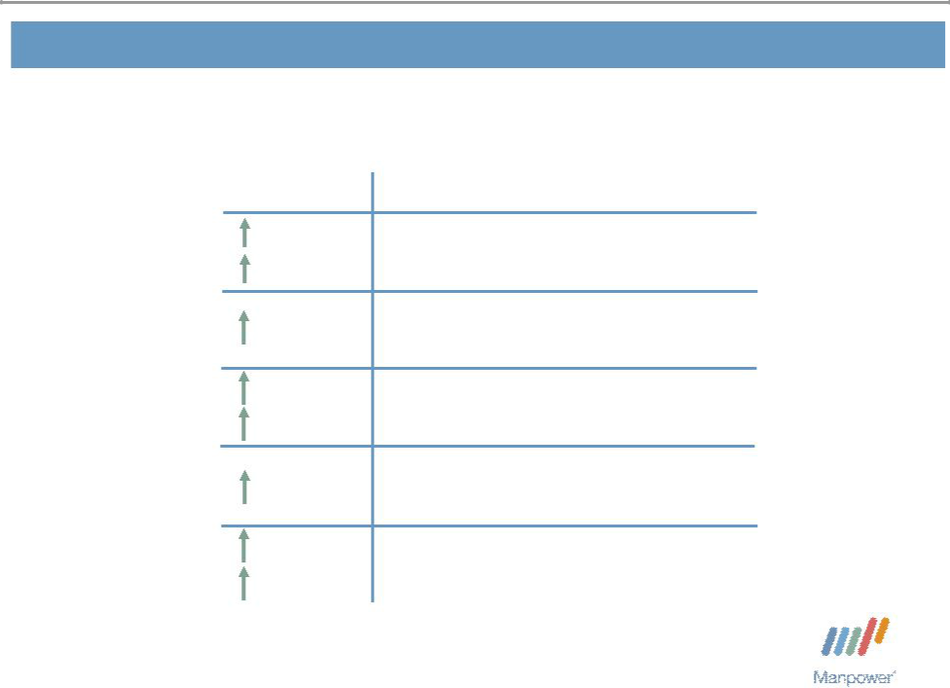

Consolidated Financial Highlights

 | Q2 Highlights
10% | Revenue $4.4B
10% CC | Revenue $4.4B
15 bps | Gross Margin 18.4%
27% | Operating Profit $139M
27% CC | Operating Profit $139M
40 bps OP Margin 3.1%
30% | EPS $ .91
29% CC | EPS $ .91

Throughout this presentation, the difference between reported variances and Constant Currency

- variances represents the impact of currency on our financial results. Constant Currency is further explained on our Web site.

Manpower Inc. 2006 2nd Quarter Results | 4
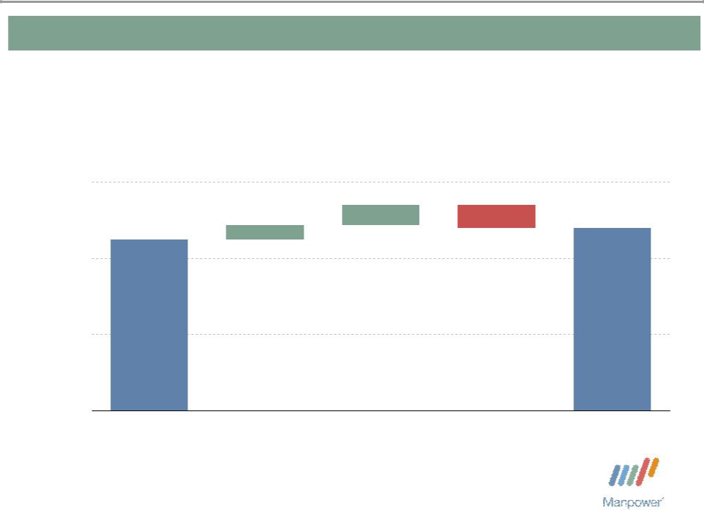

Consolidated Gross Profit Margin Change

19%

+ 0.27% - 0.31%

+ 0.19%
_{18%} 18.24%

17%

16%

18.39%

Q2 2005 | Temporary | Permanent | Mix - Right | Q2 2006
 | Recruitment | Recruitment

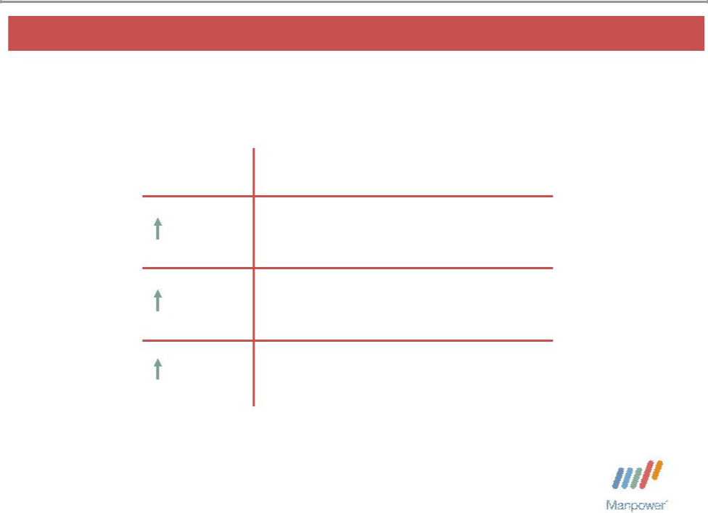
Manpower Inc. 2006 2nd Quarter Results | 5

United States Segment

Q2 Financial Highlights

6% Revenue $535M

25% OUP $22M

70 bps OUP Margin 4.2%

Operating Unit Profit (OUP) is the measure that we use to evaluate segment performance. OUP is equal to segment revenues less direct costs and branch and national headquarters operating costs.

Manpower Inc. 2006 2nd Quarter Results | 6
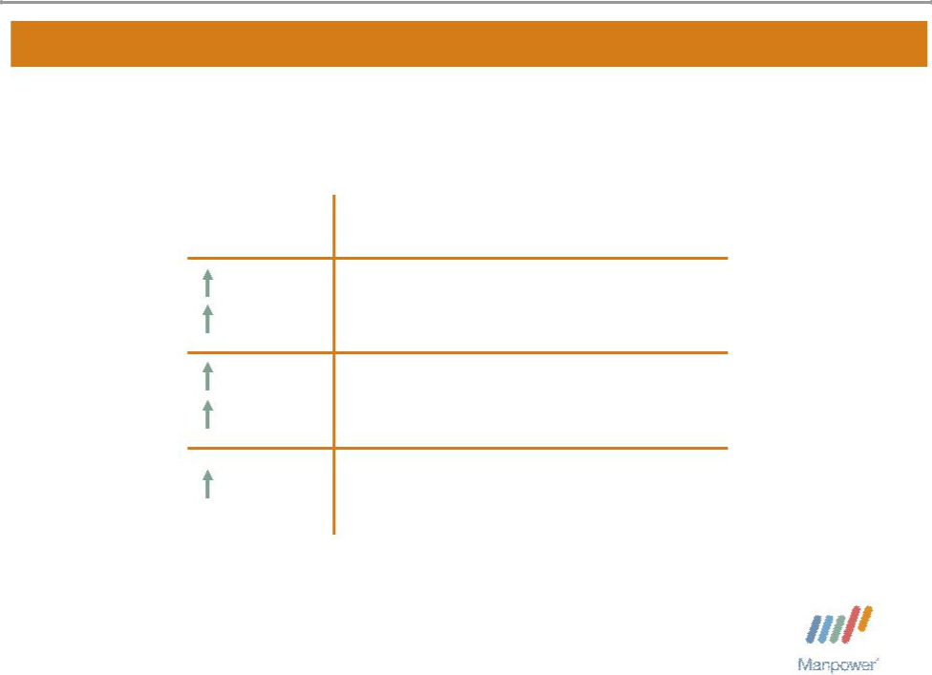

France Segment

 | Q2 Financial Highlights
10% | Revenue $1.5B
10% CC | Revenue $1.5B
18% | contemporary working
18% | OUP $50M
18% CC | OUP $50M
20 bps | OUP Margin 3.2%

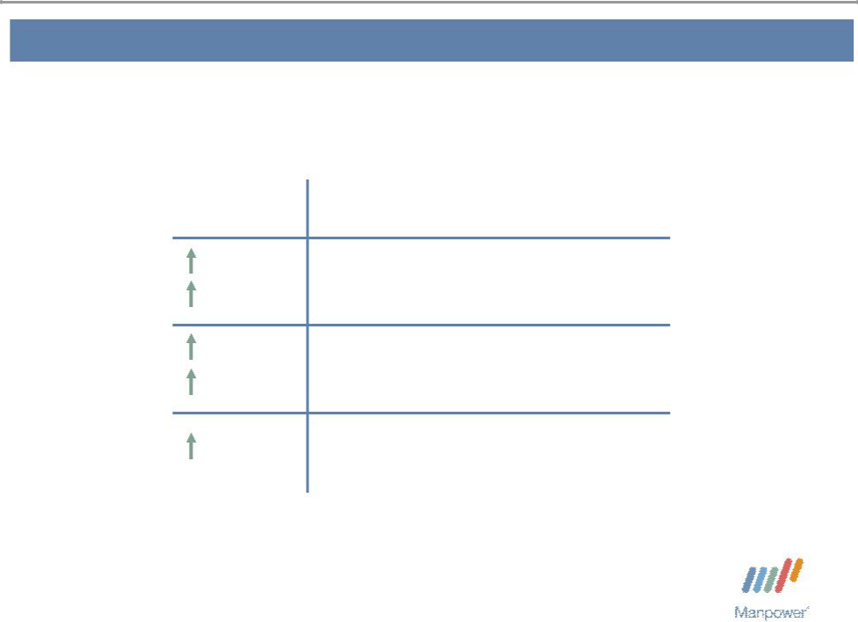
Manpower Inc. 2006 2nd Quarter Results | 7

EMEA Segment

 | Q2 Financial Highlights
11% | Revenue $1.6B
12% CC | Revenue $1.6B
36% | contemporary working
36% | OUP $52M
35% CC | OUP $52M
60 bps | OUP Margin 3.2%

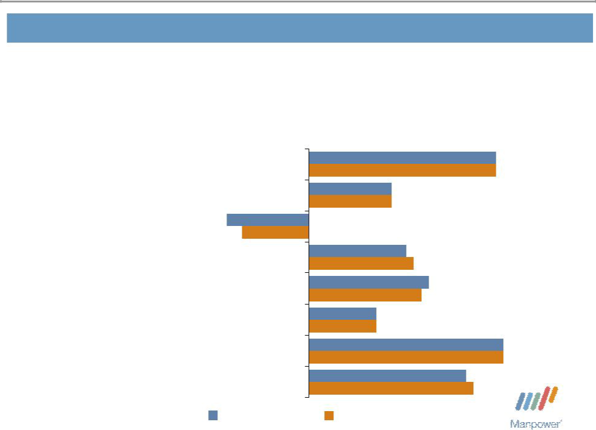
Manpower Inc. 2006 2nd Quarter Results | 8

EMEA – Q2 Revenue Growth YoY

- of Segment Revenue

18% Italy

18% Nordics

14% UK - Manpower

12% Elan

7% Germany

7% Spain

7% Holland

17% Other

25%

25%

11%
11%

-11%
-9%

13%
14%

16%
15%

9%
9%

26%
26%

21%
22%

Revenue Growth Revenue Growth - CC

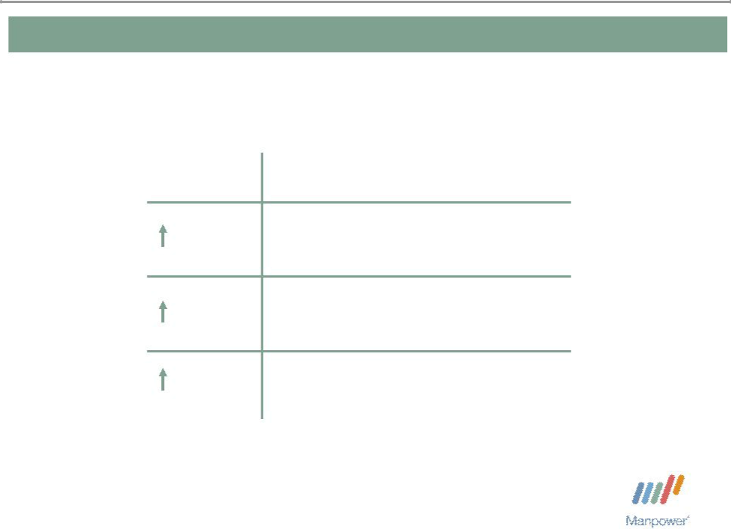
Manpower Inc. 2006 2nd Quarter Results 9

Jefferson Wells Segment

Q2 Financial Highlights

6% Revenue $99M

contemporary working
8% OUP $10M

20 bps OUP Margin 10.2%

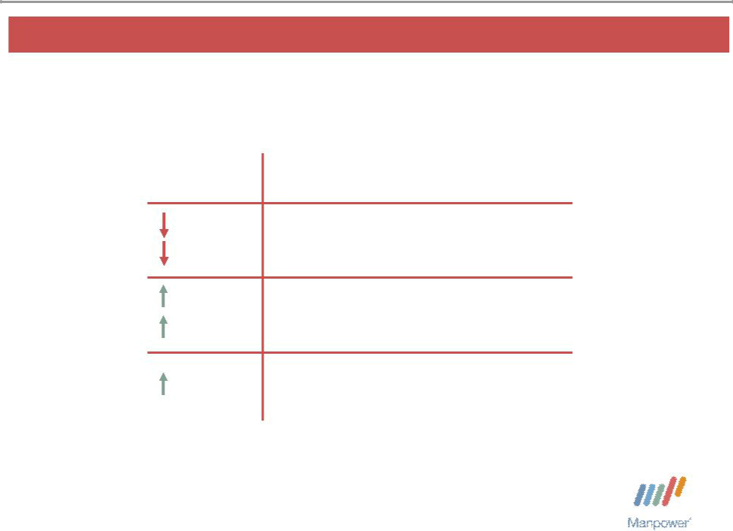
Manpower Inc. 2006 2nd Quarter Results 10

Right Management Segment

 | Q2 Financial Highlights
4% | Revenue $104M
4% CC | Revenue $104M
19% | contemporary working
19% | OUP $11M
18% CC | OUP $11M
200 bps | OUP Margin 10.6%

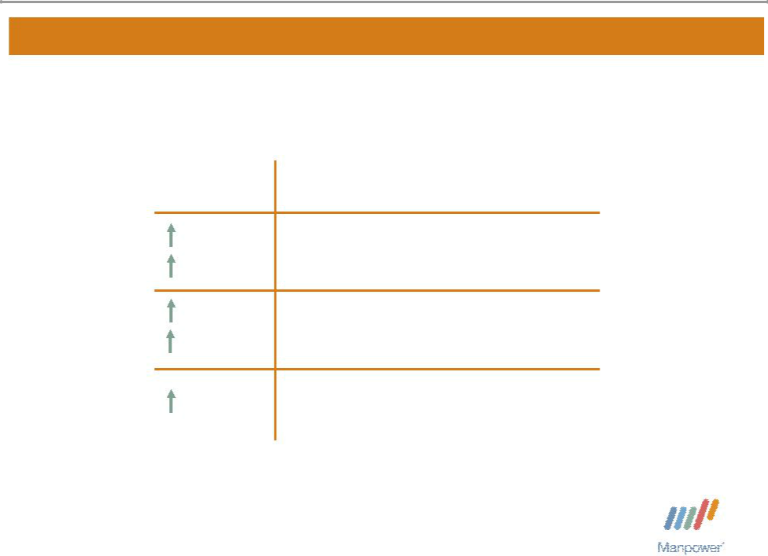
Manpower Inc. 2006 2nd Quarter Results | 11

Other Operations Segment

 | Q2 Financial Highlights
11% | Revenue $577M
14% CC | Revenue $577M
13% | contemporary working
13% | OUP $15M
18% CC | OUP $15M
10 bps | OUP Margin 2.6%

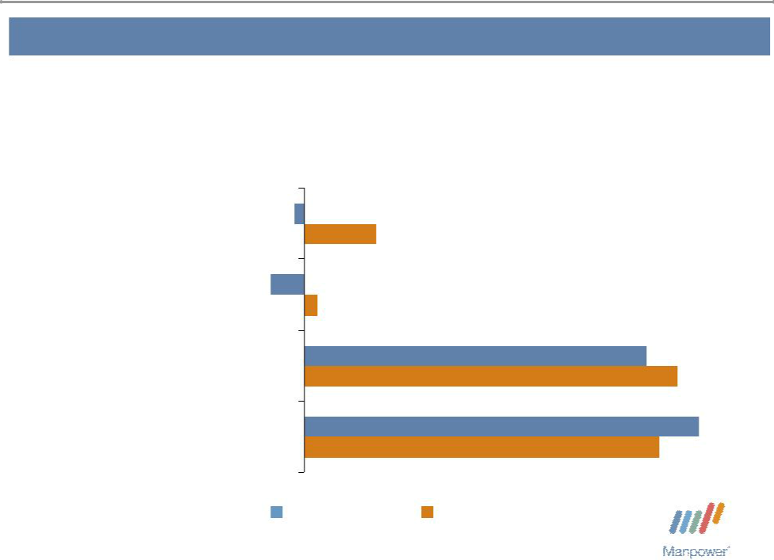
Manpower Inc. 2006 2nd Quarter Results | 12

Other Operations – Q2 Revenue Growth YoY

- of Segment Revenue

37% | Japan | -1%
37% | Japan | 6%
15% | Australia/NZ | -3%
15% | Australia/NZ | 1%
15% | Mexico | 27%
15% | Mexico | 29%
33% | Other | 31%
33% | Other | 28%

Revenue Growth Revenue Growth - CC

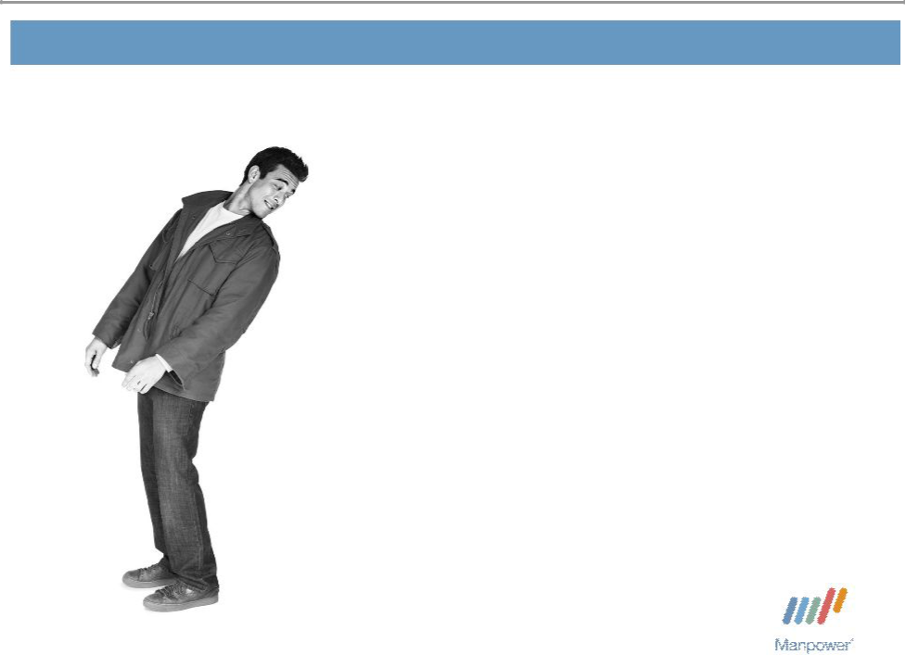
Manpower Inc. 2006 2nd Quarter Results 13

Financial Highlights

Manpower Inc. 2006 2nd Quarter Results | 14
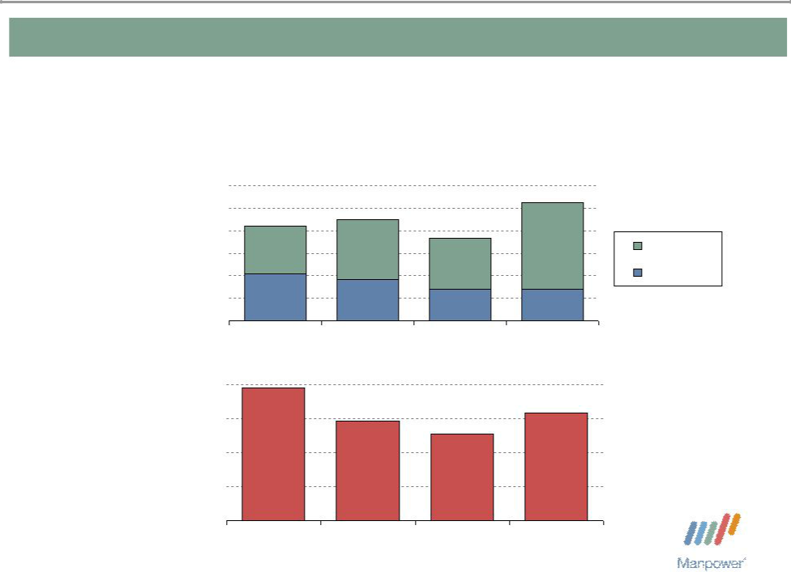

Balance Sheet Highlights

Total Debt | 1,200

($ in millions) | 1,000
 | 800
 | 600
 | 400
 | 200
 | 0

Total Debt to

Total Capitalization 40%

30%

20%

10%

0%

- 902

⁴¹⁶370

2003 2004

39%

29%

2003 2004

1,048

Total Debt
735
Net Debt

280 280

2005 Q2 2006

32%

26%

2005 Q2 2006

Manpower Inc. 2006 2nd Quarter Results | 15

Cash Flow Summary – First Half

($ in millions) | 2006 | 2005
Cash from Operations | 136 | 99
Capital Expenditures | (35) | (36)
Free Cash Flow | 101 | 63
Share Repurchases * | (119) | (204)
Proceeds from Stock Option | 42 | 8
and Purchase Plans | 42 | 8
Change in Debt | 251 | (32)
Proceeds from Sale of Business | 30 | -
Other | 8 | (4)
Change in Cash | 313 | (169)

* 1,970,300 shares in 2006 and 5,000,000 shares in 2005

Manpower Inc. 2006 2nd Quarter Results | 16
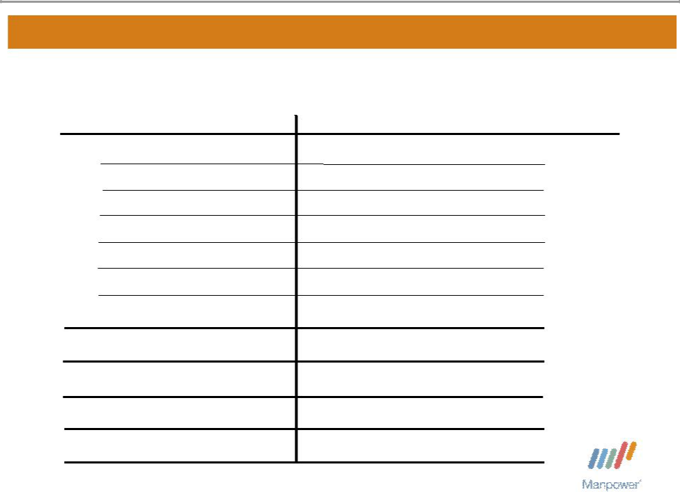

Third Quarter Outlook

Revenue U.S.

France

EMEA

Jefferson Wells

Right

Other

Total

Gross Profit Margin Operating Profit Margin

Tax Rate

EPS

Up 1-3%

Up 11-13% (Up 8-10% CC)

Up 14-16% (Up 11-13% CC)

Down 6-8%

Down 1-3% (Down 3-5% CC)

Up 12-14% (Up 14-16% CC)

Up 10-12% (Up 8-10% CC)

18.2 - 18.4%

3.2 - 3.4%

36.5%

$1.00 - $1.04(Pos. $.02 Currency)

2006 2nd Quarter Results


July 19, 2006

Questions?
Answers

2006 2nd Quarter Results

July 19, 2006

Appendix

Manpower Inc. 2006 2nd Quarter Results | 19


France and EMEA Restatement - 2006

($ in millions) |  | Q1 Restated
($ in millions) | 2006 | 2005 | Var | CC Var
Revenue:
France | 1,241 | 1,238 | 0% | 9%
EMEA | 1,433 | 1,343 | 7% | 16%
OUP:
France | 30 | 28 | 7% | 17%
EMEA | 22 | 14 | 59% | 74%

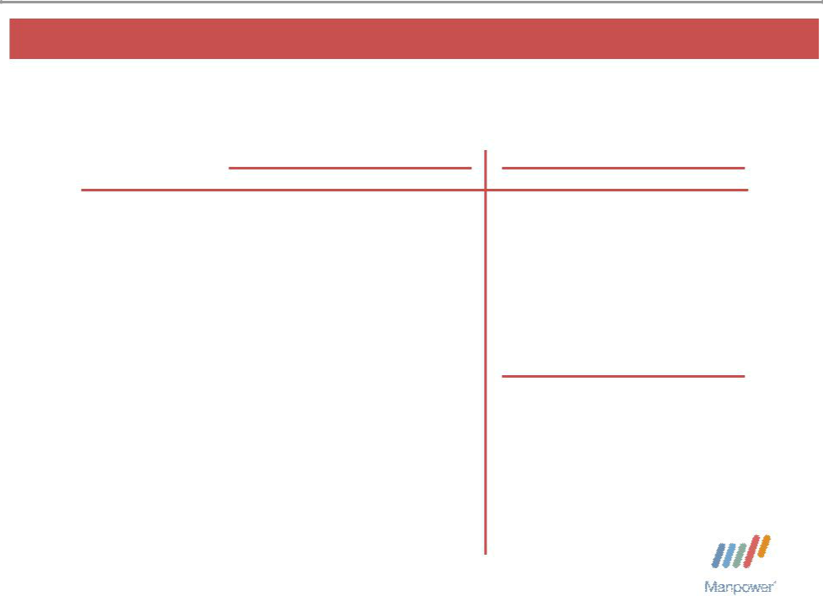
Manpower Inc. 2006 2nd Quarter Results | 20

France and EMEA Restatement - 2005

($ in millions) |  | Q1 Restated |  |  |  | Q2 Restated
($ in millions) | 2005 | 2004 | Var | CC Var | 2005 | 2004 | Var | CC Var
Revenue:
France | 1,238 | 1,131 | 9% | 4% | 1,397 | 1,273 | 10% | 5%
EMEA | 1,343 | 1,146 | 17% | 12% | 1,430 | 1,208 | 18% | 14%
OUP:
France | 28 | 29 | -2% | -7% | 42 | 39 | 7% | 3%
EMEA | 14 | 14 | 4% | -1% | 38 | 26 | 45% | 40%
Revenue: |  |  |  |  |  | YTD Restated
France |  |  |  |  | 2,635 | 2,404 | 10% | 5%
EMEA |  |  |  |  | 2,773 | 2,354 | 18% | 13%
OUP:
France |  |  |  |  | 70 | 68 | 3% | -1%
EMEA |  |  |  |  | 52 | 40 | 31% | 26%

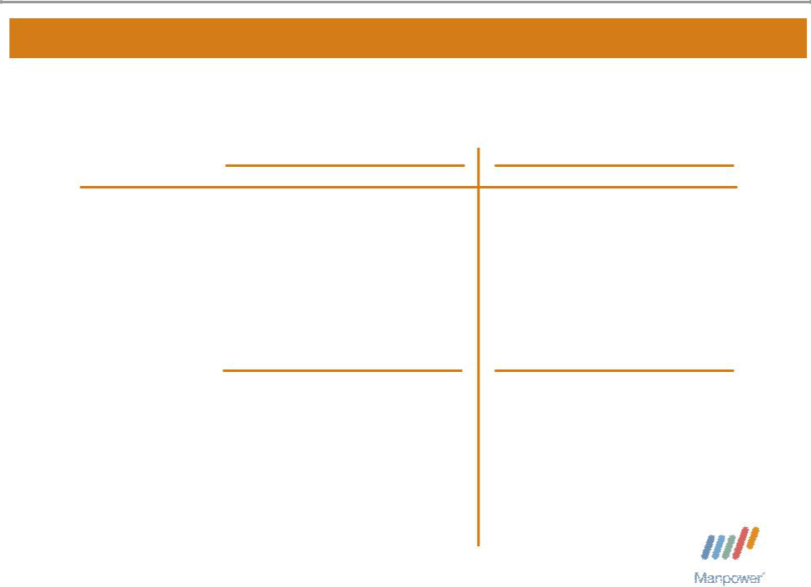
Manpower Inc. 2006 2nd Quarter Results | 21

France and EMEA Restatement - 2005

($ in millions) |  | Q3 Restated |  |  |  | Q4 Restated
($ in millions) | 2005 | 2004 | Var | CC Var | 2005 | 2004 | Var | CC Var
Revenue:
France | 1,479 | 1,395 | 6% | 6% | 1,362 | 1,401 | -3% | 6%
EMEA | 1,401 | 1,312 | 7% | 7% | 1,487 | 1,445 | 3% | 12%
OUP:
France | 51 | 56 | -9% | -8% | 48 | 55 | -14% | -6%
EMEA | 46 | 34 | 35% | 36% | 54 | 41 | 30% | 42%
Revenue: |  | YTD Restated |  |  |  | YTD Restated
France | 4,114 | 3,799 | 8% | 5% | 5,476 | 5,200 | 5% | 6%
EMEA | 4,174 | 3,666 | 14% | 11% | 5,661 | 5,111 | 11% | 11%
OUP:
France | 121 | 124 | -2% | -5% | 169 | 179 | -6% | -5%
EMEA | 98 | 74 | 33% | 30% | 152 | 115 | 32% | 35%

