UNITED STATES

SECURITIES AND EXCHANGE COMMISSION
Washington, D.C. 20549

FORM 8-K

CURRENT REPORT

Pursuant to Section 13 or 15(d) of the Securities Exchange Act of 1934

Date of Report (Date of earliest event reported): February 2, 2010

MANPOWER INC.

(Exact name of registrant as specified in its charter)

Wisconsin

(State or other jurisdiction of incorporation)

1-10686

(Commission File Number)

39-1672779

(IRS Employer Identification No.)

100 Manpower Place

Milwaukee, Wisconsin

(Address of principal executive offices)

53212

(Zip Code)

Registrant's telephone number, including area code: (414) 961-1000

Check the appropriate box below if the Form 8-K filing is intended to simultaneously satisfy the filing obligation of the registrant under any of the following provisions:

Written communications pursuant to Rule 425 under the Securities Act (17 CFR 230.425)

Soliciting material pursuant to Rule 14a-12 under the Securities Act (17 CFR 240.14a-12)

Pre-commencement communications pursuant to Rule 14d-2(b) under the Exchange Act (17 CFR 240.14d-2(b))

Pre-commencement communications pursuant to Rule 13e-4(c) under the Exchange Act (17 CFR 240.13e-4(c))

Item 2.02 Results of Operations and Financial Condition

On February 2, 2010, we issued a press release announcing our results of operations for the three months and year ended December 31, 2009. A copy of the press release is attached hereto as Exhibit 99.1 and is incorporated herein by reference.

During the fourth quarter of 2009, we determined that our Other EMEA reportable segment prematurely recognized revenues related to a workforce solutions contract. These revenues were recorded on a cash-basis rather than being deferred and earned over the four-year performance period following the month the services were performed. Accordingly, we have restated our annual and quarterly financial results for 2007, 2008, and the nine months ended September 30, 2009. This restatement has no impact on cash flows and only impacts the timing of when revenues are earned, as total revenues for the contract are expected to remain unchanged. Attached hereto as Exhibit 99.3 are the effects of this restatement on 2009, 2008 and 2007.

Item 9.01. Exhibits.
 | Exhibit No. |  | Description
 | 99.1 |  | Press Release dated February 2, 2010
99.2 |  |  | Presentation materials for February 2, 2010 conference call
99.3 |  |  | Summary of Restated Results

SIGNATURES

Pursuant to the requirements of the Securities Exchange Act of 1934, the Registrant has duly caused this Report to be signed on its behalf by the undersigned hereunto duly authorized.

MANPOWER INC.

Dated: February 2, 2010 By: /s/ Michael J. Van Handel

Michael J. Van Handel

Executive Vice President and

Chief Financial Officer

 |  | EXHIBIT INDEX
Exhibit No. |  | Description
99.1 |  | Press Release dated February 2, 2010
99.2 |  | Presentation materials for February 2, 2010 conference call
99.3 |  | Summary of Restated Results

Exhibit 99.1


FOR IMMEDIATE RELEASE

Contact:

Mike Van Handel

Manpower Inc.

+1.414.906.6305

michael.vanhandel@manpower.com

Manpower Reports 4th Quarter and Full Year 2009 Results

MILWAUKEE, WI, USA, February 2, 2010 – Manpower Inc. (NYSE: MAN) today reported that net earnings per diluted share for the three months ended December 31, 2009 decreased to 37 cents from 97 cents in the prior year period. Net earnings in the quarter decreased to $29.1 million from $76.0 million a year earlier. Revenues for the fourth quarter totaled $4.4 billion, a decrease of 4 percent from the year earlier period, or a decrease of 12 percent in constant currency.

Included in the fourth quarter results is a $12.7 million ($9.0 million after tax, or 11 cents per diluted share) reorganization charge, primarily related to office closures and consolidations, and severance costs. Net earnings in the fourth quarter were favorably impacted by 5 cents per diluted share, as foreign currencies were relatively stronger compared to the prior year period.

Jeffrey A. Joerres, Manpower Inc. Chairman and CEO, said, “We continue to see solid evidence of improving trends in nearly all geographies we operate in. Each week that passes, we are more confident about the sustainability of the recovery. The U.S. is experiencing the highest level of year-over-year growth trends. As we look to the first quarter of 2010, we are anticipating positive year-over-year revenue growth for the company as a whole, which is the first time since the third quarter of 2008.

“We are anticipating the first quarter of 2010 diluted earnings per share to be a loss in the range of 5 cents to 15 cents, which includes an estimated favorable currency impact of 3 cents.”

Net earnings per diluted share for the year ended December 31, 2009 decreased to a loss of 12 cents from earnings of $2.58 per diluted share in 2008. Net earnings were a loss of $9.2 million compared to earnings of $205.5 million in the prior year. Revenues for the year were $16.0 billion, a decrease of 26 percent from the prior year, or 21 percent in constant currency.

Earnings per diluted share for the full year 2009 include a loss on the sale of an equity investment and goodwill impairment charge totaling 85 cents, a charge of 6 cents related to the repayment of our revolver borrowings and extinguishment of an interest rate swap, and reorganization charges totaling 31 cents. Additionally, 2009 results were favorably impacted by 1 cent per diluted share due to changes in foreign currencies compared to the prior year.

Included in the full year 2008 results is the favorable impact of the business tax refund and recoverable payroll taxes in France totaling $0.91 per diluted share. Also included is the goodwill and intangible asset impairment charge of $1.94 per diluted share, an increase in our legal reserve of 63 cents per diluted share and reorganization charges of 34 cents per diluted share.

During the fourth quarter, the company became aware that it had prematurely recognized revenue related to a workforce solutions contract in 2007, 2008 and the 9 month period ended September 30, 2009. As a result, operating results have been restated for these periods, resulting in a reduction of revenues and operating profit of $14.2 million, $15.7 million and $9.7 million, respectively and diluted earnings per share of 13 cents, 17 cents and 12 cents, respectively. Further information regarding this restatement can be found in the company’s Form 8-K filing dated February 2, 2010.

In conjunction with its fourth quarter earnings release, Manpower will broadcast its conference call live over the Internet on February 2, 2010 at 7:30 a.m. CST (8:30 a.m.

EST). Interested parties are invited to listen to the webcast and view the presentation by logging on to http://investor.manpower.com.

Supplemental financial information referenced in the conference call can be found at http://investor.manpower.com.

About Manpower Inc.

Manpower Inc. (NYSE: MAN) is a world leader in the employment services industry; creating and delivering services that enable clients to win in the changing world of work. With more than 60 years of experience, the company offers employers a range of services for the entire employment and business cycle including permanent, temporary and contract recruitment; employee assessment and selection; training; outplacement; outsourcing and consulting. Manpower's worldwide network of 4,000 offices in 82 countries and territories enables the company to meet the needs of 400,000 clients per year, including small and medium size enterprises in all industry sectors, as well as the world's largest multinational corporations. The focus of Manpower’s work is on raising productivity through improved quality, efficiency and cost-reduction across the total workforce, enabling clients to concentrate on their core business activities. Manpower Inc. operates under five brands: Manpower, Manpower Professional, Elan, Jefferson Wells and Right Management. More information on Manpower Inc. is available at www.manpower.com.

Forward-Looking Statements

This news release contains statements, including earnings projections, that are forward-looking in nature and, accordingly, are subject to risks and uncertainties regarding the Company’s expected future results. The Company’s actual results may differ materially from those described or contemplated in the forward-looking statements. Factors that may cause the Company’s actual results to differ materially from those contained in the forward-looking statements can be found in the Company’s reports filed with the SEC, including the information under the heading ‘Risk Factors’ in its Annual Report on Form 10-K for the year ended December 31, 2008, which information is incorporated herein by reference.

- ### -

Manpower Inc.

Results of Operations

(In millions, except per share data)

 |  |  |  |  |  |  | Three Months Ended December 31
 |  |  |  |  |  |  |  |  |  | % Variance
 |  |  |  |  |  |  |  |  |  | Amount |  |  | Constant
 |  |  | 2009 |  |  |  | 2008 |  |  | Reported |  |  | Currency
 |  |  |  |  |  |  | (Unaudited)
 | Revenues from services (a) (b) | $ | 4,412.6 |  | $ |  | 4,589.6 |  |  | -3.9% |  |  | -11.6%
 | Cost of services |  | 3,656.5 |  |  |  | 3,639.2 |  |  | 0.5% |  |  | -7.7%
 | Gross profit |  | 756.1 |  |  |  | 950.4 |  |  | -20.5% |  |  | -26.7%
 | Selling and administrative expenses |  | 713.3 |  |  |  | 804.8 |  |  | -11.4% |  |  | -18.0%
 | Operating profit |  | 42.8 |  |  |  | 145.6 |  |  | -70.6% |  |  | -74.7%
 | Interest and other expenses |  | 12.6 |  |  |  | 12.3 |  |  | 2.4%
 | Earnings before income taxes |  | 30.2 |  |  |  | 133.3 |  |  | -77.3% |  |  | -82.7%
 | Provision for income taxes |  | 1.1 |  |  |  | 57.3 |  |  | -98.0%
 | Net earnings | $ | 29.1 |  | $ |  | 76.0 |  |  | -61.8% |  |  | -70.8%
 | Net earnings per share - basic | $ | 0.37 |  | $ |  | 0.98 |  |  | -62.2%
 | Net earnings per share - diluted | $ | 0.37 |  | $ |  | 0.97 |  |  | -61.9% |  |  | -89.6%
 | Weighted average shares - basic |  | 78.5 |  |  |  | 77.8 |  |  | 0.9%
 | Weighted average shares - diluted |  | 79.7 |  |  |  | 78.0 |  |  | 2.1%

- Revenues from services include fees received from our franchise offices of $5.7 million and $7.3 million for the three months ended December 31, 2009 and 2008, respectively. These fees areprimarily based on revenues generated by the franchise offices, which were $213.4 million and $236.5 million for the three months ended December 31, 2009 and 2008, respectively.

- During the fourth quarter of 2009, we determined that our Other EMEA reportable segment prematurely recognized revenues related to a workforce solutions contract. These revenues were recorded on a cash-basis rather than being deferred and earned over the four-year performance period following the month the services were performed. Accordingly, we have restated our annual and quarterly financial results for 2007, 2008, and the nine months ended September 30, 2009. The impact on the fourth quarter of 2008 was a $3.3 million reduction of revenues and operating profit and a $0.04 reduction in net earnings per diluted share. This restatement has no impact on cash flows and only impacts the timing of when revenues are earned, as total revenues for the contract are expected to remain unchanged.

Manpower Inc.

Operating Unit Results

(In millions)

 |  |  |  |  |  |  | Three Months Ended December 31
 |  |  |  |  |  |  |  |  |  | % Variance
 |  |  |  |  |  |  |  |  |  | Amount |  |  | Constant
 |  |  | 2009 |  |  |  | 2008 |  |  | Reported |  |  | Currency
 |  |  |  |  |  |  | (Unaudited)
 | Revenues from Services: (a)
 | Americas:
 | United States (c) | $ | 435.8 |  | $ |  | 462.5 |  |  | -5.8% |  |  | -5.8%
 | Other Americas |  | 283.9 |  |  |  | 259.9 |  |  | 9.2% |  |  | 6.2%
 |  |  | 719.7 |  |  |  | 722.4 |  |  | -0.4% |  |  | -1.5%
 | France |  | 1,304.4 |  |  |  | 1,351.4 |  |  | -3.5% |  |  | -13.8%
 | EMEA:
 | Italy |  | 269.3 |  |  |  | 301.2 |  |  | -10.6% |  |  | -20.3%
 | Other EMEA (b) |  | 1,477.7 |  |  |  | 1,578.3 |  |  | -6.4% |  |  | -14.2%
 |  |  | 1,747.0 |  |  |  | 1,879.5 |  |  | -7.0% |  |  | -15.2%
 | Asia Pacific |  | 468.7 |  |  |  | 449.1 |  |  | 4.3% |  |  | -6.3%
 | Right Management |  | 129.6 |  |  |  | 123.6 |  |  | 4.8% |  |  | -1.5%
 | Jefferson Wells |  | 43.2 |  |  |  | 63.6 |  |  | -32.1% |  |  | -32.1%
 |  | $ | 4,412.6 |  | $ |  | 4,589.6 |  |  | -3.9% |  |  | -11.6%
 | Operating Unit (Loss) Profit:
 | Americas:
 | United States (c) | $ | (5.0) |  | $ |  | (1.9) |  |  | N/A |  |  | N/A
 | Other Americas |  | 5.9 |  |  |  | 4.0 |  |  | 49.3% |  |  | 50.9%
 |  |  | 0.9 |  |  |  | 2.1 |  |  | -55.8% |  |  | -52.8%
 | France |  | 5.0 |  |  |  | 109.1 |  |  | -95.4% |  |  | -95.9%
 | EMEA:
 | Italy |  | 11.1 |  |  |  | 24.3 |  |  | -54.7% |  |  | -59.8%
 | Other EMEA (b) |  | 25.1 |  |  |  | 37.1 |  |  | -32.2% |  |  | -39.3%
 |  |  | 36.2 |  |  |  | 61.4 |  |  | -41.1% |  |  | -47.4%
 | Asia Pacific |  | 6.9 |  |  |  | (1.4) |  |  | N/A |  |  | N/A
 | Right Management |  | 20.8 |  |  |  | 17.0 |  |  | 22.2% |  |  | 15.7%
 | Jefferson Wells |  | (3.7) |  |  |  | (13.8) |  |  | N/A |  |  | N/A
 |  |  | 66.1 |  |  |  | 174.4
 | Corporate expenses |  | 23.3 |  |  |  | 28.8
 | Operating profit |  | 42.8 |  |  |  | 145.6 |  |  | -70.6% |  |  | -74.7%
 | Interest and other expenses (d) |  | 12.6 |  |  |  | 12.3
 | Earnings before income taxes | $ | 30.2 |  | $ |  | 133.3

- Our segment reporting was realigned during the first quarter of 2009 due to a change in management structure. Other Americas and Asia Pacific, previously reported in Other Operations, are now separate reportable segments. The United States and Other Americas reportable segments are reported as Americas. The Italy and Other EMEA reportable segments are reported as EMEA. Historical amounts have been restated to conform to the current year presentation.

- During the fourth quarter of 2009, we determined that our Other EMEA reportable segment prematurely recognized revenues related to a workforce solutions contract. These revenues were recorded on a cash-basis rather than being deferred and earned over the four-year performance period following the month the services were performed. Accordingly, we have restated our annual and quarterly financial results for 2007, 2008, and the nine months ended September 30, 2009. The impact on the fourth quarter of 2008 was a $3.3 million reduction of revenues and operating unit profit. This restatement has no impact on cash flows and only impacts the timing of when revenues are earned, as total revenues for the contract are expected to remain unchanged.

- In the United States, revenues from services include fees received from our franchise offices of $3.1 million and $3.9 million for the three months ended December 31, 2009 and 2008, respectively. These fees are primarily based on revenues generated by the franchise offices, which were $135.6 million and $143.5 million for the three months ended December 31, 2009 and 2008, respectively.

- The components of interest and other expenses were:

 | 2009 |  |  |  |  | 2008
Interest expense | $ | 13.2 |  | $ |  | 15.0
Interest income |  | (2.4) |  |  |  | (5.6)
Foreign exchange gains |  | (0.1) |  |  |  | (0.8)
Miscellaneous expenses, net |  | 1.9 |  |  |  | 3.7
 | $ | 12.6 |  | $ |  | 12.3

Manpower Inc.

Results of Operations

(In millions, except per share data)

 |  |  |  |  |  |  | Year Ended December 31
 |  |  |  |  |  |  |  |  |  | % Variance
 |  |  |  |  |  |  |  |  |  | Amount |  |  | Constant
 |  |  | 2009 |  |  |  | 2008 |  |  | Reported |  |  | Currency
 |  |  |  |  |  |  | (Unaudited)
 | Revenues from services (a) (c) | $ | 16,038.7 |  | $ |  | 21,537.1 |  |  | -25.5% |  |  | -20.9%
 | Cost of services |  | 13,220.5 |  |  |  | 17,450.2 |  |  | -24.2% |  |  | -19.4%
 | Gross profit |  | 2,818.2 |  |  |  | 4,086.9 |  |  | -31.0% |  |  | -27.0%
 | Selling and administrative expenses |  | 2,715.5 |  |  |  | 3,430.3 |  |  | -20.8% |  |  | -16.1%
 | Goodwill and intangible asset impairment charges (b) |  | 61.0 |  |  |  | 163.1 |  |  | N/A |  |  | N/A
 | Selling and administrative expenses |  | 2,776.5 |  |  |  | 3,593.4 |  |  | -22.7% |  |  | -18.2%
 | Operating profit |  | 41.7 |  |  |  | 493.5 |  |  | -91.5% |  |  | -91.3%
 | Interest and other expenses |  | 64.6 |  |  |  | 50.9 |  |  | 26.9%
 | (Loss) earnings before income taxes |  | (22.9) |  |  |  | 442.6 |  |  | N/A |  |  | N/A
 | Provision for income taxes |  | (13.7) |  |  |  | 237.1 |  |  | N/A
 | Net (loss) earnings | $ | (9.2) |  | $ |  | 205.5 |  |  | N/A |  |  | N/A
 | Net (loss) earnings per share - basic | $ | (0.12) |  | $ |  | 2.61 |  |  | N/A
 | Net (loss) earnings per share - diluted | $ | (0.12) |  | $ |  | 2.58 |  |  | N/A |  |  | N/A
 | Weighted average shares - basic |  | 78.3 |  |  |  | 78.7 |  |  | -0.5%
 | Weighted average shares - diluted |  | 78.3 |  |  |  | 79.7 |  |  | -1.7%

- Revenues from services include fees received from our franchise offices of $22.3 million and $30.9 million for the years ended December 31, 2009 and 2008, respectively. These fees are primarily based on revenues generated by the franchise offices, which were $746.7 million and $1,148.1 million for the years ended December 31, 2009 and 2008, respectively.

- The goodwill impairment charge for the year ended December 31, 2009 relates to our investment in Jefferson Wells. The goodwill and intangible asset impairment charge for the year ended December 31, 2008 relates to our investment in Right Management. The impact on net earnings is $61.0 million and $154.6 million, or $0.78 and $1.94 per diluted share, for the years ended December 31, 2009 and 2008, respectively.

- During the fourth quarter of 2009, we determined that our Other EMEA reportable segment prematurely recognized revenues related to a workforce solutions contract. These revenues were recorded on a cash-basis rather than being deferred and earned over the four-year performance period following the month the services were performed. Accordingly, we have restated our annual and quarterly financial results for 2007, 2008, and the nine months ended September 30, 2009. The impact was a $15.7 million reduction of revenues and operating profit and a $0.17 reduction in net earnings per diluted share for the year ended 2008. The impact was a $9.7 million reduction of revenues and operating profit and a $0.12 reduction in net earnings per diluted share for the nine months ended 2009. This restatement has no impact on cash flows and only impacts the timing of when revenues are earned, as total revenues for the contract are expected to remain unchanged.

Manpower Inc.

Operating Unit Results

(In millions)

 |  |  |  |  |  |  | Year Ended December 31
 |  |  |  |  |  |  |  |  |  | % Variance
 |  |  |  |  |  |  |  |  |  | Amount |  |  | Constant
 |  |  | 2009 |  |  |  | 2008 |  |  | Reported |  |  | Currency
 |  |  |  |  |  |  | (Unaudited)
 | Revenues from Services: (a)
 | Americas:
 | United States (c) | $ | 1,593.7 |  | $ |  | 1,945.4 |  |  | -18.1% |  |  | -18.1%
 | Other Americas |  | 967.3 |  |  |  | 1,129.8 |  |  | -14.4% |  |  | -3.1%
 |  |  | 2,561.0 |  |  |  | 3,075.2 |  |  | -16.7% |  |  | -12.6%
 | France |  | 4,675.5 |  |  |  | 6,935.6 |  |  | -32.6% |  |  | -29.2%
 | EMEA:
 | Italy |  | 950.8 |  |  |  | 1,519.5 |  |  | -37.4% |  |  | -34.2%
 | Other EMEA (b) |  | 5,371.7 |  |  |  | 7,422.0 |  |  | -27.6% |  |  | -19.2%
 |  |  | 6,322.5 |  |  |  | 8,941.5 |  |  | -29.3% |  |  | -21.7%
 | Asia Pacific |  | 1,728.0 |  |  |  | 1,841.6 |  |  | -6.2% |  |  | -9.2%
 | Right Management |  | 559.4 |  |  |  | 452.2 |  |  | 23.7% |  |  | 28.5%
 | Jefferson Wells |  | 192.3 |  |  |  | 291.0 |  |  | -33.9% |  |  | -33.9%
 |  | $ | 16,038.7 |  | $ |  | 21,537.1 |  |  | -25.5% |  |  | -20.9%
 | Operating Unit (Loss) Profit:
 | Americas:
 | United States (c) | $ | (26.2) |  | $ |  | 32.2 |  |  | N/A |  |  | N/A
 | Other Americas |  | 20.1 |  |  |  | 25.9 |  |  | -22.4% |  |  | -10.7%
 |  |  | (6.1) |  |  |  | 58.1 |  |  | N/A |  |  | N/A
 | France |  | 20.8 |  |  |  | 299.0 |  |  | -93.0% |  |  | -92.6%
 | EMEA:
 | Italy |  | 27.9 |  |  |  | 120.3 |  |  | -76.8% |  |  | -76.5%
 | Other EMEA (b) |  | 29.4 |  |  |  | 233.8 |  |  | -87.4% |  |  | -88.6%
 |  |  | 57.3 |  |  |  | 354.1 |  |  | -83.8% |  |  | -84.5%
 | Asia Pacific |  | 26.5 |  |  |  | 29.2 |  |  | -9.3% |  |  | -19.9%
 | Right Management |  | 113.4 |  |  |  | 44.7 |  |  | 153.6% |  |  | 158.8%
 | Jefferson Wells |  | (22.0) |  |  |  | (19.6) |  |  | N/A |  |  | N/A
 |  |  | 189.9 |  |  |  | 765.5
 | Corporate expenses |  | 87.2 |  |  |  | 108.9
 | Goodwill and intangible asset impairment charges |  | 61.0 |  |  |  | 163.1
 | Operating profit |  | 41.7 |  |  |  | 493.5 |  |  | -91.5% |  |  | -91.3%
 | Interest and other expenses (d) |  | 64.6 |  |  |  | 50.9
 | (Loss) earnings before income taxes | $ | (22.9) |  | $ |  | 442.6

- Our segment reporting was realigned during the first quarter of 2009 due to a change in management structure. Other Americas and Asia Pacific, previously reported in Other Operations, are now separate reportable segments. The United States and Other Americas reportable segments are reported as Americas. The Italy and Other EMEA reportable segments are reported as EMEA. Historical amounts have been restated to conform to the current year presentation.

- During the fourth quarter of 2009, we determined that our Other EMEA reportable segment prematurely recognized revenues related to a workforce solutions contract. These revenues were recorded on a cash-basis rather than being deferred and earned over the four-year performance period following the month the services were performed. Accordingly, we have restated our annual and quarterly financial results for 2007, 2008, and the nine months ended September 30, 2009. The impact was a $15.7 million reduction of revenues and operating unit profit for the year ended 2008. The impact was a $9.7 million reduction of revenues and operating unit profit for the nine months ended 2009. This restatement has no impact on cash flows and only impacts the timing of when revenues are earned, as total revenues for the contract are expected to remain unchanged.

- In the United States, revenues from services include fees received from our franchise offices of $10.5 million and $17.7 million for the years ended December 31, 2009 and 2008, respectively. These fees are primarily based on revenues generated by the franchise offices, which were $459.3 million and $746.2 million for the years ended December 31, 2009 and 2008, respectively.

- The components of interest and other expenses were:

 | 2009 |  |  |  |  | 2008
Interest expense | $ | 61.7 |  | $ |  | 63.9
Interest income |  | (11.7) |  |  |  | (22.1)
Foreign exchange loss (gain) |  | 0.8 |  |  |  | (2.9)
Miscellaneous expenses, net |  | 3.5 |  |  |  | 12.0
Loss from sale of an equity investment |  | 10.3 |  |  |  | -
 | $ | 64.6 |  | $ |  | 50.9

Manpower Inc.

Consolidated Balance Sheets

(In millions)

 |  | Dec. 31 |  |  | Dec. 31
 |  | 2009 |  |  | 2008
 |  | (Unaudited)
ASSETS
Current assets:
Cash and cash equivalents | $ | 1,014.6 |  | $ | 874.0
Accounts receivable, net |  | 3,070.8 |  |  | 3,629.7
Prepaid expenses and other assets |  | 179.6 |  |  | 119.9
Future income tax benefits |  | 67.4 |  |  | 66.5
Total current assets |  | 4,332.4 |  |  | 4,690.1
Other assets:
Goodwill and other intangible assets, net |  | 1,357.5 |  |  | 1,388.1
Other assets |  | 347.5 |  |  | 330.6
Total other assets |  | 1,705.0 |  |  | 1,718.7
Property and equipment:
Land, buildings, leasehold improvements and equipment |  | 703.6 |  |  | 744.0
Less: accumulated depreciation and amortization |  | 527.2 |  |  | 530.6
Net property and equipment |  | 176.4 |  |  | 213.4
Total assets | $ | 6,213.8 |  | $ | 6,622.2
LIABILITIES AND SHAREHOLDERS' EQUITY
Current liabilities:
Accounts payable | $ | 944.4 |  | $ | 896.3
Employee compensation payable |  | 187.8 |  |  | 213.2
Accrued liabilities |  | 465.9 |  |  | 585.7
Accrued payroll taxes and insurance |  | 572.0 |  |  | 617.5
Value added taxes payable |  | 391.2 |  |  | 479.2
Short-term borrowings and currentmaturities of long-term debt |  | 41.7 |  |  | 115.6
Total current liabilities |  | 2,603.0 |  |  | 2,907.5
Other liabilities:
Long-term debt |  | 715.6 |  |  | 837.3
Other long-term liabilities |  | 358.7 |  |  | 418.0
Total other liabilities |  | 1,074.3 |  |  | 1,255.3
Shareholders' equity:
Common stock |  | 1.0 |  |  | 1.0
Capital in excess of par value |  | 2,544.2 |  |  | 2,514.8
Retained earnings |  | 1,109.6 |  |  | 1,176.8
Accumulated other comprehensive income (loss) |  | 106.9 |  |  | (8.9)
Treasury stock, at cost |  | (1,225.2) |  |  | (1,224.3)
Total shareholders' equity |  | 2,536.5 |  |  | 2,459.4
Total liabilities and shareholders' equity | $ | 6,213.8 |  | $ | 6,622.2

Manpower Inc.

Consolidated Statements of Cash Flows

(In millions)

 |  |  | Year Ended
 |  |  | Dec. 31
 |  |  | 2009 |  |  | 2008
 |  |  | (Unaudited)
 | Cash Flows from Operating Activities:
 | Net (loss) earnings | $ | (9.2) |  | $ | 205.5
 | Adjustments to reconcile net (loss) earnings to net cash provided by operating activities:
 | Depreciation and amortization |  | 97.2 |  |  | 107.1
 | Non-cash goodwill and intangible asset impairment |  | 61.0 |  |  | 163.1
 | Deferred income taxes |  | (24.7) |  |  | (32.0)
 | Provision for doubtful accounts |  | 27.8 |  |  | 23.4
 | Loss from sale of an equity investment |  | 10.3 |  |  | -
 | Share-based compensation |  | 17.5 |  |  | 21.1
 | Excess tax benefit on exercise of stock options |  | (0.5) |  |  | (0.5)
 | Changes in operating assets and liabilities, excluding the impact of acquisitions:
 | Accounts receivable |  | 663.6 |  |  | 575.0
 | Other assets |  | (71.5) |  |  | 2.9
 | Other liabilities |  | (357.2) |  |  | (273.6)
 | Cash provided by operating activities |  | 414.3 |  |  | 792.0
 | Cash Flows from Investing Activities:
 | Capital expenditures |  | (35.1) |  |  | (93.1)
 | Acquisitions of businesses, net of cash acquired |  | (21.6) |  |  | (242.0)
 | Proceeds from the sale of an equity investment |  | 13.3 |  |  | -
 | Proceeds from the sale of property and equipment |  | 3.6 |  |  | 5.9
 | Cash used in investing activities |  | (39.8) |  |  | (329.2)
 | Cash Flows from Financing Activities:
 | Net change in short-term borrowings |  | (14.6) |  |  | 16.0
 | Proceeds from long-term debt |  | 146.5 |  |  | 233.7
 | Repayments of long-term debt |  | (359.3) |  |  | (170.7)
 | Proceeds from share-based awards |  | 14.2 |  |  | 12.2
 | Excess tax benefit on exercise of stock options |  | 0.5 |  |  | 0.5
 | Repurchases of common stock |  | - |  |  | (125.4)
 | Dividends paid |  | (58.0) |  |  | (58.1)
 | Cash used in financing activities |  | (270.7) |  |  | (91.8)
 | Effect of exchange rate changes on cash |  | 36.8 |  |  | (34.5)
 | Change in cash and cash equivalents |  | 140.6 |  |  | 336.5
 | Cash and cash equivalents, beginning of period |  | 874.0 |  |  | 537.5
 | Cash and cash equivalents, end of period | $ | 1,014.6 |  | $ | 874.0


Exhibit

99.2

MANPOWER INC.

2009 4th Quarter Results

Helping Clients and Candidates Win for Over Six Decades

2010 February 2

Manpower Inc. 2009 4th Quarter Results | 2


Forward-Looking Statement

This presentation includes forward-looking statements, including earnings projections and the timing, completion and results of the proposed transaction, which are subject to risks and uncertainties. Actual results might differ materially from those projected in the forward-looking statements. Additional information concerning factors that could cause actual results to materially differ from those in the forward-looking statements is contained in the Company’s Annual Report on Form 10-K dated December 31, 2008, which information is incorporated herein by reference, and such other factors as may be described from time to time in the Company’s SEC filings.

This presentation was issued by Manpower Inc. on February 2, 2010 and does not constitute an offer of any securities for sale. The exchange offer described herein has not commenced. Manpower intends to commence an exchange offer and file a Schedule TO and a registration statement on Form S-4, and COMSYS IT Partners, Inc. intends to file a Solicitation/Recommendation Statement on Schedule 14D-9, with the Securities and Exchange Commission in connection with the transaction. Manpower and COMSYS expect to mail a Preliminary Prospectus, the Schedule 14D-9 and related exchange offer materials to stockholders of COMSYS. These documents, however, are not currently available. INVESTORS AND SECURITY HOLDERS ARE URGED TO READ THESE DOCUMENTS CAREFULLY WHEN THEY ARE AVAILABLE BECAUSE THEY CONTAIN IMPORTANT INFORMATION ABOUT MANPOWER, COMSYS AND THE TRANSACTION. Documents filed by Manpower with the SEC may be obtained without charge at the SEC's website at www.sec.gov and at Manpower's website at www.manpower.com. Documents filed by COMSYS with the SEC may be obtained without charge at the SEC's website and at COMSYS' website at www.comsys.com.

Manpower Inc. 2009 4th Quarter Results | 3
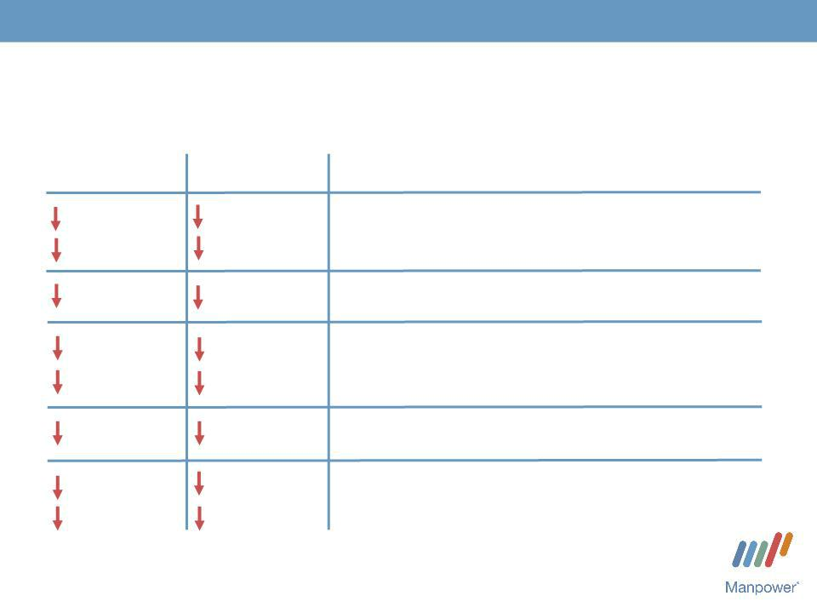

Consolidated Financial Highlights

 | Excluding
As | Non-recurring
Reported | Items⁽¹⁾
4% | 4%
12% CC | 12% CC
360 bps | 220 bps
71% | 54%
75% CC | 60% CC
220 bps | 140 bps
62% | 44%
90% CC | 49% CC

Q4 Highlights Revenue $4.4B

Gross Margin 17.1% Operating Profit $43M OP Margin 1.0%
EPS $.37

- Excludes non-recurring items for 2009 and 2008 as set forth on page 15.

Throughout this presentation, the difference between reported variances and Constant Currency (CC) variances represents the impact of currency on our financial results. Constant Currency is further explained on our Web site.

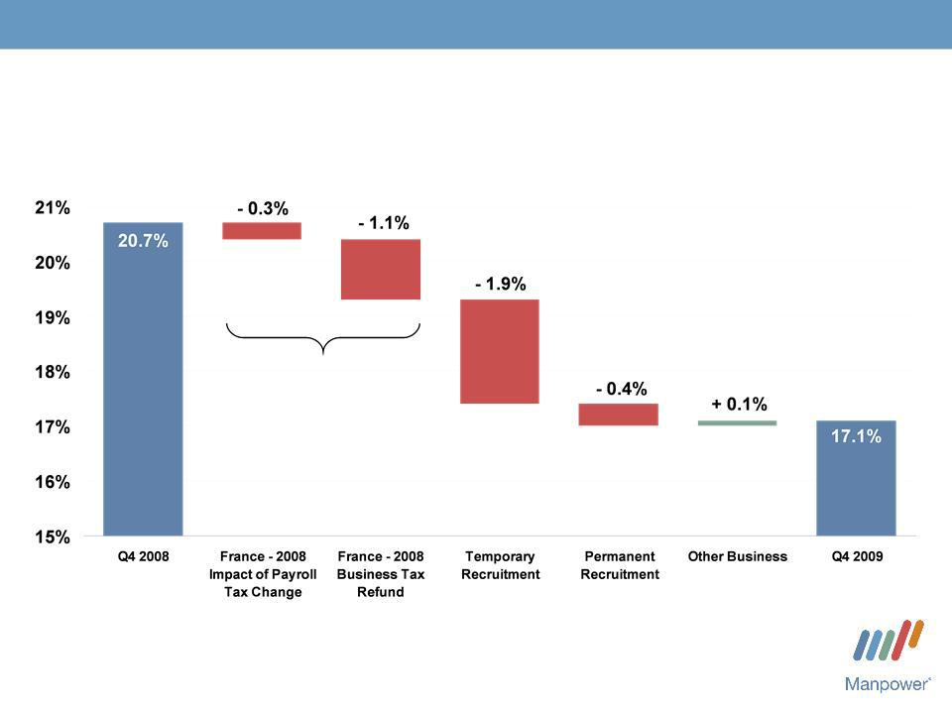
Manpower Inc. 2009 4th Quarter Results 4

Consolidated Gross Margin Change

Impact of Non-recurring Items

= - 1.4%

Manpower Inc. 2009 4th Quarter Results | 5
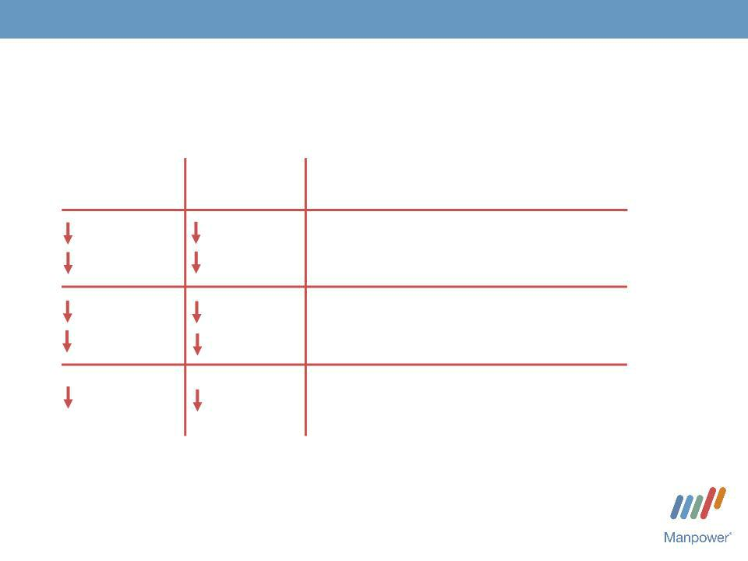

Americas Segment
(16% of Revenue)

As | Excluding Non | Q4 Financial Highlights | (1)
As | -recurring | Q4 Financial Highlights | (1)
Reported | Items ⁽²⁾ | Q4 Financial Highlights
0% | 0% | Revenue $720M
1% CC | 1% CC | Revenue $720M
56% | 55% | OUP $1M
53% CC | 54% CC
20 | 40 | OUP Margin 0.1%
bps | bps

- Included in these amounts is the US, which had revenue of $436M (-6%) and OUP of $(5M).

- Excludes the impact of the reorganization charges of $1.3M in 2009 and $3.0M in 2008.

Operating Unit Profit (OUP) is the measure that we use to evaluate segment performance. OUP is equal to segment revenues less direct costs and branch and national headquarters operating costs.

Manpower Inc. 2009 4th Quarter Results | 6
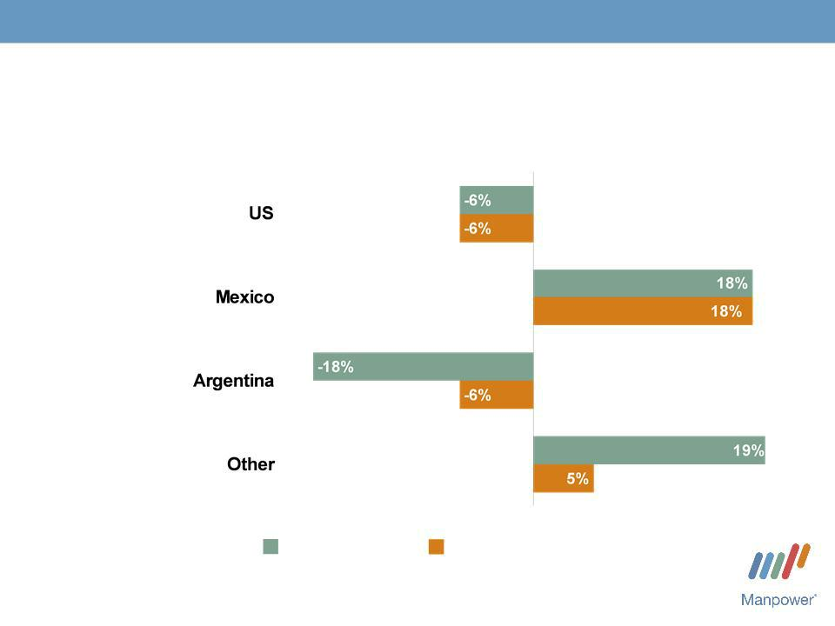

Americas - Q4 Revenue Growth YoY

- of Segment Revenue
(1)
61%

14%

8%

17%

Revenue

Growth

Revenue Growth - CC

- On an organic basis, US revenue decreased 8% in USD.

Manpower Inc. 2009 4th Quarter Results | 7
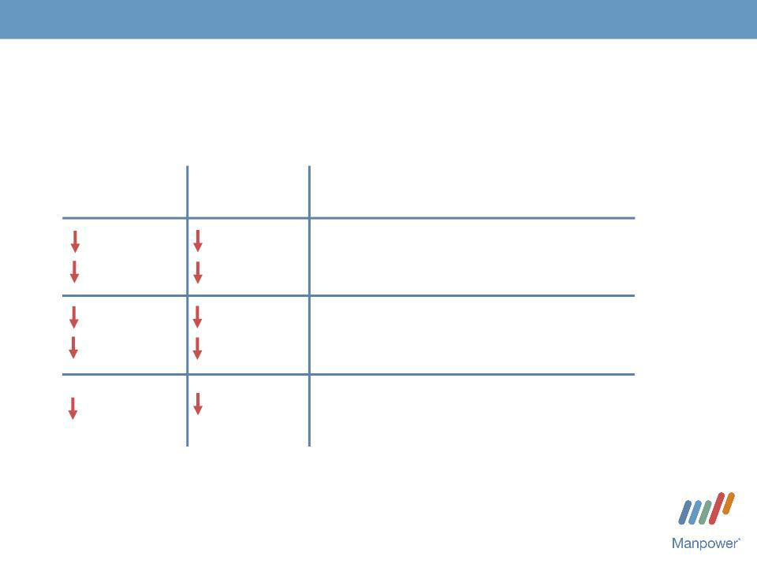

France Segment
(29% of Revenue)

Excluding Non
As -recurring

Reported Items⁽¹⁾

3% 3%

14% 14%
- CC
95%80%

96% | 82%
CC | CC
770 bps | 290 bps

Q4 Financial Highlights Revenue $1.3B

OUP $5M

OUP Margin 0.4%

- Excludes the impact of $4.7M of reorganization charges in 2009, and the business tax refund of $48.2M, the payroll tax adjustment of $14.5M and reorganization charges of $2.7M in 2008 (net favorable impact $60.0M).

Manpower Inc. 2009 4th Quarter Results | 8
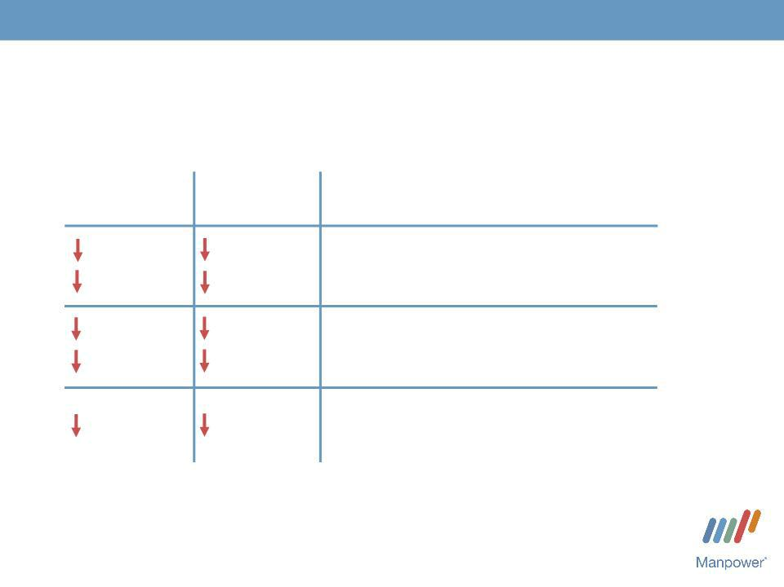

EMEA Segment
(40% of Revenue)

Excluding Non
As -recurring

Reported Items⁽²⁾

7% 7%

15% 15%
- CC
41%48%

47% | 54%
CC | CC
120 bps | 200 bps

Q4 Financial Highlights ⁽¹⁾

Revenue $1.7B

OUP $36M

OUP Margin 2.1%

- Included in these amounts is Italy, which had revenue of $269M (-11% in USD, -20% in CC) and OUP of $11M (-55% in USD, -60% in CC).
- Excludes the impact of the reorganization charges of $6.4M in 2009 and $21.2M in 2008.

Manpower Inc. 2009 4th Quarter Results | 9
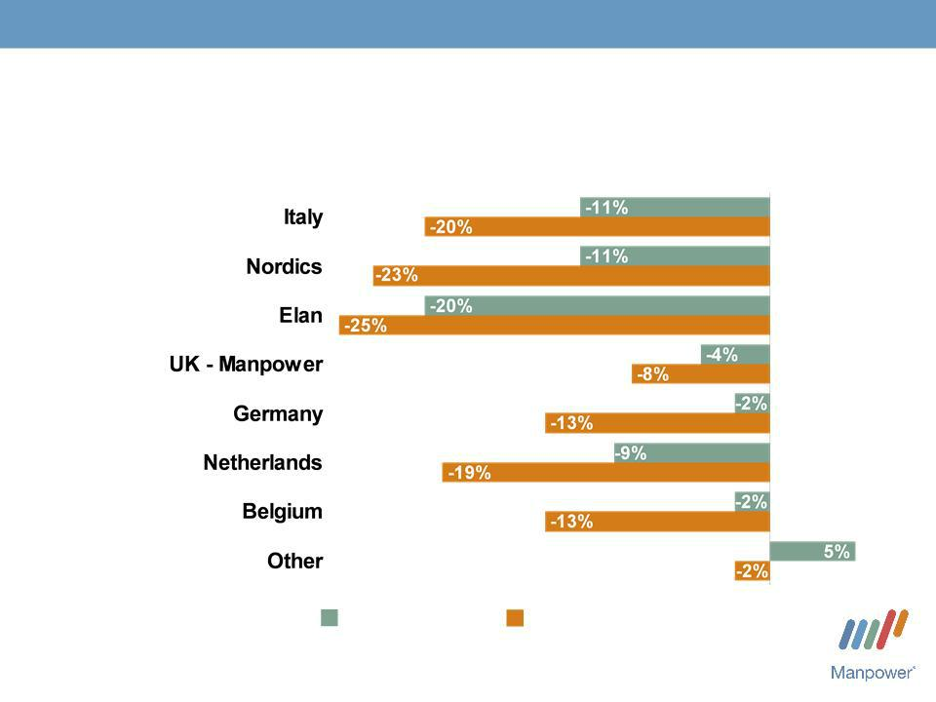

EMEA - Q4 Revenue Growth YoY

- of Segment Revenue

15%

14%

13%

11%

10%

9%

6%

22%

Revenue | Revenue Growth - CC
Growth

Manpower Inc. 2009 4th Quarter Results | 10
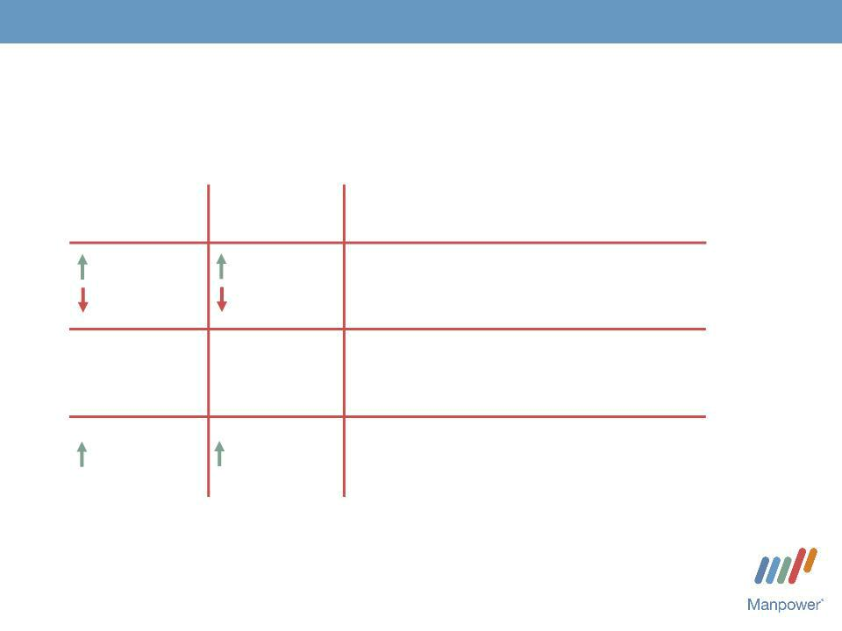

Asia Pacific Segment
(11% of Revenue)

As | Excluding Non | Q4 Financial Highlights
As | -recurring | Q4 Financial Highlights
Reported | Items⁽¹⁾ | Q4 Financial Highlights
4% | 4% | Revenue $469M
6% | 6% | Revenue $469M
CC | CC
N/A | N/A | OUP $7M
N/A | N/A | OUP $7M
180 bps | 170 bps | OUP Margin 1.5%

- Excludes the impact of the reorganization charges of $0.4M in 2009 and $0.8M in 2008.

Manpower Inc. 2009 4th Quarter Results | 11

Asia Pacific - Q4 Revenue Growth YoY

- of Segment Revenue

55%

22%

23%

Revenue | Revenue Growth - CC
Growth

Manpower Inc. 2009 4th Quarter Results | 12
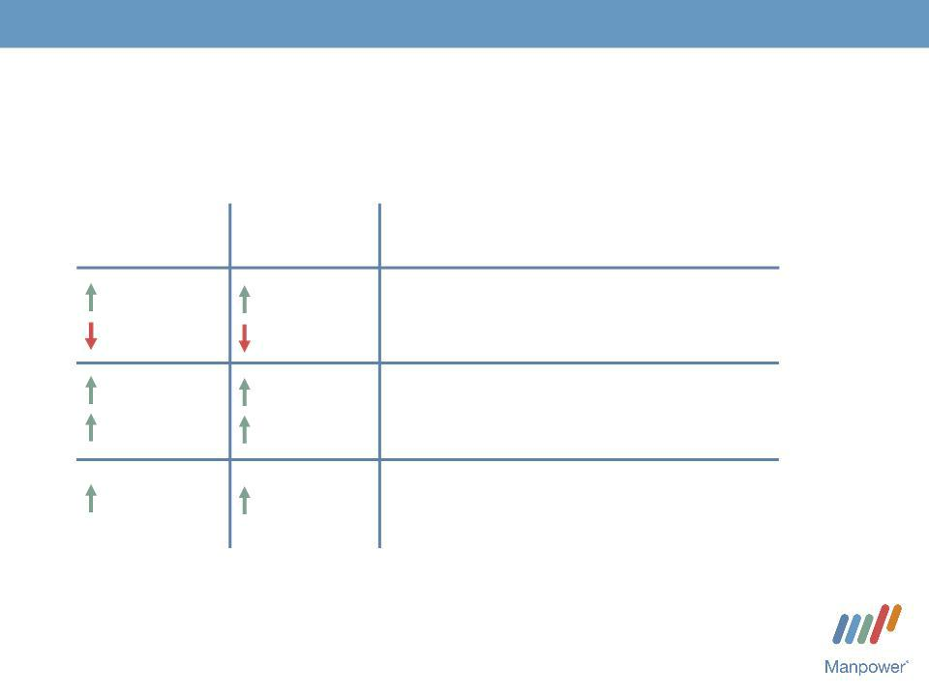

Right Management Segment
(3% of Revenue)

As | Excluding Non | Q4 Financial Highlights
As | -recurring | Q4 Financial Highlights
Reported | Items⁽¹⁾ | Q4 Financial Highlights
5% | 5% | Revenue $130M
1% | 1% | Revenue $130M
CC | CC
22% | 12% | OUP $21M
16% | 6% | OUP $21M
CC | CC | OUP Margin 16.0%
230 bps | 100 bps | OUP Margin 16.0%

- Excludes the impact of the reorganization charges of $1.5M in 2008.

Manpower Inc. 2009 4th Quarter Results | 13

Jefferson Wells Segment
(1% of Revenue)

As | Excluding Non | Q4 Financial Highlights
As | -recurring | Q4 Financial Highlights
Reported | Items⁽¹⁾ | Q4 Financial Highlights
32% | 32% | Revenue $43M
N/A | N/A | OUP $(4M)
1300 | 50 | OUP Margin - 8.6%
bps | bps

- Excludes the impact of the reorganization charges of $7.8M in 2008.

Manpower Inc. 2009 4th Quarter Results | 14


Financial Highlights

Manpower Inc. 2009 4th Quarter Results | 15
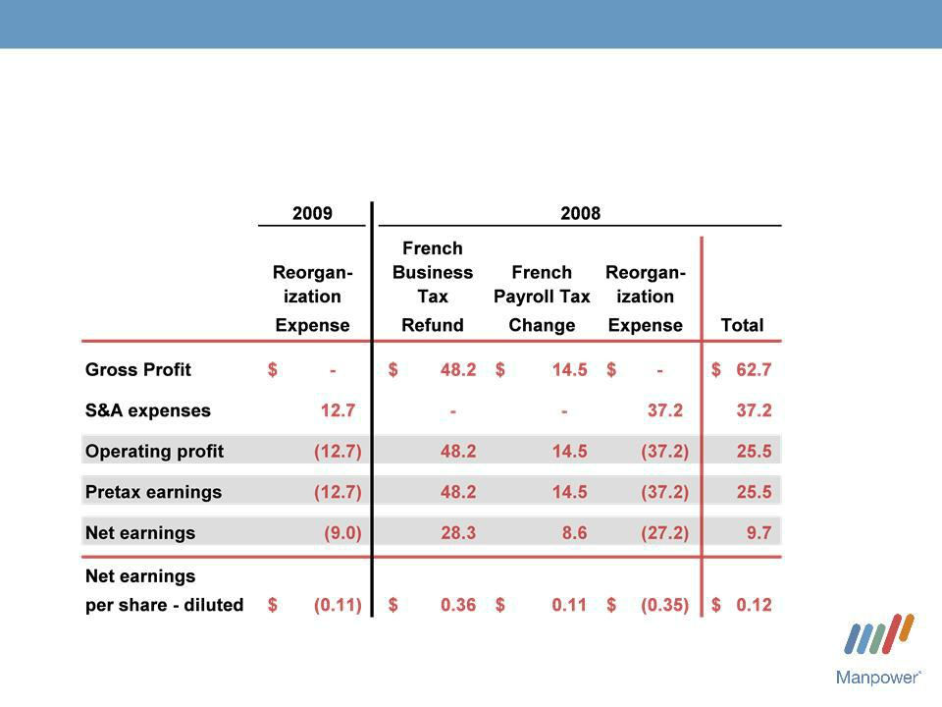

Q4 Non-recurring Items
($ in millions, except per share amounts)

Manpower Inc. 2009 4th Quarter Results | 16
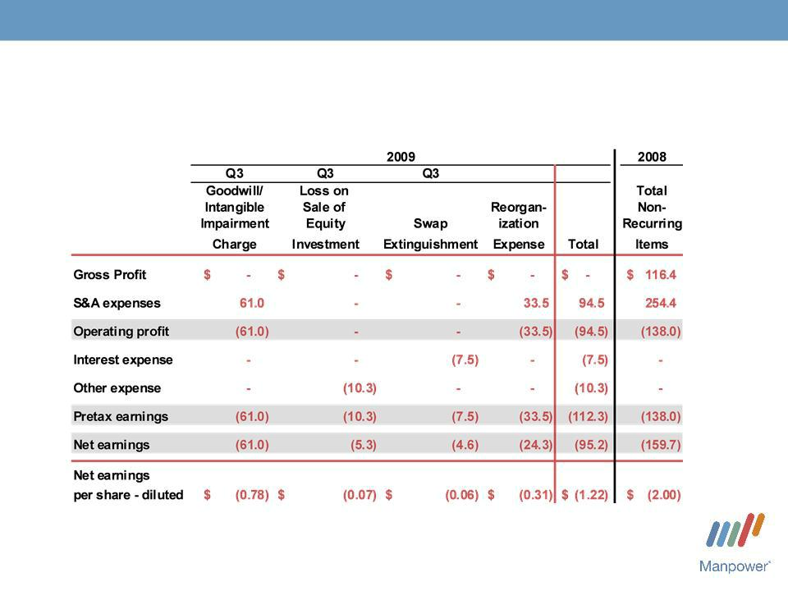

Full Year Non-recurring Items
($ in millions, except per share amounts)

(1)

- Reorganization expense was $6.9M pretax in Q1($0.06 per share), $13.0M in Q2 ($0.11 per share), $0.9M in Q3 ($0.01 per share) and $12.7M in Q4 ($0.11 per share).

Manpower Inc. 2009 4th Quarter Results | 17
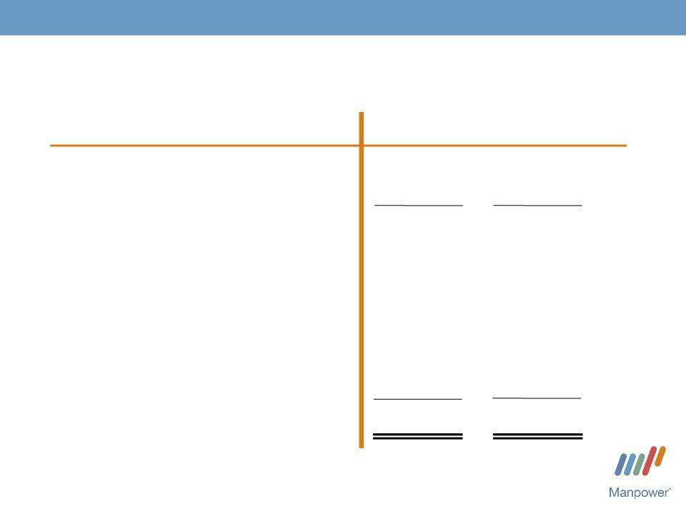

Cash Flow Summary - Full Year

($ in millions)

Cash from Operations

Capital
_{Free}Expenditures_{CashFlow}

Share Repurchases

Change in
Debt

Acquisitions of Businesses,netofcash acquired

Effect of Exchange Rate Changes Other

Change in Cash

2009 2008

- 792

  - (93)

379 699

- (125)

- 79

- (242)

37 (35)

- (39)

141337

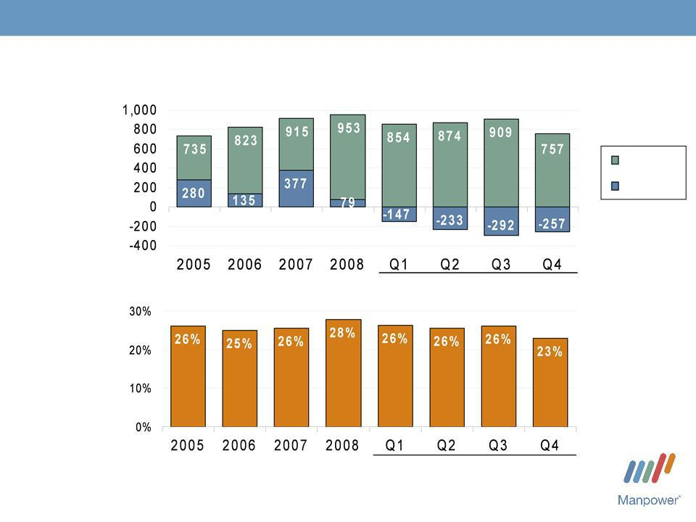
Manpower Inc. 2009 4th Quarter Results

Balance Sheet Highlights

Total Debt

($ in millions)

Total Debt to | 2009
Total Capitalization | 2009

2009

18

Total Debt

Net
Debt

Manpower Inc. 2009 4th Quarter Results | 19


Credit Facilities as of December 31, 2009
($ in millions) | Interest | Maturity | Total | Remaining
 | Rate | Date | Outstanding | Available
Euro
Notes: | 4.86% | June | 286 | -
- Euro
200M | 4.58% | 2013 | 429 | -
- Euro | 4.58% | June | 429 | -
300M | (a) | 2012 | - | 391
Revolving Credit Agreement | 2.78% | Nov 2012 | - | 391
Uncommitted lines and | Various | Various | 42 | 368
Other |  |  | 757 | (b)
Total Debt |  |  | 757 | 759

- Effective October 16, 2009, we amended our Revolving Credit Agreement. The amendment reduces the size of the facility from $625M to $400M and revises covenant levels and pricing. The amended agreement requires, as of December 31, that we comply with a Debt-to-EBITDA ratio of less than 5.25 to 1 and a fixed charge coverage ratio of greater than 1.25 to 1. As defined in the agreement, we had a Debt-to -EBITDA ratio of 3.64 and a fixed charge coverage ratio of 1.55 as of December 31, 2009.

On October 16, 2009, we elected to repay the €100M ($143M) borrowing under the agreement and terminated the related interest rate swaps. There are currently no outstanding borrowings under the agreement.

- Total additional borrowings are limited to $334 million due to the Revolving Credit Agreement covenants.

Manpower Inc. 2009 4th Quarter Results | 20
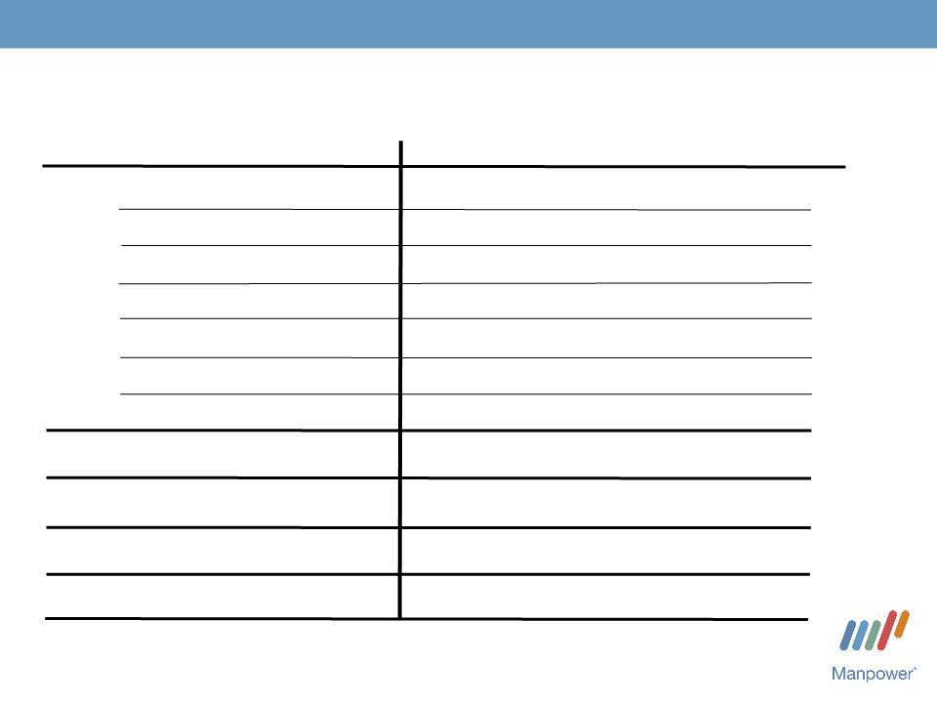

First Quarter Outlook

Revenue Total

Americas

France

EMEA

Asia
_{Right}Pacific

^{Management}JeffersonWells

Gross Profit
Margin
Operating Profit
Tax Rate^{Margin}

EPS

Up 9- | (Up 0-2%
1 % | CC)
Up 17-19% | (Up 13-15% CC)
Up 13-15% (Up 5-7% CC)
Up 7-9% | (Down 2-4%
Up 8-10% | CC)
Up 8-10% | (Down 0-2%
Down 18- | CC)
Down 18- | (Down 23-25%
20% | CC)
Down 20-
22%
16.8-17.0%
(0.2) -
0.2%
40%
Loss of $0.05-$0.15 |  | (Pos. $.03
 |  | Currency)

MANPOWER INC.

COMSYS
Acquisition

2010 February

Manpower Inc. - COMSYS Acquisition | 22


Strategic Rationale

- Increased capability to service clients’ IT requirements

- Stronger platform in higher growth market

- Enhances business mix, with over 20% of company revenue now coming from specialty services

- Good cultural fit

Manpower Inc. - COMSYS Acquisition | 23


COMSYS Business Overview

- Third largest IT staffing and managed solutions company

in the U.S. with $650 million in revenue

– | Project Management | – Applications Programming and Development
– | Business Analysis | – Quality Assurance and Testing
– | Network Infrastructure | – Workforce Solutions (RPO and MSP)

– Business Intelligence

- National footprint with 52 branches

- Diversified client base across several high growth industry sectors

Manpower Inc. - COMSYS Acquisition | 24

Combined Business

- Combined revenue of Manpower Professional and COMSYS will be over $2.5 billion

- Combined number of contractors on assignment daily will be over 25,000

- Combined footprint will be 400 offices

- Combined MSP offering will be total flow through dollars of $3.5 billion

Manpower Inc. - COMSYS Acquisition | 25
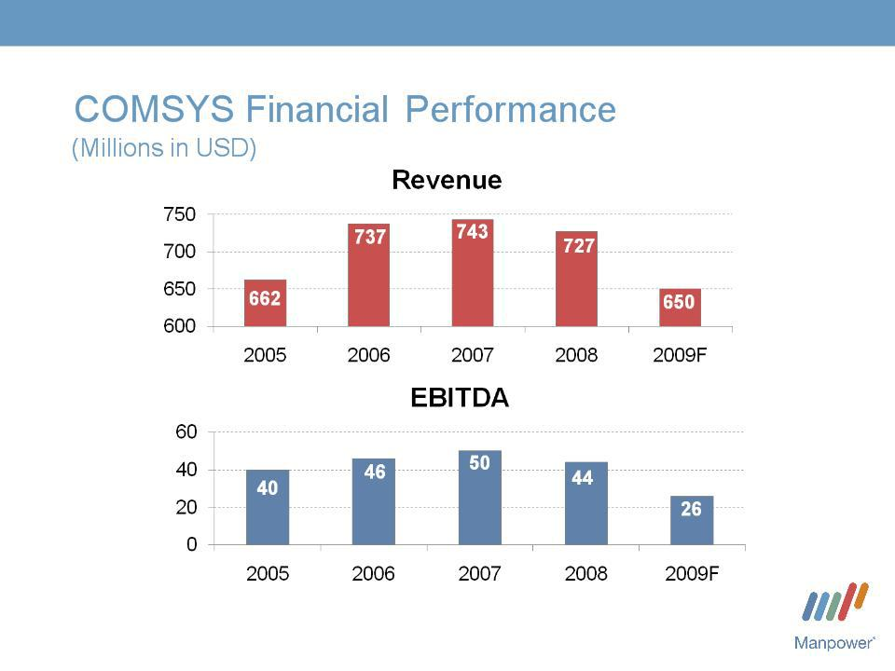

(1)

(2)

(1)

(6.0%) (6.3%) (6.8%) (6.0%) (4.0%)

- Forecast based upon management guidance issued January 6, 2010.

- Excludes one-time items.

Manpower Inc. - COMSYS Acquisition | 26

Acquisition Summary

- Purchase Price: $17.65 per share

• | Equity Value: | $378 million, including net settlement
 |  | of stock options, restricted stock and
 |  | warrants
• | Debt Retired: | $53 million, net debt outstanding as of
 |  | January 31, 2010

Manpower Inc. - COMSYS Acquisition | 27

Acquisition Summary

• | Consideration: | 50% stock / 50% cash,
 |  | with option to pay all cash
• | Tender Offer: | Expected to commence March 2010
• | Expected Closing: April 2010
• | Approvals: | Normal regulatory

Manpower Inc. - COMSYS Acquisition | 28

Acquisition Summary

• Synergies:

$20 million (3% of revenue) by 2011

• Tax NOL:

$35 million (NPV) tax shelter utilized over next 10 years

- Integration Costs: $18 million

• EPS Accretive: | 10 cents accretive in 2010
 | excluding intangible amortization


Manpower Inc.

Questions?
Answers

Exhibit 99.3

Manpower Inc.

Summary of Restated Results - Annual Earnings
December 31, 2009
(In millions, except per share data)

During the fourth quarter of 2009, we determined that our Other EMEA reportable segment prematurely recognized revenues related to a workforce solutions contract. These revenues were recorded on a cash-basis rather than being deferred and earned over the four-year performance period following the month the services were performed. Accordingly, we have restated our annual and quarterly financial results for 2007, 2008, and the nine months ended September 30, 2009. This restatement has no impact on cash flows and only impacts the timing of when revenues are earned, as total revenues for the contract are expected to remain unchanged. The effects of this restatement on 2009, 2008 and 2007 are as follows:

Revenues from services

Cost of services

Gross profit

Selling and administrative expenses

Goodwill and intangible asset impairment charge

Selling and administrative expenses

Operating profit

Interest and other expense

Year Ended December 31, 2008

 | As
 | previously |  |  |  | As
 | reported |  | Adjustment |  | restated
$ | 21,552.8 | $ | (15.7) | $ | 21,537.1
 | 17,450.2 |  |  |  | 17,450.2
 | 4,102.6 |  | (15.7) |  | 4,086.9
 | 3,430.3 |  |  |  | 3,430.3
 | 163.1 |  |  |  | 163.1
 | 3,593.4 |  |  |  | 3,593.4
 | 509.2 |  | (15.7) |  | 493.5
 | 50.9 |  |  |  | 50.9

 | Earnings before income taxes |  |  | 458.3 |  | (15.7) |  | 442.6
 | Provision for income taxes |  |  | 239.4 |  | (2.3) |  | 237.1
 | Net earnings | $ |  | 218.9 | $ | (13.4) | $ | 205.5
 | Net earnings per share - basic | $ |  | 2.78 | $ | (0.17) | $ | 2.61
 | Net earnings per share - diluted | $ |  | 2.75 | $ | (0.17) | $ | 2.58
 |  |  |  | Year Ended December 31, 2007
 |  |  |  | As
 |  |  |  | previously |  |  |  | As
 |  |  |  | reported |  | Adjustment |  | restated
 | Revenues from services | $ |  | 20,500.3 | $ | (14.2) | $ | 20,486.1
 | Cost of services |  |  | 16,651.7 |  |  |  | 16,651.7
 | Gross profit |  |  | 3,848.6 |  | (14.2) |  | 3,834.4
 | Selling and administrative expenses |  |  | 3,023.2 |  |  |  | 3,023.2
 | Operating profit |  |  | 825.4 |  | (14.2) |  | 811.2
 | Interest and other expense |  |  | 34.2 |  |  |  | 34.2
 | Earnings before income taxes |  |  | 791.2 |  | (14.2) |  | 777.0
 | Provision for income taxes |  |  | 306.5 |  | (3.2) |  | 303.3
 | Net earnings | $ |  | 484.7 | $ | (11.0) | $ | 473.7
 | Net earnings per share - basic | $ |  | 5.83 | $ | (0.13) | $ | 5.70
 | Net earnings per share - diluted | $ |  | 5.73 | $ | (0.13) | $ | 5.60

Manpower Inc.

Summary of Restated Results - Quarterly Earnings

December 31, 2009

(In millions, except per share data)

 |  |  |  |  |  |  |  |  |  |  |  |  |  |  | 2009
 |  |  |  | Three Months Ended March 31 |  |  |  |  |  |  |  |  |  |  |  |  | Three Months Ended September
 |  |  |  |  |  | (a) |  |  |  |  | Three Months Ended June 30 |  |  |  |  |  |  |  |  | 30 |  |  |  | Nine Months Ended September 30
 |  |  |  | As |  |  |  |  |  |  | As |  |  |  |  |  |  | As |  |  |  |  |  |  | As
 |  |  | previously |  |  |  |  | As |  | previously |  |  |  |  | As |  | previously |  |  |  |  | As |  | previously |  |  |  |  | As
2009 |  |  | reported |  | Adjustment |  | restated |  |  | reported |  | Adjustment |  | restated |  |  | reported |  | Adjustment |  | restated |  |  | reported |  | Adjustment |  | restated
 | Revenues from services |  | $ | 3,647.1 | $ | (4.1) | $ | 3,643.0 |  | $ | 3,796.6 | $ | (3.1) | $ | 3,793.5 |  | $ | 4,192.1 | $ | (2.5) | $ | 4,189.6 |  | $ | 11,635.8 | $ | (9.7) | $ | 11,626.1
 | Cost of services |  |  | 2,977.3 |  |  |  | 2,977.3 |  |  | 3,101.2 |  |  |  | 3,101.2 |  |  | 3,485.5 |  |  |  | 3,485.5 |  |  | 9,564.0 |  |  |  | 9,564.0
 | Gross profit |  |  | 669.8 |  | (4.1) |  | 665.7 |  |  | 695.4 |  | (3.1) |  | 692.3 |  |  | 706.6 |  | (2.5) |  | 704.1 |  |  | 2,071.8 |  | (9.7) |  | 2,062.1
 | Selling and administrative expenses |  |  | 664.3 |  |  |  | 664.3 |  |  | 673.3 |  |  |  | 673.3 |  |  | 664.6 |  |  |  | 664.6 |  |  | 2,002.2 |  |  |  | 2,002.2
 | Goodwill and intangible asset
 | impairment charge |  |  | - |  |  |  | - |  |  | - |  |  |  | - |  |  | 61.0 |  |  |  | 61.0 |  |  | 61.0 |  |  |  | 61.0
 | Selling and administrative expenses |  |  | 664.3 |  |  |  | 664.3 |  |  | 673.3 |  |  |  | 673.3 |  |  | 725.6 |  |  |  | 725.6 |  |  | 2,063.2 |  |  |  | 2,063.2
 | Operating profit |  |  | 5.5 |  | (4.1) |  | 1.4 |  |  | 22.1 |  | (3.1) |  | 19.0 |  |  | (19.0) |  | (2.5) |  | (21.5) |  |  | 8.6 |  | (9.7) |  | (1.1)
 | Interest and other expense |  |  | 11.9 |  |  |  | 11.9 |  |  | 10.8 |  |  |  | 10.8 |  |  | 29.3 |  |  |  | 29.3 |  |  | 52.0 |  |  |  | 52.0
 | (Loss) earnings before income taxes |  |  | (6.4) |  | (4.1) |  | (10.5) |  |  | 11.3 |  | (3.1) |  | 8.2 |  |  | (48.3) |  | (2.5) |  | (50.8) |  |  | (43.4) |  | (9.7) |  | (53.1)
 | Provision for income taxes |  |  | (8.7) |  | - |  | (8.7) |  |  | (8.0) |  | (0.1) |  | (8.1) |  |  | 2.1 |  | (0.1) |  | 2.0 |  |  | (14.6) |  | (0.2) |  | (14.8)
 | Net earnings (loss) |  | $ | 2.3 | $ | (4.1) | $ | (1.8) |  | $ | 19.3 | $ | (3.0) | $ | 16.3 |  | $ | (50.4) | $ | (2.4) | $ | (52.8) |  | $ | (28.8) | $ | (9.5) | $ | (38.3)
 | Net earnings per share - basic |  | $ | 0.03 | $ | (0.05) | $ | (0.02) |  | $ | 0.25 | $ | (0.04) | $ | 0.21 |  | $ | (0.64) | $ | (0.03) | $ | (0.67) |  | $ | (0.37) | $ | (0.12) | $ | (0.49)
 | Net earnings per share - diluted |  | $ | 0.03 | $ | (0.05) | $ | (0.02) |  | $ | 0.25 | $ | (0.04) | $ | 0.21 |  | $ | (0.64) | $ | (0.03) | $ | (0.67) |  | $ | (0.37) | $ | (0.12) | $ | (0.49)

- For the three months ended March 31, 2009, our net earnings of $2.3 million as previously reported changed to a net loss of $1.8 million as restated. Therefore, the weighted average shares - diluted for the three months ended 2009 changed from 78.3 million to 78.1 million due to the net loss as the assumed exercise price of stock-based awards had an anitdilutive effect and were excluded from the calculation of weighted average shares - diluted.

 |  |  |  |  |  |  |  |  |  |  |  |  |  |  | 2008
 |  |  |  |  |  |  |  |  |  |  |  |  |  |  |  |  | Three Months Ended September |  |  |  |  |  |  |  | Three Months Ended December
 |  |  |  | Three Months Ended March 31 |  |  |  |  |  |  | Three Months Ended June 30 |  |  |  |  |  |  |  |  | 30 |  |  |  |  |  |  | 31
 |  |  |  | As |  |  |  |  |  |  | As |  |  |  |  |  |  | As |  |  |  |  |  |  | As
 |  |  | previously |  |  |  |  | As |  | previously |  |  |  |  | As |  | previously |  |  |  |  | As |  | previously |  |  |  |  | As
2008 |  |  | reported |  | Adjustment |  | restated |  |  | reported |  | Adjustment |  | restated |  |  | reported |  | Adjustment |  | restated |  |  | reported |  | Adjustment |  | restated
 | Revenues from services |  | $ | 5,386.6 | $ | (5.0) | $ | 5,381.6 |  | $ | 5,904.9 | $ | (4.2) | $ | 5,900.7 | $ |  | 5,668.4 | $ | (3.2) | $ | 5,665.2 |  | $ | 4,592.9 | $ | (3.3) | $ | 4,589.6
 | Cost of services |  |  | 4,418.9 |  |  |  | 4,418.9 |  |  | 4,751.3 |  |  |  | 4,751.3 |  |  | 4,640.8 |  |  |  | 4,640.8 |  |  | 3,639.2 |  |  |  | 3,639.2
 | Gross profit |  |  | 967.7 |  | (5.0) |  | 962.7 |  |  | 1,153.6 |  | (4.2) |  | 1,149.4 |  |  | 1,027.6 |  | (3.2) |  | 1,024.4 |  |  | 953.7 |  | (3.3) |  | 950.4
 | Selling and administrative expenses |  |  | 835.7 |  |  |  | 835.7 |  |  | 946.3 |  |  |  | 946.3 |  |  | 843.5 |  |  |  | 843.5 |  |  | 804.8 |  |  |  | 804.8
 | Goodwill and intangible asset
 | impairment charge |  |  | - |  |  |  | - |  |  | - |  |  |  | - |  |  | 163.1 |  |  |  | 163.1 |  |  | - |  |  |  | -
 | Selling and administrative expenses |  |  | 835.7 |  |  |  | 835.7 |  |  | 946.3 |  |  |  | 946.3 |  |  | 1,006.6 |  |  |  | 1,006.6 |  |  | 804.8 |  |  |  | 804.8
 | Operating profit |  |  | 132.0 |  | (5.0) |  | 127.0 |  |  | 207.3 |  | (4.2) |  | 203.1 |  |  | 21.0 |  | (3.2) |  | 17.8 |  |  | 148.9 |  | (3.3) |  | 145.6
 | Interest and other expense |  |  | 11.3 |  |  |  | 11.3 |  |  | 13.9 |  |  |  | 13.9 |  |  | 13.4 |  |  |  | 13.4 |  |  | 12.3 |  |  |  | 12.3
 | Earnings before income taxes |  |  | 120.7 |  | (5.0) |  | 115.7 |  |  | 193.4 |  | (4.2) |  | 189.2 |  |  | 7.6 |  | (3.2) |  | 4.4 |  |  | 136.6 |  | (3.3) |  | 133.3
 | Provision for income taxes |  |  | 45.2 |  | (1.1) |  | 44.1 |  |  | 86.0 |  | (0.8) |  | 85.2 |  |  | 50.8 |  | (0.3) |  | 50.5 |  |  | 57.4 |  | (0.1) |  | 57.3
 | Net earnings (loss) |  | $ | 75.5 | $ | (3.9) | $ | 71.6 |  | $ | 107.4 | $ | (3.4) | $ | 104.0 | $ |  | (43.2) | $ | (2.9) | $ | (46.1) |  | $ | 79.2 | $ | (3.2) | $ | 76.0
 | Net earnings per share - basic |  | $ | 0.95 | $ | (0.05) | $ | 0.90 |  | $ | 1.36 | $ | (0.05) | $ | 1.31 | $ |  | (0.55) | $ | (0.04) | $ | (0.59) |  | $ | 1.02 | $ | (0.04) | $ | 0.98
 | Net earnings per share - diluted |  | $ | 0.94 | $ | (0.05) | $ | 0.89 |  | $ | 1.34 | $ | (0.04) | $ | 1.30 | $ |  | (0.55) | $ | (0.04) | $ | (0.59) |  | $ | 1.01 | $ | (0.04) | $ | 0.97

 |  |  |  |  |  |  |  |  |  |  |  |  |  |  | 2007
 |  |  |  |  |  |  |  |  |  |  |  |  |  |  |  |  | Three Months Ended September |  |  |  |  |  |  |  | Three Months Ended December
 |  |  |  | Three Months Ended March 31 |  |  |  |  |  |  | Three Months Ended June 30 |  |  |  |  |  |  |  |  | 30 |  |  |  |  |  |  | 31
 |  |  |  | As |  |  |  |  |  |  | As |  |  |  |  |  |  | As |  |  |  |  |  |  | As
 |  |  | previously |  |  |  |  | As |  | previously |  |  |  |  | As |  | previously |  |  |  |  | As |  | previously |  |  |  |  | As
2007 |  |  | reported |  | Adjustment |  | restated |  |  | reported |  | Adjustment |  | restated |  |  | reported |  | Adjustment |  | restated |  |  | reported |  | Adjustment |  | restated
 | Revenues from services |  | $ | 4,535.6 | $ | (2.9) | $ | 4,532.7 |  | $ | 5,034.4 | $ | (3.8) | $ | 5,030.6 | $ |  | 5,295.4 | $ | (3.6) | $ | 5,291.8 | $ |  | 5,634.9 | $ | (3.9) | $ | 5,631.0
 | Cost of services |  |  | 3,735.6 |  |  |  | 3,735.6 |  |  | 4,010.3 |  |  |  | 4,010.3 |  |  | 4,321.0 |  |  |  | 4,321.0 |  |  | 4,584.8 |  |  |  | 4,584.8
 | Gross profit |  |  | 800.0 |  | (2.9) |  | 797.1 |  |  | 1,024.1 |  | (3.8) |  | 1,020.3 |  |  | 974.4 |  | (3.6) |  | 970.8 |  |  | 1,050.1 |  | (3.9) |  | 1,046.2
 | Selling and administrative expenses |  |  | 696.7 |  |  |  | 696.7 |  |  | 747.1 |  |  |  | 747.1 |  |  | 752.5 |  |  |  | 752.5 |  |  | 826.9 |  |  |  | 826.9
 | Operating profit |  |  | 103.3 |  | (2.9) |  | 100.4 |  |  | 277.0 |  | (3.8) |  | 273.2 |  |  | 221.9 |  | (3.6) |  | 218.3 |  |  | 223.2 |  | (3.9) |  | 219.3
 | Interest and other expense |  |  | 9.6 |  |  |  | 9.6 |  |  | 7.7 |  |  |  | 7.7 |  |  | 9.1 |  |  |  | 9.1 |  |  | 7.8 |  |  |  | 7.8
 | Earnings before income taxes |  |  | 93.7 |  | (2.9) |  | 90.8 |  |  | 269.3 |  | (3.8) |  | 265.5 |  |  | 212.8 |  | (3.6) |  | 209.2 |  |  | 215.4 |  | (3.9) |  | 211.5
 | Provision for income taxes |  |  | 34.2 |  | (0.7) |  | 33.5 |  |  | 108.9 |  | (0.9) |  | 108.0 |  |  | 81.1 |  | (0.8) |  | 80.3 |  |  | 82.3 |  | (0.8) |  | 81.5
 | Net earnings |  | $ | 59.5 | $ | (2.2) | $ | 57.3 |  | $ | 160.4 | $ | (2.9) | $ | 157.5 | $ |  | 131.7 | $ | (2.8) | $ | 128.9 | $ |  | 133.1 | $ | (3.1) | $ | 130.0
 | Net earnings per share - basic |  | $ | 0.70 | $ | (0.03) | $ | 0.67 |  | $ | 1.90 | $ | (0.03) | $ | 1.87 | $ |  | 1.59 | $ | (0.03) | $ | 1.56 | $ |  | 1.65 | $ | (0.04) | $ | 1.61
 | Net earnings per share - diluted |  | $ | 0.69 | $ | (0.03) | $ | 0.66 |  | $ | 1.86 | $ | (0.03) | $ | 1.83 | $ |  | 1.57 | $ | (0.04) | $ | 1.53 | $ |  | 1.63 | $ | (0.04) | $ | 1.59

Manpower Inc.

Summary of Restated Results - Consolidated Balance Sheets

December 31, 2009

(In millions)

 |  |  |  |  |  | 2008 |  |  |  |  |  |  | 2007
 |  |  |  | As |  |  |  |  |  |  | As
 |  |  |  | previously |  |  |  | As |  |  | previously |  |  |  | As
December 31 |  |  |  | reported |  | Adjustment |  | restated |  |  | reported |  | Adjustment |  | restated
 | ASSETS
 | Current Assets
 | Cash and cash equivalents | $ |  | 874.0 |  |  | $ | 874.0 |  | $ | 537.5 |  |  | $ | 537.5
 | Accounts receivable, less allowance for doubtful
accounts |  |  |  | 3,629.7 |  |  |  | 3,629.7 |  |  | 4,478.8 |  |  |  | 4,478.8
 | Prepaid expenses and other assets |  |  | 119.9 |  |  |  | 119.9 |  |  | 122.2 |  |  |  | 122.2
 | Future income tax benefits |  |  | 66.5 |  |  |  | 66.5 |  |  | 76.3 |  |  |  | 76.3
 | Total current assets |  |  | 4,690.1 |  | - |  | 4,690.1 |  |  | 5,214.8 |  | - |  | 5,214.8
 | Other Assets
 | Goodwill |  |  | 972.9 |  |  |  | 972.9 |  |  | 1,045.9 |  |  |  | 1,045.9
 | Intangible assets, less accumulated amortization |  |  | 415.2 |  |  |  | 415.2 |  |  | 364.8 |  |  |  | 364.8
 | Other assets |  |  | 326.6 |  | 4.0 |  | 330.6 |  |  | 377.7 |  | 2.5 |  | 380.2
 | Total other assets |  |  | 1,714.7 |  | 4.0 |  | 1,718.7 |  |  | 1,788.4 |  | 2.5 |  | 1,790.9
 | Property and Equipment
 | Land, buildings, leasehold improvements and
equipment |  |  |  | 744.0 |  |  |  | 744.0 |  |  | 760.8 |  |  |  | 760.8
 | Less: accumulated depreciation and amortization |  |  | 530.6 |  |  |  | 530.6 |  |  | 539.6 |  |  |  | 539.6
 | Net property and equipment |  |  | 213.4 |  | - |  | 213.4 |  |  | 221.2 |  | - |  | 221.2
 | Total assets |  | $ | 6,618.2 | $ | 4.0 | $ | 6,622.2 |  | $ | 7,224.4 | $ | 2.5 | $ | 7,226.9
 | LIABILITIES AND SHAREHOLDERS' EQUITY
 | Current Liabilities
 | Accounts payable | $ |  | 903.2 | $ | (6.9) | $ | 896.3 |  | $ | 1,014.4 | $ | (3.4) | $ | 1,011.0
 | Employee compensation payable |  |  | 213.2 |  |  |  | 213.2 |  |  | 213.6 |  |  |  | 213.6
 | Accrued liabilities |  |  | 577.9 |  | 7.8 |  | 585.7 |  |  | 679.4 |  | 6.5 |  | 685.9
 | Accrued payroll taxes and insurance |  |  | 617.5 |  |  |  | 617.5 |  |  | 724.7 |  |  |  | 724.7
 | Value added taxes payable |  |  | 479.2 |  |  |  | 479.2 |  |  | 583.7 |  |  |  | 583.7
 | Short-term borrowings and current maturities of
 | long-term debt |  |  | 115.6 |  |  |  | 115.6 |  |  | 39.7 |  |  |  | 39.7
 | Total current liabilities |  |  | 2,906.6 |  | 0.9 |  | 2,907.5 |  |  | 3,255.5 |  | 3.1 |  | 3,258.6
 | Other Liabilities
 | Long-term debt |  |  | 837.3 |  |  |  | 837.3 |  |  | 874.8 |  |  |  | 874.8
 | Other long-term liabilities |  |  | 390.5 |  | 27.5 |  | 418.0 |  |  | 424.8 |  | 10.4 |  | 435.2
 | Total other liabilities |  |  | 1,227.8 |  | 27.5 |  | 1,255.3 |  |  | 1,299.6 |  | 10.4 |  | 1,310.0
 | Shareholders' Equity
 | Preferred stock |  |  | - |  |  |  | - |  |  | - |  |  |  | -
 | Common stock |  |  | 1.0 |  |  |  | 1.0 |  |  | 1.0 |  |  |  | 1.0
 | Capital in excess of par value |  |  | 2,514.8 |  |  |  | 2,514.8 |  |  | 2,481.8 |  |  |  | 2,481.8
 | Retained earnings |  |  | 1,201.2 |  | (24.4) |  | 1,176.8 |  |  | 1,040.3 |  | (11.0) |  | 1,029.3
 | Accumulated other comprehensive income (loss) |  |  | (8.9) |  |  |  | (8.9) |  |  | 257.6 |  |  |  | 257.6
 | Treasury stock at cost |  |  | (1,224.3) |  |  |  | (1,224.3) |  |  | (1,111.4) |  |  |  | (1,111.4)
 | Total shareholders' equity |  |  | 2,483.8 |  | (24.4) |  | 2,459.4 |  |  | 2,669.3 |  | (11.0) |  | 2,658.3
 | Total liabilities and shareholders'
 | equity | $ |  | 6,618.2 | $ | 4.0 | $ | 6,622.2 |  | $ | 7,224.4 | $ | 2.5 | $ | 7,226.9

Manpower Inc.

Summary of Restated Results - Consolidated Statements of Cash Flows

December 31, 2009

(In millions)

 |  |  |  |  |  | 2008 |  |  |  |  |  |  | 2007
 |  |  |  | As |  |  |  |  |  |  | As
 |  |  |  | previously |  |  |  | As |  |  | previously |  |  |  | As
Year Ended December 31 |  |  |  | reported |  | Adjustment |  | restated |  |  | reported |  | Adjustment |  | restated
 | Cash Flows from Operating Activities
 | Net earnings | $ |  | 218.9 | $ | (13.4) | $ | 205.5 |  | $ | 484.7 | $ | (11.0) | $ | 473.7
 | Adjustments to reconcile net earnings to net cash provided by
 | operating activities:
 | Depreciation and amortization |  |  | 107.1 |  |  |  | 107.1 |  |  | 99.0 |  |  |  | 99.0
 | Non-cash goodwill and intangible impairment charge |  |  | 163.1 |  |  |  | 163.1 |  |  | - |  |  |  | -
 | Deferred income taxes |  |  | (30.5) |  | (1.5) |  | (32.0) |  |  | 25.4 |  | (2.5) |  | 22.9
 | Provision for doubtful accounts |  |  | 23.4 |  |  |  | 23.4 |  |  | 21.8 |  |  |  | 21.8
 | Share-based compensation |  |  | 21.1 |  |  |  | 21.1 |  |  | 26.0 |  |  |  | 26.0
 | Excess tax benefit on exercise of stock options |  |  | (0.5) |  |  |  | (0.5) |  |  | (4.6) |  |  |  | (4.6)
 | Change in operating assets and liabilities, excluding the impact
of acquisitions:
 | Accounts receivable |  |  | 575.0 |  | - |  | 575.0 |  |  | (316.0) |  | - |  | (316.0)
 | Other assets |  |  | 2.9 |  |  |  | 2.9 |  |  | (3.5) |  | - |  | (3.5)
 | Other liabilities |  |  | (288.5) |  | 14.9 |  | (273.6) |  |  | 99.4 |  | 13.5 |  | 112.9
 | Cash provided by operating activities |  |  | 792.0 |  | - |  | 792.0 |  |  | 432.2 |  | - |  | 432.2
 | Cash Flows from Investing Activities
 | Capital expenditures |  |  | (93.1) |  |  |  | (93.1) |  |  | (91.6) |  |  |  | (91.6)
 | Acquisitions of businesses, net of cash acquired |  |  | (242.0) |  |  |  | (242.0) |  |  | (122.8) |  |  |  | (122.8)
 | Proceeds from the sale of property and equipment |  |  | 5.9 |  |  |  | 5.9 |  |  | 12.9 |  |  |  | 12.9
 | Cash (used) provided by investing activities |  |  | (329.2) |  |  |  | (329.2) |  |  | 201.5 |  |  |  | 201.5
 | Cash Flows from Financing Activities
 | Net change in short-term borrowings |  |  | 16.0 |  |  |  | 16.0 |  |  | 6.1 |  |  |  | 6.1
 | Proceeds from long-term debt |  |  | 233.7 |  |  |  | 233.7 |  |  | 1.0 |  |  |  | 1.0
 | Repayments of long-term debt |  |  | (170.7) |  |  |  | (170.7) |  |  | (2.2) |  |  |  | (2.2)
 | Proceeds from stock option and purchase plans |  |  | 12.2 |  |  |  | 12.2 |  |  | 35.0 |  |  |  | 35.0
 | Excess tax benefit on exercise of stock options |  |  | 0.5 |  |  |  | 0.5 |  |  | 4.6 |  |  |  | 4.6
 | Repurchases of common stock |  |  | (125.4) |  |  |  | (125.4) |  |  | (419.2) |  |  |  | (419.2)
 | Dividends paid |  |  | (58.1) |  |  |  | (58.1) |  |  | (57.1) |  |  |  | (57.1)
 | Cash used by financing activities |  |  | (91.8) |  |  |  | (91.8) |  |  | (431.8) |  |  |  | (431.8)
 | Effect of exchange rate changes on cash |  |  | (34.5) |  |  |  | (34.5) |  |  | 50.7 |  |  |  | 50.7
 | Net increase (decrease) in cash and cash equivalents |  |  | 336.5 |  |  |  | 336.5 |  |  | (150.4) |  |  |  | (150.4)
 | Cash and cash equivalents, beginning of year |  |  | 537.5 |  |  |  | 537.5 |  |  | 687.9 |  |  |  | 687.9
 | Cash and cash equivalents, end of year | $ |  | 874.0 |  |  | $ | 874.0 |  | $ | 537.5 |  |  | $ | 537.5
 | Supplemental Cash Flow Information
 | Interest paid | $ |  | 64.8 |  |  | $ | 64.8 |  | $ | 50.5 |  |  | $ | 50.5
 | Income taxes paid | $ |  | 293.5 |  |  | $ | 293.5 |  | $ | 248.5 |  |  | $ | 248.5

