UNITED STATES

SECURITIES AND EXCHANGE COMMISSION
Washington, D.C. 20549

FORM 8-K

CURRENT REPORT

Pursuant to Section 13 or 15(d) of the Securities Exchange Act of 1934

Date of Report (Date of earliest event reported): February 2, 2011

MANPOWER INC.

(Exact name of registrant as specified in its charter)

 | Wisconsin |  |  |  | 1-10686 |  |  | 39-1672779
(State or other jurisdiction of incorporation) |  |  |  |  | (Commission File Number) |  |  |  | (IRS Employer Identification No.)
 |  | 100 Manpower Place
 |  | Milwaukee, Wisconsin |  |  |  |  |  | 53212
(Address of principal executive offices) |  |  |  |  |  |  |  | (Zip Code)

Registrant's telephone number, including area code: (414) 961-1000

Check the appropriate box below if the Form 8-K filing is intended to simultaneously satisfy the filing obligation of the registrant under any of the following provisions:

Written communications pursuant to Rule 425 under the Securities Act (17 CFR 230.425)

Soliciting material pursuant to Rule 14a-12 under the Securities Act (17 CFR 240.14a-12)

Pre-commencement communications pursuant to Rule 14d-2(b) under the Exchange Act (17 CFR 240.14d-2(b))

Pre-commencement communications pursuant to Rule 13e-4(c) under the Exchange Act (17 CFR 240.13e-4(c))

Item 2.02 Results of Operations and Financial Condition

On February 2, 2011, we issued a press release announcing our results of operations for the three months and year ended December 31, 2010. A copy of the press release is attached hereto as Exhibit 99.1 and is incorporated herein by reference.

During the fourth quarter of 2010, our segment reporting was realigned due to our Jefferson Wells business being combined with our Professional Finance and Accounting vertical within the United States. Accordingly, our former reportable segment, Jefferson Wells, is now reported within our United States operating segment as part of the Americas reportable segment. All previously reported results have been restated to conform to the current year presentation. Attached hereto as Exhibit 99.3 is our Operating Unit Results since January 1, 2008, revised to conform to the current year presentation.

Item 9.01. | Exhibits.
Exhibit No. |  |  | Description
99.1 |  |  | Press Release dated February 2, 2011
99.2 |  |  | Presentation materials for February 2, 2011 conference call
99.3 |  |  | Operating Unit Results reflecting the restatement of segment results

SIGNATURES

Pursuant to the requirements of the Securities Exchange Act of 1934, the Registrant has duly caused this Report to be signed on its behalf by the undersigned hereunto duly authorized.

MANPOWER INC.

Dated: February 2, 2011 By: /s/ Michael J. Van Handel

Michael J. Van Handel

Executive Vice President and

Chief Financial Officer

 |  | EXHIBIT INDEX
Exhibit No. |  | Description
99.1 |  | Press Release dated February 2, 2011
99.2 |  | Presentation materials for February 2, 2011 conference call
99.3 |  | Operating Unit Results reflecting the restatement of segment results

Exhibit 99.1


FOR IMMEDIATE RELEASE

Contact:

Mike Van Handel

Manpower Inc.

+1.414.906.6305

michael.vanhandel@manpower.com

Manpower Reports 4th Quarter and Full Year 2010 Results

MILWAUKEE, WI, USA, February 2, 2011 – Manpower Inc. (NYSE: MAN) today reported a net loss of $4.29 per diluted share for the three months ended December 31, 2010 compared to net earnings of 37 cents in the prior year period. The net loss in the quarter was $350.4 million compared to net earnings of $29.1 million a year earlier. Revenues for the fourth quarter totaled $5.2 billion, an increase of 18 percent from the year earlier period, or an increase of 22 percent in constant currency.

Included in the fourth quarter results is a non-cash goodwill and intangible asset impairment charge of $428.8 million ($384.3 million after tax, or $4.70 per diluted share) and a reorganization charge, primarily related to office consolidations and severance costs, of $30.5 million ($20.6 million after tax or 25 cents per diluted share). Excluding the impairment and reorganization charges, earnings per diluted share was 66 cents. Net earnings in the fourth quarter were unfavorably impacted by 2 cents per diluted share, as foreign currencies were relatively weaker compared to the prior year period.

Jeffrey A. Joerres, Manpower Inc. Chairman and CEO, said, “2010 was a very strong year for us and the fourth quarter was no different. Our revenue growth in all geographies remains robust and we continue to leverage our office structure to drive profitability. Europe performed exceptionally, as did our IT staffing. We also experienced strong trends in our solutions offerings.

“We move into 2011 with much more confidence, a more complete set of solutions and a stronger organization. We are optimistic for a successful 2011.

“We are anticipating the first quarter of 2011 diluted earnings per share to be in the range of 26 cents to 34 cents with a negligible impact from currency.”

Net earnings per diluted share for the year ended December 31, 2010 was a loss of $3.26 compared to a loss of 12 cents per diluted share in 2009. Net earnings were a loss of $263.6 million compared to a loss of $9.2 million in the prior year. Revenues for the year were $18.9 billion, an increase of 18 percent from the prior year, or 19 percent in constant currency.

Earnings per diluted share for the full year 2010 include the fourth quarter goodwill and intangible asset impairment charge and reorganization costs discussed above ($4.98 per diluted share for the year). Additionally, 2010 results were unfavorably impacted by 4 cents per diluted share due to changes in foreign currencies compared to the prior year. Included in the full year 2009 results is a loss on the sale of an equity investment and goodwill impairment charge totaling 85 cents, a charge of 6 cents related to the repayment of our revolver borrowings and extinguishment of an interest rate swap, and reorganization charges totaling 31 cents.

In conjunction with its fourth quarter earnings release, Manpower will broadcast its conference call live over the Internet on February 2, 2011 at 7:30 a.m. CST (8:30 a.m. EST). Interested parties are invited to listen to the webcast and view the presentation by logging on to http://investor.manpower.com.

Supplemental financial information referenced in the conference call can be found at http://investor.manpower.com.

About Manpower Inc.

Manpower Inc. (NYSE: MAN) is a world leader in innovative workforce solutions; creating and delivering services that enable its clients to win in the changing world of work. With over 62 years’ experience, Manpower offers employers a range of services and solutions for the entire employment and business cycle including permanent, temporary and contract recruitment; employee assessment and selection; training; outplacement; outsourcing and consulting. Manpower’s worldwide network of nearly 4,000 offices in 82 countries and territories is the world’s largest in the industry and enables the company to meet the needs of its 400,000 clients per year, including small and medium size enterprises in all industry sectors, as well as the world's largest multinational corporations. The focus of Manpower’s work is on raising productivity through improved quality, efficiency a nd cost-reduction across their total workforce, enabling clients to concentrate on their core business activities. Manpower Inc. operates under five brands: Manpower, Manpower Professional, Elan, Jefferson Wells and Right Management. More information about Manpower Inc. is available at www.manpower.com.

Forward-Looking Statements

This news release contains statements, including earnings projections, that are forward-looking in nature and, accordingly, are subject to risks and uncertainties regarding the Company’s expected future results. The Company’s actual results may differ materially from those described or contemplated in the forward-looking statements. Factors that may cause the Company’s actual results to differ materially from those contained in the forward-looking statements can be found in the Company’s reports filed with the SEC, including the information under the heading ‘Risk Factors’ in its Annual Report on Form 10-K for the year ended December 31, 2009, which information is incorporated herein by reference.

- ### -

Manpower Inc.

Results of Operations

(In millions, except per share data)

 |  |  |  |  | Three Months Ended December 31
 |  |  |  |  |  |  |  |  | % Variance
 |  |  |  |  |  |  |  | Amount |  |  |  | Constant
 | 2010 |  |  |  | 2009 |  |  | Reported |  |  |  | Currency
 |  |  |  |  |  | (Unaudited)
Revenues from services (a) | $ | 5,209.6 |  | $ |  | 4,412.6 |  |  | 18.1% |  |  | 22.1%
Cost of services |  | 4,303.9 |  |  |  | 3,656.5 |  |  | 17.7% |  |  | 21.8%
Gross profit |  | 905.7 |  |  |  | 756.1 |  |  | 19.8% |  |  | 23.5%
Selling and administrative expenses, excluding impairment charges |  | 819.5 |  |  |  | 713.3 |  |  | 14.9% |  |  | 18.1%
Goodwill and intangible asset impairment charges (b) |  | 428.8 |  |  |  | - |  |  | N/A |  |  | N/A
Selling and administrative expenses |  | 1,248.3 |  |  |  | 713.3 |  |  | 75.0% |  |  | 78.2%
Operating (loss) profit |  | (342.6) |  |  |  | 42.8 |  |  | N/A |  |  | N/A
Interest and other expenses |  | 10.0 |  |  |  | 12.6 |  |  | -20.7%
(Loss) earnings before income taxes |  | (352.6) |  |  |  | 30.2 |  |  | N/A |  |  | N/A
Provision for income taxes |  | (2.2) |  |  |  | 1.1 |  |  | N/A
Net (loss) earnings | $ | (350.4) |  | $ |  | 29.1 |  |  | N/A |  |  | N/A
Net (loss) earnings per share - basic | $ | (4.29) |  | $ |  | 0.37 |  |  | N/A
Net (loss) earnings per share - diluted | $ | (4.29) |  | $ |  | 0.37 |  |  | N/A |  |  | N/A
Weighted average shares - basic |  | 81.6 |  |  |  | 78.5 |  |  | 4.0%
Weighted average shares - diluted |  | 81.6 |  |  |  | 79.7 |  |  | 2.5%

- Revenues from services include fees received from our franchise offices of $6.4 million and $5.7 million for the three months ended December 31, 2010 and 2009, respectively. These fees are primarily based on revenues generated by the franchise offices, which were $263.5 million and $213.4 million for the three months ended December 31, 2010 and 2009, respectively.

- The goodwill and intangible asset impairment charges for the three months ended December 31, 2010 relate to our investments in Right Management and Jefferson Wells. The impact on net earnings is $384.3 million, or $4.70 per diluted share.

Manpower Inc.

Operating Unit Results

(In millions)

 |  |  |  |  |  | Three Months Ended December 31
 |  |  |  |  |  |  |  |  | % Variance
 |  |  |  |  |  |  |  |  | Amount |  |  | Constant
 |  | 2010 |  |  |  | 2009 |  |  | Reported |  |  | Currency
 |  |  |  |  |  | (Unaudited)
Revenues from Services: (a)
Americas:
United States (b) | $ | 777.1 |  | $ |  | 479.0 |  |  | 62.2% |  |  | 62.2%
Other Americas |  | 347.8 |  |  |  | 283.9 |  |  | 22.5% |  |  | 19.5%
 |  | 1,124.9 |  |  |  | 762.9 |  |  | 47.5% |  |  | 46.3%
France |  | 1,433.6 |  |  |  | 1,304.4 |  |  | 9.9% |  |  | 19.5%
EMEA:
Italy |  | 294.1 |  |  |  | 269.3 |  |  | 9.2% |  |  | 18.8%
Other EMEA |  | 1,681.7 |  |  |  | 1,477.7 |  |  | 13.8% |  |  | 19.2%
 |  | 1,975.8 |  |  |  | 1,747.0 |  |  | 13.1% |  |  | 19.1%
Asia Pacific |  | 588.3 |  |  |  | 468.7 |  |  | 25.5% |  |  | 16.5%
Right Management |  | 87.0 |  |  |  | 129.6 |  |  | -32.9% |  |  | -32.4%
 | $ | 5,209.6 |  | $ |  | 4,412.6 |  |  | 18.1% |  |  | 22.1%
Operating Unit Profit (Loss) (c):
Americas:
United States (b) | $ | 14.1 |  | $ |  | (7.7) |  |  | N/A |  |  | N/A
Other Americas |  | 10.0 |  |  |  | 5.9 |  |  | 67.9% |  |  | 63.9%
 |  | 24.1 |  |  |  | (1.8) |  |  | N/A |  |  | N/A
France |  | 12.0 |  |  |  | 5.0 |  |  | 138.0% |  |  | 156.7%
EMEA:
Italy |  | 15.8 |  |  |  | 11.1 |  |  | 43.2% |  |  | 55.6%
Other EMEA |  | 65.8 |  |  |  | 26.5 |  |  | 146.9% |  |  | 157.6%
 |  | 81.6 |  |  |  | 37.6 |  |  | 116.5% |  |  | 127.6%
Asia Pacific |  | 9.6 |  |  |  | 6.9 |  |  | 42.0% |  |  | 32.4%
Right Management |  | (16.8) |  |  |  | 20.8 |  |  | N/A |  |  | N/A
 |  | 110.5 |  |  |  | 68.5
Corporate expenses |  | (30.8) |  |  |  | (20.8)
Goodwill and intangible asset impairment charges |  | (428.8) |  |  |  | -
Intangible asset amortization expense (c) |  | (11.2) |  |  |  | (4.9)
Reclassification of French business tax |  | 17.7 |  |  |  | -
Operating (loss) profit |  | (342.6) |  |  |  | 42.8 |  |  | N/A |  |  | N/A
Interest and other expenses (d) |  | (10.0) |  |  |  | (12.6)
(Loss) earnings before income taxes | $ | (352.6) |  | $ |  | 30.2

- During the fourth quarter of 2010, our segment reporting was realigned due to our Jefferson Wells business being combined with our Professional Finance and Accounting vertical within the United States. Accordingly, our former reportable segment, Jefferson Wells, is now reported within our United States operating segment as part of the Americas reportable segment. All previously reported results have been restated to conform to the current year presentation.

- The United States results include the results of COMSYS IT Partners, Inc., which was acquired on April 5, 2010. United States revenues from services include fees received from our franchise offices of $3.8 million and $3.1 million for the three months ended December 31, 2010 and 2009, respectively. These fees are primarily based on revenues generated by the franchise offices, which were $165.0 million and $135.6 million for the three months ended December 31, 2010 and 2009, respectively.

- During the third quarter of 2010, we redefined Operating Unit Profit (Loss) to exclude intangible asset amortization. Therefore, these costs are no longer included as operating costs within the reportable segments and Corporate Expenses, and all intangible asset amortization expense is now shown separately. All previously reported results have been restated to conform to the current year presentation.

- The components of interest and other expenses were:

 |  | 2010 |  |  |  | 2009
Interest expense | $ | 10.1 |  | $ |  | 13.2
Interest income |  | (2.0) |  |  |  | (2.4)
Foreign exchange loss (gain) |  | 0.8 |  |  |  | (0.1)
Miscellaneous expenses, net |  | 1.1 |  |  |  | 1.9
 | $ | 10.0 |  | $ |  | 12.6

Manpower Inc.

Results of Operations

(In millions, except per share data)

 |  |  |  |  |  | Year Ended December 31
 |  |  |  |  |  |  |  |  | % Variance
 |  |  |  |  |  |  |  |  | Amount |  |  | Constant
 |  | 2010 |  |  |  | 2009 |  |  | Reported |  |  | Currency
 |  |  |  |  |  | (Unaudited)
Revenues from services (a) | $ | 18,866.5 |  | $ |  | 16,038.7 |  |  | 17.6% |  |  | 19.2%
Cost of services |  | 15,621.1 |  |  |  | 13,220.5 |  |  | 18.2% |  |  | 19.8%
Gross profit |  | 3,245.4 |  |  |  | 2,818.2 |  |  | 15.2% |  |  | 16.4%
Selling and administrative expenses, excluding impairment charges |  | 2,938.6 |  |  |  | 2,715.5 |  |  | 8.2% |  |  | 9.1%
Goodwill and intangible asset impairment charges (b) |  | 428.8 |  |  |  | 61.0 |  |  | 602.9% |  |  | 602.9%
Selling and administrative expenses |  | 3,367.4 |  |  |  | 2,776.5 |  |  | 21.3% |  |  | 22.1%
Operating (loss) profit |  | (122.0) |  |  |  | 41.7 |  |  | N/A |  |  | N/A
Interest and other expenses |  | 43.2 |  |  |  | 64.6 |  |  | -33.1%
Loss before income taxes |  | (165.2) |  |  |  | (22.9) |  |  | N/A |  |  | N/A
Provision for income taxes |  | 98.4 |  |  |  | (13.7) |  |  | N/A
Net loss | $ | (263.6) |  | $ |  | (9.2) |  |  | N/A |  |  | N/A
Net loss per share - basic | $ | (3.26) |  | $ |  | (0.12) |  |  | N/A
Net loss per share - diluted | $ | (3.26) |  | $ |  | (0.12) |  |  | N/A |  |  | N/A
Weighted average shares - basic |  | 81.0 |  |  |  | 78.3 |  |  | 3.4%
Weighted average shares - diluted |  | 81.0 |  |  |  | 78.3 |  |  | 3.4%

- Revenues from services include fees received from our franchise offices of $23.6 million and $22.3 million for the years ended December 31, 2010 and 2009, respectively. These fees are primarily based on revenues generated by the franchise offices, which were $968.0 million and $746.7 million for the years ended December 31, 2010 and 2009, respectively.

- The goodwill and intangible asset impairment charges for the year ended December 31, 2010 relate to our investments in Right Management and Jefferson Wells. The goodwill impairment charge for the year ended December 31, 2009 relates to our investment in Jefferson Wells. The impact on net earnings is $384.3 million and $61.0 million, or $4.73 and $0.78 per diluted share, for the years ended December 31, 2010 and 2009, respectively.

Manpower Inc.

Operating Unit Results

(In millions)

 |  |  |  |  |  | Year Ended December 31
 |  |  |  |  |  |  |  |  | % Variance
 |  |  |  |  |  |  |  |  | Amount |  |  | Constant
 |  | 2010 |  |  |  | 2009 |  |  | Reported |  |  | Currency
 |  |  |  |  |  | (Unaudited)
Revenues from Services: (a)
Americas:
United States (b) | $ | 2,783.4 |  | $ |  | 1,786.0 |  |  | 55.8% |  |  | 55.8%
Other Americas |  | 1,265.5 |  |  |  | 967.3 |  |  | 30.8% |  |  | 24.4%
 |  | 4,048.9 |  |  |  | 2,753.3 |  |  | 47.1% |  |  | 44.8%
France |  | 5,208.6 |  |  |  | 4,675.5 |  |  | 11.4% |  |  | 18.0%
EMEA:
Italy |  | 1,044.2 |  |  |  | 950.8 |  |  | 9.8% |  |  | 16.0%
Other EMEA |  | 6,043.0 |  |  |  | 5,371.7 |  |  | 12.5% |  |  | 14.6%
 |  | 7,087.2 |  |  |  | 6,322.5 |  |  | 12.1% |  |  | 14.8%
Asia Pacific |  | 2,147.2 |  |  |  | 1,728.0 |  |  | 24.3% |  |  | 14.5%
Right Management |  | 374.6 |  |  |  | 559.4 |  |  | -33.0% |  |  | -33.8%
 | $ | 18,866.5 |  | $ |  | 16,038.7 |  |  | 17.6% |  |  | 19.2%
Operating Unit Profit (Loss) (c):
Americas:
United States (b) | $ | 42.8 |  | $ |  | (41.4) |  |  | N/A |  |  | N/A
Other Americas |  | 36.5 |  |  |  | 20.1 |  |  | 81.4% |  |  | 72.9%
 |  | 79.3 |  |  |  | (21.3) |  |  | N/A |  |  | N/A
France |  | 47.1 |  |  |  | 20.8 |  |  | 126.4% |  |  | 150.1%
EMEA:
Italy |  | 47.5 |  |  |  | 27.9 |  |  | 70.2% |  |  | 82.1%
Other EMEA |  | 157.4 |  |  |  | 34.7 |  |  | 353.0% |  |  | 368.0%
 |  | 204.9 |  |  |  | 62.6 |  |  | 227.0% |  |  | 240.7%
Asia Pacific |  | 47.2 |  |  |  | 26.5 |  |  | 78.4% |  |  | 63.6%
Right Management |  | 3.5 |  |  |  | 113.4 |  |  | -96.9% |  |  | -98.0%
 |  | 382.0 |  |  |  | 202.0
Corporate expenses |  | (101.2) |  |  |  | (77.4)
Goodwill and intangible asset impairment charges |  | (428.8) |  |  |  | (61.0)
Intangible asset amortization expense (c) |  | (39.3) |  |  |  | (21.9)
Reclassification of French business tax |  | 65.3 |  |  |  | -
Operating (loss) profit |  | (122.0) |  |  |  | 41.7 |  |  | N/A |  |  | N/A
Interest and other expenses (d) |  | (43.2) |  |  |  | (64.6)
Loss before income taxes | $ | (165.2) |  | $ |  | (22.9)

- During the fourth quarter of 2010, our segment reporting was realigned due to our Jefferson Wells business being combined with our Professional Finance and Accounting vertical within the United States. Accordingly, our former reportable segment, Jefferson Wells, is now reported within our United States operating segment as part of the Americas reportable segment. All previously reported results have been restated to conform to the current year presentation.

- The United States results include the results of COMSYS IT Partners, Inc., which was acquired on April 5, 2010. United States, revenues from services include fees received from our franchise offices of $13.7 million and $10.5 million for the years ended December 31, 2010 and 2009, respectively. These fees are primarily based on revenues generated by the franchise offices, which were $622.0 million and $459.3 million for the years ended December 31, 2010 and 2009, respectively.

- During the third quarter of 2010, we redefined Operating Unit Profit (Loss) to exclude intangible asset amortization. Therefore, these costs are no longer included as operating costs within the reportable segments and Corporate Expenses, and all intangible asset amortization expense is now shown separately. All previously reported results have been restated to conform to the current year presentation.

- The components of interest and other expenses were:

 |  | 2010 |  |  |  | 2009
Interest expense | $ | 43.7 |  | $ |  | 61.7
Interest income |  | (6.2) |  |  |  | (11.7)
Foreign exchange losses |  | 3.3 |  |  |  | 0.8
Miscellaneous expenses, net |  | 2.4 |  |  |  | 3.5
Loss from sale of an equity investment |  | - |  |  |  | 10.3
 | $ | 43.2 |  | $ |  | 64.6

Manpower Inc.

Consolidated Balance Sheets

(In millions)

 |  |  | Dec. 31 |  |  | Dec. 31
 |  |  | 2010 |  |  | 2009
 |  |  | (Unaudited)
ASSETS
Current assets:
Cash and cash equivalents | $ |  | 772.6 |  | $ | 1,014.6
Accounts receivable, net |  |  | 3,844.1 |  |  | 3,070.8
Prepaid expenses and other assets |  |  | 197.6 |  |  | 179.6
Future income tax benefits |  |  | 59.7 |  |  | 67.4
Total current assets |  |  | 4,874.0 |  |  | 4,332.4
Other assets:
Goodwill and other intangible assets, net |  |  | 1,330.3 |  |  | 1,357.5
Other assets |  |  | 355.1 |  |  | 347.5
Total other assets |  |  | 1,685.4 |  |  | 1,705.0
Property and equipment:
Land, buildings, leasehold improvements and equipment |  |  | 688.8 |  |  | 703.6
Less: accumulated depreciation and amortization |  |  | 518.5 |  |  | 527.2
Net property and equipment |  |  | 170.3 |  |  | 176.4
Total assets | $ |  | 6,729.7 |  | $ | 6,213.8
LIABILITIES AND SHAREHOLDERS' EQUITY
Current liabilities:
Accounts payable | $ |  | 1,313.9 |  | $ | 944.4
Employee compensation payable |  |  | 240.2 |  |  | 187.8
Accrued liabilities |  |  | 547.4 |  |  | 465.9
Accrued payroll taxes and insurance |  |  | 677.7 |  |  | 572.0
Value added taxes payable |  |  | 482.2 |  |  | 391.2
Short-term borrowings and current maturities of long-term debt |  |  | 28.7 |  |  | 41.7
Total current liabilities |  |  | 3,290.1 |  |  | 2,603.0
Other liabilities:
Long-term debt |  |  | 669.3 |  |  | 715.6
Other long-term liabilities |  |  | 373.1 |  |  | 358.7
Total other liabilities |  |  | 1,042.4 |  |  | 1,074.3
Shareholders' equity:
Common stock |  |  | 1.1 |  |  | 1.0
Capital in excess of par value |  |  | 2,781.7 |  |  | 2,544.2
Retained earnings |  |  | 785.2 |  |  | 1,109.6
Accumulated other comprehensive income |  |  | 87.0 |  |  | 106.9
Treasury stock, at cost |  |  | (1,257.8) |  |  | (1,225.2)
Total shareholders' equity |  |  | 2,397.2 |  |  | 2,536.5
Total liabilities and shareholders' equity | $ |  | 6,729.7 |  | $ | 6,213.8

Manpower Inc.

Consolidated Statements of Cash Flows

(In millions)

 |  | Year Ended
 |  | December 31
 | 2010 |  |  |  | 2009
 |  | (Unaudited)
Cash Flows from Operating Activities:
Net loss | $ | (263.6) |  | $ | (9.2)
Adjustments to reconcile net loss to net cash provided by operating activities:
Depreciation and amortization |  | 110.1 |  |  | 97.2
Non-cash goodwill and intangible asset impairment |  | 428.8 |  |  | 61.0
Deferred income taxes |  | (68.5) |  |  | (29.2)
Provision for doubtful accounts |  | 28.9 |  |  | 27.8
Loss from sale of an equity investment |  | - |  |  | 10.3
Share-based compensation |  | 24.1 |  |  | 17.5
Excess tax benefit on exercise of stock options |  | (1.3) |  |  | (0.5)
Changes in operating assets and liabilities, excluding the impact of acquisitions:
Accounts receivable |  | (708.1) |  |  | 663.6
Other assets |  | 9.9 |  |  | (71.5)
Other liabilities |  | 621.8 |  |  | (352.7)
Cash provided by operating activities |  | 182.1 |  |  | 414.3
Cash Flows from Investing Activities:
Capital expenditures |  | (58.5) |  |  | (35.1)
Acquisitions of businesses, net of cash acquired |  | (270.0) |  |  | (21.6)
Proceeds from sale of an equity investment |  | - |  |  | 13.3
Proceeds from sales of property and equipment |  | 4.9 |  |  | 3.6
Cash used in investing activities |  | (323.6) |  |  | (39.8)
Cash Flows from Financing Activities:
Net change in short-term borrowings |  | (15.6) |  |  | (14.6)
Proceeds from long-term debt |  | 1.8 |  |  | 146.5
Repayments of long-term debt |  | (1.1) |  |  | (359.3)
Proceeds from share-based awards |  | 27.1 |  |  | 14.2
Excess tax benefit on exercise of stock options |  | 1.3 |  |  | 0.5
Repurchases of common stock |  | (34.8) |  |  | -
Dividends paid |  | (60.8) |  |  | (58.0)
Cash used in financing activities |  | (82.1) |  |  | (270.7)
Effect of exchange rate changes on cash |  | (18.4) |  |  | 36.8
Change in cash and cash equivalents |  | (242.0) |  |  | 140.6
Cash and cash equivalents, beginning of period |  | 1,014.6 |  |  | 874.0
Cash and cash equivalents, end of period | $ | 772.6 |  | $ | 1,014.6

Exhibit 99.2


Manpower Inc.

2010 4th Quarter

2011 February 2


Manpower Inc. 2010 4th Quarter Results February 2011 2

Forward-Looking Statement

This presentation includes forward-looking

statements, including earnings projections

which are subject to risks and uncertainties.

Actual results might differ materially from

those projected in the forward-looking

statements. Additional information

concerning factors that could cause actual

results to materially differ from those in the

forward-looking statements is contained in

the Company’s Annual Report on Form 10-K

dated December 31, 2009, which information

is incorporated herein by reference, and

such other factors as may be described from

time to time in the Company’s SEC filings.

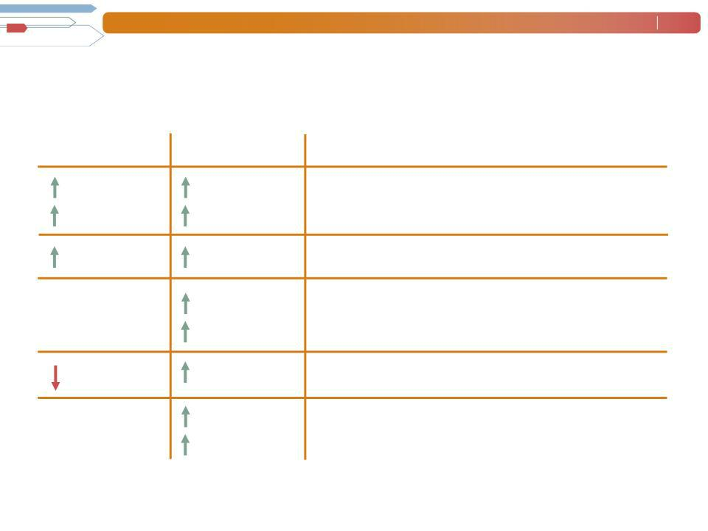
Manpower Inc. 2010 4th Quarter Results February 2011 3

Consolidated Financial Highlights

As

Reported

18%

22% CC

30 bps

N/A

N/A

760 bps

N/A

N/A

Excluding

Non-recurring
Items⁽¹⁾

18%

22% CC

30 bps

110%

122% CC

100 bps

38%

42% CC

Q4 Highlights Revenue $5.2B

Gross Margin 17.4% Operating Loss ($343M) OP Margin (6.6%)

EPS ($4.29)

- Excludes non-recurring items for 2010 as set forth on page 4, and reorganization expenses in 2009.

Throughout this presentation, the difference between reported variances and Constant Currency (CC) variances represents the impact of currency on our financial results. Constant Currency is further explained on our Web site.

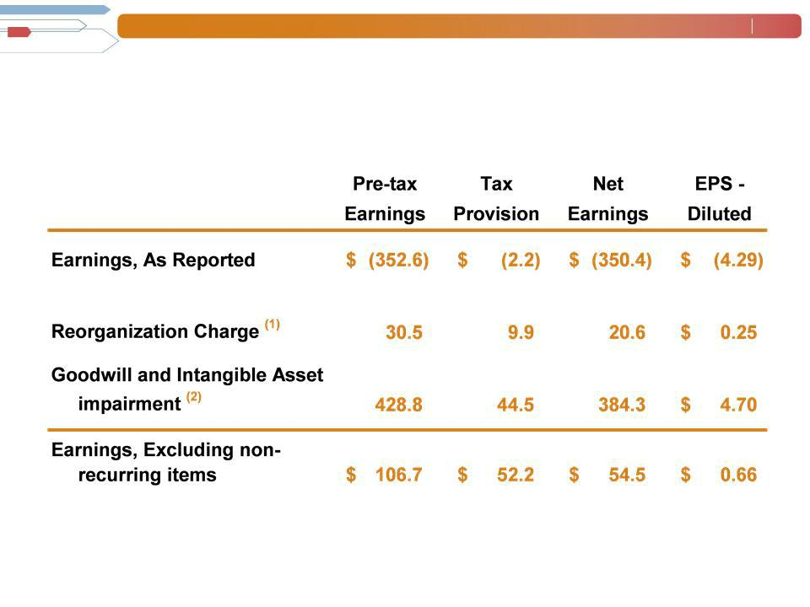
Manpower Inc. 2010 4th Quarter Results February 2011 4

Q4 Non-Recurring Items

($ in millions, except per share amounts)

- Includes reorganization charges for Jefferson Wells ($6.1M), France ($7.6M) and Right Management ($16.8M).

- Includes goodwill and intangible asset impairment charges for Jefferson Wells ($32.9M) and Right Management ($395.9M).

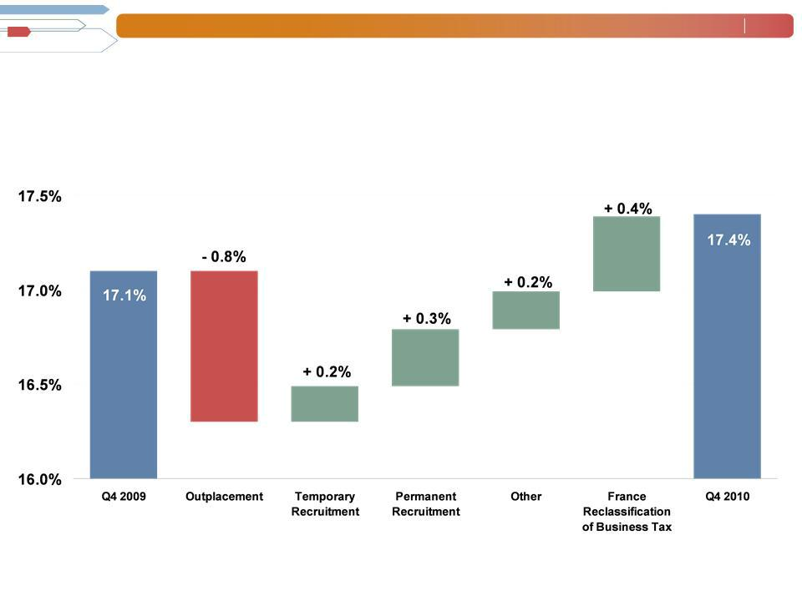
Manpower Inc. 2010 4th Quarter Results February 2011 5

Consolidated Gross Margin Change

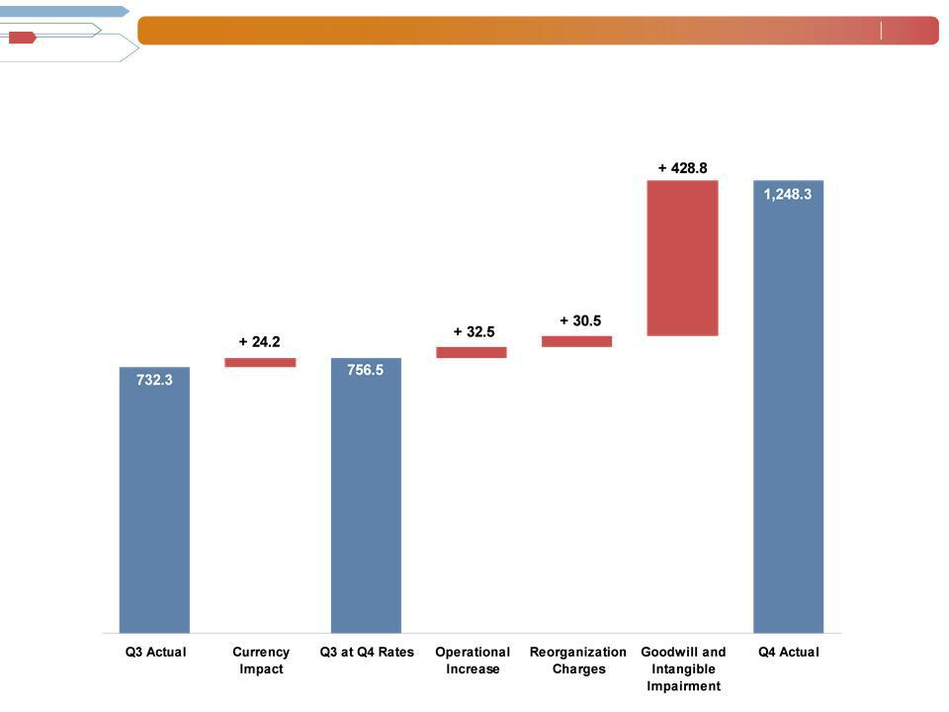
Manpower Inc. 2010 4th Quarter Results February 2011 6

SG&A Expense Sequential Bridge - Q4 vs. Q3

(in millions of USD)

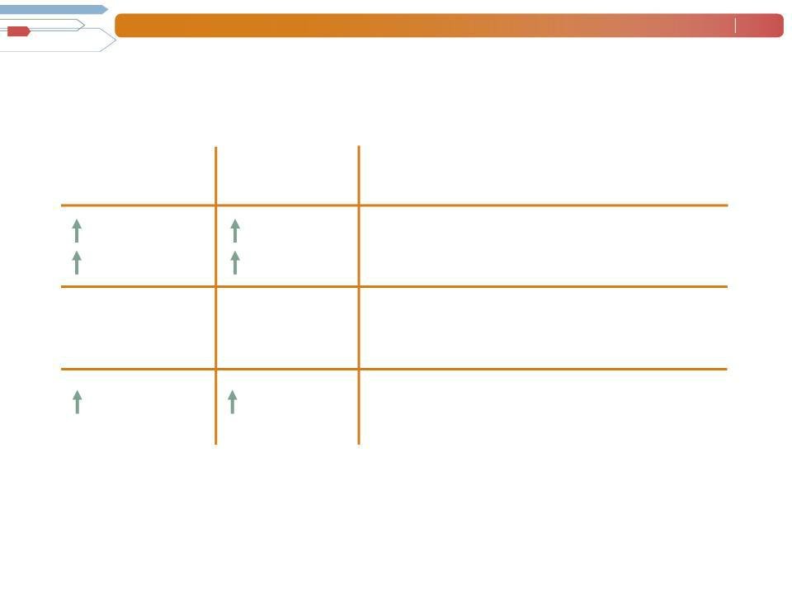
Manpower Inc. 2010 4th Quarter Results February 2011 7

Americas Segment

(22% of Revenue)

As | Excluding ⁽³⁾
As | Non-recurring
Reported | Items
47%⁽²⁾ | 47%
46% CC⁽²⁾ | 46% CC
N/A | N/A
N/A | N/A
230 bps | 280 bps

Q4 Financial Highlights ⁽¹⁾ Revenue $1.1B

OUP $24M

OUP Margin 2.1%

- Included in these amounts is the US, which had revenue of $777M (+62%) and OUP of $14M. On an organic basis, US revenue was $563M and OUP was $4M. Included in the US is Jefferson Wells, which had revenue of $44M and OUP of -$9M, including $6.1M of reorganization charges.

- On an organic basis, Americas revenue increased 19% in USD (18% in CC).

- Excludes the impact of the reorganization charges of $6.1M in 2010 and $1.1M in 2009.

Operating Unit Profit (OUP) is the measure that we use to evaluate segment performance. OUP is equal to segment revenues less direct costs and branch and national headquarters operating costs.

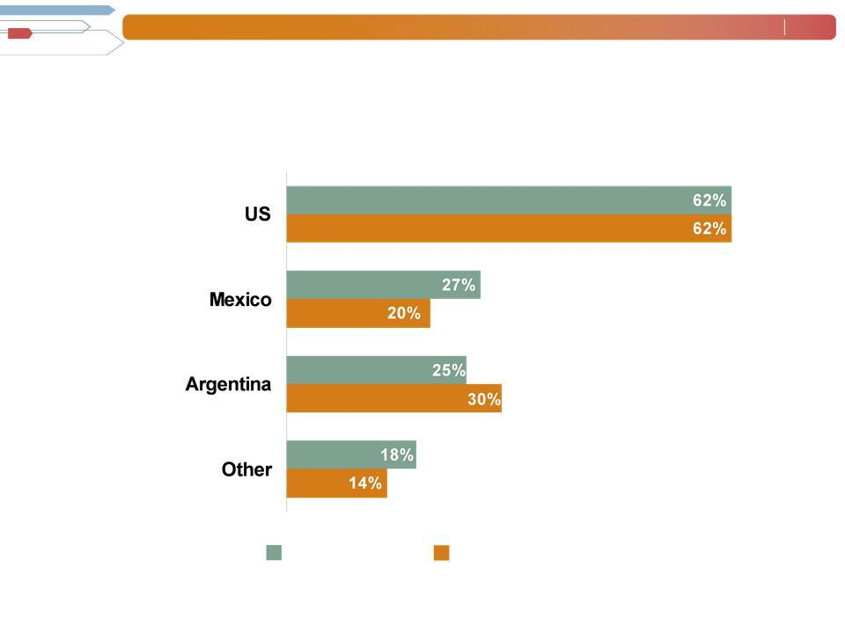
Manpower Inc. 2010 4th Quarter Results February 2011 8

Americas - Q4 Revenue Growth YoY

- of Segment Revenue
(1)

69%

11%

6%

14%

Revenue

Growth

Revenue Growth - CC

- On an organic basis, US revenue (including Jefferson Wells) was $563M (+18%).

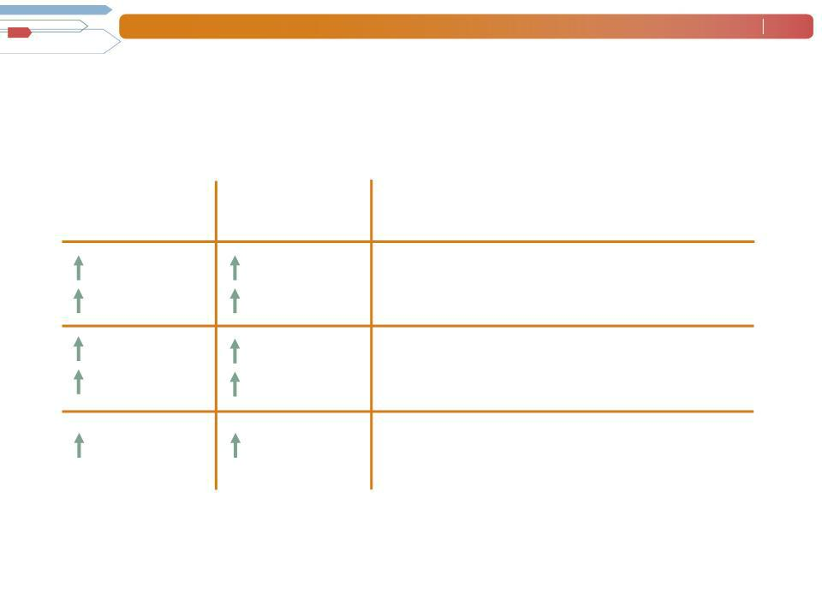
Manpower Inc. 2010 4th Quarter Results February 2011 9

France Segment

(27% of Revenue)

Reported | Excluding⁽¹⁾ | Q4 Financial Highlights
Reported | Items | Q4 Financial Highlights
As | Non-recurring
10% | 10% | Revenue $1.4B
19% CC | 19% CC
138% | 101% | OUP $12M
157% CC | 119% CC | OUP $12M
40 | 70 | OUP Margin 0.8%
bps | bps

- Excludes the impact of $7.6M of reorganization charges in 2010, and $4.7M of reorganization charges in 2009.

Manpower Inc. 2010 4th Quarter Results February 2011 10

EMEA Segment

(38% of Revenue)

As | Excluding⁽¹⁾
As | Non-recurring
Reported | Items
13% | 13%
19% CC | 19% CC
116% | 85%
128% CC | 95% CC
190 bps | 160 bps

Q4 Financial Highlights Revenue $2.0B

OUP $82M

OUP Margin 4.1%

- Excludes the impact of the reorganization charges of $6.4M in 2009.

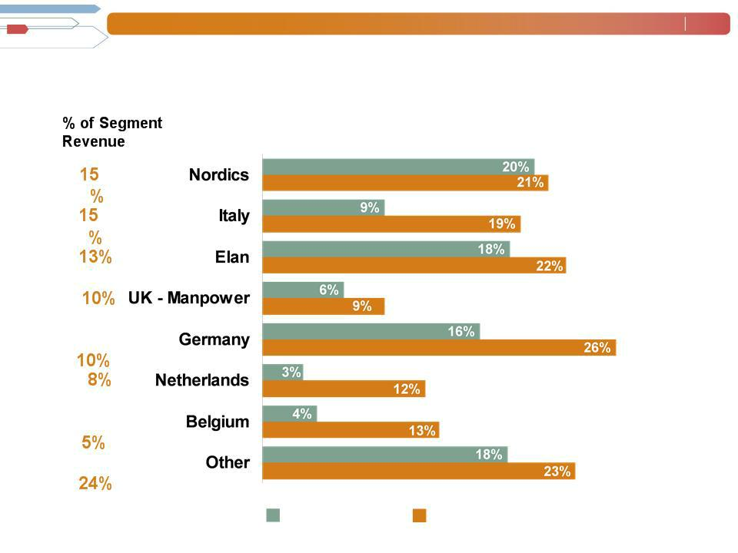
Manpower Inc. 2010 4th Quarter Results February 2011 11

EMEA - Q4 Revenue Growth YoY

Revenue | Revenue Growth - CC
Growth

Manpower Inc. 2010 4th Quarter Results February 2011 12

Asia Pacific Segment

(11% of Revenue)

Reported | Excluding⁽¹⁾ | Q4 Financial Highlights
Reported | Items | Q4 Financial Highlights
As | Non-recurring
26% | 26% | Revenue $588M
16% CC | 16% CC
42% | 34% | OUP $10M
32% CC | 25% CC | OUP $10M
20 | 10 | OUP Margin 1.7%
bps | bps

- Excludes the impact of the reorganization charges of $0.4M in 2009.

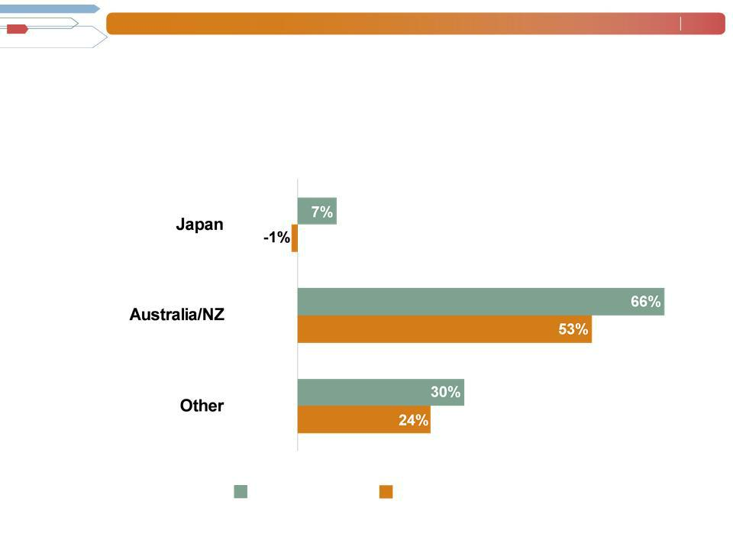
Manpower Inc. 2010 4th Quarter Results February 2011 13

Asia Pacific - Q4 Revenue Growth YoY

- of Segment Revenue

47%

29%

24%

Revenue | Revenue Growth - CC
Growth

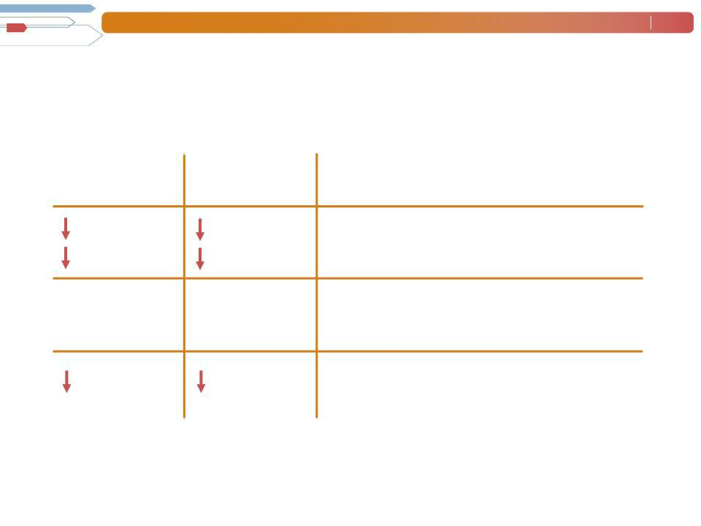
Manpower Inc. 2010 4th Quarter Results February 2011 14

Right Management Segment

(2% of Revenue)

Reported | Excluding⁽¹⁾ | Q4 Financial Highlights
Reported | Items | Q4 Financial Highlights
As | Non-recurring
33% | 33% | Revenue $87M
32% CC | 32% CC
N/A | N/A | OUP($17M)
N/A | N/A | OUP($17M)
3540 | 1600 | OUP Margin (19%)
bps | bps

- Excludes the impact of the reorganization charges of $16.8M in 2010.

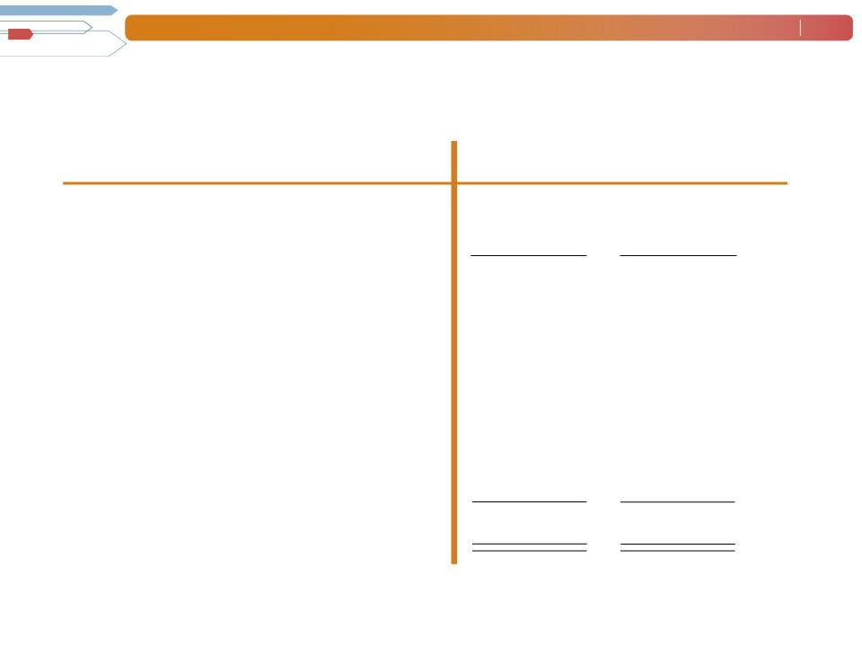
Manpower Inc. 2010 4th Quarter Results February 2011 15

Cash Flow Summary - Full Year

($ in millions)

Cash from Operations

Capital
Expenditures
Free Cash Flow

Change in

AcquisitionsDebt of

Businesses,netofcash acquired

Share Repurchases

Effect of Exchange Rate Changes Other

Change in Cash

2010 2009

- 414

  - (35)

- 379

  - (227)

- (22)

- -

  - 37

    - (26)

- 141

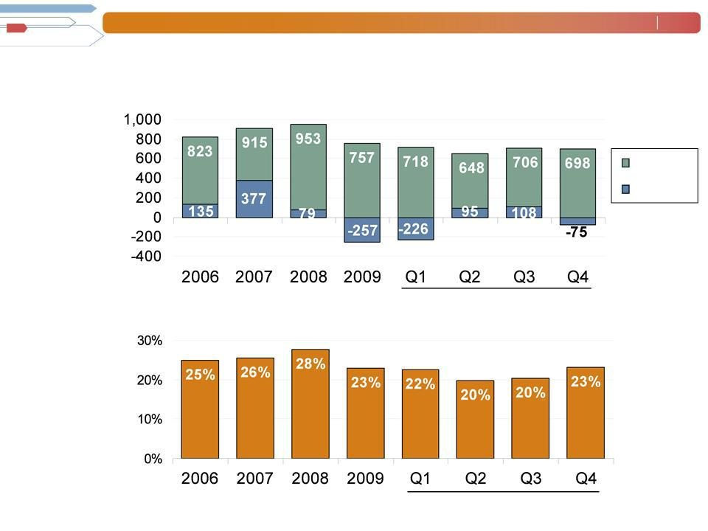
Manpower Inc. 2010 4th Quarter Results February 2011 16

Balance Sheet Highlights

Total Debt

($ in millions)

Total Debt

Net

Debt

Total Debt to
Total Capitalization | 2010

2010

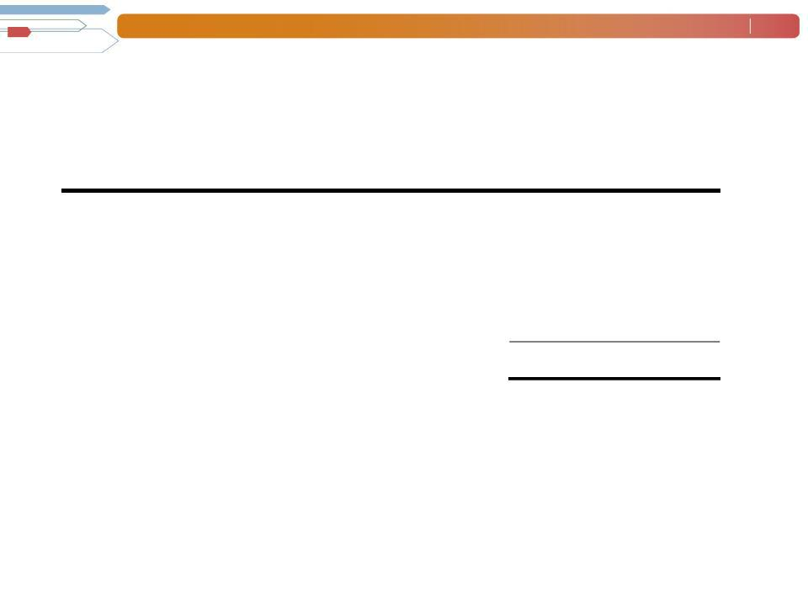
Manpower Inc. 2010 4th Quarter Results February 2011 17

Credit Facilities as of December 31, 2010

($ in millions)

 |  |  | Interest | Maturity | Total | Remaining
 |  |  | Rate | Date | Outstanding | Available
Euro
Notes: |  |  | 4.86% | Jun 2013 | 267 | -
- Euro
200M |  |  | 4.58% | Jun 2012 | 401 | -
- Euro
300M | (a) |  | 2.81% | Nov 2012 | - | 398
Revolving Credit Agreement
Uncommitted lines and |  | (b) | Various | Various | 30 | 368
Other |  |  |  |  | 698 | 766
Total Debt |  |  |  |  | 698 | 766

- This $400M agreement requires, as of December 31, that we comply with a Debt-to-EBITDA ratio of less than 5.25 to 1 and a fixed charge coverage ratio of greater than 1.25 to 1. As defined in the agreement, we had a Debt-to-EBITDA ratio of 1.60 and a fixed charge coverage ratio of 2.41 as of December 31, 2010. As of December 31, there were $2.2M of standby letters of credit issued under the agreement.

  - Represents subsidiary uncommitted lines of credit & overdraft facilities, which total $395.7M. Total subsidiary borrowings are limited to $300M due to restrictions in our Revolving Credit Facility, with the exception of Q3 when subsidiary borrowings are limited to $600M.

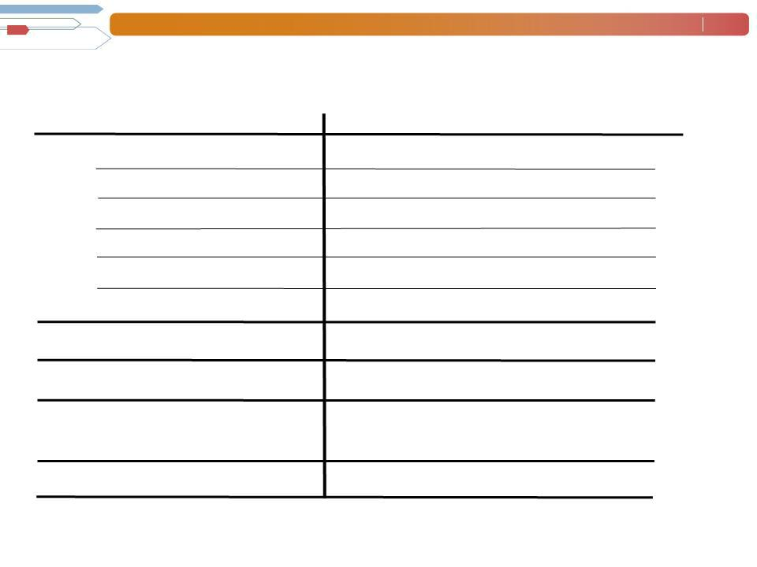
Manpower Inc. 2010 4th Quarter Results February 2011 18

First Quarter Outlook

Revenue ^{Total}
Americas

France

EMEA

Asia
_{Right}Pacific
Management
Gross Profit
Margin
Operating Profit Margin Tax Rate

EPS

Up 18-20% in constant
currency
Up 39-41% in constant currency

Up 16-18% in constant currency

Up 15-17% in constant currency

Up 8-10% in constant currency

Down 21-23% in constant
currency
17.0-17.2%

1.3-
1.5%
56% (39% excl. reclassification of

France business tax)

$0.26-$0.34

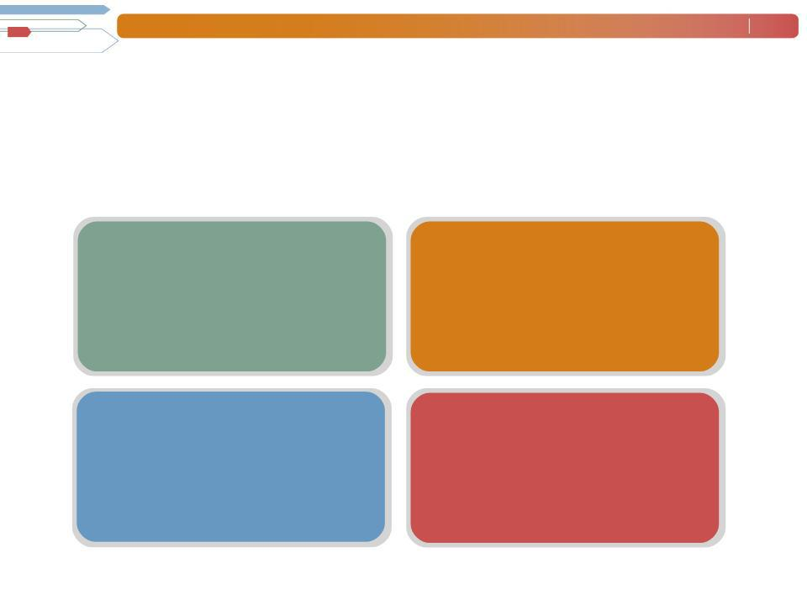
Manpower Inc. 2010 4th Quarter Results February 2011 19

Strategic Priorities

To achieve our vision, better service our clients and candidates, and differentiate ourselves from our competition, the Manpower group of companies will focus on:

 | Manpower Experience |  | Professional
• | Candidate Experience | • | ICT, Engineering, Finance and
• | Client Experience |  | Accounting, Healthcare
• | Client Experience | • | Go-to-Market Strategy
 |  | • Enhanced Business Model

 | Digital Strategy |  | New Services & Sectors
• | Direct Talent | • | Manpower Business Solutions
• | Direct Talent |  | -RPO (Recruitment Process Outsourcing)
• | Direct Office |  | -MSP (Managed Service Provider)
• | Direct Office |  | -TBO (Task Based Outsourcing)
• | Direct Time |  | -BTS (Borderless Talent Solutions)
• | Direct Time | • | Workforce Strategy
• Government Sector

Manpower Inc. 2010 4th Quarter Results February 2011 20

Questions?
Answers

Exhibit 99.3

Manpower Inc.

Restated Operating Unit Results
(In millions)

During the fourth quarter of 2010, our segment reporting was realigned due to our Jefferson Wells business being combined with our Professional Finance and Accounting vertical within the United States. Accordingly, our former reportable segment, Jefferson Wells, is now reported within our United States operating segment as part of the Americas reportable segment. All previously reported results have been restated to conform to the current year presentation.

 |  |  |  |  | Three Months Ended March 31 |  |  |  |  |  |  |  |  |  |  | Three Months Ended June 30
 |  |  |  |  |  |  | % Variance |  |  |  |  |  |  |  |  |  |  | % Variance
 |  |  |  |  |  |  | Amount |  | Constant |  |  |  |  |  |  |  |  | Amount |  | Constant
 |  | 2010 |  |  | 2009 |  | Reported |  | Currency |  |  | 2010 |  |  |  | 2009 |  | Reported |  | Currency
 |  |  |  |  | (Unaudited) |  |  |  |  |  |  |  |  |  |  | (Unaudited)
Revenues from Services:
Americas:
United States | $ | 482.7 |  | $ | 426.5 |  | 13.2% |  | 13.2% |  | $ | 726.6 |  | $ |  | 422.4 |  | 72.0% |  | 72.0%
Other Americas |  | 294.5 |  |  | 219.2 |  | 34.4% |  | 22.8% |  |  | 306.1 |  |  |  | 220.7 |  | 38.6% |  | 30.9%
 |  | 777.2 |  |  | 645.7 |  | 20.4% |  | 16.4% |  |  | 1,032.7 |  |  |  | 643.1 |  | 60.6% |  | 57.9%
France |  | 1,107.5 |  |  | 956.9 |  | 15.7% |  | 9.3% |  |  | 1,255.9 |  |  |  | 1,100.1 |  | 14.2% |  | 22.6%
EMEA:
Italy |  | 234.2 |  |  | 220.4 |  | 6.3% |  | 0.4% |  |  | 258.8 |  |  |  | 230.1 |  | 12.5% |  | 20.6%
Other EMEA |  | 1,379.6 |  |  | 1,258.8 |  | 9.6% |  | 0.4% |  |  | 1,433.7 |  |  |  | 1,255.9 |  | 14.2% |  | 18.0%
 |  | 1,613.8 |  |  | 1,479.2 |  | 9.1% |  | 0.4% |  |  | 1,692.5 |  |  |  | 1,486.0 |  | 13.9% |  | 18.4%
Asia Pacific |  | 497.5 |  |  | 425.2 |  | 17.0% |  | 5.3% |  |  | 505.7 |  |  |  | 406.2 |  | 24.5% |  | 15.4%
Right Management |  | 103.3 |  |  | 136.0 |  | -24.0% |  | -27.9% |  |  | 98.8 |  |  |  | 158.1 |  | -37.5% |  | -37.8%
 | $ | 4,099.3 |  | $ | 3,643.0 |  | 12.5% |  | 5.1% |  | $ | 4,585.6 |  | $ |  | 3,793.5 |  | 20.9% |  | 23.7%
Operating Unit Profit (Loss):
Americas:
United States | $ | (11.9) |  | $ | (20.5) |  | N/A |  | N/A |  | $ | 14.7 |  | $ |  | (14.3) |  | N/A |  | N/A
Other Americas |  | 9.6 |  |  | 4.8 |  | 101.6% |  | 87.6% |  |  | 8.7 |  |  |  | 3.9 |  | 122.3% |  | 110.7%
 |  | (2.3) |  |  | (15.7) |  | N/A |  | N/A |  |  | 23.4 |  |  |  | (10.4) |  | N/A |  | N/A
France |  | 0.2 |  |  | 1.0 |  | -83.9% |  | -69.7% |  |  | 9.9 |  |  |  | 4.2 |  | 139.8% |  | 168.6%
EMEA:
Italy |  | 6.8 |  |  | 1.4 |  | 384.9% |  | 361.8% |  |  | 13.5 |  |  |  | 6.8 |  | 99.4% |  | 115.2%
Other EMEA |  | 18.1 |  |  | (2.2) |  | N/A |  | N/A |  |  | 30.5 |  |  |  | (5.6) |  | N/A |  | N/A
 |  | 24.9 |  |  | (0.8) |  | N/A |  | N/A |  |  | 44.0 |  |  |  | 1.2 |  | N/A |  | N/A
Asia Pacific |  | 12.5 |  |  | 12.1 |  | 3.6% |  | -9.3% |  |  | 12.0 |  |  |  | 3.5 |  | 237.3% |  | 215.1%
Right Management |  | 12.5 |  |  | 29.1 |  | -56.9% |  | -58.1% |  |  | 7.8 |  |  |  | 42.3 |  | -81.5% |  | -81.7%
 |  | 47.8 |  |  | 25.7 |  |  |  |  |  |  | 97.1 |  |  |  | 40.8
Corporate expenses |  | (24.0) |  |  | (19.0) |  |  |  |  |  |  | (22.8) |  |  |  | (16.5)
Intangible asset amortization expense |  | (4.9) |  |  | (5.3) |  |  |  |  |  |  | (11.6) |  |  |  | (5.3)
Reclassification of French business tax |  | 13.7 |  |  | - |  |  |  |  |  |  | 16.4 |  |  |  | -
Operating profit |  | 32.6 |  |  | 1.4 |  | N/A |  | N/A |  |  | 79.1 |  |  |  | 19.0 |  | 314.9% |  | 331.0%
Interest and other expenses |  | (12.9) |  |  | (11.9) |  |  |  |  |  |  | (11.9) |  |  |  | (10.8)
Earnings (loss) before income taxes | $ | 19.7 |  | $ | (10.5) |  |  |  |  |  | $ | 67.2 |  | $ |  | 8.2
 |  |  |  |  |  |  |  |  |  |  |  |  |  |  |  | Six Months Ended June 30
 |  |  |  |  |  |  |  |  |  |  |  |  |  |  |  |  |  | % Variance
 |  |  |  |  |  |  |  |  |  |  |  |  |  |  |  |  |  | Amount |  | Constant
 |  |  |  |  |  |  |  |  |  |  |  | 2010 |  |  |  | 2009 |  | Reported |  | Currency
 |  |  |  |  |  |  |  |  |  |  |  |  |  |  |  | (Unaudited)
Revenues from Services:
Americas:
United States |  |  |  |  |  |  |  |  |  |  | $ | 1,209.3 |  | $ |  | 848.9 |  | 42.4% |  | 42.4%
Other Americas |  |  |  |  |  |  |  |  |  |  |  | 600.6 |  |  |  | 439.9 |  | 36.5% |  | 26.9%
 |  |  |  |  |  |  |  |  |  |  |  | 1,809.9 |  |  |  | 1,288.8 |  | 40.4% |  | 37.1%
France |  |  |  |  |  |  |  |  |  |  |  | 2,363.4 |  |  |  | 2,057.0 |  | 14.9% |  | 16.4%
EMEA:
Italy |  |  |  |  |  |  |  |  |  |  |  | 493.0 |  |  |  | 450.5 |  | 9.4% |  | 10.7%
Other EMEA |  |  |  |  |  |  |  |  |  |  |  | 2,813.3 |  |  |  | 2,514.7 |  | 11.9% |  | 9.2%
 |  |  |  |  |  |  |  |  |  |  |  | 3,306.3 |  |  |  | 2,965.2 |  | 11.5% |  | 9.4%
Asia Pacific |  |  |  |  |  |  |  |  |  |  |  | 1,003.2 |  |  |  | 831.4 |  | 20.7% |  | 10.2%
Right Management |  |  |  |  |  |  |  |  |  |  |  | 202.1 |  |  |  | 294.1 |  | -31.3% |  | -33.2%
 |  |  |  |  |  |  |  |  |  |  | $ | 8,684.9 |  |  | $ | 7,436.5 |  | 16.8% |  | 14.6%
Operating Unit Profit (Loss):
Americas:
United States |  |  |  |  |  |  |  |  |  |  | $ | 2.8 |  | $ |  | (34.8) |  | N/A |  | N/A
Other Americas |  |  |  |  |  |  |  |  |  |  |  | 18.3 |  |  |  | 8.7 |  | 110.9% |  | 98.0%
 |  |  |  |  |  |  |  |  |  |  |  | 21.1 |  |  |  | (26.1) |  | N/A |  | N/A
France |  |  |  |  |  |  |  |  |  |  |  | 10.1 |  |  |  | 5.2 |  | 96.2% |  | 122.1%
EMEA:
Italy |  |  |  |  |  |  |  |  |  |  |  | 20.3 |  |  |  | 8.2 |  | 148.4% |  | 157.5%
Other EMEA |  |  |  |  |  |  |  |  |  |  |  | 48.6 |  |  |  | (7.8) |  | N/A |  | N/A
 |  |  |  |  |  |  |  |  |  |  |  | 68.9 |  |  |  | 0.4 |  | N/A |  | N/A
Asia Pacific |  |  |  |  |  |  |  |  |  |  |  | 24.5 |  |  |  | 15.6 |  | 57.0% |  | 41.9%
Right Management |  |  |  |  |  |  |  |  |  |  |  | 20.3 |  |  |  | 71.4 |  | -71.5% |  | -72.1%
 |  |  |  |  |  |  |  |  |  |  |  | 144.9 |  |  |  | 66.5
Corporate expenses |  |  |  |  |  |  |  |  |  |  |  | (46.8) |  |  |  | (35.5)
Intangible asset amortization expense |  |  |  |  |  |  |  |  |  |  |  | (16.5) |  |  |  | (10.6)
Reclassification of French business tax |  |  |  |  |  |  |  |  |  |  |  | 30.1 |  |  |  | -
Operating profit |  |  |  |  |  |  |  |  |  |  |  | 111.7 |  |  |  | 20.4 |  | 447.6% |  | 441.4%
Interest and other expenses |  |  |  |  |  |  |  |  |  |  |  | (24.8) |  |  |  | (22.7)

Earnings (loss) before income taxes |  |  |  |  |  |  |  |  |  |  |  | $ | 86.9 |  | $ |  | (2.3)
 |  |  |  | Three Months Ended September 30 |  |  |  |  |  |  |  |  |  |  | Nine Months Ended September 30
 |  |  |  |  |  |  |  | % Variance |  |  |  |  |  |  |  |  |  |  | % Variance
 |  |  |  |  |  |  |  | Amount |  | Constant |  |  |  |  |  |  |  |  | Amount |  |  | Constant
 |  | 2010 |  |  |  | 2009 |  | Reported |  | Currency |  |  | 2010 |  |  |  | 2009 |  | Reported |  |  | Currency
 |  |  |  |  |  | (Unaudited) |  |  |  |  |  |  |  |  |  |  | (Unaudited)
Revenues from Services:
Americas:
United States | $ | 797.0 |  | $ |  | 458.1 |  | 74.0% |  | 74.0% |  | $ | 2,006.3 |  | $ |  | 1,307.0 |  | 53.5% |  | 53.5%
Other Americas |  | 317.1 |  |  |  | 243.5 |  | 30.3% |  | 25.8% |  |  | 917.7 |  |  |  | 683.4 |  | 34.3% |  | 26.5%
 |  | 1,114.1 |  |  |  | 701.6 |  | 58.8% |  | 57.3% |  |  | 2,924.0 |  |  |  | 1,990.4 |  | 46.9% |  | 44.2%
France |  | 1,411.6 |  |  |  | 1,314.1 |  | 7.4% |  | 18.8% |  |  | 3,775.0 |  |  |  | 3,371.1 |  | 12.0% |  | 17.4%
EMEA:
Italy |  | 257.1 |  |  |  | 231.0 |  | 11.3% |  | 23.1% |  |  | 750.1 |  |  |  | 681.5 |  | 10.1% |  | 14.9%
Other EMEA |  | 1,548.0 |  |  |  | 1,379.3 |  | 12.2% |  | 19.6% |  |  | 4,361.3 |  |  |  | 3,894.0 |  | 12.0% |  | 12.9%
 |  | 1,805.1 |  |  |  | 1,610.3 |  | 12.1% |  | 20.1% |  |  | 5,111.4 |  |  |  | 4,575.5 |  | 11.7% |  | 13.2%
Asia Pacific |  | 555.7 |  |  |  | 427.9 |  | 29.8% |  | 20.5% |  |  | 1,558.9 |  |  |  | 1,259.3 |  | 23.8% |  | 13.7%
Right Management |  | 85.5 |  |  |  | 135.7 |  | -37.0% |  | -36.5% |  |  | 287.6 |  |  |  | 429.8 |  | -33.1% |  | -34.2%
 | $ | 4,972.0 |  |  | $ | 4,189.6 |  | 18.7% |  | 24.1% |  | $ | 13,656.9 |  | $ |  | 11,626.1 |  | 17.5% |  | 18.0%
Operating Unit Profit (Loss):
Americas:
United States | $ | 25.9 |  | $ |  | 1.1 |  | N/A |  | N/A |  | $ | 28.7 |  | $ |  | (33.7) |  | N/A |  |  | N/A
Other Americas |  | 8.2 |  |  |  | 5.5 |  | 49.4% |  | 43.2% |  |  | 26.5 |  |  |  | 14.2 |  | 87.1% |  | 76.8%
 |  | 34.1 |  |  |  | 6.6 |  | 415.1% |  | 409.9% |  |  | 55.2 |  |  |  | (19.5) |  | N/A |  |  | N/A
France |  | 25.0 |  |  |  | 10.6 |  | 135.6% |  | 160.6% |  |  | 35.1 |  |  |  | 15.8 |  | 122.7% |  | 148.0%
EMEA:
Italy |  | 11.4 |  |  |  | 8.6 |  | 30.7% |  | 44.6% |  |  | 31.7 |  |  |  | 16.8 |  | 87.9% |  | 99.5%
Other EMEA |  | 43.0 |  |  |  | 16.0 |  | 171.0% |  | 190.8% |  |  | 91.6 |  |  |  | 8.2 |  | N/A |  |  | N/A
 |  | 54.4 |  |  |  | 24.6 |  | 121.5% |  | 139.3% |  |  | 123.3 |  |  |  | 25.0 |  | 392.8% |  | 410.2%
Asia Pacific |  | 13.1 |  |  |  | 4.0 |  | 234.1% |  | 210.9% |  |  | 37.6 |  |  |  | 19.6 |  | 93.4% |  | 76.6%
Right Management |  | - |  |  |  | 21.2 |  | N/A |  | N/A |  |  | 20.3 |  |  |  | 92.6 |  | -78.0% |  | -78.9%
 |  | 126.6 |  |  |  | 67.0 |  |  |  |  |  |  | 271.5 |  |  |  | 133.5
Corporate expenses |  | (23.6) |  |  |  | (21.1) |  |  |  |  |  |  | (70.4) |  |  |  | (56.6)
Goodwill and intangible asset
impairment |  | - |  |  |  | (61.0) |  |  |  |  |  |  | - |  |  |  | (61.0)
Intangible asset amortization expense |  | (11.6) |  |  |  | (6.4) |  |  |  |  |  |  | (28.1) |  |  |  | (17.0)
Reclassification of French business tax |  | 17.5 |  |  |  | - |  |  |  |  |  |  | 47.6 |  |  |  | -
Operating profit (loss) |  | 108.9 |  |  |  | (21.5) |  | N/A |  | N/A |  |  | 220.6 |  |  |  | (1.1) |  | N/A |  |  | N/A
Interest and other expenses |  | (8.4) |  |  |  | (29.3) |  |  |  |  |  |  | (33.2) |  |  |  | (52.0)
Earnings (loss) before income taxes | $ | 100.5 |  |  | $ | (50.8) |  |  |  |  |  | $ | 187.4 |  | $ |  | (53.1)
 |  |  |  |  |  |  |  |  |  |  |  |  |  |  |  |  | Year Ended December 31
 |  |  |  |  |  |  |  |  |  |  |  |  |  |  |  |  |  |  | % Variance
 |  |  |  |  |  |  |  |  |  |  |  |  |  |  |  |  |  |  | Amount |  |  | Constant
 |  |  |  |  |  |  |  |  |  |  |  |  | 2009 |  |  |  | 2008 |  | Reported |  |  | Currency
 |  |  |  |  |  |  |  |  |  |  |  |  |  |  |  |  | (Unaudited)
Revenues from Services:
Americas:
United States |  |  |  |  |  |  |  |  |  |  |  | $ | 1,786.0 |  | $ |  | 2,236.4 |  | -20.1% |  | -20.1%
Other Americas |  |  |  |  |  |  |  |  |  |  |  |  | 967.3 |  |  |  | 1,129.8 |  | -14.4% |  | -3.1%
 |  |  |  |  |  |  |  |  |  |  |  |  | 2,753.3 |  |  |  | 3,366.2 |  | -18.2% |  | -14.4%
France |  |  |  |  |  |  |  |  |  |  |  |  | 4,675.5 |  |  |  | 6,935.6 |  | -32.6% |  | -29.2%
EMEA:
Italy |  |  |  |  |  |  |  |  |  |  |  |  | 950.8 |  |  |  | 1,519.5 |  | -37.4% |  | -34.2%
Other EMEA |  |  |  |  |  |  |  |  |  |  |  |  | 5,371.7 |  |  |  | 7,422.0 |  | -27.6% |  | -19.2%
 |  |  |  |  |  |  |  |  |  |  |  |  | 6,322.5 |  |  |  | 8,941.5 |  | -29.3% |  | -21.7%
Asia Pacific |  |  |  |  |  |  |  |  |  |  |  |  | 1,728.0 |  |  |  | 1,841.6 |  | -6.2% |  | -9.2%
Right Management |  |  |  |  |  |  |  |  |  |  |  |  | 559.4 |  |  |  | 452.2 |  | 23.7% |  | 28.5%
 |  |  |  |  |  |  |  |  |  |  |  | $ | 16,038.7 |  |  | $ | 21,537.1 |  | -25.5% |  | -20.9%
Operating Unit Profit (Loss):
Americas:
United States |  |  |  |  |  |  |  |  |  |  |  | $ | (41.4) |  | $ |  | 17.3 |  | N/A |  |  | N/A
Other Americas |  |  |  |  |  |  |  |  |  |  |  |  | 20.1 |  |  |  | 25.9 |  | -22.2% |  | -10.5%
 |  |  |  |  |  |  |  |  |  |  |  |  | (21.3) |  |  |  | 43.2 |  | N/A |  |  | N/A
France |  |  |  |  |  |  |  |  |  |  |  |  | 20.8 |  |  |  | 299.0 |  | -93.0% |  | -92.6%
EMEA:
Italy |  |  |  |  |  |  |  |  |  |  |  |  | 27.9 |  |  |  | 120.4 |  | -76.8% |  | -76.5%
Other EMEA |  |  |  |  |  |  |  |  |  |  |  |  | 34.7 |  |  |  | 237.8 |  | -85.4% |  | -86.4%
 |  |  |  |  |  |  |  |  |  |  |  |  | 62.6 |  |  |  | 358.2 |  | -82.5% |  | -83.1%
Asia Pacific |  |  |  |  |  |  |  |  |  |  |  |  | 26.5 |  |  |  | 29.2 |  | -9.3% |  | -19.9%
Right Management |  |  |  |  |  |  |  |  |  |  |  |  | 113.4 |  |  |  | 44.7 |  | 153.6% |  | 158.8%
 |  |  |  |  |  |  |  |  |  |  |  |  | 202.0 |  |  |  | 774.3
Corporate expenses |  |  |  |  |  |  |  |  |  |  |  |  | (77.4) |  |  |  | (95.6)
Goodwill and intangible asset
impairment |  |  |  |  |  |  |  |  |  |  |  |  | (61.0) |  |  |  | (163.1)
Intangible asset amortization expense |  |  |  |  |  |  |  |  |  |  |  |  | (21.9) |  |  |  | (22.1)
Operating profit |  |  |  |  |  |  |  |  |  |  |  |  | 41.7 |  |  |  | 493.5 |  | -91.5% |  | -91.3%
Interest and other expenses |  |  |  |  |  |  |  |  |  |  |  |  | (64.6) |  |  |  | (50.9)
(Loss) earnings before income taxes |  |  |  |  |  |  |  |  |  |  |  | $ | (22.9) |  | $ |  | 442.6


