UNITED STATES

SECURITIES AND EXCHANGE COMMISSION

Washington, D.C. 20549

FORM 8-K

CURRENT REPORT

Pursuant to Section 13 or 15(d) of the Securities Exchange Act of 1934

Date of Report (Date of earliest event reported): July 19, 2007

MANPOWER INC.

(Exact name of registrant as specified in its charter)

Wisconsin | 1-10686 | 39-1672779
(State or other jurisdiction | (Commission | (IRS Employer
of incorporation) | File Number) | Identification No.)
5301 North Ironwood Road
Milwaukee, Wisconsin |  | 53217
(Address of principal executive offices) |  | (Zip Code)

Registrant’s telephone number, including area code: (414) 961-1000

Check the appropriate box below if the Form 8-K filing is intended to simultaneously satisfy the filing obligation of the registrant under any of the following provisions:

- Written communications pursuant to Rule 425 under the Securities Act (17 CFR 230.425)

- Soliciting material pursuant to Rule 14a-12 under the Securities Act (17 CFR 240.14a-12)

- Pre-commencement communications pursuant to Rule 14d-2(b) under the Exchange Act (17 CFR 240.14d-2(b))

- Pre-commencement communications pursuant to Rule 13e-4(c) under the Exchange Act (17 CFR 240.13e-4(c))

Item 2.02 Results of Operations and Financial Condition

On July 19, 2007, we issued a press release announcing our results of operations for the three- and six- month periods ended June 30, 2007. A copy of the press release is attached hereto as Exhibit 99.1 and is incorporated herein by reference.

Item 9.01. |  | Exhibits.
Exhibit No. |  |  | Description
99.1 |  |  | Press Release dated July 19, 2007
99.2 |  |  | Presentation materials for July 19, 2007 conference call

SIGNATURES

Pursuant to the requirements of the Securities Exchange Act of 1934, the Registrant has duly caused this Report to be signed on its behalf by the undersigned hereunto duly authorized.

 | MANPOWER INC.
Dated: July 19, 2007 | By: /s/ Michael J. Van Handel
 |  | Michael J. Van Handel
 |  | Executive Vice President,
 |  | Chief Financial Officer and Secretary

EXHIBIT INDEX

Exhibit No. |  | Description
99.1 |  | Press Release dated July 19, 2007
99.2 |  | Presentation materials for July 19, 2007 conference call

Exhibit 99.1

[MANPOWER logo]

FOR IMMEDIATE RELEASE

Contact:

Mike Van Handel

Manpower Inc.

+1.414.906.6305

michael.vanhandel@manpower.com

Manpower Reports 2ND Quarter and First Half 2007 Results

MILWAUKEE, WI, USA, July 19, 2007 – Manpower Inc. (NYSE: MAN) today reported that earnings per diluted share for the three months ended June 30, 2007 increased 104% to

$1.86 from 91 cents in the prior year period. Net earnings in the quarter increased to $160.4 million from $80.4 million a year earlier. Revenues for the second quarter were $5.0 billion, an increase of 15 percent from the year earlier period.

Second quarter results were favorably impacted 66 cents per diluted share as a result of a change in the calculation of French payroll taxes retroactive to January 1, 2006. Of this amount, 45 cents relates to reduced payroll taxes for 2006, 10 cents for the first quarter of 2007 and 11 cents the second quarter of 2007. Second quarter results were also favorably impacted by 5 cents per diluted share as foreign currencies were relatively stronger compared to the second quarter of 2006. On a constant currency basis, revenues increased 9% over the prior year period.

“We continue to experience positive trends throughout the major geographies and segments of our business, with the European geography driving a substantial portion of our growth in both revenue and profit,” said Jeffrey A. Joerres, Chairman and CEO.

“Throughout the world our organization continues to make great strides in securing growth at profitable levels, expanding our offering in permanent recruitment and driving efficiencies. The Manpower team is doing an impressive job of helping our clients win, while at the same time, improving our operational excellence.

“We are anticipating the third quarter of 2007 diluted earnings per share to be in the range of $1.39 to $1.43, which includes an estimated favorable currency impact of 8 cents,” Joerres stated.

Earnings per diluted share for the six months ended June 30, 2007 were $2.54 compared to $1.50 per diluted share in 2006. Net earnings were $219.9 million compared to $133.0 million in the prior year. Revenues for the six-month period were $9.6 billion, an increase of 16 percent from the prior year or 9 percent in constant currency. Foreign currency exchange rates had a favorable impact of 10 cents for the six-month period.

Included in net earnings in the first half of 2006 is a 16 cent per diluted share charge related to reorganization costs and a global cost reduction initiative. Also included in the prior year period are earnings per diluted share from discontinued operations of 27 cents.

In conjunction with its second quarter earnings release, Manpower will broadcast its conference call live over the Internet on July 19, 2007 at 7:30 a.m. CDT (8:30 a.m. EDT).

Interested parties are invited to listen to the webcast and view the presentation by logging on to http://investor.manpower.com.

Supplemental financial information referenced in the conference call can be found at http://investor.manpower.com.

About Manpower Inc.

Manpower Inc. (NYSE: MAN) is a world leader in the employment services industry; creating and delivering services that enable its clients to win in the changing world of work. The $18 billion company offers employers a range of services for the entire employment and business cycle including permanent, temporary and contract recruitment; employee assessment and selection; training; outplacement; outsourcing and consulting. Manpower’s worldwide network of 4,400 offices in 73 countries and territories enables the company to meet the needs of its 400,000 clients per year, including small and medium size enterprises in all industry sectors, as well as the world’s largest multinational corporations. The focus of Manpower’s work is on raising productivity through improved quality, efficiency and cost-reduction across their total workforce, enabling clients to concentrate on their core business activities. Manpower Inc. operates under five brands: Manpower, Manpower Professional, Elan, Jefferson Wells and Right Management. More information on Manpower Inc. is available at www.manpower.com.

Forward-Looking Statements

This news release contains statements, including earnings projections, that are forward-looking in nature and, accordingly, are subject to risks and uncertainties regarding the Company’s expected future results. The Company’s actual results may differ materially from those described or contemplated in the forward-looking statements. Factors that may cause the Company’s actual results to differ materially from those contained in the forward-looking statements can be found in the Company’s reports filed with the SEC, including the information under the heading ‘Risk Factors’ in its Annual Report on Form 10-K for the year ended December 31, 2006, which information is incorporated herein by reference.

- ### -

Manpower Inc.

Results of Operations

(In millions, except per share data)

 |  |  |  | Three Months Ended June 30
 |  |  |  |  |  |  |  | % Variance
 |  |  |  |  |  |  |  | Amount |  | Constant
 |  |  | 2007 |  |  | 2006 |  | Reported |  | Currency
 |  |  |  |  |  |  | (Unaudited)
Revenues from services (a) | $ |  | 5,034.4 | $ |  | 4,384.6 |  | 14.8% |  | 8.8%
Cost of services |  |  | 4,010.3 |  |  | 3,601.8 |  | 11.3%
Gross profit |  |  | 1,024.1 |  |  | 782.8 |  | 30.8% |  | 24.3%
Selling and administrative expenses |  |  | 747.1 |  |  | 644.7 |  | 15.9% |  | 10.4%
Operating profit |  |  | 277.0 |  |  | 138.1 |  | 100.7% |  | 89.5%
Interest and other expenses |  |  | 7.7 |  |  | 12.5 |  | -38.1%
Earnings before income taxes and discontinued operations |  |  | 269.3 |  |  | 125.6 |  | 114.5% |  | 103.7%
Provision for income taxes |  |  | 108.9 |  |  | 46.0 |  | 137.0%
Net earnings from continuing operations |  |  | 160.4 |  |  | 79.6 |  | 101.6% |  | 91.4%
Income from discontinued operations, net of income taxes |  |  | — |  |  | 0.8 |  | N/A
Net earnings | $ |  | 160.4 | $ |  | 80.4 |  | 99.6% |  | 89.5%
Net earnings per share - basic:
Continuing operations | $ |  | 1.90 | $ |  | 0.91 |  | 108.8%
Discontinued operations |  |  | — |  |  | 0.01 |  | N/A
Total | $ |  | 1.90 | $ |  | 0.92 |  | 106.5%
Net earnings per share - diluted:
Continuing operations | $ |  | 1.86 | $ |  | 0.90 |  | 106.7% |  | 96.7%
Discontinued operations |  |  | — |  |  | 0.01 |  | N/A
Total | $ |  | 1.86 | $ |  | 0.91 |  | 104.4% |  | 94.5%
Weighted average shares - basic |  |  |  |  |  |  |  | -3.3%
Weighted average shares - basic |  |  | 84.4 |  |  | 87.3
Weighted average shares - diluted |  |  | 86.2 |  |  | 88.7 |  | -2.8%

- Revenues from services include fees received from our franchise offices of $9.0 million and $8.8 million for the three months ended June 30, 2007 and 2006, respectively. These fees are primarily based on revenues generated by the franchise offices, which were $361.8 million and $388.8 million for the three months ended June 30, 2007 and 2006, respectively.

Manpower Inc.

Operating Unit Results

(In millions)

 |  |  |  |  | Three Months Ended June 30
 |  |  |  |  |  |  |  |  | % Variance
 |  |  |  |  |  |  |  |  | Amount |  | Constant
 |  |  | 2007 |  |  |  | 2006 |  | Reported |  | Currency
 |  |  |  |  |  |  |  | (Unaudited)
Revenues from Services:
United States (a) | $ |  | 488.6 |  | $ |  | 534.6 |  | -8.6% |  | -8.6%
France |  |  | 1,784.9 |  |  |  | 1,535.6 |  | 16.2% |  | 8.5%
Other EMEA (b) |  |  | 1,582.0 |  |  |  | 1,257.5 |  | 25.8% |  | 17.2%
Italy (b) |  |  | 353.8 |  |  |  | 291.7 |  | 21.3% |  | 13.3%
Jefferson Wells |  |  | 83.8 |  |  |  | 98.8 |  | -15.1% |  | -15.1%
Right Management |  |  | 105.8 |  |  |  | 102.6 |  | 3.2% |  | -0.4%
Other Operations |  |  | 635.5 |  |  |  | 563.8 |  | 12.7% |  | 10.8%
 | $ |  | 5,034.4 |  | $ |  | 4,384.6 |  | 14.8% |  | 8.8%
Operating Unit Profit:
United States | $ |  | 26.1 |  | $ |  | 22.5 |  | 16.2% |  | 16.2%
France |  |  | 163.7 |  |  |  | 49.7 |  | 229.1% |  | 209.3%
Other EMEA (b) |  |  | 55.7 |  |  |  | 29.5 |  | 89.0% |  | 77.7%
Italy (b) |  |  | 29.1 |  |  |  | 21.2 |  | 37.4% |  | 28.5%
Jefferson Wells |  |  | 1.1 |  |  |  | 10.0 |  | -89.0% |  | -89.0%
Right Management |  |  | 11.0 |  |  |  | 11.1 |  | 0.1% |  | -3.8%
Other Operations |  |  | 15.0 |  |  |  | 14.8 |  | 1.6% |  | 1.7%
 |  |  | 301.7 |  |  |  | 158.8
Corporate expenses |  |  | 21.4 |  |  |  | 17.4
Amortization of intangible assets |  |  | 3.3 |  |  |  | 3.3
Operating profit |  |  | 277.0 |  |  |  | 138.1 |  | 100.7% |  | 89.5%
Interest and other expenses (c) |  |  | 7.7 |  |  |  | 12.5
Earnings before income taxes and discontinued operations | $ |  | 269.3 |  | $ |  | 125.6

- In the United States, revenues from services include fees received from the related franchise offices of $6.5 million and $6.0 million for the three months ended June 30, 2007 and 2006, respectively. These fees are primarily based on revenues generated by the franchise offices, which were $278.5 million and $291.9 million for the three months ended June 30, 2007 and 2006, respectively.

- Italy and Other EMEA were combined as the EMEA segment in previous years. All previous years have been revised to conform to the current year presentation.

- The components of interest and other expenses were:

Interest expense | $ | 15.3 |  | $ 13.1
Interest income |  | (8.4) |  | (3.8)
Foreign exchange losses |  | 0.1 |  | 1.3
Miscellaneous expenses, net |  | 0.7 |  |  | 1.9
 | $ | 7.7 |  | $ 12.5

Manpower Inc.

Results of Operations

(In millions, except per share data)

 |  |  |  |  | Six Months Ended June 30
 |  |  |  |  |  |  |  | % Variance
 |  |  |  |  |  |  |  | Amount |  | Constant
 |  |  | 2007 |  |  | 2006 |  | Reported |  | Currency
 |  |  |  |  |  |  | (Unaudited)
Revenues from services (a) | $ |  | 9,570.0 | $ |  | 8,261.8 |  | 15.8% |  | 9.2%
Cost of services |  |  | 7,745.9 |  |  | 6,785.8 |  | 14.1%
Gross profit |  |  | 1,824.1 |  |  | 1,476.0 |  | 23.6% |  | 16.9%
Selling and administrative expenses |  |  | 1,443.8 |  |  | 1,277.6 |  | 13.0% |  | 7.2%
Operating profit |  |  | 380.3 |  |  | 198.4 |  | 91.7% |  | 79.6%
Interest and other expenses |  |  | 17.3 |  |  | 25.5 |  | -32.0%
Earnings before income taxes and discontinued operations |  |  | 363.0 |  |  | 172.9 |  | 110.0% |  | 98.4%
Provision for income taxes |  |  | 143.1 |  |  | 63.8 |  | 124.3%
Net earnings from continuing operations |  |  | 219.9 |  |  | 109.1 |  | 101.6% |  | 90.5%
Income from discontinued operations, net of income taxes |  |  | — |  |  | 23.9 |  | N/A
Net earnings | $ |  | 219.9 |  |  | 133.0 |  | 65.4% |  | 56.3%
Net earnings per share - basic:
Continuing operations | $ |  | 2.60 | $ |  | 1.25 |  | 108.0%
Discontinued operations |  |  | — |  |  | 0.27 |  | N/A
Total | $ |  | 2.60 | $ |  | 1.52 |  | 71.1%
Net earnings per share - diluted:
Continuing operations | $ |  | 2.54 | $ |  | 1.23 |  | 106.5% |  | 95.1%
Discontinued operations |  |  | — |  |  | 0.27 |  | N/A
Total | $ |  | 2.54 | $ |  | 1.50 |  | 69.3% |  | 60.0%
Weighted average shares - basic |  |  |  |  |  |  |  | -3.1%
Weighted average shares - basic |  |  | 84.6 |  |  | 87.3
Weighted average shares - diluted |  |  | 86.5 |  |  | 88.8 |  | -2.6%

- Revenues from services include fees received from our franchise offices of $17.4 million and $16.8 million for the six months ended June 30, 2007 and 2006, respectively. These fees are primarily based on revenues generated by the franchise offices, which were $724.2 million and $751.6 million for the six months ended June 30, 2007 and 2006, respectively.

Manpower Inc.

Operating Unit Results

(In millions)

 |  |  |  |  | Six Months Ended June 30
 |  |  |  |  |  |  |  | % Variance
 |  |  |  |  |  |  |  | Amount |  | Constant
 |  |  | 2007 |  |  | 2006 |  | Reported |  | Currency
 |  |  |  |  |  |  | (Unaudited)
Revenues from Services:
United States (a) | $ |  | 972.2 | $ |  | 1,044.9 |  | -7.0% |  | -7.0%
France |  |  | 3,277.9 |  |  | 2,776.1 |  | 18.1% |  | 9.3%
Other EMEA (b) |  |  | 3,058.4 |  |  | 2,407.3 |  | 27.0% |  | 17.1%
Italy (b) |  |  | 658.6 |  |  | 534.1 |  | 23.3% |  | 14.2%
Jefferson Wells |  |  | 165.1 |  |  | 194.3 |  | -15.0% |  | -15.0%
Right Management |  |  | 199.7 |  |  | 197.9 |  | 0.9% |  | -2.9%
Other Operations |  |  | 1,238.1 |  |  | 1,107.2 |  | 11.8% |  | 10.7%
 | $ |  | 9,570.0 | $ |  | 8,261.8 |  | 15.8% |  | 9.2%
Operating Unit Profit:
United States | $ |  | 37.6 | $ |  | 32.0 |  | 17.8% |  | 17.8%
France |  |  | 207.6 |  |  | 80.1 |  | 159.0% |  | 142.2%
Other EMEA (b) |  |  | 92.4 |  |  | 43.1 |  | 114.2% |  | 98.9%
Italy (b) |  |  | 45.5 |  |  | 30.6 |  | 49.0% |  | 38.3%
Jefferson Wells |  |  | 2.1 |  |  | 15.7 |  | -86.6% |  | -86.6%
Right Management |  |  | 17.1 |  |  | 15.7 |  | 9.5% |  | 5.8%
Other Operations |  |  | 27.8 |  |  | 32.4 |  | -14.3% |  | -14.5%
 |  |  | 430.1 |  |  | 249.6
Corporate expenses |  |  | 43.3 |  |  | 44.7
Amortization of intangible assets |  |  | 6.5 |  |  | 6.5
Operating profit |  |  | 380.3 |  |  | 198.4 |  | 91.7% |  | 79.6%
Interest and other expenses (c) |  |  | 17.3 |  |  | 25.5
Earnings before income taxes and discontinued operations | $ |  | 363.0 | $ |  | 172.9

- In the United States, revenues from services include fees received from the related franchise offices of $11.8 million and $11.3 million for the six months ended June 30, 2007 and 2006, respectively. These fees are primarily based on revenues generated by the franchise offices, which were $547.6 million and $574.2 million for the six months ended June 30, 2007 and 2006, respectively.

- Italy and Other EMEA were combined as the EMEA segment in previous years. All previous years’ results have been revised to conform to the current year presentation.

- The components of interest and other expenses were:

Interest expense | $ |  | 29.5 |  | $ 24.7
Interest income |  |  | (15.6) |  | (7.1)
Foreign exchange losses |  |  | 0.2 |  | 2.2
Miscellaneous expenses, net |  |  | 3.2 |  |  | 5.7
 | $ |  | 17.3 |  | $ 25.5

Manpower Inc.

Consolidated Balance Sheets

(In millions)

 |  | June 30 |  |  | Dec. 31
 |  | 2007 |  |  | 2006
 |  | (Unaudited)
ASSETS
Current assets:
Cash and cash equivalents | $ | 710.8 |  | $ | 687.9
Accounts receivable, net |  | 4,214.9 |  |  | 3,837.2
Prepaid expenses and other assets |  | 134.9 |  |  | 90.5
Future income tax benefits |  | 76.4 |  |  | 66.4
Total current assets |  | 5,137.0 |  |  | 4,682.0
Other assets:
Goodwill and other intangible assets, net |  | 1,323.1 |  |  | 1,293.6
Other assets |  | 329.9 |  |  | 336.4
Total other assets |  | 1,653.0 |  |  | 1,630.0
Property and equipment:
Land, buildings, leasehold improvements and equipment |  | 738.2 |  |  | 693.2
Less: accumulated depreciation and amortization |  | 531.7 |  |  | 491.1
Net property and equipment |  | 206.5 |  |  | 202.1
Total assets | $ | 6,996.5 |  | $ | 6,514.1
LIABILITIES AND SHAREHOLDERS’ EQUITY
Current liabilities:
Accounts payable | $ | 1,005.6 |  | $ | 889.9
Employee compensation payable |  | 192.9 |  |  | 180.7
Accrued liabilities |  | 655.0 |  |  | 562.1
Accrued payroll taxes and insurance |  | 616.6 |  |  | 699.9
Value added taxes payable |  | 573.9 |  |  | 517.0
Short-term borrowings and current maturities of long-term debt |  | 35.8 |  |  | 32.0
Total current liabilities |  | 3,079.8 |  |  | 2,881.6
Other liabilities:
Long-term debt |  | 811.9 |  |  | 791.2
Other long-term liabilities |  | 439.2 |  |  | 367.1
Total other liabilities |  | 1,251.1 |  |  | 1,158.3
Shareholders’ equity:
Common stock |  | 1.0 |  |  | 1.0
Capital in excess of par value |  | 2,464.6 |  |  | 2,420.7
Retained earnings |  | 805.5 |  |  | 617.0
Accumulated other comprehensive income |  | 164.4 |  |  | 120.6
Treasury stock, at cost |  | (769.9) |  |  | (685.1)
Total shareholders’ equity |  | 2,665.6 |  |  | 2,474.2
Total liabilities and shareholders’ equity | $ | 6,996.5 |  | $ | 6,514.1

Manpower Inc.

Consolidated Statements of Cash Flows

(In millions)

 |  | Six Months Ended
 |  |  |  | June 30
 |  | 2007 |  |  | 2006
 |  |  | (Unaudited)
 | Cash Flows from Operating Activities:
 | Net earnings | $ 219.9 |  |  | $ 133.0
 | Adjustments to reconcile net earnings to net cash provided by operating activities:
 | Gain on sale of business | — |  |  | (29.3)
 | Depreciation and amortization | 44.1 |  |  | 43.8
 | Deferred income taxes | 41.8 |  |  | (25.3)
 | Provision for doubtful accounts | 8.8 |  |  | 11.8
 | Share-based compensation | 11.8 |  |  | 10.2
 | Excess tax benefit on exercise of stock options | (5.4) |  |  | (1.6)
 | Changes in operating assets and liabilities, excluding the impact of acquisitions:
 | Accounts receivable | (296.2) |  |  | (216.4)
 | Other assets | (42.9) |  |  | 18.1
 | Other liabilities | 159.4 |  |  | 191.3
 | Cash provided by operating activities | 141.3 |  |  | 135.6
 | Cash Flows from Investing Activities:
 | Capital expenditures | (41.8) |  |  | (34.8)
 | Acquisitions of businesses, net of cash acquired | (18.1) |  |  | (7.2)
 | Proceeds from sale of business | — |  |  | 29.6
 | Proceeds from sale of an equity interest | — |  |  | 8.8
 | Proceeds from the sale of property and equipment | 5.0 |  |  | 3.1
 | Cash used by investing activities | (54.9) |  |  | (0.5)
Cash Flows from Financing Activities:
 | Net borrowings of short-term facilities and long-term debt | 3.0 |  |  | 250.8
 | Proceeds from stock option and purchase plans | 31.7 |  |  | 40.6
 | Excess tax benefit on exercise of stock options | 5.4 |  |  | 1.6
 | Repurchases of common stock | (89.0) |  |  | (119.1)
 | Dividends paid | (27.1) |  |  | (23.7)
 | Cash (used) provided by financing activities
 | Cash (used) provided by financing activities | (76.0) |  |  | 150.2
 | Effect of exchange rate changes on cash | 12.5 |  |  | 27.9
Change in cash and cash equivalents |  | 22.9 |  |  | 313.2
 | Cash and cash equivalents, beginning of period | 687.9 |  |  | 454.9
Cash and cash equivalents, end of period |  | $ 710.8 |  |  | $ 768.1

Exhibit 99.2
Manpower Inc.
2007 2nd Quarter Results


July 19, 2007

New Face
New Place

Manpower Inc. 2007 2nd Quarter Results | 2
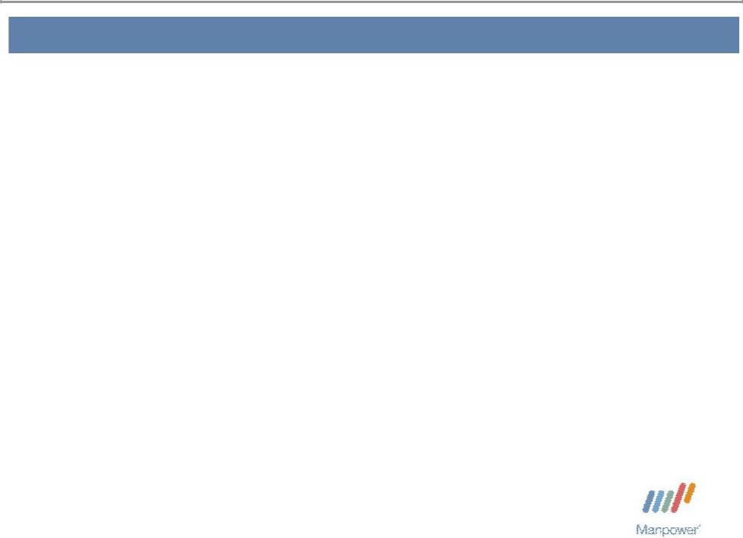

Forward Looking Statement

This presentation includes forward-looking statements which are subject to risks and uncertainties. Actual results might differ materially from those projected in the forward-looking statements. Forward-looking statements can be identified by words such as “expect,” “plan,” “may,” “will,” and similar expressions. Additional information concerning factors that could cause actual results to materially differ from those in the forward-looking statements is contained in the Company’s Annual Report on Form 10-K dated December 31, 2006, which information is incorporated herein by reference, and such other factors as may be described from time to time in the Company’s SEC filings.

Manpower Inc. 2007 2nd Quarter Results | 3
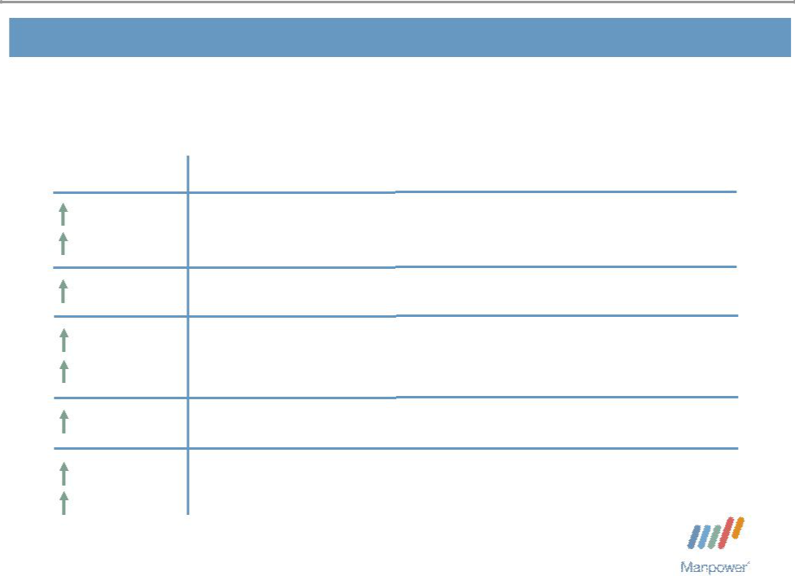

Consolidated Financial Highlights

15%

9% CC

249 bps

101%

89% CC

240 bps

107%

97% CC

Q2 Highlights Revenue $5.0B

Gross Margin 20.3%

Operating Profit $277M

OP Margin 5.5%

EPS from Continuing Operations $1.86

Throughout this presentation, the difference between reported variances and Constant Currency (CC) variances represents the impact of currency on our financial results. Constant Currency is further explained on our Web site.

Manpower Inc. 2007 2nd Quarter Results | 4
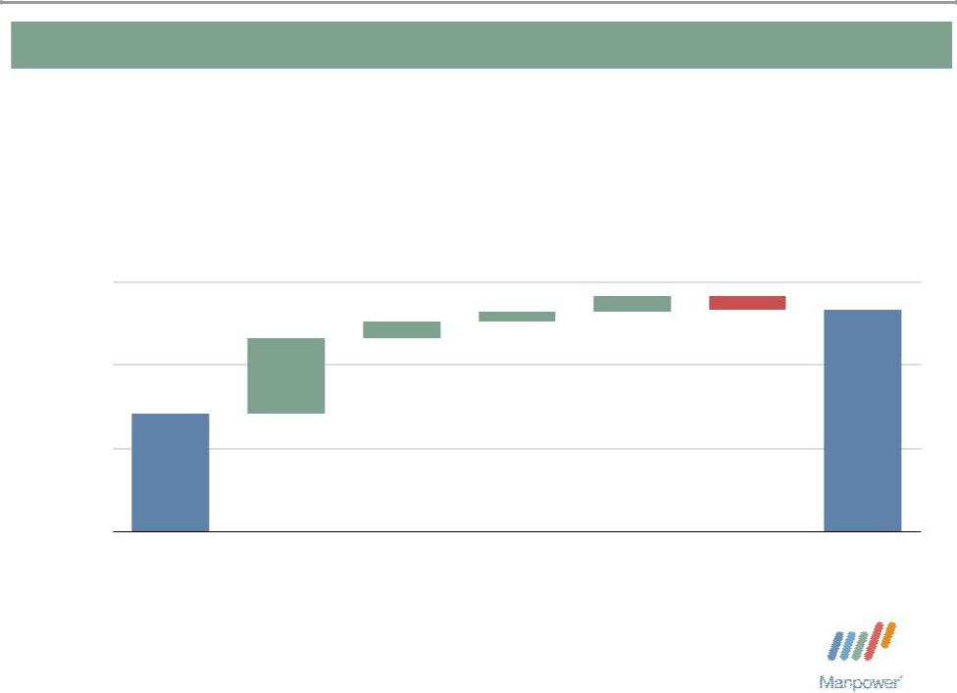

Consolidated Gross Profit Margin Change

21% | + 0.40% | + 0.24% | + 0.37% - 0.32%
+ 1.80% | + 0.40% | + 0.24%
+ 1.80% | + 0.40% |  | 20.34%
19%

17% | 17.85%

15%

Q2 2006 | France - | France - Q2 | Temporary | Permanent | Mix - | Q2 2007
 | Retroactive | Impact of | Recruitment | Recruitment | Specialty
 | Impact of | Payroll Tax
 | Payroll Tax | Change
 | Change

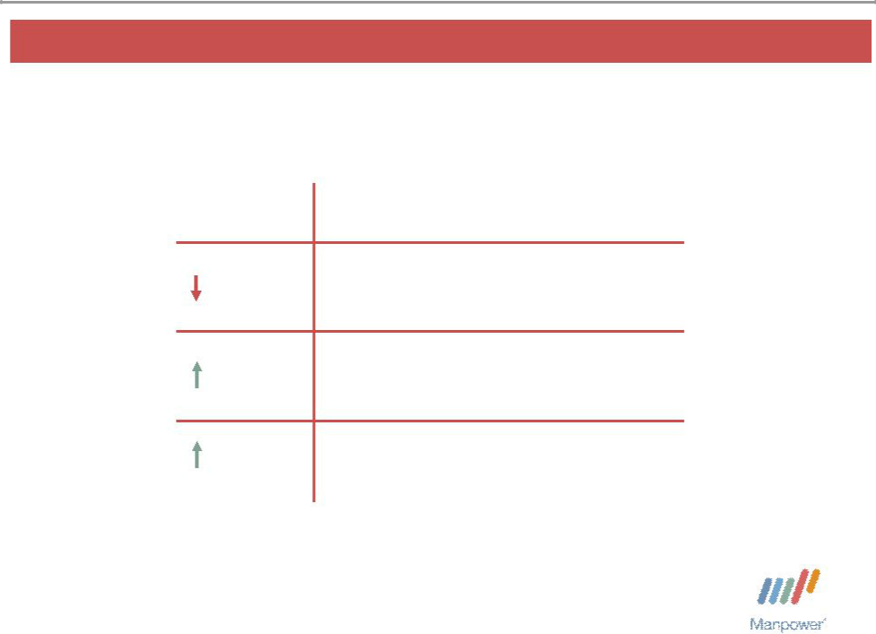
Manpower Inc. 2007 2nd Quarter Results | 5

United States Segment
(10% of Revenue)

Q2 Financial Highlights

9% Revenue $489M

16% OUP $26M

110 bps OUP Margin 5.3%

Operating Unit Profit (OUP) is the measure that we use to evaluate segment performance. OUP is equal to segment revenues less direct costs and branch and national headquarters operating costs.

Manpower Inc. 2007 2nd Quarter Results | 6
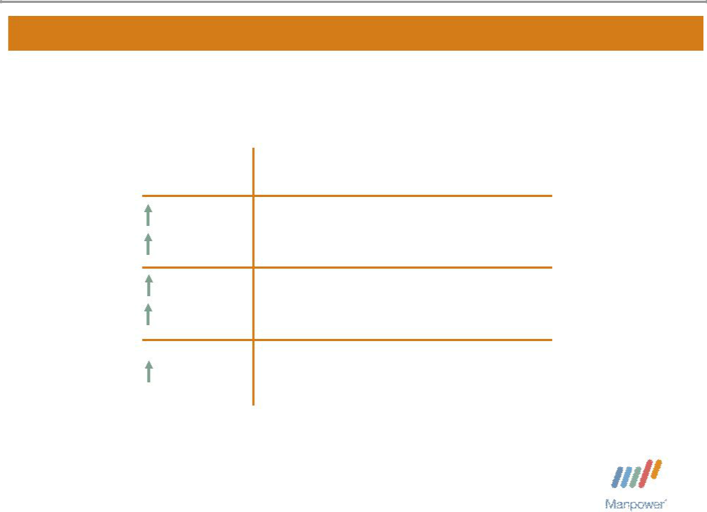

France Segment
(35% of Revenue)

Q2 Financial Highlights

16% | Revenue $1.8B
8% CC
229% | OUP $164M | (1)
209% CC | OUP $164M
600 bps | OUP Margin 9.2%⁽¹⁾

- The cumulative impact of the change in the French payroll tax calculation is included above. The cumulative change has a $99M positive impact on OUP and a positive 560 bps impact on OUP margin.

Manpower Inc. 2007 2nd Quarter Results | 7
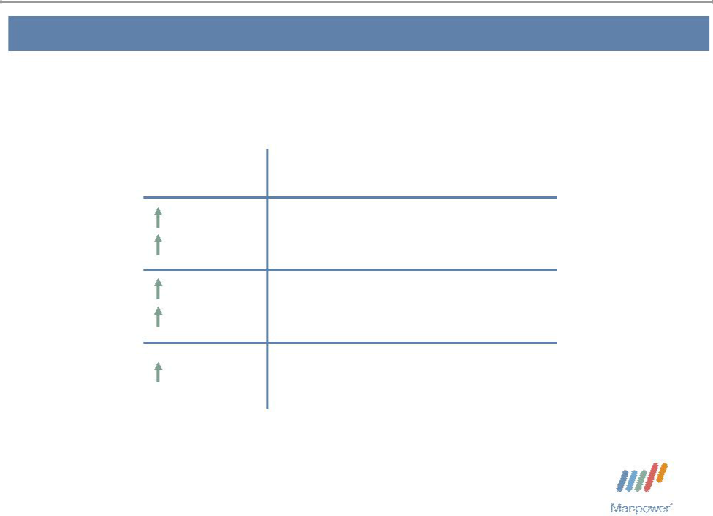

Other EMEA Segment
(31% of Revenue)

Q2 Financial Highlights
^{26%} Revenue $1.6B

17% CC
^{89%} OUP $56M

78% CC

120 bps OUP Margin 3.5%

Manpower Inc. 2007 2nd Quarter Results | 8
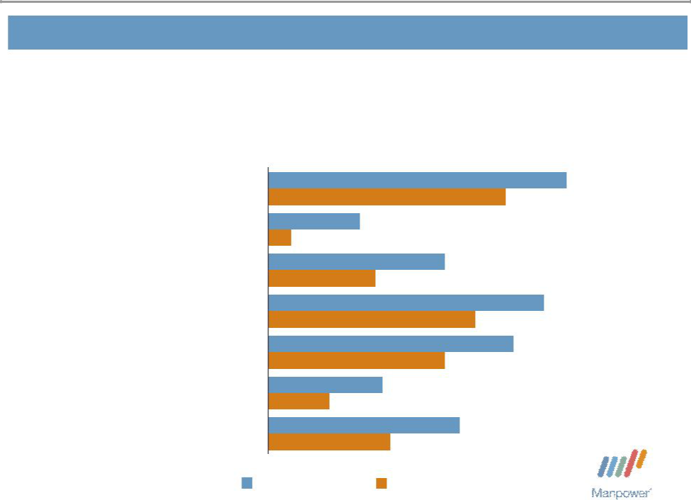

Other EMEA – Q2 Revenue Growth YoY

- of Segment Revenue

21%

16%

15%

10%

9%

8%

21%

Nordics | 39%
Nordics | 31%
UK - Manpower | 12%
UK - Manpower | 3%
Elan | 23%
Elan | 14%
Germany | 36%
Germany | 27%
Netherlands | 32%
Netherlands | 23%
Spain | 15%
Spain | 8%
Other | 25%
Other | 16%

Revenue Growth Revenue Growth - CC

Manpower Inc. 2007 2nd Quarter Results | 9
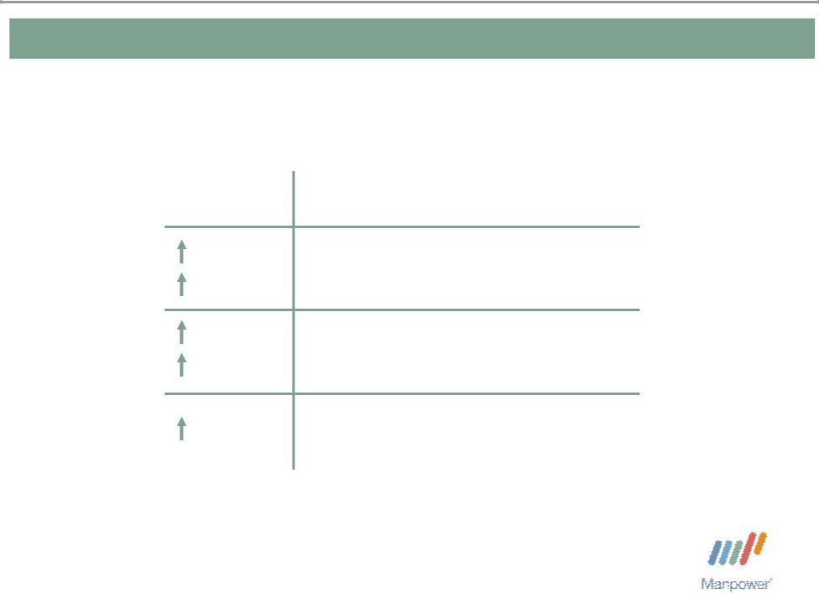

Italy Segment
(7% of Revenue)

Q2 Financial Highlights
^{21%} Revenue $354M
13% CC
^{37%} OUP $29M

28% CC

90 bps OUP Margin 8.2%

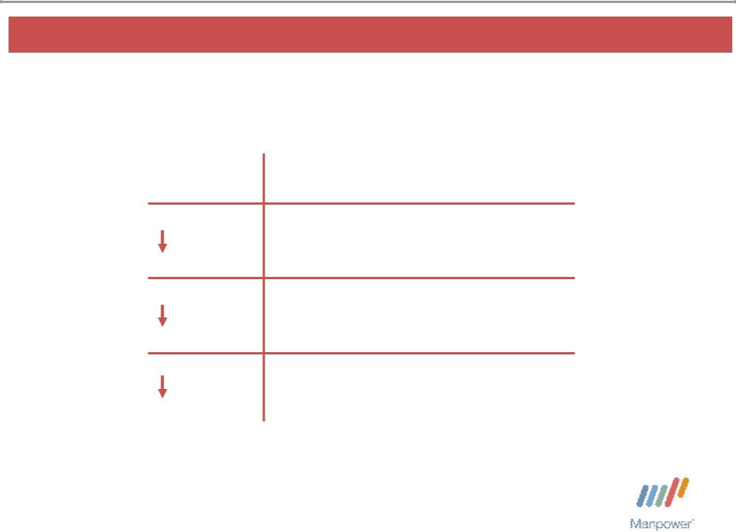
Manpower Inc. 2007 2nd Quarter Results 10

Jefferson Wells Segment
(2% of Revenue)

Q2 Financial Highlights

15% Revenue $84M

89% OUP $1M

890 bps OUP Margin 1.3%

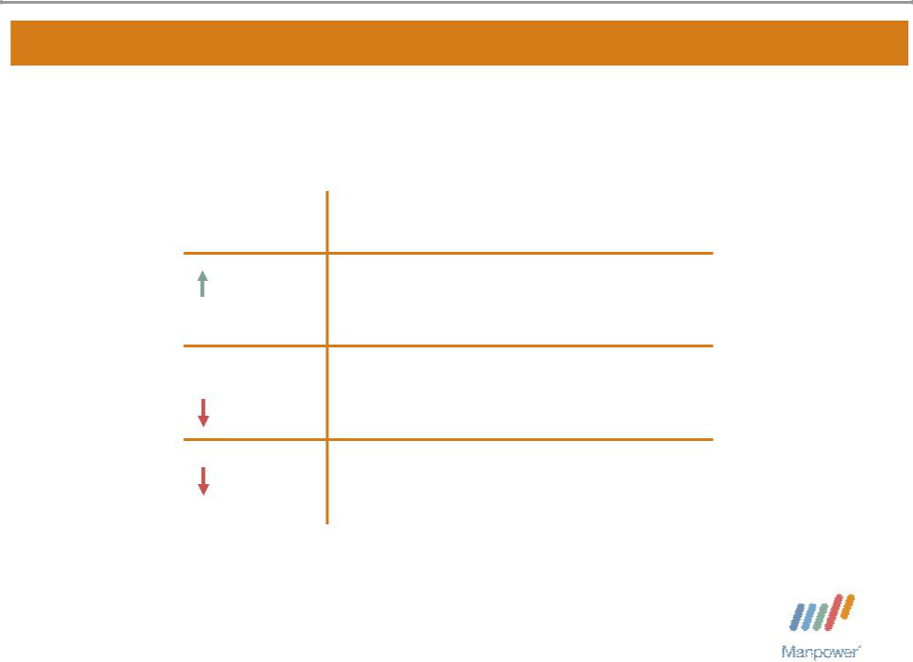
Manpower Inc. 2007 2nd Quarter Results 11

Right Management Segment
(2% of Revenue)

 | Q2 Financial Highlights
3% | Revenue $106M
0% CC | Revenue $106M
0% | OUP $11M
4% CC | OUP $11M
30 bps | OUP Margin 10.4%

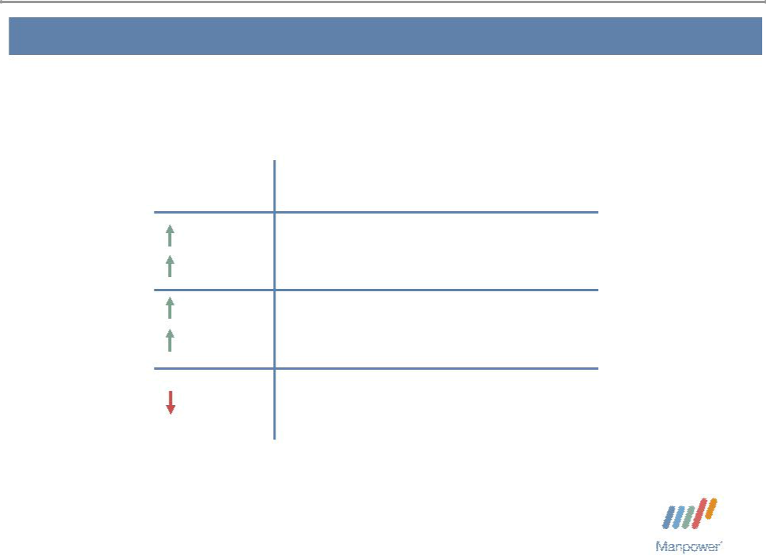
Manpower Inc. 2007 2nd Quarter Results | 12

Other Operations Segment
(13% of Revenue)

Q2 Financial Highlights
^{13%} Revenue $635M
11% CC
^{2%} OUP $15M

2% CC

20 bps OUP Margin 2.4%

Manpower Inc. 2007 2nd Quarter Results | 13
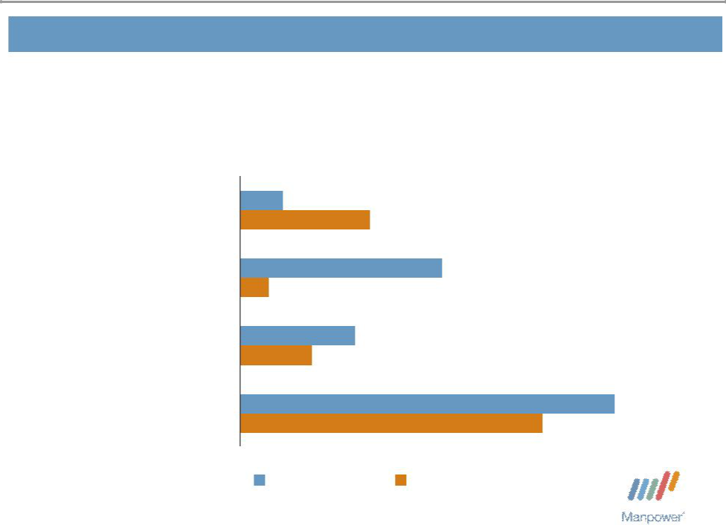

Other Operations – Q2 Revenue Growth YoY

- of Segment Revenue

34% | Japan | 3%
34% | Japan | 9%
16% | Australia/NZ | 14%
16% | Australia/NZ | 2%
15% | Mexico | 8%
15% | Mexico | 5%
35% | Other | 26%
35% | Other | 21%

Revenue Growth Revenue Growth - CC


Manpower Inc. 2007 2nd Quarter Results 14

Financial Highlights

Manpower Inc. 2007 2nd Quarter Results | 15
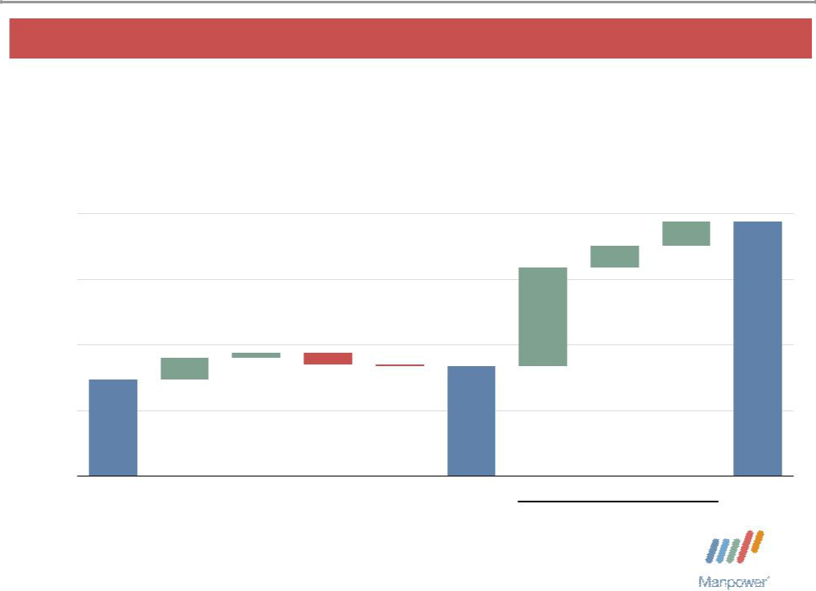

Reconciliation of Reported EPS to Q2 Guidance

$1.90
$1.60
$1.30 | + $0.10 | + $0.02 - $0.05 | - $0.01
$1.20
$1.14

$1.00

$0.70

Q2 | Operational | Interest | Tax | Currency | Q2 Before
Guidance Performance |  | and | Rate | (5¢ vs. 6¢) | Impact
(mid-point) |  | Other |  |  | of French
 |  | Expense |  |  | Payroll Tax
 |  |  |  |  | Change

+ $0.11

+ $0.10 ^{$1.86}
+ $0.45

OUP in millions:

$66.7 $15.5 $17.1

2006 Q1-07 Q2-07 Q2 2007

Impact of French Payroll

Tax Change

Manpower Inc. 2007 2nd Quarter Results | 16
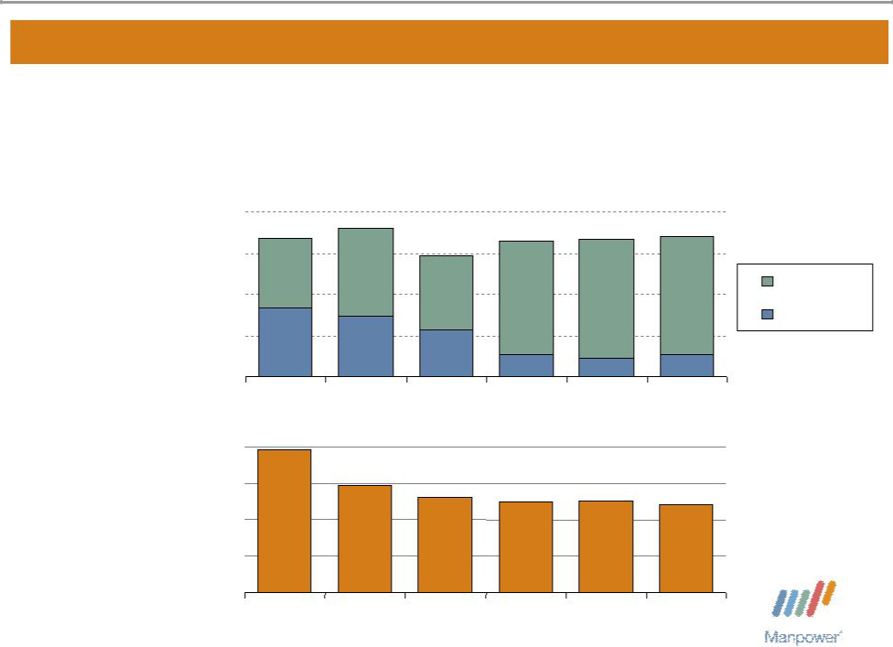

Balance Sheet Highlights

Total Debt | 1,000

($ in millions)

Total Debt to

Total Capitalization

750

500

250

0

40%

30%

20%

10%

0%

842 | 902 |  | 823 | 837 | 848
842 |  | 735 | 823 | 837 | 848
 |  | 735 |  |  | Total Debt
416 | 370 |  |  |  | Net Debt
 | 370 | 280
 |  |  | 135 | 109 | 137
2003 | 2004 | 2005 | 2006 | Q1 2007 | Q2 2007

39%
 | 29% | 26% | 25% | 25% | 24%
2003 | 2004 | 2005 | 2006 | Q1 2007 | Q2 2007

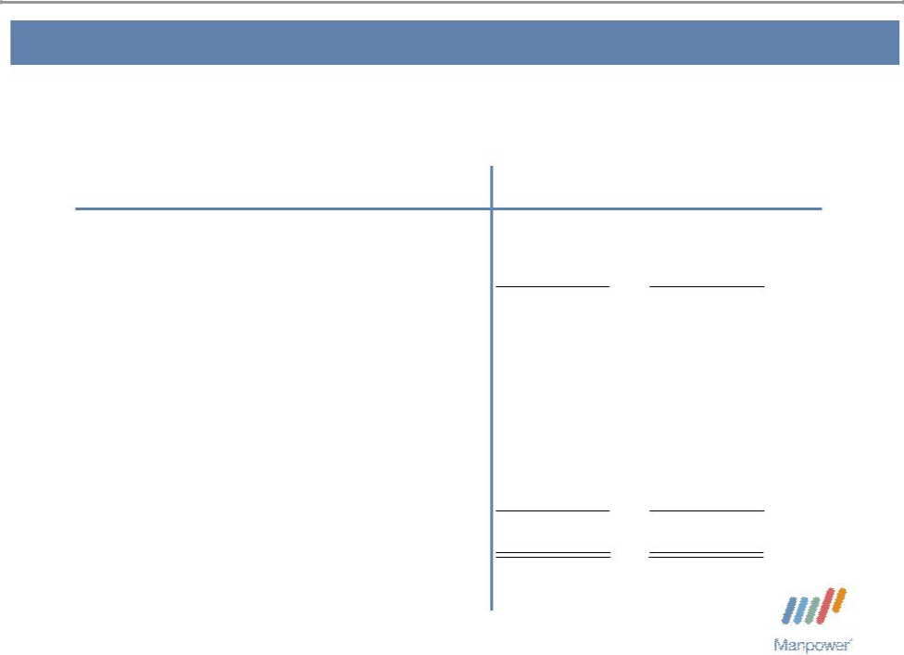
Manpower Inc. 2007 2nd Quarter Results | 17

Cash Flow Summary – First Half

($ in millions) | 2007 | 2006
Cash from Operations | 141 | 136
Capital Expenditures | (41) | (35)
Free Cash Flow | 100 | 101
Share Repurchases * | (89) | (119)
Proceeds from Equity Plans | 37 | 42
Change in Debt | 3 | 251
Proceeds from Sale of Business | - | 30
Other | (28) | 8
Change in Cash | 23 | 313

* 1,214,800 shares in 2007 and 1,970,300 shares in 2006.

Manpower Inc. 2007 2nd Quarter Results | 18
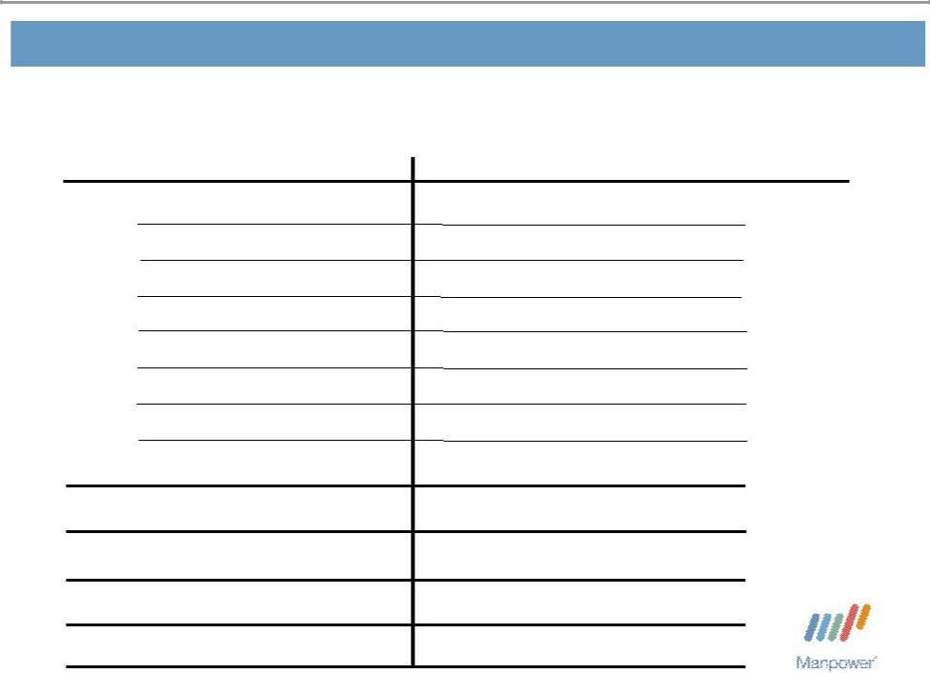

Third Quarter Outlook

Revenue U.S.

France

Other EMEA

Italy

Jefferson Wells

Right Management

Other

Total

Gross Profit Margin Operating Profit Margin

Tax Rate from Continuing Operations EPS from Continuing Operations

Down 6-8%

Up 11-13% (Up 4-6% CC)

Up 24-26% (Up 16-18% CC)

Up 21-23% (Up 13-15% CC)

Down 7-9%

Up 4-5% (Up 1-2% CC)

Up 12-14% (Up 10-12% CC)

Up 13-15% (Up 7-9% CC)

18.1-18.3%

3.9 – 4.1%

38.0%

$1.39-$1.43 (Pos. $.08 Currency)

Manpower Inc.
2007 2nd Quarter Results


July 19, 2007

Questions?
Answers

