UNITED STATES

SECURITIES AND EXCHANGE COMMISSION

Washington, D.C. 20549

FORM 8-K

CURRENT REPORT

Pursuant to Section 13 or 15(d) of the Securities Exchange Act of 1934

Date of Report (Date of earliest event reported): April 18, 2006

MANPOWER INC.

(Exact name of registrant as specified in its charter)

Wisconsin | 1-10686 | 39-1672779
(State or other jurisdiction | (Commission | (IRS Employer
of incorporation) | File Number) | Identification No.)
5301 North Ironwood Road
Milwaukee, Wisconsin |  | 53217
(Address of principal executive offices) |  | (Zip Code)

Registrant’s telephone number, including area code: (414) 961-1000

Check the appropriate box below if the Form 8-K filing is intended to simultaneously satisfy the filing obligation of the registrant under any of the following provisions:

- Written communications pursuant to Rule 425 under the Securities Act (17 CFR 230.425)

- Soliciting material pursuant to Rule 14a-12 under the Securities Act (17 CFR 240.14a-12)

- Pre-commencement communications pursuant to Rule 14d-2(b) under the Exchange Act (17 CFR 240.14d-2(b))

- Pre-commencement communications pursuant to Rule 13e-4(c) under the Exchange Act (17 CFR 240.13e-4(c))

Item 2.02 Results of Operations and Financial Condition

On April 18, 2006, we issued a press release announcing our results of operations for the quarter ended March 31, 2006. A copy of the press release is attached hereto as Exhibit 99.1 and is incorporated herein by reference.

Item 9.01. |  | Exhibits.
 | Exhibit No. |  |  | Description
 |  | 99.1 |  | Press Release dated April 18, 2006
 |  | 99.2 |  | Presentation materials for April 18, 2006 conference call

SIGNATURES

Pursuant to the requirements of the Securities Exchange Act of 1934, the Registrant has duly caused this Report to be signed on its behalf by the undersigned hereunto duly authorized.

 | MANPOWER INC.
Dated: April 18, 2006 | By: /s/ Michael J. Van Handel
 |  | Michael J. Van Handel
 |  | Executive Vice President,
 |  | Chief Financial Officer and Secretary

 |  | EXHIBIT INDEX
Exhibit No. |  | Description
99.1 |  | Press Release dated April 18, 2006
99.2 |  | Presentation materials for April 18, 2006 conference call

Exhibit 99.1

[MANPOWER logo]

FOR IMMEDIATE RELEASE

Contact:

Mike Van Handel

Manpower Inc.

+1.414.906.6305

michael.vanhandel@manpower.com

Manpower Inc. Reports 1st Quarter Results

MILWAUKEE, WI, USA, April 18, 2006 – Manpower Inc. (NYSE: MAN) today reported that net earnings for the three months ended March 31, 2006 increased 63 percent to $52.6 million, or 59 cents per diluted share, compared to $32.2 million, or 35 cents per diluted share, a year earlier. Revenues for the first quarter were $3.9 billion, an increase of 5 percent from the year-earlier period.

Results for the first quarter were negatively impacted by relatively weaker foreign currencies compared to the first quarter of 2005. On a constant currency basis, diluted earnings per share were 65 cents on an 11 percent improvement in revenues. Included in the current year results is a 27 cents per diluted share gain on the sale of a payroll processing business in Sweden and a 16 cents per diluted share charge related to reorganization and a global cost reduction initiative.

Jeffrey A. Joerres, Manpower Chairman and Chief Executive Officer, said, “The Manpower team across the world is performing well, and it shows in the results. When we get all cylinders firing, the leverage we can achieve is impressive. The United States, Italy, Germany, Sweden, Japan and other business units increased profitability by 30% or more compared to first quarter 2005. Excluding the one-time items, Manpower’s operating income increased 25 percent year over year, and earnings per share increased 37 percent in U.S. dollars and 51 percent in constant currency.”

Joerres added, “In addition to our strong performance this quarter, we also announced our new brand on February 21st, which is all about demonstrating the depth of our services and the strength of our leadership in the employment services industry. This effort has already had a positive impact with our clients and candidates.

“Given the current trends, we anticipate our second quarter diluted earnings per share to be in the range of 76 to 80 cents, which includes an estimated negative currency impact of 3 cents.”

- MORE -

Manpower Inc. Reports 1st Quarter Results/Page 2

In conjunction with its first quarter earnings release, Manpower will broadcast its conference call live over the Internet on April 18 at 7:30 a.m. CT (8:30 a.m. ET). Interested parties are invited to listen to the webcast and view the presentation by logging on to http://investor.manpower.com.

Supplemental financial information referenced in the conference call can be found at http://investor.manpower.com.

About Manpower Inc.

Manpower Inc. (NYSE: MAN) is a world leader in the employment services industry; creating and delivering services that enable its clients to win in the changing world of work. The $16 billion company offers employers a range of services for the entire employment and business cycle including permanent, temporary and contract recruitment; employee assessment and selection; training; outplacement; outsourcing and consulting. Manpower’s worldwide network of 4,400 offices in 72 countries and territories enables the company to meet the needs of its 400,000 customers per year, including small and medium size enterprises in all industry sectors, as well as the world’s largest multinational corporations. The focus of Manpower’s work is on raising productivity through improved quality, efficiency and cost-reduction across their total workforce, enabling clients to concentrate on their core business activities. Manpower Inc. operates under five brands: Manpower, Manpower Professional, Elan, Jefferson Wells and Right Management. More information on Manpower Inc. is available at www.manpower.com.

Forward-Looking Statements

This news release contains statements, including earning projections, that are forward-looking in nature and, accordingly, are subject to risks and uncertainties regarding the Company’s expected future results. The Company’s actual results may differ materially from those described or contemplated in the forward-looking statements. Factors that may cause the Company’s actual results to differ materially from those contained in the forward-looking statements can be found in the Company’s reports filed with the SEC, including the information under the heading ‘Forward-Looking Statements’ in its Annual Report on Form 10-K for the year ended December 31, 2005, which information is incorporated herein by reference.

- ### -

Manpower Inc.

Results of Operations

(In millions, except per share data)

 |  |  |  | Three Months Ended March 31
 |  |  |  |  |  |  |  | % Variance
 |  |  |  |  |  |  |  | Amount |  | Constant
 |  | 2006 |  |  |  | 2005 |  | Reported |  | Currency
 |  |  |  |  |  | (Unaudited)
Revenues from services (a) | $ | 3,929.9 |  | $ |  | 3,758.7 | 4.6% |  |  | 11.5%
Cost of services |  | 3,212.5 |  |  |  | 3,076.7 | 4.4%
Gross profit |  | 717.4 |  |  |  | 682.0 | 5.2% |  |  | 11.8%
Selling and administrative expenses |  | 657.7 |  |  |  | 619.5 | 6.2% |  |  | 12.5%
Operating profit |  | 59.7 |  |  |  | 62.5 | -4.6% |  |  | 5.0%
Interest and other (income) expense |  | (16.3) |  |  |  | 11.7 |  | N/A
Earnings before income taxes |  | 76.0 |  |  |  | 50.8 | 49.7%
Provision for income taxes |  | 23.4 |  |  |  | 18.6 | 26.0%
Net earnings | $ | 52.6 |  |  | $ | 32.2 | 63.2% |  |  | 79.4%
Net earnings per share - basic |  |  |  |  |  |  | 66.7%
Net earnings per share - basic | $ | 0.60 |  | $ |  | 0.36
Net earnings per share - diluted | $ | 0.59 |  |  | $ | 0.35 | 68.6% |  |  | 85.7%
Weighted average shares - basic |  |  |  |  |  |  | -2.6%
Weighted average shares - basic |  | 87.4 |  |  |  | 89.8
Weighted average shares - diluted |  | 88.7 |  |  |  | 96.9 | -8.5%

- Revenues from services include fees received from our franchise offices of $8.0 million and $8.3 million for the three months ended March 31, 2006 and 2005, respectively. These fees are primarily based on revenues generated by the franchise offices, which were $362.8 million and $349.8 million for the three months ended March 31, 2006 and 2005, respectively.

Manpower Inc.

Operating Unit Results

(In millions)

 |  |  |  | Three Months Ended March 31
 |  |  |  |  |  |  |  | % Variance
 |  |  |  |  |  |  |  | Amount |  | Constant
 |  | 2006 |  |  |  | 2005 |  | Reported |  | Currency
 |  |  |  |  |  | (Unaudited)
Revenues from Services:
United States (a) | $ | 510.3 |  | $ |  | 475.9 | 7.2% |  |  | 7.2%
France |  | 1,259.1 |  |  |  | 1,247.5 | 0.9% |  |  | 9.9%
EMEA |  | 1,414.3 |  |  |  | 1,333.1 | 6.1% |  |  | 15.3%
Jefferson Wells |  | 95.5 |  |  |  | 92.7 | 3.0% |  |  | 3.0%
Right Management |  | 96.0 |  |  |  | 104.0 | -7.7% |  |  | -4.3%
Other Operations |  | 554.7 |  |  |  | 505.5 | 9.8% |  |  | 14.1%
 | $ | 3,929.9 |  | $ |  | 3,758.7 | 4.6% |  |  | 11.5%
Operating Unit Profit:
United States | $ | 9.5 |  | $ |  | 4.9 | 93.3% |  |  | 93.3%
France |  | 29.7 |  |  |  | 27.5 | 7.9% |  |  | 17.6%
EMEA |  | 23.1 |  |  |  | 15.0 | 54.0% |  |  | 69.3%
Jefferson Wells |  | 5.7 |  |  |  | 8.1 | -29.4% |  |  | -29.4%
Right Management |  | 4.3 |  |  |  | 9.8 | -55.9% |  |  | -56.9%
Other Operations |  | 17.9 |  |  |  | 12.5 | 43.1% |  |  | 52.0%
 |  | 90.2 |  |  |  | 77.8
Corporate expenses |  | 27.3 |  |  |  | 12.1
Amortization of intangible assets |  | 3.2 |  |  |  | 3.2
Operating profit |  | 59.7 |  |  |  | 62.5 | -4.6% |  |  | 5.0%
Interest and other (income) expense |  | (16.3) |  |  |  | 11.7
Earnings before income taxes | $ | 76.0 |  |  | $ | 50.8

- In the United States, revenues from services include fees received from the related franchise offices of $5.3 million and $5.4 million for the three months ended March 31, 2006 and 2005, respectively. These fees are primarily based on revenues generated by the franchise offices, which were $282.3 million and $277.6 million for the three months ended March 31, 2006 and 2005, respectively.

- The components of interest and other (income) expense were:

 |  | 2006 |  |  | 2005
Interest expense | $ | 11.6 |  | $11.6
Interest income |  | (3.3) |  | (2.3)
Foreign exchange losses |  | 0.9 |  | 0.8
Miscellaneous (income) expenses, net |  | (25.5) |  | 1.6
 | $ | (16.3) |  | $11.7

Manpower Inc.

Consolidated Balance Sheets

(In millions)

 |  | Mar. 31 |  |  | Dec. 31
 |  | 2006 |  |  | 2005
 |  | (Unaudited)
ASSETS
Current assets:
Cash and cash equivalents | $ | 554.5 |  | $ | 454.9
Accounts receivable, net |  | 3,162.2 |  |  | 3,208.2
Prepaid expenses and other assets |  | 129.0 |  |  | 107.5
Future income tax benefits |  | 84.0 |  |  | 71.1
Total current assets |  | 3,929.7 |  |  | 3,841.7
Other assets:
Goodwill and other intangible assets, net |  | 1,264.9 |  |  | 1,256.5
Other assets |  | 294.4 |  |  | 273.8
Total other assets |  | 1,559.3 |  |  | 1,530.3
Property and equipment:
Land, buildings, leasehold improvements and equipment |  | 654.8 |  |  | 642.4
Less: accumulated depreciation and amortization |  | 460.5 |  |  | 446.0
Net property and equipment |  | 194.3 |  |  | 196.4
 | $ | 5,683.3 |  | $ | 5,568.4
LIABILITIES AND SHAREHOLDERS’ EQUITY
Current liabilities:
Accounts payable | $ | 793.0 |  | $ | 685.4
Employee compensation payable |  | 140.2 |  |  | 150.6
Accrued liabilities |  | 474.3 |  |  | 435.4
Accrued payroll taxes and insurance |  | 507.3 |  |  | 607.2
Value added taxes payable |  | 420.8 |  |  | 441.9
Short-term borrowings and current maturities of long-term debt |  | 268.7 |  |  | 260.0
Total current liabilities |  | 2,604.3 |  |  | 2,580.5
Other liabilities:
Long-term debt |  | 485.7 |  |  | 475.0
Other long-term liabilities |  | 388.0 |  |  | 366.3
Total other liabilities |  | 873.7 |  |  | 841.3
Shareholders’ equity:
Common stock |  | 1.0 |  |  | 1.0
Capital in excess of par value |  | 2,372.1 |  |  | 2,346.7
Retained earnings |  | 322.5 |  |  | 269.9
Accumulated other comprehensive income |  | (3.0) |  |  | (11.0)
Treasury stock, at cost |  | (487.3) |  |  | (460.0)
Total shareholders’ equity |  | 2,205.3 |  |  | 2,146.6
Total liabilities and shareholders’ equity | $ | 5,683.3 |  | $ | 5,568.4

Manpower Inc.

Consolidated Statements of Cash Flows

(In millions)

 |  |  | 3 Months Ended
 |  |  | March 31
 |  |  | 2006 |  |  | 2005
 |  |  |  | (Unaudited)
 | Cash Flows from Operating Activities:
 | Net earnings | $ | 52.6 |  | $ | 32.2
 | Adjustments to reconcile net earnings to net cash provided by operating activities:
 | Depreciation and amortization |  | 21.8 |  |  | 23.1
 | Amortization of discount on convertible debentures |  | — |  |  | 1.9
 | Deferred income taxes |  | (10.0) |  |  | (9.8)
 | Provision for doubtful accounts |  | 6.1 |  |  | 4.3
 | Stock based compensation |  | 4.6 |  |  | —
 | Other non-operating gains |  | (29.3) |  |  | —
 | Changes in operating assets and liabilities excluding the impact of acquisitions:
 | Accounts receivable |  | 76.9 |  |  | 120.7
 | Other assets |  | (19.5) |  |  | (15.4)
 | Other liabilities |  | (26.0) |  |  | (71.0)
 | Cash provided by operating activities |  | 77.2 |  |  | 86.0
 | Cash Flows from Investing Activities:
 | Capital expenditures |  | (15.2) |  |  | (19.2)
 | Acquisitions of businesses, net of cash acquired |  | (7.2) |  |  | (2.2)
 | Proceeds from sale of business |  | 29.6 |  |  | —
 | Proceeds from sale of an equity interest |  | 8.8 |  |  | —
 | Proceeds from the sale of property and equipment |  | 2.2 |  |  | 1.3
 | Cash provided (used) by investing activities |  | 18.2 |  |  | (20.1)
Cash Flows from Financing Activities:
 | Net borrowings of short-term facilities and long-term debt |  | 3.2 |  |  | 11.2
 | Cash paid to settle convertible debentures |  | — |  |  | (206.6)
 | Proceeds from settlement of swap agreements |  | — |  |  | 50.7
 | Proceeds from stock option and purchase plans |  | 26.5 |  |  | 6.6
 | Repurchases of common stock |  | (33.0) |  |  | (47.2)
 | Dividends paid |  | — |  |  | —
 | Cash used by financing activities |  | (3.3) |  |  | (185.3)
Effect of exchange rate changes on cash
 |  |  | 7.5 |  |  | (15.6)
 | Change in cash and cash equivalents |  | 99.6 |  |  | (135.0)
 | Cash and cash equivalents, beginning of period |  | 454.9 |  |  | 531.8
 | Cash and cash equivalents, end of period | $ | 554.5 |  | $ | 396.8

Manpower Inc.
2006 1st Quarter Results

Exhibit 99.2


April 18, 2006

Now
Next

Manpower Inc. 2006 1st Quarter Results | 2
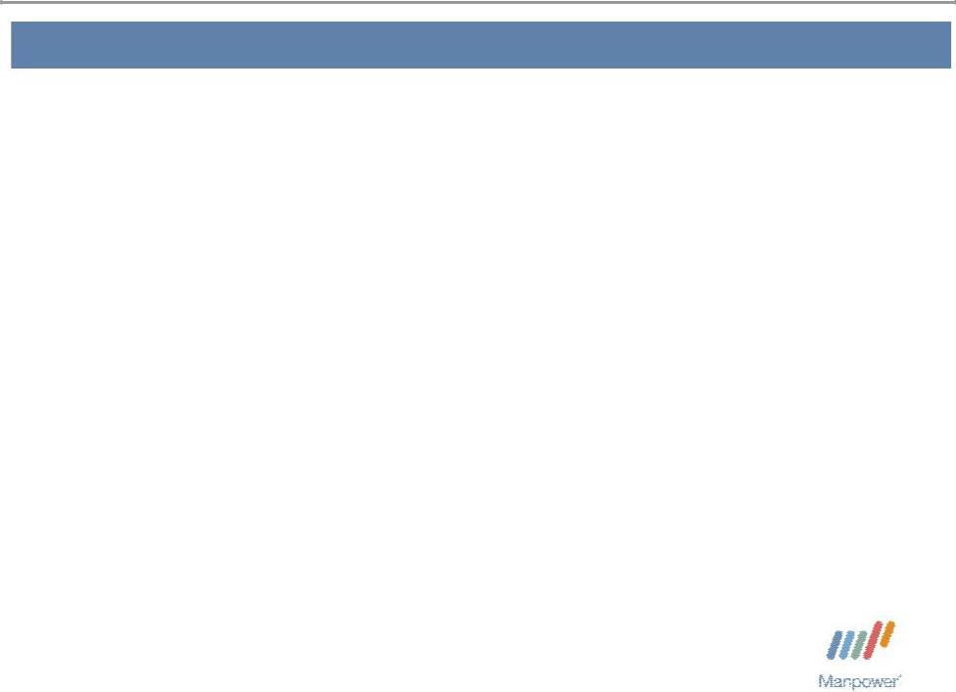

Forward Looking Statement

This presentation includes forward-looking statements which are subject to risks and uncertainties. Actual results might differ materially from those projected in the forward-looking statements. Forward-looking statements can be identified by words such as “expect,” “plan,” “may,” “will,” and similar expressions. Additional information concerning factors that could cause actual results to materially differ from those in the forward-looking statements is contained in the Company’s Annual Report on Form 10-K dated December 31, 2005, which information is incorporated herein by reference, and such other factors as may be described from time to time in the Company’s SEC filings.

Manpower Inc. 2006 1st Quarter Results | 3
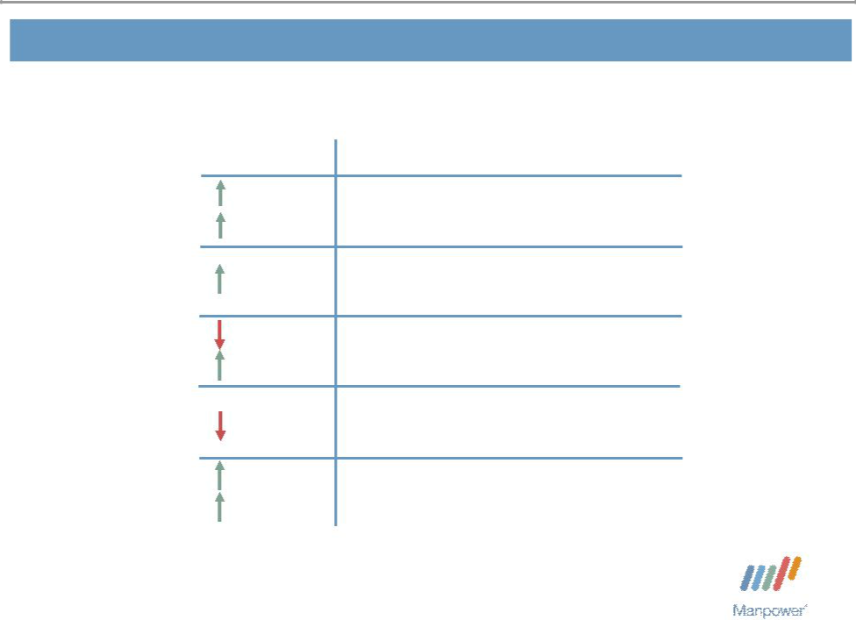

Consolidated Financial Highlights

Q1 Highlights

5%
11% CC

12 bps

5%
5% CC

14 bps

69%
86% CC

Revenue $3.9B Gross Margin 18.3% Operating Profit $60M OP Margin 1.5%

EPS $ .59 ($ .48 as adjusted*)

Throughout this presentation, the difference between reported variances and Constant Currency

  - variances represents the impact of currency on our financial results. Constant Currency is further explained on our Web site.
* Represents diluted earnings per share for the quarter adjusted to exclude the one-time non-operating gain and the expenses related to reorganization charges and Project Titan, a global cost reduction initiative. As Adjusted earnings are further explained on slide 14 of this presentation and on our Web site.

Manpower Inc. 2006 1st Quarter Results | 4
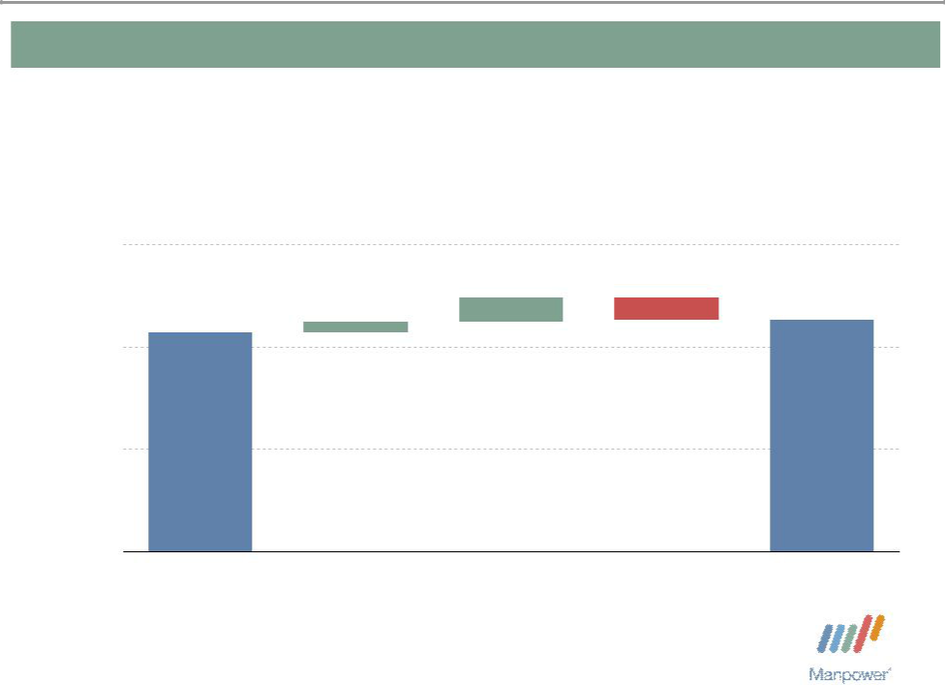

Consolidated Gross Profit Margin Change

19%

 | + 0.24% | - 0.22%
 | + 0.10%
18% | 18.14% | 18.26%

17%

16%

Q1 2005 | Temporary | Permanent | Mix - Right | Q1 2006
 | Recruitment | Recruitment

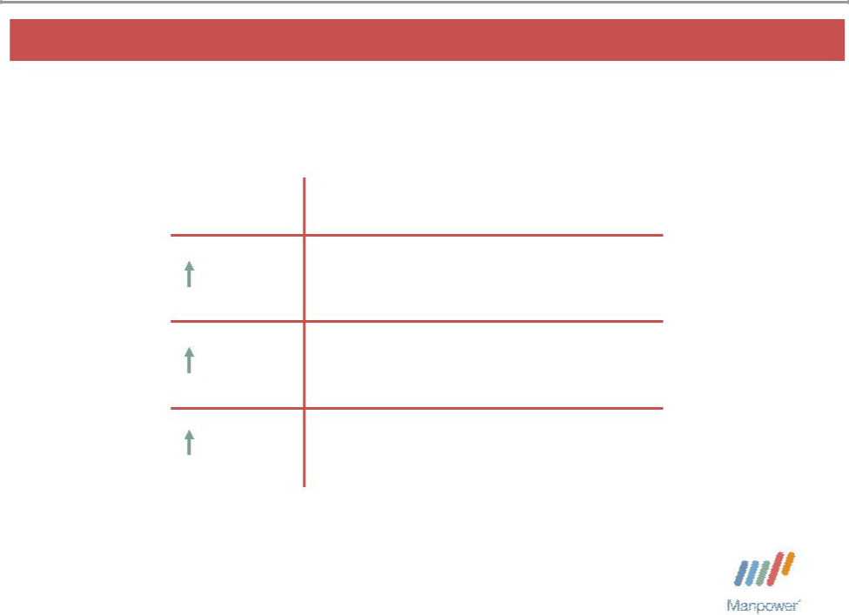
Manpower Inc. 2006 1st Quarter Results | 5

United States Segment

Q1 Financial Highlights

7% Revenue $510M

93% OUP $9M

90 bps OUP Margin 1.9%

Operating Unit Profit (OUP) is the measure that we use to evaluate segment performance. OUP is equal to segment revenues less direct costs and branch and national headquarters operating costs.

Manpower Inc. 2006 1st Quarter Results | 6
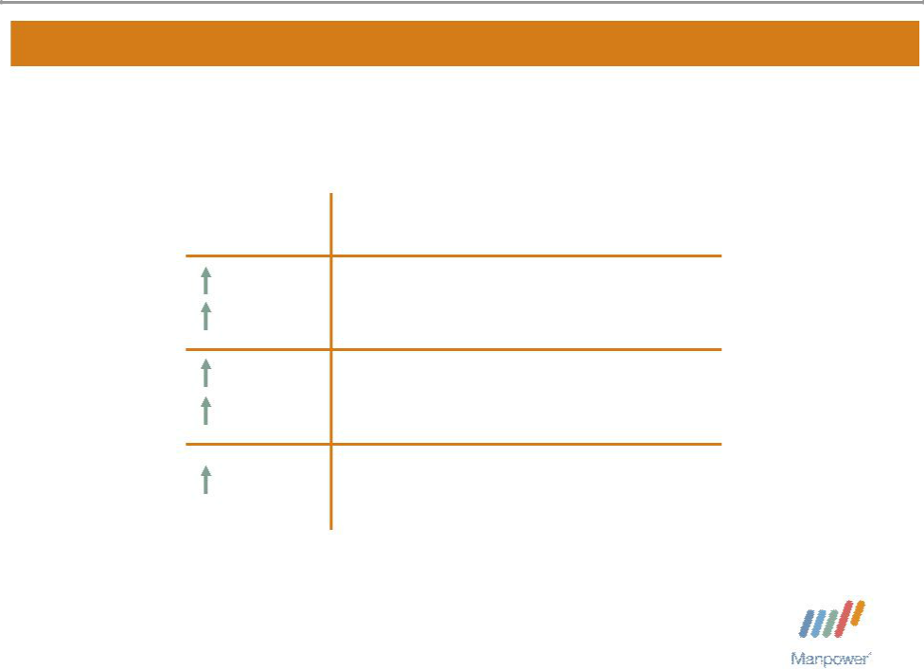

France Segment

 | Q1 Financial Highlights
1% | Revenue $1.3B
10% CC | Revenue $1.3B
8% | contemporary working
8% | OUP $30M
18% CC | OUP $30M
20 bps | OUP Margin 2.4%

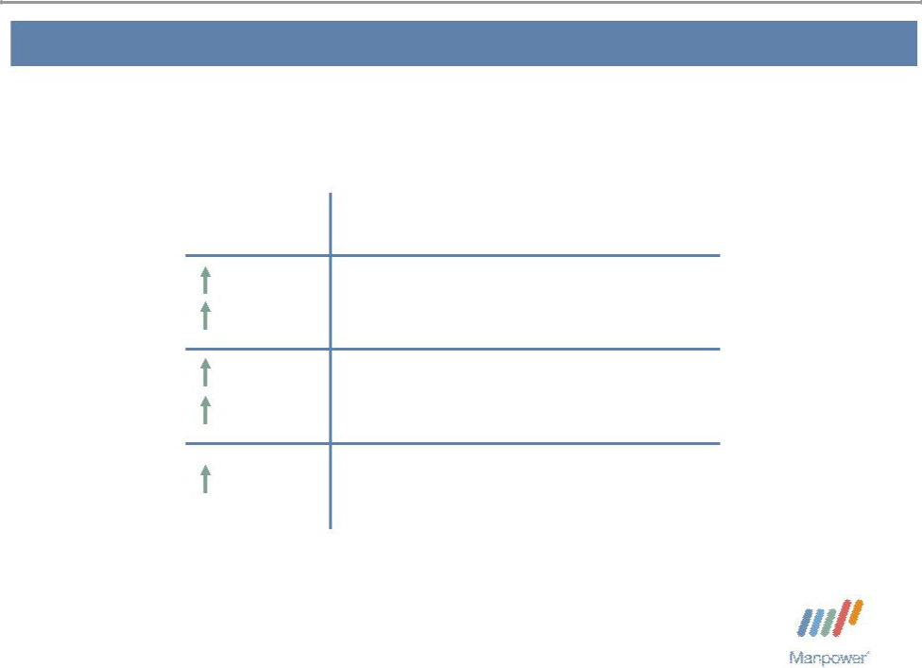
Manpower Inc. 2006 1st Quarter Results | 7

EMEA Segment

 | Q1 Financial Highlights
6% | Revenue $1.4B
15% CC | Revenue $1.4B
54% | contemporary working
54% | OUP $23M
69% CC | OUP $23M
50 bps | OUP Margin 1.6%

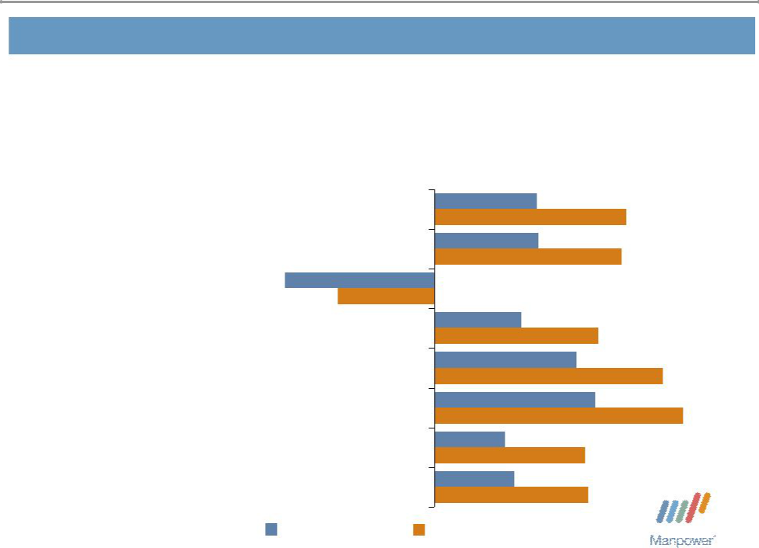
Manpower Inc. 2006 1st Quarter Results | 8

EMEA – Q1 Revenue Growth YoY

- of Segment Revenue

18% Nordics

17% Italy

16% UK - Manpower

12% Elan

8% Germany

7% Holland

7% Spain

15% Other

12%
23%

13%
23%

-18%
-12%

11%
20%

17%

28%

19%
30%

8%
18%

10%
19%

Revenue Growth Revenue Growth - CC

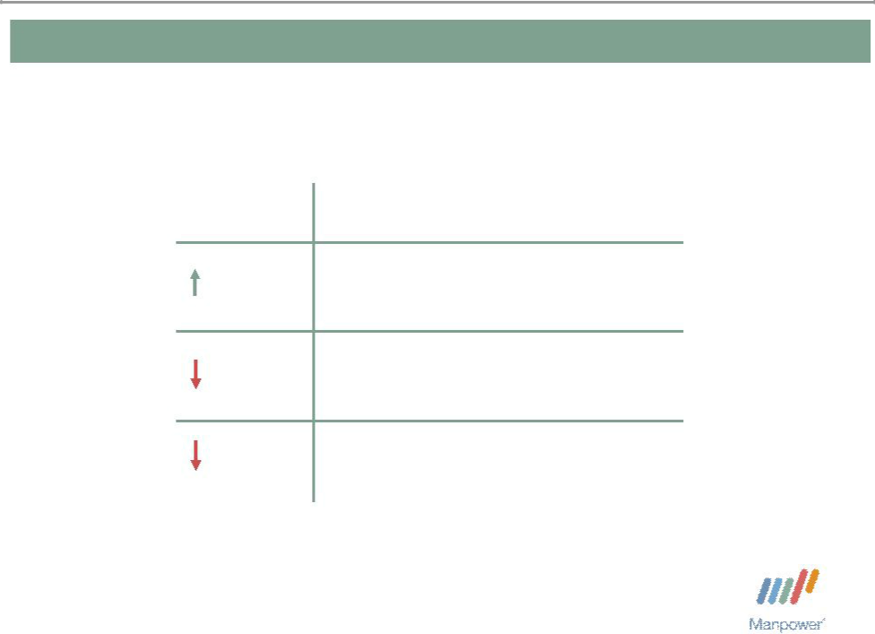
Manpower Inc. 2006 1st Quarter Results 9

Jefferson Wells Segment

Q1 Financial Highlights

3% Revenue $96M

contemporary working
29% OUP $6M

270 bps OUP Margin 6.0%

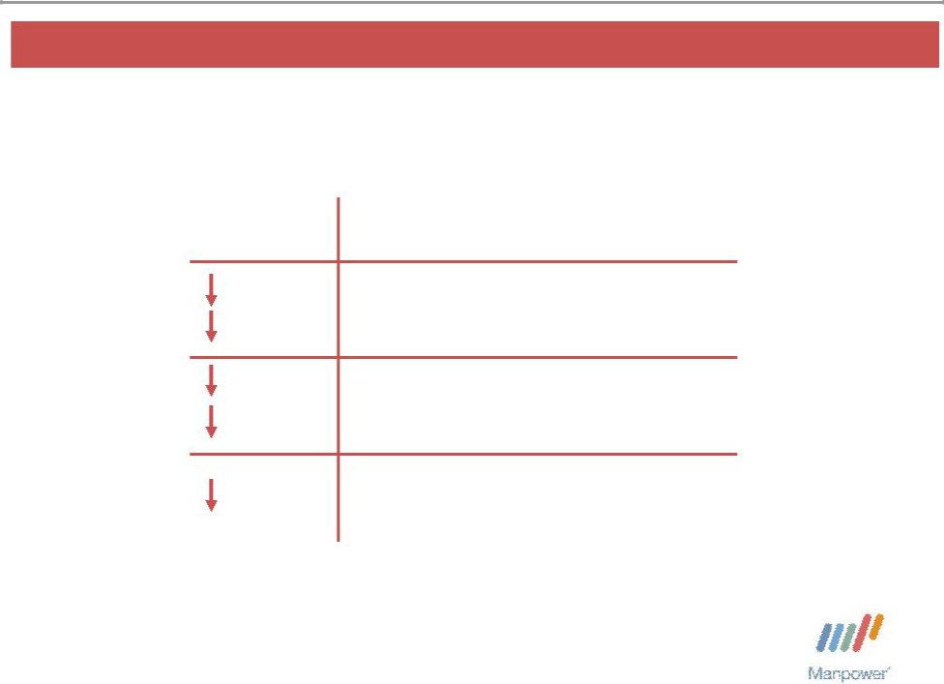
Manpower Inc. 2006 1st Quarter Results 10

Right Management Segment

 | Q1 Financial Highlights
8% | Revenue $96M
4% CC | Revenue $96M
56% | contemporary working
56% | OUP $4M
57% CC | OUP $4M
490 bps | OUP Margin 4.5%

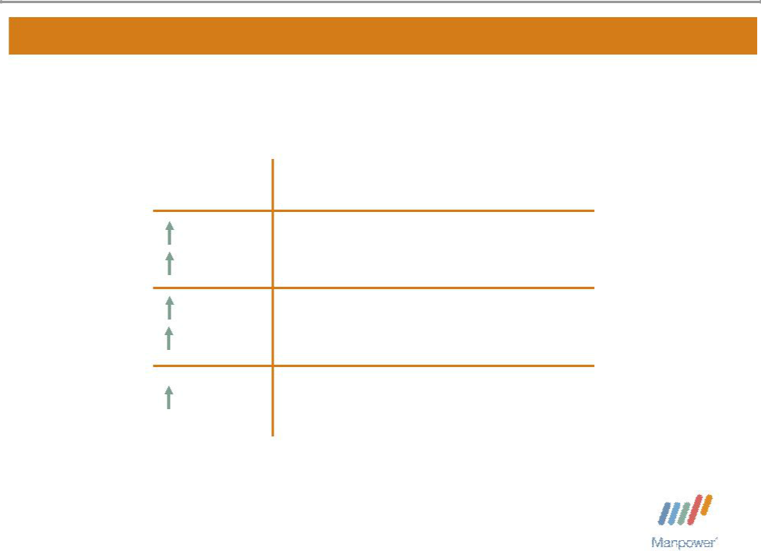
Manpower Inc. 2006 1st Quarter Results | 11

Other Operations Segment

 | Q1 Financial Highlights
10% | Revenue $555M
14% CC | Revenue $555M
43% | contemporary working
43% | OUP $18M
52% CC | OUP $18M
70 bps | OUP Margin 3.2%

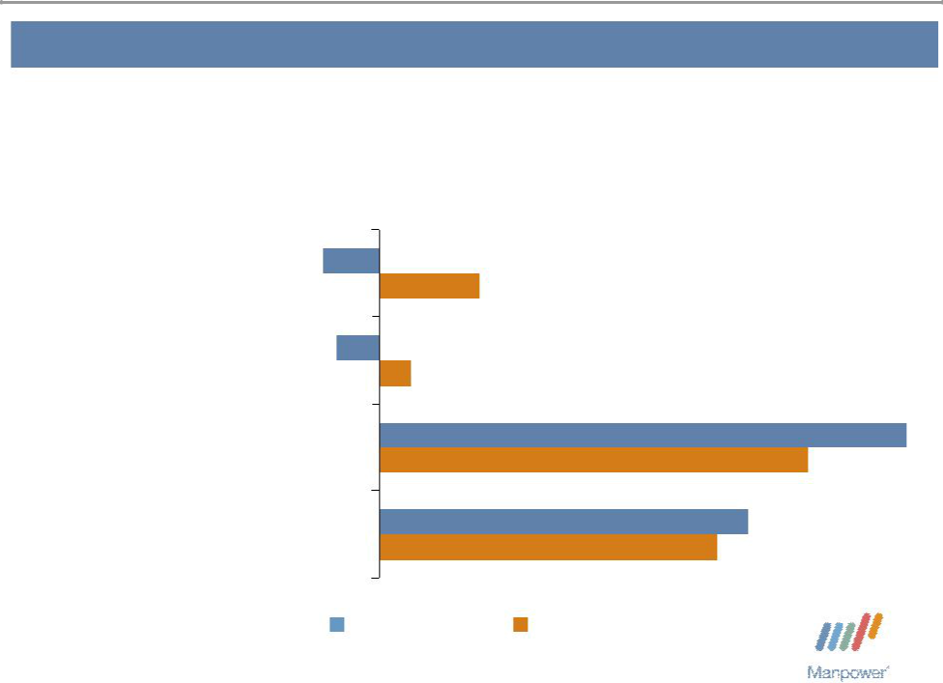
Manpower Inc. 2006 1st Quarter Results | 12

Other Operations – Q1 Revenue Growth YoY

- of Segment Revenue

37% | Japan | -4%
37% | Japan | 7%

16% Australia/NZ ^{-3%}_{2%}

15% | Mexico | 38%
15% | Mexico | 31%
32% | Other | 27%
32% | Other | 25%

Revenue Growth Revenue Growth - CC

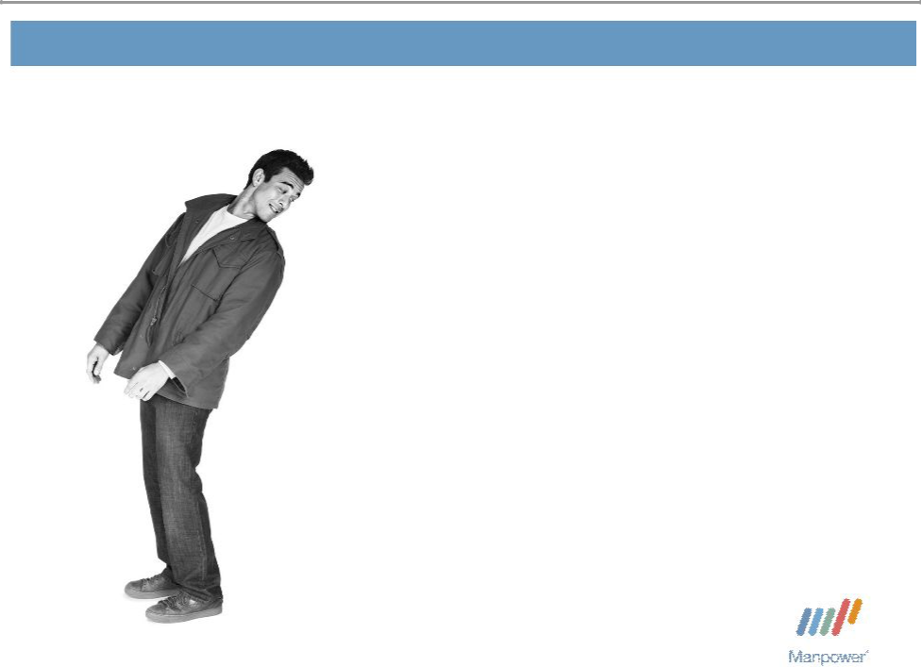
Manpower Inc. 2006 1st Quarter Results 13

Financial Highlights

Manpower Inc. 2006 1st Quarter Results | 14
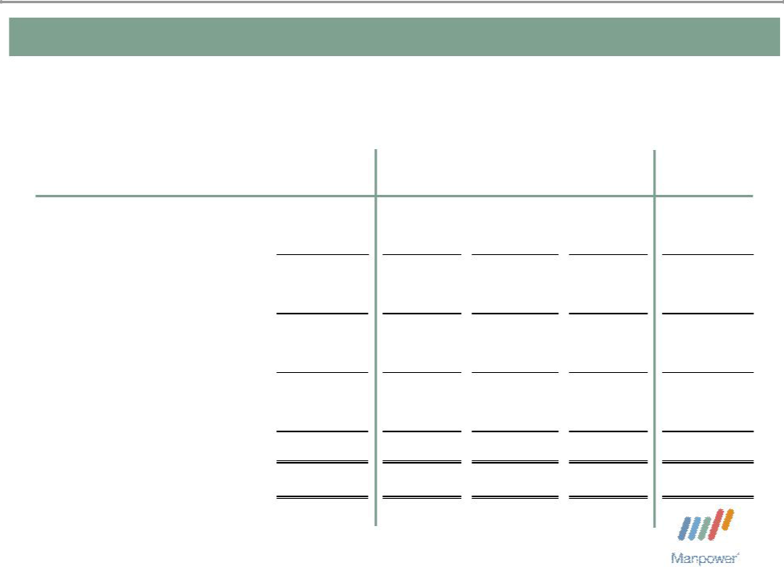

Impact of One-Time Items
($ in millions, except per share data)

 |  | 2006 | Gain on Sale |  | Reorganization |  |  | Project |  | 2006
 | As Reported |  | of Business |  |  | Charges |  | Titan | As Adjusted
Revenue | $ | 3,929.9 | $ | - | $ | - | $ | - | $ | 3,929.9
Cost of services |  | 3,212.5 |  | - |  | - |  | - |  | 3,212.5
Gross profit |  | 717.4 |  | - |  | - |  | - |  | 717.4
Selling and administrative expenses |  | 657.7 |  | - |  | (9.0) |  | (9.2) |  | 639.5
Operating profit |  | 59.7 |  | - |  | 9.0 |  | 9.2 |  | 77.9
Interest and other (income) expense |  | (16.3) |  | 29.3 |  | (1.7) |  | - |  | 11.3
Earnings before income taxes |  | 76.0 |  | (29.3) |  | 10.7 |  | 9.2 |  | 66.6
Provision for income taxes |  | 23.4 |  | (5.6) |  | 3.1 |  | 3.4 |  | 24.3
Net earnings | $ | 52.6 | $ | (23.7) | $ | 7.6 | $ | 5.8 | $ | 42.3
Net earnings per share - diluted | $ | 0.59 | $ | (0.27) | $ | 0.09 | $ | 0.07 | $ | 0.48

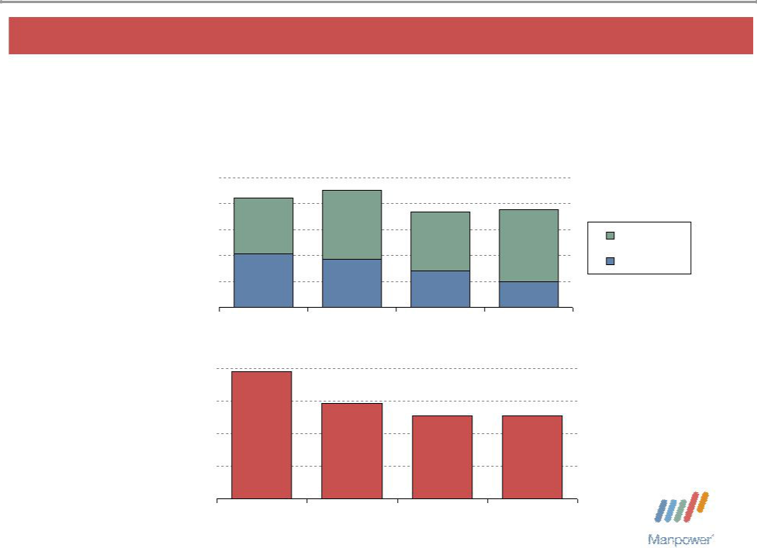
Manpower Inc. 2006 1st Quarter Results | 15

Balance Sheet Highlights

Total Debt | 1,000
($ in millions)

800

600

400

200

0

Total Debt to

Total Capitalization ^{40%}

30%

20%

10%

0%

842 | 902
842 |  | 735
 |  | 735 | 754 | Total Debt
416 | 370 |  |  | Net Debt
 | 370 | 280
 |  | 280 | 200
2003 | 2004 | 2005 | Q1 2006
39%
 | 29% | 26% | 25%
2003 | 2004 | 2005 | Q1 2006

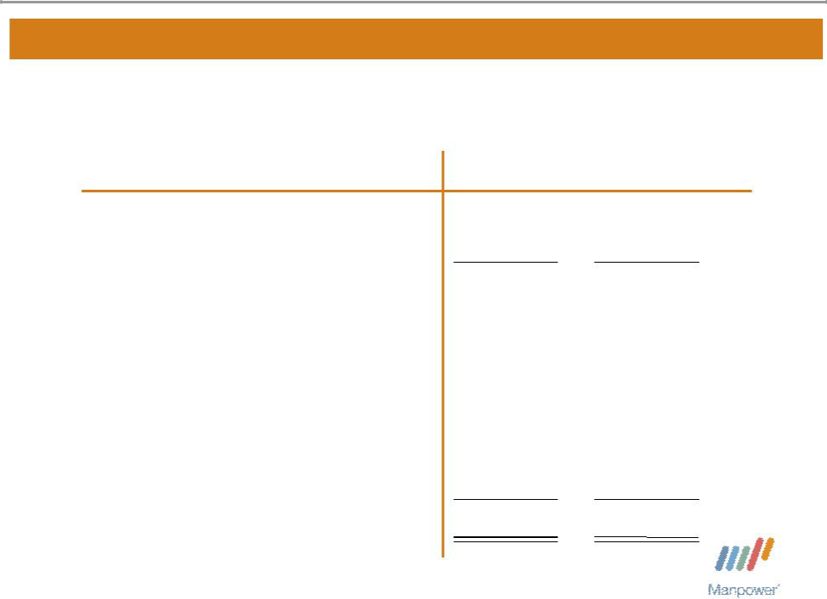
Manpower Inc. 2006 1st Quarter Results | 16

Cash Flow Summary – First Quarter

($ in millions)

Cash from Operations Capital Expenditures Free Cash Flow

Share Repurchases *

Proceeds from Stock Option and Purchase Plans

Change in Debt

Proceeds from Sale of Business Other

Change in Cash

2006 2005

$ 77 $ 86

- (19)

62 67

- (47)

27 | 7
3 | (145)
30 | -
11 | (17)
$ 100 | $ (135)

* 612,600 shares in 2006 and 1,065,000 shares in 2005

Manpower Inc. 2006 1st Quarter Results | 17
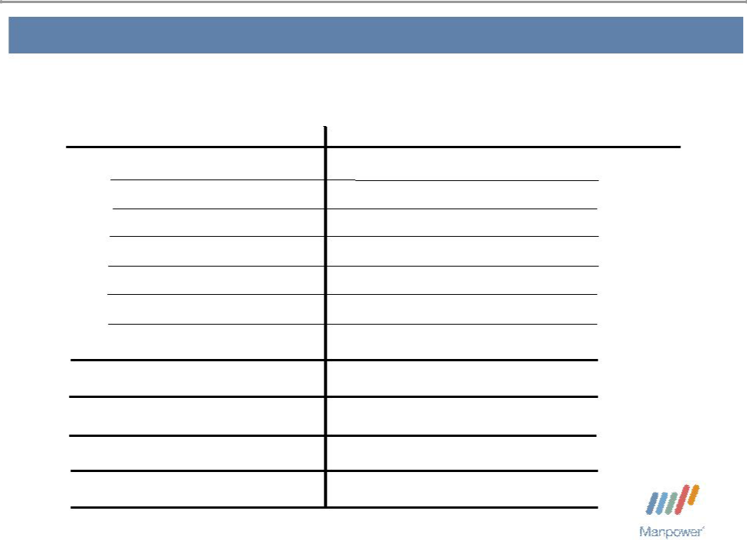

Second Quarter Outlook

Revenue U.S.

France

EMEA

Jefferson Wells

Right

Other

Total

Gross Profit Margin Operating Profit Margin

Tax Rate

EPS

Up 4-6%

Up 3-5% (Up 7-9% CC)

Up 3-5% (Up 7-9% CC)

Up 7-9%

Down 5-7% (Down 3-5% CC)

Up 9-11% (Up 12-14% CC)

Up 4-6% (Up 7-9% CC)

18.4 - 18.6%

2.8 – 3.0%

36.5%

$.76 - $.80 (Neg. $.03 Currency)

2006 1st Quarter Results

April 18, 2006

Questions?
Answers

