UNITED STATES

SECURITIES AND EXCHANGE COMMISSION
Washington, D.C. 20549

FORM 8-K

CURRENT REPORT

Pursuant to Section 13 or 15(d) of the Securities Exchange Act of 1934

Date of Report (Date of earliest event reported): July 20, 2012

MANPOWER INC.

(d/b/a ManpowerGroup)
(Exact name of registrant as specified in its charter)

Wisconsin | 1-10686 | 39-1672779
(State or other jurisdiction of incorporation) | (Commission File Number) | (IRS Employer Identification No.)
100 Manpower Place
Milwaukee, Wisconsin |  | 53212
(Address of principal executive offices) |  | (Zip Code)

Registrant's telephone number, including area code: (414) 961-1000

Check the appropriate box below if the Form 8-K filing is intended to simultaneously satisfy the filing obligation of the registrant under any of the following provisions:

Written communications pursuant to Rule 425 under the Securities Act (17 CFR 230.425)

Soliciting material pursuant to Rule 14a-12 under the Securities Act (17 CFR 240.14a-12)

Pre-commencement communications pursuant to Rule 14d-2(b) under the Exchange Act (17 CFR 240.14d-2(b))

Pre-commencement communications pursuant to Rule 13e-4(c) under the Exchange Act (17 CFR 240.13e-4(c))

Item 2.02 Results of Operations and Financial Condition

On July 20, 2012, we issued a press release announcing our results of operations for the three- and six- month periods ended June 30, 2012. A copy of the press release is attached hereto as Exhibit 99.1 and is incorporated herein by reference.

Item 9.01. Exhibits.

Exhibit No. Description

99.1 Press Release dated July 20, 2012

99.2 Presentation materials for July 20, 2012 conference call

SIGNATURES

Pursuant to the requirements of the Securities Exchange Act of 1934, the Registrant has duly caused this Report to be signed on its behalf by the undersigned hereunto duly authorized.

MANPOWER INC.

(d/b/a ManpowerGroup)

Dated: July 20, 2012 By: /s/ Michael J. Van Handel

Michael J. Van Handel

Executive Vice President and

Chief Financial Officer

EXHIBIT INDEX

Exhibit No. Description

99.1 Press Release dated July 20, 2012

99.2 Presentation materials for July 20, 2012 conference call

Exhibit 99.1


FOR IMMEDIATE RELEASE Contact:

Mike Van Handel

+1.414.906.6305

michael.vanhandel@manpowergroup.com

ManpowerGroup Reports 2nd Quarter and First Half 2012 Results

MILWAUKEE, July 20, 2012 -- ManpowerGroup (NYSE: MAN) today reported that net earnings per diluted share for the three months ended June 30, 2012 were 51 cents compared to 87 cents in the prior year period. Net earnings in the second quarter were $41.0 million compared to $72.7 million a year earlier. Revenues for the second quarter were $5.2 billion, a decrease of 8 percent from the year earlier period, or a decrease of 1 percent in constant currency.

Included in the current year second quarter results is a reorganization charge of $18.7 million ($13.9 million after tax or 17 cents per diluted share) and legal settlement costs of $10.0 million ($6.5 million after tax or 8 cents per diluted share). Excluding these charges, earnings per diluted share in the quarter were 76 cents. Net earnings in the second quarter were unfavorably impacted by 7 cents per diluted share, as foreign currencies were relatively weaker compared to the prior year period.

ManpowerGroup Chairman and CEO Jeffrey A. Joerres, said, “The second quarter underscored our ability to execute well in a difficult environment. It was a quarter in which we experienced mild but steady declines in revenue throughout the quarter. Europe, which comprises 65% of our business, not surprisingly experienced the most decline in the quarter.

“Our investments and execution in our Solutions business continued to generate strong revenue and earnings as well as contribute to our goal of gross margin expansion.

“We are anticipating the third quarter of 2012 diluted earnings per share to be in the range of 64 to 72 cents, which includes an estimated unfavorable currency impact of 8 cents,” Joerres stated.

Earnings per diluted share for the six months ended June 30, 2012 were $1.01 compared to $1.30 per diluted share in 2011. Net earnings for the period were $81.2 million compared to $108.4 million in the prior year. Revenues for the six-month period were $10.3 billion, a decrease of 4 percent from the prior year or an increase of 1 percent in constant currency. Earnings per diluted share for the current year six month period include the reorganization costs and legal costs discussed above of 25 cents per diluted share. Foreign currency exchange rates had an unfavorable impact of 9 cents for the six-month period.

In conjunction with its second quarter earnings release, ManpowerGroup will broadcast its conference call live over the Internet on July 20, 2012 at 7:30 a.m. CDT (8:30 a.m.

EDT). Interested parties are invited to listen to the webcast and view the presentation by logging on to http://www.manpowergroup.com/investors.

Supplemental financial information referenced in the conference call can be found at http://www.manpowergroup.com/investors.

About ManpowerGroup™

ManpowerGroup™ (NYSE: MAN), the world leader in innovative workforce solutions, creates and delivers high-impact solutions that enable our clients to achieve their business goals and enhance their competitiveness. With over 60 years of experience, our $22 billion company creates unique time to value through a comprehensive suite of innovative solutions that help clients win in the Human Age. These solutions cover an entire range of talent-driven needs from recruitment and assessment, training and development, and career management, to outsourcing and workforce consulting. ManpowerGroup maintains the world's largest and industry-leading network of 3,600 offices in 80 countries and territories, generating a dynamic mix of an unmatched global footprint with valuable insight and local expertise to meet the needs of its 400,000 clients per year, across all industry sectors, small and medium-sized enterprises, local, multinational and global companies. By connecting our deep understanding of human potential to the ambitions of clients, ManpowerGroup helps the organizations and individuals we serve achieve more than they imagined — because their success leads to our success. And by creating these powerful connections, we create power that drives organizations forward, accelerates personal success and builds more sustainable communities. We help power the world of work. The ManpowerGroup suite of solutions is offered through ManpowerGroup™ Solutions, Manpower®, Experis™ and Right Management®. Learn more about how the ManpowerGroup can help you win in the Human Age at www.manpowergroup.com.

ManpowerGroup is the most trusted brand in the industry, and was once again the only company in our industry to be named to the Ethisphere Institute's 2012 World's Most Ethical Companies list for our proven commitment to ethical business practices, including an outstanding commitment to ethical leadership, compliance practices and corporate social responsibility.

In January 2011, at the World Economic Forum Annual Meeting in Davos, Switzerland, ManpowerGroup announced the world has entered the Human Age, where talent has replaced capital as the key competitive differentiator. This concept of talentism as the new capitalism continues to resonate and was echoed as a core theme of the 2012 Annual Meeting of the World Economic Forum in Davos. Learn more about this new age at www.manpowergroup.com/humanage.

Gain access to ManpowerGroup's extensive thought leadership papers, annual Talent Shortage surveys and the Manpower Employment Outlook Survey, one of the most trusted indices of employment activity in the world, via the ManpowerGroup World of Work Insight iPad application. This thought leadership app explores the challenges faced by employers navigating the changing world of work and provides in-depth commentary, analysis, insight and advice on strategies for success.

Follow ManpowerGroup Chairman and CEO Jeff Joerres on Twitter: twitter.com/manpowergroupjj. Joerres is one of only six Fortune 500 CEOs who leverages a Twitter account to get his message out.

Forward-Looking Statements

This news release contains statements, including earnings projections, that are forward-looking in nature and, accordingly, are subject to risks and uncertainties regarding the Company’s expected future results. The Company’s actual results may differ materially from those described or contemplated in the forward-looking statements. Factors that may cause the Company’s actual results to differ materially from those contained in the forward-looking statements can be found in the Company’s reports filed with the SEC, including the information under the heading ‘Risk Factors’ in its Annual Report on Form 10-K for the year ended December 31, 2011, which information is incorporated herein by reference.

###

ManpowerGroup

Results of Operations

(In millions, except per share data)

 |  |  |  |  |  | Three Months Ended June 30
 |  |  |  |  |  |  |  | % Variance
 |  |  |  |  |  |  |  | Amount |  | Constant
 |  |  | 2012 |  |  | 2011 |  | Reported |  | Currency
 |  |  |  |  |  | (Unaudited)
Revenues from services (a) | $ |  | 5,206.7 |  | $ | 5,667.3 |  | -8.1% |  | -0.8%
Cost of services |  |  | 4,345.0 |  |  | 4,705.1 |  | -7.7% |  | -0.2%
Gross profit |  |  | 861.7 |  |  | 962.2 |  | -10.4% |  | -4.0%
Selling and administrative expenses |  |  | 767.3 |  |  | 811.4 |  | -5.4% |  | 0.9%
Operating profit |  |  | 94.4 |  |  | 150.8 |  | -37.3% |  | -30.5%
Interest and other expenses |  |  | 11.3 |  |  | 11.8 |  | -3.2%
Earnings before income taxes |  |  | 83.1 |  |  | 139.0 |  | -40.2% |  | -33.2%
Provision for income taxes |  |  | 42.1 |  |  | 66.3 |  | -36.5%
Net earnings | $ |  | 41.0 |  | $ | 72.7 |  | -43.6% |  | -37.0%
Net earnings per share - basic | $ |  | 0.51 |  | $ | 0.89 |  | -42.7%
Net earnings per share - diluted | $ |  | 0.51 |  | $ | 0.87 |  | -41.4% |  | -34.5%
Weighted average shares - basic |  |  | 80.1 |  |  | 82.0 |  | -2.4%
Weighted average shares - diluted |  |  | 80.4 |  |  | 83.3 |  | -3.4%

- Revenues from services include fees received from our franchise offices of $6.1 million and $5.7 million for the three months ended June 30, 2012 and 2011, respectively. These fees are primarily based on revenues generated by the franchise offices, which were $270.0 million and $249.6 million for the three months ended June 30, 2012 and 2011, respectively.

ManpowerGroup

Operating Unit Results

(In millions)

 |  |  |  |  |  | Three Months Ended June 30
 |  |  |  |  |  |  |  | % Variance
 |  |  |  |  |  |  |  | Amount |  | Constant
 |  |  | 2012 |  |  | 2011 |  | Reported |  | Currency
 |  |  |  |  |  | (Unaudited)
Revenues from Services:
Americas:
United States (a) | $ |  | 763.2 |  | $ | 791.6 |  | -3.6% |  | -3.6%
Other Americas |  |  | 389.2 |  |  | 379.4 |  | 2.6% |  | 12.0%
 |  |  | 1,152.4 |  |  | 1,171.0 |  | -1.6% |  | 1.4%
Southern Europe:
France |  |  | 1,427.6 |  |  | 1,644.0 |  | -13.2% |  | -2.5%
Italy |  |  | 274.0 |  |  | 344.9 |  | -20.6% |  | -10.8%
Other Southern Europe |  |  | 190.1 |  |  | 193.7 |  | -1.9% |  | 9.8%
 |  |  | 1,891.7 |  |  | 2,182.6 |  | -13.3% |  | -2.7%
Northern Europe |  |  | 1,415.8 |  |  | 1,566.3 |  | -9.6% |  | -1.2%
APME |  |  | 662.9 |  |  | 662.8 |  | 0.0% |  | 1.8%
Right Management |  |  | 83.9 |  |  | 84.6 |  | -0.9% |  | 2.9%
 | $ |  | 5,206.7 |  | $ | 5,667.3 |  | -8.1% |  | -0.8%
Operating Unit Profit (Loss):
Americas:
United States | $ |  | 7.7 |  | $ | 27.2 |  | -71.6% |  | -71.6%
Other Americas |  |  | 10.5 |  |  | 12.3 |  | -15.0% |  | -8.3%
 |  |  | 18.2 |  |  | 39.5 |  | -54.0% |  | -51.9%
Southern Europe:
France |  |  | 15.5 |  |  | 24.8 |  | -37.4% |  | -29.3%
Italy |  |  | 12.6 |  |  | 22.4 |  | -43.6% |  | -36.6%
Other Southern Europe |  |  | 3.0 |  |  | 2.7 |  | 12.8% |  | 26.3%
 |  |  | 31.1 |  |  | 49.9 |  | -37.5% |  | -29.7%
Northern Europe |  |  | 39.2 |  |  | 56.1 |  | -30.2% |  | -23.9%
APME |  |  | 21.8 |  |  | 18.9 |  | 16.0% |  | 17.6%
Right Management |  |  | (2.9) |  |  | 2.8 |  | N/A |  | N/A
 |  |  | 107.4 |  |  | 167.2
Corporate expenses |  |  | (22.9) |  |  | (30.5)
Intangible asset amortization expense |  |  | (9.2) |  |  | (9.4)
Reclassification of French business tax |  |  | 19.1 |  |  | 23.5
Operating profit |  |  | 94.4 |  |  | 150.8 |  | -37.3% |  | -30.5%
Interest and other expenses (b) |  |  | (11.3) |  |  | (11.8)
Earnings before income taxes | $ |  | 83.1 |  | $ | 139.0

- In the United States, revenues from services include fees received from our franchise offices of $3.8 million and $3.2 million for the three months ended June 30, 2012 and 2011, respectively. These fees are primarily based on revenues generated by the franchise offices, which were $180.6 million and $163.2 million for the three months ended June 30, 2012 and 2011, respectively.

- The components of interest and other expenses were:

 |  |  | 2012 |  |  | 2011
Interest expense | $ |  | 10.2 |  | $ | 11.1
Interest income |  |  | (1.4) |  |  | (1.6)
Foreign exchange loss (gain) |  |  | 0.5 |  |  | (0.2)
Miscellaneous expenses, net |  |  | 2.0 |  |  | 2.5
 | $ |  | 11.3 |  | $ | 11.8

ManpowerGroup

Results of Operations

(In millions, except per share data)

 |  |  |  |  |  | Six Months Ended June 30
 |  |  |  |  |  |  |  | % Variance
 |  |  |  |  |  |  |  | Amount |  | Constant
 |  |  | 2012 |  |  | 2011 |  | Reported |  | Currency
 |  |  |  |  |  | (Unaudited)
Revenues from services (a) | $ |  | 10,303.1 |  | $ | 10,739.7 |  | -4.1% |  | 1.0%
Cost of services |  |  | 8,594.0 |  |  | 8,919.9 |  | -3.7% |  | 1.5%
Gross profit |  |  | 1,709.1 |  |  | 1,819.8 |  | -6.1% |  | -1.6%
Selling and administrative expenses |  |  | 1,520.9 |  |  | 1,583.4 |  | -3.9% |  | 0.3%
Operating profit |  |  | 188.2 |  |  | 236.4 |  | -20.4% |  | -14.4%
Interest and other expenses |  |  | 23.1 |  |  | 22.9 |  | 1.0%
Earnings before income taxes |  |  | 165.1 |  |  | 213.5 |  | -22.7% |  | -16.5%
Provision for income taxes |  |  | 83.9 |  |  | 105.1 |  | -20.2%
Net earnings | $ |  | 81.2 |  | $ | 108.4 |  | -25.1% |  | -19.1%
Net earnings per share - basic | $ |  | 1.01 |  | $ | 1.32 |  | -23.5%
Net earnings per share - diluted | $ |  | 1.01 |  | $ | 1.30 |  | -22.3% |  | -16.2%
Weighted average shares - basic |  |  | 80.1 |  |  | 82.0 |  | -2.2%
Weighted average shares - diluted |  |  | 80.8 |  |  | 83.7 |  | -3.5%

- Revenues from services include fees received from our franchise offices of $11.5 million and $11.6 million for the six months ended June 30, 2012 and 2011, respectively. These fees are primarily based on revenues generated by the franchise offices, which were $523.9 million and $524.1 million for the six months ended June 30, 2012 and 2011, respectively.

ManpowerGroup

Operating Unit Results

(In millions)

 |  |  |  |  |  | Six Months Ended June 30
 |  |  |  |  |  |  |  | % Variance
 |  |  |  |  |  |  |  | Amount |  | Constant
 |  |  | 2012 |  |  | 2011 |  | Reported |  | Currency
 |  |  |  |  |  | (Unaudited)
Revenues from Services:
Americas:
United States (a) | $ |  | 1,499.0 |  | $ | 1,542.5 |  | -2.8% |  | -2.8%
Other Americas |  |  | 791.7 |  |  | 741.2 |  | 6.8% |  | 14.0%
 |  |  | 2,290.7 |  |  | 2,283.7 |  | 0.3% |  | 2.6%
Southern Europe:
France |  |  | 2,719.4 |  |  | 2,997.8 |  | -9.3% |  | -1.6%
Italy |  |  | 541.5 |  |  | 629.5 |  | -14.0% |  | -6.8%
Other Southern Europe |  |  | 385.3 |  |  | 373.7 |  | 3.1% |  | 11.7%
 |  |  | 3,646.2 |  |  | 4,001.0 |  | -8.9% |  | -1.2%
Northern Europe |  |  | 2,859.8 |  |  | 3,022.9 |  | -5.4% |  | 0.6%
APME |  |  | 1,342.9 |  |  | 1,265.7 |  | 6.1% |  | 5.6%
Right Management |  |  | 163.5 |  |  | 166.4 |  | -1.8% |  | 0.5%
 | $ |  | 10,303.1 |  | $ | 10,739.7 |  | -4.1% |  | 1.0%
Operating Unit Profit (Loss):
Americas:
United States | $ |  | 14.6 |  | $ | 35.9 |  | -59.3% |  | -59.3%
Other Americas |  |  | 25.8 |  |  | 25.1 |  | 2.7% |  | 9.3%
 |  |  | 40.4 |  |  | 61.0 |  | -33.8% |  | -31.1%
Southern Europe:
France |  |  | 21.0 |  |  | 36.8 |  | -42.9% |  | -36.5%
Italy |  |  | 27.1 |  |  | 35.3 |  | -23.1% |  | -16.7%
Other Southern Europe |  |  | 6.5 |  |  | 4.9 |  | 32.6% |  | 44.0%
 |  |  | 54.6 |  |  | 77.0 |  | -29.0% |  | -22.3%
Northern Europe |  |  | 83.1 |  |  | 98.0 |  | -15.3% |  | -10.1%
APME |  |  | 41.4 |  |  | 35.4 |  | 17.2% |  | 16.9%
Right Management |  |  | (0.4) |  |  | 6.1 |  | N/A |  | N/A
 |  |  | 219.1 |  |  | 277.5
Corporate expenses |  |  | (49.2) |  |  | (62.5)
Intangible asset amortization expense |  |  | (18.2) |  |  | (19.0)
Reclassification of French business tax |  |  | 36.5 |  |  | 40.4
Operating profit |  |  | 188.2 |  |  | 236.4 |  | -20.4% |  | -14.4%
Interest and other expenses (b) |  |  | (23.1) |  |  | (22.9)
Earnings before income taxes | $ |  | 165.1 |  | $ | 213.5

- In the United States, revenues from services include fees received from our franchise offices of $7.0 million and $5.9 million for the six months ended June 30, 2012 and 2011. These fees are primarily based on revenues generated by the franchise offices, which were $345.0 million and $311.7 million for the six months ended June 30, 2012 and 2011, respectively.

- The components of interest and other expenses were:

 |  |  | 2012 |  |  | 2011
Interest expense | $ |  | 20.8 |  | $ | 21.3
Interest income |  |  | (3.2) |  |  | (3.0)
Foreign exchange losses |  |  | 0.3 |  |  | 0.3
Miscellaneous expenses, net |  |  | 5.2 |  |  | 4.3
 | $ |  | 23.1 |  | $ | 22.9

ManpowerGroup

Consolidated Balance Sheets

(In millions)

 |  | Jun. 30 |  |  | Dec. 31
 |  | 2012 |  |  | 2011
 |  | (Unaudited)
ASSETS
Current assets:
Cash and cash equivalents | $ | 454.6 |  | $ | 580.5
Accounts receivable, net |  | 4,266.2 |  |  | 4,181.3
Prepaid expenses and other assets |  | 190.0 |  |  | 176.3
Future income tax benefits |  | 60.9 |  |  | 52.4
Total current assets |  | 4,971.7 |  |  | 4,990.5
Other assets:
Goodwill and other intangible assets, net |  | 1,360.1 |  |  | 1,339.6
Other assets |  | 400.7 |  |  | 395.1
Total other assets |  | 1,760.8 |  |  | 1,734.7
Property and equipment:
Land, buildings, leasehold improvements and equipment |  | 692.5 |  |  | 685.6
Less: accumulated depreciation and amortization |  | 517.5 |  |  | 511.1
Net property and equipment |  | 175.0 |  |  | 174.5
Total assets | $ | 6,907.5 |  | $ | 6,899.7
LIABILITIES AND SHAREHOLDERS' EQUITY
Current liabilities:
Accounts payable | $ | 1,483.0 |  | $ | 1,370.6
Employee compensation payable |  | 189.7 |  |  | 221.9
Accrued liabilities |  | 453.6 |  |  | 520.8
Accrued payroll taxes and insurance |  | 654.5 |  |  | 712.4
Value added taxes payable |  | 478.4 |  |  | 502.3
Short-term borrowings and current maturities of long-term debt |  | 308.8 |  |  | 434.2
Total current liabilities |  | 3,568.0 |  |  | 3,762.2
Other liabilities:
Long-term debt |  | 446.3 |  |  | 266.0
Other long-term liabilities |  | 382.3 |  |  | 388.1
Total other liabilities |  | 828.6 |  |  | 654.1
Shareholders' equity:
Common stock |  | 1.1 |  |  | 1.1
Capital in excess of par value |  | 2,857.7 |  |  | 2,839.9
Retained earnings |  | 1,018.6 |  |  | 971.7
Accumulated other comprehensive income |  | 35.4 |  |  | 35.3
Treasury stock, at cost |  | (1,401.9) |  |  | (1,364.6)
Total shareholders' equity |  | 2,510.9 |  |  | 2,483.4
Total liabilities and shareholders' equity | $ | 6,907.5 |  | $ | 6,899.7

ManpowerGroup

Consolidated Statements of Cash Flows

(In millions)

 | Six Months Ended
 |  | June 30
 | 2012 |  |  | 2011
 |  | (Unaudited)
Cash Flows from Operating Activities:
Net earnings | $ | 81.2 |  | $ | 108.4
Adjustments to reconcile net earnings to net cash used in operating activities:
Depreciation and amortization |  | 49.2 |  |  | 52.1
Deferred income taxes |  | (3.7) |  |  | 7.1
Provision for doubtful accounts |  | 10.0 |  |  | 14.4
Share-based compensation |  | 14.9 |  |  | 16.5
Excess tax benefit on exercise of share-based awards |  | - |  |  | (1.1)
Changes in operating assets and liabilities, excluding the impact of acquisitions:
Accounts receivable |  | (127.7) |  |  | (425.1)
Other assets |  | (17.1) |  |  | (51.4)
Other liabilities |  | (46.4) |  |  | 87.0
Cash used in operating activities |  | (39.6) |  |  | (192.1)
Cash Flows from Investing Activities:
Capital expenditures |  | (33.8) |  |  | (27.6)
Acquisitions of businesses, net of cash acquired |  | (34.0) |  |  | (15.2)
Proceeds from sales of property and equipment |  | 0.9 |  |  | 2.8
Cash used in investing activities |  | (66.9) |  |  | (40.0)
Cash Flows from Financing Activities:
Net change in short-term borrowings |  | 4.6 |  |  | 4.4
Proceeds from long-term debt |  | 751.6 |  |  | 0.1
Repayments of long-term debt |  | (700.6) |  |  | (0.1)
Proceeds from share-based awards |  | 3.9 |  |  | 17.8
Other share-based award transactions, net |  | (4.8) |  |  | 1.1
Repurchases of common stock |  | (32.6) |  |  | (18.8)
Dividends paid |  | (34.3) |  |  | (32.8)
Cash used in financing activities |  | (12.2) |  |  | (28.3)
Effect of exchange rate changes on cash |  | (7.2) |  |  | 31.3
Change in cash and cash equivalents |  | (125.9) |  |  | (229.1)
Cash and cash equivalents, beginning of period |  | 580.5 |  |  | 772.6
Cash and cash equivalents, end of period | $ | 454.6 |  | $ | 543.5

Exhibit 99.2


ManpowerGroup

2nd Quarter
July 20, 2012


ManpowerGroup 2012 2nd Quarter Results July 2012

Forward-Looking Statement

This presentation includes forward-looking statements, including earnings projections which are subject to risks and uncertainties. Actual results might differ materially from those projected in the forward-looking statements. Additional information concerning factors that could cause actual results to materially differ from those in the forward-looking statements is contained in the Manpower Inc. Annual Report on Form 10-K dated December 31, 2011, which information is incorporated herein by reference, and such other factors as may be described from time to time in the Company’s SEC filings.


ManpowerGroup 2012 2nd Quarter Results July 2012

Consolidated Financial Highlights

 | As |  | Excluding Non |  | Q2 Financial Highlights
 | Reported |  | -recurring |  | Q2 Financial Highlights
 |  |  | Items (1)
8% |  |  | 8% |  | Revenue $5.2B
 | 1% CC |  | 1% CC |  | Revenue $5.2B
 | 40 bps |  | 40 bps |  | Gross Margin 16.6%
37% |  |  | 18% |  | Operating Profit $94M
 | 30% CC |  | 11% CC |  | Operating Profit $94M
 | 90 bps |  | 30 bps |  | OP Margin 1.8%
41% |  |  | 13% |  | EPS $.51
 | 34% CC |  | 5% CC |  | EPS $.51
(1) Excludes the impact of non-recurring items of $28.7M in Q2 2012.
Throughout this presentation, the difference between reported variances and Constant Currency (CC) variances |  |  |  |  |  | 3
represents the impact of currency on our financial results. Constant Currency is further explained on our Web site.


ManpowerGroup 2012 2nd Quarter Results July 2012

Q2 Non-Recurring Items

($ in millions, except per share amounts)

 | Pre-tax |  |  | Net | EPS -
 | Earnings |  | Earnings |  | Diluted
Earnings, As Reported | $ | 83.1 | $ | 41.0 | $ | 0.51
Reorganization Charges(1) |  | 18.7 |  | 13.9 |  | 0.17
Legal Costs - US |  | 10.0 |  | 6.5 |  | 0.08
Earnings, Excluding non- | $ | 111.8 | $ | 61.4 | $ | 0.76
recurring items

(1) Includes reorganization charges for the Americas ($8.3M) and Right Management ($10.4M).

4

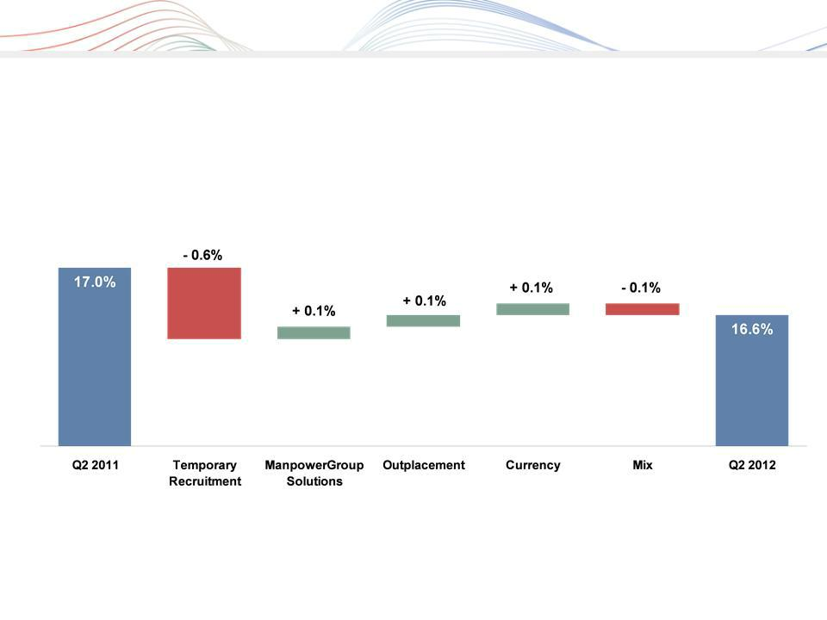
ManpowerGroup 2012 2nd Quarter Results July 2012

Consolidated Gross Margin Change

5

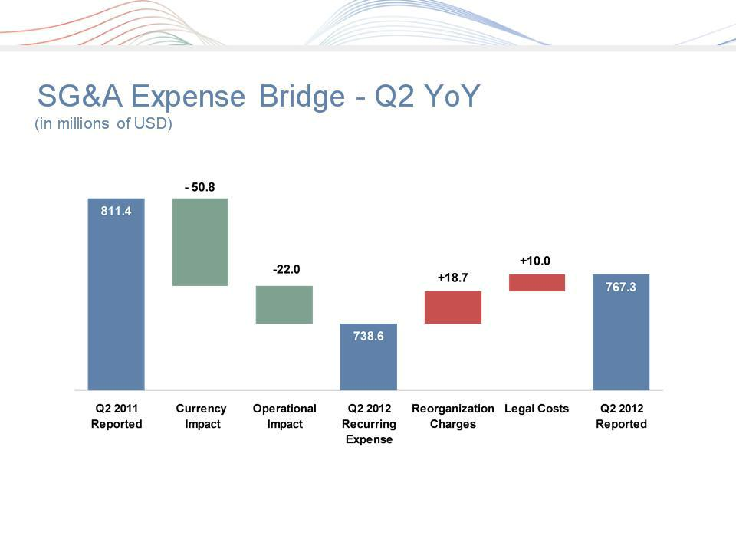
ManpowerGroup 2012 2nd Quarter Results July 2012

6

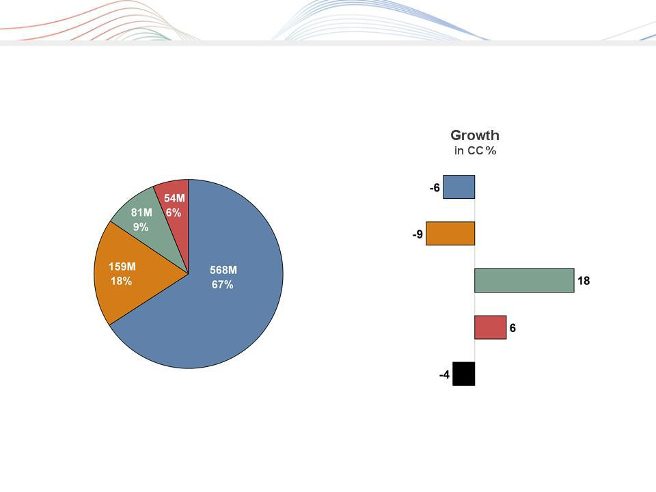
ManpowerGroup 2012 2nd Quarter Results July 2012

Business Line Gross Profit - Q2 2012

$862M

█ Manpower | █ Experis | █ ManpowerGroup - Total
█ ManpowerGroup Solutions | █ Right Management | 7

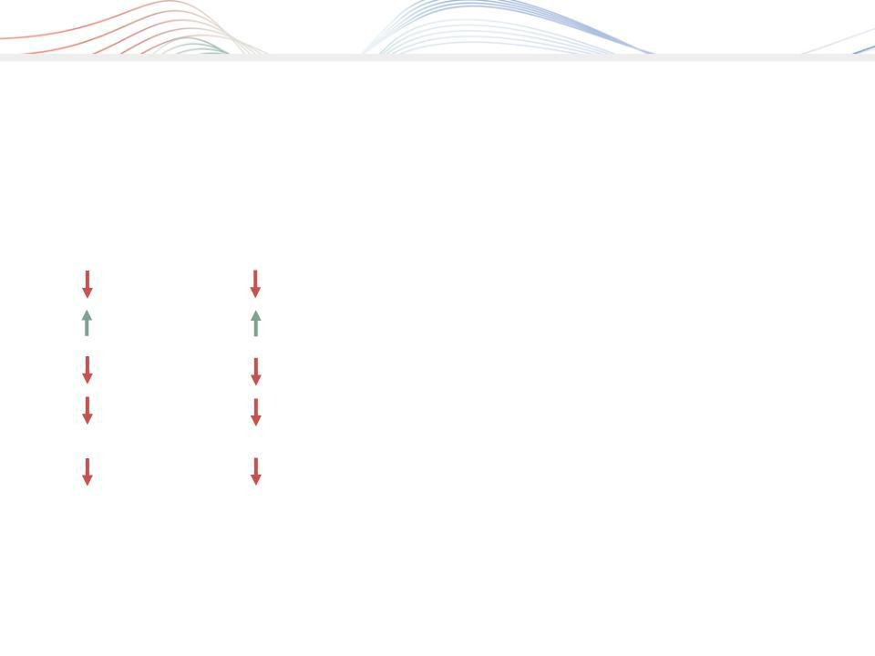
ManpowerGroup 2012 2nd Quarter Results July 2012

Americas Segment

(22% of Revenue)

As |  | Excluding |  | Q2 Financial Highlights(1)
Reported |  | Non-recurring |  | Q2 Financial Highlights(1)
 |  | Items (2)
2% |  | 2% |  | Revenue $1.2B
1% CC |  | 1% CC |  | Revenue $1.2B
54% |  | 7% |  | OUP $18M
52% CC |  | 5% CC |  | OUP $18M
180 bps |  | 20 bps |  | OUP Margin 1.6%

- Included in these amounts is the US, which had revenue of $763M (-4%) and OUP of $8M (-72%, or -10% excluding non-recurring items).

- Excludes the impact of non-recurring items of $18.3M in Q2 2012

Operating Unit Profit (OUP) is the measure that we use to evaluate segment performance. OUP is
equal to segment revenues less direct costs and branch and national headquarters operating ⁸ costs.

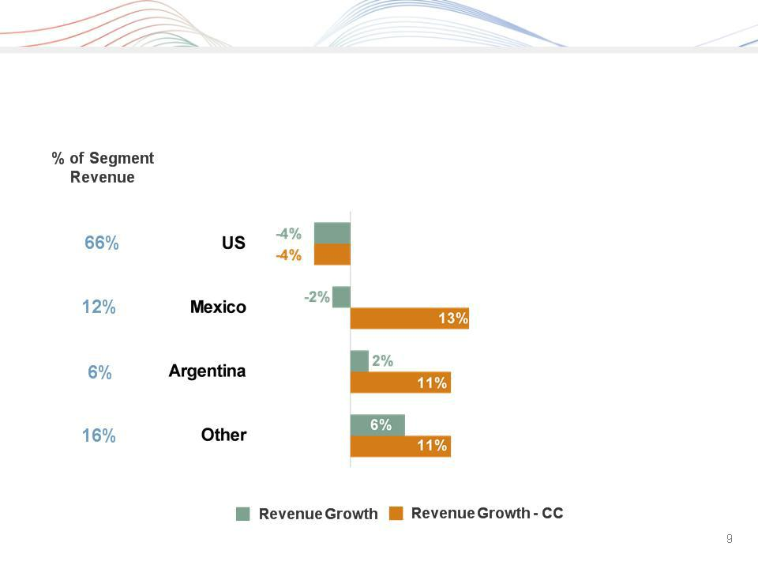
ManpowerGroup 2012 2nd Quarter Results July 2012

Americas - Q2 Revenue Growth YoY


ManpowerGroup 2012 2nd Quarter Results July 2012

Southern Europe Segment

(36% of Revenue)

As | Q2 Financial Highlights⁽¹⁾
Reported ⁽²⁾ | Q2 Financial Highlights⁽¹⁾
13% | Revenue $1.9B
3% CC | Revenue $1.9B
38% | OUP $31M
30% CC | OUP $31M
70 bps | OUP Margin 1.6%

- Included in these amounts is France, which had revenue of $1.4B (-3% CC) and OUP of $16M (-29% CC). On an organic basis, France revenue decreased 15% (-5% in CC).

- On an organic basis, Segment revenue decreased 15% (-4% in CC).
10

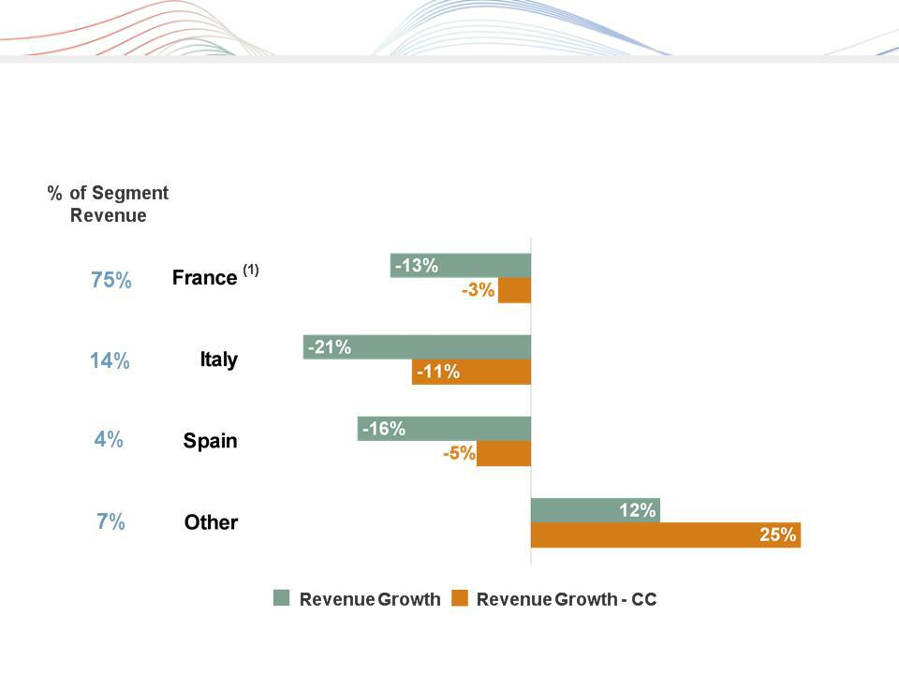
ManpowerGroup 2012 2nd Quarter Results July 2012

Southern Europe - Q2 Revenue Growth YoY

(1) On an organic basis, France revenue decreased 15% (-5% in CC). | 11


ManpowerGroup 2012 2nd Quarter Results July 2012

Northern Europe Segment

(27% of Revenue)

As | Q2 Financial Highlights
Reported | Q2 Financial Highlights
10% | Revenue $1.4B
1% CC | Revenue $1.4B
30% | OUP $39M
24% CC | OUP $39M
80 bps | OUP Margin 2.8%

12

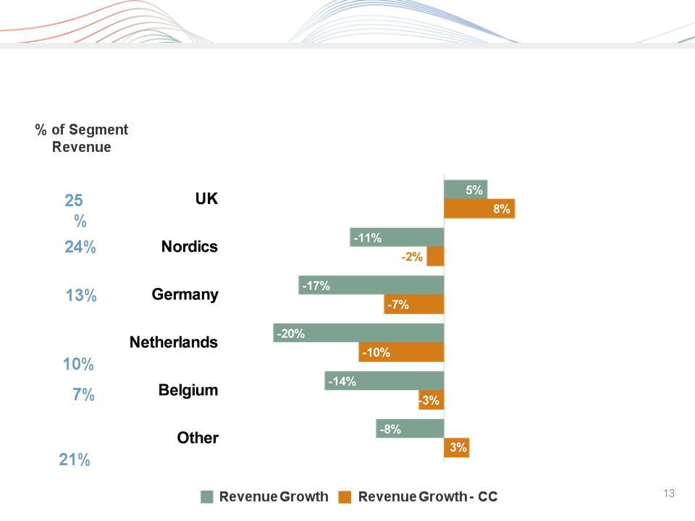
ManpowerGroup 2012 2nd Quarter Results July 2012

Northern Europe - Q2 Revenue Growth YoY


ManpowerGroup 2012 2nd Quarter Results July 2012

APME Segment

(13% of Revenue)

As | Q2 Financial Highlights
Reported | Q2 Financial Highlights
0% | Revenue $663M
2% CC | Revenue $663M
16% | OUP $22M
18% CC | OUP $22M
50 bps | OUP Margin 3.3%

14

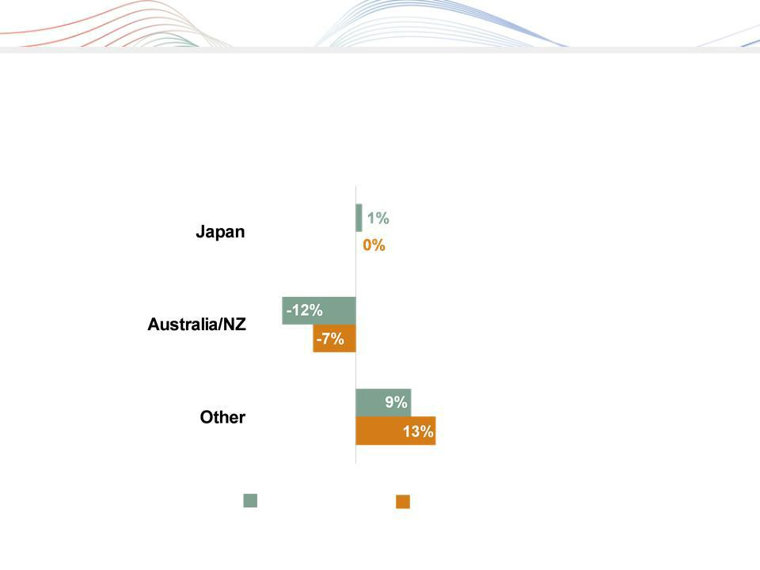
ManpowerGroup 2012 2nd Quarter Results July 2012

APME - Q2 Revenue Growth YoY

- of Segment Revenue

44%

25%

31%

Revenue

Growth

Revenue Growth - CC

15

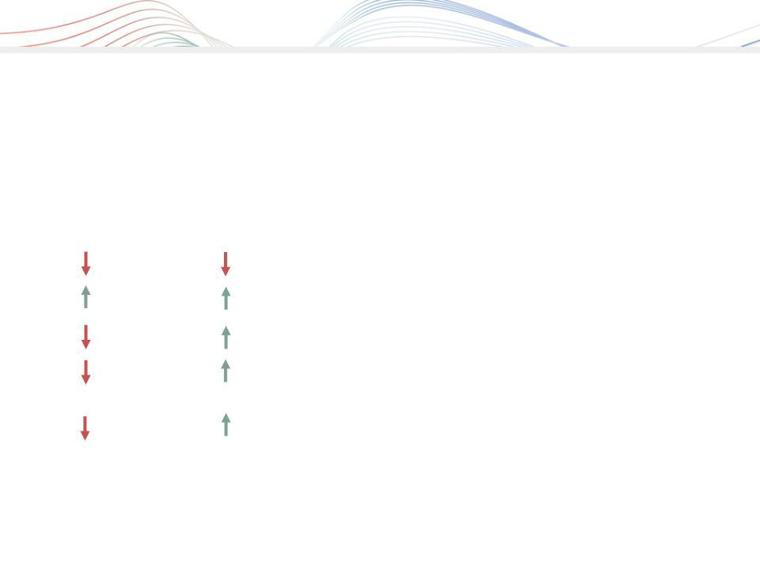
ManpowerGroup 2012 2nd Quarter Results July 2012

Right Management Segment

(2% of Revenue)

As |  | Excluding |  | Q2 Financial Highlights
Reported |  | Non-recurring |  | Q2 Financial Highlights
 |  | Items (1)
1% |  | 1% |  | Revenue $84M
3% CC |  | 3% CC |  | Revenue $84M
N/A |  | 166% |  | OUP ($3M)
N/A |  | 172% CC |  | OUP ($3M)
680 bps |  | 550 bps |  | OUP Margin (3.5%)

(1) Excludes the impact of reorganization charges of $10.4M in Q2 2012.

16


ManpowerGroup 2012 2nd Quarter Results July 2012

Cash Flow Summary - First Half

($ in millions) | 2012 | 2011
Cash used in operating activities | (40) | (192)
Capital Expenditures | (34) | (28)
Free Cash Flow
Free Cash Flow | (74) |  | (220)
Change in Debt | 56 | 4
Share Repurchases | (33) | (19)
Dividends paid | (34) | (33)
Acquisitions of Businesses | (34) | (15)
net of cash acquired | (34)
Effect of Exchange Rate Changes | (7) | 31
Other | - | 23
Change in Cash
Change in Cash | (126) |  | (229)

17

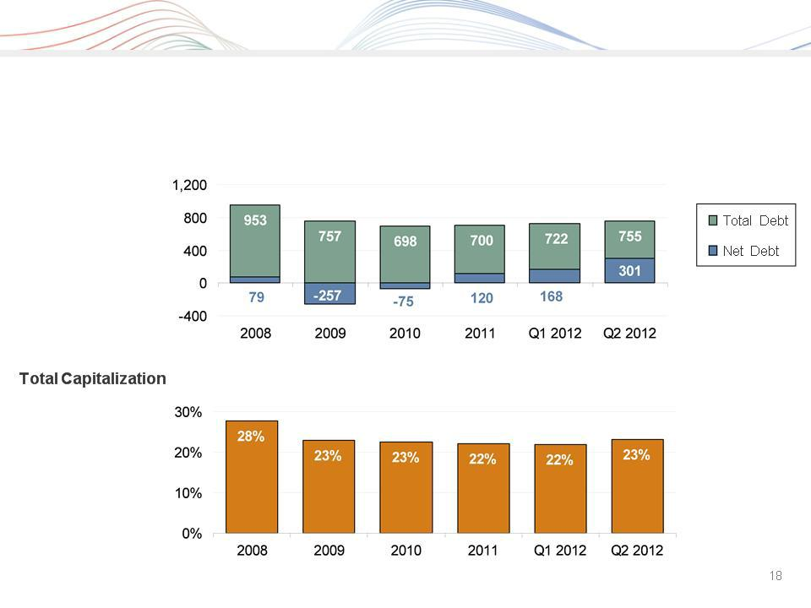
ManpowerGroup 2012 2nd Quarter Results July 2012

Balance Sheet Highlights

Total Debt

($ in millions)

Total Debt to


ManpowerGroup 2012 2nd Quarter Results July 2012

Credit Facilities

($ in millions)

 |  |  | Total |  | Remaining
 | Interest | Maturity | Outstanding |  | Available
 | Rate | Date | at 6/30/12 |  | at 6/30/12
Euro Notes:
- Euro 200M | 4.86% | Jun 2013 | 253 | -
- Euro 350M | 4.505% | Jun 2018 | 443 | -
Revolving Credit Agreement (1) | 1.52% | Oct 2016 | - | 798
Uncommitted lines and Other (2) | Various | Various | 59 | 325
Total Debt
Total Debt |  |  | 755 |  | 1,123

  - The $800M agreement requires that we comply with a Leverage Ratio (Debt-to-EBITDA) of not greater than 3.5 to 1 and a Fixed Charge Coverage Ratio of not less than 1.5 to 1, in addition to other customary restrictive covenants. As defined in the agreement, we had a Debt-to-EBITDA ratio of 1.13 and a fixed charge coverage ratio of 3.08 as of June 30, 2012. As of June 30, 2012, there were $1.6M of standby letters of credit issued under the agreement.

- Represents subsidiary uncommitted lines of credit & overdraft facilities, which total $383.7M. Total subsidiary borrowings are limited to $300M due to restrictions in our Revolving Credit Facility, with the exception of Q3 when subsidiary borrowings are limited to $600M.

19

ManpowerGroup 2012 2nd Quarter Results July 2012

Third Quarter Outlook

Revenue | Total | Down 11-13% (Down 3-5% CC)
 | Americas | Down 3-5% | (Down 1-3% CC)
 | Southern Europe | Down 18-20% (Down 6-8% CC)
 | Northern Europe | Down 11-13% (Down 2-4% CC)
 | APME | Down 2-4% | (Up 0-2% CC)
 | Right Management | Down 0-2% | (Up 2-4% CC)
Gross Profit Margin |  | 16.3 - 16.5%
Operating Profit Margin |  | 2.1 - 2.3%
Tax Rate |  | 46% (34% excl. reclassification of France business tax)
EPS |  | $0.64 - $0.72 (Neg. $.08 Currency)

20

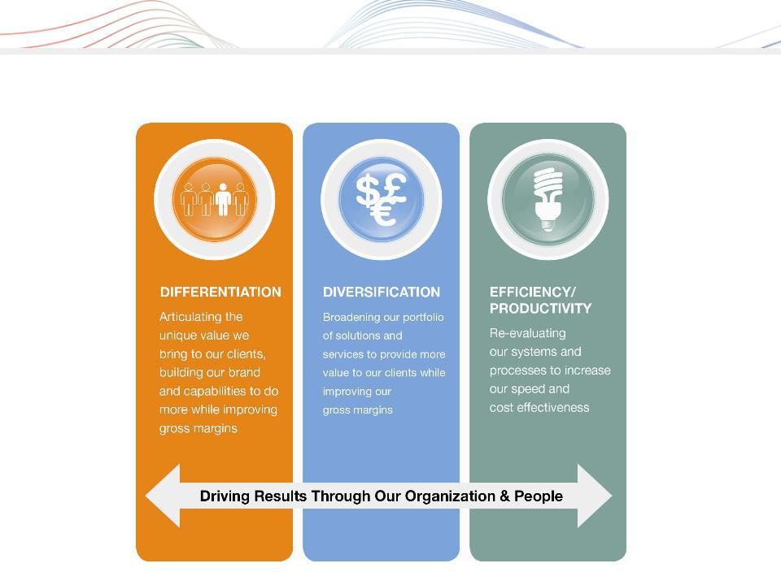
ManpowerGroup 2012 2nd Quarter Results July 2012

Strategic Drivers

21


ManpowerGroup 2012 2nd Quarter Results July 2012

Questions

22

