UNITED STATES

SECURITIES AND EXCHANGE COMMISSION
Washington, D.C. 20549

FORM 8-K

CURRENT REPORT

Pursuant to Section 13 or 15(d) of the Securities Exchange Act of 1934

Date of Report (Date of earliest event reported): July 21, 2011

MANPOWER INC.

(d/b/a ManpowerGroup)

(Exact name of registrant as specified in its charter)

Wisconsin | 1-10686 | 39-1672779
(State or other jurisdiction of | (Commission File Number) | (IRS Employer Identification No.)
incorporation)
100 Manpower Place
Milwaukee, Wisconsin |  | 53212
(Address of principal executive offices) |  | (Zip Code)

Registrant's telephone number, including area code: (414) 961-1000

Check the appropriate box below if the Form 8-K filing is intended to simultaneously satisfy the filing obligation of the registrant under any of the following provisions:

Written communications pursuant to Rule 425 under the Securities Act (17 CFR 230.425)

Soliciting material pursuant to Rule 14a-12 under the Securities Act (17 CFR 240.14a-12)

Pre-commencement communications pursuant to Rule 14d-2(b) under the Exchange Act (17 CFR 240.14d-2(b))

Pre-commencement communications pursuant to Rule 13e-4(c) under the Exchange Act (17 CFR 240.13e-4(c))

Item 2.02 Results of Operations and Financial Condition

On July 21, 2011, we issued a press release announcing our results of operations for the three- and six- month periods ended June 30, 2011. A copy of the press release is attached hereto as Exhibit 99.1 and is incorporated herein by reference.

Item 9.01. Exhibits.
 | Exhibit No. |  | Description
 | 99.1 |  |  | Press Release dated July 21, 2011
99.2 |  |  | Presentation materials for July 21, 2011 conference call

SIGNATURES

Pursuant to the requirements of the Securities Exchange Act of 1934, the Registrant has duly caused this Report to be signed on its behalf by the undersigned hereunto duly authorized.

MANPOWER INC.

(d/b/a ManpowerGroup)

Dated: July 21, 2011 By: /s/ Michael J. Van Handel

Michael J. Van Handel

Executive Vice President and

Chief Financial Officer

 |  | EXHIBIT INDEX
Exhibit No. | Description
99.1 |  | Press Release dated July 21, 2011
99.2 | Presentation materials for July 21, 2011 conference call

Exhibit 99.1


FOR IMMEDIATE RELEASE Contact:

Mike Van Handel

+1.414.906.6305

michael.vanhandel@manpowergroup.com

ManpowerGroup Reports 2nd Quarter and First Half 2011 Results

MILWAUKEE, July 21, 2011 -- ManpowerGroup (NYSE: MAN) today reported that net earnings per diluted share for the three months ended June 30, 2011 were 87 cents compared to 40 cents in the prior year period. Net earnings in the quarter were $72.7 million compared to $32.7 million a year earlier. Revenues for the second quarter were $5.7 billion, an increase of 24 percent from the year earlier period, or an increase of 12 percent in constant currency.

Net earnings in the second quarter were favorably impacted by 11 cents per diluted share, as foreign currencies were relatively stronger compared to the prior year period.

ManpowerGroup Chairman and CEO Jeffrey A. Joerres, said, “We continued to drive solid revenue growth with all geographies participating; Mexico, France and Italy all grew in excess of 15 percent in constant currency. Our emerging markets grew in excess of that. Experis, our professional resourcing brand, performed well, with global revenue increasing 12 percent in constant currency. These solid revenue gains clearly contributed to very good operational leverage. In the latter part of June certain markets experienced softening, however, we continue to be optimistic that we will achieve good year-over-year growth.

“We are anticipating the third quarter of 2011 diluted earnings per share to be in the range of 90 cents to $1.00, which includes an estimated favorable currency impact of 10 cents,” Joerres stated.

Earnings per diluted share for the six months ended June 30, 2011 were $1.30 compared to 44 cents per diluted share in 2010. Net earnings were $108.4 million compared to $35.5 million in the prior year. Revenues for the six-month period were $10.7 billion, an increase of 24 percent from the prior year or 17 percent in constant currency. Foreign currency exchange rates had a favorable impact of 14 cents for the six-month period.

In conjunction with its second quarter earnings release, ManpowerGroup will broadcast its conference call live over the Internet on July 21, 2011 at 7:30 a.m. CDT (8:30 a.m. EDT). Interested parties are invited to listen to the webcast and view the presentation by logging on to http://www.manpowergroup.com/investors.

Supplemental financial information referenced in the conference call can be found at http://www.manpowergroup.com/investors.

About ManpowerGroup™

ManpowerGroup™ (NYSE: MAN), the world leader in innovative workforce solutions, creates and delivers high-impact solutions that enable our clients to achieve their business goals and enhance their competitiveness. With over 60 years of experience, our $22 billion company creates unique time to value through a comprehensive suite of innovative solutions that help clients win in the Human Age. These solutions cover an entire range of talent-driven needs from recruitment and assessment, training and development, and career management, to outsourcing and workforce consulting. ManpowerGroup maintains the world’s largest and industry-leading network of nearly 3,900 offices in over 80 countries and territories, generating a dynamic mix of an unmatched global footprint with valuable insight and local expertise to meet the needs of its 400,000 clients per year, across all industry sectors, small and medium-sized enterprises, local, multinational and global companies. By connecting our deep understanding of human potential to the ambitions of clients, ManpowerGroup helps the organizations and individuals we serve achieve more than they imagined – because their success leads to our success. And by creating these powerful connections, we create power that drives organizations forward, accelerates personal success and builds more sustainable communities. We help power the world of work. The ManpowerGroup suite of solutions is offered through ManpowerGroup™ Solutions, Manpower®, Experis™ and Right Management®. Learn more about how the ManpowerGroup can help you win in the Human Age at www.manpowergroup.com.

Forward-Looking Statements

This news release contains statements, including earnings projections and statements about revenue growth, that are forward-looking in nature and, accordingly, are subject to risks and uncertainties regarding the Company’s expected future results. The Company’s actual results may differ materially from those described or contemplated in the forward-looking statements. Factors that may cause the Company’s actual results to differ materially from those contained in the forward-looking statements can be found in the Company’s reports filed with the SEC, including the information under the heading ‘Risk Factors’ in its Annual Report on Form 10-K for the year ended December 31, 2010, which information is incorporated herein by reference.

###

ManpowerGroup

Results of Operations

(In millions, except per share data)

 |  |  |  |  |  | Three Months Ended June 30
 |  |  |  |  |  |  |  | % Variance
 |  |  |  |  |  |  |  | Amount |  | Constant
 |  |  | 2011 |  |  | 2010 |  | Reported |  | Currency
 |  |  |  |  |  | (Unaudited)
 | Revenues from services (a) | $ | 5,667.3 |  | $ | 4,585.6 |  | 23.6% |  | 12.0%
 | Cost of services |  | 4,705.1 |  |  | 3,788.6 |  | 24.2% |  | 12.4%
 | Gross profit |  | 962.2 |  |  | 797.0 |  | 20.7% |  | 9.8%
 | Selling and administrative expenses |  | 811.4 |  |  | 717.9 |  | 13.0% |  | 3.5%
 | Operating profit |  | 150.8 |  |  | 79.1 |  | 90.6% |  | 67.5%
 | Interest and other expenses |  | 11.8 |  |  | 11.9 |  | -1.2%
 | Earnings before income taxes |  | 139.0 |  |  | 67.2 |  | 106.9% |  | 80.6%
 | Provision for income taxes |  | 66.3 |  |  | 34.5 |  | 91.6%
 | Net earnings | $ | 72.7 |  | $ | 32.7 |  | 123.1% |  | 94.8%
 | Net earnings per share - basic | $ | 0.89 |  | $ | 0.40 |  | 122.5%
 | Net earnings per share - diluted | $ | 0.87 |  | $ | 0.40 |  | 117.5% |  | 90.0%
 | Weighted average shares - basic |  | 82.0 |  |  | 81.5 |  | 0.6%
 | Weighted average shares - diluted |  | 83.3 |  |  | 82.5 |  | 1.0%

- Revenues from services include fees received from our franchise offices of $5.7 million and $5.8 million for the three months ended June 30, 2011 and 2010, respectively. These fees are primarily based on revenues generated by the franchise offices, which were $249.6 million and $237.3 million for the three months ended June 30, 2011 and 2010, respectively.

ManpowerGroup

Operating Unit Results

(In millions)

 |  |  |  |  |  | Three Months Ended June 30
 |  |  |  |  |  |  |  | % Variance
 |  |  |  |  |  |  |  | Amount |  | Constant
 |  |  | 2011 |  |  | 2010 |  | Reported |  | Currency
 |  |  |  |  |  | (Unaudited)
 | Revenues from Services: (a)
 | Americas:
 | United States (b) | $ | 791.6 |  | $ | 726.6 |  | 9.0% |  | 9.0%
 | Other Americas |  | 379.4 |  |  | 306.1 |  | 23.9% |  | 18.5%
 |  |  | 1,171.0 |  |  | 1,032.7 |  | 13.4% |  | 11.8%
 | Southern Europe:
 | France |  | 1,644.0 |  |  | 1,255.9 |  | 30.9% |  | 15.5%
 | Italy |  | 344.9 |  |  | 258.8 |  | 33.3% |  | 17.6%
 | Other Southern Europe |  | 193.7 |  |  | 168.5 |  | 14.9% |  | 3.0%
 |  |  | 2,182.6 |  |  | 1,683.2 |  | 29.7% |  | 14.5%
 | Northern Europe |  | 1,566.3 |  |  | 1,265.2 |  | 23.8% |  | 9.4%
 | APME |  | 662.8 |  |  | 505.7 |  | 31.0% |  | 16.4%
 | Right Management |  | 84.6 |  |  | 98.8 |  | -14.3% |  | -19.9%
 |  | $ | 5,667.3 |  | $ | 4,585.6 |  | 23.6% |  | 12.0%
 | Operating Unit Profit: (a)
 | Americas:
 | United States | $ | 27.2 |  | $ | 14.7 |  | 85.0% |  | 85.0%
 | Other Americas |  | 12.3 |  |  | 8.7 |  | 42.3% |  | 36.1%
 |  |  | 39.5 |  |  | 23.4 |  | 69.2% |  | 66.9%
 | Southern Europe:
 | France |  | 24.8 |  |  | 9.9 |  | 148.9% |  | 117.9%
 | Italy |  | 22.4 |  |  | 13.5 |  | 65.7% |  | 45.8%
 | Other Southern Europe |  | 2.7 |  |  | 2.1 |  | 30.1% |  | 20.0%
 |  |  | 49.9 |  |  | 25.5 |  | 95.4% |  | 71.9%
 | Northern Europe |  | 56.1 |  |  | 28.4 |  | 97.4% |  | 72.3%
 | APME |  | 18.9 |  |  | 12.0 |  | 58.9% |  | 43.3%
 | Right Management |  | 2.8 |  |  | 7.8 |  | -64.4% |  | -64.5%
 |  |  | 167.2 |  |  | 97.1
 | Corporate expenses |  | (30.5) |  |  | (22.8)
 | Intangible asset amortization expense |  | (9.4) |  |  | (11.6)
 | Reclassification of French business tax |  | 23.5 |  |  | 16.4
 | Operating profit |  | 150.8 |  |  | 79.1 |  | 90.6% |  | 67.5%
 | Interest and other expenses (c) |  | (11.8) |  |  | (11.9)
 | Earnings before income taxes | $ | 139.0 |  | $ | 67.2

- Effective January 1, 2011, we created a new organizational structure in Europe in order to elevate our service quality throughout Europe, Middle East and Africa. Other Southern Europe and Northern Europe, previously reported in Other EMEA, are now separate reportable segments. France, Italy, and Other Southern Europe are aggregated into our Southern Europe reportable segment. All previously reported results have been restated to conform to the current year presentation. Additionally, we changed the name of our Asia Pacific reportable segment to APME; the results of this reportable segment have not been restated as only the name has changed.

- In the United States, revenues from services include fees received from our franchise offices of $3.2 million and $3.4 million for the three months ended June 30, 2011 and 2010, respectively. These fees are primarily based on revenues generated by the franchise offices, which were $163.2 million and $155.8 million for the three months ended June 30, 2011 and 2010, respectively.

- The components of interest and other expenses were:

 | 2011 |  |  |  | 2010
Interest expense | $ | 11.1 |  | $ | 12.5
Interest income |  | (1.6) |  |  | (1.4)
Foreign exchange (gain) loss |  | (0.2) |  |  | 0.9
Miscellaneous expense (income), net |  | 2.5 |  |  | (0.1)
 | $ | 11.8 |  | $ | 11.9

ManpowerGroup

Results of Operations

(In millions, except per share data)

 |  |  |  |  |  | Six Months Ended June 30
 |  |  |  |  |  |  |  | % Variance
 |  |  |  |  |  |  |  | Amount |  | Constant
 |  |  | 2011 |  |  | 2010 |  | Reported |  | Currency
 |  |  |  |  |  | (Unaudited)
 | Revenues from services (a) | $ | 10,739.7 |  | $ | 8,684.9 |  | 23.7% |  | 16.6%
 | Cost of services |  | 8,919.9 |  |  | 7,186.4 |  | 24.1% |  | 17.0%
 | Gross profit |  | 1,819.8 |  |  | 1,498.5 |  | 21.4% |  | 14.6%
 | Selling and administrative expenses |  | 1,583.4 |  |  | 1,386.8 |  | 14.2% |  | 8.4%
 | Operating profit |  | 236.4 |  |  | 111.7 |  | 111.7% |  | 92.2%
 | Interest and other expenses |  | 22.9 |  |  | 24.8 |  | -7.7%
 | Earnings before income taxes |  | 213.5 |  |  | 86.9 |  | 145.7% |  | 121.2%
 | Provision for income taxes |  | 105.1 |  |  | 51.4 |  | 104.3%
 | Net earnings | $ | 108.4 |  | $ | 35.5 |  | 205.8% |  | 175.3%
 | Net earnings per share - basic | $ | 1.32 |  | $ | 0.44 |  | 200.0%
 | Net earnings per share - diluted | $ | 1.30 |  | $ | 0.44 |  | 195.5% |  | 161.4%
 | Weighted average shares - basic |  | 82.0 |  |  | 80.1 |  | 2.3%
 | Weighted average shares - diluted |  | 83.7 |  |  | 81.2 |  | 3.0%

- Revenues from services include fees received from our franchise offices of $11.6 million and $10.4 million for the six months ended June 30, 2011 and 2010, respectively. These fees are primarily based on revenues generated by the franchise offices, which were $524.1 million and $431.2 million for the six months ended June 30, 2011 and 2010, respectively.

ManpowerGroup

Operating Unit Results

(In millions)

 |  |  |  |  |  | Six Months Ended June 30
 |  |  |  |  |  |  |  | % Variance
 |  |  |  |  |  |  |  | Amount |  | Constant
 |  |  | 2011 |  |  | 2010 |  | Reported |  | Currency
 |  |  |  |  |  | (Unaudited)
 | Revenues from Services: (a)
 | Americas:
 | United States (b) | $ | 1,542.5 |  | $ | 1,209.3 |  | 27.6% |  | 27.6%
 | Other Americas |  | 741.2 |  |  | 600.6 |  | 23.4% |  | 18.9%
 |  |  | 2,283.7 |  |  | 1,809.9 |  | 26.2% |  | 24.7%
 | Southern Europe:
 | France |  | 2,997.8 |  |  | 2,363.4 |  | 26.8% |  | 19.1%
 | Italy |  | 629.5 |  |  | 493.0 |  | 27.7% |  | 19.9%
 | Other Southern Europe |  | 373.7 |  |  | 326.9 |  | 14.3% |  | 7.9%
 |  |  | 4,001.0 |  |  | 3,183.3 |  | 25.7% |  | 18.1%
 | Northern Europe |  | 3,022.9 |  |  | 2,486.4 |  | 21.6% |  | 13.0%
 | APME |  | 1,265.7 |  |  | 1,003.2 |  | 26.1% |  | 13.8%
 | Right Management |  | 166.4 |  |  | 202.1 |  | -17.7% |  | -21.3%
 |  | $ | 10,739.7 |  | $ | 8,684.9 |  | 23.7% |  | 16.6%
 | Operating Unit Profit: (a)
 | Americas:
 | United States | $ | 35.9 |  | $ | 2.8 |  | N/A |  | N/A
 | Other Americas |  | 25.1 |  |  | 18.3 |  | 37.4% |  | 33.2%
 |  |  | 61.0 |  |  | 21.1 |  | 189.1% |  | 185.5%
 | Southern Europe:
 | France |  | 36.8 |  |  | 10.1 |  | 263.3% |  | 231.3%
 | Italy |  | 35.3 |  |  | 20.3 |  | 73.4% |  | 60.1%
 | Other Southern Europe |  | 4.9 |  |  | 1.2 |  | 320.2% |  | 293.9%
 |  |  | 77.0 |  |  | 31.6 |  | 143.3% |  | 123.5%
 | Northern Europe |  | 98.0 |  |  | 47.4 |  | 106.9% |  | 88.3%
 | APME |  | 35.4 |  |  | 24.5 |  | 45.0% |  | 31.9%
 | Right Management |  | 6.1 |  |  | 20.3 |  | -70.0% |  | -70.2%
 |  |  | 277.5 |  |  | 144.9
 | Corporate expenses |  | (62.5) |  |  | (46.8)
 | Intangible asset amortization expense |  | (19.0) |  |  | (16.5)
 | Reclassification of French business tax |  | 40.4 |  |  | 30.1
 | Operating profit |  | 236.4 |  |  | 111.7 |  | 111.7% |  | 92.2%
 | Interest and other expenses (c) |  | (22.9) |  |  | (24.8)
 | Earnings before income taxes | $ | 213.5 |  | $ | 86.9

- Effective January 1, 2011, we created a new organizational structure in Europe in order to elevate our service quality throughout Europe, Middle East and Africa. Other Southern Europe and Northern Europe, previously reported in Other EMEA, are now separate reportable segments. France, Italy, and Other Southern Europe are aggregated into our Southern Europe reportable segment. All previously reported results have been restated to conform to the current year presentation. Additionally, we changed the name of our Asia Pacific reportable segment to APME; the results of this reportable segment have not been restated as only the name has changed.

- In the United States, revenues from services include fees received from our franchise offices of $5.9 million for the six months ended June 30, 2011 and 2010. These fees are primarily based on revenues generated by the franchise offices, which were $311.7 million and $288.0 million for the six months ended June 30, 2011 and 2010, respectively.

- The components of interest and other expenses were:

 | 2011 |  |  |  | 2010
Interest expense | $ | 21.3 |  | $ | 23.6
Interest income |  | (3.0) |  |  | (3.0)
Foreign exchange losses |  | 0.3 |  |  | 2.8
Miscellaneous expenses, net |  | 4.3 |  |  | 1.4
 | $ | 22.9 |  | $ | 24.8

ManpowerGroup

Consolidated Balance Sheets

(In millions)

 |  | Jun. 30 |  |  |  | Dec. 31
 |  | 2011 |  |  |  | 2010
 |  | (Unaudited)
ASSETS
Current assets:
Cash and cash equivalents | $ | 543.5 |  | $ |  | 772.6
Accounts receivable, net |  | 4,496.8 |  |  |  | 3,844.1
Prepaid expenses and other assets |  | 182.1 |  |  |  | 197.6
Future income tax benefits |  | 66.2 |  |  |  | 59.7
Total current assets |  | 5,288.6 |  |  |  | 4,874.0
Other assets:
Goodwill and other intangible assets, net |  | 1,350.5 |  |  |  | 1,330.3
Other assets |  | 456.6 |  |  |  | 355.1
Total other assets |  | 1,807.1 |  |  |  | 1,685.4
Property and equipment:
Land, buildings, leasehold improvements and equipment |  | 743.2 |  |  |  | 688.8
Less: accumulated depreciation and amortization |  | 562.3 |  |  |  | 518.5
Net property and equipment |  | 180.9 |  |  |  | 170.3
Total assets | $ | 7,276.6 |  | $ |  | 6,729.7
LIABILITIES AND SHAREHOLDERS' EQUITY
Current liabilities:
Accounts payable | $ | 1,541.0 |  | $ |  | 1,313.9
Employee compensation payable |  | 214.0 |  |  |  | 240.2
Accrued liabilities |  | 526.7 |  |  |  | 547.4
Accrued payroll taxes and insurance |  | 730.6 |  |  |  | 677.7
Value added taxes payable |  | 543.8 |  |  |  | 482.2
Short-term borrowings and current maturities of long-term debt |  | 468.2 |  |  |  | 28.7
Total current liabilities |  | 4,024.3 |  |  |  | 3,290.1
Other liabilities:
Long-term debt |  | 290.6 |  |  |  | 669.3
Other long-term liabilities |  | 406.0 |  |  |  | 373.1
Total other liabilities |  | 696.6 |  |  |  | 1,042.4
Shareholders' equity:
Common stock |  | 1.1 |  |  |  | 1.1
Capital in excess of par value |  | 2,815.1 |  |  |  | 2,781.7
Retained earnings |  | 860.8 |  |  |  | 785.2
Accumulated other comprehensive income |  | 157.5 |  |  |  | 87.0
Treasury stock, at cost |  | (1,278.8) |  |  |  | (1,257.8)
Total shareholders' equity |  | 2,555.7 |  |  |  | 2,397.2
Total liabilities and shareholders' equity | $ | 7,276.6 |  | $ |  | 6,729.7

ManpowerGroup

Consolidated Statements of Cash Flows

(In millions)

 |  | Six Months Ended
 |  |  | June 30
 |  | 2011 |  |  |  |  | 2010
 |  |  | (Unaudited)
 | Cash Flows from Operating Activities:
 | Net earnings | $ | 108.4 |  | $ |  | 35.5
 | Adjustments to reconcile net earnings to net cash used in operating activities:
 | Depreciation and amortization |  | 52.1 |  |  |  | 50.5
 | Deferred income taxes |  | (59.7) |  |  |  | (6.9)
 | Provision for doubtful accounts |  | 14.4 |  |  |  | 13.5
 | Share-based compensation |  | 16.5 |  |  |  | 11.5
 | Excess tax benefit on exercise of stock options |  | (1.1) |  |  |  | (0.8)
 | Changes in operating assets and liabilities, excluding the impact of acquisitions:
 | Accounts receivable |  | (425.1) |  |  |  | (480.1)
 | Other assets |  | (51.4) |  |  |  | (26.3)
 | Other liabilities |  | 153.8 |  |  |  | 337.4
 | Cash used in operating activities |  | (192.1) |  |  |  | (65.7)
 | Cash Flows from Investing Activities:
 | Capital expenditures |  | (27.6) |  |  |  | (27.9)
 | Acquisitions of businesses, net of cash acquired |  | (15.2) |  |  |  | (258.5)
 | Proceeds from sales of property and equipment |  | 2.8 |  |  |  | 2.3
 | Cash used in investing activities |  | (40.0) |  |  |  | (284.1)
 | Cash Flows from Financing Activities:
 | Net change in short-term borrowings |  | 4.4 |  |  |  | (5.5)
 | Proceeds from long-term debt |  | 0.1 |  |  |  | 1.4
 | Repayments of long-term debt |  | (0.1) |  |  |  | (0.8)
 | Proceeds from share-based awards |  | 17.8 |  |  |  | 14.8
 | Excess tax benefit on exercise of stock options |  | 1.1 |  |  |  | 0.8
 | Repurchases of common stock |  | (18.8) |  |  |  | -
 | Dividends paid |  | (32.8) |  |  |  | (30.6)
 | Cash used in financing activities |  | (28.3) |  |  |  | (19.9)
 | Effect of exchange rate changes on cash |  | 31.3 |  |  |  | (92.4)
 | Change in cash and cash equivalents |  | (229.1) |  |  |  | (462.1)
 | Cash and cash equivalents, beginning of period |  | 772.6 |  |  |  | 1,014.6
 | Cash and cash equivalents, end of period | $ | 543.5 |  | $ |  | 552.5

Exhibit 99.2


ManpowerGroup 2011 2nd Quarter Results July 2011

ManpowerGroup

2nd Quarter
July 21, 2011


ManpowerGroup 2011 2nd Quarter Results 2011

July

Forward-Looking Statement

This presentation includes forward-looking statements, including earnings projections which are subject to risks and uncertainties. Actual results might differ materially from those projected in the forward-looking statements. Additional information concerning factors that could cause actual results to materially differ from those in the forward-looking statements is contained in the Manpower Inc. Annual Report on Form 10-K dated December 31, 2010, which information is incorporated herein by reference, and such other factors as may be described from time to time in the Company’s SEC filings.


ManpowerGroup 2011 2nd Quarter Results 2011

July

Consolidated Financial Highlights

 |  | Q2 Financial Highlights
24% |  | Revenue $5.7B
 | 12% CC
 | 40 bps | Gross Margin 17.0%
91% |  | Operating Profit $151M
 | 67% CC
 | 100 bps | OP Margin 2.7%
118% |  | EPS $0.87
 | 90% CC
Throughout this presentation, the difference between reported variances and Constant Currency (CC) variances |  |  |  | 3
represents the impact of currency on our financial results. Constant Currency is further explained on our Web site. |  |  |  | 3

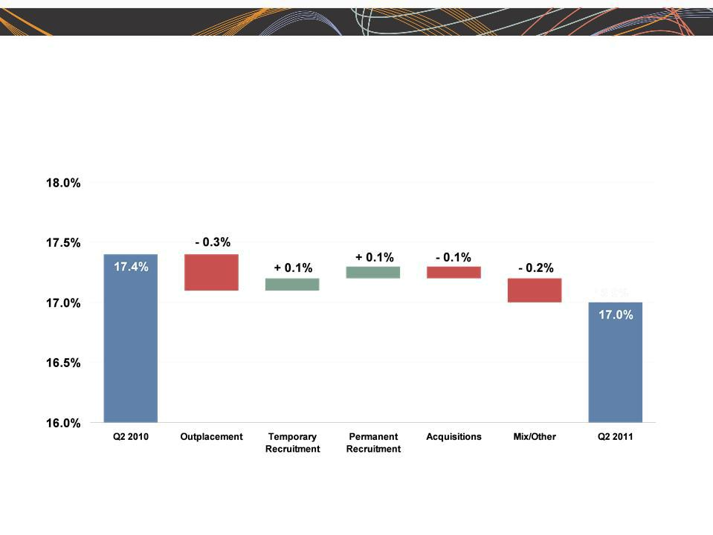
ManpowerGroup 2011 2nd Quarter Results 2011

July

Consolidated Gross Margin Change

4

ManpowerGroup 2011 2nd Quarter Results 2011

July

Americas Segment

(21% of Revenue)


Q2 Financial Highlights⁽¹⁾

13% | Revenue $1.2B
12% CC
69% | OUP | $40M
67% CC | OUP | $40M

110 bps OUP Margin 3.4%

- Included in these amounts is the US, which had revenue of $792M (+9%) and OUP of $27M (+85%).

Operating Unit Profit (OUP) is the measure that we use to evaluate segment performance.

OUP is equal to segment revenues less direct costs and branch and national ₅ headquarters operating costs.

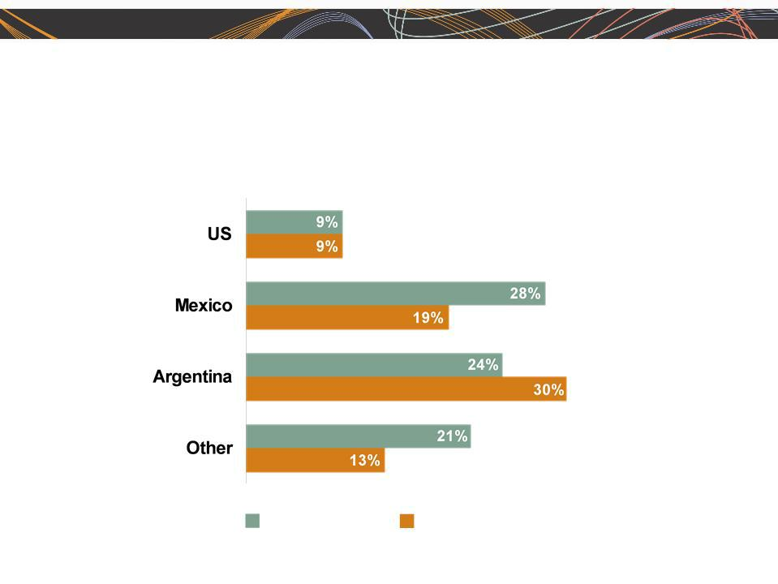
ManpowerGroup 2011 2nd Quarter Results 2011

July

Americas - Q2 Revenue Growth YoY

- of Segment Revenue

68%

12%

6%

14%

Revenue

Growth

Revenue Growth - CC

6


ManpowerGroup 2011 2nd Quarter Results 2011

July

Southern Europe Segment

(38% of Revenue)

111 | Q2 Financial Highlights⁽¹⁾
30% | Revenue $2.2B
15% CC
95% | OUP | $50M
72% CC | OUP | $50M
80 bps | OUP Margin 2.3%

- Included in these amounts is France, which had revenue of $1.6B (+15% CC) and OUP of $25M (+118% CC).

7

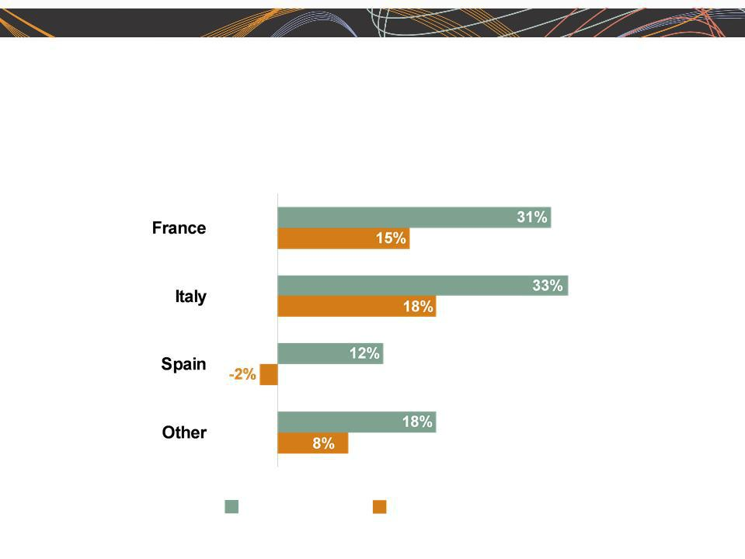
ManpowerGroup 2011 2nd Quarter Results 2011

July

Southern Europe - Q2 Revenue Growth YoY

- of Segment Revenue

75%

16%

5%

4%

Revenue

Growth

Revenue Growth - CC

8

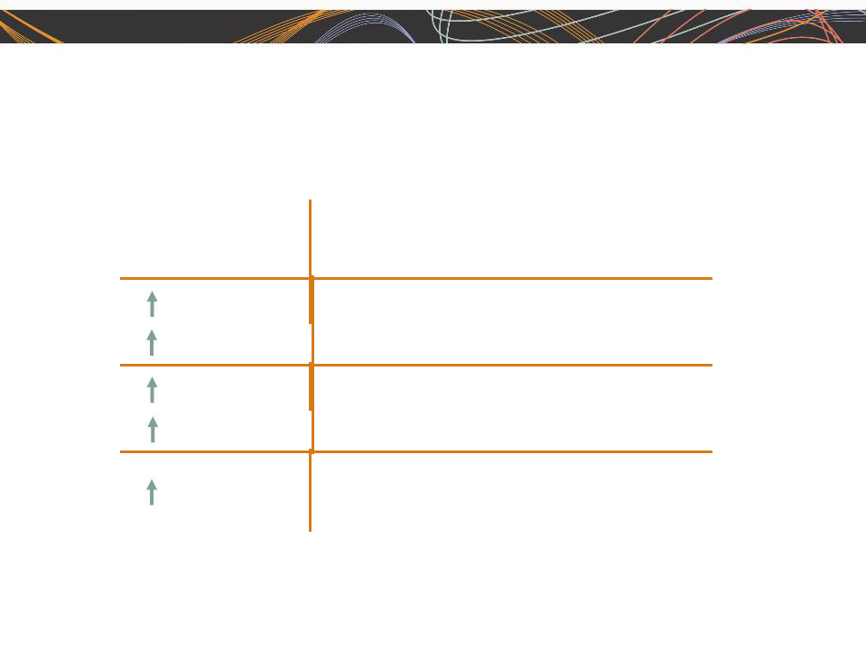
ManpowerGroup 2011 2nd Quarter Results 2011

July

Northern Europe Segment

(28% of Revenue)

Q2 Financial Highlights

24% | Revenue $1.6B
9% CC
97% | OUP | $56M
72% CC | OUP | $56M

130 bps OUP Margin 3.6%

9

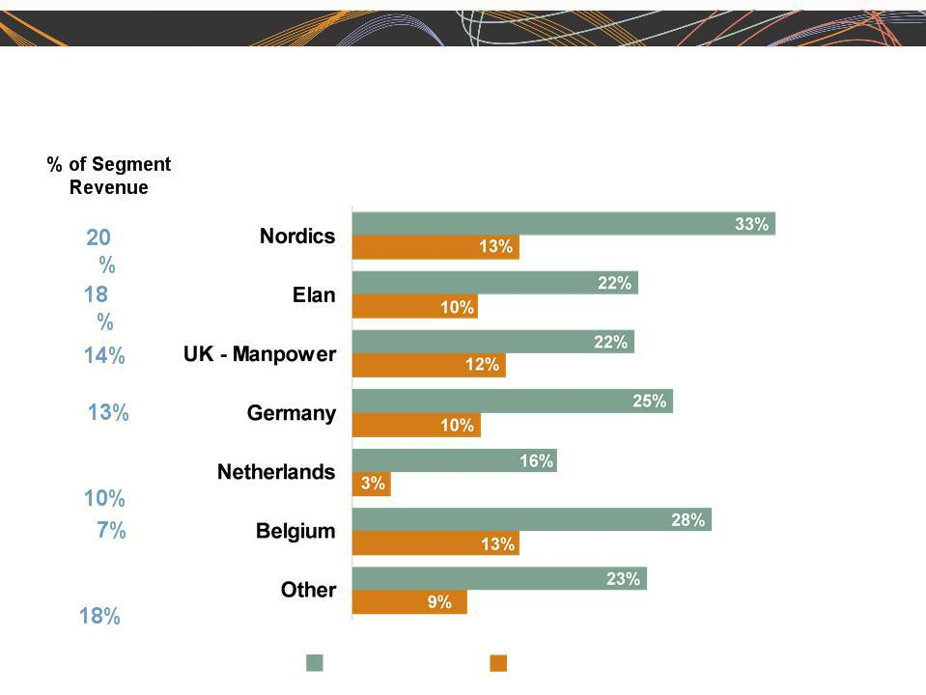
ManpowerGroup 2011 2nd Quarter Results 2011

July

Northern Europe - Q2 Revenue Growth YoY

Revenue | Revenue Growth - CC | 10
Growth

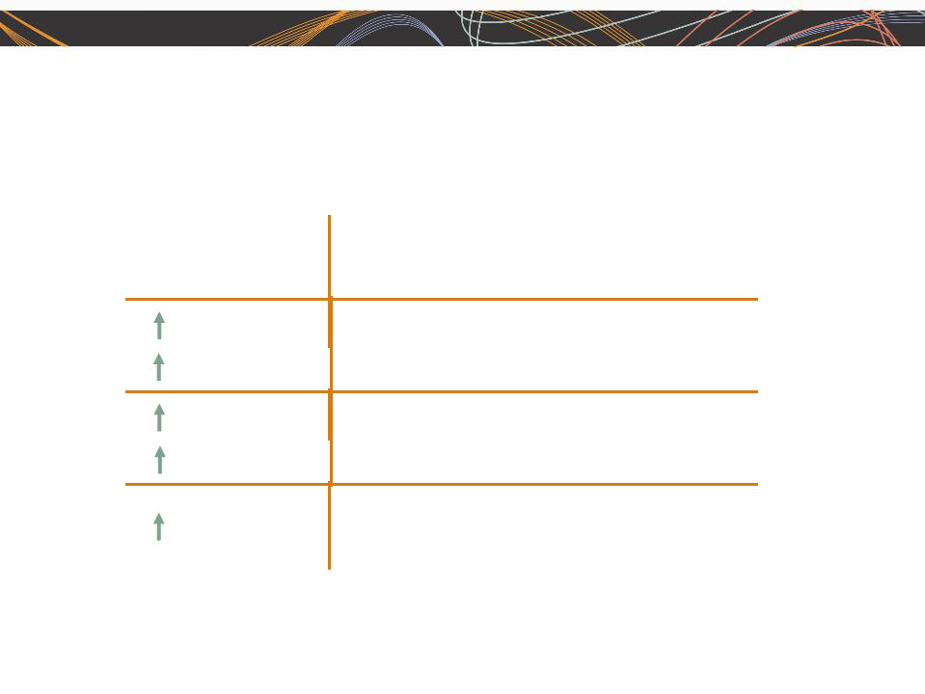
ManpowerGroup 2011 2nd Quarter Results 2011

July

APME Segment

(12% of Revenue)

Q2 Financial Highlights

31% | Revenue $663M
16% CC
59% | OUP | $19M
43% CC | OUP | $19M

50 bps OUP Margin 2.8%

11

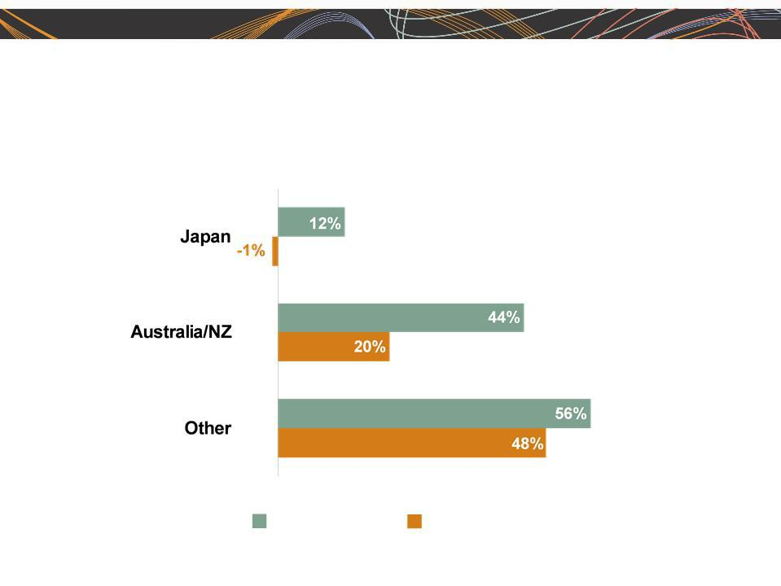
ManpowerGroup 2011 2nd Quarter Results 2011

APME - Q2 Revenue Growth YoY

- of Segment Revenue

43%

28%

(1)
29%

Revenue Revenue Growth - CC

Growth
- On an organic basis, Other revenue growth was 23% (+16% CC).

July

12

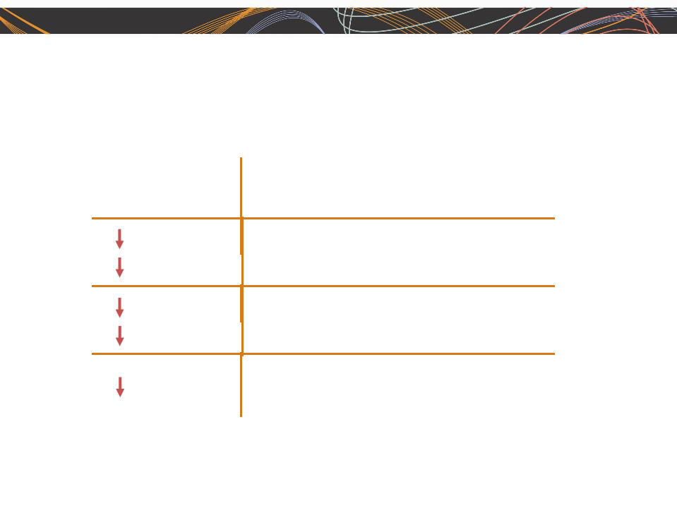
ManpowerGroup 2011 2nd Quarter Results 2011

July

Right Management Segment

(1% of Revenue)

Q2 Financial Highlights

14% | Revenue $85M
20% CC
64% | OUP | $3M
64% CC | OUP | $3M

460 bps OUP Margin 3.3%

13


ManpowerGroup 2011 2nd Quarter Results 2011

July

Cash Flow Summary - First Half

($ in millions) | 2011 | 2010
Cash from Operations | (192) | (66)
Capital Expenditures | (28) | (28)
Free Cash Flow
Free Cash Flow | (220) |  | (94)
Change in Debt | 4 | (5)
Share Repurchases | (19) | -
Acquisitions of Business | (15) | (259)
net of cash acquired | (15)
Effect of Exchange Rate Changes | 31 | (92)
Other | (10) | (12)
Change in Cash
Change in Cash | (229) |  | (462)
14

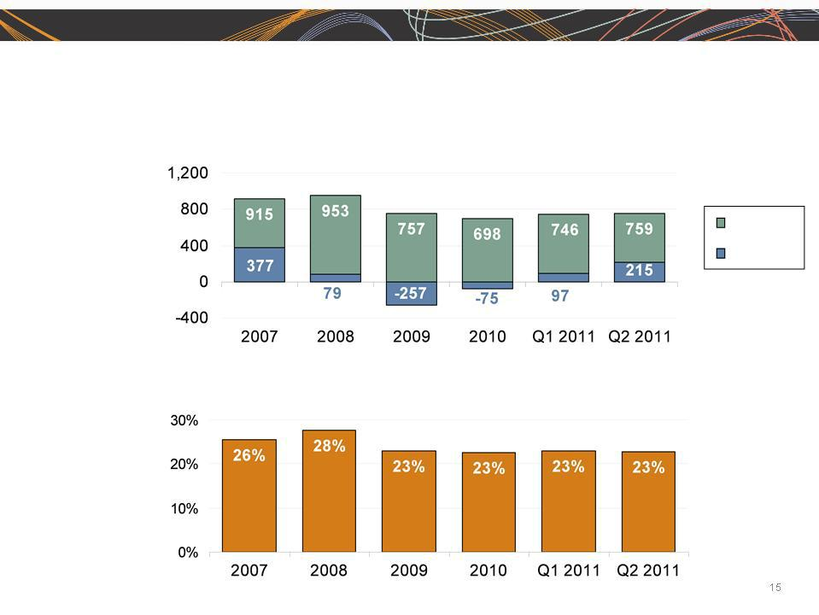
ManpowerGroup 2011 2nd Quarter Results 2011

July

Balance Sheet Highlights

Total Debt

($ in millions)

Total Debt

Net
Debt

Total Debt to

Total Capitalization


ManpowerGroup 2011 2nd Quarter Results 2011

July

Credit Facilities as of June 30, 2011

($ in millions) |  |  | Interest | Maturity | Total | Remaining
 |  |  | Rate | Date | Outstanding | Available
Euro
Notes: |  |  | 4.86% | June | 290 | -
- Euro
200M |  |  | 4.58% | 2013 | 435 | -
- Euro |  |  | 4.58% | June | 435 | -
300M | (a) |  | 2.74% | 2012 | - | 398
Revolving Credit Agreement |  |  | 2.74% | Nov 2012 | - | 398
Uncommitted lines and |  | (b) | Various | Various | 34 | 387
Other |  |  |  |  | 759 | 785
Total Debt |  |  |  |  | 759 | 785

- This $400M agreement requires, as of June 30, that we comply with a Debt-to-EBITDA ratio of less than 3.75 to 1 and a fixed charge coverage
ratio of greater than 1.35 to 1. As defined in the agreement, we had a Debt-to-EBITDA ratio of 1.35 and a fixed charge coverage ratio of 2.84 as of June 30, 2011. As of June 30, there were $2.2M of standby letters of credit issued under the agreement.

  - Represents subsidiary uncommitted lines of credit & overdraft facilities, which total $419.8M. Total subsidiary borrowing are limited to $300M due to restrictions in our Revolving Credit Facility, with the exception of Q3 when subsidiary borrowings are limited to $600M.

16


ManpowerGroup 2011 2nd Quarter Results 2011

July

Third Quarter Outlook

Revenue |  | Total | Up 16-18% (Up 8-10% CC)
 |  | Americas | Up 8-10% (Up 6-8% CC)
 |  | Southern Europe | Up 19-21% (Up 9-11% CC)
 |  | Northern Europe | Up 17-19% (Up 7-9% CC)
 |  | APME | Up 25-27% (Up 14-16% CC)
 | Right Management |  | Down 4-6% (Down 9-11% CC)
Gross Profit Margin |  |  | 16.5 - 16.7%
Operating Profit Margin |  |  | 2.6 - 2.8%
Tax Rate |  |  | 46.5%
EPS |  |  | $0.90-$1.00 (Favorable $.10 Currency)

17


ManpowerGroup 2011 2nd Quarter Results July

2011

Our brand and messages are resonating worldwide

- rebranding… in a bid to improve
the marketing of its
services.” | “[Manpower] used this
 | experience to identify a
 | new era, what it calls
 | the human age.
 | It’s changing its name
 | and logo to fit a world
 | where it says talent
“Talent is the new | replaces capital as the
capital” | key driver of economic
— Swedish newspaper | growth.”
Sundsvalls Tidning | — Bloomberg TV

“Prepare to play part in a new era: 20 epic shifts to the Human Age”
— South African newspaper, The Star

“Do changes as subtle as those exemplified by Manpower's renaming matter? Absolutely, said Columbia University business professor Bernd Schmitt - right down to the single-word styling and the replacement of ‘Inc.’ with ‘Group.’”

— Milwaukee Journal-

Sentinel

“Inc. sounds like a

faceless corporation, where ‘group’ sounds more human, more in touch”

— Jonathan Schroeder, communications professor, Rochester Institute of Technology

“The Human Age

marks the pinnacle

of a journey, when the

raw potential of

individuals ultimately takes center stage.”

— HR Asia magazine

“Group is more

contemporary”

— Deborah Mitchell, marketing professor, University Wisconsin-Madison

18

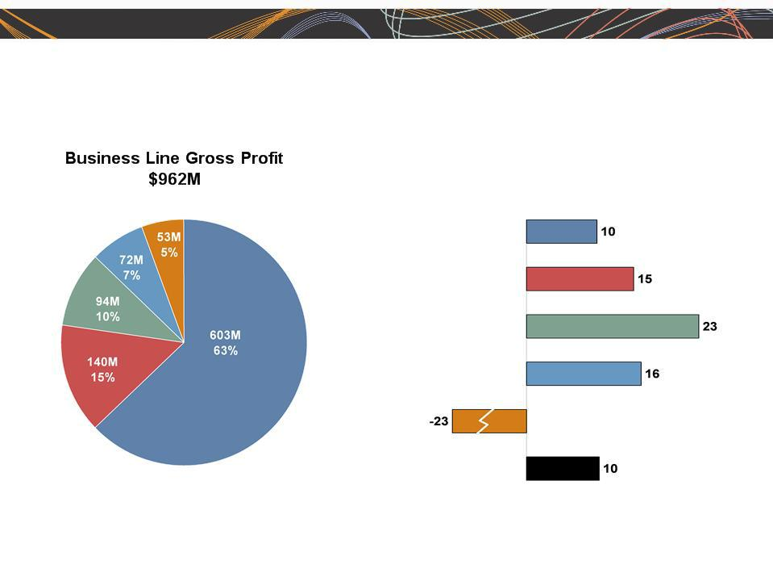
ManpowerGroup 2011 2nd Quarter Results 2011

July

Gross Profit Development - Q2 2011

Gross Profit Growth

in CC %

█ Staffing | █ Professional Resourcing | █ Permanent Recruitment (excluding RPO)
█ ManpowerGroup Solutions | █ Talent & Career Management | █ ManpowerGroup - Total | 19

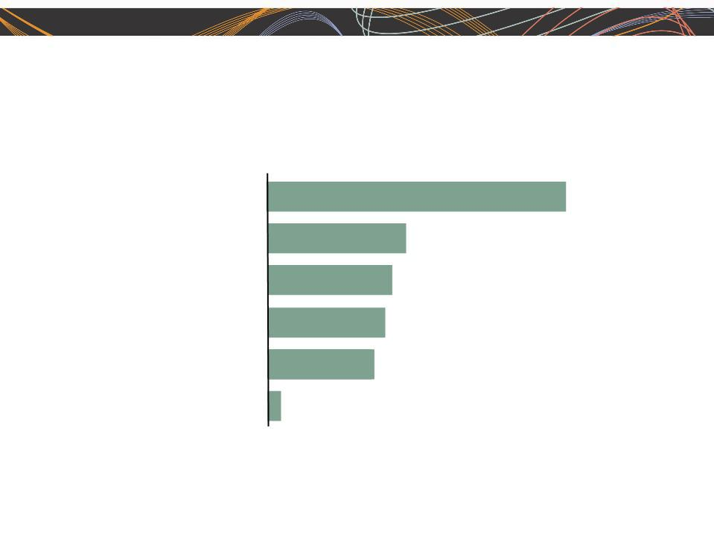
ManpowerGroup 2011 2nd Quarter Results July

2011

Employers foresee a more flexible and virtual labor force

How will your company’s workforce change over the next 5 years?

% of respondents (n = 2,000)
More part-time, temporary,
or contract workers
More telecommuting
More offshored or
outsourced workers
More older workers
(aged 55+)
Don’t know
Other types of changes | 2.9%
to the nature of work | 2.9%

57.8%

25.5%

21.5%

19.9%

16.8%

Source: McKinsey Global Institute US Jobs Survey, 2011; McKinsey Global Institute analysis
20



Questions

