UNITED STATES

SECURITIES AND EXCHANGE COMMISSION
Washington, D.C. 20549

SCHEDULE 14A INFORMATION

Proxy Statement Pursuant to Section 14(a) of the

Securities Exchange Act of 1934
(Amendment No. )

Filed by the Registrant ☒ Filed by a Party other than the Registrant ☐

Check the appropriate box:

- Preliminary Proxy Statement

- Confidential, for Use of the Commission Only (as permitted by Rule 14a-6(e)(2))

- Definitive Proxy Statement

- Definitive Additional Materials

- Soliciting Material under § 240.14a-12

MANPOWERGROUP INC.

(Name of registrant as specified in its charter)

(Name of person(s) filing proxy statement, if other than the registrant)

Payment of Filing Fee (Check the appropriate box):

- No fee required.

- Fee computed on table below per Exchange Act Rules 14a-6(i)(1) and 0-11.

  - Title of each class of securities to which the transaction applies:

  - Aggregate number of securities to which the transaction applies:

  - Per unit price or other underlying value of the transaction computed pursuant to Exchange Act Rule 0-11 (set forth the amount on which the filing fee is calculated and state how it was determined):

  - Proposed maximum aggregate value of the transaction:

  - Total fee paid:

- Fee paid previously with preliminary materials.

- Check box if any part of the fee is offset as provided by Exchange Act Rule 240.0-11(a)(2) and identify the filing for which the offsetting fee was paid previously. Identify the previous filing by registration statement number, or the Form or Schedule and the date of its filing.

  - Amount Previously Paid:

  - Form, Schedule or Registration Statement No.:

- Filing Party:

- Date Filed:

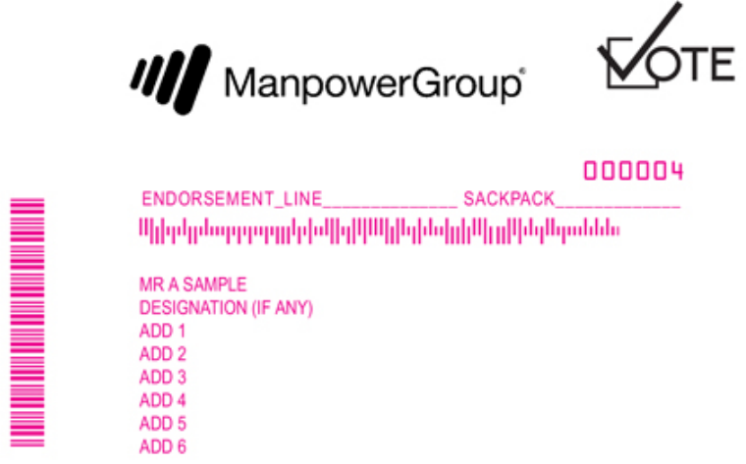

.

Online

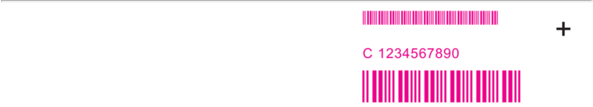


Go to www.envisionreports.com/MAN or scan the QR code – login details are located in the shaded bar below.


Votes submitted electronically must be received by May 7, 2020 at 11:59 P.M., Eastern Time

Important Notice Regarding the Availability of Proxy Materials for the

ManpowerGroup Inc. Shareholder Meeting to be Held on May 8, 2020

Under Securities and Exchange Commission rules, you are receiving this notice that the proxy materials for the annual shareholders’ meeting are available on the Internet. Follow the instructions below to view the materials and vote online or request a copy. The items to be voted on and location of the annual meeting are on the reverse side. Your vote is important!

This communication presents only an overview of the more complete proxy materials that are available to you on the Internet. We encourage you to access and review all of the important information contained in the proxy materials before voting. The Proxy Statement and the 2019 Annual Report on Form 10-K are available at:

Easy Online Access – View your proxy materials and vote.


Step 1: Go to www.envisionreports.com/MAN.

Step 2: Click on Cast Your Vote or Request Materials.

Step 3: Follow the instructions on the screen to log in.

Step 4: Make your selection as instructed on each screen for your delivery preferences.

Step 5: Vote your shares.

When you go online, you can also help the environment by consenting to receive electronic delivery of future materials.

Obtaining a Copy of the Proxy Materials - If you want to receive a copy of the proxy materials, you must request one. There is no charge to you for requesting a copy. Please make your request as instructed on the reverse side on or before 10 days before the meeting to facilitate timely delivery.


Shareholder Meeting Notice

ManpowerGroup Inc.’s Annual Meeting of Shareholders will be held on May 8, 2020 at the International Headquarters of ManpowerGroup Inc., 100 Manpower Place, Milwaukee, Wisconsin, at 9:00 a.m. Central Time.

Proposals to be voted on at the meeting are listed below along with the Board of Directors’ recommendations.

The Board of Directors recommend a vote FOR Proposals 1, 2, 3 and 4:

- Elect eleven individuals nominated by the Board of ManpowerGroup Inc. to serve until 2021 as directors.

- Ratification of Deloitte & Touche LLP as our independent auditors for 2020.

- Advisory vote to approve the compensation of our named executive officers.

- To approve the amendment and restatement of the 2011 Equity Incentive Plan of ManpowerGroup Inc.

- In their discretion, the Proxies are authorized to vote upon such other business as may properly come before the meeting.

PLEASE NOTE - YOU CANNOT VOTE BY RETURNING THIS NOTICE. To vote your shares you must go online or request a paper copy of the proxy materials to receive a proxy card. If you wish to attend and vote at the meeting, please bring this notice with you. For information on how to obtain directions to be able to attend the meeting and vote in person, please call 1-414-906-7556.

Here’s how to order a copy of the proxy materials and select delivery preferences:


Current and future delivery requests can be submitted using the options below.

If you request an email copy, you will receive an email with a link to the current meeting materials.

PLEASE NOTE: You must use the number in the shaded bar on the reverse side when requesting a copy of the proxy materials.

–Internet - Go to www.envisionreports.com/MAN. Click Cast Your Vote or Request Materials.

–Phone - Call us free of charge at 1-866-641-4276.

–Email - Send an email to investorvote@computershare.com with “Proxy Materials ManpowerGroup Inc.” in the subject line. Include your full name and address, plus the number located in the shaded bar on the reverse side, and state that you want a paper copy of the meeting materials.

To facilitate timely delivery, all requests for a paper copy of proxy materials must be received by 10 days before the meeting.

